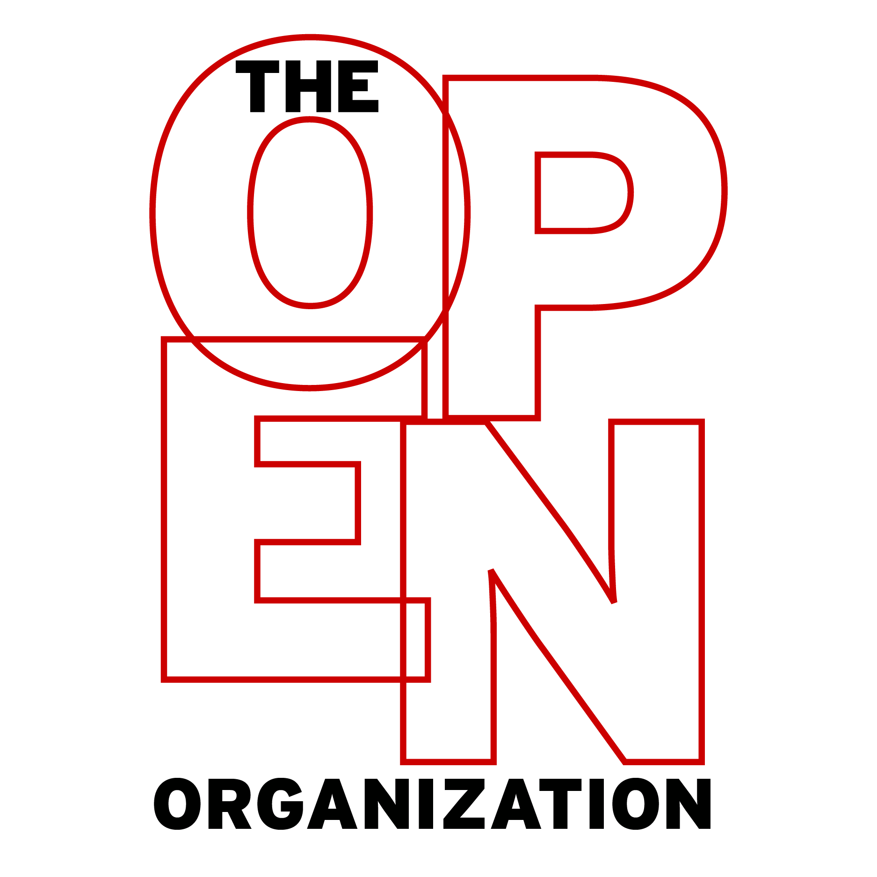
Discussion Guide
(For General Audiences)
Copyright © 2015 Red Hat, Inc. All written content licensed under a Creative Commons Attribution-ShareAlike 4.0 International License.

Foreword
Gary Hamel argues that "the human capabilities that are most critical to success [...] are precisely the ones that can’t be ‘managed.’"
- Do you agree or disagree with this statement?
- If these capabilities can’t be managed, then how can organizations make use of them?
Hamel says that "control [in organizations] comes from shared norms and aspirations, not from policies and bosses."
- How do organizations that coalesce around community practices differ from those that coalesce around formal hierarchies?
- Do shared norms and aspirations guide your organization?
Successful organizations, says Hamel, are those that engage internal and external communities—and this requires an "ethos of openness."
- What is an "ethos of openness?"
- How does it affect the way we work in "postbureaucratic" organizations?

Chapter 1: Why Opening Up Your Organization Matters
Jim defines an "open organization" as "an organization that engages participatory communities both inside and out."
- How open is your organization?
- How consistently does it engage communities inside and outside its boundaries?
Jim says an open organization "responds to opportunities more quickly, has access to resources and talent outside the organization, and inspires, motivates, and empowers people at all levels to act with accountability."
- Would you characterize your organization as an open organization?
- Can you think of additional characteristics of an open organization?
Jim explains how "open sourcing" differs from "crowd sourcing."
- How can your organization engage more communities while avoiding the "Tom Sawyer" model of collaboration?
- How can your organization avoid falling into a "transactional mindset"?
Jim suggests that in open organizations "a leader's success is no longer measured by his or her ability to simply issue orders."
- What kinds of leaders are most successful today?
- What do you look for and value in a leader?

Chapter 2: Igniting Passion
A clear and compelling mission statement is vital to an open organization, Jim says.
- What is your organization's mission statement?
- Do you feel it completely encapsulates the organization's goals? Why or why not?
- Do you think many people in your organization are familiar with and believe in its mission statement?
Jim writes that open organizations "have a goal in mind that transcends the profit motive."
- Does your organization have one of these goals? What is it?
- Do you think many organizations struggle to articulate goals beyond the profit motive? Why?
Jim distinguishes between "passion" and "purpose."
- What is the difference between "passion" and "purpose"?
- How can your organization "activate the emotional passions and desires" of its associates?
Open organizations embrace their associates' emotions, Jim argues.
- Does your organization encourage the exercise of emotions in the workplace?
- If it does, what do you think these emotions add to the organizational environment?
- If not, what do you think would be different if your organization didn't ask employees to "check their emotions at the door"?
"Culture fit is a hard thing to tease out in an interview," Jim writes. "When it's core to your company, you must find ways to ensure that you're hiring the right people."
- How does your organization go about hiring associates that believe in and share its mission?
- How might your organization's interview process change so it can better identify these candidates?

Chapter 3: Building Engagement
Open organizations work to engage their employees and partners, Jim writes.
- What is "engagement" in an organization?
- What does it mean to you?
- How does engagement differ from purpose and passion?
Jim writes that engagement is not a "morale issue."
- Why is this the case?
- What is the relationship between morale and engagement?
Jim suggests that having an "engaged workforce [...] actually changes where and how you make decisions about what needs to get done."
- How do engaged employees participate in decision-making processes?
- How might your organization’s priorities change if its associates were more engaged?
People leading open organizations must find ways to engage their employees, Jim says.
- Do you feel engaged in your organization’s activities?
- Do you feel you know enough about your organization’s strategic priorities to make informed decisions about changes you’d like to implement?
- What can your organization do to better engage its employees and partners?

Chapter 4: Choosing Meritocracy, Not Democracy
Meritocracy and democracy are two different structures, according to Jim.
- What are the most important differences between meritocratic and democratic organizational structures?
- Would you describe your organization as meritocratic?
Leading a meritocracy differs from leading a democracy, Jim explains.
- In meritocracies, how do leaders emerge?
- How would your organization change if its leaders were selected meritocratically?
- Who are your organization’s or team’s thought leaders?
Jim says that in successful open organizations "the most influence over the direction of the project lies with the people who contribute the most meaningful work."
- Is your organization or team set up to reward members with the most valuable ideas?
- If not, how would you suggest it begin doing this?
Open organizations foster advancement, not just achievement, says Jim.
- What is the difference between advancement and achievement?
- Is your organization doing all it can do cultivate advancement?

Chapter 5: Letting the Sparks Fly
Open organizations embrace collaboration, Jim says.
- How is true collaboration different from mere "brainstorming"?
- In what ways do open organizations embrace opportunities for collaboration?
Jim warns that "you don’t want to strip away differences in trying to get to consensus."
- What role does dissensus play in the development and deployment of organizational initiatives and strategies?
- What is the best way to handle productive dissensus?
- What barriers to achieving productive dissensus exist in your organization?
Jim suggests that working in an open organization requires a "new mind set."
- Can you think of a time when someone in your organization challenged one of your ideas?
- When was the last time you challenged someone else’s ideas?
- What was the result of this interaction?
Jim says that "the lack of frank dialogue is the single biggest controllable weakness that most companies impose upon themselves."
- Do you agree?
- Is your organization doing everything it can to foster productive dialogue?
- What could it gain by doing so?

Chapter 6: Making Inclusive Decisions
Open organizations approach decision making as an opportunity for collaborative conversation, according to Jim.
- What roles do participation and transparency play in decision making practices?
- What barriers to participation and transparency exist in your organization?
Jim suggests that "discovered logic is more powerful than delivered logic."
- What do you think he means by this?
- How can your organization make better use of "discovered logic?"
Participatory decision making leads to slower decisions—but faster results, Jim says.
- Do you agree?
- How can your organization better embrace participatory decision making to increase its speed and flexibility?

Chapter 7: Catalyzing Direction
Jim says that open organizations "can respond quickly to external changes without relying on running things up the chain of command."
- Does your organization or team properly equip its associates to make decisions without relying on a traditional hierarchy?
- In what ways might your organization renovate its hierarchies to increase speed and flexibility?
"Part of the art of leading a self-directing, engaged organization is to spark the organization to action," Jim says.
- How is this different than traditional leadership?
- In what ways do leaders in your organization spark action and change?
Jim writes that all initiatives begin as "half-baked ideas."
- What is the benefit of discussing ideas before they are "fully baked?"
- What are some challenges to doing this?
- How can the open organizational mission to "release early, release often" change the way you work?

Epilogue: It's a Journey
Jim thinks an open organization "can innovate faster because it is not encumbered with the need to coordinate across an entire system."
- Can your organization benefit from changing the way it coordinates?
- How might it improve?
Jim says that certain capabilities like speed and agility are more important to today’s businesses than physical assets.
- Do you agree?
- Does your organization compete with others by "matching up your products in a market-based chess game," or does it compete on the strength of its organizational structure and capabilities?
Leading an open organization requires high levels of emotional intelligence, Jim writes.
- Does your organization’s leadership demonstrate this quality?
- How can your organization better grapple with the role emotion plays in the workplace?
Now that you have finished the book, reflect on your organization’s degree of "openness."
- Can your organization become more open? Should it?
- What barriers to openness do you think you will encounter?
- How will you manage and overcome these barriers?

