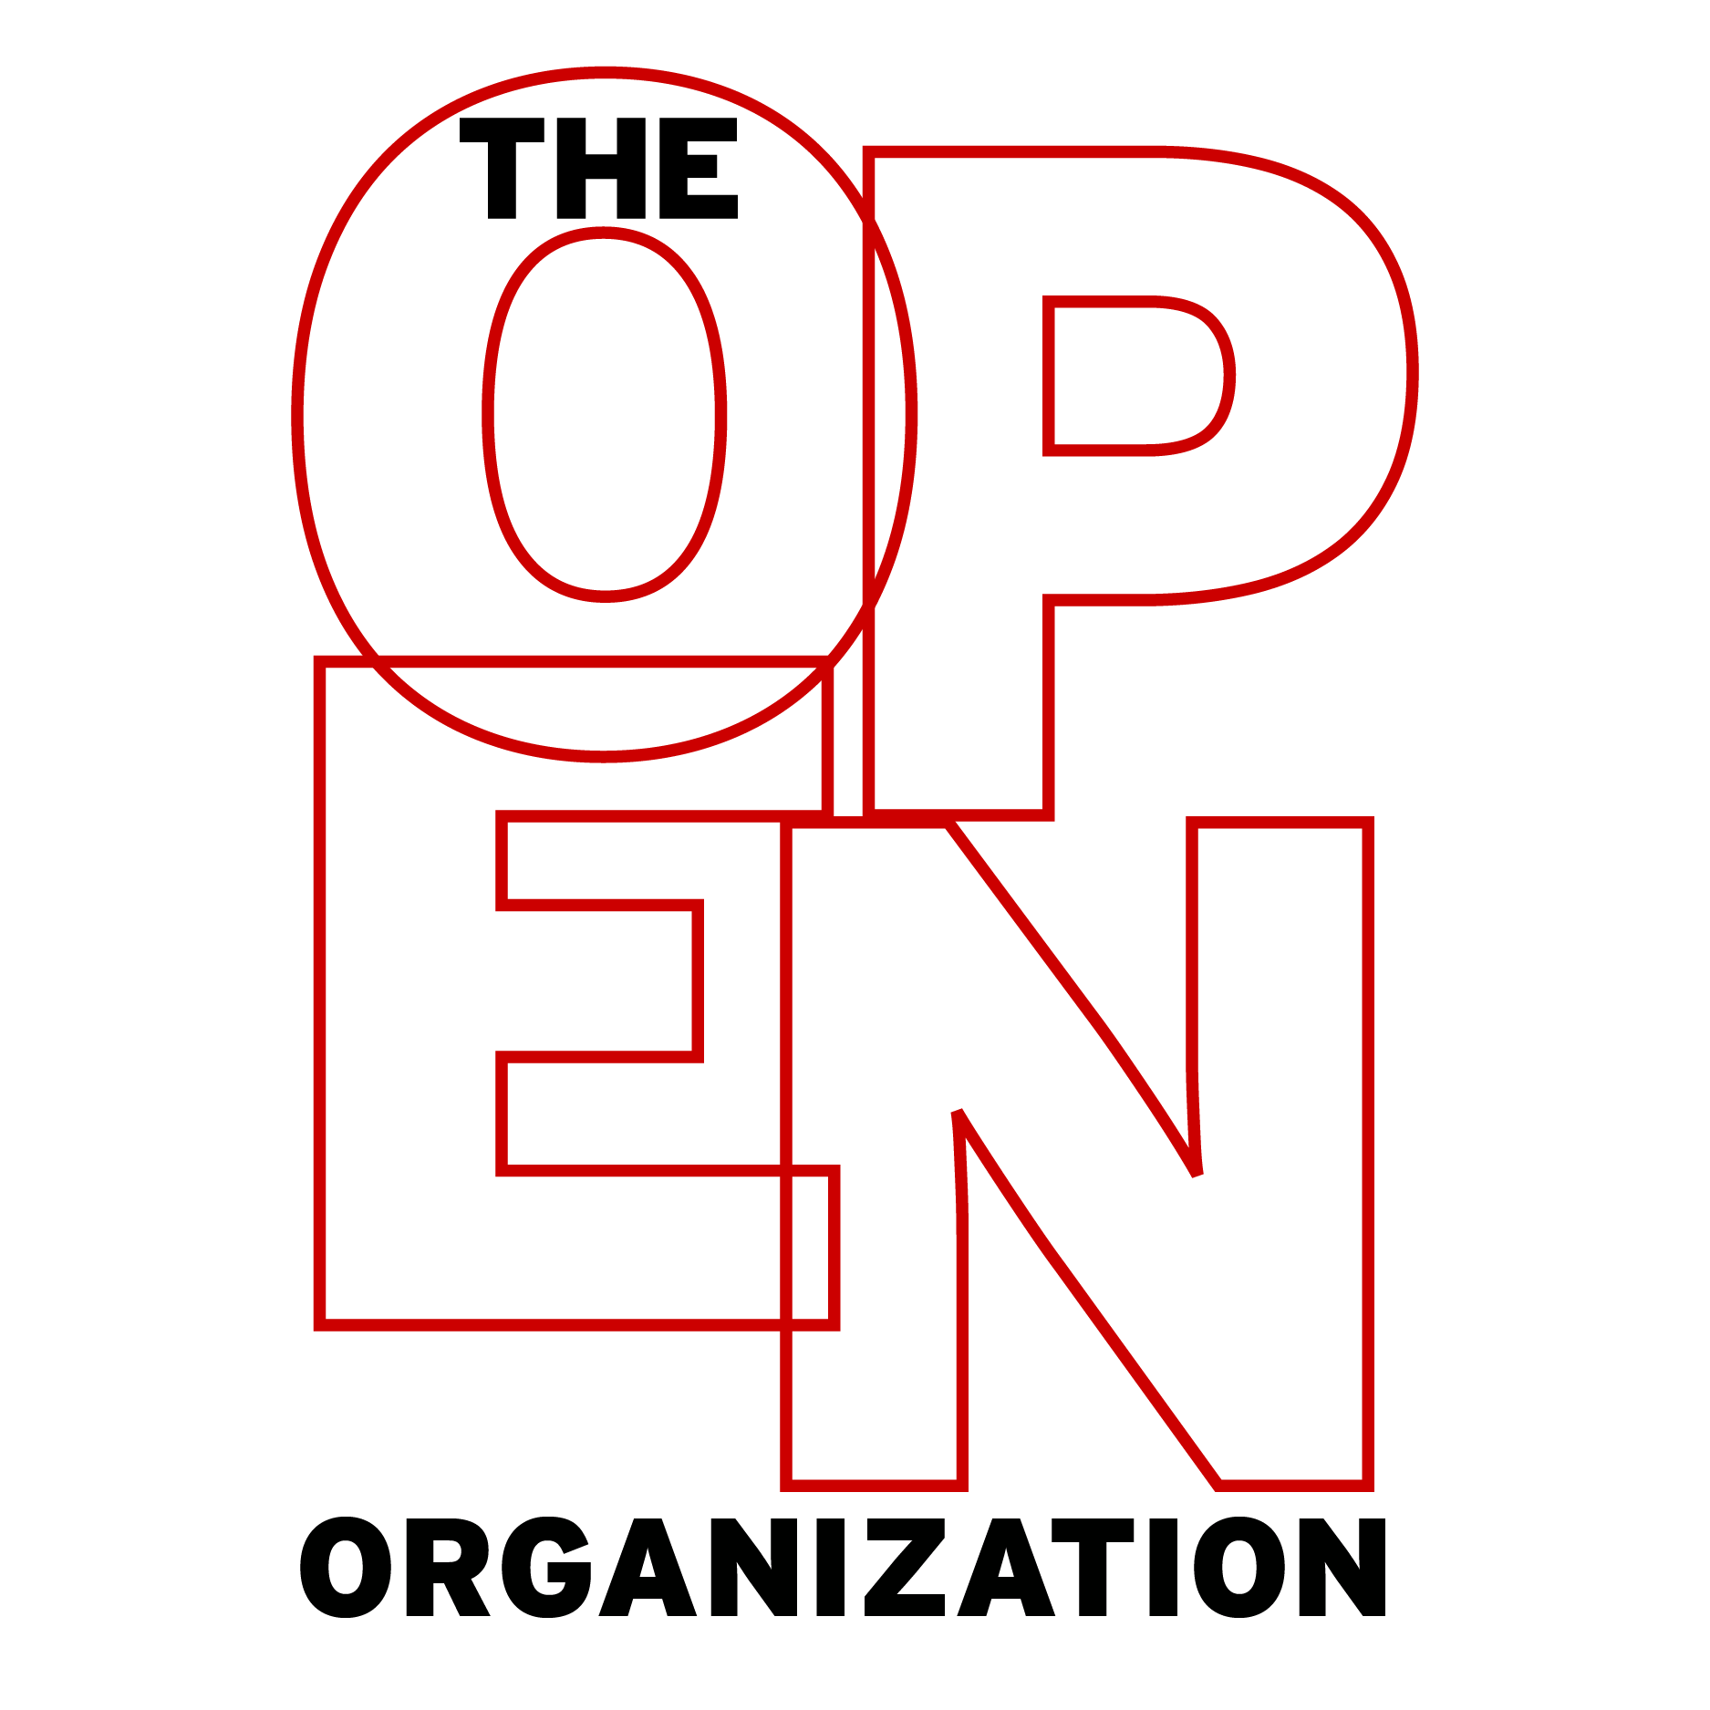
Discussion Guide
(For Managers and Other Leaders)
Copyright © 2015 Red Hat, Inc. All written content licensed under a Creative Commons Attribution-ShareAlike 4.0 International License.

Foreword
Gary Hamel argues that "the human capabilities that are most critical to success [...] are precisely the ones that can't be ‘managed.'"
- Do you agree or disagree with this statement?
- If these capabilities can't be managed, then how can organizations make use of them?
"Today, most organizations waste more human capacity than they use," writes Hamel.
- Is this true of your organization?
- In what ways would transitioning to an open organization structure or management style reverse this trend?

Chapter 1: Why Opening Up Your Organization Matters
Jim defines an "open organization" as "an organization that engages participatory communities both inside and out."
- How open is your organization or team?
- How consistently does it engage communities inside and outside its boundaries?
- How could you better identify and activate these communities?
Jim writes that "the beauty of an open organization is that it is not about pedaling harder, but about tapping into new sources of power both inside and outside to keep pace with all the fast-moving changes in your environment."
- What "fast-moving changes in your environment" does your organization struggle to address?
- What "new sources of power" do you think your organization or team could engage to address them?
Jim suggests that in open organizations "a leader's success is no longer measured by his or her ability to simply issue orders."
- What kinds of leaders are most successful today?
- Do you think your organization's leaders are comfortable managing decentralized groups?

Chapter 2: Igniting Passion
A clear and compelling mission statement is critical to an open organization, Jim says.
- What is your organization's mission statement?
- Do you think many people in your organization are familiar with and believe in its mission statement?
- Did this mission statement emerge as the result of collaborative dialogue with associates?
"Culture fit is a hard thing to tease out in an interview," Jim writes. "When it's core to your company, you must find ways to ensure that you're hiring the right people."
- How does your organization go about hiring associates that believe in and share its mission?
- How might your organization's interview process change so it can better identify these candidates?
Jim writes that "a leader and manager's role becomes more about creating context and reinforcing what purpose and end goal the organization is working toward."
- What does it mean to "create context" for your associates and partners?
- Do you think this statement mirrors your organization's image of effective management?

Chapter 3: Building Engagement
Open organizations work to engage their employees and partners, Jim writes.
- What is "engagement" in an organization?
- What does it mean to you?
- How does engagement differ from purpose and passion?
Jim suggests that having an "engaged workforce [...] actually changes where and how you make decisions about what needs to get done."
- How do engaged employees participate in decision-making processes?
- How might your organization’s priorities change if its associates were more engaged?
"If a key goal of the open organization is to build the capability for members to make their own decisions, act quickly, take initiative, and creatively solve problems," Jim writes, "then engagement is critical."
- Do you think your employees and partners know enough about your organization's operations to "deeply understand and support the direction of the company?"
- In what ways might you more effectively engage your associates?

Chapter 4: Choosing Meritocracy, Not Democracy
Meritocracy and democracy are two different structures, according to Jim.
- What are the most important differences between meritocratic and democratic organizational structures?
- Would you describe your organization as meritocratic?
Leading a meritocracy differs from leading a democracy, Jim explains.
- In meritocracies, how do leaders emerge?
- How would your organization change if its leaders were selected meritocratically?
- Who are the thought leaders in your team or organization, and what can you do to engage them?
Jim says managers of open organizations must "help foster an environment where associates feel comfortable asking to build something new [...] they create the space for people to operate."
- Does your organization do enough to support associate's individual initiatives?
- How might you implement a meritocratic mindset in your organization?

Chapter 5: Letting the Sparks Fly
Jim says that "the lack of frank dialogue is the single biggest controllable weakness that most companies impose upon themselves."
- Do you agree?
- Is your organization doing everything it can to foster productive dialogue?
- What could it gain by doing so?
Inviting dissensus in open organizations is critical. But it's also challenging. Jim writes that "the key is to strive to find the balance between shutting down debate when posts become caustic, while also continuing to push people to give you the kind of frank feedback you're looking for."
- How do you—or could you—strike this balance?
- Do your organization's leaders push associates for feedback often enough?
Jim says that working in an open organization requires "a pretty thick skin." But the rewards for developing one can be great.
- How can you eliminate barriers to productive conversation and collaboration in your organization?
- Is hierarchy inhibiting conversation and collaboration?

Chapter 6: Making Inclusive Decisions
Open organizations approach decision making as an opportunity for collaborative conversation, according to Jim.
- What roles do participation and transparency play in decision making practices?
- What barriers to participation and transparency exist in your organization?
In open organizations, leaders do not simply make decisions by fiat, Jim says.
- How does the nature of leadership change when decision making becomes a participatory process?
- How could your decision making practices become more inclusive?
When done correctly, making inclusive decision should feel like "deciding inside out," Jim writes.
- How might participatory decision making influence change management in your organization or team?
- Could your decision making practices be more transparent? How?

Chapter 7: Catalyzing Direction
Jim says that open organizations "can respond quickly to external changes without relying on running things up the chain of command."
- Does your organization or team equip its associates to make decisions without relying on a traditional hierarchy?
- In what ways could your organization encourage its associates to become more autonomous?
"Part of the art of leading a self-directing, engaged organization is to spark the organization to action," Jim says.
- How is this different than traditional leadership?
- How can leaders in your organization spark action and change?
In open organizations, "everyone should have a sense for how his or her role ultimately translates to customer value," Jim writes.
- Do you think your associates have this sense? If not, what can you do to provide it?
- What are the challenges you face when trying to create this context for your associates?
Jim says that in open organizations, good leaders are good catalysts.
- In what ways might you begin to act more like a "Catalyst in Chief?"
- How could you encourage other leaders in your organization to do the same?

Epilogue: It's a Journey
Jim says that leaders of open organizations must possess four traits. Review this list of traits (starting on page 189).
- Do your organization's leaders possess these qualities?
- Would you add anything to the list?
Now that you have finished the book, reflect on your organization's degree of "openness."
- Can your organization become more open? Should it?
- What barriers to openness do you think you will encounter?
- How will you manage and overcome them?

