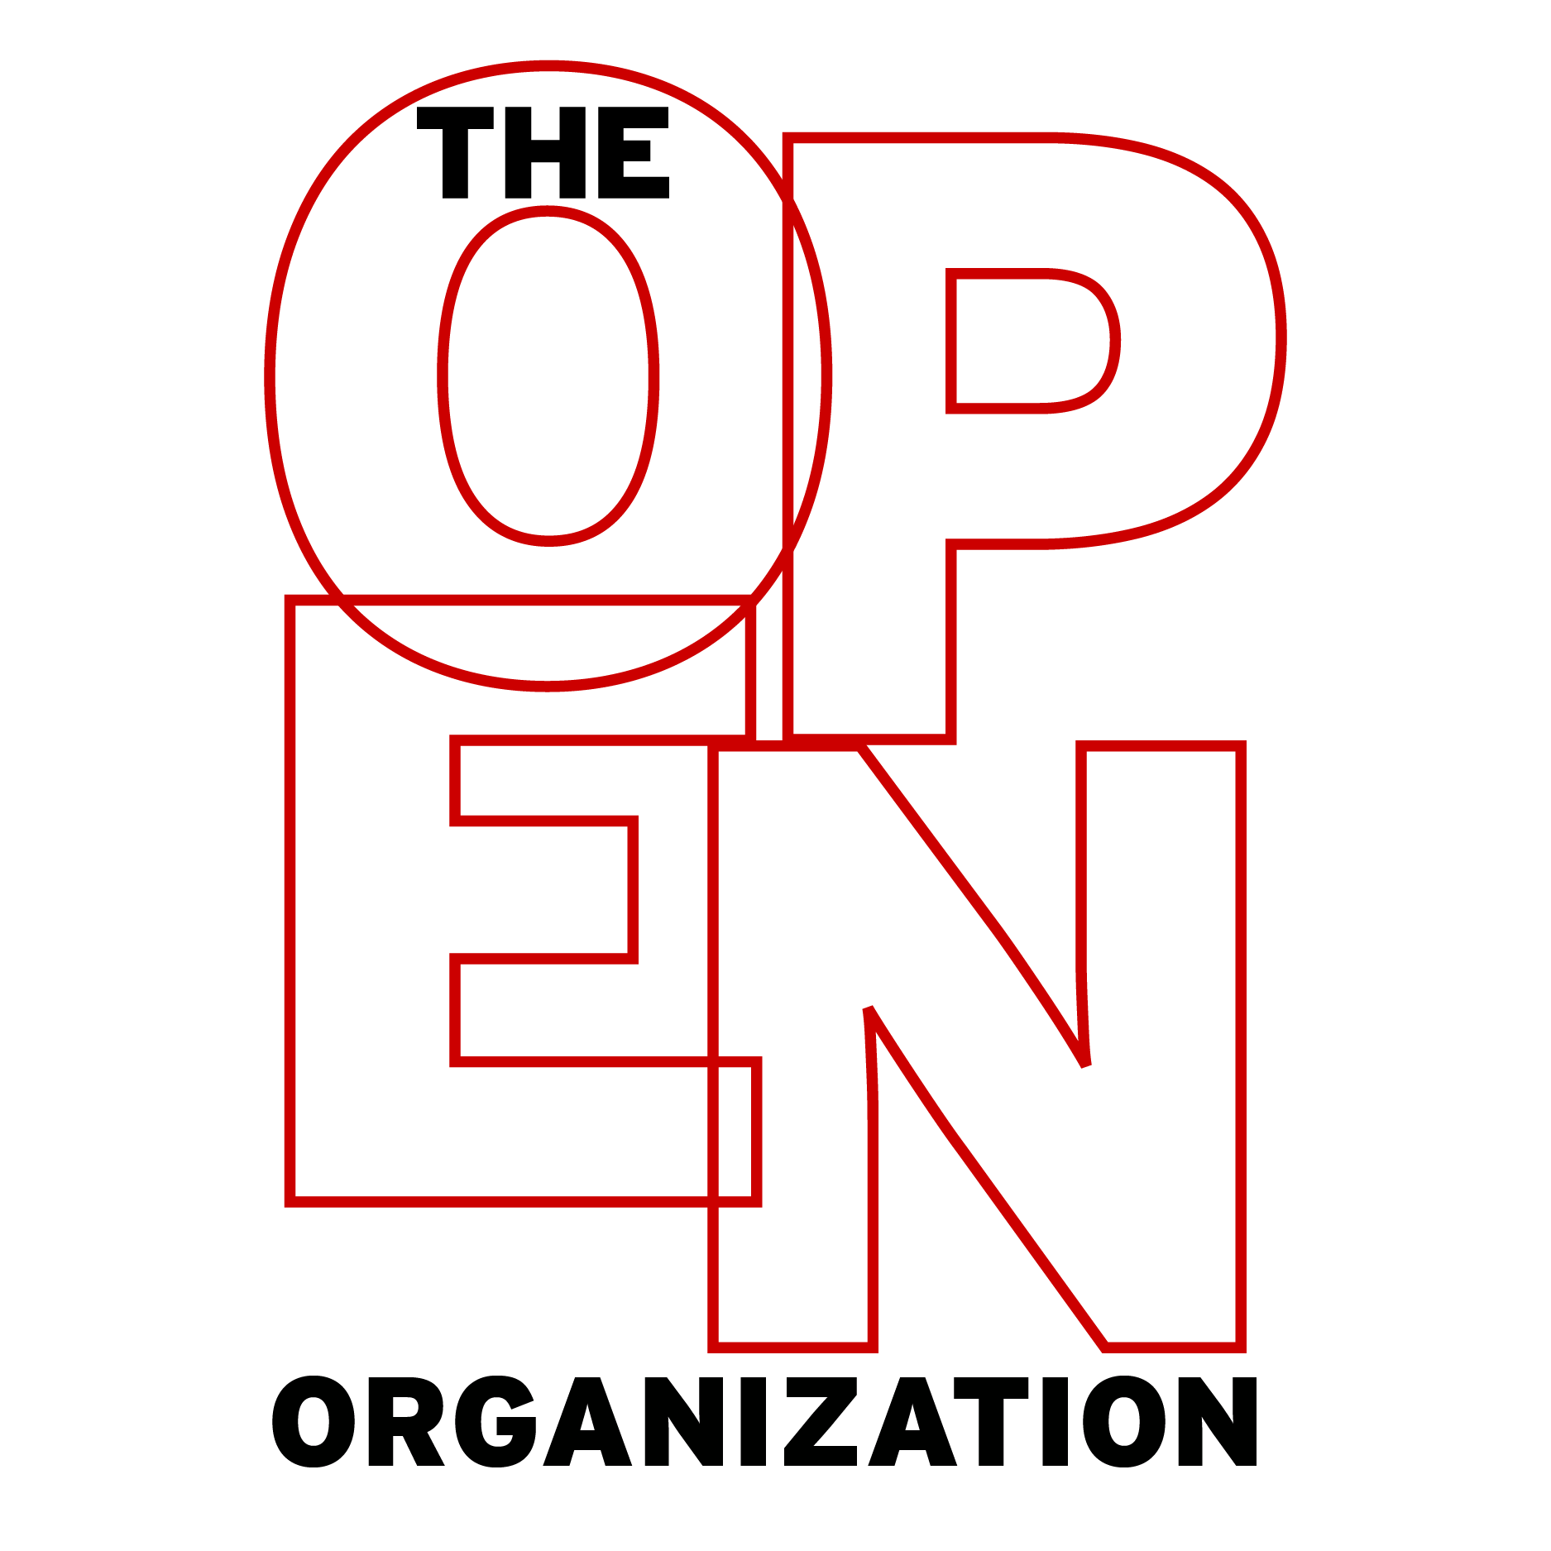
Discussion Guide
(Quick Start)
Copyright © 2015 Red Hat, Inc. All written content licensed under a Creative Commons Attribution-ShareAlike 4.0 International License.

Why

Motivating and Inspiring
- Would you characterize your organization as an open organization?
- Can you think of additional characteristics of an open organization?
- Do you think many people in your organization are familiar with and believe in its mission statement?
- What is the difference between "passion" and "purpose"?
- How can your organization "activate the emotional passions and desires" of its associates?
- Does your organization encourage the exercise of emotions in the workplace?
- How does your organization go about hiring associates that believe in and share its mission?
- What is "engagement" in an organization?
- Do you feel you know enough about your organization’s strategic priorities to make informed decisions about changes you’d like to implement?

How

Getting Things Done
- What are the most important differences between meritocratic and democratic organizational structures?
- Would you describe your organization as meritocratic?
- In meritocracies, how do leaders emerge?
- How would your organization change if its leaders were selected meritocratically?
- Is your organization or team set up to reward members with the most valuable ideas?
- Is your organization doing all it can do cultivate advancement?
- How is true collaboration different from mere "brainstorming"?
- What role does dissensus play in the development and deployment of organizational initiatives and strategies?
- What barriers to achieving productive dissensus exist in your organization?
- Can you think of a time when someone in your organization challenged one of your ideas?
- Is your organization doing everything it can to foster productive dialogue?

What

Setting Direction
- What roles do participation and transparency play in decision making practices?
- What barriers to participation and transparency exist in your organization?
- How can your organization make better use of "discovered logic?"
- How can your organization better embrace participatory decision making to increase its speed and flexibility?
- Does your organization or team properly equip its associates to make decisions without relying on a traditional hierarchy?
- In what ways might your organization renovate its hierarchies to increase speed and flexibility?
- In what ways do leaders in your organization spark action and change?
- What is the benefit of discussing ideas before they are "fully baked?"
- How can the open organizational mission to "release early, release often" change the way you work?
- Can your organization become more open?

