Opening up to leadership talent
A guide to unlocking people’s potential during transformation
Jos Groen

Open Organization Ambassador and Founder of hbrd
Part of the Open Perspectives series from the Open Organization project
Issue #001

Executive summary
- Acknowledge that people are an organization’s source of creativity and ingenuity, and that you can unlock it by providing a safe working environment based upon trust, joy, openness and inclusivity.
- Involve talented employees in all aspects of your business operations.
- Ensure inclusivity so that everyone has the opportunity to thrive.
- Create a safe environment in which people can learn and experiment.
- When considering a organizational mentoring practice, remember that leaders tend to train leaders and managers train managers (and acknowledge the difference).
- Provide enough mentors and coaches for those interested in developing their leadership talents
- Make a conscious choice whether to transform your organization and unlock its true potential or simply “change” it according to your conventional change management practices with a predictable outcome.
- Start transformation at the top by striking a balance between managers and leaders.
- A good idea can originate anywhere in an organization, and your organization’s culture and design should surface good ideas wherever they originate.
- Embrace and respect current senior management and show them the opportunities of being more open.
- A company without a core direction is not connected to its own essence.
- Let your heart, gut feelings and head guide your leadership practice; balancing these is key.
- Working through a hybrid period of organizational transformation is not easy, but it is dynamic and can be very satisfying.
- People are not simply a source of production but co-creators; they need
- spaces that elevate their uniqueness.

Foreword
As Chief People Officer at an open organization, Red Hat, and now in my work as an executive advisor and coach, regardless of the organization’s size or maturity, I hear business leaders raising the same concerns: How do we attract and engage the most talented, high performing people in our industry to enable us to achieve our potential?
The question has become a greater concern to most, as the values of many in the workforce have shifted significantly, not only as a function of generational differences, but also as the pandemic accelerates changes in expectations of the work experience.
My own experience leads me to have a deep faith that the answer to this question lies in the brilliance of the people themselves. When engaged, it is the people who will create solutions to the big problems of the workplace as well as the world. At Red Hat, we strived to default to open in our practices, and on our best days, we did so, with extraordinary results. From consulting with many of our customers—and now with my own clients—I learned just how difficult it can be for an organization to build and adopt new open practices. So I was intrigued and excited when Open Organization Ambassador and founder of hbrd, Jos Groen, shared the idea of creating a guide for organizational leaders to follow to build the open organizational “muscle.”
And the book delivers just that. It is a one stop shop for talent managers to understand open principles and practices. The book offers talent managers support in building a roadmap in adopting more open and inclusive practices and for harnessing the brilliance of the talent in their organization to drive business performance.
I particularly appreciate how Jos acknowledges that most organizations will exist in a “hybrid” state where prior traditional practices and new, open practices must co-exist, and where both emerging talent and experienced leaders must respect each other’s perspectives. This hybrid state will bring tensions that must be worked through. But like most situations, people learn and grow by overcoming challenges and working through issues. Embracing the tension is critically important to building open organizational muscles.
If you want to cultivate an organizational culture that harnesses the brilliance and passion of your people, this book is an excellent resource to get started.
DeLisa Alexander, Executive Coach and Board Director

Introduction: Taking an open perspective on talent management
Attracting and retaining young professionals is essential to creating a future-proof organization. After all, they’re the leaders of the future. And increasingly, these professionals occupy impactful positions inside our organizations at a relatively young age. But they can remain somewhat elusive because talent is scarce in today’s tight labor market.
The Central Bureau of Statistics (CBS) in the Netherlands (where I live and work) reports that in Q3 of 2021, there were even more vacancies than unemployed people. Since the CBS has been measuring stress on the labor market, this has never happened before. The tight labor market makes it more important than ever for employers to have insight into what young professionals find important and why they choose for an organization—and, even more importantly, to have insight into how best to retain young professionals in organizations today.
This generation of young professionals consists largely of millennials, also known as Generation Y. Millennials are the generation born between 1981 and 1996, meaning that today, in 2021, they’re roughly 25 to 40 years old. Millennials have grown up in an era full of technological advances in information technology, such as the internet, smartphones, and social media. The subsequent generation, Generation Z, is also entering the workforce today; individuals from this generation were born after 1996 and are also known as “digital natives.” They were born in the digital age, do not know a world without the Internet, and, as my fellow Open Organization Ambassador Jen Kelchner has observed, implicitly operate according to values and principles we might describe as “open.”
Young professionals’ views on careers differ greatly from those of previous generations. They have different requirements and expectations not only of the work they do, but also of the organizations where they do it. Issues such as room for growth and development and an organization’s attention to social issues play a major role in their choice of employer. Organizations will have to pay attention to this—and implement changes to attract and retain the younger generations accordingly.
Retaining young professionals, however, is challenging.
For starters, there’s high job mobility among this group of employees. Research by career website magnet.me, which queried more than 300 young professionals, shows that 61% of interviewees changed jobs within 24 months. The most important reason for leaving? Limited growth opportunities within an organization.
Similarly, research by Careerwise also shows that only 60% of young professionals expect to remain employed by their current employer within one year. This research (which included more than 2,500 young professionals between the ages of 18 and 35) also indicates that the most important reason respondents plan to look for a new job is that there is too little attention paid to professional development at their current organizations.
Where previous generations worked for years—or even their entire careers—with a single employer, this is no longer a matter of course for younger generations. If workers from these generations experience too little room for professional and personal growth in the workplace, they’ll simply look for the next challenge. For organizations, this means that paying attention to talent development is more important than ever.
Young professionals’ views on careers differ greatly from those of previous generations.
In line with this renewed urgency, today’s circumstances require a different view of talent development, too. Companies typically already offer various development opportunities, but the real challenge lies with executives, supervisors, and managers to really—on a personal level—engage with employees in new ways, with new goals and guiding principles in mind. These principles better align with new generations of workers’ worldviews (that is, they require more openness), and they also respond to changing global contexts for work today.
For instance, “work life” and “home life” are no longer as strictly separated as they once were, precisely because of the digital age in which we live. And young professionals have been raised in a context where the boundaries between private and professional life are blurring. Young professionals are not only looking for professional development, but also for personal growth.
Moreover, social issues are not just peripheral matters that they deal with after the workday is over or on weekends. Young people are driving social change, and they more readily speak out about it—on social media, for example. They also expect companies to take responsibility for their roles in global issues, such as sustainability, income inequality, diversity and inclusiveness.
Sustainability, to select just one major issue, is a theme that resonates strongly among younger generations. The Deloitte Global 2021 Millennials and G and Z survey shows that climate change is among the top three biggest concerns for millennials, and is even the greatest concern for Generation Z. The Millennials Employee Engagement Study from Cone Communicationsv shows that millennials consider this so important that 75% of respondents said they would be willing to sacrifice salary to work at a sustainable organization.
Millennials and Generation Z want to drive social issues not only privately, but also professionally, and when choosing an employer, they look at the extent to which organizations pay attention to issues that resonate with them. They choose companies that actually want to tackle issues such as sustainability, diversity, and inequality, and that clearly include actions that address these in their organizational policies. Many young professionals strive not only for a better society but also for an ever-improving version of themselves, and they’re looking to work for organizations that can help them achieve this.
To help foster a conversation about these changes and their urgency today, I’m offering this Open Perspective on talent management. Here you’ll read more about how executives, managers, and other leaders can respond to the development needs of young professionals today—with emphasis on the ways they can embrace open principles and practices to do it. Along the way, I present some case studies for your reflection and consideration. Drawn from my own experience as an open leader, these examples ask you to reflect on your own leadership choices and challenges as you consider becoming a more open leader yourself.
I consider this an opportunity to collaborate with new generations of leaders to build more open and sustainable organizations. It takes courage. Are you open to it, too? ◕

Elevating open leaders
Your organization’s leaders likely know the most effective and innovative path forward. Are you giving them the space they need to get you there?
Today, we’re seeing the rapid rise of agile organizations capable of quickly and effectively adapting to market new ideas with large-scale impacts. These companies tend to have something in common: they have a clear core direction and young, energetic leaders—people who encourage talented employees to develop their potential. And when adapting to new challenges, they choose transformation over “change management”—that is, they’re willing to reinvent their organizational structures, processes, and cultures to address new challenges, rather than simply respond to those challenges with their conventional methods (often oriented and orchestrated from the top down, in command-and-control fashion). They choose to accept an uncertain or undetermined outcome over a managed or controlled outcome. As a result, they’re regenerative organizations that balance the interests of the business with those of the humans who make it up.
The way these organizations apply open principles to developing their internal talent—that is, how they facilitate and encourage talented employees to develop and advance in all layers of the organization—is a critical component of their sustainability and success in creating places where people enjoy their work while advancing business goals.
The way these organizations apply open principles to developing their internal talent—that is, how they facilitate and encourage talented employees to develop and advance in all layers of the organization—is a critical component of their sustainability and success in creating places where people enjoy their work while advancing business goals. These organizations have achieved an important kind of “energetic flow,” through which talented employees can easily shift to the places in the organization where they can both learn and add the most value based on their talents, skills, and intrinsic motivators. Flow ensures fresh ideas, positive energy, and new, creative impulses. After all, the best idea can originate anywhere in the organization—no matter where a particular employee may be located.
In this book, I’ll explore various dimensions of this open and transformative approach to organizational talent management and emerging leadership. In this chapter, I explicitly focus on employees who demonstrate leadership talent. After all, we need leaders to create contexts based on open principles, leaders able to balance people and business in their organization.

The elements of success
I see five crucial elements that determine the success of businesses today:
- Talented leaders are engaged and empowered—given the space to develop, grow, and build experience under the guidance of mentors (leaders) in a safe environment. They can fail fast and learn fast.
- Their organizations know how to quickly and decisively convert new ideas into valuable products, services, or solutions.
- The dynamic between “top” and “bottom” managers and leaders in the organization is one of balance.
- Executives are willing to let go of deeply held beliefs, processes, and behaviors; it’s brave to work openly and demonstrate vulnerability.
- The organization has a clear core direction and strong identity based on open principles.
All these elements of success are connected to employees’ creativity and ingenuity.

Open and safe working environment
Companies that traditionally base their services, governance, and strategic execution on hierarchy and the authority embedded in their systems, processes, and management structure rarely leave room for this kind of open talent development. In these systems, good ideas (from leadership talent) too often get “stuck” in bureaucracies, and authority to lead is primarily based on tenure and seniority, not on talent. Moreover, traditionally minded executive teams and managers don’t always have an adequate eye for leadership talent. Managers tend to appreciate managers (look-alikes and think-alikes), and for that reason they often overlook unconventional leadership talent. Making judgments based on conventional criteria means most managers lack the kind of open attitude necessary for discovering and exploring new energies, talents, and skills that might unfold across the organization. You might say they’ve lost too much of their curiosity and instead are “stuck” in personal convictions derived from past experience—all the ways the past has shaped their ways of thinking and acting—while elevating business priorities over talent flow.
So there is the first challenge! We need leaders who can remain focused on nurturing new forms of leadership talent. That’s the first step to balancing management and leadership at the top of an organizational structure.
But empowering the most talented and passionate—rather than the more senior—makes most managers uncomfortable. So leaders with potentially innovative ideas and transformational skills rarely get invited to participate in the “inner circle.”
We need leaders who can remain focused on nurturing new forms of leadership talent. That’s the first step to balancing management and leadership at the top of an organizational structure.
Fortunately, I see these organizations beginning to realize that they need to change this attitude before they lose their competitive edge. They’re beginning to understand that they need to provide talented employees with psychologically safe spaces for experimentation—an open and safe work environment, one in which employees can experiment with new ideas, learn from their mistakes, and find that place in the organization where they thrive.
But the truth is that there is no “right” or “wrong” choice for organizing a business. The choices an organization makes are simply the choices that determine their overall speed, strength, and agility. And more frequently, organizations are choosing transformation and open approaches to building their cultures and processes, because their talent thrives better in environments based on transparency, joy and trust. Employees in these organizations have more perspective and are actively involved in the design and development of the organization itself. They keep their eyes and ears “open” for new ideas and approaches—so the organization benefits from empowering them.

Hybrid thinking
As I’ve said before: the transition from a conventional organization to a more open one is never a guaranteed success. During this transformation, you’ll encounter periods in which traditional and open practices operate side by side, even mixed and shuffled. These are an organization’s hybrid phase. I don’t know any way to become a more open organization than by passing through this phase as part a broader transition from top-down to open (unless, of course, you have the option of starting a completely new organization). But you can choose how you approach it.
When your organization enters this hybrid phase, it needs to begin thinking about changing its approach to talent management. In addition to conventional executives individual transformations, it will need to balance the needs and perspectives of senior managers and leaders alongside other management layers, which are beginning to shift. In short, it must establish a new vision and strategy for the development of leadership talent, and it must make a conscious choice whether to choose transformation or conventional, “top-down” change management.
The starting point here is to create a safe and stimulating environment where mentors and coaches support these future leaders in their growth. During this hybrid period, you will be searching for the balance between passion and performance in the organization—which means you’ll need to let go of deeply rooted beliefs, processes, and behaviors. In my opinion, this means focusing on the human elements present in your organization, its leadership, and its flows of talent, without losing sight of organizational performance. This “letting go” doesn’t happen quickly or immediately, like pressing a button, nor is it one that you can entirely influence. But it is an exciting and comprehensive journey that you and your organization will embark on.
People are more willing to change than they are to be changed. Sparking that desire for change is the challenge that awaits you during your organization’s hybrid period. Are you ready for it? ◕

To be an open leader, listen to your heart (and trust your gut)
Relying on snap judgments and purely rational decisions isn’t the best way to cultivate trust, empower people, and create open environments.
Allowing talented leadership to excel in a more open organizational structure can determine a young company’s success. But in order to transform into a more open organization, you’ll need to provide that space for talented leaders to grow. That’s your best strategy for enhancing creativity, ingenuity, and innovation.
Ultimately, however, the only way to do it is to begin with yourself—and to address the issue not only your head but also your heart and your gut.
Yet it doesn’t always come easy to leaders. Ultimately, however, the only way to do it is to begin with yourself—and to address the issue not only your head but also your heart and your gut.
You might do this in a number of areas, but in this chapter, I’ll focus on how you currently make decisions in your organization.

Conditioned for constant action
As human beings, we have been conditioned to make primarily rational choices (that is, to make choices primarily with our brains). Most of the time, however, this mode of decision making and collaborating is instinctive and quick. So when we’re facing decisions in our organizations, that means we’re most commonly opting for quick, short-term, results (the results we can deduce and “process” the fastest).
But that emphasis on rationality means that we don’t often see in advance how our decision will influence our employees or make them feel. It also means that we leave precious little time to involve others in our decision-making practices or think through multiple potential scenarios.
In short, the essential balance between people and business gets lost in the need for speedy calculations and the urgency to create shareholder value in the short term. Or worse, to avoid ego or reputation damage.
This is a destructive flaw in the current organizational model. It has a negative impact on employee motivation, feelings and engagement—precisely the effect we don’t want to have if we’re trying to build an open organization that depends directly on increased employee motivation and engagement!
We need to break this habit. Building an innovative organization requires tapping the creativity and resourcefulness of the people that make it up. But that will mean engaging in some different kinds of decision-making and a new kind of vision for the kinds of working environments we provide. (And you can still create better results for shareholders. Don’t worry!)

Listen to your heart
You can break this pattern for overly rational decision-making so that everyone will benefit, especially up-and-coming leadership talent.
The solution is actually quite simple: Ensure that when you’re making a decision, you’re involving your heart as much as your head. By this I mean: assess your intuition and gut feelings as much as your conscious thoughts, and take your time before rendering a final decision. This really starts with becoming “at ease” or “relaxed” much quicker than you might normally. In fact, you can practice this (it starts with breathing from your belly). If you’re in constant “action mode,” then there’s hardly ever time to allow any other information into your decision-making process—and certainly not from your heart or gut.
Consider your body:
- Are you relaxed and is your whole system relaxed or at ease?
- Are you aware of your breathing and inner energy flow?
- Is your breath in your belly?
- Are you capable of attending to your emotional intelligence and gut feelings?
- Is your breathing different?
- Do your temperature or heart rate change when you think about the outcome of the decision you’re making?
- How does the decision actually feel to your body?
If your head (your rational conclusion) and your heart (your emotional “gut”) seem to give you the same response, then your decision seems clear. If not, keep listening to your body to discover if there is any other information you should be paying attention to in this case. Your head may tell you something completely different than what you feel and “actually know.”. The trick is to be honest about your feelings; don’t allow your head to reign.
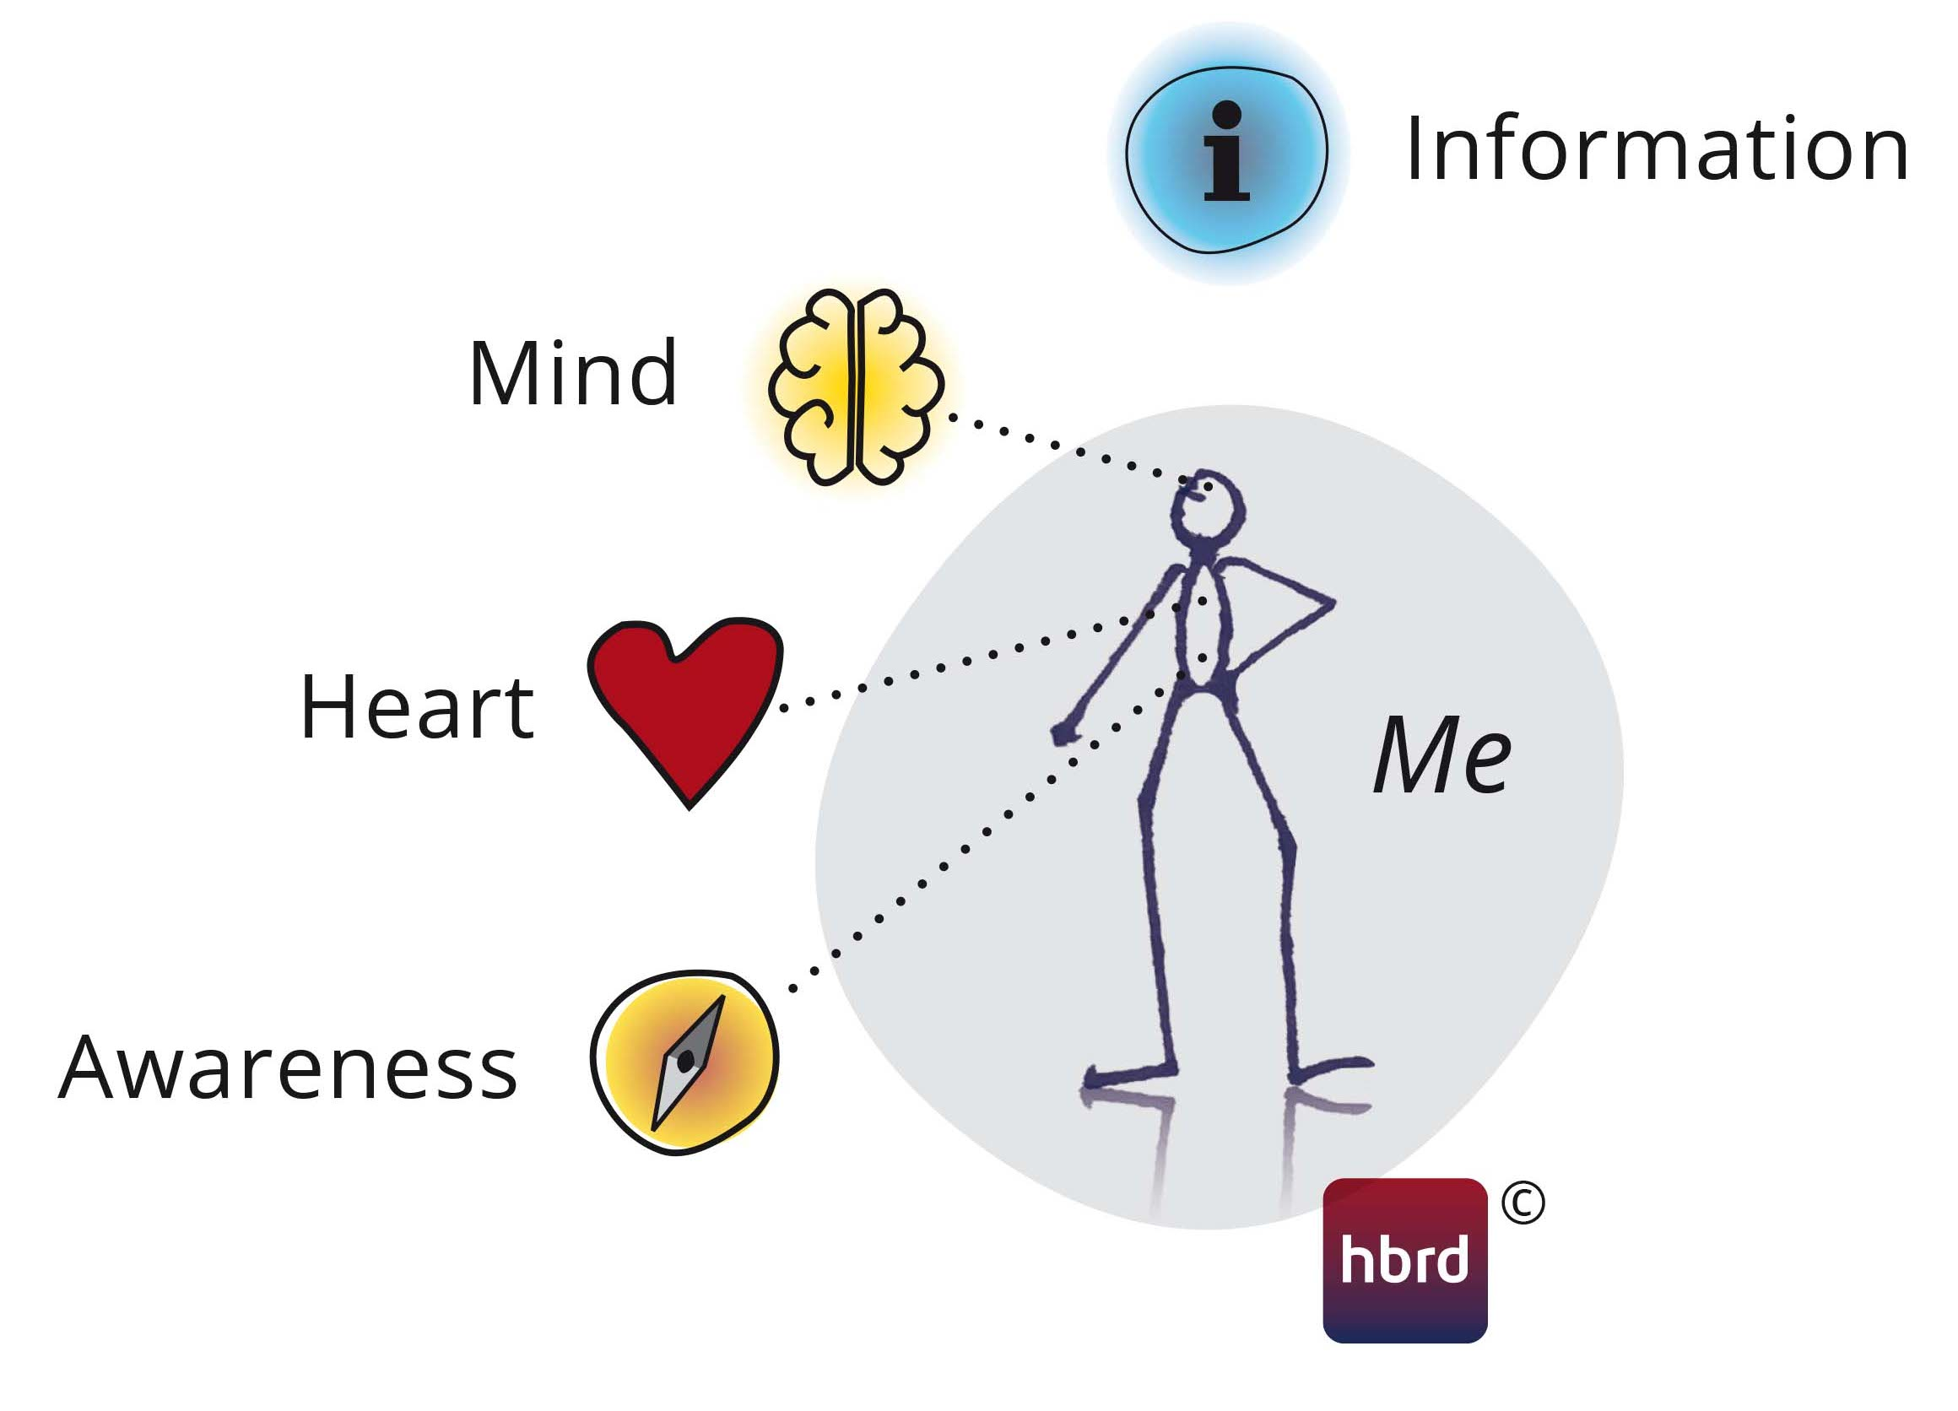Figure 1: The leadership core. Image copyright © hbrd.
This gives you the space to think about the influence your decision could have on teammates and employees before you make it. Decisions that you make slowly, deliberately or even inclusively, using a combination of your heart and head are so much stronger than the decisions you make solely based on rationality. And decisions made this way are essential for building trust.
This is an extremely powerful way to have a positive impact on people’s motivation and commitment.

Your leadership core
If your head and your heart seem to be in agreement, then your decision likely involves a sincere intention. You’ll radiate a different energy (both verbal and nonverbal), giving congruent and honest answers. People around you will notice. And when people sense the decision you’ve made isn’t sincere (is too hasty, doesn’t align with your values, their values, or the organization’s values), they’ll feel a different energy.
The information teammates and employees glean from this feeds their feelings of confidence in your decisions and, ultimately, in you as a leader. Initially, these impressions will leave only subconscious traces and impressions, but eventually, they’ll begin affecting your employees’ conscious behaviors and decision-making. And your most talented team members become aware of this more quickly (and more eagerly) than anyone else in your organization.
For many of today’s seasoned managers, however, breaking with head-driven, rational decision-making styles will be challenging. Breaking these patterns and habits of thought can be challenging because it involves going against some deeply ingrained conditioning. It might also feel like breaking organizational norms (it’s still somewhat “taboo” to express your feelings, vulnerability and talk about the “spiritual” side of decision-making in the workplace). It involves adopting different behaviors and attitudes and making decisions with a different level of conscious awareness. It involves becoming more sensitive and aware to what your heart is telling you—that something is “off,” undesirable, and possibly even destructive. Closed environments make this more conscious kind of thinking more difficult. Open environments seem to offer more space for it.
But this is also a huge opportunity—one that deserves your attention because it impacts your ability to nurture and foster up-and-coming leadership talent. A core tenet of leadership development in open organizations is providing space and context for leaders to learn and grow on their own, to extend their intrinsic passions and talents. You can’t do that if you’re not slowing down to include others in your decisions, or making purely rational decisions that don’t take the needs and desires of junior leaders into account. Think of yourself more like a coach, a mentor, creating open environments to nurture talent. These are the kinds of leaders future-proof organizations will need to be sustainably successful.
I’m not suggesting that we “lose our heads” to become better leaders, or to build better leaders in our organizations. I’m advocating for balance. On the one hand, we will have to hold on to the benefits of powerfully rational thinking but balance them with new ways of thinking, and behaving—those that account for a more complex consciousness. This begins with openness, joy, trust, and inclusivity.
So what will you choose? Will you continue to lead with your head alone? Or will you open up? ◕

Example: The emotionally sensitive leader
I once found myself talking with a female member of a management team in whom I recognized tremendous leadership talent. She shared with me her frustration at a lack of recognition, respect, and vulnerability from her male colleagues—and seemingly no support from her director. She felt unsafe in the situation and undervalued enough that she was considering leaving. I recognized that her colleagues were thinking with—and assessing her performance based on—purely”head-driven” and ego-based behaviors, disregarding the way someone with clear leadership potential approaches serious issues with gut feelings, emotions, and intuitions. I was doubly dismayed to see this young leader appearing to blame herself for this frustrating situation, as if it were a consequences of her own inadequacies in some way. In fact, she outperformed in growth and result figures! The more we chatted, the more I tried to remind her that others in her organization appeared to be the ones who had growing to do. She agreed to initiate a conversation about openness and inclusivity with both the director and the management team members to attempt to open things up.
Have you seen a similar case in your own practice?
Thinking openly: How might you help the team embrace this talent?

Optimal flow: Building open organizations where leaders can emerge
To create innovative and engaged organizations, you’ll need to set the conditions for open leaders to thrive. This checklist can help.
As someone invested in developing your organization’s next generation of leaders, know that your goal isn’t to be entirely “hands off”; instead, your goal is to spend time building the systems and processes that help new leaders find their footing and unleash their passion. The truth is that leadership talent rarely develops on its own.
Building these systems and processes is critical during your open organization’s hybrid phase. In this chapter, I’ll discuss what that means and why it’s so important. I’ll also offer a few crucial questions you should be asking yourself as you nurture talent during this phase of your organization’s transformation.

A breeding ground for leadership talent
Conventional organizations don’t become open organizations over night. They evolve into open organizations. That means your organization will never be entirely closed or entirely open; it will exist in a state of transition. This is the organization’s hybrid state.
As I’ve already said, during an organization’s hybrid phase, you’ll encounter periods in which traditional and open practices operate side by side, even mixed and shuffled. This can be a challenge. But it can also be the big opportunity.
During an organization’s hybrid phase, you’ll encounter periods in which traditional and open practices operate side by side, even mixed and shuffled. This can be a challenge. But it can also be the big opportunity.
This hybrid situation is especially critical, because it’s the time when your vision and approach to leadership talent development determine the success of the transformation to a more open organization (and the speed at which you achieve that success). It’s the breeding ground of your new organizational culture.
So your focus on vision and strategy is key here. You’ll need to create the principles and preconditions for a psychologically safe environment, one with permeable boundaries that allow talent to flow.
Here are some steps you might take to do this.

Think flow
First of all, get to know your own purpose, strengths, and passions. And do this not just “in your head,” but with greater awareness of your heart, gut, and emotional intelligence too. In this way, leaders can explore their own compasses and intuitive powers from within.
Then imagine ways you can ensure a successful flow of talent throughout your organization. Consider various leadership development stages and map those stages to the areas and positions inside your organization where leadership talent might develop step by step.
Ultimately, to create opportunities for your emerging leaders, you’re trying to connect knowledge from various areas—people, market, business, financial control and the “me” in that field. So if you’re able to put them in these positions or in projects where these areas interconnect, you’ll achieve optimal flow.
This will involve some key questions like:
- How will leadership talent contribute to the success of the organization?
- What kind of balance between managers and leaders are you aiming for?
- Identify your leadership and management potential
- Does your organization currently have enough leadership coaches and mentors available to help?
- What makes me comfortable and uncomfortable? Am I ready to allow this to emerge?
Don’t forget to tap mentors outside your pool of existing managers. Managers tend to train other managers; leaders tend to train other leaders. By “leaders” I mean those employees who assume inclusivity, openness, and trust—who recognize the qualities of colleagues that make them so successful, and who share responsibility. Leaders support responsible people in making and implementing decisions. Leaders want to make themselves superfluous.

The safety to learn
When thinking about talent development, know that you will need to provide a safe environment for emerging leaders to practice and learn. This way, talented employees can gain crucial experience. Failure is a great learning tool and a powerful part of this experience. But to be able to fail, people must feel there is a safety net—that is, that they can fail safely.
As you work through your organization’s hybrid period, ask:
- What resources do you need to create a safe environment for growth?
- How will you know that you’ve created that environment?
- Am I able to observe without judgment?

Working through tensions
You’ll experience tension and resilience during your organization’s hybrid period, as various parts of the organization (and various stakeholders) embrace change at their own paces. While some employees—especially your emerging leaders—will be pushing forward, others in the organization may not yet be ready for change that rapidly or be aware that transformation is in progress. As a result, you might observe insufficient willingness to invest in talent, in preparation, and in the guidance these emerging leaders need.
So ask yourself:
- Is the organization prepared to invest in up-and-coming leaders?
- Do you actually know how talented employees are prepared for their futures in your organization?
- Did I secure clear principles and preconditions from the key stakeholders in advance, including risks?

The space to practice
Leadership talent must be given time and space to practice; this will lay the foundation for their success. For example, you might offer highly skilled and motivated employees an opportunity to present to the executive team, or even to a group of colleagues. Or you can give potential leaders a consulting role on the executive team. Have them prepare and chair important meetings. Have them research and prepare reports. Nothing is more important than teaching them to dig deeper into a subject they’re responsible for. You can also think about giving them a significant project or task that will introduce them to some aspects of leadership and collaboration.
So ask yourself:
- How can I create opportunities for my emerging leaders to gain visibility?
- Am I available for mentoring and coaching?
- How can I better understand what my younger leaders care about?
- Am I able to get the executive team to look at the effort in an appreciative way, so that the appropriate judgment is absent to keep it safe for the talent?

Model what you seek
Leadership talent develops through collaboration. So make sure you’re available as a coach and mentor for emerging leaders in your organization. This is the best way to see precisely what future leaders are capable of and learn whether they have the capacity to stretch even further. Don’t limit the support you offer them to some training and perhaps a bit of external coaching. Offer these yourself. Teach your leadership talent how they can begin to stand on their own—and, yes, to fail on their own, too. Share the experiences that have shaped you as a leader, and offer your own insights into the aspects of the business you find most compelling. In short, help them gain the skills they need to create their own thriving teams, even when that means making their own presence less important or even unnecessary. A passionate and committed leader takes the time to do this. Great leaders create other leaders, and learn from it themselves!
So ask yourself:
- What exemplary behavior can I provide so that emerging leaders might learn from it?
- How can I be available to answer questions openly at all levels of awareness for the talent?
- What insights can I offer that are essential for further development?
- How can I personally support leaders as they develop their skills?
- What does the talent need from me to develop further?
- Can I offer other inspirational leaders in my network (in or outside the organization) to contribute?
In the next chapter, I’ll address leadership talent in various locations in your organization—at the top, in the middle management, and on the ground. ◕

Example: The high-energy leader
A talented and intelligent employee in my organization always seemed to be quite busy; both his behavior and presence were high-energy. Previous managers had inhibited his salary growth, perhaps due to the impression that he’s an unfocused person. And yet this employee’s positive disposition and good intentions contributed substantially to the organization. When assigned a new manager who began to show appreciation for his abilities, he was able to step into a crucial role as a security office for the organization. The high-energy behavior others might have considered the mark of someone “unfocused” is now something co-workers perceive as a benefit—something that makes him especially good at his job. This leader now encourages others to open up and seek the roles best suited to them. Needless to say, he’s gotten his raises—and has found new motivation at work.
Have you seen a similar case in your own practice?
Thinking openly: Does your organization recognize and embrace the neurodiversity of its people? How could it be more inclusive in this way?

To nurture open leaders, managers must learn to let go
Conventional managers and emerging leaders must work together to build open organizations. That requires respect, trust, and curiosity from everyone—and can lead to learning and great joy!
In the previous chapter, I explained how senior and upper-level executives can help young leadership talent develop without taking an entirely “hands off” approach. The truth is that leadership talent rarely develops on its own, and if organizations wishing to become more open want to see open-minded leaders thrive, upper management has a specific job to do. Contemporary advice for meeting this challenge typically involves addressing a “lack of creativity and innovation” or “designing for resilience”. But what’s even more necessary is creating balance—not only between the organization’s conventional management principles and more open ones, but also (as I’ve explained in previous chapters) between reason and feeling, head and heart. In other words, this involves creating a balance between an individual leader’s sense of self and the collective needs of those in the organization.
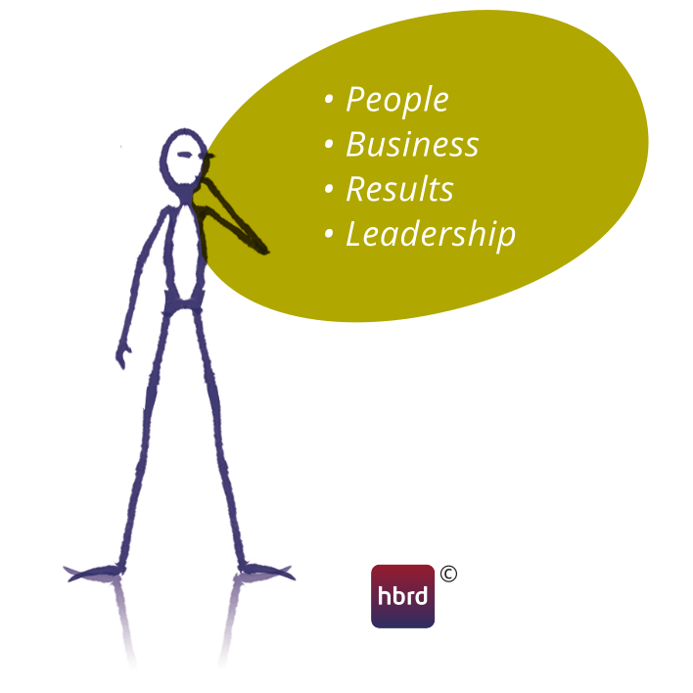Figure 2: A leader's daily dynamics. Image copyright © hbrd.
These are the primary conditions for getting the entire organization moving in an open direction.
At the beginning of what I’ve called your organization’s “hybrid phase,” the “top” of the organization consists primarily of conventional thinking and behaving like “top-down”-oriented managers. To achieve a better balance, management will have to allow leaders into the boardroom as well. This is because, as I’ve mentioned previously, managers tend to train more managers, not necessarily more leaders. To help their organizations become more open, current leaders need to break the pattern of allowing only people with similar skills participate in leadership activities; they need to be open to new dynamics by consciously seeking collaboration with leaders who embody open mindsets and behaviors (if you don’t allow this, conventional ways of thinking, managing, and behaving will remain intact). They must remain curious, open to learning and recognizing that newer generations of leaders may be tired of simply being told what to do and instead want to be invited to contribute.
Fostering open leadership mindsets and behaviors is necessary for moving forward and completing the transition from conventional organization to open one. Open doors for talented leaders, be open to learning from each other, and open new forms of value by recognizing different behaviors, mindsets, and views.
In most organizations, this kind of motivated leadership talent is already present; you just need to give it a place to add value to your organization’s open transformation. And you’ll need to do it quickly, because the war for talent could cause an outflow of people from your organization if you don’t.
Let’s examine how this might work.

Open and respectful
First, let’s discuss the role emergent leaders need to play in this process.
These leaders will have to approach seasoned and authoritative executives openly and respectfully, recognizing that these persons have acquired their current positions for a reason and have served the organization for many years. Moreover, they should recognize that these longstanding managers are opening themselves up to the transformation process, an initial step that could be somewhat nerve-wracking for them. Patience, persistence, and understanding are key.
Of course, the same dynamic is necessary in reverse. Learning happens in both directions. By acting as a team, executives will gradually gain insight into (and understanding of) the ways of thinking and behaving that are more common in open organizations. This enables them to adapt to them gradually and become proficient in them over time. Emerging leaders shouldn’t expect change to occur instantly.
If your organization has established systems for building effective connections between senior leaders and emerging leadership talent during the hybrid phase (and both are willing to learn from each other) you’ll see the possibility for real change. The kind of leadership the 21st century demands of us begins with respect for traditional ways of managing—not tossing them out, but reflecting on them and building on the parts of them that truly work.
As Dee Hock, founder of Visa, once said: It’s not hard to have new ideas, as they come naturally. What’s harder is letting go of old ideas.

Building flow
Now let’s look at the role senior leaders will play in this balancing process.
Senior leaders and managers will need to understand that shifting and rotating leaders through various executive and leadership positions in an organization—perhaps as often as every three to four years—is a healthy practice for an organization. It allows the kind of fluidity that leadership talent needs in order to emerge and make an impact on some aspect of the organization. As a leader, you’ll need to admit that this involves nurturing the talent your employees already have and then, when the time is right, stepping aside. This creates the kind of flow that encourages personal development at all layers of the organization and fosters a spirit of continuous improvement throughout.
In more traditionally run organizations, a management team determines if the time is right to move on. That is, it’s a decision that comes “from the top” and usually involves some discussion of factors like “results,” “status,” and whether the move is in senior management’s interests. Unfortunately, that consideration isn’t usually connected to talent, competences, or skills.
When emerging leaders see senior management working with a spirit of genuine curiosity and courage, they’ll likely respond with gratitude, creating a culture of mutual recognition.
So a certain dynamic tends to develop during an open organization’s hybrid phase: Managers who have earned and acquired their positions are not willing to give them up so easily. They might even see this as a form of defeat (a blow to their egos, perhaps). That’s certainly understandable, but it’s not helpful if they’re blocking valuable talent from moving to new positions where they can catalyze the organization’s transformation to an open one. In practice this is the hardest step for longstanding managers to take, because they are often to deeply rooted and ingrained in the current organization. (At least that’s what they think. They’re really guided by a sense of fear: “If I change positions, will I still receive the same respect and credibility I did in my old role?”) Unfortunately, you rarely see this practice of rotation in place; in fact, in many organizations, people actively prevent it.
However, when moving towards openness, the balance between leaders and managers requires decisiveness, clarity, and transparency—that is, leadership. This will generate more energy for the movement towards a more open organization, and builds essential trust. When emerging leaders see senior management working with a spirit of genuine curiosity and courage, they’ll likely respond with gratitude, creating a culture of mutual recognition. This positive cycle—curiosity and courage leading to respect and recognition—can help you attract more talent seeking a similar environment, creating a more diverse and inclusive organization while building your organization’s capabilities.
But it’s only possible if people feel they’re working in an environment where they can be themselves, feel included, and trust others.

Making the difference
When managers and senior leaders have embraced a new vision for talent development and committed to becoming a more open organization, they’ll have several important (and highly visible) impacts on their organizations.
For starters, employees will see opportunities to develop themselves and their talents. And if they feel safe to develop—and are allowed to make mistakes in the process, to experiment and learn—they’ll encourage others to follow their lead and do the same. When you’ve created a culture where the best ideas start winning, you’ll cultivate talent that derives a sense of pride from contribution. This way, you’ll contribute to the unity of the collective and increase your chances of success moving forward. If your talent feels seen, stimulated, and appreciated, then your talent will become more engaged.
At the same time, it will be clear to everyone that working together in a team stimulates both creativity and active contributions on the part of individual team members. You communicate that people in your organization are stronger together, and therefore are more open to failing and learning together. This belief creates (regardless of the context) the motivation to achieve the best outcome for the group. This is a critical mechanism in any organization.
Of course, real life and real transitions are often more unruly than the straightforward explanations I’ve offered here. But the process is worthwhile (and transparency throughout is key). In the next chapter, I’ll discuss employees’ choice to work on transformation under the guidance of leaders. And I’ll also summarize everything we’ve covered in the series so far, adding a few final tips for managing talent in open organizations. ◕

Example: The leader who thinks differently
I once met an extremely gifted leader whose years of excellent management work had clearly strengthened the organization. He had developed a reputation for being able to deftly handle crisis situations, and as a result had built a stable (yet over-performing) organization. He was the kind of natural leader that embodied both the spirit and skills necessary for driving organizational transformation in ways that balanced the needs of the organization and its people during times of growth. Many people I spoke to considered this leader a natural candidate for the organization’s executive team. Yet the organization had twice overlooked him when filling vacant seats on the team; managers who thought and acted similarly to people already on the management team received promotions instead. Members insisted this leader was “next in line” for promotion, but didn’t offer anything more definitive. A few weeks later, I noticed that this gifted open leader had made himself available for other assignments outside the organization, where he could really contribute and felt appreciated for his talents. Rather than wait, he’d taken his talents elsewhere.
Have you seen a similar case in your own practice?
Thinking openly: Does everyone in your organization understand leaders’ criteria and standards for ensuring the best candidate is in the right place in the organization? Could those criteria be more transparent?

What next-generation leaders expect: the choice to work openly
Transformation can only be successful when people opt into it. Forcing people to open up won’t work.
Earlier in this book, I argued that emerging, talented leaders need space to flow to those places in the organization where they add value based on their unique talents and intrinsic motivations. If the organization’s management and senior management set the right examples, extend trust, and listen, they can greatly accelerate the organization’s transformation to a more open culture. But talent needs access to an organization’s cliques and inner circles, its management and executive teams, to really kick-start the kind of collaboration and mutual learning that will move the organization forward and create sustainable succession.
This won’t just benefit these up-and-coming leaders; unleashing your inspired and high-performing employees can impact many colleagues in the organization. People will find this new energy attractive and want to tap into it. The result: increased curiosity, joy, ownership, a desire to remain at the organization, and genuine pleasure in their work.
Other colleagues will be more skeptical, or assume a “wait and see” approach to the change. They’ll need time to process the implications of your organization’s transition to openness. In some ways, initial reluctance is a positive sign; it means something has triggered someone’s curiosity, and they’re becoming aware that they have new choices to make—about the ways they work, the ways they lead, the organizational opportunities available to them, etc. For managers, the key is to recognize this skepticism as something positive and not mistake it for resistance.
This is critical, because ultimately you will want people in your organization to choose to work openly—not be forced to. You’ll want people to experience the benefits of a more open organizational culture and opt into it rather than feel like they’re just complying with a mandate.
Yes, this means some people may choose not to engage. They may even make a different choice: the choice to leave the organization. They may simply conclude that an open style of work and leadership doesn’t fit their preferences. Managers will once again need to be careful. Don’t assume that someone’s decision to leave your organization is a failure on your part. It may be confirmation of the fact that you’re facilitating an effective organizational transformation—and the new rules, norms, preferences, and standards are becoming more clear and obvious to everyone.
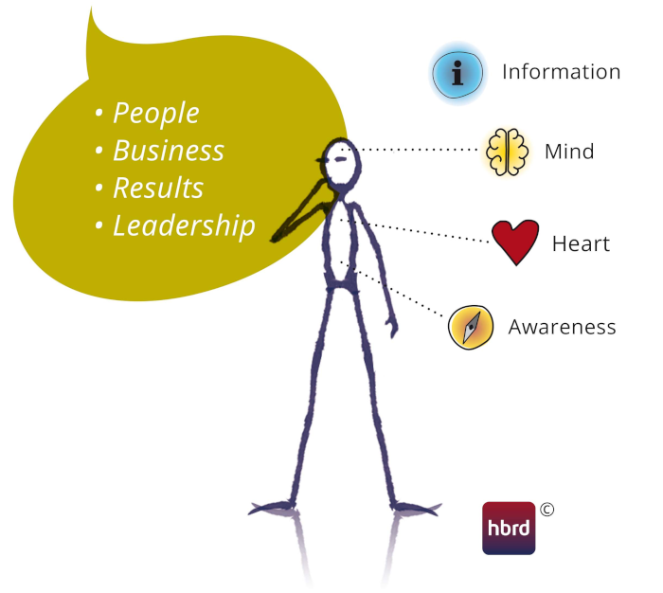Figure 3: Combining the leadership core with daily dynamics. Image copyright © hbrd.
The truth is that your organization’s talent can sense whether managers and executives are truly serious about organizational transformation. People will scrutinize your vision and approach and consider whether they’re genuine or mere stage dressing. Your most talented emerging leaders expect their managers to set desirable examples when it comes to transparency, trust, and inclusivity. They expect a certain openness to contribution or collaboration from senior leaders. And if you don’t live up to your word, then these people will make their own choice to leave your organization. That is something you might consider a failed approach to talent. (And in this case, I’d invite you to consider your own role in the situation.)
Throughout this book on open organizational design and talent management, I’ve explained how the speed and strength of your organization will determine your success in a new economic environment, one where new ideas are toppling some longstanding older ideas. These new ideas spring from the creativity and resourcefulness of your employees, but they can only do that in a safe and more open working environment. So we urgently need more focus on balancing people’s needs and the business’ needs inside our organizations. Your goal is igniting passion and performance, and you’re able to do this when people feel free and invited to contribute to the organization’s purpose—not when they’re commanded to by command-and-control structures. Unfortunately, too few organizations don’t strike that balance. When they don’t, they see the consequences: loss of competitive position in this rapidly changing market.
Surviving will mean transitioning to a more open organizational model, one built around a leadership style that doesn’t rely on formal authority. It also calls for decision-making that considers not only reason but also on feeling, on heart. Is your “inner world” aligned with your “outer world”? That sense of balance extends to managers, who need to balance their expectations with those of emerging leaders.
Surviving today’s rapidly changing business contexts will also force companies to move—not just in the market, but internally as well. This means developing organizational flow; leaders must be able to follow their passions and interests, and the degree to which your organization allows this will determine whether and how quickly you achieve the kind of organizational balance I mentioned earlier.
The transition to a more open organizational model initially leads to a hybrid situation, where old structures and processes exist alongside newer ones. That can create organizational tensions. By sharing my insights and practical experiences here, I hope to contribute to the creation of safe working environments, where people can develop, flourish, and add their unique value. ◕

Example: The overlooked leader
A very talented manager had been working in my organization for several years. As I reflected on his performance over the past four years in particular, I observed tremendous growth and development in his leadership capabilities. In just the previous year alone, he successfully served as a project manager for a number of large clients and really stimulated both openness and growth on his teams. When he applied for an executive position, however, he felt hopeless about his chances. We both recognized that the the executive team had a history of installing pre-selected managers in executive positions. People who weren’t working closely with the candidate were likely to view him as “just” a project leader and therefore unsuited to the work—a bit of a rocky foundation for judgment, I thought. Understanding that he didn’t expect an interview panel to assess the entirety of his qualifications and his potential for leadership development, I wasn’t surprised to find that he’d chosen to seek happiness elsewhere.
Have you seen a similar case in your own practice?
Thinking openly: What might greater transparency and inclusivity contribute to this situation?

Conclusion: Imagining open leadership
Throughout this Open Perspective, I’ve offered several examples of leaders at various crossroads. And I’ve invited you to not only think about but also intuitively sense their situations from a more open perspective.
What might their worlds look like if they had adopted open practices, and if open organization characteristics had played a role in their situations?
Imagine the executives have embraced, embodied, and practiced open values, both in their individual roles and together as an executive team. They’ve become aware that open leadership is necessary to move forward. To learn what they must do next, then, they open themselves up to learning what talented individuals in their organizations wish to teach them—rather than work to keep them out of the board room. Likewise, the board, too, considers striking a new balance between management and leadership. They begin approaching their work with curiousity and openness. In doing so, they recognize that both mindsets have the same goals: achieving goals, optimizing results, spreading a vision, and motivating people.
Imagine those leaders become aware that unlearning old habits and behaviors leads to personal transformation. They thus begin working on overcoming widespread fear of “losing control” and “letting go of things,” and they begin to face the new and unknown with an open mind. They begin navigating instead of simply directing, using their intuitions instead of only their rational minds. And if their talented employees support this, they too will begin to learn how important balancing leadership with management can be, because curiosity leads to learning and transformation.
Imagine that people in the oranization become aware that in addition to the balance between leadership and management, they also need to begin thinking about diversity in the composition of the executive team. They soon become aware of their own role in fostering that diversity, and see difference and resistance as something healthy, a mindset that draws them further into their own growth and development (not to mention that of the entire team and organization). They do this by exploring the possibilities of increasing diversity in all layers of the organization, adding to the balance they’ve struck between management and leadership. And they invite everyone to contribute to this exploration, as they recognize inclusivity in acting and thinking is a prerequisite for diversity.
Imagine that all this work also leads to construction of new criteria in the selection policy for people invited to contribute to management teams and the board—criteria that are grounded in diversity and inclusion, that embrace new views and skills.
Then imagine that the choices leaders faced in those examples may have led to different—perhaps extraordinary—outcomes. Leadership talent chooses to stay at the organization because people feel invited and empowere to contribute. The organization experiences quicker, more sustainable growth and development—not just growth of the creativity and innovative mindset that keeps the organization relevant in the market, but also people’s feelings of begin grenuinely valued for their contributions. People work with passion and are aware that they also (especially) have to perform, because passion and performance can go hand in hand.
That’s why opening up your organization to embrace leadership talent is critical to the future—not just to your organization in general, but to your role as a director of it specifically. The process begins with you. Exploring the pathway to openness takes courage and curiosity. But it also leads to great ideas, new possibilities, and amazing results. ◕

Author’s note
I’m grateful that you’ve taken the time to read this book. I hope it will enhance your ability to create an organization with a more open mind, and to balance passion and performance on your teams. Always remember that people make the difference, and they simply thrive better in a more open organization. So open up!

About the author
Jos Groen is founder of hbrd, a firm that guides executives and executive teams through transformation. As an executive leader, he has experience transforming conventional organizations towards open ones. He does this by helping them balance the interests of both people and business brings joy, unlocking creativity and ingenuity in the organization and creating performance shareholders cherish. As a leader Jos embraces open organization principles as the foundation of his approach to creating safe working environments based upon trust, leadership, openness, and inclusivity. He is an Open Organization Ambassador and active participant in the open source community.


Join us
Join the community-driven, global conversation about the ways open principles change how people work, manage, and lead.
Visit theopenorganization.org.

https://theopenorganization.org/roster/
https://opensource.com/open-organization/17/4/openness-and-gen-z
https://magnet.me/downloads/young-professional-rapport-februari-2020.pdf
https://www.careerwise.nl/young-professionals-en-werk/young-professional-onderzoek/zeker-40-van-de-jonge-werknemers-staat-al-met-een-been-buiten/
https://www2.deloitte.com/mt/en/pages/about-deloitte/articles/millennialsurvey.html
https://static1.squarespace.com/static/56b4a7472b8dde3df5b7013f/t/5819e8b303596e3016ca0d9c/1478092981243/2016+Cone+Communications+Millennial+Employee+Engagement+Study_Press+Release+and+Fact+Sheet.pdf
https://opensource.com/open-organization/18/5/rethink-motivation-engagement
https://theopenorganization.org/definition/open-leadership-definition/
https://opensource.com/open-organization/19/3/introduction-psychological-safety
https://opensource.com/open-organization/17/12/drive-open-career-forward
https://opensource.com/open-organization/20/6/organization-everyone-deserves
https://opensource.com/open-organization/16/1/what-community-has-taught-me-about-open-organizations
https://opensource.com/open-organization/18/10/understanding-engagement-empowerment
https://opensource.com/open-organization/18/8/7-questions-engaged-meetings
https://hbr.org/amp/2018/09/innovation-should-be-a-top-priority-for-boards-so-why-isnt-it
https://activerain.com/blogsview/5099783/delete-that-old-outdated-thinking
https://hbr.org/2021/08/let-your-top-performers-move-around-the-company
http://hbrd.eu/

