PNS ACQUISITION PLATFORM
Research Document
Elliot Wyrick
Computer Engineering – Purdue University
May 2026 – Rev 0.1 – Research Draft

1 Purpose & Project Scope
This document captures the formal design research for a wrist or arm worn surface EMG (sEMG) wearable. It covers the first three phases of the V-Model development process: Requirement Gathering, System Analysis, and Architecture Design. This wearable will form the basis for future experiments and projects whose scopes may not be included in this document.

1.1 Goals
- Build a multi-channel dry electrode platform for capturing sEMG data, worn at the wrist / forearm.
- Stream captured sEMG and IMU data over USB or Bluetooth to a host PC or mobile device for storage and processing.

1.2 Future-Looking Goals (Out of Scope)
- On-device ML gesture classification — deferred until data acquisition is verified and validated.
- Gel electrode compatibility — current scope is restricted to dry electrodes.
- Battery charging / integration — ideally fully wireless, but the complexity of a charging circuit is not critical to this project.

2 System Requirements
All requirements are stated as measurable, testable criteria. Priority levels follow MoSCoW (Must-have, Should-have, Could-have, Won't-have).

ID | Requirement | Rationale | Target / Limit | Priority
SIG-01 | ADC resolution ≥ 24 bit | Raw sEMG signals are in the µV range, amplified to mV. A 24-bit ADC with a 5V reference yields an LSB of ~300 nV, well below the µV-level signals of interest. | 24-bit minimum | MUST
SIG-02 | Sampling rate ≥ 2 kSPS per channel | sEMG spectral content spans ~50–500 Hz for gross gestures. Nyquist requires ≥ 1 kSPS; 2 kSPS provides the necessary anti-alias margin. Target 2000 SPS aligns with the ADS1298's valid data rates. | Target 2000 SPS | MUST
SIG-03 | Channel count ≥ 8 differential | 8 bipolar channels provide sufficient spatial coverage for wrist-level gesture discrimination and robustness as a generalized acquisition platform. Each channel is a differential pair across a muscle belly. | 8 channels minimum | MUST
SIG-04 | Input-referred noise ≤ 1 µVrms | Motor unit action potential amplitude at the skin surface can be <10 µV [2]. The noise floor must sit well below this. | ≤ 1 µVrms | MUST
SIG-05 | CMRR ≥ 80 dB at 50/60 Hz | Powerline interference at 50/60 Hz is the dominant noise source with dry electrodes. High CMRR suppresses it at the AFE before digital filtering. | ≥ 80 dB | MUST
SIG-06 | Input impedance ≥ 500 MΩ differential | Dry electrode-skin impedance can reach megaohms. AFE input impedance must be >> electrode impedance to avoid signal attenuation and CMRR degradation. | ≥ 500 MΩ | MUST
CON-01 | BLE 5.x wireless data stream to host | Wired tether limits wearability and introduces motion artifacts via cable pull. BLE 5.x provides sufficient throughput for compressed sEMG at target sample rates. | BLE 5.0 or later | COULD
CON-02 | BLE throughput ≥ 384 kbps effective | 8 ch × 2000 SPS × 24 bit = 384 kbps raw uncompressed. BLE 5.x 2M PHY provides up to ~2 Mbps at the PHY layer; effective application-layer throughput comfortably exceeds 384 kbps after protocol overhead. | ≥ 384 kbps sustained | COULD
CON-03 | SWD debug port accessible on main board | Required for firmware flashing and live debugging. | 10-pin SWD header | MUST
CON-04 | USB data streaming to host | USB provides a reliable, wired data path for bench sessions and initial validation independent of BLE. The nRF5340 supports USB device mode natively. Required regardless of whether BLE is also implemented. | USB Full Speed (12 Mbps) — nRF5340 native capability; provides ~31× headroom over the 384 kbps raw data rate | MUST
IMU-01 | 6-DoF IMU minimum (accel + gyro) | Wrist rotation and forearm orientation are covariates for gesture disambiguation. | 6-DoF; 9-DoF preferred | MUST
IMU-02 | IMU ODR ≥ 200 Hz | Intentional wrist gestures have a fundamental frequency of ~3–5 Hz with harmonics up to ~30 Hz. Nyquist requires ≥ 60 Hz; 200 Hz provides adequate margin and is sufficient for time-domain sensor fusion with sEMG data. | ≥ 200 Hz | SHOULD
PWR-01 | Battery life ≥ 4 hours continuous acquisition | Minimum useful session length for research data collection. | ≥ 4 hours at full operation | COULD
PWR-02 | System power draw ≤ 50 mW in acquisition mode | Drives battery sizing. As a reference: a 200 mAh LiPo (3.7 V, 740 mWh) at 50 mW yields ~14 hours theoretical — actual capacity to be confirmed during PCB design. | ≤ 50 mW target | COULD
FORM-01 | Wrist/forearm wearable form factor | Target muscle groups require placement between wrist and elbow. | Forearm band, ≤ 40 mm width | MUST
FORM-02 | Main/daughter board split architecture | Main board houses the AFE, MCU, IMU, and power management. Daughterboard handles electrode connector placement and routes all electrode signals back to the main board. No secondary AFE is anticipated. | Board-to-board connector | MUST

3 System Architecture

3.1 Block Diagram
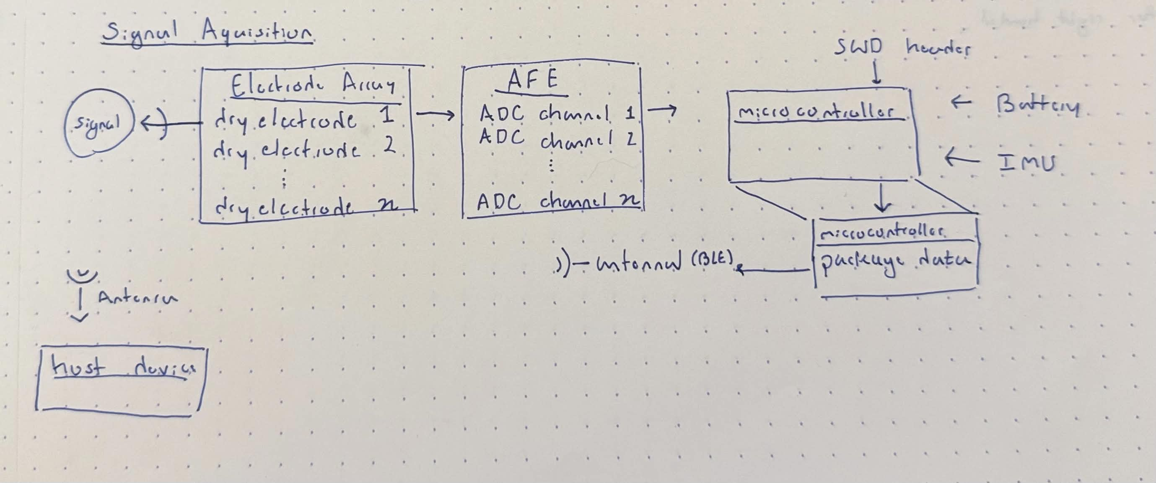

3.2 Block Descriptions

Block | Function
Electrode Array | 8 dry electrode pairs (8 differential channels per SIG-03)
Analog Front End (AFE) | 8-channel ADC & instrumentation amplifier
MCU / Radio | Microcontroller + BLE SoC
IMU | 6/9 DoF inertial measurement unit
Power Management | LiPo + PMIC – or wall power
Host Interface | USB (wired, MUST) and BLE (wireless, COULD) — PC / Mobile

3.3 Power Architecture
Ideally, the band will be battery powered. The legitimacy of this will be determined during modeling and PCB design.

4 Hardware Stack Evaluation
Three candidates are evaluated across the AFE, MCU, and IMU. Each component class is first evaluated independently, then the stacks are established and compared. The goal is to arrive at a stack that balances cost, flexibility, and accuracy.

4.1 Analog Front End (AFE)
The AFE is the most critical selection. Requirements SIG-01 through SIG-06 tightly constrain the field. Only dedicated biopotential ADCs satisfy the channel count, noise floor, and input impedance requirements simultaneously.

Part | Channels | Max SPS | Noise | CMRR | Zin | Bus | Notes
ADS1298 (TI) ~$51 | 8 ch / 24-bit | 32 kSPS/ch | 4 µVpp typ | 115 dB typ | 1 GΩ diff | SPI | Medical ECG-grade biopotential AFE; well-documented for sEMG/ECG/EEG; DRDY per chip
ADS1299 (TI) ~$86 | 8 ch / 24-bit | 16 kSPS/ch | 1 µVpp typ | 110 dB typ | 1 GΩ diff | SPI | EEG-optimized, lower noise floor; higher cost; overkill for sEMG but excellent margin
MAX86150 (Maxim/ADI) | 2 ch / 19-bit | 400 SPS | ~5 µVrms | ~70 dB | N/A | I2C | PPG+ECG combo IC; insufficient channels and sample rate for multichannel sEMG

ADS1298 vs ADS1299: The ADS1299 offers meaningfully lower noise (1 µVpp vs 4 µVpp). Both parts specify CMRR above 110 dB and far exceed the SIG-05 requirement of 80 dB minimum. For sEMG, both are within spec — sEMG does not require EEG-grade noise floors. The ADS1298's 4 µVpp noise is specified at G=6 and 150 Hz bandwidth; at G=12 and 2000 SPS in low-power mode, the datasheet reports exactly 1.0 µVrms — meeting SIG-04 at the boundary. High-resolution mode at the same conditions yields 1.2 µVrms, which does not meet SIG-04. Low-power mode at G=12 must therefore be the operating configuration to satisfy the noise requirement [3].
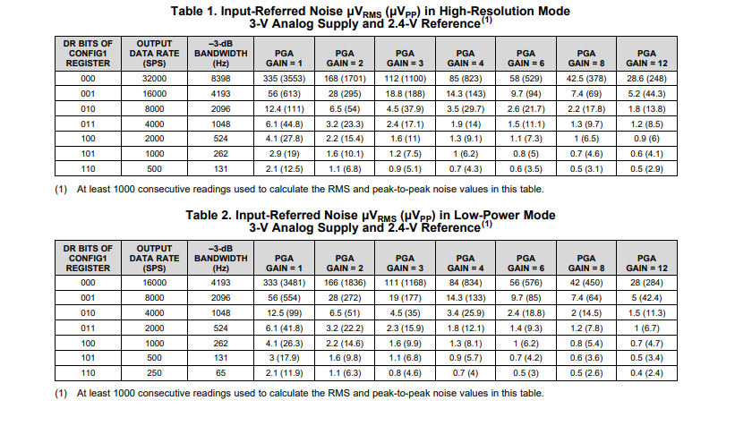
The ADS1298 is preferred for Stack A due to lower cost, identical SPI interface to the ADS1299, and well-established use in medical-grade biopotential acquisition.

4.2 MCU / Radio
The MCU must handle SPI data acquisition from the AFE, I2C from the IMU, BLE streaming, and have sufficient RAM to buffer several acquisition windows without dropping samples. Dual-core architecture is preferred to isolate the radio stack (net core) from application logic.

Part | Core | Flash+RAM | Radio | Dual Core? | Power | SDK | USB | Notes
nRF5340 (Nordic) ~$9 | Dual ARM M33 (128/64 MHz) | App: 1 MB Flash / 512 KB RAM Net: 256 KB Flash / 64 KB RAM | BLE 5.3 + BT Audio | Yes (net core) | 3.3 V / ~5 mA idle | ZephyrOS / nRF SDK | FS 12 Mbps device | Industry-standard BLE SoC; dual-core allows DSP isolation; high RAM for streaming buffer; widely used in wearables
nRF52840 (Nordic) ~$7 | Single ARM M4F (64 MHz) | 1 MB + 256 KB | BLE 5.0 | No (single core) | 3.3 V / ~4 mA idle | ZephyrOS / nRF SDK | FS 12 Mbps device | Proven single-core option; no net core separation; adequate but less headroom for on-device ML later
STM32WB55 (ST) ~$8 | Dual ARM M4/M0+ (64/32 MHz) | 1 MB + 256 KB | BLE 5.0 + Zigbee | Yes (M0+ radio) | 3.3 V / ~3 mA idle | STM32CubeWB | FS 12 Mbps device, crystal-less | Competitive dual-core; ST ecosystem; less community support for wearable BLE vs Nordic; good alternative
ESP32-S3 (Espressif) ~$2 | Dual Xtensa LX7 (240 MHz) | 8 MB (ext) | WiFi + BLE 5.0 | Partial | 3.3 V / ~20 mA idle | ESP-IDF | FS OTG (device + host); shared PHY with JTAG — external PHY needed for concurrent use | High compute; WiFi is excess for this application; higher idle power; larger package; less suited to ultra-low-power wearable

The nRF5340 dual-core architecture is a significant advantage: the network core runs the BLE stack autonomously while the application core handles SPI, DMA, and signal processing. This separation should reduce jitter in the data stream and leaves the application core free for future on-device inference.

4.3 IMU
The IMU selection is less critical than the AFE, but ODR, power draw, and I2C/SPI compatibility all matter. The IMU runs on the same power budget as the rest of the system and its ODR must be sufficient for the intended motion capture without dominating system power consumption.

Part | DoF | Max ODR | Noise | Bus | Power | Features | Notes
BMI270 (Bosch) ~$4 | 6-DoF (A+G) | 1600 Hz accel / 6400 Hz gyro | 160 µg/√Hz accel | I2C/SPI | ~685 µA @ full ODR (A+G) | Context recognition engine | Ultra-low power, built-in gesture detection, widely used in wearables
LSM6DSV (ST) ~$4 | 6-DoF (A+G) | 7680 Hz | 60 µg/√Hz accel | I2C/SPI | ~650 µA combo high-perf | Smart FIFO + sensor fusion | Onboard sensor fusion engine; ISPU programmable core; slightly higher power; excellent for fusion pipeline
ICM-42688-P (TDK) ~$5 | 6-DoF (A+G) | 32 kHz | 70 µg/√Hz accel | I2C/SPI | ~880 µA low-noise mode | APEX motion processing | Highest ODR of the group; widely used in precision wearables; good supply availability
BNO085 (CEVA/Bosch) ~$13 | 9-DoF + fusion | 400 Hz (fusion out) | N/A (fusion only) | I2C/SPI/UART | ~1.2 mA active | Full AHRS onboard | Outputs quaternions directly; lower raw ODR; higher power; useful if quaternion output is required without fusion code

The BMI270 is selected for Stack A primarily on power budget and wearable ecosystem track record. At the target operating ODR of 400 Hz, the BMI270 draws well below its full-ODR figure of ~685 µA — normal-mode current scales with ODR, and at 400 Hz both axes run comfortably under 500 µA. In low-power and accel-only modes it drops significantly lower, making it the most flexible option for duty-cycling. The LSM6DSV (~650 µA) and ICM-42688-P (~880 µA) figures are at their respective maximum ODR conditions. Its built-in context recognition engine could also be leveraged later for activity-aware calibration. The ICM-42688-P is the better choice if high-rate motion data is needed for fusion (Stack B).

4.4 Stack Comparison Summary

Stack | AFE | MCU | IMU | Cost | Signal | Power | Docs | Notes
Stack A (Primary) ~ $64.60 | ADS1298 | nRF5340 | BMI270 | ✓ Best | ✓ Best | ✓ Best* | ✓ Best | All parts well-documented; largest community. *BMI270 power advantage is primarily in low-power and accel-only modes; full A+G ODR draw is comparable to LSM6DSV.
Stack B (High Fidelity) ~ $100.37 | ADS1299 | nRF5340 | ICM-42688-P | ~ OK | ✓✓ Best | ~ OK | ~ OK | Lower noise AFE; best IMU ODR; higher cost; justified only if sub-µV noise is required
Stack C (Budget) ~ $61.23 | ADS1298 | nRF52840 | LSM6DSV | ~ OK | ✓ Best | ~ OK | ✓ Best | Proven single-core MCU; lower BLE throughput ceiling; adequate for 2 kSPS but no dual-core margin

5 Selected Stack

5.1 Decision: Stack A
Stack A is selected: ADS1298 + nRF5340 + BMI270.

ADS1298 — AFE
- Meets all signal requirements (SIG-01 through SIG-06) with margin.
- 8 simultaneous differential channels, 24-bit, 32 kSPS max, 115 dB CMRR typical (exceeds SIG-05 requirement of 80 dB minimum).
- Identical SPI interface to ADS1299; if noise floor proves insufficient after benching dry electrodes, the ADS1299 is a drop-in firmware replacement with minor schematic changes.
- Risk: dry electrode impedance mismatch will degrade effective CMRR. Mitigation: implement DRL circuit per ADS1298 datasheet; guard rings on daughterboard traces. DRL location to be determined through experimentation.

nRF5340 — MCU / Radio
- Dual ARM Cortex-M33 (128 MHz app core / 64 MHz net core) satisfies both processing and radio isolation requirements.
- BLE 5.3 with 2M PHY; effective throughput sufficient for 8 ch × 2000 SPS with packing.
- Large RAM (app core: 512 KB, net core: 64 KB) provides adequate DMA buffer depth to tolerate BLE scheduling gaps.
- ZephyrOS support mature; nRF Connect SDK well-documented for SPI + BLE concurrent operation.
- Risk: nRF5340 requires two firmware images (app core + net core), adding build system complexity. Mitigation: use nRF Connect SDK which handles multi-image builds natively.

BMI270 — IMU
- 6-DoF, target operating ODR 400 Hz (divides cleanly into 2000 SPS sEMG rate at 5:1); at 400 Hz both axes draw comfortably under 500 µA, well within power budget.
- SPI-compatible; can share SPI bus with ADS1298 via separate CS.
- Risk: 6-DoF lacks magnetometer for absolute heading. If absolute orientation is required in a later revision, upgrade path is BNO085 or a standalone magnetometer.

References
[1] L. McManus, G. De Vito, and M. M. Lowery, "Analysis and biophysics of surface EMG for physiotherapists and kinesiologists: Toward a common language with rehabilitation engineers," Frontiers in Neurology, vol. 11, p. 576729, 2020, doi: 10.3389/fneur.2020.576729.
[2] C. J. De Luca, "Surface electromyography: Detection and recording," Delsys Incorporated, Technical Tutorial, 2002.
[3] Texas Instruments, "ADS129x low-power, 8-channel, 24-bit analog front-end for biopotential measurements," Datasheet SBAS459, revised 2015.

