SD/FAST User’s Manual

Symbolic Dynamics, Inc.

Version B.2

SD/FAST User’s Manual Version B.2
September 1994 (This printing: 9/96)

AUTHORS
Michael G. Hollars, Ph.D., P.E.
Dan E. Rosenthal, Ph.D. (dr@symdyn.com) Michael A. Sherman (sherm@symdyn.com)

IMPORTANT NOTICE
The information in this manual is subject to change without notice and should not be construed as a commitment by Symbolic Dynamics, Inc.
The software described in this manual is furnished under a license agreement and may be used or copied only in accordance with the terms of such agreement.
Copyright © 1991, 1994 by Symbolic Dynamics, Inc.
All rights reserved. This manual may not be reproduced in whole or in part without the express permission of Symbolic Dynamics, Inc.

TRADEMARKS
SD/FAST is a trademark of Symbolic Dynamics, Inc. and Parametric Technology Corporation.
VAX, VMS, and DEC are trademarks of Digital Equipment Corporation.
UNIX is a trademark of Unix Systems Laboratories.
Sun and Sun Workstations are trademarks of Sun Microsystems, Inc.
ACSL is a trademark of Mitchell and Gauthier Associates. IMSL is a trademark of IMSL, Inc.
Matrix-X and System Build are trademarks of Integrated Systems, Inc.
Control-C is a trademark of Systems Control, Inc. Easy 5 is a trademark of Boeing Computer Services.
Pro-Matlab and Simulink are trademarks of The Mathworks, Inc.

LICENSING INFORMATION
For information on purchasing SD/FAST or additional copies of this manual, contact:
U.S.A., Canada and Worldwide:

Symbolic Dynamics, Inc.
561 Bush Street
Mountain View, CA, U.S.A. 94041 telephone: +1 (415) 960-1532
fax: +1 (415) 960-0338
email: info@symdyn.com web: http://www.symdyn.com
anonymous ftp: ftp.symdyn.com
Europe:

Rapid Data LTD.
Amelia House, Crescent Road Worthing, West Sussex England, U.K. BN11 1RL telephone: +44 (1903) 821266
fax: +44 (1903) 820762
email: ali@radata.demon.co.uk

TECHNICAL SUPPORT
U.S.A., Canada and Worldwide:

Symbolic Dynamics, Inc.
telephone (U.S.A.): +1 (415) 960-1532
fax: +1 (415) 960-0338
email: support@symdyn.com
Europe:

Rapid Data LTD.
telephone (U.K.): +44 (1903) 821266
fax: +44 (1903) 820762
email: ali@radata.demon.co.uk

Table of Contents

 |  | Preface | ix
P1 P2 |  | How To Use This Manual Conventions | ix x
TUTORIAL 1 |  | Introducing SD/FAST | T-1
T1.1 T1.2 |  | How To Use The Tutorials Applications of SD/FAST | T-1  T-2
T1.2.1 Mechanical systems T-3
T1.2.2 Force Models ......................................................................................................... T-4
T1.2.3 Prescribed Motions ................................................................................................ T-4
T1.2.4 Constraints............................................................................................................. T-5 T1.2.5 Types of Analyses and Design Studies.................................................................. T-5
T1.3 A Simple Example T-6
T1.4 Skills Needed to Use SD/FAST T-9
T1.5 The Features of SD/FAST T-10
T1.5.1 System Models Accepted by SD/FAST ................................................................. T-10
T1.5.2 Types of Analyses and Design Studies.................................................................. T-14
T1.5.3 System Description File ......................................................................................... T-17
T1.5.4 Generated Code .................................................................................................... T-18
T1.6 Using SD/FAST T-20

TUTORIAL 2 |  |  | Simple Pendulum | T-25
 | T2.1 T2.2 |  | A Complete Example Develop Model | T-25 T-26
T2.2.1 Draw Picture and Define Topology. T-26
T2.2.2 Define Coordinate Frames and the Reference Configuration ................................ T-27 T2.2.3 Specify Geometry and Joints................................................................................. T-28
T2.2.4 Specify Mass Properties ........................................................................................ T-29
T2.2.5 Specify Constraints and Prescribed Motion........................................................... T-30 T2.2.6 Specify Gravity....................................................................................................... T-30
T2.3 Write System Description File T-30
T2.3.1 Write Preamble ...................................................................................................... T-31 T2.3.2 Write Body Paragraph for Pendulum ..................................................................... T-31
T2.4 Run SD/FAST T-32
T2.4.1 Interactive Mode .................................................................................................... T-33
T2.4.2 Batch Mode............................................................................................................ T-33
T2.5 Create Simulation T-34
T2.5.1 Choose Method of Using SD/FAST Routines ....................................................... T-34
T2.5.2 Extract Reference Information ............................................................................... T-35
T2.5.3 Write Force and Torque Models............................................................................. T-37
T2.6 Run Analyses on Pendulum T-40
T2.6.1 Setup Main Program .............................................................................................. T-40 T2.6.2 Exercise 1: Perform Initial Static Analyses ............................................................ T-41
T2.6.3 Exercise 2: Perform Dynamic Analysis to Confirm Static Result ........................... T-42 T2.6.4 Exercise 3: Change the Mass of the Pendulum and Redo Static Analysis ............ T-43 T2.6.5 Exercise 4: Release Pendulum and Check That F=ma Holds ............................... T-43
T2.6.6 Exercise 5: Motion Analysis of Pendulum After Release ....................................... T-45
T2.6.7 Exercise 6: Static Analysis of Final Resting Position ............................................. T-45

TUTORIAL 3 |  |  | Slewing Spacecraft | T-47
 | T3.1 |  | A Complex Spacecraft Example | T-47
T3.1.1 Spacecraft Model................................................................................................... T-48 T3.1.2 The SD/FAST System Description File ................................................................. T-49
T3.1.3 Generated Roadmaps ........................................................................................... T-50
T3.2 Analyses of Slew Maneuver T-51
T3.2.1 Exercise 1: Initial Slew Maneuver with Scanner Off .............................................. T-53 T3.2.2 Exercise 2: Base Simulation: Steady Pointing with Scanner Off............................ T-54
T3.2.3 Exercise 3: Steady Pointing with Scanner Turned On ........................................... T-55 T3.2.4 Exercise 4: Steady Pointing with Scanner In Different Location ............................ T-56
T3.3 Prescribed Motion T-58
T3.3.1 Analytic Model ....................................................................................................... T-59
T3.3.2 motions() Routine ......................................................................................... T-59
T3.4 Flexible Body Model T-60
T3.4.1 Simple Model for a Uniform Beam ......................................................................... T-60
T3.4.2 Spacecraft Flexible Beam ...................................................................................... T-61
T3.5 Control Systems T-62
T3.5.1 Sensor Models....................................................................................................... T-62
T3.5.2 Thruster Model....................................................................................................... T-63
T3.5.3 Camera Pointing Controller.................................................................................... T-64
T3.5.4 forces() Routine............................................................................................ T-65
T3.6 Using General Analysis Routines T-65

TUTORIAL 4 |  |  | Quick-Return Mechanism | T-71
 | T4.1 |  | Introduction to Closed-Loop Systems | T-71
T4.1.1 Comparison to Open-Loop Systems T-72
T4.1.2 How SD/FAST Models Closed-Loop Systems ...................................................... T-72
T4.1.3 Special Considerations for Constrained Mechanisms ........................................... T-74
T4.2 Model and Assemble the Quick-Return Mechanism T-78
T4.2.1 Overview of the Quick-Return Mechanism ............................................................ T-78
T4.2.2 Choosing the Unassembled Model........................................................................ T-79
T4.2.3 Write System Description File ............................................................................... T-80
T4.2.4 Run SD/FAST and Examine Information File........................................................ T-81 T4.2.5 Applied Loads ........................................................................................................ T-83
T4.2.6 Prescribed Motion.................................................................................................. T-84
T4.2.7 Exercise 1: Assembly and Initial Velocity Analysis ................................................ T-85
T4.3 Suite of Typical Mechanism Analyses T-89
T4.3.1 Exercise 2: Inverse Dynamics................................................................................ T-90
T4.3.2 Exercise 3: Mechanical Advantage........................................................................ T-96
T4.3.3 Exercise 4: Dynamic Analysis................................................................................ T-98
T4.3.4 Exercise 5: Design Study A ................................................................................... T-101
T4.3.5 Exercise 6: Design Study B ................................................................................... T-104

SD/FAST Reference R-1
R1 Analysis Types R-4
R1.1 Dynamic (Motion) Analysis R-4
R1.2 Inverse Dynamics .................................................................................................. R-5
R1.3 Static Analysis ....................................................................................................... R-6
R1.4 Inverse Static Analysis........................................................................................... R-6
R1.5 Steady Motion Analysis ......................................................................................... R-6
R1.6 Assembly and Velocity Analyses ........................................................................... R-7
R1.7 Mechanical Advantage and Transmission Angle Analyses.................................... R-8 R1.8 Design Studies ...................................................................................................... R-8
R2 Applied Loads R-9
R2.1 Gravity ................................................................................................................... R-9
R2.2 General Loads ....................................................................................................... R-10
R3 Computations R-12
R3.1 Computational Stages ........................................................................................... R-12
R3.2 Computational Routines ........................................................................................ R-13
R4 Constraints R-17
R4.1 Constraint Violation................................................................................................ R-18
R4.2 Constraint Stabilization .......................................................................................... R-19
R4.3 Redundant Constraints .......................................................................................... R-21
R4.4 Inconsistent Constraints ........................................................................................ R-23
R5 Equations of Motion R-24
R5.1 Gravity Compensation ........................................................................................... R-24
R5.2 Computed Torque Routines ................................................................................... R-25
R5.3 System Matrices .................................................................................................... R-25
R5.4 System Jacobian ................................................................................................... R-26
R6 Euler Parameters R-27
R6.1 Conversion to and from Euler Angles .................................................................... R-27
R6.2 Normalizing Euler Parameters............................................................................... R-28
R7 Executing SD/FAST R-30
R7.1 Command Line Options ......................................................................................... R-30

R7.2 Generated Files R-32
R8 General Analysis Routines R-34
R8.1 Numerical Integration............................................................................................. R-34
R8.2 Nonlinear Root Finding .......................................................................................... R-39
R8.3 Least Squares Solution to Constrained Linear Equations ..................................... R-40
R9 Information File R-42
R9.1 Roadmap ............................................................................................................... R-42
R9.2 State Index Map..................................................................................................... R-42
R9.3 System Parameters ............................................................................................... R-43
R10 Joint Load and Reaction Information R-45
R10.1 Reaction Loads...................................................................................................... R-45
R10.2 Compute Hinge Loads ........................................................................................... R-46
R11 Joints R-48
R11.1 Tree Joints Versus Loop Joints .............................................................................. R-49
R11.2 General Joint Construction .................................................................................... R-50
R11.3 Joint Numbering..................................................................................................... R-53
R11.4 Pin Joint ................................................................................................................. R-53
R11.5 Slider Joint ............................................................................................................. R-55
R11.6 Cylinder Joint ......................................................................................................... R-56
R11.7 Universal (Hooke’s) Joint ....................................................................................... R-58
R11.8 Planar Joint............................................................................................................ R-59
R11.9 Gimbal Joint........................................................................................................... R-61
R11.10 Ball Joint ................................................................................................................ R-63
R11.11 Bearing Joint.......................................................................................................... R-64
R11.12 Bushing Joint ......................................................................................................... R-66
R11.13 Free (6dof) Joint..................................................................................................... R-67
R11.14 Weld Joint .............................................................................................................. R-68
R12 Kinematic Information R-70
R12.1 Body-Specific Information...................................................................................... R-70
R12.2 System-Wide Information ...................................................................................... R-71
R12.3 Data Manipulation.................................................................................................. R-72
R13 Mass Properties R-74
R13.1 Mass ...................................................................................................................... R-74
R13.2 Inertia..................................................................................................................... R-74 R13.3 Massless and Inertialess Bodies ........................................................................... R-75 R13.4 Ground................................................................................................................... R-75
R14 Prescribed Motion R-77
R15 Program Structure R-80
R15.1 Usage with Simplified Analysis Routines............................................................... R-80
R15.2 Usage with General Analysis Routines.................................................................. R-82
R15.3 Structure of User Written Routines ........................................................................ R-83
R16 Reference Configuration R-90
R16.1 Choose Spanning Tree .......................................................................................... R-90
R16.2 Select Zero Configuration ...................................................................................... R-91
R17 Set and Get System Parameters R-93
R17.1 Set Parameters ...................................................................................................... R-93
R17.2 Get Parameters...................................................................................................... R-94
R17.3 Get System Topology............................................................................................. R-95
R18 Simplified Analysis Routines R-98
R18.1 Assembly Analysis ................................................................................................. R-99
R18.2 Initial Velocity Analysis........................................................................................... R-100
R18.3 Static Analysis ....................................................................................................... R-101
R18.4 Steady Motion Analysis ......................................................................................... R-102
R18.5 Motion Analysis...................................................................................................... R-104

R19 System Description File R-107
R19.1 System Description File Elements R-107
R19.2 System Description File Structure ......................................................................... R-109 R19.3 Example................................................................................................................. R-112
R20 System State R-113
R20.1 Number of Coordinates and Speeds ..................................................................... R-113
R20.2 Organization of the State Array ............................................................................. R-114
R20.3 Pseudo States for Loop Joints............................................................................... R-114
R20.4 Invalid State Arrays................................................................................................ R-116 R20.5 Accessing Elements of the State Array ................................................................. R-116 R20.6 Example................................................................................................................. R-117
R21 Units of Measure R-119
R22 Usage Errors R-119
R23 Usage with ACSL R-123
R23.1 Choice of Precision................................................................................................ R-123
R23.2 Linking SD/FAST Routines to ACSL ..................................................................... R-123
R23.3 ACSL Program Structure ....................................................................................... R-124
R23.4 Examples ............................................................................................................... R-125
R24 User Constraints R-128
R25 Vector Library Routines R-133

SD/FAST Quick Reference Guide Q-1
Q1 Description File Q-2
Q2 Command Line Options Q-2
Q3 SD/FAST Computational Stages Q-3
Q4 SD/FAST Routines Q-4

Preface

This manual describes SD/FAST, a software product used in the development of high-performance analyses and design studies of mechanical systems. This preface includes sections on using this manual to your maximum benefit, and typographical conventions for understanding the examples in this manual.

P1 How To Use This Manual
Applications Release Notes
Index Quick Ref.
Reference

Tutorials
The intended user of this manual is an analyst with a good understanding of mechanics, analysis and simulation techniques.

There are six sources of documentation for SD/FAST:
- A Set of Tutorials
- A Reference Section
- A Quick Reference Guide
- Extensive Index
- Release Notes
- Application Notes

The Tutorials, Reference Section, Quick Reference Guide, and Index are provided in this manual. Installation instructions and manual revisions are distributed as Release Notes on an as-needed basis. Application Notes on theory, performance, and special-ized uses of SD/FAST are available upon request from your SD/FAST representative.

If you are a prospective user or new user, first read sequentially through the Tutorials. Each Tutorial explains new material and builds upon information presented in the previ-

ous Tutorials. Complete examples are presented to help you get started. All example code presented in the Tutorials is provided on the SD/FAST distribution media.

Experienced users will find complete documentation on all features of SD/FAST in the Reference Section. Specific Tutorials are also helpful when first setting up a problem of the type discussed in the Tutorial. An extensive Index with cross-references to both the Tutorials and the Reference Section is provided at the end of this manual.

The Quick Reference Guide, which follows the Reference Section, is a short summary of keywords, SD/FAST subroutine usage, and user guidelines. The Quick Reference Guide can be photocopied and kept near your computer for handy reference.

If the SD/FAST software does not appear to be functioning as described, first check the Release Notes for updated information. If no revisions apply, often just looking over the examples in the Tutorials or available Application Notes on problems related to your ap-plication may clear up your questions. Otherwise, help is available from Symbolic Dy-namics, both in the form of brief telephone conversations and extensive, on-site consultation for more difficult problems. Telephone, FAX, and email numbers are given at the beginning of this manual.

P2 Conventions
Typographical conventions used in this manual are:
- A typewriter or 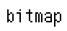font is used to represent literal text to appear in com-puter input or output.
- In conjunction with the typewriter font, italics in angle brackets is used to indi-cate a class of expected response, as in body = <bodyname>.
- Italics are also used for emphasizing crucial ideas and words with specific or precise definitions which may be different from common usage.

Each major division of the manual has its own prefix symbol for page numbers:
- T for Tutorials
- R for Reference
- Q for Quick Reference Guide
- I for Index
- Add-ons to the manual such as the Release Notes and Application Notes are num-bered conventionally.

For symbols and equations:
- Boldface symbols such as A and b represent matrices and vectors. Italic symbols such as x and y represent scalars.
- Equations are numbered and referenced by the section they occur in such as:

Au˙ = b
- A “hat” on a vector, such as nˆ , denotes a unit vector.
Eqn. T1.1

TUTORIAL 1 Introducing SD/FAST

  - Learn how to use the Tutorials effectively.
  - Understand what can be done with SD/FAST.
Objectives
  - Run a very simple example from start to finish.
  - Identify the prerequisite skills needed for successful use of SD/FAST.
  - Examine the features of SD/FAST.
  - Summarize the procedure for using SD/FAST.

T1.1 How To Use The Tutorials
First, if you have not already done so, please read the Preface to learn how the entire manual is organized and what conventions are used. Make sure that your copy of
SD/FAST is installed and operational on your computer, and that all the example files distributed with SD/FAST are installed. Your system administrator can help you locate these files. The Tutorials make extensive use of the examples and hands-on practice is the quickest way to master SD/FAST.

Each Tutorial begins with a set of objectives which are reviewed in a summary at the end. Each objective is a numbered section within the Tutorial which makes it easy to find later by using the Table of Contents. Because each Tutorial relies on information presented in previous Tutorials, it is essential for first-time users to progress through each objective in each Tutorial sequentially. Once you have completed the Tutorials, use the Reference Section, specific examples in the Tutorials, the Quick Reference Guide, and the Index to find the information you need to solve a particular problem.

The remainder of this Tutorial consists of an introduction to the kinds of problems that can be solved with SD/FAST, a simple but complete example to familiarize you with

the use of SD/FAST, information about the skills required for successful use of SD/FAST, a discussion of the available features, and a discussion of how SD/FAST fits into an overall analysis environment.

T1.2 Applications of SD/FAST
SD/FAST can be used to perform analysis and design studies on any mechanical system which can be modeled as a set of rigid bodies interconnected by joints, influenced by forces, driven by prescribed motions, and restricted by constraints. A modeled system can be free-flying or grounded. Within this broad framework, virtually any mechanical system can be modeled and analyzed.

In this section, we will take a brief look at some of the applications to which SD/FAST can be applied. At this point we will not attempt to explain what features of SD/FAST are used to model and analyze the systems shown. Most of the analyses depicted below can be performed with just SD/FAST and a small amount of user-written Fortran or C code. Some require more coding, or the use of an external analysis tool like ACSL, Ma-trix-X, Easy 5, Pro-Matlab, Simulink, or any other package designed to work with user-supplied subroutines (which, in this case are SD/FAST-supplied instead).

First we will look in general at the kinds of mechanical systems which can be modeled. Then we will look more closely at force, prescribed motion, and constraint models. Fi-nally, we will list some of the types of analyses and design studies which can be per-formed on these models.

T1.2.1 Mechanical systems

Here are some examples of mechanical systems which can be modeled using SD/FAST:



F

Ω
Mechanisms and Machines

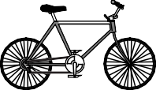
Ground vehicles




Gear trains

Articulated spacecraft


Manipulators

Cables


High speed electromechanical devices
Suspension components Multiple-arm robots Anti-lock brakes Helicopters
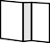
Walking/hopping machines Farm machinery Construction equipment
Precision pointing mechanisms Momentum wheels Biomechanics
. . .

T1.2.2 Force Models

Forces acting on the system can come from any source, some examples of which are pictured below.

Dampers

g
Gravity

Springs
t o

r q
+
-
u e
rpm

Motors and Engines


Feedback control

Feedforward control

Gas pressure

Tires

Hydraulic forces Aerodynamic forces Bushings

Vibration inputs Empirical data Actuators Gravity gradient Stochastic loads Friction
. . .

T1.2.3 Prescribed Motions

Prescribed motions used to drive joints in the system can be arbitrary functions of time and system state. The forces required to implement the desired motions are calculated and returned by SD/FAST. Some applications of prescribed motion are:
Locked joints
Constant-speed motors Road profiles
Orbital motion Sinusoidal motion Cam follower
. . .

T1.2.4 Constraints



Constraints used to restrict allowable motion can be arbitrary functions of time and sys-tem state. The reaction loads required to implement the constraints are calculated and returned by SD/FAST. Some applications of constraints are:



Gears
Distance constraint
Tracks

Screw joints Complex cams Roll-without-slip
Pin-in-slot constraint Rack and pinion
. . .


Belt and pulleys

T1.2.5 Types of Analyses and Design Studies

SD/FAST can be used to perform a wide variety of analyses and design studies. Some examples are:

Assembly analysis
Velocity (initial conditions) analysis Forward and inverse dynamics Statics and steady motion
Limit cycle identification Mechanical advantage Power flow
Design sensitivity
Design optimization (with external optimizer) Real-time hardware-in-the-loop
. . .


Figure T1-1 Four-Bar Mechanism Model

Loop Joint

Connect Rod (3m)

nˆ 2

N

nˆ 1

Crank (1m)
Rocker (2m)
nˆ 3

g Ground (3m)

Assemble Mechanism

Crank Joint:
Initial Velocity: 10 rad/s
Viscous Damping: 3 Nm/(rad/sec)

90 deg

T1.3 A Simple Example
This section will take you through a very simple example from start to finish. Do not worry about how the simulation was written, details will be covered in later Tutorials. The purpose of this example is to demonstrate the ease of using SD/FAST.
The example we will demonstrate is assembly and transient motion of a common four-bar mechanism shown in Figure T1-1, which consists of ground, a crank, a rocker, and a connect bar. The model parameters are shown in the figure and in the SD/FAST input System Description File. The system operates under gravity and has 3 Nm/(rad/sec) viscous damping in the joint connecting the crank to ground.
We first want to have SD/FAST assemble the mechanism since we don’t want to com-pute the geometry of the assembled system. The system is assembled with the crank in its initial vertical position—only the rocker and connect bar are allowed to move during assembly. Next, compatible initial velocities are computed for all the bodies with the crank set at a desired initial angular rate of 10 rad/sec. Finally, we integrate the equa-tions of motion, allowing the system to start with the crank velocity of 10 rad/sec, then slow down and drop due to the viscous damping and gravity. Reaction forces at the crank-ground pin are also computed.

The user-written System Description File used by SD/FAST to generate the equations of motion and all other computational routines is in fbar.sd on your distribution me-dia and is reproduced in Figure T1-1. After installation of the SD/FAST software, you can run this file to generate the simulation code by simply typing
“sdfast fbar.sd”. Note that the file is very succinct, easy to read, and uses friend-ly user-selected names for the bodies.

Figure T1-1 Complete SD/FAST System Description File for Four-Bar Mechanism (fbar.sd)

Gravity

Description for each body

A comment line Loop joint description

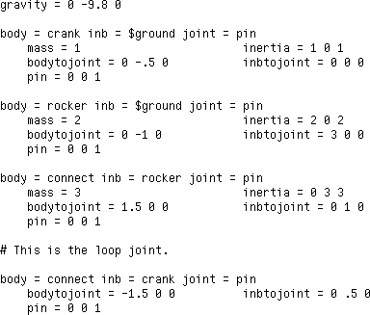

All of the basic geometry and mass properties, and gravity, are passed to SD/FAST in the System Description file. Any other features of the model that depend upon the state of the system (such as viscous damping force being a function of the velocity state) are passed at run time to the SD/FAST routines via user-written routines linked with the simulation code.

Figure T1-2 Complete Driver Simulation for Four-Bar Mechanism (fbar.f)
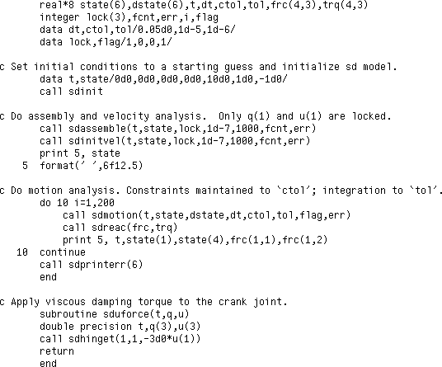
SD/FAST provides dimensions

Initialize SD/FAST model

Assemble mechanism Compute compatible velocities

Integrate E.O.M. Compute reaction loads

Error checking

Viscous damping model

The main driver program is usually written by the user along with routines that describe time- and state-dependent model features, such as applied loads (forces and/or torques) and prescribed motion. The entire program used to drive the crank model is in fbar.f and is reproduced in Figure T1-2. This includes a main program (in Fortran) and a rou-tine that specifies the viscous damping for the crank joint.

After compiling, linking, and running the simulation, we get the following state vector just after the assembly and initial velocity analyses are done:

Zero (rad) initial crank angle (as desired)
Rocker and connect rod initial angles required to assemble mechanism

Initial crank velocity of 10 rad/sec (as desired)

Rocker and connect rod angular velocities required to prevent mechanism from “flying apart”

Rather than list the time history of the subsequent motion analysis, the crank position and velocity, and the reaction forces in the nˆ ₁ and nˆ ₂ directions (Fx and Fy) acting on the crank were plotted using one of many commercially available plotting packages:
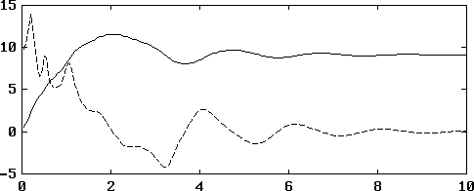
Crank position (rad)
Crank velocity (rad/sec)
Time (sec)

Note that the crank had sufficient kinetic energy to swing around once through 2π radi-ans before the viscous damping and gravity trapped the mechanism into oscillatory mo-tion that rapidly damped out. The reaction forces were also high, particularly in the vertical direction, until the motion significantly damped.
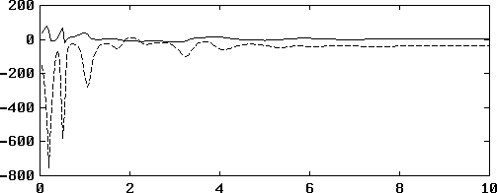
Fx (newtons)
Fy (newtons)
Time (sec)

T1.4 Skills Needed to Use SD/FAST
SD/FAST is a tool for the engineering analyst or sophisticated designer. It is designed to provide these specialists with maximal expressive power for analysis and design stud-ies of even the most advanced and complex designs, while retaining a naturalness and familiarity that makes it useful for even the simplest of problems.

To achieve these goals, SD/FAST builds on certain knowledge and skills that its users are expected to possess. These requirements are listed below.

Required skills

These are the minimum set of skills necessary for successful use of SD/FAST.
- Understanding of the basic concepts in mechanics.
These include: rigid bodies and their mass properties; forces and torques; position, velocity, and acceleration; orientation, angular velocity, and angular acceleration.
- Understanding of appropriate mathematical concepts.
User should be comfortable with: simple vector arithmetic; the concepts of a deriva-tive and integral; functions; linear vs. nonlinear; basic linear algebra.
- Ability to write a modest program in a general purpose language like Fortran or C, or in a simulation language like ACSL, Easy 5, Simulink or Matrix-X.
Necessary skills include: ability to use a text editor; declaring and indexing arrays; assigning values to variables; calling Fortran or C subroutines and functions; writing DO loops; writing simple subroutines; and generating numerical output.
- Ability to produce plots from numerical data.
The results of most analyses and design studies are more readily interpreted when presented in plots rather than as tables of numerical data. If you use an external analysis package like ACSL, Matrix-X, Easy 5, Control-C or Pro-Matlab you will need to know how to use the plotting facilities of these tools. If you work directly in Fortran or C, you will need access to some plotting package and the ability to use it to produce a plot from numerical output.

Useful skills

Users with the following skills will find they can put them to good use in conjunction with the advanced features of SD/FAST.
- Advanced modeling of force elements and actuators.
Users with large investments in pre-existing software models of complex nonlinear elements such as tires, control systems, rockets and thrusters, combustion forces, aerodynamic and hydraulic effects, gravity models, road profiles or empirical data can generally apply these models directly in analyses using SD/FAST with little or no re-coding.
- Design optimization.
SD/FAST has a complete and natural facility for incorporating design variables into models being analyzed. Figures of merit (objective functions) can be constructed for any aspect of interest. Design variables can be driven programmatically in sensitivi-

ty studies. For the user with access to a numerical optimizer such as those in OPT-DES, Pro-Matlab, or Matrix-X, the design variables can be driven automatically to improve the design.
- Control system design and evaluation.
In addition to the use of SD/FAST to perform nonlinear simulations to test linear control systems, an external linearization capability can be used with SD/FAST in the design of these control systems. Such capabilities are provided in packages like ACSL, Matrix-X, and Pro-Matlab.

T1.5 The Features of SD/FAST
This section outlines the various features of SD/FAST, including a more detailed dis-cussion of the classes of physical systems which can be modeled, user-interface fea-tures, analysis, and design features.

T1.5.1 System Models Accepted by SD/FAST
Put succinctly, SD/FAST is a very powerful software tool that can be used to model any mechanical system which can be described as a set of joint-connected rigid bodies plus constraint conditions. The following sections describe acceptable system geometries, the types of motion constraints that can be imposed upon the system, the types of forces and torques that can be applied internally and externally to the system, and the types of analyses and design studies that can be performed with SD/FAST.

System Geometry
Any set of joint-connected rigid bodies can be considered topologically equivalent to a tree (chains of bodies with branches) which may have some branches connected to form loops. Various rotational and sliding joints connect the bodies.
- System Topologies: The system topology can be open-loop (trees) or closed-loop. The systems can be free-flying, (e.g., a satellite) or grounded (e.g., a manipulator or vehicle). Multiple ground connections are allowed. Multiple interacting systems coupled by forces (such as gravitational interaction between two spacecraft) or by constraints (such as a multiple-arm manipulator) can be modeled. Figure T1-41 shows some of the system topologies accepted by SD/FAST.
- Wide Selection of Joint Types: SD/ FAST allows specification of joints based upon assemblies of three joint primitives: one-dimensional rotational joints (pin joint), one-dimensional translational joints (slider joint), and three-dimensional ball joints (no hinge axes). You can assemble your own special joints using these primi-tives or use pre-defined joint types which include Ujoints (two-dimensional rotation-al joint using hinge axes), gimbal joints (three-dimensional rotational joint using

- In this manual, we represent bodies pictorially as “blobs” (in three dimensions you might think of them as “potatoes”) rather than as regular figures such as lines or rectangles. We have found that this technique prevents one’s intuition from leaping to unwarranted generalizations based on the behavior of simple bodies. It also serves as a reminder that the bodies’ geometry is irrelevant in the model — only the mass properties and joint locations matter.


Figure T1-4 System Topologies Acceptable to SD/FAST

Open-Loop Tree Topologies
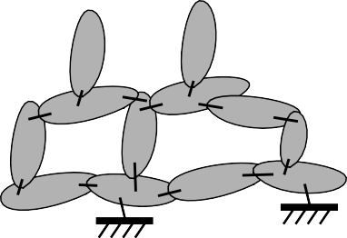
Closed-Loop Topologies

hinge axes), bearing joints (four-DOF joint with one slider and a gimbal, useful in non-redundant modeling of shaft bearings), two kinds of six degree-of-freedom “joints” (free joint, using three sliding joints and a ball joint, and bushing joint, using three sliding joints and a gimbal joint), cylinder joints (combined pin and slider joint), planar joints (two slider joints plus a pin joint), and weld joints (a zero DOF “joint” useful for attaching bodies together rigidly). Figure T1-5 shows the
SD/FAST-defined joints.
  - Large Systems: SD/ FAST accepts systems with up to 300 rigid bodies and 1000 degrees of freedom. The advanced Kane’s formulation2 and Order(N) formulation3 combined with symbolic equation manipulation produces simulations that run much faster than conventional methods, thus allowing such large systems to be reasonably modeled.
  - Modeling Flexible Bodies: It is important to point out that SD/ FAST does not pro-vide explicit models of body flexibility. Instead, a flexible body is represented by a set of rigid bodies connected by joints and subject to internal forces appropriate to the material properties of the flexible body. Also, SD/ FAST can be used as a high-performance rigid body “core” of a more comprehensive user-provided simulation

- Kane, T.R. and Levinson, D.A., Dynamics: Theory and Application, McGraw-Hill, New York, 1985.
- Rosenthal, D.E.,“An Order n Formulation for Robotic Systems,” The Journal of the Astronau-tical Sciences, Vol. 38, No. 4, OCt-Dec 1990, pp. 511-529.

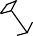
Figure T1-5
SD/FAST Built-in Joint Types
λˆ
λˆ
Pin Joint
Sliding Joint
Ball Joint
λˆ 1
λˆ 2
Weld Joint
λˆ 2
λˆ 1
λˆ 3
Universal Joint
Gimbal Joint
λˆ
λˆ
3
λˆ 2
λˆ 3
λˆ 1
λˆ 2
Planar Joint
Cylinder Joint
λˆ 1
Free Joint
λˆ 3
λˆ 3
λˆ 1
λˆ 2
Bearing Joint
λˆ 1
λˆ 2
Bushing Joint
environment which adds in linear flexibility effects on top of the nonlinear rigid-body results.4


Fext
T₂
Text
T₁
m g
1
m2g
g

Forces and Torques
In general, forces and torques (to which we often refer collectively as loads) can be ap-plied to any body and about any joint axis. SD/FAST provides three ways of specifying these loads:

- See for example, Liu, D., Yocum, J., and Kang, D., “Control and Dynamics of a Flexible Spacecraft During Station-keeping Maneuvers,” Proceedings of the Fourth NASA Workshop on Computational Control of Flexible Aerospace Systems, Williamsburg, Virginia, July 1990.

  - Externally Applied: External forces can be applied to any location on any body. Likewise, external torques can applied to any body. Thus system components such as thrusters, tires, external friction, and fluid forces can easily be modeled. Interact-ing forces, such as a spring connecting two arbitrary bodies in the system, are mod-eled as equal and opposite external forces acting on the bodies.
  - Internally Applied: Internal forces and torques at any joint axis can be applied. Thus internal system motors, hydraulic actuators, hinge springs, damping, and other internal forces and torques are easily modeled.
  - Gravity: A uniform gravitational field acting on a system can be specified in the in-put System Description File. The effects of this field are then included in the gener-ated routines so that they do not need to be accounted for in user-supplied forces at simulation run time. Nonuniform gravitational forces are handled through externally applied forces.

Motion Constraints
Motion constraints are handled in three ways by SD/FAST: as joint constraints, pre-scribed motion, and user-definable general constraints:

  - Joint Constraints: A joint enforces certain allowable motions between two bodies, such as relative rotation about joint axes. For joints in the “tree” system, the equa-tions of motion are derived to allow only the motion permitted by the joints, so no explicit constraint equations are necessary. For those joints which make the final connection of tree branches into topological loops (called loop joints), explicit con-straint equations are generated to enforce the joints’ motion restrictions. All con-straint equations needed to enforce the joint connections and the loop connectivity are generated automatically by SD/FAST. Redundant constraints are detected and eliminated automatically.


  - Prescribed Motion: In addition to enforcing motion between two bodies to occur about certain joint axes (joint constraints), the actual motion about those axes can be prescribed as a function of time (and sometimes system state). That is, instead of al-lowing motion to occur about the joint axis as would be caused by natural dynamic motion, the user can specify that motion (position, velocity and acceleration) such as would occur if an actuator of infinite bandwidth moved the axis in a pre-determined manner. This allows modeling of motors that (for practical purposes) drive parts of machines regardless of the dynamic loads imposed. This also allows inverse dynam-ics computations, in which motion is prescribed and the forces and torques needed to achieve that motion are computed. Prescribed motion can be turned on and off dur-ing a simulation to model changes such as a solar panel locking into position after being deployed. Again, the constraint equations needed to enforce prescribed mo-tion are generated automatically by SD/FAST.

q = f(time)
  - User-Supplied General Constraint Equations: User-supplied general constraint equations (user constraints) can be provided explicitly to implement such motion re-strictions as gears, tracks, and wheels rolling without slip. Like prescribed motion, user constraints can also be turned on and off during a simulation to model situations such as manipulators grasping objects on the ground or vehicle wheels hopping off the ground.

T1.5.2 Types of Analyses and Design Studies

Available Information
?

Many types of analyses can be performed on systems modeled by SD/FAST. Some can be performed simply by calling the basic routines for calculating information about the system. This information includes:
- the angular and translational locations, velocities, and accelerations of any body, point, or joint axis in the system, expressed in any reference frame. Various conver-sion tools are available for expressing body orientation several different ways.
- reaction forces at every joint
- joint forces needed to implement prescribed motions
- constraint multipliers (e.g., gear tooth contact forces) for every constraint
- the system angular and linear momentum and kinetic energy
- system center of mass and central inertia matrix

Much more powerful analyses and design studies can be performed by making repeated calls to these routines under changing conditions guided by a numerical integrator, lin-ear or nonlinear root finder, numerical optimizer, or user-written code. There are several methods available for driving SD/FAST-generated routines:
- Use problem specific, SD/FAST-generated Simplified Analysis Routines.
- Use generic, SD/FAST-generated General Analysis Routines.
- Use an external, commercially available analysis code such as ACSL, Matrix-X, Easy 5, Pro-Matlab, Simulink, or OPTDES.
- Use analysis and optimization tools available in numerical libraries such as IMSL, NAG, and EISPACK.
- Write your own analysis code in a language like Fortran or C. Features accessible with all these methods are discussed below. Simplified Analysis Routines
SD/FAST generates Simplified Analysis Routines for some of the more common analy-ses. These routines are generated specifically for the problem at hand. As a conse-quence, they are very simple to use but are not very general in their capability. They are, however, built on more general routines described below.

Here are the analyses that can be performed with Simplified Analysis Routines:
- Assembly Analysis: Systems with topological loops can be assembled automatical-ly so that you do not have to worry about computing initial system geometries. The general unconnected tree topology is entered and SD/FAST generates a routine which assembles all the loop joints at run time.
- Velocity Analysis: Compatible initial velocities for the assembled system are auto-matically computed using the velocity analysis routine.
- Kinematic and Dynamic Motion Analysis: The time history of the system kine-matics, dynamics and reaction forces are computed for given constraints, loads, and parameter values. Time is advanced using either a fixed-step or variable-step explic-

it integrator. Constraint errors are monitored, and constraint stabilization is provided using user-selectable feedback rates.
  - Static Analysis: Computes the system equilibrium position given forces and torques.

Ω
  - Steady Motion Analysis: Computes system steady motion solutions given forces, torques, and some desired non-zero joint velocities, e.g., flyball governors.

General Analysis Routines

For more general analysis needs, the routines underlying the Simplified Analysis Rou-tines may be called directly. These are called General Analysis Routines. While these routines are useful in conjunction with other SD/FAST-generated routines, they are fully general and may be used in other contexts as well. There are three basic capabilities provided:
  - Numerical Integration: Two methods are provided, a basic fixed-step Runge Kutta fourth-order integrator with error estimation, and a variable time-step integrator built on the basic method. Any number of state variables may be integrated. The step size adjustments can be based on error estimates relative to a user-specified toler-ance, constraint violations, or any user-detected conditions. This is not a sophisticat-ed integrator, however it is very robust and can handle a wide variety of problems, including those with discontinuities. The integrator can detect lockup and other in-tractable conditions, and returns with time set just before the disaster would occur. Because this is an explicit integrator, it does not perform well on stiff problems. However, it will produce correct answers even for these problems.
  - Constrained Linear Least-Squares Solver: A routine is provided which can solve constrained linear least-squares problems. This corresponds to solving sets of linear equations in which some equations must be solved (the constraints) while others are to be solved as well as possible (the objectives). Any size problem can be accommo-dated, subject to computer memory limitations. For underdetermined problems, the solution vector of minimum 2-norm (least squares solution) is found. For overdeter-mined problems, the solution which minimizes the 2-norm of the residual error in the constraints is found (least squares error). Any remaining degrees of freedom are used to minimize the residual error in the objectives.
  - Constrained Nonlinear Root Finder: A routine is provided which can solve con-strained sets of nonlinear equations. This corresponds to solving a set of nonlinear equations in which some of the equations must be solved (the constraints) while oth-ers are to be solved as well as possible (the objectives). Problems of this nature arise naturally in many analyses and design studies. For example, the Assembly and Stat-ic Simplified Analysis Routines are based on this root finder. As another example, the root finder can be used to perform Inverse Static Analysis, i.e., find values for the parameters of force elements (e.g., spring constants) which will make the current configuration a static equilibrium.
The user of this routine provides a function for it to call which, when passed the cur-rent solution vector, returns the residual error in each of a set of equations. The non-linear root finder is based on the Newton-Raphson method, but it uses the above-described Constrained Linear Least Squares Solver for its internal linear steps. This makes it extremely robust — a singular Jacobian does not cause difficulties. It is of-

ten convenient to use the nonlinear solver to solve linear problems as well, to avoid the need to set up matrices.

External Analysis Codes and Libraries

Using external tools such as those described above in conjunction with SD/FAST-gener-ated models, very powerful analyses are possible. For example:
- Numerical integration of stiff problems: many external codes and libraries contain implicit integrators, such as Gear’s integrator, which perform well on stiff problems. Other more sophisticated integrators may yield better performance than SD/FAST’s built-in integrators. ACSL and Matrix-X, for example, contain implicit integrators.
- Extensive plotting and visualization: plotting and animation facilities provided by external codes and libraries can be used to great advantage to display the results of SD/FAST-generated analyses. All the available analysis codes contain plotting facil-ities of various sophistication levels. In addition many commercial plotting packag-es and libraries are available on all platforms. Externally-drivable animation packages exist for some of the more powerful graphics workstations.
- Linearization and control system design: the linearization and eigenvalue analysis features of many external codes and libraries can make use of SD/FAST-generated models in control system design. ACSL, for example, has a linearization capability.
- Frequency analysis: further analysis of the linearized models can yield frequency response information such as Bode plots. Pro-Matlab and Matrix-X, for example, have this capability.
- Automated Design Optimization: SD/FAST provides the capability to build pa-rameterized models and construct merit functions to evaluate the quality of candi-date designs. External packages containing numerical optimizers (OPTDES, for example) can be used to drive the design parameters to seek optimal values for the merit (objective) functions.

User-written Analyses and Design Studies

Because SD/FAST-generated routines are designed to be driven from general purpose languages such as Fortran and C, all the capabilities of these languages can be brought to bear to provide a great deal of flexibility in analysis and design studies. A few simple examples:
- Design sensitivity: design parameters can be varied by small amounts and the deriv-atives of merit functions can be calculated with respect to any of these variables.
- Design parameter sweep: the looping constructs of Fortran or C can be used to iter-ate one or more design parameters through a predefined range to generate a coarse search of the entire design space.
- Mechanical advantage, power flow, etc.: by combining some of the above analyses (such as initial velocity analysis) with simple calculations, a great many interesting properties of mechanical systems can be measured.

A more extensive discussion of the types of analyses possible is given in Reference Section R1.

T1.5.3 System Description File
The SD/FAST software accepts a user-supplied System Description File that describes the system to be modeled. The information in that file is used to generate a problem-specific source-code numerical model (in either Fortran or C) to be incorporated into your simulation environment. This section presents the features available for modeling the system in the System Description File. The next section presents the features of the SD/FAST-generated source code.

These are some of the important features of the SD/FAST System Description File:

Natural System Description
The system to be simulated is described to SD/FAST in a simple, natural input lan-guage. The system is described in familiar engineering terms in a free format, keyword-oriented specification that is both easy to produce and easy to read.

Free Format Input
The input file can be produced with any convenient text editor and the information spec-ified can be spaced and aligned in any manner which proves convenient and readable for the user.

Two Methods of Parameter Specification
# Engine Model
body = crankshaft mass = 15
inertia = 10 0 0
0 ? 0
0 0 5?
Any system parameter can be specified in two ways:
- Constant Parameter: System parameters which are known in advance can be pro-vided as constants in the SD/FAST System Description File. These constants are then used to symbolically simplify the equations of motion, so that unneeded calcu-lations are not done during simulation run time.
- Variable Parameters: Optionally, system parameters can be left unspecified in the input description (using a “?” instead of a number), with actual values to be provided later at run time. A default numerical value can be provided before the “?”. This al-lows equations of motion to be produced with varying degrees of generality, allow-ing a trade-off of flexibility versus performance. With variable parameters, design studies can be performed without needing to regenerate the system model. This vari-able parameter feature also applies to prescribed motion constraints so that they may be turned on and off during simulation.

Model 1
(sat_sdinit...)


Model 2
(arm_sdinit...)
Comments
Commentary text (following “#”) may be included in the system description, making it easier to share and archive system descriptions to be re-used at a later date or by another person.

User-Selectable Prefix on SD/FAST-Generated Simulation Code
The complete set of simulation routines generated by SD/FAST can be prefaced by user-selectable characters. This allows several multibody systems to be simulated si-multaneously with interacting forces and torques. The prefixes also allow the user to as-semble libraries of models for effective management of large simulation projects.

Error Diagnostics
SD/FAST reports any problems found in the System Description File with clear and de-tailed error messages. These include both syntactic or typographical errors and prob-lems with the physical realizability of the system described.

Information File Produced
After successfully processing the System Description File, SD/FAST produces an infor-mation file with tables showing the body interconnections, joint types, coordinate defi-nitions, state/joint index maps, system parameters, and the number, type and placement of constraints. This is useful for verifying that the system has been correctly specified, and for associating run time quantities with their corresponding bodies and joints. Also produced is a list of all the array dimensions needed to call SD/FAST-generated rou-tines.

T1.5.4 Generated Code
Following are some of the more important features of the SD/FAST-generated subrou-tines:

a + b + c - b a + c

ACSL
Matrix-X System Build
Matlab Simulink
Easy 5
Your Special Analysis Tools
Extremely Efficient
SD/FAST uses advanced Kane’s dynamics and our proprietary Order(N) formulation for the equations of motion combined with symbolic algebra to precompute and simpli-fy many of the terms. This produces equations that execute many times faster than sim-ulations produced by conventional methods (i.e., with a general purpose numerical multibody simulation program).

Multiple Output Languages Available
The SD/FAST-generated simulation code is produced in either Fortran or C as request-ed. Generated Fortran routines can be compiled with any ANSI-standard Fortran 77 compiler that has an extension allowing names up to 16 characters in length5. Generat-ed C routines can be compiled with most C compilers, including both K&R and ANSI
C. The routines are designed so that optimizations commonly performed by compilers will be highly effective.

User-Selectable Precision
The SD/FAST-generated simulation code may be generated in either single or double precision, as specified by the user in the System Description File or on the command line. (We normally recommend double precision, however.)

Compatible with Simulation Languages
Because the output routines are in standard Fortran or C, they can be called from any of the commonly used simulation languages such as ACSL or Matrix-X System Build.
They can be used with numerical libraries like IMSL and NAG as well. Also, experi-ence has shown that the generated routines fit smoothly into almost any common simu-

- The ANSI-standard Fortran 77 requires maximum 6 character names. We have used longer names for improved readability, and most Fortran compilers have this extension.

lation methodology, resulting in much higher performance without requiring major changes to the way users work.

Constraint Stabilization
When using Ordinary Differential Equation (ODE) integrators (such as those provided with SD/FAST) to integrate constrained systems, the position and velocity constraints can drift if they are not stabilized. SD/FAST prevents this drift by using the Baumgarte Stabilization6 method. The Baumgarte constants are user-selectable, providing for the most efficient stabilization on a problem-specific basis. Several callable routines are provided for evaluating constraint drift so that cases in which stabilization is necessary are easily identified.

Compatible with Differential-Algebraic Integrators
A routine is available for computing residuals as needed by a Differential-Algebraic Equations (DAE) integrator. For those familiar with these methods, the problem is pre-sented in Index 2 form. This eliminates the potential for drift in the velocity constraints. Position constraints can be stabilized (if necessary) using Baumgarte feedback.

Reusable Numerical Library
In addition to the problem-specific generated code, SD/FAST outputs a separate Library File containing a set of generic routines which have proven useful in mechanical system analysis. These routines included numerical integrators and linear and nonlinear root finders as described in General Analysis Routines on page T-15. Other routines for per-forming commonly needed calculations and transformations are available.

Error Diagnostics
Run time error-checking routines can be called to find errors such as not specifying vari-able parameters, exceeding array dimensions, and improper use of the generated rou-tines.

call sdreac(frc,trq) call sdacc(bdy,pt,acc)
Powerful Routines Available for Extracting Information
- Directly Computes Bearing Reaction Forces and Torques: Any component of bearing reaction force and torque at any joint can be computed. The constraint Lagrange Multipliers are also available.
- Full Kinematic Information: The orientation, angular velocity and angular accel-eration of any body; the position, velocity and acceleration of any point on any body; and the position, velocity and acceleration of any joint axis are available in any coor-dinate frame.
- Coordinate Frame Conversions: Routines are available for transforming a vector defined in any coordinate frame to any other frame. Other utility routines are avail-able for conversion of body (coordinate frame) orientation among three forms: direc-tion cosines, Euler angles, and Quaternions (Euler parameters).
- Total System Kinematic and Dynamic Information: System angular momentum, system kinetic energy, system linear momentum, system mass center, and system in-

- Baumgarte, J. “Stabilization of Constraints and Integrals of Motion in Dynamical Systems,” Comp. Meth. Appl. Mech. Engr., 1 (1972), 1-16.

ertia are available. These quantities can also be used to verify that conservation laws are being obeyed by the simulation.

T1.6 Using SD/FAST
SD/FAST
System Description
Your Analysis Environment
Simulation Routines
SD/FAST handles only one part of the simulation process. It produces the equations of motion describing the dynamic behavior of the system being simulated. For many sys-tems of interest, the equations of motion account for the largest portion of the simula-tion code. They are also extremely difficult to write by hand and very difficult to program correctly on a computer. Furthermore, they are in some sense the least interest-ing part of the simulation—there is an unambiguous “right answer”. While the task of generating equations of motion for a large multibody system is extremely hard, and may take an experienced analyst many months, it leaves little room for engineering creativi-ty. Some creativity is often required in the valiant attempts made to debug the equations after it is realized that they are not producing correct results. But the real talents of good engineers are largely wasted in “grinding out” equations of motion.

It is important to point out that SD/FAST is not a simulation language or environment. The philosophy behind SD/FAST is to produce the critical dynamic model portion of a multibody simulation in an open way which allows it to be used with a wide variety of other analysis tools. The complete simulation or other analysis will in general include models of sensors, actuators, materials, and control systems as well as an integrator and often a plotting or animation system for displaying the output.

SD/FAST provides some examples of these tools, such as integrators. However, it does not lock you into our idea of what is the best approach to the overall analysis. Con-versely, SD/FAST is designed to integrate smoothly into your idea of the best simula-tion approach. SD/FAST will continue to work well in your environment even as you upgrade your analysis methodologies to take advantage of new technologies.

The rest of this section is intended to provide some perspective about how SD/FAST re-lates to other methods of analysis of mechanical systems. Figure T1-6 shows three ways in which a simulation of a mechanical system can be implemented. For each of these methods, we discuss the trade-offs which occur in development time versus execu-tion time.

Figure T1-6 Three Ways to Model System Dynamics in a Simulation

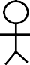
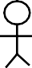
Development Phase

Human Developed
System Parameters
Execution Phase

Forces and
current system state

Specific

Simulation results

Develop Equations

Write Code
simulation code for this system
Integration

Accelerations


Interpret Results

Numerical Codes

System

General

Forces and
current system state


Simulation results

Parameters
purpose multibody code for
any system
Integration

Interpret Results

Accelerations

Symbolic Codes
System Parameters

Specific

Forces and
current system state


Simulation results

SD/FAST
simulation code for this system
Integration

Interpret

Develop Equations
Write Code

Accelerations
Results

Human Developed
Figure T1-6(a) represents the process of generating equations of motion by hand. Engi-neers work from a specification of the system parameters to develop the explicit equa-tions of motion of that system. These equations are then coded in a programming language, such as a Fortran or C subroutine.

This routine is then incorporated into a larger (often pre-existing) simulation frame-work. The complete simulation maintains the system state vector, and uses it in combi-nation with external commands to compute forces and torques. These forces and torques are passed to the hand-generated routine which computes the resultant accelera-tions. These accelerations are then integrated by a suitable numerical method and used to modify the simulation’s representation of the system state, which is monitored to ob-tain information about the system’s behavior. The process is repeated at each time step during the simulation.

Numerical Codes
As may be apparent from the above discussion, generating an executable model of a system’s dynamic behavior is an ideal task for a computer to do. It is a shame to waste the creativity and engineering judgement of a valuable human being on this tedious task. In recognition of this, computer codes have been available since the early 1970’s which contain generic numerical codes for the equations of motion of multibody systems.
These codes can be used to model system dynamics in the same way as a hand-written routine containing specific equations of motion. Figure T1-6(b) shows how a general purpose code can be used instead of the hand-written code in Figure T1-6(a). The spe-cific system parameters are provided to the multibody code at simulation run time.
These parameters are used in the fully-general multibody model to produce the dynamic response of the desired system.

There are several drawbacks to the use of a general purpose multibody code of this type. By far the biggest problem is that the run time performance is abysmal. The general purpose multibody program is unable to exploit the simplifications available in most physical systems to reduce the complexity of the equations. The engineers of
Figure T1-6(a) will notice the symmetric bodies, perpendicular or coplanar hinge axes, terms which cancel out or must evaluate to zero, identical expressions which need be computed only once, and many other opportunities for simplification which abound in the task of programming equations of motion. The general purpose multibody code, on the other hand, will be unable to take advantage of any of these since the equations were written long before the specific system parameters are known. From actual measure-ments, between 60 and 90 percent of the computations performed in executing the most
general form of the equations of motion of a typical multibody system are unnecessary.7

Symbolic Codes
Figure T1-6(c) shows the SD/FAST approach. Instead of acting as a replacement for the human-generated equations of motion in the development phase of a simulation, SD/FAST acts as a replacement for the humans! Like the engineers in the left half of
Figure T1-6(a), SD/FAST takes a description of a particular system and produces a For-tran or C subroutine containing the equations of motion derived specifically for that sys-tem. This routine can then be incorporated into the larger simulation framework. Since the generated routine is written with full knowledge of the system parameters, it is able to employ all the simplifications available in the physics of the system to produce the simplest possible equations of motion. Consequently, this technique combines the high run time performance of hand-generated equations of motion with the accuracy and shortened development time provided by the generic-equation codes.

With SD/FAST you can produce simulations whose performance is comparable or bet-ter to that provided by hand-written equations of motion, but with the reliability and productivity of a general purpose multibody code. Since SD/FAST generates explicit Fortran or C subroutines just as a human programmer would, its equations can be used

- Rosenthal, D.E. and Sherman, M.A., “High performance multibody simulations via symbolic equation manipulation and Kane’s method,” The Journal of the Astronautical Sciences, Vol. 34, No. 3, July-September 1986, pp. 223-239, (also available from your SD/FAST distributor) dis-cusses in detail this problem and others associated with the generic-equation approach, and gives specific performance measurements.

in any environment in which you would have been able to use the hand-generated code. And you can go back to interesting and intellectually challenging work such as design-ing appropriate models, designing control systems, developing simulation methodolo-gies, and interpreting results.
Summary

  - First read the Tutorials in sequential order to learn how to use SD/FAST. Then use the Reference section, Index, and Application Notes to develop your specific simula-tion. Hands-on practice with the sample problems in the Tutorials is the quickest way to develop proficiency in using SD/FAST.
  - SD/FAST can model a wide variety of mechanical systems that can be represented as a set of joint-connected rigid bodies influenced by forces and restricted by con-straint conditions.
  - Your simulation environment interacts with SD/FAST via routine calls. A simple four bar linkage example demonstrates the powerful routines available for the user, such as one-line calls to initialize or assemble a model.
  - An SD/FAST user must have a certain set of prerequisite skills to make effective use of the program. These include the ability to write modest programs in Fortran, C or a simulation language, the ability to produce plots of numerical results, and an un-derstanding of the basic concepts of mechanics.
  - A natural, easy-to-use system description format makes entering models straightfor-ward. An extremely efficient Fortran or C source code model of the system is then generated by SD/FAST for incorporation into your favorite simulation environment, or for direct use from a user-written driver routine.
  - SD/FAST provides an extremely powerful and flexible tool for generating multi-body simulations by combining the best features of human-generated code with the automation, accuracy, and speed of a computer.

TUTORIAL 2 Simple Pendulum

  - Go through a complete example from start to finish.
  - Develop the model.
Objectives
  - Write the system description input file.
  - Run SD/FAST.
  - Incorporate SD/FAST simulation code into a simple simulation.
  - Run a suite of static, dynamic, and analytic analyses on the pendulum.

T2.1 A Complete Example
This tutorial will take you through a complete example from start to finish. Not all the features of SD/FAST will be covered, but the process described will be similar for all the simulations you will develop using SD/FAST.

The basic steps in using SD/FAST for any simulation project are:
- Develop a model of the system.
- Write the input System Description File.
- Run SD/FAST.
- Incorporate the SD/FAST-generated routines in your simulation environment.

The necessary computer files for this example can be found by looking in the SD/FAST installation directory for all the files called:
pend*
where “*” stands for a suffix indicating a System Description File, a file containing all the SD/FAST-generated routines, or the main program controlling the analysis and in-

put/output. Please see the Release Notes for your system to determine the recommend-ed character extensions and suffixes. This tutorial will use character extensions and suffixes for a simulation developed in Fortran on a UNIX-based Sun Workstation. The files for this case are:
pend.sd User-generated input System Description file pend_dyn.f SD/FAST-generated DYNamic simulation code pend_sar.f SD/FAST-generated Simplified Analysis Routines pend_info SD/FAST-generated INFOrmation file
pend.doc Machine-specific DOCumentation for running this example
pend.f User-generated simulation Fortran code
sdlib.f SD/FAST-generated LIBrary file (required for all analyses)

Note that SD/FAST used the file prefix “pend” to automatically generate the files pend_dyn.f, pend_sar.f, and pend_info. The automatic prefix (“pend” in this case) can be selected by the user as will be shown shortly. Avoid using “_dyn,” “_sar,” and “_info” in any file names that you generate.

The library file “sdlib.f” contains analysis code that is independent of a particular model, such as integration routines, and needs to be generated and compiled only once for each version of the software you receive. Refer to your Release Notes for the meth-od of generating this file. Be sure to include this file in your link commands.

T2.2 Develop Model
There are six steps in developing the system model to be entered in the System Descrip-tion File:
- Draw picture and define topology.
- Define coordinate frames and the Reference Configuration.
- Specify geometry and joints.
- Specify mass properties.
- Specify constraints and prescribed motion.
- Specify gravity if needed.

Not all of these steps are necessary for this example, but will be used for other systems. We shall use this pattern to present a rigorous approach to using SD/FAST. We suggest that you try our methodology before developing your own.

T2.2.1 Draw Picture and Define Topology
Figure T2-1shows a simple pendulum on the left with various internal and external forces and torques applied. On the right we have drawn a simple “blob” picture of the system showing the topology (one body in an open-tree structure, connected to the ground), and the joints (a single pin joint). The forces and torques in this problem are gravity acting downward, an external spring attached to the pendulum, and a torsional spring and damper at the hinge. Note that we have put the system in a so-called refer-

ence configuration and have added coordinate frames and vectors to be explained short-ly.

Key Idea
The key idea in this step is to draw a simple picture devoid of extraneous information, such as the shapes of the bodies, so that just the information essential for the dynamic model is clearly shown.

Figure T2-1 Model of a Simple Pendulum

Hinge Spring & Damper





nˆ 2
Q
λˆ
r
bˆ 2
bˆ 1
bˆ 3
B

N

External Spring

g
Pin Joint


Mass Center

mg

nˆ 3
nˆ 3

= nˆ 1

× nˆ

nˆ 1

2

Original System Reference Configuration

T2.2.2 Define Coordinate Frames and the Reference Configuration
The so-called reference configuration shows the bodies in a different configuration than the original system sketch, and coordinate frames and vectors have been added. This is necessary to generate the proper information concerning the location and orientation of each body and joint for the input file and for interpreting results from the simulation.
Correct understanding and usage of coordinate frames and vectors defined within them are critical to using SD/FAST properly. Before we rigorously define the reference con-figuration, we shall discuss coordinate frames.

There are only two types of coordinate frames: inertial and all others. Note that all co-ordinate frames are assumed to be right-handed and orthogonal. That is, the coordinate frame is defined by a set of sequentially-numbered unit vectors arranged orthogonal to each other and obeying the equation: nˆ ₃ = nˆ ₁ × nˆ ₂ , where boldface n is a vector, the hat means it is a unit vector, and the cross represents a vector cross-product. We use the convention that the frame defined using unit vectors aˆi is represented by the boldface capital letter A; similarly, N for nˆ i , etc.

Symbol for Inertial Frame
Inertial Frame
The inertial or ground frame is that frame about which all the equations of motion are generated. It is always present and must be used at least once in the definition of the problem. In the input file, it is referred to by the reserved keyword “$ground”. We shall reserve the frame N for inertial frames in all examples in this manual. The selec-tion of the inertial frame must be carefully considered by the analyst. Since no truly in-ertial frame exists, one must be chosen. For mechanisms and ground vehicles, a frame attached to the Earth is usually sufficient. However for vehicles in orbit, a frame at-

tached to the Earth, the Sun, or moving along the orbit may be used, depending upon relative accelerations generated.1 In most cases, common sense can be used to select the inertial frame.

All Other Frames
All other coordinate frames include one attached to each rigid body and any others which you may wish to define for your use. For the purposes of defining the position and orientation of a rigid body, a coordinate frame and rigid body are identical (as op-posed to a flexible body which may undergo relative motion or deformation). For this example, the frame B is attached to the pendulum.

Key Idea

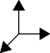
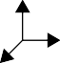
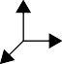
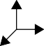
B
C
A
N
A Reference Configuration

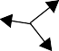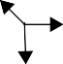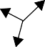
A
B
C
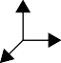

N
Subsequent Motion
Reference Configuration
The key idea behind the reference configuration is that when all of the generalized coor-dinates defining the position of each body or frame in the system are equal to zero, the axes of all the coordinate frames are exactly aligned. More importantly, all geometry, mass properties, joint locations and orientations are defined in this configuration.

Thus, in the pendulum example we have chosen the reference configuration to be that position with the pendulum hanging straight down, which is the “natural” position usu-ally chosen, and the angle defining the position of the pendulum is zero. Other positions could have been chosen; it is your choice. Reference configurations are chosen for a va-riety of reasons, including a “natural” equilibrium position, or one in which the geome-tries and mass properties are easy to compute, such as bodies aligned or at right angles and coordinate frames aligned with axes of symmetry of each body.

Some care should be given to selection of the reference configuration. You can take bet-ter advantage of SD/FAST’s symbol manipulator by choosing a reference configuration in which many of the parameters, such as products of inertia, joint locations, and pin vector coordinates, are zero. Because explicit equations of motion are generated from the description of the system in its reference configuration, a choice which results in ge-ometry being described by vectors with some components being “0” or “1” will gener-ate simpler equations (which run faster) than vectors with more general orientations and lengths. A reference configuration in which all pins are aligned on a single axis is ideal. Initial conditions at runtime can be used to put the hinges into the starting configura-tion—it is not necessary for the reference configuration to be the starting configuration. The performance effects of various reference configuration choices are discussed further in Reference Section R16.2.

T2.2.3 Specify Geometry and Joints
Now that the general topology, coordinate frames and the reference configuration have been defined, numerical specifics for the geometry and the joint are required. The ge-ometry and joint information are all given in terms of vectors written in the chosen ref-erence configuration. Since all the coordinate frames are aligned in the reference configuration, it doesn’t matter in which frame (B or N) you write the vector!

- For a rigorous methodology in selecting inertial frames, see Dynamics: Theory and Applica-tions, Kane, T.R., and Levinson, D.A., McGraw-Hill, New York, 1985, pp. 158-169.

For any system, the only information needed to specify the geometry are vectors from a body mass center to a joint. The specification of which body is connected to which joint naturally leads to the system topology, as we shall see. For the pendulum shown in Figure T2-1, the vector from the mass center of the pendulum to hinge point Q lying on the axis of the pin joint is given by:

r = 1.5nˆ ₂
Eqn. T2.1

which is equivalent to 1.5bˆ 2 . It is important to note that this vector is not unique for a 1-D rotational joint (pin joint) or 1-D translational joint (slider joint). The point Q can lie anywhere along the hinge axis. See Reference Section R11.4 (Pin Joint) for more de-tails.

The orientation of the hinge axis for the pendulum is given by the hinge vector:

λˆ = nˆ 3

Eqn. T2.2

Note that the hinge vector is always a unit vector2 (in this case it happened to line up with nˆ ₃ , but it can be in any direction). Also a relative rotation between the connected
bodies that yields a “right-hand-rule” vector aligned with λˆ gives an increasingly posi-
tive value in the coordinate measuring that rotation. (See Reference Section R11 for rigorous definitions and descriptions.)
λˆ

Thus for the pendulum, the coordinate describing the rotation of the pendulum with re-spect to the ceiling is zero when the pendulum hangs straight down (its location in the reference configuration) and increases positively as the pendulum swings to the right (the “right-hand-rule” applied to the rotation gives a vector aligned with λˆ ).

Right-Hand Rule Gives a Positive Rotation
We have not mentioned units yet. Only one type of unit, angular displacement, is as-sumed and it is always in radians. All other units including mass, length, and time units are left unspecified. That is, the distance of 1.5 from the mass center of the pendulum to the pin joint could be in feet, meters, miles, etc. These units are irrelevant to SD/FAST. It is the user’s responsibility to choose consistent units! For example, if time is in sec-onds, length is in meters, and mass is in kilograms; inertia must be in kg-m2 and force must be in kg-m/s2 (= 1 newton). See Reference Section R21 for more information.

For this example, we shall use the MKS system (meters, kilograms, seconds) and choose the distance from the pendulum mass center to the pin joint to be 1.5 meters.

T2.2.4 Specify Mass Properties
Each body in the system must have a mass and inertia matrix specified. Mass is a scalar quantity, and for this example we choose 10.0 kg as the mass of the pendulum. Note that the ground or inertial frame is considered to be of “infinite mass” and is not speci-fied. Massless bodies created by entering zero for the mass and/or inertia, can also be

- SD/FAST automatically normalizes any hinge vector you give it. Thus a hinge vector given

by λˆ
= 3nˆ ₂ + 4nˆ ₃
will be normalized to λˆ
= -3-nˆ 2 + -4-nˆ 3 .

5 5

used to connect pre-defined joints to create special joints. These should be used cau-tiously, however, and in accordance with the restrictions discussed in Reference Section R13.3. No massless bodies are used in this example.

The inertia matrix (alternatively dyadic or tensor of second order) of each body is speci-
fied about the mass center of that body, for that body in the reference configuration. The rigorous definition of the SD/FAST inertia matrix is given in Reference
Section R13.2. It is important to note that different engineering disciplines use different conventions for the sign of the products of inertia (the off-diagonal terms of the inertia matrix). Most dynamicists, including us, use the “minus sign” convention, while some structural analysts use a “plus sign” convention. Make sure that you know which con-vention is employed by your source of mass properties so that you can reverse the sign of the products of inertia if necessary.

For the pendulum example we shall use the inertia matrix:

5 0 0
I = 0 1 0 kg-m2 Eqn. T2.3
0 0 5

Again, the ground or inertial frame is immovable and has no specific mass properties.

T2.2.5 Specify Constraints and Prescribed Motion
The motion constraint imposed by the pin joint has already been specified. No other constraints or prescribed motion are needed for this problem. Later Tutorials make use of these features.

T2.2.6 Specify Gravity
The pendulum operates in a uniform gravitation field in the –nˆ ₂ direction with a magni-tude of 9.8 m/s2. This constant known force will be specified in the input file so that the symbol manipulator can incorporate the known constant directly into the equations of motion. The springs and damper generate time varying forces and torques on the pen-dulum or at the joint. They are specified at runtime using appropriate routine calls as discussed in Section T2.5.

T2.3 Write System Description File
Now we are ready to write the SD/FAST input System Description File using the infor-mation we gathered as we developed the model. The example System Description File is named pend.sd in your SD/FAST installation directory. Since the System Descrip-tion File is free-format, the exact format is completely up to the user. However, we sug-gest that you try using the format shown in this manual. See Reference Section R19 for exact rules of syntax. The contents of pend.sd is shown in Figure T2-2.

Figure T2-2 System Description File for Pendulum Example

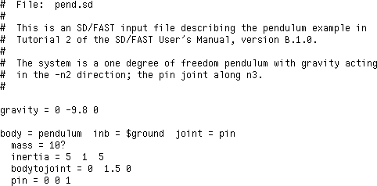
Comments

Preamble

Body Paragraph

That’s the entire input file! We always start with a comment section describing the sys-tem which is modeled. Any line beginning with “#” is treated as a comment and is not processed. The rest of the file is a sequence of “paragraphs”: a preamble of globally ap-plied commands followed by a paragraph for each body.

T2.3.1 Write Preamble
The preamble contains any information that applies to the entire system. In this case only information on gravity is included in the preamble. Other keywords such as “single” for generating single precision code would be included here. See Table R-3 on page 108 in the Reference Section for a list of all SD/FAST keywords and their us-age. Following the keyword “gravity” is an equal sign followed by three scalars.
These scalars are the measure numbers (or components) of the vector representing grav-
ity in the reference configuration:

g = 0nˆ ₁ – 9.8nˆ ₂ + 0nˆ ₃
Eqn. T2.4

Gravity always remains constant3 with respect to the inertial frame N as subsequent mo-tion occurs. Since we are using MKS units, the acceleration due to gravity is in units of m/s2.

T2.3.2 Write Body Paragraph for Pendulum
The first body paragraph contains all the information concerning the one pendulum. The keyword “body” is followed by an equal sign and its alphanumeric identifier cho-sen by the user. This identifier is useful when describing connections to it by other bod-ies and when interpreting simulation results. All information that is listed after “body=”, but before the next “body=” is assumed to apply to that specific body only, hence the natural tendency to use a separate paragraph for each body.

- SD/FAST can also be used with more complex gravity models such as gravity gradients, using the general force application methods rather than the “gravity” keyword.

The next phrase “inb = $ground” tells SD/FAST to which body this body is being connected. It is identified as “$ground”. $ground is a built-in body name that indi-cates the inertial or ground frame. This inboard body (hence, inb) must be already de-fined ($ground or one you previously defined). Thus the order of the paragraphs is very important. The global keywords must appear first in a preamble, and each body paragraph must reference an already defined body.

The next phrase “joint = pin” tells SD/FAST that the connection to the inboard body is a simple pin joint. Both of these words are SD/FAST keywords. Joint connec-tions to outboard bodies never need be specified since the system topology can be spec-ified using only inboard connections. More complex system topologies will be demonstrated in later Tutorials. The vector r = 1.5nˆ ₂ (Eqn. T2.1) from the center of mass of the pendulum to point Q on the pin joint is passed using the phrase “bodytojoint = 0 1.5 0”, where the implied units are meters. (Remember that SD/FAST makes no assumptions regarding units except that angular units are radians. The user is responsible for using consistent units.) The axis of positive rotation of the
pin joint λˆ = nˆ 3 (Eqn. T2.2) is passed using the phrase “pin = 0 0 1”.

Add bodies by connecting to previously defined bodies.
The mass of the pendulum is passed to SD/FAST using the phrase “mass = 10?” where the units are implied to be kilograms to be consistent with other quantities. Note that a question mark has been added so that we can change the mass to a different value at runtime, although 10 will be the default. Had we specified just the numerical con-stant, the SD/FAST symbol manipulator would fold the constant into the equations of motion for maximum efficiency, but regeneration would be required to change the value. If we had just supplied the “?”, there would be no default value.

The inertia (Eqn. T2.3) is passed to SD/FAST using the phrase
“inertia = 5 1 5”. There are two ways of passing inertia properties: (1) via 3 numbers which assumes that the three numbers are the principle inertias and all the products of inertia are zero, or (2) via 9 numbers which are all the components of the in-ertia matrix, entered by rows. Any legitimate inertia matrix is symmetric about the main (top left to lower right) diagonal. You can avoid duplicate entry by providing only one of each pair of symmetric terms, and specifying just a “?” as a placeholder for the other term. In this case the “?” does not represent any variability in the model.
Again, the implied units for inertia in this problem are kg-m2 and the components are measured with respect to the reference configuration about that body’s center of mass. The exact syntax and usage of all the keywords in the body paragraphs can be found in the Reference Section.

T2.4 Run SD/FAST
At this point we are ready to run SD/FAST and generate the equations of motion for the pendulum system. It is assumed that you have typed (or copied from the installation di-rectory) the SD/FAST System Description File “pend.sd” onto a computer that has a licensed copy of SD/FAST available. There are two ways of running SD/FAST: (1) a verbose interactive mode useful for debugging the model, and (2) a quiet batch mode for iterating small changes in the model.

T2.4.1 Interactive Mode
For this example, follow this script:
- To start SD/FAST, type: sdfast
- Copyright, licensing, and time-stamp information should be followed by:
- System description file:
To which you type: pend.sd
- The System Description File is replayed and if the file is syntactically acceptable you see:
Input file successfully processed. Followed by:
- Name for generated Dynamics File: (pend_dyn.f)
To which you type a carriage return to get the suggested default. Followed by:
- Name for generated Information File: (pend_info)
To which you type a carriage return to get the suggested default. Followed by:
- Name for generated Analysis File: (pend_sar.f)
To which you type a carriage return to get the suggested default. Followed by:
- The SD/FAST “Roadmap” of the system is listed:
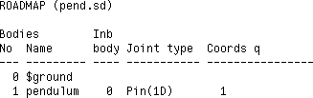
from which you can check if the system described is indeed the one you thought you described. This roadmap is duplicated in the “_info” file and will be described in detail in the next section.
- Information on the progress of computing various parts of the dynamics is followed by a summary of equation complexity in terms of the number of adds, multiplies, di-vides and assignments. SD/FAST should terminate normally with no error messag-es and return the system prompt.

If SD/FAST terminates with no errors and the Roadmap is consistent with the system you wanted to model, then you are ready to incorporate the SD/FAST-generated simula-tion code in the file “pend_dyn.f” with your simulation environment4. If errors oc-cur, information messages (such as “Unrecognized joint type ‘glorp’ for body ‘pendulum’”) should lead to correction of the error.

T2.4.2 Batch Mode
A way to run SD/FAST without generating all the screen output is to pass the system description input file directly to SD/FAST on the first line entered:

- “pend_dyn.f” is created by appending “_dyn.f” to the basename of the input file name: “pend” from “pend.sd”. Suffixes are different under DOS or NT, see Section R7.2.

sdfast pend.sd

After the work is all done and the output files (using the default file names) are generat-ed, the prompt will return quietly unless errors are found. This should take only a few seconds.

Other options can also be entered on the command line that can select, for example, use of the Order(N) formulation, desired precision, language, and output file “basename” prefix used. See Reference Section R7.1 and the Release Notes for your machine for details.

T2.5 Create Simulation
At this point, we have all the SD/FAST-generated routines for simulating the dynamics of the simple pendulum. As shown in Figure T1-6 on page T-21, we now need to add routines for numerically integrating the equations of motion and passing the results to the output device of choice. The steps for creating a simulation are:
- Choose method of using SD/FAST routines.
- Extract reference information from information file.
- Write simulation driver code.
- Run simulation.

T2.5.1 Choose Method of Using SD/FAST Routines
Section T1.5.2 on page T-14 discussed the different methods which can be used with SD/FAST-generated routines to perform analyses and design studies. These methods include the use of Simplified Analysis Routines (Reference Section R18), General Analysis Routines (Reference Section R8), external analysis environments and libraries, and user-written analysis code.

In this example, we will use only Simplified Analysis Routines and a little user-written code. In general, unless you are using an external analysis environment, we recommend the use of Simplified Analysis Routines if they can do what you need.

Simplified Analysis Routines
These are a set of six simple “we-have-done-it-all-for-you” routines that allow you to quickly write and test most simulations or portions of simulations. The Simplified Analysis Routines are in the generated “_sar” file. These routines will probably allow you to perform most of your analysis tasks, but do not provide completely general anal-ysis capability. For more general analyses without use of an external analysis environ-ment, use the General Analysis Routines.

We will only use two of the six Simplified Analysis Routines in the pendulum example:
- SDSTATIC(): Finds static equilibrium configurations of the system. See Refer-ence Section R18.3 and the Quick Reference Guide. More general capability, in-cluding inverse static analysis, can be performed with the underlying General Analysis Routine SDROOT() as described in Reference Section R8.2.

- SDMOTION(): This routine propagates the system equations of motion through time using a Runge-Kutta-Merson variable step integrator. See Reference
Section R18.5 and the Quick Reference Guide. Note that SDMOTION() is limited in its usefulness because it can not be used to propagate user-defined differential equations such as controllers. The General Analysis Routine SDVINTEG() (Refer-ence Section R8.1) provides a more sophisticated capability. Fixed step integration is also available, as required for real-time simulations, and is discussed in these same Reference Sections.

T2.5.2 Extract Reference Information
Before you can write the main simulation code, you should examine the Information File produced by SD/FAST to find the reference numbers and array dimensions for making calls to SD/FAST-generated routines. The default name for this file is created by adding “_info” to the root of the input file name; in this case, “pend_info” (Figure T2-3).

The Information File contains (1) a Roadmap, which describes the system topology as a cross-check of the input System Description File, (2) a State Index Map which maps the “position” states, the q’s, and the “velocity” states, the u’s, to their locations in the state vector; and (3) a list of system parameters and their values. The Information File is dis-cussed briefly below, and in more detail in Reference Section R9.

Roadmap
The Roadmap is the table at the top of the Information File. The Roadmap for the pen-dulum system is very simple. Reading down the Roadmap, we see that the first body is “$ground,” which is numbered “0”. The next body is “pendulum,” which is num-bered “1” and is connected to the inboard body (Inb body) “0,” the ground. The type of joint connecting the pendulum to the ground is a 1-D pin joint (Pin(1D)). This de-scription matches the system we expected.

State Index Map
The second table in the information file is the state index which maps the “position” states, the q’s, and the “velocity” states, the u’s, to their locations in the state vector. There are two states for the pendulum. The first, and only, position state or coordinate of the pin joint, q, is the first component of the state vector. The velocity state, u, for the pin joint is the second component. More complex examples will follow in later tutori-als.

Figure T2-3 SD/FAST Information File for Pendulum

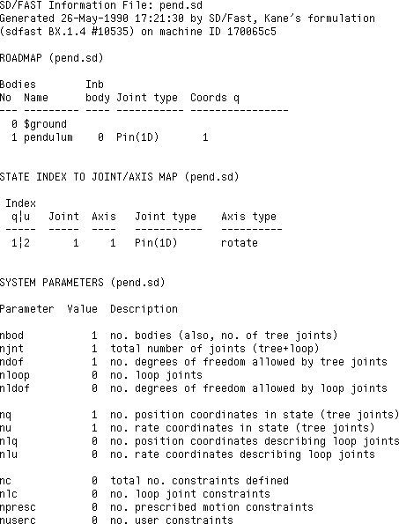
Roadmap

State Index

System Parameters

System Parameters
The third table of the information file lists the overall system parameters such as the to-tal number of bodies, the number of degrees of freedom in the system, the number of loop joints, etc. For the pendulum, there is one body (nbod), which is also the number of tree joints and total joints (njnt) in the system. There is one degree of freedom (ndof) allowed by tree joints, one position coordinate (nq), and one rate state (nu).
There are no loop joints, constraints, or prescribed motion in this problem.

Key Idea
It is important to note that you must use the body, joint, state, and axis numbers listed in the Roadmap and State Index Map when making calls to SD/FAST routines. Necessary arrays should be declared using the provided System Parameter values. These reference numbers and system parameters are also available by calling SDINFO(), SDJNT(), and SDCONS(), described in Reference Section R17.3. This feature is available for those developing general purpose simulation codes that automatically extract informa-tion about arbitrary models.

T2.5.3 Write Force and Torque Models
The main simulation program is called “pend.f” in your tutorial directory. Rather than reproduce that file in one figure, we discuss each segment as it is used and then show the computer output generated by that segment of code. This section covers the user-written force and torque models, and the next section covers the analyses per-formed. To get this example running on your machine, follow the directions in pend.doc. Various steps including compiling and linking the library file may be needed. While going through this example you may wish to have a printout copy of the entire code pend.f.

To use the Simplified Analysis Routines, you must write at least one, possibly two, rou-tines that provide the rest of the system model required for simulation, namely, (1) the applied forces and torques through sduforce() [SD-User-FORCEs], and (2) pre-scribed motion functions through sdumotion() [SD-User-MOTIONs]. If you have user constraints defined, additional routines will be required; see Reference Section R24 (User Constraints).

We shall use only the first user-supplied routine, sduforce(), to compute the torsion-al spring and damper torques and the force from the externally attached linear spring.
The other user-supplied routines are not needed for this problem and will be explained in later tutorials. Note that sduforce() must be written if you are linking with any Simplified Analysis Routines, even if it only returns without any forces or torques. This is because SD/FAST can not determine from the input file if the user wants to apply forces or torques, but it can determine if prescribed motions or user constraints are needed. Therefore the Simplified Analysis Routines always make a call to sduforce().
A detailed drawing of the forces and torques applied to the pendulum are shown in Figure T2-4. The gravity force, mg, has already been accounted for in the input file.

Figure T2-4 Forces and Torques Applied to the Pendulum




Hinge Spring & Damper

1.0 m

τ
Pin Joint

External Spring
1.0 m

F
P = 0.5 bˆ 2 m

Mass Center

Unstretched Length
1.0 m mg

Hinge Spring Bias

Write sduforce(): Hinge Spring and Damper
The torque applied at the hinge is given by:

τ = {–K rotate(q – qbias ) – Ffrictu}λˆ

Eqn. T2.5

Hinge Spring Bias
where q is the angle measured from vertical with a positive rotation counterclockwise about the hinge axis λˆ , qbias is the offset of the torsion spring zero point from q = 0, u is the angular rate of the pendulum, and K rotate and Ffrict are the spring and damping con-
stants, initially 100 N-m/rad and 10 Nm/(rad/sec), respectively.
τ

The initial set-up and hinge torque code segment of sduforce() is:
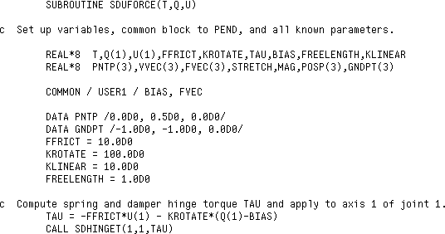
The variables passed to sduforce(T,Q,U) are time, T, a vector of all the general-ized coordinates of the system, Q(NQ)5, and a vector of all the generalized speeds of the system, U(NU). The variables will be explained when they are used. The common block is used to pass some variables to the main program for printing or changing dur-ing the simulation. We shall change BIAS during the simulation and use FVEC in some computations in the main program.

The hinge torque, TAU, is computed as in (Eqn. T2.5) with the variable names roughly equivalent to the mathematical symbols. TAU is passed to SD/FAST through the utility routine call SDHINGET() [SD-HINGE-Torque] where the first parameter is the joint number, the second parameter is the axis number of that joint (e.g., a U-joint has 2 num-bered axes), and the third parameter is the hinge torque passed to SD/FAST.6

Write sduforce(): Attached Spring
The external force F applied to the pendulum by the linear spring is given by:
F
P

F = K linear(l – lfree)vˆ
Eqn. T2.6

- Symbols in parentheses such as “NQ” inside of Q(NQ) indicate a vector of size 1 x NQ.
- The only supported way to pass information to and from the SD/FAST model is through vari-ables in the routine list. Direct access to SD/FAST-generated common blocks or global variables is not supported and not recommended.

where K linear is the linear spring constant, 10 N/m; l is the total length of the spring in meters; lfree is the free length of the spring in meters, i.e., the length of the spring for
which the force it exerts is zero; and vˆ is a unit vector aligned with the linear spring in
the direction of the force applied to the pendulum. Note that this vector equation must be transformed between various coordinate frames, as required by the various routines. The external spring force is rather complicated in that the direction of the applied force changes in a nonlinear fashion with changes in the pendulum angle.

The code written to implement this external spring force constitutes the remainder of the
sduforce() routine:
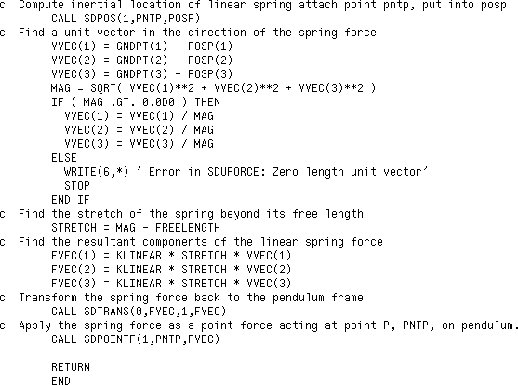
We first compute the inertial position of the linear spring attach point P (PNTP) which is
0.5 meters along bˆ 2 from the center of mass of the pendulum. This is accomplished by using the utility routine SDPOS() which computes the inertial position7 of any point on any body. The first parameter passed to SDPOS(1,PNTP,POSP) is the number of the body, in this case 1, as we learned from the Roadmap (Figure T2-3). The second param-eter passed is a vector in the body frame from the body mass center to the desired point, in this case, point P, 0.5bˆ 2 meters form the mass center. The third variable, POSP, is a vector of the returned position of the point in the inertial or ground frame, N.

The unit vector, VVEC, aligned with the linear spring is formed by subtracting the POSP vector from the linear spring ground attach point GNDPT (– 1nˆ 1 – 1nˆ 2 + 0nˆ 3 ), and then normalizing by its magnitude, MAG. The stretch of the spring is given by subtracting its

- You may have noticed that we have not identified the location of the origin of the inertial frame N. An arbitrary location could have been specified by an inbtojoint (inboard-to-joint) vector in the pendulum body paragraph of the input file. Left unspecified, the default location is the first joint connection to ground.

free length from MAG. Finally the linear spring force is computed and resolved along the three components of VVEC.

Note that FVEC has been computed in the inertial frame, but must be transformed to the pendulum frame as required by SDPOINTF(). We do this by using the SDTRANS(0,FVEC,1,FVEC) utility routine which transforms from frame 0 (the ground or inertial frame) the vector FVEC to frame 1 (the pendulum) the vector FVEC. Note that we simply overwrote the new vector onto itself. Finally we call SDPOINTF(1,PNTP, FVEC) to apply to body 1 (the pendulum) at PNTP, the attach point of the spring, the external force FVEC, computed in the body frame.

T2.6 Run Analyses on Pendulum
Now that we have written the routines required to complete the force and torque models for the pendulum, we can write the main simulation or analysis program for performing the analyses. After setting up the main program, we shall perform a suite of static, dy-namic, and analytic analyses.

T2.6.1 Setup Main Program
The initial setup code of the main program pend.f is:
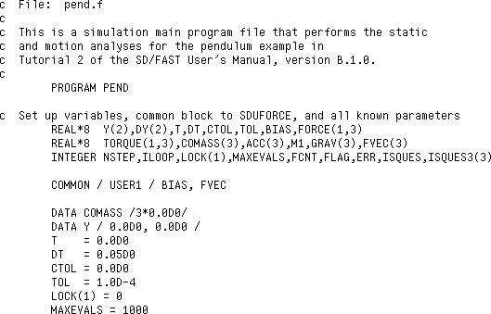

The variables will be described as they are used. The common block USER1 is used to pass variables to and from sduforce() as explained before.

T2.6.2 Exercise 1: Perform Initial Static Analyses
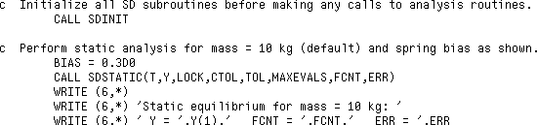
The next segment of code performs a static analysis of the pendulum with the mass set to its initial value of 10 kg and the bias of the rotational spring set to 0.3 radians.
τ
F

0.1169 rad

Static Equilibrium for 10 kg Pendulum
SDSTATIC() attempts to find a set of hinge positions q which constitute a static con-figuration for the system, that is, one in which all the accelerations are zero when the ve-locities are as supplied in the state vector. SDSTATIC() uses a nonlinear root finder to drive all the hinge accelerations to zero. Note that SDINIT() must be called after all System Description File “?” parameters have been set but before any analysis is per-formed. This means that any future changes to a mass, inertia, length, i.e., any question mark parameter in the System Description File must be followed by a call to SDINIT() before another analysis is performed. (For details on ordering requirements of SD/FAST-generated routines, see Reference Section R3.1 or the diagram in Quick Reference Section Q3.)

The variables passed to SDSTATIC() are the current time T, the initial guess at a static state vector Y(NQ+NU), a vector LOCK(NU)8 whose nonzero elements indicate to SDSTATIC() not to vary that coordinate during the analysis (useful for limiting which coordinates can change from your initial setting and for specifying known values such as prescribed motion coordinates to speed up the analysis), the allowable tolerance on maintaining constraints CTOL which is set to 0 since this problem has no constraints, the desired tolerance of the solution for all accelerations TOL which is set to 1.0D-4, and the maximum number of function evaluations MAXEVALS allowed by the root find-er, which is set to 1000. Passed back is the state vector Y in a static configuration (if one is found), the actual number of derivative evaluations used FCNT, and an error variable ERR which returns 0 if successful, 1 if search failed, 2 if exceeded MAXEVALS.

The result of running this segment of code is:

Thus the static equilibrium point is computed to be 0.1169 radians, the number of func-tion calls was only 6 out of a maximum allowable of 1000, and the error variable indi-cates a successful analysis.

- LOCK is dimensioned NU rather than NQ because the four Euler parameters used to represent ball joint orientations are not all independent. See Reference Section R18.1 (Assembly Analysis) for a discussion.

T2.6.3 Exercise 2: Perform Dynamic Analysis to Confirm Static Result

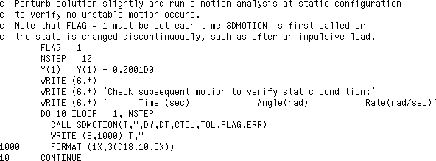
Since the static equilibrium analysis uses only a first-order root finding technique, stable versus unstable equilibria can not be determined (for example a pendulum just balanced to point straight up is in equilibrium, but at an unstable equilibrium point). To deter-mine if indeed the equilibrium point is stable, a small perturbation can be introduced (to “knock” the pendulum over if it’s actually at an unstable equilibrium point) and motion analysis can be run for a while (say 10 steps at 0.05 seconds per step):
τ
F
Time

q

Perturb Stable Equilibrium

q
Time

Perturb Unstable Equilibrium
Note that a call to SDINIT() is not needed since no system parameters were changed since the last time SDINIT() was called. The variables passed to SDMOTION(), the equations of motion propagation routine are: the current time T, the state vector Y(NQ+NU), the state derivative vector DY(NQ+NU) which currently has incorrect in-formation since we perturbed the state, the time increment DT which was previously set to 0.05 sec, the allowable tolerance on maintaining constraints CTOL which is set to 0 since this problem has no constraints, the desired tolerance of the solution for all accel-erations TOL which is set to 1.0d-4, the initial call FLAG9 which must be set to 1 each time SDMOTION() is first called or Y has been changed by the user (such as after an impulsive load has been analytically computed and imposed), and ERR which reports 0 for success, 1 as a warning that a discontinuity in the derivatives was encountered, 2 the system has locked up and integration can’t proceed, or 3 constraints were violated and integration can’t proceed.

The results of this code segment show that, indeed, the pendulum returns to the 0.1169 radians solution (from the perturbed value of 0.1170) as the motion analysis proceeds:
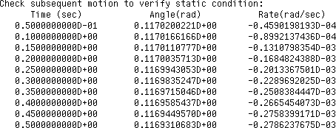

- The purpose of the flag FLAG is to indicated that initial derivatives need to be generated.

T2.6.4 Exercise 3: Change the Mass of the Pendulum and Redo Static Analysis
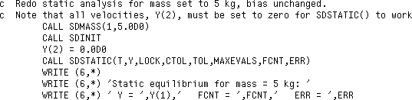
Next we run the static analysis again, this time for a pendulum mass of 5 kg:

0.1639 rad

Static Equilibrium for 5 kg Pendulum
The mass was changed by calling SDMASS(1,5.0D0) where 1 indicates the body number of the pendulum and 5.0 is the new mass. The mass can only be changed if the input file initially had a “?” attached to the value of the mass. If we had attempted to change the mass or any other parameter that was not “changeable,” the analyses would proceed (incorrectly), but the error handling routine SDPRINTERR() would report the error when called. Note that SDINIT() had to be called after the change in the mass of body 1 was made. Also note that the pendulum velocity had to be set exactly to zero since SDSTATIC() will try to solve using the given velocities. The result of running this code segment is:

where the static equilibrium point is computed to be 0.1639 radians, the number of func-tion calls was only 6 out of a maximum allowable of 1000, and the error variable indi-cates a successful analysis. We shall proceed using a 5 kg pendulum mass for the remaining analyses.
τ
F

T2.6.5 Exercise 4: Release Pendulum and Check That F=ma Holds
Next we shall instantaneously reset the rotational spring set-point bias from 0.3 radians
to 0 radians and check Newton’s Second Law (ΣF = ma) for the pendulum just at the
start of its subsequent motion. Here we shall show more uses of the SD/FAST-generat-ed routines to extract useful information from the simulation.

Since we instantaneously changed a torque acting on the system by changing the offset bias of the rotational spring, the system derivatives in DY are now invalid. However, we can re-evaluate the equations of motion just at the instant the torque was changed by set-ting the time increment DT to zero. (Normally we should set the “derivatives invalid” flag FLAG, but for DT=0 this is unnecessary.10):
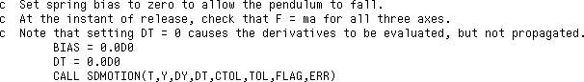

- When in doubt, go ahead and set the FLAG. It won’t ever hurt except for some additional computations.

Next we call SDREAC(FORCE,TORQUE) which passes back all the current reaction forces FORCE(NJNT,3) and torques TORQUE(NJNT,3) acting on all the bodies at their hinge connections:
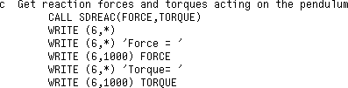
with the results reported in the body frame:
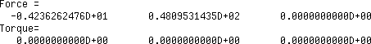

F reac
Then we transform the reaction force from the body frame to the inertial frame using SDTRANS(); ask for the acceleration ACC of the center of mass of the pendulum using SDACC(1,COMASS,ACC), which is already given in the inertial frame; transform the external force FVEC from the linear spring to the inertial frame; ask SD/FAST for its current values of the mass of the pendulum and gravity; and compute both sides of the vector equation (ΣF = ma) :11


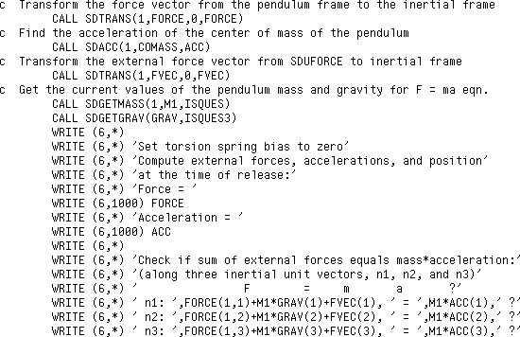
mg

Fvec

ma
)
)

Check
ΣF = ma

- It is a good idea to get into the habit of asking SD/FAST directly for any model parameters, since you may have changed them in other routines or by terminal i/o. There’s no point in enter-ing the same numerical values twice and inviting future errors when changes have to be made.

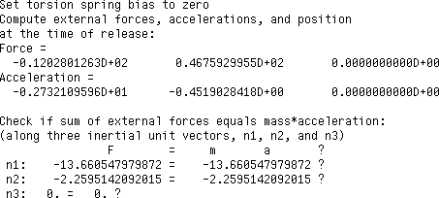
with the expected results:

T2.6.6 Exercise 5: Motion Analysis of Pendulum After Release
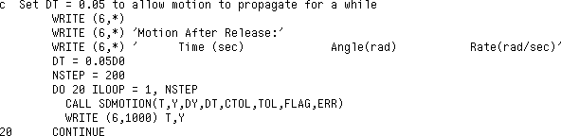
To propagate subsequent motion of the pendulum, we simply set DT = 0.05 and allow to run from the current 0.50 seconds to 10.50 seconds (200 steps):

Rather than print all the output, we have plotted the results in Figure T2-5. (Note that the first point plotted is at T=.55.)

Figure T2-5 Time History of Position and Velocity After Release of the Pendulum
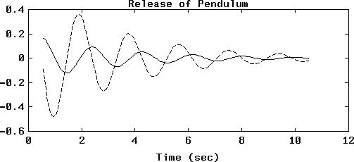
Rate (rad/sec)
Position (rad)

T2.6.7 Exercise 6: Static Analysis of Final Resting Position
Finally, we can check the final position of the pendulum after all motion has stopped by performing another static analysis. Note that the velocity, Y(2), had to be set to zero or

the static analysis would have attempted to find a solution with the last velocity comput-ed by the motion analysis:
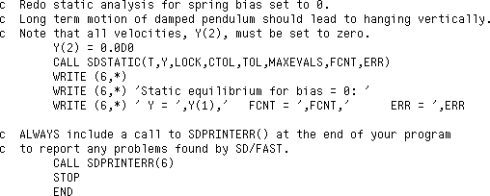

with the expected result of the pendulum hanging vertically:

- This tutorial covered a complete example of using SD/FAST from start to finish, in-cluding (1) develop the model, (2) write system description file, (3) run SD/FAST, and (4) incorporate SD/FAST-generated routines into a stand-alone simulation and execute.
- The key idea in developing the system model for use by SD/FAST is to extract the required information in the most advantageous manner. That is, select a reference configuration to minimize complex geometries and mass properties. Selection of a reference configuration with simple geometry and mass properties also has the side benefit of allowing the SD/FAST symbolic manipulator reduce the computational load.
Summary
- Once the model is developed, the input System Description File is easily written by simply picking off the model parameters from the sketches.
- Running SD/FAST on the input file generates up to four files: (1) a “_dyn.f” file containing most system-specific routines; (2) a “_sar.f” file containing the Sim-plified Analysis Routines; (3) an “_info” file containing the system roadmap, state index, and system parameters; and (4) a library file, “sdlib.f”, if not previously generated, containing the General Analysis Routines and some utilities.
- You then write a main driver program or write the required “hooks” in your simula-tion environment that call the SD/FAST-generated routines.
- The analyses demonstrated in this tutorial included: (1) static analyses to determine system equilibrium configurations (SDSTATIC()); (2) dynamic analyses to com-pute time histories of system motion (SDMOTION()); and (3) extraction of system information before and after instantaneous changes in system state or model parame-ters (SDMOTION(DT=0)).
- Several generated routines were introduced including: (1) application of hinge and body loads (SDHINGET(), SDPOINTF()); (2) transforming vectors between co-ordinate frames (SDTRANS()); (3) changing model parameters (SDMASS()); (4) obtaining information about the system (SDPOS(), SDACC(), SDGETMASS(), SDGETGRAV(), SDREAC()); and (5) checking for errors (SDPRINTERR()).

TUTORIAL 3 Slewing Spacecraft

  - Develop a complex open-loop topological model.
  - Use prescribed motion.
Objectives
  - Approximate flexible-body dynamics using lumped mass-springs.
  - Use a control system in a simulation.
  - Integrate user states using General Analysis Routines.
  - Perform a design study by changing model parameters.

T3.1 A Complex Spacecraft Example
This tutorial will take you through the modeling and simulation of a realistic spacecraft with prescribed motion, simple flexible-body dynamics, a control system with sensors and actuators, and studies of proposed changes in the design of a camera on the space-craft. The spacecraft model is based upon an early three-axis (non-spinning) interplane-tary exploration spacecraft built by the Jet Propulsion Laboratory1. The necessary computer files for this example can be found by looking in the SD/FAST installation di-rectory for all the files starting with slew.

This section covers the rigid-body model of the spacecraft, the SD/FAST System De-scription File, and the generated roadmaps.

- G. E. Fleischer and P. W. Likins, “Attitude Dynamics Simulation Subroutines for Systems of Hinge-Connected Rigid Bodies”, NASA JPL Technical Report 32-1592, pp. 13-36.

T3.1.1 Spacecraft Model
The model to be used for the spacecraft is pictured in its reference configuration in Figure T3-1. The model chosen has five bodies and a total of eleven degrees of freedom (assuming that prescribed motion is not enforced). The bus and its attached solar panels are modeled as a single rigid body which is the base body for this system. The camera sits on a shaft called the “clock” which is attached to the bus by a pin joint. The camera is hinged to the clock by another pin joint orthogonal to the clock-bus pin joint. Inside the camera is a small high-speed scanner. The scanner oscillates under control of a very high band-width controller whose dynamics are unaffected by the relatively slow mo-tions of the camera and the spacecraft attitude dynamics. Thus its motions can be fully prescribed as discussed in Section T3.3.

Figure T3-1 Reference Configuration of the Five-Body Spacecraft Model



X
CAMERA (3)
SCANNER (5)
Y
CLOCK (2)
GAS JETS
BUS (1)

BOOM (4)
Z
Note: A Hollow Vector is a Hinge Axis

There is a flexible boom attached to the bus which is modeled as a rigid body connected to the bus by a U-joint. The selection of appropriate hinge torques to model the funda-mental frequency of the actual flexible boom is discussed in Section T3.4.

The spacecraft is equipped with a rate-integrating gyro that reports bus attitude and bus attitude rates about its three orthogonal body-fixed axes. There are gas jet thrusters on the bus which are pulsed (with a minimum on-time) to exert restoring torques if the bus attitude or attitude rates exceed acceptable tolerances as the slew maneuver of the cam-era progresses. Initially all bus attitude and attitude rates are zero and the attitude con-trol system attempts to keep them close to zero. Motors at the clock and camera hinges are slewed by applying varying amounts of torque. A controller model is provided

T3.1 A Complex Spacecraft Example

which drives these motors. All sensors, actuators, and controller models are described in Section T3.5.

T3.1.2 The SD/FAST System Description File
The SD/FAST System Description File for this spacecraft model using the mass proper-ties of the original JPL model (except the scanner which is new in this model) is in slew.sd in the installation directory and is reproduced in Figure T3-2.

Figure T3-2 SD/FAST System Description File for the Spacecraft Model
body = bus
mass = 410
inertia = 115 | -14 | 14
? | 316 | -34.6
? | ? | 440

body = clock inb = bus joint = pin mass = 6.8
inertia = 0.35 0.35 0
bodyToJoint | = | 0 | 0 | -0.75
inbToJoint | = | 0 | 0 | -1.5
pin = 0 0 1

body = camera inb = clock joint = pin mass = 57.5
inertia = 4.85 |  | 0.41 | -0.07
? |  | 2.2 | 0.54
? |  | ? | 5.5
bodyToJoint = | 0 | -0.22 | 0.2
inbToJoint = | 0 | -0.1 | -0.75
pin = -1 0 0

body = boom inb = bus joint = ujoint mass = 10.7
inertia = 27.2 0.2 27.2
bodyToJoint = 0 3.3 0
inbToJoint = 0 -1.2 0
pin = 0 0 1
pin = 1 0 0

body = scanner inb = camera joint = pin prescribed mass = 1.0
inertia = 0.1 0.1 0.5
bodyToJoint = 0 0.01 0
inbToJoint = 0 0? 0
pin = 0 0 1

This System Description File should be completely understandable at this point with three exceptions: (1) The three question marks used in the lower off-diagonal terms of the inertia matrices are simply an easy way to enforce the symmetry of the matrix with-out possibility of incorrectly typing the symmetric entry, (2) the keyword pre-scribed on the fifth body (scanner) tells SD/FAST that the motion of the pin joint connecting the scanner to the camera will be prescribed as discussed in Section T3.3, and (3) the combined number 0 and the “?” entered as the second component of the in-bToJoint vector for scanner indicates to SD/FAST that we will be changing this pa-rameter during the simulation and thus leave it in symbolic form rather than reducing it numerically, and that 0 is the default value placed in the variable. Study the mass prop-erties and geometry to convince yourself that this is a plausible model of the system pic-tured in Figure T3-1.

T3.1.3 Generated Roadmaps
Once the input file has been processed by SD/FAST (use the command:
sdfast -ge slew.sd to get all the files), we can look at the slew_info file and examine the roadmap for a more complex system:
SD/FAST Information File: slew.sd
Generated 5-Jan-1991 19:04:31 by SD/Fast, Kane’s formulation (sdfast BX.1.2 #10643) on machine ID 1700e754

ROADMAP (slew.sd)

Bodies No Name | Inb  body Joint type Coords q |  |  |  |  |  |  | Multipliers
0 $ground |  |  |  |  |  |  |  |  |  | |
1 bus |  | 0 |  | 6dof(Trans) |  | 1 | 2 | 3 |  | |
 |  |  |  | 6dof(Rot) |  | 4 | 5 | 6 | 12 | |
2 clock |  | 1 |  | Pin(1D) |  | 7 |  |  |  | |
3 camera |  | 2 |  | Pin(1D) |  | 8 |  |  |  | |
4 boom |  | 1 |  | U-joint(2D) |  | 9 | 10 |  |  | |
5 scanner |  | 3 |  | Pin(1D) |  | 11p |  |  |  | | 1p

There are five bodies plus ground. We shall use the body numbers assigned to integer variables (SCANNER=5 being the scanner, etc.) to reference these bodies in the driver code (this is recommended to help keep the code more readable for complex systems). The inboard body reference numbers all indicate the topology desired. The joint types are all correct. The assigned coordinates indicate that there are indeed eleven degrees of freedom, with the scanner being prescribed as indicated by the 11p. One multiplier is needed to adjoin the prescribed motion constraint to the equations of motion. We are not concerned with the multiplier in this problem, but if you want more information, see Constraint Multipliers on page R-22.

The State Index To Joint/Axis Map shows the location in the state vector of the position coordinate q and the rate coordinate u for each joint axis, the joint type and the axis type for each joint. Note that there is not a matched number of q’s and u’s for the 6dof joint used to track the bus attitude. There are four quaternions and only three angular veloc-ity measure numbers. The use of four parameters in quaternions guarantees that no sin-gularity will be encountered in the attitude equations (See Euler Parameters on page R-27 for details). You can either use this map to pick out what you need from the state

vector, or use the SDINDX() routine to avoid explicit dependencies on the assignment of coordinates to place in the state array. We have taken the latter approach in this ex-ample, and recommend it highly.
STATE INDEX TO JOINT/AXIS MAP (slew.sd)

Index
q|u Joint Axis Joint type Axis type

1|13 |  | 1 |  | 1 | 6dof |  | translate
2|14 |  | . |  | 2 | . |  | translate
3|15 |  | . |  | 3 | . |  | translate
4|16 |  | . |  | 4 | . |  | quaternion
5|17 |  | . |  | 5 | . |  | quaternion
6|18 |  | . |  | 6 | . |  | quaternion
7|19 |  | 2 |  | 1 | Pin(1D) |  | rotate
8|20 |  | 3 |  | 1 | Pin(1D) |  | rotate
9|21 |  | 4 |  | 1 | U-joint(2D) |  | rotate
10|22 |  | . |  | 2 | . |  | rotate
11|23 |  | 5 |  | 1p | Pin(1D) |  | rotate
12| |  | 1 |  | 7 | 6dof |  | 4th quat

The System Parameters list summarizes the numbers of various components in the sys-tem. These numbers are useful for dimensioning certain arrays in your routines. For the spacecraft there are 5 bodies, 5 joints, 11 degrees of freedom including any prescribed axes, no loop joints and loop joint degrees of freedom, 12 position coordinates versus 11 rate coordinates (one extra quaternion), no loop position or rate coordinates, and only one constraint (which comes from the prescribed motion).
SYSTEM PARAMETERS (slew.sd)

Parameter Value Description

nbod 5 no. bodies (also, no. of tree joints) njnt 5 total number of joints (tree+loop)
ndof 11 no. degrees of freedom allowed by tree joints nloop 0 no. loop joints
nldof 0 no. degrees of freedom allowed by loop joints

nq 12 no. position coordinates in state (tree joints) nu 11 no. rate coordinates in state (tree joints)
nlq 0 no. position coordinates describing loop joints nlu 0 no. rate coordinates describing loop joints

nc 1 total no. constraints defined
nlc 0 no. loop joint constraints
npresc 1 no. prescribed motion constraints nuserc 0 no. user constraints

T3.2 Analyses of Slew Maneuver
Rather than first discussing the details of modeling prescribed motion, controllers, etc., we shall show the results of the simulations to motivate the modeling. Four simulations are developed for the spacecraft: (1) Initial slew maneuver to set up initial conditions for the rest of the exercises, (2) steady pointing of the camera with its scanner turned off and locked, (3) steady pointing of the camera with its scanner turned on, and (4) a de-

sign study which repeats run #3, but with the scanner located at a different location in the camera body. In all cases we are examining the spacecraft pointing errors.
Figure T3-3 shows the four simulations:

Figure T3-3 Spacecraft Simulations

Exercise 2
Steady Pointing Scanner Locked
t = 200 to 250 sec.
Exercise 4 Steady Pointing
Move Scanner, Ex 3 t = 200 to 250 sec.

Setup Slew Parameters
First the main program set-up code is listed:
c Spacecraft simulation example. This is the example from
Exercise 1
Slew maneuver to set initial conditions t = 0 to 200 sec.
Exercise 3
Steady Pointing Scanner Active
t = 200 to 250 sec.
c Tutorial 3 of the SD/FAST manual. Time histories for each of c the four analyses go into fort.11, fort.12, fort.13, and
c fort.14, resp.
c NQ = # of q’s (generalized coordinates) c NU = # of u’s (generalized speeds)
c NEQ = # of equations to integrate (q’s, u’s and command rates) c AZCMD, ELCMD = location of command values in system state array
integer NQ,NU,NEQ,AZCMD,ELCMD
parameter (NQ=12,NU=11,AZCMD=NQ+NU+1,ELCMD=AZCMD+1,NEQ=NQ+NU+2)
c The body numbers. Note that these are also the numbers for c these bodies’ inboard joints.
integer GROUND,BUS,CLOCK,BOOM,CAMERA,SCANNER
parameter (GROUND=0,BUS=1,CLOCK=2,CAMERA=3,BOOM=4,SCANNER=5)
real*8 y(NEQ),t,dt,tol,camscan(3)
real*8 savey(NEQ),tscan,slwstrt,slwstp,azrate,elrate,scanrt integer nout,nbtw,i,scan,SDINDX
external deriv
common /scanner/tscan,scanrt,scan
common /slewparm/slwstrt,slwstp,azrate,elrate
c The slew is set up to begin at the camera current position, to c slew for 10s at the indicated rates, after waiting for 1s.
slwstrt = 1d0 slwstp = 11d0 azrate = -.025d0 elrate = .01d0

Initialize SD Routines

Start Body at 0,0,0 Euler Angles

Setup Camera Command

Lock Scanner

Run Initial Slew Simulation

Save End State To Start Other Simulations
c During integration, report any state or constraint c errors gt tol.
tol = 1d-3
c When the scanner is enabled, it scans at this rate (rad/s). scanrt = 1d0
c We’ll start out using the default parameters for the system, as c provided in the System Description File.
call SDINIT

T3.2.1 Exercise 1: Initial Slew Maneuver with Scanner Off
First we perform the standard camera slew maneuver with the scanner locked:
c==================================================================
c ANALYSIS #1: simulate the slew maneuver with the scanner locked. c==================================================================

c Set up initial conditions. Start with everything at 0 (reference
c configuration). We’ll fill in the base body orientation coordinates c as though they were 1-2-3 Euler angles, rather than quaternions.
c (Then the reference configuration is 0,0,0.) Then we can use c SDANG2ST to convert to quaternions.

t = 0d0
do 10 i=1,NEQ
10 y(i) = 0d0
call SDANG2ST(y,y)

c Command the camera’s initial azimuth and elevation, and set the c initial conditions for these angles to the commanded values.
y(AZCMD) = 4d0 y(ELCMD) = -0.5d0
y(SDINDX(CLOCK,1)) = y(AZCMD) y(SDINDX(CAMERA,1)) = y(ELCMD)

c Lock the scanner.
scan = 0

c We run long enough to let the system settle down after the slew. dt = .05
nout = 1000
nbtw = 4
call simulate(1,nout,nbtw,dt,tol,scan,t,y)

c Save the state at the end of the above simulation, so we can run c several analyses each beginning at this state.

do 40 i=1,NEQ
40 savey(i) = y(i) tscan = t

Rather than printing the numerical output, the following plots shows the time history of the simulation results. Note that the maximum pointing error is almost 3 milliradians during the slew with the scanner off. The thrusters fire early in the slew maneuver, and

the flexible boom is excited. The spacecraft bus attitude is kept within the 2.5 milliradi-an deadband by the thruster controller.

Figure T3-4 Exercise 1 Results
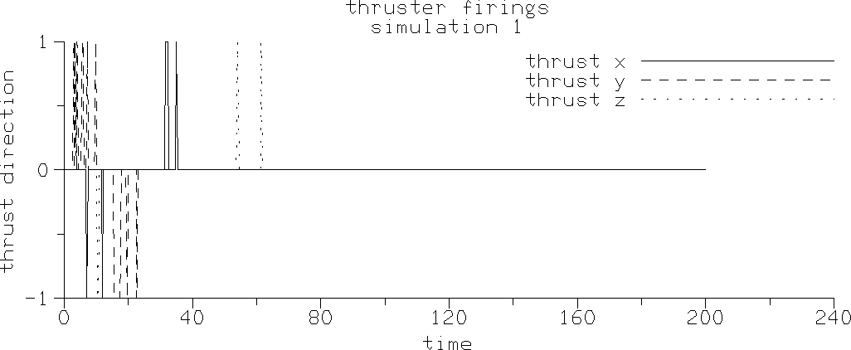
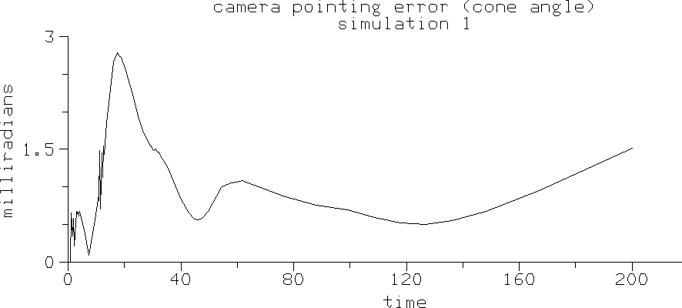

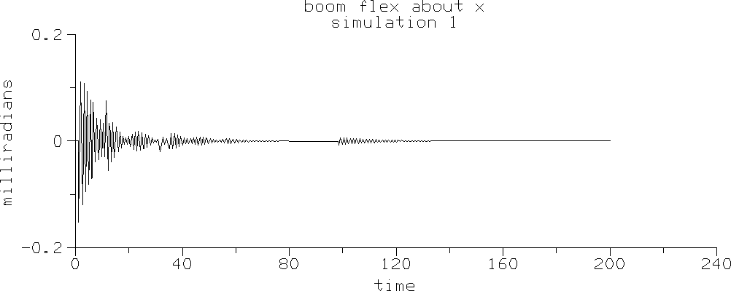

Continue Run
as a Control Study

T3.2.2 Exercise 2: Base Simulation: Steady Pointing with Scanner Off
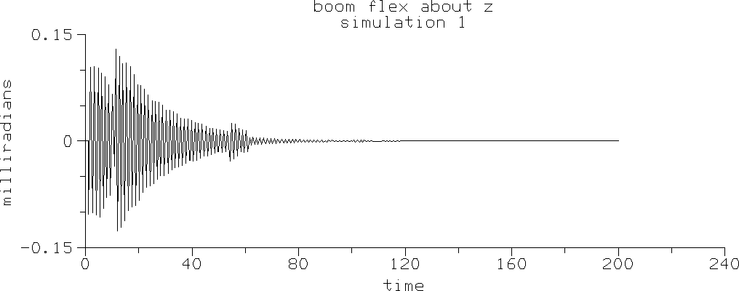
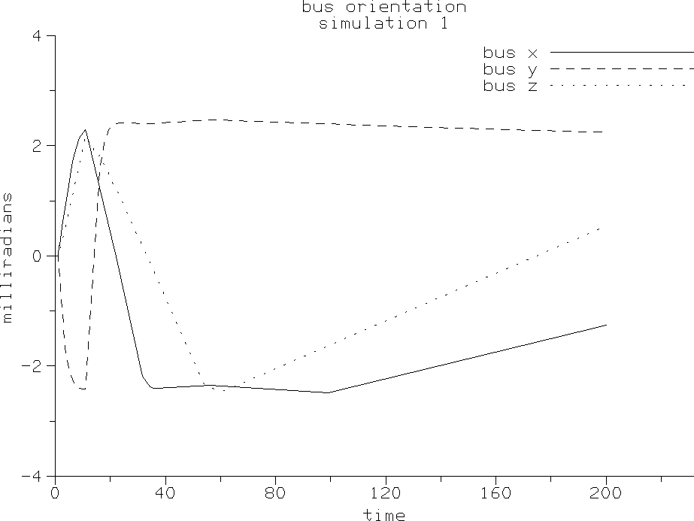
Next we simply allow the steady pointing to continue with the scanner off.
c===================================================================
c ANALYSIS #2: continue run with scanner locked as a control study. c===================================================================
c After finishing the slew, the camera is supposed to remain still in c inertial space, with its bore sight at AZCMD and ELCMD in the
c ‘celestial sphere’. Now as a control, we’ll observe the pointing c accuracy with the scanner off, continuing the above simulation.

nout = 1000
nbtw = 1
call simulate(2,nout,nbtw,dt,tol,scan,t,y)

Plots of the simulation show that the flex boom finally damps out, and the bus attitude is kept within the desired 2.5 milliradian deadband.

Figure T3-5 Exercise 2 Results

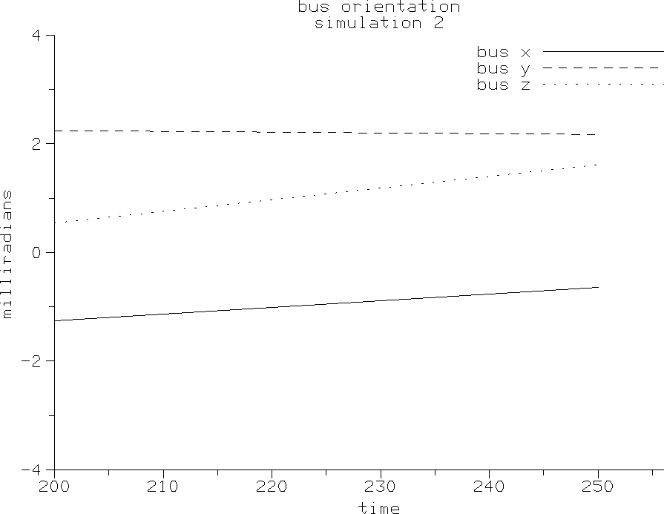
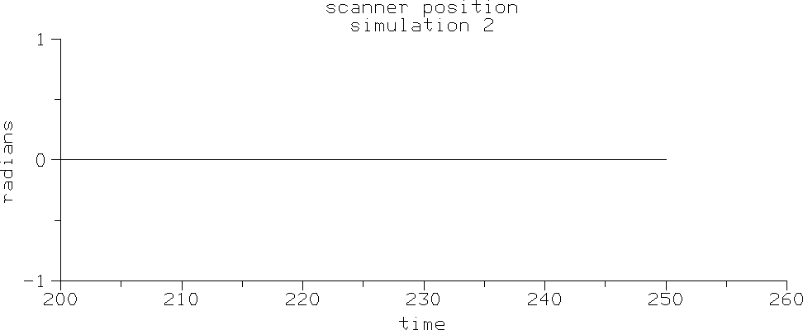
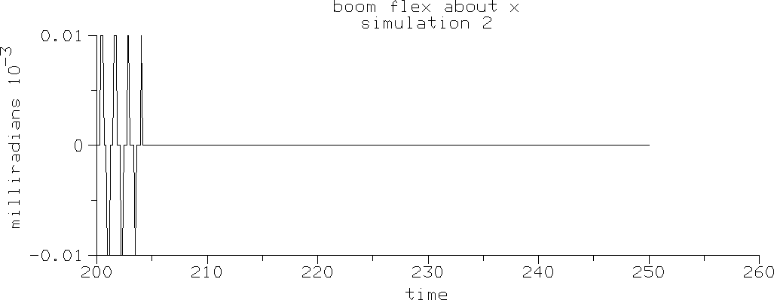

Turn Scanner On

Reset Simulation to End of Sim 1

Run with Scanner On

T3.2.3 Exercise 3: Steady Pointing with Scanner Turned On
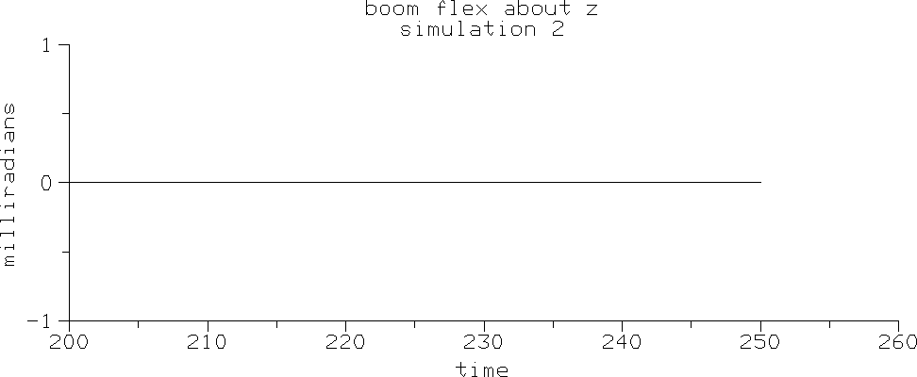
Next we restart the steady pointing of Exercise 2, but this time with the scanner on.
c===================================================================
c ANALYSIS #3: simulate effect of scanner on camera pointing error. c===================================================================
c We will enable the scanner and observe its effect on camera pointing c accuracy. (Scanner motion is defined in subroutine motions() as a c sinusoid beginning at tscan.)
scan = 1

c Put state back to the end of the first analysis. do 44 i=1, NEQ
44 y(i) = savey(i)
y( SDINDX(SCANNER,1)) = 0d0 y(NQ+SDINDX(SCANNER,1)) = scanrt
t = tscan
call simulate(3,nout,nbtw,dt,tol,scan,t,y)

The simulation results show that the scanner causes a steady vibration in the flexible boom and some thruster firings.

Figure T3-6 Exercise 3 Results
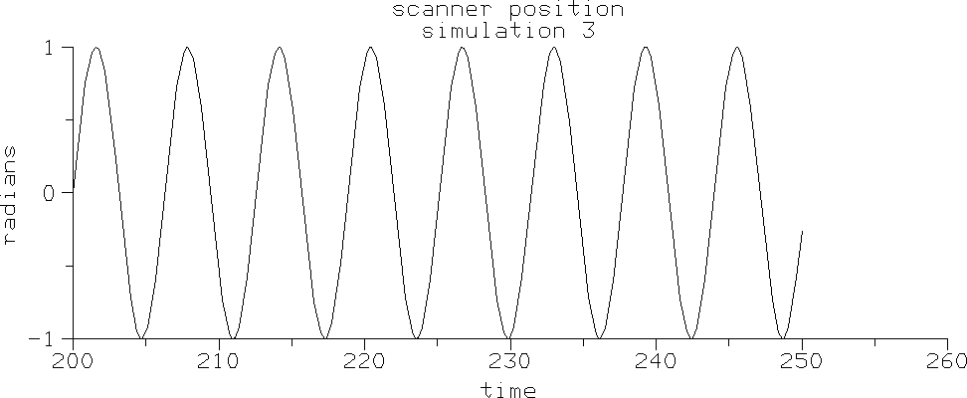
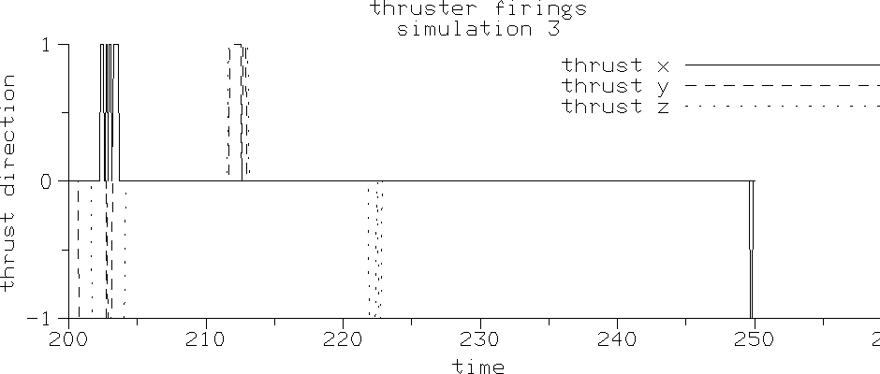

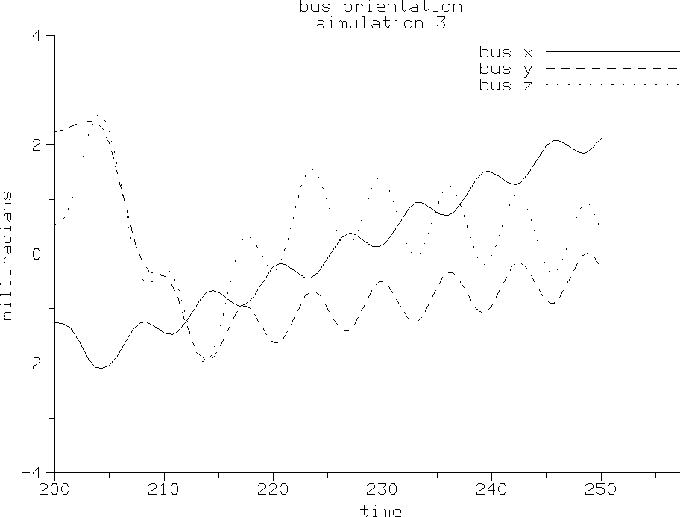
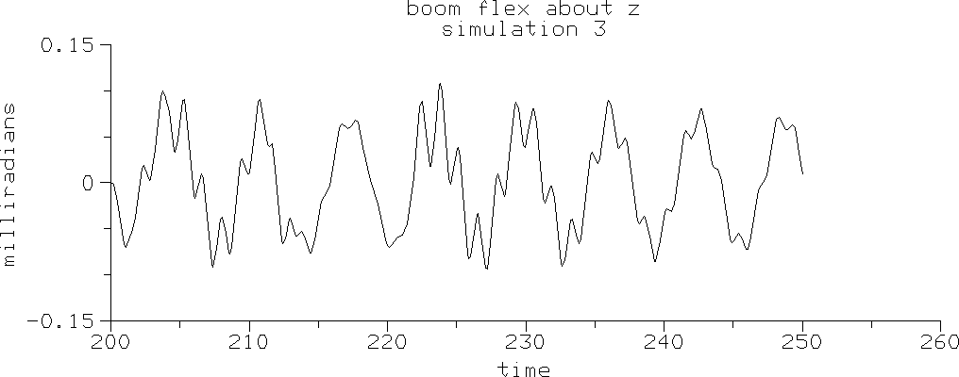
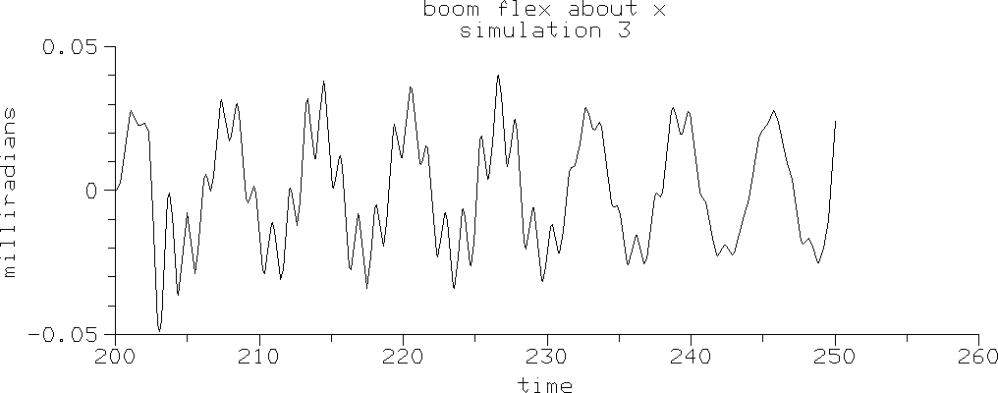
T3.2.4 Exercise 4: Steady Pointing with Scanner In Different Location
A very powerful feature of SD/FAST is the ability to leave some of the model parame-ters as variables in the simulation so that the user can change the physical model without having to rerun SD/FAST, re-compile, and re-link. In the fourth exercise, we perform a design study by changing the location of the scanner hinge location in the camera by us-ing the SDITJ() routine (to modify the Inboard To Joint vector), and rerun the third analysis. In this case, we want to move the scanner along the y-axis of the camera body.
c=================================================================
c ANALYSIS #4: repeat #3 but with different location for scanner. c=================================================================

Change Scanner Location. Note
SDINIT was called again because we changed
a system parameter
write(6,*) ‘Changing geometry.’ camscan(2) = -.2d0
call SDITJ(SCANNER,camscan) call SDINIT

Reset Simulation to End of Sim 1

Run with Scanner in Different Location
c Put state back to the end of the first analysis. do 60 i=1, NEQ
60 y(i) = savey(i)
y( SDINDX(SCANNER,1)) = 0d0 y(NQ+SDINDX(SCANNER,1)) = scanrt
t = tscan
call simulate(4,nout,nbtw,dt,tol,scan,t,y) call SDPRINTERR(6)
end

The simulation plots show qualitatively similar behavior to Exercise 3.

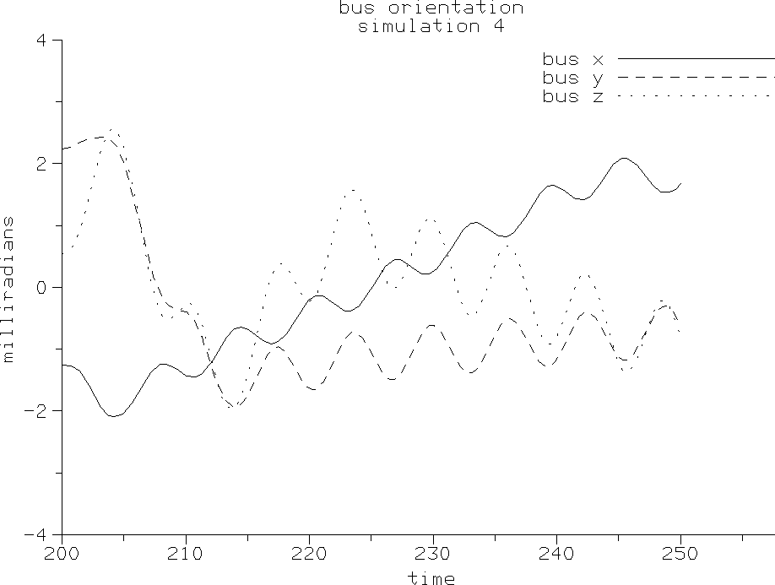
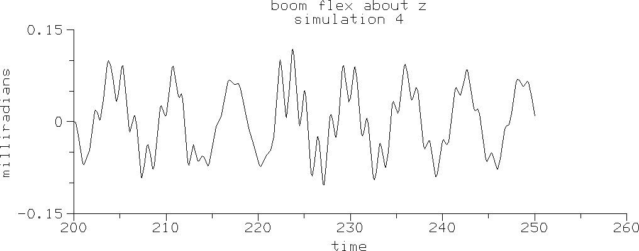
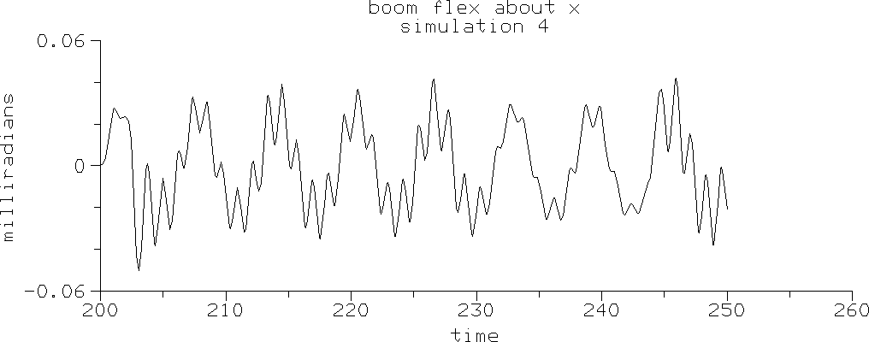

Figure T3-7 Exercise 4 Results
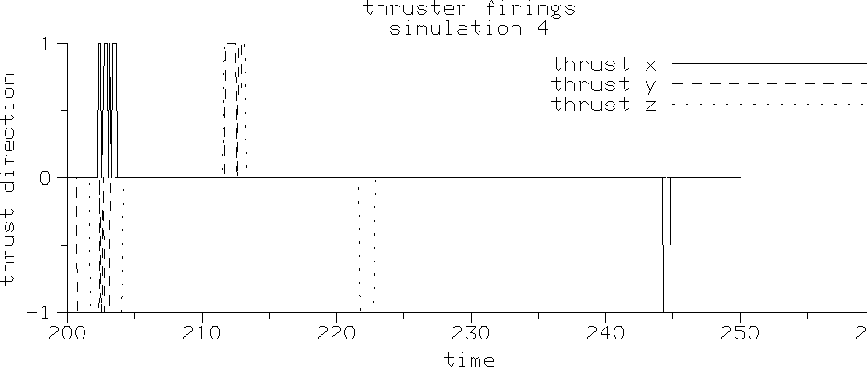

Finally, the camera pointing error is plotted for the last three simulations to show the rel-ative performance of the scanner off, then on in two different locations.
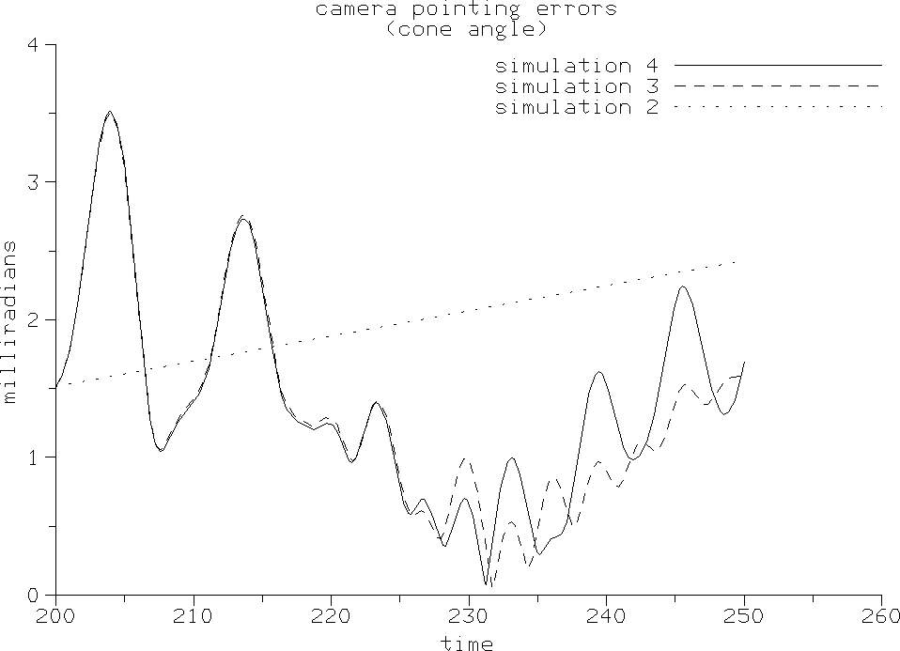

In the rest of this Tutorial, we shall describe in detail how we modeled the prescribed motion of the scanner, the flexible boom, the spacecraft control system with sensors and actuators, and the use of Generalized Analysis Routines to integrate user states. Finally the simulate() routine that ties all these models together for easy use by the main program is discussed.

T3.3 Prescribed Motion
Prescribing the motion of a mechanism (or just part of a mechanism) simply means im-posing a time history of position, velocity, and acceleration on one or more joint axes, regardless of the effects of any other forces or torques applied to the system. Prescribed motion is useful in primarily two cases: (1) driving a system with known motion to ob-tain the “inverse dynamics” solution, i.e., you want to determine the forces and torques required to cause a desired motion of the system, and (2) easily modeling a part of the system under high-bandwidth control compared to the rest of the system, e.g., a small scanning mirror driven at high frequency compared to the natural frequencies of the rest of the system2. We are using prescribed motion for the latter reason in this problem.
Note that SD/FAST does not restrict mixing prescribed motion with natural motion, i.e., a simulation can contain both “forward dynamics” and “inverse dynamics.” Other ex-amples of using prescribed motion include modeling high-speed momentum wheels in a spacecraft, and driving input shafts to machines.

In summary, the motion of a joint axis can be either calculated by SD/FAST as a func-tion of the current system state and the forces acting on the system, or the motion can be

- Note, however, that using prescribed motion on a sub-assembly of the system makes the dy-namic coupling one-way. For example, the motion of the high-speed scanner may affect the natu-ral motion of the spacecraft to which it is attached, but no possible motion of the spacecraft can affect the scanner motion relative to the camera body.

prescribed, usually as a function of time but in general as a function of time and some system states. When the motion is prescribed, SD/FAST calculates the actuator force or torque which would be required at that axis to produce the desired motion. Prescribed motion is discussed in detail in the reference, Section R14, which also explains how to turn prescribed motion on and off at runtime.

Key Idea

T3.3.1 Analytic Model
For prescribed motion to work best, position, velocity, and acceleration of the joint axis must all be specified and must be compatible3, i.e., the equation used to specify velocity must exactly be the derivative of the equation used to specify the position, and accelera-tion is exactly the derivative of velocity. Likewise, velocity must be the integral of ac-celeration and position must be the integral of velocity. The three prescribed motion routines used to specify the joint axis prescribed motion are SDPRESPOS() for posi-tion, SDPRESVEL() for velocity, and SDPRESACC() for acceleration. Generally, all specifications of prescribed motion should be grouped together in the user-written rou-tine (commonly called sdumotion()), just as forces are grouped in sduforce(). See Section R15.3.2 for information on writing the sdumotion() routine.
For the spacecraft example, the scanner is either locked (prescribed to be zero) or scan-ning with a sinusoidal motion. The equations for prescribed sinusoidal position P, ve-locity V, and acceleration A are:

P = sin (ω(t – tscan ))
V = ω cos (ω(t – tscan ))

A = –ω2 cos (ω(t – tscan ))
(T3.1)

(T3.2)

(T3.3)

where tscan is the time at which the scanner is turned on.

T3.3.2 motions() Routine
The user-written code to implement this prescribed motion for the spacecraft scanner is in the routine motions() in the file slew.f. Note that we would have named this routine sdumotion() if we wanted to use the Simplified Analysis Routines. Howev-er, in this case we are writing our own analysis driver so the name doesn’t matter.
c motions c
c Prescribe the scanner motion. If ‘scan’ is zero, set the c motion to 0 (i.e., locked). Otherwise, prescribe it to
c follow a sinusoidal motion with frequency w=scanrt radians c per second.

- Using some integration methods, specifying all prescribed motions is optional. However, we strongly recommend that all three are specified and are compatible to maintain stability of the in-tegration process, and to detect errors. See Section R14.

subroutine motions(t,q,u) integer NQ,NU,SCANNER
parameter (NQ=12, NU=11, SCANNER=5)
real*8 t,q(NQ),u(NU),w,tscan,scanrt integer scan
common /scanner/tscan,scanrt,scan

Prescribed Motion for Locked Scanner

Prescribed Motion for Moving Scanner
w = scanrt
if (scan .eq. 0) then
call SDPRESPOS(SCANNER,1,0d0) call SDPRESVEL(SCANNER,1,0d0) call SDPRESACC(SCANNER,1,0d0)
else
call SDPRESPOS(SCANNER,1, sin(w*(t-tscan))) call SDPRESVEL(SCANNER,1, w*cos(w*(t-tscan))) call SDPRESACC(SCANNER,1, -w*w*sin(w*(t-tscan)))
end if

return end

Notice that the information from slew_info was used to set integer variables NQ, NU, and SCANNER to the correct values for dimensioning the state vectors and joint num-bers. Each call to SDPRESPOS(), SDPRESVEL(), and SDPRESACC() takes the joint number (SCANNER=5), the axis (1 in this case for a pin joint), and the prescribed values to be passed. scan is a flag defined elsewhere and used to switch the scanner on and off for different analyses. Real variable tscan is the time at which the scanner joint position is zero and scanrt is the user-defined scan rate of the scanner mirror.

T3.4 Flexible Body Model
To model flexible bodies in SD/FAST, the body must be broken into rigid bodies con-nected by joints with spring (and possibly damper) torques at the joint axes. Correctly dividing a body and finding joint locations, and spring and damping constants can be very difficult, especially if you want to match several mode shapes and their frequen-cies. This area is usually reserved for the expert structural analyst.

T3.4.1 Simple Model for a Uniform Beam
In the case of bending in two orthogonal directions for a simple uniform beam, one pos-sible model is to divide the beam into “n” equal length segments connected by U-joints.
Using a simple static deflection model for the segment of length l with a stiffness EI (I may be different in the two orthogonal directions), the torsional spring constant is found to be K = 3EI / l. Note that even if you use 10 or more segments, only the first
two or three mode shapes and frequencies will be even close to being correct. Damping is usually kept small to cover worst case vibrations. Figure T3-8 summarizes this mod-el.

Figure T3-8 A Multi-Rigid-Body Model of a Uniform Flexible Beam

12 l
Stiffness: EI

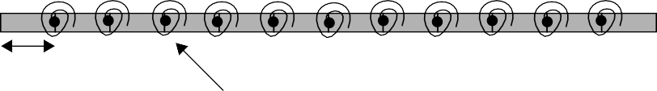
l
Each Joint Axis has a Torsional Spring with a Spring Constant of K = 3 EI / l









T3.4.2 Spacecraft Flexible Beam
For our case, only the first mode and its frequency are of interest. Thus a single beam element is sufficient. The spring constant and damping constant for a single U-joint be-tween the beam and the bus were determined in a manner similar to above. The routine boomflex below implements this simple model and will be called by forces().
c boomflex c
c This routine models the first cantilever mode of the boom, c using empirically derived stiffness and damping constants.

subroutine boomflex(q,u) real*8 q(*),u(*),k,b,torq integer BOOM,SDINDX parameter (BOOM=4)
data k,b/2000d0,10d0/

Spring & Damping Model for Both Axes
torq = - (k*q(SDINDX(BOOM,1)) + b*u(SDINDX(BOOM,1)))
call SDHINGET(BOOM,1,torq)
torq = - (k*q(SDINDX(BOOM,2)) + b*u(SDINDX(BOOM,2)))
call SDHINGET(BOOM,2,torq) return
end

Again, note that the integer variable BOOM is set to the body number 4 (same as the joint number for non-loop joints) to improve readability. The SD/FAST utility routine SDINDX() is used to find the correct q and u locations in the state vectors. You could

have used the numbers directly from the State Index to Joint/Axis Map, but again, the use of SDINDX() is recommended to enhance maintainability and clarity. The routine SDHINGET() is used to apply the computed hinge torques.

T3.5 Control Systems
Control systems are a common component of many vehicles and machines, from motor velocity regulators to spacecraft attitude controllers. Control systems usually consist of three parts: (1) one or more sensors to measure some states of the system, (2) a control algorithm that may contain internal states, and (3) one or more actuators that apply loads to the system to cause it to behave in a desired manner. SD/FAST provides utili-ties to help the user model these sensors, control algorithms, and actuators.

In this section, we will discuss the gyro and camera sensor models used in the space-craft, the thruster model, the camera actuator model, and the force() routine that ties them all together.

T3.5.1 Sensor Models
The sensor() routine models the camera azimuth and elevation angle sensors, the gyro sensing of the bus attitude and attitude rates, and the logic used to compute the de-viation in these quantities from their desired values. The inputs are the q and u state vectors, and the desired (commanded) azimuth azcmd and elevation elcmd of the camera. The attitude and attitude rates are always desired to be zero in this study, so are not inputs. The outputs are the azimuth error azerr, the azimuth rate error azerrt (deviation from desired zero), the elevation error elerr, the elevation error rate elerrt (deviation from desired zero), and a combined attitude/attitude rate error sig-nal err for the 1-2-3 Euler angles describing the bus attitude. After the subroutine set-up:
c sensor c
c The sensed quantities are camera az and el positions and c rates, base body attitude error and error rate
c (123 Euler Angles).

subroutine sensor(q,u,azcmd,elcmd,
& azerr,azerrt,elerr,elerrt,err) real*8 q(*),u(*),azcmd,elcmd,azerr,azerrt,elerr,elerrt real*8 atterr(3),raterr(3),dc(3,3),err(3),gyro
integer BUS,CLOCK,CAMERA,SDINDX,i parameter (BUS=1,CLOCK=2,CAMERA=3)
data gyro/2d0/

Position and Rate Errors for Camera
the azimuth and elevation position and rate errors are computed using the current and commanded states of the camera angles:
azerr = azcmd - q(SDINDX(CLOCK,1)) elerr = elcmd - q(SDINDX(CAMERA,1)) azerrt = -u(SDINDX(CLOCK,1))
elerrt = -u(SDINDX(CAMERA,1))

Get Spacecraft Attitude Error

Get Spacecraft Rate Error

Compute Gyro Error Signals
The SD/FAST utility SDORIENT() is used to obtain the 3x3 direction cosine matrix
dc for the bus attitude. The SD/FAST utility SDDC2ANG() is used to convert dc to
1-2-3 Euler angles, atterr (it’s also the error since 0,0,0 are the desired Euler angles).
c Convert bus attitude to 1-2-3 Euler angles. call SDORIENT(BUS, dc)
call SDDC2ANG(dc,atterr(1),atterr(2),atterr(3))

The bus inertial angular rate is obtained using the utility SDANGVEL() and the attitude position and rate errors are combined (gyro is a scale factor on the rate error) to gener-ate an overall attitude error signal err.
c Get bus inertial angular velocity (in the bus frame). call SDANGVEL(BUS,raterr)

c The deadband logic mixes pos and vel errors for each axis. do 10 i = 1,3
10 err(i) = gyro*raterr(i) + atterr(i)

return end

T3.5.2 Thruster Model
The thrusters apply body-fixed torques about any of the spacecraft’s three axes. Howev-er, the thrusters must remain on for a minimum length of time tmin. The thrust() routine provides the logic to provide a delay of at least tmin seconds in turning the thrusters off when the combined attitude/attitude rate error signal error falls within the acceptable deadband dband for a particular axis. The actual application of the thrust is handled in the next routine, actuator().
c thrust c
c Thruster model. Each thruster can fire in the positive or c negative direction. If the error is large enough to
c trigger a thruster firing, the thruster must remain on for c a minimum amount of time. This routine can cause problems c for variable step integrators because of the ‘memory’
c built into the routine.

real*8 function thrust(t,axis,error) real*8 t,error,dband,tmin,fire(3),toff(3) integer axis
data dband,tmin /0.0025d0, 0.02d0/ data fire,toff /3*0d0,3*0d0/

Fire Thrusters
if Exceed Deadband
if (error .lt. -dband) then fire(axis) = 1d0 toff(axis) = t + tmin
else if (error .gt. dband) then fire(axis) = -1d0 toff(axis) = t + tmin
else if (t .ge. toff(axis)) then fire(axis) = 0d0
end if

thrust = fire(axis) end

Note that the direction of the thrust is handled by the side of the deadband that the error lies on, and toff is used to enforce the minimum off-delay.

T3.5.3 Camera Pointing Controller
The routine actuator() handles the camera motor control and the actual application of the body-fixed thruster torques. After the routine setup code:
c actuator c
c This routine applies the forces and torques acting on the c spacecraft, as a function of the passed-in errors.

subroutine actuator(t,azerr,azerrt,elerr,elerrt,err) real*8 t,azerr,elerr,err(3),azerrt,elerrt
real*8 torq(3),thrust,k1,k2,b1,b2,l(3) integer BUS,CLOCK,CAMERA,axis parameter (BUS=1,CLOCK=2,CAMERA=3)
data k1,k2,b1,b2/2*3500d0,2*20d0/ data l/0.23d0,0.21d0,0.31d0/

Proportional-Derivative Camera Controller

Apply Body Torques From Thruster Pulses
the camera motor control torques are applied to the camera using the SD/FAST SDHINGET() routine. Note that the controller consists of two independent Propor-tional-Derivative (PD) control laws:
c The camera controller just uses rate and position error c feedback.
call SDHINGET(CLOCK,1, k1*azerr + b1*azerrt) call SDHINGET(CAMERA,1, k2*elerr + b2*elerrt)

The body-fixed torques are applied using the SD/FAST SDBODYT() routine:
c Compute base body torques from model of thrusters and their c controller, expressed in base body frame.

do 10 axis = 1,3
10 torq(axis) = l(axis)*thrust(t,axis,err(axis)) call SDBODYT(BUS,torq)

return end

The user-written thrust() routine conveniently enforces the minimum off-delay for each of the three spacecraft axes.

T3.5.4 forces() Routine
The user-written forces() routine simply calls all the sensor and actuator routines in the proper order, along with the flexible boom model. Note that we would have named the routine sduforce() if we wanted to use the Simplified Analysis Routines. How-ever, in this case, we are writing our own analysis driver routines so the name doesn’t matter.
c forces c
c This subroutine takes time, the system state, and the camera c azimuth and elevation commands as inputs. These are used to c generate sensor outputs which are then passed to the
c actuator routine. Bending of the flexible boom is handled c in a separate subroutine.

subroutine forces(t,q,u,az,el) real*8 t,q(*),u(*),az,el
real*8 azerr,azerrt,elerr,elerrt,buserr(3)

Read Sensors

Apply Camera & Thruster Torques

Flex Boom Forces
c Sense errors in camera and base body orientations and rates. call sensor(q,u,az,el,azerr,azerrt,elerr,elerrt,buserr)

c Apply control forces to reduce the sensed errors.
call actuator(t,azerr,azerrt,elerr,elerrt,buserr)

c Apply forces to model boom flexibility. call boomflex(q,u)

return end

T3.6 Using General Analysis Routines
To integrate the equations of motion supplied by SD/FAST, or to perform other types of analyses, the user has three options:
- Use the Simplified Analysis Routines (See Simplified Analysis Routines on page R-98) if your problem can be solved using these easy-to-use routines provided by SD/FAST. This is the easiest approach.
- Use the General Analysis Routines (See General Analysis Routines on page R-34) if your problem can’t be solved using the Simplified Analysis Routines, such as if you have additional states which must be integrated (like the command rates in this prob-lem), or need the services of a nonlinear root finder.
- Use your own simulation environment, such as ACSL, Easy 5, System Build with Matrix-X, Simulink, or a proprietary tool.

The Simplified Analysis Routines are discussed in Tutorials 1, 2, and 4. We shall use the General Analysis Routines in this Tutorial. The General Analysis Routines consist of two integrators: one a variable-step, the other a fixed-step; and a nonlinear root finder. For this problem, we shall use the fixed-step integrator, SDFINTEG(), a 4th order Runge-Kutta integrator with a Merson error estimator. We used the fixed-step integrator because the thruster model we wrote used off-delay time “memory” that a variable-step integrator would cause to malfunction.

Rather than simply passing the numerical derivatives to be integrated, like we did when using SDMOTION() (See page R-42), we must write the derivative routine ourselves. Here we show the deriv() routine for the slewing spacecraft problem. deriv() must be declared external in the main program. This first section of code is the set-up. Note the two additional states for the command rates, az and el are indexed by in-tegers AZCMD and ELCMD to be tacked to the end of the state() and dstate() arrays:
c deriv c
c Compute state derivatives. We’ll return with non-zero
c status if a constraint error is larger than a particular
c tolerance. The tolerance is passed in param(1). (In this c problem, the only constraint is the prescribed motion on
c the scanner.)

Deriv() Routine for Integrating SD and User States
subroutine deriv(time,state,dstate,param,status) integer NQ,NU,NC,AZCMD,ELCMD
parameter (NQ=12,NU=11,NC=1,AZCMD=NQ+NU+1,ELCMD=AZCMD+1)
real*8 time,state(*),dstate(*),param(1),errs(NC) real*8 slwstrt,slwstp,azrate,elrate
common /slewparm/slwstrt,slwstp,azrate,elrate integer status,i

Next we assign the command rate states to their positions in the state vector, call SDSTATE() to supply the current states to SD/FAST (SDSTATE() will not affect the user states), call forces() and motions() to compute and apply the current forces and prescribed motions, and finally call SDDERIV() to compute the SD/FAST deriva-tives. Note that the state(1) through state(NQ) are the SD/FAST q’s, state(NQ+1) through state(NQ+NU) are the SD/FAST u’s, and state(NQ+NU+1) and state(NQ+NU+2) (that is, state(AZCMD) and state(ELCMD)) are the two user states.
call SDSTATE(time,state,state(NQ+1))
call forces(time,state,state(NQ+1),state(AZCMD),state(ELCMD)) call motions(time,state,state(NQ+1))
call SDDERIV(dstate,dstate(NQ+1))

Next we compute the state derivatives for the two user states:
c Determine the currently commanded rate for the clock and
c camera motors. This rate is a constant during the slewing c maneuver, and zero otherwise.

Compute User State Derivatives

Constraint Error Checking
(Should be done by User when using Generalized Analysis Routines.)
if ((time .ge. slwstrt) .and. (time .lt. slwstp)) then dstate(AZCMD) = azrate
dstate(ELCMD) = elrate
else
dstate(AZCMD) = 0.0D0 dstate(ELCMD) = 0.0D0
end if

We also should check for velocity and position constraint errors. The tolerance is passed through the available PARAM array. If the constraints are violated, status=1 is returned.
c Check that constraint errors are below tol. status = 1
call SDVERR(errs) do 10 i=1,NC
10 if (abs(errs(i)) .gt. param(1)) return call SDPERR(errs)
do 20 i=1,NC
20 if (abs(errs(i)) .gt. param(1)) return status = 0
return end

The routine simulate() organizes one simulation and is called for each desired run. simulate() makes calls to deriv() using the fixed-step integrator SDFINTEG() where each element in the call is explained on page R-37.
c simulate c
c Run a simulation of the spacecraft to produce nout data points
c beginning at time t and separated by (nbtw*dt) seconds. Complain if c the integration error or a constraint error exceeds tol. Output all c the interesting data. Set scan nonzero to enable the scanner.
c Output goes to file 10+<simulation number>, i.e., fort.11, fort.12, c fort.13, or fort.14.
c

Initialize
subroutine simulate(n,nout,nbtw,dt,tol,scan,t,y) integer NQ,NU,NEQ,AZCMD,ELCMD,BUS,BOOM,SCANNER
parameter (NQ=12,NU=11,AZCMD=NQ+NU+1,ELCMD=AZCMD+1,NEQ=NQ+NU+2) parameter (BUS=1,BOOM=4,SCANNER=5)
integer i,j,n,nout,nbtw,scan,err,SDINDX
real*8 dt,tol,t,y(NEQ),param(1),dy(NEQ),cone,ori(3),dc(3,3) real*8 est,work(4*NEQ),fire(3)
common /firing/ fire

Generate Headings

Compute Initial Derivatives

Extract Output

Integrate Between Print Intervals Using
Fixed-Step Kutta-Merson
write(6,*)’Simulation #’,n,’ for ’,dt*nout*nbtw, & ’ seconds from t=’,t
if (scan .ne. 0) write(6,*)’Scanner is on.’ if (scan .eq. 0) write(6,*)’Scanner is off.’

c Supply the tolerance for the prescribed motion constraint. param(1) = tol

c Integrator requires correct derivatives passed in dy --c evaluate now.
call deriv(t,y,dy,param,err)

c Integrate and write out data. Note that bus orientation is 1-2-3 c Euler angles (millirad) rather than Euler parameters.

do 20 i = 1,nout+1
call SDORIENT(BUS,dc)
call SDDC2ANG(dc, ori(1), ori(2), ori(3)) call pointerr(y(AZCMD),y(ELCMD),cone)

write(10+n,30) t, ori(1)*1000., ori(2)*1000., ori(3)*1000., & y(SDINDX(SCANNER,1)), y(SDINDX(BOOM,1))*1000.,
& y(SDINDX(BOOM,2))*1000., fire(1), fire(2), fire(3), cone

if (i .le. nout) then do 10 j = 1,nbtw
call SDFINTEG(deriv,t,y,dy,param,dt,NEQ,work,est,err) if ((err .ne. 0) .or. (est .gt. tol)) then
print *,’at time=’,t,’ err=’,err,’ errest=’,est end if
10 continue
end if
20 continue
30 format(10f10.5) end

The pointerr() routine called above computes the camera pointing error:
c To compute pointing accuracy, just reading the gimbal angle
c errors is insufficient since it does not take into account base c body pointing error. If the system is in its reference
c configuration, the correct camera pointing vector v is given by c first rotating the camera about the clock z-axis, followed by a c rotation about the camera -x axis. Expressed in the inertial
c frame this is:
c
c v = [ -sin(az)*cos(el) cos(az)*cos(el) -sin(el) ] c
c The pointing error can be found by transforming the actual camera c bore sight into the inertial frame, dot multiplying with v to
c obtain the cosine of the cone angle, and then using acos. c The cone angle is reported in milliradians.
subroutine pointerr(az,el,cone)
real*8 az,el,cone,v(3),bore(3),boreg(3),c integer CAMERA,GROUND
parameter (GROUND=0,CAMERA=3)

Compute Bore sight Pointing Error
c This is the orientation of the bore sight in the camera’s c local frame.
data bore/0d0,1d0,0d0/
v(1) = -sin(az)*cos(el) v(2) = cos(az)*cos(el) v(3) = -sin(el)
call SDTRANS(CAMERA,bore,GROUND,boreg)
c = boreg(1)*v(1) + boreg(2)*v(2) + boreg(3)*v(3) cone = acos(c)*1000d0
end
Summary

- This tutorial covered an example of using SD/FAST for a complex open-loop topo-logical system with prescribed motion, flexible body dynamics, a control system, in-tegration of user-defined states using General Analysis Routines, and design study capability.
- The roadmaps in the “_info” file are essential to use the SD/FAST routines cor-rectly.
- Prescribed motion can be enforced on any hinge axis, and turned on and off if the position and velocity states are continuous. Compatible position, velocity, and ac-celeration time histories must be supplied.
- Flexible-body dynamics can be approximated in SD/FAST by using lumped mass-spring models, but the correct geometry, masses, and spring constants must be sup-plied by the user.
- Control systems and other models requiring the integration of user-defined states re-quire the usage of General Analysis Routines or a user-supplied integrator.
- Physical model parameters, such as hinge locations and body masses can be left as variables in the SD/FAST routines to allow studies of system performance versus de-sign changes.
- Several generated routines were introduced including: (1) user-written prescribed motion routines SDPRESPOS(), SDPRESVEL(), SDPRESACC() specifying pre-scribed position, velocity and acceleration; (2) specifying the location of state vari-ables in the state vector using SDINDX(); (3) obtaining information about a free-flying body (SDORIENT(), SDDC2ANG(), SDANGVEL()); (4) applying body torques (SDBODYT()); and (5) General Analysis Routine for fixed-step integration (SDFINTEG()).

TUTORIAL 4 Quick-Return Mechanism

  - Discuss special considerations for modeling and analyzing closed-loop systems.
  - Develop and assemble the model of a quick-return mechanism.
Objectives
  - Run a suite of typical mechanism analyses on the quick-return mechanism.


T4.1 Introduction to Closed-Loop Systems
Tool
This tutorial will take you through an example of a simple, but useful closed-loop sys-tem: a quick-return mechanism. This particular quick-return mechanism is used to cut a workpiece by applying a shaping tool rigidly mounted on the horizontal sliding body. The tool slides along a horizontal axis as the workpiece is engaged. At the end of the working stroke, the tool quickly retracts back to the starting position, ready to repeat the cycle. A motor turning the crank at the joint in the center drives the mechanism.

Systems with closed-loop topology are one instance of constrained mechanical systems. SD/FAST can handle closed loops automatically and provides the tools needed for the user to specify more general constraints, including non-holonomic constraints. We will only consider closed-loop systems in this tutorial. More general constraints are covered in Reference Section R24 of this manual and in Application Notes.

In Section T4.1, we discuss closed-loop mechanical systems in general and specifically how SD/FAST models closed-loop systems. In Section T4.2 and Section T4.3, we will run through the model development and several analyses of a quick-return mechanism.

The necessary computer files for this example can be found by looking in the “tutorials” subdirectory of the SD/FAST distribution directory for all the files called:
quickret*

where “*” stands for a suffix indicating the various SD/FAST-generated or user-gener-ated files. Please see the Release Notes for your system to determine the recommended character extensions and suffixes. This tutorial will use character extensions and prefix-es for a simulation developed in Fortran on a UNIX-based Sun Workstation.

T4.1.1 Comparison to Open-Loop Systems
Closed-loop systems such as mechanisms, that is, chains of bodies connected into one or more ringlike structures, usually are quite different from open-loop systems such as spacecraft or robotic manipulators. Open-loop systems are typically characterized by a large number of degrees of freedom for providing general position and orientation, while closed-loop systems characterizing mechanisms have only one or a few degrees of freedom, so the motion is highly constrained. SD/FAST is designed to favorably handle these highly-constrained closed-loop systems as well as the open-loop systems.

Open-loop systems generally move in all three dimensions, whereas many closed-loop mechanisms are characterized by all motion constrained to lie in a plane—perhaps be-cause of limitations of available synthesis and analysis tools for mechanism designers. However, SD/FAST is capable of easily handling analyses in full three dimensions as well as two.

The objectives of mechanism designers can be different from those for designers of open-loop systems such as spacecraft. Whereas spacecraft or robot designers may be interested in achievable pointing accuracy and stability, the mechanisms designer is con-cerned with function and path generation for the output body of the mechanism, power transmission and conversion, mechanical advantage, static and dynamic balancing, bearing reactions, etc. All these analysis capabilities, and more, are available in
SD/FAST.

Cut Here

T4.1.2 How SD/FAST Models Closed-Loop Systems
The equations of motion underlying SD/FAST directly represent open-loop chains. The capability for analyzing closed-loop systems is achieved by adding loop joints that con-nect open-loop chains together. Additionally, tools for assembling these “broken loops” into the final closed-loop system are provided that eliminate any need for the user to compute complex geometrical relationships or compatible velocities of the bodies.

Thus the user can enter the system as a set of “parts” laid out for easy entry of geometry and mass properties, and SD/FAST will assemble these parts into the final system with compatible velocities. The additional tasks in using SD/FAST to model closed-loop systems are to (1) define loop joints, (2) perform an assembly analysis, if needed, and
Or Here
(3) perform a velocity analysis, if needed.

Loop Joints
When modeling a closed-loop system with SD/FAST, the model must be divided into one or more open-loop topological “tree” systems and a set of “loop joints” which pro-duce closed loops in the topology. This is done by identifying loops in the system topol-ogy and making one cut” in each loop. Although any joint in the loop may be cut, it is most efficient to cut at the joint with the most degrees of freedom since that produces the least number of constraints. It is also good to minimize the maximum length of any

chain of bodies in the system, so cutting a loop in the middle is generally better than cut-ting it at either end.

You can also cut inside a body and re-form the loop by placing a weld joint between the two pieces. This has advantages in terms of uniform treatment of all joints. However, no DOFs are removed and weld joint adds 6 constraints, so this method is computation-ally more expensive. Note that the easiest way to “cut” a body is to replace it with two identical bodies, each with one-half the density of the original body and occupying the same space when assembled. The weld joint is simply placed at the center of mass.

If the reference configuration is input such that all the loop joints are already assembled, then the loop joint specifications are exactly like those for joints in the tree system. Oth-erwise, some additional vectors can be specified to control the allowable assembled con-figurations and to define the zero positions for the loop joint coordinates (called “pseudo coordinates”). If these additional vectors are not specified, SD/FAST will choose de-faults. The body pin will be aligned with the final inboard pin, and the reference lines will be parallel.

There are a few minor restrictions that apply to loop joints which do not apply to tree joints. Please refer to Reference Section R11.1 for details.

Assembly Analysis
SD/FAST automatically supplies a routine (SDASSEMBLE()) to assemble loop joint constraints, enforce prescribed motion constraints, and enforce user-defined constraints (Section R24). All of these tasks are solved under the general approach called “assem-bly analysis,” perhaps more appropriately thought of as “initial constraint enforce-ment.” The most obvious use is assembling the various parts laid out into the final assembled system.

The user can also write functions to enforce many other types of initial constraints such as: positioning the ends of open loop chains (as in positioning the end of a robot), giving initial conditions otherwise difficult to find geometrically, orienting bodies with respect to the ground or other bodies, enforcing a specific distance between two points, etc. In fact, any number of functions of the coordinates can be imposed as “required” to be ab-solutely enforced or “desired” to be enforced in a “least-squares” minimization form af-ter the “requireds” are satisfied. Also these functions can be imposed just to generate an initial condition of the system, to impose constraints throughout an analysis, or to be ac-tivated at any time (turned on and off at will) during an analysis.

The SD/FAST assembly analysis routine attempts to find a set of hinge position q’s which meet all the position constraints so that the largest error in any one constraint is at or below a desired tolerance. The velocities (u’s) passed are ignored.

The analysis proceeds incrementally from the passed-in initial state to obtain the assem-bled system configuration. If there are any prescribed motion or user-defined con-straints in the problem, the SD/FAST assembly analysis routine will enforce those constraints as well. There is no guarantee that SD/FAST will find a solution even if there is one. If it fails, and you feel that there actually is a solution, you should provide SD/FAST with a better initial guess in the passed-in q’s.

Loop Joint

Poor Choice of Initial q’s
SDASSEMBLE()

Two Possible Branches in the Assembly of a
Crank-Rocker Mechanism
Note that the initial guess influences the configuration of the final assembled system. In particular, a different “branch” of the system than that desired may be found (multiple “branch” solutions may exist for some systems of connected bodies). Thus, you should make an initial rough guess to the final desired configuration.

Any particular joint can be “locked” at a desired q if a specific relative joint angle is de-sired. If the problem contains prescribed motion, it is a good idea to set the q to its cor-rect prescribed value for time t, and then lock that q to remove it from consideration during the analysis. If you start a q a long distance from its correct prescribed value, it may slow convergence or even prevent a solution from being found.

Velocity Analysis
Once the system is assembled to force the loop joints to coincide in space, velocities of the bodies must be computed to allow the system to remain assembled. Otherwise the system will “fly apart.” An SD/FAST routine (SDINITVEL()) is provided to find ini-tial u’s to satisfy loop closure velocities, prescribed velocity conditions, and user-de-fined velocity constraints. Every user-defined position constraint must have a user-defined velocity constraint.

The velocity analysis assumes that the position analysis is already done. That is, the q’s are not changed. The velocity analysis assures that the loop joint connect points have the same velocities (derivatives of the position constraints are zero). It also ensures that the relative angular velocity of the bodies connected by a loop joint lies along the joint axis, in the case of a pin joint for instance.

In a manner similar to locking hinge axes in the assembly analysis, locks are also used to set required hinge velocities (such as a motor or crank) which will then remain un-changed by the velocity analysis. Compatible velocities of other bodies are then com-puted. Unlike the assembly analysis, there is no concept of entering a “wrong branch” in the velocity analysis.

T4.1.3 Special Considerations for Constrained Mechanisms
This section discusses the special considerations that pertain only to constrained mecha-nisms such as those with closed loops. These considerations can cause problems for the unsuspecting mechanisms designer or analyst. However, most of the problems arising from these considerations can be avoided or mitigated by proper mechanism design in the first place.

Stabilization of Loop Joints
The equations of a constrained multibody system are a set of coupled differential and al-gebraic equations. If these are converted into a set of differential equations only (as is commonly done) the new equations will be subject to “drift” during a motion simula-tion. This drift is caused by the imperfect nature of numerical integration and will cause the original set of algebraic constraints to be violated as the integration proceeds. In that case, the numerical drift must be stabilized to prevent the constraint violations from becoming arbitrarily large (i.e., the mechanism literally “flies apart”).

SD/FAST automatically includes a stabilization method called Baumgarte Stabiliza-tion1 in the equations of motion and monitors constraint errors in SDMOTION().

Baumgarte Stabilization works roughly like a proportional-derivative (PD) control feed-back loop acting at the level of the accelerations. The user may choose two constants: the two feedback “gains” on the proportional (position) and derivative (velocity) loops. These constants must generally be chosen for the specific problem, with larger gains for higher-frequency problems. By default, the gains are zero so there is no stabilization. We suggest that you start with no stabilization and monitor constraint errors. If you must change these constants to effect stabilization or improve response to constraint er-rors, Baumgarte suggests that the position to velocity ratio be changed as a2:2a to maintain “critical damping.” For many mechanism problems, selecting a=1 is a good place to start if constraints are being violated during a simulation. See Section R4.2 for more detail on choosing stabilization constants.


In general, once the Baumgarte constants are large enough to stabilize the system, fur-ther increases reduce the position and velocity errors to just within the integration error tolerance, and no further. However, the speed of recovery from initial condition errors and impulsive changes to the system is increased with larger Baumgarte constants (sim-ilar to the way increasing the gains in a PD controller increases the frequency of the sec-ond-order error dynamics). However, larger Baumgarte constants introduce higher frequencies in the system which may slow down a variable-step integrator or destabilize a fixed-step integrator. Effect on CPU usage is variable with changes in Baumgarte con-stants. Some experimentation may be required to find good values to use.

Bifurcation

Bifurcation

A “bifurcation” in motion can occur when the system has two (or more) possible dis-tinct paths to take when moving through a configuration that momentarily increases the number of degrees of freedom in the system (i.e., some constraint becomes redundant, allowing a momentary increase in the degrees of freedom). A simple example is a four-bar mechanism with exactly equal length crank and rocker (a double-crank mechanism). If the system is allowed to move through the position where all links are aligned, the system can continue around as a parallelogram or bifurcate into an “X” shaped mecha-nism, with the chosen path bearing no relation to the physical parameters of the model.

In physical systems, bifurcations may never happen if there is joint slop or flexibility. However, since infinitely hard materials are used to model rigid bodies in SD/FAST, any sudden switch in the direction of motion is modeled as a perfectly elastic “collision” and entire chains of bodies will happily “bounce” back the other direction and proceed. In other words, bifurcations are perfectly correct behavior for these very rigid systems modeled by SD/FAST, but are not usually desirable behavior in physical systems one wants to model.

Bifurcation should never occur in a properly designed mechanism, but can occur if, say, the crank and rocker become equal in length during variation of rocker length in a de-sign study. The analyst should then be aware of the problem and correct it if it occurs.

1. Baumgarte, J. “Stabilization of constraints and integrals of motion in dynamical systems,” Comp. Meth. Appl. Mech. Engrg., 1 (1972), 1-16.

Prescribed Crank

Loop Joint






Broken Joint
Lockup
A lockup occurs if a mechanism driven by prescribed motion (see Section T3.3) is not able to physically complete its motion without breaking a loop joint or violating a con-straint. An example would be a four-bar mechanism with the rocker shorter in length than the crank, which is driven in a circle by prescribed motion. As the crank tries to complete a circle, the links must stretch or a joint must break. If you use the SD/FAST variable-step integrators (SDMOTION() or SDVINTEG()), an error flag will be set if an apparent lockup occurs. (There may be situations other than lockup which can pre-vent the integrator from advancing. These may be numerically similar to lockup, so the analyst should apply some common sense to see if the system is really locked up. See Reference Section R8.1 for more information.)

“Lockup”



Incompatible Constraint
It is important to note that if the motion that causes the mechanism to stop moving is driven by loads rather than prescribed motion, lockup is not considered to have oc-curred. That is, if the crank in the above example was driven by a constant torque, a joint does not have to break. The mechanism will bounce and, if damping is present, settle to a perfectly acceptable static configuration; similar to the static configurations we studied in Tutorial #2. The key idea is that only prescribed motion can drive a sys-tem into a true lockup.

Improper Assembly
“Improper” (i.e., undesired) assembly occurs if the system assembles into the wrong branch or configuration. This was discussed in the assembly analysis section above (page T-73). For example, a crank-rocker mechanism could assemble with the rocker roughly 180° turned around. This is easily fixed by changing initial q’s to start the sys-tem closer to its desired assembled configuration.

Incompatible Constraints
Incompatible constraints cause the mechanism to assemble into an immovable system or the system may not even assemble. If the system cannot assemble, an error is returned by SDASSEMBLE(). Using the crank-rocker example we’ve been discussing, the as-sembly could fail if the links are not long enough to reach between the ground points, or two loop-joint pins (one on each body to be joined) entered in the input file are not par-allel to each other. No amount of adjusting the system could cause the pins to align.
Thus the system cannot be assembled.






The system would be immovable if any one pin (either regular tree-joint pin or the final assembled loop-joint pin) was not parallel with the others. Binding would occur and the mechanism would not move. These are simple examples, but these problems can easily occur in more complex mechanisms if one is not careful. Note that the user can set a de-sired tolerance for assembling systems and checking for binding. Prescribed motion and user constraints can also generate incompatible constraints.
Idle DOF

Idle or Passive Degrees of Freedom
An idle or passive degree of freedom (DOF) is a motion of the system not associated with the “principal” or primary motion of the system. The definition of what consti-tutes “principal” motion is, of course, up to the user. The problem usually arises when an unwanted idle or passive DOF appears solely by virtue of the model used. For exam-ple, a link with ball joints at both ends can spin freely about the line connecting the two ball joints. Unless that spinning motion is important, you would be better off replacing

one of the ball joints with a Ujoint to remove the idle DOF. Of course, if no torques are applied about the spin axis, no acceleration occurs. A problem may also appear if the idle DOF was not discovered and the inertia of the link was modeled as zero about its spin axis to save compute time. Any axial torque would cause infinite acceleration!
Note that idle degrees of freedom can also occur in unconstrained systems, but show up more frequently in closed-loop systems.

Another example would be to have cylindrical joints instead of pin joints in the four-bar planar mechanism we have been discussing. This would allow links to “lift off” out of the plane of the mechanism. Again, this is not usually a problem unless forces are ap-plied which will accelerate the body along the passive DOF. But it is usually a better idea (and more efficient computationally) to rearrange joints or add constraints to elimi-nate passive DOFs.

Redundant Constraints and Non-Uniqueness of Bearing Loads
Most mechanisms are overconstrained, i.e., have redundant constraints. For example, the four-bar mechanism we’ve been discussing would still move in a plane if one of the pin joints were replaced with a ball joint. Thus the two additional constraints provided by the pin joint over the ball joint were not needed; they were redundant. (In fact to completely remove all redundant constraints, you would replace one pin joint with a ball joint and another pin joint with a cylindrical joint). Another example is a door hung by three hinges. Only one rigid hinge is needed to hold the door in place and thus the other two are redundant (for real doors with real-world flexibility and joint slop, at least two separate hinges are advisable!).

Some mechanism analysis codes require the user to eliminate all redundant constraints. This might be easy for some systems, but can be very difficult for complex systems.
However, redundant constraints are not a problem with SD/FAST. Those constraints which are always redundant are often deleted by the SD/FAST symbol manipulator and eliminated from the equations. A subset of the remaining constraints which yields an active nonredundant set is continuously computed at each time step. This subset of con-straints is computed to yield the most numerically “robust” solution, and may change during a simulation.

Key Idea
However, bearing loads will not be unique for a redundant system. The load path and resultant bearing forces will be correct for the set of active constraints chosen by
SD/FAST. But in systems with redundant constraints, the actual bearing loads depend upon details of the joints and elastic models of the bodies not considered by SD/FAST. However, in some special situations, some bearing loads reported for redundant mecha-nisms are correct. For example, the out-of-plane bearing forces in the joints of a planar four-bar linkage constructed with four pin joints are not unique, whereas the in-plane bearing forces are uniquely defined. In general, the in-plane loads for all planar mecha-nisms are unique, provided that there are no in-plane redundancies.

If the user wants to eliminate redundant constraints to find all bearing loads uniquely, more of the local effects must be taken into account, such as joint slop. Thus a theoreti-cal pin joint may be better modeled as a ball joint to account for small tipping motion al-lowed by the joint. In fact, high-speed or high-precision mechanism are usually designed to avoid redundant constraints (such as the joint between the connecting rod

and its piston in an internal combustion engine which is actually designed to allow small tipping motions that are better modeled by a ball joint than a pin joint.)

Figure T4-1 Model of the Quick-Return Mechanism
r1

Tool
0.025m

F
0.25m

Desired Linear Motion of Tool


r1
Quick Return
Time

Coupler (0.53m)
0.1m

Crank (0.1m)
Sleeve

Rocker (0.1m)

θ₂
θ θ₄
3
θ₅
r3

0.20m

Slow Steady Linear Advance

T4.2 Model and Assemble the Quick-Return Mechanism
In this section we model and assemble the quick-return mechanism. First we give an overview of the mechanism. Next the unassembled model is developed. Then the meth-od for writing system description files for closed-loop mechanisms is described. Final-ly, the actual SD/FAST assembly and velocity analyses are performed.

T4.2.1 Overview of the Quick-Return Mechanism
Figure T4-1 shows the assembled quick-return mechanism. This particular quick-return mechanism is used to cut a workpiece by applying a shaping tool rigidly mounted on the body named “tool.” The tool slides along a horizontal axis as the workpiece is engaged. At the end of the working stroke, the tool quickly retracts back to the starting position, ready to repeat the cycle. The force F applied to the shaping tool is zero during the re-traction of the tool.
The mechanism consists of five moving links(1:tool, 2:crank, 3:sleeve, 4:coupler, 5:rocker) plus the ground. The five desired position coordinates for the bodies are tool displacement r1 , crank angle θ₂ , sleeve displacement r3 , coupler angle θ₄ , and rocker angle θ₅ . Also, the angle between the sleeve and the crank, θ₃ , will be used. The links are connected by five pin joints and two sliding joints. There are two closed-loops in this mechanism. The length of each link is given in the figure, if needed by the model. Mass properties and other model parameters will be introduced as needed.
Depending upon the analysis under consideration, the crank in this problem is driven by either prescribed motion or a motor with a linear torque-speed curve. When driven by a motor, the mechanism has one dynamic degree of freedom. When driven by prescribed

motion, the mechanism has zero degrees of freedom (that is, no loads applied anywhere on the mechanism can affect the motion). The crank is actually a flywheel (for smooth-ing the stroke under varying shaper loads), but has been drawn as a link for clarity.

Figure T4-2 Quick-Return Mechanism Configurations

r1 = 0
Coupler-Tool Loop Joint

+
nˆ 1
nˆ 3
+x

θ₃ = 0

r3 = 0
θ₂ = 0

θ₅ = 0

+y nˆ 2

Coupler-Rocker Loop Joint
= 90°

θ₄ = θ₂ + θ₃ = 0


Reference Configuration
r1 = 0
z
θ₂ = 90°
r3 = 0
θ₃ = –90°
θ₄ = θ₂ + θ₃ = 0
θ₅
Configuration Used for Initial Guess

T4.2.2 Choosing the Unassembled Model
There are several methods of presenting the geometrical model of the mechanism to SD/FAST. One method would be to enter the mechanism already assembled. While this may be easy for simple symmetrical mechanisms such as equal-length-link four-bar mechanisms, complex mechanisms such as this quick-return would require a lot of te-dious trigonometric calculations. Thus, we should allow SD/FAST to automatically as-semble the mechanism.

The next question then, is to decide how to cut the loops and lay out the resulting trees to be joined. We can either cut the mechanism at a joint, thus making it a loop joint, or we could cut a body itself to be later joined by the zero DOF weld joint. Cutting at a joint is preferable since a weld joint always adds six more constraints, whereas a loop joint adds only zero (for a sixdof joint) to five constraints (for a pin joint), and removes the equations associated with the tree joint it replaces. However, if your mechanism is simple and you would prefer to avoid pseudo loop joint coordinates and their additional considerations, use weld joints. We shall cut at the joints so that the more efficient case can be studied.

We have two loops to break, and should break them to create short-chained trees (more efficient computationally). We choose to break the pin joint between tool and the cou-pler, and the pin joint between the rocker and the coupler. We then lay the parts out in their reference configuration as shown in Figure T4-2. Note that the parts are positioned either vertically or horizontally for easy entry and generation of lots of zeros in the mass and geometrical parameters. The parts have been arranged in orientations we desire to represent zero for our chosen position coordinates.
All desired position variables, except θ₄ , are the relative joint angles between bodies in
unassembled trees, which are automatically reported by SD/FAST. θ₄ can be easily
found by simply adding up all the relative joint angles along the tree from the ground:
θ₄ = θ₂ + θ₃ . We could also compute θ₄ by asking SD/FAST for the orientation of
the coupler in the ground frame—the third Euler angle is exactly θ₄ .

The reference configuration, however, does not have to be the initial configuration from which the assembly analysis is begun (any initial set of tree joint coordinates can be used). In fact, the reference configuration shown is not the best initial configuration.
The rocker could move either to the left as desired or to the right and produce the wrong branch. Thus for the initial guess for the assembly, we chose an initial configuration with the loop joints closer together and clearly in the correct branch. We rotated the rocker to the left 90° , then rotated the crank-sleeve-coupler tree down 90° , followed by rotating just the sleeve-coupler back up 90° . We will check the assembly to make sure we entered the correct branch.

T4.2.3 Write System Description File
Now that we have defined our model for the quick-return mechanism, we can proceed with writing the SD/FAST system description file. The details of describing open-loop tree geometry and mass properties are the same as previously described and will not be discussed extensively. The example system description file is named quickret.sd on your distribution media and is shown in Figure T4-3, without the comments.

There is no preamble, since we ignored gravity for this system. The five body para-graphs describe the geometry and mass properties of the five bodies in the mechanism as laid out in the unassembled reference configuration of Figure T4-2. The bodies are assumed to be uniform bars with mass centers midway along their lengths (except for the crank which is really a flywheel with its mass center at its attach point to ground). The masses and inertias are typical for the actual mechanism. Note that the crank has been set with optional prescribed motion, since some of the analyses will require it.

The last two paragraphs describe the loop joints. SD/FAST recognizes these para-graphs as describing loop joints because the body “coupler” has been previously de-fined. Only the bodytojoint, inbtojoint, and pin vectors are defined since the mass properties have already been specified (indeed, you’ll get an error if you try to multiply define mass properties of a body) and no special vectors or reference lines for the loop joints are needed since the pins on the inboard and outboard bodies are already aligned in the reference configuration, and we will not need to use loop joint pseudo-co-ordinates.

Figure T4-3 System Description File for Quick-Return Mechanism

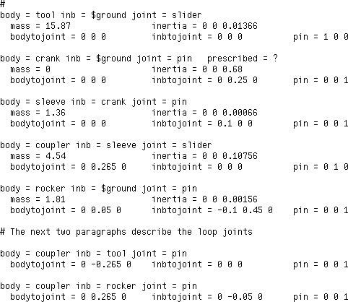
Body Paragraphs

Loop Joint Paragraphs

T4.2.4 Run SD/FAST and Examine Information File
Next run the quick-return mechanism system description file through SD/FAST:

sdfast quickret.sd
and examine the resulting quickret_info file in Figure T4-4. Notice that there are new sections containing information about the loop joints.

In the ROADMAP, an entire section named Loop Joints is added for closed-loop sys-tems. The pseudo coordinates lq are available to the user exactly the same way as for tree joints with the exception of no wraparound (integrate the lu’s to accumulate total number of revolutions). We have set up this problem to avoid the use of pseudo coordi-nates.

The STATE INDEX section lists the mapping from the state vector to the specific joint and axis, with an additional section exclusively for pseudo coordinates and rates.

The SYSTEM PARAMETERS section lists overall degrees of freedom, numbers of joints, etc., as discussed previously. Note that the total number of constraints nc is 11. Assuming all prescribed motion and user constraints are active and the rank of the con-straint matrix reported by SDMULT() falls below 11, the system has redundant con-straints and thus any bearing loads reported should be suspected to be non-unique.

Section for loop joints

Examination of the generated code in quickret_dyn.f shows that 6 of the 11 con-straints were eliminated symbolically and do not even appear in the code. The tree sys-tem has 5 DOF. So the 5 constraints yield 0 DOF when prescribed motion is enabled, 1 DOF otherwise. Since the mechanism is planar and has no in-plane redundancies, the in-plane loads are unique.

All the user-written code for this example is in the file quickret.f.

Figure T4-4 Information File for the Quick-Return Mechanism
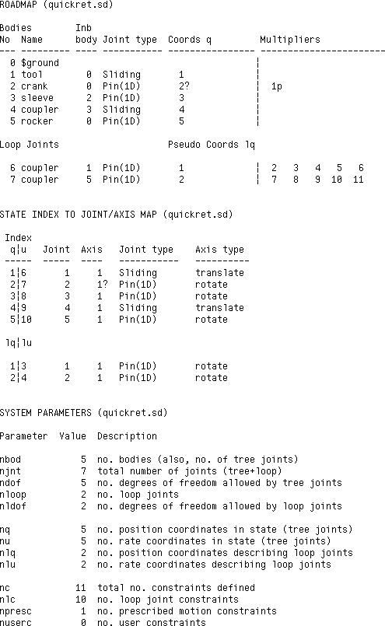
Constraint Information
Tree DOF
Section for loop joints
Multipliers to enforce ten loop joint constraints
Pseudo coordinates for loop pin joints
Possible prescribed motion with multiplier to enforce

T4.2.5 Applied Loads
Since we have ignored gravity in this system (it’s not a major contributor to the dynam-ics of the system), only two sources of applied loads remain: (1) the force applied to the shaper during its cutting stroke, and (2) the motor driving the crank. The applied loads will be computed in user-written sduforce() since we shall use the Simplified Anal-ysis Routines.
Cutter Force
The cutter force is a constant force of 450 Newtons applied only during the forward stroke of the tool:
⎧ –450nˆ , r˙ ≥ 0

F = ⎪
⎨
1 1
0nˆ , r˙ < 0
Eqn. T2.4

⎪ 1 1
⎩

The initial set-up code and cutter force code in SDUFORCE() to implement this applied force is:
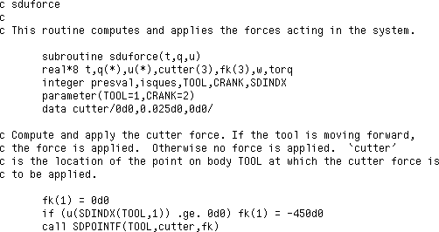

The first element of the force vector fk() is set to zero, unless the velocity of the tool is greater than zero. Note that the velocity of the tool (which is one of the generalized speeds passed in u) is obtained by using SDINDX() with the parameter TOOL set to the body number “1” as reported by the roadmap of the system. If the velocity is posi-tive, the force is computed and applied to TOOL at point of application “cutter” using SDPOINTF().
Crank Motor
Unless the crank motor is prescribed by sdumotion(), the motor applies a torque as a function of the speed of the crank according to the following linear torque-speed rela-tionship:

⎧
⎪
τ = ⎨
⎪
⎩
90, u < 0
90 – 3u, 0 < u < 30
0, u > 30

Eqn. T2.5

where the stall torque is 90 Newton-meters and the no-load speed is 30 rad/sec.

The crank motor torque code in sduforce() is:
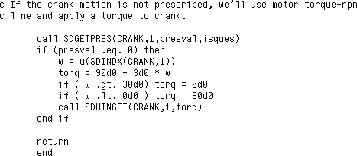
)

where presval (returned from SDGETPRES()) determines if prescribed motion is turned on (remember to always use SD/FAST-supplied routines to determine the values of parameters or the state of flags, etc.). The velocity of the crank to use in the torque-speed relation is also extracted using the SDINDX() routine. torq is applied through SDHINGET().

T4.2.6 Prescribed Motion
The only prescribed motion is a constant spin rate for the crank during some of the anal-yses. It is generally a good idea to provide position, velocity, and acceleration informa-tion if you can, but only acceleration is required. If all are provided, make sure that the expression you give for velocity is the time derivative of the one you provide for posi-tion, and that likewise the acceleration is the derivative of velocity. See Reference Section R14 for more information.

The code for the prescribed motion of the crank is contained in sdumotion():
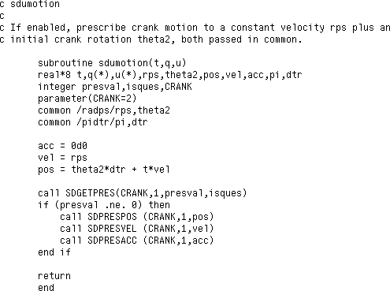
)

Once again, the user wisely checks to see if prescribed motion is desired by using the SD/FAST-supplied routine SDGETPRES(). Note that the prescribed motion is com-

puted exactly correct analytically. Integration of acceleration to give velocity and an-other integration to give position may drift somewhat from the analytical results (although not when the acceleration is a constant as it is in this case). Providing posi-tion and velocity information allows tracking of any errors, and can be used directly to prevent drift if constraint stabilization is enabled (see Reference Section R4.2). This in-formation is also used during assembly and initial velocity analysis to bring the initial conditions into line with the desired prescribed positions and velocities.

T4.2.7 Exercise 1: Assembly and Initial Velocity Analysis
At this point we are ready to show how to perform an assembly and initial velocity anal-ysis. Since we shall be using the assembly and initial velocity analyses several times, we have written these analyses into the routine initconds():
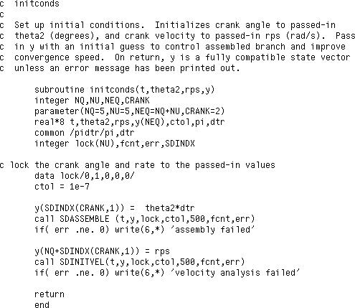

This routine allows the system to be assembled for any desired crank angle, theta2, which is locked at the passed-in value. Note that the initial configuration we show in Figure T4-2 is good for assembling the mechanism only when θ₂ is near 90° . For other values of θ₂ , we will pass in configurations close to the desired assembled configuration (see Exercise 2).

The assembly analysis is performed using a call to SDASSEMBLE() where the parame-ters passed are time t, the initial guess state vector y, the lock vector indicating that the crank is locked at its current position, the constraint tolerance ctol indicating that the allowable error in assembling the joints is 1 × 10^{–7} meters and radians, a limit of 500 function calls, and an error variable that returns 0 if the assembly is successful. De-tails on the routine SDASSEMBLE() can be found in Reference Section R18.1.

The initial velocity analysis is performed after the assembly analysis by using a call to SDINITVEL() where the parameters passed are identical to those passed for SDASSEMBLE(), except that the velocities u in the state vector y are used as the initial guess for the velocities and the lock vector applies to locking the velocities. The q’s are assumed all locked. Details on the routine SDINITVEL() can be found in Refer-ence Section R18.2. Next we set up the main program and perform the first assembly and velocity analyses.

The main program setup code used by all the later analyses is:
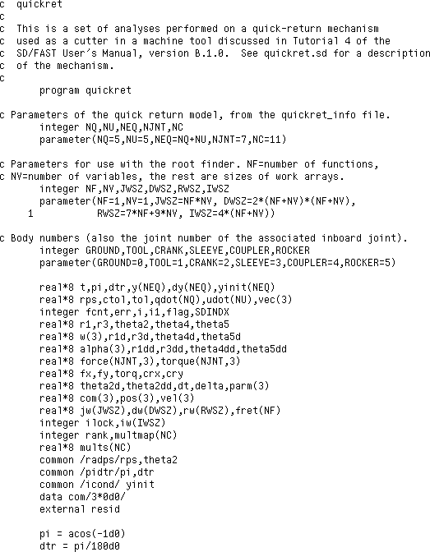
9*(NF+NV)
A nice way to use system parameters such as the number of q’s, NQ, or body numbers such as CRANK=2 is to write them as parameters (instead of integer numbers) to im-prove the readability of the code. The variables used are self-explanatory or will be ex-plained as needed. The common blocks are used to pass some variables between routines. The external function resid is used in Exercises 5 and 6.

Next SDINIT() is called to initialize the SD/FAST-generated code. Then the configu-ration for the initial guess shown in Figure T4-2 is generated and placed into yinit.
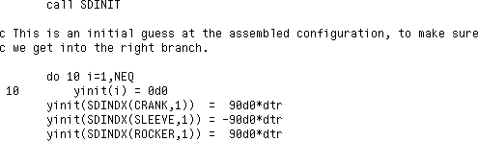
-60
135

The first exercise is to assemble the system with prescribed crank motion with the initial
position θ₂ = 90° (theta2) and u₂ = 20 rad/sec (rps). Prescribed motion is
turned on using a call to SDPRES(). The initial guess is passed from yinit to y. The assembly and velocity analyses are performed by calling initconds().
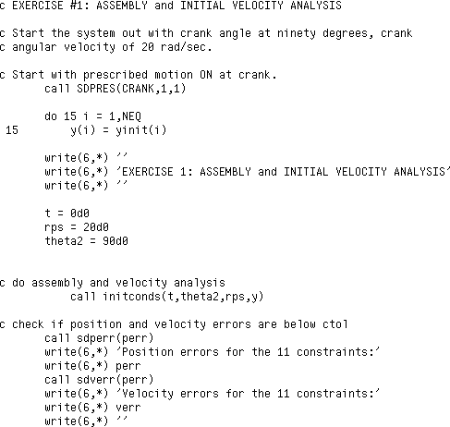
The reported position and velocity errors are well below the desired ctol of 1 × 10^{–7} :
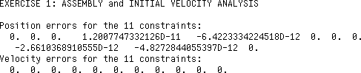
Since no errors were reported by initconds(), the user is guaranteed that the posi-tion and velocity constraint errors are less than ctol. So checking here is just for add-ed assurance. Next we can check the configuration to see if the correct branch was entered.


Figure T4-5 Two Possible Branches for Assembling the Quick-Return Mechanism with Crank at 90°


Desired Branch
Wrong Branch

The following code segment prints out the information on the positions and orientations of the bodies to check the validity of the assembly analysis:
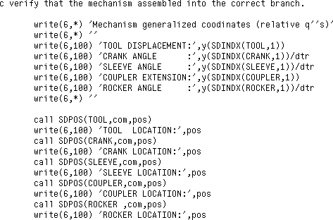

Checking a few key results in the printout show that the correct branch was entered:
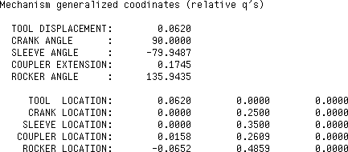

The crank angle is at the locked angle of 90° as desired. The tool displacement, sleeve angle, coupler extension, and rocker angle are all close to the desired branch shown in Figure T4-5. The center of mass locations of each body also match those of the desired branch. Thus, a rough sketch of the assembled mechanism, or better, a graphical display of the system, can be used to ensure that the correct branch was entered. Usually, an in-correct branch is immediately apparent.

A check of the velocities can also give insight into the assembled system:
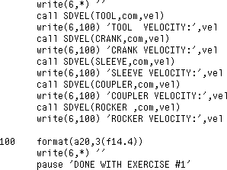

The resulting velocities of the mass centers are:
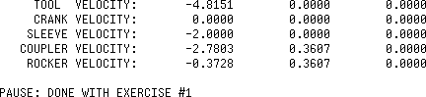

The tool is clearly retracting. Since the crank is really a flywheel, its mass center veloc-ity will always be zero. The sleeve is attached to the tip of the crank with a velocity of:

v = ω × r =
20nˆ ₃ × 0.1nˆ ₂ =
–2.0nˆ ₁
Eqn. T2.6

which matches the computed result. Other velocities, such as at the ends of the coupler, could also have been checked for correctness.

Key Idea
The main point of this exercise was to not only set up the assembly and velocity analy-sis, but to point out that the final assembled system should be started with an initial guess “close” to the desired configuration and then carefully checked for assembly into the desired branch. Fortunately, it is usually obvious when an incorrect branch has been entered—but check it!

T4.3 Suite of Typical Mechanism Analyses
This section consists of five more exercises that take you through some typical mecha-nism analyses. These five exercises are:
Ex #2: Inverse Dynamics: Generate a specified motion and applied load at the tool (all prescribed so that the system has zero degrees of freedom) and find the torque applied at the crank required to generate that motion. This would be useful in sizing a motor to drive this mechanism.
Ex #3: Mechanical Advantage: Compute the ratio of cutter force to crank torque. This is a standard mechanism kinematic analysis to find such things as regions of possible binding, approximate motor sizing, etc.

Ex #4: Dynamic Analysis: Run dynamic analysis with actual motor model. This is used to check the actual timing of the cutting stroke for the selected motor.
Ex #5: Design Study A: The chosen motor may not be able to drive the mechanism back to the same crank velocity as it started with. We could change the motor size to match the desired initial crank velocity, or, since motors come in discrete sizes, sim-ply run a suite of dynamic analyses with a range of starting velocities to find the ac-tual starting velocity for that motor driving the mechanism (after initial transients have died out). Then we check if the stroke cycle time meets our requirements.
Ex #6: Design Study B: Design Study A is repeated using just one pass through the nonlinear root finder supplied by SD/FAST. This advanced technique shows how to perform these types of studies much more quickly.

Exercises 1 through 4 are essential for learning to set up mechanism analyses using SD/FAST. Exercises 5 and 6 discuss more advanced features.

T4.3.1 Exercise 2: Inverse Dynamics
An inverse dynamics analysis computes the loads given a desired motion, as opposed to a (forward) dynamic analysis which computes the motion given the loads. Inverse dy-namics is commonly used to compute feed-forward commands to obtain a desired mo-tion, get a rough idea of actuator sizing, determine bandwidth requirements of a feedback controller to follow a desired trajectory, etc.

For example, a robot may have its tip commanded to follow a specified path in a high-speed, repetitive manufacturing process. An inverse dynamics analysis would give you the feed-forward command history for each motor in the robot. The command history could be computed off-line and then stored for use by the robot in real-time. For the quick-return mechanism, we desire to compute the motor torque applied to the crank to give the desired tool motion.

There are two ways (at least) to use SD/FAST to compute inverse dynamics. The meth-od that first comes to mind is to run an actual forward dynamic analysis with all motion prescribed (zero DOF for system), and then read back the motor torque required to cre-ate the motion. The second method would be to re-assemble the mechanism for a range of crank angles that cover the entire 360° crank cycle, say, every 10° ; and compute dy-namic equilibrium at each angle of the crank. The second method may appear to be in-efficient, but an assembly and velocity analysis is actually quite fast and can be more computationally efficient than integrating the equations of motion.

For this example, we shall use the second method of re-assembling every 10° and com-puting dynamic equilibrium (Integration of the equations of motion is shown in Exercise 4, for forward dynamics. The identical code will work for inverse dynamics if all the motion is prescribed.). Each new re-assembly uses the previous configuration to ensure that the initial guess for the assembly is very “close.” This makes the new assembly analysis very fast using only a few derivative evaluations, as opposed to the numerous derivative evaluations required to integrate the equations of motion.

There is one caveat in using this method. If the mechanism is being assembled near a bifurcation configuration (or what would be a bifurcation configuration if link lengths

were slightly adjusted, such as making a crank-rocker close to a double-crank), then the system may re-assemble into an undesired branch. If you suspect this may be a prob-lem, then we suggest you use the first method of running a dynamic analysis with all the motion prescribed.

The following code segment implements the inverse dynamics for each 10° by first call-ing initconds() to perform a new assembly and velocity analysis, then calling sduforce() to apply system loads . Finally, SDDERIV() is called to obtain the sys-tem derivatives and corresponding loads Note that sdumotion(), used to enforce prescribed motion, is already called in SDINITVEL().
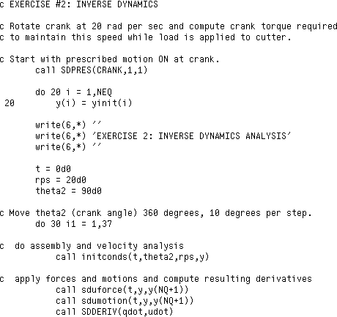
The next code segment computes the position, velocity, and acceleration for each of the five coordinates of interest: tool displacement r₁ , crank angle θ₂ (already prescribed), sleeve displacement r₃ , coupler angle θ₄ , and rocker angle θ₅ . Note the exclusive use of parameters to identify bodies, instead of numbers, and direct calls to SD/FAST-gen-erated utility and indexing routines such as SDANGVEL() and SDINDX() to reduce the chance of programming errors.

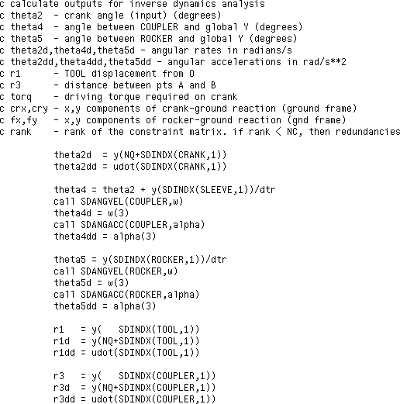
Plots for each of the positions, velocities, and accelerations were obtained by processing the output of this example program through a commonly available plotting package.

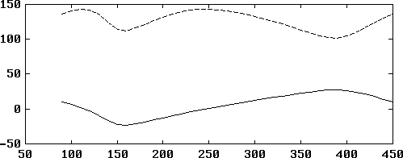
(deg)
θ₅
θ₄

Crank Angle θ2 (deg)

Note that the coupler angle θ₄ and rocker angle θ₅ rock a few tens of degrees as expect-ed. The rates and accelerations change slowly during the cutting stroke, and are very large at the turnaround points.

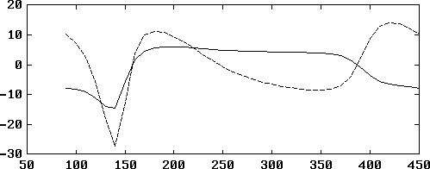
(rad / sec)
θ˙4
θ˙5

Crank Angle θ2 (deg)

(rad / sec 2)

˙θ˙4
˙θ˙5

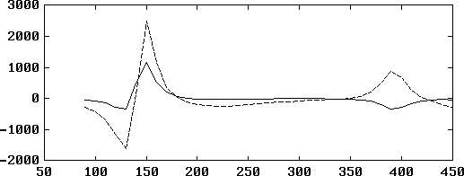
Crank Angle θ2 (deg)

The cutter stroke r₁ is a smooth ramp during the cut as expected:

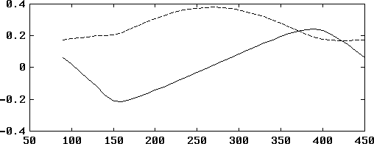
( m )
r3
r1

Crank Angle θ2 (deg)

Again, the rates and accelerations are low during the forward and backward strokes, whereas they are large near the turnaround points:

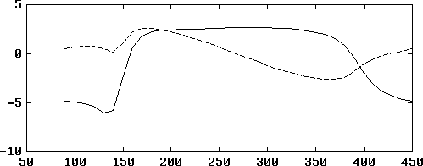
( m / sec )
r˙1
r˙3

Crank Angle θ2 (deg)

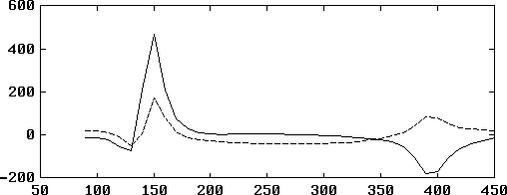
( m / sec 2)
r˙˙1
r˙˙3

Crank Angle θ2 (deg)

The next code segment calls SDGETHT() to find the hinge torque applied at the crank to produce the prescribed motion, and SDREAC() to find the reaction loads at the joints. The reaction loads are transferred from their local body frames to the ground frame using SDTRANS().
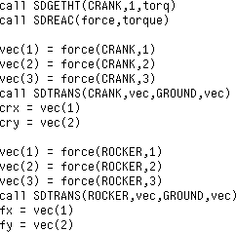

Finally, the rank of the constraint matrix is computed using a call to SDMULT(), and all the desired variables are both printed and stored for plotting. You will find that the con-straint matrix always has a rank of 5, meaning that 6 of the 11 constraints are redundant.

However, the in-plane constraints are not redundant and thus the in-plane reaction loads are unique. Ten degrees is added to the crank angle and the loop rerun until a full revo-lution has occurred.
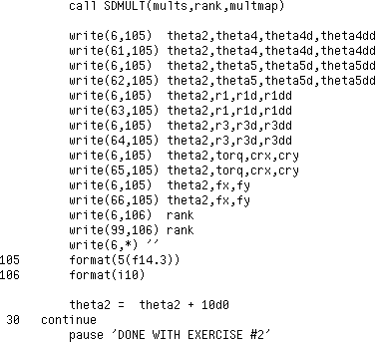

The hinge torque torq applied to the crank as a function of the crank angle to make the mechanism follow the prescribed motion is plotted next:
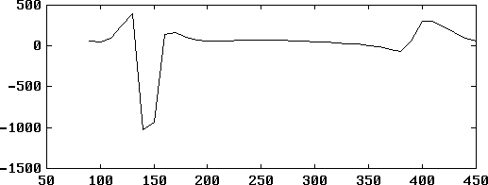
( N-m )
Crank Torque
Crank Angle θ2 (deg)

Note that the crank torque is very large near the turnaround points. If this level of torque is not available from the motor, two solutions can be tried. First we can run a for-ward dynamics solution with the actual motor model implemented and check if the de-viations from desired motion are acceptable. Second, we could increase the flywheel inertia to smooth out the torque requirements. In this case, we will accept the perfor-mance as is (see Exercise 4).
The in-plane reaction forces at the crank (crx and cry) and the in-plane reaction forc-es at the rocker ground attach point (fx and fy) are plotted below. The reactions are

small throughout most of the forward and backward strokes, and large during turn-around as expected.

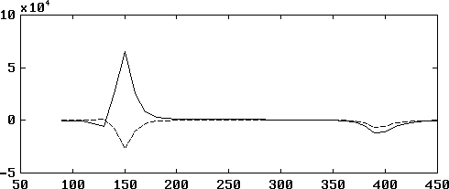
( Newtons )
Crank Reaction Force in x-direction
Crank Reaction Force in y-direction

Crank Angle θ2 (deg)

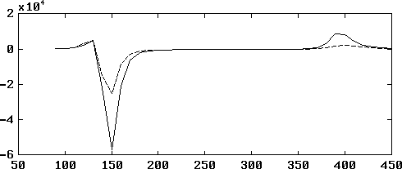
( Newtons )

Rocker Reaction Force in y-direction

Rocker Reaction Force in x-direction

Crank Angle θ2 (deg)

T4.3.2 Exercise 3: Mechanical Advantage
Mechanical advantage is usually computed as a kinematic function of the ratio of the differential change in the input position of the mechanism (the crank in this case) over the differential change in output position (the tool). In terms of the loads required to hold the mechanism in equilibrium, the mechanical advantage is the ratio of the output load over the input load. (Note the input/output ratio is reversed).

Using SD/FAST, we can go one step further, and find the mechanical advantage for the mechanism in dynamic motion, rather than just in static equilibrium. That is, take the ratio of output over the input loads while the system is in motion. This is perhaps closer conceptually to the “real” meaning of mechanical advantage for a mechanism that oper-ates near a steady state velocity (crank angular rate). We shall compute “static” me-chanical advantage in this exercise.

The code for implementing the mechanical advantage analysis is almost identical to the code for the inverse dynamics analysis. We shall use the re-assembly method instead of forward dynamic analysis. This time, the analysis is performed with the crank rotation

rate prescribed at 0 rad/sec to produce a “static” analysis at each configuration. For this analysis, we shall loop every degree instead of every 10 degrees.
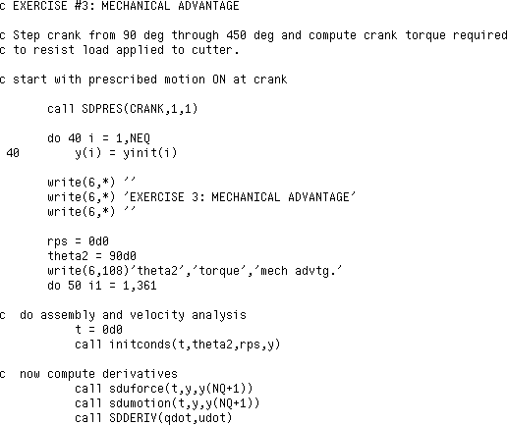

Mechanical advantage is computed using the known constant applied force at the tool. (Note that for this analysis the force is applied throughout the forward and backward stroke since sduforce() is coded to apply the force whenever the velocity is less than or equal to zero. Note also that any force could have been used to compute me-chanical advantage—most typically a unit force. However, we already had a 450N force applied for use in other analyses, so we’ll use that.)
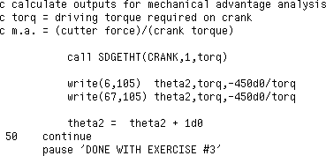

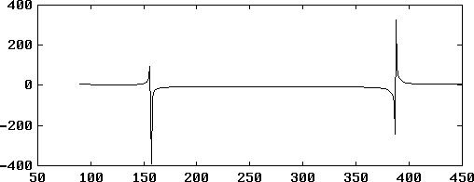
The resulting plot of mechanical advantage is:

m.a.

Crank Angle θ2 (deg)

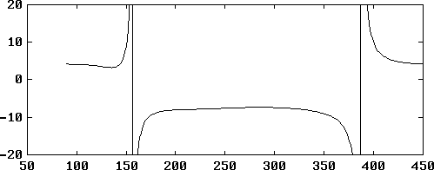
The mechanical advantage approaches infinity near the two turnaround points. A close-up of the constant region shows a mechanical advantage of about 10 for the forward cut-ting stroke. A constant mechanical advantage over the forward stroke indicates a well designed mechanism that should supply the cutter with a fairly constant force.

m.a.

Crank Angle θ2 (deg)

T4.3.3 Exercise 4: Dynamic Analysis
In the dynamic analysis we shall use the motor model in sduforce() instead of pre-scribing the motion. Before we begin the dynamic analysis, we first turn off prescribed

motion and perform an assembly and velocity analysis to place the mechanism back in our initial configuration with a crank velocity of 20 rad/sec.
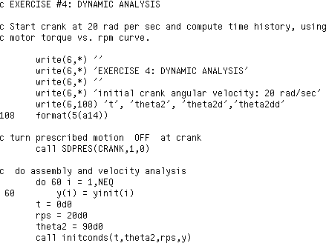

Next we set up the desired step size, tolerances, etc. Note that we call SDMOTION() once at the beginning with dt=0 just so that we have acceleration information for plot-ting at the start time.
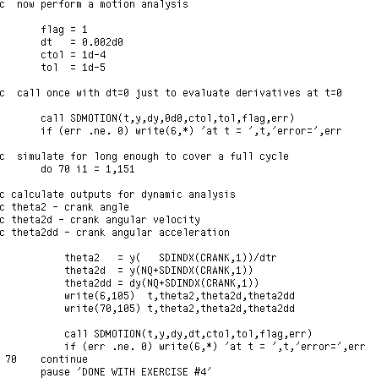

For this analysis we shall only plot the position, velocity, and acceleration for the crank angle.

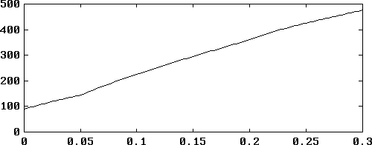
(degrees)
θ₂

Time (sec)

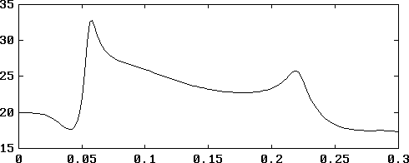
(rad/sec)
θ˙2

Time (sec)

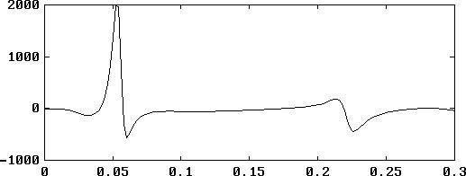
˙θ˙2

(rad/sec 2)

Time (sec)

Note that the crank velocity at the end of one cycle is well below the velocity at the start. This means that the motor is not powerful enough to sustain the desired rate. If we al-low the system to integrate long enough, the natural damping generated by the back EMF in the motor (as represented by the torque-rpm curve) will dampen out the tran-sients, and a steady state cycle at a lower average crank velocity will emerge. The final two exercises show other methods of finding the steady state cycle.

T4.3.4 Exercise 5: Design Study A
In this design study we shall run a suite of dynamic analyses that sweep through initial crank velocities to find one that just matches the crank velocity after one cycle. This will give us the steady cycle motion for the given motor.

Since we shall be performing several dynamic analyses, we wrote routine resid() to perform the analysis and return the difference in initial and final crank velocity. The reason we named the routine “resid” is that we shall also use it in the next exercise in which it is called by a nonlinear root finder to find the “residual” error to reduce. The variables passed to resid() are rps, the initial crank velocity, and parm, a vector of integration control parameters. The variable returned is the difference in the initial and final crank velocities, delta.
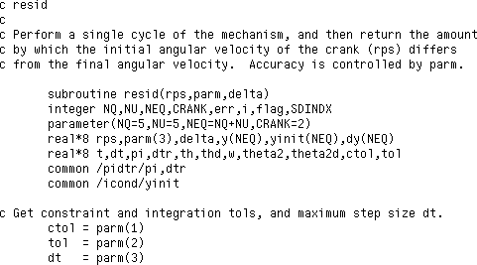

An assembly and velocity analysis is performed before each dynamic analysis by call-ing initconds() as usual:
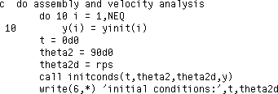

Next the dynamic analysis is started and proceeds until the crank angle just passes its initial position (plus 360 degrees). Stall conditions are also checked just in case the ini-tial velocity is not large enough to allow the mechanism to complete a cycle.
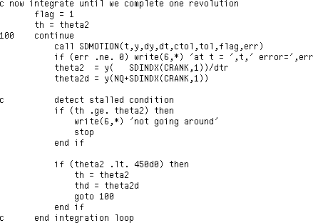

An interpolation is performed to provide a much better estimate of the final crank veloc-ity just as the crank angle passes the start angle:
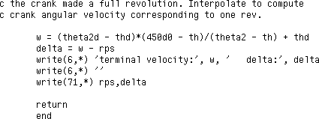

The design study in the main program starts with variable assignments, turning pre-scribed motion off so that the motor model is enabled, and performing an assembly and velocity analysis:
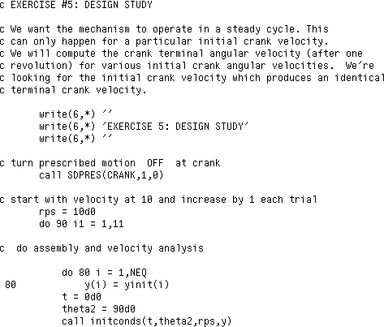

Next the parameters required by the resid() routine are loaded and resid() is called. The crank velocity is increased by one rad/sec and the analysis repeated.
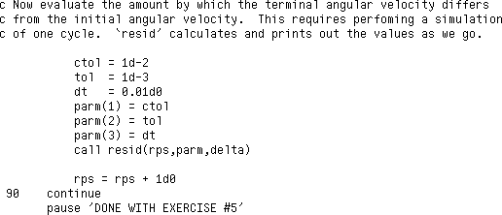

The plot of delta in crank velocity versus initial crank velocity shows that the initial crank velocity that yields an equivalent final crank velocity is approximately 15.2.

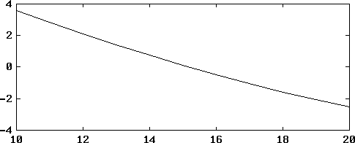
delta (rad/sec)

Initial Crank Velocity (rad/sec)

T4.3.5 Exercise 6: Design Study B
In this design study we repeat the analysis just performed, but using the nonlinear root finder supplied by SD/FAST to find the correct crank velocity quickly and more accu-rately. We start by turning prescribed motion off:
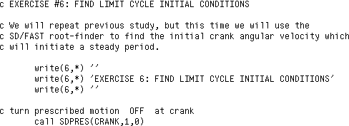

Then we set up all the variables required to be passed to SD2ROOT(). Note that we used SD2ROOT() instead of SDROOT(). They are exactly the same routines, but an additional copy had to be created (by passing the prefix “SD2” to SD/FAST) because Fortran does not allow reentrant routines (SD2ROOT() calls resid() which calls initconds() which calls SDASSEMBLE() which calls SDROOT()). Check Refer-ence Section R8.2 for complete details on how to use SDROOT().
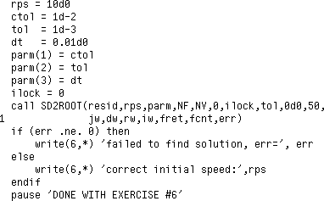

The printed results of the last few calls to resid() show that a closer answer for the initial crank velocity that yields the same final velocity is 15.193:
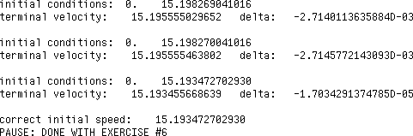

Finally, a call to SDPRINTERR() is made to check for usage errors.
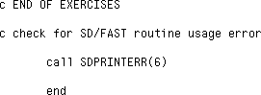

- This tutorial covered the first example of using SD/FAST for a closed-loop system, namely, a common quick-return mechanism used for shaping parts.
- Closed-loop systems are created by joining branches of open-loop tree systems by using loop joints. The open-loop tree systems are created by “cutting” the loops at joints or inside bodies. The system is re-assembled by (1) laying out the parts into an easy-to-model reference configuration of your choice, (2) adjusting the parts by changing the hinge coordinates to get the system into its initial configuration which is “close” to the assembled configuration you desire, (3) perform an assembly analy-sis (routine supplied by SD/FAST) to bring the cut loops together, and (4) perform an initial velocity analysis (routine supplied by SD/FAST) to compute compatible velocities for the system (so it won’t fly apart).
Summary
- Special considerations for constrained systems such as closed-loop systems were discussed, including: (1) numerical stabilization of loop joints using Baumgarte’s method; how to recognize and avoid problems such as (2) mechanism bifurcations,
(3) mechanism lockup, (4) assembly into an undesired branch, (5) incompatible con-straints, (6) passive degrees of freedom, and (7) redundant constraints with non-unique reaction loads.
- A quick-return mechanism was modeled and assembled using routines supplied by SD/FAST. A reference configuration is chosen for which it is easy to write the sys-tem description and provides computational advantages. The reference configura-tion is adjusted to place the system “close” to the desired assembled configuration to avoid assembly into the wrong branch.
- A suite of mechanism analyses was performed on the quick-return mechanism, in-cluding (1) inverse dynamic analysis, (2) mechanical advantage, (3) motion analysis, and (4) a design study (performed two different ways) to find steady state cycle of the mechanism. The motion was studied both as prescribed crank motion and using an actual motor model.

SD/FAST Reference

This chapter contains the detailed reference material for the SD/FAST software pack-age. Entries are arranged alphabetically. Each entry is intended to be technically rigor-ous, yet concise. The Table of Contents contains a compressed listing of all the entries and the Index contains extensive cross references between the Tutorials and this refer-ence. The Tutorials and this Reference are also cross-referenced to help you quickly find needed information. Please read the following section on the conventions used to describe SD/FAST-generated code and its usage.

Reference Section Conventions
Many of the subsections in the Reference portion of this manual document subroutines and functions generated by SD/FAST. We use the general term “routines” to include both subroutines and value-returning functions.

Most routines are generated specifically for the system at hand, and are placed by
SD/FAST into the Dynamics or Simplified Analysis files. Some routines are the same every time they are generated and thus are placed in the Library File, which need be generated only once. The routines are grouped in the reference section by function, rather than by the file in which they are placed.

Routines are documented formally here, by showing their declarations in both Fortran and K&R C (of course ANSI C compilers can also be used). When referring to an
SD/FAST-generated routine by name, we write the name in upper case typewriter font and follow it by parentheses, for example SDSTATE(). When referring to a user-writ-ten routine, we use lower case typewriter font instead, for example sduforce(). Ex-amples of user-written code are also shown in lower case, except that values declared in parameter statements and calls to SD/FAST-generated routines are shown in upper case.

Table R-1 Names for System Parameter Constants

Constant Name Meaning
NBOD no. bodies (also, no. of tree joints)
NJNT total number of joints (tree+loop)
NQ no. position coordinates in state (tree joints)
NU no. rate coordinates in state (tree joints)
NLQ no. position coordinates describing loop joints
NLU no. rate coordinates describing loop joints
NC total no. constraints defined
NUSERC no. user constraints

When discussing array dimensions, we use the names shown in Table R-1 for the vari-ous system parameters. The values for these names can be obtained from the generated Information File. We strongly recommend that you use these names, rather than the numbers they represent, in your analysis code. In Fortran, this can be done with PARAMETER or DATA statements. In C, use the #define feature to define names.
This technique eliminates many common errors which occur when a code has to be
modified from its original specification, which is almost inevitable. It also facilitates development of a common framework which can be reused for different analysis tasks.

In Fortran, where an array of known length is passed as a parameter, that length is shown in the parameter declaration. This is not really legal Fortran, but serves to get the point across. For example, in the declaration
SUBROUTINE SDMULT(MULTS,RANK,MULTMAP) DOUBLE PRECISION MULTS(NC)
INTEGER RANK,MULTMAP(NC)

the MULTS and MULTMAP parameter are both known to be of length NC (number of constraints), but that number is not passed in since the SDMULT() routine was generat-ed with full knowledge of the array lengths. In the actual generated code, the arrays are simply declared to be the appropriate length. For example, if NC=7 the actual declara-tion for SDMULT() is
SUBROUTINE SDMULT(MULTS,RANK,MULTMAP) DOUBLE PRECISION MULTS(7)
INTEGER RANK,MULTMAP(7)

C allows constants to be given names which are known throughout the entire file, unlike Fortran PARAMETER statements which are visible only in the current subroutine. (Many Fortran compilers also support a #define pre-processor which works the same way as in C. We recommend this over PARAMETER statements, but it is non-standard).

We show the array dimensions in C declarations assuming that the appropriate constants have been defined. For example, SDMULT() is declared in C as
sdmult(mults,rank,multmap) double mults[NC];
int *rank, multmap[NC];

Again, the actual declaration in the generated code simply has the constant name re-placed by its value.

In Fortran, we use the common convention that array indices begin at 1 and range up to n for an array of length n. This applies to all enumerated items, such as body, joint and axis numbers. In C, all indices follow the C convention of beginning at 0, with maxi-mum index n-1.

In both languages the ground “body” (named $ground) is given the body number one less than the first user-defined body. That is, in Fortran $ground is body number 0 and in C it is body number -1.

Floating point parameters are always shown declared in double precision since this is the most common (and recommended) usage. If SD/FAST has been run with the single precision option, the declarations should be considered to have REAL substituted for DOUBLE PRECISION in Fortran, and float substituted for double in C. We do not recommend use of the single precision option on computers whose single precision real numbers are less than 56 bits wide, especially for systems with constraints.

Some of the SD/FAST-generated routines must be called before other calls are valid. These are common-sense requirements, for example you cannot ask for the acceleration of a point until after the system derivatives have been calculated. This is discussed more fully in Section R3, and the complete list of routines and their ordering requirements is given in the SD/FAST Quick Reference Guide, Section Q4 and Section Q3.

R1 Analysis Types

SD/FAST can be used to perform a wide range of engineering analyses for multibody systems. Spacecraft dynamics are typically studied by simulation, which we generally refer to as dynamic analysis or motion analysis. Mechanism and machine dynamics may require additional types of analysis, such as static analysis which is used to find an equilibrium configuration. Quite often, a mechanism may be analyzed only at certain configurations of interest. Any mechanical system can benefit from design studies in which the effects of changing design parameters can be analyzed or optimized.
SD/FAST offers the versatility to support almost every type of analysis that may be de-sired.

Below, we discuss several of the most common analyses done with SD/FAST. See the Tutorials for examples showing most of these analyses. This is not an exhaustive list — the analyses possible with SD/FAST are limited primarily by the imagination of the an-alyst.

R1.1 Dynamic (Motion) Analysis
Dynamic analysis is concerned with obtaining the response over time of a multibody system when driven by loads (forces and torques). The motion is a highly nonlinear function of the applied loads. The basic characteristic of dynamic analysis is that the system is subjected to loads, and some or all of the motion is unknown. Dynamic anal-ysis is usually used to predict the behavior of a multibody system during transient con-ditions.

The motion of a multibody system is governed by equations called dynamical equations of motion. These equations can be formulated by any number of classical methods.
Modern treatments of multibody dynamics give rise to formalisms that are well-suited for computer solution, because of the need to obtain numerical results. This is because the governing equations are too complicated to be solved by hand. The equations of motion comprise a set of differential equations, with algebraic constraint equations.
The differential equations are an expression of physical laws (Newton’s Laws of Mo-tion), while the constraint equations take into account desired restrictions on the geome-try of the system, or its motion. Closed loops of joint-connected bodies and prescribed motion are common types of constraints.

The computer model of the multibody system is organized to allow the system motion to be propagated in time. The motion of the system is represented by the system state vector. This consists of a set of coordinates and a set of velocity variables (see Section R20 for details). Knowledge of the state vector is sufficient to compute the position and velocity of every material point of the multibody system. The number of velocity vari-ables in an unconstrained system is said to be the number of degrees of freedom (DOFs). Each independent constraint added to the system reduces the number of usable degrees of freedom by one. The difference between the number of degrees of freedom in an un-constrained system and the number of independent constraints on that system is called the system’s mobility. This number is not necessarily constant as the system moves.

The motion of the multibody system is driven by three possible sources: initial condi-tions, applied loads, and prescribed motion. The applied loads can be functions of the system state or time. There are three possible types of loads: forces applied to points, torques applied to bodies, and loads applied at joint axes (these may be forces or torques depending on the joint type). Prescribed motion can be used when the time history of a joint is known as a function of time. This means that the joint angle (or position), its rate, and acceleration are specified. Given the complete description of the multibody system, the loads acting on it, and any prescribed motion functions, the equations of motion are numerically integrated in time, starting from the given initial conditions.
The state vector for any subsequent instant of time can then be used as a new initial con-dition for further analysis. To perform the numerical integration, the derivatives of the state vector are computed from the equations of motion. This step is done in such a way that no constraint equations are violated. The integrator then updates the solution in time, attempting to meet the user’s solution accuracy requirements.

Some problems may require execution of two additional analyses before dynamic anal-ysis can begin. This is the case when the system must satisfy constraint equations. The coordinates must satisfy position constraint equations, while the velocity variables must satisfy velocity constraints. Special routines generated by SD/FAST can be used to perform these prerequisite analyses, called assembly analysis and velocity analysis.
These are described below.

R1.2 Inverse Dynamics
Inverse dynamics is simpler than dynamic analysis. In this case, all the motion of the system is specified. This means that the constraint equations and prescribed motion functions completely determine the solution time history. Additional applied loads do not change the motion, but do alter bearing reaction loads. The applied joint loads need-ed to make the motion occur are computed. This type of analysis is useful for sizing ac-tuators and assessing joint loads, and for computing the loads needed to drive a system (such as a robot) through a known motion sequence.

Since all the motion is specified, the position, velocity and acceleration of any point can be found just through kinematic analysis. This gives the user a choice of solution proce-dure if inverse dynamic analysis is to be performed at many different solution points. If only one solution point is desired, the system state vector for a constrained system must be initialized by performing an assembly analysis and a velocity analysis. Then the ap-plied loads and prescribed motion functions must be executed. The state derivatives are computed next. All information regarding accelerations is then available. This includes the acceleration of points, the angular acceleration of bodies, all bearing loads in the system, and driving actuator loads at prescribed joints. If many solution points are re-quired, inverse dynamics can be simply treated as a dynamic analysis case. The solution can be obtained by numerical integration. In this way, solution points are obtained which are spaced in time by the integration time step.

In some cases, the user is interested in performing inverse dynamic analysis at just a few widely spaced points. Then, it can be more efficient to analyze each point separately, by performing a new assembly and velocity analysis before each derivative computation. This is because the numerical integrator makes multiple evaluations of the system deriv-ative to advance each time step, and these evaluations usually require more arithmetic

operations than performing an assembly and velocity analysis. However, whenever an assembly analysis is performed, one must be careful to verify that the mechanism has assembled into the correct branch.

R1.3 Static Analysis
Here the problem is to determine the equilibrium configuration of a multibody system, given the loads acting on it. This is a configuration in which all the bodies are at rest or moving at a known, steady velocity, and all accelerations are zero. The typical situation is to allow loads acting upon the system to be functions of the system state (such as springs). The value of state-dependent loads will then also be found during the static analysis.

Static analysis requires the user’s starting guess at an equilibrium configuration. Some-times a static configuration can be found that is unstable or otherwise undesired. In this case a different initial guess closer to desired configuration must be input. The stability of an equilibrium point can be tested by perturbing the system state and performing a dynamic analysis. (See Tutorial Section T2.6.3 for an example of this procedure.) If the system state stays within an acceptable neighborhood of the equilibrium the system is probably stable in an engineering sense. Static configurations can also be found by add-ing damping to the joints of the system and then performing a dynamic analysis. This method can be used to find an estimate of a static configuration, by letting the system settle for some length of time. A subsequent static analysis can then determine the coor-dinates to greater accuracy, and with far less expenditure of computer time, compared to letting the system settle solely under the influence of added damping.

R1.4 Inverse Static Analysis
When the equilibrium configuration is given, the statics problem becomes that of find-ing applied loads compatible with the equilibrium state. In some cases, this type of stat-ic analysis can be treated as a special case of inverse dynamics. This is so when the desired load type is an actuator force or torque at a joint. Then the motion can be pre-scribed to zero, and inverse dynamics analysis used to obtain the compatible applied hinge loads.

In the more general case, the applied loads will have unknown application points, force magnitudes, or directions expressed as functions of design variables. If the user can pa-rameterize the set of loads acting upon the system, then a static configuration can be found using nonlinear root-finding methods. This problem is set up as a design problem with an underlying single-step dynamic analysis. The root finder provided with
SD/FAST (see Section R8.2) can be used to find values for the design variables (and hence the forces) which produce zero system accelerations. Once solved, static analysis can be used to verify the result.

R1.5 Steady Motion Analysis
Steady motion analysis is sometimes called “dynamic equilibrium”. This is a special case of motion in which the system moves in a simplified way. In particular, all joint ac-celerations are zero. Examples of steady motion are a spinning coin and an airplane in level flight (if the airplane is “trimmed” properly). The difference between a steady mo-

tion problem and a static problem is that, in addition to the coordinates, the velocities are unknown in the steady motion problem.

Usually, a steady motion is used as a precursor to dynamic analysis. An aerospace vehi-cle could be intended to perform a steady flight. The steady motion analysis would show the relationship between “stick” setting and steady state climb, for instance. Dy-namic analysis would show how the system deviated from the desired profile in re-sponse to gusts, or slight initial errors. During steady motion, the velocity variables remain constant. Their derivatives are zero. The hinge coordinates might also be con-stant, in which case the whole system would be moving as a single rigid body. In other cases, parts of the system may have relative motion, as when the system includes spin-ning wheels or shafts. This type of steady motion occurs in many spacecraft problems.

Note that if all velocities are known in advance, it is more efficient to use static analysis than steady motion since there are fewer unknowns.

R1.6 Assembly and Velocity Analyses
The above analysis types apply to all systems, constrained or unconstrained. For con-strained systems (commonly called mechanisms) additional analyses may be required. These include assembly and velocity analysis. Most mechanisms possess loops formed by the bodies. Assembly analysis describes the computation of the joint angles or posi-tions (and hence body positions) required to close the loops. Velocity analysis refers to the computation of velocities that are compatible with the loop conditions in the mecha-nism. When some of the joint angle rates or body rotation rates are specified, the rest of the velocity variables in the system must be chosen so that the loops are not “flying apart.”

A basic assembly analysis solves for a set of coordinates which satisfy all loop-joint constraint equations, prescribed motion position functions, and all user-written holo-nomic (position) constraints. Loop-joint constraint equations include requiring hinge points on designated bodies to become coincident (for rotational joints) and causing axes to have the correct relative orientation. Arbitrary additional constraints on joint or body configurations can be accommodated with the SD/FAST-generated nonlinear root finder.

Assembly analysis can succeed or fail, depending upon the user’s initial guess at an as-sembled configuration. The user can freeze any subset of the system position variables, and not allow the assembly analysis to alter the assumed values for these variables. This can speed up the assembly process, but if too many variables are frozen it may become impossible to find a solution. After assembly of a mechanism, the user can obtain the position of any point of the system, or the orientation of any rigid body.

Velocity analysis is used to initialize the system velocity variables so that all loop veloc-ity constraints, prescribed motion velocity functions, and user velocity constraints are satisfied. Velocity analysis is initiated after a successful assembly analysis, so that all coordinates are known. Velocity analysis requires solution of a set of linear equations, so it usually requires very little computer time. Again, arbitrary velocity constraints on hinges or bodies can be accommodated with the SD/FAST-generated root finder.

R1.7 Mechanical Advantage and Transmission Angle Analyses
Mechanism analyses also traditionally include such types as mechanical advantage or transmission angle calculation. These are related to the force transmission characteris-tics of the mechanism. Other mechanism analyses are concerned with path or function generation, and rigid body guidance. To perform mechanical advantage analysis, a mechanism is assembled in the desired configuration first. Then a unit load is applied at the mechanism input. The equilibrating output force can be found by performing static analysis as described above. Since mechanical advantage is related to the inverse of the velocity ratio between the input point and the output point, it can also be computed by assigning a arbitrary value to a joint rate, performing a velocity analysis, and computing the velocity ratio between the input point and the output point. Transmission angle de-termination requires computing the angle between the static force in a link and the di-rection of motion of the coupler point. These quantities can be found by performing a static analysis from which the bearing loads can be obtained, followed by a velocity analysis to determine the direction of the hinge point velocity vector.

R1.8 Design Studies
Engineering design typically involves studying trade-offs between different parameters under the engineer’s control. This is primarily what engineers “do”. SD/FAST can be used effectively to study the performance of a system while parameters such as mass, inertia, length, pivot location, and spring stiffness are varied. This lets the engineer find the parameters which are important to the success of the design, and learn how to modi-fy a design to improve the performance or meet new requirements.

In a typical design study, the multibody system is viewed as operating as a function of design variables. The design variables alter some, possibly many, dimensions or proper-ties of the mechanism. For instance, the mass of a part could be a design variable. The length of a link could be a design variable also. In this case, the location of the part mass center, the part mass, the part inertia matrix, and the location of the part’s pivots could all be regarded as functions of the part length. The designer specifies a series of analyses, and extracts from each analysis a figure or figures of merit. The variation of these figures of merit as a function of small changes in the design variables yields sensi-tivity and tolerance information. Plots of the figures of merit versus larger changes in the design variables (called a parameter sweep) provide valuable design guidance. Fi-nally, using the figures-of-merit calculations to guide an externally-supplied nonlinear optimizer yields an automated design capability.

SD/FAST provides a very convenient analysis capability, to support design studies that would otherwise be extremely difficult to perform. The format in which SD/FAST pro-duces the multibody model (that is, explicit subroutines) allows the user to exercise all model features programmatically. This means that the SD/FAST model can be used di-rectly from Fortran or C, or in conjunction with any other program which can access subroutines written in these languages. All the looping, testing, and computational fa-cilities of these languages can thus be brought to bear on the design problem, for exam-ple to drive the design variable changes for a parameter sweep. SD/FAST models can be embedded in simulation programs written in special computer languages, or used as analysis modules within optimization routines.

R2 Applied Loads

Most analyses require that loads (forces and torques) be applied to the system being an-alyzed. SD/FAST allows loads to be applied in four ways:
- Specify a uniform gravitational field in the System Description File.
- Apply a force (vector) to a point on a body.
- Apply a torque (vector) to a body.
- Apply a hinge force or torque (scalar) at a hinge axis.

Uniform gravitational loads are specified as acting on all bodies in the system, and thus are entered in the System Description File. Gravitational loads are discussed below. All other loads (including non-uniform gravitational loads) are usually state dependent and are generated by user-written code. These loads are discussed in the following section, beginning on page R-10.

R2.1 Gravity
Gravity is handled as a special case for convenience. You can specify a gravity vector in the System Description File using the gravity keyword with constants and/or ques-tion marks. If there are question marks in the gravity specification, then the actual grav-ity vector can be specified (or turned off) at run time using the SDGRAV() routine. The gravity vector g, if present, produces a force mg acting at the center of mass of each body in the system. Note that this produces the effect of a uniform gravitational field. If more sophisticated modeling is required, such as gravity gradient or gravitational inter-actions among the bodies, these forces should be modeled using the general load appli-cation routines described below rather than with the System Description File gravity feature.
SUBROUTINE SDGRAV(GRAV) DOUBLE PRECISION GRAV(3)
SDGRAV() is called at the beginning of an analysis. It is most commonly used to turn gravity on and off as needed for different analyses. Only those elements of GRAV which were specified with question marks in the System Description File will be changed by SDGRAV(). The others are ignored and need not be set. If there were no question marks in the System Description File gravity specification, SDGRAV() will post an er-ror which can be retrieved with SDPRINTERR().

After calling SDGRAV(), SDINIT() must be called before any further analysis can be done.
SUBROUTINE SDGETGRAV(GRAV) DOUBLE PRECISION GRAV(3)
The current value of the gravity vector can be retrieved with SDGETGRAV().

C Language
sdgrav(grav) double grav[3];

sdgetgrav(grav) double grav[3];

R2.2 General Loads
There are three generated routines (SDPOINTF(), SDBODYT(), and SDHINGET()) corresponding to the last three methods described above for applying loads. Whenever a new state is specified (by a call to SDSTATE()) all of these loads are set to zero.
Then, the three load-applying routines can be called as many times as necessary to spec-ify all the loads. The effect of these routines is cumulative so that, for example, if two torques are applied to the same body the effective torque applied is their vector sum.

Applying a force or torque to ground is allowed but has no effect. If non-existent bodies or joint axes are specified, the call is ignored and an error is posted for retrieval with SDPRINTERR().

All loads should be applied before evaluating state derivatives either with SDDERIV() or SDRESID(). Any attempt to call these routines either before SDSTATE() or after SDDERIV() will raise an error for SDPRINTERR().

The calls to the load-application routines are usually grouped together in a user-written subroutine conventionally named sduforce(). See Section R15.3.1 on page R-83 for more information and examples. In addition to their use in providing external loads on the system, these routines are used in the user constraint force routine sduconsfrc() to apply reaction loads which result from user constraints. See the discussion in Section R24 for details.
SUBROUTINE SDPOINTF(BODY,POINT,FORCE) INTEGER BODY
DOUBLE PRECISION POINT(3),FORCE(3)

SDPOINTF() applies a force vector to a particular point on a given body. The point and the force vector are expressed in the body local frame.
SUBROUTINE SDBODYT(BODY,TORQUE) INTEGER BODY
DOUBLE PRECISION TORQUE(3)

SDBODYT() applies a pure torque to a body. The torque is expressed in the body local frame.
SUBROUTINE SDHINGET(JOINT,AXIS,TORQUE) INTEGER JOINT,AXIS
DOUBLE PRECISION TORQUE

SDHINGET() applies a torque (force in the case of a slider) at a particular hinge of a joint. The joint can be either a tree joint or a loop joint. Only the magnitude of the force is given since the direction is implicitly the same as the hinge axis. The given load is applied to the outboard body, while an equal and opposite load is applied to the inboard. In the case of a ball joint (or the rotational portion of a six degree of freedom joint), three “hinge torques” can be applied. These represent the measure numbers of the ac-tive torque vector applied by the inboard body to the outboard body, expressed in the outboard body’s frame. This can be expressed more succinctly using SDBODYT(), but in that case you must apply equal and opposite torques to the two bodies yourself.

C Language
sdpointf(body,point,force) int body;
double point[3],force[3];

sdbodyt(body,torque) int body;
double torque[3];

sdhinget(joint,axis,torque) int joint,axis;
double torque;

R3 Computations

This section describes the SD/FAST-generated routines which perform the main computations involved in a multibody analysis. These computations can be loosely divided into three categories: initialization, kinematics, and dynamics. Other
SD/FAST-generated routines depend on the computations performed by these routines. Below, we first discuss the stages through which the computations proceed. Then we discuss the computational routines themselves.

R3.1 Computational Stages
During execution of the generated routines, your program will be in one of four compu-tational stages, depending on what routines have been called so far. These stages are called (1) New System, (2) Initialized, (3) Kinematics Ready, and (4) Dynamics Ready. Typically a program proceeds through these stages in order, and then toggles between Kinematics Ready and Dynamics Ready during analyses. Some generated routines can be called only when the program is in a particular stage or stages. (These are common-sense requirements — for example, you cannot ask for point positions until kinematic computations have been performed.) In addition, some routines will cause the computa-tion to advance to a different stage. Routines are classified into several classes accord-ing to the stages they can be called in and the resulting stage.

Each of the four computational stages is described below. For a detailed list showing the routines in each classification, the stage(s) they are allowed in, and the resulting stage, see the SD/FAST Quick Reference Guide, Section Q4 and Section Q3.

New System Stage
Start Change Parameter

New System

SDINIT()

Initialized

SDSTATE()

Kinematics Ready

SDDERIV()

Dynamics Ready
This is the stage that the SD/FAST generated routines are in initially, that is, before any of the routines have been called. In addition, a program returns to this stage if any sys-tem parameter (specified with “?” in the input) is changed.
While in the New System stage, the only generated routines which can be called are: Utilities, Change Parameter Routines, and SDINIT(). The latter results in a change to the Initialized stage.

Initialized Stage
This stage is entered from any other stage by a call to SDINIT(). Most commonly, SDINIT() is called only once in a program, at the beginning or after all the “?” pa-rameters have been set with Change Parameter Routines.

While in the Initialized stage, the only generated routines which can be called are: Util-ities, Simplified Analysis Routines, or SDSTATE(). The Simplified Analysis Routines SDASSEMBLE() and SDINITVEL() put the program in the Kinematics Ready stage, while the remainder of these routines put the program in the Dynamics Ready stage.
SDSTATE() always puts the program in the Kinematics Ready stage.

Kinematics Ready Stage
Being in the Kinematics Ready stage means that all computations involving positions and velocities have been performed. This stage is entered only by SDSTATE(), or in-directly by the Simplified Analysis Routines SDASSEMBLE() and SDINITVEL() each of which calls SDSTATE() as its final act.

While in this stage, a program may call: Utilities, Position and Velocity Information Routines, Force and Motion Application Routines, and Derivative Computation Routines. If SDDERIV() or SDRESID() is called, the routines will be left in the Dynamics Ready stage. Alternatively, you may call SDSTATE() again with a new state, or a Change Parameter Routine or SDINIT() to begin the analysis anew.

Dynamics Ready Stage
Being in the Dynamics Ready stage means that all computations involving accelerations and forces have been performed. This stage is entered only by SDRESID() and SDDERIV(), or indirectly by the Simplified Analysis Routines SDSTATIC(), SDSTEADY(), SDMOTION(), and SDFMOTION() each of which calls SDDERIV() as its final act.

While in this stage, a program may call: Utilities, Position and Velocity Information Routines, and Acceleration and Force Information Routines. SDSTATE() or any of the Simplified Analysis Routines can be called to continue analysis at a new state. A Change Parameter Routine or SDINIT() may be called to begin the analysis anew.

R3.2 Computational Routines
This section documents the three main computational routines SDINIT(), SDSTATE(), and SDDERIV() and the routine SDRESID() which performs deriva-tive computations for Differential-Algebraic Equation (DAE) integrators. Each of these moves the computation to the next stage.

Initialization
SUBROUTINE SDINIT

This parameterless routine must be called once before beginning a simulation. SDINIT() normalizes pin vectors and computes fixed quantities like total system mass. It also verifies that all “?” parameters have been given a value. An error indica-tion will be posted if an error (such as not setting a defaultless “?” parameter) is detected.

In addition to the call at the beginning, SDINIT() must be called whenever any system “?” parameters have been changed via the Change Parameter Routines SDGRAV(), SDMASS(), etc. described in Section R17.1.

Kinematics Computations
SUBROUTINE SDSTATE(T,Q,U) DOUBLE PRECISION T,Q(NQ),U(NU)

SDSTATE() is called whenever a new state has been calculated, to register the new state and to compute state-dependent quantities, such as body positions and velocities. This information is placed in globals (or common) for access by subsequently-called routines. The current state is saved for later use. Applied forces and prescribed acceler-ations are set to zero. Prescribed positions and velocities are set to the corresponding state variables (from Q or U) so that there is no current error.
SDSTATE() should also be called to perform a second calculation (with different forces) at the same state. In this case it performs almost no computation, it just resets the applied forces to zero and the prescribed motions as above. If only the U’s have changed, only velocity-related computations are performed. When modeling Coulomb friction, for example, SDSTATE() (and SDDERIV()) may be called repeatedly during fixed-point iteration to converge the forces. Since the state doesn’t change, the iteration will execute very quickly.

The state variables Q and U are organized as described in Section R20. SDSTATE() checks that the state variables are valid and posts an error if not. There are only three conditions which are considered invalid: (1) gimbal lock, (2) badly unnormalized Euler parameters, and (3) singular mass matrix. The first two are detected immediately by SDSTATE() while singular mass matrix detection is deferred until the mass matrix (or similar computation in Order(N)) is actually required.

Gimbal lock can only occur if there are gimbal-containing joints (either tree or loop joints) in the system. Gimbal-containing joints are: gimbal, bearing, and bushing. Gimbal lock is the condition in which the first and third axes of a gimbal joint are aligned or very nearly aligned. Physically, gimbal lock is a configuration in which the normally three-degree-of-freedom gimbal joint is reduced to a two-degree-of-freedom joint. In SD/FAST, where the internal gimbals of the joint are modeled as massless, gimbal lock corresponds to an untenable situation in which any torque applied to the first pin would result in infinite acceleration of one of the intermediate gimbals. This can produce numerically invalid results, and probably does not represent a configu-ration within the operating region of the system, so SDSTATE() treats this as an error case. Even if gimbal lock is detected, however, SDSTATE() will continue to execute after raising the error condition. You should be skeptical of the results, however, if a gimbal lock condition has been reported.

SDSTATE() expects any Euler parameters (ball joint and sixdof coordinates) in Q to be normalized, or nearly normalized. (See Section R6 for more information about Euler parameters.) These parameters are always normalized before use internally, however the passed-in Q’s are never modified by SDSTATE(). If any set of Euler parameters is excessively far from being normalized (defined as norm less than 0.9 or greater than 1.1), an error is posted which can be retrieved with SDPRINTERR(). (This is consid-ered a usage error since Euler parameters should remain normalized to at least integra-tion tolerance during simulations.) Even in this case, however, SDSTATE() will normalize and proceed. Euler parameters of (0,0,0,0) are normalized to (0,0,0,1).

If any illegal massless or inertialess bodies have been specified, the error “Singular mass matrix” will be reported by SDPRINTERR() after the condition has been detected.
Although this is only a function of the Q’s, the actual computation is deferrered and is

normally not done until SDDERIV() is called (see below). See Section R13.3 on page R-75 for more information on massless and inertialess bodies.

Dynamic Computations
SUBROUTINE SDDERIV(QDOT,UDOT) DOUBLE PRECISION QDOT(NQ),UDOT(NU)
SDDERIV() computes state derivatives and constraint multipliers for the system using the state (T,Q,U) as last passed to SDSTATE(). It also makes use of any applied loads or prescribed motions as described in Section R2 and Section R14. State deriva-tives q˙ and u˙ are returned in QDOT and UDOT. The QDOT and UDOT arrays are numbered the same way as Q and U (see Section R20). SDINDX() can be used to index them in the (joint,axis) format.

Note that the error condition “Singular mass matrix” may be detected by SDDERIV(), although it is really just a problem with the state. See SDSTATE() above for more information.

Constraint stabilization is done using the current value of the Baumgarte constants STABVEL and STABPOS, which are set using SDSTAB() as described in Section R4.2. STABVEL times velocity constraint errors and STABPOS times position constraint errors are added to acceleration constraint errors to stabilize the numerical integration. The default values for these are zero, so no stabilization is performed. If stabilization is desired, set these to non-zero values with SDSTAB(). Suggestions for choosing these values appropriately are given in Section R4.2. Prescribed motion constraints can be stabilized if you provide velocity or position constraints via SDPRESVEL() and SDPRESPOS() as described in Section R14.
If there are user constraints, SDDERIV() will issue calls to the four user-written routines sduaerr(), sduverr(), sduperr() and sduconsfrc().

Dynamic computations for DAE integration
The following routine is analogous to SDDERIV() but is for use with a differential-al-gebraic equation (DAE) integrator such as DASSL1. In integrators of this sort, the ac-celerations and multipliers are estimated by the integrator rather than calculated directly from the state and forces as they are with SDDERIV(). These estimates are passed to a user-written routine which returns a residual array which, when driven to zero, indicates the correct solution. In general, it is possible to compute a residual array in much less time than it takes to compute accelerations and multipliers with SDDERIV(). The fol-lowing SD/FAST-generated routine can be used as the basis for the user residual-calcu-lating routine.
SUBROUTINE SDRESID(QDOT,UDOT,MULT,RESID) DOUBLE PRECISION QDOT(NQ),UDOT(NU),MULT(NC) DOUBLE PRECISION RESID(NQ+NU+NC)

- See Brenan, Campbell, and Petzold, Numerical Solution of Initial-Value Problems in Differen-tial-Algebraic Equations, North-Holland, New York, 1989, chapter 5.

SDRESID() computes residual errors in passed-in state derivatives and multipliers using the state (T,Q,U) as last passed to SDSTATE(). It takes as inputs estimated q˙ , u˙ , and Lagrange multipliers in QDOT, UDOT and MULT. It also makes use of any applied loads or prescribed motions as described in Section R2 and Section R14. Errors in state equations and velocity constraints are returned in RESID, suitable for use by a DAE solver like DASSL, operating on an unstabilized Index 2 form of the problem. In addition, if STABPOS (the Baumgarte position stabilizing constant set with SDSTAB()) is non-zero, STABPOS times the position errors will be added to the velocity errors returned in RESID. This adds some position stabilization to the other-wise uncontrolled position errors. This is often unnecessary, however, and should be used cautiously since it may adversely affect the execution time of the integrator for some problems.

MULT must always be present but is not referenced if there are no constraints. See the SDMULT() routine (Section R4.3) for information on how to initialize the multipliers when doing a DAE simulation. SDDERIV() is used to initialize QDOT and UDOT.

Routines requiring acceleration and multiplier information (e.g., SDACC(), SDREAC()) can be called and will return valid answers immediately after SDRESID() has been called. However, when using SDRESID() as the underlying routine for use by a DAE integrator, you may want to make a call to SDDERIV() after the integrator returns at the end of a communication interval. SDDERIV() will give somewhat more accurate accelerations and multipliers since it calculates them directly from the state and applied forces and motions, while the DAE integrator estimates them.

If there are user constraints, SDRESID() will issue calls to the appropriate user-written routines, namely sduverr(), sduperr() and sduconsfrc(). Note that although SDRESID() does not call sduaerr(), that routine must be written anyway since it is necessary for initialization which requires a call to SDDERIV().

C language
sdinit()

sdstate(t,q,u)
double t,q[NQ],u[NU];

sdderiv(qdot,udot)
double qdot[NQ],udot[NU];

sdresid(qdot,udot,mult,resid)
double qdot[NQ],udot[NU],mult[NC],resid[NQ+NU+NC];

R4 Constraints

Multibody systems are idealized in SD/FAST as collections of bodies, connections be-tween bodies, and loads acting on the system. Additional conditions, called constraints, may be imposed upon the multibody system. Constraints are added to the multibody system to reflect modeling assumptions about the system, and cause the system motion and internal forces to differ from the unconstrained case. Examples of constrained sys-tems are: a point forced to move on the surface of a sphere, a coin rolling without slip-ping on the surface of a plane, a robot whose end-effector contacts the ground, a multibody system in which bodies form loops. The last example is by far the most com-mon situation which causes constraints to appear. Almost all mechanisms and machines have a multi-loop structure. In both tree- and loop-structured systems, prescribed joint motion is another very common example of a constraint.

A constraint condition can be expressed as a function of the system generalized coordi-nates (the configuration variables), and the generalized speeds (the motion variables). If the constraint expresses an algebraic relationship involving only the configuration coor-dinates and time, it is called a position constraint. If the constraint involves generalized speeds as well, it is called a velocity constraint. Physically realizable constraints can al-ways be expressed as either nonlinear position constraints or velocity constraints which are linear in the generalized speeds. Velocity constraints are normally obtained by dif-ferentiating position constraints with respect to time. Constraints of this type, consist-ing of position constraint equations and their derivatives, are called holonomic constraints. Examples are joints and distance constraints. Some cases exist in which a velocity constraint is present, but it cannot be obtained by differentiating a position con-straint. These are called nonholonomic constraints. The case mentioned above of a roll-ing coin is a classical example of a nonholonomic constraint. Another is gear motion. In both cases, the condition of rolling without slipping restricts the possible motion, but it does not restrict the configurations which the coin or gears can attain.

The most common example of a constraint between two bodies is a joint. Joints in SD/FAST are classified as either tree joints or loop joints. Both types of joints restrict
the relative motion allowed between the bodies. All joints are equivalent to a set of po-sition and velocity constraints. (We can even introduce the time derivative of the veloci-ty constraint, the acceleration constraint.) For instance, a ball and socket joint imposes the condition that a material point of one body remain coincident with a material point of a different body. This results in three position constraints and three velocity con-straints. Every joint can be defined by the constraints it imposes.

In the method used by SD/FAST to model multibody systems, a distinction is drawn be-tween tree joints and loop joints, as discussed in Section R11.1. All the constraints as-sociated with tree joints are eliminated by the multibody formalism used. That is, for the tree system, equations appear only for the degrees of freedom granted by the joint
— none appears for the constraints imposed by the joint. Consequently, tree joints do not produce explicit constraints. Loop joints, on the other hand, are implemented by equations representing the constraints imposed by the joints, while none are needed for the degrees of freedom granted by the joint.

The constraint condition does not just “happen” in the multibody system. Each body of the multibody system is moving in accordance with Newton’s Laws of motion. A con-straint condition is enforced by the addition of constraint forces to the multibody sys-tem. For each constraint SD/FAST introduces a constraint force (called a Lagrange Multiplier), which appears in the governing equations as an additional unknown, along with the system accelerations.
Constraints in SD/FAST can be invoked in two different ways: by using “built-in” con-straints, namely loop joints and prescribed motion, or by using user-defined constraints. The user-defined feature allows the user to extend the capabilities of SD/FAST beyond its built-in capability.

The routines in this section are used in managing the sometimes intransigent numerical behavior of constrained systems. These numerical issues fall into four categories: (1) constraint violation, (2) constraint stabilization, (3) redundant constraints, and (4) in-consistent constraints. These are discussed below.

R4.1 Constraint Violation
An arbitrary system state (that is, a set of values for the hinge positions and rates of the tree joints) will, in general, violate system constraints to some degree. An analysis which alters the system state must restrict its solutions to states in which the constraint violations are limited to within a predefined tolerance. By this we mean that the con-straint error of largest absolute value is still smaller than the tolerance. For example, an assembly analysis searches for a set of generalized coordinates (tree hinge positions) which meet all the position constraints in the system. A motion analysis should produce a series of system states each of which limits violation of position and velocity con-straints to tolerance. Acceleration constraints are met automatically when using SDDERIV() (if they can be met at all) since the accelerations are directly computed so as to meet the acceleration constraints.

The routines in this section can be used to monitor constraint errors so that violation can be detected during a motion analysis. These routines are also used during assembly and velocity analysis to provide the information needed by the root finder as it searches for states which produce small constraint errors.
SUBROUTINE SDPERR(PERRS) DOUBLE PRECISION PERRS(NC)

SUBROUTINE SDVERR(VERRS) DOUBLE PRECISION VERRS(NC)

SUBROUTINE SDAERR(AERRS) DOUBLE PRECISION AERRS(NC)
These routines return the constraint errors for all constraints (prescribed motion, loop joints, and user constraints). SDPERR() returns position constraint errors, SDVERR() returns velocity constraint errors, and SDAERR() returns acceleration constraint errors. The errors are ordered in the PERRS, VERRS, and AERRS arrays as shown under Multipliers in the Roadmap section of the Information File generated by
SD/FAST (see Section R9).

SDPERR() and SDVERR() may be called anytime after SDSTATE() has been called. If these routines are to report prescribed motion constraint errors, the appropriate SDPRESPOS() and SDPRESVEL() routines must have been called first. SDAERR() may be called only after SDDERIV() has been called. Note that SDAERR() will al-ways return zeroes unless some of the constraints are inconsistent (meaning that there is no possible solution). This can be used to detect lockup conditions.

C Language
sdperr(perrs) double perrs[NC];

sdverr(verrs) double verrs[NC];

sdaerr(aerrs) double aerrs[NC];

R4.2 Constraint Stabilization
The equations of a constrained multibody system are a set of coupled differential equa-tions of motion and algebraic constraint equations. If these are converted (by differenti-ation of the constraint equations) into a set of differential equations only (as is commonly done) the new equations will be subject to “drift” during motion simulations caused by the imperfect nature of numerical integration. This drift will cause the origi-nal set of algebraic constraints to be violated as the integration proceeds. In that case, the numerical drift must be stabilized to prevent the constraint violations from becom-ing arbitrarily large.

The SD/FAST-generated routine SDDERIV() uses the above-described method and simulations using it are subject to numerical drift. To stabilize the solution, Baum-garte’s method is employed.2 This involves feeding back a multiple of the velocity and position constraint violations into the calculations for the accelerations, so that subse-quent integration tends to reduce these errors. Two feedback constants are required, one for the position error feedback and one for the velocity error feedback. We refer to these as STABPOS and STABVEL. Baumgarte suggests that these be chosen in the ratio a2:2a, to achieve a kind of “critical damping.” SD/FAST chooses a=0 by default, so no stabilization is performed.

These constants may be set to any desired values by the user. Values too large will slow down or destabilize the integration (depending on the chosen integration time step and method). Values too small will either slow down the integrator by forcing a small time step, or be unable to stabilize the constraint errors. In practice, however, it is usually fairly easy to find a reasonably good value of a. We suggest the following procedure for choosing the Baumgarte constant a for use with SDDERIV():

- Baumgarte, J. “Stabilization of Constraints and Integrals of Motion in Dynamical Systems,” Comp. Meth. Appl. Mech. Engr., 1 (1972), 1-16.

Run the system unstabilized, monitoring the constraint violation using the rou-tines discussed in the previous section (SDMOTION() and SDFMOTION() do that automatically). Add Baumgarte stabilization if either (1) the constraints be-come violated or (2) the step size seems unreasonably small and the constraints are close to being violated. The latter condition indicates that the step size is be-ing held down to keep the constraints from being violated. Choose a single value a and call SDSTAB(2.*a, a*a)(see below). Start with a choice for a which is 1/100 of the highest frequency in the system (e.g., 2000HZ => a=20). Then raise a as needed to keep the constraint errors under control. You may want to continue raising a as long as the higher values are producing better performance (this happens because the integrator can avoid step size reductions which may be required to keep constraints from being violated if the Baumgarte constants are not sufficiently high).

The SD/FAST-generated routine SDRESID() supports the more recent Differential Algebraic Equation (DAE) Integration methods as represented in the DASSL integra-tion code.3 This method of integration allows the constrained system to be integrated in its original form — that is, as a set of coupled differential and algebraic equations.
When handled this way, the constraint errors cannot drift, so stabilization is not re-quired. In practice, however, we support the so-called “Index 2” form of the differen-tial-algebraic equations, in which only the velocity constraint equations are included in the DAE system. For holonomic (position) constraints, the position errors can still drift. These are much easier to stabilize than velocity constraints, however. SDRESID() thus uses the STABPOS Baumgarte constant to stabilize the position errors. As men-tioned above, the default value for STABPOS is 0 so position constraints will not be sta-bilized by default. We suggest the following procedure for choosing the Baumgarte position feedback constant STABPOS for use with SDRESID():
Run the system unstabilized, monitoring the position constraint violation with the SDPERR() routine described above. If the observed drift is unacceptable, set STABPOS to 1 by calling SDSTAB(0d0,1d0). This value will generally pro-duce equal position and velocity constraint errors. However, you should then monitor both position and velocity constraint errors, and reduce the integration tolerance if they are still unacceptable.

When using either the ODE or DAE methods, Euler parameters used to represent ball and sixdof joint orientations are stabilized using the STABVEL value. The need for sta-bilization is indicated for Euler parameters if they become substantially unnormalized during a simulation. See Section R6 for more information.

- Brenan, Campbell, and Petzold, Numerical Solutions of Initial-Value Problems in Dif-ferential-Algebraic Equations, North-Holland, 1989.

The following routines are available for setting and examining the Baumgarte constants.
SUBROUTINE SDSTAB(VEL,POS) DOUBLE PRECISION VEL,POS

SUBROUTINE SDGETSTAB(VEL,POS) DOUBLE PRECISION VEL,POS

SDSTAB() is used to change the Baumgarte stabilization constants. VEL is used to sta-bilize velocity constraint errors and POS is for position constraint errors. To control the shape of the error decay, we commonly use a single stabilization value a, and set VEL=2a and POS=a2. By default, both of the Baumgarte constants are set to zero, cor-responding to a=0. Advice on choosing an appropriate value for a is given above.

SDGETSTAB() returns the current values of both the Baumgarte stabilization constants in VEL and POS.

C Language
sdstab(vel,pos) double vel,pos;

sdgetstab(vel,pos) double *vel, *pos;

R4.3 Redundant Constraints
Another numerical issue is the fact that constraints are not always independent. As an example, a planar four bar linkage (say a crank and rocker) modeled with four pin joints has five constraints but only two which are independent. The other three constraints are redundant and contribute nothing to the motion or forces in the system. SD/FAST will eliminate and ignore these so-called redundant constraints. As a system moves, the number of independent constraints may change, or the particular set of constraints which are chosen as the independent ones may change. These redundancies or changes may cause difficulties for some analysis methods. A routine, described below, is provid-ed for monitoring the set of independent constraints.

Numerical Considerations of Redundancy
Redundancy of the constraints refers to the numerical rank of the coefficient matrix of the acceleration constraint equations. Nonredundant mechanisms possess completely independent constraint equations and a non-singular constraint coefficient matrix. Re-dundant mechanisms possess constraints which are not independent. This means that some set of the acceleration constraints can be expressed as linear combinations of the remaining constraints. Redundancy can exist for all configurations of a mechanism, or at isolated points. The degree of redundancy can change during the motion as well.

The presence of redundancy in a mechanism has implications for computing the motion of the mechanism, and solving for the bearing reaction loads. When a redundant mech-anism is to be modeled, numerically reliable procedures must be used. The solution for the motion is physically unique, but the governing equations may become numerically

poorly conditioned. SD/FAST uses numerically sound procedures to assess the inde-pendence of the system constraints. Thus, the motion can be computed accurately.

Reaction loads in a system with redundant constraints are not unique. The reaction loads can be determined only up to a minimal set, plus a set of reactions which produce no accelerations, but only contribute to “squeezing forces” in the mechanism.
SD/FAST will always determine a set of loads which correspond to deleting enough of the constraints to make the reduced system have full rank. This means that in general, no statement can be made about the physical meaning of the calculated bearing loads in a redundant mechanism. In the real mechanism, the actual bearing loads will be deter-mined by imprecision or flexible effects in the joints which comprise the system, that is, effects which are not modeled in SD/FAST. SD/FAST will determine a possible load path, corresponding to zero load at the constraints which were deleted. Which con-straints were deleted can be determined by reference to the generated Information File which orders and labels the constraints, together with the map returned by SDMULT(), described below. This reports the number of active constraints and indicates which equations were active.
Constraint redundancy can be removed by changing the model of a mechanism, often in rather subtle ways. Use of bushings in place of rigid joints is one common way of elim-inating redundancy, although there are performance implications. The vast literature on mechanism theory sets forth ways to assess the freedom of motion in a redundant mech-anism4. Further discussion of this topic is beyond the scope of this manual. Suffice it to say, redundancy in the computer model can sometimes be an indication of potential problems in the design. Consequently, if SD/FAST detects redundancy, careful thought should be given to the system design, or to the model of the system, to determine wheth-er the redundancy is indicative of a design or modeling problem.

A notable exception of frequent interest is the analysis of planar mechanisms. These will normally exhibit redundancy in the out-of-plane constraints. For example, in a four-bar linkage implemented with four pin joints three of the five constraints provided by the loop joint are redundant. These are the out-of-plane translational constraint and both rotational constraints (which prevent out-of-plane rotation). Only the two in-plane translational constraints are active. (For most planar mechanisms, SD/FAST will detect and eliminate the redundant constraints symbolically so that they do not even appear in the generated equations.) The in-plane bearing loads (reaction forces and torques) in a planar mechanism are unique and will be calculated correctly by SD/FAST, unless the mechanism also has redundant degrees of freedom in the plane of motion. Only the out-of-plane loads, which are not normally needed, are indeterminate.

Constraint Multipliers
In most cases, direct access to the constraint multipliers is unneeded. However, there are times when the multipliers are needed. The routine described below provides the

- As an example, see: Phillips, J., Freedom in Machinery; Volume 1: Introducing Screw Theory, Cambridge University Press, 1984.

multipliers, as well as information about the independent subset of the multipliers which actually influenced the system accelerations in the last call to SDDERIV().
SUBROUTINE SDMULT(MULTS,RANK,MULTMAP) DOUBLE PRECISION MULTS(NC)
INTEGER RANK, MULTMAP(NC)

SDMULT() returns the constraint multipliers last calculated by SDDERIV(), and their rank, that is, the number of independent (nonredundant) constraints. The first RANK el-ements of MULTMAP contain indices, in ascending order, of the multipliers in MULTS which were chosen as the independent set. All other multipliers in MULTS are set to 0. The rank can be of interest in spotting singularities in the mechanism motion — a rank reduction indicates a configuration in which some constraints become redundant or in-consistent. A change in MULTMAP (even if there is no rank change) indicates a change in problem structure which, for some integration methods, may necessitate a restart of the integration on the restructured problem.

The multipliers are not normally needed in an ODE simulation (such as a simulation performed using SDMOTION() or SDFMOTION()), but they are required for initial-ization of a DAE simulation. The values returned by SDMULT() are not affected by calls to SDRESID().

C Language
sdmult(mults,rank,multmap) double mults[NC];
int *rank, multmap[NC];

R4.4 Inconsistent Constraints
When constraints are redundant, they may also be inconsistent. That means that the re-dundant acceleration constraint equations are not all solved by the same set of multipli-ers. This most commonly occurs with a prescribed motion constraint being inconsistent at some point with the integrity of a loop joint. That is, to continue to follow the pre-scribed motion would cause a loop joint to break. The point at which this inconsistency first occurs is called a lockup configuration of the mechanism.5

Lockup is most easily detected by examining the values returned by the SDAERR() routine after a call to SDDERIV(). One or more of the acceleration errors will be sub-stantially non-zero if the constraints are inconsistent in the current state. Also, at a lock-up point the numerical integrator will be unable to proceed without breaking a velocity or position constraint.

- Note that driving a mechanism with a force (as opposed to a prescribed motion) cannot pro-duce an inconsistency of this type. Instead of locking up, the mechanism will respond by bounc-ing or, if damping is present, by settling into a static configuration.

R5 Equations of Motion

The routines in this section provide direct access to the system equations of motion. These routines are for very specialized applications and most users will never need to call them. If you think you may need a routine from this section, you might want first to make a call to Symbolic Dynamics customer support to see if there might be a simpler way to accomplish your task.

The full equations of motion are Mu˙ + A^{T}λ =

f , where u˙ represents the tree-system

hinge accelerations, λ is the constraint multiplier array, and f is an array of forces and torques, one for each tree hinge in the system. M is the system mass matrix, and A is the constraint coefficient matrix. Note that SD/FAST does not necessarily form these matrices explicitly, especially when using the Order(N) formulation. Under normal use, SD/FAST is used to efficiently calculate u˙ and λ using SDDERIV(). Routines in this section are used when explicit access to M, A, or f is needed.

The routines covered here are: SDEQUIVHT(), SDCOMPTRQ(), SDFULLTRQ(), SDMASSMAT(), SDFRCMAT(), and SDREL2CART().

R5.1 Gravity Compensation
SUBROUTINE SDEQUIVHT(TAU) DOUBLE PRECISION TAU(NU)
SDEQUIVHT() returns the hinge torques τ which would produce the same motion as all the applied forces and torques, ignoring inertial forces (see SDFRCMAT() below if you want inertial forces included). You can use this for gravity compensation like this:
call SDSTATE(t,q,u) call SDEQUIVHT(tau) do i=1,NU
call SDHINGET(i,1,-tau(i)) end do
call SDDERIV(qdot,udot)

The example above assumes that gravity is on and that all the joints have one degree of freedom (that way the joint number is the same as the index into the tau array). In gen-eral, this would have to be done joint by joint if some joints have multiple degrees of freedom, using SDINDX() to index into the tau array.
This routine illustrates the equivalence between two cases: 1) the mechanical system at rest, but acted upon by arbitrary forces including gravity, and 2) the same system at rest in the same configuration, but acted upon only by hinge torques (and hinge forces).
Both systems have the same hinge accelerations when the hinge torques are computed by this routine.

R5.2 Computed Torque Routines
SUBROUTINE SDCOMPTRQ(UDOT,TAU) DOUBLE PRECISION UDOT(NU),TAU(NU)

SUBROUTINE SDFULLTRQ(UDOT,MULT,TAU)
DOUBLE PRECISION UDOT(NU),MULT(NC),TAU(NU)
The SDCOMPTRQ() routine returns the hinge torques (and forces) τ which would pro-duce the indicated u˙ ’s, ignoring constraints. Here’s an example:
call SDSTATE(t,q,u)
... apply forces if you want ...
... set udot to desired u˙ ’s ...
call SDCOMPTRQ(udot,tau) do i=1,NU
call SDHINGET(i,1,tau(i)) end do
call SDDERIV(qdot,udot)
... now the u˙ ’s will be as you desired ...

Again the tau indexing here assumes one degree of freedom per joint; see above.

The SDFULLTRQ() routine is the same as SDCOMPTRQ() except that it takes con-straints into account and therefore expects both u˙ ’s and multipliers λ to be passed in.

Note that SDFULLTRQ()is an “open loop” routine in that you must pass in multipliers, but that those multipliers might not be the correct ones for the system with the con-straints enforced. The routine maps the passed-in multipliers into physical forces acting on the mechanism and then computes the additional hinge torques which would be re-
quired to produce the passed-in u˙ ’s.

R5.3 System Matrices
SUBROUTINE SDMASSMAT(M) DOUBLE PRECISION M(NU,NU)

SUBROUTINE SDFRCMAT(F) DOUBLE PRECISION F(NU)
These routines return the mass matrix M and the “right hand side” forces f. Note that SDFRCMAT() is actually the same as SDEQUIVHT() except that SDFRCMAT() in-cludes inertial forces while SDEQUIVHT() ignores them.
Already-computed matrices are returned for M and f if possible. Otherwise, these rou-tines will do the minimum calculations necessary to return the matrices. In particular, no decomposition of the mass matrix will have been performed.

Note: if you are using the Order(N) formulation, which does not produce a mass matrix, SDMASSMAT() will be very expensive since the mass matrix will have to be construct-ed on the spot. (A mass matrix has N2 elements and thus cannot even be written down

in Order(N)!) Much of the performance benefit of the Order(N) message will be lost if you call SDMASSMAT(). However, there is normally no need for an explicit mass ma-trix while using the Order(N) method. If you believe that you need an explicit mass ma-trix for your application, please consider calling Symbolic Dynamics customer support to discuss ways in which you may avoid it.

R5.4 System Jacobian
SUBROUTINE SDREL2CART(COORD,BODY,PT,LIN,ROT) INTEGER COORD,BODY
DOUBLE PRECISION PT(3),LIN(3),ROT(3)

This routine returns vectors indicating how the orientation of a body and the location of a point on that body change with motion about a particular joint hinge axis (coordinate). The coordinate must be from 1 to NU (number of tree degrees of freedom). No attempt is made to give derivatives with respect to Euler parameters for ball joints.

You can easily build up a complete Jacobian by repeated calls to this routine; very little computation is involved in each call. This is very fast if you are using Kane’s formula-tion, because it can use previously calculated information. It is a little more expensive with Order(N).

C Language
sdequivht(tau) double tau[NU];

sdcomptrq(udot,tau) double udot[NU],tau[NU];

sdfulltrq(udot,mult,tau)
double udot[NU],mult[NC],tau[NU];

sdmassmat(m) double m[NU][NU];

sdfrcmat(f) double f[NU];

sdrel2cart(coord,body,pt,lin,rot) int coord,body;
double pt[3],lin[3],rot[3];

R6 Euler Parameters

The orientation of one body (reference frame) with respect to another can be represent-ed in several different ways.6 The most common of these are called orientation angles or Euler angles, which represent the orientation by a series of three rotations around specified axes. The common pitch, roll and yaw coordinates are an example of Euler angles. In SD/FAST, the relative orientation of two bodies connected by a rotational joint (e.g., pin, U-joint, gimbal) is implicitly represented as a sequence of Euler angles, one for each joint axis.

For bodies connected by a ball joint or a six degree-of-freedom joint, however, Euler angles are not a convenient way to represent the relative orientation. One reason is that there is no obvious set of axes about which to perform the rotations. More importantly, any three-coordinate representation of orientation must necessarily have a singular configuration, that is, a configuration in which the derivatives of the orientation go to infinity as the configuration is approached during a simulation. For gimbal joints this configuration is called gimbal lock, and corresponds to the alignment of the first and third axes. Gimbal lock is a physical characteristic of gimbal joints, so it is not a problem to have them represented by Euler angles. For ball or sixdof joints there is no inherent singular configuration, so the use of Euler angles would lead to limitations in the motion of the model which do not exist in the physical system. This is resolved by using quaternions, a representation of orientation which uses four coordinates rather than three.

ε ≡ λ sin -θ-

(i = 1, 2, 3)
Different sets of quaternions can be used for this purpose. We use a set called Euler parameters, defined as follows. The orientation of a frame B relative to a frame A can

i i 2
ε ≡ cos -θ-
4
2
always be described as a simple rotation θ about some unit vector λ =(λ1 λ2 λ3) which is fixed in both A and B during the rotation. (This is sometimes known as Chasle’s Theorem.) The four Euler parameters ε1 ε2 ε3 ε4 are then given by the definitions shown at the left. Note that these parameters cannot vary freely — their definition requires that
they obey the constraint ε 2+ε 2+ ε 2+ε 2 = 1. Thus the four Euler parameters collec-

1 2 3 4
tively have three degrees of freedom, as required for representing orientation.

A drawback of Euler parameters is that they cannot capture “tumbling” motion. That is, adding multiples of 4π to θ in the above expressions does not change the Euler parame-ters. Euler angles, on the other hand, include this additional rotational information. If you need to track tumbling motion, you should use gimbal joints rather than ball joints.

R6.1 Conversion to and from Euler Angles
While the use of Euler parameters resolves the undesirable numerical properties of Eul-er angles, they are generally inconvenient to work with. It is usually preferable to think of orientations in Euler angles or other convenient representation, and convert to Euler parameters only when necessary. For example, you can initialize your state vector as though ball and sixdof joint orientations were measured with Euler angles, then call an

- For an extensive discussion, see Kane, Likins, and Levinson Spacecraft Dynamics, McGraw-Hill, New York, 1983, pp. 1-38.

SD/FAST-generated routine which will automatically alter the state to contain the cor-responding Euler parameters instead. Also, if you are using a root finder to perform an analysis, you will find that the nonlinear methods generally work better on the unre-stricted Euler angles than the constrained Euler parameters.

SD/FAST provides the routines described below to convert a complete set of configura-tion coordinates between Euler angles and Euler parameters. Other routines (described in Section R12.3) are available which will convert individual sets of Euler parameters to and from the equivalent direction cosine matrix.
SUBROUTINE SDST2ANG(Q, QANG) DOUBLE PRECISION Q(NQ),QANG(NU)

SUBROUTINE SDANG2ST(QANG, Q) DOUBLE PRECISION QANG(NU),Q(NQ)
SDST2ANG() takes as input a configuration state array Q (that is, just the q’s, not the u’s) containing all the hinge positions with ball and sixdof joint orientations represented with four Euler parameters each. Q is copied to the output array QANG except that the ball and sixdof orientations are replaced with equivalent body-fixed 1-2-3 Euler angles. (These are sometimes called “Bryant angles.”) The Euler angles are measured around the local coordinate frame axes of the outboard body (the “body-fixed 1-2-3” indicates that the rotation sequence is around the first axis, then around the new position of the second axis, then around the final position of the third axis). Note that the NQ–NU elements at the end of Q (in which the fourth Euler parameters reside, see Section R20) are not present in the output QANG. It is allowed for Q and QANG to be the same array, in which case the conversion is done in place.

SDANG2ST() takes as input a configuration array QANG containing all the hinge posi-tions with ball and sixdof joint orientations represented by body-fixed 1-2-3 Euler angles as described in the previous paragraph. QANG is copied to the output array Q except that the ball and sixdof orientations are replaced with equivalent Euler parame-ters. The first three Euler parameters replace the corresponding Euler angles directly; the associated fourth Euler parameters are placed in the last NQ-NU elements of Q, an organization which can be used directly with the SD/FAST-generated routines. The Euler parameters returned will always be normalized (see below). It is allowed for QANG and Q to be the same array, in which case the conversion is done in place.
Note that for both of the above routines it is acceptable to pass in a full state array of length NQ+NU for either Q or QANG since the u portion of the array will be neither examined nor changed.

Warning: a call to SDST2ANG() followed by a call to SDANG2ST(), or vice versa, will not necessarily return the original coordinates.

R6.2 Normalizing Euler Parameters
As mentioned above, a legitimate set of Euler parameters always satisfies the equation
ε 2+ε 2+ ε 2+ε 2 = 1. During numerical integration of the Euler parameter derivatives,
1 2 3 4
the computed Euler parameters will deviate from this ideal somewhat, due to normal in-

tegration error. Euler parameter derivatives computed by SD/FAST can be stabilized, so the constraint violation should not grow without bound; however, there will always be some error. Euler parameter stabilization is performed by feeding normalization er-rors back into the derivative calculations using the stabilization feedback constant STABVEL. See Section R4.2 for information on setting STABVEL. Warning: by de-fault, Euler parameters (and all other constraints) are unstabilized, so they should be monitored.

Before beginning an analysis, you may want to “clean up” the state array by normaliz-ing the Euler parameters. A routine is provided which will normalize any Euler param-eters present in a state array.
SUBROUTINE SDNORMST(Q, NORMQ) DOUBLE PRECISION Q(NQ),QANG(NU)
SDNORMST() normalizes all Euler parameters in the passed-in configuration state array Q. Euler parameters of (0,0,0,0) are normalized to (0,0,0,1). Any other set of Euler parameters is normalized by dividing each element by ε 2+ε 2+ ε 2+ε 2. It is
1 2 3 4
allowed for Q and NORMQ to be the same array, in which case the normalization is done in place. Note that only the q portion of the state is affected — if the actual arrays are longer than NQ, the elements after NQ (the u’s) will neither be examined nor changed.

R7 Executing SD/FAST

This section discusses the command line options available when executing the
SD/FAST program on your computer, and documents the files which SD/FAST produc-es as a result.

R7.1 Command Line Options
This is the Unix and DOS command line description. The feature descriptions here are correct for other systems as well, but see the Release Notes for your system for the spe-cific invocation instructions.
usage: sdfast [-nbvs] [-l language] [-p prefix] [-g dilse] [infile [basename]]
-n Use the Order(N) formulation
-b Break up Dynamics file into smaller files
-v Verbose: output roadmap, stats, etc.; -vv echos input file also
-s Use single precision
-l Specify output language: fortran, c
-p Specify prefix to be used for all generated external symbol names
-g 1-4 letters to generate dyn,sar,info, or lib files (def: dsi); e means generate everything
infile System Description File name
basename Base to use in forming output file names

Parameters can appear in any order, with options appearing before the infile name and basename. Options which do not take arguments can appear together, e.g. -vn means “verbose, use Order(N)”. For options which do take arguments, the argument can follow the key letter immediately or be separated by white space.

The Order(N) formulation “-n” is an optional high-performance formulation for use of SD/FAST on large systems (typically over twenty degrees of freedom). This requires a license and an option key from Symbolic Dynamics.

The breakup “-b” option causes the Dynamics file to be broken into several smaller files. This can be helpful to avoid compiler limits which may prevent compiliation of very large Dynamics files. Instead, you compile several smaller files and link them to-gether.

The single precision “-s” option should be used very cautiously. We do not recom-mend using this option on computers where single precision numbers occupy fewer than 56 bits.

Legal languages are c, f, and fortran (f is short for fortran), with Fortran the de-fault output language. When generating in C, K&R C is generated rather than ANSI C, so that either K&R or ANSI compilers can compile the generated code. (ANSI compil-ers accept K&R syntax, but not vice versa.)

The -g option takes a string of up to four of the letters d, s, i, and l, or the letter e. These say exactly which files will be generated. The default is -gdsi. Output file names are constructed by adding suffixes to the basename. If there is no explicit basename, one is built by removing the final suffix (if any) from infile.

If there is no infile name on the command line, and the Dynamics, Simplified Anal-ysis or Information File is to be generated, SD/FAST prompts for file names of the Sys-tem Description File and any required output files and enables verbose mode. A “return” gives the default file name. If only the library file is being generated, no Sys-tem Description File is requested and verbose mode is not enabled.

Command line options supercede options specified in the System Description File.

Examples
sdfast
Prompt for all needed files. Use defaults for all options unless they are set inside the System Description File.

sdfast crank.sd

Run SD/FAST on the System Description File crank.sd and produce output files crank_info, crank_dyn.f and crank_sar.f (crank_i, crank_d.f and crank_s.f under DOS).

sdfast -lc crank.sd

Same as previous example except output is generated in C rather than Fortran. The out-put files are crank_info, crank_dyn.c and crank_sar.c (crank_i, crank_d.c and crank_s.c under DOS).

sdfast -gl

Generate only the library sdlib.f. sdfast -gl -lc
Generate a C version of the Library File (its name will be sdlib.c). sdfast -nb -ge -p xyz crank.sd test
Run SD/FAST on crank.sd, generating all the output routines prefixed with xyz in-stead of the default sd (the space between -p and xyz is optional). In addition, we generate the library (because -ge means “generate everything”) whose name will be xyzlib.f rather than the usual sdlib.f. The Order(N) formulation will be used to derive the equations. The Dynamics file will be broken into several smaller pieces, with the output file names controlled by the explicit basename test, so they will be test_info, test_dyn.f, test_dyn00.f, test_dyn01.f, etc. and test_sar.f (or the DOS equivalents).

Table R-2 Suffixes for Generated Files

 | Unix | VMS | DOS, NT
Dynamics | _dyn.<lang> | _dyn.<lang> | _d.<lang>
with “-b” | _dynnn.<lang> | _dynnn.<lang> | _dnn.<lang>
Analysis | _sar.<lang> | _sar.<lang> _s.<lang>
Info | _info | _info | _i
Library | sdlib.<lang> | sdlib.<lang> | sdlib.<lang>
 | <lang>=f,c | <lang>=for,c | <lang>=f,c

R7.2 Generated Files
SD/FAST normally generates three files:
Dynamics File Contains all system equations and system-specific
generated code. This file may be broken into several smaller files using the “-b” option to SD/FAST.
Simplified Analysis File Contains system-specific “canned” analyses for com-
mon operations.
Information File Contains conveniently organized information about the specific system.

In addition, upon request it will generate:
Library File Contains purely numerical, problem independent li-brary routines used by routines in the Dynamics and Simplified Analysis Files, or useful in working with those routines.

The Dynamics, Simplified Analysis and Library files are source code in Fortran or C. The Information file is just a text file. Whether to generate each file can be controlled through command line options. By default, the Dynamics, Simplified Analysis and In-formation files will be given the same name as the System Description File, minus its suffix if any, and then followed by the suffix shown in Table R-2.

Note for DOS or “FAT” filesystem NT users: since file names are limited to eight characters, and a suffix like “_d” uses two of them, you must limit your basename to six characters. When using the breakup (-b) option, the suffix will be like “_d02” and will consume four characters. In that case, keep your basename to four.

All Library Files produced by a given version of SD/FAST are identical and need be generated and compiled only once (actually once for each language to be used). Once generated and compiled, the same Library File can be linked with any Dynamics and

Simplified Analysis Files produced by the same version of SD/FAST. The Library File’s name will be as shown above. If you have specified a prefix other than “sd” for the generated routines, the corresponding Library File name will begin with that prefix rather than “sd”.
For convenience, your system administrator may have placed an already-compiled ver-sion of the SD/FAST library in a system directory. If so, you can simply link with the library when you need it. Otherwise you will have to generate and compile one your-self. Check with your System Administrator to find the location of the precompiled li-brary and to get instructions for linking with it.

R8 General Analysis Routines

These routines are tools which can be useful for constructing analyses in a programming language (Fortran or C). These are the more general routines which underlie the Simpli-fied Analysis Routines. There are two basic analysis methods used: numerical integra-tion and nonlinear equation solving. Numerical integration is used for motion analyses, that is, for simulating the motion of the multibody system through time. Nonlinear equation solving is used to obtain configurations of the system which satisfy certain de-sired properties, such as having zero constraint errors or zero accelerations. Both of these methods have a wide variety of other applications as well, some of which are dis-cussed under Analysis Types, Section R1.

Underlying the nonlinear equation solver is a linear equation solving method which is documented below in case the use of nonlinear methods is too inefficient and the prob-lem being solved is actually linear. Both the linear and nonlinear solver are capable of solving under- and overdetermined constrained sets of equations.

It is important to stress that these routines are provided simply for your convenience. SD/FAST-generated routines are designed to work smoothly with any numerical meth-ods you may have at your disposal. There are many integration methods superior to the ones provided here for many problems. Simulation environments like ACSL, Easy 5, Simulink and Matrix-X provide a good selection, as do numerical libraries like IMSL and NAG. Other linear and nonlinear equation solvers can be used, although the ones supplied by SD/FAST are as good or better than most and have some unusual capabili-ties. A numerical optimizer such as OPTDES (as opposed to a root finder) can be used with SD/FAST to perform automated design studies. SD/FAST does not provide an optimizer.

R8.1 Numerical Integration
SD/FAST provides two integrators in the Library File. These are both based on the venerable Runge-Kutta 4th order explicit integration formula with Merson error estima-tion. For many problems, other integration methods (such as Gear’s stiff integration or DAE methods) will yield better performance, sometimes dramatically so. However, the variable time step RK4 integrator provided here is among the most robust methods available. It will almost always find its way over even the roughest terrain and yield good answers in a reasonable amount of time.

Because these are explicit integration methods, they will perform poorly on “stiff” prob-lems. The fixed-step integrator will become unstable on these problems, while the vari-able-step will choose unreasonably small step sizes. Answers will still be correct, however, with the variable-step method on a stiff problem. Integration of stiff systems7 can be done much more efficiently with an implicit integrator.

- A simple test for stiffness is to run a motion analysis with the variable step integrator at two widely separated tolerances, while monitoring the step sizes it chooses. If the step sizes appear to be almost independent of the tolerance, the problem is likely to be stiff and you should consider an implicit integrator.

Please note that these integrators are provided for your convenience and so that we can provide the Simplified Motion Analysis routines SDMOTION() and SDFMOTION(). We are by no means recommending these as the integrators of choice for the solution of multibody equations. If you have access to more sophisticated routines, say through ACSL or Matrix-X, by all means use them. However, these routines may prove handy if you are doing your analysis in Fortran or C or if you need a fallback during debugging.

R8.1.1 Variable Step Integrator

SUBROUTINE SDVINTEG(F,T,Y,DY,PARAM,DT,STEP,
1 NEQ,TOL,WORK,ERR,WHICH) EXTERNAL F
DOUBLE PRECISION T,Y(NEQ),DY(NEQ),PARAM(*),
1 DT,STEP,TOL
INTEGER NEQ,ERR,WHICH
DOUBLE PRECISION WORK(6*NEQ)

F is defined:
SUBROUTINE F(T,Y,DY,PARAM,STATUS) DOUBLE PRECISION T,Y(*),DY(*),PARAM(*) INTEGER STATUS

ERR=0 => success
1 => went over a step
2 => can’t continue
3 => non-zero status return from user function F

SDVINTEG() integrates a set of functions from time T to T+DT, using a variable time step method built on a 4th order Runge-Kutta-Merson step. The function F is called to compute the derivatives of the state variables Y via a call like F(T,Y,DY,PARAM,STATUS). These derivatives are integrated between T and T+DT, with relative error normally kept to below TOL. On input, the parameter DY should already have been set to the derivative vector via a prior call to F(T,Y,...). The array PARAM is passed through unchanged to F().

STEP is used as an initial guess at the step size, and is returned as a suggested initial step size for the next call to SDVINTEG(). This reflects a “locality” assumption that the function’s behavior in the next interval is likely to be similar to its behavior in the current interval. The idea is that you set STEP=DT before the first call to SDVINTEG() and then leave it alone for subsequent calls. STEP will never be re-turned larger than DT.

On return Y, DY, and T will have been updated. DY will contain the result of F(T+DT,Y,...), i.e., the derivative of the updated Y at T+DT. This routine is nor-mally called in a loop. In that case the returned DY from one iteration can simply be passed in unchanged to the next.

ERR is returned 0 if we’re successful, 1 if the step size got too small, suggesting that we integrated over a discontinuity. In that case, WHICH is the index of the function exhibit-ing the first alleged discontinuity during the interval. We continue integrating over the whole interval, since ERR=1 means that the function returned to normal after a single minimum-width step which appeared to contain the discontinuity. Provided the discon-tinuity is simply a step function and not an impulse at the resolution of the minimum step, the local error will be no worse than any other step.

ERR=2 is much more serious in that the integrator could not continue because the func-tion did not return to normal after a single small step. T, Y, and DY are returned just after the last successful step. WHICH says which function exhibited the non-recoverable be-havior. This function might, for example, be leaping quickly towards infinity. (This happens, for example, when a mechanism being driven by prescribed motion reaches a lockup configuration.) This can also happen if a function is changing extremely fast but for very short periods of time (“chattering”). This usually indicates a modeling error.

ERR=3 says that the user-supplied function F() returned with a non-zero status (STATUS is set to 0 before calling F()). In that case T, Y, and DY are returned just after the last (very small) step in which F() returned 0 status. WHICH is returned set to the actual status returned by F() when the next step was attempted. This can be used, for example, to detect the occurrence of discontinuous events, measured quantities reaching predefined limits, or constraints exceeding some tolerance. The returned time and state are those one minimum step width or less before the event occurs.

Important Notes:
- When a function is very near 0, the relative error can become large even though the absolute error is still small. If the absolute error is below 0.1*TOL, we do not attempt to achieve further accuracy even if the relative error is high.

- Tolerance applies only within a single integration interval. In the worst case, every interval could introduce an error the size of TOL. If these were all in the same direction, the global error could be much larger than TOL. It is bounded by TOL*n where n is the number of time steps made, but the number of time steps is variable here and not explic-itly tracked. Normally the errors are not systematic so the global error will be about the same as the local error. If you are concerned about global error, the best way to check it is to rerun your simulation at a higher tolerance and note how many leading digits of the answer do not change between the two simulations — those ones will have been inte-grated correctly.

- The functions being integrated must not contain any impulses of duration much less than DT. Otherwise, the variable step algorithm might take a step starting before the im-pulse and ending after, in which case the impulse will not be noticed at all. In that case, the potential error is unbounded.

C Language

sdvinteg(f,t,y,dy,param,dt,step,neq,tol,work,err,which) int (*f)();
double *t,y[/*neq*/],dy[/*neq*/],param[], dt,*step,tol;
double work[/* 6*neq */]; int neq,*err,*which;

f is defined:
f(t,y,dy,param,status) double t,y[],dy[],param[]; int *status;
R8.1.2 Fixed Step Integrator

SUBROUTINE SDFINTEG(F,T,Y,DY,PARAM,DT,NEQ,
1 WORK,ERREST,FSTATUS) EXTERNAL F
DOUBLE PRECISION T,Y(NEQ),DY(NEQ),PARAM(*),DT,ERREST INTEGER NEQ,FSTATUS
DOUBLE PRECISION WORK(4*NEQ)

F is defined:
SUBROUTINE F(T,Y,DY,PARAM,STATUS) DOUBLE PRECISION T,Y(*),DY(*),PARAM(*) INTEGER STATUS
This is a 4th order Runge-Kutta fixed step integrator with a Merson error estimator. The function F(T,Y,DY,PARAM,STATUS) sets DY to the derivatives of the NEQ func-tions evaluated at time T and state Y. Initially, DY must be passed in as the correct deriv-ative at the initial point. The function is then integrated from T to T+DT. Y is returned as the state at T+DT, and DY is returned as F(T+DT,Y,DY,...), where Y is the up-dated state. Normally, this routine is called repeatedly in a loop. In that case the DY re-turned by the previous iteration is passed in unchanged to the next iteration.

ERREST is returned with an estimate of the integration error introduced in the step. This value has the same interpretation as the TOL parameter of SDVINTEG(). That is, every integrated function had a relative error ≤ ERREST or an absolute
error ≤ 0.1*ERREST.

FSTATUS is the status value returned by F() when it was called at the end of the inter-val. (STATUS is set to zero before F() is called.)

It is normally not a good idea to use a fixed step integrator for multibody simulations, especially if they contain constraints. In almost all circumstances, a variable step inte-grator is to be preferred. Even if the functions being integrated are known to be very

smooth, the variable-step integrator can often be made to run faster since it can take a larger step size over the smoother portions of the function. There are several occasions which may call for a fixed-step integrator, however:
- Debugging
- Software models which cannot tolerate time moving backwards
- Real-time simulations

Debugging: The fixed-step integrator plows blindly ahead over problems while the variable-step may get stuck. In that case, you may get some hint as to what is wrong by examining the results that come from the fixed-step. However, you will not get correct answers from the fixed-step integrator if the variable-step (at a comparable initial step size) fails to solve the problem.

Time going backwards: One circumstance that requires a fixed-step integrator oc-curs when your simulation incorporates sensors or actuators which have “memory”, say a rocket motor which, once turned on, cannot be turned off for a period of time (see Tu-torial 3). Unless you code these very carefully, the penchant of variable step integrators to go backwards in time when they adjust the step can cause incorrect behavior.

Real-time: In a real-time simulation, predictable performance is more important than absolute performance. A fixed-step integrator always performs the same number of function evaluations per step, so its runtime is very predictable.

In any case, if you do use a fixed-step integrator, be sure to monitor the error estimate and use a smaller fixed step if the errors appear to be intolerable.

C Language
sdfinteg(f,t,y,dy,param,dt,neq,work,errest,fstatus) int (*f)();
double *t,y[/*neq*/],dy[/*neq*/],param[],dt,*errest; double work[/* 4*neq */];
int neq,*fstatus;

f is defined:
f(t,y,dy,param,status) double t,y[],dy[],param[]; int *status;

R8.2 Nonlinear Root Finding
SUBROUTINE SDROOT(F,VARS,PARAM,NFUNC,NVAR,NDES,
1 LOCK,RTOL,DTOL,MAXEVAL,
2 JW,DW,RW,IW,FRET,FCNT,ERR) EXTERNAL F
DOUBLE PRECISION VARS(NVAR),PARAM(*),RTOL,DTOL,
1 FRET(NFUNC)
INTEGER NFUNC,NVAR,NDES,LOCK(NVAR),MAXEVAL,FCNT,ERR DOUBLE PRECISION JW(NFUNC*NVAR),DW(2*(NFUNC+NVAR)**2) DOUBLE PRECISION RW(9*(NFUNC+NVAR))
INTEGER IW(4*(NFUNC+NVAR))

F is defined:
SUBROUTINE F(VARS,PARAM,RESID)
DOUBLE PRECISION VARS(NVAR),PARAM(*),RESID(NFUNC)

This routine underlies the simplified analysis routines SDASSEMBLE(), SDINITVEL(), SDSTATIC(), and SDSTEADY(). It can be used to perform any analysis which requires the solution of nonlinear equations. For example, much more sophisticated assembly analysis than SDASSEMBLE() can be done with SDROOT()
— assemble such that body A is at a certain orientation, or body A’s x axis is parallel to body B’s y axis, or some point on body A is within some distance of a point on body B, etc.

SDROOT() provides solutions to constrained systems of NFUNC nonlinear equations (of course, linear equations can be handled as well, but this is not the most efficient method, see SDLSSLV() on page R-40). Unlike linear equation solving, nonlinear equation solving is an iterative process fraught with perils. There is, in general, no guar-antee that roots to nonlinear equations can be found even if they exist. And since there can be many solutions, a returned solution may not be the desired one. Furthermore, it may take arbitrarily long to find a solution even if the routine is heading in the right di-rection. Fortunately, in practice many interesting problems can be solved and the chanc-es of finding a solution can be greatly increased if a fairly good initial guess can be provided as a starting point.

F() is a passed-in routine which can be called to simultaneously calculate the residual error in each of the NFUNC equations at a trial solution point. (PARAM is simply passed through to F() uninterpreted.) The first NREQ=NFUNC–NDES equations are required (constraints) while the last NDES equations are desired (objectives). An initial guess at the solution is passed in the array VARS. On return, VARS will be set to the best solu-tion SDROOT() was able to find. In the best case, the returned solution is such that all the residuals are below tolerance (requireds must go below RTOL while desireds are pushed below DTOL if possible).

The LOCK array is used to prevent some of the VARS from being changed during the search for a solution. If LOCK(i) is nonzero, VARS(i) will not be changed.
MAXEVAL limits the number of calls that SDROOT() can make to the passed-in F(). SDROOT() will return early if it exceeds MAXEVAL calls before finding a solution.

The actual number of calls made is returned in FCNT and may be somewhat larger than
MAXEVAL.

On return, ERR=0 if the residuals for all required equations are below RTOL and the re-siduals for the desireds are all below DTOL. ERR=1 if the required residuals are below RTOL but the desireds exceed DTOL. ERR=2 if the required’s residuals are not all be-low RTOL. If MAXEVAL >= FCNT on return, SDROOT() was still making progress (possibly very slow progress!) when it ran out of time. In that case another call may im-prove the solution.

C Language
sdroot(f,vars,param,nfunc,nvar,ndes,lock,rtol,dtol, maxeval,jw,dw,rw,iw,fret,fcnt,err)
int (*f)();
double vars[/*nvar*/], param[], rtol, dtol, fret[/*nfunc*/];
int nfunc, nvar, ndes, lock[/*nvar*/], maxeval,
*fcnt, *err;
double jw[/* nfunc*nvar */],
dw[/* 2*(nfunc+nvar)**2 */], rw[/* 9*(nfunc+nvar) */];
int iw[/* 4*(nfunc+nvar) */];

f is defined:
f(vars,param,resid)
double vars[/*nvar*/], param[], resid[/*nfunc*/];

R8.3 Least Squares Solution to Constrained Linear Equations

SUBROUTINE SDLSSLV(NR,NC,NRA,NCA,NDES,MAPR,MAPC,
1 TOL,DW,RW,IW,W,B,X)
INTEGER NR,NC,NRA,NCA,NDES,MAPR(NRA),MAPC(NCA) DOUBLE PRECISION TOL,W(NR,NC),B(NR),X(NC) DOUBLE PRECISION DW(2*(NRA+NCA)**2)
DOUBLE PRECISION RW(4*(NRA+NCA)) INTEGER IW(3*(NRA+NCA))
This routine is used by the SDROOT() nonlinear equation solver to solve intermediate linear systems which arise during the attempt to solve the nonlinear system. For most linear problems which occur in mechanism analysis (such as finding a compatible set of initial velocities) the nonlinear solver can be used with adequate performance. It is usu-ally easier to set up the problem for SDROOT() than for SDLSSLV(). However, con-servative assumptions in SDROOT() limit how far it can adjust the solution in one step, so many steps may be required to solve a linear problem which SDLSSLV() would solve in a single step. In those cases it may be desirable to use SDLSSLV() directly.

SDLSSLV() provides least squares solutions to constrained systems of linear equations
WX=B, with W an NRA × NCA matrix in an NR × NC storage area (NRA ≤ NR, NCA ≤ NC).

X is NCA elements in an NC-element storage area, B is NRA elements in an NR-element storage area. MAPR contains NRA integers which provide the locations of the NRA rows of W out of the NR rows of the storage area. MAPC is applied similarly to the columns. That is, if A is the storage area, W=A(MAPR(I),MAPC(J)), I=1..NRA, J=1..NCA. X is similarly indexed by MAPC, and B by MAPR.

The first NREQ=NRA-NDES rows of W are treated as constraints which are required to be met to the greatest degree possible, while the last NDES rows are objectives which are desired to be met provided that can be done while keeping the requireds met. W can be an arbitrary shape, poorly conditioned, over- or under-determined. For overdetermined problems (no solution) X is returned as the solution which minimizes the 2-norm (sum of squares) of the residual. The solution returned for an underdetermined set of equa-tions will be the one whose 2-norm is least.

This routine is both slower and numerically less accurate than a straight QR decomposi-tion, especially when desired equations are involved. If NA=NRA=NCA, performance is about 3*NA**3 floating point operations if there are no desireds, and NDES*(NA**2)+3*(NA+NREQ)**3 otherwise. If NDES=NREQ=NA/2, the operation count is about 10*NA**3.

C Language

sdlsslv(nr,nc,nra,nca,ndes,mapr,mapc,tol,dw,rw,iw,w,b,x) int nr, nc, nra, nca, ndes, mapr[/*nra*/],
mapc[/*nca*/];
double tol, w[/*nr,nc*/], b[/*nr*/], x[/*nc*/], dw[/* 2*(nra+nca)**2 */],
rw[/* 4*(nra+nca) */]; int iw[/* 3*(nra+nca) */];

R9 Information File

SD/FAST generates an Information File containing important information about the system for which it generated equations. This information is organized into three sepa-rate tables called the Roadmap, State Index Map, and System Parameters. Each of these is described below.

R9.1 Roadmap
The Roadmap is a tabular representation of the system topology. First the tree system is described, followed by the loop joints. Each joint (and body) is numbered, the type of joint is shown, and the inboard and outboard bodies involved are indicated. The hinge coordinate numbers and multipliers (if any) assigned to each joint are listed. Hinge co-ordinates and multipliers associated with prescribed motion are indicated with a “p” or a “?” following the index number. “p” indicates that the axis is prescribed, “?” means that the axis may be prescribed. In either case, a multiplier is always allocated for the prescribed motion constraint.

The Roadmap below is for a four-bar linkage consisting of ground and three links, with the tree system consisting of two pins and a cylinder joint. Thus there are four hinge co-ordinates (q’s) and four rate variables (u’s) in the tree. The first joint may have pre-scribed motion enabled at run time, so there is a multiplier (index 1 in the multiplier array) allocated. The loop joint which connects the rocker back to ground is a ball joint. That means it is represented by four Euler parameters, or quaternions. Note that the in-dex for these pseudo-coordinates begins at 1 again. Three multipliers are allocated (in-dices 2, 3, and 4) to implement the three constraints provided by the ball joint.
ROADMAP (fourbar.sd)
Bodies No Name | Inb  body Joint type |  |  |  | Coords q |  |  | Multipliers
0 $ground |  |  |  |  |  |  |  | |
1 crank |  | 0 |  | Pin(1D) |  | 1? |  | | 1p
2 coupler |  | 1 |  | Pin(1D) |  | 2 |  | |
3 rocker |  | 2 |  | Cylinder |  | 3 | 4 | |

Loop Joints Pseudo Coords lq

4 rocker 0 Ball 1 2 3 4 | 2 3 4

If there are user constraints, they are also numbered and listed in the Roadmap. Each user constraint is assigned a multiplier, beginning at the next available multiplier after the last loop joint multiplier.

When SD/FAST generates code in C instead of Fortran, the indices in the Roadmap (and elsewhere) are consistent with C’s convention of numbering from 0 rather than 1 as in Fortran.

R9.2 State Index Map
The configuration and velocity of a system are represented by a state vector, composed of position coordinates (q’s) followed by velocity variables (u’s). Only the positions

and velocities of the tree joint axes need be known to fully determine the system motion. However, SD/FAST also maintains a similar state vector of “pseudo-coordinates” which give the corresponding information for loop joint axes. The State Index Map documents the correspondence between the entries in the state or pseudo-state vectors and the associated joint number/axis number pair. The structure of the state array and pseudo-state variables is discussed in Section R20.

Normally, there is one q and one u for each joint axis. The state index for the q and u are thus shown on the same line in the table. However, for ball joints there are four q’s (quaternions) and only three u’s. To keep the indexing of the q’s and u’s in correspon-dence, the fourth quaternion is placed at the end of the q’s in the state, rather than adja-cent to the other three q’s for that joint. (This is not clear from the example below since the ball was the only loop joint.)

SD/FAST provides a generated routine SDINDX() which performs this mapping, so it is not normally necessary to use the table. This routine is discussed in Section R20.5. However, if you want to know exactly which state variable corresponds to each system coordinate, the information is here.
STATE INDEX TO JOINT/AXIS MAP (fourbar.sd)

Index q|u |  | Joint |  | Axis | Joint type |  | Axis type
1|5 |  | 1 |  | 1? | Pin(1D) |  | rotate
2|6 |  | 2 |  | 1 | Pin(1D) |  | rotate
3|7 |  | 3 |  | 1 | Cylinder |  | translate
4|8 |  | . |  | 2 | . |  | rotate
lq|lu 1|5 |  | 1 |  | 1 | Ball |  | quaternion
2|6 |  | . |  | 2 | . |  | quaternion
3|7 |  | . |  | 3 | . |  | quaternion
4| |  | 1 |  | 4 | Ball |  | 4th quat

R9.3 System Parameters
The final table in the Information File simply lists the important system parameters, such as number of bodies and joints, number of constraints, etc. These parameters are important to know when using the SD/FAST-generated routines, since arrays are typi-cally dimensioned to these values.

We recommend use of these names in PARAMETER statements in your Fortran program to avoid the potential confusion caused by the direct use of the numerical values. In C, use #define statements to the same end.
SYSTEM PARAMETERS (fourbar.sd)
Parameter Value Description

nbod 3 no. bodies (also, no. of tree joints) njnt 4 total number of joints (tree+loop)
ndof 4 no. degrees of freedom allowed by tree joints nloop 1 no. loop joints
nldof 3 no. degrees of freedom allowed by loop joints

nq 4 no. position coordinates in state (tree joints) nu 4 no. rate coordinates in state (tree joints)
nlq 4 no. position coordinates describing loop joints nlu 3 no. rate coordinates describing loop joints

nc 4 total no. constraints defined
nlc 3 no. loop joint constraints
npresc 1 no. prescribed motion constraints nuserc 0 no. user constraints

R10 Joint Load and Reaction Information

This section explains how to obtain information about the loads occurring at joints. Two kinds of loads can be obtained: reaction loads, which are always applicable, and computed hinge loads, which are most valuable when a joint axis is being made to fol-low prescribed motion. Two SD/FAST-generated routines are provided for extracting this information. These routines are described below after some introductory material.

R10.1 Reaction Loads
During the motion of a multibody system, the individual bodies exert loads upon each other which arise because of the joints in the system. These loads, called reaction loads, are of interest in many mechanical design studies. Knowledge of the reaction loads al-lows the designer to make the parts and joints strong enough to withstand the stresses that will be experienced during the motion.

Reaction loads are available from SD/FAST after accelerations have been computed. A reaction load is computed for each joint in the system. A simple way to think of the re-action load is to think of cutting the joint, then visualizing the loads required to make the system move in the same manner as when the joint is present. This is what the reac-tion loads accomplish. Each joint enforces kinematic constraints upon the relative mo-tion (rotation and translation) permitted by the joint. The reaction loads are the set of forces and torques needed to enforce the joint kinematic relationships, plus the forces and torques contributed by active elements at the joint, such as motors, springs, and dampers.

Reaction loads in SD/FAST include joint loads produced by actuators, springs, damp-ers, etc.8 Actuator loads such as those produced by motors, springs, and dampers con-tribute to active forces, and are included in the reaction loads. For example, in a pin joint the reaction torque may have a component in the direction of the pin axis. This component is equal to the motor torque. In a U-joint, the reaction torque comes from contributions from the hinge torques and a joint constraint torque. The projection of the reported reaction torque vector in the direction of the joint axes gives the corresponding joint torque, even when the joint axis vectors are not perpendicular (as allowed in tree joints). In a gimbal joint, there is no constraint torque, so any reaction torque is due to hinge torques. Again, the projection of the reported reaction torque on the hinge axes gives the hinge torque.

The following routine is used to obtain the reaction loads.
SUBROUTINE SDREAC(FORCES,TORQUES)
DOUBLE PRECISION FORCES(NJNT,3), TORQUES(NJNT,3)

- Some conventions do not include the hinge loads in the definition of a reaction load. We chose to include hinge loads since this preserves Newton’s Third Law of equal and opposite reactions between bodies. So be careful!

SDREAC() returns all the reaction (bearing) loads for all the joints in the system. The forces are those applied by the inboard body to the outboard body, at the hinge point on the outboard body, and expressed in the outboard body frame. The torques are those ap-plied by the inboard body to the outboard body, expressed in the outboard body frame. These are the total reaction loads felt by the outboard body, including those produced by active hinge loads. To find the reaction loads exclusive of the hinge load, subtract the hinge load applied at the outboard hinge from the reported reaction loads. You can use SDGETHT() to find the magnitude of this hinge load; the direction, of course, is the di-rection of the hinge axis. For a ball joint (which has no axes), there are no reaction torques exclusive of the active “hinge” torques.

FP
MP
FP’ = - FP

P’
Outboard Body


P

r MP’=
-MP- r × FP

F
The reaction loads obey Newton’s Third Law. This means that an equal and opposite set of reaction loads are exerted upon the point of the joint’s inboard body that is coincident with the hinge point of the outboard body. For joints which permit relative rotation only, the coincident point is the inboard hinge point of the joint. For joints which permit relative translation, the reaction loads at the inboard hinge point can be found by using the transfer rules for shifting a set of forces from one point to another. This means that the moment of the forces about the new point must be added to the torque vector. The moment arm of the force is the extension of the joint. Thus for translational joints, the

Inboard Body
MP’
P’ absolute values of the reaction torques M at the inboard and outboard hinge points will differ by an amount - r × F, where F is the reaction force on the outboard body and r is the vector from the hinge point P’ to the hinge point P.

SDREAC() is a computational routine, that is, it is relatively expensive to call so should be called only once per integration communication interval. You cannot call SDREAC() until SDDERIV() or SDRESID() has been called, either directly or by a Simplified Analysis Routine.

R10.2 Compute Hinge Loads
When some joint axes are being made to follow prescribed motion, it is often desirable to know what loads would have to be applied at those axes to produce that motion.
Knowledge of these loads can be valuable in sizing actuators and also in determining an appropriate set of commands to give the actuators to produce a desired motion.

The computed hinge loads are commonly referred to as computed torques, although the loads will actually be forces in the case of translational axes. The following routine is available for obtaining computed torques.
SUBROUTINE SDGETHT(JOINT,AXIS,HINGET) INTEGER JOINT,AXIS
DOUBLE PRECISION HINGET

SDGETHT() returns the hinge torque being applied at a particular hinge axis of any joint. For sliders, this is a force rather than a torque. Only the magnitude is returned; the direction is the direction of the hinge axis. For ball joints, SDGETHT() should be called three times with successive “axes”. The three returned values are the three com-ponents of the active torque vector.

If the hinge axis in question is not prescribed, then the returned torque will just be the user-applied hinge torque. When prescribed, the returned torque is that which would be required to obtain the desired prescribed motion. Note that if there are explicit loads ap-plied with SDHINGET() to a prescribed hinge, these loads are included in the values returned by SDGETHT(). That is, the computed torque due just to the prescribed mo-tion is the difference between the value reported by SDGETHT() and the sum of all the loads applied with SDHINGET() to the same hinge.

SDGETHT() is a data access routine, that is, it is inexpensive to call. The hinge torques are actually computed by SDDERIV() or SDRESID(). You cannot call SDGETHT() until SDDERIV() or SDRESID() has been called, either directly or by a Simplified Analysis Routine.

C Language
sdreac(forces,torques)
double forces[NJNT][3],torques[NJNT][3];

sdgetht(joint,axis,hinget) int joint,axis;
double *hinget;

R11 Joints

Joints are the devices that SD/FAST uses to make “connections” between the bodies, or between a body and the ground. These connections typically impose constraints on the relative motion between the bodies. In addition, internal loads (e.g., motors or springs at joints) can be applied between bodies using joints, and joint coordinates are used to measure the relative motion between bodies.
These connections range from models of classic devices such as a pin joint (door hinge) to a completely free six degrees-of-freedom (DOF) joint for tracking arbitrary motion between two bodies. SD/FAST has eleven defined joint types (Figure T1-5 on page T-12 contains illustrations of all eleven):
- Pin Joint: A 1-DOF rotational joint.
- Slider Joint: A 1-DOF translational joint.
- Cylinder Joint: A 2-DOF joint with one translational and one rotational DOF aligned on the same axis.
- Universal (Hooke’s) Joint: A 2-DOF rotational joint.
- Planar Joint: A 3-DOF joint with two translational plus one rotational DOF (like a hockey puck on ice).
- Gimbal Joint: A 3-DOF rotational joint.
- Ball Joint: A 3-DOF rotational joint without axes.
- Bearing Joint: A 4-DOF joint with one translational plus three rotational DOFs (like a slider followed by a gimbal). This joint is useful in non-redundant modeling of a shaft bearing, like a race of ball bearings through which the shaft can translate as well as rotate and tip.
- Bushing Joint: A six DOF joint with three translational plus three rotational DOFs, with rotations occurring about defined axes, like a gimbal joint. The name comes from the fact that this joint is useful in modeling flexible bushings.
- Free (6dof) Joint: A completely free, 6-DOF joint with three translational plus three rotational DOF, but without rotational axes, like a ball joint. Unlike a bushing joint, there is no singular configuration (gimbal lock) for a free joint.
- Weld Joint: A zero DOF joint, i.e., no relative motion allowed.

Several of these joints come in “reverse” flavors for convenience in modeling the tree portion of a system which includes loop joints. Reverse just means that the DOFs are in the opposite order with respect to the joint’s inboard and outboard bodies. For example, a bearing joint normally has 1 translational DOF followed by 3 rotational DOFs. The reverse-bearing joint has 3 rotational DOFs followed by 1 translational DOF. The avail-able reverse joints are: reverse planar, reverse bearing, reverse bushing and reverse free joints. Reverse joints are only used as tree joints, never loop joints, since reversing a loop joint is accomplished simply by interchanging its “inboard” and “outboard” bod-ies.

Any of these joints can also be combined to create other special joints. For example, a ball joint and a slider joint can be connected with a massless body9 to form a telescop-ing ball joint. Below, we’ll discuss each of the eleven joint types. All joints can be used

as a tree or a loop joint. Restrictions or extensions which apply only for use in the tree or as a loop joint are noted where applicable. Before we discuss each specific joint type, the two classes of joints (tree and loop), and general joint construction will be dis-cussed.

R11.1 Tree Joints Versus Loop Joints
When modeling a system with SD/FAST, the model must be divided into an open loop topology “tree” system and a set of “loop joints” which produce closed loops in the to-pology. This is done by identifying loops in the system topology and making one “cut” in each loop. Although any body or joint in the loop may be cut, it is most efficient to cut at the joint with the most degrees of freedom since that produces the least number of constraints and removes the most degrees of freedom from the tree system. It is also good to minimize the maximum length of any chain of bodies in the system, so cutting a loop in the middle is generally better than cutting it at either end. If there are massless or inertialess bodies in the system, you must avoid making a cut which will leave the tree system ill-conditioned. This is discussed in detail in Section R13.3.

Tree joints are always assembled. If the reference configuration is input such that all the loop joints are also already assembled, then the loop joint specifications are exactly like those for joints in the tree system. Otherwise, some additional vectors can be specified to control the allowable assembled configurations and to define the zero positions for the loop joint coordinates (called pseudo-coordinates).

There are several restrictions applying to loop joints which do not apply to tree joints. These are:
  - Loop U-joint: the two axes must be perpendicular.
  - Loop gimbal and bearing joints: the first two axes must be perpendicular, and the third axis must be perpendicular to the second.
  - Loop planar joint: the three axes must be mutually perpendicular, and must form a right handed set. That is, the third pin must be in the direction of the vector formed by the cross product of the first pin with the second.
  - Loop free and bushing joints: as for the loop planar joint, the three axes must be mu-tually perpendicular and form a right handed set.
  - There are no “reverse” loop joints. Instead, simply reverse the order of the two bod-ies connected by the loop joint.

The coordinates for tree joints are position states of the system, as you would expect. However, loop joints can only add constraints to the system and do not represent any ad-ditional states. That is why we call loop-joint coordinates pseudo-coordinates. Special routines (and additional computations) are needed to access these coordinates. Also, while tree-joint coordinates are continuously integrated and can build up to represent

- A “massless” body is simply an SD/FAST body specified with zero mass and/or inertia. Massless bodies are useful for creating complex joints from primitive joints, enforcing distance constraints (two ball joints with an intervening massless rod), and other constructs deemed useful by the analyst. However, these must be used cautiously. See Section R13.3 for details.

multiple revolutions of a joint axis, loop-joint pseudo-coordinates are computed kine-matically and cycle through zero for each revolution. You can, however, integrate the loop-joint pseudo-velocities to capture multiple revolutions. Because of this additional complexity, we recommend that, whenever possible, loop joints be created only at joints for which large-rotation coordinate information is not needed.

Another way to avoid pseudo-coordinates is to break a loop in a body rather than at a joint. Then the two “half” bodies are connected with a loop weld joint. There is a com-putational penalty associated with this method, but it can be useful if the additional compute time can be tolerated. See Section R16.1 for more details.

In summary, all the necessary routines exist to use loop joints exactly as you would tree joints, but we recommend you weigh the following (sometimes conflicting) guidelines, in this order, in selecting the joint to cut:
- Never cut a joint or body in such a way that the resulting tree system is ill-condi-tioned due to the placement of massless or inertialess bodies.
- If you don’t mind the additional computational burden or want to avoid pseudo-coor-dinates, cut loops only in bodies and use only weld loop joints.
- If you do cut a joint, cut the highest-DOF joint in the loop. Each DOF in the cut joint reduces the number of constraint equations by one, and reduces the number of DOFs in the tree system by one.
- Cut the joint or body that results in the shortest tree branches. Shorter tree branches reduce the computational load when using Kane’s formulation, sometimes substan-tially. The effect on the Order(N) formulation is much less noticeable.
- Cut a joint for which the coordinates are not of interest. In that case the pseudo-co-ordinates can be ignored and your driving program will be simpler.

R11.2 General Joint Construction
The best way to understand SD/FAST joints and how to use them is simply to proceed through a typical modeling process and generate the input file information. We shall proceed through a general example with specific examples shown in each joint descrip-tion. The additional information required for specifying unassembled loop joints will also be discussed.

In describing a joint in the SD/FAST System Description File, the first information specified is the body (also called the outboard body), the inboard body, and the type of joint between these bodies:
body = bodyname inb = bodyname joint = jointtype

where jointtype is one of the defined SD/FAST joint types. In a tree joint, the named body is one which has not previously appeared in the System Description File. The in-board body is one which has already appeared as a body earlier in the file. Thus for a tree joint the inboard body always has the lower body number. For a loop joint, the choice of inboard and outboard is arbitrary, although it does determine sign conventions and pseudo-coordinate ordering. In this case, both the inboard and outboard body must already have appeared in earlier body statements in the tree section.

Figure R-1 Generic Joint Parameters


P’ P

N
c.m.
Body


Inboard Body

c.m.

InbToJoint vector
BodyToJoint vector hinge point

Figure R-1 diagrams the parameters common to all joint types (we draw the bodies as “blobs” to represent general rigid bodies). The (outboard) body has a hinge point P lo-cated by the vector bodytojoint from the center of mass of the body to point P. Similarly, the inboard body has a hinge point P’ located by the vector inbtojoint from the center of mass of the inboard body to point P’. The hinge points and vectors are fixed in their respective bodies.

The point P’ on the inboard body is selected from the set of all possible points such that all the joint axes of the joint pass through that point. For a pin joint, slider joint, or cyl-inder joint, P’ can lie anywhere along a line parallel to and passing through the joint.
For a U-joint, planar joint, gimbal joint, bearing joint, or ball joint, P’ can only lie at the one point where all joint axes intersect. For a weld joint, free joint or bushing joint, P’ can lie anywhere in space.

Assuming the joint is assembled, the outboard hinge point P must lie at exactly the same point as P’ for welds and all joints that only involve rotation, namely: pin joint, U-joint, gimbal joint, and ball joint. For joints with translational degrees-of-freedom, P coin-cides with P’ only when the coordinates of the translational joint axes are all zero (i.e., in the reference configuration).

The two hinge point vectors are defined in the system reference configuration and are entered as three scalar measures of the vectors:
inbtojoint = x x x bodytojoint = x x x
“x” can be either a constant real number or a variable parameter “?”, possibly with a default value “x?”. As we suggest for all system parameters, it is wise to choose a refer-ence configuration in which as many as possible of the parameters are zero or constant to minimize the simulation computational load.

Next, the joint axes are defined using the “pin” keyword. There should be as many “pin” statements as there are joint axes in the joint. The pin, slider, and cylinder joints only have one joint axis; the U-joint has two; the planar, gimbal, bearing, free and bushing joints have three; and the ball and weld joint have none. The ball joint and the ball joint portion of the free joint have no joint axes since relative orientation is tracked using quaternions, not successive rotations about joint axes (see Section R6).

Figure R-2 suggests how axes are specified for joints in general. The order in which the joint axes are entered is very important. The joints are built by successively adding the pins, always starting on the inboard body.

Figure R-2 Generic Joint Axes

λˆ 1

First joint axis
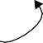
attached to inboard body

c.m.

Body

P’ P

N

c.m.

λˆ 2

λˆ b
One axis on outboard body to align with last inboard axis

Inboard Body
Second joint axis
attached to first axis, and so on...

For example, in setting up a gimbal joint, a roll-pitch-yaw sequence is definitely not equivalent to a pitch-yaw-roll sequence! This is especially important when tracking the individual joint axes is required. Also, for joints which provide both rotational and translational motion along different axes, the ordering defines which axes are rotational and which are translational. The pin axes for, say a gimbal joint would be entered in order from the inboard body to the outboard body as follows:
pin = x x x pin = x x x pin = x x x
where the same options of real numbers and variable parameters “?” apply. Although joint axes are unit vectors, the specified pins do not have to be. They will be normalized as required for SD/FAST internal use. Also note that pin axes of a multi-axis joint on a tree joint do not have to be successively perpendicular. However, pin joints on loop joints must be successively perpendicular. No pin vector for any joint can be specified as zero. See the individual joint descriptions below for more specific restrictions on the allowable joint axes.

The last hinge axis is considered attached to the outboard body. For joints entered already assembled (including all tree joints), the last joint axis is fixed in the outboard body in the orientation it has in the reference configuration. Also, all joint coordinates for already-assembled joints have a value of zero in the reference configuration.
However, when the joint is an unassembled loop joint, additional information is needed; namely, the orientation of the last joint axis in the outboard body (i.e., a “socket” into which to “plug” the last joint axis) and some reference lines to define zero.

When entering an unassembled loop joint, it is best to view the “break” in the joint as occurring between the last joint axis and the outboard body. That is, all the axes and intermediate frames of the joint should be viewed as though they were attached to the inboard body. Then an additional axis can be provided on the outboard body. When

assembled, this axis will be aligned with the last of the axes “attached” to the inboard body.

In addition to the extra axis on the outboard body (specified with the bodypin keyword), you can specify a reference line in the outboard body, using the bodyref keyword. The angle between this line and a specified line on the inboard body is defined as the pseudo-coordinate of the joint’s final axis (the one attached to the outboard body). For joints with multiple axes, the reference line on the inboard body is one of the joint axes (see each joint for a specification). For single axis joints (pin, slider, cylinder, and weld) you may specify an additional axis in the inboard body (called the inboard reference line and specified with the inbref keyword) to use for measuring the axis rotation. The reference lines will be given default values by
SD/FAST if they are unspecified, so unless you are interested in controlling loop joint pseudo-coordinate definitions you can safely ignore reference lines. Reference lines, if specified, must be perpendicular to the axis specified on the same body.

R11.3 Joint Numbering
A unique number is assigned by SD/FAST to each joint appearing in the System Desrip-tion file. This number is used to designate the joint in generated routines. For tree joints, the joint number is identical to the body number of the joint’s outboard body. (Bodies are numbered in the order their definitions appear in the System Description file.) Loop joints are numbered beginning at one greater than the highest-numbered tree joint, that is, at the highest body number plus 1.

The joint and body numbers assigned by SD/FAST may be seen in the Information File, as described in Section R9.

R11.4 Pin Joint
A pin joint is a one degree-of-freedom rotational joint. A diagram of an assembled pin joint is shown in Figure R-3. If the joint is entered into the system description file as as-sembled (or if you don’t care what defaults SD/FAST chooses for an unassembled joint), you only need to specify three vectors:
inbtojoint = x x x Vector from inboard body c.o.m. to hinge point P’.
bodytojoint = x x x Vector from body c.o.m. to hinge point P.
pin = x x x Vector defining joint axis on inboard body and body.

Figure R-3 Assembled Pin Joint (1-D Rotational Joint)




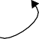
λˆ
pin

c.m.

Body

N

bodytojoint
c.m.

Inboard Body

inbtojoint
P
hinge axis
hinge point (also P’)

There are no restrictions on the values of these vectors, except that pin can not have a length of zero. All vectors are specified when the bodies are in the reference configura-tion in which all coordinate frames are aligned. Inbtojoint and bodytojoint are vectors fixed in their respective bodies with their components using the assumed units of length. Pin is a vector fixed in both bodies defining the joint axis orientation. A posi-tive increase in the coordinate defining the angle between the two bodies follows the right-hand-rule as defined by pin.

Figure R-4 Unassembled Pin Joint

pin

N
bodypin
Body

P
P’

Inboard Body
inbref bodyref

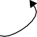
For an unassembled loop pin joint shown in Figure R-4, you may also specify an inboard reference line inbref, an outboard pin bodypin, and an outboard reference line bodyref. Inbref is required to be perpendicular to pin, and bodyref is required to be perpendicular to bodypin. After assembly, the hinge points are collo-

cated and the inboard and outboard pins are aligned. The angle between the reference lines is the value reported for the joint pseudo coordinate.
inbref = x x x Vector on inboard body defining the zero reference line. bodyref = x x x Vector on body defining the zero reference line. bodypin = x x x Vector defining joint axis on body.

R11.5 Slider Joint
A slider joint is a one degree-of-freedom translational joint. A diagram of an assembled slider joint is shown in Figure R-5. If the joint is entered into the System Description File as assembled (or if you don’t care what defaults SD/FAST chooses for an unassem-bled joint), you only need to specify three vectors:
inbtojoint = x x x Vector from inboard body c.o.m. to hinge point P’.
bodytojoint = x x x Vector from body c.o.m. to hinge point P.
pin = x x x Vector defining joint axis on inboard body and body.

There are no restrictions on the values of these vectors, except that pin can not have a length of zero. All vectors are specified when the bodies are in the reference configura-tion in which all coordinate frames are aligned. Inbtojoint and bodytojoint are vectors fixed in their respective bodies with their components using the assumed units of length. Pin is a unit vector fixed in both bodies defining the joint axis orientation. A positive increase in the coordinate defining the distance between the two bodies occurs as hinge point P moves in the direction of pin relative to the inboard body.

Figure R-5 Assembled Slider Joint (1-D Translational Joint)


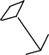

λˆ
pin

N

c.m.

Body

c.m.
bodytojoint

P

Inboard Body

inbtojoint
P’
hinge axis
hinge points

For an unassembled loop slider joint shown in Figure R-5, you may also specify an in-board reference line inbref, an outboard pin bodypin, and an outboard reference line bodyref. Inbref is required to be perpendicular to pin, and bodyref is re-quired to be perpendicular to bodypin. After assembly, the inboard and outboard pins

are aligned and the inboard and body reference lines are aligned (to set the relative ori-entation of the bodies, not to be a zeroing line for the pseudo-coordinate).

Figure R-6 Unassembled Slider Joint





Body
bodypin
N
pin
P
Inboard Body
P’
inbref
bodyref

Also, after assembly the displacement of P’ from P has no component perpendicular to the axis, that is, P’ lies on the sliding axis passing through P. The displacement (signed) between the hinge points is the value reported for the joint pseudo-coordinate. Note that assembly does not necessarily bring this displacement to zero as it does for the hinge points of purely rotational joints.
inbref = x x x Vector on inboard body defining the relative orientation. bodyref = x x x Vector on body defining the relative orientation. bodypin = x x x Vector defining joint axis on body.

R11.6 Cylinder Joint
A cylinder joint is a two degree-of-freedom joint composed of a slider followed by a pin joint. Both the slider and pin are on the same axis. A diagram of an assembled cylinder joint is shown in Figure R-7. If the joint is entered into the system description file as as-sembled (or if you don’t care what defaults SD/FAST chooses for an unassembled joint), you only need to specify three vectors:
inbtojoint = x x x Vector from inboard body c.o.m. to hinge point P’.
bodytojoint = x x x Vector from body c.o.m. to hinge point P.
pin = x x x Vector defining joint axis on inboard body and body.

Figure R-7 Assembled Cylinder Joint (1-D Translational Plus Coaxial 1-D Rotational Joint)






λˆ
pin

N

c.m.

D

Body

Inboard Body

c.m.

C
bodytojoint

P
P’ hinge points

inbtojoint
hinge axis

There are no restrictions on the values of these vectors, except that pin can not have a length of zero. All vectors are specified when the bodies are in the reference configura-tion in which all coordinate frames are aligned. Inbtojoint and bodytojoint are vectors fixed in their respective bodies with their components using the assumed units of length. Pin is a unit vector fixed in both bodies defining the joint axis orientation. A positive increase in the coordinate defining the distance between the two bodies occurs as hinge point P moves in the direction of pin relative to the inboard body. A positive increase in the coordinate defining the angle between the two bodies follows the right-hand-rule as defined by pin.
The first (lower-numbered) coordinate is the translational one, and the second is rota-tional. There is no explicit “reverse” cylinder joint. If your physical joint has the trans-lational and rotational components reversed, you can still use the joint as defined here. Because the rotational and translational axes are identical, a rotation does not re-orient the translational axis. That means that the two coordinates are independent and could have been modeled in either order. Just change the order and sign of your interpretation of the coordinates to obtain the effect of a reverse cylinder joint.

Figure R-8 Unassembled Cylinder Joint




bodypin
pin
Body
N
P
Inboard Body
P’
inbref
bodyref

For an unassembled loop cylinder joint shown in Figure R-7, you may also specify an inboard reference line inbref, an outboard pin bodypin, and an outboard reference

line bodyref. Inbref is required to be perpendicular to pin, and bodyref is re-quired to be perpendicular to bodypin. After assembly, the inboard and outboard pins are aligned. P’ lies on the sliding axis passing through P. The displacement (signed) be-tween the hinge points is the value reported for the joint translational pseudo coordinate. The angle between the reference lines is the value reported for the second joint pseudo coordinate.
inbref = x x x Vector on inboard body defining the zero reference line. bodyref = x x x Vector on body defining the zero reference line. bodypin = x x x Vector defining joint axis on body.

R11.7 Universal (Hooke’s) Joint
A Universal joint (U-joint) is a two degree-of-freedom joint composed of two pin joints. Both the pins intersect at hinge point P (equivalent to P’). A diagram of an assembled universal joint is shown in Figure R-9. If the joint is entered into the system description file as assembled (or if you don’t care what defaults SD/FAST chooses for an unassem-bled joint), you only need to specify four vectors:
inbtojoint = x x x Vector from inboard body c.o.m. to hinge point P’.
bodytojoint = x x x Vector from body c.o.m. to hinge point P.
pin = x x x Vector defining joint axis fixed on inboard body.
pin = x x x Vector defining joint axis fixed on body and w.r.t the first pin.

Figure R-9 Assembled Universal Joint (2-D Rotational Joint, U-joint, or Hooke’s Joint)



Body
λˆ 1
pin
hinge point (also P’)
c.m.
P
c.m.
λˆ 2
pin
bodytojoint

N

Inboard Body

inbtojoint

The restrictions on the values of these vectors are that pin cannot have a length of zero and the two pins cannot be collinear. Furthermore, if the joint is a loop joint, the two pins must be perpendicular. All vectors are specified when the bodies are in the refer-ence configuration in which all coordinate frames are aligned. Inbtojoint and bodytojoint are vectors fixed in their respective bodies with their components using the assumed units of length.

Note that the order that the pins are entered is important. The first pin is a vector fixed in the inboard body defining the joint axis orientation. The second pin is a vector fixed with respect to the first pin and w.r.t. the outboard body.10 A positive increase in the co-

ordinate defining the angle between the two bodies follows the right-hand-rule as de-
fined by each pin.

For an unassembled loop universal joint shown in Figure R-9, you may also specify an outboard pin bodypin, and an outboard reference line bodyref (no inbref is needed since the first inboard pin is used instead). Bodyref is required to be perpen-dicular to bodypin. After assembly, the hinge points are collocated and the second pin and bodypin are aligned. The first pseudo coordinate is the angle between the original orientation of the second inboard pin and the current orientation of the outboard bodypin. The second pseudo coordinate is the angle between the first inboard pin and bodyref.
bodyref = x x x Vector on body defining the zero reference line.
bodypin = x x x Vector defining joint axis on body.

Figure R-10 Unassembled Universal Joint

λˆ 1

N
pin

P’


Body
bodyref
P

Inboard Body
pin λˆ 2

bodypin

R11.8 Planar Joint
A planar joint is a three degree-of-freedom joint composed of two sliders followed by a pin joint. (A “reverse” planar joint is also available, in which the first axis is rotational and the second and third are translational.) All the pins intersect at hinge point P’ on the inboard body. Normally the two sliders are perpendicular to one another and the pin axis is perpendicular to both of the sliders (the perpendicularity is required for a loop planar joint, but not a tree planar joint). As an example, a planar joint describes the rela-tionship between a hockey puck and the ice (assuming the hockey puck remains in con-tact with the ice). A diagram of an assembled planar joint is shown in Figure R-11. If the joint is entered into the system description file as assembled (or if you don’t care what defaults SD/FAST chooses for an unassembled joint), you only need to specify five vectors:

- Since both pins are fixed with respect to each other, another way of looking at the joint would have both pins fixed to an inner massless gimbal body, as suggested by the figures.

inbtojoint = x x x Vector from inboard body c.o.m. to hinge point P’.
bodytojoint = x x x Vector from body c.o.m. to hinge point P.
pin = x x x Vector defining slider joint axis fixed on inboard body.
pin = x x x Vector defining second sliding axis fixed on inboard body.
pin = x x x Vector defining pin joint axis fixed on inboard body and body.

The restrictions on the values of these vectors are that no pin can have a length of zero and the two sliding pins can not be collinear. Furthermore, if the joint is a loop joint, all pins must be perpendicular with λˆ 3 = λˆ 1 × λˆ 2 (a right-handed set). All vectors are specified when the bodies are in the reference configuration in which all coordinate frames are aligned. Inbtojoint and bodytojoint are vectors fixed in their re-spective bodies with their components using the assumed units of length.

Figure R-11 Assembled Planar Joint (2-D Translational plus 1-D Rotational Joint)
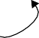
N
pin
λˆ 3
pin λˆ 2
Body
λˆ 1 pin
P’
c.m.
P
Inboard Body
c.m.
hinge points
bodytojoint
inbtojoint
Note that the order that the pins are entered is important. The first pin is a vector fixed in the inboard body defining the orientation of the first sliding axis. The second pin is a vector fixed with respect to the first pin which also defines the plane of sliding. The third pin is a vector fixed w.r.t. to the sliding plane and is a rotational axis. A positive increase in each coordinate defining the distance between the two bodies occurs as hinge point P moves in the direction of each of the first two pins relative to the inboard body. A positive increase in the coordinate defining the angle between the two bodies follows the right-hand-rule as defined by the third pin.

For an unassembled loop planar joint shown in Figure R-11, you may also specify an outboard pin bodypin, and an outboard reference line bodyref (no inbref is needed since an inboard pin is used instead). Bodyref is required to be perpendic-ular to bodypin. After assembly, the hinge points are both in a plane formed by the first two pins, and bodypin is aligned with the third inboard pin. The first two pseudo-coordinates are the vector from the inboard hinge point to the outboard hinge point, projected along the first two axes. The third pseudo coordinate is the angle between the first pin and bodyref.
bodyref = x x x Vector on body defining the zero reference line.
bodypin = x x x Vector defining joint axis on body.


Figure R-12 Unassembled Planar Joint

N


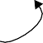
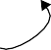
pin

λˆ 3

pin

P’

λˆ 2

λˆ 1

pin

bodyref
Body

bodypin
P
Inboard Body

R11.9 Gimbal Joint
A gimbal joint is a three degree-of-freedom joint composed of three pin joints. All the pins intersect at hinge point P (equivalent to P’). A diagram of an assembled gimbal joint is shown in Figure R-13. If the joint is entered into the System Description File as assembled (or if you don’t care what defaults SD/FAST chooses for an unassembled joint), you only need to specify five vectors:
inbtojoint = x x x Vector from inboard body c.o.m. to hinge point P’.
bodytojoint = x x x Vector from body c.o.m. to hinge point P.
pin = x x x Vector defining joint axis fixed on inboard body.
pin = x x x Vector defining joint axis fixed w.r.t the first pin.
pin = x x x Vector defining joint axis fixed on body and w.r.t the 2nd pin.

Figure R-13 Assembled Gimbal Joint (3-D Rotational Joint)

pin


inbtojoint λˆ 2

N

c.m.
hinge point (also P’)

P

c.m.

Body

Inboard Body
pin λˆ 1

λˆ 3
pin
bodytojoint

The restrictions on the values of these vectors are that no pin can have a length of zero and no two of the three pins can be successively collinear, i.e., neither λˆ 1 || λˆ 2 nor
λˆ 2 || λˆ 3 . Furthermore, if the joint is a loop joint, the pins must be successively perpen-
dicular, i.e., λˆ 1⊥λˆ 2 and λˆ 2⊥λˆ 3 . All vectors are specified when the bodies are in the ref-

erence configuration in which all coordinate frames are aligned. Inbtojoint and bodytojoint are vectors fixed in their respective bodies with their components using the assumed units of length.
Note that the order that the pins are entered is important. The first pin is a vector fixed in the inboard body defining the orientation of the first axis. The second pin is a vector fixed with respect to the first pin, and the third pin is a vector fixed w.r.t. the second pin and w.r.t. the outboard body. If the three pins form a right-handed triad such that
λˆ 3 = λˆ 1 × λˆ 2 , then the gimbal is equivalent to body-fixed 1-2-3 Euler angles. If
λˆ 1 || λˆ 3 , then we have body-fixed 1-2-1 Euler angles, and so on.

Gimbal joints suffer from a singularity called “gimbal lock.” This condition occurs when the first and third gimbal axes are aligned. In a physical gimbal joint, this is a con-figuration in which the normally three DOF joint allows only two DOFs. In SD/FAST, where the internal gimbals are modeled as massless, this is a singular configuration in which any torque applied to the first pin would result in infinite acceleration of one of the intermediate gimbals. Consequently, it is considered an error for a gimbal joint to be in this configuration. You should choose your axes carefully to make sure that the gim-bal will not have to operate at or near gimbal lock during any movement of the system. If unrestricted motion is required, a ball joint should be used rather than a gimbal.

The inner gimbal bodies shown in Figure R-13 are modeled as massless. If you want to model a system with gimbals having mass, you must build it up with pin joints and bod-ies.



Figure R-14 Unassembled Gimbal Joint

N

λˆ 2
pin

P’

Body
bodyref
P

pin
λˆ 1
λˆ 3
pin

bodypin

Inboard Body

For an unassembled loop gimbal joint shown in Figure R-14, you may also specify an outboard pin bodypin, and an outboard reference line bodyref (no inbref is needed since an inboard pin is used instead). Bodyref is required to be perpendic-ular to bodypin. After assembly, the hinge points are collocated. There are three pseudo-coordinates described as follows.

In the reference configuration, the pins are given as expressed in the inboard body’s frame, which is itself aligned with the global frame. Let p2 and p3 be vectors expressed

in the gimbal’s first intermediate frame which initially were aligned with the second and third pins λˆ 2 and λˆ 3 , respectively. The first pseudo coordinate is the angle between λˆ 2 and p2. The second pseudo-coordinate is the angle between p3 and the outboard
bodypin. The third pseudo-coordinate is the angle between p2 and the outboard
bodyref line.11
bodyref = x x x Vector on body defining the zero reference line.
bodypin = x x x Vector defining joint axis on body.

R11.10 Ball Joint
A ball joint shown in Figure R-15 allows no pins and no reference axes. Its motion is al-ways modeled as a relationship between the local coordinate frames of the two connect-ed bodies. Where axes are desired, a gimbal joint should be used in place of a ball. Ball joint orientations (whether used alone or in a sixdof joint) are represented by quater-nions (Euler parameters) for numerical stability (see Section R6). Some utility routines are provided for conversion among Euler parameters, direction cosines and Euler an-gles. A drawback of quaternions is that they cannot capture “tumbling” motion, that is, they represent only the relative orientations between the connected bodies not how many times they may have rotated to end up in their current orientations. If tumbling is to be modeled, it must either be tracked by user-written code, or a gimbal joint should be used in place of the ball.

Figure R-15 Assembled Ball Joint (3-D Rotational Joint without axes)

y
N
c.m. Bod
P
bodytojoint
c.m.
Inboard Body
hinge point (also P’)
inbtojoint

No pins or reference lines are allowed for this joint. After assembly, the hinge points are collocated. The four pseudo coordinates are the Euler parameters expressing the relative orientation of the outboard body’s local frame with respect to the inboard body’s local frame.
inbtojoint = x x x Vector from inboard body c.o.m. to hinge point P’.
bodytojoint = x x x Vector from body c.o.m. to hinge point P.

- While this definition of the pseudo-coordinates is somewhat awkward, it is actually a very natural one in practice. This is best seen by experimenting with a loop gimbal joint to compare the reported pseudo-coordinates with your expectations.

An unassembled ball joint is shown in Figure R-16.

Figure R-16 Unassembled Ball Joint

Body
P

N

Inboard Body
P’

R11.11 Bearing Joint
A bearing joint is a four degree-of-freedom joint composed of a slider followed by a gimbal joint. (A “reverse” bearing joint is available which is equivalent to a gimbal joint followed by a sliding joint.) One of the most common uses for this joint is for re-dundancy-free modeling of shaft bearings, hence the name. This joint is like a race of ball bearings through which a shaft can translate as well as rotate and tip (slightly).
Since this joint contains a gimbal, it has the same singularity as a gimbal joint and is not intended for use when the outboard body can attain arbitrary orientations with respect to the inboard body. It is not, however, restricted to small angles; it just cannot be used near the “gimbal lock” configuration.

All the pins intersect at hinge point P’. A diagram of an assembled bearing joint is shown in Figure R-17. If the joint is entered into the System Description File as assem-bled (or if you don’t care what defaults SD/FAST chooses for an unassembled joint), you only need to specify five vectors:
inbtojoint = x x x Vector from inboard body c.o.m. to hinge point P’.
bodytojoint = x x x Vector from body c.o.m. to hinge point P.
pin = x x x Vector defining joint axis fixed on inb. body (rot & trans).
pin = x x x Vector defining joint axis fixed w.r.t the first pin.
pin = x x x Vector defining joint axis fixed on body and w.r.t the 2nd pin.

The restrictions on the values of these vectors are the same as for a gimbal joint. All vectors are specified when the bodies are in the reference configuration in which all co-ordinate frames are aligned. Inbtojoint and bodytojoint are vectors fixed in their respective bodies with their components using the assumed units of length.

Note that the order that the pins are entered is important. The first pin is a vector fixed in the inboard body defining the orientation of the first axis. This pin is used as the bear-ing’s translational axis as well as its first rotational axis. The second pin is a vector fixed with respect to the first pin, and the third pin is a vector fixed w.r.t. the second pin and w.r.t. the outboard body.

Figure R-17 Assembled Bearing Joint (1-D Translational plus 3-D Rotational Joint)

λˆ 3

pin

N

inbtojoint P

P’
λˆ 1
Body

bodytojoint

pin

Inboard Body
λˆ 2
pin


Figure R-18 Unassembled Bearing Joint

N

inbtojoint

λˆ 1
pin
λˆ 3

pin

P’

Inboard Body

λˆ 2

pin

bodypin

P

Body

bodyref

For an unassembled loop bearing joint shown in Figure R-18, you may also specify an outboard pin bodypin, and an outboard reference line bodyref (no inbref is needed since an inboard pin is used instead). Bodyref is required to be perpendic-ular to bodypin. After assembly, the hinge points will both lie along the translational (first) axis, but will not necessarily be collocated. There are four pseudo-coordinates. The first is the (signed) displacement giving the displacement of P from P’ along the

translational axis. The remaining three have the same definition as the three pseudo-coordinates of a loop gimbal joint (see above).
bodyref = x x x Vector on body defining the zero reference line.
bodypin = x x x Vector defining joint axis on body.

R11.12 Bushing Joint
The bushing joint shown in Figure R-19 represents unrestricted motion between two bodies, and is actually implemented as three sliding joints followed by a gimbal joint. (A “reverse” bushing joint is available which is equivalent to a gimbal joint followed by three sliding joints.) One of the most common uses for this joint is as the underlying joint connecting two bodies which are physically connected by a bushing. Bushing forces are easily computed with respect to the bushing joint axes, which form the coor-dinate frame for the bushing.

Since this joint contains a gimbal, it has the same singularity as a gimbal joint and is not intended for use when the outboard body can attain arbitrary orientations with respect to the inboard body. It is not, however, restricted to small angles; it just cannot be used near the “gimbal lock” configuration. If unrestricted orientations are required, you should use a free joint instead of a bushing (see below).

Figure R-19 Bushing Joint (3-D Translational plus 3-D Gimbal Joint)



bodypin

N

pin
λˆ 3 P
bodyref

Body

inbtojoint

P’

pin
λˆ 2

bodytojoint

Inboard Body
λˆ 1
pin

If the bushing joint is a loop joint, then three mutually perpendicular axes are required
for this joint, forming a right-handed set, i.e., λˆ 3 = λˆ 1 × λˆ 2 . These axes are the transla-
tional axes and are also used as the reference configuration orientations for the rota-tional axes. If the bushing joint is a tree joint, the perpendicularity requirement is dropped, but no two joint axes may be collinear.

Note that even if this is a loop bushing, it is always assembled. The first three pseudo-coordinates are the vector from the inboard hinge point to the outboard hinge point,

projected along each of the translational axes. The last three pseudo coordinates are defined exactly as for a loop gimbal joint (see above).

The vectors are required for any bushing joint, tree or loop:
inbtojoint = x x x Vector from inboard body c.o.m. to hinge point P’.
bodytojoint = x x x Vector from body c.o.m. to hinge point P.
pin = x x x Vectors defining sliding axes. All are fixed on the
pin = x x x inboard body.
pin = x x x

These vectors are optional for loop bushings:
bodyref = x x x Vector on body defining the zero reference line.
bodypin = x x x Vector defining joint axis on body.

R11.13 Free (6dof) Joint
The free joint (a.k.a. 6dof joint) shown in Figure R-20 represents unrestricted motion between two bodies, implemented as three sliding joints followed by a ball joint. (A “reverse” free joint is available which is equivalent to a ball joint followed by three slid-ing joints.) A free joint is used by default between the base body of a free-flying system and the ground. Note that this joint provides the identical motion as a “bushing” joint (see above) but a free joint has no singularities while the bushing joint can suffer from gimbal lock.

Figure R-20 Free Joint (3-D Translational plus 3-D Ball Joint)




pin

N

Body

inbtojoint
λˆ 3 P
c.m.

Inboard Body

c.m.

P’

λˆ 1
pin
pin
λˆ 2

bodytojoint

hinge points

If the free joint is a loop joint, then three mutually perpendicular axes are required for this joint, forming a right-handed set, i.e., λˆ 3 = λˆ 1 × λˆ 2 . These axes are all transla-tional. If the free joint is a tree joint, the perpendicularity requirement is dropped, but no two joint axes may be collinear.

When used as a loop joint, note that the free joint is always assembled. The first three pseudo coordinates are the vector from the inboard hinge point to the outboard hinge point, projected along each of the axes. The last four pseudo coordinates are the Euler

parameters expressing the relative orientation of the outboard body’s local frame with respect to the inboard body’s local frame.
inbtojoint = x x x Vector from inboard body c.o.m. to hinge point P’.
bodytojoint = x x x Vector from body c.o.m. to hinge point P.
pin = x x x Vectors defining sliding axes. All are fixed on the
pin = x x x inboard body.
pin = x x x

No bodypin or bodyref vectors are allowed for a free joint.

R11.14 Weld Joint
A weld is a zero DOF joint which simply joins two bodies together as shown in Figure R-21.

No pins are allowed for the tree form of this joint. However, for loop weld joints you may specify an inboard and outboard pin and an inboard and outboard reference line. After assembly, the hinge points are collocated, the inboard and outboard pins are aligned, and the inboard and outboard reference lines are aligned. There are no pseudo coordinates for this joint.
inbtojoint = x x x Vector from inboard body c.o.m. to hinge point P’.
bodytojoint = x x x Vector from body c.o.m. to hinge point P.
pin = x x x Vector defining joint “axis” on inboard body and body.
bodypin = x x x Vector defining joint “axis” on body.
inbref = x x x Vector on inboard body defining the reference line.
bodyref = x x x Vector on body defining the reference line.

Figure R-21 Assembled Weld Joint (Zero DOF Joint)

y
c.m. Bod
P
bodytojoint
c.m.
hinge point (also P’)
inbtojoint

N

Inboard Body

An unassembled weld joint is shown in Figure R-21.

Figure R-22 Unassembled Weld Joint

inbref

N

P’
bodyref


P
Body

pin
bodypin

Inboard Body

R12 Kinematic Information

Each body in the system has linear and angular position, velocity and acceleration. Ev-ery joint axis also has a position, velocity, and acceleration which may be linear or an-gular depending on the joint type. In addition, the system as a whole has angular and linear momentum, and kinetic energy. There are aggregate mass properties for the sys-tem as well (total system mass, center of mass location, and system inertia matrix).
SD/FAST generates a collection of routines for use in retrieving these values, which we collectively call kinematic information. In addition, there are routines for manipulating this information. These routines are described below.

R12.1 Body-Specific Information
The routines in this section return body kinematic information as last computed by SDSTATE() (for positions and velocities) or SDDERIV() or SDRESID() (for accel-erations). These are data access routines, that is, they do very little computation; rather, they report information that has already been calculated. Thus they are relatively inex-pensive to call.

It is allowed for the body number to be the ground body (0 for Fortran, -1 for C), in which case the routines simply return the appropriate response, e.g. the angular velocity is zero.
SUBROUTINE SDPOS(BODY,POINT,LOC) INTEGER BODY
DOUBLE PRECISION POINT(3),LOC(3)

SUBROUTINE SDVEL(BODY,POINT,VEL) INTEGER BODY
DOUBLE PRECISION POINT(3),VEL(3)

SUBROUTINE SDACC(BODY,POINT,ACC) INTEGER BODY
DOUBLE PRECISION POINT(3),ACC(3)

SUBROUTINE SDORIENT(BODY,DIRCOS) INTEGER BODY
DOUBLE PRECISION DIRCOS(3,3)

SUBROUTINE SDANGVEL(BODY,ANGVEL) INTEGER BODY
DOUBLE PRECISION ANGVEL(3)

SUBROUTINE SDANGACC(BODY,ANGACC) INTEGER BODY
DOUBLE PRECISION ANGACC(3)

SDPOS() returns the location with respect to the global origin of a point on a body. The point is expressed in the body-local frame so point (0,0,0) yields the location of the center of mass. The returned location is expressed in the ground frame.

SDVEL() returns the linear velocity with respect to ground of a point on a body. The point is expressed in the body-local frame so point (0,0,0) yields the velocity of the cen-ter of mass. The returned velocity is expressed in the ground frame.

SDACC() returns the linear acceleration with respect to ground of a point on a body. The point is expressed in the body-local frame so point (0,0,0) yields the acceleration of the center of mass. The returned acceleration is expressed in the ground frame.

SDORIENT() returns the orientation of a body with respect to the ground frame, ex-pressed as a direction cosine mapping a ground frame vector into a body frame vector. That is, if NC B is the returned direction cosine and vN a vector expressed in the ground frame, then vB = vN•NC B is that same vector expressed in the body frame.

SDANGVEL() returns a body’s angular velocity with respect to the ground frame, but expressed in the body-local frame.

SDANGACC() returns the angular acceleration of the body frame with respect to the ground frame, but expressed in the body frame.

R12.2 System-Wide Information
These routines return system-global information, using information computed by the previous call to SDSTATE(). They are computational routines; that is, they are rela-tively expensive to call so they should be called only once per integration communica-tion interval.
SUBROUTINE SDMOM(LM,AM,KE) DOUBLE PRECISION LM(3),AM(3),KE

SUBROUTINE SDSYS(MTOT,CM,ICM)
DOUBLE PRECISION MTOT,CM(3),ICM(3,3)

SDMOM() returns absolute linear and angular momentum for the system with respect to ground, in the ground frame, in LM and AM. Angular momentum is referred to the sys-tem center of mass. KE is total system kinetic energy from rotation and translation.

SDSYS() returns the total system mass in MTOT, the system center of mass location with respect to ground in CM and the system inertia matrix for the system center of mass, measured in the ground frame, in ICM.

R12.3 Data Manipulation
These routines are used to manipulate information obtained from the routines above or from other sources.
SUBROUTINE SDTRANS(FROMBODY,VEC,TOBODY,OVEC) INTEGER FROMBODY,TOBODY
DOUBLE PRECISION VEC(3),OVEC(3)

SUBROUTINE SDQUAT2DC(E1,E2,E3,E4,DIRCOS) DOUBLE PRECISION E1,E2,E3,E4,DIRCOS(3,3)

SUBROUTINE SDDC2QUAT(DIRCOS,E1,E2,E3,E4) DOUBLE PRECISION DIRCOS(3,3),E1,E2,E3,E4

SUBROUTINE SDANG2DC(A1,A2,A3,DIRCOS) DOUBLE PRECISION A1,A2,A3,DIRCOS(3,3)

SUBROUTINE SDDC2ANG(DIRCOS,A1,A2,A3) DOUBLE PRECISION DIRCOS(3,3),A1,A2,A3

SDTRANS() transforms a vector from one frame into another. Despite its name, this is a pure rotational transformation, not a translation. The starting frame is specified by a body number in FROMBODY. The input vector VEC is assumed to be expressed in that frame. The desired frame is given by TOBODY, and the resulting vector is returned in OVEC. It is fine for OVEC and VEC to be the same Fortran or C array. The ground frame is specified as body 0 (in Fortran) or -1 (in C).

SDQUAT2DC() and SDDC2QUAT() convert quaternions (Euler parameters) to/from direction cosines. SDQUAT2DC() normalizes the quaternions (internally) before using them. (0,0,0,0) is treated as (0,0,0,1).

SDANG2DC() and SDDC2ANG() perform the same service for body-fixed 1-2-3 Euler angles. Note that although “tumbling” motion can be captured by Euler angles, it is lost in the conversion either to quaternions or direction cosines. Euler angles with tumbling information can be obtained directly only through the use of gimbal-containing joints.

C Language
sdpos(body,point,loc) int body;
double point[3],loc[3];

sdvel(body,point,vel) int body;
double point[3],vel[3];

sdacc(body,point,acc) int body;
double point[3],acc[3];

sdorient(body,dircos) int body;
double dircos[3][3];

sdangvel(body,angvel) int body;
double angvel[3];

sdangacc(body,angacc) int body;
double angacc[3];

sdmom(lm,am,ke)
double lm[3],am[3],*ke;

sdsys(mtot,cm,icm)
double *mtot,cm[3],icm[3,3];

sdtrans(frombody,vec, tobody,ovec) int frombody,tobody;
double vec[3],ovec[3];

sdquat2dc(e1,e2,e3,e4,dircos) double e1,e2,e3,e4,dircos[3][3];

sddc2quat(dircos,e1,e2,e3,e4)
double dircos[3][3],*e1,*e2,*e3,*e4;

sdang2dc(a1,a2,a3,dircos) double a1,a2,a3,dircos[3][3];

sddc2ang(dircos,a1,a2,a3)
double dircos[3][3],*a1,*a2,*a3;

R13 Mass Properties

Each body in the system must have a mass and inertia matrix specified. In this section we discuss the definitions of these parameters as used by SD/FAST, and the restrictions on their allowable values. The special cases of zero mass (massless or inertialess bod-ies) and infinite mass (ground) are also discussed here. Section R19 shows how mass, inertia, and ground are entered into the System Description File.

R13.1 Mass
Mass is a scalar quantity. Generally speaking, there are no restrictions on the values al-lowable for a body’s mass. However, a problem can become numerically poorly condi-tioned if bodies of widely varying mass appear in the same problem.
If your model contains bodies whose masses differ by a factor of about 106 or more, you should consider whether a different model might be more appropriate. You could model some of the bodies as massless. Or, you might break the problem into separate analyses with the more massive bodies treated as ground in an analysis of a model containing only the smaller bodies. See Section R13.3 and Section R13.4 below for more informa-tion.

R13.2 Inertia
The inertia matrix (alternatively dyadic or tensor of second order) of each body is speci-fied about the mass center of that body, for that body in the reference configuration. For any coordinate frame with unit vector subscripts 1,2,3 (remember all the coordinate frames are aligned in the reference configuration) the inertia matrix I is given by:

nˆ 2

where:
I 11 I 12 I 13
I = I 21 I 22 I 23
I 31 I 32 I 33


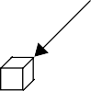
I ≡ ( x² + x²)dm
x₃
dm
x₂
x₁
nˆ
nˆ 3
I ≡ – x x dm
I ≡ – x x dm

11 ∫ 2 3
22 ∫ 1 3
12 ∫ 1 2
13 ∫ 1 3

I 21 ≡ I 12
I ≡ ( x² + x²)dm
I 23 ≡ –∫x2 x3dm

I 31 ≡ I 13
I 32 ≡ I 23
I ≡ ( x² + x²)dm

and xi is the distance from the mass center to mass element dm along the axis in the di-
33 ∫ 1 2
1 rection of nˆ i . Note that the minus sign in the definitions of the products of inertia may be a different convention from your sources of mass property information.13 To im-
prove your simulation efficiency, try to pick reference configurations in which products of inertia are zero for as many of the bodies as possible.

- Dynamicists usually use the minus sign while some structural analysts use a positive sign convention. Be careful!

R13.3 Massless and Inertialess Bodies
Massless and inertialess bodies can be used as fictitious bodies to aid construction of custom joints. In addition, when some bodies in a system have masses or inertias a great deal smaller than others, it often makes sense to treat them as though they had no mass or inertia at all. When a body is entered with a zero mass or principal inertia, the SD/FAST symbol manipulator can greatly simplify the equations of motion, and can avoid most of the numerical conditioning problems which can occur in problems con-taining bodies of widely varying mass and inertia. There is, however, an important re-striction on the use of this feature.

Recall that SD/FAST models are structured as a set of bodies and joints which form a topological “tree” plus an additional set of joints (loop joints) which connect branches of the tree to form topological loops. Looking only at the tree system with the loop joints removed, a massless or inertialess body is not allowed if there exists any joint axis (or joint degree of freedom) on which an applied load would accelerate only the mass-less body or a set of massless bodies, or would produce a rotational acceleration only on a body or set of bodies with no inertia about the axis of rotation. Since this would pro-duce infinite accelerations, the model would become numerically ill-conditioned and any results obtained from analysis using this model would be invalid.

Another way of expressing the above restriction is to say that a massless or inertialess body is only allowed if any force applied to the massless body or torque applied in the inertialess direction “drags along” a body with mass or inertia as well, when considering only the tree joints in the system. A body with neither mass nor inertia is never allowed as the terminal body of a tree branch, since the lack of an outboard body in that case means that a load applied at the body’s inboard joint would produce infinite accelera-tion. A non-terminal massless or inertialess body can also be illegal if a load on either its inboard or outboard joints could cause infinite acceleration.

The above restriction applies without regard to the presence or absence of prescribed motion. That is, even if a massless body’s motion is prescribed so that it can never un-dergo any large accelerations, the model will be numerically intractable if the massless body could have undergone these accelerations if the prescribed motion were removed.

It is important to note that the presence of massless or inertialess bodies should be taken into account when choosing where to break loops when modeling the system. You must avoid making choices which can produce a terminal massless or inertialess body in the resulting tree system. This is discussed more in Section R11.1.

R13.4 Ground
At the opposite extreme from massless bodies is ground, or the inertial frame. Ground is considered to be of “infinite mass”. Again, the SD/FAST symbol manipulator can produce much better equations if extremely massive bodies (with respect to other bodies in the system) can be modeled as ground.

Generally, engineering judgement is a sufficient guide to the use of ground to represent massive bodies in a system. For example, when modeling an automobile, the Earth can safely be treated as ground. In some cases, the decision can be more difficult. For a rig-

orous treatment, see Dynamics: Theory and Applications, Kane, T.R., and Levinson, D.A., McGraw-Hill, New York, 1985, pp. 158-169.

R14 Prescribed Motion

Normally the motion of a joint axis is calculated by SD/FAST as a function of the cur-rent system state and the forces acting on the system. Instead, the motion can be pre-scribed, usually as a function of time but in general as a function of time and some system states. When the motion is prescribed, SD/FAST calculates the actuator force or torque which would be required at that axis to produce the desired motion. (Use SDGETHT() to obtain the computed value; see Section R10.2.)
The System Description File must request prescribed motion if it is to be used. If a question mark is used in the specification(see Table R-3 on page R-108), then prescribed or free motion can be controlled at run time and in fact can be turned on and off during a simulation. When turning prescribed motion on, you must be careful to see that all con-straint conditions are met so that no discontinuous change in position or velocity is re-quired. A routine is provided for enabling and disabling prescribed motion.

Prescribed motion is implemented as a constraint, requiring one constraint equation (and consequently one multiplier) for each joint axis whose motion is to be prescribed. Routines are available for providing desired accelerations, velocities and positions to SD/FAST for prescribed axes. These routines must be called whenever system deriva-tives are to be computed with SDDERIV() or SDRESID(). Generally, all specifica-tions of prescribed motion should be grouped together in the user-written sdumotion() routine, just as forces are grouped in sduforce(). See Section R15.3.2 for information on writing the sdumotion() routine.

When using the ODE formulation (as implemented in SDDERIV()), prescribed motion is supplied as an acceleration constraint. Velocity and position constraints are optional-ly provided to control initial conditions and to provide numerical stability. When using the DAE formulation (as implemented in SDRESID()), prescribed motion is supplied as a velocity constraint. A position constraint is optionally provided to control initial conditions and to provide numerical stability. In that case the acceleration constraint is used only for initialization of constraint multipliers.

The routines available for dealing with prescribed motion are described below.
SUBROUTINE SDPRESACC(JOINT,AXIS,ACC) INTEGER JOINT,AXIS
DOUBLE PRECISION ACC

SUBROUTINE SDPRESVEL(JOINT,AXIS,VEL) INTEGER JOINT,AXIS
DOUBLE PRECISION VEL

SUBROUTINE SDPRESPOS(JOINT,AXIS,POS) INTEGER JOINT,AXIS
DOUBLE PRECISION POS

SUBROUTINE SDPRES(JOINT,AXIS,PRES) INTEGER JOINT,AXIS,PRES

SUBROUTINE SDGETPRES(JOINT,AXIS,PRES) INTEGER JOINT,AXIS,PRES
SDPRESACC() is used to set the desired acceleration for a particular joint axis. Pre-scribed acceleration may be a function of time and any state variables. For a ball joint, three calls to SDPRESACC() are used to provide the prescribed angular acceleration vector. The prescribed acceleration is set to zero by SDSTATE(), so SDPRESACC() must be called between SDSTATE() and SDDERIV() to have any effect. (The Sim-plified Analysis Routines issue a call to the user-written sdumotion() routine in the appropriate place.) SDDERIV() uses this value to compute accelerations and con-straint multipliers. Note that if SDPRESACC() is not called for a prescribed joint axis, the effect is to prescribe the acceleration of that axis to zero.

SDPRESVEL() and SDPRESPOS() are used to provide required values for the current velocities and positions, respectively. During a motion analysis (integration) these rou-tines will have no effect unless stabilization has been enabled with SDSTAB(). Pre-scribed velocity may be a function of time and any state position variables. Prescribed position may be a function of time only. SDPRESVEL() is optional unless you are us-ing the SDRESID() routine (generally because you are using a DAE integrator). For a ball joint, three calls to SDPRESVEL() are used to provide the prescribed angular ve-locity vector. SDPRESPOS() is always optional, and is not allowed for use with ball joints. However, if supplied these routines will affect Initial Velocity and Assembly analyses, respectively. Also, they can add numerical stability during integration if stabi-lization feedback constants have been set non-zero (see Section R4.2). Generally, it is best to provide the prescribed velocities and positions if you have them available, but don’t turn on stabilization unless monitoring of constraint errors shows that it is neces-sary. If you do provide these, you must compute the velocity from a function which is the integral of the prescribed acceleration, and the position must come from a function which is the integral of the velocity. You cannot set them to arbitrary values as you can with the acceleration provided to SDPRESACC(). SDSTATE() sets the prescribed velocity and position to the current state values, so these routines must be called after SDSTATE() and before SDDERIV() or SDRESID() in order to have an effect.
Note that if these routines are not called for a prescribed joint axis, the effect is to leave
the velocity and position for that axis unconstrained.

If you are going to attempt to provide loop-joint prescribed position, using
SDPRESPOS() can be tricky since rotational loop q’s are always measured from -π to
π regardless of the number of turns. If your desired position is outside that range, you should integrate loop q˙ ’s (from SDPSQDOT()) yourself and report them via an SDPSSTATE() call following your SDSTATE() call. (See Section R20.3 for details.) Normally, stabilizing just by specifying the velocity will be sufficient so we recommend that you not use SDPRESPOS() for rotational loop joint axes unless you are having a measurable stabilization problem. (This can be checked by reducing your desired q into the -π to π range and seeing if it is acceptably close to the loop q returned by SDPSEUDO().) A simpler alternative is to choose different “cuts” for your loops so

that you can prescribe motion at a tree joint rather than a loop joint. This can always be done (at some cost in execution time) by splitting a loop inside a body rather than at a joint (see Section R16.1).

For the DAE method, using SDRESID() instead of SDDERIV(), it is the velocities that are prescribed rather than the accelerations. This is done using SDPRESVEL(), giving the desired velocity. This value is then used by SDRESID(). The function used to generate values for SDPRESVEL() must not have any discontinuities, although it does not have to be smooth.

SDPRES() is used to turn prescribed motion on or off at a particular joint axis, assum-ing that axis was designated as having “runtime” prescribed motion (i.e., a question mark appeared in the appropriate place in the System Description File). The PRES pa-rameter is an integer, with 0 indicating that the axis motion is free and 1 indicating that it is prescribed.

SDGETPRES() returns PRES as an integer 0 or 1 to allow a test (most commonly in sdumotion() and sduforce()) to see whether axis motion is currently free or pre-scribed.

C Language
sdpresacc(joint,axis,acc) int joint,axis;
double acc[3];

sdpresvel(joint,axis,vel) int joint,axis;
double vel[3];

sdprespos(joint,axis,pos) int joint,axis;
double pos[3];

sdpres(joint,axis,pres) int joint,axis,pres;

sdgetpres(joint,axis,pres) int joint,axis,*pres;

R15 Program Structure

SD/FAST generates subroutines for use in constructing various analyses of the input system. To use these routines, the user needs to write a simulation program in Fortran, C, or a simulation language like ACSL, Easy 5, Simulink, or Matrix-X which can call Fortran or C routines.

Normally, only a small fraction of the generated routines need be used for any particular analysis. There are several routines, called Simplified Analysis Routines, which contain commonly used “canned” analyses. When these are used, direct calls to most of the generated routines are unnecessary.

The following summarizes the recommended program structure, both for Simplified Analysis Routines and the more basic tools.

R15.1 Usage with Simplified Analysis Routines
The Simplified Analysis Routines are present in the Simplified Analysis File (suffix like “_sar.f” or “_s.f”) generated by SD/FAST. This file need not be compiled and linked with your analysis program if you are not going to use these routines. However, even if you don’t use these routines you may find the contents of the “_sar” file helpful as examples of how to set up an analysis using an integrator or root finder.

There is always one subroutine which must be written by the user when using the Sim-plified Analysis Routines. That routine, called sduforce (or more generally,
<prefix>uforce where <prefix> is the routine prefix specified when SD/FAST was run), applies forces to the model as a function of time and state. Three routines are pro-
vided for applying a force at a point, a torque on a body, and a hinge torque or force (see Section R2.2). Even if there are no forces applied (or if the only force is gravity, which is provided automatically if requested) an empty sduforce() routine must be provid-ed if any of the Simplified Analysis Routines are to be used.

If there is any prescribed motion defined for the system (even if it is currently disabled) an additional routine (called sdumotion) must be provided to apply the prescribed motions as a function of time and state.

Following are the basic steps for organizing an analysis program built around the Sim-plified Analysis Routines.
- write sdumotion and sduforce routines see below
- set variable system parameters (?’s) SDMASS,SDPIN,...
- initialize system SDINIT
- close loops by adjusting q’s SDASSEMBLE
- compute compatible velocities (u’s) SDINITVEL
- perform static or steady analyses if needed SDSTATIC, SDSTEADY

- perform motion (dynamic) analysis if needed:
for each communication interval
  - integrate equations across interval SDMOTION,SDFMOTION
  - compute system momentum, energy, mass SDMOM, SDSYS
  - compute reaction forces SDREAC
  - output quantities of interest
- check for usage errors SDPRINTERR

Example
The following example shows an analysis of the crank mechanism whose System De-scription File is shown in Section R19.3 on page R-112. The Simplified Analysis Rou-tines are used to find compatible initial conditions for the mechanism and to perform a dynamic (motion) analysis.
program crank integer NQ,NU,NEQ
parameter (NQ=3, NU=3, NEQ=NQ+NU) integer lock(NU),fcnt,err,i,flag
double precision state(NEQ),dstate(NEQ),t,dt,ctol,tol data lock/1,0,0/, dt,ctol,tol/.01d0,1d-5,1d-6/
c Set init conds q1 q2 q3 u1 u2 u3 to a starting guess. data state/0d0,0d0,0d0,1d0,1d0,-1d0/, t/0d0/
call SDINIT

c Perform assembly and velocity analysis. q1 and u1
c are locked, while the others are varied until compatible. call SDASSEMBLE(t,state,lock,1d-7,1000,fcnt,err) print 10,’sdassemble’,err,fcnt
call SDINITVEL(t,state,lock,1d-7,1000,fcnt,err) print 10,’sdinitvel’,err,fcnt
10 format(’ ’, a10,’ returned err=’,i5,’ fcnt=’,i5) print 20,’qic=’,(state(i),i=1,NQ)
print 20,’uic=’,(state(nq+i),i=1,NU)
20 format(’ ’, a5, 3f12.5)

c Do a motion analysis, printing out q1 and u1 at 100
c timesteps, each ‘dt’ apart. Constraints must be maintained to
c ‘ctol’. The integration will be performed to a tolerance ‘tol’. flag = 1
do 40 i=1,100
call SDMOTION(t,state,dstate,dt,ctol,tol,flag,err) print 30,t,state(1),state(nq+1),err
30 format(’ ’,3f12.5,i5)
40 continue

c Check for usage errors. call SDPRINTERR(6)
end

c Apply the damping torque to the crank joint. subroutine sduforce(t,q,u)
double precision t,q(*),u(*),damping data damping/3d0/
call SDHINGET(1,1,-damping*u(1)) return
end

R15.2 Usage with General Analysis Routines
For analyses which do not use the Simplified Analysis Routines, we still recommend or-ganizing your program with sduforce() and sdumotion() routines even though they are not required. In addition you may need to write several other routines which are described in this section.

To use an integrator, you will need to write a subroutine for the integrator to call when it needs state derivatives calculated. We will call this subroutine sduderiv(), although you may use any convenient name.

To use the root finder, you will need to write a routine for it to call when it needs to eval-uate its current solution estimate. We refer to this routine as sdueval(), although you may use any convenient name.

The routines sduaerr(), sduverr(), sduperr(), and sduconsfrc() are re-quired if there are user constraints in the system. Most users will not need user con-straints and hence will not have to write these routines. If present, these routines must have the indicated names. See Section R24 for further discussion of user constraints.

Following are the basic steps for organizing an analysis program using more of the ca-pabilities of the generated routines.
- write sdumotion and sduforce routines see below
- if integrating, write sduderiv routine see below
- if using root finder, write sdueval routine see below
- write user constraint routines, if needed see Section R24
for each system variant
- set variable system parameters SDMASS, SDPIN,...
for each analysis of this variant
- initialize system SDINIT
- compute compatible initial q’s SDASSEMBLE or SDROOT
- compute compatible initial u’s SDINITVEL or SDROOT
- find roots of nonlinear equations, if desired SDROOT
- perform dynamic (motion) analysis
  - initialize derivatives sduderiv
for each communication interval
    - integrate equations across interval SDVINTEG, SDFINTEG
    - compute system momen., energy, mass SDMOM, SDSYS
    - compute reaction forces SDREAC
    - output quantities of interest
next communication interval next analysis
next system variant
- check for usage errors SDPRINTERR

For simple examples of the usage of the SDROOT(), SDFINTEG(), and SDVINTEG() routines, examine the implementations of SDASSEMBLE(), SDINITVEL(), SDMOTION(), etc., in a generated Simplified Analysis File.

R15.3 Structure of User Written Routines
Below are outlines of how the user written routines are constructed, as well as some ex-amples.

R15.3.1 The sduforce() Routine
The user-written sduforce() routine should be declared like this:
subroutine sduforce(t,q,u) parameter (NQ=..., NU=...)
double precision t,q(NQ),u(NU)

The basic structure of the routine is as follows:
- obtain any needed kinematic information SDPOS, SDVEL,...
- apply point forces and body torques SDPOINTF, SDBODYT
- apply hinge torques SDHINGET

Example
This example shows an sduforce() routine implementing a spring between two points and a damper on a joint axis.

The spring is stretched between point (1,2,3) on body 1 (ARM) and point (1,1,0) on body 2 (CHASSIS). The spring constant is K = 10, and the natural length of the spring is L = 5. The damper is acting on the first axis of joint 3. The damping constant is C = 2. Note that this system must not be run in a configuration in which the two spring connection points are coincident, since it is impossible to determine the force di-rection in that case.
subroutine sduforce(t,q,u) double precision t,q(*),u(*)
double precision K,L,C,dist,stretch,
1 armpt(3),chpt(3),armptg(3),chptg(3),frcg(3),frc(3) integer GROUND, ARM, CHASSIS, SDINDX
parameter (K=10., L=5., C=2., GROUND=0, ARM=1, CHASSIS=2)
data armpt/1d0,2d0,3d0/, chpt/1d0,1d0,0d0/

c obtain the ground frame location of the points call SDPOS(ARM,armpt,armptg)
call SDPOS(CHASSIS,chpt,chptg)

c compute the force vector in gnd frame, in arm->chassis direction do 10 i=1,3
10 frcg(i) = (chptg(i)-armptg(i))
dist = sqrt(frcg(1)**2+frcg(2)**2+frcg(3)**2) stretch = dist - L
do 15 i=1,3
15 frcg(i) = K*stretch*frcg(i)/dist

c convert force into body frames and apply to the bodies c body1: force is positive
call SDTRANS(GROUND,frcg,ARM,frc) call SDPOINTF(ARM,armpt,frc)
c body2: force is negative
call SDTRANS(GROUND,frcg,CHASSIS,frc) do 20 i=1,3
20 frc(i) = -frc(i)
call SDPOINTF(CHASSIS,chpt,frc)

c now apply the damping to joint 3, axis 1 call SDHINGET(3,1, -C*u(SDINDX(3,1)))
return end

C Language
sduforce(t,q,u) double t,q[NQ],u[NU];
R15.3.2 The sdumotion() Routine
The user-written sdumotion() routine should be declared like this:
subroutine sdumotion(t,q,u) parameter (NQ=..., NU=...)
double precision t,q(NQ),u(NU)

The basic structure of the routine is as follows:
- obtain any needed kinematic information SDPOS, SDVEL,...
- enable/disable prescribed motion SDPRES
- provide prescribed pos, vel, accel as desired SDPRESPOS, SDPRESVEL,...

In this example, we prescribe the motion of axis 1 of joint 2 to have an initial position of
0.1 radians and a constant velocity of 10 radians/sec.
subroutine sdumotion(t,q,u)
double precision t,q(*),u(*),INITPOS,VEL parameter (INITPOS=.1D0, VEL=10d0)

call SDPRESPOS(2,1, INITPOS+VEL*t) call SDPRESVEL(2,1, VEL)
call SDPRESACC(2,1, 0d0)

return end

In this example, we prescribe the acceleration of axis 1 of joint 2 to follow a sinusoidal function of time. The desired period is 0.1s, and the amplitude is 10.
subroutine sdumotion(t,q,u)
double precision t,q(*),u(*),PERIOD,AMP,twopi,radps parameter (PERIOD=.1d0, AMP=10d0)

twopi = 2d0*acos(-1d0) radps = twopi/PERIOD
call SDPRESACC(2,1, AMP*sin(rasps*t))

return end
The above example does not specify the position or velocity of the prescribed joint, so these will simply be the values obtained as the acceleration is integrated, which may be subject to numerical drift. These can be stabilized if desired by specifying the velocity and position as functions of time as well. Knowledge of the initial position and velocity is required, so we assume here that they are passed in common.
subroutine sdumotion(t,q,u) double precision
t,q(*),u(*),PERIOD,AMP,twopi,radps,initpos,initvel parameter (PERIOD=.1d0, AMP=10d0)
common /initcond/ initpos,initvel

twopi = 2d0*acos(-1d0) radps = twopi/PERIOD
call SDPRESACC(2,1, AMP*sin(radps*t))
call SDPRESVEL(2,1, initvel - AMP*cos(radps*t)/radps) call SDPRESPOS(2,1, initpos+initvel*t -
1 AMP*sin(radps*t)/(radps**2))

return end

C Language
sdumotion(t,q,u) double t,q[NQ],u[NU];
R15.3.3 The sduderiv() Routine

The user-written sduderiv() routine should be declared like this:
subroutine sduderiv(t,state,dstate,param,status) parameter (NEQ=...)
double t,state(NEQ),dstate(NEQ),param(*) integer status

The basic structure of the routine is as follows:
- compute kinematic information SDSTATE
- apply forces sduforce
- specify prescribed motions sdumotion
- compute system derivatives SDDERIV
- compute other needed derivatives
- check for constraint errors SDPERR, SDVERR,SDAERR
- check for other errors or events

Here is the basic routine, for a system with 11 q’s and 10 u’s:
subroutine sduderiv(t,state,dstate,param,status) integer NQ,NU,NEQ parameter(NQ=11,NU=10,NEQ=NQ+NU)
double precision t,state(NEQ),dstate(NEQ),param(*) integer status

call SDSTATE(t,state,state(NQ+1)) call sduforce(t,state,state(NQ+1)) call sdumotion(t,state,state(NQ+1)) call SDDERIV(dstate,dstate(NQ+1)) status = 0

return end
If you have constraints, you may wish to monitor constraint errors here and report a non-zero status if there is a problem. Here we’ll assume that there are 7 constraints, and the desired constraint tolerance is passed in param(1).
subroutine sduderiv(t,state,dstate,param,status) integer NQ,NU,NEQ,NC parameter(NQ=11,NU=10,NEQ=NQ+NU,NC=7)
double precision t,state(NEQ),dstate(NEQ),param(*),errs(NC) integer status,i

call SDSTATE(t,state,state(NQ+1)) call sduforce(t,state,state(NQ+1)) call sdumotion(t,state,state(NQ+1)) call SDDERIV(dstate,dstate(NQ+1))

status = 1
call SDAERR(errs) do 10 i=1,NC
10 if (abs(errs(i)) .gt. param(1)) return call SDVERR(errs)
do 20 i=1,NC
20 if (abs(errs(i)) .gt. param(1)) return call SDPERR(errs)
do 30 i=1,NC
30 if (abs(errs(i)) .gt. param(1)) return status = 0

return end

C Language
sduderiv(t,state,dstate,param,status) double t,state[NEQ],dstate[NEQ],param[]; int *status;
R15.3.4 The sdueval() Routine

The user-written sdueval() routine for use with the root finder SDROOT() should be declared like this:
subroutine sdueval(vars,param,resid) parameter (NVAR=..., NFUNC=...)
double precision vars(NVAR),param(*),resid(NFUNC)

NVAR is the number of variables and NFUNC the number of (possibly nonlinear) func-tions to be simultaneously driven to zero by adjustment of the variables. The basic structure of the routine is as follows:
- evaluate each function at the current value of vars
- report these values back in the array resid

A warning for Fortran users: Fortran does not normally allow subroutines to call them-selves recursively. If your sdueval() routine itself calls SDROOT(), either directly or indirectly, then you cannot use SDROOT() with that routine. Instead, use the “pre-fix” option of SD/FAST to generate another copy of SDROOT() but with a different name. For example, if you specify a prefix of SD2, SD/FAST will generate a routine by the name of SD2ROOT() which can be used in conjunction with your sdueval() routine which calls SDROOT(). Routines generated by SD/FAST which call SDROOT() are: SDASSEMBLE(), SDINITVEL(), SDSTATIC(), and
SDSTEADY(). You will need a second version of SDROOT() if your sdueval()
routine calls any of these. An example of this is given in Tutorial 4.

Example
A pendulum is supported by a pin joint which has a torsional spring. With the pin coor-dinate at 0, the pendulum is straight down. The spring is attached at 90o (that is, it would exert no torque if the pendulum were sticking straight out to the right). Conse-quently, it exerts a positive torque when the pendulum hangs straight down. Gravity acts downward. The problem to solve is: what spring stiffness k is required to make the equilibrium position for the pendulum 40o?

This problem has a single variable, the spring stiffness. The pin joint acceleration will serve as a function which measures how close to equilibrium the system is — if we place the pendulum at 40o with zero velocity and see no acceleration, then the system must be in equilibrium. The sdueval() routine for this problem is shown below.
subroutine sdueval(vars,param,resid)

integer NVAR,NFUNC,NQ,NU
parameter (NVAR=1, NFUNC=1, NQ=1, NU=1)
double precision vars(NVAR),param(*),resid(NFUNC),
1 q(NQ),u(NU),qdot(NQ),udot(NU),pi,dtr,k,stretch pi = acos(-1d0)
dtr = pi/180d0

c put the pendulum at +40 degrees q(1) = 40d0 * dtr
u(1) = 0d0

c the spring is stretched down from 90 degrees stretch = -(90d0*dtr - q(1))
k = vars(1)

c compute and return the resulting joint acceleration call SDSTATE(0d0,q,u)
call SDHINGET(1,1, k*stretch) call SDDERIV(qdot,udot) resid(1) = udot(1)

return end

A complete program for solving this problem using the above sdueval() routine with the root finder is shown next.
program pendulum

integer NQ,NU,NVAR,NFUNC,NFNV,IWSZ,JWSZ,DWSZ,RWSZ parameter (NQ=1,NU=1,NVAR=1,NFUNC=1,NFNV=NFUNC+NVAR,
1 IWSZ=4*NFNV,JWSZ=NFUNC*NVAR,DWSZ=2*NFNV*NFNV,RWSZ=9*NFNV)

double precision vars(NVAR),param(1),fret(NFUNC),
1 jw(JWSZ),dw(DWSZ),rw(RWSZ)
integer lock(NVAR),iw(IWSZ),fcnt,err external sdueval

call SDINIT

c set initial guess for k, and leave k free vars(1) = 10d0
lock(1) = 0

c solve for the desired k
call SDROOT(sdueval,vars,param,NFUNC,NVAR,0,lock,1d-6,0d0,
1 100,jw,dw,rw,iw,fret,fcnt,err)
print *,’SDROOT returned err=’,err,’ after ’,fcnt,’ evals’ print *,’k=’,vars(1),’ N-m/rad with residual accel ’,fret(1)
stop end

C Language
sdueval(vars,param,resid)
double vars[NVAR],param[],resid[NFUNC];

R16 Reference Configuration

SD/FAST accepts the description of a multibody system and develops equations of mo-tion for the system. To do this, the system description must convey information regard-ing mass properties of the bodies, location of the hinge points, orientation of the bodies, and orientation of joint axes. The configuration of the system is parameterized in terms of scalars called generalized coordinates. Knowledge of the system coordinates com-pletely specifies the location of each body and its orientation in the inertial frame. This specification is done by measuring the system configuration with respect to a particular configuration called the reference configuration. The multibody system is described to SD/FAST in its reference configuration, in which all generalized coordinates are de-fined to be zero.

R16.1 Choose Spanning Tree
The multibody system can have tree structure or can have one or more closed loops. In the case of loops, the user must cut each loop to form a tree-structured system (which includes, or spans, all the bodies in the system) and a set of loop joints, one per loop. This can be done in one of two ways: a loop can be cut at a joint or at a point fixed in a body. When a loop is cut at a joint the number of joints in the resulting system is re-duced by one. The removed joint becomes a loop joint in the system. When a body is cut, the number of bodies in the system is increased. The original system is recovered by “welding” the two bodies back together. SD/FAST supports a “weld” joint useful for this purpose.

Splitting a body allows some arbitrariness in the choice of point at which to cut, and the resulting mass properties of the sub-parts. The only rule is that the two bodies should have a total mass equal to the original mass, and a composite inertia equal to the original part inertia. An easy way to accomplish this is to choose the mass center of the part as the point at which to split. The two parts can then each be assigned half the original part mass, and half the original part inertia, provided the mass center of each sub-part is de-fined to be at the original part mass center. Another way to think of this is to imagine two copies of the original part, each made of material of half the density of the original. The original part is built by superimposing the two bodies (allowing them to occupy the same space!), and then welding some point of the bodies. The two joints which form the loop in question are each assigned to a different member of the pair. Other points fixed in the original body can be arbitrarily assigned to either member of the pair.

The choice of spanning tree can have an influence on the execution speed of the result-ing generated equations of motion. It is best to cut a loop so as to minimize the maxi-mum length of any chain of bodies. That is, it is better to cut a loop in the middle than at either end. This reduces the amount of coupling among the bodies and simplifies the equations. The choice of whether to cut at a joint or in a body also has performance im-plications. The equations are always simpler if a joint is cut since that reduces the num-ber of degrees of freedom in the tree system. And if you have a choice of different types of joints at which to cut, always pick the one with the greater number of degrees of free-dom. Cutting in a body leaves all the joints in the tree system, and adds six constraint equations to effect the weld joint. Still, when the performance difference14 is not a ma-jor issue, cutting a body means that all the joints can be treated uniformly, avoiding the

need to deal with loop joint pseudo coordinates. The choice is yours. See Section R11.1 on page R-49 for more discussion.

R16.2 Select Zero Configuration
Once a tree has been chosen, the multibody system is deposited in inertial space (that is, relative to a ground frame) in any arbitrary configuration. There are some consider-ations to follow, which will be discussed below, but essentially there are no restrictions on the user’s choice. The reference configuration does not restrict the motion of the sys-tem, or imply that eventual motion studies will begin at the reference, or even operate near the reference. After depositing the system in inertial space, the user should choose some point fixed in the inertial (ground) frame as a reference point (origin), and fix a co-ordinate basis in the inertial frame. An image of the inertial coordinate basis is then fixed in each body, so that in the reference configuration, all the body-fixed frames have the same orientation as the inertial frame. As the bodies move, and the joints rotate, the body frames do not remain parallel to each other, but the coordinates of points fixed in any body and the body central inertia matrix are constant when expressed in the local body frame.

All vectors contained in the SD/FAST System Description File and all the body inertia matrices are measured in the reference configuration. Any connection points between a body and ground are specified by giving the vector from the chosen reference point (the ground “origin”) to the connection point.

When SD/FAST generates equations of motion for the multibody system the choice of reference configuration has some influence over the efficiency of the resulting equa-tions. This is because the system geometry and mass properties enter into the equations of motion as parameters. The system geometry is the specification for each axis vector, and the vectors from the body mass centers to the hinge points. The mass properties in-clude the mass of each body and the central inertia matrix of each body. Choices for the reference configuration which allow the SD/FAST symbol manipulator to simplify the equations are those which reduce the number of non-zero parameters. For example, ori-enting bodies so that the inertially-fixed coordinate directions are parallel to the body central principal directions causes the inertia matrix to have only three inertia scalars rather than the usual six scalars. Likewise, positioning bodies to align joint axes with coordinate directions, or to cause the bodytojoint or inbtojoint vectors to lie along coordinate directions will simplify the equations. It is usually true as well that the simplest reference configuration is also the easiest for the user to specify. When per-forming an analysis, the user can specify initial conditions to bring the multibody sys-tem into any allowable configuration.

- The additional cost of the body-splitting approach depends strongly on the available alterna-tives. For example, if you would otherwise have to cut a loop pin joint you would remove only one equation from the tree system and add five constraint equations. This is not much better than adding the weld, which would leave the tree system as is and add six constraints. On the other hand, a cut ball joint removes three equations and adds only three constraints, and a cut sixdof joint removes six equations and adds none!

As mentioned above, the multibody system may possess loops of bodies, which must be broken to define the reference. There is no requirement when choosing the reference configuration that loop joints be in an assembled state. The user is free to not only break the loop, but to then move the ends of the loops away from each other. The user must simply designate loop closure points (the inboard and outboard hinge points) and the type of loop joint desired, but the closure points do not need to be coincident in the ref-erence configuration. Likewise, orientation constraints associated with loop joints do not have to be satisfied in the reference configuration. After creating the equations of motion, SD/FAST provides an analysis routine (SDASSEMBLE()) whose purpose is to assemble the system. The system can be defined in an unassembled state, which makes the system specification much easier to perform.

R17 Set and Get System Parameters

This section documents the set of routines used for setting the system parameters which were specified with question marks in the System Description File; for retrieving the current value of any system parameter; and for retrieving invariant topological informa-tion about the system.

R17.1 Set Parameters
In the SD/FAST System Description File, mass properties and system geometry can be specified as variable, by providing their values with a “?”, either alone or with a default value. Any parameters which have been specified this way may be modified by the rou-tines described below. Parameters whose values were provided as constants may not be modified and any attempt to do so will cause an error to be posted for SDPRINTERR(). After any of these parameter-modifying routines has been called, SDINIT() must be called before any subsequent analysis can be performed. (Multiple calls to these rou-tines may be made before the SDINIT() call.)

Every System Description File parameter which was specified with a lone question mark (no default) must have a value provided with one of these routines before the call to SDINIT(), or SDINIT() will post an error.
SUBROUTINE SDMASS(BODY,MASS) INTEGER BODY
DOUBLE PRECISION MASS

SUBROUTINE SDINER(BODY,INERTIA) INTEGER BODY
DOUBLE PRECISION INERTIA(3,3)

SUBROUTINE SDBTJ(JOINT,BODYTOJOINT) INTEGER JOINT
DOUBLE PRECISION BODYTOJOINT(3)

SUBROUTINE SDITJ(JOINT,INBTOJOINT) INTEGER JOINT
DOUBLE PRECISION INBTOJOINT(3)

SUBROUTINE SDPIN(JOINT,PINNO,PIN) INTEGER JOINT,PINNO
DOUBLE PRECISION PIN(3)

In each of the above routines, the supplied parameter is of the appropriate dimension for the quantity being set. Note that entire vectors and the whole inertia matrix are set with a single call. Any elements of the vector or matrix which correspond to parameters which were not specified with question marks are simply ignored and need not be set prior to the call. If none of the elements was specified with a question mark, an error will be posted.

SDINER() looks only at the upper right triangle of INERTIA and sets the off-diagonal lower triangle elements equal to the corresponding upper triangle elements.

For loop joints, SDPIN() treats the inboard pins as pin numbers 1, 2, and 3, inbref as pin no. 4, bodypin as pin no. 5, and bodyref as pin no. 6. Attempts to set values for nonexistent pins or reference lines are ignored and an error indication is posted.

C language
sdmass(body,mass) int body;
double mass;

sdiner(body,inertia) int body;
double inertia[3][3];

sdbtj(joint,bodytojoint) int joint;
double bodytojoint[3];

sditj(joint,inbtojoint) int joint;
double inbtojoint[3];

sdpin(joint,pinno,pin) int joint,pinno; double pin[3];
As always, the body and joint numbers begin at 0 in C (it doesn’t make sense to supply ground, body -1, here). In addition, the pin number parameter to sdpin() varies from 0 to 5 in C, not 1 to 6 as described above.

R17.2 Get Parameters
The routines in this section are used to access the current values of system parameters. If these were specified with “?” in the input file, the returned values will be the ones most recently supplied via the corresponding routines described above.
SUBROUTINE SDGETMASS(BODY,MASS) INTEGER BODY
DOUBLE PRECISION MASS

SUBROUTINE SDGETINER(BODY,INERTIA) INTEGER BODY
DOUBLE PRECISION INERTIA(3,3)

SUBROUTINE SDGETBTJ(JOINT,BODYTOJOINT) INTEGER JOINT
DOUBLE PRECISION BODYTOJOINT(3)

SUBROUTINE SDGETITJ(JOINT,INBTOJOINT) INTEGER JOINT
DOUBLE PRECISION INBTOJOINT(3)

SUBROUTINE SDGETPIN(JOINT,PINNO,PIN) INTEGER JOINT,PINNO
DOUBLE PRECISION PIN(3)

For each routine, the returned argument is a floating point value of the appropriate type and dimension.

For loop joints, SDGETPIN() returns the inboard pins as pin numbers 1, 2, and 3, inbref as pin no. 4, bodypin as pin no. 5, and bodyref as pin no. 6. Attempts to get values for nonexistent pins or reference lines are ignored and an error indication is posted.

C language
sdgetmass(body,mass) int body;
double *mass;

sdgetiner(body,inertia) int body;
double inertia[3][3];

sdgetbtj(joint,bodytojoint) int joint;
double bodytojoint[3];

sdgetitj(joint,inbtojoint) int joint;
double inbtojoint[3];

sdgetpin(joint,pinno,pin) int joint,pinno;
double pin[3];

As always, the body and joint numbers begin at 0 in C (it doesn’t make sense to supply ground, body -1, here). In addition, the pin number parameter to sdgetpin() varies from 0 to 5 in C, not 1 to 6 as described above.

R17.3 Get System Topology
The routines in this section return topological (integer) information about the system as a whole, about the joints and about the constraints. These routines can be used to write

generic simulation codes usable with any SD/FAST-generated simulation. Note that most of this information is available in the generated Information File as well.
SUBROUTINE SDINFO(INFO) INTEGER INFO(50)

SUBROUTINE SDJNT(JOINT,INFO,SLIDER) INTEGER JOINT,INFO(50),SLIDER(6)

SUBROUTINE SDCONS(CONSNO,INFO) INTEGER CONSNO,INFO(50)
The meaning of each of the returned values in the different INFO arrays for the three routines, and the SLIDER array for SDJNT() are shown below.

SDINFO()
INFO(1) GROUNDED 1 if system is grounded, 0 if free-flying
  - NBOD number of bodies (and tree joints) in the system
  - NDOF number of tree hinge degrees of freedom (ign. pres)
  - NC total number of constraints
  - NLOOP number of loop joints in the system
  - NLDOF number of loop hinge degrees of freedom (ignoring prescribed)
  - NLC number of loop constraints (ign. pres)
  - NB number of 6dof and ball joints in the tree system
  - NLB number 6dof and ball joints which are loop joints
  - NPRESC total number of prescribed motion constraints
  - NUSERC number of user constraints
  - RANK number constraints not obviously redundant (<=nc)
(13..50) not currently used

Several quantities displayed in the Information File are not directly returned by
SDINFO(). These can be computed from the above quantities as follows:
NQ=NDOF+NB, NU=NDOF, NLQ=NLDOF+NLB, NLU=NLDOF, NJNT=NBOD+NLOOP

SDJNT()
INFO(1) TYPE 1=pin,2=ujoint,3=gimbal,4=ball,5=slider,6=free,7=cylindrical,
8=planar,9=weld,10=bushing,11=bearing, 20=rplanar,21=rfree,22=rbushing,23=rbearing
- ISLOOP 0=tree joint, 1=loop joint
- INB body number of inboard (first) body
- OUTB body number of outboard (second) body
- NDOF no. dof provided by joint (ignoring prescribed)
- NC no. constraints used to implement jt (ignoring prescribed)
- NP no. prescribed or run-time prescribed hinges
- FIRSTQ coord or pseudo-coord index of 1st axis (in q,lq,u,lu)
- BALLQ for ball or 6dof, index of 4th Euler param (in q or lq)
- FIRSTM for any loop joint, MULT index of 1st multiplier
- FIRSTP if any prescribed motion, MULT index of 1st multiplier
(12..50) not currently used

SLIDER(1..6) 0 if corresponding axis is rotational,
1 if slider, undefined for SLIDER(i), i > NDOF

SDCONS()
INFO(1) TYPE 1=user
(2) MULT mult index of multiplier for this constraint
(3..50) not currently used

C language
sdinfo(info) int info[50];

sdjnt (joint,info,slider)
int joint,info[50],slider[6];

sdcons(consno,info) int consno,info[50];
Note also that all the indices shown above are numbered from 1. In C, these indices are numbered from 0 so you should subtract 1 from each index shown above. The values for TYPE returned by SDJNT() and SDCONS() are as shown, however.

R18 Simplified Analysis Routines

SD/FAST generates routines for performing several common analyses without having to use the more general (and more numerous) underlying routines and analysis tools. The analyses that can be performed this way are limited forms of assembly analysis, ini-tial velocity analysis, static analysis, motion analysis, and steady motion analysis. The following restrictions apply:
- Forces and prescribed motions (if any) must have been supplied via user-written sduforce() and sdumotion() subroutines. If your analysis program is orga-nized differently, the Simplified Analysis Routines cannot be used, although all of the General Analysis Routines are available (see Section R8).
- The only constraints that can be met by the Simplified Assembly and Initial Velocity Analyses are those that are also maintained during motion analysis, that is, loop joint constraints, prescribed motion constraints, and user constraints. In addition, indi-vidual state variables can be set to particular values and locked at those values. To impose other conditions to be met by these analyses, the SDROOT() nonlinear equa-tion solving tool described in Section R8.2 (or any other such tool you may have at your disposal) should be used explicitly.
- Simplified Motion Analysis assumes that the only state variables are the hinge posi-tions and velocities, and further that the state array consists of the q’s followed im-mediately by the u’s. (For a more detailed discussion of the system state, see Section R20.) If you have additional state variables, such as those modeling control ele-ments, you should use the supplied integrators SDVINTEG() or SDFINTEG() or any other integration method you may have available, such as those provided by ACSL, Simulink, Matrix-X, Easy-5, or IMSL.
- Simplified Static and Steady Motion analyses operate by trying to find configura-tions (and velocities, in the case of Steady Motion) which yield zero accelerations. Depending on initial conditions, these routines may discover unstable solutions. You may be able to define better functions to minimize for your system, such as potential energy for static analysis. In that case you should use SDROOT() or oth-er nonlinear equation solving methods rather than the simplified routines.

Routines in this section are placed in the Simplified Analysis File (“_sar” or “_s” file). It is not necessary to generate and compile these routines if you do not plan to use them. However, they are often quite useful even when putting together a complicated analysis, so they are generated by default.

It is important to stress that these routines are provided for convenience only. It is by no means necessary to use them; nor is it particularly difficult to use the more general underlying analysis tools. Furthermore, the SD/FAST routines are designed to be used with any analysis tools, including simulation languages, not just the tools provided with SD/FAST.

R18.1 Assembly Analysis
SUBROUTINE SDASSEMBLE(T,STATE,LOCK,TOL,MAXEVALS,FCNT,ERR) DOUBLE PRECISION T,STATE(NQ+NU),TOL
INTEGER LOCK(NU), MAXEVALS,FCNT,ERR

ERR=0 => success
1 => failed
2 => ran out of time

SDASSEMBLE() attempts to find a set of hinge positions q (in the first NQ elements of STATE) which meet all the position constraints so that the largest error in any one constraint is at or below TOL. Position constraints are (1) loop joint constraints (assembly constraints), (2) prescribed motion constraints, and (3) user defined position constraints. Only the first NQ elements of STATE are examined and changed. Any elements of STATE after that are neither examined nor changed.

The analysis proceeds incrementally from the passed-in initial STATE, using a nonlinear root finding method which involves repeated calls to SDSTATE() and, if there is any prescribed motion in the problem, the user-written sdumotion() routine. Position constraint errors are evaluated using SDPERR() (which, if there are user constraints, will mean a call to the user-written sduperr() routine). The passed-in MAXEVALS parameter limits the number of calls to SDSTATE() which may be made by SDASSEMBLE() in searching for the answer. The returned FCNT says how many calls actually were made. This may be somewhat higher than MAXEVALS.

There is no guarantee that SDASSEMBLE() will find a solution even if there is one. If it fails, and you feel that there actually is a solution, you should provide SDASSEMBLE() with a better initial guess in the passed-in STATE.
If LOCK(i) is nonzero, the corresponding qi (in STATE(i)) will not be changed by SDASSEMBLE(). For ball joints, although the q’s are Euler parameters, the locks really correspond to body-fixed 1-2-3 Euler angles (see Section R6). For example, if the first joint is a ball then setting LOCK(2) will restrict the rotations to those which are reachable by a rotation around axis 1 followed by a rotation around axis 3. However, the initial and final rotations will be represented in STATE by four Euler parameters, all of which may change during the analysis. Only the three locks in locations corre-sponding to the first three Euler parameters are needed. Thus only NU locks are needed even though there are NQ q’s in STATE.

If the motion of a particular joint is prescribed, it is a good idea to set the corresponding q to its correct prescribed value for time T, and then lock that q to remove it from consideration during the analysis. If you start a q a long distance from its correct prescribed value, it may slow convergence or even prevent a solution from being found.

If ERR=0 on return, STATE contains q’s which bring all the position errors to TOL or below. Otherwise, it contains the best set of q’s encountered during the analysis, that is, the configuration which produced the smallest maximum position error. If ERR=1, SDASSEMBLE() had either hit a local minimum or was improving so slowly that there is no point continuing. If ERR=2, SDASSEMBLE() was still making some progress (although it may have been very slow) when it exceeded MAXEVALS calls to

SDSTATE(). In that case, another call to SDASSEMBLE() may result in further improvement.

After calling SDASSEMBLE(), a call to SDPERR() can be used to check how well the initial positions have been met. SDASSEMBLE() guarantees that the last call it made to SDSTATE() was made at the final value of the hinge positions, so you do not need to call SDSTATE() prior to calling SDPERR() or other routines, such as SDPOS().

R18.2 Initial Velocity Analysis
SUBROUTINE SDINITVEL(T,STATE,LOCK,TOL,MAXEVALS,FCNT,ERR) DOUBLE PRECISION T,STATE(NQ+NU),TOL
INTEGER LOCK(NU), MAXEVALS,FCNT,ERR

ERR=0 => success
1 => failed
2 => ran out of time

SDINITVEL() attempts to find a set of hinge velocities u (in the final NU elements of STATE) which meet all the velocity constraints so that the largest error in any one constraint is at or below TOL. Velocity constraints are (1) loop joint constraints (that is, the velocities must not cause the loop joints to unassemble), (2) prescribed motion velocity constraints, and (3) user defined velocity constraints.

Note: a successful SDASSEMBLE() analysis should have been performed before attempting an SDINITVEL() analysis.

The analysis proceeds incrementally from the passed-in initial velocities u. The initial positions q (in the first NQ elements of STATE) are not changed by the analysis. This is a linear problem so the solution (if there is one) will always be found. If there is no solution, a least squares solution will be found. Repeated calls are made to SDSTATE() and, if there is any prescribed motion in the problem, the user-written sdumotion() routine. Velocity constraint errors are evaluated using SDVERR() (which, if there are user constraints, will mean a call to the user-written sduverr() routine).

If LOCK(i) is nonzero, the corresponding ui (in STATE(NQ+i)) will not be changed by SDINITVEL(). The passed-in MAXEVALS parameter limits the number of calls to SDSTATE() which may be made by SDINITVEL() in searching for the answer. The returned FCNT says how many calls actually were made. This may be somewhat higher than MAXEVALS.

If ERR=0 on return, STATE contains a set of hinge velocities u which bring all the velocity errors to or below TOL. Otherwise, it contains the best set of velocities encoun-tered during the analysis, that is, the velocities which produced the smallest maximum velocity error. If ERR=1, there are no values for the unlocked u’s which, while main-taining the locked u’s, meet all the velocity constraints. If ERR=2, SDINITVEL() was still making progress when it exceeded MAXEVALS calls to SDSTATE(). In that case, another call to SDINITVEL() may result in further improvement.

After calling SDINITVEL(), a call to SDVERR() can be used to check how well the initial velocities have been met. SDINITVEL() guarantees that the last SDSTATE() call it made was at the final STATE value, so SDVERR(), SDVEL() and other routines that depend on SDSTATE() can be called immediately after return from SDINITVEL().

R18.3 Static Analysis
SUBROUTINE SDSTATIC(T,STATE,LOCK,CTOL,TOL,MAXEVALS,FCNT,ERR) DOUBLE PRECISION STATE(NQ+NU),CTOL,TOL
INTEGER LOCK(NU), MAXEVALS,FCNT,ERR

ERR=0 => success
1 => failed
2 => ran out of time

SDSTATIC() attempts to find a set of hinge positions q which constitute a static configuration for the system, that is, one in which all the accelerations are 0 when the hinge velocities u are as supplied in the last NU elements of STATE. SDSTATIC() maintains the position constraints to tolerance CTOL, and searches for a solution in which the maximum hinge acceleration (u˙ ) is at or below TOL.

Note: a successful SDASSEMBLE() analysis should have been performed to tolerance at least CTOL before attempting an SDSTATIC() analysis. Velocity errors should also be small, although this is usually guaranteed by setting all the velocities to 0 before the SDSTATIC() call.

The analysis proceeds incrementally from the q’s in the first NQ elements of the passed-in initial STATE, using a nonlinear root finding method which involves repeated calls to SDSTATE(), the user-written sduforce() and sdumotion() routines, and SDDERIV(). Position constraint errors are evaluated using SDPERR() (which, if there are user constraints, will mean a call to the user-written sduperr() routine).
Accelerations are evaluated with SDDERIV() which, if there are user constraints, will call the user-written sduaerr() and sduconsfrc() routines.

Normally, all velocities are set to zero for static analysis. SDSTATIC() does allow more generality in that non-zero velocities can be passed in; however, no attempt is made to maintain velocity constraints. Only the hinge coordinates (q’s) are varied to minimize the hinge accelerations — the hinge velocities (u’s) are not changed. If you pass in non-zero velocities you must be certain that velocity errors will remain zero in any configuration. Normally, that means that all the velocities in parts of the system which form closed loops are zero.

There is no guarantee that SDSTATIC() will find a solution even if there is one. If it fails, and you feel that there actually is a solution, or if it finds an undesired solution (such as an unstable equilibrium), you should provide SDSTATIC() with a better initial guess in the passed-in q’s. It is sometimes helpful to run a motion analysis (perhaps with added damping) for a while to let the system move “downhill” before beginning the static analysis.

The passed-in MAXEVALS parameter limits the number of calls to SDSTATE() which may be made by SDSTATIC() in searching for the answer. The returned FCNT parameter says how many calls actually were made. This may be somewhat larger than MAXEVALS.

If LOCK(i)is nonzero, the corresponding qi (in STATE(i)) will not be changed by SDSTATIC(). For ball joints, the same considerations apply as for SDASSEMBLE() (see page R-99). If the problem contains prescribed motion, you can speed up the anal-ysis somewhat by locking the corresponding q’s.

If ERR=0 on return, STATE contains a set of q’s which bring all the hinge accelerations to or below TOL with the velocities as supplied. Otherwise, STATE contains the best configuration encountered during the analysis, that is, the configuration which produced the smallest maximum hinge acceleration. If ERR=1, SDSTATIC() had either hit a local minimum or was improving so slowly that there is no point continuing. If ERR=2, SDSTATIC() was still making some progress (although it may have been very slow) when it exceeded MAXEVALS calls to SDSTATE(). In that case, another call to SDSTATIC() may result in further improvement.

After calling SDSTATIC(), a call to SDDERIV(), SDACC(), etc., can be used to check how well the static configuration has been obtained. SDSTATIC() guarantees that the last calls to SDSTATE() and SDDERIV() were made with the final state, so you do not need to call these routines again before calling routines such as SDACC() or SDREAC(). The position errors will always be at most CTOL if they were met to that tolerance when SDSTATIC() was called.

R18.4 Steady Motion Analysis
SUBROUTINE SDSTEADY(T,STATE,LOCK,CTOL,TOL,MAXEVALS,FCNT,ERR) DOUBLE PRECISION STATE(NQ+NU),CTOL,TOL
INTEGER LOCK(NU+NU),MAXEVALS,FCNT,ERR

ERR=0 => success
1 => failed
2 => ran out of time

SDSTEADY() attempts to find a set of hinge positions q (in the first NQ elements of STATE) and hinge velocities u (the last NU elements of STATE) which constitutes a “steady” configuration for the system, that is, one in which all the hinge axis accelera-tions are 0. Unlike SDSTATIC(), SDSTEADY() maintains both the position constraints and velocity constraints to tolerance CTOL, and will modify both the hinge positions and velocities in search of a solution.

Note: a successful SDASSEMBLE() and SDINITVEL() analysis should have been performed to tolerance at least CTOL before attempting an SDSTEADY() analysis.

A successful return from SDSTEADY() does not necessarily mean that a solution that is steady over time has been found, only that the accelerations at the given time are 0. A simple example is a pendulum swinging around its pivot in a gravity field — its hinge acceleration will be 0 at the top and bottom of its stroke, but there is no steady solution

since its velocity changes with time. A motion analysis (e.g., with SDMOTION()) should be performed after SDSTEADY() to verify that the solution is still steady after some time has elapsed. If not, there may be no steady solution, or you may have to start SDSTEADY() with a state that is closer to the desired solution.

The analysis proceeds incrementally from the passed-in initial state, using a nonlinear root finding method which involves repeated calls to SDSTATE(), the user-written sduforce() and sdumotion() routines, and SDDERIV(). Constraint errors are evaluated using SDPERR() and SDVERR() which, if there are user constraints, will mean calls to the user-written sduperr() and sduverr() routines. Accelerations are evaluated with SDDERIV() which, if there are user constraints, will call the user-written sduaerr() and sduconsfrc() routines.

There is no guarantee that SDSTEADY() will find a solution even if there is one. If it fails, and you feel that there actually is a solution, or if it finds an undesired solution, you should provide SDSTEADY() with a better initial guess in the passed-in STATE. The passed-in MAXEVALS parameter limits the number of calls to SDSTATE() which may be made by SDSTEADY() in searching for the answer. The returned FCNT parameter says how many calls actually were made. This may be somewhat larger than MAXEVALS.

If LOCK(i) is nonzero, the corresponding q or u in STATE will be left unchanged by SDSTEADY(). If there are no ball (or sixdof) joints in the problem LOCK(i) corre-sponds directly to STATE(i). With ball joints, LOCK corresponds to a “compressed” state in which all the ball joint Euler parameters (4 per ball) have been converted to Euler angles (3 per ball). That is, while STATE is NQ+NU long, LOCK will be just 2*NU long, with the first NU elements corresponding to STATE(1) to STATE(NU) and the second NU elements corresponding to STATE(NQ+1) to STATE(NQ+NU). Hinges with prescribed motion can be locked to improve analysis performance.
NU
NU
4th
q’s Euler Params
NQ
u’s
NU
u locks
q locks

If ERR=0 on return, STATE contains q’s and u’s which brings all the hinge accelera-tions to or below TOL. Otherwise, STATE contains the best set of q’s and u’s encoun-tered during the analysis, that is, the set which produced the smallest maximum hinge acceleration. If ERR=1, SDSTEADY() had either hit a local minimum or was improving so slowly that there is no point continuing. If ERR=2, SDSTEADY() was still making some progress (although it may have been very slow) when it exceeded MAXEVALS calls to SDSTATE(). In that case, another call to SDSTEADY() may result in further improvement.

After calling SDSTEADY(), a call to SDDERIV(), SDACC(), etc., can be used to check how well the steady configuration has been obtained. SDSTEADY() guarantees that the last call to SDSTATE() and SDDERIV() was made with the final state, so these routines do not need to be called again before calling routines such as SDACC() or SDREAC(). The position and velocity errors will always be at most CTOL if they were met to that tolerance when SDSTEADY() was called.

R18.5 Motion Analysis
SUBROUTINE SDMOTION(T,STATE,DSTATE,DT,CTOL,TOL,FLAG,ERR) DOUBLE PRECISION T,STATE(NQ+NU),DSTATE(NQ+NU),DT,CTOL,TOL INTEGER FLAG,ERR

ERR=0 => success
1 => warning: went over a step
2 => can’t continue (lock-up)
3 => can’t continue (constraint violated)

SUBROUTINE SDFMOTION(T,STATE,DSTATE,DT,CTOL,FLAG,ERREST,ERR) DOUBLE PRECISION T,STATE(NQ+NU),DSTATE(NQ+NU),DT,CTOL,ERREST INTEGER FLAG,ERR

ERR=0 => success
1 => warning: constraint violated

SDMOTION() integrates the state from time T to T+DT using a variable-timestep inte-grator. Local error is controlled not to exceed TOL, provided the system accelerations contain no impulses (sharp spikes whose duration is small compared to the integration interval). Global errors are not controlled, but in practice tend to be similar to the local error. If you are concerned about global error, the best approach is to rerun the integra-tion at a tighter tolerance and retain only the digits that do not change between the two runs.

SDFMOTION() integrates from T to T+DT using a fixed step (fourth order Runge-Kutta, or RK4) integrator. An estimate of the integration error introduced in the step is returned in ERREST. ERREST is similar in meaning to SDMOTION()’s TOL param-eter. That is, ERREST is returned as the TOL value which would just have been met at this step size.

Note: successful SDASSEMBLE() and SDINITVEL() analyses should have been performed before attempting an SDMOTION() or SDFMOTION() analysis.

These routines are normally called repeatedly in a loop to obtain a time history of system motion. The first call should be made with FLAG=1. This causes all internal data structures to be initialized and causes the routines not to depend on the values currently in DSTATE. At the end of the first call, the routines set FLAG to zero, update T, and put valid derivatives in DSTATE. On subsequent calls, they assume that DSTATE contains the valid derivative of STATE at T. Anytime a change has been made which invalidates DSTATE, set FLAG=1 again. (This is not necessary, however, if DT=0, since the invalid DSTATE will not be referenced.)

Position and velocity constraint errors are stabilized using Baumgarte’s method, feeding the constraint position and velocity errors back to the acceleration equations (see Section R4.2). SDMOTION() returns with ERR=3 if any of these constraints are violated by more than CTOL. SDMOTION() will return with T just before the step at which the constraints would have been violated (thus the constraints are not actually violated at the point where SDMOTION() returns). SDFMOTION() returns ERR=1 in this case which is just a warning. It always integrates across the entire interval and

simply reports the constraint violation as a warning. If you find that constraints are violated during the simulation, the Baumgarte constants should be increased and/or the integration tolerance TOL (or the step size DT for SDFMOTION()) should be decreased and the analysis should be re-run from the beginning.

SDMOTION() has additional error returns of 1 and 2. ERR=1 means that it reduced the step size to its smallest allowable value, without being able to reduce the error to below TOL. This normally corresponds to integrating over a step in some function, which usually produces acceptable errors. However, if the step was unexpected it is likely to indicate something wrong with the way the problem is set up. The integration proceeds over the whole interval even if ERR=1 is returned. It is simply a warning. ERR=2, on the other hand, is more severe. It indicates that the relative error did not improve on the other side of the minimum-size step. This generally means that the integration cannot proceed, possibly because some function is leaping towards infinity. This is often an indication of a lock-up configuration having been reached, so that constraints are about to become inconsistent. In this case the returned T is that just before the first (very small) step for which the errors were not going to be below TOL.
Regardless of the error return value, SDFMOTION() always integrates across the entire interval, so T has always moved to T+DT on return. SDMOTION() halts integration early if the error return is 2 or 3; otherwise, it integrates across the full interval.

After a call to either routine, you may call any of the data access routines (SDPOS(), SDANGACC(), etc.) to obtain information about the system at time T+DT. That is, these routines guarantee that the last calls to SDSTATE() and SDDERIV() were made at the final state, so you do not need to call them again before calling routines which depend on them. The returned DSTATE is always the one valid for the returned T and STATE.

C language
sdassemble(t,state,lock,tol,maxevals,fcnt,err) double t,state[NQ+NU],tol;
int lock[NU],maxevals,*fcnt,*err;

sdinitvel(t,state,lock,tol,maxevals,fcnt,err) double t,state[NQ+NU],tol;
int lock[NU],maxevals,*fcnt,*err;

sdstatic(t,state,lock,ctol,tol,maxevals,fcnt,err) double t,state[NQ+NU],ctol,tol;
int lock[NU],maxevals,*fcnt,*err;

sdsteady(t,state,lock,ctol,tol,maxevals,fcnt,err) double t,state[NQ+NU],ctol,tol;
int lock[2*NU],maxevals,*fcnt,*err;

sdmotion(t,state,dstate,dt,ctol,tol,flag,err) double *t,state[NQ+NU],dstate[NQ+NU],dt,ctol,tol; int *flag,*err;

sdfmotion(t,state,dstate,dt,ctol,flag,errest,err) double *t,state[NQ+NU],dstate[NQ+NU],dt,ctol,*errest; int *flag,*err;

R19 System Description File

This section describes in detail the rules for construction of an SD/FAST System De-scription File. It does not explain why you might want to put a particular construct into a System Description File, just how to do so. The purpose of each construct is explained in the Tutorials and in the Reference Sections for the individual topics. A complete Sys-tem Description File is shown at the end of this section. This information is summa-rized in the SD/FAST Quick Reference Guide, Section Q1 on page R-2

In the material below, the following conventions are followed for defining syntax:
- Text in typewriter font represents a literal string which must appear in the System Description File at the indicated point. Upper and lower case letters are con-sidered indistinguishable except in a prefix string (see below).
- Angle brackets around text in italics font indicate that the text is a description of the element which should appear at that point, rather than the literal element. For exam-ple, <bodyname>.
- Square brackets around a construct indicate that it is optional. For example,
[ this is optional stuff ].
- Curly braces around a construct indicate that it is required. For example,
{ this must appear }.
- The “or” bar indicates that a choice is to be made, for example
[ choice1 | choice2 ].
- A “*” following any construct indicates repetition (0 or more if the construct is en-closed in square brackets, 1 or more if curly braces. For example,
[ zero or more of these ]*
{ at least one of these }*

R19.1 System Description File Elements
Their are ten individual elements of the System Description File: keywords, names, joint types, real numbers, integers, logicals, question marks, prefix string, whitespace, and comments. Below, each of these elements is described in detail.

Keywords
Keywords are predefined sequences of letters and digits, having special meaning to SD/FAST when they appear in the appropriate places in the input file. A keyword may require a value, in which case the keyword is followed by an equal sign and the value. A complete list of SD/FAST-recognized keywords and the values they expect is shown in Table R-3.

Names
Names are user-chosen sequences of up to 32 letters, digits, and underscores (_). A name must begin with a letter except for names predefined by SD/FAST, which be-gin with a dollar sign ($). Two kinds of names are currently used: body names and user constraint names. The only predefined name is $ground, the name for the ground body. Otherwise any name may be used — it does not matter if the name du-plicates an SD/FAST keyword.

Table R-3 Keywords

Preamble keywords Data expected
gravity vector (3 real numbers)
language fortran,c
prefix prefix string
single/double none
Body and joint keywords
body name (of body)
mass real number
inertia 3×3 matrix (3 or 9 real numbers)
inboard (inb) name (of body)
joint weld,pin,ujoint,gimbal,ball, slider,cylinder,[r]planar, [r]bearing,[r]free,[r]bushing
bodytojoint (btj) vector
inbtojoint (itj) vector
pin vector
prescribed none, or logical (1 or 0) for each joint dof
Loop joint only keywords
bodypin vector
inbref vector
bodyref vector
User constraint keywords
constraint name
constraints integer (number of user constraints)

Joint Types
Joint types are keywords which are recognized only after the keyword joint. These indicate which type of joint is being defined, for example joint=slider.

Real Numbers
Real numbers (i.e., floating point numbers) are specified as follows:
[+|-][<digits>][. [<digits>]][e [+|-] <digits>]
that is, an optional sign followed by a number like 1, 1., .1, or 1.1, followed op-tionally by an exponent. Note that only the letter “e” (upper or lower case) can be used to introduce the exponent — “d” is not allowed. Nevertheless, the numbers are interpreted as double precision.

mass = ?

bodytojoint= 2.5? 3.72? 0

prescribed = 1?

inertia = 1.5 .5 .6

? 2 .7

? ? 3

Integers
Integers are simply strings of digits (unsigned). These are used only to provide the number of user constraints in the system.

Logicals
Logicals are represented by the integer 1 (true) and 0 (false). These are used only after the prescribed keyword to say for each hinge of a joint whether that hinge is to follow prescribed motion.

Question Marks
Question marks are used to indicate for a particular system parameter that the gener-ated equations should allow variation of that parameter at run time. A question mark can be used instead of or in addition to the specification of a real number or a logical. When a value is supplied, the question mark is placed immediately after the number, with no intervening spaces, e.g. “24.2?”. In this case the value is a default which can be changed at run time.
As a special case to avoid duplicate entry, if a question mark appears in an off-diago-nal position of a full (9 numbers) inertia matrix (which must be symmetric), and the corresponding symmetric term is not a question mark, then the question mark is sim-ply replaced by the symmetric term — no variability is indicated in that case.

Prefix String
A prefix string is provided following the keyword prefix. It defines a string of characters which is to be prepended to the names of all the generated subroutines. The string should be composed only of characters which will produce legitimate rou-tine names in the target language, although SD/FAST will not check. In C, the case (upper or lower) of the letters in the string is preserved. By default, the prefix string is “sd”.

Whitespace
Whitespace (blank, newline, tab, and form feed) may appear between any elements in the file without altering the meaning. Whitespace may not appear inside any key-word, name, or number. When a variable parameter is specified with a default (e.g., “mass=10?”) no whitespace may appear between the number and the question mark.

Comments
Comments are introduced by the “#” character and continue to the end of the line. The meaning of the System Description File is the same as if the “#” and all the characters following it on the same line were removed.

R19.2 System Description File Structure
The SD/FAST System Description File is divided conceptually into four sections, all but one of which is optional. The sections are provided as shown below. A description of each section follows.
[ <preamble> ]
<body and tree joint section> [ <loop joint section> ]
[ <constraint section> ]

Preamble
This optional section consists of specifications which affect the system as a whole. There are four possible specifications here: (1) gravity, (2) output language, (3) prefix for generated routines, and (4) single or double precision selection. Except for gravity, these specifications can also be set from the command line when SD/FAST is invoked. Examples:
gravity = 0 -9.8? 0 language = c
prefix = mod1 single
Language, prefix and precision can also be given on the SD/FAST command line; see Section R7.

Body And Tree Joint Section
Recall that the system must be modeled as a tree of bodies with a “root” at $ground, plus some loop joints (if needed) to produce closed topological loops. In the body and tree joint section, each of the bodies is described, beginning with a body which is con-nected to $ground. (A free-flying system, that is, one which does not specify a con-nection to $ground, has an implicit “free joint” connection to $ground.) The mass and inertia properties are given and the inboard joint type and location are provided. Each body/joint description is entered like this:
body = <bodyname1> inboard = <bodyname2> joint = <jointtype>
mass = <real>
inertia = <real><real><real> | <real><real><real>
<real><real><real>
<real><real><real>
bodyToJoint = <vector> inbToJoint = <vector> [pin = <vector>]*
[prescribed [ = { 1 | 0 }* ] ]

The body, inboard, and joint parameters should be provided in the order shown (they do not have to be on the same line, however). The remaining parameters may be listed in any order which is convenient. <bodyname2>, the name of the inboard body, must either be $ground or the name of a body which was defined earlier in the System Description File.

See Section R13 for definitions and restrictions which apply to the mass and inertia
parameters.

The number of pin vectors provided must match the number of axes in the specification of the <jointtype> being defined. That is, no pins for a weld or ball joint; one pin for a pin, slider, or cylinder joint; two pins for a U-joint; and three pins each for a gimbal, pla-nar, bearing, bushing or free (6dof) joint. In joints with both translational and rotational axes (cylinder, planar, bearing, and bushing), the pins for the sliding axes are defined first unless the joints are reversed. See Section R11 for more information.

If the “=” appears after prescribed the number of 1’s and 0’s following it must be equal to the number of degrees of freedom provided by the joint being defined.

Loop Joint Section
Loop joints are specified in a manner similar to tree joints. However, both the inboard and outboard bodies must already have been defined in the tree section, and no mass properties are required or allowed.
body = <bodyname1> inboard = <bodyname2> joint = <jointtype>
bodyToJoint = <vector> inbToJoint = <vector> [pin = <vector>] * [bodypin = <vector>] [inbref = <vector>] [bodyref = <vector>]
[prescribed [ = { 1 | 0 }* ] ]

The body, inboard, and joint parameters should be provided in the order shown (they do not have to be on the same line, however). The remaining parameters may be listed in any order which is convenient. <bodyname1>, the name of the “outboard” body, and <bodyname2>, the name of the “inboard” body, must either be $ground or the names of bodies which were defined earlier in the tree section of the System De-scription File.

The number of pin vectors provided must match the number of axes in the specification of the <jointtype> being defined. The number required is the same as described under tree joints above, except that a weld joint requires one pin. Bodypin, inbref, and bodyref may only be specified if allowed by the specification of <jointtype> when used as a loop joint. The <jointtype> specification will also place some perpendiculari-ty restrictions on the various pins and reference lines. See Section R11 for more infor-mation.

If the “=” appears after prescribed the number of 1’s and 0’s following it must be equal to the number of degrees of freedom provided by the joint being defined.

Constraint Section
Currently the only type of constraint which may be specified in this section is the User Constraint. These can be given individual names, or you can simply specify how many user constraints there are. In that case, SD/FAST will choose names for the constraints, like user_1.
The syntax is:
constraint = <name> | constraints = <integer>

These lines may be repeated as many times as necessary. If the constraints=<integer> form appears more than once, the total number of user con-straints will be the sum of the specified values.

preamble

body and tree joints

R19.3 Example
The following is an example of a complete SD/FAST System Description File for a four-bar crank and rocker mechanism. This file has a preamble, three tree joints and a loop joint. There is no constraint section.
# A 4-bar linkage (crank and rocker)
# y|
# connect |
# *------------o | x
# | /
# * | rocker z/
# crank | |
# o------------o * = loop joint # |
# //////
#
# Reference configuration is as shown. Note that system is not # assembled. All joints, including the loop joint, are pins.
# The crank has length 1, the rocker has length 2, and the connecting
# bar and ground baseline each have length 3. The crank is attached to # ground at the origin.
#
gravity = 0 -9.8 0

body = crank inb = $ground joint = pin
mass = 1 inertia = 1 0 1
bodytojoint = 0 -.5 0 inbtojoint = 0 0 0 pin = 0 0 1 body = rocker inb = $ground joint = pin
mass = 2 inertia = 2 0 2
bodytojoint = 0 -1 0 inbtojoint = 3 0 0 pin = 0 0 1 body = connect inb = rocker joint = pin
mass = 3 inertia = 0 3 3
bodytojoint = 1.5 0 0 inbtojoint = 0 1 0 pin = 0 0 1

loop joints
# This is the loop joint.
body = connect inb = crank joint = pin
bodytojoint = -1.5 0 0 inbtojoint = 0 .5 0 pin = 0 0 1

R20 System State

SD/FAST makes use of a state vector to represent the position and velocities of a multi-body system. The elements of the state vector are called generalized coordinates and generalized speeds. They are given the symbols q and u, respectively. The generalized coordinates determine the configuration of the multibody system. The location of every material point in the system can be computed from knowledge of the generalized coor-dinates. In particular, the location of every body’s mass center and the orientation of each body in inertial space is determined by the generalized coordinates. The general-ized speeds determine the motion of the multibody system. Given the configuration of the system, the velocity of every material point in the system is determined by the gen-eralized speeds. In particular, the linear velocity of every body mass center, and the an-gular velocity of every body is determined by the generalized speeds.

R20.1 Number of Coordinates and Speeds
SD/FAST introduces coordinates and speeds that are associated with motion permitted by the joints in the system. For example, a pin joint permits one degree of freedom be-tween the connected bodies, and the joint rotation angle and rotation rate are part of the SD/FAST state vector. In describing the multibody system to SD/FAST, the user must specify a spanning tree plus loop closures (see Section R16.1). The joints included in the spanning tree determine the number of generalized coordinates and generalized speeds. The number of coordinates NQ is a simple function of the number and type of each joint in the tree system:
NQ = # of pins + # of sliders + 2 * # of cylinders + 2 * # of U-joints +
3 * # of gimbals + 3 * # of planars + 4 * # of bearings +
6 * # of bushings + 4 * # of balls + 7 * # of frees

The number of generalized speeds is a similar function of the number and type of each tree joint:
NU = # of pins + # of sliders + 2 * # of cylinders + 2 * # of U-joints +
3 * # of gimbals + 3 * # of planars + 4 * # of bearings +
6 * # of bushings + 3 * # of balls + 6 * # of frees

Note that the difference between the number of coordinates and the number of speeds is due only to ball joints (including ball joints that make up free joints). Ball joints contribute four elements to the coordinate array, but only three elements to the speed array. The coordinates used to describe all joints except ball joints are joint rotation angles for rotational degrees of freedom, and sliding displacements for sliding degrees of freedom. Ball joint orientation is described using a set of four Euler parameters (see Section R6). The speeds used to describe all joints except balls are the rate of change of the joint coordinates, namely rotation rate and sliding rate. Ball joint motion is described using the three measure numbers of the relative angular velocity vector of the connected bodies, expressed in the outboard body frame.

q’s
Joint Coords | 4th Euler Params

NU
NQ

u’s
Joint Rates
NU

R20.2 Organization of the State Array
The NQ elements in the coordinate state array q are labelled in the order in which tree joints are defined in the input System Description File. (This is documented for each system in the generated Information File, as described in Section R9.) The coordinates q for each joint are ordered after the coordinates for the previous joint, except for ball-containing joints (ball, free, and rfree joints). Ball joint coordinates (four Euler parame-ters, see Section R6) are split into a group of three elements and a single scalar. The first three Euler parameters are placed immediately after the coordinates for the previous joint, just as for any other joint. The fourth Euler parameter is grouped with all the other fourth Euler parameters in the system at the end of the coordinate array. Thus the coor-dinate array has in its first NU elements the first three Euler parameters for all ball joints, plus all other system coordinates, followed by NQ-NU fourth Euler parameters.
The NU elements in the speeds state array u are the collection of generalized speeds, arranged in the same order as the tree joints in the System Description File. Again, the generated Information File provides the details for each individual system. Because of the splitting of the Euler parameters into two groups as described above, the generalized speeds for a particular joint begin at the same location within the u array as do the generalized coordinates in the q array.

NQ NU
q’s | u’s

Composite State Array
Low-level SD/FAST-generated routines deal separately with q’s and u’s. Some of the higher-level analysis routines (for example, SDASSEMBLE() and SDMOTION()) take as input a composite state array which is formed by simply concatenating the coordinate and speed arrays. The first NQ elements of the resulting array are the coordinates q, and the last NU elements are the speeds u.

R20.3 Pseudo States for Loop Joints
Only tree joints contribute elements of the q and u arrays. However, user applications may require the same coordinate information for loop joints as for tree joints.
Loop Joint Coords | 4th Euler Params

NLU

NLU
Loop Joint Rates

NLQ

loop q’s

loop u’s
SD/FAST provides the values of pseudo-coordinates and pseudo-speeds corresponding to loop joints via the generated routine SDPSEUDO(), discussed below. The loop q’s are organized similarly to the tree q’s, and the loop u’s are organized similarly to the tree u’s. The primary difference between the loop states and the tree states is that the tree states can be assigned initial conditions. The values of the loop q’s and u’s are com-pletely determined by the tree variables. In essence, the relative rotation or translation of all loop joints is computed in terms of the tree states. The values of the loop variables are then found by decomposing the relative rotation and translation into a coordinate de-scription.
Pseudo-coordinates for rotational loop joint axes are always reported in the range -π to
π, with the exception of the middle rotational axis of a loop gimbal-containing joint which is restricted to the range -π/2 to π/2. To track the actual number of rotations about a loop joint axis, you should integrate the pseudo-coordinate derivatives as described below. In most cases this is unnecessary.

There are four SD/FAST-generated routines which deal explicitly with the loop joint pseudo-state variables.
SUBROUTINE SDPSEUDO(LQ,LU) DOUBLE PRECISION LQ(NLQ),LU(NLU)

SUBROUTINE SDPSQDOT(LQDOT) DOUBLE PRECISION LQDOT(NLQ)

SUBROUTINE SDPSUDOT(LUDOT) DOUBLE PRECISION LUDOT(NLU)

SUBROUTINE SDPSSTATE(LQ) DOUBLE PRECISION LQ(NLQ)
SDPSEUDO() returns loop joint pseudo-coordinates in LQ and LU. These are valid any time after SDSTATE() has been called.

SDPSQDOT() and SDPSUDOT() return the derivatives of the loop joint pseudo coor-dinates. SDPSQDOT() may be called any time after SDSTATE() while SDPSUDOT() is callable only after SDDERIV() has been called.

The pseudo-state variables are organized similarly to the state variables Q and U. LQ contains the loop joints’ hinge position coordinates, with loop ball joints represented by four Euler parameters. The fourth Euler parameters are in elements LQ(NLU+1) to LQ(NLQ), while the first three are left in slots of LQ which correspond to the angular velocity of that same joint in LU. This way the numbering for LQ and LU matches except for the fourth Euler parameters, and SDINDX() can be used to index both LQ and LU in the (joint, axis) format.

The LQ’s are calculated from body orientations and do not include any “tumbling” information. Rotational (non-slider, non-ball) LQ’s will always range between the limits specified above regardless of how many times the joint may have rotated. If it is desired to track number of rotations, the LQDOT’s returned by SDPSQDOT() should be integrated and the resulting LQ’s reported instead of the LQ’s returned here.

An optional call to SDPSSTATE() may (immediately) follow the SDSTATE() call to replace the SD/FAST-calculated values of the loop q’s with user-calculated values. This is needed only when prescribed motion is specified at a rotational (i.e., non-slider, non-ball) loop joint hinge and the prescribed motion is outside the limited range returned by SDPSEUDO(). Only the elements of LQ corresponding to prescribed rotational hinges need be filled in; the rest are ignored. The correct values for these loop q’s should be calculated by integrating the loop q˙ ’s returned by SDPSQDOT(). This is rarely neces-sary, however. In most cases you can simply choose a different joint as the loop joint so that you can prescribe motion at a tree joint. Or, just prescribe the joint velocity. See Section R14.

C language
sdpseudo(lq,lu)
double lq[NLQ], lu[NLU];

sdpsqdot(lqdot) double lqdot[NLQ];

sdpsudot(ludot) double ludot[NLU];

sdpsstate(lq) double lq[NLQ];

R20.4 Invalid State Arrays
Normally, the generalized coordinates and speeds in a state array may be set to any nu-merical values. These values might not satisfy system constraints, but they still consti-tute a legitimate state for passing in to SDSTATE(). (That is very important when the type of analysis you are doing is one which tries to find a state which does satisfy the constraints, for example assembly analysis.) However, there are three conditions which are considered an invalid state. These are (1)gimbal lock, (2) badly unnormalized Euler parameters, and (3) singular mass matrix. A state exhibiting either of these conditions cannot be used for further analysis.

The SDSTATE() routine will post an error if either of these conditions is detected. See the discussion on that routine in Section R3.2 for more information.

R20.5 Accessing Elements of the State Array
The specific assignment of joint axis coordinates and speeds to elements of the state ar-ray is given in the generated Information File for each system (see Section R9). To in-crease program flexibility and clarity, and to reduce the potential for error, we recommend that user programs not use this information when accessing individual ele-ments of the state array. Instead, SD/FAST provides an integer function SDINDX() which maps a (joint number, axis number) pair to a state array index. This function can be used directly as an index for the state arrays, so the actual index number does not have to appear in your program at all. If the joint number is provided using a variable or parameter name rather than as a numerical constant, your program will be easier to maintain if model changes are made.
FUNCTION SDINDX(JOINT,AXIS) INTEGER JOINT,AXIS,SDINDX
SDINDX() is useful for converting from the (joint, axis) specification of a coordinate or speed to its location in the Q, U, QDOT or UDOT arrays. In addition, it can be used to access elements of a composite STATE or DSTATE (state derivatives) array. For example, say joint 4 is a U-joint which is the inboard joint of body ANTENNA. The initial pin angles are 1.2 and 1.5 radians and the initial velocities are zero. SDINDX()

can be used to initialize either individual coordinate and speed arrays or a composite state array as follows:
parameter (NQ=..., NU=..., ANTJNT=4)

q(SDINDX(ANTJNT,1)) = 1.2 state(SDINDX(ANTJNT,1)) = 1.2
q(SDINDX(ANTJNT,2)) = 1.5 state(SDINDX(ANTJNT,2)) = 1.5
u(SDINDX(ANTJNT,1)) = 0. state(NQ+SDINDX(ANTJNT,1)) = 0.
u(SDINDX(ANTJNT,2)) = 0. state(NQ+SDINDX(ANTJNT,2)) = 0.

If the specified joint is a ball or sixdof joint, the 4th Euler parameter can be located by specifying “axis” 4 (for balls) or “axis” 7 (for free joints). SDINDX() also returns correct indices into the pseudo-state variables LQ, LU, LQDOT and LUDOT when the passed-in joint is a loop joint. (Loop joints are numbered starting after the last tree joint.) An out-of-range joint or axis number produces an undefined return value and posts an error condition.

R20.6 Example
Suppose we want to assign initial conditions to the coordinates and speeds of a two-body spacecraft. The system is modeled with a free joint connection between the first body (called BUS) and ground, plus a pin joint between the second body (called ROTOR) and the first. From the generated Information File, we would find that the first three coordinates are sliding displacements, followed by three Euler parameters, fol-lowed by the pin joint rotation, followed by the fourth Euler parameter. The speeds are three sliding velocities, then three angular velocity components, followed by the pin joint rotation rate. The above description is “canonical” in the sense that SD/FAST will make this choice for any two body spacecraft with a pin joint. There is nothing prob-lem-specific about the order or definition of the state variables for such a two-body sys-tem.

The following program fragment illustrates how a user program can create the Q and U array by using the integer function SDINDX(). The initial values of the coordinates and speeds are read in. The orientation read in is provided as Euler angles rather than the required Euler parameters. The Euler angles are converted to Euler parameters by the generated routine SDANG2ST()(see Section R6).

parameter (NQ=8,NU=7,BUS=1,ROTOR=2)
double precision t,q(NQ),u(NU) integer SDINDX
double precision x0,y0,z0,th1,th2,th3,phi double precision v1,v2,v3,w1,w2,w3,phidot

read (5,*) x0,y0,z0,th1,th2,th3,phi read (5,*) v1,v2,v3,w1,w2,w3,phidot call SDINIT
c
c initialize the coordinate array q and convert c
q(SDINDX(BUS,1)) = x0 q(SDINDX(BUS,2)) = y0 q(SDINDX(BUS,3)) = z0 q(SDINDX(BUS,4)) = th1 q(SDINDX(BUS,5)) = th2 q(SDINDX(BUS,6)) = th3 q(SDINDX(ROTOR,1)) = phi
call SDANG2ST(q,q)
c
c initialize the speed array u c
u(SDINDX(BUS,1)) = v1 u(SDINDX(BUS,2)) = v2 u(SDINDX(BUS,3)) = v3 u(SDINDX(BUS,4)) = w1 u(SDINDX(BUS,5)) = w2 u(SDINDX(BUS,6)) = w3 u(SDINDX(ROTOR,1)) = phidot

t = 0d0
call SDSTATE(t,q,u)
...

R21 Units of Measure

The equations of motion generated by SD/FAST are unitless. That is, there is no way to tell from the SD/FAST input System Description File what system of units is being used. The user must use a system which makes dimensional sense (i.e., Newton’s Law is valid!). Common systems of units are SI (meters, kilograms, Newtons, seconds), CGS (centimeters, grams, dynes, seconds), English (feet, slugs, pounds, seconds). Iner-tia will then have units of mass*length2, torque is measured in force*length, etc. Gravi-ty at sea level has the value 9.80665 m/s2, 980.665 cm/s2, and 32.174 ft/s2.

Angular measure is always in radians.

R22 Usage Errors

There are a large number of simple errors which can easily be made in the use of the SD/FAST-generated routines. For example, an illegal body number might be passed to SDPOS(). Or, a call to SDACC() might be made before the derivatives have been cal-culated with SDDERIV(). The user might forget to include a call to SDINIT() after modifying a system parameter.

Most errors of this sort can easily be detected by the SD/FAST routines themselves. Each routine performs some checks to be sure it has been called correctly. If not, the routine “posts” an error notification, which will remain posted until explicitly cleared. (Only the first error posted is remembered, in case there are multiple usage errors.) At some convenient point in the user’s program (usually right at the end) a call can be made to an SD/FAST routine which will check for a posted error and return or print out the error message. Should a message be displayed, the programmer can use it to locate the incorrect call and fix it.

Note that this error handling facility is primarily for debugging, concerned with proper usage of the SD/FAST-generated routines. It is not used to detect run time events such as failure to find a static configuration, system lockup, or constraint violation during integration — these conditions are reported separately by the appropriate routines.

Table R-4 SD/FAST Usage Errors

Error No. Meaning
1 a tree joint pin axis was zero 2 the 1st inboard pin for a loop joint was zero
- the 2nd inboard pin for a loop joint was zero
- the 3rd inboard pin for a loop joint was zero
- an inboard reference line was zero
- a set of loop joint axes was not right handed
- a loop joint bodypin was zero
- a loop joint body reference line was zero
- 1st/2nd pins in a loop joint not perpendicular
- 2nd/3rd pins in a loop joint not perpendicular
- 1st/3rd pins in a loop joint not perpendicular
- a loop jt pin and inbref were not perpendicular
- a bodypin and bodyref were not perpendicular
- Euler parameters were far from normalized
- illegal body number
- illegal joint number
- illegal axis number
- illegal axis number for this joint
- tried to set non-variable (i.e., non-?) parameter
- prescribed motion was neither 0 (off) or 1 (on)
- illegal user constraint number
- SDINIT must be called first
- SDSTATE must be called first
- SDDERIV must be called first
- a gravity ? parameter is unspecified
- a ? mass is unspecified
- a ? inertia is unspecified
- a ? tree jt pin is unspecified
- a ? tree bodyToJoint vector is unspecified
- a ? tree inbToJoint vector is unspecified
- a ? prescribed tree jt axis is unspecified
- the stabvel ? parameter is unspecified
- the stabpos ? parameter is unspecified
- a ? loop jt inboard pin is unspecified
- a ? loop jt inbref is unspecified
- a ? loop jt bodypin is unspecified
- a ? loop jt bodyref is unspecified
- a ? loop jt bodyToJoint vector is unspecified
- a ? loop jt inbToJoint vector is unspecified
- a ? prescribed loop jt axis is unspecified
- Dynamics & Library File serial nos. differ
- Dynamics & Analysis File gen. times differ
- A tree gimbal joint is in gimbal lock
- A loop gimbal joint is in gimbal lock
- Bad tree coordinate number
- Can’t rotate about a zero vector
- Singular mass matrix

Table R-5 SD/FAST Routine Numbers

Routine No. Name Routine No. Name
  - .................................SDGRAV 32. SDACC
  - .................................SDMASS 33. SDANGACC
  - .................................SDINER 34. SDMULT
  - .................................SDBTJ 35. SDAERR
  - .................................SDITJ 36. SDINDX
  - .................................SDPIN 37. SDPRES
  - .................................SDINIT 38. SDSTAB
  - .................................SDSTATE 39. SDGETGRAV
  - .................................SDPSSTATE 40. SDGETMASS
- ...............................SDPRESACC 41. SDGETINER
- ...............................SDPRESVEL 42. SDGETBTJ
- ...............................SDPRESPOS 43. SDGETITJ
  - ...............................SDHINGET 44. SDGETPIN
  - ...............................SDPOINTF 45. SDGETPRES
  - ...............................SDBODYT 46. SDGETSTAB
17................................SDDERIV 47. SDINFO
16................................SDRESID 48. SDJNT
- ...............................SDPSEUDO 49. SDCONSB
- ...............................SDMOM 50. SDASSEMBLE
- ...............................SDSYS 51. SDINITVEL
- ...............................SDPOS 52. SDSTATIC
- ...............................SDVEL 53. SDSTEADY
- ...............................SDORIENT 54. SDMOTION
- ...............................SDANGVEL 55. SDFMOTION
- ...............................SDTRANS 56. SDEQUIVHT
- ...............................SDPERR 57. SDMASSMAT
- ...............................SDVERR 58. SDFRCMAT
- ...............................SDPSQDOT 59. SDREL2CART
- ...............................SDPSUDOT 60. SDCOMPTRQ
- ...............................SDGETHT 61. SDFULLTRQ
- ...............................SDREAC 62. SDVROT

SUBROUTINE SDERROR(ROUTINE,ERRNO) INTEGER ROUTINE, ERRNO

SUBROUTINE SDPRINTERR(FILE) INTEGER FILE

SUBROUTINE SDCLEARERR()

SDERROR() sets ERRNO to 0 if no usage errors have occurred since the beginning of the program or since the last call to SDCLEARERR(). Otherwise, it returns the error number of the first error which occurred and the routine number of the routine in which the error was detected. An exhaustive list of the returned error numbers is given in Table R-4. The complete list of routine numbers for the routines that can return errors using this facility is given in Table R-4.

SDPRINTERR() prints the routine name and a description of the error to the file number indicated by its argument. This is the same information as would be returned by

an SDERROR() call, although in a human-readable form. If no error has been posted, nothing is printed.

SDCLEARERR() clears any indication that an error has occurred, so that the next error to occur will be the one reported by SDERROR() or SDPRINTERR().

The simplest use of this facility is to place a call to SDPRINTERR() at the end of your program, just before you terminate. Or, you may want to place a call at the end of each analysis you perform. If you have not made any errors in using the generated routines, there will be no error reported. If any errors have been made, the first one encountered will be reported. You should then examine your call(s) to the reported routine to see what is wrong. If there are multiple calls, you may have to add additional SDPRINTERR() calls earlier in the program to track down which one is failing. Once they have all been fixed, you can go back to having just one SDPRINTERR() call at the end. You should always leave in at least this one call to guard against errors which may be introduced in the future or which may not have been caught due to unexecuted branches of the program.

SDERROR() is used when you want to modify the behavior of your program as a consequence of an error having occurred. The most common behavior modification is to print out a message and terminate.

C language
#include <stdio.h>

sdprinterr(file) FILE *file;

sderror(routine,errno) int *routine, *errno;

sdclearerr();

R23 Usage with ACSL

ACSL (Advanced Continuous Simulation Language) is a commercial product marketed by MGA, Inc. It is just one of many analysis tools which can be used with SD/FAST. Other popular analysis tools such as Matrix-X, Pro-Matlab, Simulink, and Easy5 can be used equally as well with SD/FAST. SD/FAST does not contain any special interface to ACSL; rather, SD/FAST is designed to interface easily with other programs. We show use with ACSL here since it is one of the more popular environments employed by SD/FAST users. This can also serve as a suggestive example for use of SD/FAST in other environments, since the interface method is similar.

R23.1 Choice of Precision
Please note that we do not recommend use of single precision SD/FAST-generated code on machines whose single precision floating point numbers occupy fewer than 56 bits, especially for systems with constraints. Therefore we suggest that ACSL always be used in double precision mode.

R23.2 Linking SD/FAST Routines to ACSL
Normally, you will link your ACSL program with only the SD/FAST-generated Dy-namics File and Library File, using a command like this (on the Sun):
acsl myprog -lib ”myprog_dyn.o sdlib.o”

A similar command would be used on other computer systems. See your System Administrator for advice.

If you want to use any of the SD/FAST-generated Simplified Analysis Routines like SDASSEMBLE() and SDINITVEL(), you should link in the Simplified Analysis File (e.g. myprog_sar.o) as well. Note that these routines expect to be able to access sduforce() and sdumotion() user-written Fortran routines. That means you will need to provide at least stubs for these routines at the end of your ACSL program if you want to link successfully with the Simplified Analysis File.

Instead of using SDASSEMBLE(), another way to perform assembly analysis with ACSL is to use its ANALYZ ’TRIM’ feature. In this case, make sure there are no forces acting on the system and that the Baumgarte stabilization constants are non-zero (see Section R4.2). Then the only cause of accelerations is the Baumgarte stabilization feedback constants. ANALYZ ’TRIM’ will try to make those accelerations go to zero, which drives the system towards assembly.

R23.3 ACSL Program Structure

Here is the basic skeleton for an ACSL program using SD/FAST:
PROGRAM INITIAL
- set variable system parameters SDMASS,SDPIN,...
- initialize system SDINIT
- set stabilization parameters if desired SDSTAB
- perform assembly and initial velocity SDASSEMBLE
analysis if needed SDINITVEL END
DERIVATIVE
- compute forces and motions (ACSL code)

PROCEDURAL
- set time and state SDSTATE
- apply forces SDHINGET,SDBODYT,SDPOINTF
- prescribe motions SDPRESPOS,...
- compute derivatives SDDERIV END
- integrate (ACSL integ or intvc) END
TERMINATE
- check for usage errors SDPRINTERR END
END

<provide any needed Fortran code here>

R23.4 Examples
Here is an example of a two-body spring-mass system with variable masses. There are no constraints. This assumes that ACSL is running in double precision mode or the equations have been generated in single precision (but see Section R23.1 above).
PROGRAM
’initial masses, spring constants, and simulation stop time’ constant mass1 = 10., mass2 = 10., k1 = 5., k2 = 5., tstop = 5.

INITIAL
call SDMASS(1, mass1) call SDMASS(2, mass2) call SDINIT
END

DERIVATIVE
real qic(2), uic(2), q(2), u(2), qdot(2), udot(2)
constant qic = 0.,0., uic = 1., 1. $ ’initial conditions’ f1 = -k1*q(1) $ ’calc. spring forces’ f2 = -k2*q(2)
PROCEDURAL(qdot,udot=t,q,u,f1,f2) $ ’compute derivatives’ call SDSTATE(t,q,u)
call SDHINGET(1,1,f1) call SDHINGET(2,1,f2)
call SDDERIV(qdot,udot=)
END
u = intvc(udot,uic) $ ’integrate’ q = intvc(qdot,qic)
termt(t .ge. tstop)
END

TERMINAL
call SDPRINTERR(6)
END END
The following more complex example shows use of the Simplified Analysis Routines SDASSEMBLE() and SDINITVEL() to set the initial conditions for a motion anal-ysis. In addition, we use the SD/FAST-generated constraint error monitoring routines to track the degree to which constraints are violated during the motion analysis. We let the Baumgarte stabilization constants be set at runtime.

With the structure shown below, the ACSL user can at runtime restart the motion anal-ysis using the ACSL REINIT command, which copies the current state into the initial conditions. Then the assembly and velocity analyses in the INITIAL section will serve to “touch up” the mechanism; that is, they will change the state only enough to bring the constraint errors below the tolerance INTTOL.
The system being simulated is the four-bar crank and rocker mechanism whose System Description File is shown in Section R19.3 on page R-112. There is a damper at the crank-to-ground joint. We’re assuming that ACSL is running in double precision mode, or that the SD/FAST routines have been generated in single precision (but see Section R23.1 above).

PROGRAM
real qic(3), uic(3)
constant tstop = 2., damper = 3. $ ’run time & damping constant’
’These are initial guesses at the initial conditions. The first’ ’must be met; the other two will be adjusted to be compatible.’ constant qic=0.,0.,0., uic=1., 1., -1.
’inttol is max tol for constraint errs after assembly & velocity’ ’analyses. oktol says max err tolerated during motion analysis.’ constant inttol=1e-6, oktol = 1e-4
INITIAL
real state(6)
integer lock(3),fcnt,err,i
constant lock = 1, 0, 0, a=1. $ ’a is Baumgarte constant’
call SDINIT
call SDSTAB(2.*a, a*a)
do 5 i=1,3 $ ’initialize state to qic,uic’ state(i) = qic(i)
5 .. state(3+i) = uic(i)
call SDASSEMBLE(fcnt,err=t,state,lock,inttol,1000) print 10,err,fcnt
10 .. format(’ sdassemble returned err=’,i5,’ fcnt=’,i5)
call SDINITVEL(fcnt,err=t,state,lock,inttol,1000) print 20,err,fcnt
20 .. format(’ sdinitvel returned err=’,i5,’ fcnt=’,i5)
do 25 i=1,3 $ ’set ICs to analysis results’ qic(i) = state(i)
25 .. uic(i) = state(3+i)
print 30,’qic=’,qic print 30,’uic=’,uic
30 .. format(’ ’, a5, 3f12.5) END

DERIVATIVE
real q(3), u(3), qdot(3), udot(3), maxerr, errs(5), trq trq = -damper * u(1) $ ’calc. damping torque’

PROCEDURAL(qdot,udot,maxerr=t,q,u,trq)
call SDSTATE(t,q,u) $ ’compute derivatives’ call SDHINGET(1,1,trq)
call SDDERIV(qdot,udot=)

’check for excessive constraint errors’ maxerr = 0.
call SDVERR(errs=) do 40 i=1,5
40 .. if (abs(errs(i)) .gt. maxerr) maxerr = abs(errs(i)) call SDPERR(errs=)
do 50 i=1,5
50 .. if (abs(errs(i)) .gt. maxerr) maxerr = abs(errs(i)) END

u = intvc(udot,uic) $ ’integrate’ q = intvc(qdot,qic)

if (maxerr .gt. oktol) print 60,maxerr
60 .. format (’ max constraint error too big =’, f12.5)

termt((t .ge. tstop) .or. (maxerr .gt. oktol))
END

TERMINAL
call SDPRINTERR(6)
END END
subroutine sduforce(t,q,u)
c This stub is present to avoid linker errors when linking with c the Simplified Analysis Routines in the ‘_sar’ file.
double precision t,q(3),u(3) return
end

R24 User Constraints

SD/FAST implements two types of constraints automatically: loop joint constraints and prescribed motion constraints. In addition to these, it provides a general mechanism called user constraints by which a user can implement arbitrary constraints. Examples of constraints which can be implemented this way are gears, screws, pulleys, distance constraints, tracks, pin-in-slot, and roll-without-slipping constraints. In general, any ho-lonomic (position) constraint or non-holonomic (velocity) constraint can be implement-ed using user constraints.

The method used here allows specification of the constraint in a way in which you can account for the physical implementation of the constraint. This allows correct computa-tion of the reaction forces both within the constraining components and elsewhere in the system.
The basic idea is that you write (1) a set of routines which, given the current system positions, velocities, and accelerations can return the error in the position, velocity and acceleration user constraints; and (2) a routine which, given the current state and
SD/FAST-calculated Lagrange multipliers applies the appropriate forces to the system.
Although user written, the names of these routines must be exactly as shown below, since SD/FAST-generated code will call them by these names. (If the prefix has been changed from “sd” to something else, it should be changed here as well.)
subroutine sduperr(t,q,errs)
double precision t,q(NQ),errs(NUSERC)

subroutine sduverr(t,q,u,errs)
double precision t,q(NQ),u(NU),errs(NUSERC)

subroutine sduaerr(t,q,u,udot,errs)
double precision t,q(NQ),u(NU),udot(NU),errs(NUSERC)

subroutine sduconsfrc(t,q,u,mults)
double precision t,q(NQ),u(NU),mults(NUSERC)
The basic structure of the sduperr(), sduverr() and sduaerr() routines is as follows:
- obtain any needed information SDPOS, SDVEL, SDACC,...
- calculate and return constraint errors

The basic structure of the sduconsfrc() routine is as follows:
- obtain any needed information SDPOS, SDVEL,...
- apply hinge torques, point forces, body torques SDHINGET,SDPOINTF,SDBODYT

To write a user constraint, first decide whether your constraint is holonomic (a position constraint) or non-holonomic (a velocity constraint). For holonomic constraints, you will need to write constraint error equations for positions, velocities, and accelerations. For non-holonomic constraints, you can set all the position errors to zero and write

equations only for velocity and acceleration errors. Acceleration error functions must always be the time derivatives of their corresponding velocity error functions. For holo-nomic constraints, velocity error functions must also be the time derivatives of their corresponding position error functions.

You can have both holonomic and non-holonomic constraints in the same problem. For holonomic constraints, write your position error function in sduperr() first, then differentiate each error function twice to produce your velocity and acceleration error functions (in sduverr() and sduaerr(), resp.). For non-holonomic constraints, set the position errors in sduperr() to 0. Write the velocity constraint error function and put it in sduverr(). Then differentiate once to produce the acceleration error function for sduaerr().

For the force-application routine sduconsfrc(), the meaning of the passed-in multi-pliers can be obtained by examining your sduverr() function. In general, a valid velocity constraint error function can be written as a linear function of point velocities, body angular velocities, and hinge axis velocities (u’s). That is, the point velocities and body angular velocities will each appear dot-multiplied by a vector, and the hinge veloc-ities will appear multiplied by a scalar. Application of suitable vector identities may be required to get the error function into this form. Once in this form, the sduverr() equations can be used directly to construct the sduconsfrc() routine, as follows.

For a particular velocity error function, call the associated multiplier passed-in to sduconsfrc() m. Now consider a term of the velocity error function involving the velocity of a point multiplied by some vector v. For each such term, a call to SDPOINTF() should be made in sduconsfrc() specifying that point and using m*v as the force. For each term consisting of the angular velocity of a body multiplied by some vector w, a call to SDBODYT() should be made specifying that body and using m*w as the torque. For each term consisting of a hinge velocity multiplied by some scalar s, call SDHINGET() specifying that same hinge and using m*s as the torque (or force, in case of a slider). Be sure to take signs into account when producing these forces. In most cases, these applied forces represent significant physical quantities such as the meshing force of gears or the tension in a rod used to enforce a distance constraint.

The following example may help to clarify the above. Further examples are available as Application Notes. If you are still not sure how to proceed, you may wish to contact Symbolic Dynamics for support.

Example
The following example shows a distance constraint. The point pt1 on body1 is con-strained to remain a distance d from point pt2 on body2. Body1, body2, pt1, pt2, and d are passed in common.
- pt2

body2
d
- pt1
body1
subroutine sduperr(t,q,errs)

c This routine computes the position error (perr) for the c distance constraint. If d is the desired distance and
c p1 and p2 are the current global frame locations of c points pt1 and pt2, then

A Distance Constraint
c perr = ((p1-p2)*(p1-p2) - d**2)/2

double precision t,q(*),errs(1) integer body1,body2,i
double precision pt1(3),pt2(3),d,p1(3),p2(3),dot common /const/ body1,body2,pt1,pt2,d

call SDPOS(body1,pt1,p1) call SDPOS(body2,pt2,p2) dot = 0d0
do 10 i=1,3
10 dot = dot + (p1(i)-p2(i))**2 errs(1) = 0.5d0*(dot-d**2)

return end

subroutine sduverr(t,q,u,errs)

c This routine computes the velocity error (verr) for the distance c constraint, which must be the derivative of the position
c error function above. If v1 and v2 are the current global c frame velocities of points pt1 and pt2, then

c verr = (v1-v2)*(p1-p2)

double precision t,q(*),u(*),errs(1) integer body1,body2,i
double precision pt1(3),pt2(3),d,p1(3),p2(3),v1(3),v2(3) common /const/ body1,body2,pt1,pt2,d

call SDPOS(body1,pt1,p1) call SDPOS(body2,pt2,p2) call SDVEL(body1,pt1,v1) call SDVEL(body2,pt2,v2) errs(1) = 0d0
do 10 i=1,3
10 errs(1) = errs(1) + (v1(i)-v2(i))*(p1(i)-p2(i))

return end

subroutine sduaerr(t,q,u,udot,errs)

c This routine computes the acceleration error (aerr) for the
c distance constraint, which must be the derivative of the velocity c error function above. If a1 and a2 are the current global frame
c accelerations of points pt1 and pt2, then

c aerr = (a1-a2)*(p1-p2) + (v1-v2)*(v1-v2)

double precision t,q(*),u(*),udot(*),errs(1) integer body1,body2,i
double precision pt1(3),pt2(3),d,p1(3),p2(3) double precision v1(3),v2(3),a1(3),a2(3) common /const/ body1,body2,pt1,pt2,d

call SDPOS(body1,pt1,p1) call SDPOS(body2,pt2,p2) call SDVEL(body1,pt1,v1) call SDVEL(body2,pt2,v2) call SDACC(body1,pt1,a1) call SDACC(body2,pt2,a2) errs(1) = 0d0
do 10 i=1,3
10 errs(1) = errs(1) + (a1(i)-a2(i))*(p1(i)-p2(i))
1 + (v1(i)-v2(i))**2

return end

subroutine sduconsfrc(t,q,u,mults)

c This routine applies appropriate forces to the two points to cause c the distance between them to remain as desired. By inspection of
c the verr function above, we see the terms involving velocities are: c v1*(p1-p2) and -v2*(p1-p2)
c Thus, if we call the passed-in multiplier m, the forces to be c applied are:
c f1 = m*(p1-p2) and f2 = -m*(p1-p2) = -f1
c f1 is to be applied to pt1 and f2 is to be applied to pt2. Note that c these forces are in the global frame and must be converted into the c appropriate body-local frame before being applied.

double precision t,q(*),u(*),mults(1) integer body1,body2,i
double precision pt1(3),pt2(3),d,p1(3),p2(3),frc(3) common /const/ body1,body2,pt1,pt2,d

call SDPOS(body1,pt1,p1) call SDPOS(body2,pt2,p2) do 10 i=1,3
10 frc(i) = mults(1)*(p1(i)-p2(i)) call SDTRANS(0,frc,body1,frc)
call SDPOINTF(body1,pt1,frc) do 20 i=1,3
20 frc(i) = -frc(i)
call SDTRANS(body1,frc,body2,frc) call SDPOINTF(body2,pt2,frc)

return end

C language

sduconsfrc(t,q,u,m)
double t,q[NQ],u[NU],m[NUSERC];

sduaerr(t,q,u,udot,errs)
double t,q[NQ],u[NU],udot[NU],errs[NUSERC];

sduverr(t,q,u,errs)
double t,q[NQ],u[NU],errs[NUSERC];

sduperr(t,q,errs)
double t,q[NQ],errs[NUSERC];

R25 Vector Library Routines

In the SD/FAST Library File is a set of routines for manipulating 3-element vectors. These routines are not problem-specific at all; they are just generic vector manipulation routines which may come in handy while using SD/FAST. There is no requirement to use these routines ever if you prefer to work some other way.

In the description below “ivec” indicates an input vector and “ovec” an output vector. For any of these routines, the output vector can be the same Fortran or C array as one of the input vectors with no ill effects.

Vector Library Routines

Routine | Description
subroutine SDVROT(ivec,rvec,theta,ovec)  double precision ivec(3),rvec(3),theta,ovec(3) | Rotate a vector ivec around a vector rvec by an angle  theta, and put the resulting vector in ovec.
function SDVDOT(vec1,vec2)  double precision sdvdot,vec1(3),vec2(3) | Compute the dot product vec1*vec2.
function SDVNORM(vec)  double precision sdvnorm,vec(3) | Compute the norm (length) of vector vec.
subroutine SDVCOPY(ivec,ovec) double precision ivec(3),ovec(3) | Vector copy. Set ovec = ivec.
subroutine SDVSET(s1,s2,s3,ovec) double precision s1,s2,s3,ovec(3) | Set ovec = [s1,s2,s3].
subroutine SDVADD(vec1,vec2,sum)  double precision vec1(3),vec2(3),sum(3) | Vector addition. Set sum = vec1 + vec2.
subroutine SDVSUB(vec1,vec2,diff)  double precision vec1(3),vec2(3),diff(3) | Vector subtraction. Set diff = vec1 – vec2.
subroutine SDVMUL(sclr,ivec,prod) double precision sclr,ivec(3),prod(3) | Scalar multiply. Set prod = sclr * ivec.
subroutine SDVAXPY(sclr,ivec1,ivec2,ovec) double precision sclr,ivec1(3),ivec2(3),ovec(3) | Scalar multiply and vector add “ax+y”. Set ovec = sclr * ivec1 + ivec2.
subroutine SDVCROSS(vec1,vec2,ovec) double precision vec1(3),vec2(3),ovec(3) | Cross product.  Set ovec = ivec1 × ivec2.

C language
sdvrot(ivec,rvec,theta,ovec)
double ivec[3],rvec[3],theta,ovec[3];

double sdvdot(vec1,vec2) double vec1[3],vec2[3];

double sdvnorm(vec) double vec[3];

sdvcopy(ivec,ovec) double ivec[3],ovec[3];

sdvset(s1,s2,s3,ovec) double s1,s2,s3,ovec[3];

sdvadd(vec1,vec2,sum)
double vec1[3],vec2[3],sum[3];

sdvsub(vec1,vec2,diff)
double vec1[3],vec2[3],diff[3];

sdvmul(sclr,ivec,prod) double sclr,ivec[3],prod[3];

sdvaxpy(sclr,ivec1,ivec2,ovec)
double sclr,ivec1[3],ivec2[3],ovec[3];

sdvcross(vec1,vec2,ovec)
double vec1[3],vec2[3],ovec[3];

SD/FAST Quick Reference Guide

This is a very condensed reference guide intended for knowledgeable users. Please read the referenced sections for details and clarification.

You may wish to photocopy the next four pages in this section and place them near your computer for convenient reference.

Preamble (optional)

Body (1 or more)

Loop Joint (0 or more)

User Constraint (0 or more)

Q1 Description File
(See Section R19 on page R-107)
# Any text following a ‘#’ is considered a comment
[ gravity = <vector> ]
[ language = { fortran | c } ] [ prefix = <string> ]
[ single | double ]

body = <name> inboard = { $ground | <name> } joint = <jointtype>
mass = <real>
inertia = { <real><real><real> | <real><real><real>
<real><real><real>
<real><real><real> }
bodyToJoint = <vector>
inbToJoint = <vector>
[ pin = <vector> ]*
[ prescribed [ = { 1 [?] | 0 [?] | ? }* ] ]

body = <name> inboard = { $ground | <name> } joint = <jointtype>
inbToJoint = <vector> bodyToJoint = <vector>
[ pin = <vector> ] *
[ bodypin = <vector> ] [ inbref = <vector> ]
[ bodyref = <vector> ]
[ prescribed [ = { 1 [?] | 0 [?] | ? }* ] ]

constraint = <name> | constraints = <integer>

Notes: [] = optional {} = required * = repeat | = choice
<real> = [+|-] [<digits>] [. [<digits>] ] [e [+|-] <digits>] [ ? ] ? = parameter
<jointtype> = weld,pin,ujoint,gimbal,ball,slider,cylinder,[r]planar,
[r]bearing,[r]bushing,[r]free
<vector> = <real> <real> <real>
<name> = user-chosen sequence up to 32 letters, digits, and _. Must start with a letter.
<string> = user-chosen sequence of characters legal to user’s compiler.
$ground = predefined name for inertial frame.

Q2 Command Line Options
(See Section R7.1 on page R-30)
sdfast [-snbv] [-l <language>] [-p <prefix>] [-g dsile] [<infile> [<basename>]]
-s single precision
-n use Order(N) formulation
-b break up Dynamics file into several smaller pieces
-v verbose (-vv very verbose, also echoes <infile>)
-l <language> = {fortran | c}
-p <prefix> = user-chosen sequence of characters legal to user’s compiler.
-g generate = { [d] [s] [i] [l] | e } (dyn,sar,info,lib) or (everything)
<infile> = System Description File name (legal file name)
<basename> = Base for output file names (any text string part of a legal file name)

Notes: [] = optional {} = required | = choice

Q3 SD/FAST Computational Stages

Q3 SD/FAST Computational Stages (See Section R3.1 on page R-12)
This diagram below shows the ordering dependencies among the SD/FAST-generated routines. The individual routines which cause entry into each of the four computational stages are shown to the left of each stage box. Only routines in certain classes can be called in a given stage. These classes are shown inside each box. Routines in certain classes cause a change to a different stage; these are also shown inside the boxes. The typical computational flow in a simulation is shown by arrows. For a list of the mem-bers of each class, see Section Q4 following. Note that routines in the Utilities class can be called any time, resulting in no change of stage. Routines in the Change Parame-ters class can also be called any time, but always leave you in the New System stage in the diagram.

Start

SDGRAV() SDMASS() SDINER() SDBTJ() SDITJ() SDPIN()

New System
- Change Parameters
- Utilities
- Initialize →

Initialized

SDINIT()

- Utilities

Initialized

  - Change Parameters →
  - Specify System State →
New System Kinematics Ready

SDSTATE() SDASSEMBLE() SDINITVEL()

Kinematics Ready
- Obtain Position and Velocity Information
- Apply Loads and Prescribed Motions
- Specify System State
- Utilities

  - Change Parameters → New System
  - Calculate Derivatives → Dynamics Ready

SDDERIV() SRESID() SDSTATIC() SDSTEADY() SDMOTION() SDFMOTION()

Dynamics Ready
- Obtain Acceleration and Load Information
- Obtain Position and Velocity Information
- Utilities
- Change Parameters → New System
- Specify System State → Kinematics Ready

dimensions
NC total # of constraints

Q4 SD/FAST Routines
These are most user-callable routines generated by SD/FAST, grouped into eight class-es, followed by user-written routines. Parameters are documented as shown in the sam-

NEQ # state eqns (= NQ+NU) NFUNC # functions to zero NJNT total # tree & loop jts NLQ # loop jnt pos coords lq NLU # loop jnt rate coords lu
ple below. Unless explicitly indicated, parameters are input only, type real (single or double as specified when generated), dimension one (scalar). A brief description and Reference Section page number is given for each routine.

NQ # tree jnt pos coords q
NU # tree jnt rate coords u
routine name input parameters i=integer type
↑=output parameters



NUS user-specified length NUSERC # of user constraints NVAR # variables in functions
SDSAMPLE (F(),RIN,INTINi,tRINOUTN,3
,↑ROUT,↑INTOUTi3)

()=callable function parameter
t=input/output parameter
dimensions

Change Parameters

Initialize

Specify System State

Calculate Derivatives

Apply Loads and Prescribed Motions

Obtain Position and Velocity Information
SDBTJ (JOINTi,BODYTOJOINT3) Set loc. of outboard hinge point, R-93
SDGRAV(GRAV3) Set gravity, R-9
SDINER(BODYi, INERTIA3,3) Set inertia matrix for a body, R-93 SDITJ (JOINTi,INBTOJOINT3) Set loc. of inboard hinge point, R-93 SDMASS(BODYi, MASS) Set mass for a body, R-93
SDPIN (JOINTi,PINNOi,PIN3) Set joint axis orientation, R-93
SDINIT () Init. at start or after param. change, R-13

SDSTATE(T,QNQ,UNU) Specify time and system state, R-13
SDASSEMBLE Adj. q’s to satisfy position constraints, R-99
(T,tSTATENEQ,LOCKiNU,TOL,MAXEVALSi,↑FCNTi,↑ERRi)
SDINITVEL Adj. u’s to satisfy velocity constraints, R-100
(T,tSTATENEQ,LOCKiNU,TOL,MAXEVALSi,↑FCNTi,↑ERRi)

SDDERIV(↑QDOTNQ,↑UDOTNU) Calculate state derivatives, R-15
SDRESID Calc. err. in DAE est. of derivs & mults, R-15
(QDOTNQ,UDOTNU,MULTNC,↑RESIDNQ+NU+NC)
SDSTATIC Adj. q’s to find static configuration, R-101
(T,tSTATENEQ,LOCKiNU,CTOL,TOL,MAXEVALSi,↑FCNTi,↑ERRi)
SDSTEADY Adj. q’s and u’s to find steady config., R-102
(T,tSTATENEQ,LOCKi2*NU,CTOL,TOL,MAXEVALSi,↑FCNTi,↑ERRi)
SDMOTION Integrate state from t to t+dt, R-104
(tT,tSTATENEQ,tDSTATENEQ,DT,CTOL,TOL,tFLAGi,↑ERRi)
SDFMOTION Integ. state from t to t+dt w/ fixed step, R-104
(tT,tSTATENEQ,tDSTATENEQ,DT,CTOL,tFLAGi,↑ERREST,↑ERRi)
SDBODYT (BODYi,TORQUE3) Apply body-fixed torque, R-10
SDHINGET (JOINTi,AXISi,TORQUE) Apply joint axis load (force or torque), R-10 SDPOINTF (BODYi,POINT3,FORCE3) Apply body-fixed force to pt. on body, R-10 SDPRESACC(JOINTi,AXISi,ACCEL) Prescribe joint axis acceleration, R-77 SDPRESVEL(JOINTi,AXISi,VEL) Prescribe joint axis velocity, R-77 SDPRESPOS(JOINTi,AXISi,POS) Prescribe joint axis position, R-77
SDPSSTATE(LQNLQ) Repl. pres. lq’s with integrated values, R-114
SDANGVEL (BODYi,↑ANGVEL3) Inertial angular velocity, in body frame, R-70 SDMOM (↑LM3,↑AM3,↑KE) Inertial linear & ang. mom., kin. energy, R-71 SDORIENT (BODYi,↑DIRCOS3,3) Body orientation with respect to ground, R-70 SDPERR (↑PERRSNC) Position constraint errors, R-18
SDPOS (BODYi,POINT3,↑LOC3) Inertial position of any point on body, R-70
SDPSEUDO (↑LQNLQ,↑LUNLU) Return pseudo-state variables, R-114
SDPSQDOT (↑LQDOTNLQ) Return pseudo-q derivatives, R-114 SDTRANS (FRBODYi,FVEC3,TOBODYi,↑TVEC3) Xform vector from one frame to another, R-72 SDSYS (↑MTOT,↑CM3,↑ICM3,3) System mass, ctr. of mass, inertia mat., R-71 SDVEL (BODYi,POINT3,↑VEL3) Inertial velocity of any point on body, R-70 SDVERR (↑VERRSNC) Velocity constraint errors, R-18

Obtain Acceleration and Load Information

Utility Routines

User-Written Routines
SDACC (BODYi,POINT3,↑ACC3) Inertial accel. of any point on body, R-70 SDAERR (↑AERRSNC) Acceleration constraint errors, R-18 SDANGACC (BODYi,↑ANGACC3) Inertial angular accel. in body frame, R-70 SDGETHT (JOINTi,AXISi,↑HINGET) Get applied or computed hinge load, R-46 SDMULT (↑MULTSNC,↑RANKi,↑MULTMAPiNC) Constraint multiplier information, R-22 SDPSUDOT (↑LUDOTNLU) Return pseudo-u derivatives, R-114 SDREAC (↑FORCESNJNT,3,↑TORQUESNJNT,3) Outb. body reaction loads, body frame, R-45
SDANG2DC (A1,A2,A3,↑DIRCOS3,3) Cnvt. 1-2-3 Euler angles to dir. cos., R-72
SDANG2ST (STANGNU,↑STNQ) Cnvt. Euler angles in state to quats, R-27
SDCLEARERR() Clear posted usage error (if any), R-119
SDCONS (CONSNOi,↑INFOi50) Get info. about a constraint, R-95 SDDC2ANG (DIRCOS3,3,↑A1,↑A2,↑A3) Cnvt. dir. cos. to 1-2-3 Euler angles, R-72 SDDC2QUAT(DIRCOS3,3,↑E1,↑E2,↑E3,↑E4) Cnvt. direction cosine to quaternions, R-72
SDERROR (↑ROUTINEi,↑ERRNOi) Return posted usage error no. (if any), R-119
SDFINTEG Fixed-step RK4 integrator, R-37 (F( ),tT,tYNEQ,tDYNEQ,tPARAMNUS,DT,NEQi,WORK4*NEQ,↑ERREST,↑FSTATUSi) F(T,YNEQ,↑DYNEQ,tPARAMNUS,↑STATUSi)
SDGETBTJ (JOINTi,↑BODYTOJT3) Get loc. of outboard hinge point, R-94
SDGETGRAV(↑GRAV3) Get current value of gravity vector, R-9 SDGETINER(BODYi, ↑INERTIA3,3) Get a body’s inertia matrix, R-94 SDGETITJ (JOINTi,↑INBTOJT3) Get loc. of inboard hinge point, R-94 SDGETMASS(BODYi, ↑MASS) Get a body’s mass, R-94
SDGETPIN (JOINTi,PINNOi,↑PIN3) Get joint axis orientation, R-94
SDGETPRES(JOINTi,AXISi,↑PRESi) Find out if prescribed motion on or off, R-77
SDGETSTAB(↑VEL,↑POS) Get current Baumgarte constants, R-19
↑SDINDXi (JOINTi,AXISi) Function returning q or u indx of jt axis, R-116
SDINFO (↑INFOi50) Get general info. about system, R-95 SDJNT (JOINTi,↑INFOi50,↑SLIDERi6) Get information about a joint, R-95 SDLSSLV Linear equations least-squares solver, R-40
(NRi,NCi,NRAi,NCAi,NDESi,MAPRiNRA,MAPCiNCA,TOL,
DW2*(NRA+NCA)**2,RW4*(NRA+NCA),IWi3*(NRA+NCA),WNR,NC,BNR,↑XNC)
SDNORMST (STNQ,↑NORMSTNQ) Normalize quaternions in state, R-28 SDPRES (JOINTi,AXISi,PRESi) Turn prescribed motion on or off, R-77 SDPRINTERR(FILEi) Print posted usage error (if any) to file, R-119
SDQUAT2DC(E1,E2,E3,E4,↑DIRCOS3,3) Cnvt. quaternions to direction cosine, R-72
SDROOT Nonlinear equations solver, R-39
(F( ),tVARSNVAR,tPARAMNUS,NFUNCi,NVARi,NDESi,LOCKiNVAR,RTOL,DTOL,MAXEVALi, JWNFUNC*NVAR,DW2*(NFUNC+NVAR)**2,RW9*(NFUNC+NVAR),IWi4*(NFUNC+NVAR),
↑FRETNFUNC,↑FCNTi,↑ERRi)
F(VARSNVAR,tPARAMNUS,↑RESIDNFUNC)
SDST2ANG (STNQ,↑STANGNU) Cnvt. quats in state to Euler angles, R-27
SDSTAB (VEL,POS) Set Baumgarte constants, R-19
SDVINTEG Variable-step RK4 integrator, R-35
(F( ),tT,tYNEQ,tDYNEQ,tPARAMNUS,DT,tSTEP,NEQi,TOL,WORK6*NEQ,↑ERRi,↑WHICHi) F(T,YNEQ,↑DYNEQ,tPARAMNUS,↑STATUSi)

sduaerr (T,QNQ,UNU,UDOTNU,↑ERRSNUSERC)Calc. user accel. constraint errors, R-128 sduconsfrc(T,QNQ,UNU,MULTNUSERC) Apply user constraint reaction loads, R-128 sduderiv Calculate derivatives for integrator, R-85
(T,YNEQ,↑DYNEQ,tPARAMNUS,↑STATUSi)
sdueval Evaluate residual error for root finder, R-87
(VARSNVAR,tPARAMNUS,↑RESIDNFUNC)
sduforce (T,QNQ,UNU) Apply forces and torques, R-83
sdumotion(T,QNQ,UNU) Apply prescribed motions, R-84
sduperr (T,QNQ,↑ERRSNUSERC) Calc. user position constraint errors, R-128
sduverr (T,QNQ,UNU,↑ERRSNUSERC) Calc. user velocity constraint errors, R-128

Index

$ground T-27, R-110
A
absolute error R-36
acceleration of a point, obtaining R-70 accuracy of solution R-104
ACSL, using SD/FAST with R-123 actuator model T-64
actuator sizing R-46 analysis
assembly T-73, T-85, R-7, R-99 assembly, effect of prescribed motion
on R-78 design studies T-56
different methods of T-14 dynamic T-90, T-98, R-4, R-104
information available T-14 initial conditions R-7
inverse dynamic T-58, T-89, R-5, R-46 inverse static R-6, R-88
mechanical advantage T-89, T-96, R-8 mechanism T-72, R-8
motion, see analysis, dynamic static R-6, R-98, R-101 steady motion R-6, R-102 transmission angle R-8
types of T-5, R-4 user written T-16
velocity T-74, T-86, R-7, R-100
velocity, effect of prescribed motion on R-78
with external code and libraries T-16, R-34 with General Analysis Routines R-82
with Simplified Analysis Routines R-80
angular acceleration of a body, obtaining R-70
angular momentum, system R-71
angular velocity of a body, obtaining R-70 animation T-16
applied loads R-9 array dimensions R-43
assembly analysis, see analysis, assembly attitude control T-47, T-62
B
ball bearings, see joints, bearing R-64 ball-and-socket joint, see joints, ball-and-
socket
basename, specifying on command line R-31 Baumgarte stabilization, see constraints, sta-
bilization of
Baumgarte, J. T-19, T-74, R-19 beam,lumped mass model of T-60 bearing joint, see joints, bearing bearing loads, see reaction loads belt and pulley T-5, R-128
bifurcation of mechanism motion T-75, T-90

bodies
angular velocity and angular acceleration of R-70
flexible T-11, T-60 inboard and outboard R-50
location,velocity and acceleration of points on R-70
massless and inertialess R-75 numbering of
orientation of R-70
specifying in System Description File R-110
specifying names of R-107 body frame, see frames, body body keyword R-110
body paragraph T-31
body to joint vector R-51 bodypin keyword R-111 bodyref keyword R-111
branches of a mechanism T-74, T-76, T-88
Brenan, K.E. R-15, R-20
Bryant angles R-28
bushing joint, see joints, bushing
C
Campbell, S.L. R-15, R-20 cams T-4
center of mass, system R-71 closed-loop topology T-71 command line options R-30
quick reference Q-2
comments, in System Description File T-31 compatible velocities, see analysis, velocity computational stages R-12
quick reference Q-3
computed torques, see loads, computed hinge loads
consistency of units T-29
constrained mechanical systems T-71
constraint keyword R-111
constraints R-17 active T-77
choosing feedback constants for stabilization R-20
desired vs. required T-73 different types T-13
drift, see constraints, stabilization of holonomic and nonholonomic R-17 inconsistent T-76, R-23 inconsistent, detection of R-19 multiplier initialization R-16 multipliers R-16, R-18, R-22
number of independent, obtaining R-23 numerical behavior of R-18
position R-17
redundant T-77, T-94, R-21
redundant, effect on reaction loads R-22 specifying in System Description
File R-111
stabilization of T-75, R-19, R-104 stabilization of Euler parameters R-20 stabilization of prescribed motion R-78 stabilization of, in SDDERIV() R-15 stabilization of, in SDRESID() R-16 user specified R-128
uses of T-5 velocity R-17
violation of T-67, T-74, R-18 control systems
actuator model example T-64 example of T-47, T-62 modeling high-bandwidth T-58 modeling of R-98
pointing error T-68
proportional-derivative control example T-64
sensor models T-62 conventions
manual x
reference section R-1 coordinate frames, see frames
coordinates, generalized T-28, R-113 assignment to joint axes R-42 initialization of R-116
zero position R-90
crank and rocker mechanism T-6, R-112 in ACSL R-125
cylinder joint, see joints, cylinder
D
DAE formulation R-15, R-77
DAE integration, see integration, DAE damping T-6, R-6, R-83
dashpot, see damping DASSL R-16
deadband T-63 debugging R-38, R-119 degrees of freedom R-4
idle or passive T-76

dependent constraints, see constraints, redun-dant
design studies T-56, T-90, T-104, R-8 design studies, see also analysis design variables R-8
how to specify R-109
spring stiffness as a design variable R-88 differential-algebraic equation integration, see
integration, DAE dimensions, array R-43 direction cosines
converting to/from Euler angles R-72 converting to/from Euler parameters R-72
discontinuities R-36 distance constraint R-130
double crank mechanism, see crank and rock-er mechanism
dynamic analysis, see analysis, dynamic dynamic equilibrium analysis, see analysis,
steady motion
dynamical equations of motion R-4 Dynamics File R-32
E
efficiency of equations R-90 equation solving, see root finding equations of motion R-4
equilibrium analysis, see analysis, static error codes, table of R-120
error handling R-119 Euler angles R-27
converting to/from direction cosines R-72 converting to/from Euler parameters in
state vector R-27 Euler parameters R-27
converting to/from direction cosines R-72 converting to/from Euler angles in state
vector R-27 definition of R-27 initialization of R-27
location in state vector R-114 normalizing R-28 stabilization of R-20, R-29 unnormalized R-14, R-116
excess constraints, see constraints, redundant executing SD/FAST T-32, R-30
external function usage in Fortran T-86
F
files
generated R-32 naming R-31
specifying which to generate R-31
table of suffixes for generated files R-32 fixed-step integrator, see integration, fixed-
step
Fleischer, G. E. T-47 flexible bodies T-11, T-48
lumped mass model T-60 forces, see loads
Fortran
ANSI standard T-18 common blocks T-38 external function usage T-86 reentrant routines T-104
four-bar mechanism, see crank and rocker mechanism
frames
body T-28
choice of inertial reference frame R-75 ground (inertial frame) R-75
origin of ground frame T-39 transforming vectors between R-72
free joint, see joints, free free-flying system R-110 friction R-14
function generation R-8
G
gears T-5, R-17, R-128
General Analysis Routines R-34 example usage T-65 programming with R-82 summary T-15
generalized coordinates, see coordinates, gen-eralized
generalized speeds, see speeds, generalized generated code
changing names of generated routines R-109
features T-18
quick reference Q-4
routine numbers, table of R-121 generated files R-32
geometry, acceptable system T-10 gimbal joint, see joints, gimbal gimbal lock R-14, R-27, R-62, R-116 global variables T-38
graphics T-16
gravity T-30, T-31, R-9 compensation R-24
specifying in System Description File R-110
value of gravitational constant R-119
gravity keyword T-31
$ground T-27, R-110 ground R-75
ground frame, see frames, ground gyroscope T-48, T-62
H
hinge joint, see joints, pin Hollars, M.G. ii
holonomic constraint, see position constraint Hooke’s joint, see joints, universal
I
idle degrees of freedom T-76 impulses R-36
inb keyword T-32

inboard body T-32, R-50 inboard keyword R-110 inboard to joint vector R-51 inbref keyword R-111
inconsistent constraints, see constraints, in-
consistent inertia T-29
definition of inertia matrix R-74 how to specify T-32
inertialess bodies R-75 products of R-74
specifying in System Description File R-110
system inertia matrix R-71 inertia keyword T-32 inertia matrix T-30, R-74
avoiding entering symmetric terms twice R-109
sign conventions R-74 system R-71
inertial frame, see frames, ground inertialess bodies R-75
infinite acceleration R-75 Information File T-35, R-32, R-42 initial conditions R-5
initial conditions analysis, see analysis, as-sembly and see analysis, velocity
initial configuration vs. reference configuration T-80
initial constraint enforcement, see analysis, assembly and see analysis, velocity
initial velocity analysis, see analysis, velocity initialization R-13
of constraint multipliers R-16
of derivatives for integration R-104 of Euler parameters R-27
of models R-13
of multipliers for DAE integration R-16 of state vector R-116
in-plane loads
see loads, in-plane integration R-5, R-34
DAE R-15, R-20, R-79
differential-algebraic equations, see inte-gration, DAE
errors R-36 fixed-step R-37
fixed-step, when to use R-38 lockup detection R-36
of stiff systems R-34 of user states T-66
over discontinuities R-36 over impulses R-36 program loop T-68 tolerance R-36
variable-step R-35
with General Analysis Routines T-66,
R-34
with Simplified Analysis Routines R-104
invalid state vector, see state vector, invalid inverse dynamic analysis, see analysis, in-
verse dynamic
inverse static analysis, see analysis, inverse static
J
Jacobian, system R-26
Jet Propulsion Laboratory T-47 joint keyword R-108, R-110 joint loads, see reaction loads joints
axes, specifying R-52
ball joint, meaning of coordinates for R-113
ball-and-socket joint R-63 bearing joint R-64
building custom joints R-75
built-in types, group picture T-12 bushing joint R-66
cylinder joint R-56
free (sixdof) joint, meaning of coordinates for R-113
free joint R-67 geometry of R-51 gimbal joint R-61 hinge points R-51 how to specify R-50
locking T-74, R-78, R-111 number of equations R-17 numbering of R-53 parameters of R-51
pin joint R-53
pins, number of R-110 planar joint R-59 relative angles T-80 screw joint R-128
setting zero positions R-49
six degree-of-freedom joint T-50 slider joint R-55
specifying in System Description File R-110
supported types T-10 tree vs. loop R-49
universal joint (U-joint) R-58 weld joint R-68
weld, use in breaking loops R-90
K
Kane, T.R. T-11, T-28, R-27, R-76 Kang, D. T-12
keywords, table of System Description File R-108
kinematic analysis, see analysis, inverse dy-namic
kinematic information, obtaining R-70 kinematics computations R-13 kinematics, see also prescribed motion kinetic energy, system R-71

L
Lagrange multipliers, see constraints, multi-pliers
language, output
specifying in System Description File R-110
specifying on command line R-30 least squares equation solving R-40 Levinson, D.A. T-11, T-28, R-27, R-76
Library File T-26, R-1, R-32 licensing SD/FAST ii Likins, P.W. T-47, R-27
limits T-11
linear momentum, system R-71 Liu, D. T-12
loads R-9
ball joint, applying at R-11 computed hinge loads R-46 examples of T-4
general R-10 gravity R-9
hinge, applying at R-10 in-plane T-77, T-82
joint axis, see loads, hinge point, applying at R-10 programming R-80, R-83 reaction, see reaction loads torques, applying on body R-10 ways to apply T-12, R-9
local frame, see frames, body location of a point, obtaining R-70 locking a prescribed joint T-60
locking and unlocking joints T-74, R-78,
R-111
lockup of mechanism T-76, R-19, R-23, R-36 loop joints T-72, R-49
how to cut loops R-50
in quick-return mechanism T-80 prescribed motion applied to R-78 pseudo-coordinates R-49, R-114 restrictions R-49
setting pin parameters R-94 specifying in System Description
File R-111 stabilization of T-74
loops
breaking T-72, T-79, R-50, R-75, R-90,
R-92
closing with weld joints T-73
M
mass T-29
excessive dynamic range R-74 heterogenous system R-74 massless bodies R-75
specifying in System Description File R-110
system center of mass R-71 total system R-71
mass keyword T-32
mass matrix
obtaining explicitly R-25 singular R-14
with Order(N) formulation R-25 mass properties T-29, R-74 massless bodies R-75
creating custom joints with R-48 when allowed R-75
mechanical advantage, see analysis, mechani-cal advantage
mechanism analysis, see analysis, mechanism mechanisms
active constraints T-77 bifurcation T-75, T-90 branching T-76 examples of T-3
idle degrees of freedom T-76 improper assembly T-76 incompatible constraints T-76 lockup T-76
passive degrees of freedom T-76 planar R-22
quick-return T-78 redundant constraints T-77 stabilization of T-74
mobility R-4 models
acceptable types T-2, T-10 initialization of R-13
moment of inertia, see inertia R-74 momentum wheels T-58 momentum, system R-71
motion analysis, see dynamic analysis motion, prescribed see prescribed motion motor controller T-64
multipliers, see constraints, multipliers
N
names, changing
generated routines R-110 output files R-31
NBOD R-2
NC R-2
Newton, Isaac R-4, R-18, R-45, R-46 Newtonian reference frame, see frames,
ground NJNT R-2 NLQ R-2 NLU R-2
nonholonomic constraint, see velocity con-
straint
nonlinear root finding, see root finding, non-linear
normalized unit vectors T-29
NQ R-2
NU R-2
numbering, of bodies and joints R-53 numbers, entering in System Description
File R-108
numerical integration, see integration

numerical problems R-18, R-75
NUSERC R-2
O
open-loop systems T-72 optimization R-8 ordering SD/FAST ii
orientation angles, see Euler angles orientation of a body, obtaining R-70
origin of ground frame, see frames, origin of ground frame
outboard body R-50
output language, see language, output overconstrained system, see constraints, re-
dundant
P
parameter sweep R-8 parameters
changing value of R-93 obtaining values of R-94 question mark T-50, R-93, R-109 system R-93
table of system R-2 parts, see bodies
passive degrees of freedom T-76 path generation R-8
pendulum T-25, R-88 performance R-90 Petzold, L.R. R-15, R-20
Phillips, J. R-22
pin joint, see joints, pin pin keyword R-110 pin, see joints, axes R-52 pitch angle R-27, R-52
planar joint, see joints, planar planar mechanisms R-22 plotting T-8, T-16
pointing error T-68
position analysis, see analysis assembly
position constraint R-17
preamble, of System Description File T-31 precision
double R-108 single T-31
single, specifying in System Description File R-110
with ACSL R-123 prefix keyword R-109 prefix string R-109 prefix, external name
specifying in System Description File R-110
specifying on command line R-30
prescribed keyword R-111 example of T-50
prescribed motion R-5, R-77 at loop joints R-78
causing mechanism lockup T-76 causing zero degrees of freedom T-78 computed hinge loads R-47 constraint errors R-19
example of T-58 programming R-84 stabilization of R-78, R-85
turning on and off R-78, R-111 uses of T-4
prismatic joint, see joints, slider
products of inertia, see inertia, products of program structure R-80
with ACSL R-124
with General Analysis Routines R-82 with Simplififed Analysis Routines R-80
programming
derivative routine R-85 loads R-83
prescribed motion R-84 recommendations R-2, R-44 residual routine for root finder R-87
with General Analysis Routines R-82 with Simplified Analysis Routines R-80
pseudo-coordinates T-73, R-49, R-114 assignment to joint axes R-42 avoiding R-49
limited range of R-114 reference lines R-53
pulleys, see belt and pulley purchasing SD/FAST ii
Q
quaternions, see Euler parameters question mark parameters, see parameters,
question mark
quick-return mechanism T-71, T-78
R
rack and pinion T-5 reaction loads R-45
definition of R-45
non-uniqueness due to redundant constraints T-77, R-22
on inboard body R-46 real time simulation R-38
redundant constraints, see constraints, redun-dant
reentrant routines T-104
reference configuration T-26, T-48, T-73, T-80, R-90
effect on inertia matrix R-74 effect on performance R-91 vs. initial configuration T-80
reference lines R-53 relative error R-36 relative joint angles T-80
revolute joint, see joints, pin RK4, see integration

Roadmap T-33, T-35, T-81, R-42
example of T-50 roll angle R-27, R-52
rolling constraints R-128 root finding
example of R-89 linear R-40
nonlinear T-101, R-39 programming residual routine R-87
Rosenthal, D.E. ii, T-22 rotational joint, see joints, pin Runge-Kutta, see integration running SD/FAST T-32, R-30
S
scanner T-48 screw joint R-128 SDACC() R-70 SDAERR() R-18
SDANG2DC() R-72 SDANG2ST() T-53, R-28 SDANGACC() R-70 SDANGVEL() T-91, R-70 SDASSEMBLE() T-73, T-85, R-99 SDBODYT() R-10
SDBTJ() R-93 SDCLEARERR() R-121 SDCOMPTRQ() R-25 SDCONS() R-96 SDDC2ANG() R-72 SDDC2QUAT() R-72 SDDERIV() T-91, R-15 SDEQUIVHT() R-24 SDERROR() R-121 SDFINTEG() R-37 SDFMOTION() R-104 SDFRCMAT() R-25 SDFULLTRQ() R-25 SDGETBTJ() R-94 SDGETGRAV() R-9 SDGETHT() T-94, R-46 SDGETINER() R-94 SDGETITJ() R-95 SDGETMASS() R-94 SDGETPIN() R-95 SDGETPRES() T-84, R-78 SDGETSTAB() R-21 SDGRAV() R-9
SDHINGET() T-64, T-84, R-10
SDINDX() T-51, T-61, T-83, T-91, R-116
SDINER() R-93 SDINFO() R-96 SDINIT() T-87, R-13
SDINITVEL() T-74, T-86, R-100
SDITJ() R-93
SDJNT() R-96
sdlib.f file T-26 SDLSSLV() R-40 SDMASS() R-93 SDMASSMAT() R-25, R-26
SDMOM() R-71
SDMOTION() T-76, T-99, R-104 SDMULT() T-81, T-94, R-23 SDNORMST() R-29 SDORIENT() T-63, R-70 SDPERR() R-18
SDPIN() R-93 SDPOINTF() T-83, R-10 SDPOS() R-70 SDPRES() T-87, R-78 SDPRESACC() T-59, R-77 SDPRESPOS() T-59, R-77 SDPRESVEL() T-59, R-77
SDPRINTERR() T-105, R-121 SDPSEUDO() R-115 SDPSQDOT() R-115 SDPSSTATE() R-115 SDPSUDOT() R-115 SDQUAT2DC() R-72 SDREAC() T-94, R-45 SDRESID() R-15, R-20 SDROOT() T-104, R-39 SDST2ANG() R-28 SDSTAB() R-21
SDSTATE() R-13
SDSTATIC() R-101 SDSTEADY() R-102 SDSYS() R-71 SDTRANS() T-94, R-72
sduaerr() R-128 sduconsfrc() R-128 sduderiv() T-66, R-85 sdueval() R-87 sduforce() T-65, T-83, R-83
sdumotion() T-59, T-83, T-91, R-84
sduperr() R-128 sduverr() R-128 SDVADD R-133 SDVAXPY R-133 SDVCOPY R-133 SDVCROSS R-133 SDVDOT R-133 SDVEL() R-70 SDVERR() R-18 SDVINTEG() T-76, R-35 SDVMUL R-133 SDVNORM R-133 SDVROT R-133
SDVSET R-133
SDVSUB R-133
sensitivity R-8
sensor, see gyroscope and see control systems shaft bearing, see joints, bearing R-64 Sherman, M.A. ii, T-22
Simplified Analysis File R-32

Simplified Analysis Routines T-34, T-83,
R-80, R-98
assembly analysis R-99
dynamic (motion) analysis R-104 example of usage R-81 programming with R-80
static analysis R-101
steady motion analysis R-102 summary T-14
velocity analysis R-100 simulation environment T-33, R-123 simulation language R-123 simulation, see analysis, dynamic single keyword T-31
sinusoidal prescribed motion T-59
sixdof joint, see joints, free slew maneuver T-51
slider joints, see joints, slider slots R-128
solution accuracy R-104
solving equations, see root finding spacecraft T-47
spanning tree R-90 speeds, generalized R-113
spherical joint, see joints, ball-and-socket spring
between two points, example of R-83 zero length R-83
spring-mass system example R-125 stabilization of constraints, see constraints,
stabilization of STABPOS R-19 STABVEL R-19
stages, computational R-12
state array, see state vector State Index Map T-35, R-42
example of T-50 state vector R-4
coordinate locations R-42 indexing of R-116 initialization of R-116 invalid R-14, R-116 organization of R-114 specifying R-14
state, system, see state vector static analysis, see analysis, static
steady motion analysis, see analysis, steady motion
stiff systems integration of R-34 test for R-34
support, technical ii
symbol manipulation T-22, T-28
syntax, System Description File R-107, Q-2
System Description File T-30, R-107 comments in T-31
example of T-49, R-112 features T-17
keywords table R-108 quick reference Q-2
specifying on command line R-31 System Parameters
example of T-51
in Information File R-43 system state, see state vector system topology T-29
generated table of R-42 systems, examples of T-3 system-wide information R-71
T
technical support ii thrusters T-48, T-63
tolerance analysis, see sensitivity topology
acceptable system topology T-10 generated table of system topology R-42 obtain topological information R-95 system T-29
torques, see loads tracks T-5
translational joint, see joints, slider transmission angle R-8
tree, spanning R-90 tumbling R-27, R-115
U
U-joint, see joints, universal unassembled configuration T-79 unit vector normalization T-29 units of measure T-29, R-119 universal joint, see joints, universal usage errors R-119
user constraints R-128
distance constraint example R-130 specifying in System Description
File R-111
with DAE integration R-16
with General Analysis Routines R-82 user state integration, see integration user-written routines
sduaerr() R-128 sduconsfrc() R-128 sduderiv() R-85 sdueval() R-87 sduforce() R-83 sdumotion() R-84 sduperr() R-128 sduverr() R-128
V
variable-step integrator, see integration, vari-able-step
vector library routines R-133

vectors, transforming between frames R-72 velocity analysis, see analysis, velocity velocity constraint R-17
velocity of a point, obtaining R-70 viscous damping, see damping visualization T-16
W
weld joint, see joints, weld
weld joint, using to close loops T-73
Y
yaw angle R-27, R-52 Yocum, J. T-12
Z
zero configuration, see reference configura-tion
zero DOF joint, see joints, weld zero finding, see root finding zero mass, see massless bodies

