Bosch Incident Zero
Day 1 Completion and Status Report
23 October 2026, updated 12:50 UTC · Repository kirthang/opentelemetry-demo-team8 · Branch day1-incident-agent (pushed head 3e3e06f2) · Project bosch-incident-zero/
How to read this report. Each result is labelled Verified (run in the checkpoint-readiness session on 23 Oct, 12:20 to 12:50 UTC, with the command shown; raw logs in ~/Desktop/bosch/day1-readiness/), Reported (from an earlier run or another team session, not reproduced for this update) or Planned (not done; usually waiting for an organiser input). No secrets appear in this document.

1. Executive summary
The Day 1 agent and its evaluation harness are ready and verified. All 135 tests passed on Day 1 (Day 2 update, 2026-10-24: the merged harness now has 65 tests and the full suite 355, all passing). The rewritten harness ran end to end on the incident that was live at the time. It scored that run PASS: root cause payment, category dependency_unreachable, schema-valid report, 11 model requests. That incident was switched on through the demo's Feature Flags UI, so it is not an official practice incident.
The Brain checkpoint is BLOCKED. The organiser slides list faultctl, the JSON output schema, the practice incident definitions and an LLM key as organiser-supplied starter-kit items. A search of the repository and this laptop found none of them. No official practice incident has therefore been run.
Area | Status | Basis
Agent capability (see, diagnose, guard, report) | PASS | Verified: 135/135 tests; tool smoke test; harness run PASS on a live fault
Root-cause attribution fix (D7) | PASS | Verified: 18 regression tests; live harness run named payment / dependency_unreachable. Committed and pushed (d05a650b, 3e3e06f2)
Evaluation harness | PASS | Verified: 26 new tests on Day 1 (65 after the Day 2 merge); one unofficial end-to-end run with machine-readable results
Official practice incidents (3 correct) | BLOCKED | No organiser faultctl or incident definitions on this machine; none run
10-incident evaluation table | BLOCKED | Same inputs missing; harness is ready for them
Organiser report schema | BLOCKED | Not available; reports use the provisional team schema
LLM capacity | PARTIAL | Verified: 11 requests per investigation. Daily-quota 429 seen on gemini-3.5-flash; the exact limit is Reported only
Security and repository hygiene | PASS | Verified: no key in files or pushed history; outputs git-ignored

2. What changed in this update
No working agent code was changed: verification found no defect in it. The changes are:
Change | Files | Why
Evaluation harness rewritten | src/agent/eval_harness.py | Validate approved cases, keep expected answers away from the agent, classify failures, count model requests, write results.json and summary.json
Harness tests added | tests/test_eval_harness.py (26 tests) | The harness had no tests
Kill-switch sentinel ignored | bosch-incident-zero/.gitignore | A runtime .kill_switch file could otherwise be committed
This report regenerated | docs/DAY1_COMPLETION_AND_STATUS_REPORT.docx | Record verified results, blockers and the verdict
Reported Already committed and pushed by the agent session before this update, file contents verified here by the test run: telemetry client fixes (1bf7b54a), Day 1 agent (bb8a4d21), agent attribution fix (d05a650b), analyzer attribution fix (3e3e06f2). The four changes above are uncommitted.

3. Verification
All commands run from bosch-incident-zero/ with the project virtualenv (Python 3.11).
Check | Command | Result
Full suite | .venv/bin/python -m pytest tests/ -q | Verified  135 passed, 0 failed (0.77 s)
Attribution regressions | pytest tests/test_dependency_calls.py tests/test_agent_loop.py -v -k "depend or reach or caller or callee" | Verified  18 passed
Tool cap, citations, gate, transcript, errors | pytest tests/ -v -k "cap or citation or gate or confidence or transcript or escalat or unavailable or malformed or quota or reask" | Verified  22 passed
Harness | .venv/bin/python -m pytest tests/test_eval_harness.py -q | Verified  26 passed
Live tools | .venv/bin/python -m src.agent --tools-only | Verified  every tool ok; deploy_history source_unavailable by design (12:13 UTC)
Live rule-based diagnosis | EvidenceCollector + RootCauseAnalyzer on checkout | Verified  payment, DEPENDENCY_OUTAGE, 0.90; impacted checkout; schema valid (12:13 UTC)
Live agent via harness | python -m src.agent.eval_harness cases-unofficial.json --no-inject | Verified  PASS (section 4)

Test file | Tests | Covers
tests/test_agent_loop.py | 30 | Loop, cap, citations, gate, re-ask, attribution, LLM errors
tests/test_eval_harness.py | 26 | Case validation, scoring, isolation, faultctl handling, outputs
tests/test_prometheus_client.py | 15 | Span-metric queries, baselines, overview
tests/test_jaeger_client.py | 13 | Error-trace search, 404 as empty
tests/test_root_cause_analyzer.py | 12 | Rule-based analyzer
tests/test_dependency_calls.py | 11 | Unreachable-dependency attribution (rule-based)
tests/test_opensearch_client.py | 10 | Log fields and query
tests/test_safety_controls.py | 6 | Kill switch, approval gate
tests/test_config.py | 5 | Settings, port discovery
tests/test_evidence_collector.py | 5 | Evidence bundle
tests/test_models.py | 2 | Report model

Mechanisms confirmed by those tests
- Tool-call limit: test_step_cap_stops_tool_execution, test_cap_notice_is_sent_to_model.
- Citation validation: test_fabrication_after_retry_lowers_confidence_and_drops_evidence and the attribution re-ask tests.
- Confidence gate: test_single_signal_caps_at_medium_without_alternative, test_unavailable_sources_escalate_even_if_model_is_confident.
- Transcript persistence: test_happy_path_records_transcript_and_produces_valid_report checks transcript.json and report.json on disk; the live harness run wrote both.
- Error handling: test_malformed_model_output_escalates, test_llm_failure_mid_run_escalates_instead_of_crashing, test_daily_quota_429_fails_fast_without_retrying.

Does the rule-based analyzer reach the final report?
Verified No. grep for analysis, RootCauseAnalyzer and EvidenceCollector in src/agent/ finds nothing. The agent's report comes only from the LLM diagnosis after the citation and confidence guards (report.py). RootCauseAnalyzer is a separate deterministic path: EvidenceCollector, then RootCauseAnalyzer, then DiagnosisResult.to_incident_report. Nothing can overwrite its output because the agent never consumes it. On the live incident both paths reached the same answer independently.
Planned Feed the analyzer's result to the agent as a cross-check, or report both. Not done in this update because no defect was demonstrated and working agent code was not to be changed without one.

4. Evaluation harness
Run: FAULTCTL_CMD="<organisers' faultctl>" .venv/bin/python -m src.agent.eval_harness cases.json [--only ID ...], or --no-inject for one incident that is already active.
- Approved cases only: a JSON list with id, alert, expected.service (expected.category optional, from the agent's category list), official, source, inject, reset and warmup. Unknown keys, duplicate ids, unknown categories and missing fields are rejected before anything runs.
- Expected answers stay with the evaluator: the agent is called with the alert text and an incident id only. A case is rejected if its alert contains the fault name or the expected category.
- Injection: only through FAULTCTL_CMD; reset before and after each case, also after a crash. Without FAULTCTL_CMD, or with --no-inject on more than one case, the harness refuses to run.
- Outputs: incident_output/eval-<stamp>/<case>-<stamp>/transcript.json and report.json, plus results.json (expected and observed answers kept apart, checks, detail, request count, duration) and summary.json (counts per outcome, official passes).

Outcome | Meaning (checked in this order)
ERROR_INFRA | faultctl failed, the run crashed, or every tool call hit an unavailable source
ERROR_MODEL | LLM failure (quota, network) or no parseable diagnosis
ESCALATED | The agent escalated with low confidence; never counted as a pass
FAIL | Wrong root-cause service, or wrong category when one is expected
ERROR_SCHEMA | Right diagnosis, but the report failed schema validation
PASS | Right service (and category) with a schema-valid report

End-to-end run (unofficial)
Verified 12:22 UTC, model gemini-3.5-flash-lite, no injection by the harness:
$ .venv/bin/python -m src.agent.eval_harness ~/Desktop/bosch/day1-readiness/cases-unofficial.json --no-inject
unofficial-payment-unreachable PASS observed=payment/dependency_unreachable conf=high calls=9 llm_requests=11
1/1 passed (0/0 official). LLM requests: 11.
Observed: payment, dependency_unreachable, high confidence, impacted checkout, frontend and frontend-proxy, schema valid, 9 tool calls, 20.8 s. The expected answer was written by the team, who knew which flag a teammate had switched on. It is marked official: false and does not count toward the checkpoint. Results: incident_output/eval-20261023-122245/ (copied to ~/Desktop/bosch/day1-readiness/).
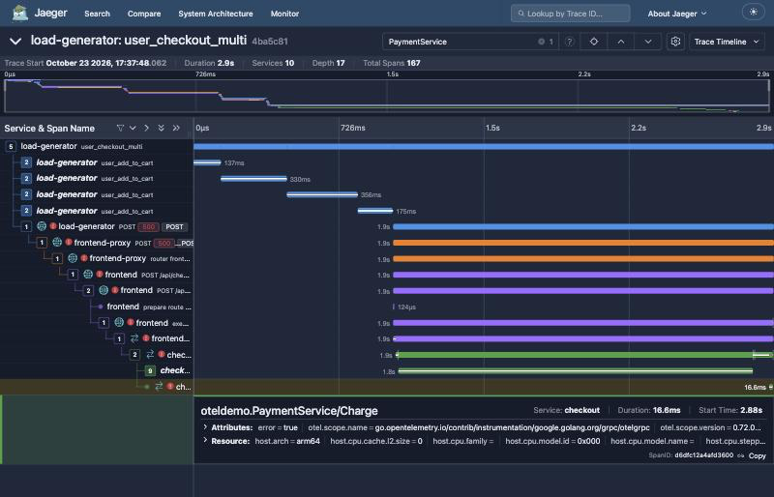
Figure 1. Jaeger, trace cited by the agent: checkout's oteldemo.PaymentService/Charge call fails and no payment span exists beneath it.
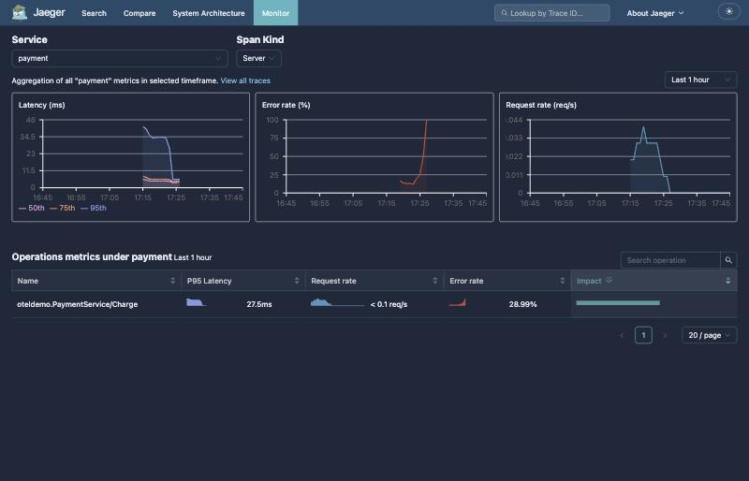
Figure 2. Jaeger Monitor for payment: the request rate drops to zero, consistent with payment never being reached.

5. Report schema status
BLOCKED The organiser schema is not available. The slides say the required output format (JSON schema) ships in the organisers' template repository, which is not in the public demo repository.
Verified Searched: the repository, originals/src.zip, and ~/Desktop, ~/Downloads and ~/Documents for schema, incident, starter and Bosch files. Found only the team's own config/incident_schema.json and the organiser slides (PDF), which describe the schema but do not contain it.
Until the organiser schema arrives, reports are validated against the team schema, which is provisional. Every saved post-fix report and the harness run were schema-valid against it. This is not a claim of compliance with the official format.
Planned On receipt: add the schema under config/, point report.validate_report at it, update report.build_report for any field differences, and add tests for required fields, types and invalid reports.

6. Official incident workflow
BLOCKED The organisers' faultctl is not available: not on PATH, not in Docker images, not in the repository or the starter zip. The only file named faultctl is the team's own src/faultctl/ adapter, which is not used for injection.
No substitute was used. A home-made injector written earlier in the day was deleted unused after the team confirmed that injection must go through the official faultctl only. The Feature Flags UI and flagd were not used by the agent or the harness for injection.
Former unofficial fault: Day 2 update (2026-10-24): src/flagd/demo.flagd.json is clean in the working tree. The unofficial fault edit was never committed and now exists only in the local backup stash (stash@{0}); it must never be restored or used for an official run.

7. LLM usage
Measure | Label | Value
Requests per investigation | Verified | 11 for 9 tool calls (harness counter, one live run)
Requests per saved run (upper bound) | Verified | Tool calls + 2 + re-asks, from transcripts: 5 to 12 tool calls per run, so at most 14 requests
Tokens | Planned | Not recorded: llm.py does not keep the provider's usage numbers, so tokens cannot be measured from logs
Daily quota | Verified | INC-20261023-112653 stopped on HTTP 429 "You exceeded your current quota" (gemini-3.5-flash)
Exact daily limit | Reported | About 20 requests a day per model, read by the tester session from a full error text; not reproduced

Model failures produce an ERROR_MODEL result or an escalation, never a false success: the agent escalates on LLM errors and fails fast on daily-quota 429s, and the harness classifies those runs as ERROR_MODEL (tests: test_model_failure_is_error_model_not_pass and test_daily_quota_429_fails_fast_without_retrying).
Planned Efficiency: in the measured run the model asked for about one tool per turn, so a prompt that encourages independent calls in one turn could lower the request count. Not changed, because it alters investigation behaviour and should be checked against official incidents first. Also record token usage in llm.py.

8. Security and repository hygiene
Check (commands in 07_security_hygiene.txt) | Status | Result
Live API key in tracked or untracked files | PASS | None (matched by value; value not printed)
Key-shaped strings (Google, OpenAI, Anthropic, GitHub) | PASS | None
Key in pushed branch history | PASS | 0 occurrences in team8/day1-incident-agent
Key assignments with values in tracked files | PASS | Only a placeholder in the demo's src/agent/README.md
Machine-specific paths in project files | PASS | None
.env, incident_output/, audit_logs/ | PASS | git-ignored; .env permissions 600
Personal data in saved transcripts | PASS | No emails or card numbers; two 16-digit matches are span IDs
.kill_switch sentinel | PASS | Was not ignored; added to .gitignore
Root .env.override | PARTIAL | Clean in the working tree (Day 2 update); the old Gemini edit exists only in the local backup stash. Keep it out of commits

9. Practice incidents actually run
Official practice incidents: none. No run used the organisers' faultctl.
Run | Condition | Named root cause | Confidence | Assessment
LIVE-001, TEST-A, TEST-B | No fault; background slowdown before the restart | product-catalog | high | Reported. Real symptom, cause not established
INC-…112653 | LLM daily quota exhausted | none | low, escalated | Verified from transcript. Correct failure handling
LIVE-002, DEMO-001, INC-…115012 | Feature Flags UI fault | checkout | high | Reported. Wrong attribution (before D7)
DEMO-002, INC-…121354 | Same fault, after D7 | payment | high | Reported. Expected attribution
eval-20261023-122245 | Same fault, harness run | payment | high | Verified. PASS (unofficial)

Open question on the expected answer. The organiser slides describe paymentUnreachable as making "checkout call a bad address so payment looks down". The team scored payment as the root cause, which matches what the telemetry shows: payment was never reached. A mentor may instead expect checkout, because its configured address is wrong. The agent's own recommended action already points at checkout's payment address and DNS. This needs a mentor ruling before it is used as an official case.

10. Defects fixed today
ID | Defect | Fix | Evidence
D1 | Missing container reported as source_unavailable | Case-insensitive Docker message check | Verified: regression test passes
D2 | Size cap hid 26 of 27 containers but kept their evidence | Evidence pruned with rows | Verified: regression test passes
D3 | Error search scanned only the newest 60 traces | Jaeger error filter first | Verified: regression tests pass
D4 | Alternative counted as ruled out without evidence | Alternatives need refs found in tool results | Verified: regression tests pass
D5/D6 | Tooling flagged in overview; smoke test picked jaeger | Tooling excluded; shop service picked | Verified: --tools-only
D7 | Caller named instead of the unreachable dependency | Callee detection, prompt rule, attribution guard; same rule in the analyzer | Verified: 18 tests and live harness PASS

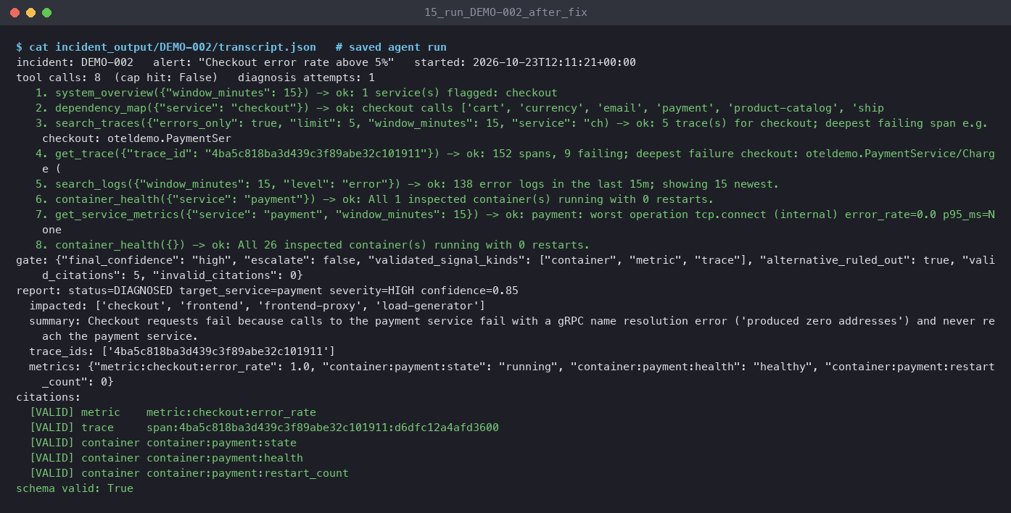
Figure 3. Reported: DEMO-002 after the fix, root cause payment, 5 of 5 citations valid.

11. Remaining blockers and questions for the organisers
Blocker | What is needed | Owner
Official faultctl | Binary or container, usage (inject, reset, list) and how to run it here | Organisers; team lead
Practice incident definitions | The 10 published incidents, inject and reset arguments, and the mentor's three for Checkpoint 2 | Organisers / mentor
Organiser JSON schema | The template repository's output schema and an example report | Organisers
LLM key | The organiser key with a spend limit (slides), or a paid tier | Organisers; team lead
Active unofficial fault | Switch paymentUnreachable off in the Feature Flags UI | Teammate who switched it on
Uncommitted work | Harness, its tests, .gitignore and this report; commit when the user approves | Team lead
All members commit | Organiser rule: every team member commits code | Each member

Questions to send
- Where do we get faultctl and its instructions? Is there a Docker image or a binary for macOS arm64?
- Where is the template repository with the required JSON output schema, the README template and the team form?
- Which 10 practice incidents are published, with their faultctl names, and which three will the mentor choose for Checkpoint 2?
- How is a diagnosis scored: by root-cause service only, or also a category? Is there a fixed category list?
- For paymentUnreachable, is the expected root cause payment (unreachable) or checkout (wrong address)?
- When do we get the organiser LLM key, and what is its request or spend limit?
- What is the deploy-history source? It is not part of the public demo.
- Are the offline incident bundles available, and is the code freeze at 14:00 or 16:30?

12. Day 1 checkpoint verdict
Verdict: BLOCKED
PASSED needs at least three mentor-selected official practice incidents diagnosed correctly through the authorised workflow, with the required output contract verified. None of those inputs exist on this machine: no official faultctl, no incident definitions, no organiser schema. No official incident has been run, so the checkpoint has not passed. It is not NOT YET PASSED either, because the inputs needed to attempt it are missing.
Ready to run as soon as the inputs arrive: put the mentor's cases in a cases.json with official: true and set FAULTCTL_CMD. Then run python -m src.agent.eval_harness cases.json and read summary.json. Each case uses about 11 model requests.

Evidence files
File in ~/Desktop/bosch/day1-readiness/ | Contents
01_full_suite.txt | Full test run, 135 passed
02_attribution_tests.txt, 03_guard_tests.txt | Targeted regression and guard tests
04_analyzer_wiring.txt | grep showing the agent does not call the analyzer
05_harness_live_run.txt, 05b/05c | Harness run output, summary.json, results.json
06_external_inputs_search.txt | Search for faultctl, schema and incident files
07_security_hygiene.txt | Secret, path and ignore checks
cases-unofficial.json | The one evaluator-only case used
Related: the team's Day 1 build log and runbook is a separate shared document ("Bosch Incident Zero: Day 1 Build Log & Runbook").

