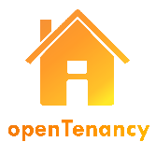

**OpenTenancy Questionnaire Summary**

The following document details the questions and corresponding answers that you gave in the questionnaire.

|  |
| --- |
|  |
|  |

|  |
| --- |
| {% for q in questionFile.keys()%}  {{ q }}  {{ questionFile[q] }}  {% endfor %}  {% if defined("landlordLate") %}  {% if landlordLate == True %} {  { repairAdvice[“noLandlordResponse”] }}  {% endif %}  {% endif %}  {% if defined("landlordTell") %}  {% if landlordTell == True %}  {{ repairAdvice[“contactLandlord”] }}  {% endif %}  {% endif %}  {% if defined("landlordWait") %}  {% if landlordWait == True %}  {{ repairAdvice[“waitForLandlord”] }}  {% endif %}  {% endif %} |
|  |
|  |