WireEquipment

or how to deal with SFPs

# Introduction

Information modeling of the equipment for the WireInterface has to cope with a couple of specific aspects.

E.g. the Capability information of the individual WireInterface instance depends on the type of SFP (SFP shall represent all types of physical connectors in this text), but not all types and models of SFPs, which might be used with the device, are known during design time of the firmware of the device.

Further on, the concrete SFP might be replaced due to failure and the replacing SFP might just be similar, but not of identical type or model. Nevertheless an already instantiated WireInterface object should continue existing and also operating, in case original and replacing SFP have sufficiently identical characteristics.

This document does not describe technology specific attributes, which are augmented to the ONF Core information model. It is a prescription of how to use the existing attributes of the Core Physical Model.

# Contradicting Approaches

The resulting information modeling has to cope with contradictory processes.

Roll-out

The Planning Driven Approach represents nowadays way of humans using planning tools to define a future should-be-network. The planning is often done before the devices are actually existing in the network and it shall be exactly executed, or not at all. This means that Interfaces[1] and ExpectedEquipment are instantiated and configured on the application layer first and on the device later.

The Plug’n Play Approach assumes that applications are automatically configuring already existing devices. In divergence to the Planning Driven Approach, ExpectedEquipment is instantiated on the device first (namely identically to the ActualEquipment) and afterwards on the application layer.

Repair

Replacing SFPs is another area of contradictory requirements. Surely, the majority of users is expecting the configuration of an interface[2] to “survive” a failure of the associated SFP. It can also be anticipated that the replacing SFP will not be of the same version or even model in many cases. On the other hand, the Netconf server can certainly not be expected to check, whether the existing Interface Configuration can be implemented on the replacing SFP type, and to re-instantiate all affected Interfaces with updated capability information.

The modelling described in this document leaves it to the operators’ responsibility to decide about, which hardware related information to asses for assuring sufficient compatibility of an existing Interface Configuration and a replacing SFP.

# Successful Configuration

In accordance with Requirement no. 3 of the TR-545 DMIP, a <commit> operations for changing configuration values of an Interface shall be denoted successful, whenever the changes have been successfully validated against the characteristic of an ExpectedEquipment.

This means that any process of instantiating and configuring an Interface must start with defining the ExpectedEquipment.

# General Understanding

An instance of the Equipment class represents an abstract potential for equipment, which is already bound to a specific position.

An instance of the ActualEquipment class represents a concrete module, which is actually plugged into the Device.

The group of instances of the ExpectedEquipment class, which is associated with the instance of the Equipment class, represents the variety of modules that could be plugged for operating the same interface configuration (according to general linguistic usage).

All existing Equipment instances have to be associated (composite) by the _equipment[*] attribute to the ControlConstruct instance. The _occupyingFru[3][0..1] attribute at the Holder instance is just referencing (shared) already existing Equipment instances.

# Instantiation

Equipment and Holder

Holder as well as associated Equipment shall be automatically instantiated as soon as the ExpectedEquipment in the overlying level of the hierarchy got instantiated. Every existing Holder instance shall always be referencing an Equipment instance.

Example: As soon as an Ethernet board accommodating ten SFP cages got instantiated as ExpectedEquipment, the corresponding ten Holder and ten Equipment objects shall be instantiated. Everything shall be prepared for instantiating an SFP as ExpectedEquipment in the next step.

ActualEquipment

The Equipment class of the ONF Core IM comprises a reference to 0 or 1 ActualEquipment instances.

If there is no SFP in the cage (includes: never before, just pulled, or broken), there shall be no instance of ActualEquipment.

When an SFP is put into the cage, the device shall automatically instantiate an ActualEquipment object and associate it with the Equipment object.

(SFP shall represent all types of physical connectors in this text; e.g. a soldered RJ45 connector shall be seen as a permanently plugged SFP.)

ExpectedEquipment

The Equipment class of the ONF Core IM comprises a reference to a list of an undefined number of ExpectedEquipment instances.

An arbitrary number of ExpectedEquipment objects might be instantiated and associated to the Equipment object via the management interface at any time.

A single ExpectedEquipment object shall be automatically instantiated by the device whenever an ActualEquipment object gets instantiated and no ExpectedEquipment object is already existing.

LogicalTerminationPoint and LayerProtocol

As soon as an ExpectedEquipment object, which is representing an SFP, has been instantiated, the device shall automatically instantiate a LogicalTerminationPoint and a matching (including e.g. Capability information) technology specifically augmented LayerProtocol object.

The LogicalTerminationPoint::_physicalPortReference attribute shall be automatically configured to associate the Equipment object with the LogicalTerminationPoint object.

This shall at least apply for all SFP types, which could be purchased from the provider of the device during design time of the firmware or are currently plugged.

# Configuration

Interface Configuration

Any change of the Interface Configuration shall be validated against its Capability information.

It is important to consider that this Capability information perpetually embodies the characteristics of that type of ExpectedEquipment, which initiated the instantiation of the LogicalTerminationPoint.

ExpectedEquipment Configuration

An existing ExpectedEquipment shall not be altered.

It is the operators’ responsibility to assure that additionally instantiated ExpectedEquipment objects (representing SFP types, which have been approved for alternative use) are matching the Capability information that has been written into the technology specifically augmented LayerProtocol object during its instantiation.

# Deletion

ExpectedEquipment Deletion

At the moment the last ExpectedEquipment object gets disassociated from the Equipment object, the associated LogicalTerminationPoint including its associated technology specifically augmented LayerProtocol object have to be automatically deleted by the Device.

At the moment the last ExpectedEquipment object gets disassociated from the overlaying Equipment object, the subordinated Holder and Equipment objects including their associated ActualEquipment and ExpectedEquipment objects have to be automatically deleted by the Device. Lowering the number of ExpectedEquipment objects (or even deleting the first one) shall neither impact the LogicalTerminationPoint instance nor the values of the technology specifically augmented LayerProtocol object as long as at least one ExpectedEquipment object remains.

# Information

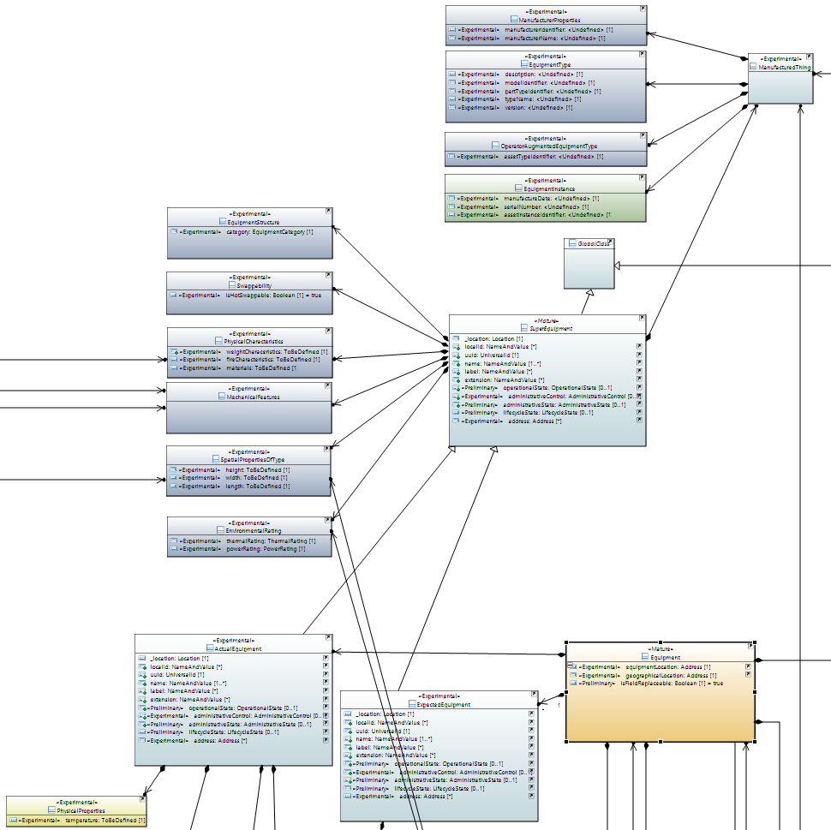

ActualEquipment

The ActualEquipment object (incl. associated objects) shall contain as much as possible information about the currently plugged SFP.

For pluggable SFPs, this shall include at least the following information:

| Attribute Name in Core IM | To be filled with following data according to SFF‑8472 Rev12.3 |
| --- | --- |
| ManufacturerProperties::manufacturerIdentifier | Vendor OUI [Address A0h, Bytes 37-39]  The vendor organizationally unique identifier field (vendor OUI) is a 3-byte field that contains the IEEE Company Identifier for the vendor. A value of all zero in the 3-byte field indicates that the Vendor of the SFP did not specify the OUI on the EEPROM. |
| ManufacturerProperties::manufacturerName | Vendor name [Address A0h, Bytes 20-35]  The vendor name is a 16 character field that contains ASCII characters, left-aligned and padded on the right with ASCII spaces (20h). The vendor name shall be the full name of the corporation, a commonly accepted abbreviation of the name of the corporation, the SCSI company code for the corporation, or the stock exchange code for the corporation. According to SFF 8472 Rev12.3 the vendor of the SFP has to fill at least one of the vendor name or the vendor OUI fields with valid data. |
| EquipmentType::partTypeIdentifier | Vendor PN [Address A0h, Bytes 40-55]  The vendor part number (vendor PN) is a 16-byte field that contains ASCII characters, left-aligned and padded on the right with ASCII spaces (20h), defining the vendor part number or product name. A value of all zero in the 16-byte field indicates that the Vendor of the SFP did not specify the vendor PN on the EEPROM. |
| EquipmentType::version | Vendor Rev [Address A0h, Bytes 56-59]  The vendor revision number (vendor rev) is a 4-byte field that contains ASCII characters, left-aligned and padded on the right with ASCII spaces (20h), defining the Vendor's product revision number. A value of all zero in the 4-byte field indicates that the Vendor of the SFP did not specify the vendor revision on the EEPROM. |
| EquipmentInstance::manufactureDate | Date Code [Address A0h, Bytes 84-91]  The date code is an 8-byte field that contains the Vendor's date code in ASCII characters.  A0h Description  84-85 ASCII code, two low order digits of year. (00 = 2000).  86-87 ASCII code, digits of month (01 = Jan through 12 = Dec)  88-89 ASCII code, day of month (01-31)  90-91 ASCII code, vendor specific lot code, may be blank  Information shall be formatted according the DateTime datatype from the ImplementationCommonDataTypes definitions. |
| EquipmentInstance::serialNumber | Vendor SN [Address A0h, Bytes 68-83]  The vendor serial number (vendor SN) is a 16 character field that contains ASCII characters, left-aligned and padded on the right with ASCII spaces (20h), defining the Vendor's serial number for the transceiver. A value of all zero in the 16-byte field indicates that the Vendor of the SFP did not specify the vendor SN on the EEPROM. |
| PhysicalProperties::temperature | Current temperature (in degree Celsius) inside the transceiver. |

For non-pluggable connectors (like e.g. soldered RJ-45), this shall include at least the following information:

| Attribute Name in Core IM | To be filled with following information from 802.3 |
| --- | --- |
| ManufacturerProperties::manufacturerIdentifier | Describes the IEEE Company identifier of the vendor of the transceiver (1st part of 802.3 ResourceTypeID) according to 802.3 22.2.4.3.1 PHY Identifier and also referenced in 45.2.1.13 PMA/PMD package identifier. |
| ManufacturerProperties::manufacturerName | Vendor's name. Might be left blank, if manufacturerIdentifier is filled. |
| EquipmentType::partTypeIdentifier | Uniquely identifies the transceiver in the vendor's product lists according to 802.3 22.2.4.3.1 PHY Identifier and also referenced in 45.2.1.13 PMA/PMD package identifier as six bit model number. |
| EquipmentType::version | Identifies the revision number of the transceiver (3rd part of 802.3 ResourceTypeID) according to 802.3 22.2.4.3.1 PHY Identifier and also referenced in 45.2.1.13 PMA/PMD package identifier as four-bit revision number. |
| EquipmentInstance::manufactureDate | Vendor's date code for the transceiver.  Information shall be formatted according the DateTime datatype from the ImplementationCommonDataTypes definitions. |
| EquipmentInstance::serialNumber | Vendor's serial number for the transceiver (0 = not applicable). |
| PhysicalProperties::temperature | Current temperature (in degree Celsius) inside the transceiver. |

ExpectedEquipment

If the ExpectedEquipment object has been automatically instantiated by the device, exactly the following information shall be copied from the ActualEquipment object:

| Attribute Name in Core IM |
| --- |
| ManufacturerProperties::manufacturerIdentifier |
| ManufacturerProperties::manufacturerName |
| EquipmentType::partTypeIdentifier |
| EquipmentType::version |

If an ExpectedEquipment object is instantiated via the management interface, it is up to the operator to decide about which fields to be filled.

It is strongly recommended to define at least the following minimum set of information:

| Attribute Name in Core IM |
| --- |
| ManufacturerProperties::manufacturerIdentifier |
| ManufacturerProperties::manufacturerName |
| EquipmentType::partTypeIdentifier |

Capability

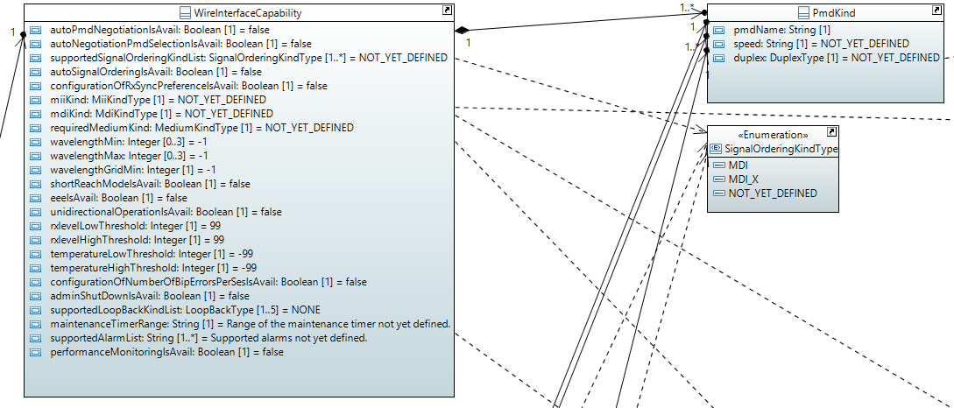

For being able to automatically instantiate a LogicalTerminationPoint and a technology specifically augmented LayerProtocol object at the moment an SFP of a known type is plugged to the Device, the following Capability information[4] of the WireInterface definition has to be stored on the device for those types.

| Attribute Name | Type | Multiplicity | Description |
| --- | --- | --- | --- |
| _supportedPmdKindList | PmdKind  ./. | 0..* | List of Physical Medium Dependent (PMD) that can be operated |
| autoPmdNegotiationIsAvail | Boolean  false | 1 | 1 = device is supporting auto-negotiation |
| autoNegotiationPmdSelectionIsAvail | Boolean  false | 1 | 1 = device is supporting restricting auto-negotiation on a pre-defined list of PMDs |
| supportedSignalOrderingKindList | MDI MDI_X NOT_YET_DEFINED  NOT_YET_DEFINED | 0..* | Describes the different (e.g. MDI, MDI-X) ways of ordering the signals on the physical medium |
| autoSignalOrderingIsAvail | Boolean  false | 1 | 1 = there is a mechanism for automatically crossing over tx and rx implemented |
| configurationOfRxSyncPreferenceIsAvail | Boolean  false | 1 | 1 = Configuration of the behavior during the synchronization of transmitter and receiver is available. This attribute has nothing to do with clock signals. |
| miiKind | GBIC SOLDERED_CONNECTOR SFP_SFP_PLUS_SFP28 XBI_300_PIN XENPAK …  NOT_YET_DEFINED | 1 | Kind of Medium Independent Interface (MII) provided by this Medium Attachment Unit (MAU) (e.g. SFP, moldered port) |
| mdiKind | SC FIBRE_CHANNEL_STYLE_1 FIBRE_CHANNEL_STYLE_2 BNC_TNC FC …  NOT_YET_DEFINED | 1 | Kind of Medium Dependent Interface (MDI) provided by this Medium Attachment Unit (MAU) |
| requiredMediumKind | TP_CAT3 TP_CAT5 TP_CAT6 TP_CAT8 SINGLE_MODE …  NOT_YET_DEFINED | 1 | Kind of medium required for operating this Medium Attachment Unit (MAU), more like an information field |
| wavelengthMin | Integer  -1 | 0..3 | Source: SFF-8690. Minimum laser wavelength in pico meter, -1 = not applicable, 0 = not known, if (wavelengthMin==wavelengthMax): wavelength cannot be configured; multiplicity=0..3 for 10GBASE-LX4 according to 802.3 53.5. Value to be read from the EPROM of the SFP. |
| wavelengthMax | Integer  -1 | 0..3 | Source: SFF-8690. Maximum laser wavelength in pico meter, -1 = not applicable, 0 = not known, if (wavelengthMax==wavelengthMin): wavelength cannot be configured; multiplicity=0..3 for 10GBASE-LX4 according to 802.3 53.5. Value to be read from the EPROM of the SFP. |
| wavelengthGridMin | Integer  -1 | 1 | Source: SFF-8690. Minimum grid spacing supported by the transceiver, -1 = not applicable, 0 = not known |
| shortReachModeIsAvail | Boolean  false | 1 | 1 = Indicates that Short Reach Mode for 10GBASE-T according to 802.3 45.2.1.64 is available |
| eeeIsAvail | Boolean  false | 1 | 1 = Indicates that Energy-Efficient Ethernet (EEE) is available at the device. |
| unidirectionalOperationIsAvail | Boolean  false | 1 | Source: 802.3. 1 = Medium Attachment Unit (MAU) able to transmit from Media Independent Interface (MII) regardless of whether the MAU has determined that a valid link has been established, 0 = MAU able to transmit from MII only when the MAU has determined that a valid link has been established |
| rxlevelLowThreshold | Integer  99 | 1 | Threshold for alarming low RX levels. Value pre-defined by SFP manufacturer (SFF- 8472) |
| rxlevelHighThreshold | Integer  99 | 1 | Threshold for alarming high RX levels. Value pre-defined by SFP manufacturer (SFF- 8472) |
| temperatureLowThreshold | Integer  -99 | 1 | Threshold for alarming low temperature values. Value pre-defined by SFP manufacturer (SFF- 8472) |
| temperatureHighThreshold | Integer  -99 | 1 | Threshold for alarming high temperature values. Value pre-defined by SFP manufacturer (SFF- 8472) |
| configurationOfNumberOfBipErrorsPerSesIsAvail | Boolean  false | 1 | 1 = SET operation on the Line SES threshold defined by aLineSESThreshold in 30.8.1.1.11 of 802.3-2015 is available. |
| statisticsIsAvail | Boolean  false | 1 | 1 = Continuous statistics counters are available. |
| performanceMonitoringIsAvail | Boolean  false | 1 | 1 = Collection and aggregation of performance values is available. |
| supportedLoopBackKindList | LoopBackType  NONE | 0..5 | Source: 802.3 45.2.1.12.1 PMA remote loopback ability. List of supported kinds of looping back of header information to the remote site. |
| maintenanceTimerRange | String  Range of the maintenance timer not yet defined. | 1 | Available time periods for maintenance configurations (e.g. the loop back) to be described. Concrete values shall be separated by commas (e.g. '10, 60, 360'). Ranges shall be expressed as two values separated by a minus (e.g. '10-360'). |
| supportedAlarmList | String  Supported alarms not yet defined. | 0..* | Available alarms to be listed. Mandatory: 'rxLos'. Optional: 'txFault', 'tempHigh', 'tempLow', 'rxLevelHigh', 'rxLevelLow', 'vccHigh', 'vccLow', 'txBiasHigh', 'txBiasLow', 'txPowerHigh', 'txPowerLow', 'laserTempHigh', 'laserTempLow', 'tecCurrentHigh', 'tecCurrentLow'. Further alarms might be added by the device. |

Table 1: WireInterfaceConfiguration

Plus the list of associated PMDs.

| Attribute Name | Type | Multiplicity | Description |
| --- | --- | --- | --- |
| pmdName | String  ./. | 1 | To be chosen from the following list of PMD names according to IEEE 802.3 '10BASE5', 'FOIRL', '10BASE2', '10BROAD36', '10BASE-T', '10BASE-FP',  … |
| Speed | String  NOT_YET_DEFINED | 1 | Line speed of the PMD. Value to be chosen from '2Mbit/s', '10Mbit/s', '100Mbit/s', '1000Mbit/s', '10Gbit/s', '40Gbit/s', '100Gbit/s' or 'NOT_YET_DEFINED'. |
| Duplex | HALF_DUPLEX FULL_DUPLEX NOT_YET_DEFINED  NOT_YET_DEFINED | 1 | To be expressed, whether the PMD is full duplex or just half duplex |

Table 2: PmdKind

# Operational States

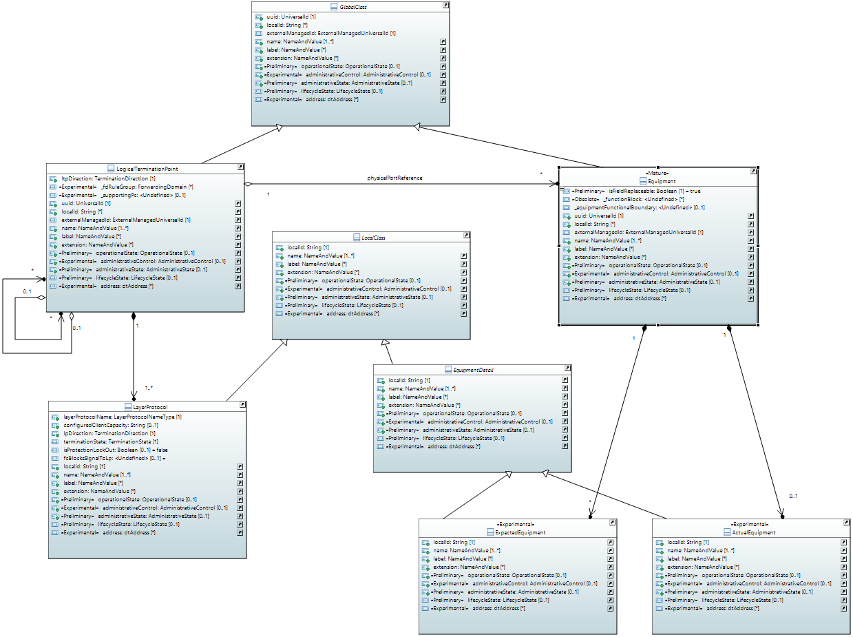

ActualEquipment

The value of the ActualEquipment::operationalState attribute shall be false, except the currently plugged SFP is fully operational.

ExpectedEquipment

The value of the ExpectedEquipment::operationalState attribute shall be false, except there is an ActualEquipment object instantiated (regardless of its operational state), which has the exact same values in all those fields, which are not empty in the ExpectedEquipment object. (Empty fields of the ExpectedEquipment object shall be interpreted as wildcards.)

Equipment

The value of the Equipment::operationalState attribute can only be true, if the ActualEquipment::operationalState attribute of the associated ActualEquipment object and the ExpectedEquipment::operationalState attribute of at least one of the associated ExpectedEquipment objects is true.

LogicalTerminationPoint

An interface must not operate and the value of its LogicalTerminationPoint::operationalState attribute must be false, if the value of the Equipment::operationalState attribute of the associated Equipment is false.

Technology specific operationalState attributes

The values of all attributes, which are describing some kind of operational status inside some technology specific augmentation of the LayerProtocol class (e.g. transceiverIsOnList, autoPmdNegotiationIsOn, performanceMonitoringIsOn …), must be false, if the value of the LogicalTerminationPoint::operationalState attribute is false.

Remark

Because the operational state of the LogicalTerminationPoint depends on the operational state of the ExpectedEquipment…

* … extensive use of wildcards allows plugging a wider range of SFPs without updating the list of ExpectedEquipment objects, but increases the risk of mismatching LayerProtocol instances (Capability or Configuration values are mismatching the actual hardware characteristics).
* … reduced use of wildcards, leads to constant need for updating the list of ExpectedEquipment objects on the individual Device, because otherwise Interfaces will not get operational again after replacing broken SFPs e.g. with more recent SFP versions.

So the extend of leaving fields of the ExpectedEquipment objects blank, is a trade-off between maintenance effort and operational stability. Because the operationalState of just one of the listed ExpectedEquipment objects needs to be true for activating the interface, the poorliest defined ExpectedEquipment object is most relevant.

1. “Interface” (starting with upper case) relates to a technology specifically amended instance of the LayerProtocol class.
2. “interface” (starting with lower case) relates the general linguistic usage.
3. FRU = Field Replaceable Unit
4. In case of divergences the WireInterface Definition is the relevant source of this information.