

Microwave Information Model

Version 1.1

February 2019

ONF TR-532

ONF Document Type: Technical Recommendation



ONF Document Name: Microwave Information Model Version 1.1

Disclaimer

THIS SPECIFICATION IS PROVIDED "AS IS" WITH NO WARRANTIES WHATSOEVER, INCLUDING ANY WARRANTY OF MERCHANTABILITY, NONINFRINGEMENT, FITNESS FOR ANY PARTICULAR PURPOSE, OR ANY WARRANTY OTHERWISE ARISING OUT OF ANY PROPOSAL, SPECIFICATION OR SAMPLE.

Any marks and brands contained herein are the property of their respective owners.

Open Networking Foundation

2275 E. Bayshore Road, Suite 103, Palo Alto, CA 94303

[www.opennetworking.org](http://www.opennetworking.org)

©2016 Open Networking Foundation. All rights reserved.

Open Networking Foundation, the ONF symbol, and OpenFlow are registered trademarks of the Open Networking Foundation, in the United States and/or in other countries. All other brands, products, or service names are or may be trademarks or service marks of, and are used to identify, products or services of their respective owners.

Table of Contents

Disclaimer 2

Open Networking Foundation 2

Table of Contents 3

List of Figures 7

List of Tables 7

Document History 10

1 Introduction 10

2 Definitions 10

2.1 Terms 10

2.2 Abbreviations and Acronyms 10

3 Compliance Statement 11

4 Overview of the Microwave Information Model 12

4.1 Coverage 12

4.2 Overview 12

5 Conventions 14

5.1 UML Modeling Conventions 14

5.2 Default Values 14

5.3 General Stereotypes 15

5.3.1 Is read only 15

5.3.2 Is unique 15

5.3.3 Multiplicity 15

5.3.4 Further General Stereotypes 15

5.4 Comments 16

5.5 ONF Stereotypes 16

5.5.1 attributeValueChangeNotification 16

5.5.2 objectCreationNotification and objectDeletionNotification 16

5.5.3 isInvariant 16

5.5.4 valueRange 17

5.5.5 partOfObjectKey 17

5.5.6 unit 17

5.5.7 Support Qualifier 17

5.5.8 bitLength 18

5.5.9 Unsigned, Encoding and Counter 18

5.6 Future Versions and Release Management 18

6 Special elements 18

6.1 Capabilities of the Radio Interface 18

6.2 Multiple Structure Classes 20

6.3 Problem Definitions, Associations and Inheritances 21

6.4 Performance Values 22

6.5 TDM Containers 23

7 Attachment to the Core Information Model 24

7.1 Attachment of *_Pacs 25

7.2 Attachment of the Co-Channel Group Class 26

7.3 Attachment of the HSB Pac 27

8 Future Work 28

9 UML Model Files 28

10 Data Dictionary 28

10.1 AirInterface_Pac and CoChannelGroup 29

10.1.1.1 MW_AirInterface_Pac 30

10.1.1.2 AirInterfaceHistoricalPerformances 31

10.1.1.3 CoChannelGroup 32

10.1.1.4 AirInterfaceStatus 33

10.1.1.5 AirInterfaceConfiguration 38

10.1.1.6 AirInterfaceCurrentPerformance 46

10.1.1.7 AirInterfaceCapability 46

10.1.1.8 AirInterfaceCurrentProblems 50

10.2 Structure_Pacs 52

10.2.1 PureEthernetStructure_Pac 52

10.2.1.1 PureEthernetStructureConfiguration 52

10.2.1.2 PureEthernetStructureCurrentProblems 53

10.2.1.3 PureEthernetStructureCapability 54

10.2.1.4 PureEthernetStructureStatus 55

10.2.1.5 PureEthernetStructureCurrentPerformance 56

10.2.1.6 MW_PureEthernetStructure_Pac 56

10.2.1.7 PureEthernetStructureHistoricalPerformances 58

10.2.2 HybridMwStructure_Pac 60

10.2.2.1 HybridMwStructureCurrentProblems 60

10.2.2.2 HybridMwStructureHistoricalPerformances 61

10.2.2.3 HybridMwStructureCurrentPerformance 61

10.2.2.4 HybridMwStructureCapability 62

10.2.2.5 MW_HybridMwStructure_Pac 63

10.2.2.6 HybridMwStructureStatus 65

10.2.2.7 HybridMwStructureConfiguration 66

10.3 Container_Pacs 68

10.3.1 EthernetContainer 68

10.3.1.1 MW_EthernetContainer_Pac 68

10.3.1.2 EthernetContainerCapability 70

10.3.1.3 EthernetContainerStatus 73

10.3.1.4 EthernetContainerConfiguration 74

10.3.1.5 EthernetContainerCurrentProblems 77

10.3.1.6 EthernetContainerCurrentPerformance 78

10.3.1.7 EthernetContainerHistoricalPerformances 78

10.3.2 TdmContainer 80

10.3.2.1 TdmContainerCapability 80

10.3.2.2 TdmContainerStatus 81

10.3.2.3 MW_TdmContainer_Pac 82

10.3.2.4 TdmContainerCurrentProblems 84

10.3.2.5 TdmContainerConfiguration 85

10.3.2.6 TdmContainerCurrentPerformance 86

10.3.2.7 TdmContainerHistoricalPerformances 87

10.4 AirInterfaceHsb 88

10.4.1.1 MW_AirInterfaceHsbFcSwitch_Pac 88

10.4.1.2 MW_AirInterfaceHsbEndPoint_Pac 90

10.5 AirInterfaceDiversity_Pac 91

10.5.1.1 AirInterfaceDiversityCurrentProblems 91

10.5.1.2 AirInterfaceDiversityCurrentPerformance 92

10.5.1.3 AirInterfaceDiversityCapability 92

10.5.1.4 AirInterfaceDiversityConfiguration 93

10.5.1.5 AirInterfaceDiversityHistoricalPerformances 95

10.5.1.6 MW_AirInterfaceDiversity_Pac 95

10.5.1.7 AirInterfaceDiversityStatus 97

10.6 Data Types 98

10.6.1 AirInterfaceCurrentPerformanceType 98

10.6.2 AirInterfaceCurrentProblemType 99

10.6.3 AirInterfaceDiversityCurrentPerformanceType 99

10.6.4 AirInterfaceDiversityCurrentProblemType 100

10.6.5 AirInterfaceDiversityHistoricalPerformanceType 100

10.6.6 AirInterfaceDiversityPerformanceType 101

10.6.7 AirInterfaceDiversityProblemSeverityType 102

10.6.8 AirInterfaceHistoricalPerformanceType 102

10.6.9 AirInterfacePerformanceType 103

10.6.10 AirInterfaceProblemSeverityType 111

10.6.11 ChannelPlanType 112

10.6.12 ContainerCurrentPerformanceType 113

10.6.13 ContainerCurrentProblemType 114

10.6.14 ContainerHistoricalPerformanceType 114

10.6.15 ContainerPerformanceType 115

10.6.16 ContainerProblemSeverityType 116

10.6.17 ContainerType 116

10.6.18 DiversityType 117

10.6.19 SegmentIDType 118

10.6.20 SegmentStatusType 119

10.6.21 StructureCurrentPerformanceType 120

10.6.22 StructureCurrentProblemType 120

10.6.23 StructureHistoricalPerformanceType 121

10.6.24 StructurePerformanceType 121

10.6.25 StructureProblemSeverityType 123

10.6.26 TdmContainerType 124

10.6.27 TdmStructureType 124

10.6.28 ThresholdCrossAlarmType 125

10.6.29 TimeXStatesType 126

10.6.30 TransmissionModeType 127

10.7 Enumeration Types 130

10.7.1 AirInterfaceDiversityStatusType 130

10.7.2 G826Type 130

10.7.3 GranularityPeriodType 130

10.7.4 LoopBackType 131

10.7.5 PolarizationType 131

10.7.6 ProtectionType 132

10.7.7 RoleType 132

10.7.8 SeverityType 132

10.8 Super Classes 132

10.8.1.1 MwCurrentProblem 132

10.9 Notifications 134

10.9.1 AttributeValueChangedNotification 134

10.9.2 ObjectCreationNotification 135

10.9.3 ObjectDeletionNotification 136

10.9.4 ProblemNotification 137

11 Translation Table Functional Model 140

12 References 140

13 Back matter 140

13.1 Editors 140

13.2 Contributors 141

List of Figures

Figure 1: Model Overview 13

Figure 2: Structure of *_Pacs 14

Figure 3: Tree Structure of AirInterface Capabilities 20

Figure 4: Example for Current Problems Associations and Inheritances 21

Figure 5: Example for Current Problems Definition 22

Figure 6: Example for Performance Associations and Inheritances 23

Figure 7: TDM Container Capabilities 24

Figure 8: TDM Container Configuration 24

Figure 9: Usage of ONF Core Information Model 1.2 25

Figure 10: Associations between LayerProtocol and *_Pac 26

Figure 11: Associations between CoChannelGroup and LTP 27

Figure 12: HSB is covered by the ForwardingConstruct of the Core Information Model 27

List of Tables

Table 1: Examples for supportedChannelPlan values 19

Table 2: Attributes for MW_AirInterface_Pac 30

Table 3: Attributes for AirInterfaceHistoricalPerformances 32

Table 4: Attributes for CoChannelGroup 32

Table 5: Attributes for AirInterfaceStatus 33

Table 6: Attributes for AirInterfaceConfiguration 38

Table 7: Attributes for AirInterfaceCurrentPerformance 46

Table 8: Attributes for AirInterfaceCapability 47

Table 9: Attributes for AirInterfaceCurrentProblems 50

Table 10: Attributes for PureEthernetStructureConfiguration 53

Table 11: Attributes for PureEthernetStructureCurrentProblems 53

Table 12: Attributes for PureEthernetStructureCapability 54

Table 13: Attributes for PureEthernetStructureStatus 55

Table 14: Attributes for PureEthernetStructureCurrentPerformance 56

Table 15: Attributes for MW_PureEthernetStructure_Pac 57

Table 16: Attributes for PureEthernetStructureHistoricalPerformances 59

Table 17: Attributes for HybridMwStructureCurrentProblems 61

Table 18: Attributes for HybridMwStructureHistoricalPerformances 61

Table 19: Attributes for HybridMwStructureCurrentPerformance 62

Table 20: Attributes for HybridMwStructureCapability 62

Table 21: Attributes for MW_HybridMwStructure_Pac 64

Table 22: Attributes for HybridMwStructureStatus 65

Table 23: Attributes for HybridMwStructureConfiguration 66

Table 24: Attributes for MW_EthernetContainer_Pac 69

Table 25: Attributes for EthernetContainerCapability 70

Table 26: Attributes for EthernetContainerStatus 73

Table 27: Attributes for EthernetContainerConfiguration 74

Table 28: Attributes for EthernetContainerCurrentProblems 77

Table 29: Attributes for EthernetContainerCurrentPerformance 78

Table 30: Attributes for EthernetContainerHistoricalPerformances 79

Table 31: Attributes for TdmContainerCapability 81

Table 32: Attributes for TdmContainerStatus 82

Table 33: Attributes for MW_TdmContainer_Pac 82

Table 34: Attributes for TdmContainerCurrentProblems 84

Table 35: Attributes for TdmContainerConfiguration 85

Table 36: Attributes for TdmContainerCurrentPerformance 86

Table 37: Attributes for TdmContainerHistoricalPerformances 87

Table 38: Attributes for MW_AirInterfaceHsbFcSwitch_Pac 88

Table 39: Attributes for MW_AirInterfaceHsbEndPoint_Pac 90

Table 40: Attributes for AirInterfaceDiversityCurrentProblems 92

Table 41: Attributes for AirInterfaceDiversityCurrentPerformance 92

Table 42: Attributes for AirInterfaceDiversityCapability 93

Table 43: Attributes for AirInterfaceDiversityConfiguration 94

Table 44: Attributes for AirInterfaceDiversityHistoricalPerformances 95

Table 45: Attributes for MW_AirInterfaceDiversity_Pac 96

Table 46: Attributes for AirInterfaceDiversityStatus 97

Table 47: Attributes for AirInterfaceCurrentPerformanceType 98

Table 48: Attributes for AirInterfaceCurrentProblemType 99

Table 49: Attributes for AirInterfaceDiversityCurrentPerformanceType 99

Table 50: Attributes for AirInterfaceDiversityCurrentProblemType 100

Table 51: Attributes for AirInterfaceDiversityHistoricalPerformanceType 100

Table 52: Attributes for AirInterfaceDiversityPerformanceType 101

Table 53: Attributes for AirInterfaceDiversityProblemSeverityType 102

Table 54: Attributes for AirInterfaceHistoricalPerformanceType 102

Table 55: Attributes for AirInterfacePerformanceType 103

Table 56: Attributes for AirInterfaceProblemSeverityType 111

Table 57: Attributes for ChannelPlanType 112

Table 58: Attributes for ContainerCurrentPerformanceType 113

Table 59: Attributes for ContainerCurrentProblemType 114

Table 60: Attributes for ContainerHistoricalPerformanceType 114

Table 61: Attributes for ContainerPerformanceType 115

Table 62: Attributes for ContainerProblemSeverityType 116

Table 63: Attributes for ContainerType 116

Table 64: Attributes for DiversityType 117

Table 65: Attributes for SegmentIDType 118

Table 66: Attributes for SegmentStatusType 119

Table 67: Attributes for StructureCurrentPerformanceType 120

Table 68: Attributes for StructureCurrentProblemType 120

Table 69: Attributes for StructureHistoricalPerformanceType 121

Table 70: Attributes for StructurePerformanceType 121

Table 71: Attributes for StructureProblemSeverityType 123

Table 72: Attributes for TdmContainerType 124

Table 73: Attributes for TdmStructureType 124

Table 74: Attributes for ThresholdCrossAlarmType 125

Table 75: Attributes for TimeXStatesType 126

Table 76: Attributes for TransmissionModeType 127

Table 77: Attributes for MwCurrentProblem 133

Table 78: Attributes for AttributeValueChangedNotification 134

Table 79: Attributes for ObjectCreationNotification 136

Table 80: Attributes for ObjectDeletionNotification 137

Table 81: Attributes for ProblemNotification 138

Document History

|  |  |  |
| --- | --- | --- |
| Version | Date | Description of Change |
| 0.1 | 2016-07-08 | Initial version of the Microwave Information Model as technology specific extension to the TR-512 ONF Core Information Model 1.1 {{ONF CM}} |
| 0.2 | 2016-18-11 | Consolidating review comments and findings of the 3rd MW PoC. Version for ONF-wide review. |
| 1.0 | 2016-15-12 | Consolidating comments of the ONF-wide review and finalizing for approval by ONF Tech Council. Version for official publishing. |

# Introduction

This ONF Technical Recommendation (TR) is a technology specific extension to the TR-512 ONF Core Information Model 1.2 {{ONF CM}}. In accordance with the SDN architecture for wireless transport networks {{ONF SDN Arch WL}}, this management-control is expected to be achieved by wireless devices and SDN applications within or on top of an SDN Controller.

# Definitions

## Terms

The primary purpose of this document is to define terms and hence terms are defined throughout the document. Key terms are highlighted in section 2.2 Abbreviations and Acronyms of this document and of the TR-512 ONF Core Information Model 1.2 {{ONF CM}} by referring to the section in this document where the term is defined.

## Abbreviations and Acronyms

| Term | Explanation |
| --- | --- |
| ALIC | Adjacent Link Interference Cancelation |
| CEPT | European Conference of Postal and Telecommunications Administrations |
| CPRI | Common Public Radio Interface |
| CTP | Connection Termination Point |
| Cur | Current |
| DCN | Data Communication Network |
| E1 | TDM frame containing 30 digital voice channels |
| ERC | European Research Council |
| FDD | Frequency Devision Duplex |
| Hsb | Hot stand-by |
| ID | Identifier |
| Int | Integer |
| LTP | Logical Termination Point |
| MIMO | Multiple Input Multiple Output Transmission |
| MW | Point-to-point microwave, including millimeter wave |
| MWPS | Microwave Physic Section |
| MWS | Microwave Section |
| NGFI | Next Generation Fronthaul Interface |
| *_Pac | Technology Specific Conditional Package |
| PDH | Plesiochrone Digitale Hierarchie |
| PmP | Point-to-multipoint |
| REC | Recommendation |
| Ref | Reference |
| Rx | Receive |
| SDH | Synchrone Digitale Hierarchie |
| SDN | Software Defined Network |
| SNCP | Sub-Network Connection Protection |
| TDD | Time Devision Duplex |
| TDM | Time-division multiplexing |
| TTP | Trail Termination Point |
| TR | ONF Technical Recommendation |
| tx | Transmit |
| UUID | Universally Unique Identifier |
| XPIC | Cross Polarization Interference Cancelation |

# Compliance Statement

**Completeness**

A device's interface must not be denoted as compliant to this Microwave Information Model, if it doesn't implement all components.

**Support**

The hardware does not necessarily need to make available all functionalities covered by this modeling. In case some functionality is not available at the hardware, the device's interface shall answer the default values defined in this model. All functionalities, which are available at the hardware and covered by the Microwave Information Model, must be manageable with this model (to the extent of the comprised attributes).

**Options**

This Microwave Information Model offers several alternative modeling of the logical structuring of the physical resource provided by the radio link. The device's interface must at least implement the alternative, which is specific to its device type (e.g. pure Ethernet, Ethernet+TDM Hybrid).

**Proprietary Extensions**

Interfaces implementing elements of this Microwave Information Model plus additional components must not be denoted as compliant. Such interfaces might be called "based on" or "expanding" it.

# Overview of the Microwave Information Model

## Coverage

The Microwave Information Model covers the following aspects:

* The radio link with its analogue characteristics like center frequency, channel bandwidth, modulation etc.
* Grouping of radio links into diversity or protection configurations
* Segmentation of the transport resources provided by a radio link
* Allocation of higher layer traffic flows (e.g. Ethernet, E1, CPRI) on these segments
* Bundling of several radio links' resources for Ethernet transport
* Header compression on the transmission path

It does not cover e.g. synchronization, user management, DCN, TDM multiplexing or Ethernet.

The Microwave Information Model provides the necessary attributes for

* the device informing the SDN Controller about its capabilities
* the Controller configuring the device
* the device providing status, problem and performance information

## Overview

The Microwave Information Model comprises the following three most important elements:

* AirInterface_Pac – Contains the analogue characteristics of the physical layer of a single radio link; represents the combination of modem and radio
* Structure_Pac – Segments the physical resource provided by the AirInterface into logical pieces that can be booked by Containers
* Container_Pac – Offers transport services to higher protocol layers, e.g. fixed size containers for TDM or containers of dynamic size for Ethernet

The following three additional elements are required for modeling microwave features based on bundling of radio links into specific types of groups:

* AirInterfaceHsb – Provides hot-stand-by protection
* AirInterfaceDiversity_Pac – Required for space and frequency diversity
* CoChannelGroup – Groups AirInterface_Pacs for modeling XPIC, MIMO and ALIC

The following picture shall help understanding the logical concept, but it has to be noted that the associations between the *_Pacs are implemented in a more complex way, which is described in chapter 7.1 Attachment of *_Pacs.

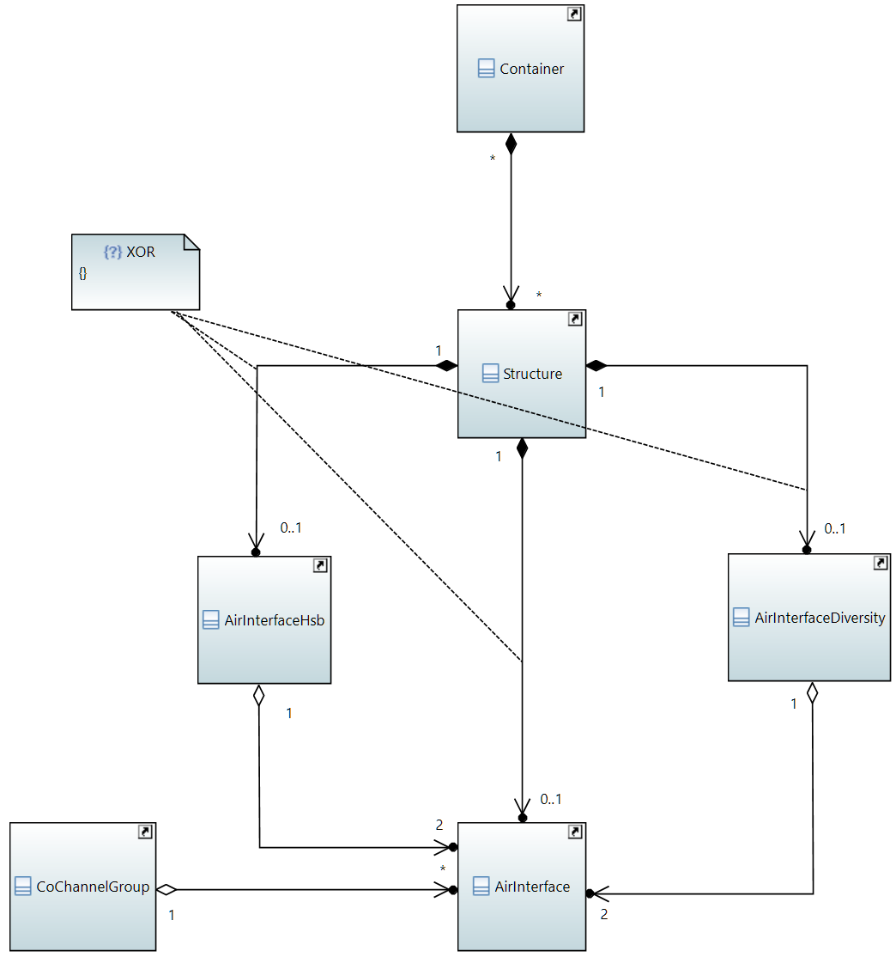

Figure 1: Model Overview

All *_Pacs are sub-structured into the following classes:

* Capabilities – The device informs about its features, characteristics and parameter value ranges
* Configuration – The Controller configures the device and the device informs about its current configuration
* Status – The device informs about measurement values and its current operational status
* Problems – The device proactively informs about events
* Current Performance – The device informs about the current status of its performance counters
* Historical Performance – The device informs about the status of its performance counters at the end of a well-defined time period

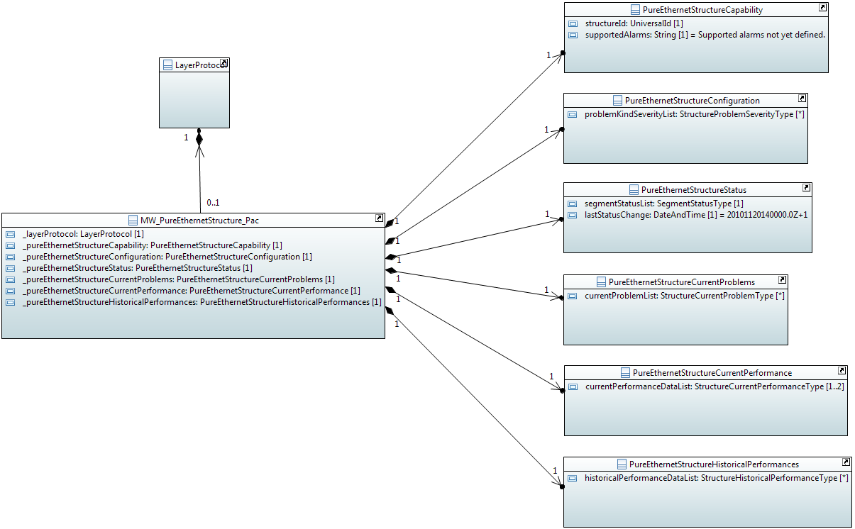

Figure 2: Structure of *_Pacs

Each *_Pac is sufficiently described by one set of capability, configuration, status and current performance attributes, but several current problem and historical performance value sets might be required. Nevertheless, *CurrentProblems and *HistoricalPerformances classes are in a one to one association to the *_Pac. The necessary multiplicity is generated by lists inside these classes. This additional hierarchy is required by the mediator implementation after conversion to YANG.

# Conventions

## UML Modeling Conventions

This TR follows the conventions as described in the TR-512 ONF Core Information Model 1.2 {{ONF CM}} and the TR-514 ONF UML Modeling Guidelines {{ONF UMLG}}.

## Default Values

The default values in the Microwave Information Model have been defined in accordance to the following basic principles:

* Every attribute (except keys, which have to be unique) shall have a default value.
* The default value shall be inside the value range of the data type of the attribute.
* Capability attributes:
  + The default value shall either indicate unavailability of the functionality (if applicable)
  + or be outside the range of reasonable values of the attribute.
* Configuration, status and performance attributes:
  + The default value shall either represent the configuration, status or performance measurement value right after starting the device (in case such a "neutral" value is applicable to the attribute)
  + or be outside the range of reasonable values of the attribute.

Lists of data types shall contain the minimum multiplicity number of elements. This also means that lists of data types with a minimum multiplicity of zero shall have "null" as default value.

## General Stereotypes

### Is read only

The "Is read only" stereotype has been set on "true" for all attributes that can only be read, but not modified by the SDN Controller. This applies to all attributes, which are comprised in Capability, Status, CurrentProblem, CurrentPerformance and HistoricalPerformance classes or in data types used by attributes of these classes.

The "Is read only" stereotype has been set on "false" for all attributes that need to be configurable. This applies to all attributes, which are comprised in Configuration classes or data types that are used by attributes of these classes.

Moreover, the attributes within the CoChannelGroup class need to be configurable, so their "Is read only" stereotype has also been set on "false".

### Is unique

The "Is unique" stereotype has been set on "true" for all *Id attributes, which are of data type UniversalId.

This does not apply on *IdRef attributes, which are referring on values of the *Id attributes.

It does also not apply on containerID attributes that represent a configurable string and are required for associating traffic flows to the transport resources (Container) provided by the Microwave Information Model.

### Multiplicity

The "Multiplicity" stereotype has been set in accordance with technology specific requirements.

### Further General Stereotypes

The remaining stereotypes were left on their individual default values.

| Stereotypes | Value |
| --- | --- |
| Visibility | public |
| Is derived | false |
| Is leaf | false |
| Is derived union | false |
| Is ordered | false |
| Is static | false |
| Aggregation | none |

## Comments

The comprised comments are meant to explain the attributes in such a way that further documentation is not required for understanding the attributes' meaning.

In rare cases (e.g. Problems) the modeling is open for amending device specific elements. This is done by Capability attributes of data type String, which are foreseen to contain an unspecified number of elements separated by comma. In such cases, the comment field is also used for defining a minimum set of elements, which must be supported. Of course, adding additional elements to these lists is not seen as a Proprietary Extensions according to chapter 3.

Double quotes have been avoided within the comments for supporting the conversion to YANG.

## ONF Stereotypes

### attributeValueChangeNotification

This stereotype defines whether a notification has to be raised, when the attribute changes its value.

It has been set on "true" for all attributes, which are comprised in Configuration classes or in data types used by attributes of the Configuration classes.

It has also been set on "true" for status attributes, which might be subject to automated changes but do not represent gradually changing measurement value.

The attributeValueChangeNotification stereotype has been set on "false" for status attributes, which are exclusively following configuration activities. This is for avoiding double messaging.

### objectCreationNotification and objectDeletionNotification

These stereotypes define whether a notification has to be raised when an instance of a class has been created, respectively deleted.

It has been set on "true" for all *_Pac classes, which are potentially attached to the LayerProtocol class of the Core Information Model (see chapter 7.1 Attachment of *_Pacs for details).

### isInvariant

This stereotype defines whether the value of the attribute can be changed, or not, after it has been created.

It has been set on "true" (means: cannot be changed) for the following attributes:

* *Ids, which are representing target addressed for referencing data types or classes, (except ContainerIDs, which are required for connecting logical traffic from outside the reach of the modeling with a Container)
* All attributes, which are comprised in Capability classes or in data types used by attributes of the Capability classes
* All attributes, which are comprised in data types that are attached to the CurrentProblems classes.
* All attributes, which are comprised in data types that are attached to the *Performance classes.
* All attributes, which are comprised in Notifications

It has been set on "false" (means: can be changed) for the following attributes:

* All attributes, which are comprised in Configuration classes
* All attributes, which are comprised in Status classes or in data types used by attributes of the Status classes

### valueRange

This stereotype identifies the allowed values for the attribute.

It has not been used within the Microwave Information Model, because of a conflict with the policy defined for default values in chapter 5.2

### partOfObjectKey

This stereotype indicates whether the attribute is part of the object key or not. Value "0" (default) means the attribute is not part of the object key. Values > "0" indicate that the attribute is part of the object key and the value defines the order of the attribute in case the key is composed of more than one attribute.

The partOfObjectKey stereotype has been set on "1" for all *Id attributes, which are of data type UniversalId, but not the *IdRef attributes, which are referring on them.

It does also not apply on containerID attributes that represent a configurable string and are required for associating traffic flows to the transport resources (Container) provided by the Microwave Information Model.

### unit

This optional stereotype contains a textual definition of the unit associated with the attribute's value.

The following units have been used in the Microwave Information Model

| Unit | Meaning |
| --- | --- |
| % | Percentage |
| Bytes | Total number of Bytes |
| Bytes/min | Bytes per minute |
| Bytes/s | Bytes per second |
| Celsius | Degree Celsius |
| dB | Decibel |
| dBm | Decibel milliwatt |
| kbit/s | 1000 bit per second |
| kHz | 1000 Hertz |
| s | Second |
| symbols | Number of symbols |

### Support Qualifier

This stereotype qualifies the support of the object class at the management interface.

Aside the following exceptions, the SupportQualifier has always been left on its default value "mandatory":

* The MW_PureEthernetStructure_Pac class is "conditional_mandatory" for device types transporting pure Ethernet.
* The MW_HybridMwStructure_Pac class is "conditional_mandatory" for device types transporting Ethernet + TDM.

### bitLength

The bitLength stereotype has been used to define Integer primitives smaller than 64bit.

### Unsigned, Encoding and Counter

The unsigned, encoding and counter stereotypes have not been applied.

## Future Versions and Release Management

In future, it may become desirable to revise the Microwave Information Model. However, changes are not allowed if they have any potential to cause interoperability problems between a client using an original version and a server using an updated version.

For any published update, a new revision statement {{section 7.1.9 of RFC 7950}} must be included in the YANG Microwave Data Model in front of the existing revision statements and modifications must comply with the constraints for updating YANG modules {{section 11 of RFC 7950}}.

The SupportQualifier {{section 5.9 of ONF UMLG}}, which results in feature {{section 7.20.1 of RFC 7950}} and if-feature {{section 7.20.2 of RFC 7950}} statements in YANG, might be used to add further device type specific portions to the Microwave Information Model.

The lifecycle state properties {{section 6.2.1 of ONF UMLG}}, which are translated into status statements {{section 7.21.2 of RFC 7950}} in YANG, might be used to mark outdated portions for not being used in new implementations.

# Special elements

## Capabilities of the Radio Interface

The value ranges of the devices' parameters, which are for configuring the analogue characteristics of the physical layer, are depending from each other.

Example 1: The availability of XPIC depends (in some cases) on the channel bandwidth, which depends on the center frequency.

Example 2: The maximum and minimum configurable transmit power are depending on the adjusted modulation scheme.

The number of permutations of value ranges can reach the area of several thousand depending on the number of center frequencies, channel bandwidths and modulation schemes adjustable at the device.

To limit the volume of capability information, it has been decided not to describe the radio characteristics for each and every explicit center frequency, but to reference on an external description of the allowed center frequencies and to describe the transmission modes, which are adjustable based on this channel plan.

Example: ECC/REC/(01) 04 Annex 5 is describing 7MHz, 14MHz, 28MHz, 56MHz, 112MHz and 224MHz channels. In case a device would not support 224MHz channels, the list of supported transmission modes shall just not contain any element with a channel bandwidth of 224MHz.

The supportedChannelPlan attribute is used for unambiguously referencing a single channel plan description. The following list shows a couple of non-binding examples for official documents, which are relevant for Europe.

Table 1: Examples for supportedChannelPlan values



For handling the dependencies, the description of the capabilities of the radio interface has been organized in three layers:

* The Capability class, which is common to all *_Pacs, contains several characteristics that are specific to the combination of modem and radio, but applicable to all modes the radio link could operate. Further on, it contains a list of supported channel plans.
* The ChannelPlanType data type mainly contains the supportedChannelPlan attribute, which is a String containing the name of a channel plan description, and a list of transmission modes, which can be operated on the referenced channel plan.
* The TransmissionModeType data type contains the attributes required to describe the analogue characteristics of the radio link.

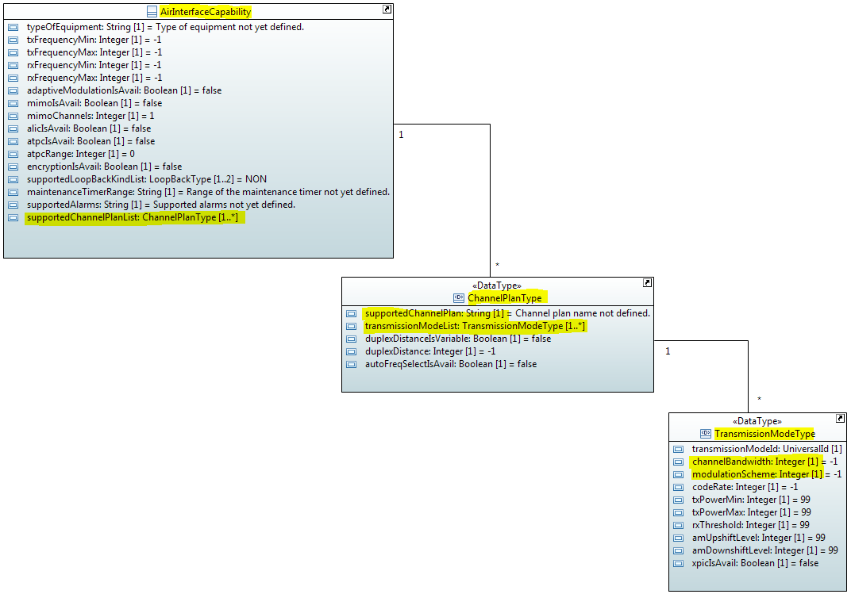

Figure 3: Tree Structure of AirInterface Capabilities

The attributes of the Capability class and its associated data types are expressing the capabilities of the hardware type. This applies also to the xpicIsAvail attribute, which is contained in the TransmissionModeType data type and does not give any information about the operational capability of the individual installation on site.

## Multiple Structure Classes

The Microwave Information Model supports allocating traffic flows on the physical resources of the radio interface. The allocation is modeled by associating *Container classes with sub-segments provided by the *Structure classes.

The methods of sub-segmenting and allocating depend on the implementation of the wireless transport device (e.g. time division duplex vs. frequency division duplex, point-to-point vs. shared medium).

Due to the very basic differences of these methods and the ways of modeling them, the Microwave Information Model offers several Structure_Pacs that must be alternatively applied depending on the devices type (see also chapter 3).

The current version of the modeling offers Structure_Pacs for point-to-point links, which are implementing frequency division duplex and are distinguishing Pure Ethernet and Hybrid microwave links.

* The PureEthernetStructure_Pac offers a single segment, which might vary in size, if adaptive modulation is activated. One or several (only in case the value of the EthernetContainerCapability: bundlingIsAvail attribute is set on "1") of those segments can be linked to an EthernetContainer_Pac.
* The HybridMwStructure_Pac provides multiple TDM segments, which are of fixed size, and an additional segment for Ethernet that is of variable size. There is a one to one relation between TdmContainer_Pac and TDM segment. The Ethernet segment behaves equally to the one provided by the PureEthernetStructure_Pac.

Besides allowing definition of much simpler *Structure classes, this way of modeling is also seen to be more flexible in regards to future expansions.

## Problem Definitions, Associations and Inheritances

As already stated in chapter 4.2, the multiplicity of the associations between *_Pac and *CurrentProblems classes are always one and *CurrentProblems classes contain a list of *CurrentProblemType data type.

Problem statements, respectively alarms contain generic attributes. Usually, generic attributes are consolidated in classes belonging to the Core Information Model and are inherited from these classes.

Since no such super class is available in the currently valid version of the Core Information Model, an individual super class has been defined as a preliminary substitute.

So the *CurrentProblemType data types contain a problemName attribute. problemSeverity, sequenceNumber and timestamp attributes are inherited from the generic MwCurrentProblem super class.

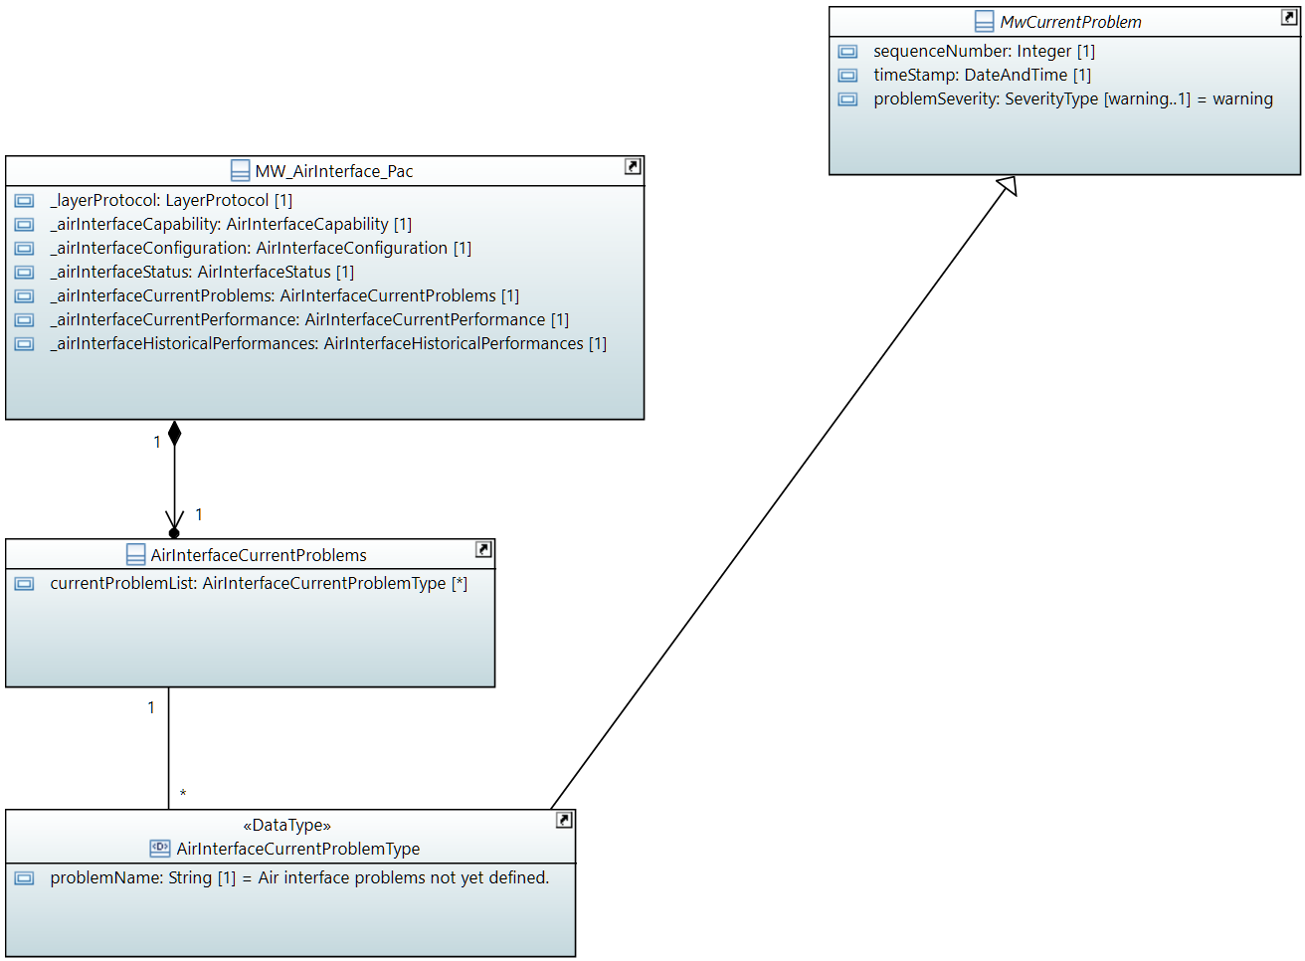

Figure 4: Example for Current Problems Associations and Inheritances

The problemName attributes are just seemingly identical in all *CurrentProblemType data types. The problemName attributes cannot be inherited from the MwCurrentProblem super class, because corresponding supportedAlarms attributes in *Capability classes are referenced in their respective comment fields.

The severity of a kind of problem shall be configurable. A problemKindSeverityList attribute is added to each of the *Configuration classes for that purpose. The severity defined in *ProblemSeverityType data types shall then be applied to all instances of the *CurrentProblemType data type comprising the same problem name.

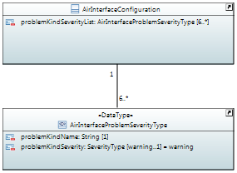

Figure 5: Example for Current Problems Definition

The multiplicity of the association towards the *ProblemSeverityType data type is determined by the number of problem types specified in the corresponding supportedAlarms attribute in the *Capability class. The number of problem types, which are prescribed in the comment field of the corresponding supportedAlarms attribute is always given as the minimum multiplicity.

## Performance Values

As already stated in chapter 4.2, the multiplicities of the associations between *_Pac and *CurrentPerformance respectively *HistoricalPerformances classes are always one and *CurrentPerformance respectively *HistoricalPerformances classes contain a *CurrentPerformanceType respectively *HistoricalPerformanceType data type list.

Technology specific performance value attributes have been put into *PerformanceType data types for being able of referencing them as current performance values as well as historical performance values. Generic performance value attributes are inherited from super classes provided by the Core Information Model.

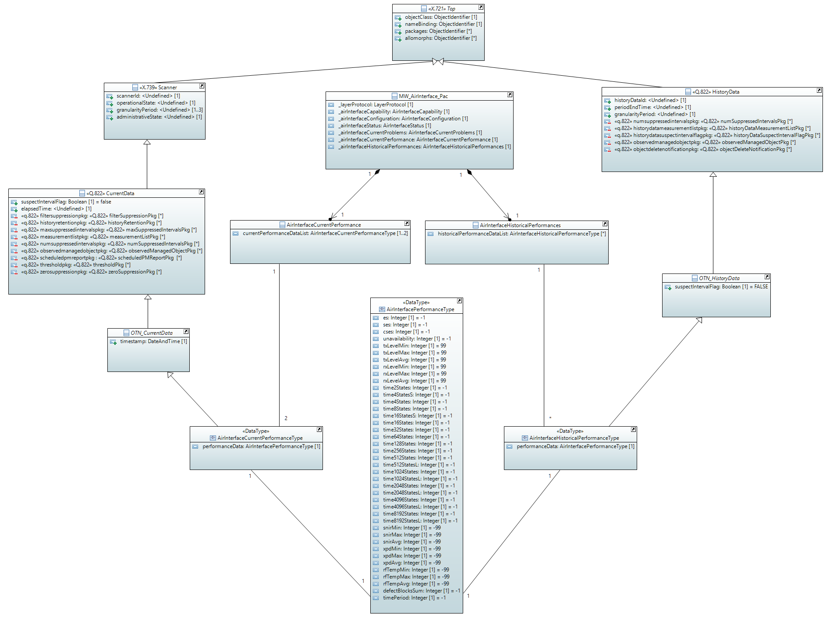

Figure 6: Example for Performance Associations and Inheritances

The isInvariant stereotype of the attributes, which are contained in the *PerformanceType data types, are set on 'true'. This applies also on the current performance values. As a consequence, current performance values have to be readout as a complete, new instance of the *PerformanceType data type. This matches also with the inherited timestamp attribute.

The *PerformanceType data types also inherit a granularityPeriod attribute. Since there is no filtering of 15min or 24h performance values at the device or mediator, data for both granularity periods is uploaded and has to be sorted based on this attribute on application level.

## TDM Containers

The Microwave Information Model basically allows transporting any kinds of TDM signals. This is possible, because neither TDM containers nor TDM segments are fixedly predefined in the modeling.

Instead the Capability class of the TdmContainer_Pac is associated with a list of TdmContainerType data types. Name and bandwidth consumption of container types can be defined within the TdmContainerType data type. Prescriptions for names and sizes are made within the comments at the corresponding attributes.

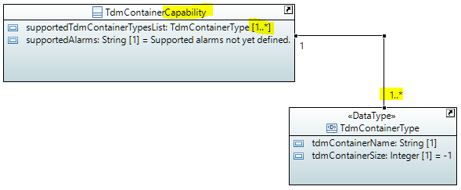

Figure 7: TDM Container Capabilities

The actual type of an instance of a TDM container can then be chosen from the defined types.

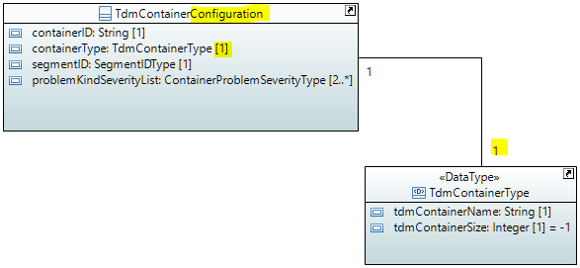

Figure 8: TDM Container Configuration

The modeling of the HybridMwStructure class is very similar. Obviously, bandwidth consumption of the container (tdmContainerSize attribute in TdmContainerType data type) and size of the transport resource (tdmSegmentSize attribute in TdmStructureType data type) have to have the same value for successful allocation.

# Attachment to the Core Information Model

The Core Information Model is the basis of the Microwave Information Model. However not all object classes of the Core Information Model are necessary for a control interface between microwave devices and SDN Controller. For example the root element of the Microwave Information Model is the NetworkElement object class. The SdnController object class must not be implemented in network elements, because a network element cannot offer any control for SDN Controllers.

The following classes of the Core Information Model are not used by the Microwave Information Model:

* SdnController
* NetworkControlDomain
* Link
* LinkPort
* FcRoute

Figure 9 highlights the classes of the Core Information Model, which are part of the Microwave Information Model.

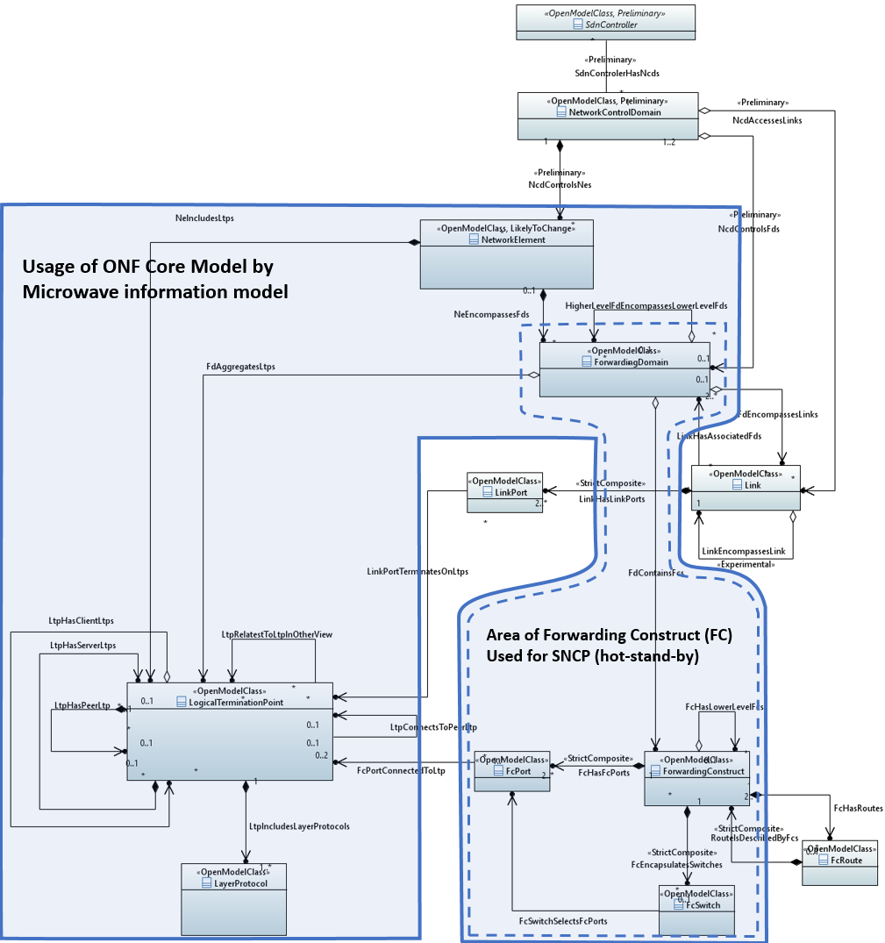

Figure 9: Usage of ONF Core Information Model 1.2

The LogicalTerminationPoints (LTP) is the most important class. Its associations allow complex hierarchies of LTPs. A LayerProtocol class provides content to the generic LTP class and describes its function.

## Attachment of *_Pacs

Technology specific extensions of the Core Information Model are implemented by extending the LayerProtocol class with conditional packages. These conditional packages are called *_Pacs.

The Microwave Information Model defines six technology specific conditional packages, pointing to the LayerProtocol:

* The MW_AirInterface_Pac defines an LTP as microwave physical section trail termination point (MWPS-TTP).
* The MW_AirInterfaceDiversity_Pac defines an LTP as microwave section connection termination point (MWS-CTP). This conditional package is only required, while SpaceDiversity or FrequencyDiversity is used.
* The MW_PureEthernetStructure_Pac defines an LTP as microwave section trail termination point (MWS-TTP) for pure Ethernet microwave systems.
* The MW_HybridMWStructure_Pac defines an LTP as microwave section trail termination point (MWS-TTP) for microwave systems transporting Ethernet and TDM containers.
* The MW_EthernetContainter_Pac defines an LTP as a microwave client connection termination point (MW-Client-CTP) for an Ethernet client signal.
* The MW_TdmContainter_Pac defines an LTP as a microwave client connection termination point (MW-Client-CTP) for any type of TDM client signal.

Figure 10 shows the associations between the LayerProtocol class of the Core Information Model and the six microwave specific conditional packages. Please note that for simplicity reasons the ForwardingConstruct class is not displayed.

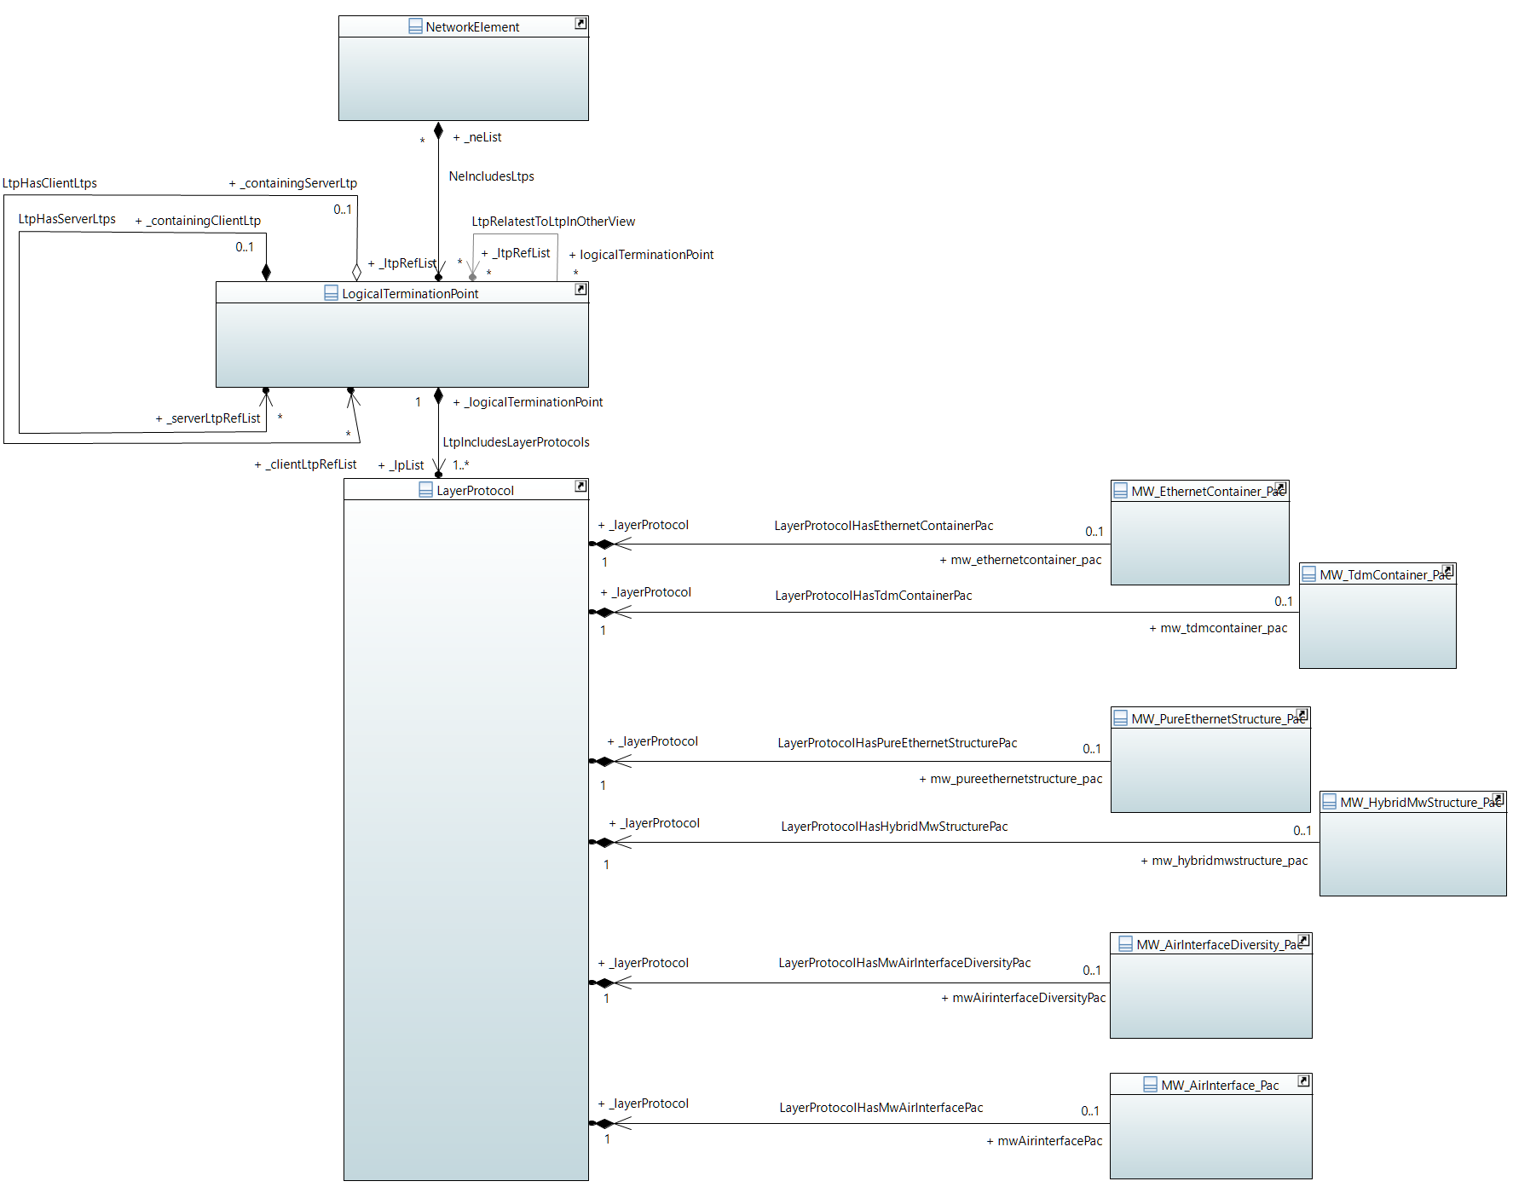

Figure 10: Associations between LayerProtocol and *_Pac

## Attachment of the Co-Channel Group Class

The CoChannelGroup class is for modeling XPIC, MIMO and ALIC, which are required for operating groups of air interfaces that are sharing the same frequency channel. The grouping is done by a list of LogicalTerminationPoint (LTPs) with associated AirInterface_Pacs.



Figure 11: Associations between CoChannelGroup and LTP

## Attachment of the HSB Pac

The hot-stand-by (HSB) functionality of microwave devices is a 1+1 SNCP of the microwave section (MWS). The Core Information Model covers such protection function by the ForwardingConstruct class. Therefore the Microwave Information Model has no technology specific conditional package for that purpose.

It needs to be mentioned that not all required protection control functions are yet defined. Future versions of the Core Information Model or the Microwave Information Model will define those functions. Please see also a corresponding entry in chapter 8 Future Work.

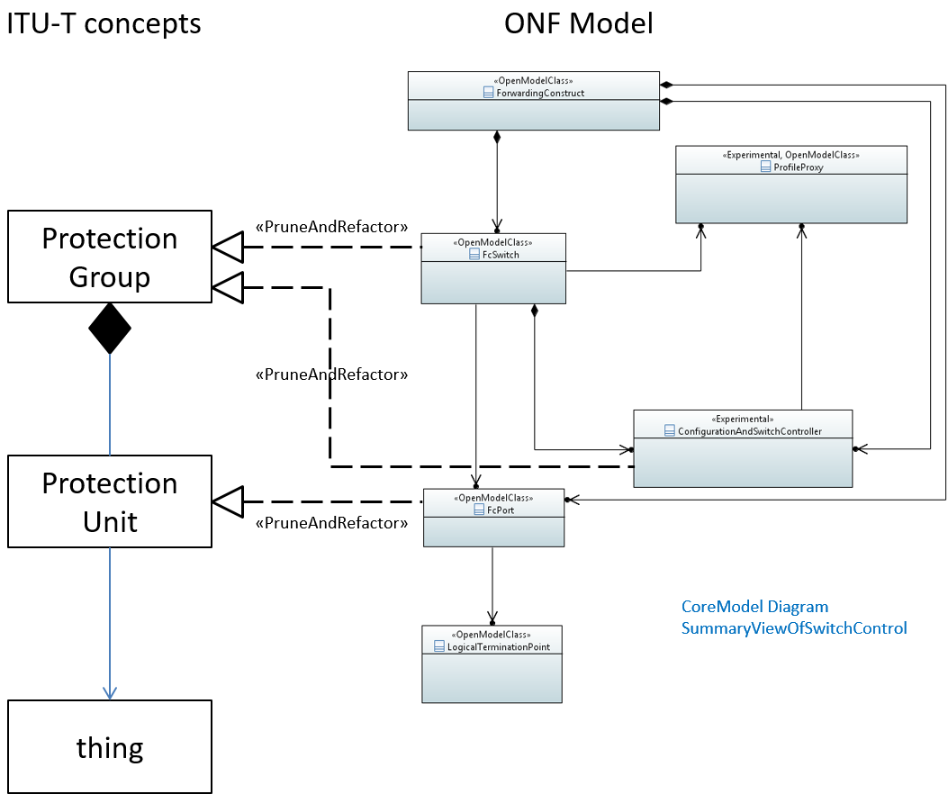

Figure 12: HSB is covered by the ForwardingConstruct of the Core Information Model

# Future Work

Additional aspects and functionality will incrementally be added to the Microwave Information Model in future versions. The following areas for potential amendments have been identified:

* Aligning the modeling of *CurrentProblemType data types to the Core Information Model after provisioning of corresponding super classes
* Aligning the modeling of protection after planed changes at the Core Information Model.
* Adding additional attributes (e.g. "coChannelConfigurationIsComplete") for expressing the operational readiness for operating e.g. XPIC.
* Optimization of Loopback configuration
* Enriching modeling of MIMO according to hardware implementations
* Adding Structure classes for covering point-to-multipoint (PmP) systems
* Adding references to models of Ethernet switches
* Adding automatic neighbor discovery and its relation to trail trace identifier according to ITU‑T REG 7714.1
* Adding relations to the Equipment Model
* Adding references or models of TDM (e.g. PDH, SDH, CPRI) matrixes
* Adding Structure classes for covering Time Devision Duplex (TDD) systems
* Adding Structure classes for covering Next Generation Fronthaul Interface (NGFI)

# UML Model Files

The UML model files can be found here

or here

[https://login.opennetworking.org/bin/ 0](https://login.opennetworking.org/bin/%200)

# Data Dictionary

Please be aware that the following lists are showing not all the attribute's characteristics and stereotypes, e.g. default value and unit are missing. In case of any doubt or ambiguity the attached UML (Papyrus export) is the relevant description of the Microwave Information Model.

## AirInterface_Pac and CoChannelGroup

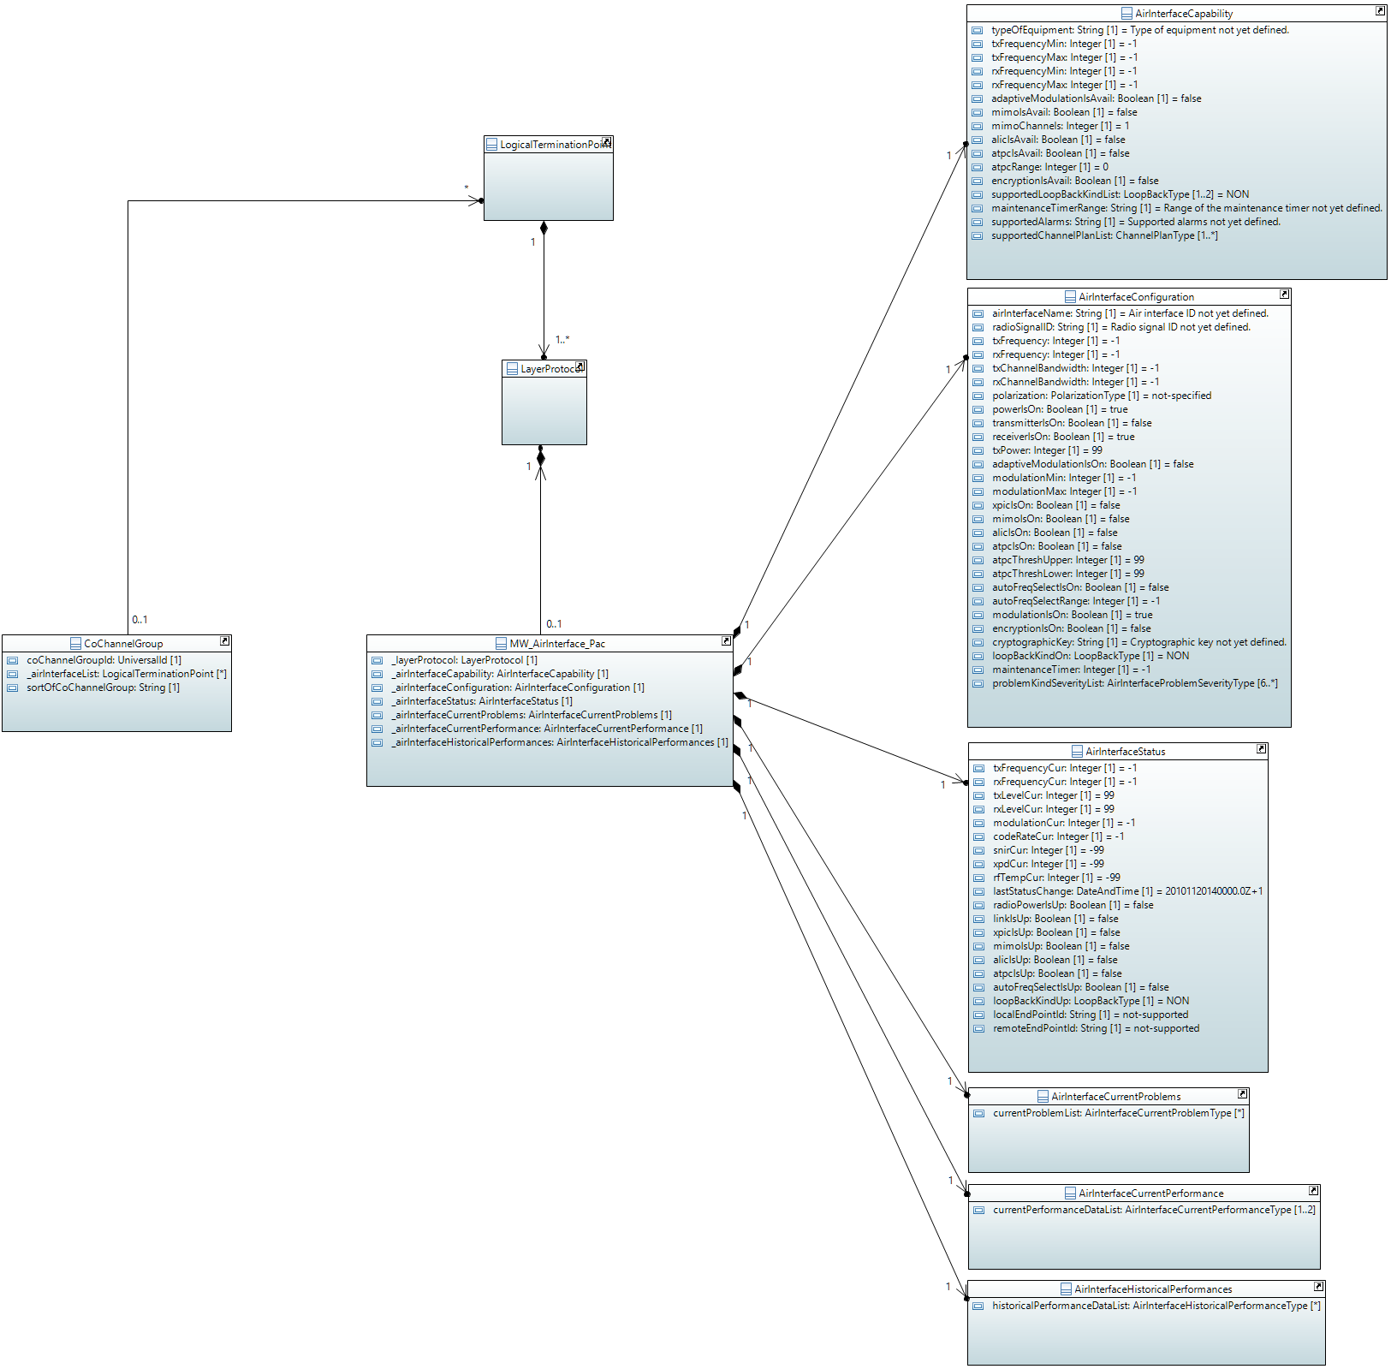

#### MW_AirInterface_Pac

Qualified Name: MicrowaveModel::ObjectClasses::AirInterface::MW_AirInterface_Pac

Applied stereotypes:

* OpenModelClass
* objectCreationNotification: YES
* objectDeletionNotification: YES
* support: MANDATORY

Table 2: Attributes for MW_AirInterface_Pac

| **Attribute Name** | **Type DefaultValue** | **Multiplicity** | **Access** | **Stereotypes** | **Description** |
| --- | --- | --- | --- | --- | --- |
| _layerProtocol | LayerProtocol  ./. | 1 | RW | OpenModelAttribute   * partOfObjectKey: 1 * AVC: NO * isInvariant: false * valueRange: no range constraint * bitLength: NA * unit: no unit defined * support: MANDATORY | CoreModel-CoreNetworkModule-ObjectClasses:NetworkElement/_ltpRefList/_lpList/uuid |
| _airInterfaceCapability | AirInterfaceCapability  ./. | 1 | R | OpenModelAttribute   * partOfObjectKey: 0 * AVC: NO * isInvariant: false * valueRange: no range constraint * bitLength: NA * unit: no unit defined * support: MANDATORY | See referenced class |
| _airInterfaceConfiguration | AirInterfaceConfiguration  ./. | 1 | RW | OpenModelAttribute   * partOfObjectKey: 0 * AVC: NO * isInvariant: false * valueRange: no range constraint * bitLength: NA * unit: no unit defined * support: MANDATORY | See referenced class |
| _airInterfaceStatus | AirInterfaceStatus  ./. | 1 | R | OpenModelAttribute   * partOfObjectKey: 0 * AVC: NO * isInvariant: false * valueRange: no range constraint * bitLength: NA * unit: no unit defined * support: MANDATORY | See referenced class |
| _airInterfaceCurrentProblems | AirInterfaceCurrentProblems  ./. | 1 | R | OpenModelAttribute   * partOfObjectKey: 0 * AVC: NO * isInvariant: false * valueRange: no range constraint * bitLength: NA * unit: no unit defined * support: MANDATORY | See referenced class |
| _airInterfaceCurrentPerformance | AirInterfaceCurrentPerformance  ./. | 1 | R | OpenModelAttribute   * partOfObjectKey: 0 * AVC: NO * isInvariant: false * valueRange: no range constraint * bitLength: NA * unit: no unit defined * support: MANDATORY | See referenced class |
| _airInterfaceHistoricalPerformances | AirInterfaceHistoricalPerformances  ./. | 1 | R | OpenModelAttribute   * partOfObjectKey: 0 * AVC: NO * isInvariant: false * valueRange: no range constraint * bitLength: NA * unit: no unit defined * support: MANDATORY | See referenced class |

#### AirInterfaceHistoricalPerformances

Qualified Name: MicrowaveModel::ObjectClasses::AirInterface::AirInterfaceHistoricalPerformances

Aggregated performance information of the air interface for a pre-defined measurement interval.

Applied stereotypes:

* OpenModelClass
* objectCreationNotification: NO
* objectDeletionNotification: NO
* support: MANDATORY

Table 3: Attributes for AirInterfaceHistoricalPerformances

| **Attribute Name** | **Type DefaultValue** | **Multiplicity** | **Access** | **Stereotypes** | **Description** |
| --- | --- | --- | --- | --- | --- |
| historicalPerformanceDataList | AirInterfaceHistoricalPerformanceType  ./. | 0..* | R | OpenModelAttribute   * partOfObjectKey: 0 * AVC: NO * isInvariant: false * valueRange: no range constraint * bitLength: NA * unit: no unit defined * support: MANDATORY |  |

#### CoChannelGroup

Qualified Name: MicrowaveModel::ObjectClasses::AirInterface::CoChannelGroup

Required for configuring XPIC, MIMO and ALIC.

Applied stereotypes:

* OpenModelClass
* objectCreationNotification: YES
* objectDeletionNotification: YES
* support: MANDATORY

Table 4: Attributes for CoChannelGroup

| **Attribute Name** | **Type DefaultValue** | **Multiplicity** | **Access** | **Stereotypes** | **Description** |
| --- | --- | --- | --- | --- | --- |
| coChannelGroupId | UniversalId  ./. | 1 | RW | OpenModelAttribute   * partOfObjectKey: 1 * AVC: NO * isInvariant: true * valueRange: no range constraint * bitLength: NA * unit: no unit defined * support: MANDATORY |  |
| _airInterfaceList | LogicalTerminationPoint  ./. | 0..* | RW | OpenModelAttribute   * partOfObjectKey: 0 * AVC: YES * isInvariant: false * valueRange: no range constraint * bitLength: NA * unit: no unit defined * support: MANDATORY | List of air interfaces, which are part of the co-channel (XPIC, MIMO, ALIC) group. |
| sortOfCoChannelGroup | String  Kind of co-channel group not specified. | 1 | RW | OpenModelAttribute   * partOfObjectKey: 0 * AVC: YES * isInvariant: false * valueRange: no range constraint * bitLength: NA * unit: no unit defined * support: MANDATORY | Type of group of air interfaces with the same transmit and receive frequency. The values shall be chosen from the following _list:'XPIC', 'MIMO', 'ALIC'; |
| _logicalterminationpoint | LogicalTerminationPoint  ./. | 0..* | RW | OpenModelAttribute   * partOfObjectKey: 0 * AVC: NA * isInvariant: false * valueRange: no range constraint * bitLength: NA * unit: no unit defined * support: MANDATORY   Deprecated | See referenced class |

#### AirInterfaceStatus

Qualified Name: MicrowaveModel::ObjectClasses::AirInterface::AirInterfaceStatus

Measurements of current values on the air interface and operational status of the device.

Applied stereotypes:

* OpenModelClass
* objectCreationNotification: NO
* objectDeletionNotification: NO
* support: MANDATORY

Table 5: Attributes for AirInterfaceStatus

| **Attribute Name** | **Type DefaultValue** | **Multiplicity** | **Access** | **Stereotypes** | **Description** |
| --- | --- | --- | --- | --- | --- |
| txFrequencyCur | Integer  -1 | 1 | R | OpenModelAttribute   * partOfObjectKey: 0 * AVC: YES * isInvariant: false * valueRange: no range constraint * bitLength: LENGTH_32_BIT * unit: kHz * support: MANDATORY | Center frequency of the currently operated transmit channel. |
| rxFrequencyCur | Integer  -1 | 1 | R | OpenModelAttribute   * partOfObjectKey: 0 * AVC: YES * isInvariant: false * valueRange: no range constraint * bitLength: LENGTH_32_BIT * unit: kHz * support: MANDATORY | Center frequency of the currently operated receive channel. |
| txLevelCur | Integer  99 | 1 | R | OpenModelAttribute   * partOfObjectKey: 0 * AVC: NO * isInvariant: false * valueRange: no range constraint * bitLength: LENGTH_8_BIT * unit: dBm * support: MANDATORY | Current transmit level. |
| rxLevelCur | Integer  99 | 1 | R | OpenModelAttribute   * partOfObjectKey: 0 * AVC: NO * isInvariant: false * valueRange: no range constraint * bitLength: LENGTH_8_BIT * unit: dBm * support: MANDATORY | Current receive level. |
| _transmissionModeCur | TransmissionModeType  None | 1 | R | OpenModelAttribute   * partOfObjectKey: 0 * AVC: YES * isInvariant: false * valueRange: no range constraint * bitLength: NA * unit: no unit defined * support: MANDATORY | Currently operated transmission mode according to definitions in Capabilities. |
| modulationCur | Integer  -1 | 1 | R | OpenModelAttribute   * partOfObjectKey: 0 * AVC: YES * isInvariant: false * valueRange: no range constraint * bitLength: LENGTH_16_BIT * unit: symbols * support: MANDATORY   Deprecated | Currently operated modulation on transmit path. The modulation scheme shall be described by the number of states in the phase diagram (e.g. BPSK->'2' or 256QAM->'256'). Allowed values are defined in TypeDefinitions::transmissionModeType::modulationScheme. |
| codeRateCur | Integer  -1 | 1 | R | OpenModelAttribute   * partOfObjectKey: 0 * AVC: NO * isInvariant: false * valueRange: no range constraint * bitLength: LENGTH_8_BIT * unit: % * support: MANDATORY   Deprecated | Code rate of the currently operated coding scheme (Net bit rate ≤ Gross bit rate · code rate). |
| receivedSignalID | Integer  -1 | 1 | R | OpenModelAttribute   * partOfObjectKey: 0 * AVC: YES * isInvariant: false * valueRange: no range constraint * bitLength: LENGTH_16_BIT * unit: no unit defined * support: MANDATORY | ID of the signal, which the receiver is currently synchronized on. |
| snirCur | Integer  -99 | 1 | R | OpenModelAttribute   * partOfObjectKey: 0 * AVC: NO * isInvariant: false * valueRange: no range constraint * bitLength: LENGTH_8_BIT * unit: dB * support: MANDATORY | Currently measured signal to (noise+interference) ratio. |
| xpdCur | Integer  -99 | 1 | R | OpenModelAttribute   * partOfObjectKey: 0 * AVC: NO * isInvariant: false * valueRange: no range constraint * bitLength: LENGTH_8_BIT * unit: dB * support: MANDATORY | Currently measured cross polarization discrimination. |
| rfTempCur | Integer  -99 | 1 | R | OpenModelAttribute   * partOfObjectKey: 0 * AVC: NO * isInvariant: false * valueRange: no range constraint * bitLength: LENGTH_8_BIT * unit: Celsius * support: MANDATORY | Current temperature (in degree Celsius) of the radio module inside the outdoor unit. |
| lastStatusChange | DateTime  2010-11-20T14:00:00+01:00 | 1 | R | OpenModelAttribute   * partOfObjectKey: 0 * AVC: NO * isInvariant: false * valueRange: no range constraint * bitLength: NA * unit: no unit defined * support: MANDATORY | Time the Air Interface entered its current operational status. _format:yyyyMMddhhmmss.s[Z|{+|-}HHMm]; yyyy='0000'..'9999' year; MM='01'..'12' month; dd='01'..'31' day; hh='00'..'23' hour; mm='00'..'59' minute; ss='00'..'59' second; s='.0'..'.9'tenth of second (set to '.0' if EMS or NE cannot support this granularity); Z='Z' indicates UTC (rather than local time); {+|-}='+' or '-' delta from UTC; HH='00'..'23' time zone difference in hours; Mm='00'..'59' time zone difference in minutes. |
| radioPowerIsUp | Boolean  false | 1 | R | OpenModelAttribute   * partOfObjectKey: 0 * AVC: YES * isInvariant: false * valueRange: no range constraint * bitLength: NA * unit: no unit defined * support: MANDATORY | If the radio unit has power and is switched on, this shall be expressed as a 'true'. |
| linkIsUp | Boolean  false | 1 | R | OpenModelAttribute   * partOfObjectKey: 0 * AVC: YES * isInvariant: false * valueRange: no range constraint * bitLength: NA * unit: no unit defined * support: MANDATORY | If connection is established to the remote site with the same linkID, this shall be expressed as a 'true'. |
| xpicIsUp | Boolean  false | 1 | R | OpenModelAttribute   * partOfObjectKey: 0 * AVC: NO * isInvariant: false * valueRange: no range constraint * bitLength: NA * unit: no unit defined * support: MANDATORY | If XPIC is currently actually working (not just configured), this shall be expressed as a 'true'. |
| mimoIsUp | Boolean  false | 1 | R | OpenModelAttribute   * partOfObjectKey: 0 * AVC: NO * isInvariant: false * valueRange: no range constraint * bitLength: NA * unit: no unit defined * support: MANDATORY | If MIMO is currently actually working (not just configured), this shall be expressed as a 'true'. |
| alicIsUp | Boolean  false | 1 | R | OpenModelAttribute   * partOfObjectKey: 0 * AVC: NO * isInvariant: false * valueRange: no range constraint * bitLength: NA * unit: no unit defined * support: MANDATORY | If Adjacent Link Interference Cancelation (ALIC) is currently actually working (not just configured), this shall be expressed as a 'true'. |
| atpcIsUp | Boolean  false | 1 | R | OpenModelAttribute   * partOfObjectKey: 0 * AVC: NO * isInvariant: false * valueRange: no range constraint * bitLength: NA * unit: no unit defined * support: MANDATORY | If ATPC is currently actually working (not just configured), this shall be expressed as a 'true'. |
| autoFreqSelectIsUp | Boolean  false | 1 | R | OpenModelAttribute   * partOfObjectKey: 0 * AVC: NO * isInvariant: false * valueRange: no range constraint * bitLength: NA * unit: no unit defined * support: MANDATORY | If automated frequency selection is currently actually working (not just configured), this shall be expressed as a 'true'. |
| loopBackKindUp | LoopBackType  NON | 1 | R | OpenModelAttribute   * partOfObjectKey: 0 * AVC: NO * isInvariant: false * valueRange: no range constraint * bitLength: NA * unit: no unit defined * support: MANDATORY | The currently active (not just configured) type of looping back of the air interface header shall be expressed here. The received header is returned to the remote site. |
| localEndPointId | String  not-supported | 1 | R | OpenModelAttribute   * partOfObjectKey: 0 * AVC: NO * isInvariant: false * valueRange: no range constraint * bitLength: NA * unit: no unit defined * support: MANDATORY | The value of the localEndPointId is a vendor specific identifier of the air interface, used by the node to discover a microwave radio link. |
| remoteEndPointId | String  not-supported | 1 | R | OpenModelAttribute   * partOfObjectKey: 0 * AVC: NO * isInvariant: false * valueRange: no range constraint * bitLength: NA * unit: no unit defined * support: MANDATORY | The value of the remoteEndPointId is a vendor specific identifier or the airinterface at the remote side, used to by the node to discover a microwave radio link. |

#### AirInterfaceConfiguration

Qualified Name: MicrowaveModel::ObjectClasses::AirInterface::AirInterfaceConfiguration

Configuration of the radio link.

Applied stereotypes:

* OpenModelClass
* objectCreationNotification: NO
* objectDeletionNotification: NO
* support: MANDATORY

Table 6: Attributes for AirInterfaceConfiguration

| **Attribute Name** | **Type DefaultValue** | **Multiplicity** | **Access** | **Stereotypes** | **Description** |
| --- | --- | --- | --- | --- | --- |
| airInterfaceName | String  Air interface ID not yet defined. | 1 | RW | OpenModelAttribute   * partOfObjectKey: 0 * AVC: YES * isInvariant: false * valueRange: no range constraint * bitLength: NA * unit: no unit defined * support: MANDATORY | Operator specific microwave link ID (often used for coding area, type of element and sequential number). |
| remoteAirInterfaceName | String  Air interface ID at the remote site not yet defined. | 1 | RW | OpenModelAttribute   * partOfObjectKey: 0 * AVC: YES * isInvariant: false * valueRange: no range constraint * bitLength: NA * unit: no unit defined * support: MANDATORY | Name of the air interface, which belongs to the same link, at the remote site. |
| expectedSignalID | Integer  0 | 1 | RW | OpenModelAttribute   * partOfObjectKey: 0 * AVC: YES * isInvariant: false * valueRange: no range constraint * bitLength: LENGTH_16_BIT * unit: no unit defined * support: MANDATORY | If set on '0', the receiver ignores the signal ID of the received signal. If set on any other value, the receiver exclusively synchronizes on signals with the same signal ID. |
| transmittedSignalID | Integer  0 | 1 | RW | OpenModelAttribute   * partOfObjectKey: 0 * AVC: YES * isInvariant: false * valueRange: no range constraint * bitLength: LENGTH_16_BIT * unit: no unit defined * support: MANDATORY | Transmitted radio signal ID for synchronizing the receiver. |
| radioSignalID | String  Radio signal ID not yet defined. | 1 | RW | OpenModelAttribute   * partOfObjectKey: 0 * AVC: YES * isInvariant: false * valueRange: no range constraint * bitLength: NA * unit: no unit defined * support: MANDATORY   Deprecated | The radioSignalId is transmitted on the air interface so the remote site of the link synchronizes on the correct transmitter. The local radio MUST NOT synchronize on a radio signal with a different radioSignalId. The link ID is neither an ID necessary to span the model nor an ID referencing external data. It is just some sort of name of the link transmitted so the correct remote site can be identified in an interference situation. The value zero might be used to make the microwave to disable the link ID check. |
| txFrequency | Integer  -1 | 1 | RW | OpenModelAttribute   * partOfObjectKey: 0 * AVC: YES * isInvariant: false * valueRange: no range constraint * bitLength: LENGTH_32_BIT * unit: kHz * support: MANDATORY | Center frequency of the transmit channel. The values to be configured have to exactly match the values listed in the international agreement referenced in channelPlanID. In case of automated selection of the transmit frequency this field shall describe the lowest center frequency selectable. |
| rxFrequency | Integer  -1 | 1 | RW | OpenModelAttribute   * partOfObjectKey: 0 * AVC: YES * isInvariant: false * valueRange: no range constraint * bitLength: LENGTH_32_BIT * unit: kHz * support: MANDATORY | Center frequency of the receive channel. |
| _transmissionModeMin | TransmissionModeType  ./. | 1 | RW | OpenModelAttribute   * partOfObjectKey: 0 * AVC: YES * isInvariant: false * valueRange: no range constraint * bitLength: NA * unit: no unit defined * support: MANDATORY | Minimum transmission mode to be configured (in case adaptive modulation is not used, this value represents also the fixed transmission mode). |
| _transmissionModeMax | TransmissionModeType  ./. | 1 | RW | OpenModelAttribute   * partOfObjectKey: 0 * AVC: YES * isInvariant: false * valueRange: no range constraint * bitLength: NA * unit: no unit defined * support: MANDATORY | Maximum transmission mode to be configured. |
| txChannelBandwidth | Integer  -1 | 1 | RW | OpenModelAttribute   * partOfObjectKey: 0 * AVC: YES * isInvariant: false * valueRange: no range constraint * bitLength: LENGTH_32_BIT * unit: kHz * support: MANDATORY   Deprecated | Bandwidth of the transmit channel. The value shall be expressed explicitly (means in kHz) not as a reference to an international agreement. The values shall be chosen from the following _list: 3.500, 7.000, 14.000, 27.500, 28.000, 29.000, 29.650, 30.000, 40.000, 50.000, 55.000, 56.000, 59.300, 60.000, 80.000, 100.000, 112.000, 120.000, 150.000, 200.000, 250.000, 500.000, 750.000, 1.000.000, 1.250.000, 1.500.000, 1.750.000, 2.000.000; |
| rxChannelBandwidth | Integer  -1 | 1 | RW | OpenModelAttribute   * partOfObjectKey: 0 * AVC: YES * isInvariant: false * valueRange: no range constraint * bitLength: LENGTH_32_BIT * unit: kHz * support: MANDATORY | Bandwidth of the receive channel. The value shall be expressed explicitly (means in kHz) not as a reference to an international agreement. The values shall be chosen from the following _list: 3.500, 7.000, 14.000, 27.500, 28.000, 29.000, 29.650, 30.000, 40.000, 50.000, 55.000, 56.000, 59.300, 60.000, 80.000, 100.000, 112.000, 120.000, 150.000, 200.000, 250.000, 500.000, 750.000, 1.000.000, 1.250.000, 1.500.000, 1.750.000, 2.000.000; |
| polarization | PolarizationType  NOT_SPECIFIED | 1 | RW | OpenModelAttribute   * partOfObjectKey: 0 * AVC: YES * isInvariant: false * valueRange: no range constraint * bitLength: NA * unit: no unit defined * support: MANDATORY | Allows documenting the polarization of the air interface. |
| powerIsOn | Boolean  true | 1 | RW | OpenModelAttribute   * partOfObjectKey: 0 * AVC: YES * isInvariant: false * valueRange: no range constraint * bitLength: NA * unit: no unit defined * support: MANDATORY | Power ON. Activation of the entire radio in a split mount configuration shall be expressed as a 'true'. |
| transmitterIsOn | Boolean  false | 1 | RW | OpenModelAttribute   * partOfObjectKey: 0 * AVC: YES * isInvariant: false * valueRange: no range constraint * bitLength: NA * unit: no unit defined * support: MANDATORY | Activation of the transmitter inside the radio shall be expressed as a 'true'. |
| receiverIsOn | Boolean  true | 1 | RW | OpenModelAttribute   * partOfObjectKey: 0 * AVC: YES * isInvariant: false * valueRange: no range constraint * bitLength: NA * unit: no unit defined * support: MANDATORY | Maintenance Feature. Activation of the receiver inside the radio shall be expressed as a 'true'. Attribute shall also be used for RX main and RX diversity squelches in case of diversity configurations. |
| txPower | Integer  99 | 1 | RW | OpenModelAttribute   * partOfObjectKey: 0 * AVC: YES * isInvariant: false * valueRange: no range constraint * bitLength: LENGTH_8_BIT * unit: dBm * support: MANDATORY | Transmit power to be configured on the microwave link. Signed Byte is required. The actually operated transmit power might be lower depending on adaptive modulation and ATPC. |
| adaptiveModulationIsOn | Boolean  false | 1 | RW | OpenModelAttribute   * partOfObjectKey: 0 * AVC: YES * isInvariant: false * valueRange: no range constraint * bitLength: NA * unit: no unit defined * support: MANDATORY | Adaptive Modulation. Activation of adaptive modulation shall be expressed as a 'true'. |
| modulationMin | Integer  -1 | 1 | RW | OpenModelAttribute   * partOfObjectKey: 0 * AVC: YES * isInvariant: false * valueRange: no range constraint * bitLength: LENGTH_16_BIT * unit: symbols * support: MANDATORY   Deprecated | Minimum modulation to be configured (in case adaptive modulation is not used, this value represents also the fixed modulation). The modulation scheme shall be described by the number of states in the phase diagram (e.g. BPSK->'2' or 256QAM->'256'). Allowed values are defined in TypeDefinitions::transmissionModeType::modulationScheme. |
| modulationMax | Integer  -1 | 1 | RW | OpenModelAttribute   * partOfObjectKey: 0 * AVC: YES * isInvariant: false * valueRange: no range constraint * bitLength: LENGTH_16_BIT * unit: symbols * support: MANDATORY   Deprecated | Maximum modulation to be configured. The value of this field is only relevant, if Adaptive Modulation has been activated. The modulation scheme shall be described by the number of states in the phase diagram (e.g. BPSK->'2' or 256QAM->'256'). Allowed values are defined in TypeDefinitions::transmissionModeType::modulationScheme. |
| xpicIsOn | Boolean  false | 1 | RW | OpenModelAttribute   * partOfObjectKey: 0 * AVC: YES * isInvariant: false * valueRange: no range constraint * bitLength: NA * unit: no unit defined * support: MANDATORY | Activation of Cross Polarization Interference Cancelation shall be expressed as a 'true'. In case XPIC is not available for the current combination of channel bandwidth and modulation or the hardware in general, this parameter shall always be set to 'false'. |
| mimoIsOn | Boolean  false | 1 | RW | OpenModelAttribute   * partOfObjectKey: 0 * AVC: YES * isInvariant: false * valueRange: no range constraint * bitLength: NA * unit: no unit defined * support: MANDATORY | Activation of Multiple Input Multiple Output (MIMO) shall be expressed as a 'true'. |
| alicIsOn | Boolean  false | 1 | RW | OpenModelAttribute   * partOfObjectKey: 0 * AVC: YES * isInvariant: false * valueRange: no range constraint * bitLength: NA * unit: no unit defined * support: MANDATORY | Activation of Adjacent Link Interference Cancelation (ALIC) shall be expressed as a 'true'. |
| atpcIsOn | Boolean  false | 1 | RW | OpenModelAttribute   * partOfObjectKey: 0 * AVC: YES * isInvariant: false * valueRange: no range constraint * bitLength: NA * unit: no unit defined * support: MANDATORY | ATPC. Activation of Automated Transmit Power Control shall be expressed as a 'true'. |
| atpcThreshUpper | Integer  99 | 1 | RW | OpenModelAttribute   * partOfObjectKey: 0 * AVC: YES * isInvariant: false * valueRange: no range constraint * bitLength: LENGTH_16_BIT * unit: dBm * support: MANDATORY | If the receive level is higher than the upper threshold value, the transmitter is notified to decrease transmit power. |
| atpcThreshLower | Integer  99 | 1 | RW | OpenModelAttribute   * partOfObjectKey: 0 * AVC: YES * isInvariant: false * valueRange: no range constraint * bitLength: LENGTH_16_BIT * unit: dBm * support: MANDATORY | If the receive level is lower than the lower threshold value, the transmitter is notified to increase transmit power. |
| atpcTxPowerMin | Integer  -99 | 1 | RW | OpenModelAttribute   * partOfObjectKey: 0 * AVC: YES * isInvariant: false * valueRange: no range constraint * bitLength: LENGTH_8_BIT * unit: dBm * support: MANDATORY | Transmit power, which is not to be undercut, while operating ATPC. |
| autoFreqSelectIsOn | Boolean  false | 1 | RW | OpenModelAttribute   * partOfObjectKey: 0 * AVC: YES * isInvariant: false * valueRange: no range constraint * bitLength: NA * unit: no unit defined * support: MANDATORY | Activation of automatically selecting the transmit frequency in unlicensed bands shall be expressed as a 'true'. |
| autoFreqSelectRange | Integer  -1 | 1 | RW | OpenModelAttribute   * partOfObjectKey: 0 * AVC: YES * isInvariant: false * valueRange: no range constraint * bitLength: LENGTH_8_BIT * unit: channels * support: MANDATORY | Number of transmit channels (starting at the center frequency defined in txFrequency and with channel bandwidth according to txChannelBandwidth) that define the range within the transmit frequency can automatically been chosen. |
| modulationIsOn | Boolean  true | 1 | RW | OpenModelAttribute   * partOfObjectKey: 0 * AVC: YES * isInvariant: false * valueRange: no range constraint * bitLength: NA * unit: no unit defined * support: MANDATORY | Maintenance Feature. De-activation of the modulation of the carrier signal for fault management shall be expressed as a 'false'. |
| encryptionIsOn | Boolean  false | 1 | RW | OpenModelAttribute   * partOfObjectKey: 0 * AVC: YES * isInvariant: false * valueRange: no range constraint * bitLength: NA * unit: no unit defined * support: MANDATORY | Activates encryption of the payload. |
| cryptographicKey | String  Cryptographic key not yet defined. | 1 | RW | OpenModelAttribute   * partOfObjectKey: 0 * AVC: YES * isInvariant: false * valueRange: no range constraint * bitLength: NA * unit: no unit defined * support: MANDATORY | Key for transforming plaintext into ciphertext data. |
| performanceMonitoringCollectionIsOn | Boolean  false | 1 | RW | OpenModelAttribute   * partOfObjectKey: 0 * AVC: YES * isInvariant: false * valueRange: no range constraint * bitLength: NA * unit: no unit defined * support: MANDATORY | Enables measurement, collection, storage and access to performance data. |
| thresholdCrossAlarmList | ThresholdCrossAlarmType  ./. | 0..6 | RW | OpenModelAttribute   * partOfObjectKey: 0 * AVC: YES * isInvariant: false * valueRange: no range constraint * bitLength: NA * unit: no unit defined * support: MANDATORY | List of threshold cross alarms to be configured. |
| loopBackKindOn | LoopBackType  NON | 1 | RW | OpenModelAttribute   * partOfObjectKey: 0 * AVC: YES * isInvariant: false * valueRange: no range constraint * bitLength: NA * unit: no unit defined * support: MANDATORY | Maintenance Feature. The currently configured type of looping back of the air interface header shall be expressed here. The received header is returned to the remote site. |
| maintenanceTimer | Integer  -1 | 1 | RW | OpenModelAttribute   * partOfObjectKey: 0 * AVC: YES * isInvariant: false * valueRange: no range constraint * bitLength: LENGTH_32_BIT * unit: s * support: MANDATORY | Time of existence of any maintenance configuration (e.g. the loop back of microwave header information). Valid values are defined in AirInterface::AirInterfaceCapability::maintenanceTimerRange. |
| problemKindSeverityList | AirInterfaceProblemSeverityType  ./. | 6..* | RW | OpenModelAttribute   * partOfObjectKey: 0 * AVC: YES * isInvariant: false * valueRange: no range constraint * bitLength: NA * unit: no unit defined * support: MANDATORY | Severity of the problem to be configured. |

#### AirInterfaceCurrentPerformance

Qualified Name: MicrowaveModel::ObjectClasses::AirInterface::AirInterfaceCurrentPerformance

Aggregated performance information of the air interface at a particular moment.

Applied stereotypes:

* OpenModelClass
* objectCreationNotification: NO
* objectDeletionNotification: NO
* support: MANDATORY

Table 7: Attributes for AirInterfaceCurrentPerformance

| **Attribute Name** | **Type DefaultValue** | **Multiplicity** | **Access** | **Stereotypes** | **Description** |
| --- | --- | --- | --- | --- | --- |
| currentPerformanceDataList | AirInterfaceCurrentPerformanceType  ./. | 1..2 | R | OpenModelAttribute   * partOfObjectKey: 0 * AVC: NO * isInvariant: false * valueRange: no range constraint * bitLength: NA * unit: no unit defined * support: MANDATORY | At least values of the counters, which are reset every 15 minutes, are to be provided. If available, the current values of the counters, which are reset every 24 hour, can be provided, too. |

#### AirInterfaceCapability

Qualified Name: MicrowaveModel::ObjectClasses::AirInterface::AirInterfaceCapability

Describes the 'analog' capabilities of modem and transmitter of the microwave device. Value ranges of attributes are not independently (e.g. min. and max. transmit power depends on modulation). Legal combinations of values are expressed in transmissionModeTypes.

Applied stereotypes:

* OpenModelClass
* objectCreationNotification: NO
* objectDeletionNotification: NO
* support: MANDATORY

Table 8: Attributes for AirInterfaceCapability

| **Attribute Name** | **Type DefaultValue** | **Multiplicity** | **Access** | **Stereotypes** | **Description** |
| --- | --- | --- | --- | --- | --- |
| typeOfEquipment | String  Type of equipment not yet defined. | 1 | R | OpenModelAttribute   * partOfObjectKey: 0 * AVC: NO * isInvariant: true * valueRange: no range constraint * bitLength: NA * unit: no unit defined * support: MANDATORY | This parameter indicates the equipment type. Instead of uploading the complete set of capabilities, capabilities of the same equipment type could be reused. Should be unique for a combination of modem, radio and their respective firmware. |
| txFrequencyMin | Integer  -1 | 1 | R | OpenModelAttribute   * partOfObjectKey: 0 * AVC: NO * isInvariant: true * valueRange: no range constraint * bitLength: LENGTH_32_BIT * unit: kHz * support: MANDATORY | Value of the minimum transmit frequency tunable at the air interface. |
| txFrequencyMax | Integer  -1 | 1 | R | OpenModelAttribute   * partOfObjectKey: 0 * AVC: NO * isInvariant: true * valueRange: no range constraint * bitLength: LENGTH_32_BIT * unit: kHz * support: MANDATORY | Value of the maximum transmit frequency tunable at the air interface. |
| rxFrequencyMin | Integer  -1 | 1 | R | OpenModelAttribute   * partOfObjectKey: 0 * AVC: NO * isInvariant: true * valueRange: no range constraint * bitLength: LENGTH_32_BIT * unit: kHz * support: MANDATORY | Value of the minimum receive frequency tunable at the air interface. |
| rxFrequencyMax | Integer  -1 | 1 | R | OpenModelAttribute   * partOfObjectKey: 0 * AVC: NO * isInvariant: true * valueRange: no range constraint * bitLength: LENGTH_32_BIT * unit: kHz * support: MANDATORY | Value of the maximum receive frequency tunable at the air interface. |
| supportedChannelPlanList | ChannelPlanType  Supported alarms not yet defined. | 1..* | R | OpenModelAttribute   * partOfObjectKey: 0 * AVC: NO * isInvariant: true * valueRange: no range constraint * bitLength: NA * unit: no unit defined * support: MANDATORY | List of channel spacing that are supported by the device. |
| adaptiveModulationIsAvail | Boolean  false | 1 | R | OpenModelAttribute   * partOfObjectKey: 0 * AVC: NO * isInvariant: true * valueRange: no range constraint * bitLength: NA * unit: no unit defined * support: MANDATORY | In case the device is capable of adaptive modulation, this field shall contain a 'true'. |
| mimoIsAvail | Boolean  false | 1 | R | OpenModelAttribute   * partOfObjectKey: 0 * AVC: NO * isInvariant: true * valueRange: no range constraint * bitLength: NA * unit: no unit defined * support: MANDATORY | In case the device is capable of MIMO, this field shall contain a 'true'. |
| mimoChannels | Integer  1 | 1 | R | OpenModelAttribute   * partOfObjectKey: 0 * AVC: NO * isInvariant: true * valueRange: no range constraint * bitLength: LENGTH_8_BIT * unit: channels * support: MANDATORY | Maximum number (n) of spatial multiplexing streams that can be conveyed by an n x n MIMO configuration. |
| alicIsAvail | Boolean  false | 1 | R | OpenModelAttribute   * partOfObjectKey: 0 * AVC: NO * isInvariant: true * valueRange: no range constraint * bitLength: NA * unit: no unit defined * support: MANDATORY | In case the microwave radio is capable of Adjacent Link Interference Cancelation (canceling of interference cause by transmitters located at the same site), this field shall contain a 'true'. |
| atpcIsAvail | Boolean  false | 1 | R | OpenModelAttribute   * partOfObjectKey: 0 * AVC: NO * isInvariant: true * valueRange: no range constraint * bitLength: NA * unit: no unit defined * support: MANDATORY | In case the microwave radio is capable of ATPC, this field shall contain a 'true'. |
| atpcRange | Integer  0 | 1 | R | OpenModelAttribute   * partOfObjectKey: 0 * AVC: NO * isInvariant: true * valueRange: no range constraint * bitLength: LENGTH_8_BIT * unit: dB * support: MANDATORY | Extent of the ATPC range. This value represents a device specific maximum value. The actual range of the ATPC at a specific link might be limited by the difference between configured transmit power (AirInterface::AirInterfaceConfiguration::txPower) and minimum transmit power of the device (TypeDefinitions::TransmissionModeType::txPowerMin). |
| encryptionIsAvail | Boolean  false | 1 | R | OpenModelAttribute   * partOfObjectKey: 0 * AVC: NO * isInvariant: true * valueRange: no range constraint * bitLength: NA * unit: no unit defined * support: MANDATORY | Shall be marked 'true', if payload encryption is available. |
| supportedLoopBackKindList | LoopBackType  NON | 1 | R | OpenModelAttribute   * partOfObjectKey: 0 * AVC: NO * isInvariant: true * valueRange: no range constraint * bitLength: NA * unit: no unit defined * support: MANDATORY | List of supported kinds of looping back of header information to the remote site. |
| maintenanceTimerRange | String  Range of the maintenance timer not yet defined. | 1 | R | OpenModelAttribute   * partOfObjectKey: 0 * AVC: NO * isInvariant: true * valueRange: no range constraint * bitLength: NA * unit: s * support: MANDATORY | Available time periods for maintenance configurations (e.g. the loop back of microwave header information) to be described. Concrete values shall be separated by commas (e.g. '10, 60, 360'). Ranges shall be expressed as two values separated by a minus (e.g. '10-360'). |
| supportedAlarmList | String  Supported alarms not yet defined. | 7..* | R | OpenModelAttribute   * partOfObjectKey: 0 * AVC: NO * isInvariant: true * valueRange: no range constraint * bitLength: NA * unit: no unit defined * support: MANDATORY | Available alarms to be listed. Mandatory:'signalIsLost','rslIsExceeded','signalIDMismatching','temperatureIsExceeded','modemIsFaulty','radioIsFaulty' and 'modulationIsDownShifted'. Further alarms might be added by the vendor. |
| supportedAlarms | String  Supported alarms not yet defined. | 1 | R | OpenModelAttribute   * partOfObjectKey: 0 * AVC: NO * isInvariant: true * valueRange: no range constraint * bitLength: NA * unit: no unit defined * support: MANDATORY   Deprecated | Available alarms to be listed. Mandatory:'signalIsLost','rslIsExceeded','temperatureIsExceeded','modemIsFaulty','radioIsFaulty' and 'modulationIsDownShifted'. Further alarms might be added by the device. Names are to be separated by commas. |

#### AirInterfaceCurrentProblems

Qualified Name: MicrowaveModel::ObjectClasses::AirInterface::AirInterfaceCurrentProblems

Applied stereotypes:

* OpenModelClass
* objectCreationNotification: NO
* objectDeletionNotification: NO
* support: MANDATORY

Table 9: Attributes for AirInterfaceCurrentProblems

| **Attribute Name** | **Type DefaultValue** | **Multiplicity** | **Access** | **Stereotypes** | **Description** |
| --- | --- | --- | --- | --- | --- |
| currentProblemList | AirInterfaceCurrentProblemType  ./. | 0..* | R | OpenModelAttribute   * partOfObjectKey: 0 * AVC: NO * isInvariant: false * valueRange: no range constraint * bitLength: NA * unit: no unit defined * support: MANDATORY |  |

## Structure_Pacs

### PureEthernetStructure_Pac

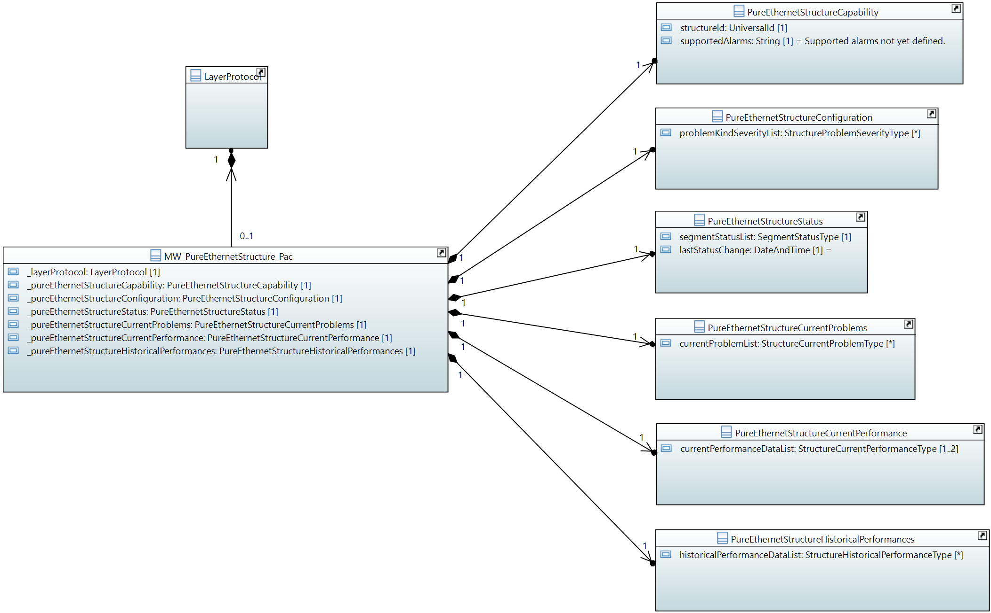

#### PureEthernetStructureConfiguration

Qualified Name: MicrowaveModel::ObjectClasses::PureEthernetStructure::PureEthernetStructureConfiguration

Applied stereotypes:

* OpenModelClass
* objectCreationNotification: NO
* objectDeletionNotification: NO
* support: MANDATORY

Table 10: Attributes for PureEthernetStructureConfiguration

| **Attribute Name** | **Type DefaultValue** | **Multiplicity** | **Access** | **Stereotypes** | **Description** |
| --- | --- | --- | --- | --- | --- |
| performanceMonitoringCollectionIsOn | Boolean  false | 1 | RW | OpenModelAttribute   * partOfObjectKey: 0 * AVC: YES * isInvariant: false * valueRange: no range constraint * bitLength: NA * unit: no unit defined * support: MANDATORY | Enables measurement, collection, storage and access to performance data. |
| problemKindSeverityList | StructureProblemSeverityType  ./. | 0..* | RW | OpenModelAttribute   * partOfObjectKey: 0 * AVC: YES * isInvariant: false * valueRange: no range constraint * bitLength: NA * unit: no unit defined * support: MANDATORY | Severity of the type of problem to be configured. |

#### PureEthernetStructureCurrentProblems

Qualified Name: MicrowaveModel::ObjectClasses::PureEthernetStructure::PureEthernetStructureCurrentProblems

Applied stereotypes:

* OpenModelClass
* objectCreationNotification: NO
* objectDeletionNotification: NO
* support: MANDATORY

Table 11: Attributes for PureEthernetStructureCurrentProblems

| **Attribute Name** | **Type DefaultValue** | **Multiplicity** | **Access** | **Stereotypes** | **Description** |
| --- | --- | --- | --- | --- | --- |
| currentProblemList | StructureCurrentProblemType  ./. | 0..* | R | OpenModelAttribute   * partOfObjectKey: 0 * AVC: NO * isInvariant: false * valueRange: no range constraint * bitLength: NA * unit: no unit defined * support: MANDATORY |  |

#### PureEthernetStructureCapability

Qualified Name: MicrowaveModel::ObjectClasses::PureEthernetStructure::PureEthernetStructureCapability

Describes the logical structuring of the physical capacity provided by a pure Ethernet microwave device. Segmentation is not available. No fixed segment size. No TDM transport.

Applied stereotypes:

* OpenModelClass
* objectCreationNotification: NO
* objectDeletionNotification: NO
* support: MANDATORY

Table 12: Attributes for PureEthernetStructureCapability

| **Attribute Name** | **Type DefaultValue** | **Multiplicity** | **Access** | **Stereotypes** | **Description** |
| --- | --- | --- | --- | --- | --- |
| structureId | UniversalId  ./. | 1 | R | OpenModelAttribute   * partOfObjectKey: 1 * AVC: NO * isInvariant: true * valueRange: no range constraint * bitLength: NA * unit: no unit defined * support: MANDATORY | Identifies the Structure for bundling and container. |
| supportedAlarmList | String  Supported alarms not yet defined. | 0..* | R | OpenModelAttribute   * partOfObjectKey: 0 * AVC: NO * isInvariant: true * valueRange: no range constraint * bitLength: NA * unit: no unit defined * support: MANDATORY | Available alarms to be listed. Mandatory:non. Names are to be separated by commas. Further alarms might be added by the vendor. |
| supportedAlarms | String  Supported alarms not yet defined. | 1 | R | OpenModelAttribute   * partOfObjectKey: 0 * AVC: NO * isInvariant: true * valueRange: no range constraint * bitLength: NA * unit: no unit defined * support: MANDATORY   Deprecated | Available alarms to be listed. Mandatory:non. Names are to be separated by commas. Further alarms might be added by the device. |

#### PureEthernetStructureStatus

Qualified Name: MicrowaveModel::ObjectClasses::PureEthernetStructure::PureEthernetStructureStatus

Applied stereotypes:

* OpenModelClass
* objectCreationNotification: NO
* objectDeletionNotification: NO
* support: MANDATORY

Table 13: Attributes for PureEthernetStructureStatus

| **Attribute Name** | **Type DefaultValue** | **Multiplicity** | **Access** | **Stereotypes** | **Description** |
| --- | --- | --- | --- | --- | --- |
| segmentStatusList | SegmentStatusType  ./. | 1 | R | OpenModelAttribute   * partOfObjectKey: 0 * AVC: YES * isInvariant: false * valueRange: no range constraint * bitLength: NA * unit: no unit defined * support: MANDATORY | Status of the Ethernet transport segment. Always just one segment. |
| lastStatusChange | DateTime  2010-11-20T14:00:00+01:00 | 1 | R | OpenModelAttribute   * partOfObjectKey: 0 * AVC: NO * isInvariant: false * valueRange: no range constraint * bitLength: NA * unit: no unit defined * support: MANDATORY | Time and date of the last update of the status information. _format:yyyyMMddhhmmss.s[Z|{+|-}HHMm]; yyyy='0000'..'9999' year; MM='01'..'12' month; dd='01'..'31' day; hh='00'..'23' hour; mm='00'..'59' minute; ss='00'..'59' second; s='.0'..'.9'tenth of second (set to '.0' if EMS or NE cannot support this granularity); Z='Z' indicates UTC (rather than local time); {+|-}='+' or '-' delta from UTC; HH='00'..'23' time zone difference in hours; Mm='00'..'59' time zone difference in minutes. |

#### PureEthernetStructureCurrentPerformance

Qualified Name: MicrowaveModel::ObjectClasses::PureEthernetStructure::PureEthernetStructureCurrentPerformance

Aggregated performance information of the structure of an pure Ethernet microwave at a particular moment.

Applied stereotypes:

* OpenModelClass
* objectCreationNotification: NO
* objectDeletionNotification: NO
* support: MANDATORY

Table 14: Attributes for PureEthernetStructureCurrentPerformance

| **Attribute Name** | **Type DefaultValue** | **Multiplicity** | **Access** | **Stereotypes** | **Description** |
| --- | --- | --- | --- | --- | --- |
| currentPerformanceDataList | StructureCurrentPerformanceType  ./. | 1..2 | R | OpenModelAttribute   * partOfObjectKey: 0 * AVC: NO * isInvariant: false * valueRange: no range constraint * bitLength: NA * unit: no unit defined * support: MANDATORY | At least values of the counters, which are reset every 15 minutes, are to be provided. If available, the current values of the counters, which are reset every 24 hour, can be provided, too. |

#### MW_PureEthernetStructure_Pac

Qualified Name: MicrowaveModel::ObjectClasses::PureEthernetStructure::MW_PureEthernetStructure_Pac

The pureEthernetStructure_Pac and its attached classes MUST be provided on management interfaces of microwave devices, which are transporting Ethernet traffic only.

Applied stereotypes:

* OpenModelClass
* objectCreationNotification: YES
* objectDeletionNotification: YES
* support: CONDITIONAL_MANDATORY
* condition: pure-ethernet In case the microwave device allows using the entire air interface capacity for Ethernet transport only, it has to support this feature on its management interface.

Table 15: Attributes for MW_PureEthernetStructure_Pac

| **Attribute Name** | **Type DefaultValue** | **Multiplicity** | **Access** | **Stereotypes** | **Description** |
| --- | --- | --- | --- | --- | --- |
| _layerProtocol | LayerProtocol  ./. | 1 | RW | OpenModelAttribute   * partOfObjectKey: 1 * AVC: NO * isInvariant: false * valueRange: no range constraint * bitLength: NA * unit: no unit defined * support: MANDATORY | CoreModel-CoreNetworkModule-ObjectClasses:NetworkElement/_ltpRefList/_lpList/uuid |
| _pureEthernetStructureCapability | PureEthernetStructureCapability  ./. | 1 | R | OpenModelAttribute   * partOfObjectKey: 0 * AVC: NO * isInvariant: false * valueRange: no range constraint * bitLength: NA * unit: no unit defined * support: MANDATORY | See referenced class |
| _pureEthernetStructureConfiguration | PureEthernetStructureConfiguration  ./. | 1 | RW | OpenModelAttribute   * partOfObjectKey: 0 * AVC: NO * isInvariant: false * valueRange: no range constraint * bitLength: NA * unit: no unit defined * support: MANDATORY | See referenced class |
| _pureEthernetStructureStatus | PureEthernetStructureStatus  ./. | 1 | R | OpenModelAttribute   * partOfObjectKey: 0 * AVC: NO * isInvariant: false * valueRange: no range constraint * bitLength: NA * unit: no unit defined * support: MANDATORY | See referenced class |
| _pureEthernetStructureCurrentProblems | PureEthernetStructureCurrentProblems  ./. | 1 | R | OpenModelAttribute   * partOfObjectKey: 0 * AVC: NO * isInvariant: false * valueRange: no range constraint * bitLength: NA * unit: no unit defined * support: MANDATORY | See referenced class |
| _pureEthernetStructureCurrentPerformance | PureEthernetStructureCurrentPerformance  ./. | 1 | R | OpenModelAttribute   * partOfObjectKey: 0 * AVC: NO * isInvariant: false * valueRange: no range constraint * bitLength: NA * unit: no unit defined * support: MANDATORY | See referenced class |
| _pureEthernetStructureHistoricalPerformances | PureEthernetStructureHistoricalPerformances  ./. | 1 | R | OpenModelAttribute   * partOfObjectKey: 0 * AVC: NO * isInvariant: false * valueRange: no range constraint * bitLength: NA * unit: no unit defined * support: MANDATORY | See referenced class |

#### PureEthernetStructureHistoricalPerformances

Qualified Name: MicrowaveModel::ObjectClasses::PureEthernetStructure::PureEthernetStructureHistoricalPerformances

Aggregated performance information of the structure of an pure Ethernet microwave for a pre-defined measurement interval.

Applied stereotypes:

* OpenModelClass
* objectCreationNotification: NO
* objectDeletionNotification: NO
* support: MANDATORY

Table 16: Attributes for PureEthernetStructureHistoricalPerformances

| **Attribute Name** | **Type DefaultValue** | **Multiplicity** | **Access** | **Stereotypes** | **Description** |
| --- | --- | --- | --- | --- | --- |
| historicalPerformanceDataList | StructureHistoricalPerformanceType  ./. | 0..* | R | OpenModelAttribute   * partOfObjectKey: 0 * AVC: NO * isInvariant: false * valueRange: no range constraint * bitLength: NA * unit: no unit defined * support: MANDATORY |  |

### HybridMwStructure_Pac

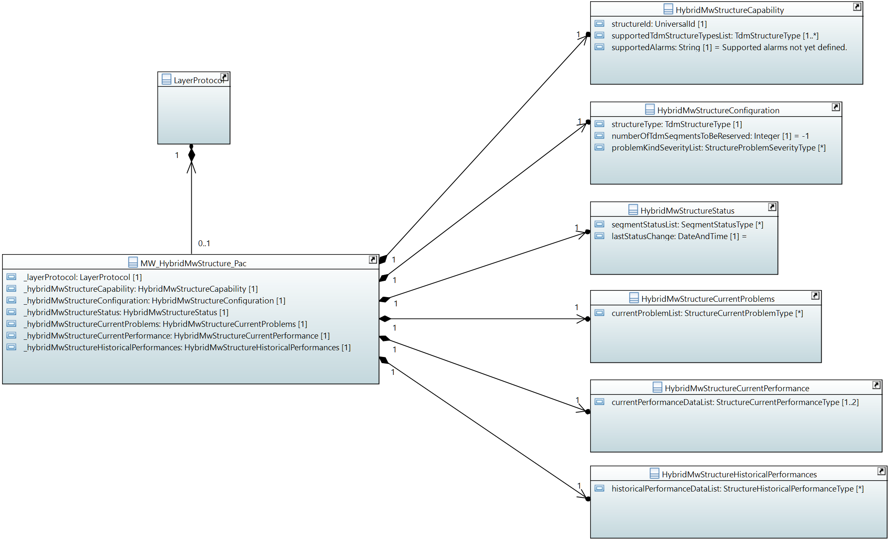

#### HybridMwStructureCurrentProblems

Qualified Name: MicrowaveModel::ObjectClasses::HybridMwStructure::HybridMwStructureCurrentProblems

Applied stereotypes:

* OpenModelClass
* objectCreationNotification: NO
* objectDeletionNotification: NO
* support: MANDATORY

Table 17: Attributes for HybridMwStructureCurrentProblems

| **Attribute Name** | **Type DefaultValue** | **Multiplicity** | **Access** | **Stereotypes** | **Description** |
| --- | --- | --- | --- | --- | --- |
| currentProblemList | StructureCurrentProblemType  ./. | 0..* | R | OpenModelAttribute   * partOfObjectKey: 0 * AVC: NO * isInvariant: false * valueRange: no range constraint * bitLength: NA * unit: no unit defined * support: MANDATORY |  |

#### HybridMwStructureHistoricalPerformances

Qualified Name: MicrowaveModel::ObjectClasses::HybridMwStructure::HybridMwStructureHistoricalPerformances

Aggregated performance information of the structure of a hybrid microwave for a pre-defined measurement interval.

Applied stereotypes:

* OpenModelClass
* objectCreationNotification: NO
* objectDeletionNotification: NO
* support: MANDATORY

Table 18: Attributes for HybridMwStructureHistoricalPerformances

| **Attribute Name** | **Type DefaultValue** | **Multiplicity** | **Access** | **Stereotypes** | **Description** |
| --- | --- | --- | --- | --- | --- |
| historicalPerformanceDataList | StructureHistoricalPerformanceType  ./. | 0..* | R | OpenModelAttribute   * partOfObjectKey: 0 * AVC: NO * isInvariant: false * valueRange: no range constraint * bitLength: NA * unit: no unit defined * support: MANDATORY |  |

#### HybridMwStructureCurrentPerformance

Qualified Name: MicrowaveModel::ObjectClasses::HybridMwStructure::HybridMwStructureCurrentPerformance

Aggregated performance information of the structure of a hybrid microwave at a particular moment.

Applied stereotypes:

* OpenModelClass
* objectCreationNotification: NO
* objectDeletionNotification: NO
* support: MANDATORY

Table 19: Attributes for HybridMwStructureCurrentPerformance

| **Attribute Name** | **Type DefaultValue** | **Multiplicity** | **Access** | **Stereotypes** | **Description** |
| --- | --- | --- | --- | --- | --- |
| currentPerformanceDataList | StructureCurrentPerformanceType  ./. | 1..2 | R | OpenModelAttribute   * partOfObjectKey: 0 * AVC: NO * isInvariant: false * valueRange: no range constraint * bitLength: NA * unit: no unit defined * support: MANDATORY | At least values of the counters, which are reset every 15 minutes, are to be provided. If available, the current values of the counters, which are reset every 24 hour, can be provided, too. |

#### HybridMwStructureCapability

Qualified Name: MicrowaveModel::ObjectClasses::HybridMwStructure::HybridMwStructureCapability

Describes the logical structuring of the physical capacity provided by a hybrid microwave device (TDM + Ethernet). Segmentation is available. TDM transport is available.

Applied stereotypes:

* OpenModelClass
* objectCreationNotification: NO
* objectDeletionNotification: NO
* support: MANDATORY

Table 20: Attributes for HybridMwStructureCapability

| **Attribute Name** | **Type DefaultValue** | **Multiplicity** | **Access** | **Stereotypes** | **Description** |
| --- | --- | --- | --- | --- | --- |
| structureId | UniversalId  ./. | 1 | R | OpenModelAttribute   * partOfObjectKey: 1 * AVC: NO * isInvariant: true * valueRange: no range constraint * bitLength: NA * unit: no unit defined * support: MANDATORY | Identifies the Structure for bundling and container. |
| supportedTdmStructureTypesList | TdmStructureType  ./. | 1..* | R | OpenModelAttribute   * partOfObjectKey: 0 * AVC: NO * isInvariant: true * valueRange: no range constraint * bitLength: NA * unit: no unit defined * support: MANDATORY | Lists the TDM frame types that are supported. |
| supportedAlarmList | String  Supported alarms not yet defined. | 0..* | R | OpenModelAttribute   * partOfObjectKey: 0 * AVC: NO * isInvariant: true * valueRange: no range constraint * bitLength: NA * unit: no unit defined * support: MANDATORY | Available alarms to be listed. Mandatory:non. Names are to be separated by commas. Further alarms might be added by the vendor. |
| supportedAlarms | String  Supported alarms not yet defined. | 1 | R | OpenModelAttribute   * partOfObjectKey: 0 * AVC: NO * isInvariant: true * valueRange: no range constraint * bitLength: NA * unit: no unit defined * support: MANDATORY   Deprecated | Available alarms to be listed. Mandatory:non. Names are to be separated by commas. Further alarms might be added by the device. |

#### MW_HybridMwStructure_Pac

Qualified Name: MicrowaveModel::ObjectClasses::HybridMwStructure::MW_HybridMwStructure_Pac

The HybridMwStructure_Pac and its attached classes MUST be provided on management interfaces of microwave devices, which are transporting TDM and Ethernet traffic.

Applied stereotypes:

* OpenModelClass
* objectCreationNotification: YES
* objectDeletionNotification: YES
* support: CONDITIONAL_MANDATORY
* condition: hybrid-microwave In case the microwave device allows Ethernet and native TDM transport in parallel, it has to support this feature on its management interface.

Table 21: Attributes for MW_HybridMwStructure_Pac

| **Attribute Name** | **Type DefaultValue** | **Multiplicity** | **Access** | **Stereotypes** | **Description** |
| --- | --- | --- | --- | --- | --- |
| _layerProtocol | LayerProtocol  ./. | 1 | RW | OpenModelAttribute   * partOfObjectKey: 1 * AVC: NO * isInvariant: false * valueRange: no range constraint * bitLength: NA * unit: no unit defined * support: MANDATORY | CoreModel-CoreNetworkModule-ObjectClasses:NetworkElement/_ltpRefList/_lpList/uuid |
| _hybridMwStructureCapability | HybridMwStructureCapability  ./. | 1 | R | OpenModelAttribute   * partOfObjectKey: 0 * AVC: NO * isInvariant: false * valueRange: no range constraint * bitLength: NA * unit: no unit defined * support: MANDATORY | See referenced class |
| _hybridMwStructureConfiguration | HybridMwStructureConfiguration  ./. | 1 | RW | OpenModelAttribute   * partOfObjectKey: 0 * AVC: NO * isInvariant: false * valueRange: no range constraint * bitLength: NA * unit: no unit defined * support: MANDATORY | See referenced class |
| _hybridMwStructureStatus | HybridMwStructureStatus  ./. | 1 | R | OpenModelAttribute   * partOfObjectKey: 0 * AVC: NO * isInvariant: false * valueRange: no range constraint * bitLength: NA * unit: no unit defined * support: MANDATORY | See referenced class |
| _hybridMwStructureCurrentProblems | HybridMwStructureCurrentProblems  ./. | 1 | R | OpenModelAttribute   * partOfObjectKey: 0 * AVC: NO * isInvariant: false * valueRange: no range constraint * bitLength: NA * unit: no unit defined * support: MANDATORY | See referenced class |
| _hybridMwStructureCurrentPerformance | HybridMwStructureCurrentPerformance  ./. | 1 | R | OpenModelAttribute   * partOfObjectKey: 0 * AVC: NO * isInvariant: false * valueRange: no range constraint * bitLength: NA * unit: no unit defined * support: MANDATORY | See referenced class |
| _hybridMwStructureHistoricalPerformances | HybridMwStructureHistoricalPerformances  ./. | 1 | R | OpenModelAttribute   * partOfObjectKey: 0 * AVC: NO * isInvariant: false * valueRange: no range constraint * bitLength: NA * unit: no unit defined * support: MANDATORY | See referenced class |

#### HybridMwStructureStatus

Qualified Name: MicrowaveModel::ObjectClasses::HybridMwStructure::HybridMwStructureStatus

Applied stereotypes:

* OpenModelClass
* objectCreationNotification: NO
* objectDeletionNotification: NO
* support: MANDATORY

Table 22: Attributes for HybridMwStructureStatus

| **Attribute Name** | **Type DefaultValue** | **Multiplicity** | **Access** | **Stereotypes** | **Description** |
| --- | --- | --- | --- | --- | --- |
| segmentStatusList | SegmentStatusType  ./. | 0..* | R | OpenModelAttribute   * partOfObjectKey: 0 * AVC: YES * isInvariant: false * valueRange: no range constraint * bitLength: NA * unit: no unit defined * support: MANDATORY | Status of each segment (all TDM and one Ethernet). Multiplicity = HybridMwStructure::StructureConfiguration::tdmReservedNumberOfSegments + 1 |
| lastStatusChange | DateTime  2010-11-20T14:00:00+01:00 | 1 | R | OpenModelAttribute   * partOfObjectKey: 0 * AVC: NO * isInvariant: false * valueRange: no range constraint * bitLength: NA * unit: no unit defined * support: MANDATORY | Time and date of the last update of the status information. _format:yyyyMMddhhmmss.s[Z|{+|-}HHMm]; yyyy='0000'..'9999' year; MM='01'..'12' month; dd='01'..'31' day; hh='00'..'23' hour; mm='00'..'59' minute; ss='00'..'59' second; s='.0'..'.9'tenth of second (set to '.0' if EMS or NE cannot support this granularity); Z='Z' indicates UTC (rather than local time); {+|-}='+' or '-' delta from UTC; HH='00'..'23' time zone difference in hours; Mm='00'..'59' time zone difference in minutes. |

#### HybridMwStructureConfiguration

Qualified Name: MicrowaveModel::ObjectClasses::HybridMwStructure::HybridMwStructureConfiguration

Applied stereotypes:

* OpenModelClass
* objectCreationNotification: NO
* objectDeletionNotification: NO
* support: MANDATORY

Table 23: Attributes for HybridMwStructureConfiguration

| **Attribute Name** | **Type DefaultValue** | **Multiplicity** | **Access** | **Stereotypes** | **Description** |
| --- | --- | --- | --- | --- | --- |
| _structureKind | TdmStructureType  ./. | 1 | RW | OpenModelAttribute   * partOfObjectKey: 0 * AVC: YES * isInvariant: false * valueRange: no range constraint * bitLength: NA * unit: no unit defined * support: MANDATORY | TDM frame to be applied. |
| structureType | TdmStructureType  ./. | 1 | RW | OpenModelAttribute   * partOfObjectKey: 0 * AVC: YES * isInvariant: false * valueRange: no range constraint * bitLength: NA * unit: no unit defined * support: MANDATORY   Deprecated | TDM frame to be applied. |
| numberOfTdmSegmentsToBeReserved | Integer  -1 | 1 | RW | OpenModelAttribute   * partOfObjectKey: 0 * AVC: YES * isInvariant: false * valueRange: no range constraint * bitLength: LENGTH_16_BIT * unit: no unit defined * support: MANDATORY | Allows to configure the number of segments reserved for TDM frames of the type specified in HybridMwStructure::HybridMwStructureConfiguration::structureType |
| performanceMonitoringCollectionIsOn | Boolean  false | 1 | RW | OpenModelAttribute   * partOfObjectKey: 0 * AVC: YES * isInvariant: false * valueRange: no range constraint * bitLength: NA * unit: no unit defined * support: MANDATORY | Enables measurement, collection, storage and access to performance data. |
| problemKindSeverityList | StructureProblemSeverityType  ./. | 0..* | RW | OpenModelAttribute   * partOfObjectKey: 0 * AVC: YES * isInvariant: false * valueRange: no range constraint * bitLength: NA * unit: no unit defined * support: MANDATORY | Severity of the type of problem to be configured. |

## Container_Pacs

### EthernetContainer

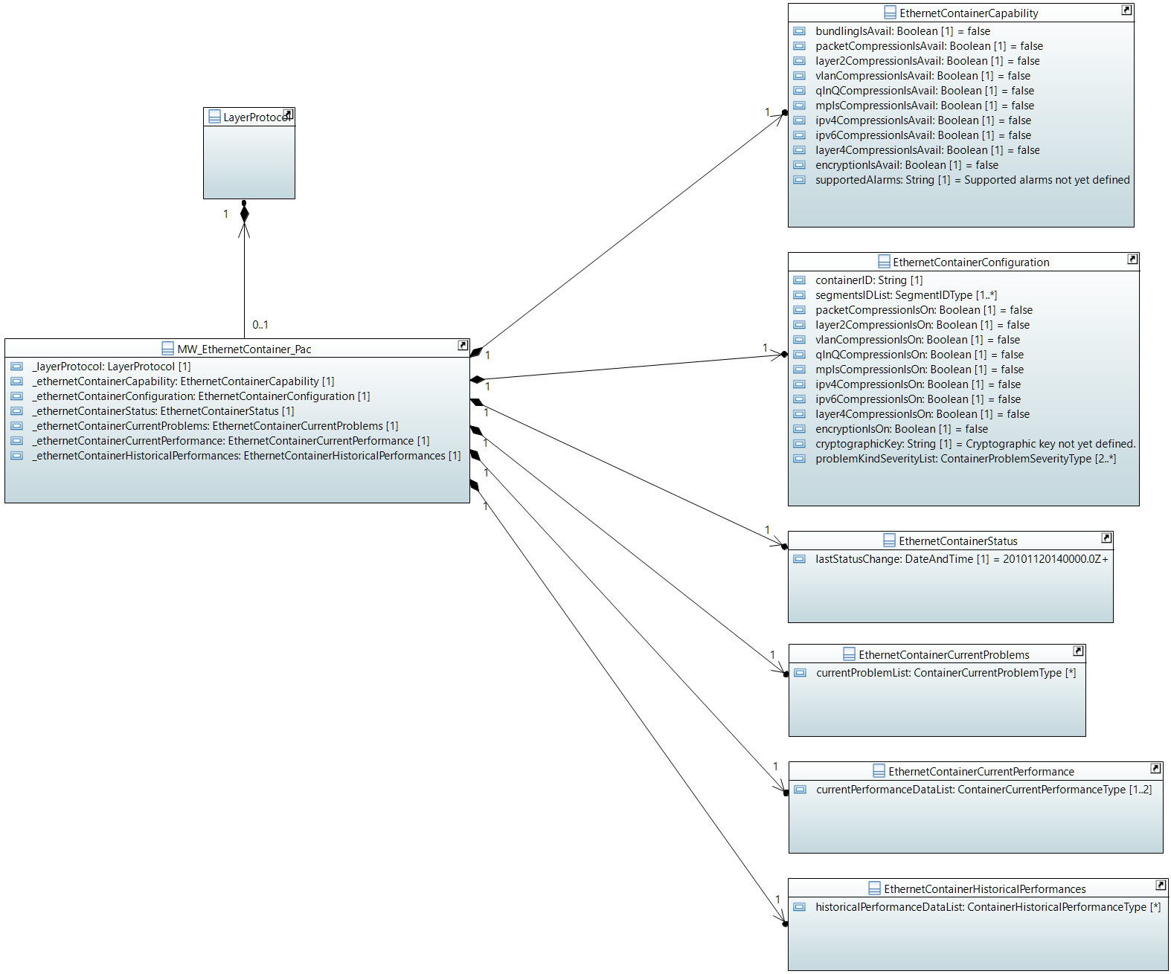

#### MW_EthernetContainer_Pac

Qualified Name: MicrowaveModel::ObjectClasses::EthernetContainer::MW_EthernetContainer_Pac

Applied stereotypes:

* OpenModelClass
* objectCreationNotification: YES
* objectDeletionNotification: YES
* support: MANDATORY

Table 24: Attributes for MW_EthernetContainer_Pac

| **Attribute Name** | **Type DefaultValue** | **Multiplicity** | **Access** | **Stereotypes** | **Description** |
| --- | --- | --- | --- | --- | --- |
| _layerProtocol | LayerProtocol  ./. | 1 | RW | OpenModelAttribute   * partOfObjectKey: 1 * AVC: NO * isInvariant: false * valueRange: no range constraint * bitLength: NA * unit: no unit defined * support: MANDATORY | CoreModel-CoreNetworkModule-ObjectClasses:NetworkElement/_ltpRefList/_lpList/uuid |
| _ethernetContainerCapability | EthernetContainerCapability  ./. | 1 | R | OpenModelAttribute   * partOfObjectKey: 0 * AVC: NO * isInvariant: false * valueRange: no range constraint * bitLength: NA * unit: no unit defined * support: MANDATORY | See referenced class |
| _ethernetContainerConfiguration | EthernetContainerConfiguration  ./. | 1 | RW | OpenModelAttribute   * partOfObjectKey: 0 * AVC: NO * isInvariant: false * valueRange: no range constraint * bitLength: NA * unit: no unit defined * support: MANDATORY | See referenced class |
| _ethernetContainerStatus | EthernetContainerStatus  ./. | 1 | R | OpenModelAttribute   * partOfObjectKey: 0 * AVC: NO * isInvariant: false * valueRange: no range constraint * bitLength: NA * unit: no unit defined * support: MANDATORY | See referenced class |
| _ethernetContainerCurrentProblems | EthernetContainerCurrentProblems  ./. | 1 | R | OpenModelAttribute   * partOfObjectKey: 0 * AVC: NO * isInvariant: false * valueRange: no range constraint * bitLength: NA * unit: no unit defined * support: MANDATORY | See referenced class |
| _ethernetContainerCurrentPerformance | EthernetContainerCurrentPerformance  ./. | 1 | R | OpenModelAttribute   * partOfObjectKey: 0 * AVC: NO * isInvariant: false * valueRange: no range constraint * bitLength: NA * unit: no unit defined * support: MANDATORY | See referenced class |
| _ethernetContainerHistoricalPerformances | EthernetContainerHistoricalPerformances  ./. | 1 | R | OpenModelAttribute   * partOfObjectKey: 0 * AVC: NO * isInvariant: false * valueRange: no range constraint * bitLength: NA * unit: no unit defined * support: MANDATORY | See referenced class |

#### EthernetContainerCapability

Qualified Name: MicrowaveModel::ObjectClasses::EthernetContainer::EthernetContainerCapability

Applied stereotypes:

* OpenModelClass
* objectCreationNotification: NO
* objectDeletionNotification: NO
* support: MANDATORY

Table 25: Attributes for EthernetContainerCapability

| **Attribute Name** | **Type DefaultValue** | **Multiplicity** | **Access** | **Stereotypes** | **Description** |
| --- | --- | --- | --- | --- | --- |
| bundlingIsAvail | Boolean  false | 1 | R | OpenModelAttribute   * partOfObjectKey: 0 * AVC: NO * isInvariant: true * valueRange: no range constraint * bitLength: NA * unit: no unit defined * support: MANDATORY | This attribute has to be set on 'true', if the device allows combining resources from several air interfaces for transporting this Ethernet container. |
| packetCompressionIsAvail | Boolean  false | 1 | R | OpenModelAttribute   * partOfObjectKey: 0 * AVC: NO * isInvariant: true * valueRange: no range constraint * bitLength: NA * unit: no unit defined * support: MANDATORY | In case packet compression can be activated, but not configured to a certain type, packetCompressionAvail shall be set on 'true', but none of the compression level specific booleans. |
| layer2CompressionIsAvail | Boolean  false | 1 | R | OpenModelAttribute   * partOfObjectKey: 0 * AVC: NO * isInvariant: true * valueRange: no range constraint * bitLength: NA * unit: no unit defined * support: MANDATORY | Packet compression on layer 2 available at the device. |
| vlanCompressionIsAvail | Boolean  false | 1 | R | OpenModelAttribute   * partOfObjectKey: 0 * AVC: NO * isInvariant: true * valueRange: no range constraint * bitLength: NA * unit: no unit defined * support: MANDATORY | Packet compression on VLAN layer available at the device. |
| qInQCompressionIsAvail | Boolean  false | 1 | R | OpenModelAttribute   * partOfObjectKey: 0 * AVC: NO * isInvariant: true * valueRange: no range constraint * bitLength: NA * unit: no unit defined * support: MANDATORY | Packet compression on layer of a second VLAN available at the device. |
| mplsCompressionIsAvail | Boolean  false | 1 | R | OpenModelAttribute   * partOfObjectKey: 0 * AVC: NO * isInvariant: true * valueRange: no range constraint * bitLength: NA * unit: no unit defined * support: MANDATORY | Packet compression on mpls layer available at the device. |
| ipv4CompressionIsAvail | Boolean  false | 1 | R | OpenModelAttribute   * partOfObjectKey: 0 * AVC: NO * isInvariant: true * valueRange: no range constraint * bitLength: NA * unit: no unit defined * support: MANDATORY | Packet compression on layer 3 for IPv4 available at the device. |
| ipv6CompressionIsAvail | Boolean  false | 1 | R | OpenModelAttribute   * partOfObjectKey: 0 * AVC: NO * isInvariant: true * valueRange: no range constraint * bitLength: NA * unit: no unit defined * support: MANDATORY | Packet compression on layer 3 for IPv6 available at the device. |
| layer4CompressionIsAvail | Boolean  false | 1 | R | OpenModelAttribute   * partOfObjectKey: 0 * AVC: NO * isInvariant: true * valueRange: no range constraint * bitLength: NA * unit: no unit defined * support: MANDATORY | Packet compression on layer 4 (TCP and UDP header) available at the device. |
| encryptionIsAvail | Boolean  false | 1 | R | OpenModelAttribute   * partOfObjectKey: 0 * AVC: NO * isInvariant: true * valueRange: no range constraint * bitLength: NA * unit: no unit defined * support: MANDATORY | Shall be marked 'true', if Ethernet payload encryption is available. |
| supportedAlarmList | String  Supported alarms not yet defined. | 2..* | R | OpenModelAttribute   * partOfObjectKey: 0 * AVC: NO * isInvariant: true * valueRange: no range constraint * bitLength: NA * unit: no unit defined * support: MANDATORY | Available alarms to be listed. Mandatory:'framingIsFaulty' and 'containerIsDown'. Further alarms might be added by the vendor. |
| supportedAlarms | String  Supported alarms not yet defined. | 1 | R | OpenModelAttribute   * partOfObjectKey: 0 * AVC: NO * isInvariant: true * valueRange: no range constraint * bitLength: NA * unit: no unit defined * support: MANDATORY   Deprecated | Available alarms to be listed. Mandatory:'framingIsFaulty' and 'containerIsDown'. Further alarms might be added by the device. |

#### EthernetContainerStatus

Qualified Name: MicrowaveModel::ObjectClasses::EthernetContainer::EthernetContainerStatus

Applied stereotypes:

* OpenModelClass
* objectCreationNotification: NO
* objectDeletionNotification: NO
* support: MANDATORY

Table 26: Attributes for EthernetContainerStatus

| **Attribute Name** | **Type DefaultValue** | **Multiplicity** | **Access** | **Stereotypes** | **Description** |
| --- | --- | --- | --- | --- | --- |
| lastStatusChange | DateTime  2010-11-20T14:00:00+01:00 | 1 | R | OpenModelAttribute   * partOfObjectKey: 0 * AVC: NO * isInvariant: false * valueRange: no range constraint * bitLength: NA * unit: no unit defined * support: MANDATORY | Time the Container entered its current operational status. _format:yyyyMMddhhmmss.s[Z|{+|-}HHMm]; yyyy='0000'..'9999' year; MM='01'..'12' month; dd='01'..'31' day; hh='00'..'23' hour; mm='00'..'59' minute; ss='00'..'59' second; s='.0'..'.9'tenth of second (set to '.0' if EMS or NE cannot support this granularity); Z='Z' indicates UTC (rather than local time); {+|-}='+' or '-' delta from UTC; HH='00'..'23' time zone difference in hours; Mm='00'..'59' time zone difference in minutes. |

#### EthernetContainerConfiguration

Qualified Name: MicrowaveModel::ObjectClasses::EthernetContainer::EthernetContainerConfiguration

Applied stereotypes:

* OpenModelClass
* objectCreationNotification: NO
* objectDeletionNotification: NO
* support: MANDATORY

Table 27: Attributes for EthernetContainerConfiguration

| **Attribute Name** | **Type DefaultValue** | **Multiplicity** | **Access** | **Stereotypes** | **Description** |
| --- | --- | --- | --- | --- | --- |
| containerID | String  No Ethernet Flow associated yet. | 1 | RW | OpenModelAttribute   * partOfObjectKey: 0 * AVC: YES * isInvariant: false * valueRange: no range constraint * bitLength: NA * unit: no unit defined * support: MANDATORY | ContainterID in Netconf must be the same as EthernetPortID in OpenFlow so a connection can be made between the two items, which separately exist in the controller. |
| segmentsIDList | SegmentIDType  ./. | 1..* | RW | OpenModelAttribute   * partOfObjectKey: 0 * AVC: YES * isInvariant: false * valueRange: no range constraint * bitLength: NA * unit: no unit defined * support: MANDATORY | Lists the segments used for transporting this Ethernet container. In case EthernetContainer::ContainerCapability::bundlingIsAvail==0, all TypeDefinitions::segmentIdType::structureId must be identical in the list. |
| packetCompressionIsOn | Boolean  false | 1 | RW | OpenModelAttribute   * partOfObjectKey: 0 * AVC: YES * isInvariant: false * valueRange: no range constraint * bitLength: NA * unit: no unit defined * support: MANDATORY | In case packet compression is activated, but no type is activated, it is assumed that the device chooses the optimum. |
| layer2CompressionIsOn | Boolean  false | 1 | RW | OpenModelAttribute   * partOfObjectKey: 0 * AVC: YES * isInvariant: false * valueRange: no range constraint * bitLength: NA * unit: no unit defined * support: MANDATORY | Packet compression on layer 2 configured at the device. |
| vlanCompressionIsOn | Boolean  false | 1 | RW | OpenModelAttribute   * partOfObjectKey: 0 * AVC: YES * isInvariant: false * valueRange: no range constraint * bitLength: NA * unit: no unit defined * support: MANDATORY | Packet compression on VLAN layer configured at the device. |
| qInQCompressionIsOn | Boolean  false | 1 | RW | OpenModelAttribute   * partOfObjectKey: 0 * AVC: YES * isInvariant: false * valueRange: no range constraint * bitLength: NA * unit: no unit defined * support: MANDATORY | Packet compression on layer of a second VLAN configured at the device. |
| mplsCompressionIsOn | Boolean  false | 1 | RW | OpenModelAttribute   * partOfObjectKey: 0 * AVC: YES * isInvariant: false * valueRange: no range constraint * bitLength: NA * unit: no unit defined * support: MANDATORY | Packet compression on MPLS layer configured at the device. |
| ipv4CompressionIsOn | Boolean  false | 1 | RW | OpenModelAttribute   * partOfObjectKey: 0 * AVC: YES * isInvariant: false * valueRange: no range constraint * bitLength: NA * unit: no unit defined * support: MANDATORY | Packet compression on layer 3 for IPv4 configured at the device. |
| ipv6CompressionIsOn | Boolean  false | 1 | RW | OpenModelAttribute   * partOfObjectKey: 0 * AVC: YES * isInvariant: false * valueRange: no range constraint * bitLength: NA * unit: no unit defined * support: MANDATORY | Packet compression on layer 3 for IPv6 configured at the device. |
| layer4CompressionIsOn | Boolean  false | 1 | RW | OpenModelAttribute   * partOfObjectKey: 0 * AVC: YES * isInvariant: false * valueRange: no range constraint * bitLength: NA * unit: no unit defined * support: MANDATORY | Packet compression on layer 4 (TCP and UDP header) configured at the device. |
| encryptionIsOn | Boolean  false | 1 | RW | OpenModelAttribute   * partOfObjectKey: 0 * AVC: YES * isInvariant: false * valueRange: no range constraint * bitLength: NA * unit: no unit defined * support: MANDATORY | Activates encryption of the Ethernet payload. |
| cryptographicKey | String  Cryptographic key not yet defined. | 1 | RW | OpenModelAttribute   * partOfObjectKey: 0 * AVC: YES * isInvariant: false * valueRange: no range constraint * bitLength: NA * unit: no unit defined * support: MANDATORY | Key for transforming plaintext into cipher text data. |
| performanceMonitoringCollectionIsOn | Boolean  false | 1 | RW | OpenModelAttribute   * partOfObjectKey: 0 * AVC: YES * isInvariant: false * valueRange: no range constraint * bitLength: NA * unit: no unit defined * support: MANDATORY | Enables measurement, collection, storage and access to performance data. |
| problemKindSeverityList | ContainerProblemSeverityType  ./. | 2..* | RW | OpenModelAttribute   * partOfObjectKey: 0 * AVC: YES * isInvariant: false * valueRange: no range constraint * bitLength: NA * unit: no unit defined * support: MANDATORY | Severity of the problem to be configured. |

#### EthernetContainerCurrentProblems

Qualified Name: MicrowaveModel::ObjectClasses::EthernetContainer::EthernetContainerCurrentProblems

Applied stereotypes:

* OpenModelClass
* objectCreationNotification: NO
* objectDeletionNotification: NO
* support: MANDATORY

Table 28: Attributes for EthernetContainerCurrentProblems

| **Attribute Name** | **Type DefaultValue** | **Multiplicity** | **Access** | **Stereotypes** | **Description** |
| --- | --- | --- | --- | --- | --- |
| currentProblemList | ContainerCurrentProblemType  ./. | 0..* | R | OpenModelAttribute   * partOfObjectKey: 0 * AVC: NO * isInvariant: false * valueRange: no range constraint * bitLength: NA * unit: no unit defined * support: MANDATORY |  |

#### EthernetContainerCurrentPerformance

Qualified Name: MicrowaveModel::ObjectClasses::EthernetContainer::EthernetContainerCurrentPerformance

Aggregated performance information of the Ethernet container at a particular moment.

Applied stereotypes:

* OpenModelClass
* objectCreationNotification: NO
* objectDeletionNotification: NO
* support: MANDATORY

Table 29: Attributes for EthernetContainerCurrentPerformance

| **Attribute Name** | **Type DefaultValue** | **Multiplicity** | **Access** | **Stereotypes** | **Description** |
| --- | --- | --- | --- | --- | --- |
| currentPerformanceDataList | ContainerCurrentPerformanceType  ./. | 1..2 | R | OpenModelAttribute   * partOfObjectKey: 0 * AVC: NO * isInvariant: false * valueRange: no range constraint * bitLength: NA * unit: no unit defined * support: MANDATORY |  |

#### EthernetContainerHistoricalPerformances

Qualified Name: MicrowaveModel::ObjectClasses::EthernetContainer::EthernetContainerHistoricalPerformances

Aggregated performance information of the Ethernet container for a pre-defined measurement interval.

Applied stereotypes:

* OpenModelClass
* objectCreationNotification: NO
* objectDeletionNotification: NO
* support: MANDATORY

Table 30: Attributes for EthernetContainerHistoricalPerformances

| **Attribute Name** | **Type DefaultValue** | **Multiplicity** | **Access** | **Stereotypes** | **Description** |
| --- | --- | --- | --- | --- | --- |
| historicalPerformanceDataList | ContainerHistoricalPerformanceType  ./. | 0..* | R | OpenModelAttribute   * partOfObjectKey: 0 * AVC: NO * isInvariant: false * valueRange: no range constraint * bitLength: NA * unit: no unit defined * support: MANDATORY |  |

### TdmContainer

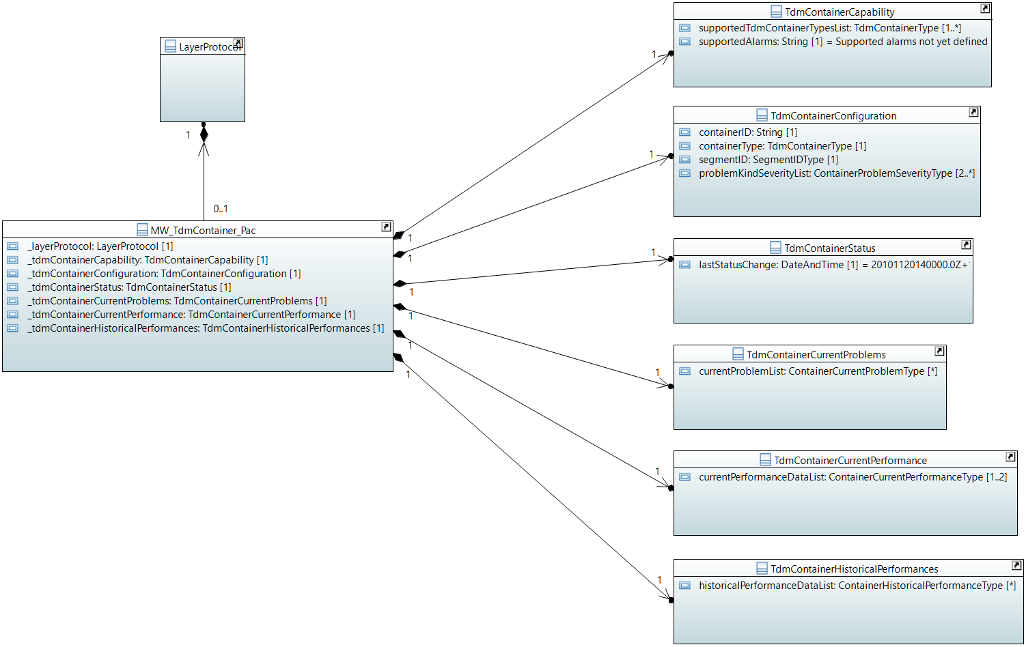

#### TdmContainerCapability

Qualified Name: MicrowaveModel::ObjectClasses::TdmContainer::TdmContainerCapability

Bundling is not available.

Applied stereotypes:

* OpenModelClass
* objectCreationNotification: NO
* objectDeletionNotification: NO
* support: MANDATORY

Table 31: Attributes for TdmContainerCapability

| **Attribute Name** | **Type DefaultValue** | **Multiplicity** | **Access** | **Stereotypes** | **Description** |
| --- | --- | --- | --- | --- | --- |
| supportedTdmContainerTypesList | TdmContainerType  ./. | 1..* | R | OpenModelAttribute   * partOfObjectKey: 0 * AVC: NO * isInvariant: true * valueRange: no range constraint * bitLength: NA * unit: no unit defined * support: MANDATORY | Lists the TDM containers that are supported. |
| supportedAlarmList | String  Supported alarms not yet defined. | 2..* | R | OpenModelAttribute   * partOfObjectKey: 0 * AVC: NO * isInvariant: true * valueRange: no range constraint * bitLength: NA * unit: no unit defined * support: MANDATORY | Available alarms to be listed. Mandatory:'framingIsFaulty' and 'containerIsDown'. Further alarms might be added by the vendor. |
| supportedAlarms | String  Supported alarms not yet defined. | 1 | R | OpenModelAttribute   * partOfObjectKey: 0 * AVC: NO * isInvariant: true * valueRange: no range constraint * bitLength: NA * unit: no unit defined * support: MANDATORY   Deprecated | Available alarms to be listed. Mandatory:'framingIsFaulty' and 'containerIsDown'. Further alarms might be added by the device. |

#### TdmContainerStatus

Qualified Name: MicrowaveModel::ObjectClasses::TdmContainer::TdmContainerStatus

Applied stereotypes:

* OpenModelClass
* objectCreationNotification: NO
* objectDeletionNotification: NO
* support: MANDATORY

Table 32: Attributes for TdmContainerStatus

| **Attribute Name** | **Type DefaultValue** | **Multiplicity** | **Access** | **Stereotypes** | **Description** |
| --- | --- | --- | --- | --- | --- |
| lastStatusChange | DateTime  2010-11-20T14:00:00+01:00 | 1 | R | OpenModelAttribute   * partOfObjectKey: 0 * AVC: NO * isInvariant: false * valueRange: no range constraint * bitLength: NA * unit: no unit defined * support: MANDATORY | Time the Container entered its current operational status. _format:yyyyMMddhhmmss.s[Z|{+|-}HHMm]; yyyy='0000'..'9999' year; MM='01'..'12' month; dd='01'..'31' day; hh='00'..'23' hour; mm='00'..'59' minute; ss='00'..'59' second; s='.0'..'.9'tenth of second (set to '.0' if EMS or NE cannot support this granularity); Z='Z' indicates UTC (rather than local time); {+|-}='+' or '-' delta from UTC; HH='00'..'23' time zone difference in hours; Mm='00'..'59' time zone difference in minutes. |

#### MW_TdmContainer_Pac

Qualified Name: MicrowaveModel::ObjectClasses::TdmContainer::MW_TdmContainer_Pac

The TdmContainer_Pac and its attached classes MUST be provided on management interfaces of microwave devices, which are transporting TDM traffic.

Applied stereotypes:

* OpenModelClass
* objectCreationNotification: YES
* objectDeletionNotification: YES
* support: CONDITIONAL_MANDATORY
* condition: hybrid-microwave In case the microwave device allows Ethernet and native TDM transport in parallel, it has to support this feature on its management interface.

Table 33: Attributes for MW_TdmContainer_Pac

| **Attribute Name** | **Type DefaultValue** | **Multiplicity** | **Access** | **Stereotypes** | **Description** |
| --- | --- | --- | --- | --- | --- |
| _layerProtocol | LayerProtocol  ./. | 1 | RW | OpenModelAttribute   * partOfObjectKey: 1 * AVC: NO * isInvariant: false * valueRange: no range constraint * bitLength: NA * unit: no unit defined * support: MANDATORY | CoreModel-CoreNetworkModule-ObjectClasses:NetworkElement/_ltpRefList/_lpList/uuid |
| _tdmContainerCapability | TdmContainerCapability  ./. | 1 | R | OpenModelAttribute   * partOfObjectKey: 0 * AVC: NO * isInvariant: false * valueRange: no range constraint * bitLength: NA * unit: no unit defined * support: MANDATORY | See referenced class |
| _tdmContainerConfiguration | TdmContainerConfiguration  ./. | 1 | RW | OpenModelAttribute   * partOfObjectKey: 0 * AVC: NO * isInvariant: false * valueRange: no range constraint * bitLength: NA * unit: no unit defined * support: MANDATORY | See referenced class |
| _tdmContainerStatus | TdmContainerStatus  ./. | 1 | R | OpenModelAttribute   * partOfObjectKey: 0 * AVC: NO * isInvariant: false * valueRange: no range constraint * bitLength: NA * unit: no unit defined * support: MANDATORY | See referenced class |
| _tdmContainerCurrentProblems | TdmContainerCurrentProblems  ./. | 1 | R | OpenModelAttribute   * partOfObjectKey: 0 * AVC: NO * isInvariant: false * valueRange: no range constraint * bitLength: NA * unit: no unit defined * support: MANDATORY | See referenced class |
| _tdmContainerCurrentPerformance | TdmContainerCurrentPerformance  ./. | 1 | R | OpenModelAttribute   * partOfObjectKey: 0 * AVC: NO * isInvariant: false * valueRange: no range constraint * bitLength: NA * unit: no unit defined * support: MANDATORY | See referenced class |
| _tdmContainerHistoricalPerformances | TdmContainerHistoricalPerformances  ./. | 1 | R | OpenModelAttribute   * partOfObjectKey: 0 * AVC: NO * isInvariant: false * valueRange: no range constraint * bitLength: NA * unit: no unit defined * support: MANDATORY | See referenced class |

#### TdmContainerCurrentProblems

Qualified Name: MicrowaveModel::ObjectClasses::TdmContainer::TdmContainerCurrentProblems

Applied stereotypes:

* OpenModelClass
* objectCreationNotification: NO
* objectDeletionNotification: NO
* support: MANDATORY

Table 34: Attributes for TdmContainerCurrentProblems

| **Attribute Name** | **Type DefaultValue** | **Multiplicity** | **Access** | **Stereotypes** | **Description** |
| --- | --- | --- | --- | --- | --- |
| currentProblemList | ContainerCurrentProblemType  ./. | 0..* | R | OpenModelAttribute   * partOfObjectKey: 0 * AVC: NO * isInvariant: false * valueRange: no range constraint * bitLength: NA * unit: no unit defined * support: MANDATORY |  |

#### TdmContainerConfiguration

Qualified Name: MicrowaveModel::ObjectClasses::TdmContainer::TdmContainerConfiguration

Applied stereotypes:

* OpenModelClass
* objectCreationNotification: NO
* objectDeletionNotification: NO
* support: MANDATORY

Table 35: Attributes for TdmContainerConfiguration

| **Attribute Name** | **Type DefaultValue** | **Multiplicity** | **Access** | **Stereotypes** | **Description** |
| --- | --- | --- | --- | --- | --- |
| containerID | String  No TDM Flow associated yet. | 1 | RW | OpenModelAttribute   * partOfObjectKey: 0 * AVC: YES * isInvariant: false * valueRange: no range constraint * bitLength: NA * unit: no unit defined * support: MANDATORY | ContainterID in Netconf must be the same as TDM Flow ID so a connection can be made between the two items, which separately exist in the controller. |
| containerType | TdmContainerType  ./. | 1 | RW | OpenModelAttribute   * partOfObjectKey: 0 * AVC: YES * isInvariant: false * valueRange: no range constraint * bitLength: NA * unit: no unit defined * support: MANDATORY | Type of TDM container. |
| segmentID | SegmentIDType  ./. | 1 | RW | OpenModelAttribute   * partOfObjectKey: 0 * AVC: YES * isInvariant: false * valueRange: no range constraint * bitLength: NA * unit: no unit defined * support: MANDATORY | Multiplicity = 1; One segment per TDM container; Type of segment must match type of container; |
| performanceMonitoringCollectionIsOn | Boolean  false | 1 | RW | OpenModelAttribute   * partOfObjectKey: 0 * AVC: YES * isInvariant: false * valueRange: no range constraint * bitLength: NA * unit: no unit defined * support: MANDATORY | Enables measurement, collection, storage and access to performance data. |
| problemKindSeverityList | ContainerProblemSeverityType  ./. | 2..* | RW | OpenModelAttribute   * partOfObjectKey: 0 * AVC: YES * isInvariant: false * valueRange: no range constraint * bitLength: NA * unit: no unit defined * support: MANDATORY | Severity of the problem to be configured. |

#### TdmContainerCurrentPerformance

Qualified Name: MicrowaveModel::ObjectClasses::TdmContainer::TdmContainerCurrentPerformance

Aggregated performance information of the TDM container at a particular moment.

Applied stereotypes:

* OpenModelClass
* objectCreationNotification: NO
* objectDeletionNotification: NO
* support: MANDATORY

Table 36: Attributes for TdmContainerCurrentPerformance

| **Attribute Name** | **Type DefaultValue** | **Multiplicity** | **Access** | **Stereotypes** | **Description** |
| --- | --- | --- | --- | --- | --- |
| currentPerformanceDataList | ContainerCurrentPerformanceType  ./. | 1..2 | R | OpenModelAttribute   * partOfObjectKey: 0 * AVC: NO * isInvariant: false * valueRange: no range constraint * bitLength: NA * unit: no unit defined * support: MANDATORY | At least values of the counters, which are reset every 15 minutes, are to be provided. If available, the current values of the counters, which are reset every 24 hour, can be provided, too. |

#### TdmContainerHistoricalPerformances

Qualified Name: MicrowaveModel::ObjectClasses::TdmContainer::TdmContainerHistoricalPerformances

Aggregated performance information of the TDM container for a pre-defined measurement interval.

Applied stereotypes:

* OpenModelClass
* objectCreationNotification: NO
* objectDeletionNotification: NO
* support: MANDATORY

Table 37: Attributes for TdmContainerHistoricalPerformances

| **Attribute Name** | **Type DefaultValue** | **Multiplicity** | **Access** | **Stereotypes** | **Description** |
| --- | --- | --- | --- | --- | --- |
| historicalPerformanceDataList | ContainerHistoricalPerformanceType  ./. | 0..* | R | OpenModelAttribute   * partOfObjectKey: 0 * AVC: NO * isInvariant: false * valueRange: no range constraint * bitLength: NA * unit: no unit defined * support: MANDATORY |  |

## AirInterfaceHsb

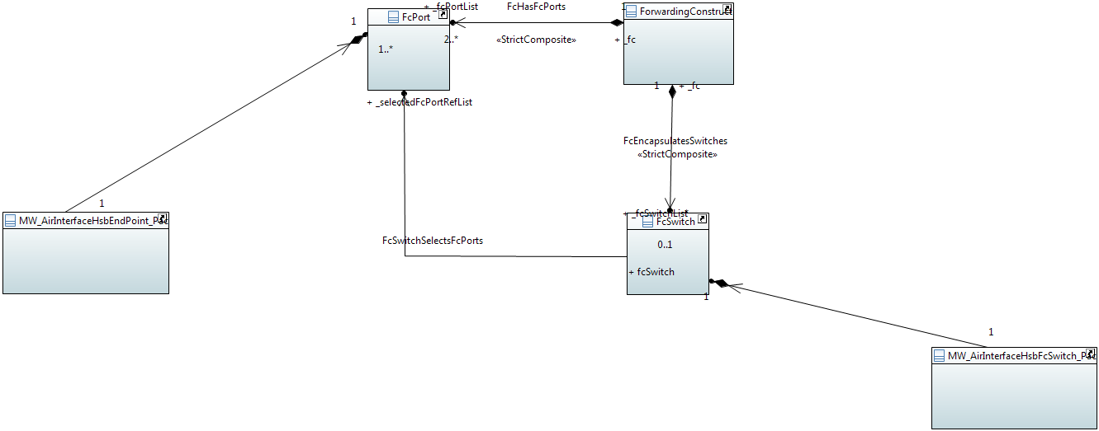

#### MW_AirInterfaceHsbFcSwitch_Pac

Qualified Name: MicrowaveModel::ObjectClasses::AirInterfaceHsb::MW_AirInterfaceHsbFcSwitch_Pac

Represents and defines a protection switch structure encapsulated in the forwarding construct. Essentially performs the function of Protection Group. Associates to 2 or more Endpoints each playing the role of a Protection Unit. One or more protection EndPoints (standby/backup) provide protection for one or more working (i.e. regular/main/preferred) Endpoints where either protection or working can feed one or more protected Endpoint. May be used in revertive or non-revertive (symmetric) mode. When in revertive mode may define waitToRestore time. May be used in one of several modes including source switch, destination switched, source and destination switched etc (covering cases such as 1+1 ane 1:1). May be lockout (prevented from switching), force switched or manual switched. Will indicate switch state and change of state.

Applied stereotypes:

* OpenModelClass
* objectCreationNotification: YES
* objectDeletionNotification: YES
* support: MANDATORY

Table 38: Attributes for MW_AirInterfaceHsbFcSwitch_Pac

| **Attribute Name** | **Type DefaultValue** | **Multiplicity** | **Access** | **Stereotypes** | **Description** |
| --- | --- | --- | --- | --- | --- |
| protType | ProtectionType  HSB | 1 | RW | OpenModelAttribute   * partOfObjectKey: 0 * AVC: YES * isInvariant: false * valueRange: no range constraint * bitLength: NA * unit: no unit defined * support: MANDATORY | Indicates the protection scheme that is used for the ProtectionGroup. |
| airInterfaceHsbConfigurationIsFaultySeverity | SeverityType  WARNING | 1 | RW | OpenModelAttribute   * partOfObjectKey: 0 * AVC: YES * isInvariant: false * valueRange: no range constraint * bitLength: NA * unit: no unit defined * support: MANDATORY | The level of severity of an airInterfaceHsbConfigurationIsFaulty alarm shall be chosen from an enumeration. |
| airInterfaceHsbIsPartlyDownSeverity | SeverityType  WARNING | 1 | RW | OpenModelAttribute   * partOfObjectKey: 0 * AVC: YES * isInvariant: false * valueRange: no range constraint * bitLength: NA * unit: no unit defined * support: MANDATORY | The level of severity for one link out of the HSB configuration being down shall be chosen from an enumeration. |
| airInterfaceHsbIsDownSeverity | SeverityType  WARNING | 1 | RW | OpenModelAttribute   * partOfObjectKey: 0 * AVC: YES * isInvariant: false * valueRange: no range constraint * bitLength: NA * unit: no unit defined * support: MANDATORY | The level of severity of the total HSB configuration being down shall be chosen from an enumeration. |
| _fcswitch | FcSwitch  ./. | 1 | RW | OpenModelAttribute   * partOfObjectKey: 1 * AVC: YES * isInvariant: false * valueRange: no range constraint * bitLength: NA * unit: no unit defined * support: MANDATORY | See referenced class |

#### MW_AirInterfaceHsbEndPoint_Pac

Qualified Name: MicrowaveModel::ObjectClasses::AirInterfaceHsb::MW_AirInterfaceHsbEndPoint_Pac

The EndPoint (EP) object class models the access to the FC function. Each EndPoint instance has a role (e.g., working, protection, protected, hub, spoke, leaf, root, etc.) with respect to the FC function. The association of the FC to LTPs is made via EndPoints (essentially the ports of the FC) where each EndPoint (EP) of the FC has a role in the context of the FC. The traffic forwarding between the associated End PointsEPs of the FC depends upon the type of FC and may be associated with FCSwitch object instances. In cases where there is protection conveys the protecting role of the access to the FC. The EP replaces the Protection Unit of a traditional protection model. It represents a protected (resilient/reliable) point or a protecting (unreliable working or protection) point.

Applied stereotypes:

* OpenModelClass
* objectCreationNotification: YES
* objectDeletionNotification: YES
* support: MANDATORY

Table 39: Attributes for MW_AirInterfaceHsbEndPoint_Pac

| **Attribute Name** | **Type DefaultValue** | **Multiplicity** | **Access** | **Stereotypes** | **Description** |
| --- | --- | --- | --- | --- | --- |
| role | RoleType  WORKING | 1 | RW | OpenModelAttribute   * partOfObjectKey: 0 * AVC: YES * isInvariant: false * valueRange: no range constraint * bitLength: NA * unit: no unit defined * support: MANDATORY |  |
| _endpoint | FcPort  ./. | 1 | RW | OpenModelAttribute   * partOfObjectKey: 1 * AVC: YES * isInvariant: false * valueRange: no range constraint * bitLength: NA * unit: no unit defined * support: MANDATORY | See referenced class |

## AirInterfaceDiversity_Pac

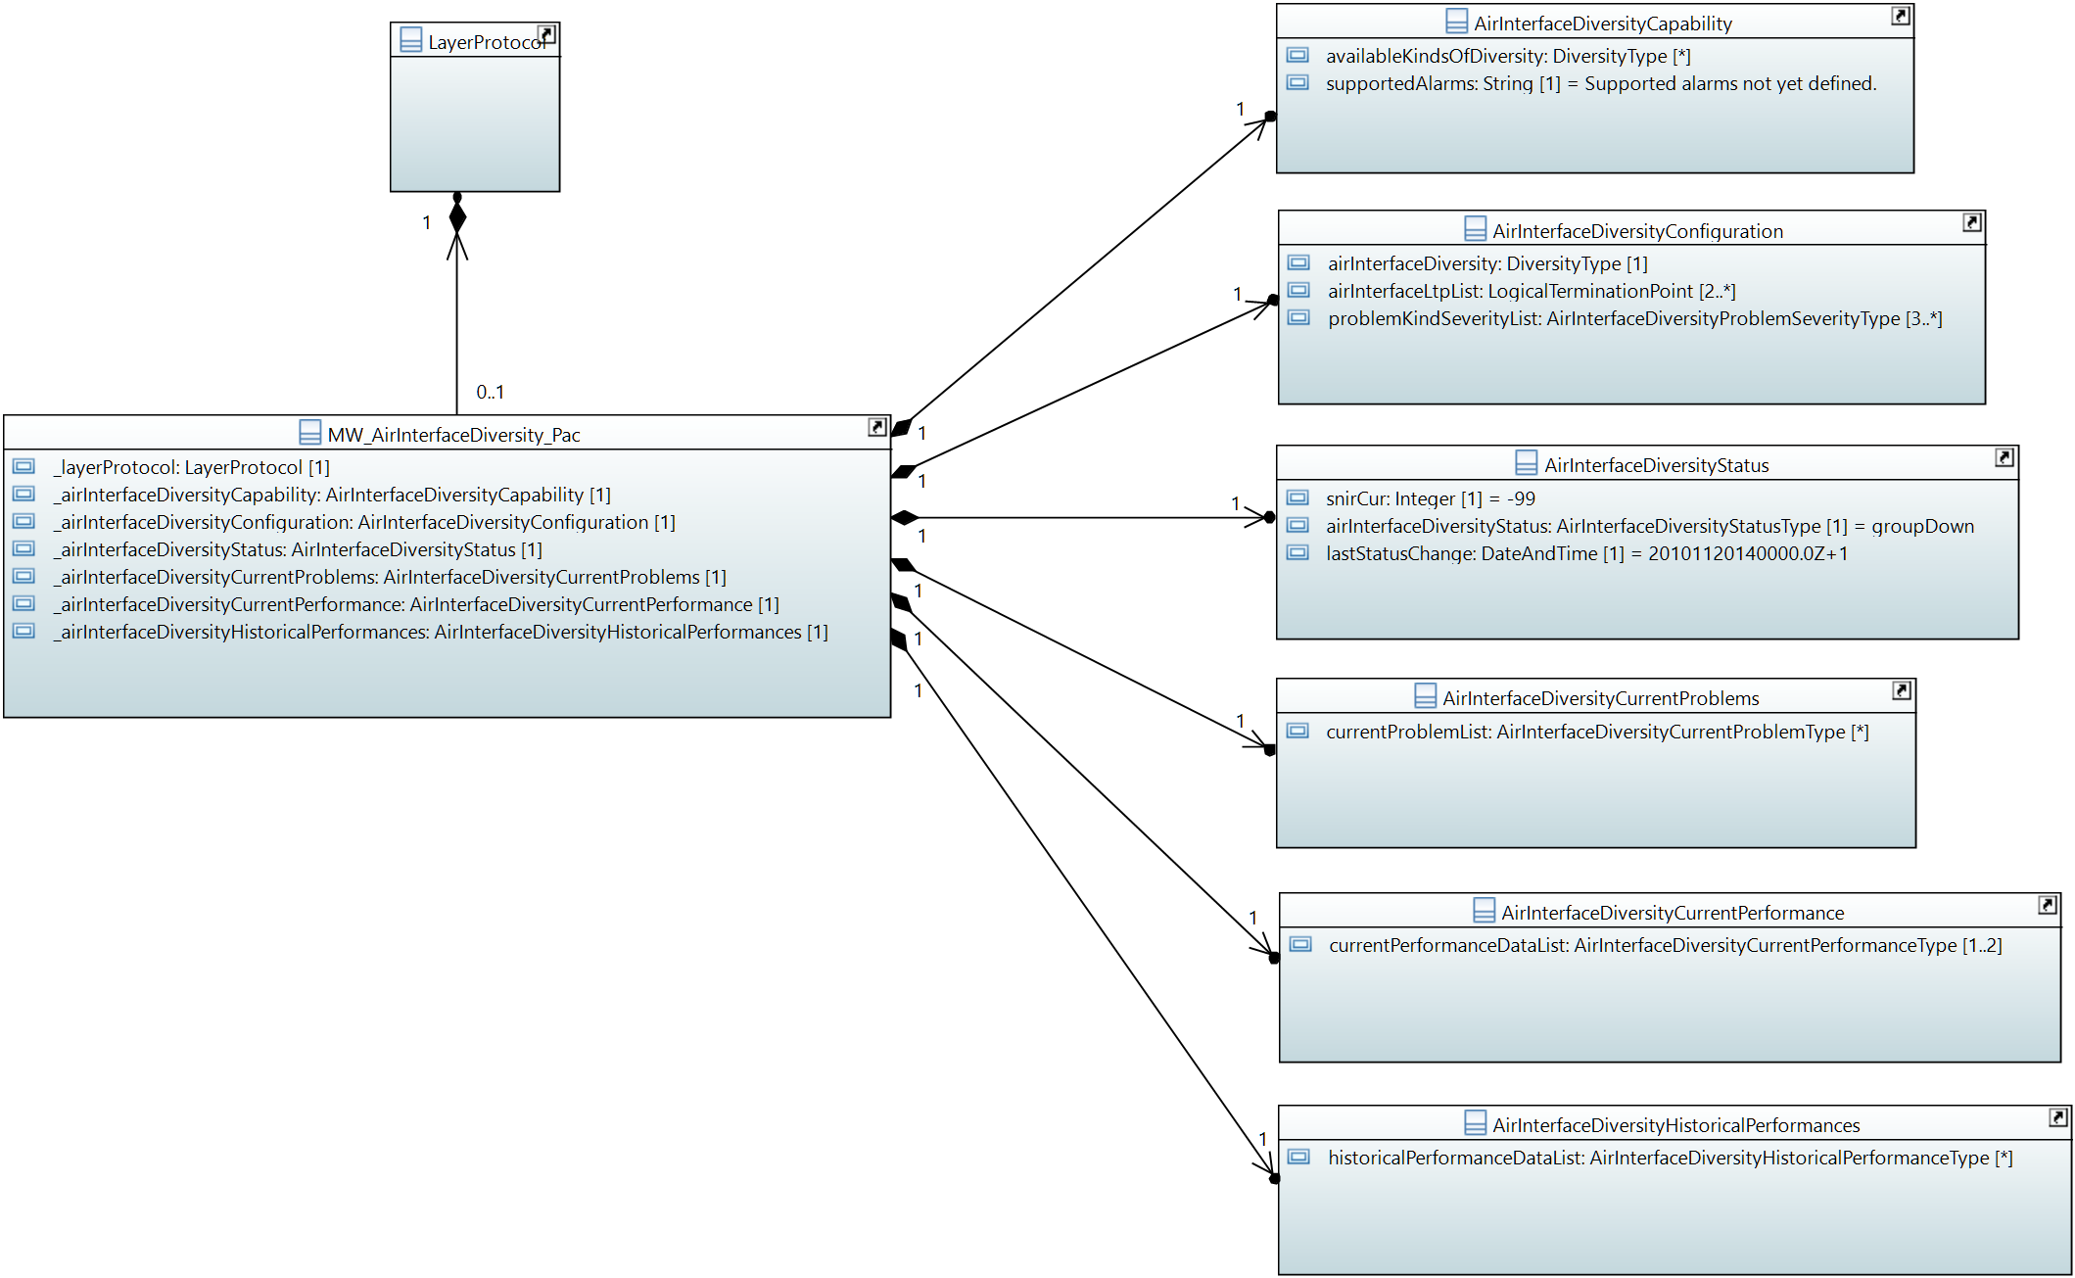

#### AirInterfaceDiversityCurrentProblems

Qualified Name: MicrowaveModel::ObjectClasses::AirInterfaceDiversity::AirInterfaceDiversityCurrentProblems

Applied stereotypes:

* OpenModelClass
* objectCreationNotification: NO
* objectDeletionNotification: NO
* support: MANDATORY

Table 40: Attributes for AirInterfaceDiversityCurrentProblems

| **Attribute Name** | **Type DefaultValue** | **Multiplicity** | **Access** | **Stereotypes** | **Description** |
| --- | --- | --- | --- | --- | --- |
| currentProblemList | AirInterfaceDiversityCurrentProblemType  ./. | 0..* | R | OpenModelAttribute   * partOfObjectKey: 0 * AVC: NO * isInvariant: false * valueRange: no range constraint * bitLength: NA * unit: no unit defined * support: MANDATORY |  |

#### AirInterfaceDiversityCurrentPerformance

Qualified Name: MicrowaveModel::ObjectClasses::AirInterfaceDiversity::AirInterfaceDiversityCurrentPerformance

Aggregated performance information of the air interface diversity configuration at a particular moment.

Applied stereotypes:

* OpenModelClass
* objectCreationNotification: NO
* objectDeletionNotification: NO
* support: MANDATORY

Table 41: Attributes for AirInterfaceDiversityCurrentPerformance

| **Attribute Name** | **Type DefaultValue** | **Multiplicity** | **Access** | **Stereotypes** | **Description** |
| --- | --- | --- | --- | --- | --- |
| currentPerformanceDataList | AirInterfaceDiversityCurrentPerformanceType  ./. | 1..2 | R | OpenModelAttribute   * partOfObjectKey: 0 * AVC: NO * isInvariant: false * valueRange: no range constraint * bitLength: NA * unit: no unit defined * support: MANDATORY | At least values of the counters, which are reset every 15 minutes, are to be provided. If available, the current values of the counters, which are reset every 24 hour, can be provided, too. |

#### AirInterfaceDiversityCapability

Qualified Name: MicrowaveModel::ObjectClasses::AirInterfaceDiversity::AirInterfaceDiversityCapability

Describes the capabilities in implementing different types of air interface diversity.

Applied stereotypes:

* OpenModelClass
* objectCreationNotification: NO
* objectDeletionNotification: NO
* support: MANDATORY

Table 42: Attributes for AirInterfaceDiversityCapability

| **Attribute Name** | **Type DefaultValue** | **Multiplicity** | **Access** | **Stereotypes** | **Description** |
| --- | --- | --- | --- | --- | --- |
| availableKindsOfDiversity | DiversityType  ./. | 0..* | R | OpenModelAttribute   * partOfObjectKey: 0 * AVC: NO * isInvariant: true * valueRange: no range constraint * bitLength: NA * unit: no unit defined * support: MANDATORY | Available types of diversity to be listed. |
| supportedAlarmList | String  Supported alarms not yet defined. | 2..* | R | OpenModelAttribute   * partOfObjectKey: 0 * AVC: NO * isInvariant: true * valueRange: no range constraint * bitLength: NA * unit: no unit defined * support: MANDATORY | Available alarms to be listed. Mandatory:'airInterfaceDiversityConfigurationIsPartlyDown' (at least one air interface is down, but not all of them) and 'airInterfaceDiversityConfigurationIsDown' (all air interfaces are down). Further alarms might be added by the vendor. |
| supportedAlarms | String  Supported alarms not yet defined. | 1 | R | OpenModelAttribute   * partOfObjectKey: 0 * AVC: NO * isInvariant: true * valueRange: no range constraint * bitLength: NA * unit: no unit defined * support: MANDATORY   Deprecated | Available alarms to be listed. Mandatory:'airInterfaceDiversityConfigurationIsPartlyDown' (at least one air interface is down, but not all of them) and 'airInterfaceDiversityConfigurationIsDown' (all air interfaces are down). Further alarms might be added by the device. Names are to be separated by commas. |

#### AirInterfaceDiversityConfiguration

Qualified Name: MicrowaveModel::ObjectClasses::AirInterfaceDiversity::AirInterfaceDiversityConfiguration

Applied stereotypes:

* OpenModelClass
* objectCreationNotification: NO
* objectDeletionNotification: NO
* support: MANDATORY

Table 43: Attributes for AirInterfaceDiversityConfiguration

| **Attribute Name** | **Type DefaultValue** | **Multiplicity** | **Access** | **Stereotypes** | **Description** |
| --- | --- | --- | --- | --- | --- |
| airInterfaceDiversity | DiversityType  ./. | 1 | RW | OpenModelAttribute   * partOfObjectKey: 0 * AVC: YES * isInvariant: false * valueRange: no range constraint * bitLength: NA * unit: no unit defined * support: MANDATORY | Type of air interface diversity configured at the link. |
| _airInterfaceLtpList | LogicalTerminationPoint  ./. | 2..* | RW | OpenModelAttribute   * partOfObjectKey: 0 * AVC: YES * isInvariant: false * valueRange: no range constraint * bitLength: NA * unit: no unit defined * support: MANDATORY | _multiplicity:2-ThisAirInterfaceDiversity::AirInterfaceDiversityConfiguration::airInterfaceDiversity::diversityType::numberOfAirInterfacesMax |
| performanceMonitoringCollectionIsOn | Boolean  false | 1 | RW | OpenModelAttribute   * partOfObjectKey: 0 * AVC: YES * isInvariant: false * valueRange: no range constraint * bitLength: NA * unit: no unit defined * support: MANDATORY | Enables measurement, collection, storage and access to performance data. |
| thresholdCrossAlarmList | ThresholdCrossAlarmType  ./. | 0..6 | RW | OpenModelAttribute   * partOfObjectKey: 0 * AVC: YES * isInvariant: false * valueRange: no range constraint * bitLength: NA * unit: no unit defined * support: MANDATORY | List of threshold cross alarms to be configured. |
| problemKindSeverityList | AirInterfaceDiversityProblemSeverityType  ./. | 3..* | RW | OpenModelAttribute   * partOfObjectKey: 0 * AVC: YES * isInvariant: false * valueRange: no range constraint * bitLength: NA * unit: no unit defined * support: MANDATORY | Severity of the problem to be configured. |

#### AirInterfaceDiversityHistoricalPerformances

Qualified Name: MicrowaveModel::ObjectClasses::AirInterfaceDiversity::AirInterfaceDiversityHistoricalPerformances

Aggregated performance information of the air interface diversity configuration for a pre-defined measurement interval.

Applied stereotypes:

* OpenModelClass
* objectCreationNotification: NO
* objectDeletionNotification: NO
* support: MANDATORY

Table 44: Attributes for AirInterfaceDiversityHistoricalPerformances

| **Attribute Name** | **Type DefaultValue** | **Multiplicity** | **Access** | **Stereotypes** | **Description** |
| --- | --- | --- | --- | --- | --- |
| historicalPerformanceDataList | AirInterfaceDiversityHistoricalPerformanceType  ./. | 0..* | R | OpenModelAttribute   * partOfObjectKey: 0 * AVC: NO * isInvariant: false * valueRange: no range constraint * bitLength: NA * unit: no unit defined * support: MANDATORY |  |

#### MW_AirInterfaceDiversity_Pac

Qualified Name: MicrowaveModel::ObjectClasses::AirInterfaceDiversity::MW_AirInterfaceDiversity_Pac

Applied stereotypes:

* OpenModelClass
* objectCreationNotification: YES
* objectDeletionNotification: YES
* support: MANDATORY

Table 45: Attributes for MW_AirInterfaceDiversity_Pac

| **Attribute Name** | **Type DefaultValue** | **Multiplicity** | **Access** | **Stereotypes** | **Description** |
| --- | --- | --- | --- | --- | --- |
| _layerProtocol | LayerProtocol  ./. | 1 | RW | OpenModelAttribute   * partOfObjectKey: 1 * AVC: NO * isInvariant: false * valueRange: no range constraint * bitLength: NA * unit: no unit defined * support: MANDATORY | CoreModel-CoreNetworkModule-ObjectClasses:NetworkElement/_ltpRefList/_lpList/uuid |
| _airInterfaceDiversityCapability | AirInterfaceDiversityCapability  ./. | 1 | R | OpenModelAttribute   * partOfObjectKey: 0 * AVC: NO * isInvariant: false * valueRange: no range constraint * bitLength: NA * unit: no unit defined * support: MANDATORY | See referenced class |
| _airInterfaceDiversityConfiguration | AirInterfaceDiversityConfiguration  ./. | 1 | RW | OpenModelAttribute   * partOfObjectKey: 0 * AVC: NO * isInvariant: false * valueRange: no range constraint * bitLength: NA * unit: no unit defined * support: MANDATORY | See referenced class |
| _airInterfaceDiversityStatus | AirInterfaceDiversityStatus  ./. | 1 | R | OpenModelAttribute   * partOfObjectKey: 0 * AVC: NO * isInvariant: false * valueRange: no range constraint * bitLength: NA * unit: no unit defined * support: MANDATORY | See referenced class |
| _airInterfaceDiversityCurrentProblems | AirInterfaceDiversityCurrentProblems  ./. | 1 | R | OpenModelAttribute   * partOfObjectKey: 0 * AVC: NO * isInvariant: false * valueRange: no range constraint * bitLength: NA * unit: no unit defined * support: MANDATORY | See referenced class |
| _airInterfaceDiversityCurrentPerformance | AirInterfaceDiversityCurrentPerformance  ./. | 1 | R | OpenModelAttribute   * partOfObjectKey: 0 * AVC: NO * isInvariant: false * valueRange: no range constraint * bitLength: NA * unit: no unit defined * support: MANDATORY | See referenced class |
| _airInterfaceDiversityHistoricalPerformances | AirInterfaceDiversityHistoricalPerformances  ./. | 1 | R | OpenModelAttribute   * partOfObjectKey: 0 * AVC: NO * isInvariant: false * valueRange: no range constraint * bitLength: NA * unit: no unit defined * support: MANDATORY | See referenced class |

#### AirInterfaceDiversityStatus

Qualified Name: MicrowaveModel::ObjectClasses::AirInterfaceDiversity::AirInterfaceDiversityStatus

Applied stereotypes:

* OpenModelClass
* objectCreationNotification: NO
* objectDeletionNotification: NO
* support: MANDATORY

Table 46: Attributes for AirInterfaceDiversityStatus

| **Attribute Name** | **Type DefaultValue** | **Multiplicity** | **Access** | **Stereotypes** | **Description** |
| --- | --- | --- | --- | --- | --- |
| snirCur | Integer  -99 | 1 | R | OpenModelAttribute   * partOfObjectKey: 0 * AVC: NO * isInvariant: false * valueRange: no range constraint * bitLength: LENGTH_8_BIT * unit: dB * support: MANDATORY | Currently measured signal to (noise+interference) ratio of the combined signals. |
| airInterfaceDiversityStatus | AirInterfaceDiversityStatusType  GROUP_DOWN | 1 | R | OpenModelAttribute   * partOfObjectKey: 0 * AVC: YES * isInvariant: false * valueRange: no range constraint * bitLength: NA * unit: no unit defined * support: MANDATORY | Status of the air interface bundle. |
| lastStatusChange | DateTime  2010-11-20T14:00:00+01:00 | 1 | R | OpenModelAttribute   * partOfObjectKey: 0 * AVC: NO * isInvariant: false * valueRange: no range constraint * bitLength: NA * unit: no unit defined * support: MANDATORY | Time the Diversity Group entered its current operational status. _format:yyyyMMddhhmmss.s[Z|{+|-}HHMm]; yyyy='0000'..'9999' year; MM='01'..'12' month; dd='01'..'31' day; hh='00'..'23' hour; mm='00'..'59' minute; ss='00'..'59' second; s='.0'..'.9'tenth of second (set to '.0' if EMS or NE cannot support this granularity); Z='Z' indicates UTC (rather than local time); {+|-}='+' or '-' delta from UTC; HH='00'..'23' time zone difference in hours; Mm='00'..'59' time zone difference in minutes. |

## Data Types

### AirInterfaceCurrentPerformanceType

Qualified Name: MicrowaveModel::TypeDefinitions::AirInterfaceCurrentPerformanceType

Turns performance information into current performance information by inheriting from OTN_CurrentData.

Table 47: Attributes for AirInterfaceCurrentPerformanceType

| **Attribute Name** | **Type DefaultValue** | **Multiplicity** | **Access** | **Stereotypes** | **Description** |
| --- | --- | --- | --- | --- | --- |
| performanceData | AirInterfacePerformanceType  ./. | 1 | R | OpenModelAttribute   * partOfObjectKey: 0 * AVC: NO * isInvariant: true * valueRange: no range constraint * bitLength: NA * unit: no unit defined * support: MANDATORY |  |

### AirInterfaceCurrentProblemType

Qualified Name: MicrowaveModel::TypeDefinitions::AirInterfaceCurrentProblemType

Table 48: Attributes for AirInterfaceCurrentProblemType

| **Attribute Name** | **Type DefaultValue** | **Multiplicity** | **Access** | **Stereotypes** | **Description** |
| --- | --- | --- | --- | --- | --- |
| problemName | String  Problem name not specified. | 1 | R | OpenModelAttribute   * partOfObjectKey: 0 * AVC: NO * isInvariant: true * valueRange: no range constraint * bitLength: NA * unit: no unit defined * support: MANDATORY | Name of the alarm according to AirInterface::AirInterfaceCapability::supportedAlarms |

### AirInterfaceDiversityCurrentPerformanceType

Qualified Name: MicrowaveModel::TypeDefinitions::AirInterfaceDiversityCurrentPerformanceType

Turns performance information into current performance information by inheriting from OTN_CurrentData.

Table 49: Attributes for AirInterfaceDiversityCurrentPerformanceType

| **Attribute Name** | **Type DefaultValue** | **Multiplicity** | **Access** | **Stereotypes** | **Description** |
| --- | --- | --- | --- | --- | --- |
| performanceData | AirInterfaceDiversityPerformanceType  ./. | 1 | R | OpenModelAttribute   * partOfObjectKey: 0 * AVC: NO * isInvariant: true * valueRange: no range constraint * bitLength: NA * unit: no unit defined * support: MANDATORY |  |

### AirInterfaceDiversityCurrentProblemType

Qualified Name: MicrowaveModel::TypeDefinitions::AirInterfaceDiversityCurrentProblemType

Table 50: Attributes for AirInterfaceDiversityCurrentProblemType

| **Attribute Name** | **Type DefaultValue** | **Multiplicity** | **Access** | **Stereotypes** | **Description** |
| --- | --- | --- | --- | --- | --- |
| problemName | String  Problem name not specified. | 1 | R | OpenModelAttribute   * partOfObjectKey: 0 * AVC: NO * isInvariant: true * valueRange: no range constraint * bitLength: NA * unit: no unit defined * support: MANDATORY | Name of the alarm according to AirInterfaceDiversity::AirInterfaceDiversityCapability::supportedAlarms |

### AirInterfaceDiversityHistoricalPerformanceType

Qualified Name: MicrowaveModel::TypeDefinitions::AirInterfaceDiversityHistoricalPerformanceType

Turns performance information into historical performance information by inheriting from OTN_HistoryData.

Table 51: Attributes for AirInterfaceDiversityHistoricalPerformanceType

| **Attribute Name** | **Type DefaultValue** | **Multiplicity** | **Access** | **Stereotypes** | **Description** |
| --- | --- | --- | --- | --- | --- |
| performanceData | AirInterfaceDiversityPerformanceType  ./. | 1 | R | OpenModelAttribute   * partOfObjectKey: 0 * AVC: NO * isInvariant: true * valueRange: no range constraint * bitLength: NA * unit: no unit defined * support: MANDATORY |  |

### AirInterfaceDiversityPerformanceType

Qualified Name: MicrowaveModel::TypeDefinitions::AirInterfaceDiversityPerformanceType

Consolidated performance information of the air interface diversity group.

Table 52: Attributes for AirInterfaceDiversityPerformanceType

| **Attribute Name** | **Type DefaultValue** | **Multiplicity** | **Access** | **Stereotypes** | **Description** |
| --- | --- | --- | --- | --- | --- |
| snirMin | Integer  -99 | 1 | R | OpenModelAttribute   * partOfObjectKey: 0 * AVC: NO * isInvariant: true * valueRange: no range constraint * bitLength: LENGTH_8_BIT * unit: dB * support: MANDATORY | Minimum signal to (noise+interference) ratio of the combined signals. |
| snirMax | Integer  -99 | 1 | R | OpenModelAttribute   * partOfObjectKey: 0 * AVC: NO * isInvariant: true * valueRange: no range constraint * bitLength: LENGTH_8_BIT * unit: dB * support: MANDATORY | Maximum signal to (noise+interference) ratio of the combined signals. |
| snirAvg | Integer  -99 | 1 | R | OpenModelAttribute   * partOfObjectKey: 0 * AVC: NO * isInvariant: true * valueRange: no range constraint * bitLength: LENGTH_8_BIT * unit: dB * support: MANDATORY | Average signal to (noise+interference) ratio of the combined signals. |

### AirInterfaceDiversityProblemSeverityType

Qualified Name: MicrowaveModel::TypeDefinitions::AirInterfaceDiversityProblemSeverityType

Table 53: Attributes for AirInterfaceDiversityProblemSeverityType

| **Attribute Name** | **Type DefaultValue** | **Multiplicity** | **Access** | **Stereotypes** | **Description** |
| --- | --- | --- | --- | --- | --- |
| problemKindName | String  ./. | 1 | RW | OpenModelAttribute   * partOfObjectKey: 1 * AVC: NA * isInvariant: true * valueRange: no range constraint * bitLength: NA * unit: no unit defined * support: MANDATORY | Name of the alarm according to AirInterfaceDiversity::AirInterfaceDiversityCapability::supportedAlarms |
| problemKindSeverity | SeverityType  WARNING | 1 | RW | OpenModelAttribute   * partOfObjectKey: 0 * AVC: YES * isInvariant: false * valueRange: no range constraint * bitLength: NA * unit: no unit defined * support: MANDATORY | Severity of this type of alarm. |

### AirInterfaceHistoricalPerformanceType

Qualified Name: MicrowaveModel::TypeDefinitions::AirInterfaceHistoricalPerformanceType

Turns performance information into historical performance information by inheriting from OTN_HistoryData.

Table 54: Attributes for AirInterfaceHistoricalPerformanceType

| **Attribute Name** | **Type DefaultValue** | **Multiplicity** | **Access** | **Stereotypes** | **Description** |
| --- | --- | --- | --- | --- | --- |
| performanceData | AirInterfacePerformanceType  ./. | 1 | R | OpenModelAttribute   * partOfObjectKey: 0 * AVC: NO * isInvariant: true * valueRange: no range constraint * bitLength: NA * unit: no unit defined * support: MANDATORY |  |

### AirInterfacePerformanceType

Qualified Name: MicrowaveModel::TypeDefinitions::AirInterfacePerformanceType

Consolidated performance information of the air interface.

Table 55: Attributes for AirInterfacePerformanceType

| **Attribute Name** | **Type DefaultValue** | **Multiplicity** | **Access** | **Stereotypes** | **Description** |
| --- | --- | --- | --- | --- | --- |
| es | Integer  -1 | 1 | R | OpenModelAttribute   * partOfObjectKey: 0 * AVC: NO * isInvariant: true * valueRange: no range constraint * bitLength: LENGTH_32_BIT * unit: s * support: MANDATORY | Number of errored seconds. |
| ses | Integer  -1 | 1 | R | OpenModelAttribute   * partOfObjectKey: 0 * AVC: NO * isInvariant: true * valueRange: no range constraint * bitLength: LENGTH_32_BIT * unit: s * support: MANDATORY | Number of severely errored seconds. |
| cses | Integer  -1 | 1 | R | OpenModelAttribute   * partOfObjectKey: 0 * AVC: NO * isInvariant: true * valueRange: no range constraint * bitLength: LENGTH_32_BIT * unit: s * support: MANDATORY | Number of consecutive severely errored seconds. |
| unavailability | Integer  -1 | 1 | R | OpenModelAttribute   * partOfObjectKey: 0 * AVC: NO * isInvariant: true * valueRange: no range constraint * bitLength: LENGTH_32_BIT * unit: s * support: MANDATORY | Total time of unavailability in seconds. |
| txLevelMin | Integer  99 | 1 | R | OpenModelAttribute   * partOfObjectKey: 0 * AVC: NO * isInvariant: true * valueRange: no range constraint * bitLength: LENGTH_8_BIT * unit: dBm * support: MANDATORY | Minimum transmit power. Signed integers are required. |
| txLevelMax | Integer  99 | 1 | R | OpenModelAttribute   * partOfObjectKey: 0 * AVC: NO * isInvariant: true * valueRange: no range constraint * bitLength: LENGTH_8_BIT * unit: dBm * support: MANDATORY | Maximum transmit power. Signed integers are required. |
| txLevelAvg | Integer  99 | 1 | R | OpenModelAttribute   * partOfObjectKey: 0 * AVC: NO * isInvariant: true * valueRange: no range constraint * bitLength: LENGTH_8_BIT * unit: dBm * support: MANDATORY | Averaged transmit power. Signed integers are required. |
| rxLevelMin | Integer  99 | 1 | R | OpenModelAttribute   * partOfObjectKey: 0 * AVC: NO * isInvariant: true * valueRange: no range constraint * bitLength: LENGTH_8_BIT * unit: dBm * support: MANDATORY | Minimum receive level. Signed integers are required. |
| rxLevelMax | Integer  99 | 1 | R | OpenModelAttribute   * partOfObjectKey: 0 * AVC: NO * isInvariant: true * valueRange: no range constraint * bitLength: LENGTH_8_BIT * unit: dBm * support: MANDATORY | Maximum receive level. Signed integers are required. |
| rxLevelAvg | Integer  99 | 1 | R | OpenModelAttribute   * partOfObjectKey: 0 * AVC: NO * isInvariant: true * valueRange: no range constraint * bitLength: LENGTH_8_BIT * unit: dBm * support: MANDATORY | Averaged receive level. Signed integers are required. |
| timeXStatesList | TimeXStatesType  ./. | 1..* | R | OpenModelAttribute   * partOfObjectKey: 0 * AVC: NO * isInvariant: true * valueRange: no range constraint * bitLength: NA * unit: no unit defined * support: MANDATORY | Time period the transmitter operated in the respective transmission mode. |
| time2States | Integer  -1 | 1 | R | OpenModelAttribute   * partOfObjectKey: 0 * AVC: NO * isInvariant: true * valueRange: no range constraint * bitLength: LENGTH_32_BIT * unit: s * support: MANDATORY   Deprecated | Sum of all seconds the transmitter operated in e.g. BPSK. |
| time4StatesS | Integer  -1 | 1 | R | OpenModelAttribute   * partOfObjectKey: 0 * AVC: NO * isInvariant: true * valueRange: no range constraint * bitLength: LENGTH_32_BIT * unit: s * support: MANDATORY   Deprecated |  |
| time4States | Integer  -1 | 1 | R | OpenModelAttribute   * partOfObjectKey: 0 * AVC: NO * isInvariant: true * valueRange: no range constraint * bitLength: LENGTH_32_BIT * unit: s * support: MANDATORY   Deprecated |  |
| time8States | Integer  -1 | 1 | R | OpenModelAttribute   * partOfObjectKey: 0 * AVC: NO * isInvariant: true * valueRange: no range constraint * bitLength: LENGTH_32_BIT * unit: s * support: MANDATORY   Deprecated |  |
| time16StatesS | Integer  -1 | 1 | R | OpenModelAttribute   * partOfObjectKey: 0 * AVC: NO * isInvariant: true * valueRange: no range constraint * bitLength: LENGTH_32_BIT * unit: s * support: MANDATORY   Deprecated |  |
| time16States | Integer  -1 | 1 | R | OpenModelAttribute   * partOfObjectKey: 0 * AVC: NO * isInvariant: true * valueRange: no range constraint * bitLength: LENGTH_32_BIT * unit: s * support: MANDATORY   Deprecated |  |
| time32States | Integer  -1 | 1 | R | OpenModelAttribute   * partOfObjectKey: 0 * AVC: NO * isInvariant: true * valueRange: no range constraint * bitLength: LENGTH_32_BIT * unit: s * support: MANDATORY   Deprecated |  |
| time64States | Integer  -1 | 1 | R | OpenModelAttribute   * partOfObjectKey: 0 * AVC: NO * isInvariant: true * valueRange: no range constraint * bitLength: LENGTH_32_BIT * unit: s * support: MANDATORY   Deprecated |  |
| time128States | Integer  -1 | 1 | R | OpenModelAttribute   * partOfObjectKey: 0 * AVC: NO * isInvariant: true * valueRange: no range constraint * bitLength: LENGTH_32_BIT * unit: s * support: MANDATORY   Deprecated |  |
| time256States | Integer  -1 | 1 | R | OpenModelAttribute   * partOfObjectKey: 0 * AVC: NO * isInvariant: true * valueRange: no range constraint * bitLength: LENGTH_32_BIT * unit: s * support: MANDATORY   Deprecated |  |
| time512States | Integer  -1 | 1 | R | OpenModelAttribute   * partOfObjectKey: 0 * AVC: NO * isInvariant: true * valueRange: no range constraint * bitLength: LENGTH_32_BIT * unit: s * support: MANDATORY   Deprecated |  |
| time512StatesL | Integer  -1 | 1 | R | OpenModelAttribute   * partOfObjectKey: 0 * AVC: NO * isInvariant: true * valueRange: no range constraint * bitLength: LENGTH_32_BIT * unit: s * support: MANDATORY   Deprecated |  |
| time1024States | Integer  -1 | 1 | R | OpenModelAttribute   * partOfObjectKey: 0 * AVC: NO * isInvariant: true * valueRange: no range constraint * bitLength: LENGTH_32_BIT * unit: s * support: MANDATORY   Deprecated |  |
| time1024StatesL | Integer  -1 | 1 | R | OpenModelAttribute   * partOfObjectKey: 0 * AVC: NO * isInvariant: true * valueRange: no range constraint * bitLength: LENGTH_32_BIT * unit: s * support: MANDATORY   Deprecated |  |
| time2048States | Integer  -1 | 1 | R | OpenModelAttribute   * partOfObjectKey: 0 * AVC: NO * isInvariant: true * valueRange: no range constraint * bitLength: LENGTH_32_BIT * unit: s * support: MANDATORY   Deprecated |  |
| time2048StatesL | Integer  -1 | 1 | R | OpenModelAttribute   * partOfObjectKey: 0 * AVC: NO * isInvariant: true * valueRange: no range constraint * bitLength: LENGTH_32_BIT * unit: s * support: MANDATORY   Deprecated |  |
| time4096States | Integer  -1 | 1 | R | OpenModelAttribute   * partOfObjectKey: 0 * AVC: NO * isInvariant: true * valueRange: no range constraint * bitLength: LENGTH_32_BIT * unit: s * support: MANDATORY   Deprecated |  |
| time4096StatesL | Integer  -1 | 1 | R | OpenModelAttribute   * partOfObjectKey: 0 * AVC: NO * isInvariant: true * valueRange: no range constraint * bitLength: LENGTH_32_BIT * unit: s * support: MANDATORY   Deprecated |  |
| time8192States | Integer  -1 | 1 | R | OpenModelAttribute   * partOfObjectKey: 0 * AVC: NO * isInvariant: true * valueRange: no range constraint * bitLength: LENGTH_32_BIT * unit: s * support: MANDATORY   Deprecated |  |
| time8192StatesL | Integer  -1 | 1 | R | OpenModelAttribute   * partOfObjectKey: 0 * AVC: NO * isInvariant: true * valueRange: no range constraint * bitLength: LENGTH_32_BIT * unit: s * support: MANDATORY   Deprecated |  |
| snirMin | Integer  -99 | 1 | R | OpenModelAttribute   * partOfObjectKey: 0 * AVC: NO * isInvariant: true * valueRange: no range constraint * bitLength: LENGTH_8_BIT * unit: dB * support: MANDATORY | Minimum signal to (noise+interference) ratio. |
| snirMax | Integer  -99 | 1 | R | OpenModelAttribute   * partOfObjectKey: 0 * AVC: NO * isInvariant: true * valueRange: no range constraint * bitLength: LENGTH_8_BIT * unit: dB * support: MANDATORY | Maximum signal to (noise+interference) ratio. |
| snirAvg | Integer  -99 | 1 | R | OpenModelAttribute   * partOfObjectKey: 0 * AVC: NO * isInvariant: true * valueRange: no range constraint * bitLength: LENGTH_8_BIT * unit: dB * support: MANDATORY | Averaged signal to (noise+interference) ratio. |
| xpdMin | Integer  -99 | 1 | R | OpenModelAttribute   * partOfObjectKey: 0 * AVC: NO * isInvariant: true * valueRange: no range constraint * bitLength: LENGTH_8_BIT * unit: dB * support: MANDATORY | Minimum cross polarization discrimination. |
| xpdMax | Integer  -99 | 1 | R | OpenModelAttribute   * partOfObjectKey: 0 * AVC: NO * isInvariant: true * valueRange: no range constraint * bitLength: LENGTH_8_BIT * unit: dB * support: MANDATORY | Maximum cross polarization discrimination. |
| xpdAvg | Integer  -99 | 1 | R | OpenModelAttribute   * partOfObjectKey: 0 * AVC: NO * isInvariant: true * valueRange: no range constraint * bitLength: LENGTH_8_BIT * unit: dB * support: MANDATORY | Averaged cross polarization discrimination. |
| rfTempMin | Integer  -99 | 1 | R | OpenModelAttribute   * partOfObjectKey: 0 * AVC: NO * isInvariant: true * valueRange: no range constraint * bitLength: LENGTH_8_BIT * unit: C * support: MANDATORY | Lowest temperature (in degree Celsius) of the radio module inside the outdoor unit. |
| rfTempMax | Integer  -99 | 1 | R | OpenModelAttribute   * partOfObjectKey: 0 * AVC: NO * isInvariant: true * valueRange: no range constraint * bitLength: LENGTH_8_BIT * unit: C * support: MANDATORY | Highest temperature (in degree Celsius) of the radio module inside the outdoor unit. |
| rfTempAvg | Integer  -99 | 1 | R | OpenModelAttribute   * partOfObjectKey: 0 * AVC: NO * isInvariant: true * valueRange: no range constraint * bitLength: LENGTH_8_BIT * unit: C * support: MANDATORY | Averaged temperature (in degree Celsius) of the radio module inside the outdoor unit. |
| defectBlocksSum | Integer  -1 | 1 | R | OpenModelAttribute   * partOfObjectKey: 0 * AVC: NO * isInvariant: true * valueRange: no range constraint * bitLength: LENGTH_16_BIT * unit: blocks * support: MANDATORY | Total number of blocks that were defect after receiving and could not be corrected by the FEC. |
| timePeriod | Integer  -1 | 1 | R | OpenModelAttribute   * partOfObjectKey: 0 * AVC: NO * isInvariant: true * valueRange: no range constraint * bitLength: LENGTH_32_BIT * unit: s * support: MANDATORY | Total length of the measurement period. |

### AirInterfaceProblemSeverityType

Qualified Name: MicrowaveModel::TypeDefinitions::AirInterfaceProblemSeverityType

Table 56: Attributes for AirInterfaceProblemSeverityType

| **Attribute Name** | **Type DefaultValue** | **Multiplicity** | **Access** | **Stereotypes** | **Description** |
| --- | --- | --- | --- | --- | --- |
| problemKindName | String  ./. | 1 | RW | OpenModelAttribute   * partOfObjectKey: 1 * AVC: NA * isInvariant: true * valueRange: no range constraint * bitLength: NA * unit: no unit defined * support: MANDATORY | Name of the alarm according to AirInterface::AirInterfaceCapability::supportedAlarms |
| problemKindSeverity | SeverityType  WARNING | 1 | RW | OpenModelAttribute   * partOfObjectKey: 0 * AVC: YES * isInvariant: false * valueRange: no range constraint * bitLength: NA * unit: no unit defined * support: MANDATORY | Severity of this type of alarm. |

### ChannelPlanType

Qualified Name: MicrowaveModel::TypeDefinitions::ChannelPlanType

Table 57: Attributes for ChannelPlanType

| **Attribute Name** | **Type DefaultValue** | **Multiplicity** | **Access** | **Stereotypes** | **Description** |
| --- | --- | --- | --- | --- | --- |
| supportedChannelPlan | String  ./. | 1 | R | OpenModelAttribute   * partOfObjectKey: 1 * AVC: NO * isInvariant: true * valueRange: no range constraint * bitLength: NA * unit: no unit defined * support: MANDATORY | Unique name (e.g. ECC/REC/(01)04_Annex 5) of a document, which describes a frequency grid that can be adjusted at the air interface. Corresponding channel plans to be delivered by the hardware vendor and to be stored by the operator in an controller/application attached database. |
| transmissionModeList | TransmissionModeType  ./. | 1..* | R | OpenModelAttribute   * partOfObjectKey: 0 * AVC: NO * isInvariant: true * valueRange: no range constraint * bitLength: NA * unit: no unit defined * support: MANDATORY |  |
| duplexDistanceIsVariable | Boolean  false | 1 | R | OpenModelAttribute   * partOfObjectKey: 0 * AVC: NO * isInvariant: true * valueRange: no range constraint * bitLength: NA * unit: no unit defined * support: MANDATORY | To be set on 'true', if the distance between transmitted and received frequency is variable. |
| duplexDistanceList | Integer  -1 | 1..* | R | OpenModelAttribute   * partOfObjectKey: 0 * AVC: NO * isInvariant: true * valueRange: no range constraint * bitLength: LENGTH_32_BIT * unit: kHz * support: MANDATORY | Distance between transmitted and received frequency. To be filled with single value, in case duplex distance is not variable. To be filled with all configurable values, in case duplex distance is variable. |
| duplexDistance | Integer  -1 | 1 | R | OpenModelAttribute   * partOfObjectKey: 0 * AVC: NO * isInvariant: true * valueRange: no range constraint * bitLength: LENGTH_32_BIT * unit: kHz * support: MANDATORY   Deprecated | Distance between transmitted and received frequency. |
| autoFreqSelectIsAvail | Boolean  false | 1 | R | OpenModelAttribute   * partOfObjectKey: 0 * AVC: NO * isInvariant: true * valueRange: no range constraint * bitLength: NA * unit: no unit defined * support: MANDATORY | In case the microwave radio is capable of automatically selecting the transmit frequency in unlicensed bands, this field shall contain a 'true'. |

### ContainerCurrentPerformanceType

Qualified Name: MicrowaveModel::TypeDefinitions::ContainerCurrentPerformanceType

Turns performance information into current performance information by inheriting from OTN_CurrentData.

Table 58: Attributes for ContainerCurrentPerformanceType

| **Attribute Name** | **Type DefaultValue** | **Multiplicity** | **Access** | **Stereotypes** | **Description** |
| --- | --- | --- | --- | --- | --- |
| performanceData | ContainerPerformanceType  ./. | 1 | R | OpenModelAttribute   * partOfObjectKey: 0 * AVC: NO * isInvariant: true * valueRange: no range constraint * bitLength: NA * unit: no unit defined * support: MANDATORY |  |

### ContainerCurrentProblemType

Qualified Name: MicrowaveModel::TypeDefinitions::ContainerCurrentProblemType

Table 59: Attributes for ContainerCurrentProblemType

| **Attribute Name** | **Type DefaultValue** | **Multiplicity** | **Access** | **Stereotypes** | **Description** |
| --- | --- | --- | --- | --- | --- |
| problemName | String  Problem name not specified. | 1 | R | OpenModelAttribute   * partOfObjectKey: 0 * AVC: NO * isInvariant: true * valueRange: no range constraint * bitLength: NA * unit: no unit defined * support: MANDATORY | Name of the alarm according to Container::ContainerCapability::supportedAlarms |

### ContainerHistoricalPerformanceType

Qualified Name: MicrowaveModel::TypeDefinitions::ContainerHistoricalPerformanceType

Turns performance information into historical performance information by inheriting from OTN_HistoryData.

Table 60: Attributes for ContainerHistoricalPerformanceType

| **Attribute Name** | **Type DefaultValue** | **Multiplicity** | **Access** | **Stereotypes** | **Description** |
| --- | --- | --- | --- | --- | --- |
| performanceData | ContainerPerformanceType  ./. | 1 | R | OpenModelAttribute   * partOfObjectKey: 0 * AVC: NO * isInvariant: true * valueRange: no range constraint * bitLength: NA * unit: no unit defined * support: MANDATORY |  |

### ContainerPerformanceType

Qualified Name: MicrowaveModel::TypeDefinitions::ContainerPerformanceType

Consolidated performance information of the Container.

Table 61: Attributes for ContainerPerformanceType

| **Attribute Name** | **Type DefaultValue** | **Multiplicity** | **Access** | **Stereotypes** | **Description** |
| --- | --- | --- | --- | --- | --- |
| txEthernetBytesMaxS | Integer  -1 | 1 | R | OpenModelAttribute   * partOfObjectKey: 0 * AVC: NO * isInvariant: true * valueRange: no range constraint * bitLength: LENGTH_32_BIT * unit: Bytes/s * support: MANDATORY | Counts the number of Bytes of Ethernet traffic (before header compression) transmitted within a second and keeps the highest value within the measurement period. Field to be left blank for all types of TDM containers. |
| txEthernetBytesMaxM | Integer  -1 | 1 | R | OpenModelAttribute   * partOfObjectKey: 0 * AVC: NO * isInvariant: true * valueRange: no range constraint * bitLength: LENGTH_64_BIT * unit: Bytes/min * support: MANDATORY | Counts the number of Bytes of Ethernet traffic (before header compression) transmitted within a minute and keeps the highest value with in the measurement period. Field to be left blank for all types of TDM containers. |
| txEthernetBytesSum | Integer  -1 | 1 | R | OpenModelAttribute   * partOfObjectKey: 0 * AVC: NO * isInvariant: true * valueRange: no range constraint * bitLength: LENGTH_64_BIT * unit: Bytes * support: MANDATORY | Total number of Bytes of Ethernet traffic (before header compression) transmitted (in direction out of the device) during the measurement period. Field to be left blank for all types of TDM containers. |
| timePeriod | Integer  -1 | 1 | R | OpenModelAttribute   * partOfObjectKey: 0 * AVC: NO * isInvariant: true * valueRange: no range constraint * bitLength: LENGTH_32_BIT * unit: s * support: MANDATORY | Total length of the measurement period in seconds. |

### ContainerProblemSeverityType

Qualified Name: MicrowaveModel::TypeDefinitions::ContainerProblemSeverityType

Table 62: Attributes for ContainerProblemSeverityType

| **Attribute Name** | **Type DefaultValue** | **Multiplicity** | **Access** | **Stereotypes** | **Description** |
| --- | --- | --- | --- | --- | --- |
| problemKindName | String  ./. | 1 | RW | OpenModelAttribute   * partOfObjectKey: 1 * AVC: NA * isInvariant: true * valueRange: no range constraint * bitLength: NA * unit: no unit defined * support: MANDATORY | Name of the alarm according to Container::ContainerCapability::supportedAlarms |
| problemKindSeverity | SeverityType  WARNING | 1 | RW | OpenModelAttribute   * partOfObjectKey: 0 * AVC: YES * isInvariant: false * valueRange: no range constraint * bitLength: NA * unit: no unit defined * support: MANDATORY | Severity of this type of alarm. |

### ContainerType

Qualified Name: MicrowaveModel::TypeDefinitions::ContainerType

* Obsolete

Table 63: Attributes for ContainerType

| **Attribute Name** | **Type DefaultValue** | **Multiplicity** | **Access** | **Stereotypes** | **Description** |
| --- | --- | --- | --- | --- | --- |
| containerName | String  ./. | 1 | R | OpenModelAttribute   * partOfObjectKey: 1 * AVC: NO * isInvariant: true * valueRange: no range constraint * bitLength: NA * unit: no unit defined * support: MANDATORY | Names to be chosen from the following list: 'ethernet','e1','t1','j1','e3','ds3','stm1','cpri1','cpri2','cpri3','cpri4','cpri5','cpri6' or 'cpri7' |
| numberOfTimeSlotsRequired | Integer  -1 | 1 | R | OpenModelAttribute   * partOfObjectKey: 0 * AVC: NO * isInvariant: true * valueRange: no range constraint * bitLength: LENGTH_16_BIT * unit: timeslots * support: MANDATORY | Number of time slots required for transporting this type of container. Value must be calculated by the vendor after defining the timeSlotCapacity. For containers of fixed size: numberOfTimeSlotsRequired = required bandwidth of the container divided by timeSlotCapacity. For containers of variable size the minimum (most probably 1) is to be stated. |
| tdmTimeSlotsIsRequired | Boolean  false | 1 | R | OpenModelAttribute   * partOfObjectKey: 0 * AVC: NO * isInvariant: true * valueRange: no range constraint * bitLength: NA * unit: no unit defined * support: MANDATORY | Shall be set to '1', if this container type requires bandwidth (times slots) reserved for TDM transport. |
| bundlingIsAvail | Boolean  false | 1 | R | OpenModelAttribute   * partOfObjectKey: 0 * AVC: NO * isInvariant: true * valueRange: no range constraint * bitLength: NA * unit: no unit defined * support: MANDATORY | If it is possible to combine transport resources of several radio links to transport this container type, this attribute shall be set to '1'. |

### DiversityType

Qualified Name: MicrowaveModel::TypeDefinitions::DiversityType

Table 64: Attributes for DiversityType

| **Attribute Name** | **Type DefaultValue** | **Multiplicity** | **Access** | **Stereotypes** | **Description** |
| --- | --- | --- | --- | --- | --- |
| diversityName | String  ./. | 1 | R | OpenModelAttribute   * partOfObjectKey: 1 * AVC: NO * isInvariant: true * valueRange: no range constraint * bitLength: NA * unit: no unit defined * support: MANDATORY | Names to be chosen from the following list: 'spaceDiversity', 'frequencyDiversity' |
| numberOfAirInterfacesMax | Integer  1 | 1 | R | OpenModelAttribute   * partOfObjectKey: 0 * AVC: NO * isInvariant: true * valueRange: no range constraint * bitLength: LENGTH_8_BIT * unit: air interfaces * support: MANDATORY | Maximum number of air interfaces that could be part of this kind of diversity. |

### SegmentIDType

Qualified Name: MicrowaveModel::TypeDefinitions::SegmentIDType

Identifies the segments, which are used to transport the container.

Table 65: Attributes for SegmentIDType

| **Attribute Name** | **Type DefaultValue** | **Multiplicity** | **Access** | **Stereotypes** | **Description** |
| --- | --- | --- | --- | --- | --- |
| structureIdRef | UniversalId  ./. | 1 | RW | OpenModelAttribute   * partOfObjectKey: 1 * AVC: YES * isInvariant: false * valueRange: no range constraint * bitLength: NA * unit: no unit defined * support: MANDATORY |  |
| segmentIdRef | Integer  ./. | 1 | RW | OpenModelAttribute   * partOfObjectKey: 2 * AVC: YES * isInvariant: false * valueRange: no range constraint * bitLength: LENGTH_16_BIT * unit: no unit defined * support: MANDATORY | Combinations of structureId and segmentId must be unique inside the device to assure that every resource is used just once. |

### SegmentStatusType

Qualified Name: MicrowaveModel::TypeDefinitions::SegmentStatusType

Table 66: Attributes for SegmentStatusType

| **Attribute Name** | **Type DefaultValue** | **Multiplicity** | **Access** | **Stereotypes** | **Description** |
| --- | --- | --- | --- | --- | --- |
| segmentStatusTypeId | Integer  ./. | 1 | R | OpenModelAttribute   * partOfObjectKey: 1 * AVC: NO * isInvariant: true * valueRange: no range constraint * bitLength: LENGTH_16_BIT * unit: no unit defined * support: MANDATORY |  |
| segmentIsReservedForTdm | Boolean  false | 1 | R | OpenModelAttribute   * partOfObjectKey: 0 * AVC: NO * isInvariant: false * valueRange: no range constraint * bitLength: NA * unit: no unit defined * support: MANDATORY | The number of segments, which is configured by Structure::StructureConfiguration::tdmReservedNumberOfSegements, has to be reserved for TDM. Starting from the lowest index value, these segments have to be marked with a 'true' in segmentIsReservedForTdm. |
| operationalStatus | OperationalState  DISABLED | 1 | R | OpenModelAttribute   * partOfObjectKey: 0 * AVC: NO * isInvariant: false * valueRange: no range constraint * bitLength: NA * unit: no unit defined * support: MANDATORY | Current operational status of each segment. |
| obsoletePriorityClass | Integer  -1 | 1 | R | OpenModelAttribute   * partOfObjectKey: 0 * AVC: NO * isInvariant: false * valueRange: no range constraint * bitLength: LENGTH_8_BIT * unit: no unit defined * support: MANDATORY   Obsolete | PriorityClass as inherited from the associated Container::ContainerConfiguration::priorityClass. In case the device is capable of adapting the sequence, in which segments are being dropped in case of decreasing capacity of the air interface, priorityClass shall be considered, while calculating the dropOrderRank. |
| obsoleteDropOrderRank | Integer  -1 | 1 | R | OpenModelAttribute   * partOfObjectKey: 0 * AVC: NO * isInvariant: false * valueRange: no range constraint * bitLength: LENGTH_16_BIT * unit: no unit defined * support: MANDATORY   Obsolete | In case the device is NOT capable of adapting the sequence, in which segments are being dropped in case of decreasing capacity of the air interface, dropOrderRank is number of segments minus sequence number of the segment. In case the device is capable of adapting the sequence, dropOrderRank has to be calculated by the device in dependency to the assigned priorityClass. _unique: within Structure::StructureStatus::segmentStatusList |

### StructureCurrentPerformanceType

Qualified Name: MicrowaveModel::TypeDefinitions::StructureCurrentPerformanceType

Turns performance information into current performance information by inheriting from OTN_CurrentData.

Table 67: Attributes for StructureCurrentPerformanceType

| **Attribute Name** | **Type DefaultValue** | **Multiplicity** | **Access** | **Stereotypes** | **Description** |
| --- | --- | --- | --- | --- | --- |
| performanceData | StructurePerformanceType  ./. | 1 | R | OpenModelAttribute   * partOfObjectKey: 0 * AVC: NO * isInvariant: true * valueRange: no range constraint * bitLength: NA * unit: no unit defined * support: MANDATORY |  |

### StructureCurrentProblemType

Qualified Name: MicrowaveModel::TypeDefinitions::StructureCurrentProblemType

Table 68: Attributes for StructureCurrentProblemType

| **Attribute Name** | **Type DefaultValue** | **Multiplicity** | **Access** | **Stereotypes** | **Description** |
| --- | --- | --- | --- | --- | --- |
| problemName | String  Problem name not specified. | 1 | R | OpenModelAttribute   * partOfObjectKey: 0 * AVC: NO * isInvariant: true * valueRange: no range constraint * bitLength: NA * unit: no unit defined * support: MANDATORY | Name of the alarm according to Structure::StructureCapability::supportedAlarms |

### StructureHistoricalPerformanceType

Qualified Name: MicrowaveModel::TypeDefinitions::StructureHistoricalPerformanceType

Turns performance information into historical performance information by inheriting from OTN_HistoryData.

Table 69: Attributes for StructureHistoricalPerformanceType

| **Attribute Name** | **Type DefaultValue** | **Multiplicity** | **Access** | **Stereotypes** | **Description** |
| --- | --- | --- | --- | --- | --- |
| performanceData | StructurePerformanceType  ./. | 1 | R | OpenModelAttribute   * partOfObjectKey: 0 * AVC: NO * isInvariant: true * valueRange: no range constraint * bitLength: NA * unit: no unit defined * support: MANDATORY |  |

### StructurePerformanceType

Qualified Name: MicrowaveModel::TypeDefinitions::StructurePerformanceType

Consolidated performance information of the Structure.

Table 70: Attributes for StructurePerformanceType

| **Attribute Name** | **Type DefaultValue** | **Multiplicity** | **Access** | **Stereotypes** | **Description** |
| --- | --- | --- | --- | --- | --- |
| timePeriod | Integer  -1 | 1 | R | OpenModelAttribute   * partOfObjectKey: 0 * AVC: NO * isInvariant: true * valueRange: no range constraint * bitLength: LENGTH_32_BIT * unit: s * support: MANDATORY | Total length of the measurement period in seconds. |
| es | Integer  -1 | 1 | R | OpenModelAttribute   * partOfObjectKey: 0 * AVC: NO * isInvariant: true * valueRange: no range constraint * bitLength: LENGTH_32_BIT * unit: s * support: MANDATORY | Number of errored seconds. 1+0: Same value as for single air interface. 1+1 and Diversity: Value representing the combined signals. |
| ses | Integer  -1 | 1 | R | OpenModelAttribute   * partOfObjectKey: 0 * AVC: NO * isInvariant: true * valueRange: no range constraint * bitLength: LENGTH_32_BIT * unit: s * support: MANDATORY | Number of severely errored seconds. 1+0: Same value as for single air interface. 1+1 and Diversity: Value representing the combined signals. |
| cses | Integer  -1 | 1 | R | OpenModelAttribute   * partOfObjectKey: 0 * AVC: NO * isInvariant: true * valueRange: no range constraint * bitLength: LENGTH_32_BIT * unit: s * support: MANDATORY | Number of consecutive severely errored seconds. 1+0: Same value as for single air interface. 1+1 and Diversity: Value representing the combined signals. |
| unavailability | Integer  -1 | 1 | R | OpenModelAttribute   * partOfObjectKey: 0 * AVC: NO * isInvariant: true * valueRange: no range constraint * bitLength: LENGTH_32_BIT * unit: s * support: MANDATORY | Total time of unavailability in seconds. 1+0: Same value as for single air interface. 1+1 and Diversity: Value representing the combined signals. |
| rxLevelMin | Integer  99 | 1 | R | OpenModelAttribute   * partOfObjectKey: 0 * AVC: NO * isInvariant: true * valueRange: no range constraint * bitLength: LENGTH_8_BIT * unit: dBm * support: MANDATORY | Minimum receive level. 1+0: Same value as for single air interface. 1+1: Value representing the combined signals. Diversity: To be left on default value. |
| rxLevelMax | Integer  99 | 1 | R | OpenModelAttribute   * partOfObjectKey: 0 * AVC: NO * isInvariant: true * valueRange: no range constraint * bitLength: LENGTH_8_BIT * unit: dBm * support: MANDATORY | Maximum receive level. 1+0: Same value as for single air interface. 1+1: Value representing the combined signals. Diversity: To be left on default value. |
| rxLevelAvg | Integer  99 | 1 | R | OpenModelAttribute   * partOfObjectKey: 0 * AVC: NO * isInvariant: true * valueRange: no range constraint * bitLength: LENGTH_8_BIT * unit: dBm * support: MANDATORY | Averaged receive level. 1+0: Same value as for single air interface. 1+1: Value representing the combined signals. Diversity: To be left on default value. |

### StructureProblemSeverityType

Qualified Name: MicrowaveModel::TypeDefinitions::StructureProblemSeverityType

Table 71: Attributes for StructureProblemSeverityType

| **Attribute Name** | **Type DefaultValue** | **Multiplicity** | **Access** | **Stereotypes** | **Description** |
| --- | --- | --- | --- | --- | --- |
| problemKindName | String  ./. | 1 | RW | OpenModelAttribute   * partOfObjectKey: 1 * AVC: NA * isInvariant: true * valueRange: no range constraint * bitLength: NA * unit: no unit defined * support: MANDATORY | Name of the alarm according to Structure::StructureCapability::supportedAlarms |
| problemKindSeverity | SeverityType  WARNING | 1 | RW | OpenModelAttribute   * partOfObjectKey: 0 * AVC: YES * isInvariant: false * valueRange: no range constraint * bitLength: NA * unit: no unit defined * support: MANDATORY | Severity of this type of alarm. |

### TdmContainerType

Qualified Name: MicrowaveModel::TypeDefinitions::TdmContainerType

Table 72: Attributes for TdmContainerType

| **Attribute Name** | **Type DefaultValue** | **Multiplicity** | **Access** | **Stereotypes** | **Description** |
| --- | --- | --- | --- | --- | --- |
| tdmContainerName | String  ./. | 1 | R | OpenModelAttribute   * partOfObjectKey: 1 * AVC: NO * isInvariant: true * valueRange: no range constraint * bitLength: NA * unit: no unit defined * support: MANDATORY | Names to be chosen from the following list: 'e1','t1','j1','e3','t3','stm1','cpri1','cpri2','cpri3','cpri4','cpri5','cpri6' or 'cpri7' |
| tdmContainerSize | Integer  -1 | 1 | R | OpenModelAttribute   * partOfObjectKey: 0 * AVC: NO * isInvariant: true * valueRange: no range constraint * bitLength: LENGTH_32_BIT * unit: kbit/s * support: MANDATORY | Capacity required for transporting this type of container (in kbit/s). Values to be chosen from the following list: '2048','1544','34000','44736 ','155520','614400','1228800','2457600','3072000','4915200','6144000' or '9830400; |

### TdmStructureType

Qualified Name: MicrowaveModel::TypeDefinitions::TdmStructureType

Table 73: Attributes for TdmStructureType

| **Attribute Name** | **Type DefaultValue** | **Multiplicity** | **Access** | **Stereotypes** | **Description** |
| --- | --- | --- | --- | --- | --- |
| tdmStructureName | String  ./. | 1 | R | OpenModelAttribute   * partOfObjectKey: 1 * AVC: NO * isInvariant: true * valueRange: no range constraint * bitLength: NA * unit: no unit defined * support: MANDATORY | Names to be chosen from the following list: 'e1','t1','j1','e3','ds3','stm1','cpri1','cpri2','cpri3','cpri4','cpri5','cpri6' or 'cpri7' |
| tdmSegmentSize | Integer  -1 | 1 | R | OpenModelAttribute   * partOfObjectKey: 0 * AVC: NO * isInvariant: true * valueRange: no range constraint * bitLength: LENGTH_32_BIT * unit: kbit/s * support: MANDATORY | Size of the TDM segment in kbit/s. Values to be chosen from the following list: '2048','1544','34000','44736 ','155520','614400','1228800','2457600','3072000','4915200','6144000' or '9830400; |
| maxNumberOfSegmentsReservable | Integer  -1 | 1 | R | OpenModelAttribute   * partOfObjectKey: 0 * AVC: NO * isInvariant: true * valueRange: no range constraint * bitLength: LENGTH_8_BIT * unit: segments * support: MANDATORY | Device specific maximum number of segments (not depending on current air interface configuration) that can be reserved for this type of segment on a single air interface. |

### ThresholdCrossAlarmType

Qualified Name: MicrowaveModel::TypeDefinitions::ThresholdCrossAlarmType

Allows defining a threshold cross alarm.

Table 74: Attributes for ThresholdCrossAlarmType

| **Attribute Name** | **Type DefaultValue** | **Multiplicity** | **Access** | **Stereotypes** | **Description** |
| --- | --- | --- | --- | --- | --- |
| g826ValueKind | G826Type  ./. | 1 | RW | OpenModelAttribute   * partOfObjectKey: 1 * AVC: YES * isInvariant: false * valueRange: no range constraint * bitLength: NA * unit: no unit defined * support: MANDATORY | Kind of performance value that shall be equipped with a threshold alarm. |
| granularityPeriod | GranularityPeriodType  ./. | 1 | RW | OpenModelAttribute   * partOfObjectKey: 2 * AVC: YES * isInvariant: false * valueRange: no range constraint * bitLength: NA * unit: no unit defined * support: MANDATORY | Period of the performance data collection. |
| alarmRaisingThreshold | Integer  -1 | 1 | RW | OpenModelAttribute   * partOfObjectKey: 0 * AVC: YES * isInvariant: false * valueRange: no range constraint * bitLength: LENGTH_32_BIT * unit: s * support: MANDATORY | Number of events required for raising the threshold cross alarm. |
| alarmClearingThreshold | Integer  -1 | 1 | RW | OpenModelAttribute   * partOfObjectKey: 0 * AVC: YES * isInvariant: false * valueRange: no range constraint * bitLength: LENGTH_32_BIT * unit: s * support: MANDATORY | Number of events required for clearing the threshold cross alarm. |

### TimeXStatesType

Qualified Name: MicrowaveModel::TypeDefinitions::TimeXStatesType

Table 75: Attributes for TimeXStatesType

| **Attribute Name** | **Type DefaultValue** | **Multiplicity** | **Access** | **Stereotypes** | **Description** |
| --- | --- | --- | --- | --- | --- |
| _transmissionMode | TransmissionModeType  ./. | 1 | R | OpenModelAttribute   * partOfObjectKey: 0 * AVC: NO * isInvariant: true * valueRange: no range constraint * bitLength: NA * unit: no unit defined * support: MANDATORY | Operated transmission mode. |
| time | Integer  -1 | 1 | R | OpenModelAttribute   * partOfObjectKey: 0 * AVC: NO * isInvariant: true * valueRange: no range constraint * bitLength: LENGTH_32_BIT * unit: s * support: MANDATORY | Sum of all seconds the transmitter operated the transmission mode. |

### TransmissionModeType

Qualified Name: MicrowaveModel::TypeDefinitions::TransmissionModeType

Table 76: Attributes for TransmissionModeType

| **Attribute Name** | **Type DefaultValue** | **Multiplicity** | **Access** | **Stereotypes** | **Description** |
| --- | --- | --- | --- | --- | --- |
| transmissionModeId | UniversalId  ./. | 1 | R | OpenModelAttribute   * partOfObjectKey: 1 * AVC: NO * isInvariant: true * valueRange: no range constraint * bitLength: NA * unit: no unit defined * support: MANDATORY | Indentifies the transmissionMode for internal reference. |
| transmissionModeName | String  Name of the transmission mode not yet defined. | 1 | R | OpenModelAttribute   * partOfObjectKey: 0 * AVC: NO * isInvariant: true * valueRange: no range constraint * bitLength: NA * unit: no unit defined * support: MANDATORY | Name of the transmission mode. BBBB-m*-i*/t*-r*. B=four digits of channel bandwidth in MHz. m*=required number of digits for modulation name. (i*/t*=code rate.) i*=required number of digits for number of information bits. t*=required number of digits for total bits. r*=required number of digits for rate reduction factor. Example: 028-4QAM-188/204-1 |
| channelBandwidth | Integer  -1 | 1 | R | OpenModelAttribute   * partOfObjectKey: 0 * AVC: NO * isInvariant: true * valueRange: no range constraint * bitLength: LENGTH_32_BIT * unit: kHz * support: MANDATORY | Bandwidth of the transmit channel. The value shall be expressed explicitly (means in kHz) not as a reference to an international agreement. The values shall be chosen from the following _list: 3.500, 7.000, 14.000, 27.500, 28.000, 29.000, 29.650, 30.000, 40.000, 50.000, 55.000, 56.000, 59.300, 60.000, 80.000, 100.000, 112.000, 120.000, 150.000, 200.000, 250.000, 500.000, 750.000, 1.000.000, 1.250.000, 1.500.000, 1.750.000, 2.000.000; |
| modulationScheme | Integer  -1 | 1 | R | OpenModelAttribute   * partOfObjectKey: 0 * AVC: NO * isInvariant: true * valueRange: no range constraint * bitLength: LENGTH_16_BIT * unit: symbols * support: MANDATORY | Modulation scheme, which is base to the other characteristics described in the same transmissionModeType data type. The modulation scheme shall be described by the number of states in the phase diagram (e.g. BPSK->'2' or 256QAM->'256'). |
| codeRate | Integer  -1 | 1 | R | OpenModelAttribute   * partOfObjectKey: 0 * AVC: NO * isInvariant: true * valueRange: no range constraint * bitLength: LENGTH_8_BIT * unit: % * support: MANDATORY | Code rate of the coding scheme in % (Net bit rate ≤ Gross bit rate · code rate). |
| symbolRateReductionFactor | Integer  1 | 1 | R | OpenModelAttribute   * partOfObjectKey: 0 * AVC: NO * isInvariant: true * valueRange: no range constraint * bitLength: LENGTH_8_BIT * unit: no unit defined * support: MANDATORY | Reduction factor for the symbol rate. Example: value would be 4 for 1/4BPSK. |
| txPowerMin | Integer  99 | 1 | R | OpenModelAttribute   * partOfObjectKey: 0 * AVC: NO * isInvariant: true * valueRange: no range constraint * bitLength: LENGTH_8_BIT * unit: dBm * support: MANDATORY | Value of the minimum transmit power the modem can operate in dBm. |
| txPowerMax | Integer  99 | 1 | R | OpenModelAttribute   * partOfObjectKey: 0 * AVC: NO * isInvariant: true * valueRange: no range constraint * bitLength: LENGTH_8_BIT * unit: dBm * support: MANDATORY | Value of the maximum transmit power the modem can operate in dBm. |
| rxThreshold | Integer  99 | 1 | R | OpenModelAttribute   * partOfObjectKey: 0 * AVC: NO * isInvariant: true * valueRange: no range constraint * bitLength: LENGTH_16_BIT * unit: dBm * support: MANDATORY | Value of the receive level required to decode the received signal with a Bit Error Rate of 1e-6 or less. |
| amUpshiftLevel | Integer  99 | 1 | R | OpenModelAttribute   * partOfObjectKey: 0 * AVC: NO * isInvariant: true * valueRange: no range constraint * bitLength: LENGTH_8_BIT * unit: dBm * support: MANDATORY | Value of the receive level that has to be exceeded to shift into a higher modulation scheme. |
| amDownshiftLevel | Integer  99 | 1 | R | OpenModelAttribute   * partOfObjectKey: 0 * AVC: NO * isInvariant: true * valueRange: no range constraint * bitLength: LENGTH_8_BIT * unit: dBm * support: MANDATORY | Value of the receive level that has to be exceeded for not shifting into a lower modulation scheme. |
| xpicIsAvail | Boolean  false | 1 | R | OpenModelAttribute   * partOfObjectKey: 0 * AVC: NO * isInvariant: true * valueRange: no range constraint * bitLength: NA * unit: no unit defined * support: MANDATORY | In case this air interface type is capable of XPIC, this field shall contain a 'true'. This information shall purely relate to capabilities of the equipment type, but not to the operational capability of a specific hardware composition on site. Means for example that this attribute might contain a 'true' statement, even if an additional cable would have been required to actually operate XPIC in a specific case. |

## Enumeration Types

### AirInterfaceDiversityStatusType

Qualified Name: MicrowaveModel::TypeDefinitions::AirInterfaceDiversityStatusType

Contains Enumeration Literals:

* GROUP_DOWN:
  + All air interfaces that are members of the diversity configuration are down.
* NOT_ALL_AI_ACTIVE:
  + At least one, but not all of the air interfaces that are part of the diversity configuration is not working.
* ALL_AI_ACTIVE:
  + All air interfaces that are part of the diversity configuration are working.

### G826Type

Qualified Name: MicrowaveModel::TypeDefinitions::G826Type

Contains Enumeration Literals:

* ES:
  + Errored Seconds. Threshold cross alarm will relate to TypeDefinitions::AirInterfacePerformanceType::es .
* SES:
  + Severely Errored Seconds. Threshold cross alarm will relate to TypeDefinitions::AirInterfacePerformanceType::ses .
* CSES:
  + Consecutive Severely Errored Seconds. Threshold cross alarm will relate to TypeDefinitions::AirInterfacePerformanceType::cses .
* NOT_SPECIFIED:

### GranularityPeriodType

Qualified Name: MicrowaveModel::TypeDefinitions::GranularityPeriodType

The enumeration with the options for granularity period of the performance data.

Contains Enumeration Literals:

* UNKNOWN:
* PERIOD-15-MIN:
* PERIOD-24-HOURS:

### LoopBackType

Qualified Name: MicrowaveModel::TypeDefinitions::LoopBackType

Contains Enumeration Literals:

* RF_TO_REMOTE:
  + Returning the header information of the remote site back to the remote site on the radio interface between both outdoor units.
* RF_TO_LOCAL:
  + Returning the header information of the local site back to the local site on the radio interface between both outdoor units.
* IF_TO_REMOTE:
  + Returning the header information of the remote site back to the remote site on the intermediate frequency interface between local indoor unit and outdoor unit.
* IF_TO_LOCAL:
  + Returning the header information of the local site back to the local site on the intermediate frequency interface between local indoor unit and outdoor unit.
* NONE:
* IF:
  + Intermediate Frequency on the interface between indoor and outdoor unit.
    - Deprecated
* RF:
  + Radio Frequency on the interface between outdoor unit and outdoor unit at the remote site.
    - Deprecated
* NON:
  + - Deprecated

### PolarizationType

Qualified Name: MicrowaveModel::TypeDefinitions::PolarizationType

Contains Enumeration Literals:

* NOT_SPECIFIED:
* HORIZONTAL:
* VERTICAL:

### ProtectionType

Qualified Name: MicrowaveModel::TypeDefinitions::ProtectionType

Contains Enumeration Literals:

* HSB:

### RoleType

Qualified Name: MicrowaveModel::TypeDefinitions::RoleType

Contains Enumeration Literals:

* WORKING:
* PROTECTION:
* PROTECTED:

### SeverityType

Qualified Name: MicrowaveModel::TypeDefinitions::SeverityType

According to ITU-T M.3160

Contains Enumeration Literals:

* NON_ALARMED:
* WARNING:
* MINOR:
* MAJOR:
* CRITICAL:

## Super Classes

#### MwCurrentProblem

Qualified Name: MicrowaveModel::ObjectClasses::SuperClasses::MwCurrentProblem

Applied stereotypes:

* OpenModelClass
* objectCreationNotification: NO
* objectDeletionNotification: NO
* support: MANDATORY

Table 77: Attributes for MwCurrentProblem

| **Attribute Name** | **Type DefaultValue** | **Multiplicity** | **Access** | **Stereotypes** | **Description** |
| --- | --- | --- | --- | --- | --- |
| sequenceNumber | Integer  ./. | 1 | R | OpenModelAttribute   * partOfObjectKey: 1 * AVC: NO * isInvariant: true * valueRange: no range constraint * bitLength: LENGTH_32_BIT * unit: no unit defined * support: MANDATORY | Unique sequence number of the current problem object. |
| timeStamp | DateTime  2010-11-20T14:00:00+01:00 | 1 | R | OpenModelAttribute   * partOfObjectKey: 0 * AVC: NO * isInvariant: true * valueRange: no range constraint * bitLength: NA * unit: no unit defined * support: MANDATORY | Time and date of the problem. _format:yyyyMMddhhmmss.s[Z|{+|-}HHMm]; yyyy='0000'..'9999' year; MM='01'..'12' month; dd='01'..'31' day; hh='00'..'23' hour; mm='00'..'59' minute; ss='00'..'59' second; s='.0'..'.9'tenth of second (set to '.0' if EMS or NE cannot support this granularity); Z='Z' indicates UTC (rather than local time); {+|-}='+' or '-' delta from UTC; HH='00'..'23' time zone difference in hours; Mm='00'..'59' time zone difference in minutes. |
| problemSeverity | SeverityType  WARNING | 1 | R | OpenModelAttribute   * partOfObjectKey: 0 * AVC: NO * isInvariant: true * valueRange: no range constraint * bitLength: NA * unit: no unit defined * support: MANDATORY | Severity of the alarm. |

## Notifications

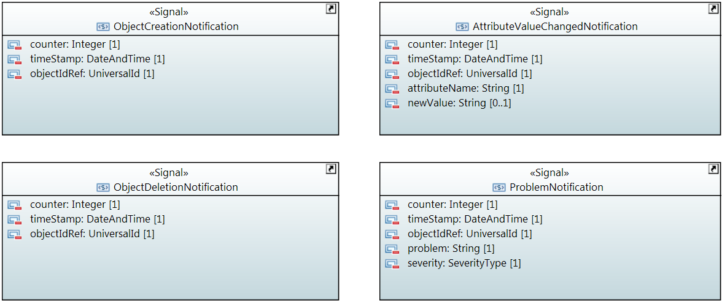

### AttributeValueChangedNotification

Qualified Name: MicrowaveModel::Notifications::AttributeValueChangedNotification

To be sent when an attribute has changed and one or more controllers have to update their data.

Applied stereotypes:

* OpenModelNotification
* triggerConditionList: invalid
* support: MANDATORY

Table 78: Attributes for AttributeValueChangedNotification

| **Attribute Name** | **Type DefaultValue** | **Multiplicity** | **Access** | **Stereotypes** | **Description** |
| --- | --- | --- | --- | --- | --- |
| counter | Integer  -1 | 1 | RW | OpenModelAttribute   * partOfObjectKey: 0 * AVC: NO * isInvariant: true * valueRange: no range constraint * bitLength: LENGTH_32_BIT * unit: no unit defined * support: MANDATORY | Counts attribute value changed notifications. |
| timeStamp | DateTime  2010-11-20T14:00:00+01:00 | 1 | RW | OpenModelAttribute   * partOfObjectKey: 0 * AVC: NO * isInvariant: true * valueRange: no range constraint * bitLength: NA * unit: no unit defined * support: MANDATORY |  |
| objectIdRef | UniversalId  ./. | 1 | RW | OpenModelAttribute   * partOfObjectKey: 0 * AVC: NO * isInvariant: true * valueRange: no range constraint * bitLength: NA * unit: no unit defined * support: MANDATORY | ID of the affected MW_AirInterface_Pac, MW_AirInterfaceDiversity_Pac, MW_Structure_Pac, MW_PureEthernetStructure_Pac, MW_HybridMwStructure_Pac, MW_Container_Pac, MW_EthernetContainer_Pac or MW_TdmContainer_Pac. |
| attributeName | String  Attribute name not specified. | 1 | RW | OpenModelAttribute   * partOfObjectKey: 0 * AVC: NO * isInvariant: true * valueRange: no range constraint * bitLength: NA * unit: no unit defined * support: MANDATORY | Name of the attribute that has been changed. |
| newValue | String  New value not specified. | 0..1 | RW | OpenModelAttribute   * partOfObjectKey: 0 * AVC: NO * isInvariant: true * valueRange: no range constraint * bitLength: NA * unit: no unit defined * support: MANDATORY | Attribute value converted to a string (xml, json, ...) |

### ObjectCreationNotification

Qualified Name: MicrowaveModel::Notifications::ObjectCreationNotification

To be sent when a new MW_AirInterface_Pac, MW_AirInterfaceDiversity_Pac, MW_Structure_Pac, MW_PureEthernetStructure_Pac, MW_HybridMwStructure_Pac, MW_Container_Pac, MW_EthernetContainer_Pac or MW_TdmContainer_Pac has to be instancieted in the controller.

Applied stereotypes:

* OpenModelNotification
* triggerConditionList: invalid
* support: MANDATORY

Table 79: Attributes for ObjectCreationNotification

| **Attribute Name** | **Type DefaultValue** | **Multiplicity** | **Access** | **Stereotypes** | **Description** |
| --- | --- | --- | --- | --- | --- |
| counter | Integer  -1 | 1 | RW | OpenModelAttribute   * partOfObjectKey: 0 * AVC: NO * isInvariant: true * valueRange: no range constraint * bitLength: LENGTH_32_BIT * unit: no unit defined * support: MANDATORY | Counts object creation notifications. |
| timeStamp | DateTime  2010-11-20T14:00:00+01:00 | 1 | RW | OpenModelAttribute   * partOfObjectKey: 0 * AVC: NO * isInvariant: true * valueRange: no range constraint * bitLength: NA * unit: no unit defined * support: MANDATORY |  |
| objectIdRef | UniversalId  ./. | 1 | RW | OpenModelAttribute   * partOfObjectKey: 0 * AVC: NO * isInvariant: true * valueRange: no range constraint * bitLength: NA * unit: no unit defined * support: MANDATORY | ID of the affected MW_AirInterface_Pac, MW_AirInterfaceDiversity_Pac, MW_Structure_Pac, MW_PureEthernetStructure_Pac, MW_HybridMwStructure_Pac, MW_Container_Pac, MW_EthernetContainer_Pac or MW_TdmContainer_Pac. |
| objectType | String  Type of created object not specified. | 1 | RW | OpenModelAttribute   * partOfObjectKey: 0 * AVC: NO * isInvariant: true * valueRange: no range constraint * bitLength: NA * unit: no unit defined * support: MANDATORY | Type of Object to be chosen from the following list of values: 'MW_AirInterface_Pac', 'MW_AirInterfaceDiversity_Pac', 'MW_Structure_Pac', 'MW_PureEthernetStructure_Pac', 'MW_HybridMwStructure_Pac', 'MW_Container_Pac', 'MW_EthernetContainer_Pac' or 'MW_TdmContainer_Pac'. |

### ObjectDeletionNotification

Qualified Name: MicrowaveModel::Notifications::ObjectDeletionNotification

To be sent when a new MW_AirInterface_Pac, MW_AirInterfaceDiversity_Pac, MW_Structure_Pac, MW_PureEthernetStructure_Pac, MW_HybridMwStructure_Pac, MW_Container_Pac, MW_EthernetContainer_Pac or MW_TdmContainer_Pac instance has to be deleted in the controller.

Applied stereotypes:

* OpenModelNotification
* triggerConditionList: invalid
* support: MANDATORY

Table 80: Attributes for ObjectDeletionNotification

| **Attribute Name** | **Type DefaultValue** | **Multiplicity** | **Access** | **Stereotypes** | **Description** |
| --- | --- | --- | --- | --- | --- |
| counter | Integer  -1 | 1 | RW | OpenModelAttribute   * partOfObjectKey: 0 * AVC: NO * isInvariant: true * valueRange: no range constraint * bitLength: LENGTH_32_BIT * unit: no unit defined * support: MANDATORY | Counts object deletion notifications. |
| timeStamp | DateTime  2010-11-20T14:00:00+01:00 | 1 | RW | OpenModelAttribute   * partOfObjectKey: 0 * AVC: NO * isInvariant: true * valueRange: no range constraint * bitLength: NA * unit: no unit defined * support: MANDATORY |  |
| objectIdRef | UniversalId  ./. | 1 | RW | OpenModelAttribute   * partOfObjectKey: 0 * AVC: NO * isInvariant: true * valueRange: no range constraint * bitLength: NA * unit: no unit defined * support: MANDATORY | ID of the affected MW_AirInterface_Pac, MW_AirInterfaceDiversity_Pac, MW_Structure_Pac, MW_PureEthernetStructure_Pac, MW_HybridMwStructure_Pac, MW_Container_Pac, MW_EthernetContainer_Pac or MW_TdmContainer_Pac. |

### ProblemNotification

Qualified Name: MicrowaveModel::Notifications::ProblemNotification

To be sent when a problem occurs at a MW_AirInterface_Pac, MW_AirInterfaceDiversity_Pac, MW_Structure_Pac, MW_PureEthernetStructure_Pac, MW_HybridMwStructure_Pac, MW_Container_Pac, MW_EthernetContainer_Pac or MW_TdmContainer_Pac.

Applied stereotypes:

* OpenModelNotification
* triggerConditionList: invalid
* support: MANDATORY

Table 81: Attributes for ProblemNotification

| **Attribute Name** | **Type DefaultValue** | **Multiplicity** | **Access** | **Stereotypes** | **Description** |
| --- | --- | --- | --- | --- | --- |
| counter | Integer  -1 | 1 | RW | OpenModelAttribute   * partOfObjectKey: 0 * AVC: NO * isInvariant: true * valueRange: no range constraint * bitLength: LENGTH_32_BIT * unit: no unit defined * support: MANDATORY | Counts problem notifications |
| timeStamp | DateTime  2010-11-20T14:00:00+01:00 | 1 | RW | OpenModelAttribute   * partOfObjectKey: 0 * AVC: NO * isInvariant: true * valueRange: no range constraint * bitLength: NA * unit: no unit defined * support: MANDATORY |  |
| objectIdRef | UniversalId  ./. | 1 | RW | OpenModelAttribute   * partOfObjectKey: 0 * AVC: NO * isInvariant: true * valueRange: no range constraint * bitLength: NA * unit: no unit defined * support: MANDATORY | ID of the affected MW_AirInterface_Pac, MW_AirInterfaceDiversity_Pac, MW_Structure_Pac, MW_PureEthernetStructure_Pac, MW_HybridMwStructure_Pac, MW_Container_Pac, MW_EthernetContainer_Pac or MW_TdmContainer_Pac. |
| problem | String  Problem name not specified. | 1 | RW | OpenModelAttribute   * partOfObjectKey: 0 * AVC: NO * isInvariant: true * valueRange: no range constraint * bitLength: NA * unit: no unit defined * support: MANDATORY | Name of the problem according to AirInterface::AirInterfaceCapability::supportedAlarms or AirInterfaceDiversity::AirInterfaceDiversityCapability::supportedAlarms or Structure::StructureCapability::supportedAlarms or PureEthernetStructure::PureEthernetStructureCapability::supportedAlarms or HybridMwStructure::HybridMwStructureCapability::supportedAlarms or Container::ContainerCapability::supportedAlarms or EthernetContainer::EthernetContainerCapability::supportedAlarms or TdmContainer::TdmContainerCapability::supportedAlarms. |
| severity | SeverityType  WARNING | 1 | RW | OpenModelAttribute   * partOfObjectKey: 0 * AVC: NO * isInvariant: true * valueRange: no range constraint * bitLength: NA * unit: no unit defined * support: MANDATORY | Severity of the problem according to AirInterface::AirInterfaceConfiguration::problemSeverityList, AirInterfaceDiversity::AirInterfaceDiversityConfiguration::problemSeverityList, Structure::StructureConfiguration::problemSeverityList, PureEthernetStructure::PureEthernetStructureConfiguration::problemSeverityList, HybridMwStructure::HybridMwStructureConfiguration::problemSeverityList, Container::ContainerConfiguration::problemSeverityList, EthernetContainer::EthernetContainerConfiguration::problemSeverityList or TdmContainer::TdmContainerConfiguration::problemSeverityList |

# Translation Table Functional Model

|  |  |
| --- | --- |
| Functional Model | Information Model |
| MW-Client | Container |
| MWS | Structures |
| MWS-X | Group of Structures |
| MWPS | AirInterface |

# References

|  |  |
| --- | --- |
| Reference | Comment |
| {{ONF CM}} | TR-512 ONF Core Information Model Version 1.2, September 2016 (https://www.opennetworking.org/images/stories/downloads/sdn-resources/technical-reports/TR-512_CIM_(CoreModel)_1.2.zip) |
| {{ONF SDN Arch WL}} | SDN Architecture for Wireless Transport Networks 1.0, July 2016 (<https://www.opennetworking.org/images/stories/downloads/sdnresources/technical-reports/TR_SDN_ARCH_WL_1.0.pdf>) |
| {{ONF UMLG}} | TR-514 UML Modeling Guidelines; Version 1.2, September 2016  (https://www.opennetworking.org/images/stories/downloads/sdn-resources/technical-reports/TR-514_UML_Modeling_Guidelines_v1.2.pdf and https://www.opennetworking.org/images/stories/downloads/sdn-resources/technical-reports/IISOMI_514_UML_Modeling_Guidelines_v1.2.pdf) |
| {{RFC 7950}} | YANG - A Data Modeling Language for the Network Configuration; Version 1.1, August 2016 (https://tools.ietf.org/html/rfc7950) |

# Back matter

## Editors

Thorsten Heinze

Telefonica Germany GmbH & Co. OHG

Martin Skorupski

highstreet technologies GmbH consulting Telefonica Germany GmbH & Co. OHG

## Contributors

Many thanks to Ariel Adam, Jonas Ahlberg, Ippei Akiyoshi, Dudu Bercovich, Michael Binder, Giorgio Cazzaniga, George Clapp, Luis Miguel Contreras, Nigel Davis, Chris Hartley, Ahsen Javed, Petr Jurcik, Thomas Kessler, Linda Ming, Danilo Pala, James Ries, Giuseppe Roveda, Paolo Spallaccini, Alexandru Stancu, Tracy Van Brakle, Maarten Vissers, Min Ye, Yang Yonggang, Bernd Zeuner and Nader Zein for reviewing and commenting of the Microwave Information Model.

_______________________