Content

2 Classes 1

2.1 HttpClientInterfaceConfiguration 1

2.2 HttpClientInterfaceLpSpec 2

2.3 HttpClientInterface_Pac 2

3 Data Types 3

4 Enumeration Types 3

4.1 AuthenticationKindType 3

4.2 LayerProtocolNameType 3

5 Primitive Types 4

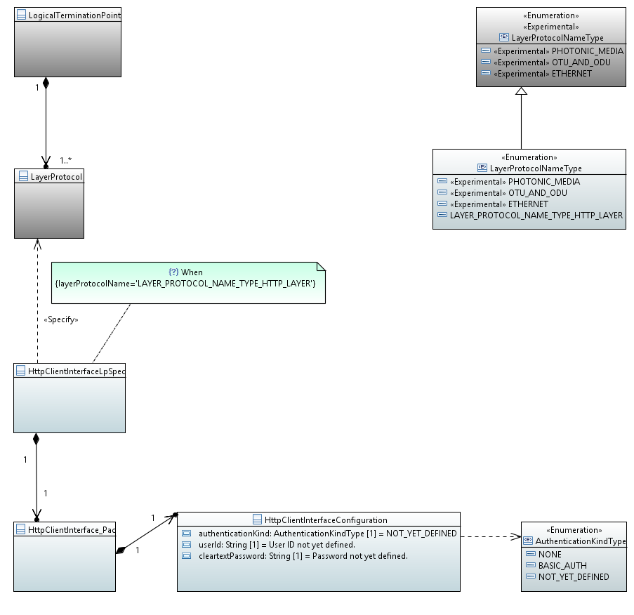

# Classes

## HttpClientInterfaceConfiguration

Applied stereotypes:

* OpenInterfaceModelClass
* objectCreationNotification: NO
* objectDeletionNotification: NO
* OpenModelClass
* support: MANDATORY

Attributes for HttpClientInterfaceConfiguration

Table 1: Attributes for HttpClientInterfaceConfiguration

|  |  |  |  |  |  |
| --- | --- | --- | --- | --- | --- |
| **Attribute Name** | **Type** | **Multiplicity** | **Access** | **Stereotypes** | **Description** |
| authenticationKind | AuthenticationKindType  NOT_YET_DEFINED | 1 | RW | OpenInterfaceModelAttribute  • AVC: NA  • bitLength: NA  OpenModelAttribute  • partOfObjectKey: 0  • isInvariant: false  • valueRange: no range constraint  • unit: no unit defined  • support: MANDATORY | Configuration of the authentication method. |
| userId | String  User ID not yet defined. | 1 | RW | OpenInterfaceModelAttribute  • AVC: NO  • bitLength: NA  OpenModelAttribute  • partOfObjectKey: 0  • isInvariant: false  • valueRange: no range constraint  • unit: no unit defined  • support: MANDATORY  Reference | Only configurable, if (authenticationKind==BASIC_AUTH). The user-id for the authenticating client. |
| cleartextPassword | String  Password not yet defined. | 1 | RW | OpenInterfaceModelAttribute  • AVC: NO  • bitLength: NA  OpenModelAttribute  • partOfObjectKey: 0  • isInvariant: false  • valueRange: no range constraint  • unit: no unit defined  • support: MANDATORY  Reference | Only configurable, if (authenticationKind==BASIC_AUTH). The cleartext value of the password. |

## HttpClientInterfaceLpSpec

Applied stereotypes:

* OpenInterfaceModelClass
* objectCreationNotification: NO
* objectDeletionNotification: NO
* OpenModelClass
* support: MANDATORY

Attributes for HttpClientInterfaceLpSpec

Table 1: Attributes for HttpClientInterfaceLpSpec

|  |  |  |  |  |  |
| --- | --- | --- | --- | --- | --- |
| **Attribute Name** | **Type** | **Multiplicity** | **Access** | **Stereotypes** | **Description** |
| _httpClientInterface_Pac | HttpClientInterface_Pac  ./. | 1 | RW | OpenInterfaceModelAttribute  • AVC: NA  • bitLength: NA  OpenModelAttribute  • partOfObjectKey: 0  • isInvariant: false  • valueRange: no range constraint  • unit: no unit defined  • support: MANDATORY | See referenced class |

## HttpClientInterface_Pac

Applied stereotypes:

* OpenInterfaceModelClass
* objectCreationNotification: NO
* objectDeletionNotification: NO
* OpenModelClass
* support: MANDATORY

Attributes for HttpClientInterface_Pac

Table 1: Attributes for HttpClientInterface_Pac

|  |  |  |  |  |  |
| --- | --- | --- | --- | --- | --- |
| **Attribute Name** | **Type** | **Multiplicity** | **Access** | **Stereotypes** | **Description** |
| _httpClientInterfaceConfiguration | HttpClientInterfaceConfiguration  ./. | 1 | RW | OpenInterfaceModelAttribute  • AVC: NA  • bitLength: NA  OpenModelAttribute  • partOfObjectKey: 0  • isInvariant: false  • valueRange: no range constraint  • unit: no unit defined  • support: MANDATORY | See referenced class |

# Data Types

# Enumeration Types

## AuthenticationKindType

Contains Enumeration Literals:

* NONE:
  + Authentication is switched off.
* BASIC_AUTH:
  + Basic HTTP Authentication Scheme according to IETF RFC 7617.
* NOT_YET_DEFINED:

## LayerProtocolNameType

A controlled list of LayerProtocol names.

Contains Enumeration Literals:

* LAYER_PROTOCOL_NAME_TYPE_HTTP_LAYER: