Content

2 Classes 1

2.1 TcpClientInterfaceConfiguration 1

2.2 TcpClientInterfaceLpSpec 2

2.3 TcpClientInterface_Pac 2

3 Data Types 3

4 Enumeration Types 3

4.1 LayerProtocolNameType 3

5 Primitive Types 3

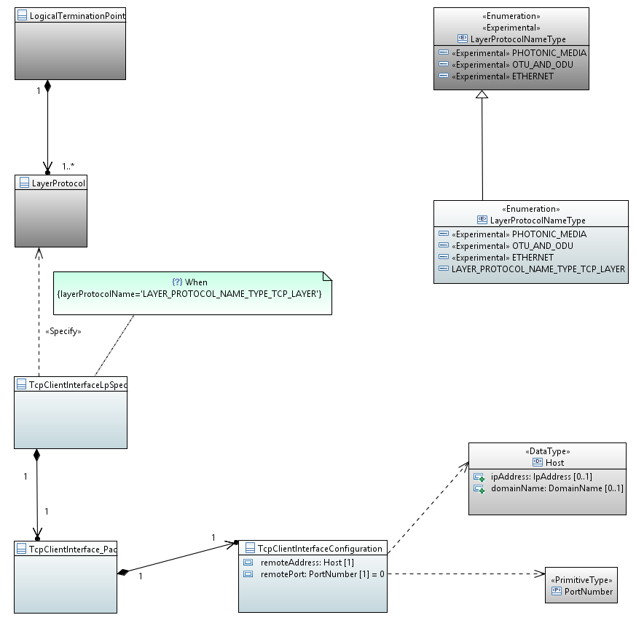

# Classes

## TcpClientInterfaceConfiguration

Applied stereotypes:

* OpenInterfaceModelClass
* objectCreationNotification: NO
* objectDeletionNotification: NO
* OpenModelClass
* support: MANDATORY

Attributes for TcpClientInterfaceConfiguration

Table 1: Attributes for TcpClientInterfaceConfiguration

|  |  |  |  |  |  |
| --- | --- | --- | --- | --- | --- |
| **Attribute Name** | **Type** | **Multiplicity** | **Access** | **Stereotypes** | **Description** |
| remoteAddress | Host  ./. | 1 | RW | OpenInterfaceModelAttribute  • AVC: NO  • bitLength: NA  OpenModelAttribute  • partOfObjectKey: 0  • isInvariant: false  • valueRange: no range constraint  • unit: no unit defined  • support: MANDATORY  Reference | The IP address or hostname of the remote peer to establish a connection with. If a domain name is configured, then the DNS resolution should happen on each connection attempt. If the DNS resolution results in multiple IP addresses, the IP addresses are tried according to local preference order until a connection has been established or until all IP addresses have failed. |
| remotePort | PortNumber  0 | 1 | RW | OpenInterfaceModelAttribute  • AVC: NO  • bitLength: NA  OpenModelAttribute  • partOfObjectKey: 0  • isInvariant: false  • valueRange: no range constraint  • unit: no unit defined  • support: MANDATORY  Reference | The IP port number for the remote peer to establish a connection with. An invalid default value (0) is used (instead of 'mandatory true') so that as application level data model may 'refine' it with an application specific default port number value. |

## TcpClientInterfaceLpSpec

Applied stereotypes:

* OpenInterfaceModelClass
* objectCreationNotification: NO
* objectDeletionNotification: NO
* OpenModelClass
* support: MANDATORY

Attributes for TcpClientInterfaceLpSpec

Table 1: Attributes for TcpClientInterfaceLpSpec

|  |  |  |  |  |  |
| --- | --- | --- | --- | --- | --- |
| **Attribute Name** | **Type** | **Multiplicity** | **Access** | **Stereotypes** | **Description** |
| _tcpClientInterface_Pac | TcpClientInterface_Pac  ./. | 1 | RW | OpenInterfaceModelAttribute  • AVC: NA  • bitLength: NA  OpenModelAttribute  • partOfObjectKey: 0  • isInvariant: false  • valueRange: no range constraint  • unit: no unit defined  • support: MANDATORY | See referenced class |

## TcpClientInterface_Pac

Applied stereotypes:

* OpenInterfaceModelClass
* objectCreationNotification: NO
* objectDeletionNotification: NO
* OpenModelClass
* support: MANDATORY

Attributes for TcpClientInterface_Pac

Table 1: Attributes for TcpClientInterface_Pac

|  |  |  |  |  |  |
| --- | --- | --- | --- | --- | --- |
| **Attribute Name** | **Type** | **Multiplicity** | **Access** | **Stereotypes** | **Description** |
| _tcpClientInterfaceConfiguration | TcpClientInterfaceConfiguration  ./. | 1 | RW | OpenInterfaceModelAttribute  • AVC: NA  • bitLength: NA  OpenModelAttribute  • partOfObjectKey: 0  • isInvariant: false  • valueRange: no range constraint  • unit: no unit defined  • support: MANDATORY | See referenced class |

# Data Types

# Enumeration Types

## LayerProtocolNameType

A controlled list of LayerProtocol names.

Contains Enumeration Literals:

* LAYER_PROTOCOL_NAME_TYPE_TCP_LAYER: