ET_UNDEF (0)

ET_POINT (1)

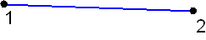

ET_LINE2 (2)

1 = (-1, 0, 0)
2 = (1, 0, 0)
3 = (0, 0, 0)

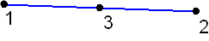

ET_LINE3 (3)

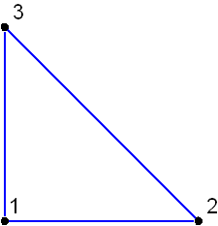

ET_TRIA3 (4)

1 = (0 0 0), 2 = (1 0 0),
3 = (0 1 0), 4 = (0.5 0 0)
5 = (0.5 0.5 0), 6 = (0 0.5 0)

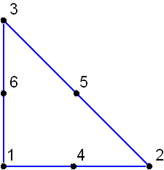

ET_TRIA6 (5)

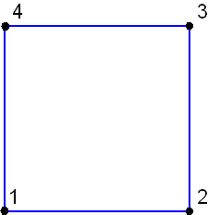

ET_QUAD4 (6)

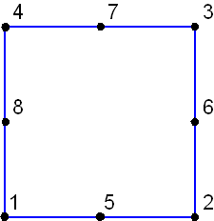

ET_QUAD8 (7)

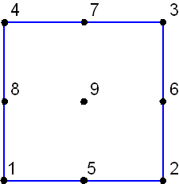

ET_QUAD9 (8)

1 = (-1 -1 0), 2 = (1 -1 0),
3 = (1 1 0), 4 = (-1 1 0),
5 = (0 -1 0), 6 = (1 0 0),
7 = (0 1 0), 8 = (-1 0 0),
9 = (0 0 0)

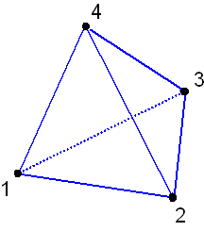
ET_TET4 (9)

1 = (0 0 0), 2 = (1 0 0),
3 = (0 1 0), 4 = (0 0 1),
5 = (0.5 0 0), 6 = (0.5 0.5 0),
7 = (0 0.5 0), 8 = (0 0 0.5),
9 = (0.5 0 0.5), 10 = (0 0.5 0.5)

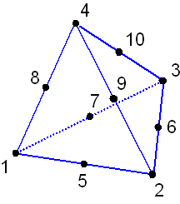
ET_TET10 (10)

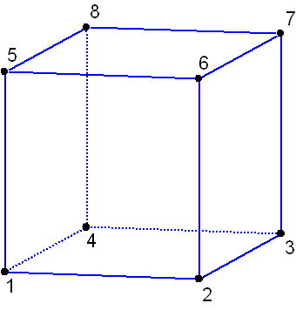

ET_HEXA8 (11)
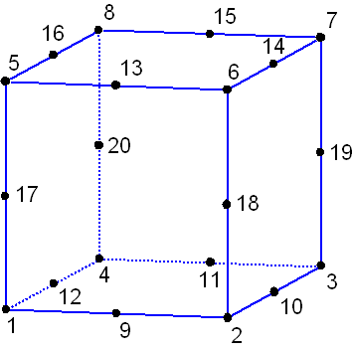

ET_HEXA20 (12)

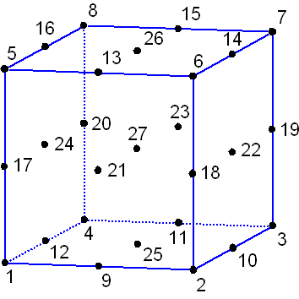

ET_HEXA27 (13)

1 = (-1 -1 -1), 2 = (1 -1 -1),
3 = (1 1 -1), 4 = (-1 1 -1),
5 = (-1 -1 1), 6 = (1 -1 1),
7 = (1 1 1), 8 = (-1 1 1),
9 = (0 -1 -1), 10 = (1 0 -1),
11 = (0 1 -1), 12 = (-1 0 -1),
13 = (0 -1 1), 14 = (1 0 1),
15 = (0 1 1), 16 = (-1 0 1),
17 = (-1 -1 0), 18 = (1 -1 0),
19 = (1 1 0), 20 = (-1 1 0),
21 = (0 -1 0), 22 = (1 0 0),
23 = (0 1 0), 24 = (-1 0 0),
25 = (0 0 -1), 26 = (0 0 1),
27 = (0 0 0)

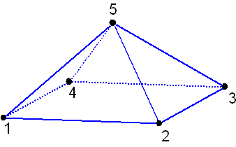

ET_PYRA5 (14)

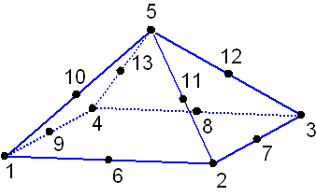

ET_PYRA13 (15)

1 = (1 1 0), 2 = (-1 1 0),
3 = (-1 -1 0), 4 = (1 -1 0),
5 = (0 0 1), 6 = (0 1 0),
7 = (-1 0 0), 8 = (0 -1 0),
9 = (1 0 0), 10 = (0.5 0.5 0.5),
11 = (-0.5 0.5 0.5), 12 = (-0.5 -0.5 0.5),
13 = (0.5 -0.5 0.5)

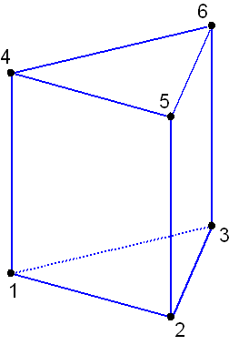

ET_WEDGE6 (16)

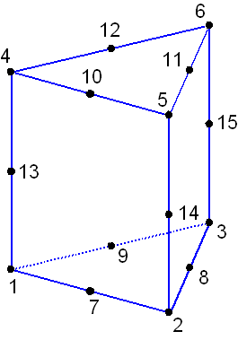

ET_WEDGE15 (17)

1 = (0 0 -1), 2 = (1 0 -1),
3 = (0 1 -1), 4 = (0 0 1),
5 = (1 0 1), 6 = (0 1 1),
7 = (0.5 0 -1), 8 = (0.5 0.5 -1),
9 = (0 0.5 -1), 10 = (0.5 0 1),
11 = (0.5 0.5 1), 12 = (0 0.5 1),
13 = (0 0 0), 14 = (1 0 0),
15 = (0 1 0)

