How to Create Split-Boundary in 2D ANSYS models
using the old ICEM-CFD meshing interface
The 2D ANSYS mesh in Fig 1. consists of three patches (= CSMP regions):
PATCH_A, PATCH_B and PATCH_C.
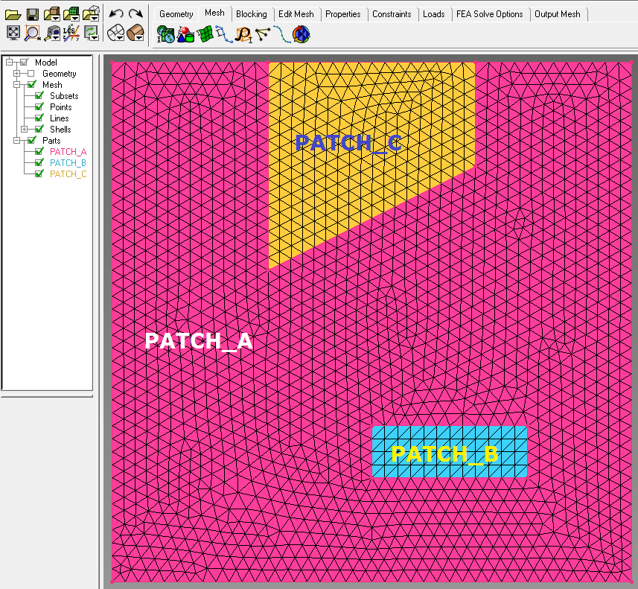
Figure 1 A three-patches mesh of triangular elements that conforms with the patch boundaries.
The nodes at the patch boundaries (interfaces) are shared with the adjacent patch(es) (contact lines). With a little trick, we can get ANSYS to duplicate those interface nodes to arrive at a mesh with collocated multiplicated interface nodes that can then be easily converted into a CSMP model with split boundaries.

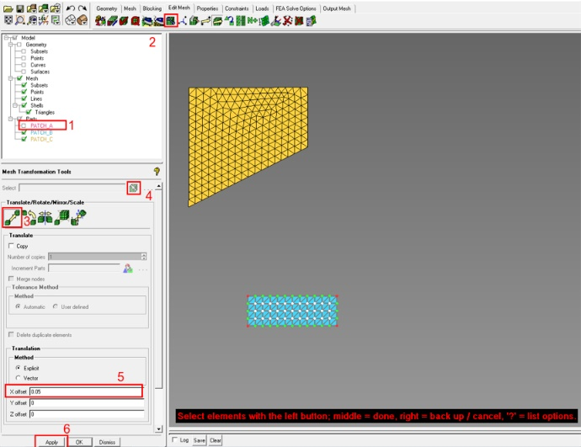
Figure 2 Shifting elements
In ANSYS (ICEM-CFD), when an element is detached from its neighbours, the shared nodes are split automatically. ANSYS supports several transform functions, such as translation, rotation and mirroring which can be utilised to dislocate a particular patch from the rest of the model. In this example, the following steps are performed to create split boundaries surrounding PATCH_B and PATCH_C.
- Disable PATCH_A from model tree
- From the utility menu, select Edit Mesh > Transform Mesh
- Choose Translate mode
- In Mesh Transformation Tools, select all elements in PATCH_B with left mouse button. Confirm selection with middle mouse button. Use the right mouse button to cancel if the wrong elements were selected.
- Assign a translation value, for instance 0.05
- Hit Apply button to shift the patch (called part in ANSYS). This command causes the nodes to be copied and assigned to the moved elements (Fig. 3).
- Reverse the translation by adding a minus sign to the translation value: -0.05. This will return the elements and nodes to their original position.
- Hit the Apply button again. While this undoes the translation, the duplicated nodes are retained.
The same steps are performed to detach PATCH_A and PATCH_C from the contiguous model (or in step 4 above, one can select PATCH_B & PATCH_C at the same time)

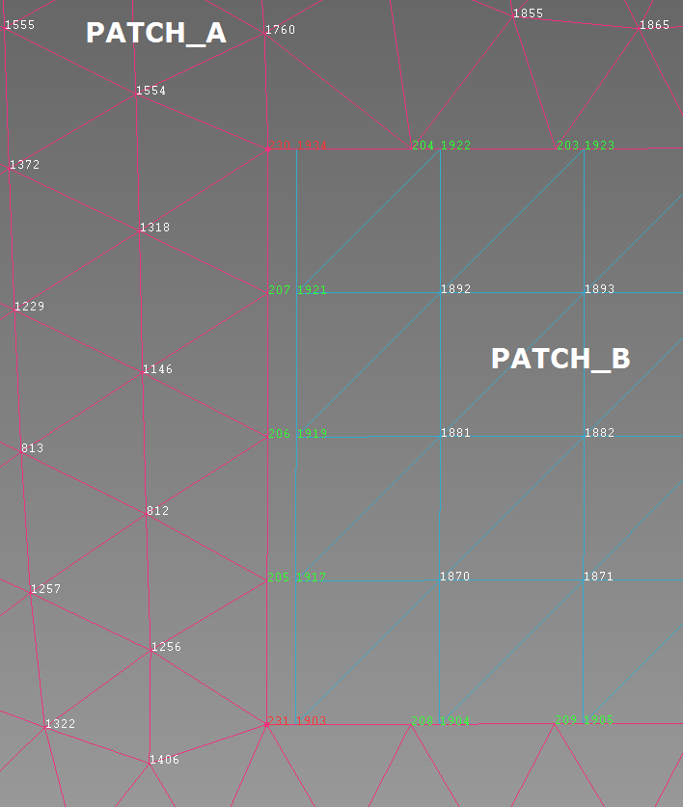
Figure 3 PATCH_B after the first translation.

