How to use Paraview (VTK) to display Flow and Transport Processes
Tutorial by Stephan Matthai, Chair of Reservoir Engineering, IE, The University of Melbourne.

Developed with Paraview version 5.1.0 (64-bit) on Mac OS X, minor differences may exist to current version.

1. Properties to display and ways to visualise them

Scalars: fluid pressure / hydraulic head, concentration, volume flux
- Color-shading (value range gets transformed into range of colour values) or values, point data, or volume rendition
- Contours

Vectors: Darcy and interstitial velocity, fluid pressure gradient
- Arrows or other ‘glyphs’ (with special versions in 2D)
- Streamlines routed on the basis of a vector field

Tensors: Permeability (although this is treated as a scalar in many of the detailed models
- tensor glyphs (for instance ellipsoids color-coded with eigenvalues

The property display also depends on the discretisation of the property. Properties can be cell or vertex based and this determines how they can be displayed.

Cell-based properties are usually displayed using a ‘flat’ (piecewise constant) shading. The default (surface) based display of vertex (=finite element node)-properties is via a piecewise linear shading.

2. Visualisation goals

- Illustrate, analyse and quantify the flow processes computed using the numeric model.
- Illustrate the relationships between the different variables of the model and the flow patterns and the permeability structure in particular

3. General process

Paraview consists of a Viewport with a specific layout, a PipelineBrowser and Properties and Information panels. In order to visualise variables, corresponding VTK or VTU files have to be loaded into the PipelineBrowser where they can be selected to perform specific visualisation tasks.
Standard visualisation tasks are enlisted in the task bar directly above the PipelineBrowser. They are executed using the Apply button in the Properties panel.

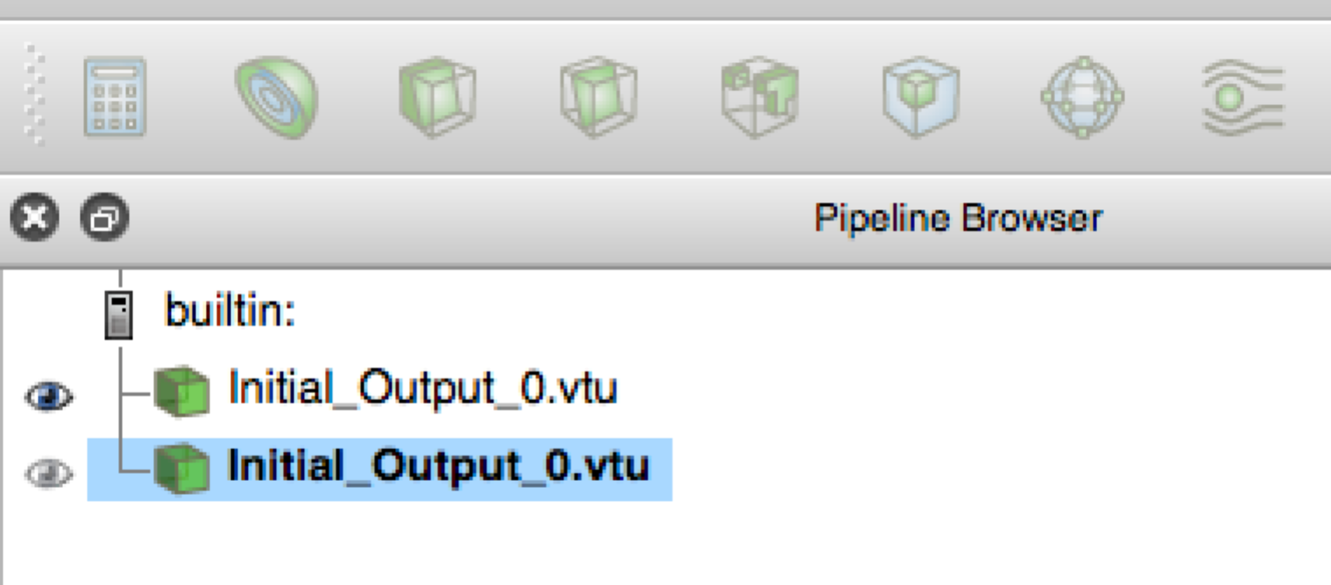

From the left to the right, these options are “property calculator”, “contours”, “slice”, “cutplane”, “threshold”, “extract subset”, “vector glyph” and “streamline” display. In any visualisation these different options can be combined into a multi-variable display. In this case, transparency (using a slider bar in the Properties panel) comes in handy to blend different variables visualised on top of one another.

For any of these visualisations, a color scheme is needed to relate variable values to display colors. The rainbow color palette for instance

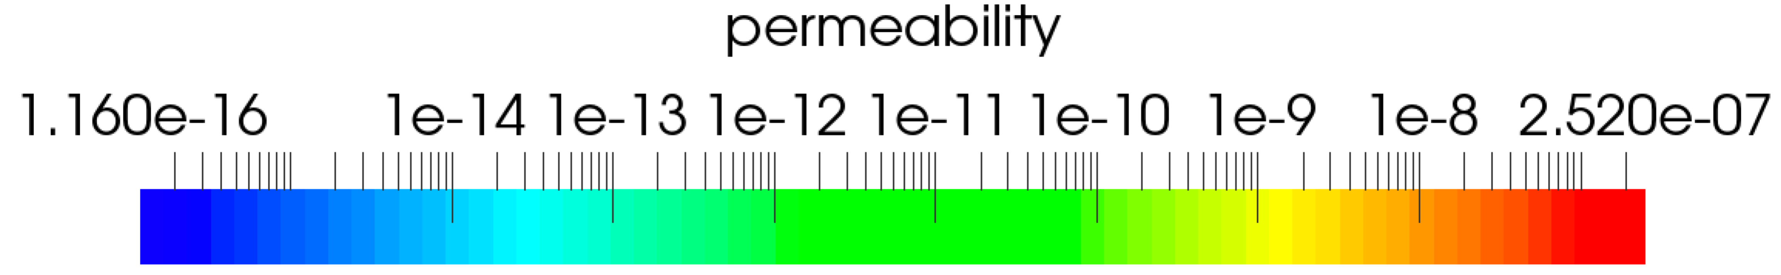

that is used here after taking the log10 of the values of the permeability in order to see the variations more clearly (for such wide ranging properties, one will only see the largest and smallest values (red and blue) when using a linear conversion scheme).

Scalar visualisation: your variables: fluid pressure (Pa) / hydraulic head, concentration (kg/m3), volume flux (m3/s).

To obtain the color shading (value range gets transformed into range of colour values) of the cell or point data, select the dataset. Then select the variable of interest in the ParaView display panel; use surface display:

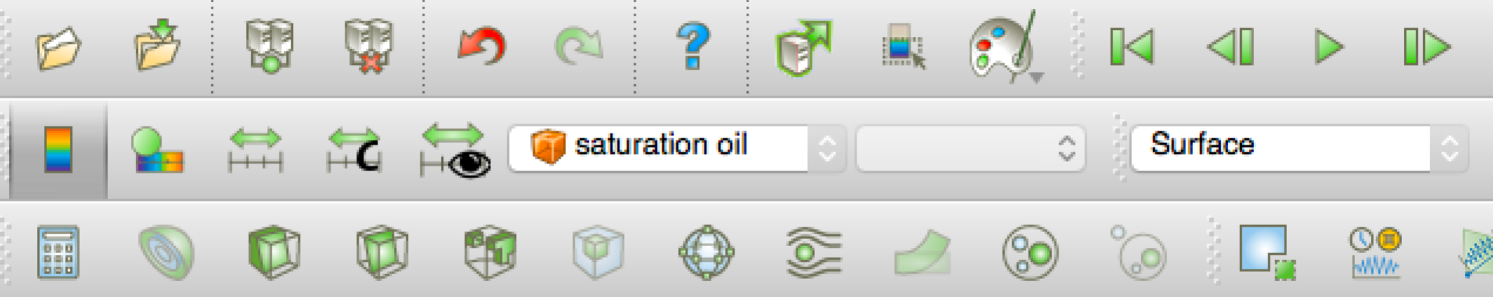
In the display below, permeability and saturation oil have been juxtaposed on top of one another using transparency so that both varialbles are blended. You can see how the oil flows around low permeability nodules.

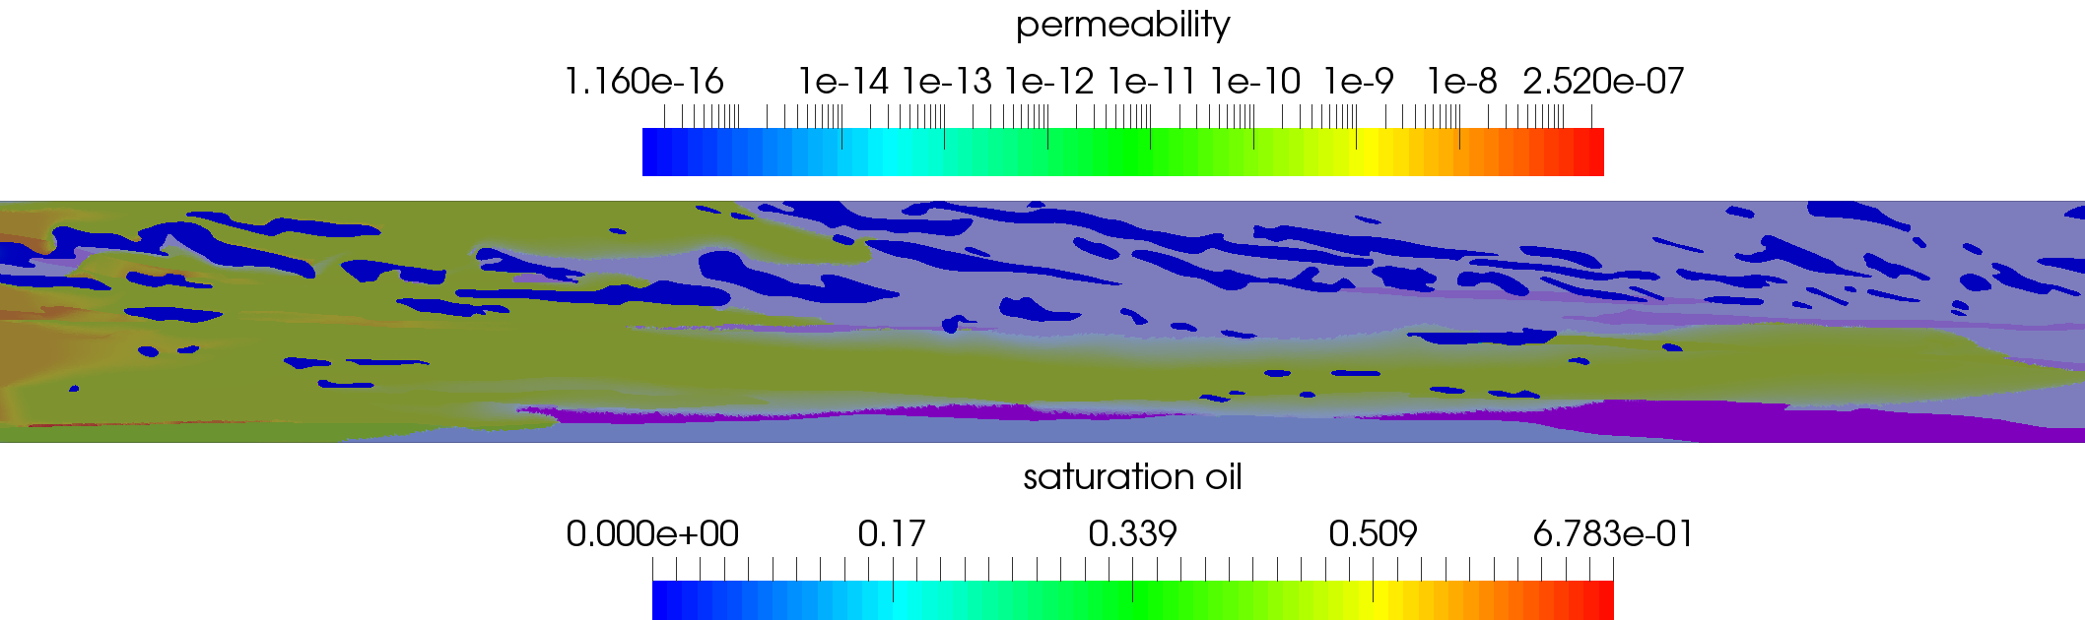

You can also use “Surface with Edges” which will show you the finite-element mesh:

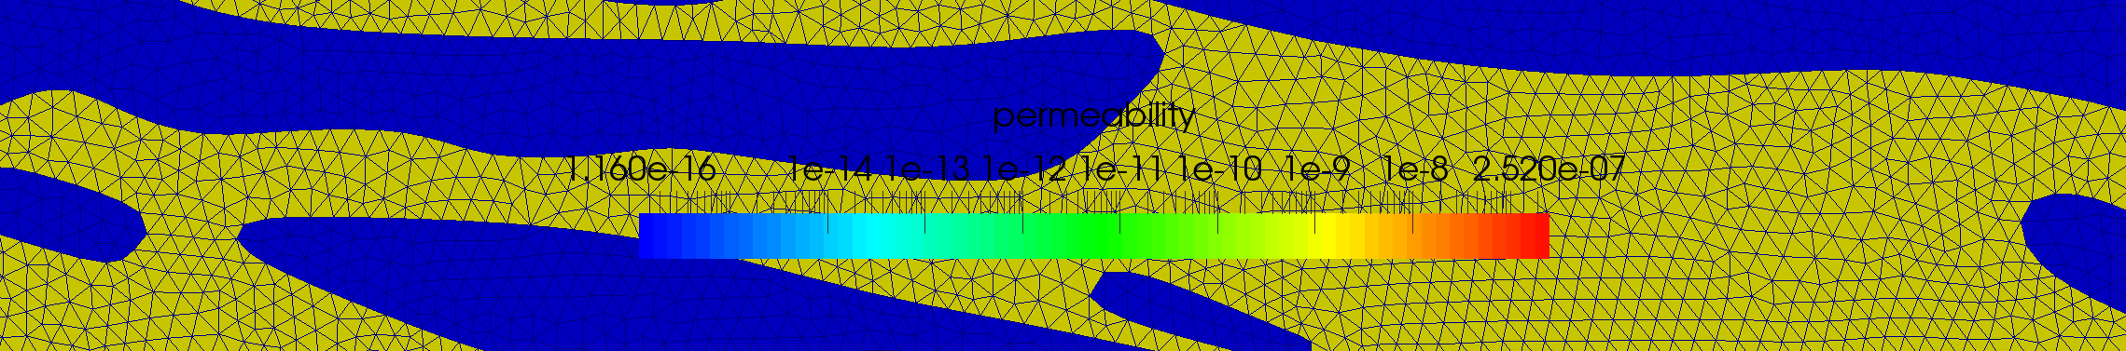

Contours. Use the same scalar variable and click on the “onion-shell” half sphere symbol. This will present you with the following menu in the Properties panel:
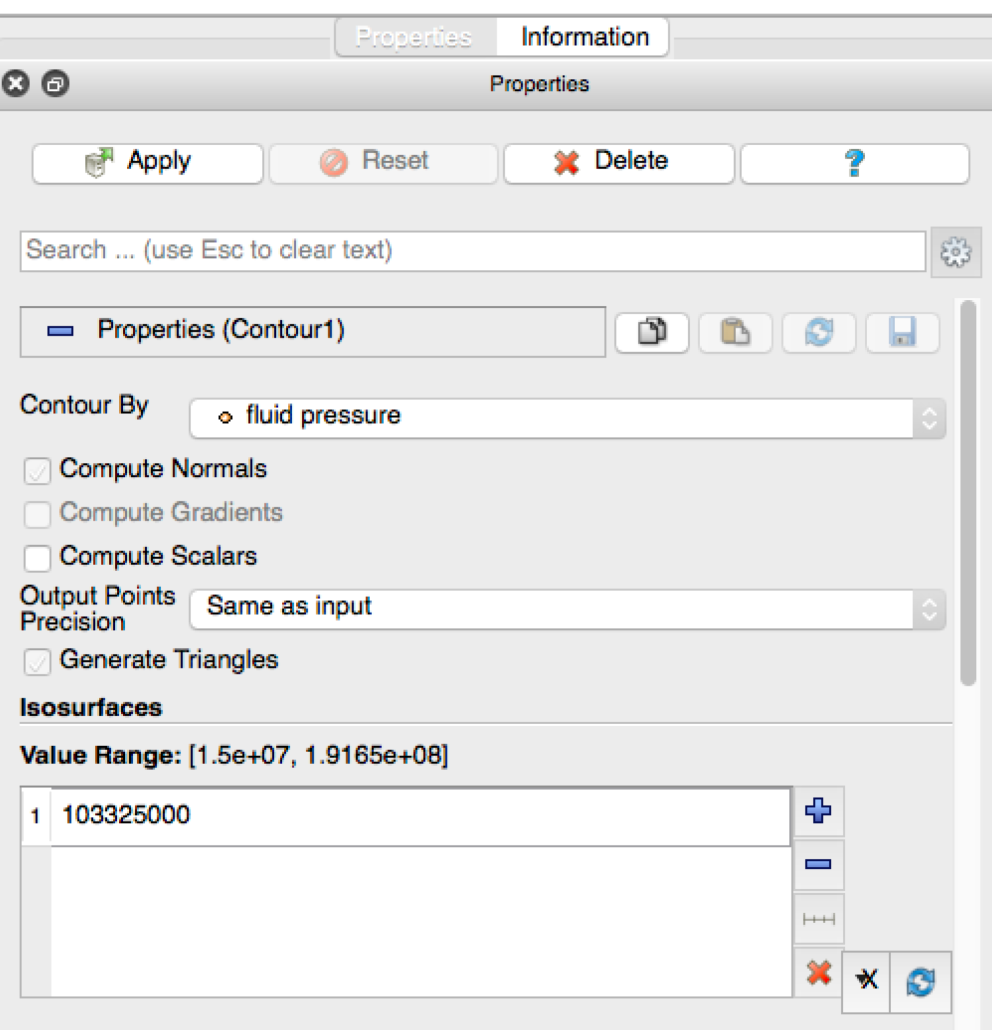

By default, when you click Apply, this will only get you a single contour (isobar) of the indicated fluid pressure value. However, you can click on the range symbol

below the minus sign in the menu on the right and this will present you with the option to plot multiple contours (default=10). If you select this option it will produce evenly spaced parameter values. With this option, you can create contour overlays on your model:

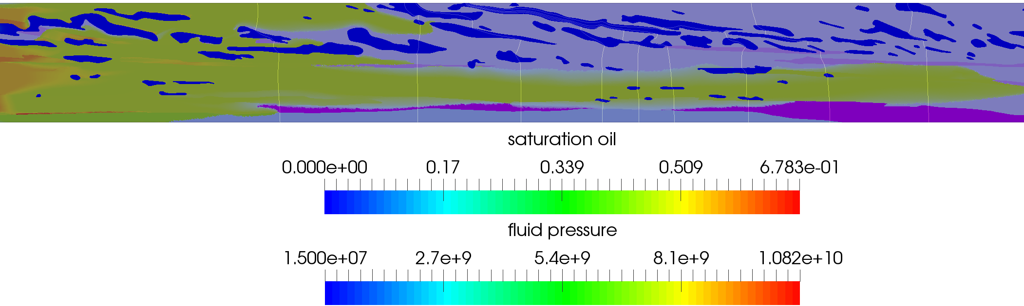

You may choose to change the point thickness to enhance these contours (in the example above, they are only a single point thick).

Vectors are visualised using glyphs. Again you select the variable of interest (for instance velocity), and then you press green Glyph symbol next to the streamline symbol in the toolbar above the Pipeline browser. Now you need to make a number of choices:
- Which glyph you want
- Which variable you want to create the vectors from
- How to scale them (slider bar or value entered); choose scale mode Off and then enter your target vector length. Express magnitude by color.
- Masking: all points
- Coloring: by glyph vector magnitude

This is how you can visualise the Darcy and interstitial velocity, and the fluid pressure gradient, see overleaf.

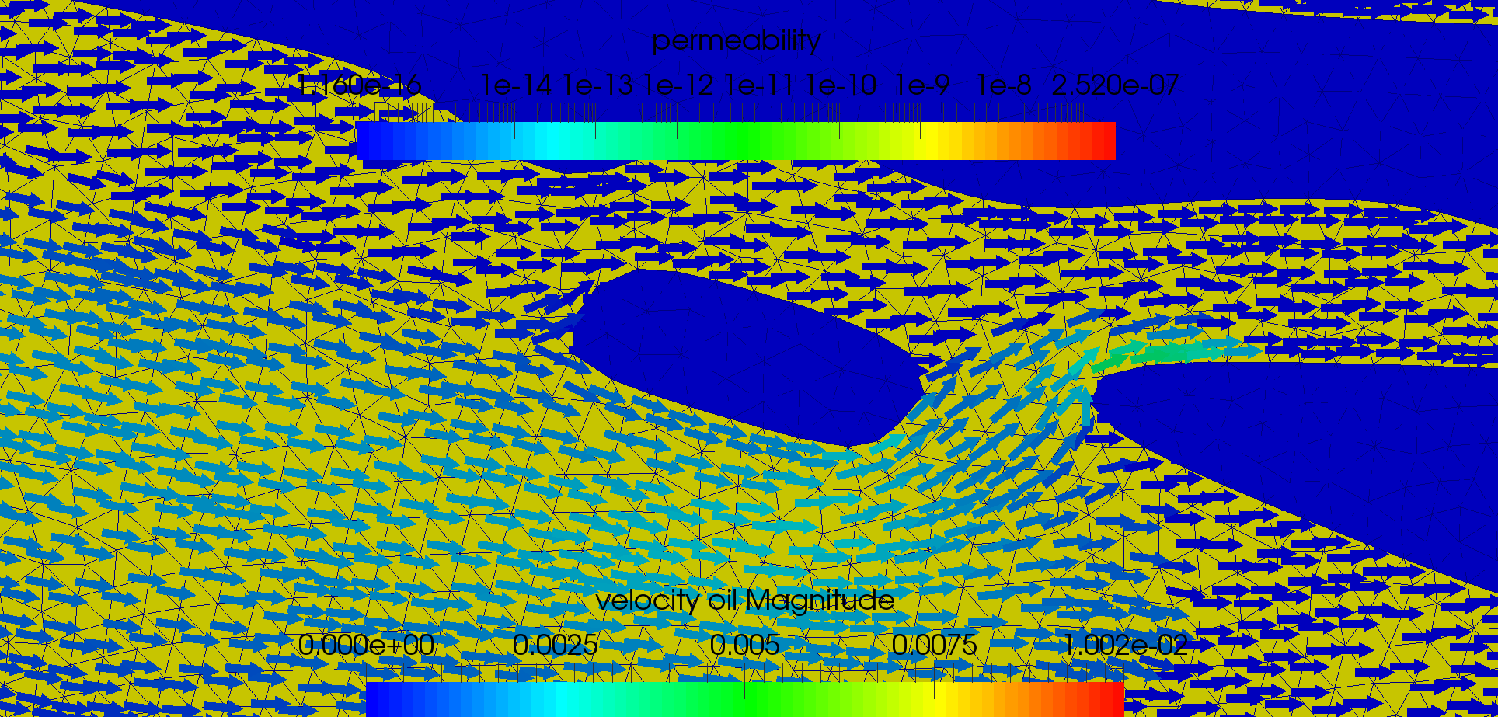

Streamlines. Often a vector display is not convenient because far too many vectors will be created and the graph will look rather busy. If the velocity field is stationary, streamlines represent a valid way to show the flow paths and velocities in a more visually accessible fashion. This display also gives you the option to gauge how far the fluid would travel over a certain amount of time.

For the display of streamlines you will first need to convert the cell (=finite element) piecewise constant data to point (=finite-element node) data. Use Filter -> Alphabetical -> Cell to Point data to create such a new dataset.

Select the newly created point dataset and then press the streamline icon above the pipeline browser to activate the streamline tracer. There are many options in this tool which are described in the official Paraview users guide and the documentation of VTK. Most of the defaults are good. Use the following options:

High-resolution line source (from which the streamlines will be mapped in the upstream and downstream directions.

Terminal velocity = 1.0e-16 or smaller to avoid that the streamlines terminate in the slow flowing regions of the model.

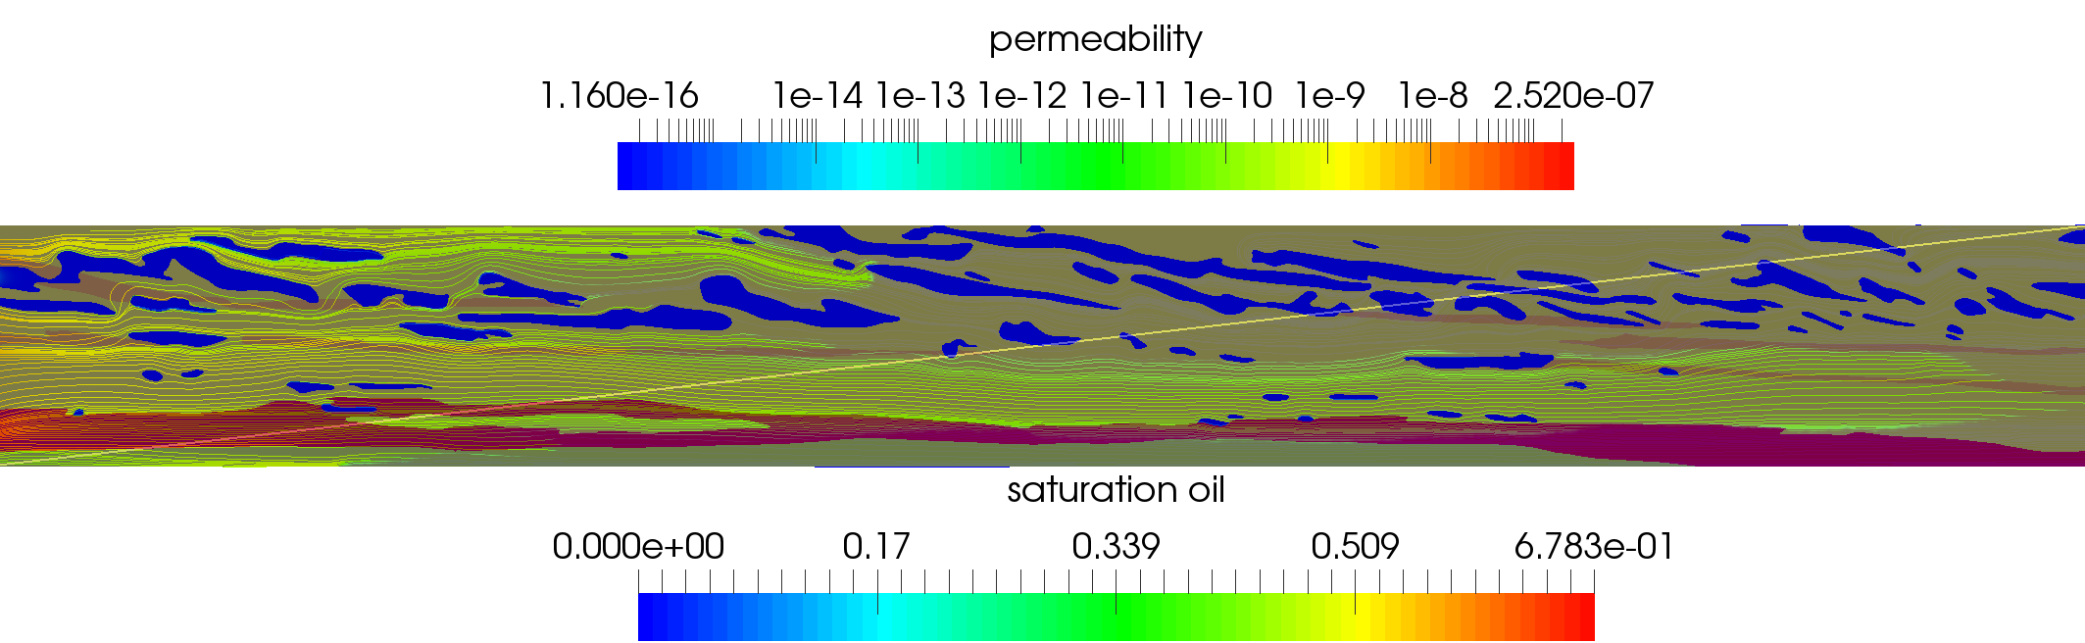

The streamlines can be coloured by any variable of choice (for instance the volume flux = velocity magnitude). To see them better, you may want to wrap them in tubes, which you can achieve by applying a tube filter:

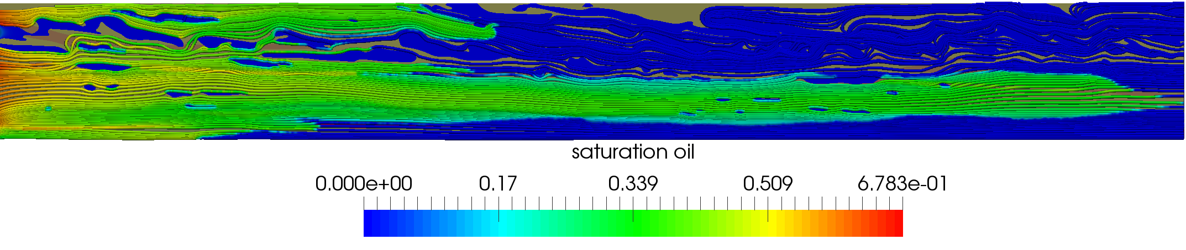

Tensors: Permeability (although this is treated as a scalar in many of the detailed models) usually is a tensor property. At the very least, hydrologists use a Kv/Kh ratio to reflect a reduced vertical permeability that arises when multiple continuous horizontal layers are averaged over because they are too thin to give them a discrete representation in the simulation models.

Tensor glyphs (for instance ellipsoids color-coded with eigenvalues) are created by selecting the tensor variables and using

Filters -> Alphabetical -> TensorGlyph

There are many display and scaling options. You want to scale by the eigenvalues and only display a few tensors at first (default) so that you do not overwhelm your graphics card:

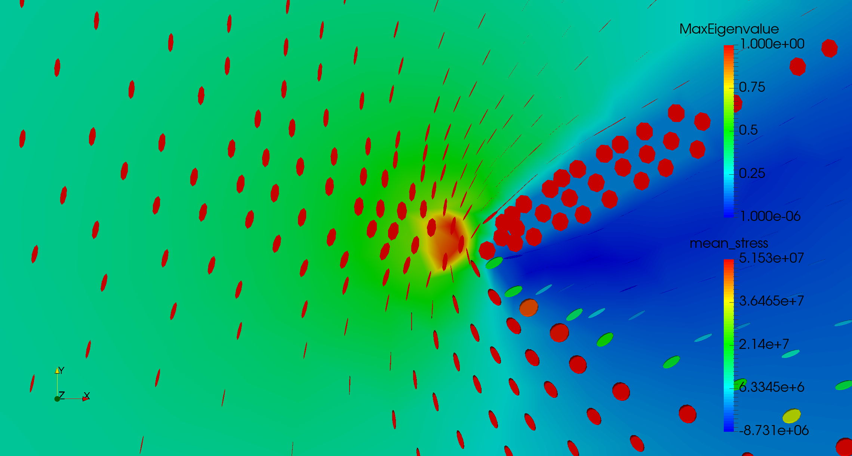

For further options, please refer to the extensive Paraview and VTK documentation on the web, e.g.:

https://www.paraview.org/Wiki/The_ParaView_Tutorial

