Hi Luat,

there is 2 way of creating split boundaries. Either with
- 1) matching Nodes (duplicate Nodes matching in either sides of the surface)
- 2) Not matching Nodes.

For 1) : you create a surface. Mesh in volume 3D and then Edit you mesh to duplicate the nodes on the this surface mesh
In Edit Mesh / Split Mesh

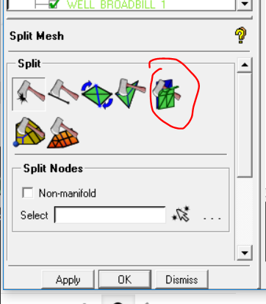
Ps : the Surfaces needs to be set as internal wall when you mesh them
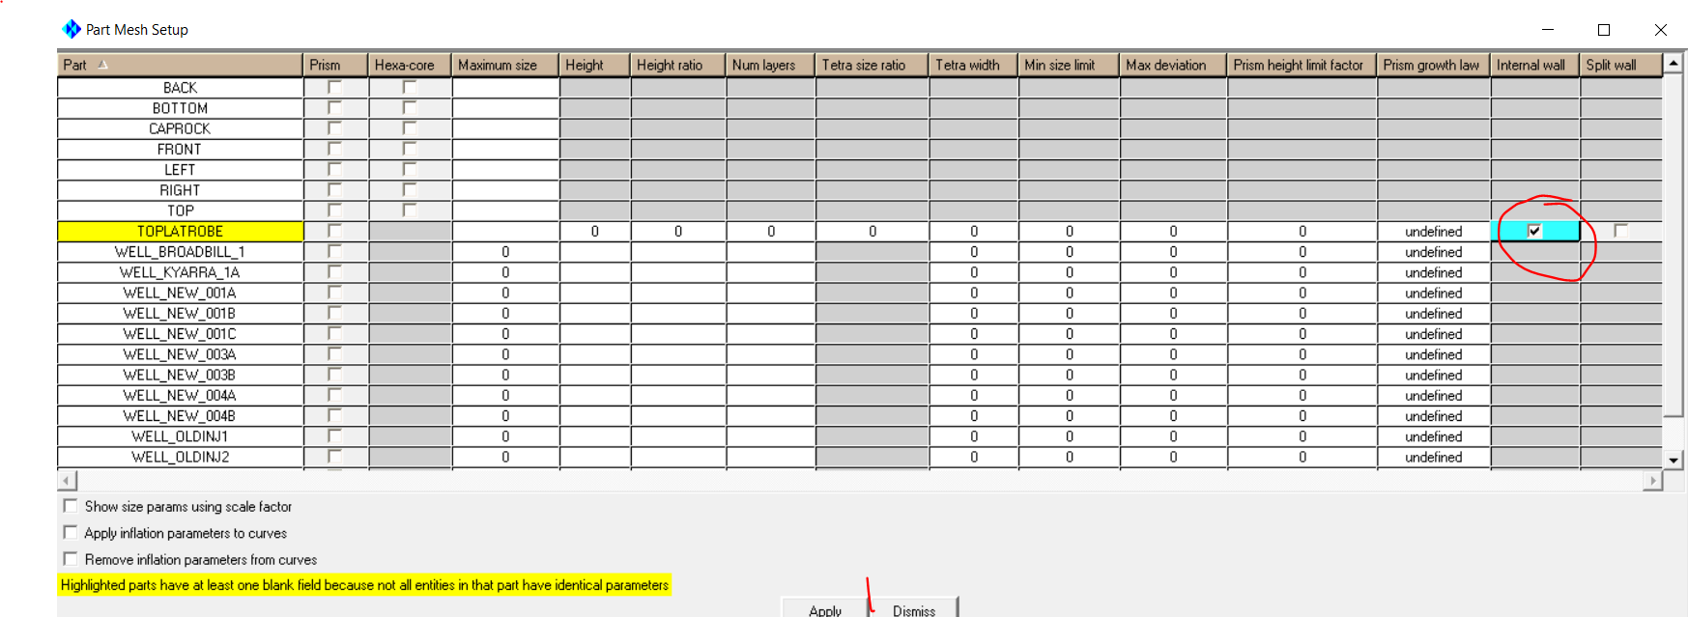

For 2)
you set the split boundaries
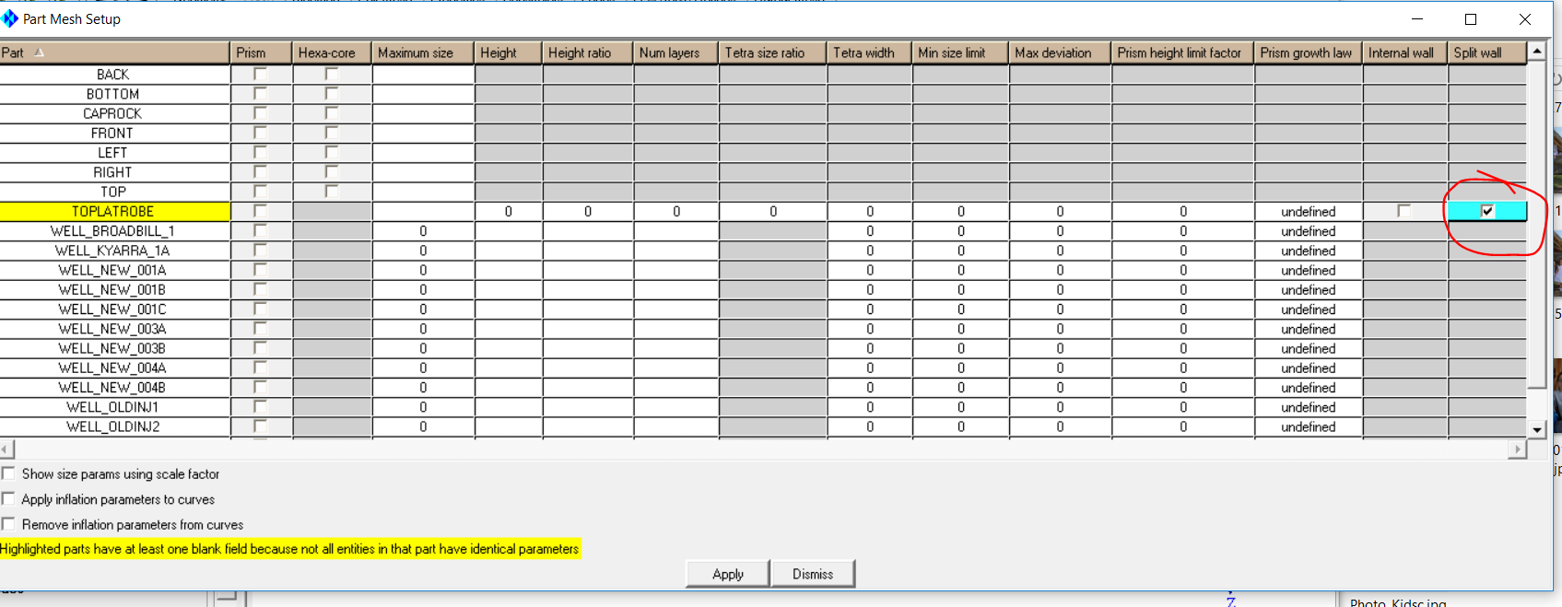

Let me know if you have more questions

chloe

Le jeu. 17 janv. 2019 à 14:22, Luat Khoa Tran <luatkhoat@student.unimelb.edu.au> a écrit :
Hi Chloe,

I have just created two regions in ICEM and I need to create the split-boundary between two regions by generating a set of duplicate nodes as the following figure.
Could you please show me how to do this?

Best regards,

Luat

