How to use RING mesh to build a valid CSMP model with Boundaries

The key implementation goals apart from transferring the model geometry are:

- correctness of model geometry / automatic checking for degenerate cells and their repair
- transfer of cell properties (including tensors) to elements, nodes and regions
- treatment of lower dimensional model entities
- representation and treatment of wells
- automatic generation of Boundary objects in CSMP; automatic treatment of Box boundaries
- automatic generation of SplitBoundary objects (where the mesh has been exploded into node-matched patches)
- controlling refinement
- coordinate systems: In the final CSMP++ model, the Y coordinate will record elevation above sea level, and the results from any property modelling done in GoCad or SKUA

The desired outcome is a module in RING-CSMP that writes a native CSMP model or just binary versions of VSet mesh container and ModelTopology region map instances.

Side- and internal model boundaries will be represented by csmp::Boundary or SplitBoundary objects. Respective Face or InterFace (element) objects will be stored in the VSet after the elements

Well completions will be represented by chains of line elements which will – like any other entitt - be regions with names, corresponding to those in the geomodel.

How to initialise a VSet

The VSet is a container for polygonal meshes and their associated properties. It was conceived by NCSA, Urbana Champaign, Illinois, USA as part of their HDF file format, which now also forms part of RESQML.

In CSMP++ the VSet is implemented in the form of a base class VData, which contains the mesh connectivity and the derived class VSet, which contains PropertyData physical properties associated with the meshed model.

The main data arrays stored in the VData part of the VSet in this given order are:

1. (double64) px, py, pz [0..n-1] = coordinates of n nodes (= finite element vertices)

2. (enum) pelmt [0..e-1] = CSMP_FEM_TYPE specifiers for each finite element class (1 entry only for single element-type mesh) are enlisted in FiniteElement.h and parsed with the help of finite_elements/CSMP_ElementSpecifications.h. CSMP uses the latter object to deduce the number of nodes, neighbors, faces etc. , as well as their numbering adhering to the conventions given in CSMP_finite, which is information that CSMP needs to read the VSet, see below:

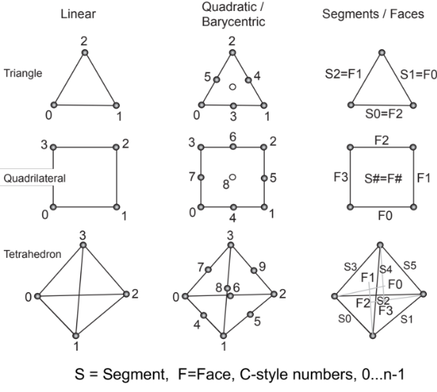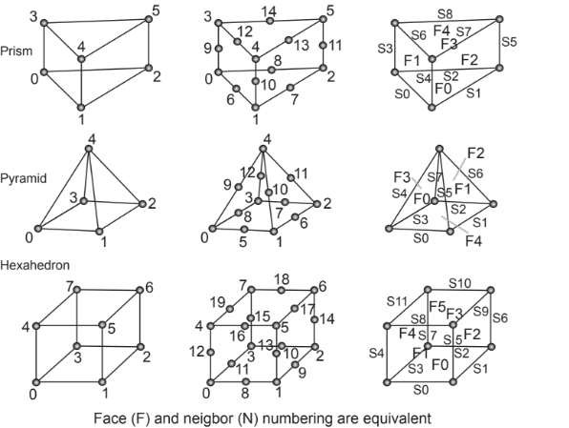

We introduced the pelmt array newly into the VSet data structure so that we would be able to read its ‘plist’ and ‘pfverts’ records correctly in the case of poly-element type meshes.

(size_t) plist[0..e *[sum npe[e]]] = 1-dimensional array, sequentially enlisting the node IDs of each element, provided in counter-clockwise order.

int32) pfverts[0..e *[sum fpe[e]]] = 1-dimensional array, sequentially enlisting the equidimensional neighbor elements that are either volumetric, surfacic or line type elements. These neighbors are listed using the ordering of the element faces across which it is in contact with its neighbors.
Note 1: For Face and InterFace objects, enlisted at the end of the ‘plist’ and ‘pfverts’ arrays there are also higher-dimensional neighbors
Note 2: Elements that are at the model boundary and, therefore, some of their faces have no boundary. In this case the corresponding boundary flag is written as a negative integer into ‘pfverts.’

(int32) bflags [0..n-1] = 1-dimensional array, enlisting negative integers for nodes (mesh vertices) located at the model boundary.
For an arbitrarily shaped model, the correct enumeration value is IRREGULAR for any outside and INTERNAL for any inside boundary. Any other boundary in the coordinate plane is labelled using CSMP’s Box flags: RIGHT (max-x), LEFT (min-x), TOP (max-y) BOTTOM (min-y), and FRONT (max-z) and BACK (min-z). CSMP will then create the extra 12 Box edges EDGE# and 6 CNR# model corners.
These constitute special provisions made in CSMP++ for box-shaped models and enlisted in Box.h.

Before the mesh connectivity can be written to the VSet, it needs to be resized:

Vset.Resize( const std::deque<int32>& etypes, // pelmt
const std::deque<size_t>& npes, // nodes per element
const std::deque<size_t>& epes, // nbors of each element
size_t nodes, size_t faces, size_t interfaces);

Boundary<Face> objects are written, following the last element in the VSet, followed by SplitBoundary<InterFace> objects that can only represent internal boundaries in a model.
Since 2016, the FEM_Data container in the VSet has been deprecated and replaced by the PropertyData container. Instances of this container are stored in a map within the VSet that uses property names as keys:

Vset.AddData( const char* propname, const PropertyData& );

How to initialise ModelTopology

The ModelTopology is a simple container of regions (boundary and splitboundary) objects identified by a unique name and collection of Element, Face or InterFace objects. CSMP can only construct geomodels with multiple domains and boundaries if a ModelTopology object can be provided.

About RINGMesh

Some observations:
- Property assignment and geometry manipulation have to be done in GoCad because the RingMesh OpenGL interface lacks the interactivity required for this.
- To get the desired regions and boundaries in CSMP, respective model objects have to be named in GoCad (where volumes are TSolids)
- RingMesh is not a mesher, but an intermediary datamodel to facilitate any kind of operations on GeoModels because GoCad devkit is not sufficiently open.
- Whatever model makes it into RINGMesh is already watertight. Thus all the watertightness and other geometrical checks are performed prior to meshing
- Dependent on which mesher is chosen, different element types, refinement and quality metric options are available. Gmesh, Tetgen and J. Pellerin’s mixed element mesher are available.
- Well completions are meshed as a series of line elements
- TODO: Intervening surfaces are always meshed, but need not be retained in volumetric models passed to CSMP
- Identification mechanism by name-string BOUNDARY works for CSMP
- TODO: Using the region by region node-numbered GeoModel, SplitBoundary objects could be built.
- TODO: Bflags should be passed to CSMP (test can be done against recreate boundary functionality in CSMP, which should subsequently be avoided).
- A specific version of a RESQML file is needed to get all relevant data from SKUA to RINGMesh.
- TODO: prototype the new workflow and create a use-case example

goCad – model -> .ml file

GeoModel
= set of meshes (separate)

GeoModelMesh
- Global numbering
GeoModelMesh::Entity = region, surface etc. = named entitites

Mapping to VSet

Box-shaped models (prenamed entities)

Executables in:
/Users/smatthai/Documents/meshing/RINGMesh/RINGMesh/build/Release/ringmesh/bin

GoCad – CSMP Workflow

Testing: RINGMeshTestModel/MazuModel

Label all entities in GoCad

Test model: sandbox_with_well (fault pattern extracted from sandbox experiment)

Property modelling

