Abaqus .inp file format documentation
H. Agheshlui 22/2/2017
Keyword lines:
Keywords (or options) always begin with a star or asterisk (*). Keywords are often followed by parameters, some of which may be required. For instance:
*ELEMENT, TYPE=T2D2, ELSET=FRAME (optional)
Parameters are separated by a comma and a comma at the end of the line means that the next line is continuing from the previous one.

List of commands for defining geometry:

*NODE | Defining node coordinates
*ELEMENT | element connectivity
*Elset | Creates element sets

Keywords and parameters are case independent and must use enough characters to make them unique.
Data Line
Keyword lines are usually followed by data lines. Examples:
*NODE
101, 0., 0., 0.
102, 1., 0., 0.
103, 2., 0., 0.
104, 0.5, 0.866, 0.
105, 1.5, 0.866, 0.
*Element, type=C3D10
1, 825, 9671, 948, 1900, 18753, 18677, 16384, 18756, 18748, 18749

*Elset, elset=Set-1, generate
1 (first element), 62252 (last element), 1 (increment)

Element types:
2D Stress/displacement elements
Plane Strain Elements:
CPE3 3-node linear
CPE4 4-node bilinear
CPE6 6-node quadratic
CPE8 8-node biquadratic

Plane stress elements
CPS3 3-node linear
CPS4 4-node bilinear
CPS6 6-node quadratic
CPS8 8-node biquadratic

3D Stress/displacement elements
Element naming convention
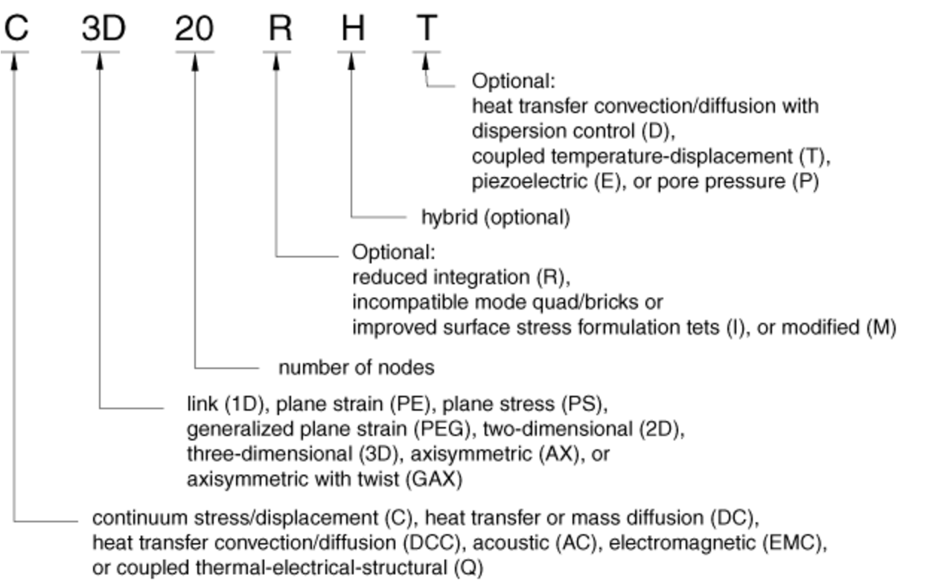

C3D4 4-node linear tetrahedron
C3D6 6-node linear triangular prism
C3D8 8-node linear brick
C3D10 10-node quadratic tetrahedron
C3D15 15-node quadratic triangular prism
C3D20 20-node quadratic brick

Defining Regions in Input Model

Use parts. As below:

*Part, name=Part-1
*Node
1, 0.852882206, 2., 2.5292635
.
.
.
*Element, type=C3D10
1, 1, 9, 4, 2, 12, 11, 10, 14, 13, 15
.
.
.
**The next four lines are optional and not needed for geometry definition. But they can be used if they make it easier for CSMP purposes.
*Elset, elset=Set-1, generate
1 (first elem), 249653 (last elem), 1 (step)
** Section: TopSeal
*Solid Section, elset=Set-1, material=Shale

*End Part

