Fracture Aperture Modeling
Arguably, fracture aperture is at least as important for the flow through a fractured porous medium as connectivity or length are. As for these parameters, it is the nature of the distribution rather than an “average” value that has to be captured for reproducing the flow characteristics of the fractured medium. Given the fracture geometry, attributes, pore pressure and the in situ stress state state aperture distributions can be modeled. Respective techniques range from ad hoc set-by-set assignments over analytical models, to numerically computations. While the latter can resolve stress perturbations around individual fractures and even fracture interaction during growth (e.g., Paluszny and Matthai, 2009), these methods have the disadvantage that they cannot be applied to stochastic (randomly) generated DFN models (e.g., Dershowitz, 1989) because the spatial organization of the fractures is not correct. This problem is addressed in Section 1.2. In the following, aperture modeling techniques are described that can be - albeit with care - be applied to stochastically generated fracture populations. Apart from aperture distributions, these methods also permit estimations of the fracture contribution to the porosity of the rock.

Introduction
The state of a natural fracture in a porous medium in the subsurface controls its aperture. Attempting to introduce some systematics, one can distinguish fractures that are:
  - open and potentially growing because they are critically stressed (including the effects of fluid pressure),
  - partially open due to contacting asperities that counteract the fracture normal stress,
  - partially open because they have been sheared and are now propped open by granulated rock fragments separating their walls,
  - open because mineral bridges support the normal stress acting on the fracture walls,
  - closed (equivalent to state 2),
  - sealed / healed fractures = mineral veins.
Open fractures. The aperture of open fractures is controlled by the fracture dimensions, elastic properties of the rock, the tractions acting on the fracture walls, and the internal fluid pressure (e.g., Cruikshank et al., 1991). Dilatation can occur in tension and in shear and there are semi-analytic models that can predict it. However, these models do not account for fracture interaction and are therefore not applicable to closely spaced fractures or fragmented rocks.
Fractures open in shear. For fractures that do not terminate against material discontinuities, the semi-analytic models also permit to calculate dilatation in shear. A special case are bed-confined fractures with an approximately rectangular cross-section: these have apertures similar but larger than fractures entirely enclosed in a homogeneous isotropic medium, see discussion further below. From engineering geology applications, we know that the shear strength of fragmented rock is strongly reduced as compared with intact rock. Fragmented rock tends to fail by frictional sliding on favourably oriented (conjugate) planes delimiting the fragments. Fractures subparallel to the - plane also get activated, especially at low effective stress (e.g., Zhang and Sanderson, 1997).
Closed fractures. An important control on aperture in this state (5) is exerted by surface markings (plumose, hackle, rib-marks, Fig. 1, top right), which form during fracture growth. These are studied by research on “Fractography” (Lawn, 1975(1993), Pollard and Aydin, 1988).
In finite-length fractures that do not terminate against material interfaces (and including veins with open space filling textures), there is often a systematic increase of fracture aperture from the tip to the center. This is the main feature that is described by semi-analytic aperture models and is best seen in short (<10-m long) fractures. Renshaw and Park (1997) discuss that the aperture of larger fractures is strongly influenced by interactions with other fractures as opposed to length only. For fractures in State 4, extensive field evidence from carbonate host rocks indicates that original- critically stressed apertures are preserved due to the contemporaneously growing mineral bridges (Marret et al., 2002, Gale et al., 2004).
Propped fractures filled with crushed rock fragments or with offset contacting asperities (State 3) are treated using empirically established site-specific correlations (e.g., Rutquist and Stephansson, 2002). These do not include systematic tip-to-centre aperture variations. Importantly, since these fractures are filled with granular materials their infill can be treated as a porous medium such that a linear “aperture” permeability scaling applies. Such gouge-filled fractures are therefore much less sensitive to aperture variations than fractures permitting open channel flow.
Sealed fractures and veins can be impermeable obstacles to flow, but are in some cases distinctly more permeable than their country rock because they localize secondary fracturing or the mineral precipitates have a saccharoidal porous texture. This needs to be established on a case by case basis.
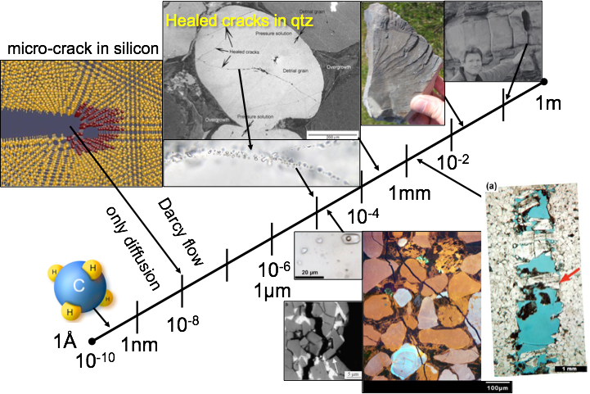
The absolute magnitude of fracture aperture determines whether a fracture can stay open in the presence of a reactive pore fluid (Brantley et al., 1990), see Figure 1, and whether this fracture affects the permeability of the rock. Matthai and Belayneh (2004) inferred that fracture aperture modes should exceed at least the average pore throat diameter for fractures to have a significant influence on the permeability of the host rock.
Figure 1: Fracture aperture in reservoir rocks. At aperture values above a few microns fractures void space can survive in the presence of a reactive pore fluid. At aperture values above 20 micrometers, fractures start to have a pronounced effect on the permeability of reservoir rocks with permeabilities greater that 1 mD. Crystal bridges can stabilize open fractures leading to their preservation.
If aperture is modeled as constant in a pervasively fractured rock, it will behave like a homogeneous isotropic medium. For stochastically generated fracture discrete models and ones grown from randomly distributed flaws using a rigorous stress-intensity factor based simulation approach Bogdanov et al. (2007) and Paluszny and Matthai (2009) have shown, respectively, that the nature of fracture percolation as a function of fracture density is also radically different if constant fracture apertures are used (Fig. 2).
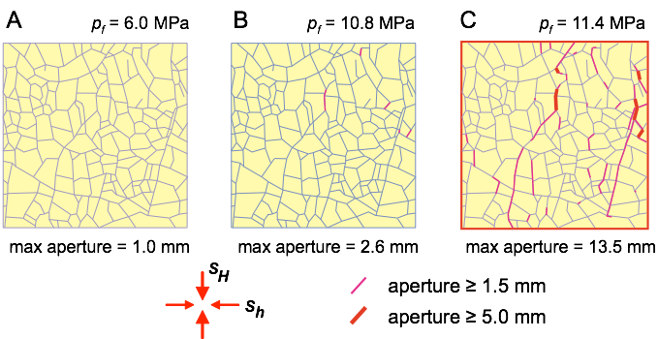
Figure 2: Comparison of the equivalent permeability of a very large suite of discrete fracture and permeable matrix models with fracture densities in the neighborhood of fracture percolation. Only models with a power-law fracture length versus frequency distribution are considered (polydisperse discrete fracture models, Bogdanov et al., 2007). a-b): variable fracture aperture correlated with length; c-d): constant fracture density, given rise to a marked difference between percolating and non-percolating models. Note that this difference disappears in variable aperture models.
Figure 3: UDEC model of horizontal fragmented layer subjected to differential stress at increasing levels of pore pressure promoting to the shear activation of favorably oriented fractures (Zhang and Sanderson, 1999). In (c), frictional sliding and dilatation of jogs occurs on conjugate fracture planes. The dilatation of macroscopically straight fractures is not considered.
The potential dilatation of fractures subjected to frictional sliding was already discussed above. In fragmented rocks, it manifests itself additionally by rotation of fragments relative to one another giving rise to large block-to-block aperture variations. Zhang and Sanderson (1998, 2001, 2002) researched and documented this phenomenon using UDEC 2D (geomechanics software package, Itasca group) simulations (Fig. 3). Although these simulations give much more physically plausible results than far-field stress based fracture-by-fracture models, they fail to capture the dilatation that the sheared fractures would experience due to asperity gliding. Attempts to incorporate this have been presented by Lang and Matthai (2012).
Critically stressed fractures will always form a small subset of the total fracture population (cf., Barton et al., 1996, Zoback, 2007). This highlights the importance of a realistic treatment of closure apertures. Again, constant values should be avoided here to prevent homogeneous isotropic behavior that is inconsistent with field observations (e.g., Lorenz et al., 2002, AAPG Bull.).
The discussed research studies highlight the importance of fracture aperture modeling for the flow and the need to capture aperture distributions realistically.

Fracture Aperture Modeling Options
The CSMP DFM Simulator implements a subset of the aperture calculation methods discussed above. Importantly, it permits set-by-set calculations and sequential processing of the fractures, combining input of static data from configuration files with computed dynamic data like fluid pressure. This way, the fracture aperture model can be generated and refined in a step by step fashion. This workflow starts with the import of an unstructured volumetric matrix mesh, including the fractures as triangulated surfaces. If this is done through CSMP’s interface to the mesh generation tool ICEMCFD-Engineering in ANSYS, the ID numbers of the elements making up the model subdomains (fracture sets and rock matrix layers / bodies) are reported in a separate *.asc file in the input deck. Fracture regions can be included or excluded using a so-called *-regions.txt text file in which the regions that shall be considered are enlisted.
When the simulator is launched the user is presented with the menu:
_______________________________________________________________

CSMP++ Discrete Fracture & Matrix (DFM) Simulator, vs. 2014 alpha.
___________________________________________________________________________________________________

(slightly compressible flow formulation for undersatured oil).

running in RELEASE mode.

main: What would you like to do? - simulation options:
(1) COMPULSORY: read and convert ANSYS model into CSMP native binary format (all other options
require this as input).
(2) map properties from region-specific point clouds to CSMP model.
(3) calculate failure criteria, fracture apertures, and permeabilities for a given in situ stress,
mechanical rock properties and fluid pressure.
(4) analyse diagonal-only tensor k_equiv, qfqm, and velocity spectra.
(5) analyse full-tensor k_equiv.
(6) output 'thickness' and 'permeability' of selected regions to VTU file.

Option 1: file conversion. Before any DFM calculations can be performed, the model has to be transformed into native CSMP format. Apart from transforming the ANSYS input deck into CSMP’s native binary format, this operation includes a computationally expensive integrity check of the mesh, the node numbering, potential overlapping and interpenetrating elements. The simulator is set to verbose output so that this process can be examined in the console window or the command line.
A important prerequisite for correct aperture modeling is that fractures are not fused with one another unless they are geometrical units. Since this would mean that each disconnected fracture would need to have an object name of its own before passing the model to CSMP and because ANSYS becomes very slow when it is tasked with handling so many model parts, Option 1 of the CSMP DFM Simulator offers the user to partition discontiguous fracture regions into subregions with names that simply consist of the original region name plus a number. This accomplishes the task. At the end of the transformation process, the original region is deleted so that no fracture duplicates remain in the model. The regions file is also modified accordingly. This implies that it no longer matches the original ANSYS output deck.
In a further step, non-unique regions containing all fractures and all matrix layers are created to simplify the fracture-matrix flux calculations and model output to the visualization toolkit.
Note: For Option 1 to work properly, the run directory must include the text file “CSMP_k_analysis-variables.txt”.

Option 2: grid-to-grid interpolation. permits to interpolate material properties from a property modeling tool (for instance from a structured grid for Eclipse) output as points, to the unstructured poly-element type grid that CSMP uses. Importantly, this is done region by region so that the property values do not spill over into adjacent regions. This is possible also for fracture properties that - provided that it was possible to generate the aperture data in another tool - can be interpolated onto CSMP fracture surfaces, see Mosser (SPE167629STU). The property transfer file format is ASCII text. The file simply enlists the region names, property (cell center) coordinates, and property values for each region:

REGION_NAME,X,Y,Z,porosity
EPC_EW_10_BSM,699874.918945,-4332.125000,-1042574.062500,0.018301
EPC_EW_10_BSM,699889.501953,-4332.125000,-1042574.062500,0.018285
EPC_EW_10_BSM,699904.083984,-4332.125000,-1042574.062500,0.011879
EPC_EW_10_BSM,699918.666016,-4332.125000,-1042574.062500,0.013300
EPC_EW_10_BSM,699904.083984,-4332.125000,-1042588.125000,0.007565
EPC_EW_10_BSM,699918.666016,-4332.125000,-1042588.125000,0.013490
EPC_EW_10_BSM,699933.249023,-4332.125000,-1042588.125000,0.007189

Since the CSMP grid is spatially adaptively refined, in some regions there will be many points per element while there are not enough points to fill all cells in others. To deal with this situation, the Option 2 algorithm contains averaging and extrapolation features written to preserve the original patterns and statistics of the input data.
Attention: In CSMP the Y coordinate axis points upward, X increases from the W to the E, and Z from the N to the S. Thus, some transformation of the coordinates of the point data may be required before passing them to CSMP.

Option 3: surface tractions, failure and fracture permeability evaluation. Looping over all fractures, this option performs a series of calculations that establish the input data for the fracture aperture modeling:
  - Computation of element barycenter - tip- and centerline distances. For each element of the surface mesh of a given fracture, these parameters are computed and stored as attributes.
  - Projection of the far-field stress (supplied via another text file) onto the fracture elements. This yields the fracture-normal stress, the shear stress, and - under consideration of the fluid pressure that can either be treated as constant single-valued or as hydrostatic (variation with depth), the effective stress. If there is no stress data file available, the user is prompted to enter the necessary values from the command line. These entries will be recorded in the “*-runtime.log” file.
  - Evaluation of a range of failure- and irreversible deformation criteria:
    - compressive failure of the fracture when the UCS of the host rock is exceeded by the fracture normal stress and the fluid pressure does not give enough support.
    - fricitional sliding on the fracture plane
    - shear failure of the fractured rock
    - dilatation of the fracture when the fluid pressure exceeds the fracture normal stress
    - tensile failure of the fractured rock or the mineral precipitates within the fractures.
all elastic and failure-relevant rock properties have to be supplied via the configuration file.
Regarding (2), the far-field stress is supplied via a “*-permeability-modeling-data.txt” file that enlists all the model regions where aperture data shall be overwritten with newly computed values. This may look like this:

'XXX-permeability-modeling-data.txt' fracture sets to be included into property modeling.
50 EPC_EW_10_BSM EPC_EW_11_BSM EPC_EW_16_BSM EPC_EW_22_BSM EPC_EW_23_BSM EPC_NW_SE_12_BSM EPC_NW_SE_4_BSM EPC_NW_SE_8_BSM EW_11_BSM EW_12_BSM EW_63_BSM EW_64_BSM F1_12_BSM F1_1_BSM F1_3_BSM F1_4_1_BSM F1_4_BSM F1_5_BSM F1_6_BSM F1_7_BSM F2_1_BSM F2_2_BSM F2_3_BSM F2_4_BSM F2_5_BSM F2_6_BSM F2_7_BSM F2_9_BSM F3_1_BSM F3_2_BSM F3_3_BSM F3_4_BSM F3_5_BSM F4_10_BSM F4_18_BSM F4_2_BSM NEW_F_W_BSM NS_01_BSM NS_02_BSM NS_05_BSM REVERSE_FAULT T10_BSM T12_BSM T13_BSM T14_BSM T2_BSM T3_BSM T4_BSM T6_BSM T9_BSM -3793 2700 8.09e+07 1 0.85 0.68 45

The in situ stress state is enlisted after the 50 regions for the property modeling. The first value is the TVD of the stress measurement, the second, the density of the rock where the measurement was taken, the third value corresponds to the overburden stress Sv and the followings ones to the magnitudes of the principal stresses normalized by the overburden stress.
Directly after the completion of the evaluation of the failure criteria the VTU output file “*.-mechanical_characteristics.vtu” is written, allowing the user to examine the computed values with Paraview or other applications build on the basis of the Visualization Toolkit (kitware.com).
Option 3 also performs the fracture permeability modeling. The first option, Option 3.0, is the assignment of permeability values to entire regions in data block 2 of the configuration file “*-configuration.txt”:

‘aperture_20_frac-configuration.txt’ - test model for aperture calculations, CM6/6/2014

# model has 10571 nodes
# default properties
permeability 1e-17
porosity 0.5
thickness 1.
# mechanical properties of the formation and fractures
Youngs modulus 4.5e10
shear modulus 1.5e10
Poissons ratio 0.2
tensile strength 1.0e7
friction coefficient 0.6
cohesion 5.0e6
unconfined compressive strength 5.0e7
joint roughness coefficient 5.
fluid pressure 5.0e7

# regional properties: fractures
SET1_EW complete permeability 8.33E-14
SET1_EW complete thickness 1.0e-4
SET1_EW complete porosity 1.
SET2_NNW_SSE complete permeability 8.33E-14
SET2_NNW_SSE complete thickness 1.0e-4
SET2_NNW_SSE complete porosity 1.

Here “thickness” represents fracture aperture and the permeability is the corresponding parallel plate permeability (), unless granulation seams are modeled.
Attention: If any of the additional options shall be used, the aperture and permeability values entered into the configuration file should represent minima because the additional algorithms will overwrite these only if the calculated values are greater than those given in this file. The logic of this condition lies in facilitating the application of multiple permeability modeling algorithms, i.e. for critically stressed, closed, sheared fractures and so forth. If there was an unconditional overwrite, the configuration file values would be irreversibly lost because the configuration file is read only once at the beginning of the modeling process.
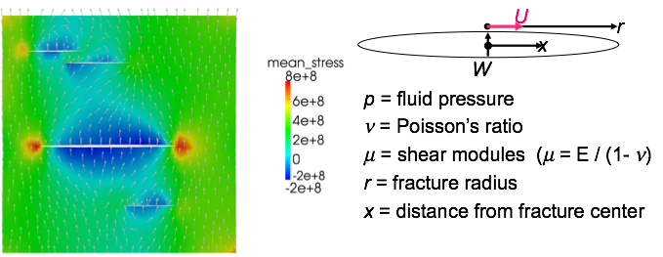
Options 3.1 - 3.3 apply only to critically stressed fractures. They are variations of the analytic aperture calculation method described in Cruikshank et al. (1991), see Figure 4.
Figure 4: Elliptical opening mode fracture model relating fracture aperture to normal and shear stress, pore pressure, shear modulus and Poisson’s ratio. Extension of Pollard and Segall (1987). This model matches the aperture distribution obtained with the mechanical model on the left exactly, except for the 2 closely spaced fractures on the upper left whose aperture is reduced in the region of overlap.
The elliptical crack model predicts fracture opening as a function of fracture size. The maximum opening, W, occurs in the center of the fracture (x = 0, see Fig. 4). This value gets assigned to the entire fracture if the user chooses Option 3.1 (Cruikshank 91’ maximum aperture). Else, Option 3.2 (Cruikshank 91’ with aperture variations), these are resolved across the fracture plane, taking into account the local fluid pressure. If a hydrostatic variation of fluid pressure with depth has been computed before, the fractures will be wider at the top than at the bottom.
The fracture aperture variations across the fracture plane are computed using the equations 5b and 5c from Cruikshank et al. (1991) while simultaneously obeying the “Moab rule” that related fracture opening in shear to that in tension:
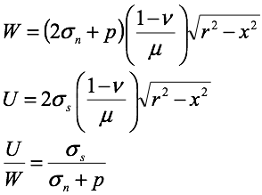
Here U is the shear displacement inferred from the shear stress. Since the individual orientation of every fracture surface element is considered, non-planar fractures can be considered as well. Cruikshank’s analysis of sheared joints in the Garden Area of Arches National Park further shows that their model also predicts the aperture of segmented joints reasonably well.
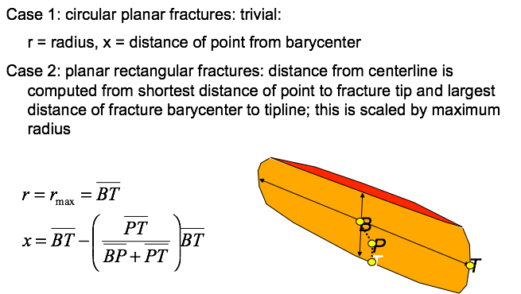
Option 3.3 (Cruikshank 91’ rectangular fractures) applies the Cruikshank model to layer restricted fractures in multilayer aggregates with reduced-friction layer boundaries or weak intervening layers. The study of mineral veins in this setting (for instance at Kilve, Bristol Channel coast, UK), indicates no variations of fracture aperture across the thickness of the beds. This is captured by a modified version of equations 5b and 5c that is illustrated in Figure 5.
Figure 5: Aperture of layer restricted fractures that propagated to the upper and lower bed boundaries. The geometrical construction using a fracture centerline and the maximum distance from the fracture tip as opposed to the fracture center, permit the application of equations 5b and c to this special case of fracturing.
All the fracture modeling options permit the user to output apertures before and after their execution so that their effects on aperture can be examined directly. No effect might mean that there are no critically stressed fractures. Also, if Option 3.2 is applied after 3.1, no difference will be seen because aperture is only overwritten where the new values exceed those assigned before (see discussion of the sequential modeling approach above).
If the rock mass is critically stressed, rotations of the stress tensor, the orientation of which may only be poorly known, can have a dramatic effect on fracture aperture (Fig. 6). In such cases, stress tensor orientation should be included in any sensitivity analysis of aperture.
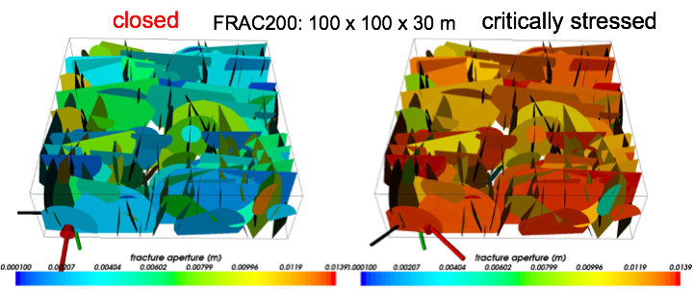
Option 3.4: (lower aperture limit for fractures undergoing compressional failure) permits to diminish the aperture of fracture elements where the effective fracture-normal stress exceeds the unconfined compressive strength of the host rock. This is the only option by which the fracture aperture can be diminished.
Figure 6: Impact of the orientation of the stress tensor on fracture aperture. 200 fracture model, 2 fracture sets, log-normal diameter frequency relationship. Strike-slip stress regime with s1=1.1 Sv, s2=Sv, and s3=0.8 Sv, hydrostatic fluid pressure.

Option 3.5: (upper limit on fracture aperture), can be used to limit the maximum aperture of especially large fractures.
Option 3.6: (fractures treated as faults), combines a wide variety of criteria with a residual fault permeability derived from field data, computing the permeability (not aperture) of the fault rock with a given thickness, obtaining upper and lower bounds corresponding to the conversion of all fracture porosity into a single flow-aligned fracture versus a fault breccia with a certain mean fragment size or internal surface area. The user is prompted to provide missing input data. This option can produce permeability values that are lower than those of the country rock. If so, the lower-dimensional representation of the fault is no longer applicable because the nodes on either side of the fault are shared. Such cases can only be simulated if the fault is represented by volumetric finite elements.
Option 3.7: (re-read the configuration file), overwrites all computed values with the original values so that the modeling process can be restarted.
Remember to save the computed results to the native CSMP binary file prior to exciting the fracture aperture modeling module (Option 3). After this step has been completed successfully, flow-based (=equivalent = determined by homogenisation) ensemble permeabilities can be calculated by rerunning the CSMP DFM Simulator choosing the Options 4 and 5.
Note also that the aperture and thickness of specific individual fractures can be output using Option 6.

Equivalent Permeability Calculation
The CSMP DFM Simulator provides two ways of calculating the equivalent permeability of the fracture - matrix ensemble represented by the parameterized discrete fracture and matrix (DFM) model. The first (Option 4), determines the DFM model permeabilities in the directions of the cube axes of the box-shaped model, yielding a diagonal permeability tensor, see Matthai and Belayneh (2004). The second (Option 5), uses the velocity volume-averaging approach reviewed by Durlofsky (2005), to obtain the full-tensor permeability of the DFM model. This method also works if the principal axes of the permeability tensor are not aligned with the mesh box. The accuracy of this method is on the order of 0.1%, see Azizmohammadi (2013, in prep., Lang, Paluszny, and Zimmerman, 2014).
Either of the two options, can be selected from the command line menu of the CSMP DFM Simulator once the model has been loaded. The simulator does not check whether any aperture modeling has been conducted, but if parameter values remain uninitialized they are flagged according to IEEE conventions as Not a Number (NaN). Such NANs propagate through calculations and an exception will be thrown halting the execution of the simulator.
At the end of the calculation, the equivalent permeability tensor is written to file. Together with the diagonal permeability tensor, the fracture-to-matrix flux ratio qf/qm is calculated and output. The qf/qm ratio describes the relative contribution that the fracture system makes to the total flow through any flow-perpendicular cross-section of the model. Therefore it also is a tensor property. Since its value is reported normalized by the flow that would have occurred through the model in the absence of fractures, a qf/qm ratio greater than one indicates that the fractures dominate the flow. In practice, very large qf/qm ratio values can occur if the fracture network is percolating and fracture apertures reach the millimeter range.
Note: The CSMP DFM Simulator computes the equivalent permeability of the fracture and matrix ensemble. Effective medium theory suggests that this value should be greater than the sum of the permeabilities of the fractures and the matrix calculated in isolation because
the fractures impart a strongly correlated permeability structure on the fractured porous medium and the fractures interact with the rock matrix (cf., Milton, 2002). Thus, for dual porosity simulations the ensemble value should be used for the fracture domain, and for dual permeability simulations one has to rely on values calculated separately for the fractures and the matrix. The dual permeability model as a whole then has to be calibrated with the ensemble result.

Bibliography
Bogdanov, I.I., Mourzenko, V. V., Thovert, J.-F., Adler, P. M., “Effective permeability of fractured porous media with power-law distribution of fracture sizes.” Physical Review E 76, DOI: 10.1103/PhysRevE.76.036309 (2007).
Cruikshank, K., Zhao, G., Johnson, A. M., “Analysis of minor fractures associated with joints and faulted joints.” J. Structural Geology 13:8, 865 - 86 (1991).
Durlofsky, L., “Upscaling and Gridding of Fine Scale Geological Models for Flow Simulation.” Paper presented at the 8th International Forum on Reservoir Simulation, Les Borromees, Stresa, Italy, June 20-24, 2005
Lang, P., Paluszny, A., Zimmermann, R., “Permeability tensor of three-dimensional fractured porous rock and a comparison to trace-map predictions.” Journal of Geophysical Research B, DOI: 10.1002/2014JB011027, 2014).
Lawn, B., “Fracture of Brittle Solids.” 2nd ed., Cambridge Solid State Science Series., Cambridge University Press, 1993.
Milton, G. W., “The Theory of Composites.” Cambridge Mon. on Appl. and Computational Mathematics, Cambridge University Press, UK (2002).

