Checking the volume calculation by CSMP for a single linear hexahedron element (by HA):

Different scenarios, as shown in Figure 1, have been considered for a single hexahedron element which are:
- Cube: 90 degrees corners. All the opposite faces are parallel.
- Top face twisted 30 degrees while the bottom face is kept in its original position. The top face is still parallel to the bottom face.
- Side face twisted 30 degrees while the opposite face is kept in its original position. The side faces are parallel.
- Fully skewed element. None of the opposite faces are parallel. Coordinates are generated randomly.

The calculation of the volumes for each of these single hexahedron elements has been conducted using the following methods:
- Analytical solution. In this method a function was written to split the hexahedron element into six tetrahedron elements and then to calculate their volume using their coordinates.
- Calculation of the volume of the hexahedron by splitting it into 6 tetrahedra and then asking CSMP to calculate the volume of each of the tetrahedra. The summation of the volume of the elements provides the hexahedron volume.
- Asking CSMP to calculate the volume of the Isoperimetric Linear Hexahedron element with 8 integration points.
- Calculating the volume of the hexahedron element by summing up the volumes of the Finite Volume sectors within the element.
- Calculating the volume of the hexahedron by multiplying the integration point weights of the sectors within the finite element by the determinant of the jacobian matrix of the element at the barycentre of the element.
- Calculating the volume of the hexahedron using Abaqus 6.14 for comparison.
The results of the volume calculation using methods (a) to (f) for each of the hexahedron elements of (1) to (4) are given in the following table.
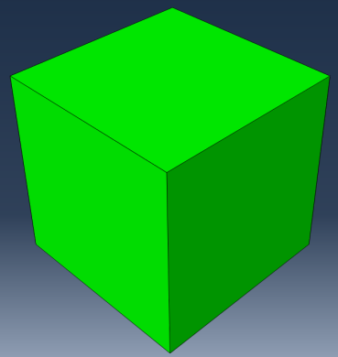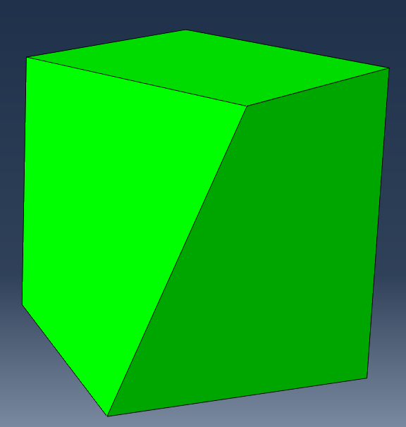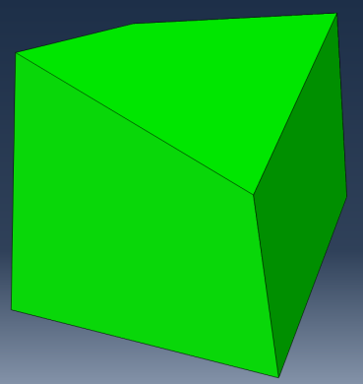
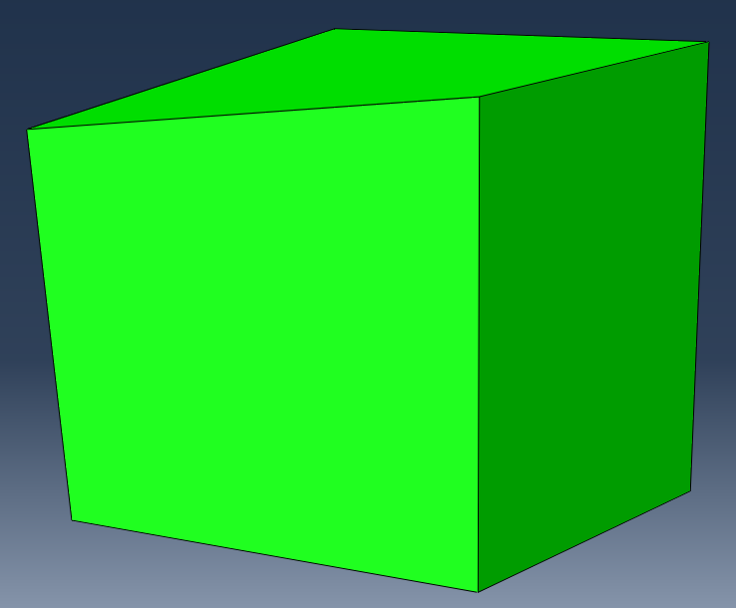
Figure 1. From top left: (1) Cube; (2) Top face twisted 30 degrees anticlockwise; (3) Side face twisted 30 degrees anticlockwise; (4) Skewed.

Table 1. Volumes calculated for hexahedra using different methods in CSMP
 | Cube | Top face Twisted | Side face Twisted | Skewed element
Analytical solution | 0.99999999999999989 | 0.95534180145778769 | 0.95534180145778769 | 1.1173243606190002
Sum of the Tetra volumes calculated by CSMP | 0.99999999999999989 | 0.95534180145778769 | 0.95534180145778780 | 1.1173243606189998
Hexa volume calculated by CSMP | 1.0000000000000000 | 0.95534180145778769 | 0.95534180145778758 | 1.1324339180849166
Sum of volumes of FV sectors within Hexa | 1.0000000000000000 | 0.94975952661667606 | 0.94975952661667606 | 1.1326138401370311
Integration Point weight * Det(Jac) of each FV sector within Hexa | 1.0000000000000000 | 0.94975952671001695 | 0.94975952671001651 | 1.1400749771827732
Volume calculated using Abaqus | 1.00000 | 0.955342 | 0.955342 | 1.13243
Table 2. Hexahedra volume calculation errors using different methods in CSMP
 | Error (%)  Cube | Error (%)  Top face Twisted | Error (%)  Side face Twisted | Error (%)  Skewed element
Analytical solution | 0.0000 | 0.0000 | 0.0000 | 0.0000
Sum of the Tetra volumes calculated by CSMP | 0.0000 | 0.0000 | 0.0000 | 0.0000
Hexa volume calculated by CSMP | 0.0000 | 0.0000 | 0.0000 | 1.3523
Sum of volumes of FV sectors within Hexa | 0.0000 | -0.5843 | -0.5843 | 1.3684
Integration Point weight * Det(Jac) of each FV sector within Hexa | 0.0000 | -0.5843 | -0.5843 | 2.0362
Volume calculated using Abaqus | 0.0000 | 0.0000 | 0.0000 | 1.3519

