Neighbor-numbering conventions for Hexahedra

ANSYS (and OpenCSMP) – the faces of a hexahedron are
BOTTOM, FRONT, RIGHT, BACK, LEFT, TOP

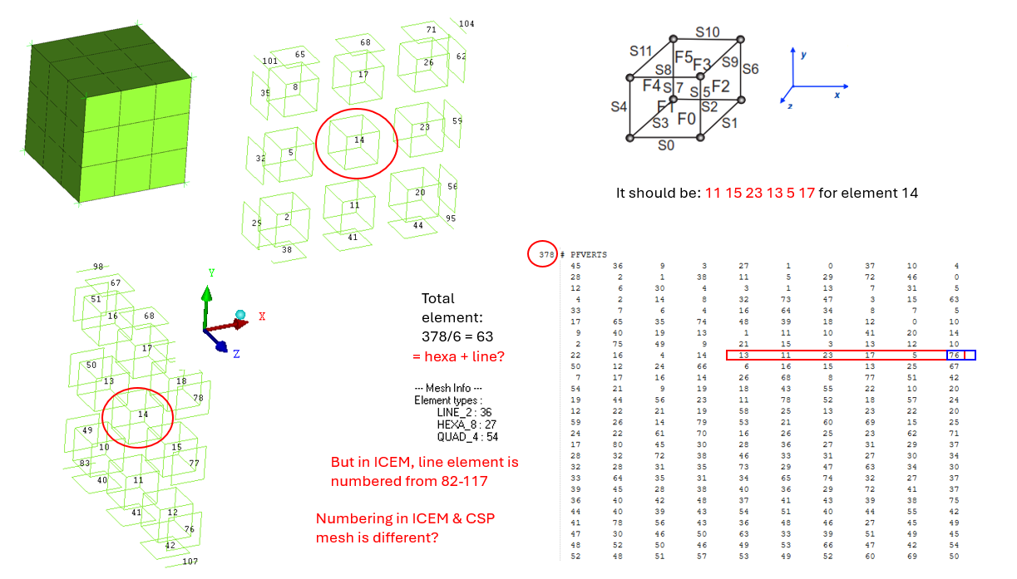

This analysis of cell neighbours clarifies that CSMP’s conventions match those in ANSYS, but that the ‘pfverts’ output from ANSYS to CSP is broken, not only w.r.t. the number of entries in the array, but also in terms of its content.

Use VData::EstablishNeighborConnectivity3D()

Or the BuildConnectivity<dim> in the MeshManager inside of CSMP to recreate the correct numbering. This is important! – else the faces and face node numbers will not match.

Note the difference to Eclipse where corner-point cells are defined

https://en.wikipedia.org/wiki/Corner-point_grid

and the face numbering seems to be determined by the grid axes, ie.,

LEFT, RIGHT, FRONT, BACK, TOP, BOTTOM

as opposed to

BOTTOM, FRONT, RIGHT, BACK, LEFT, TOP as you showed for ANSYS.

In a wider sense Corner Point Grids are related to finite element meshes as described by Wang & Bauer 2016. This description is incomplete.
It does not give any numbering.

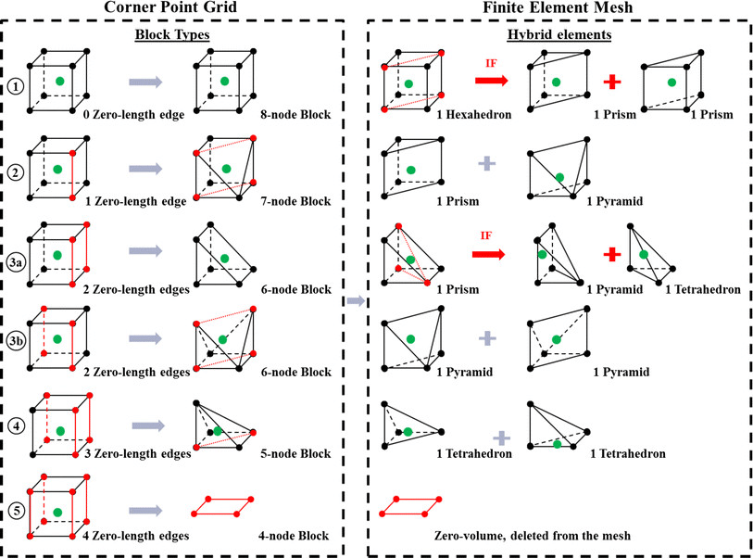

From: Cuong Ma Bong <cuongb@student.unimelb.edu.au>
Date: Tuesday 16 July 2024 at 00:45
To: Stephan Matthai <stephan.matthai@unimelb.edu.au>
Subject: Re: Face numbering of elements in ANSYS

Dear Prof. Matthai,

Thank you for your explanation.

I fell into it for hours, trying to mesh the box in different ways but could not link the output .dat and ICEM mesh files. I wonder whether the numbering is different for the two - The same issue was reported with Ansys Fluent & ICEM as I found on the Internet. Here is the mesh info I got after blocking:

Hope that we can discuss this so I can understand more. Thank you for your time.

Kind regards,
Cuong Bui

On Tue, Jul 16, 2024 at 11:44 AM Stephan Matthai <stephan.matthai@unimelb.edu.au> wrote:
As said in the last message, each element has 6 nbors.
The line break after 10 entries is just for readability.
The numbers should be the element numbers, but it seems that your model
more than 1000 elements.
I would suggest that you make one with 27 elements only.
This way the cell in the middle has all its neighbors.

From: Cuong Ma Bong <cuongb@student.unimelb.edu.au>
Date: Monday 15 July 2024 at 21:00
To: Stephan Matthai <stephan.matthai@unimelb.edu.au>
Subject: Re: Face numbering of elements in ANSYS

Hi Prof. Matthai,

I am quite confused. I wonder what is listed in the 'pfverts' part because each line has 10 numbers.
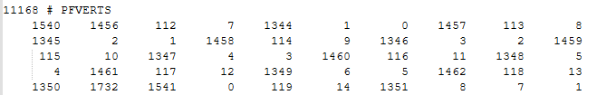

And they are not the numbers of the neighbour elements I saw in ICEM. Can you please advise me on this?
Kind regards,
Cuong Bui

On Tue, Jul 16, 2024 at 8:17 AM Stephan Matthai <stephan.matthai@unimelb.edu.au> wrote:
Hi Cuong,

Can you please make a super simple box model of hexahedra in ANSYS,
output it to CSP in ascii format, and then check for one of the elements in which order the faces are numbered?
In order to do that , you need to visualise the element numbers in ANSYS and then compare those with the element neighbors listed in the
‘pfverts’ record within the ascii-formatted ‘.dat’ file. This record lists the neighbor elements of each element, one per face, in the order of the faces.
Relative to the coordinate system of your model, on which side of the hexahedron are these neighbors located? – BOTTOM, TOP, LEFT, RIGHT, BACK FRONT?

Happy to clarify this more if there is the need.

Many thanks for checking this for me.

Best,
Stephan

Prof. Stephan K. Matthai
Chair of Reservoir Engineering
Department of Infrastructure Engineering
The University of Melbourne
Building 175 (Engineering Block B), Level 2, Room B205A
Grattan Street, Melbourne, VIC 3010, Australia
T: +61 3 834 46084
M: +61 452 521 033
E: stephan.matthai@unimelb.edu.au
W: http:/www.ie.unimelb.edu.au/matthai
W: https://geocquest.org/

