CSP Model Building

&

Interfaces Guide

with contributions from:

Mandefro Belayneh,

Stephan Matthai,

Andrey Mezentsev,

Richard Tomlinson

Last saved by Dr. Stephan K Matthai 3/27/25

FRED

GoCAD

MezGen

NIH_Image

Rhinoceros

Triangle

Foundations of Model Building

1. Introduction

1.1 Scope of the document
Current document provides short theoretical background and recommendations on the optimal definition of CAD Computer Aided Design (CAD) geometry in Boundary Representation (BREP) format for further import to the geometry editor of the ICEM CFD mesh generation code. This workflow reflects the specifics of building and discretisation of complex multiply connected free form Non-uniform B-spline (NURBS) geometry, prepared in the Rhino3D geometrical CAD package [1] for further simulation in the CSP 3D code. Typical transport simulation in a fractured fault configuration is shown in Fig. 1. This geometry includes 3D free form displaced highly permeable fractured fault, with fractures as 3D free form surfaces. Concentration of a passive advector, transported by a highly inhomogeneous velocity field in the fracture-matrix continuum is represented by a rainbow scheme.
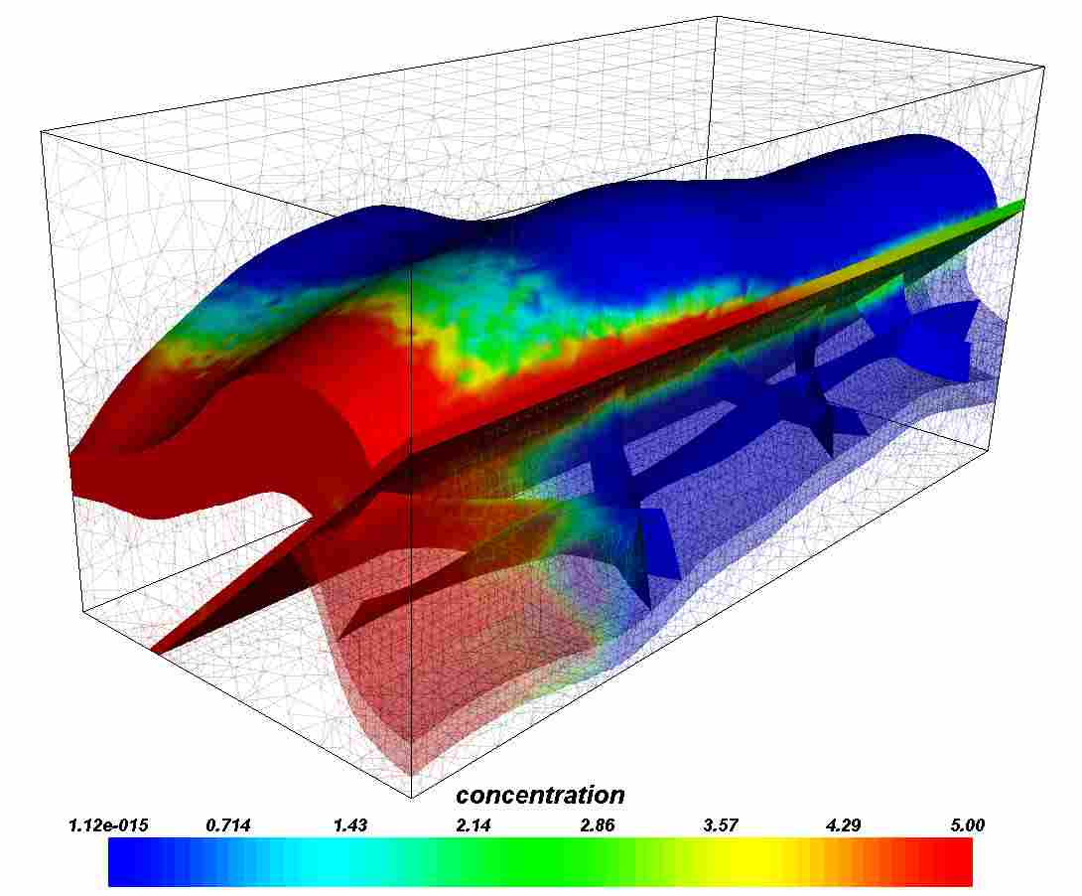
Fig 1. CSP4.0 computational model of the complex fault geometry with unstructured hybrid mesh.

2. Short theoretical background: CAD, Errors and Meshing
The BREP CAD format approximates volumetric objects by the boundary, represented by the Non-Uniform Rational B-splines (NURBS) [1,3].

2.1 NURBS curves and surfaces: geometry
The NURBS curve is a composite curve, consisting from connected curved segments, spanning between the knots (black dots on Fig 2 b)) [2]. The position of the spline knots (some parameter values in side the spline parametric interval, lines at Fig 2.a)) is defined by the position of the so-called control points (P0-P6, Fig 2). Knots are also shown at parametric positions on Fig 2 a), so the shape of the curve will be defined by the weighted sum of univariate B-spline functions N_{ij} at the given control points positions. To move the spline we need just to relocate the control plygon. Changing degree of spline, we change the number B-spline functions in the summation and the way how close the curve is to control polygon.
The degree of spline. This number is usually 1, 2, 3 or 5, but can be any positive whole number. NURBS lines and polylines are usually degree 1, NURBS circles are degree 2, and most free-form curves are degree 3 or 5. Sometimes the terms linear, quadratic, cubic, and quintic are used. Linear means degree 1, quadratic means degree 2, cubic means degree 3, and quintic means degree 5. You may see references to the order of a NURBS curve. The order of a NURBS curve is positive whole number equal to (degree+1). Consequently, the degree is equal to order-1.It is possible to increase the degree of a NURBS curve and not change its shape. Generally, it is not possible to reduce a NURBS curve’s degree without changing its shape.
Fig 2. Parametric interval and quadratic B-spline functions (a) of a NURBS curve with control polygon (b).
A p-th degree B-spline parametric curve is defined by:
Control points P_{i}. The control points are a list of at least degree+1 points.
One of easiest ways to change the shape of a NURBS curve is to move its control points.
The control points have an associated number called a weight. With a few exceptions, weights are positive numbers. When a curve’s control points all have the same weight (usually 1), the curve is called non-rational, otherwise the curve is called rational. The R in NURBS stands for rational and indicates that a NURBS curve has the possibility of being rational. In practice, most NURBS curves are non-rational. A few NURBS curves, circles and ellipses being notable examples, are always
Knots. The knots are a list of degree+N-1 numbers, where N is the number of control points. Sometimes this list of numbers is called the knot vector. In this term, the word vector does not mean 3-D direction.
This list of knot numbers must satisfy several technical conditions. The standard way to ensure that the technical conditions are satisfied is to require the numbers to stay the same or get larger as you go down the list and to limit the number of duplicate values to no more than the degree. For example, for a degree 3 NURBS curve with 11 control points, the list of numbers 0,0,0,1,2,2,2,3,7,7,9,9,9 is a satisfactory list of knots. The list 0,0,0,1,2,2,2,2,7,7,9,9,9 is unacceptable because there are four 2s and four is larger than the degree.
The number of times a knot value is duplicated is called the knot’s multiplicity. In the preceding example of a satisfactory list of knots, the knot value 0 has multiplicity three, the knot value 1 has multiplicity one, the knot value 2 has multiplicity three, the knot value 3 has multiplicity one, the knot value 7 has multiplicity two, and the knot value 9 has multiplicity three. A knot value is said to be a full-multiplicity knot if it is duplicated degree many times. In the example, the knot values 0, 2, and 9 have full multiplicity. A knot value that appears only once is called a simple knot. In the example, the knot values 1 and 3 are simple knots.
If a list of knots starts with a full multiplicity knot, is followed by simple knots, terminates with a full multiplicity knot, and the values are equally spaced, then the knots are called uniform. For example, if a degree 3 NURBS curve with 7 control points has knots 0,0,0,1,2,3,4,4,4, then the curve has uniform knots. The knots 0,0,0,1,2,5,6,6,6 are not uniform. Knots that are not uniform are called non-uniform. The N and U in NURBS stand for non-uniform and indicate that the knots in a NURBS curve are permitted to be non-uniform.
Duplicate knot values in the middle of the knot list make a NURBS curve less smooth. At the extreme, a full multiplicity knot in the middle of the knot list means there is a place on the NURBS curve that can be bent into a sharp kink. For this reason, some designers like to add and remove knots and then adjust control points to make curves have smoother or kinkier shapes. Since the number of knots is equal to (N+degree-1), where N is the number of control points, adding knots also adds control points and removing knots removes control points. Knots can be added without changing the shape of a NURBS curve. In general, removing knots will change the shape of a curve.
A common misconception is that each knot is paired with a control point. This is true only for degree 1 NURBS (polylines). For higher degree NURBS, there are groups of 2 x degree knots that correspond to groups of degree+1 control points. For example, suppose we have a degree 3 NURBS with 7 control points and knots 0,0,0,1,2,5,8,8,8. The first four control points are grouped with the first six knots. The second through fifth control points are grouped with the knots 0,0,1,2,5,8. The third through sixth control points are grouped with the knots 0,1,2,5,8,8. The last four control points are grouped with the last six knots. Some modelers that use older algorithms for NURBS evaluation require two extra knot values for a total of degree+N+1 knots.

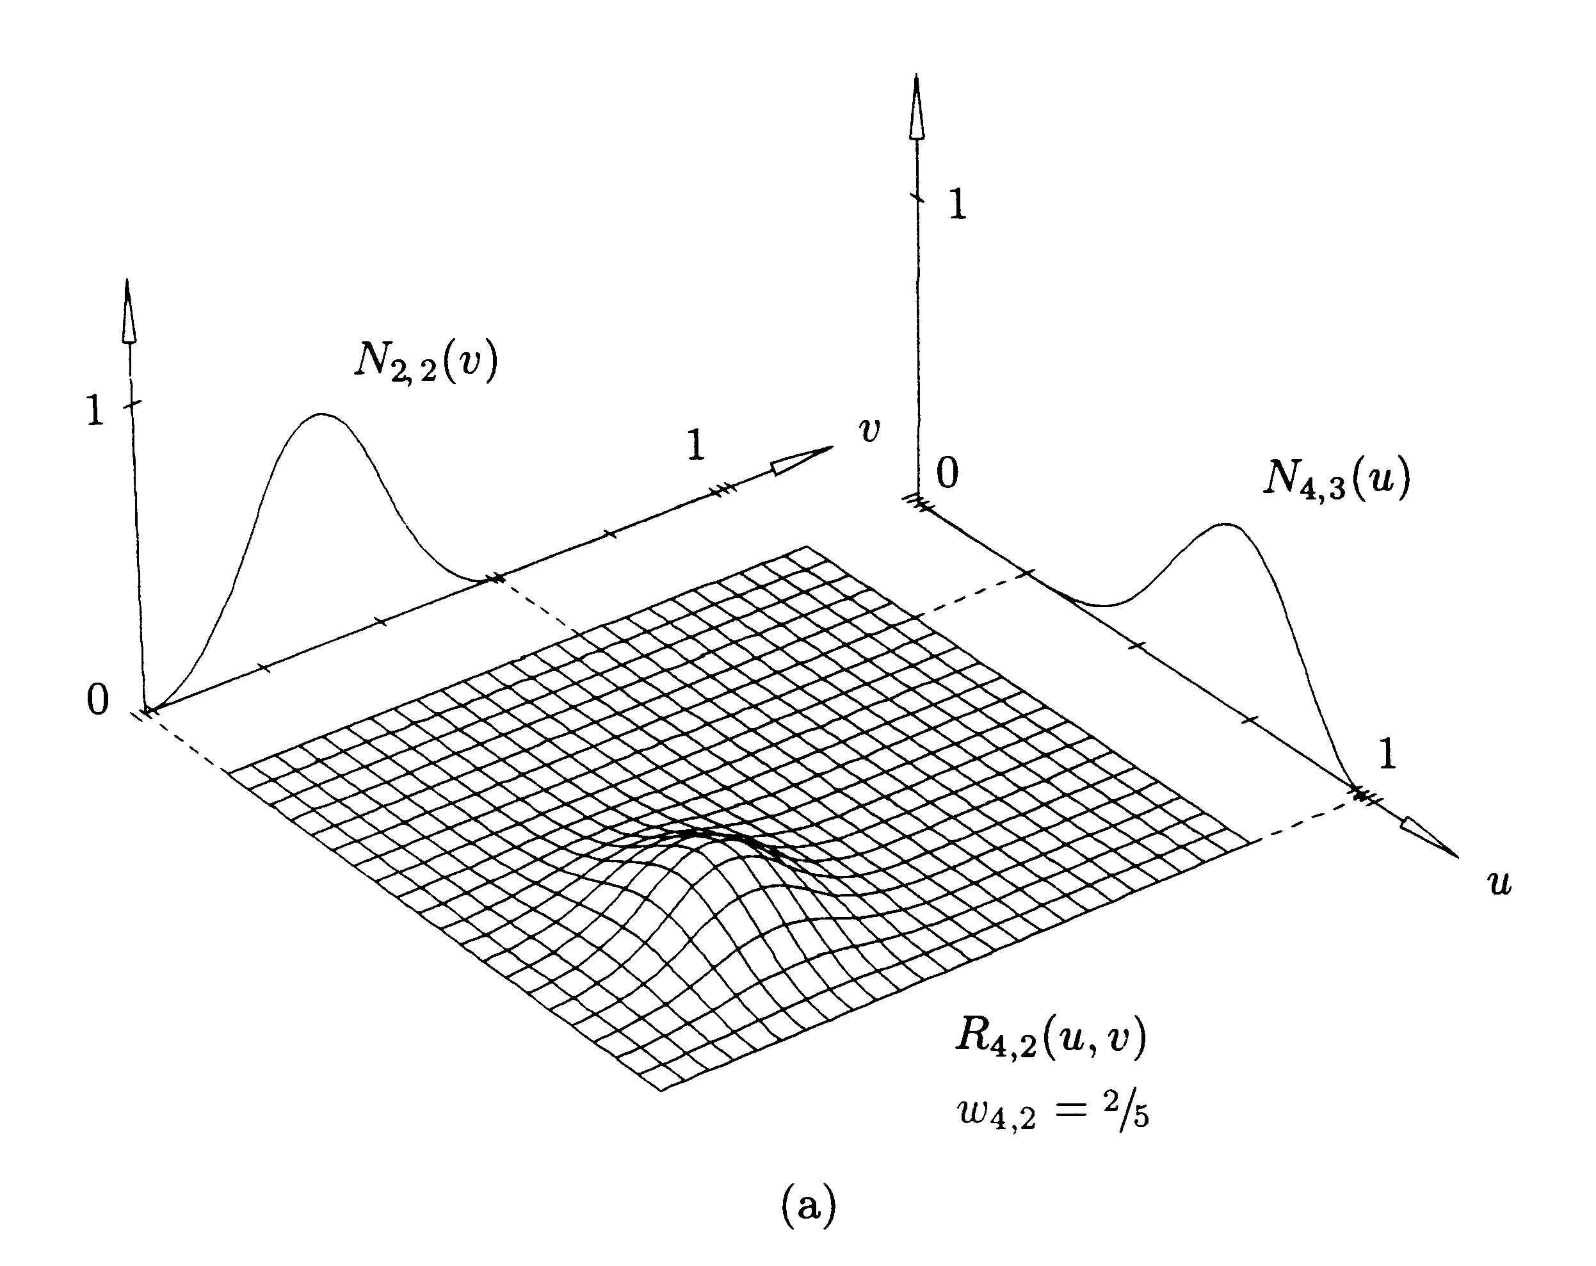
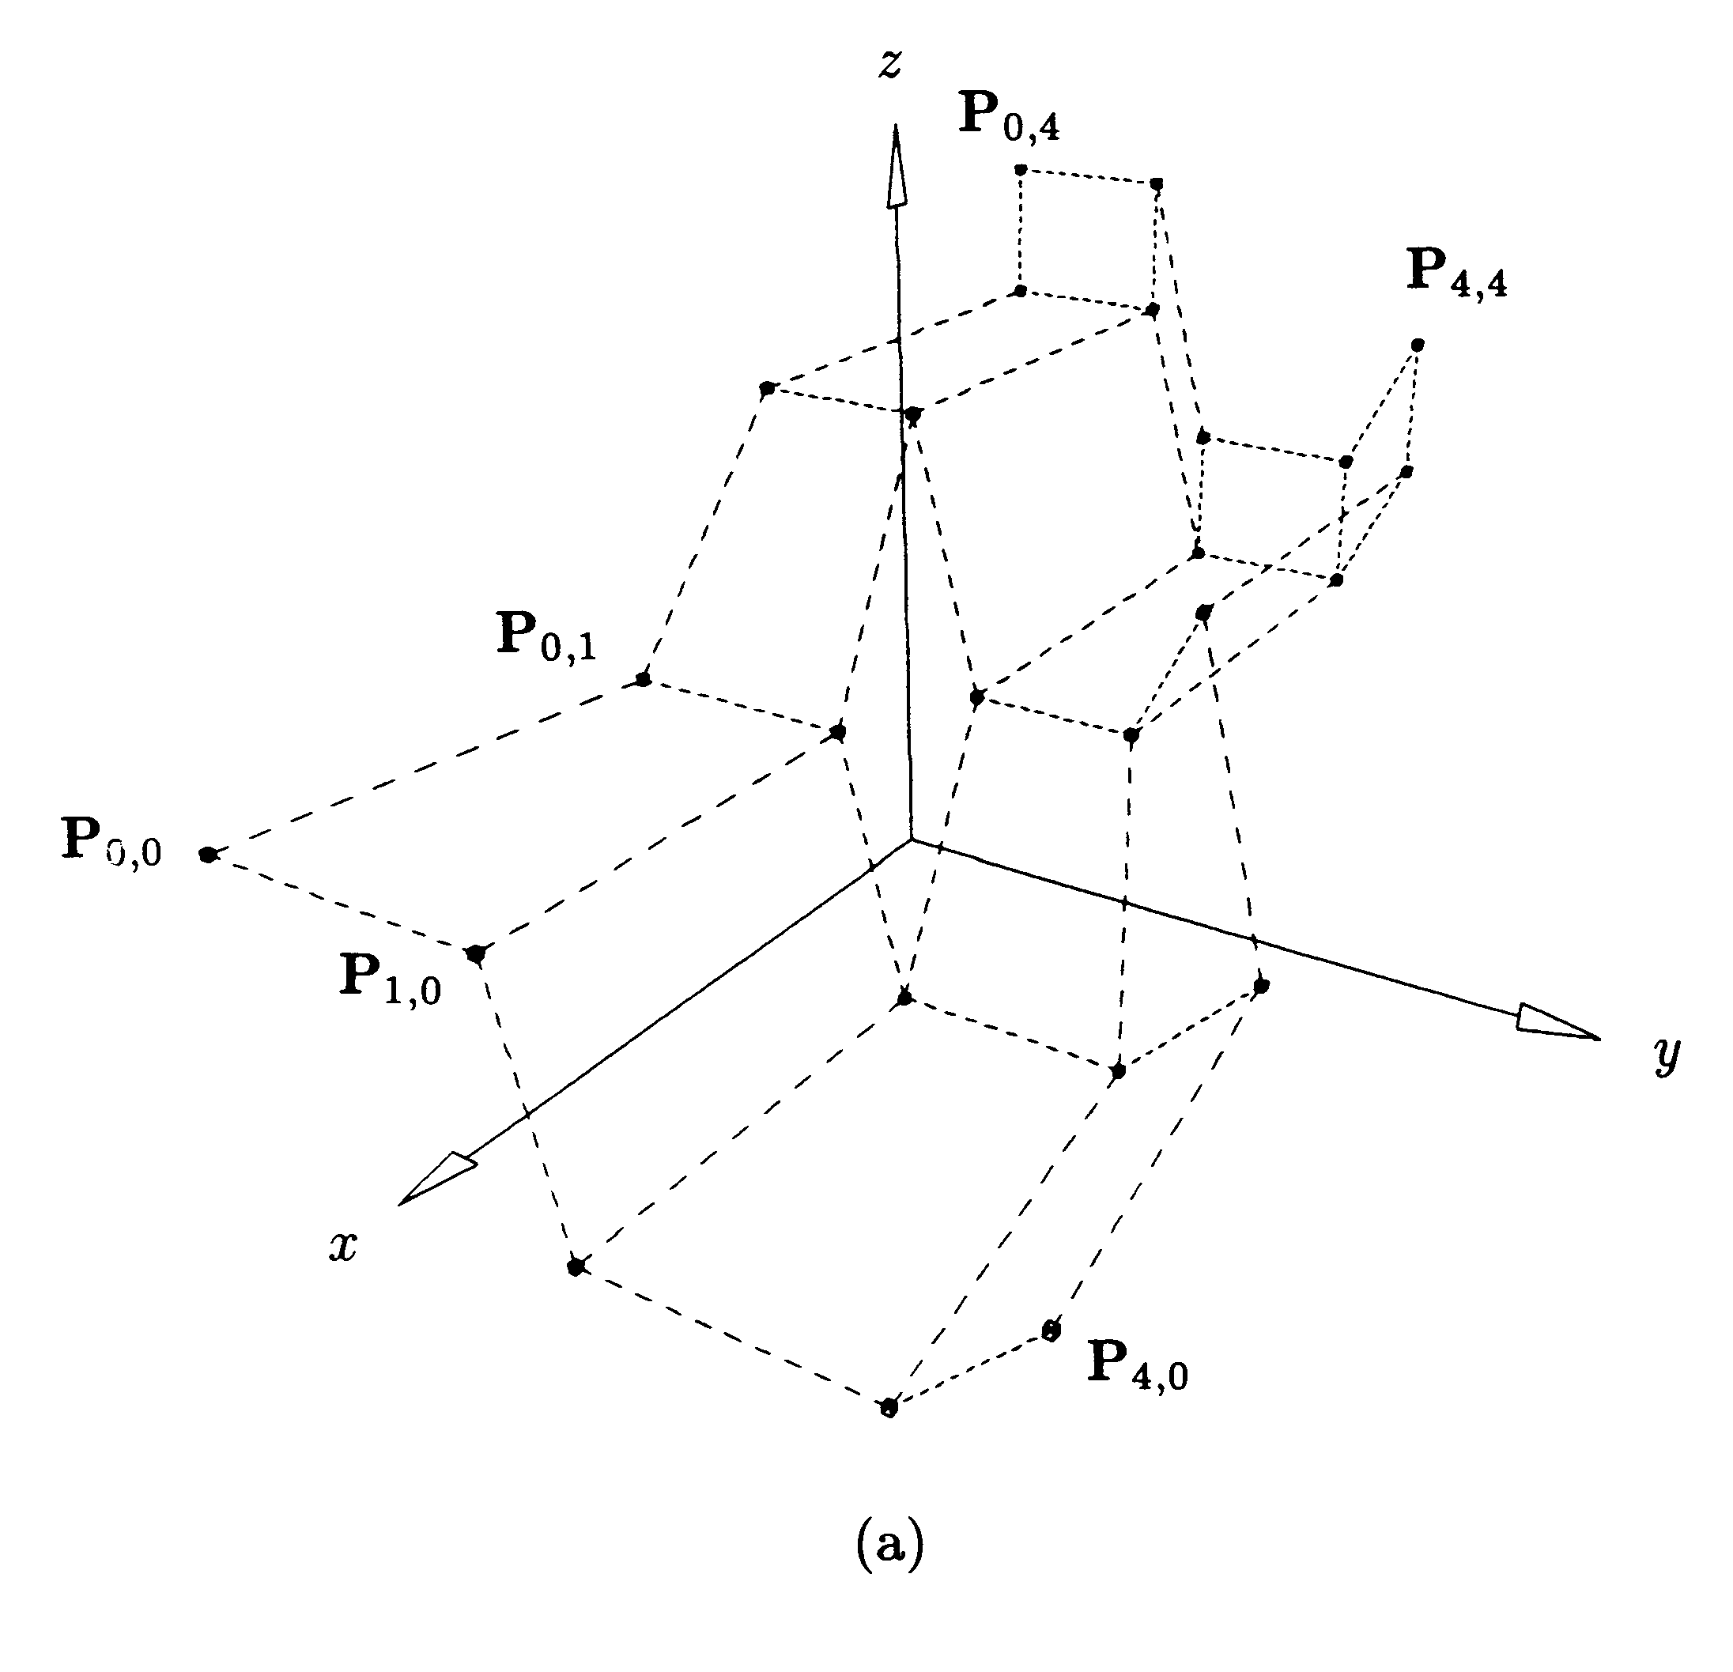
Fig 3. Control net (a) and tensor product blending functions (b).
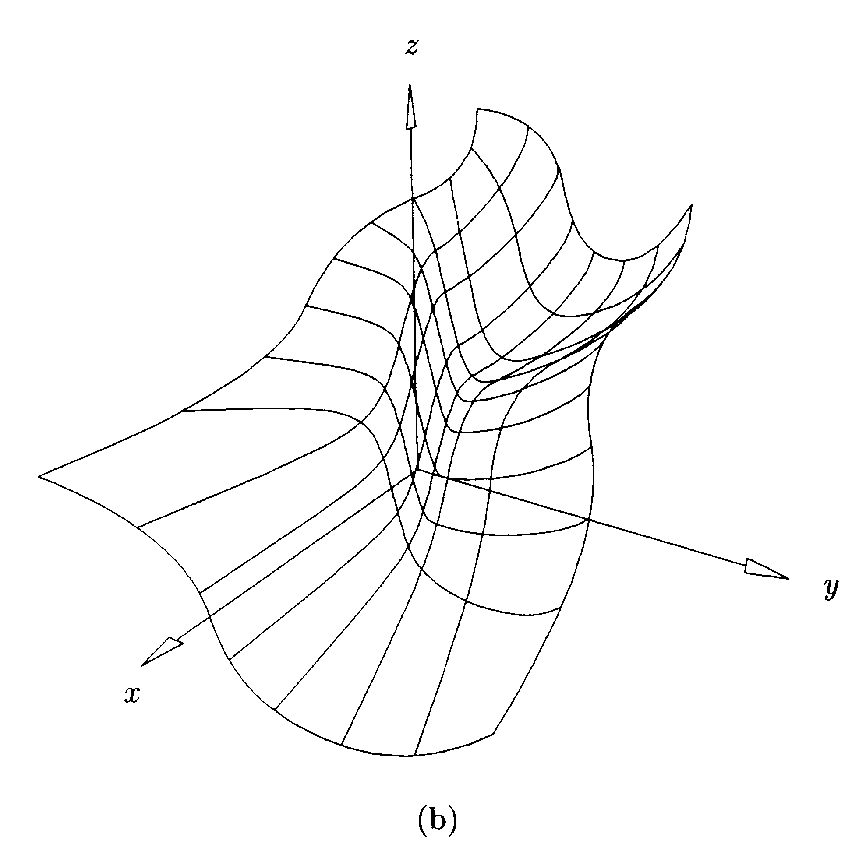
To create a NURBS surface we use control points net in 3D (Fig 3 a)) and the tensor product of the B-spline functions, so this type of surface is called a tensor product surface. Again, it is a composite surface with an order of continuity, defined by the order of blending functions. If we use control polygon, shown in Fig. 3 we will receive the tensor product NURBS surface, shown in Fig. 4.
Fig 4. Tensor product NURBS surface, corresponding to control net at Fig 3.

2.2 NURBS curves and surfaces: topology
The fundamental property of BREP geometrical format is approximation of volumetric objects by their outer/inner boundary by NURBS bounding surfaces and curves (see 2.1). Fig. 5 shows a cubic shape, with NURBS definition of the outer boundary, where actually planes are also defined as NURBS objects. The material point inside the volume will uniquely define the properties of the domain in our computational model.

Fig. 5. Unique definition of the geometric model’s sub-volume in BREP format.

In this context, BREP uses a graph of topological relations of the geometrical entities of the model, shown in Fig. 6. Starting from the root node of the CAD MODEL, which is the CAD itself with model related attributes (material, for example) we go to the BODY, representing full isolated 3D shape, say, fracture. Each BODY consists of two LUMPS, forming the external and internal (if it has one) boundary of the object. Each LUMP is composed from several SHELLS, and each SHELL is just a collection of adjoining FACES. Each FACE is bounded (trimmed) by the LOOP, which is a collection of adjoining edges. A COEDGE is a special case of edge, belonging to two neighbouring loops. The lowest level entity in the hierarchy of the geometrical elements is a VERTEX. It is interesting to point out, that for patch-independent meshing mesh generator requires direct access to faces of the model, as shown in the right had side of Fig 6.
Fig 6. Graph of the topological tree of the geometric model in the BREP CAD format.

2.3 CAD Errors as a consequence of different modelling requirements

Geometrical models provide definition of surfaces and curves for spatial disretisation (mesh generation) as required by the computational applications. Main problem of the CAD-mesh interface is in inherently different requirements for the CAD and computational models. While CAD models have the main purpose of the efficient free form geometry definition and manipulation, computational models are mainly required to capture subdivision of space into isolated volumetric entities by the geometric simplicies –Finite Elements (FE) or Finite Volumes (FV). CAD models normally do not have the property of conformal space subdivision and contain the so-called “errors” mainly gaps and overlaps between the patches [5,6], as shown in Fig. 7 a). We can distinguish two main types of CAD errors that create difficulties for meshing: independent and dependent errors from the type of meshing algorithm.
a) b)
Fig 7. Independent (a) and dependent (b) CAD errors.
While independent CAD errors are real geometrical errors that violate water tightness of the geometric boundary and make impossible valid mesh generation (for example, gap between two surface patches in Fig 7 a)), dependent errors are attributed to valid geometrical entities, but they create specific geometric problems a given meshing algorithm can fail (for example, long taper face in Fig 7 b)). However, both classes of errors do create problems for meshing, but dependent errors are easier to avoid. These errors are commonly attributed to the known shapes of patches (mainly the so called “sliver” high aspect ratio patches). Detailed classification and examples of the dependent and independent CAD errors are given in Annex 2.

2.3 The tolerance issues of the BREP format

Most of independent CAD errors are closely connected with the tolerance problems of NURBS approximation of the object's boundary. Should the tolerance of two sub-volumes of the model be different, it can lead to gaps or overlaps in the model boundary (similar to the situation in Fig 7 a)). The mesh generator interprets these gaps as independent errors and overall consistency of the mesh will be violated. It is therefore important to maintain same tolerance of NURBS modelling throughout the whole process of model development and export as well.

Checklist of tolerance related problems:
- Check the default tolerance of the CAD modeller, the value should be at least 1*e-5, recommended value is the default setting of the ACIS NURBS modeller, used in Rhino 3D;
- If the model is typically interfaced with ICEM mesh generator via the IGES (International Graphics Exchange) format, therefore the tolerance of the IGES format should be higher then the tolerance of the ACIS kernel;
- In some cases it is possible to adjust triangles discretization tolerance (see Fig.) to the geometric tolerance, removing the so-called non-manifold vertices in the mesh. This, however, can lead to the situation, when the surface triangles will be non-aliened;

Fig 8 shows typical NURBS curve intersection problem, when the accuracy of the ACIS modeller is not sufficient to maintain surfaces intersection in 3D, resulting in a trimming curve, not lying on the surface (Rhino 3D CAD package).

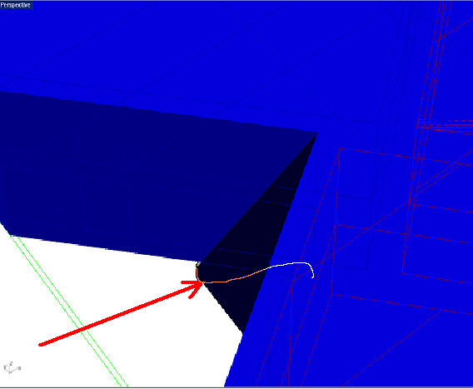
Fig 8. Independent topological CAD error at the intersection of two surfaces of the reservoir model.

2.4 Brief description of the algorithms in the ICEM CFD mesh generator

The ICEM CFD mesh generator uses the octree method for unstructured 3D tetrahedral mesh generation [4]. Surface mesh is created as a by-product of volumetric meshing (the so called "fill"). The ICEM CFD mesh generator therefore does not require fully watertight CAD model and can handle small gaps and overlaps between the patches. The draw back of this approach is the necessity to define explicit “separators” for patches, intersecting at small angles. This leads to significant increase of manual operations during meshing of a typical geological geometry (see, for example Fig. 39). The quality of reconstructed surface mesh is also considered to be worth then in incremental meshing. However, possibility to mesh imperfect geometry permits to use IGES input for surface definition and minimises influence of certain geometric shapes on the quality of the mesh (i.e. the number of patch shapes that are will result in bad mesh is less).

3. Workflow of GUI-driven geometric modelling in Rhino3D and Discretisation in ICEM CFD

3.1 Algorithm of GUI-driven Typical Geometrical Operations for Geological Models in the Rhino3D
Typical geometry creation in Rhino3D [] involves generation of free-form fault-type geometry, using free form spline curves and surfaces. One starts with the creation of rail spline curves to define at least two spline surfaces for further definition of the watertight fracture solid. Here we use two spline curves, interpolation the point wise data to define fault surfaces. Each surface provides the upper and lower boundaries of the fault geometry; side surfaces of the fault will be created by cutting (trimming) of these surfaces by a box-type 3D solid.
The algorithm for definition of the watertight fault will be as follows:
- Interpolate geologically mapped points by a curve in X direction for upper fault surface;
- Interpolate geologically mapped points by a curve in Y direction for upper fault surface;
- Loft upper fault surface, using two orthogonal curves and Rhino command Surface->Loft. It is recommended to accept default Rhino lofting settings, shown in Fig 9.
- Repeat operations 1.-3. for lower fault surface. Typical result of lofting is for both surfaces of a fault is presented in Fig 9.
- Using command Edit->Layers->EditLayers create two more layers for upper and lower fault surfaces;
- Using command Edit->Layers->ChangeObjectLayer change object layers for upper and lower fault surfaces;
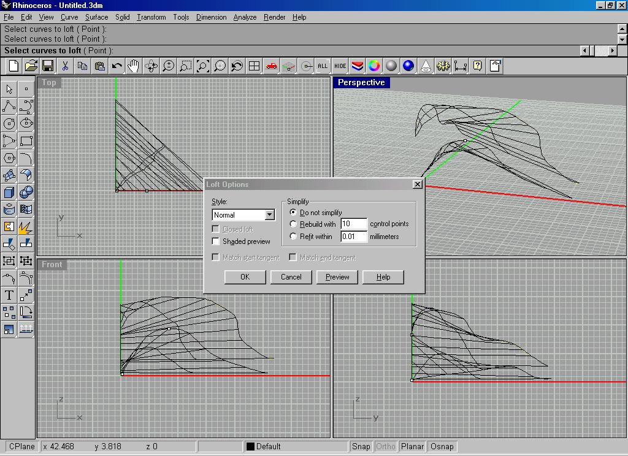
Fig 9. Lofting of 2 free form surfaces for further generation of watertight free form solid geometry of a fault.
- Using command Solid->Box->CornerToCornerHeight create a box-shaped solid, which is in plane smaller, that X-Y dimensions of the lofted fault geometry, as it is shown in Fig 10.
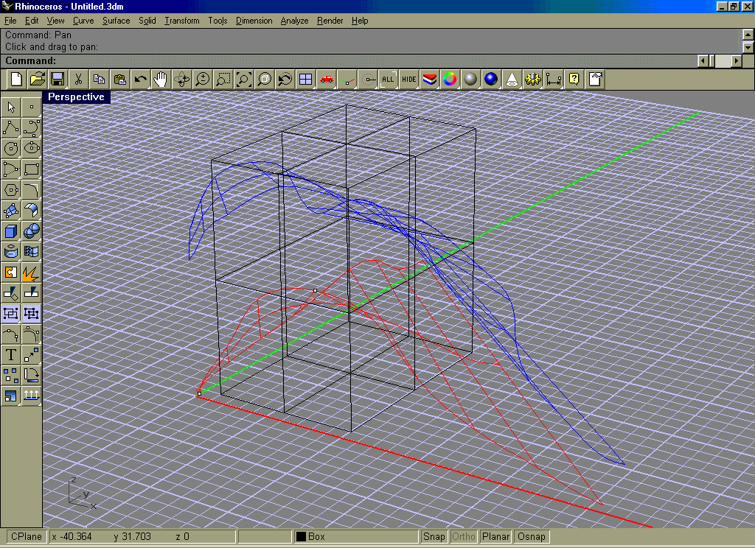
Fig 10. Create a trimming box with smaller dimensions in plane, then upper and lower surfaces of the fault
- Highlight the black box by left mouse click and copy it by the Cntrl-C command;
- Using command Solid->Intersection at Rhino3D first prompt chose first solid – the box. At Rhino3D second prompt chose second surface – upper fault surface (blue). Perform intersection. The result is shown in Fig. 11.
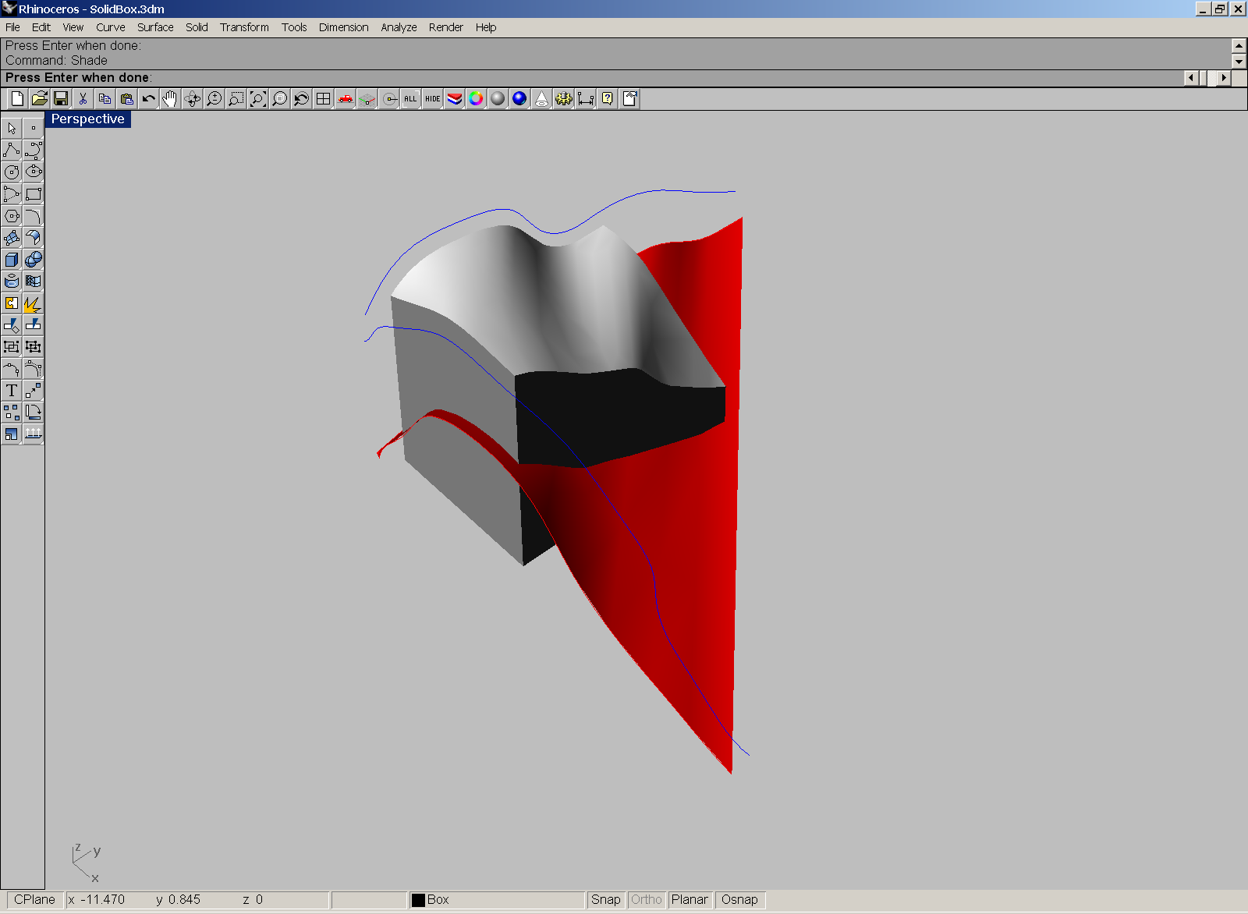
Fig 11. The result of intersection operation of the box and the upper fault surface
- Using command Solid->Intersection at Rhino3D first prompt chose trimmed box. At Rhino3D second prompt chose second surface – lower fault surface (red). Perform intersection. The result of the operation is shown in Fig 12.
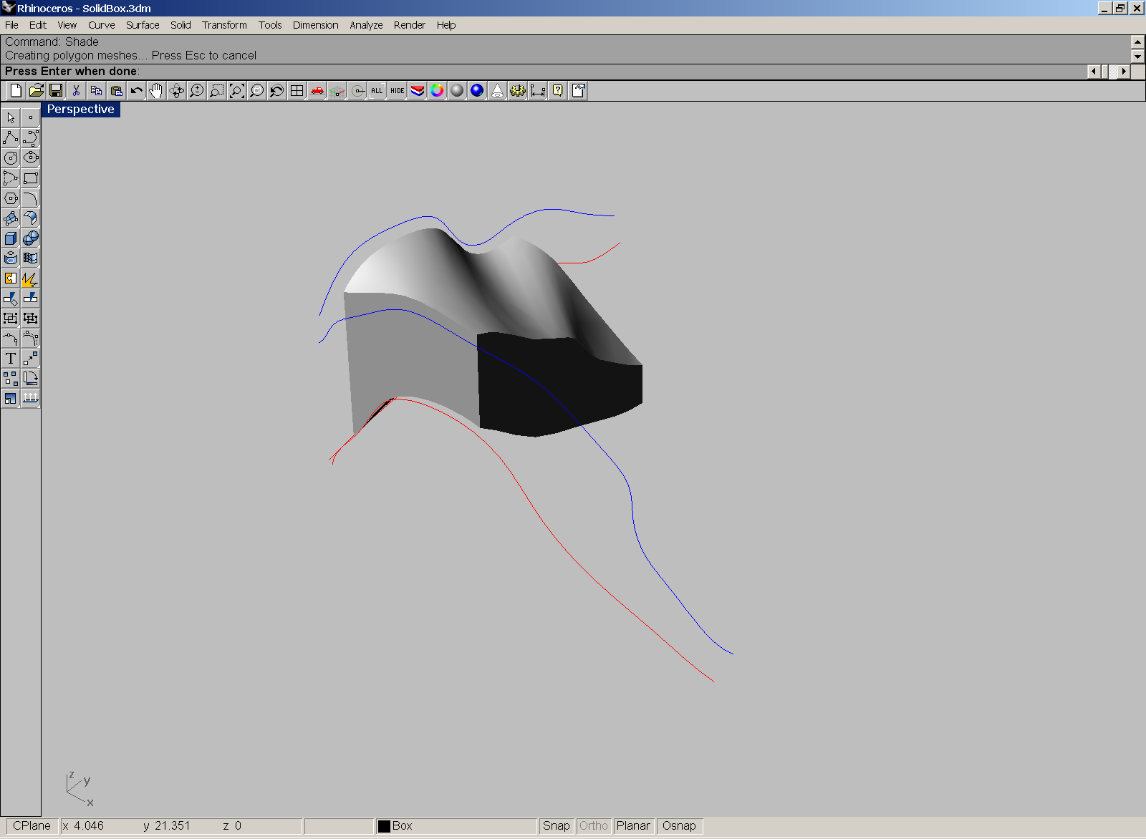
Fig 12. The result of intersection operation of the box and the lower fault surface.
- Highlight and delete support blue and red curves (see Fig 12), used for lofting.
- Using Ctrl-V command copy the box solid, used for trimming. Finally, the geometric model will be as it appears in Fig. 13.
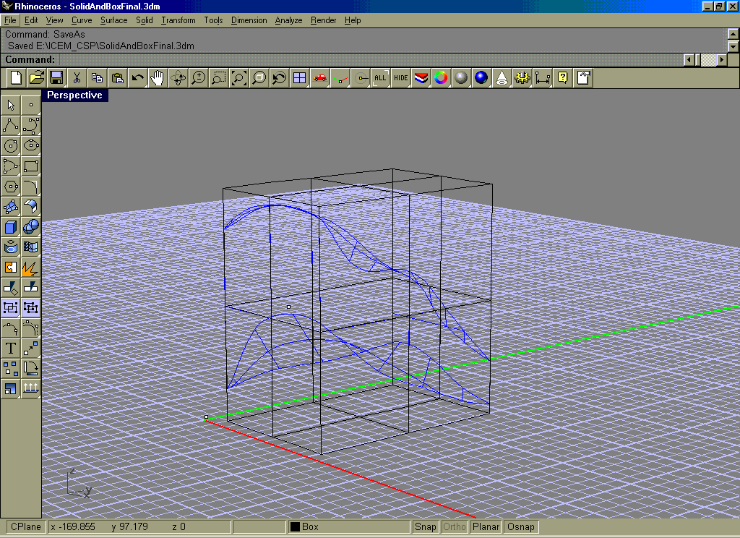
Fig 13. Final geometry of the box and the fault solid.
- Very important to define points inside the domains of our model, using the “point” command of Rhino3D. In this case we need 3 points inside the fault and in the upper and lover parts of the box, separated by the fault.
- The geometry needs to be imported to ICEM CFD mesh generator via the IGES (International Graphics Exchange Format). IGES export is produced by the following Rhino3D command File->ExportSelected. On the Rhino3D prompt select by the mouse all required objects. Export is a critical operation and IGES format should be always “default”, as shown in Fig. 14.
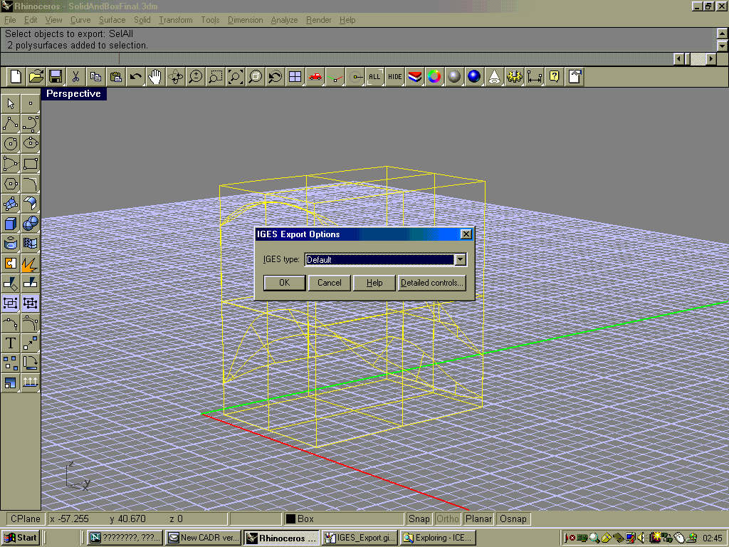
Fig 14. IGES export of the Rhino3D geometry.
This operation ends creation and editing of the 3D geological geometry in Rhino3D. Obtained IGES file is imported to ICEM CFD as discussed in the next section.

3.2 Typical GUI-driven Meshing Operations in the ICEM CFD mesh generator

Next step is to import IGES spline geometry to Tetin, which is the geometric pre-processor of ICEM CFD mesh generator. Typical import screen is shown in Fig 15. It is recommended to create separate sub-directory in the ICEM work directory, later this directory will be the ICEM project, where all the geometry and mesh files of the current configuration will be stored. IGES file (extension *.igs or *.iges) should be also stored in that sub-directory.

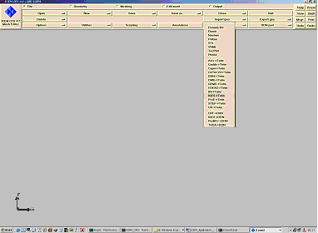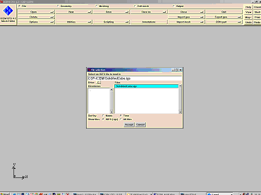
Fig 15. Screen shot of the ICEM IGES import menu.
Choosing appropriate file will bring free form spline model to Tetin. In the options menu of the IGES import the “Default” directive file option should be chosen.
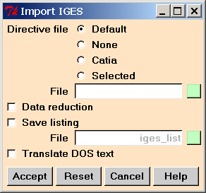
Fig 16. Options of the IGES input to ICEM CFD and recommended options.
In many cases the screen of the mesh generator remains blank and from the left up menu “Orient” an option “Home” should be chosen, as shown in figure 17.
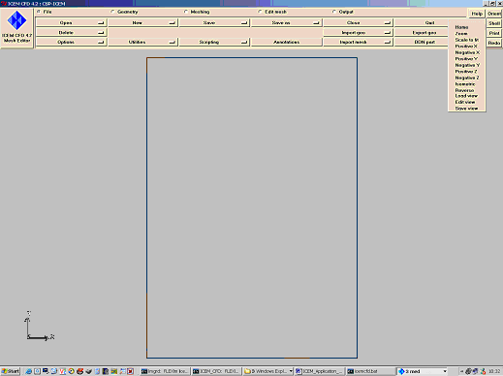
Fig 17. Adjusting the orientation of the imported geometry via “Home” command.
Due to the IGES format constraints, the names of the Rhino3D families are lost in translation. It is recommended to assign meaningful names to the “Levels”, which are found in the IGES file, see Fig 18.
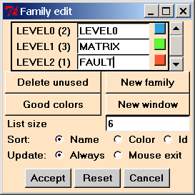
Fig 18. Screen shot of the “Family edit” menu of Tetin.
Typically, the IGES translation will position all the trimming curves of the imported geometry to a separate level, as shown in Fig 19.
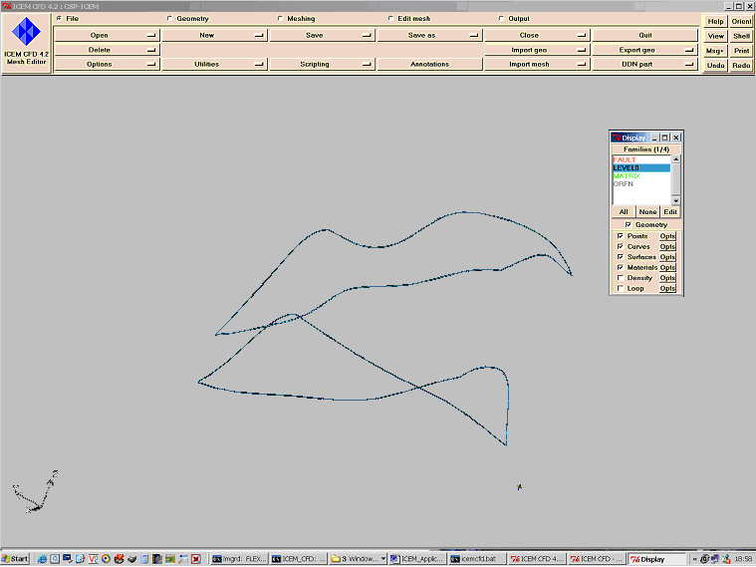
Fig 19. Positioning of the trimming curves to separate family during IGES translation.

We re-name this IGES level to the ICEM family “CURVES” and will keep it as a separate family for the time being. In general it is highly recommended to introduce the highest possible number of families, as ICEM distinguishes different sub-regions of the model by family names. If in future some sub-region will require assignment of a different property (permeability, porosity, etc.), a priory presence of a family can help. At this stage of model preparation for meshing standard CSP box-shape boundary names should be introduced. This is achieved by switching to the “Geometry” main level sub-menu, ticking the appropriate dot at the upper line of menus. In the “surface” sub-menu of that level we press the “Change family” button and by the left mouse button we select appropriate (in our example – Left) boundary of the matrix region (see Fig 20). Middle button of the mouse terminates select mode and brings the dialog of new family assignment. Then in the “New family” menu we enter the name of the standard CSP boundary flags (“LEFT”, “RIGHT”, “TOP”, “BOTTOM”, “FRONT”, “BACK”).
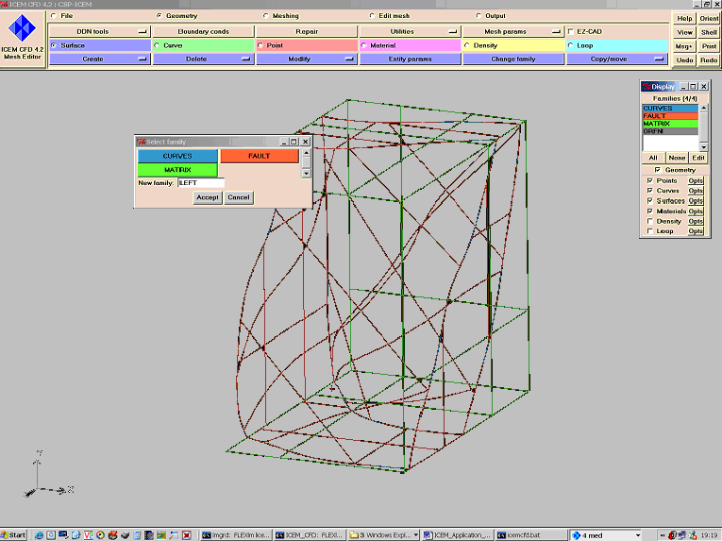
Fig 20. Introducing standard CSP box-shape model family “LEFT”.
Described procedure should be repeated for all standard CSP boundary families. At this stage it is recommended to go to the main menu option “File” and in sub-menu “Save” save the geometry file. The result of family assignment is given at Fig. 21. It is important, that the bounding box of the geometry and internal surfaces should be trimmed by edges (curves or lines) and geometrical points at the corners of the box, otherwise the mesh will be invalid, not adjusting to edges of the box, see Fig. 19. It is possible to create such edges in ICEM dialog, using command Geometry->Curve-> Create->Extract but this is not recommended, as ICEM tends to extract all curves from the intersections of surfaces and that will duplicate existing trimming curves on the free form surfaces, for example, on our fault sub-region. To check presence of edges in the geometry one should tick off all the boxes except curves in the “Display” field of ICEM menus see Fig. 20.

Next operation in geometry preparation deals with introduction of the so-called material points that distinguish different sub-volumes of the geometric model. For complex models it is recommended to introduce material points during model preparation in Rhino3D. In this case it will be simple points in 3D space and material points in ICEM are introduced using command Geometry->Material->Create-> ScreenSelect, as shown in Fig. 22. Material points should be defined for all volumetric sub-regions with distinctive properties (for example, for matrix and fault sub-regions of the geometry).

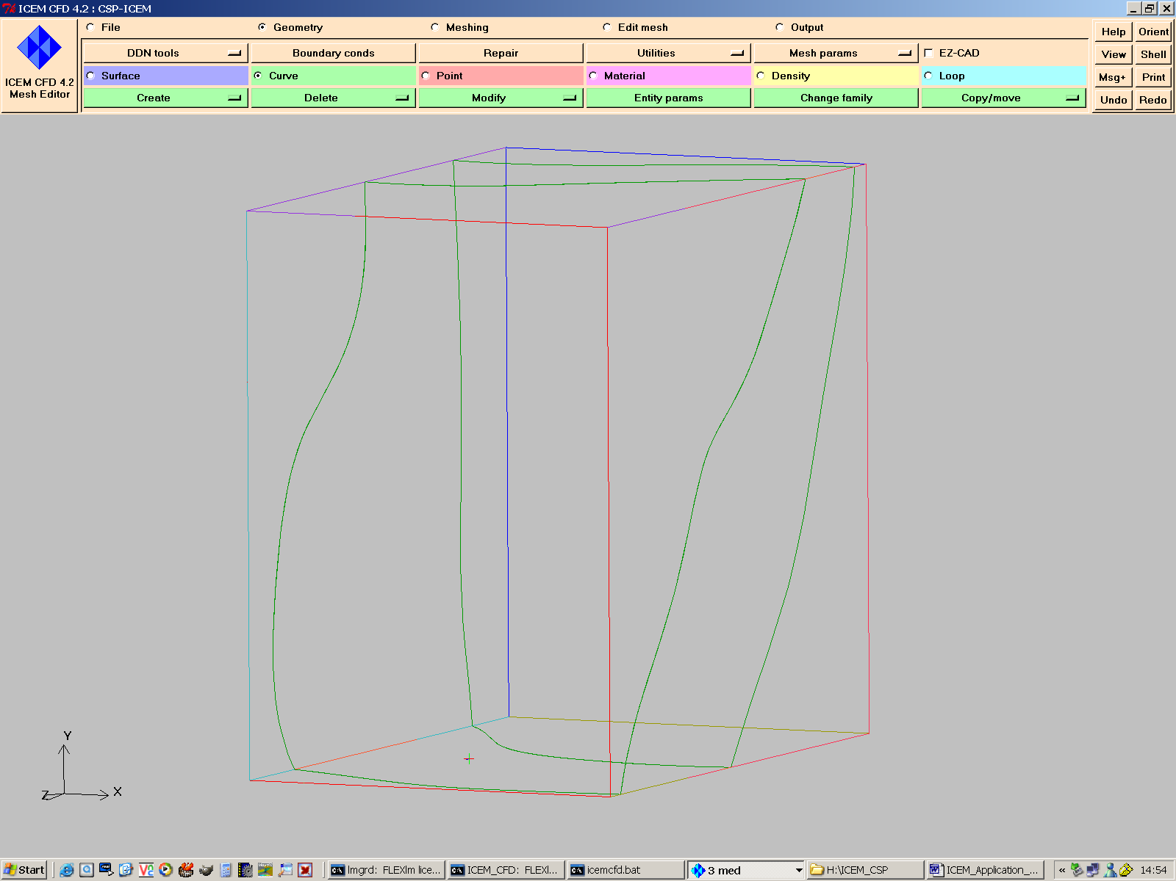
Fig 21. Check of the trimming curves in the geometry.
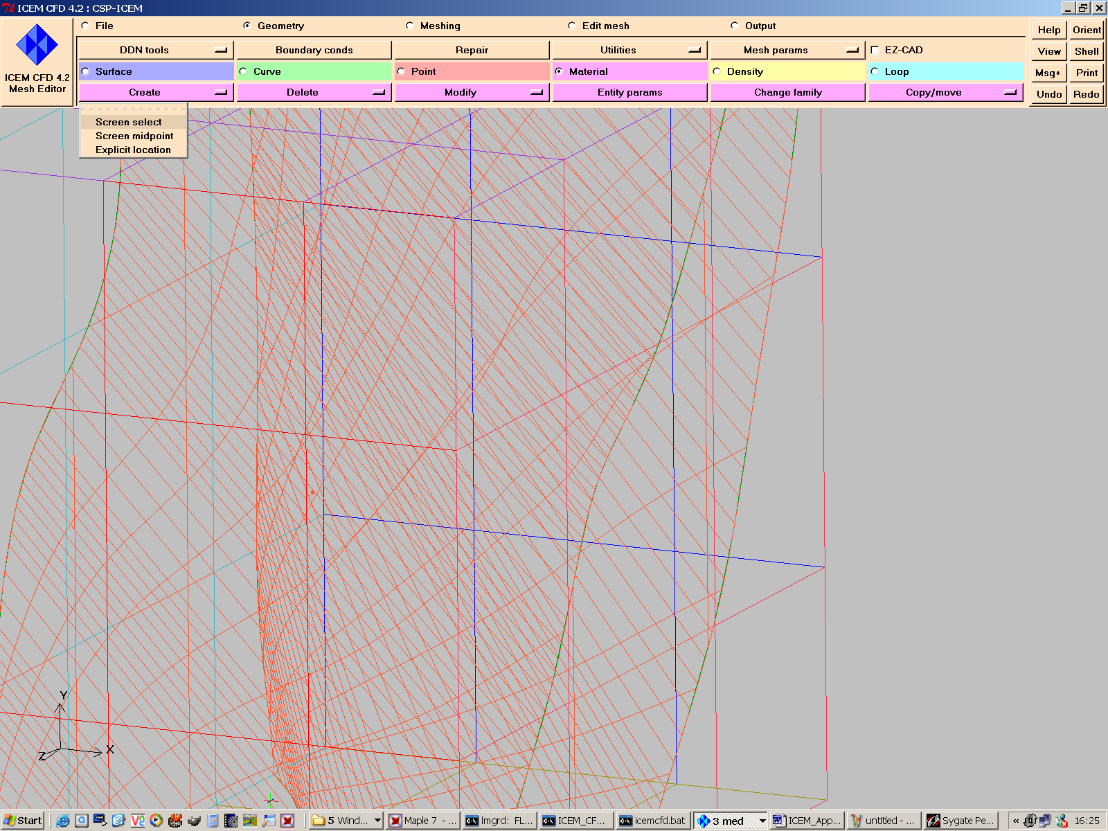
Fig 22. Creation of the material points, using 3D points from Rhino (dark red point).
Final view of the ICEM screen is given in Fig 23, showing both material points and geometry.
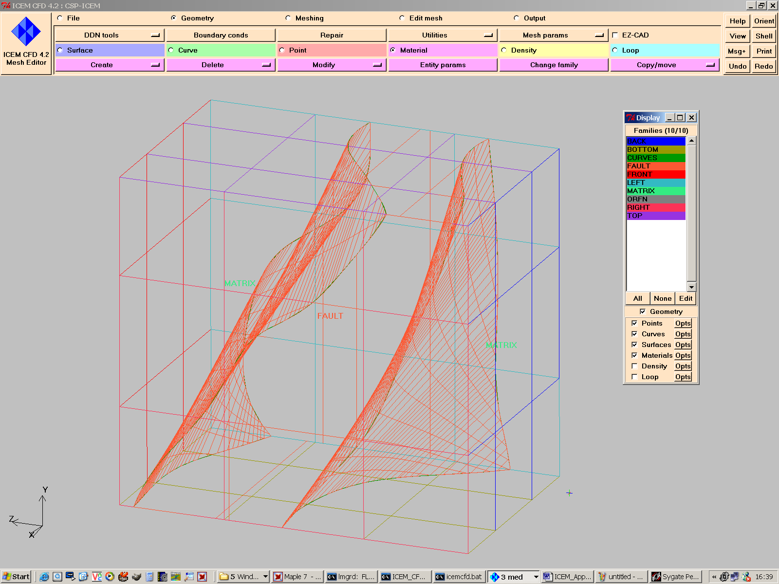
Fig 23. Full set of material points for the geometry with two regions.
Note, that similar to assigning families to the geometry, there is a possibility to introduce new family during the operation of the material points creation.

The next operation sets up the spacing of the mesh in different regions of the model. Pressing menu sequence Geometry->MeshParameters->Model will invoke the general mesh parameters menu, shown in Fig 24.
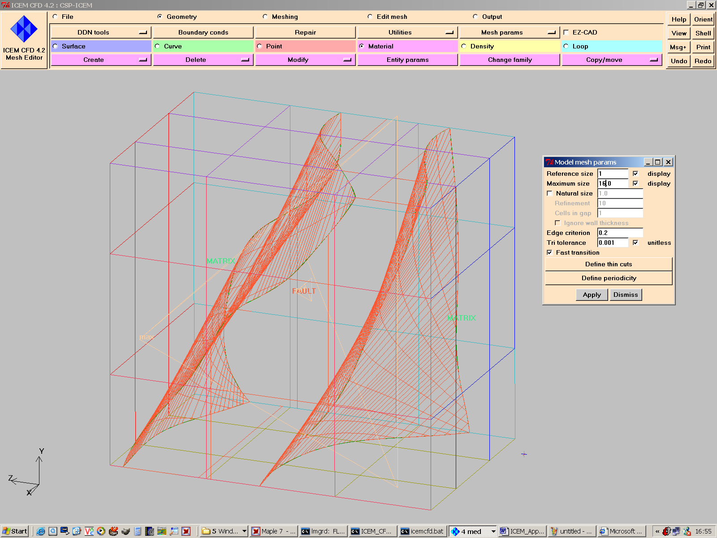
Fig 24. General menu of the Mesh Parameters set up with typical values.
Note, that in the main “Mesh Parameters” dialog box (Fig 24) ticking the “Display” boxes permits to visualize respective reference sizes of the elements. It is recommended to use “Fast transition” option that defines the gradient of element sizes change between regions of the model with different element sizes. Applying Geometry->MeshParameters->AllFamilies invokes menu, shown in Fig 25.
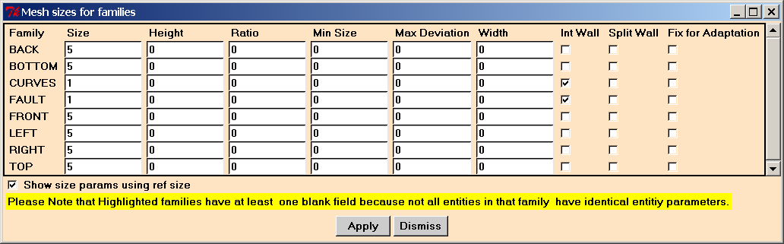
Fig 25. “AllFamilies” menu of the Mesh Parameters set up with typical values.
Note, that the outer box families have bigger values of the Size parameter (5) and size of elements will be respectively bigger. It is important, that at the internal sub-regions boundaries, corresponding to the “Fault” region, the “Int Wall” boxes should be ticked in. The same procedure is used for surface representations of fractures, for example, otherwise ICEM will not mesh the surfaces inside the domain. Pressing “Apply” and “Dismiss” buttons will apply settings and hide the menu. At this stage it is necessary to go to the main menu option “File” and in sub-menu “Save” and save the geometry file.

3.3 Meshing in ICEM CFD

All the following operations are related to the process of meshing and mesh smoothening (quality improvement). Pressing sequence Meshing->Tetra->FromCAD/SurfaceMesh will invoke the following file menu (Fig 26), defining the input geometry file and expert options of meshing:
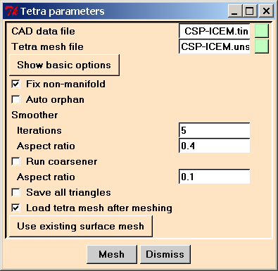
Fig 26. “TetraParameters” menu of the Mesh Parameters with typical values.
In the setting, shown in Fig 26 it is assumed, that we perform tetrahedral meshing, as the smoother will perform 5 iterations and apparently perform local mode movement and swapping of the tetrahedrons diagonals in order to improve the mesh. After smoothening the efficiency of hybrid meshing, based on the merging of 12 tetrahedrons to one hexahedron will be lower, so in case of further hybrid meshing the parameter “Iterations” of the smoother should be set to 0 and smoothening performed on the after mesh hybridisation. Note, that it is also recommended to change default name of the Tetra mesh file to some meaningful name.
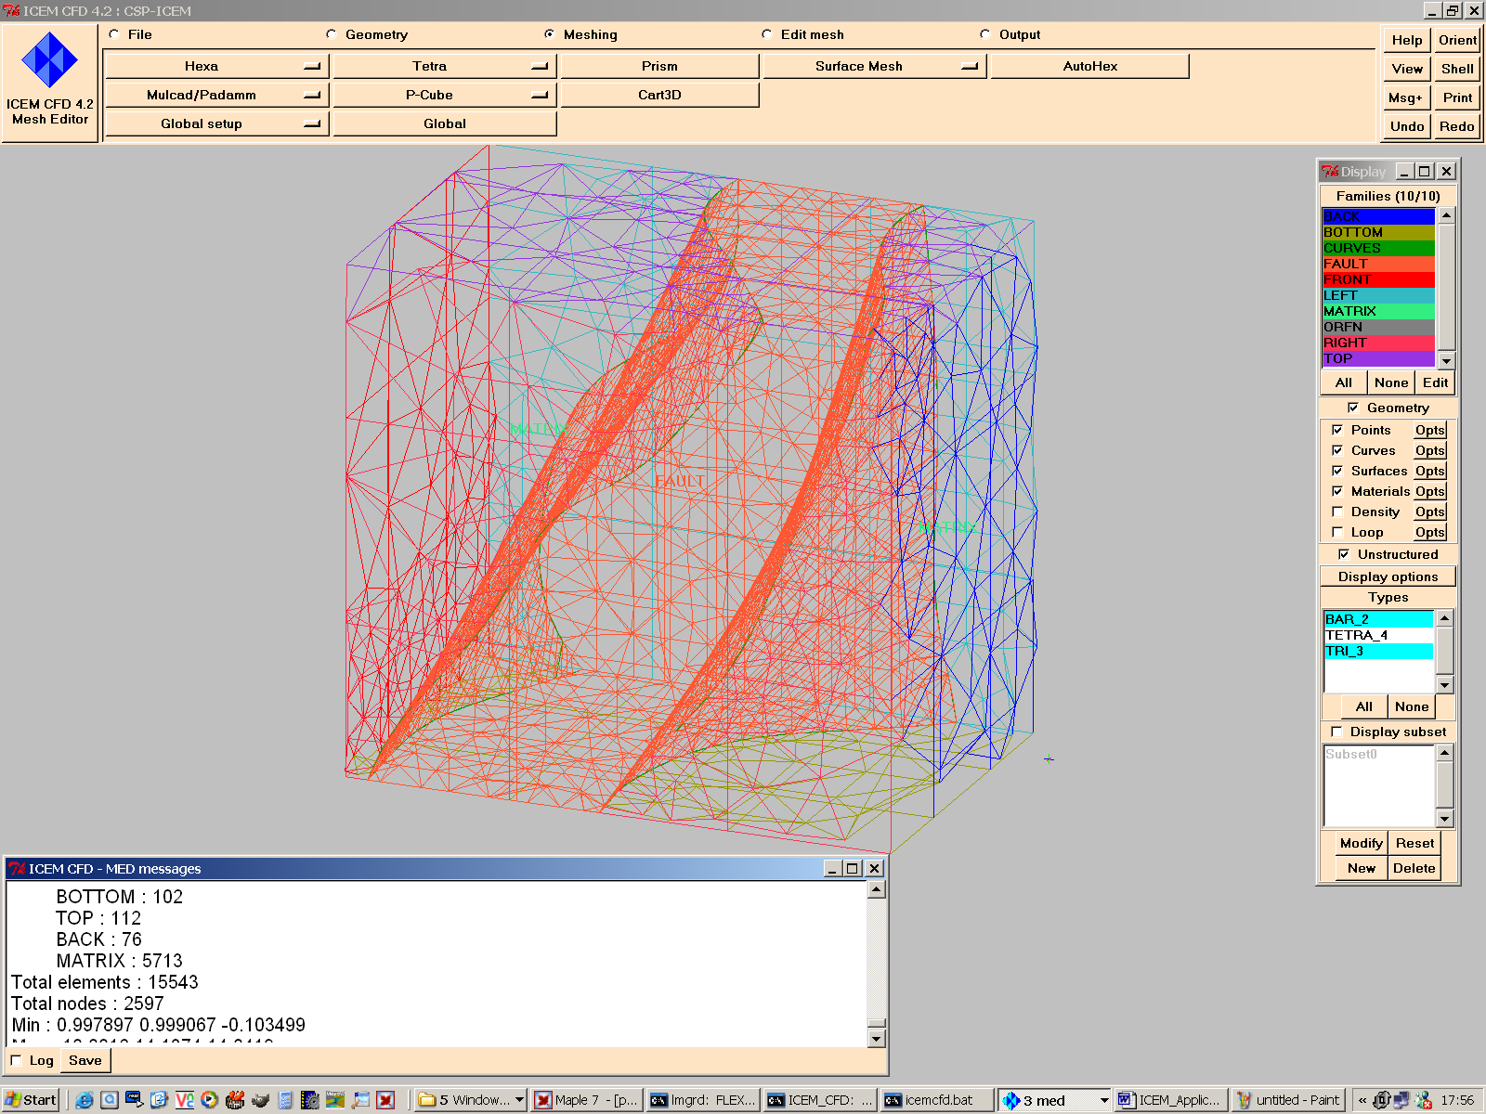
Fig 27. Typical view of the tetrahedral mesh after Tet mesh generator.
Pressing “Mesh” button will invoke the Tetra mesh generator. The messages of the meshing process will be displayed in the “Message” window and mesh will be loaded to the editor window, as shown in Fig 27. Sometimes the geometry description is not adequate (some bounding curves are not presented and the mesh generator positions tetrahedrons only using surfaces definition, Fig 28) and therefore loaded surface and volume mesh should be carefully checked for validity.
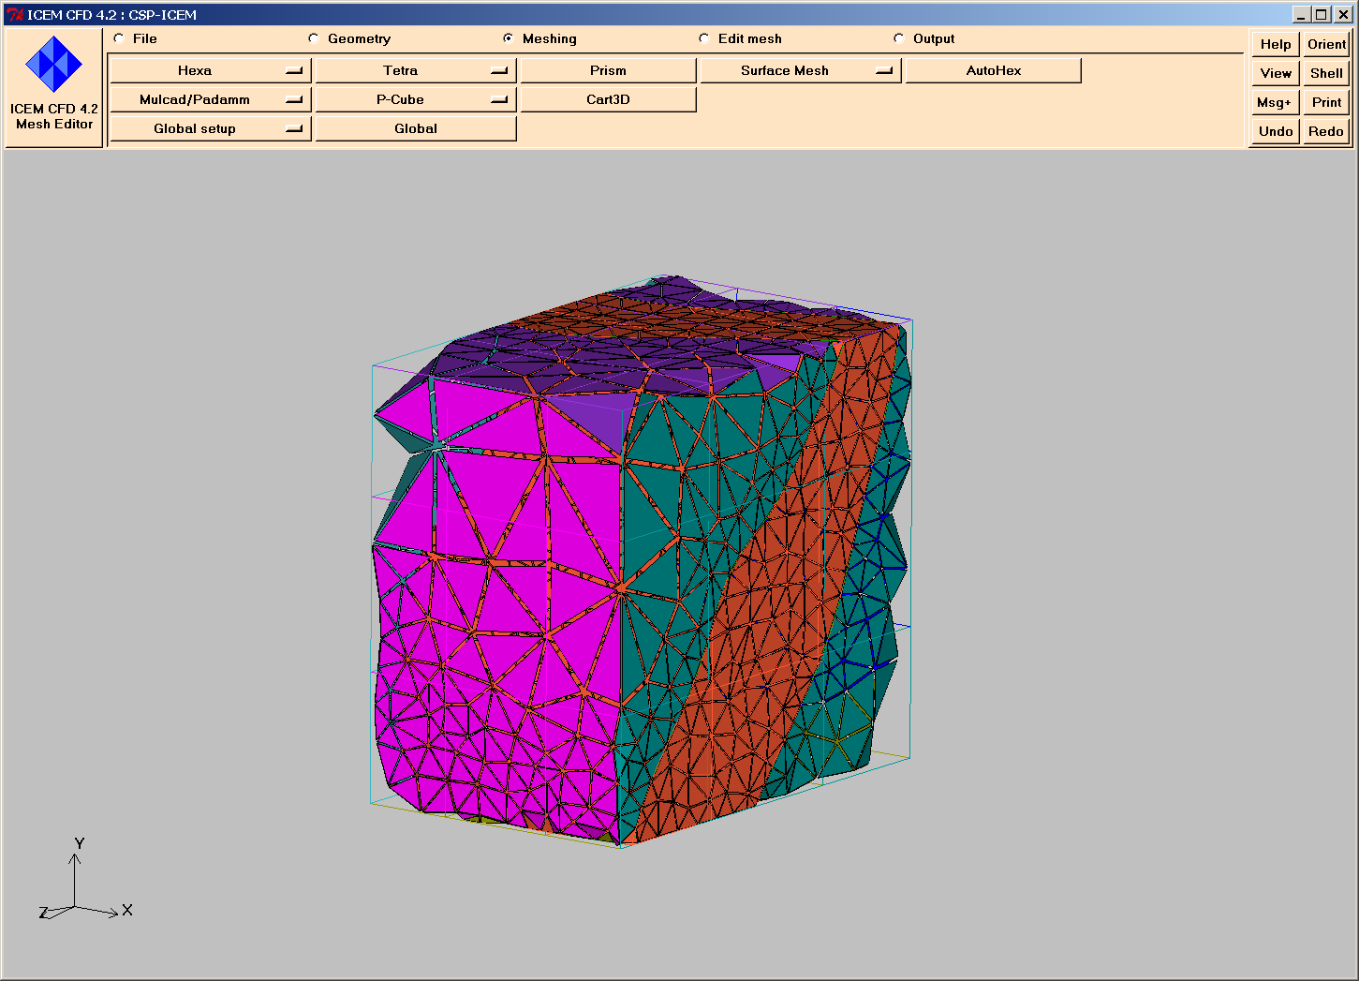
Fig 28. Tetrahedral mesh when the edge curves of the box are missing.
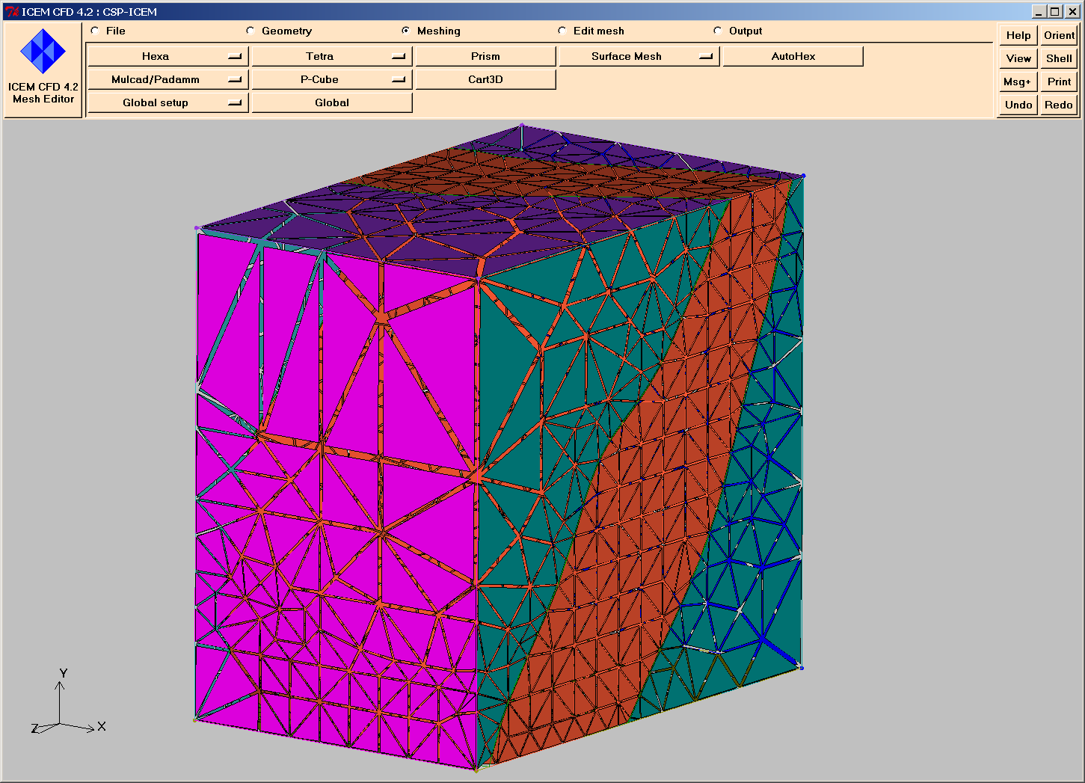
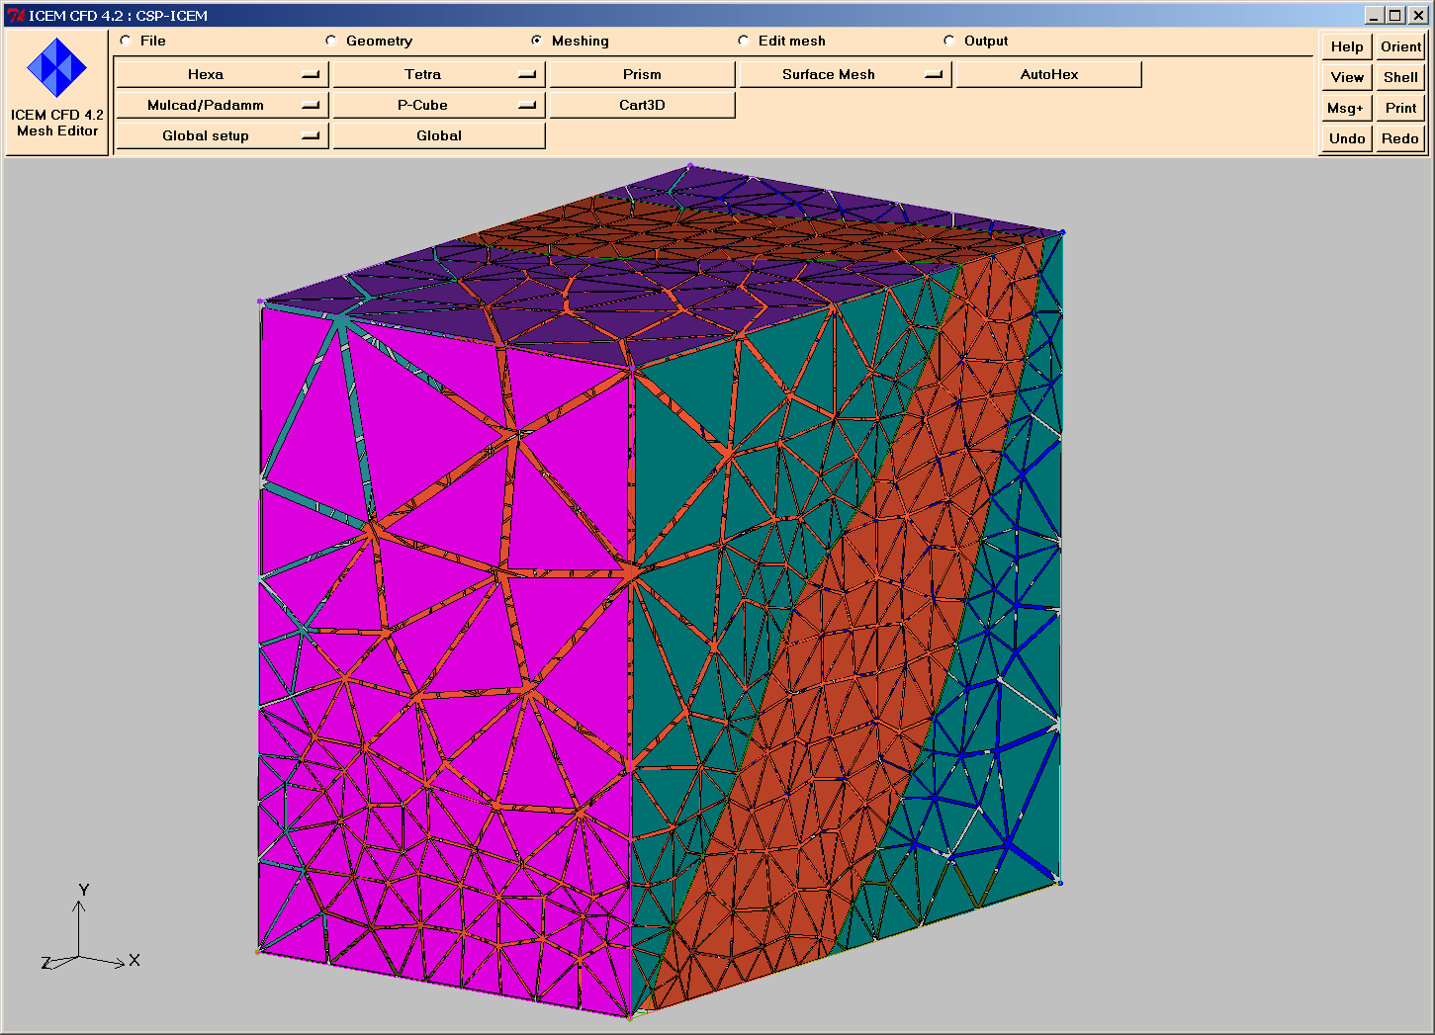
Fig 29. Non-smoothed vs. smoothed mesh with the edge curves of the box geometry.

3.4 Mesh smoothening and modification in ICEM CFD

Mesh smoothening, analyses and modification is carried out in the high level menu “Edit mesh” of ICEM.

The first step is to check the validity of generated tetrahedral mesh. This is done via command EditMesh->Diagnostics->CheckMesh. Typical values of the dialog are given in Fig 30.
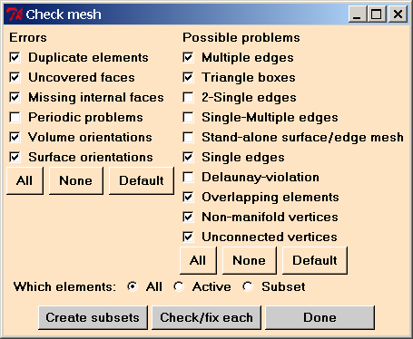
Fig 30. Typical values of Check Mesh dialog.
Pressing the button “Create Subset” we give the command to put problematic elements into a separate sub-group, and this is rather handy for further mesh editing and improvement. Each subset can be visualised by ticking in “Display Subset” option in the “Display” menu of ICEM.

Normally, “duplicate elements” and “overlapping elements” do not create any problems for further FE computations. In most cases these problems are created by duplicate curves in the geometry and affect only duplication of the bar elements, used for curves discretisation in ICEM. As in standard cases CSP do not use bar elements in 2D and 3D models, these duplicate elements will not show up, unless for very special cases. All the other problems with the mesh are critical, especially the so called “non-manifold” vertices.

Next step involves check of the mesh quality with respect to some quality metrics. Quality metrics defines an ideal element and distance of the given element to that ideal in some metrics space. ICEM have a variety of different metrics and it is recommended to use for quality checks the default synthetic metrics, using several different criterions. Calculation of the metrics quality for the whole mesh and/or subsets of the mesh is invoked by the command EditMesh->Diagnostics->QualityMetrics.
Fig 31 shows the histogram of the ICEM synthetic quality metrics before and after smoothening.
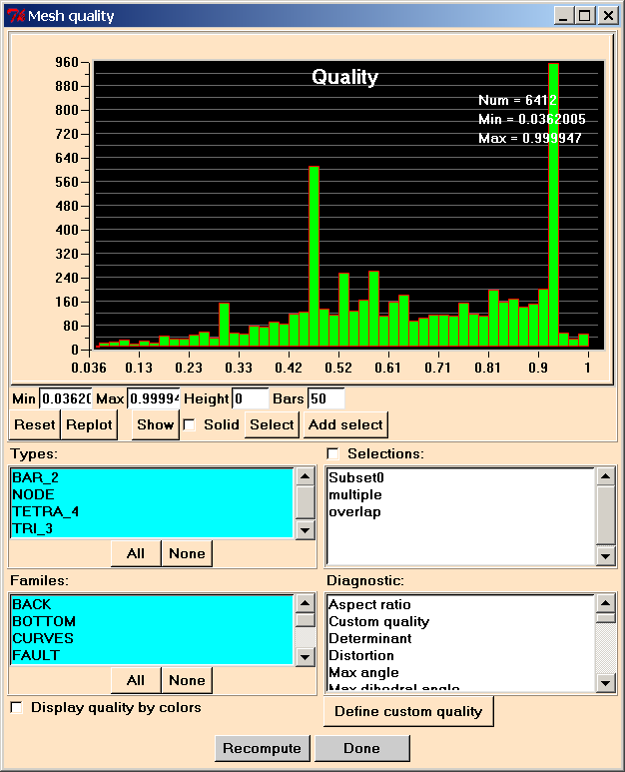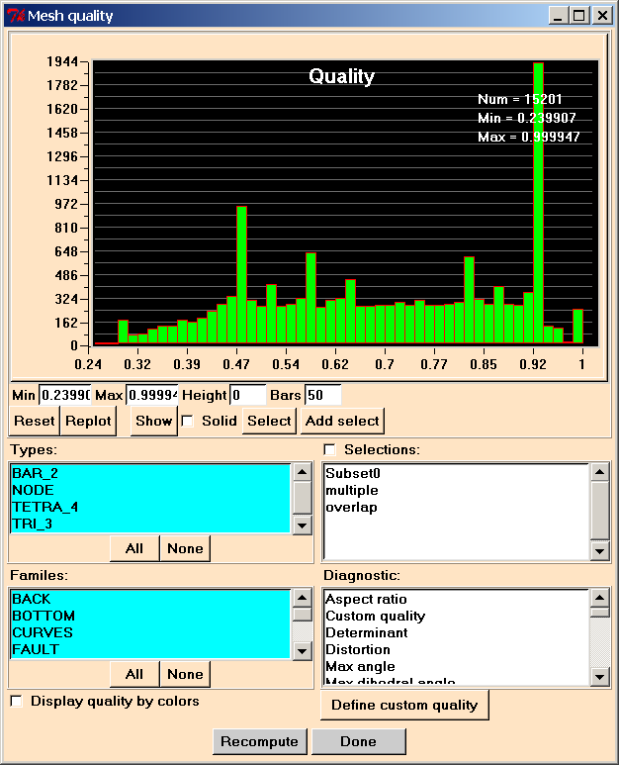
Fig 31. Quality metrics of tetrahedral mesh before and after smoothening.
Let us remind, that if we are generating hybrid mesh, no smoothening should be carried out after tetrahedral mesh generation. This is connected with the specifics of the octree mesh generation technique, when hybrid mesh is most efficiently created by indirect method of ICEM on original non-smoothed octree mesh.

Hybrid mesh is created a-posteriory from initial all-tetrahedral mesh using command EditMesh->ChangeType->12Tetra-1Hexa. Execution of that command will invoke the dialog, shown at Fig 32:
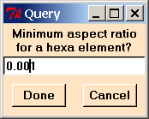
Fig 32. Quality of hybrid mesh generation query and recommended value.
The hybrid mesh is loaded after conversion to the main window of the mesh generator. Hybrid mesh for discussed configuration is shown in Fig 26.

Normally the hybrid mesh inherits all the topological/consistency problems of the initial tetrahedral mesh, but in some cases hybridisation can introduces own errors, so it is recommended to check the validity of generated hybrid mesh as well. This is done via command EditMesh->Diagnostics->CheckMesh. For the discussion of the mesh errors see above.

After hybrid mesh generation it is necessary to perform mesh smoothening, using command EditMesh->Smooth. Activating this command, we receive access to the smoothening menu and also receive information about mesh quality, as shown in Fig 31. It is recommended to perform 5-7 cycles of smoothening (optimisation), bearing in mind that this process uses a combination of local and global mesh optimisation techniques with respect to the default or user defined mesh quality metrics. This explains why in some cases increasing number of smoothening iterations does not improve overall quality of the mesh (due to locality of optimisation criterion). For big meshes around 1 million elements that process could be rather lengthy.

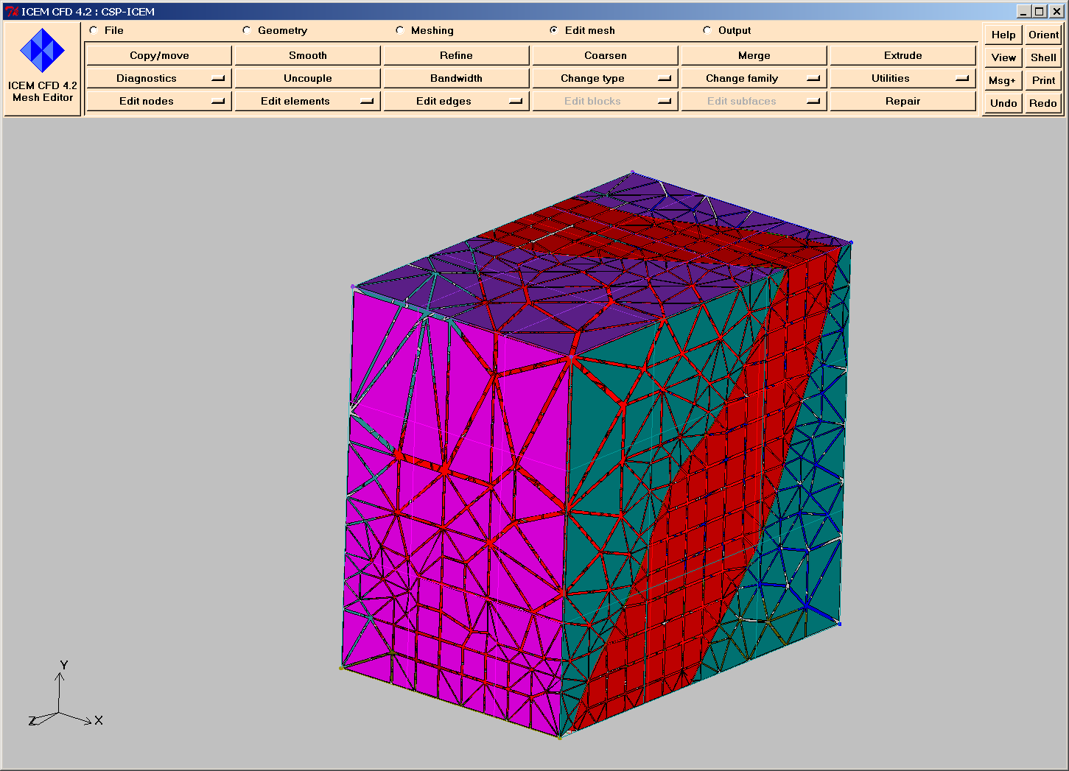
Fig 33. Hybrid mesh generated from all-tetrahedral by indirect method.
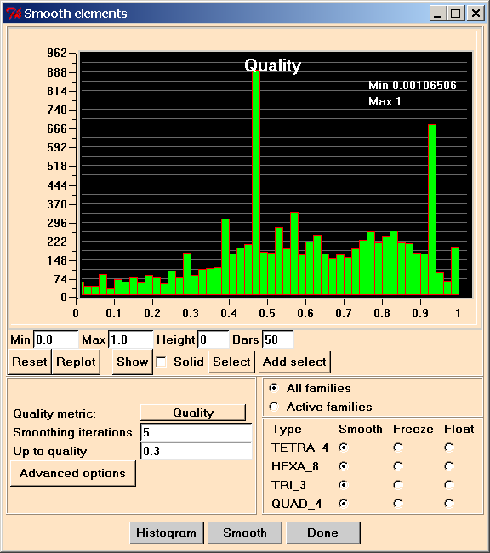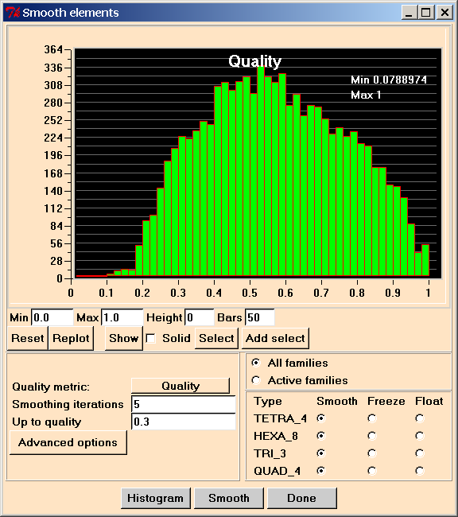
Fig 34. Typical mesh smoothening values and initial/final quality of the mesh after optimisation.
Using first-level “Edit Mesh” menu it is also possible to convert linear finite elements to quadratic, applying ICEM command EditMesh->ChangeType->Quadratic->Linear (see Fig 35). The option “Create midface nodes” should be not used!
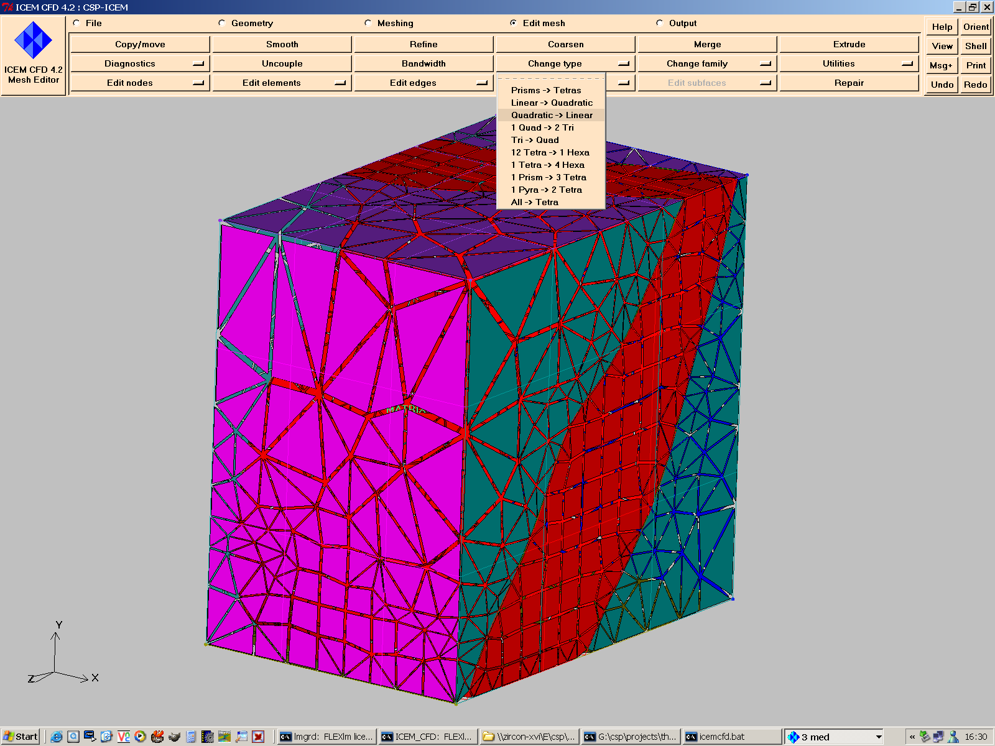
Fig 35. Conversion of linear hybrid mesh to quadratic.

3.5 Mesh output to CSP
To run simulations, generated mesh need to be output in the internal format (ascii or binary) of the CSP code. The latest version of CSP uses the binary format of mesh storage and requires definition of the ICEM families with the standard CSP names for box-shaped models (see above). The output menu is invoked by the ICEM GUI command “Output->SelectSolver”. This command brings the following dialog window (Fig. 36) to select mesh output format for appropriate solver:
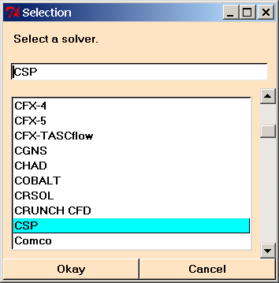
Fig 36. Select Solver dialog in ICEM.
Pressing OK on the prompt of the mesh generator we must save the ICEM project (see above) and later on choose the ICEM binary domain mesh file to be converted to the CSP format (Fig. 37):
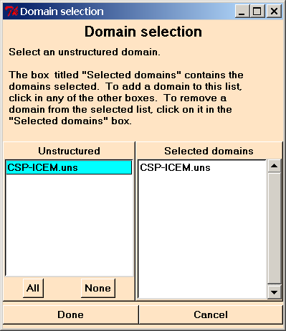
Fig 37. Select Domain dialog in ICEM.
After that ICEM GUI prompts the user (see Fig 38) to define ASCII of BINARY format (BINARY should be used) and a name for a group of CSP mesh files (in this example ICEM-CSP.*, which will correspond to ICEM-CSP.dat, ICEM-CSP.asc and ICEM-CSP.log files) in the ICEM project directory.
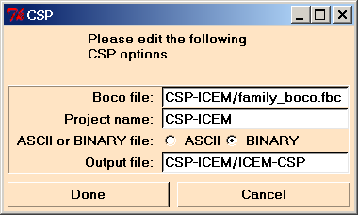
Fig 38. CSP options dialog in ICEM.
Output of the mesh finalizes the procedure of mesh generation. CSP mesh files could be now moved to the simulation directory.

4. What can go wrong during meshing with ICEM

Unfortunately, there is no hard and fast rule how to produce the geometry, well suited for mesh generation. It should be kept in mind that most of the meshing errors are resulting from [3]:
- The non-matching tolerances of the Rhino3D model and the IGES input to ICEM CFD (see paragraph 2.2).
- The missing elements of the geometry: trimming curves that bound the underlying surface, vertices, bounding the curves (see, for example, see paragraph 3.2 and Annex 2).
- Missing material points in isolated sub-volumes of the model.

As an example example, let us consider typical free-form fault geometry with fracture surfaces as shown in Fig. 39. The geometry was prepared in Rhino3D and exported to ICEM CFD via IGES format.
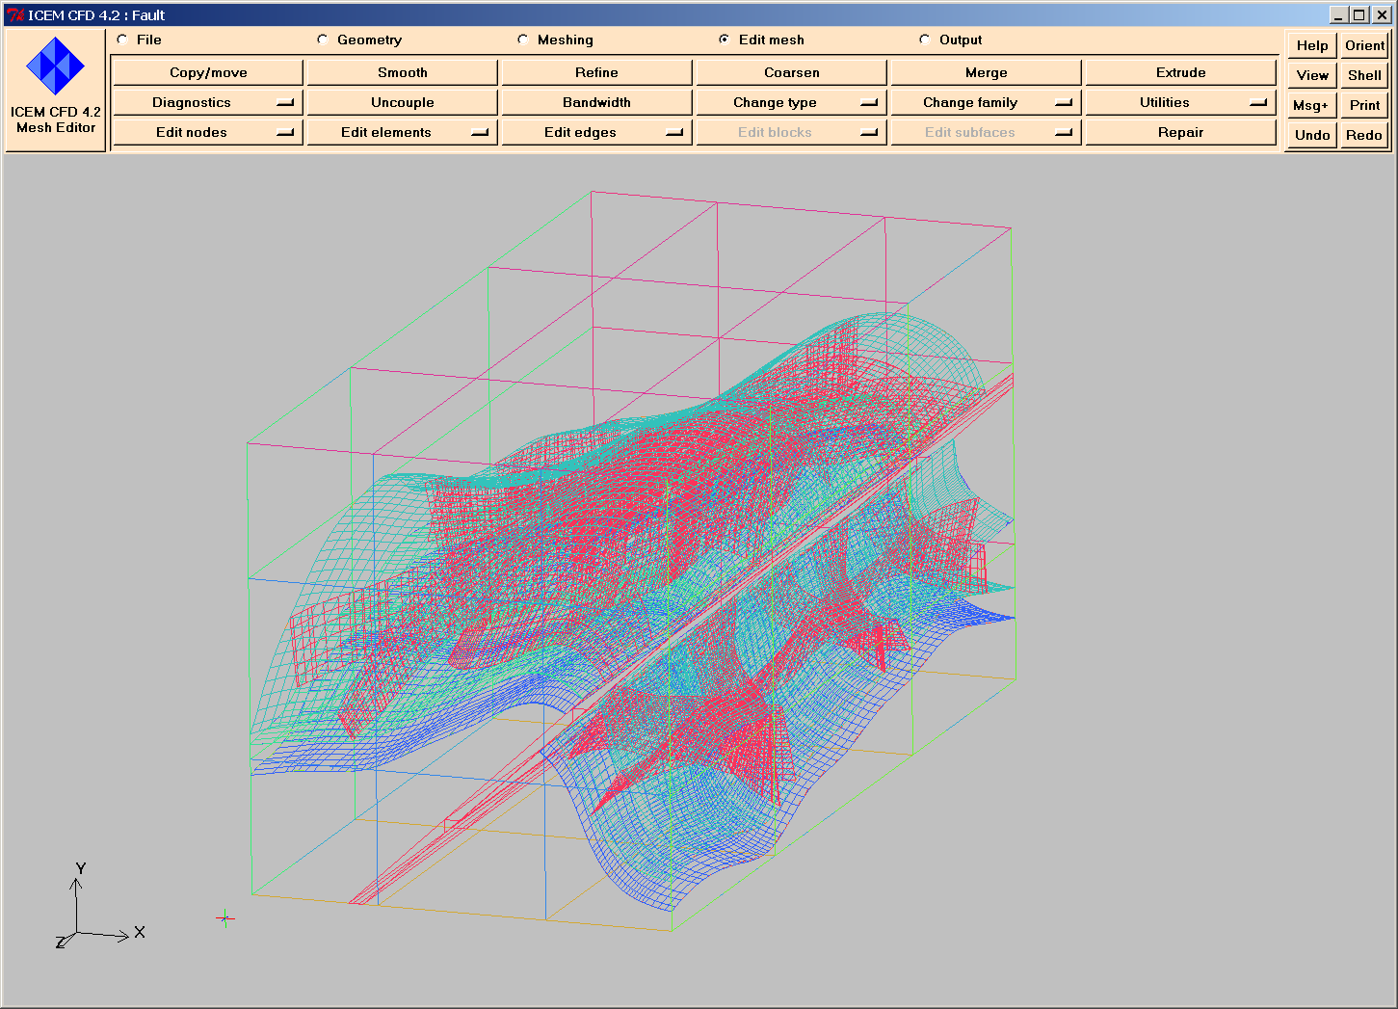
Fig 39. Complex fault geometry with multiple intersecting free-form surfaces. Special attention should be paid to adequate parameters in the “Model Mesh” menu.
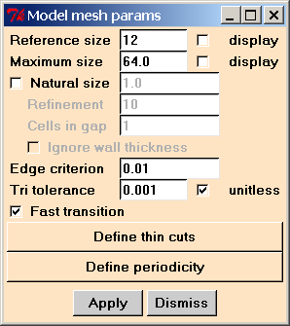
Fig 40. “Model Mesh Parameters” menu and critical values of the “Edge criterion” and “Tri tolerance” parameters for Rhino3D geometry, using lofting and railing operations.
Fig 40 shows adequate values of the edge and triangle tolerances for a 750x80x80 meters model with expected 400K elements. However, edge criterion could be too small, as we will see during the mesh generation process. Starting ICEM CFD Tet mesh generation code, we will receive the following output in the Message window of the mesh generator (Fig 41):
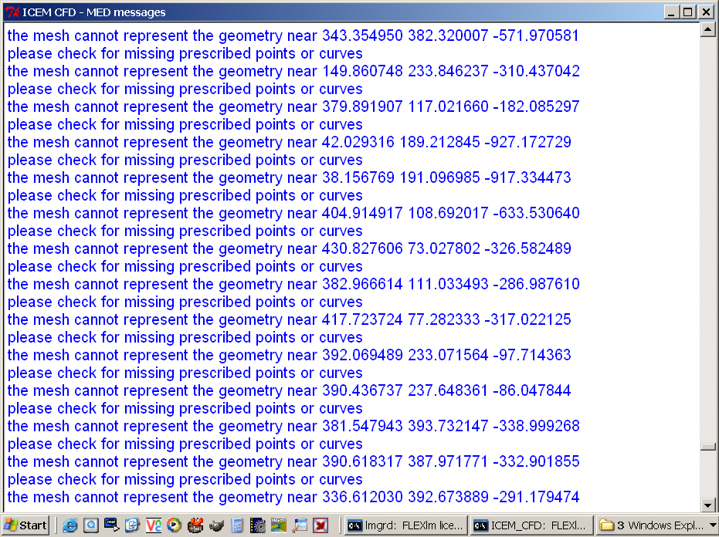
Fig 41. Message window of ICEM CFD, showing typical warnings, related to gaps between trimming curve and underlying surface.
This indicates, that most probably in some of the regions the trimming curves of the railed surfaces do not lie on the surface and the attempt to position the mesh modes both on curves and surface will result in the so called “non-manifold” vertices.
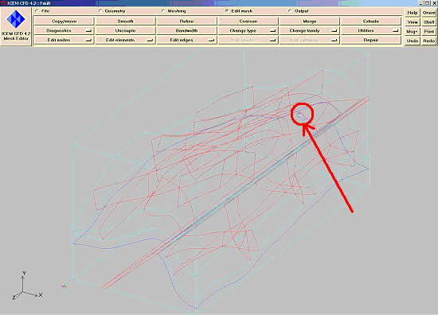
Fig 42. Non-manifold vertices (found during mesh check) following the error messages on Fig 41, related to gaps between trimming curve and underlying surface.
Fig 43 shows the output of the mesh quality check (see also discussion above and Fig 30) in the message window of ICEM CFD mesh generation code. The “Multiple edges” and “Single Edges” problem is related here to the presence of the coinciding trimming curves on the fracture and fault surfaces. However as we do not use edge elements in our computations that will not introduce any errors to the solution, moreover these elements will be disregarded during translation. The real problem here is the presence of non-manifold vertices.
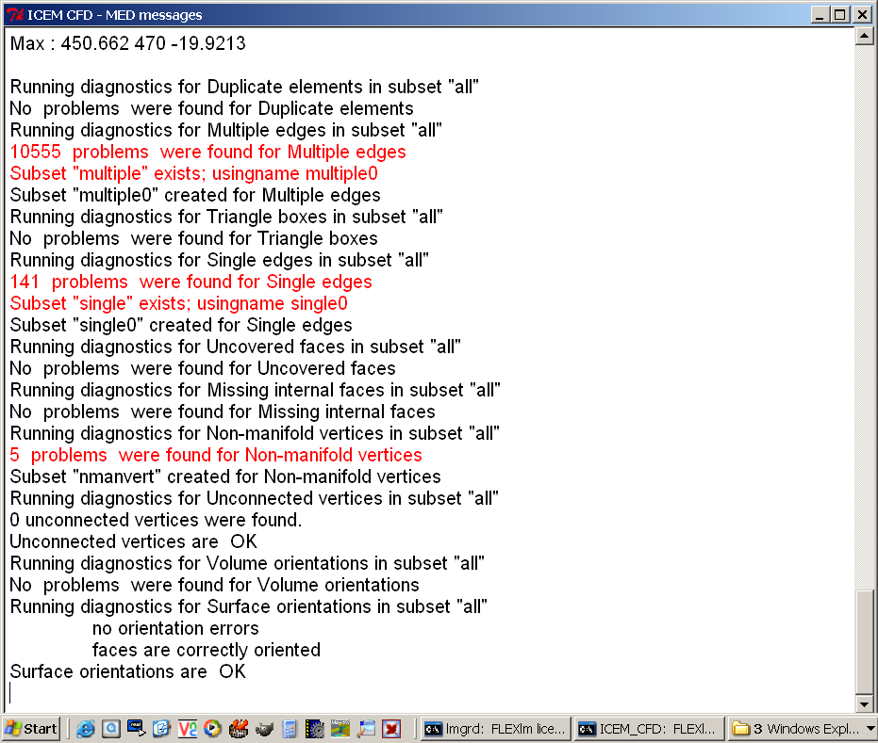
Fig 43. Output of the mesh check, showing multiple edges, single edges and non-manifold vertices in the mesh following the above error messages, related to gaps between trimming curve and underlying surface.
To correct it, we should increase parameter “Edge criterion” to 0.02-0.03 and that will eliminate non-manifold vertices, giving the valid mesh suitable for computations, shown in Fig 1.

Refrences:
- http://www.rhino3d.com/
- Piegl L, Tiller W. The NURBS book, Springer, 1997, 646 p.
- Thompson JF, Soni B, Weatherill NP. Handbook of grid generation, CRC Press, 1998.
- http://www.icemcfd.com/
- Schneiders R. http://www-users.informatik.rwth-aachen.de/~roberts/mesh generation.html.
- Mezentsev A, Woehler T. CAD repair for incremental surface meshing, in: 8th International Meshing Roundtable, South Lake Tahoe, 1999:299-309.
Annex 1. Grossary.

CAD – Computer Aided Design, mostly preparation, processing and output of drawings on computers.
NURBS – Non-uniform Rational B-spline, mathematical apparatus for representation of curves in CAD;
BREP – Boundary Representation, a format for representation of 3D free form objects by it’s boundary, defined by NURBS curves and surfaces. BREP essentially uses NURBS approximation of the outer boundary to define the shape of the object.
Rivet – small periodical patches on a larger patch with certain periodicity.
Taper – narrowed toward a point;

Annex 2. Boundary Representation errors, creating problems for mesh generation
Part 1: Meshing algorithm independent errors
Class of CAD error | Type of CAD error | CAD errors examples and typical Rhino Operations
Independent | Geometrical | Non-abutting patches of a surface | Curve self-intersection | Surface self-intersections | Intersections  Railing  Lofting
Independent | Topological | Vertex on an edge does not match underlying curve | Face with open loop | Difference of surface and boundary curve | Trimming with big tolerance

Part 2: Meshing algorithm dependent errors
Class of CAD error | Type of CAD error | CAD errors examples
Dependent | Incremental and octree meshing | Taper face | Small face | Singular face | Conical faces
Dependent | Incremental  and octree meshing | Long thin face |  | Rivets on a face | Specific periodic shapes
Dependent | Incremental and octree meshing | Tied face |  | Warped face | Specific 3D shapes

Spatially-Variably Refined Meshes from PSLG’s

Constrained-conforming 2D Delauney triangulations can be created from “parallel straight line graphs” with the very efficient and flexible program Triangle (J. Shewchuk, http://www.cs.cmu.edu/~quake/triangle.html). Please refer to the documentation of this program for details on how to operate it (on the command line type “triangleMesher –h” in the directory where the triangleMesher.exe lives). The utility program GeometryPreprocessor.exe by SKM is provided with CSP to create “.poly” input files for Triangle using “.dxf” files as input (DXF is a graphics interchange format created by AutoCAD. One must make sure that the DXF file format is compatible with the original DXF standard specification (new AutoCAD files are not, those up to version 12 are). A number of other rules must be adhered to when creating a DXF file for the GeometryPreprocessor program:

- The first polygon in the drawing must be the bounding rectangle/graph (drawn as a closed polygon, not as a rectangle and insuring that the origin is in 0.0, 0.0).
- The absolute dimensions of the drawing will be those of the final model. Change the drawing scales accordingly.
- Draw polygons and lines, but do not smooth any of these. Also duplicate polygon segments must be avoided. Thus, at least one of two polygons which share a boundary, must be an open polygon.
- “Triangle” expects minimum angle bounds for the triangular finite-elements it generates. These should not be violated by any intersections of lines in the drawing or by angles inside the polygons themselves (Triangle cannot discriminate between wanted and unwanted angle bounds and will therefore continue to refine the model until it runs out of numerical precision). The angle bound (option –qXX.) can be used to influence element size gradients in the mesh. The larger the bound the more smoothly transitions will be.
- Triangle will need “material points” to assign properties to polygon- or line-delimited regions in the model. One can pick such points manually and create a regional property list inside of the “.poly” file (see instructions in Triangle documentation for the format of this list). Alternatively, (Option 2 in G.P. menu) one can let the GeometryPreprocessor assign these points on the basis of specific fill colors applied to closed polygons in the drawing. The GeometryPreprocessor program will prompt the user for property values which shall be assigned for each color. However, preparing the material points list by hand (Option 1) is highly recommended over the more advanced option 2 since the conversion algorithm is much more robust.
- One can also use drawing layers in DXF files to discriminate among objects which should or should not become part of the mesh. The GeometryPreprocessor expects at least one drawing layer specification. If the drawing program does not indicate the name of the default layer, the DXF file can be examined directly since it is in text format. Many drawing programs call the initial layer DEFAULT layer. Use input layer names in capital letters since DXF file content is not case sensitive.
- In the “.poly” files one can specify a maximum triangle size for each PSLG region. Otherwise, Triangle will make the mesh as coarse as possible given the amount of geometric detail in the model. The GeometryPreprocessor’s Option 2 will assign default size bounds which can be edited before the meshing.
- The PSLG must be exact ! - Duplicate region boundaries must be avoided and filled polygons which overlap each other cannot be used to mimic cross-cutting relationships. Triangle removes duplicate points, but the more of such glitches occur the more likely it is that one will get a corrupted mesh. The error reporting of Triangle (options –CV), is very good.
- When running Triangle (on a PC or Unix/Irix machine) one must give angle bounds for the triangulation and also request a “*.neigh” file needed by CSP to establish neighbors of each finite element. The suggested set of command line arguments for Triangle is (run triangle –h for what the options mean):

triangle –a –A –e –p –q30. –n –O –V myfile.poly

The GeometryPreprocessor (Option 2) program helps to identify faulty input geometries by writing a separate DXF file (*.faulty.dxf”) containing polygons that violate the angle bounds for Triangle. This, however, is useful only for input geometries which consist entirely of closed polygons. Furthermore, Option 2 reports if it cannot find a unique material point for a polygon by outputting the coordinates of the problematic polygon as well as those of the polygon which contains the ambiguous material point. In most cases the reason for this type of error are duplicate or overlapping polygons. The GeometryPreprocessor (Option 2) will fail to detect small angles that arise where polygons intersect. Such locations (in model coordinates) will however be reported by ‘Triangle’ which is useful for fixing these errors.

Triangle creates “.node, .ele” and “.neigh” files with a number corresponding to the refinement level (one can refine the same mesh several times to test for mesh convergence and mesh sensitivity of a computation). With the verbose meshing option, some useful mesh diagnostics will be reported in the meshing process. One can also examine the quality of meshes visually, with the program “ShowMe”. This program was also written by J. Shewchuk but runs only on platforms with X-windows capabilities.

While a Triangle output mesh may be perfectly fine in terms of angle bounds etc., it may still contain knots where clusters of extremely small elements were created. This is most certainly the case when the reported mesh statistics indicate the existence of elements with an area below 1.0e-3. In this case two very closely spaced points in a polygon, or a failed point snap leaving a minute gap in the model, are the most likely culprits.

“Triangle”-generated meshes are imported into CSP using its mesh interface which is encapsulated into the class MeshInterface. The code for this is simple:

CSP_TRIANGLE_Interface mesh_interface;
CSP_VSet<csp_float,2> vset;
char fname[200];

cout <<"\nmain: Enter name of 'Triangle' input file set: ";
cin >> fname;
mesh_interface.ReadTriangle2DMesh( fname, vset );

SuperGroup<csp_float,2> my_new_model( vset );

The method ReadTriangle2DMesh() reads the set of input text files (.node, .ele, .neigh) created by Triangle and puts the results into the CSP_Vset with the name ‘vset’. Property values will be stored and interpreted as the element variable “permeability”. A fast way of arriving from this data at desired values of other properties is to first create element Group objects for each of the permeability values and then use the Group class interface to modify the corresponding regional properties:

set<string> group_names;
my_new_model.GroupsFromPropertyValues( "permeability", group_names );

In this example, the names of the new groups are output to an STL set of group names.

Trouble Shooting. There are many checks that CSP performs on mesh topology and additional checks can be invoked while running Triangle by using the –C option. If one still gets a message from the Solver, e.g., DIAGONAL NOT POSITIVE, the most likely reason for this is that one of the region points failed to lie inside the target region and the Triangle flag –O (no holes) was specified. In this case, Triangle assigns a zero material property value to the Elements in that region. Clearly this value will be propagated into the global solution matrix. One can see whether this is the case by examining the “*.1.ele” file with the material properties of the elements.

PSLG Creation in Rhinoceros

The following documentation stems from Mandefro Belayneh’s PhD thesis entitled “Analysis of natural fracture networks in massive and well-bedded carbonates and the impacts of these networks on fluid flow in dual porosity modeling.” (Imperial College London). Mandefro created extremely intricate fractured limestone models with Rhino and encounted all possible caveats of PSLG’s in this process.

CAD representation: as points, lines, poly-lines in 2D, surfaces and poly-surfaces in 3D.
Initial step: Fracture trace maps representing the geometry of fractures saved as Adobe Illustrator as my file.ai or my file.dxf format can be used as initial step. These are then imported to the Rhinoceros2.0TM commercial software package. In the ‘properties’ dialogue box, initial settings are set before proceeding to the next step. Unless otherwise stated, all the measurements are in SI units.
Set the following properties: Absolute tolerance (0.001) in metres is one order of magnitude smaller than the smallest feature in the model. The smallest feature in the model is 1mm by default. Relative tolerance (0.01) is the ratio of the smallest to the largest feature expressed as percentage. If the smallest and largest features in the model have magnitudes of 0.001m and 10m, the relative tolerance will be 0.01. Angle tolerance is by definition 0.01 and determines the quality of mesh.
The grid spacing dialogue box shows snap spacing, grid spacing, major lines every and grid extents. These properties are dependent on the size of the 2D map under consideration. After setting these properties, the joint/fracture trace map can be imported to Rhinoceros.
To assign an aperture for each joint trace map, each joint has to be offset by the magnitude of the effective hydraulic aperture of the joint (e.g. 0.003 and 0.005m). Joint aperture is the distance measured perpendicular to the plane between the opposite walls of a joint. Joint surfaces are far from being planar and the distance between the two varies along the fracture. The boundary object that bounds the fracture trace map on the default layer is carefully redrawn. The fracture traces are drawn as poly-lines. The poly-lines in the middle of the model are closed poly-lines whereas the ones adjoining the boundary object are open. All points along the boundary lines intersecting the boundary object should be precisely snapped.
On a different drawing layer, each region has to be defined by material points. Each fracture bounded block is bounded by a poly-line defined by material points with co-ordinates (x,y) in the 2D plane and (x,y,z) in 3D space. These points serve to uniquely identify fracture bounded blocks (matrix) and fractures within the model, as shown in Table 1. The assignment of the material points shown in Table 1 can be done using Microsoft Excel and saved as a tab-delimited text document.

Table 1 Material points assigned to joints and joint bounded blocks (matrix).
1 x₁ y₁ z₁ k₁ A₁ (all columns are tab-delimited)
2 x₂ y₂ z₂ k₂ A₂
. . . . . .
. . . . . .
n x_{n} y_{n} z_{n} k_{n} A_{n}

where n represents the number of the material point within the model. The first column is a positive integer ranging from 1 to n allocated to each data point, the second to the fourth column represent the position in the 2D plane or 3D space, the fifth column represents permeability and the last column is the maximum area of the largest finite element allowed in the mesh of this region of the finite element model. Because of their different sizes, fractures and matrix will have different mesh sizes. This adaptation to size gives a unique possibility of representing and analysing the smallest features in the model. In this model, joints and matrix have permeability (k) values of 1.00e-12m² and 1.00e-15m² respectively. If the joints are interconnected, a single value of permeability will define the property of the network. To distinguish each block so that it can later be addressed individually, permeability variation of 1.00e-10m² has been added in order to simulate a realistic variation of permeability that would be found in rocks. This artificially enhances the permeability and enables the variations encountered in naturally fractured rock masses to be represented. In this work the specified apertures are large enough to ensure that joint permeability is always greater than the permeability of the matrix unless otherwise stated. The complete view of the joint trace map drawn using Rhinoceros commercial software with the material points assigned is shown in Fig. 1.

Fig. 1 to be shown here if necessary

The default layer is saved in ‘Rhinoceros’ as my file.3dm and my file.dxf in AutoCad release 12. The dialogue box appears and the settings entities only, polyline maximum angle (0.01), polyline chord height (0.001) and polyline segment length are selected. The layer containing the material points will be saved as my file.csv and then the extension converted to my file.txt.

Run a GeometryPreprocessor .exe
This program is an input file for triangleMesher and helps to identify faulty input geometries such as those violating the angle limit of 30º. To run this command, type 1 and press enter. Main: enter the name of the dxf file: type the file name without the extension and press enter. Please enter the number of the drawing layers to be read from file: type 1 and press enter. Please enter the name of the desired layer: type DEFAULT all in upper case letters. This program reads polygon(s) and lines from AutoCad.dxf format and converts polylines to triangleMesher input such as my file.poly and my file.vtk files. Open my file.poly and type the number of material points described in Table 1 and type 1 separated by a tab. Then copy and paste the five columns from Microsoft Excel saved as tab delimited *.txt format from Table 1 in my file.poly created by the GeometricPreprocessor.exe program.

triangleMesher (command prompt window)
Go to (change directory) the directory where the triangle mesher is located and type csp-etc\meshing\triangleMesher –aAnepCVq30. my file.poly. The combination of letters signifies a range of options available through -help. The number 30 denotes the minimum angle criterion in the triangle mesh (i.e. that the angle between two poly-lines within the mesh should be greater than or equal to 30). The mesher creates five output files with the extensions *.1.poly, *.1.ele, *.1.node, *.1.neigh and *.1.edge. The maximum number of points, triangles, segments, encroached segments and bad triangles will be displayed on the screen. In the example shown (Fig. 2) 623,975 nodes, 1,897,141 segment faces and 1,264,167 triangles are allocated. In addition to this information the mesher shows the minimum area of individual triangles in the mesh which should be greater than 1.00e-06 in this analysis.

Run CSP3D_Mesh_to_VTK.exe
Type my file.1 without extension. In this analysis the main element width range, element area range and model dimensions (x,y) 0-x and 0-y in metres will be displayed on the screen. The program checks the existing files and creates the files mesh0.vtk and log10-permeability-node.vtk which will later be displayed in the viewing directory. It also shows SMALL_ELEMENTS-mesh.vtk when the areas of the finite elements are less than or equal to 1.00e-06 and ZERO_ELEMENTS_mesh.vtk when there are regions in which material points are absent. Small elements will be created if extremely small regions (less than the value in the default) accidentally exist in the model or when the poly-lines (traces of joints) are not properly snapped to boundaries in ‘Rhinoceros’. Before proceeding to the next step, regions with no material point should be assigned one, and small areas need to be removed. The mesh can be displayed by copying and pasting mesh0.vtk and log10-permeability-node.vtk files into the VTK examples directory as shown in Fig. 2.
Compared to the ‘finite grid difference methods’ in which all objects are discretized with equal resolution, the unstructured grids of the combined finite element and finite volume methods have the advantage of flexibility in grid size and are therefore capable of representing the smallest features, such as fractures, reasonably well (Fig. 2). In finite difference methods, the properties of the material are assumed to be continuous and uniform. A continuous material within the model can be represented as a set of discrete points arranged as an equally spaced grid. The unknown variables in the equation are solved at the nodes. Associated with each node or block are the known values. There are two types of nodal representations: (i) ‘block centred grid’ where the nodes are placed at the centre of the grid and (ii) ‘mesh centred grid’ where the nodes are placed at the intersection of the grids. The finite difference method is commonly employed in hydrogeology where mesh- and grid-centred methods are most convenient in situations where head and flux are specified respectively (Fetter, 2001). The grid is regular with the rows and columns representing small increments in x (i.e. Δx) and y (i.e. Δy) directions respectively from the reference point.

Figure 2 be shown here if required

Figure 3 to be shown here if necessary

Figure 4can be included here

Copy and paste both mesh0.vtk and log10-permeability-node.vtk created by running CSP3D_Mesh-to_VTK.exe and my file.vtk created when running the GeometricPreprocessor.exe program into PermeabilityViewer. This will show conductive areas in red and the surrounding matrix in blue (Fig. 4). Thus it can be used to detect incorrectly assigned areas, for example when the joint traces are not properly snapped to the boundary line or matrix blocks are not constructed from closed poly lines. In the latter case, the model will flood with red indicating that the matrix has the same permeability as the fractures.

CSP3D_linear_flow_analysis.exe
Copy and paste the five files *.1.poly, *.1.ele, *.1.node, *.1.neigh and *.1.edge created by running the triangleMesher.exe program in the working directory and write the configuration file as shown in Table 2.

Table 2 Configuration file for the linear flow analysis in CSP3D.
'my file.1' model configuration file for CSP3D example file set

joints permeability 1.0e-12 1.0e-12
matrix permeability 1.0e-15 1.0e-15

# material properties applied to the whole model
porosity 0.25
storativity 1.0e-9
fluid volume source 0.0
fluid pressure 0.0

# property assignment to model subregions
joints complete porosity 1.0
joints complete permeability 1.0e-9

# global essential conditions (in this case boundary conditions)
LEFT Dirichlet fluid pressure 1.0e+7 1.0e+7
RIGHT Dirichlet fluid pressure 0.0e+0 0.0e+0
CSP3D_linear_flow_analysis.exe reads *.1.node, *.1.ele, *.1.neigh and this configuration file displays the properties of the model described in Table 2. The permeability at each nodal point, each finite element and neighbouring elements will be computed. The user will then be prompted to indicate whether he/she (i) requires the output in the form of JPEG images of the pressure and velocity distribution or (ii) if the user would like to group integral by group volume or if he/she (iii) would like to vary permeability in a single group or if he/she (iv) would like to model transient flow.
The output from the linear flow analysis is a series of files for the visualisation toolkit (VTK, Kitware.com) such as fluid-pressure0.vtk, nvelocity0.vtk, nvolume-flux0.vtk, volume-flux0.vtk, velocity0.vtk, CSP-monitored regions in text format, and a flow velocity histogram for the model. Fluid-pressure0.vtk depicts the pressure distribution within the model for a given far-field pressure. The output file velocity shows the fluid flow velocity in the finite elements and nvolume flux shows the nodal volume flux within the model. Flux is extrapolated to the nodes so that it can be visualised using rainbow colour shading. Flux_histogram.bins creates joints-volume_flux.txt and matrix-volume_flux.txt which are the velocities of fluid within the joints and matrix respectively, computed as a range of normalised frequency versus velocity (as class intervals) which will later be opened with Microsoft ExcelTM or notepad. The results can be plotted as histograms to determine the characteristic velocity of fluid flow either within the joints or within the matrix.
A hydrostatic far-field fluid pressure gradient has been assigned to the models in order to give flow velocities a physical meaning. A fixed (Dirichlet) fluid pressure is applied on the two opposing edges of the model. The other two edges are treated as no flow boundaries. In the model, this makes the fractures impermeable on the no-flow boundary region.
Outputs will be velocity histograms, pressure distribution, stream lines, etc.

3D Meshes generated by GoCad

An interface between CSP and GoCad is provided by the CSP_GocadInterface. CSP can write GoCad ‘TSolid’ and TSurf’ files and it can read GoCad output in the same format. Clearly, the GoCad program has a very extensive documentation by itself. File formats are briefly explained in the publically available part of the GoCad documentation at
(http://www.ensg.u-nancy.fr/GOCAD/Welcome.html).

Geometry building in GoCad is difficult, not in terms of creating individual surfaces but in terms of achieving a volumetric decomposition with correct surface intersections as is needed before a useful 3D mesh can be generated. Hence, the program Rhinoceros (R. McNeel & Associates) is recommended as a more flexible tool to build initial three-dimensional object descriptions for input into GoCad where these geometries can be meshed.

From Rhino

If closed surfaces have been prepared for 3D volumetric meshing in GoCad or other meshing tools one must first check whether these surfaces have any holes i.e. naked edges. If Rhino is used for the geometry generation, choose: Analysis -> Edge Tools -> Show Naked Edges.
- Naked edges can be capped by surfaces which are joined to repair the closed surface.
- While blending in Rhino gives very aesthetic caps and transitions, care should be taken since once such surfaces are meshed an extremely large number of triangles arises in the regions with tiny radii. GoCad has difficulties with triangulated surfaces over which triangle size varies a lot.

When one outputs Rhino geometry as raw triangles (File -> Export Selected -> filename and dropdown menu option “triangulated surfaces (*.raw)), as is necessary to bring these objects into GoCad, Rhino must first create triangle meshes from the analytical NURBS curves (non-uniform regular B-splines) which it uses internally to describe geometry. This process is controlled by the output menu. Rhino will first break the surface down into quadrilaterals, the properties of which the user can control. These can be viewed with the preview command. The actual triangles will only be displayed in part.

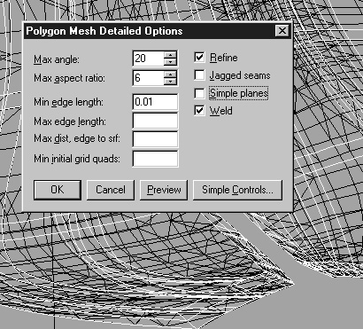

Figure 14: “raw triangles” output menu in the NURBS modeling program Rhino (version 1.1-2.0).

The options and their desirable settings depend on the goals of the modeling. A highly resolved surface will lead to 3D meshes with a very large number of tetrahedra. The options in the Rhino dialog box have the following meaning:
Max angle: Angle between NURBS and actual triangle plane. The smaller, the more triangles are generated and the better the surface is matched.
Max aspect ratio: Aspect-ratio (width over height) of quadrilateral which is broken into triangles.
Min edge length: Lower bound on quadrilateral edges such that the meshes do not get too fine.
Max edge length: Upper bound which can be used to force a certain degree of refinement, especially for flat surfaces where “Max angle” has no effect.
Max distance: Gives alternative way to “Max angle” in terms of specifying how well the mesh will actually match the triangulated surfaces.
Min initial grid quads: Sets the minimum size of the quadrilaterals on the basis of which the matching iterations will be performed.

CSP Geometry Preprocessor

Again the GeometryPreprocessor module (GeometryPreprocessor.exe) is needed to transform the Rhino output into input files for GoCad. Option 3 or 4 are currently used for the processing of triangulated surfaces from Rhino. Use the possible coordinate transformation only for models relating to the Sigma mine project. The preprocessor will list the objects by their Rhino name prompting the user for a specification of the GoCad object type (see GoCad documentation for an explanation of the deeper significance of the available options for geological objects). The preprocessor will write a GoCad TSurf file for each surface object. These files can be read directly in GoCad using the: File -> Load Object option.

In Gocad

Rule 1: Save project after each processing step since GoCad is prone to crash without warning. Once a triangulated surface from Rhino has been imported into the current GoCad project, it must be examined again for its suitability for meshing. If a closed surface shall be meshed using tetrahedra, it first must be tested for holes which may have accidentially been created when Rhino carried out the triangulation of the NURBS surfaces. The steps in GoCaD are:

1. Import Tsurf objects from the CSP Geometry Preprocessor module into GoCad.

2. Test surfaces for holes by choosing Surface Mode -> Graphics -> Show Borders in the property visualization panel on the left. To get the properties for the surface of interest, this surface’s name must be selected in the box above the property panel.

3. Complicated closed surfaces should be tetrahedralized individually, before creating a model which is meshed as a whole. This way, potential errors are located and detected before time is invested into complex model building.

4. If there are problems meshing individual volumes, - under the Edit menu - options can be found to improve surface meshes (Since GoCad cannot move nodes on surface meshes when building the volumetric meshes, this may help). Try the options:

Edit -> Beautify -> Beautify triangles
-> Switch Triangle
-> Remove Mercedes.

to improve surface meshes while examining these in the display window.

5. Create a geological model from closed surfaces, open surfaces, and the bounding box (this will not copy properties which must therefore be assigned to the model at a later stage). The model is created by:

Model -> From Surfaces (in the Surface mode).

6. Change from General to Solid mode and mesh the model by calling:

New (Solid) -> From Model.

Various options exist: Choose all three ! - “to densify”, “get constraint faces”, and “copy properties”. If the constraint faces are omitted, Gocad will only output a single TVOLUME object such that CSP will not be able to discern different model regions. Worse ! – CSP will not be able to read the file correctly, because GoCad will present the property information in a different way.
With option “To densify” selected, GoCad may crash, especially when trying to allocate memory for its expensive octrees. However, this option must be selected, because, otherwise, GoCad will not insert node points inside the surface-delimited volumes which define the model. If “to densify” is omitted pointy tetrahedra will reach from one side of a volume to the other !

7. Assign material properties to the model. Only one property named “permeability” is needed by CSP. From the space subdivision given by this property other material regions can be derived later after defining CSP groups. Choosing

Property -> Create

brings up a dialog which allows to define the property. Select each of the surface assigning properties by entering property name (“permeability”), unit, and NODATA Value. The latter value permits to assign property values which are unique to the tetrahedralized volumes delimited by the closed surfaces to which the property was assigned. However, only one NODATA value is currently recognized per Tsolid input file.

8. Output model as GoCad TSolid object (Save Object As...) with extension *.so. Open this file in a text editor to see whether the material properties were assigned correctly and whether it contains the right number of TVOLUME descriptors corresponding to the volumina delimited by the input surfaces. Warning: If the property “permeability” is missing or other properties are included, the standard CSP MeshInterface object will not be able to read the “Tsolid” file.

When the GoCad Tsolid file is generated on a UNIX system and CSP is used on a PC, care must be taken to ftp this textfile correctly to the PC file system. The “ascii” option must be used in ftp in order to turn unix line breaks into PC-suitable ones. If the file is opened in CodeWarrior, the line breaks can be changed after the transfer using the respective editor bar, drop-down menu.

Caveats

The calculate range dialog in the GoCad property menu does not work. If fractures are to be included as planes or other surfaces shall be output explicitly for computations, those must be used which GoCad creates in conjunction with the generation of the Solid. Only these are compatible with the solids in that their triangles represent the faces of the adjacent tetrahedra. If this approach is used, however, there appears to be no way of correctly transferring assigned property values to the TSolid and TSurf output files.

3D Mixed Tetrahedral & Triangular Element Meshes From GoCad

In three-dimensional fluid-flow models, it is possible to represent planar zones which are more permeable than the surrounding rock by triangular surface meshes. In such models, each triangular element shares the nodes of, and lies in between two adjacent tetrahedral elements which still have eachother as neighbors. The neighbors of the triangular elements forming the surface mesh are assigned as they would be in 2-D models. Thus, only triangles feature in neighbor lists of triangles and only tetrahedra feature in the neighbor lists of tetrahedra.

Since the triangles are oriented arbitrarily in space, a special mapping from 3D to the triangles local (2D) coordinate system must be applied. Thus far, this is only implemented for the QuadraticTriangle element. The mapping is switched on by constructing this element with the boolean value “true” as constructor argument (see example code 14).

Mixed triangular-tetrahedral meshes will contain far less elements than equivalent meshes where planar objects have a volumetric representation. As an alternative application of the mixed surface-volume mesh capability, one may use it to compute and assign boundary conditions on irregular 3D boundaries or interpolate displacements on fault planes. Importantly, CSP also supports the input of material property values from surface meshes such that these can be used as input data or for comparison with modeling results. This capability facilitates a direct comparison of modeling results with surface-based information from mining or seismics. Through the CSP interface to GoCad one can also use its smooth interpolation capabilities to the benefit of CSP (in GoCad, scattered material properties data can be directly interpolated on surfaces).

With surface elements, one should also be able to model surface-normal growth processes or moving interfaces in a model: Erosion, mineral precipitation, friction etc.

Implementation (see example19.cpp)

- MeshInterface class object reads GoCad surfaces with associated property information and stores this information in a CSP_VSet.
- CSP_VSet object: If necessary, node property data (such as vein thickness) is converted to element property data as the latter cannot be assigned in GoCad.
- CSP_VSetConverter: Converts CSP_VSet for element type which is being used.
- CSP_MeshManager: Renumbers nodes in CSP_VSet, identifying to which nodes inside the already existing SuperGroup the new nodes correspond to. This comparison is carried out for the node coordinates up to a user-defined precision. If corresponding coordinates can not be found in the SuperGroup object, a fatal error is reported.
- CSP_MemoryManager: Assigns the property data to the SuperGroup model. This requires the creation of new storage for element variables assigned to the new planar elements.
- SuperGroup: Special Group interface AddGroupFrom( CSP_VSet, element type ) builds group from supplied element and node lists. This method uses the new element ID’s to form a Group object which corresponds to the added surface mesh. It entails the steps from above, using the corresponding Managers.

Example code 14, illustrates how mixed meshes from GoCad are used in a 3D steady-state fluid-flow simulation. Very importantly, when exporting the surfaces from GoCad, only surfaces created together with the solids can be used, because GoCad modifies original surface meshes when it creates the solids.

Processing of CAD models in ICEM

Stephan’s step by step procedures for ICEM Tetra, volume, and surface meshes as well as the procedure of extruding surfaces to wedge layers with PRISM.

Creation of surface-only models

The following description gives an overview of the most important commands of ICEM's Tetra GUI. It is attempted to give step by step instructions how to pre-process
geometrical objects imported from an IGES (stereolithography file) to get them ready to run the mesher. Note that for this process a 3-button mouse is essential. Left button to select, middle button to enter selection, right button to end sequence of commands and to confirm operations.

ICEM's interface actions are monitored in the status window at the bottom which also provides help with commands. On the right there is an object display window which allows to select objects and display properties such as “Tetra size”, named material points, full or simple surfaces etc. See also the web documentation at

Geometry (Pre-Processing) Tick Box

D:\applications\icemcfd\4.1-win\help\med\med-Geometry-5.html

Step 1: Create a new project and corresponding) directory tree by typing a subdirectory name into the target directory which shall contain the model. Older projects available under the “previous projects” dropdown menu.

Step 2: Copy geometry *.stl or IGES file into the import/ directory inside the new project and import the geometry with the corresponding option in the ICEM top menu. Before choosing the file, select the file type as STL. (There are direct interfaces such as STL, IGES, or VDA in contrast to import options which require geometry preprocessing in DDN).

Step 3: ICEM top menu; choose Geometry option. From new menu which crops up process in this sequence:
surfaces
curves
material (points)
mesh parameters for model, families or surfaces, and curves

Surfaces: Submenu surface -> create -> segment surface: In order to build individual surfaces from the input geometry which is first treated as a whole one must segment it into surfaces. First, the whole is segmented, then the subsurfaces are created and added to “families” of surfaces using the “change family” command. NB: Objects in each family must still have unique names in order to be recognized and stored as entities. IMPORTANT: To get tetra to honour free surfaces in a model, boundary conditions must be defined on these (“boco’s”). This is done in the “Edit mesh” menu, in the mesh parameters subsection.

Curves: Submenu curves -> create -> segment curve: Curves are necessary such that the mesher will honor sharp edges, i.e. derivative breaks in the input objects. Given the options in the submenu, choose “from both” and enter an angle tolerance which is small enough such that surface undulations are captured.

Material points: Geometry -> Material -> Create -> Screen Midpoint: Points with unique names define the subvolumes which are delimited by closed surfaces or surface groups. These points are later associated with the tetrahedral meshes (triangle meshes are associated with surfaces). Material points are used also to associate properties with volumes. To get a material point to lie inside a volume choose create -> midpoints and click on a range of surface edges such that the coordinate average of the chosen point will lie in the delimited volume. So-called ORFN tetrahedra etc. always lie outside of the considered volume. When choosing midpoints use curves rather than surfaces to locate the point.

Mesh Parameters: These can be set for the entire model (global), or for families (entailing surfaces or curves), or for individual surfaces or curves. The options and procedures are, respectively:

(Model): Geometry -> Surface -> Mesh params -> Model -> enter size etc.: The overall model parameters are set. Apart from sensible default parameters which are chosen by Tetra given an entry of zero, important parameters to set manually are:
Ref size: Scale factor to change the size of all elements in the model.
Max size: Largest elements in the model.
Natural size (tick box): To get a curvature-dependent mesh refinement.
Cells in gap: Used when natural size is on, in order to limit refinement in gaps or other narrow crevaces or small-angled slits in the model.
Edge criterion: Precision with which curves shall be honored.
Tri tolerance: How well the triangles representing the surfaces shall match the input geometry.
Fast Transition (tick box): To get a steep element-size gradient between coarsely and finely refined model regions, thereby limiting the size of the overall model. Use this option first before optimizing the model for later production runs.
Define thin cuts: Specify to the mesher which surfaces are very close together, itentionally, such that Tetra is not allowed to violate their spacing in an attempt to match the size constraints applied to the elements. In order to use this command, the surfaces must belong to different families.

A good magic number for the refinement is 12.
Ignore wall thickness: To replace parallel closely spaced surfaces by a single surface.
(Families): Geometry -> Surface -> Mesh params -> families -> Select family -> Accept -> enter: Size (tetrahedra target ideal size), Height, Ratio (mesh gradient), Minimum Size, Maximum Deviation (relative to input geometry which shall be matched by the mesher), Width (up to what distance from the surface or curve, the mesh shall have the element size defined for the entity). For all options, 0, presents a default value which prompts tetra to place its own choice. At least, the Size and minimum size should be set by the user.
Curves: Same parameter menu as for the surfaces.

The tetra mesher will attempt to achieve the global element size as defined in the model menu away from the constraint surfaces or curves.

Surface entity mesh parameters: For each surface, subsequently a refinement in terms of a desired minimum element size is specified by selecting the corresponding family and then setting the criterion. In this context, ratio refers to the allowed mesh gradient, width to element size, mas deviation to deviations from curves.
Resulting tetrahedra sizes can be displayed in the options panels for curves and surfaces.

Step 5: Boundary conditions: Choose Geometry -> Bound conds -> select family -> New b.c.: For a “generic” solver values can be assigned through this menu. One types “INT” into the type-selection box upon which another box menu appears into which the variable name, an integer identifier, and a variable value can be entered (assigning uniform first order boundary values).

Meshing Tick Box

Step 4: Invoke the mesher: Meshing -> Tetra -> Interactive from CAD -> Fix non-manifold (sticking tetrahedra). Quit the mesher when it has completed and everything is O.K. This will put one back into the general ICEM menu.

The mesher first meshes the entire model and then uses a “flood fill” technique to assign tetrahedra to volumes, starting sweeps at the material points. After the mesher has executed, thin green lines will arise following edges of tetrahedra, at where these have squeezed through holes in closed surfaces. NB: If green lines indicate holes, these can be patched using the “close holes” and the “mesh repair” (Edit Mesh menu) options. After such a repair, an additional floodfill must be carried out.

Edit Mesh Tick Box

The default *tetin file contains the initial input geometry for the mesher. The cut- and uncut domain files contain the mesh. To visualize the mesh first select the material points referring to the meshed volumes and, second, select surface element types from the “Types” section to be displayed in the Display menu. The correct domain file must have been loaded before (File -> Domain File -> Load -> cut.domain).

To avoid lengthy rendering use surface meshes only in order navigate the geometry in the following steps:

Step 5: Edit Mesh Tick box -> Diagnostics -> Quality: This and other options in the diagnostics drop-down menu must be checked sequentially to get an understanding of how well the mesher performed. The determinant option should give values greater than 0.4 for the tetrahedra and the triangles. If this is not the case initially, the mesh quality can be improved with the smooth command. Bad tetrahedra can be smoothed out using the “Smooth” button or edited manually if odd intersections have formed. Individual columns in the quality histogram can be selected and corresponding elements displayed (use display option solid / wireframe).
Apart from the quality histogram, the whole range of error cheques listed in the Diagnostics menu should be performed (Triangle boxes are empty regions between tetrahedra).

Cross sections (of one or a few elements thickness): Display menu -> tick Display Subset -> Modify -> Element selection window -> tick cut plane: Define a cutplane and move it such that it intersects the model at the target position. With the “Layer” menu additional element layers can be added to the single-element thick initial layer in which elements from different families are visualized with different colors. Recommended display setting: Display options -> Solid /Wireframe, Shrink 50% to see individual tetrahedra such that there shapes can be evaluated.

Miscellaeneous Issues

Environment variables which must be set for ICEM are:

ICEM_ACN -> installation directory,
ICEM_LICENSEFILE which the lmgrd.exe uses to retrieve the licensing information for icem. In order for this to work, the icem control panel (.opts) file must be copied into the control panel directory.

Output of Mesh

When the mesh is output, line elements corresponding to curves which were honoured, triangular elements corresponding to surfaces, and tetrahedral elements corresponding to volumes are output automatically. These elements will have unique numbers and associated boundary values are output as well.

Boundary conditions necessary for CSP will be stored in a boco file (e.g., “family.boco”). This file will hold family names and associated boundary conditions.

Element Types. Changing element interpolation to target setting: Edit Mesh -> Change Type -> choose for instance TETRA_10, TRI_6, BAR_4 to replace the standard types TETRA_4, TRI_6, and BAR_2 into higher-order elements. Tetra actually projects the midside nodes onto the target surfaces which shall be matched by the geometry.

Ulrike Wolf's CSP interface needs to be invoked in order to output data in CSP format. This also requires that all the boundaries and boundary edges of the model are stored as ICEM "families" with the corresponding CSP names as described in the CSP User's Guide.

Creating tapered volumes from surfaces with Tetra’s Prism Mesher
SKM 28/12/03 after PRISM customisation with Mike Hohmeyer at ICEM Technologies, Berkeley.

1. Set CAD tolerances to desired values and build model topology representing fractures and faults as surfaces. Create intersection curves and export to SAT or IGES. NB: The tolerances for curves surrounding surfaces in the IGES file must be exactly the ones you set for the Rhino CAD. It is impossible for to regenerate curves that are shared by multiple surfaces inside MED because this will create artificial thin cuts. For isolated surfaces, however, this can be done if there is a mismatch between surfaces and boundary curves. Note also that if the surface margins consist of multiple curves, points need to be created in MED where these curves connect. Otherwise the geometrical description is incomplete. To do this go: Geometry -> Points -> Create -> Extract from Curves.

2. Read model topology file and create volume and surface mesh as usual using tetra and poly-element type post-processing. Get the surfaces to mesh with triangles by making them internal walls. Make sure that surface element shape and quality are optimised.

3. Bring up PRISM in the meshing menu (this procedure will create the prism_params file in the current project directory):
- Set the number of prism layers that shall be created in top-level dialog box
- Go to advanced options:
- Specify growth law i.e. the thickness evolution of the successive prism layers that will be grown. If an exponent of 1 is chosen the layer thickness stays constant. Use this option to mesh faults or fractures.
- Initial height. Should be the thickness of each prism layer in meters.
- Height ratio. This should be 1.0 if one wants to keep the thickness of the successively grown prism layers constant.
- Number of layers. Specifies how many layers of prisms will be added on each side of the surface. Thus, if 3 is specified, the fault will consist of 6 prism layers total.
- Fillet ratio. 0.0
- Minimum prism quality. Specifies the minimum aspect ratio of the prisms that will be generated on the fracture surface.
- Triangle quality. Use laplacian smoother.
- New volume family. In order to group the newly generated prism elements into a new family of choice, for instance, the name of the fracture surface with a _volume appended. One can be more specific and devise two different families for the top and the bottom elements, respectively. This is allows to assign diverse properties to the faults.
- Ratio multiplier. Below this box are two fields to enter ICEM specific commands which are essential for the way the prism elements are created at the tips of the fractures. Enter the following commands here:
  - extend_pyramids 0
- This last step is absolutely essential to avoid that orphan pyramids that extend into space are created.
- DO NOT: smooth the Tetra elements
The taper angle at the tip of the extruded fault is controlled indirectly by the prism (pyramid) element thickness (of each individual layer) and the element aspect ratio as determined by the element size of the original triangle surface mesh.
Currently the downside of prism meshing is that fracture terminations at intersections with other fractures will force these be pinched to zero element thickness in the meshing process. Sequential prism meshing may be the answer to this problem. Give it a try !

An example of a correct prism_params file as written by MED follows:

extend_pyramids 0
n_triangle_smoothing_steps 5
surface_file prism-test1/SKM3fracs-for-prisms.tin
new_volume FRAC_VOLUMES
n_tetra_smoothing_steps 0
ortho_weight 0.50
max_prism_angle 180
triangle_quality laplace
input_file prism-test1/prism-model.uns
fillet 0.00
layers 3
output_file prism-test1/prism.uns
law exponential
smoothing_steps 6
min_prism_quality .01
extend_pyramids 0
family FRACTURES ratio 1 height .01 n_layers 2

Processing CAD models in ICEM
(detailed procedure established by Richard Tomlinson)

Pre-processing:

- FILE
Import Geometry ->IGES to TETIN (select your file and accept)

Now you need to group the parts on your geometry into families by selecting the geometry option and using the change family option, e.g.
- GEOMETRY
  - SURFACES
Change Family. Select surfaces to add to separate families such as TOP, BOTTOM, LEFT, RIGHT, BACK and FRONT, as well as other surfaces such as faults etc.

The same also needs to be done for the curves, eg.
- GEOMETRY
  - CURVES
Change Family (select curves and add to appropriate families).

If no curves are present in the geometry, they can be created in ICEM by:
- GEOMETRY
  - CURVES
Create
Extract From Surfaces (select surfaces to extract curves from).

Points are only needed where a FE node must be located such as at the bounding box corner, fault intersection edges or other sharp, angular intersections. They do not need to be family specific. There family can be changed by:

- GEOMETRY
  - POINTS
Change Family (select points).

If they don’t exist, they can be created by:
- GEOMETRY
  - POINTS
Create
Extract From Curve (select curves)

To delete points:
- GEOMETRY
  - POINTS
Delete
Select (then select points to delete) OR (delete) All Visible.

Finally, Material Points need to be created for volumes only:

- GEOMETRY
  - MATERIAL
Create
Screen Midpoint (select 2 points on the screen and a Material Point will be created which lies in the centre of that line. Give the MP a name or select its appropriate family then ensure the MP lies within the volume by zooming-in).

Once this pre-processing stage has been completed, the TETIN file should be saved by:

- FILE
  - Save As Tetin (Geometry) File (chose a name e.g. test.tin and location).

Please note that it is recommended to give all of the files created from this point onwards the same name as the .tin file, with only the extension varying. Also, it is recommended to save the .tin file several times during this pre-processing stage, this is especially true for complex geometries.

Boundary Conditions:

Now, a Boundary Condition (BOCO FILE) needs to be created and set-up:

- FILE
  - New
Boundary Condition File
THEN
Save As
Boco File (give name, e.g. tets.fbc)

- GEOMETRY
  - BOUNDARY CONDITIONS
Select Solver = CSP, OK.

With the new screen that pop’s up, select:

Back Surface
Create New
Boundary Node ID

THEN, Click on the green tab and select BACK_OUTSIDE, accept, then save Boco File:

- FILE
  - SAVE AS
Boco File

Now, save the whole project (that is the folder which contains the tetin file and boco files):

- FILE
  - SAVE AS
Project (then select project folder).

Mesh Preparation:

- GEOMETRY
  - MESH PARAMETERS
Model:
  - Select reference size and view by ticking the ‘display’ box
  - Maximum size should be 1 to make it the same size as the reference size.
  - Enter appropriate tolerances, i.e. edge criterion should equal the tolerance from Rhino

APPLY, DISMISS

This will apply to the whole model, if however you want smaller elements in certain families:

- GEOMETRY
  - MESH PARAMETERS
Selected Families (select families and assign element sizes to them – these sizes are based on the previously assigned model reference size so 0.5 will mean elements half the size of the model reference size. If the family is an internal surface, select ‘internal wall’. Repeat for all required families.

To view all of the family-assigned element sizes (or to change them):

- GEOMETRY
  - MESH PARAMETERS
All Families

N.B. All of the families will have the model element sizes unless specified differently in the ‘select family’ process.

Once this has been done,

Save the .tin file (as this stores the element size information on it):

- FILE
  - SAVE AS
Tetin (select and save).

Mesh Generation:

- MESHING
  - TETRA
From CAD/Surface Mesh (make sure that the appropriate tetin file is selected. Also the mesh file will have a .uns extension so give the mesh file created an appropriate name, e.g. test.uns.

Click on MESH

Look at the mesh, remembering that different families can be turned on/off, as can different element types.

If you are happy, save the .uns file and project and proceed to outputting the mesh.

If you are not happy, change the element sizes assigned in the tetin file (as described previously) and repeat the meshing process. It is important to note that the mesh can be coarsened or refined by post-mesh generation processing. Here, there are many options but the most common/usefull will be described:

Post-Mesh Generation Processing:

- EDIT MESH
  - SMOOTH (A histogram will appear with mesh quality data. Ideally, the minimum quality should be ~0.3 plus.)
Select Number of Iterations and change ‘up to quality’ then SMOOTH.

N.B. Different element types can be smoothed or frozen (see bottom right corner). Also, in the ‘advanced options’, there is the option of implementing a Laplacian Smoother.

If you’re happy with the mesh, SAVE the tetin file and the project.

Another usefull option is the refine option. This can be applied a singular ‘rogue element’ of several elements or an entire family:

- EDIT MESH
  - REFINE
All Visible OR Select Individual Elements.

The coarsening option may also be usefull, it is implemented in exactly the same way as the smoothing option.

The mesh can be viewed as a solid, wireframe or mixed, by clicking ‘Display Options’ on the right-hand side column and selecting the desired viewing option.

Once happy, save tetin file and the project.
Prism Meshing:

- MESHING
  - PRISM (give the prsim mesh file to be created a distinct name, e.g. testprism.uns).

Number of Layers = number of elements on either side of the surface to be created, e.g. 3 = 6 elements thick in total.

Height Ratio = 1

Click on ‘FAMILIES’ tab and then select families to use the prism mesher on.

Initial Height = element thickness (in metres)
Height Ratio = 1
Number of Layers = as before

ACCEPT

ADVANCED OPTIONS:

-Give outputted file a name as before (testprism.uns)
-Check which tetin file is used
-Enter total height / thickness (= number of layers x 2 x initial height).
-Ensure that the nu,ber of Tetra Smoothing steps = 0.
-New Volume Family = give a name for the family to be created.
-In the bottom boxes, write the following if the geometry should taper at the edges (usefull foe creating faults):

EXTEND_PYRAMIDS 0

ACCEPT.

Once the prism mesh has loaded, switch on the new elements (on the right-hand side) to view them.

Ensure that the prism.uns mesh is up to date and save the project.

Outputting the Mesh:

- OUTPUT
CSP INPUT (Click on file to put out, either test.uns or testprism.uns or both)
DONE
Select Binary and give the mesh files a name e.g. test

ICEM will then write:
Test.asc
Test.log
Test.dat

Auxiliary Programs

Mesh Pre-Processors

The GeometryPreprocessor.exe was already described in the chapter on data input and output. It constitutes the “glue” needed to use the Triangle mesher and other programs.

CSP also comes with a meshing module named Triangulator for the creation of two-dimensional triangulations from regular-gridded geometry representations. This module is used internally by the SuperGroup. The source code “example1.cpp” illustrates how to use the Triangulator to generate a mesh from which a SuperGroup is build.

The MeshInterface class provides further capabilities needed to pre-process GoCad and NASTRAN mesh files for the use in CSP. One of the tasks of these pre-processor methods is the identification of the neighbor elements of each finite-element. This type of data is rarely provided by third-party meshers. The CSP_VSetConverter module takes triangular and tetrahedral input meshes and inserts midside and barycentric nodes such that these meshes can be used with the higher-order finite elements from the Finite-Element Library. It also replaces those corner elements in 2D meshes which have sides on two model boundaries simultaneously. Such elements are unsuitable for computations since they would have zero degrees of freedom if boundary conditions were assigned to the two model boundaries.

Geometry Utilities

A set of topology manipulation classes is integrated into the CSP basic library. They comprise Point, Edge, Polygon, and Triangle classes for two-dimensional operations, and Point3D, Edge3D, and Triangle3D classes for finding line triangle intersections etc. in three dimensional space. Since these classes were based on a book on computational geometry by M. J. Lazlo, their names are prefaced with MJL_. The main reason for the integration of these classes in CSP, is the pre-processing of mesh input files containing parallel straight line graphs (PSLG’s) of models for the program Triangle.

It is an auxiliary program by SKM which reads DXF files prepared according to the specifications in Chapter 4. The interpreted files are converted into input files for the program Triangle. This program by J. Shewchuk performs constrained-conforming Delauney triangulations of excellent quality. The GeometryPreprocessor also converts raw triangulated surfaces from Rhino (R. McNeel & Associates) into GoCad TSurf format. This capability permits to circumvent GoCads or TSurf’s cumbersome geometry generation routines.

