Title: Modelling and Meshing workflow

Part 1: 2D Modelling and Meshing workflow for Rhinoceros Project
Part 2: 3D Modelling and Meshing workflow for simple 3D Rhinoceros Project.
Part 3: 3D Modelling and Meshing workflow for Gocad Skua Project.

Report Code: RGS - 001

The Reservoir Engineering Team,
Department of Infrastructure Engineering,
The University of Melbourne
24/9/2025

Document Status
Report type | INTERNAL REport
Full Title | 2D Modelling and Meshing
Addressee | Members of the Matthai Team
Date of issue | 24/9/2025

 | Name | Signature
Prepared by | Chloe Burney
Checked by | Kuncho Kurtev
Approved by | Prof. Stephan Matthai

Document History
Report Code | Date issued | Prepared by
TRG – 001 | 10/03/2016 | Rep Port
TRG – 002 | 11/03/2016 | Rep Port

Note: Document status is typical for technical reports.

PART 1:
2D Modelling and Meshing Workflow for Rhinoceros Project.

Table of Contents
Title: 2D Modelling and Meshing workflow 1
1. Introduction 11
2. 3D Rhinoceros geological Modelling 11
2.1 New Project and Set up Tolerance 11
2.2 Create Outline box of the project 13
2.3 Assign objects to layers 15
2.4 Import Image to support geological modelling 16
2.5 Create surfaces 17
2.6 Split surfaces 18
2.7 Start and end points for all curves 20
2.8 Advices 21
2.9 Save project 22
3. Ansys 2D Meshing 22
3.1 Import Rhino’s project into Ansys 22
3.2 Tolerance 22
3.3 Repair Geometry 23
3.4 Moving objects into another layer 23
3.5 Check list on the Geometry before meshing 24
3.6 Meshing: Global Mesh Setup 25
3.7 Mesh sizes for parts 27
3.8 Compute Mesh 27
3.9 Vizualise Mesh 27
3.10 Check mesh for quality with Edit Mesh: 28
3.11 Assign boundary conditions and output the mesh: 30
4. References 31
Appendix A. Writing an Appendix 32
A.1 Headings in an Appendix 32

NOTE: In general, abstracts and executive summaries are not included in the TOC (Table of Contents), as it is expected that they are the first section that can be seen as soon as the report is opened for reading.
List of Figures
Figure 1.2 Units properties Menu to set up Model Tolerance. 12
Figure 2.2. Add Layers for boundaries of the project 14
Figure 3.2 Boundaries box, split in 4 edges LEFT, RIGHT, TOP, BOTTOM 15
Figure 4.2 Select object that will be objects created will be assigned to. 15
Figure 5.2 Change Layer for objects already created. 16
Figure 6.2 Import Geological image to build the geometry of the model 17
Figure 7.2 Create first surface of the entire model. 18
Figure 8.2 Model with 2 surfaces 19
Figure 9.2 Example of 2D Model created using the steps 2.3 to 2.6. 19
Figure 10. low angle between 2 curves will create later problem in the meshing and should be avoid as much as possible. 21
Figure 11. Geometry of the Rhino project imported into Ansys. 22
Figure 12. Left: Geometry curves and points in Ansys set with the default Tolerance but not the same as the Rhino project. Right: Tolerance adjusted to the same value to the Rhino project. 23
Figure 13. Add Geometry to an existing part. 24
Figure 14. 25
Figure 15. Checks for 2D Mesh 28
Figure 16. elements in missing internal faces subset. 29
Figure 17. CSP export window. 30

List of Tables
Table 1: Table of Report Sections 15
Glossary
Tolerance: is simply a way of stating how much precision you need, or conversely, how much error you are willing to accept in your project.
NURBS curves: Non-Uniform Rational B-Splines, are mathematical representations of 3-D geometry that can accurately describe any shape from a simple 2-D line. NURBS have a precise and well-known definition. A NURBS curve is defined by four things: degree, control points, knots, and an evaluation rule.
Curvature/proximity based refinement when enabled, the mesh is automatically refined based on geometry curvature and proximity. This will result in larger elements on flat planar surfaces and smaller elements in areas of high curvature or within small gaps.
Nodes In general, a node is a localized swelling (a "knot") or a point of intersection
Elements scale factor multiplies other mesh parameters to globally scale the model. For a list of parameters affected by this scale factor, see the tables in Global Mesh Setup.
All Tri: meshes the geometry with a pure triangular mesh.
Quad w/one Tri: allows for a Quad Dominant mesh with one tri element per surface. The tri element allows for better transition between uneven mesh distribution on the loop edges. Automatic tri-reduction steps may even remove the tri element.
Quad Dominant: creates a quad mesh that allows for several transitional triangles. This mesh type is very useful in meshing complicated surfaces where a pure quad mesh may have poor quality.
All Quad: meshes the geometry with a pure quadrilateral surface mesh.
Patch Dependent: This is a free surface mesh generator that meshes closed regions called loops. Loops are created from surfaces or curves, and holes and internal curves are taken into account.
Patch Independent: patch independent meshing is best for low quality geometry or surfaces with poor connectivity. It uses the Octree method to create a robust patch independent surface mesh.m surfaces or curves, and holes and internal curves are taken into account.

Introduction
Introduction

3D Rhinoceros geological Modelling
For most 2D Modelling and some simple 3D modelling the software Rhinoceros will be used to create the geometry model.

New Project and Set up Tolerance
Before starting any project, the Tolerance of the project should be set accordingly to the size and the resolution of object within the model.
Tolerance is simply a way of stating how much precision you need, or conversely, how much error you are willing to accept in your project. Nothing is 100% accurate or perfect. Different projects and sizes of objects will have widely varying needs for accuracy.
It is important that tolerances should be set at the beginning of the modeling process, for, although you can change the tolerances while you work, objects which were previously modeled with lower tolerances will not be fixed if you raise them.
STEPS:
- Open Rhino and set up tolerance
From menu: File / Properties -> Units
Model Unit: Meters (does it have to be meters? No, but will CSMP treats it as Meters anyway!)

Different Tolerances
In Rhino's terms, the absolute tolerance setting dictates the greatest permissible distance apart that two objects or elements can be and still considered close enough. Close enough means that two surfaces or curves are capable of being joined or that an approximate operation like a sweep will generate a surface whose edges follow the rails to within the specified absolute tolerance.
- Abs. tolerance = size of smallest feature (treated as Meters by CSMP) = i.e. 0.01
- Rel. tolerance = ratio between smallest and largest object (in %) = i.e. 1.0
- Angle tolerance = similar to abs. tolerance, but for angles = i.e. 0.01 (SKM: 0.1)
Use a high tolerance for large models, but low tolerance when meshing
- recommended value 0.001
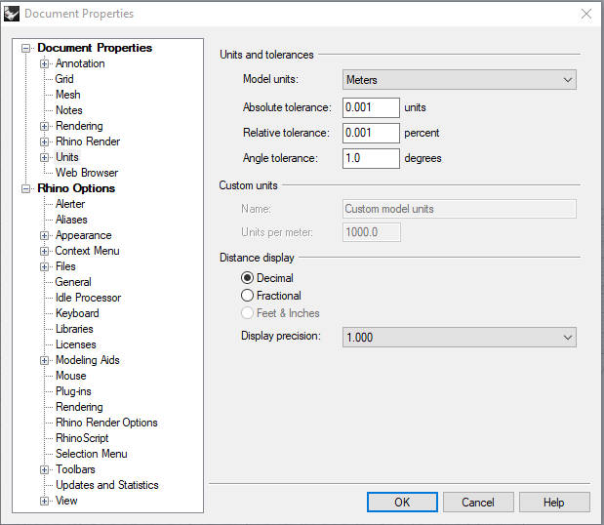
Figure 2.1. Units properties Menu to set up Model Tolerance.

Note: The Lower Tolerance the best is not always the case.
A too small topo tolerance may lead to poor tracking of curved surfaces.
A too low triangle tolerance may lead to very poor tracking of the geometry.

Create Outline box of the project
For CSMP Boundaries conditions, the model need to be delimited by top, bottom, right, left edges. Each side of the model need to be in individual parts (Layers). That will allow in CSMP to attribute different boundaries condition in different side of the model. IRREGULAR Boundaries are not possible in 2D!!!.
Draw around origin (best centered!), otherwise significant digits can be lost.
(Y = up, X = left-right draw in “TOP” view for 2D) Doesn’t matter if using box or line drawing (must be NURBS curves . it can be checked in Object properties).
It is recommended but not compulsory to use the curve interpolate points 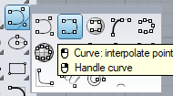 instead of the control point curve tool to draw lines. The curves will go through all the control points. It will easier later in Rhino or Ansys to change those curves if using curve interpolate points .
Use snapping to exactly close lines at intersections:
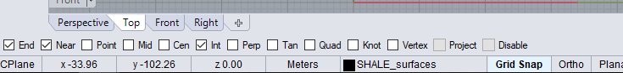
The radius of snapping can be change in File/ Properties/ Document Prpoerties/ Grid / Grid Snap 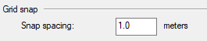.

STEPS:
Create 4 New Layers LEFT, RIGHT, TOP, BOTTOM (doesn’t have to be upper case, ICEM automatically converts into upper case) in the Model. name syntax of the objects (families, points, curves, surfaces) is checked to ensure their compliance with TETIN file restrictions:
A name may not contain blank spaces. The interface will repair blank spaces by substituting
them with an underscore.
A name may only contain the following characters: a-zA-Z0-9., /
A family name may not start with a number and must be in upper case.
Names of the Layers should not exceed 20 characters for CSMP.
STEPS:
In the Layer Tab Menu, Right-Click/ New Layer.
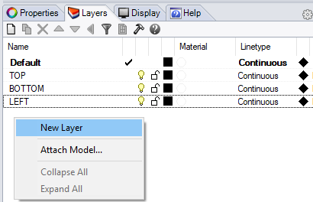
Figure 2.2. Add Layers for boundaries of the project

Draw the sides either using or .
If using curve tool , Select one by one each sides layer and draw one side at the time. To add a control point Left-click. To terminate the curve Right-click.
If using the box tool . Draw the four sides at the same time. Split the box curve into 4 parts using Explode . It will split all the sides but keep each 4 curves in the same original layer. Assign the 4 curves into the 4 new layers (see paragraph below).
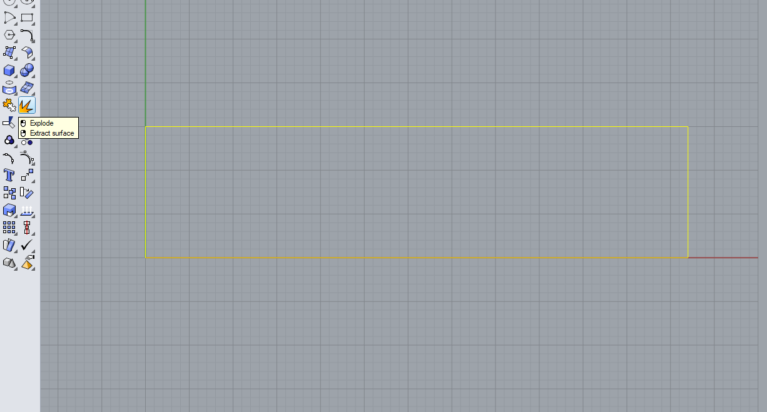
Figure 2.3. Boundaries box, split in 4 edges LEFT, RIGHT, TOP, BOTTOM

Assign objects to layers
Assign objects to certain layers (to e.g. separate fractures from bedding). By separating Geological regions, faults, bedding… into different layers (region) , it will allow to have different properties for each regions in CSMP simulation.

STEPS:
To Assign an object a layer:
If object (Curves, surfaces) not created yet. Select the new layer before drawing the object. The object will be automatically assigned to the layer selected.
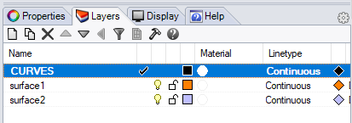
Figure 2.4. Select object that will be objects created will be assigned to.

If the object already exists and need to be assigned to a new layer. In Properties Tab (SHIFT right-click) change the layer “Select Object Layer”
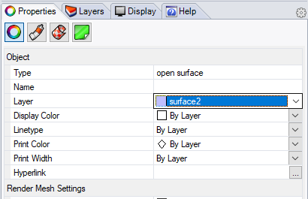
Figure 2.5. Change Layer for objects already created.

Layers can be turn off and on .

Import Image to support geological modelling
Any image: cross-section, geological map, seismic sections… in .jpg format can be imported in the background of Rhino grid to help the modelling.
STEPS:
In the Command line type: BackgroundBitmap
Possibility to Place, Move, Rotate… the image (only one image at the time)
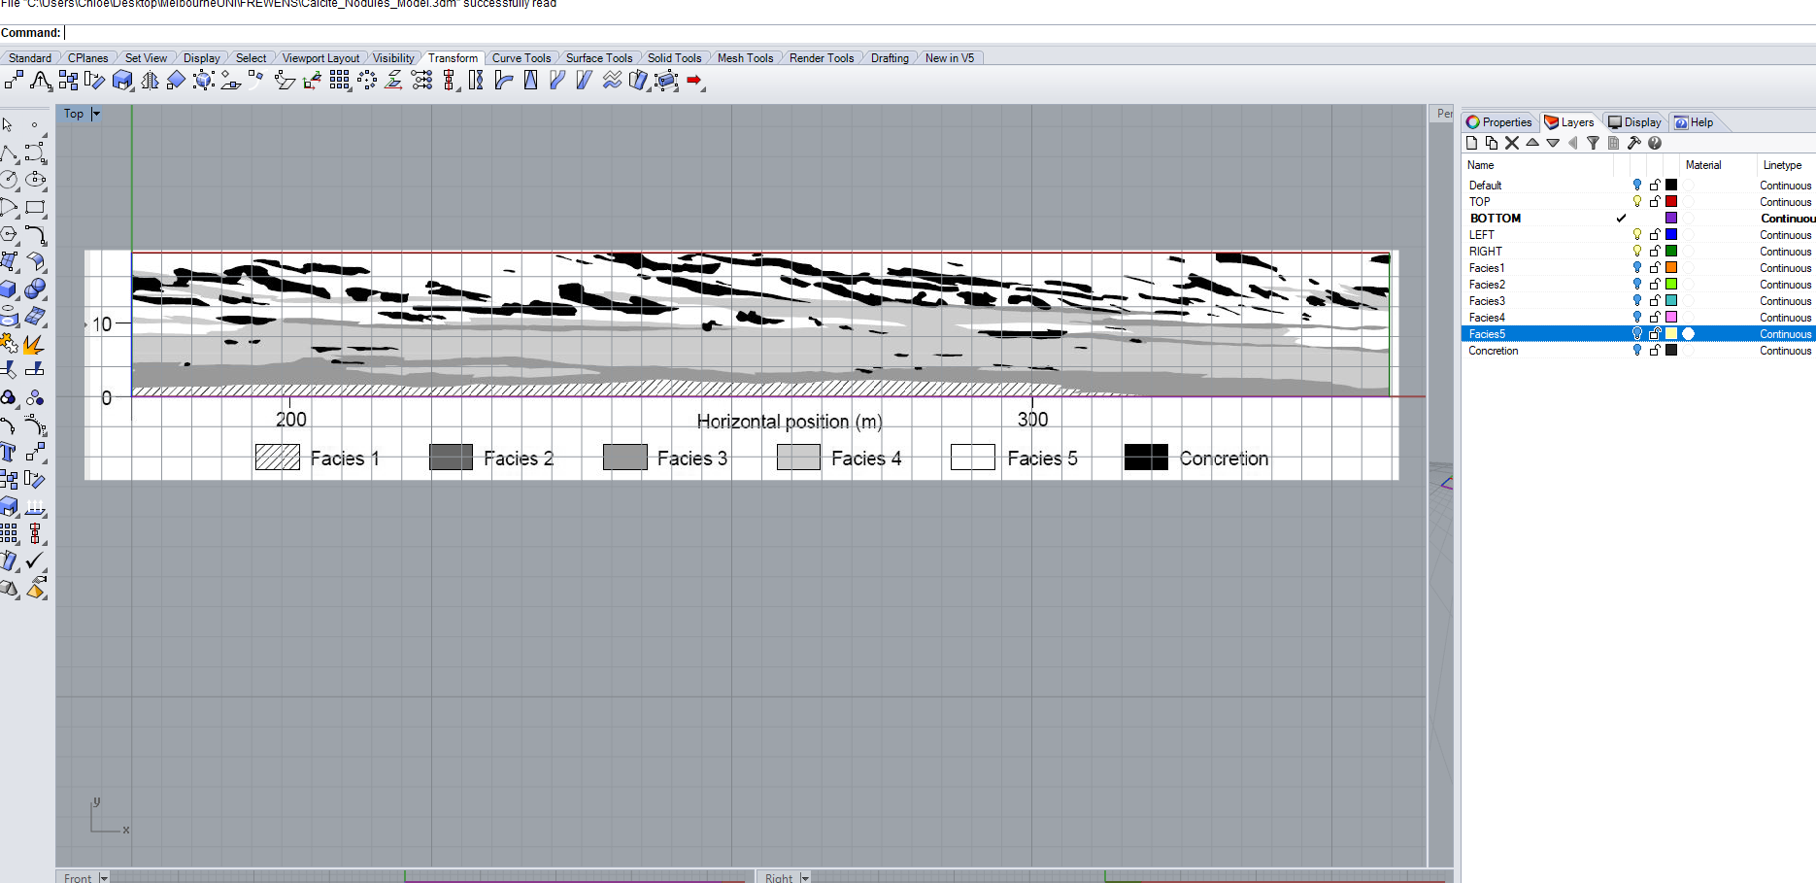
Figure 2.6. Import Geological image to build the geometry of the model

Create surfaces
Surfaces will determine geological region to be meshed in Ansys. The model require surface within the model for the Mesher. A first surface in created covering the entire mode. This surface will later be split in different geological layer.
STEPS:
Create one surface that covers all the model:
Select all curves boundaries (top,left,…). In the main menu : Surface / Planar Curve
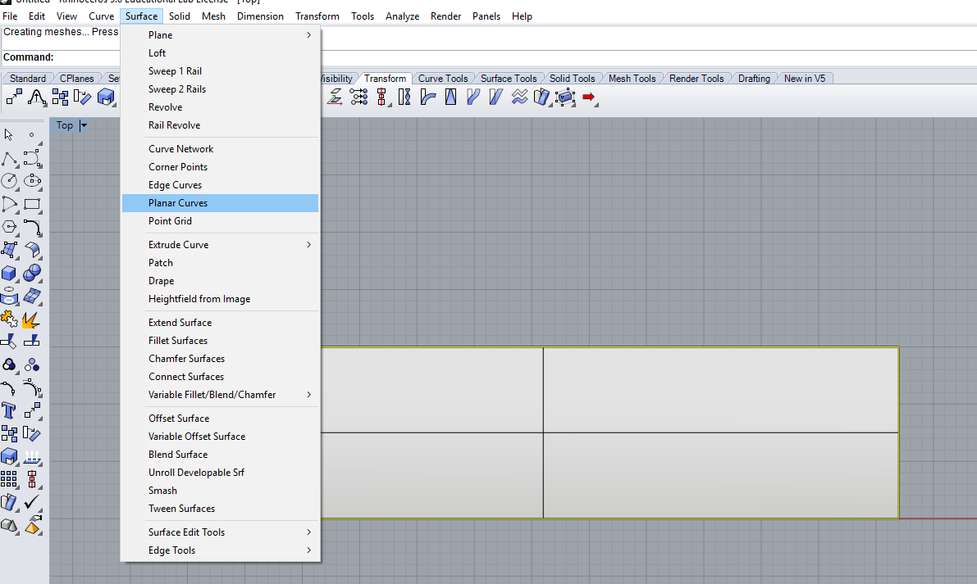
Figure 2.7. Create first surface of the entire model.

Split surfaces
To Create different geological surfaces within the model box, the initial surface need to be split with Curves.
STEPS:
Create the curves (Faults, geological horizons) that will split the surface into 2 geological regions. Splitting of surfaces by fractures that do not cut all through the model is not possible.
Split the surface: select the surface -> command line: Split
Select the cutting object: Select the curve that will split the surface in two.
Press Enter
The surface will be split but stay in the same layer.
Assign new surfaces to separate (new) layers (ref 2.3 Assign objects to layers)
To show surfaces in layer colors: Right-click on View corner “TOP” and select: Shaded
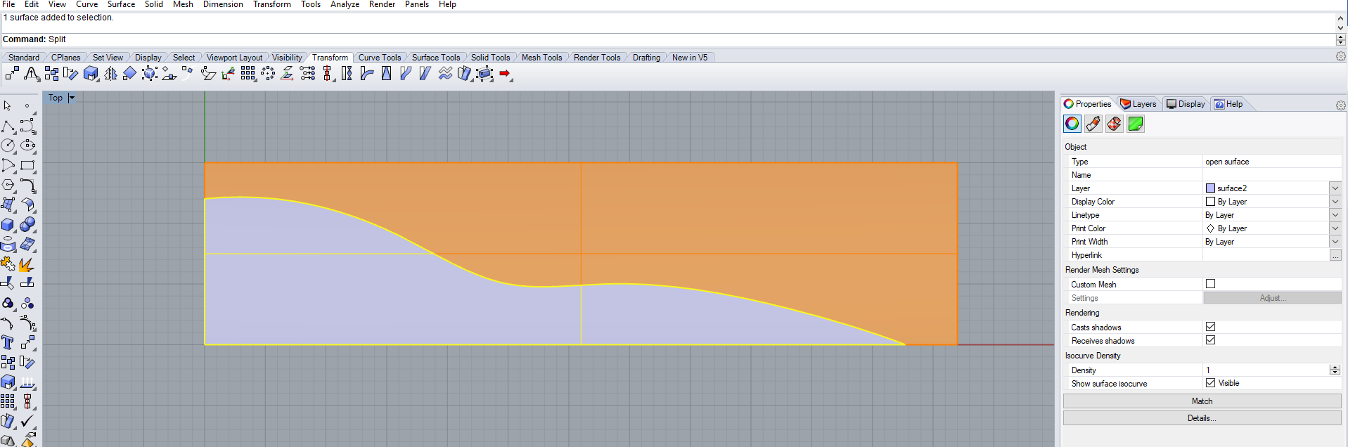
Figure 2.8. Model with 2 surfaces

Complexes 2D geology features can be created by repeating steps 2.3 to 2.6.
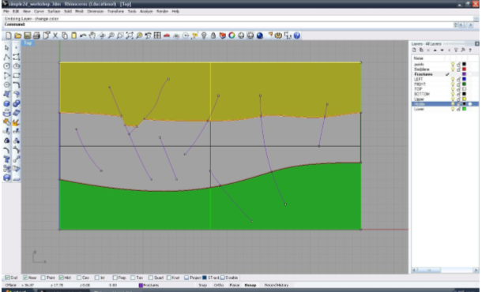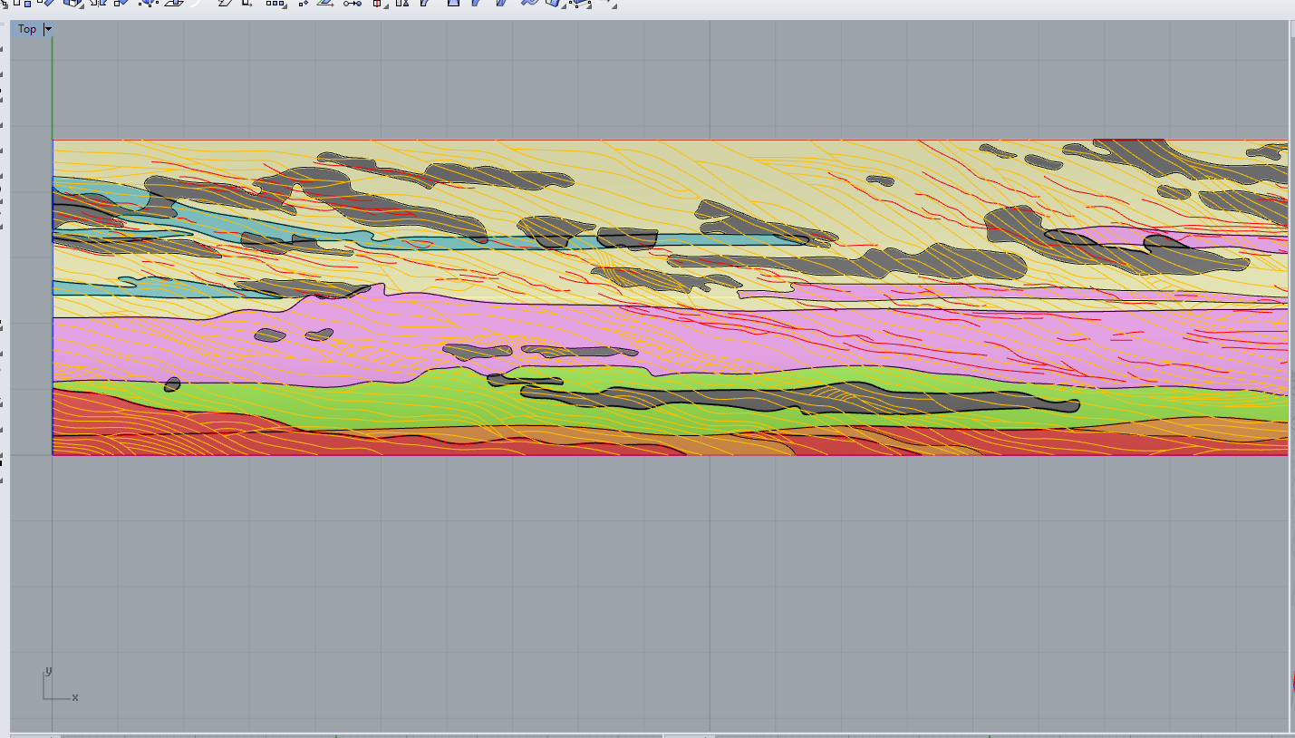
Figure 2.9. Example of 2D Model created using the steps 2.3 to 2.6.

Start, end and Intersections points for all curves
The mesh software Ansys ICEM needs to have a point the beginning and end of all objects and at each curve intersections (it will put node there). Any missing curve intersection point will lead to penetrating / overlapping elements and non-manifold vertices.
STEPS:
Create start and end points for all curves: select all curves / Curve / Point Object / Mark Curve Start & End,
create points at intersections: Curve / Curve From Objects / Intersection (or command “Intersection”)
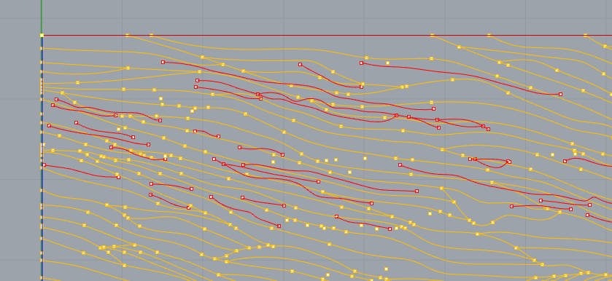
Figure 2.10. Points at start , end and intersections of curves of the model.

It is important to remove any duplicates points and curves : Edit / Select Objects / Duplicate Objects / DELETE)
NOTES:
Any missing curve intersection point will lead to penetrating / overlapping elements and non-manifold vertices during Meshing

Extra Advice
- Low angle between two curves (geological objects)
When creating Curves that define a geological feature, faults, bedding, horizons… Avoid Low angle approach between 2 curves, as much as possible.
A too low angle approach between 2 curves will pose problem during meshing at the intersection creating penetrating / overlapping elements
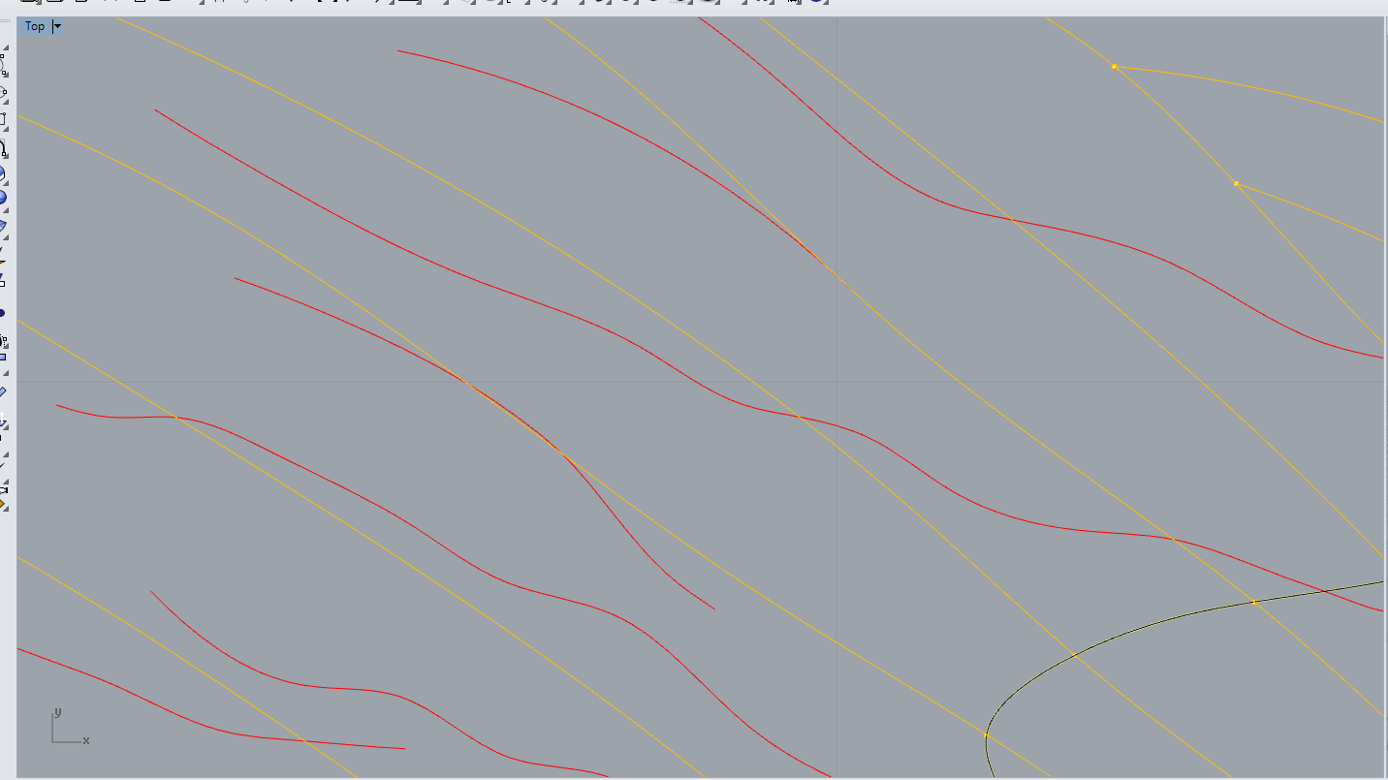

Figure 2.11. low angle between 2 curves will create later problem in the meshing and should be avoid as much as possible.

Save project
Save as Rhino version 3 (.3dm) – all layers of objects that should be exported, should be visible (light bulb on)!
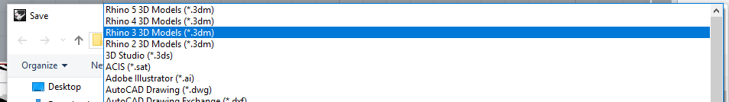

Ansys 2D Meshing

Import Rhino’s project into Ansys
The geometry of Rhinoceros software can be directly imported to Ansys Icem.
STEPS:
In the main menu: File/ Import Geometry / Legacy / Rhino 3DM (choose .3dm; ICEM automatically).
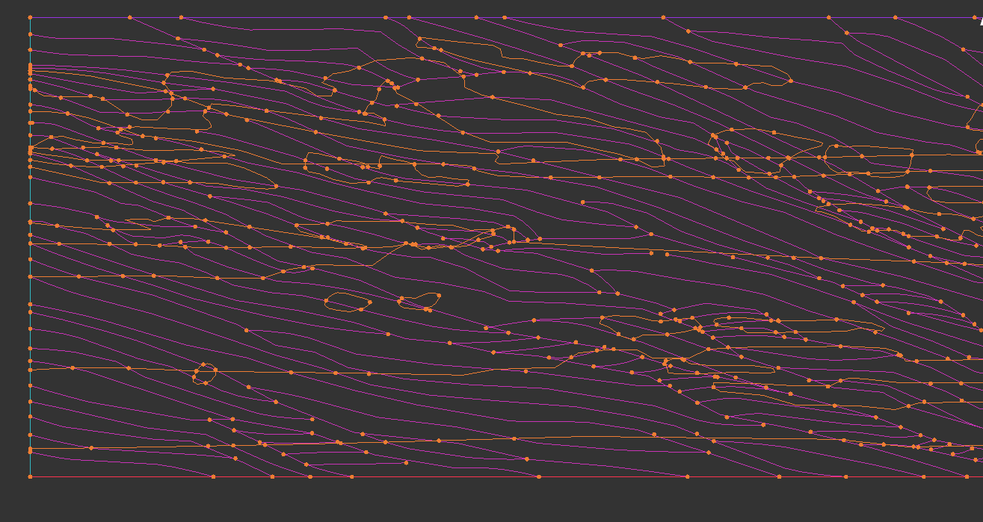
Figure 3.1. Model Geometry imported into Icem Ansys.

Tolerance
Setting the same Tolerance in the Ansys project that was set in Rhino project.
If Tolerance is not set the same as the Rhino project, the geometry might look normal but zoomed in, it is easy to see that intersection points are not always placed at the exact intersection of the curves. This will cause problem at each intersection during meshing if not addressed before.
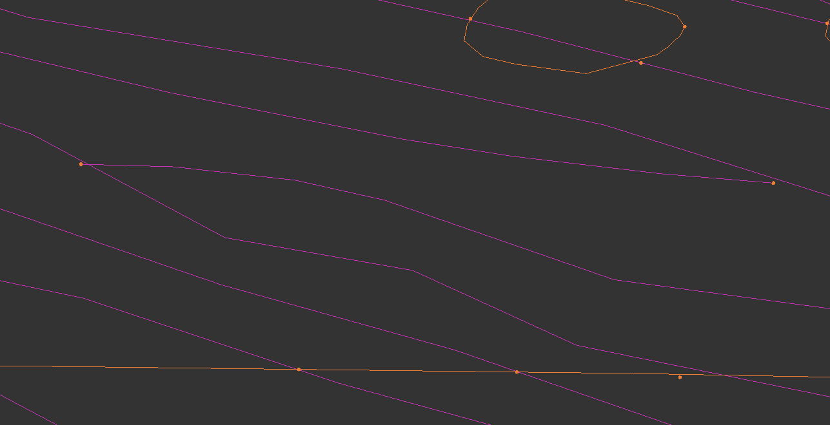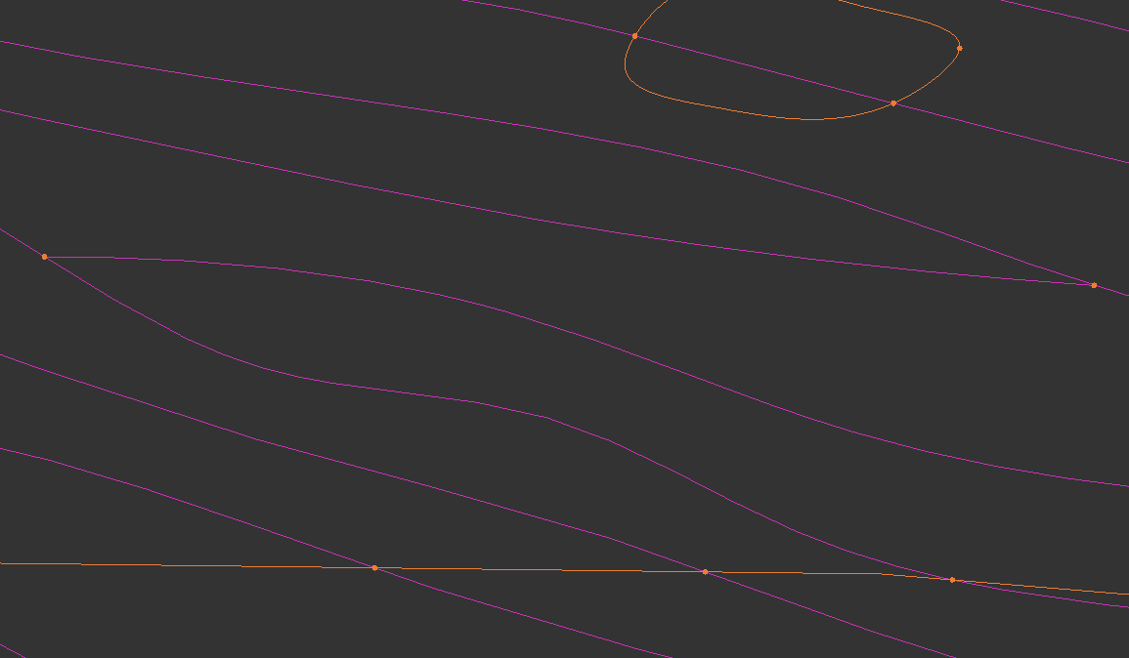
Figure 3.2. Left: Geometry curves and points in Ansys set with the default Tolerance but not the same as the Rhino project. Right: Tolerance adjusted to the same value to the Rhino project.

STEPS:
In the Main Menu : Settings / Model/Units
Use Rhino Tolerance for Topo Tolerance and Triangulation tolerance.
NOTES:
- A too small topo tolerance may lead to poor tracking of curved surfaces
- A too low triangle tolerance may lead to very poor tracking of the geometry

Repair Geometry
It is possible to make small changes to the geometry of the model, if necessary. However, if the geometry requires big changes. It is advised to go back to Rhino, as Ansys has limited capabilities. In the Menu Tab “Geometry” objects
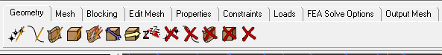
STEPS :
If a point,line/surface/... is missing (e.g. bottom line), draw your own line/surface/...:
Right-click on “Parts” Create Part. Call it BOTTOM Select the two corner points draw a line with one of the Curve tools.
If points are intersections are missing: use 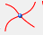 in Create Point menu.

Moving objects into another layer
In Parts: Right Click on to the Part you want add it the Geometry in (curves, points, lines…)
Select the geometry. Left-click/ Select, right-click /undo and middle-click confirm. Or click on Apply.
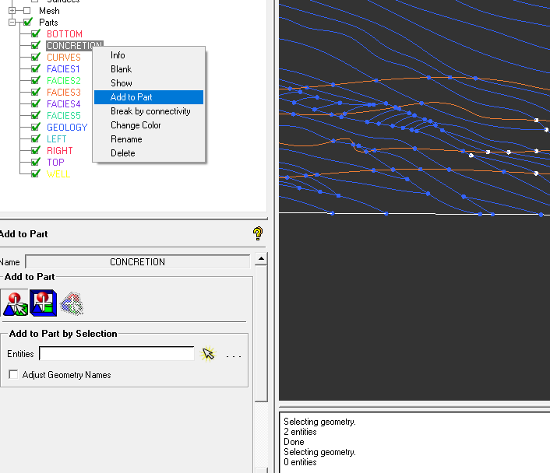
Figure 3.3. Add Geometry to an existing part.

Check list on the Geometry before meshing

The 2 Model should contain four edges curves (parts) named : TOP,BOTTOM, LEFT, RIGHT
Each intersection of curves in defined with point
No duplicates on curves or points
Avoid low angle approach between curves
Surfaces are defined in the model.
Table 3.1. Geometry check list before meshing.

Meshing: Global Mesh Setup
In the Mesh Menu Tab, are present all the option to control the meshing. Those options will be described below for 2D Meshing.

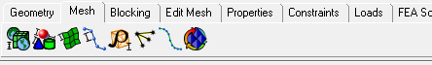
Global Mesh Setup
- Keep the scale factor to 1.
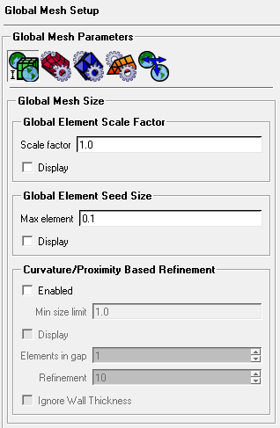
scale factor multiplies other mesh parameters to globally scale the model. For a list of parameters affected by this scale factor, see the tables in Global Mesh Setup.
Figure 3.4. Global mesh Setup guy.
For example, if the Max Element Size of a given entity is 4 units, and the Global Element Scale Factor is 3.5, then the actual maximum element size used for meshing of that entity will be 4 * 3.5 = 14.0 units. The Global Element Scale Factor can be any positive real number, and it allows you to globally control the mesh size instead of changing the mesh parameters for different entities.
- Max element: if small, mesh will be fine – if large, mesh will be coarse (= max. size a mesh element will have)
- Curvature/proximity based refinement: when enabled, the mesh is automatically refined based on geometry curvature and proximity. This will result in larger elements on flat planar surfaces and smaller elements in areas of high curvature or within small gaps.
This option can be used if needed but it recommended not to use it as much as possible as the grouping of small elements will slow down meshing and CSMP computing. A more homogeneous mesh is preferred.
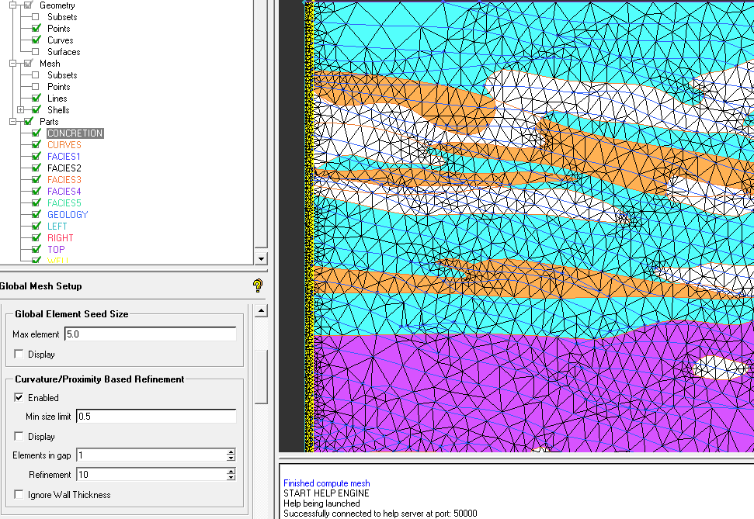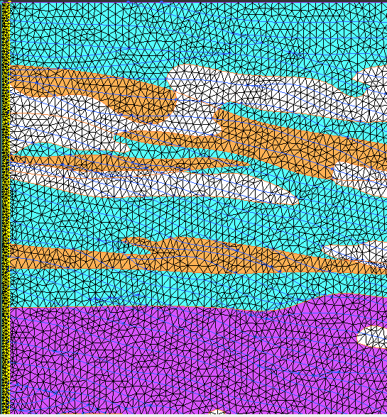
Figure 3.5. Left Mesh using the Curvature/proximity based refinement. Right: Mesh Not using Curvature/proximity based refinement but a smaller Max element size.

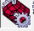 Surface: Mesh type (depending on what kind of mesh elements is wanted),
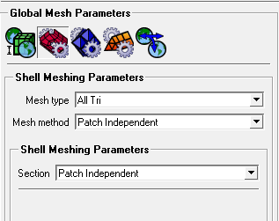
- All Tri
Figure 3.6. Meshing surface menu.
meshes the geometry with a pure triangular mesh.
- Quad w/one Tri
allows for a Quad Dominant mesh with one tri element per surface. The tri element allows for better transition between uneven mesh distribution on the loop edges. Automatic tri-reduction steps may even remove the tri element.
- Quad Dominant
creates a quad mesh that allows for several transitional triangles. This mesh type is very useful in meshing complicated surfaces where a pure quad mesh may have poor quality.
- All Quad
meshes the geometry with a pure quadrilateral surface mesh.
Mesh Method = Patch Independent recommended (more robust)
- Patch Dependent
This is a free surface mesh generator that meshes closed regions called loops. Loops are created from surfaces or curves, and holes and internal curves are taken into account.
- Patch Independent
Patch independent meshing is best for low quality geometry or surfaces with poor connectivity. It uses the Octree method to create a robust patch independent surface mesh. surfaces or curves, and holes and internal curves are taken into account.

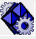Volume (only for 3D)

Mesh sizes for parts
In some case scenario, some part of the model will require specific meshing parameters. It is possible in Ansys to enter for each part of the model different meshing setings. The Part Mesh Setup opens a dialog where you can specify the mesh parameters for different parts.
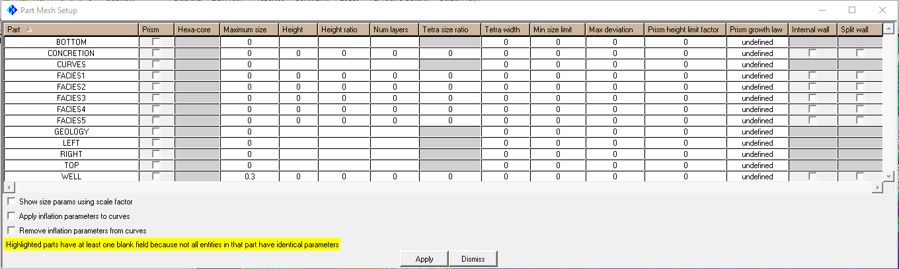
Figure 3.7. Part Mesh Dialog box.

- Prism
Select the parts on which prism layers will be grown. Volume, surface and/or curve parts can be selected.
- Max Size
specifies the maximum element size. The actual maximum element size will be this value multiplied by the Global Element Scale Factor.
Num Layers
is the number of layers to be grown from the surface or curve.
Min size limit
Mesh elements will be limited from being subdivided smaller than this value. For Tetra meshing, this value overrides the value calculated by the Curvature/Proximity Based Refinement option.
Split Wall
if enabled, the part will be meshed as a split wall with overlapping pairs of elements and nodes, so that both sides of the wall are effectively treated as having surface elements. This applies to Octree Tetra Meshing only.

Compute Mesh
Select surface meshing 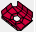 . Possibility to overwrite global settings
Click Compute

Vizualise Mesh
Once the mesh is computed it will be displayed automatically as default Wire frame mode. This can be changed. Turn off all geometries. Right-click on Shells (in Mesh) select solid and wire.
This mode help on detect errors visually.

Check mesh for quality with Edit Mesh:
The mesh can be modified Manually checked or fixed without having to re-mesh the entire model.
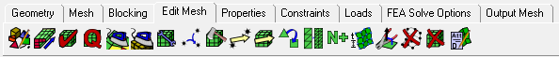

Check the Mesh : For Surface 2D mesh it is important for CSMP that the mesh pass this checks
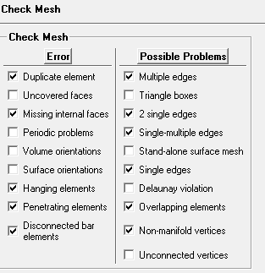
Figure 3.8. Checks for 2D Mesh

For some of the check ansys will provide an automatic fixe. However, it is advice to for first choose to create a subset to visualize the elements that cause the problem.
When a subset is created the elements can be visualize by turning off the mesh and geometry and turn on the subset.
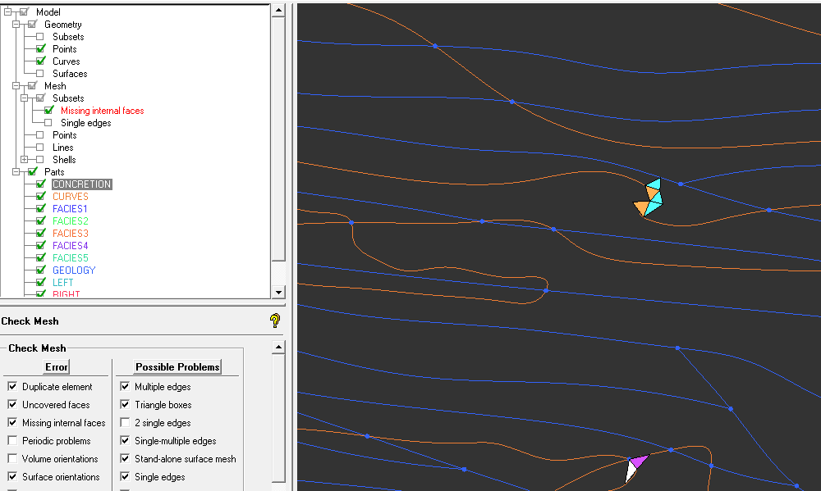
Figure 3.9.3 elements in missing internal faces subset.
- Duplicate element
locates elements that share all of their nodes with another element of the same type. Duplicate elements should not exist in an ideal mesh.
Note: The deleting of elements during the automatic fix will remove one of the two duplicate elements, thereby eliminating this error without creating a hole in the geometry.
- Missing internal faces
For 2D meshes, this function finds two adjacent surface elements in different parts with no line element between them. The automatic fix will create surface or line elements between these elements.
- Disconnected bar elements
checks for bar elements with both nodes unconnected.
Multiple edges
refers to elements with at least one edge shared among three or more elements. Legitimate multiple edges would be found at a "T" junction, where more than two geometry surfaces meet.
- 2 single edges
refers to elements with two single edges. These are either corners of baffles or are triangles that are protruding from a surface and are therefore undesirable in the mesh.
Single-multiple edges
refers to elements that have both single and multiple edges. These elements are probably not wanted.
- Single edges
Refers to surface elements with at least one edge that is not shared with any other surface element. This would represent a hanging edge, and the element would be an internal baffle. These may or may not be legitimate. Legitimate single edges would exist where the geometry has a zero thickness baffle with a free or hanging edge.

Note : if at boundary, it is OK click Ignore

Assign boundary conditions and output the mesh:
Select the CSV solver : In Main Menu / settings / solver. Select the CSP soler.
Output the mesh for CSMP
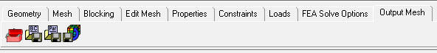
CSM requires Binary format. 3 files : .log, .ascii and .dat will be created
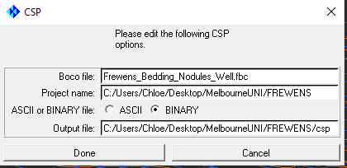
Figure 3.10. CSP export window.

Part 2:
3D Modelling and Meshing workflow for simple 3D Rhinoceros Project.

List of Figures
Figure 1. Units properties Menu to set up Model Tolerance. 14
Figure 2. Boundaries box, split in 4 edges LEFT, RIGHT, TOP, BOTTOM. 15
Figure 3. Select object that will be objects created will be assigned to. 15
Figure 4. Change Layer for objects already created. 16
Figure 5. Import Geological image to build the geometry of the model 16
Figure 6. Create surface 17
Figure 7. 18
Figure 8. low angle between 2 curves will create later problem in the meshing (…). 20

List of Tables
Table 1: Table of Report Sections 15

Introduction
3D Modelling and meshing workflow from SKUA Gocad geology project to CSMP

SKUA Gocad Export project
Output model as (AutoCAD) DXF from SKUA and read it into Rhinoceros software

3D Rhinoceros
New versions of Ansys software doesn’t import DXF format, therefore The DXF files are imported into Rhino.

Set up Tolerance
Before starting of importing file for any project the Tolerance of the project should be set accordingly to the size and the resolution of object within the model. If not set from the start, the Model could be completely jeopardized for the following steps.
- Open Rhino and set up tolerance
From menu: File / Properties -> Units
Model Unit: Meters (does it have to be meters? No, but will CSMP treats it as Meters anyway!)
Topo Tolerance
- Abs. tolerance = size of smallest feature (treated as Meters by CSMP) = i.e. 0.01
- Rel. tolerance = ratio between smallest and largest object (in %) = i.e. 1.0
- Angle tolerance = similar to abs. tolerance, but for angles = i.e. 0.01 (SKM: 0.1)
Use a high tolerance for large models, but low tolerance when meshing
- recommended value 0.001
Figure 2.1. Units properties Menu to set up Model Tolerance.

Import triangulated surfaces meshes
Import Surface Meshed from SKUA Model in DXF format. All The geological horizons and faults can be imported together in the same file. Well curves will be imported the same way in a separate file.
STEPS:
Drag and Drop files work from directory
Or
Main Menu : File / Import (in import format select Autocad DXF)
Each Surfaces will create a new Rhino Layer. Make sure the names of the layers comply with TETIN file restrictions:
A name may not contain blank spaces. The interface will repair blank spaces by substituting
them with an underscore. A name may only contain the following characters: a-zA-Z0-9., /
A family name may not start with a number and must be in upper case.
Names of the Layers should not exceed 20 characters for CSMP.

Model at the origin.
If the Model was created in a GPS or UTM projection, it need to be move back to the origin, otherwise significant digits can be lost. It is recommended to Move the project to the origin it can be either done in Rhino, or Ansys prior Meshing. Select the lowest coordinates value corner and move the entire model to X =0 and Y =0. Z (Altitudes values doesn’t have to change. To keep real depth values)
STEPS:
3. put one corner of the Model at the origin of the grid. Model being away from the center of the Grid will cause problem later in Ansys.
Command Line: MOVE (Select all Model)
Point to move from: (Select point on one corner of the model)
Point to move from: type 0,0

Convert DXF mesh surface to Nurbs polysurfaces
The DXF surfaces exported by SKUA are imported as Mesh objects into Rhino.
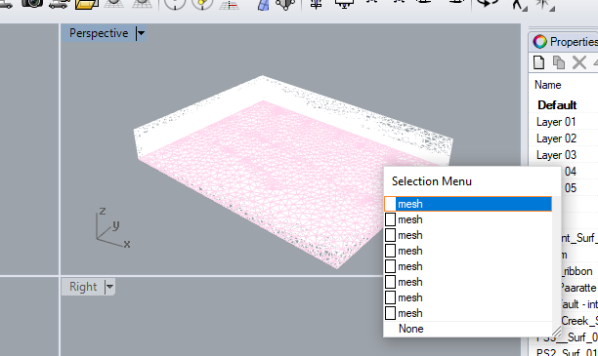
Figure 2.2 DXF Meshes surfaces imported into Rhinoceros.

The Mesh need to be turn into Nurbs surfaces to create surface outlines and intersection curves between surfaces.
STEPS:
Command Line: MeshtoNURB
Select a surface mesh: select part by part (make sure they are attributed back to the right part/layer)
Example: To convert Skull_Creek_Surf_01. In Layer Tab, select Skull_Creek_Surf_01 and hide all other layers . Command Line: MeshtoNURB select the surface. Enter.
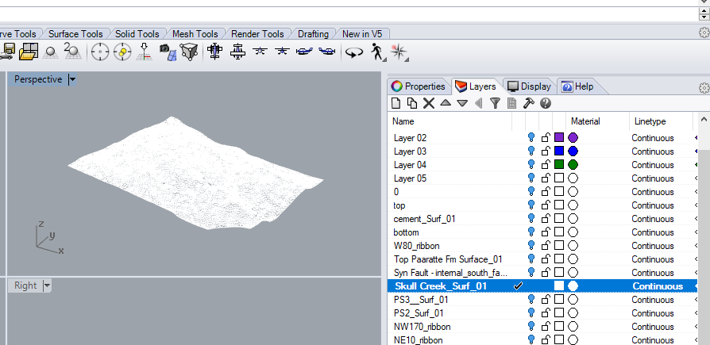
Figure 2.3 One surface mesh selected to create a Nurb surface.

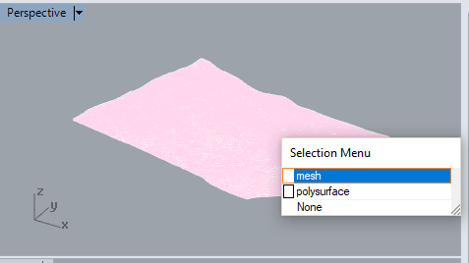
The Skull_Creek_Surf_01 layer should now have a mesh and polysurface object. Repeat the steps for each layers.
Figure 2.4 layer with 2 objects, mesh and polysurface

Create edge and intersection curves of the surfaces
Curves need to be extracted: for each surface, edge curves will be added to the model. Intersection curves between surfaces will be created and added to the model.
STEPS:
Create a new layer: Edge_Curves
Commands Lines to extract edge curves from surfaces : DupBorder
DupBorder creates a curve or polyline that duplicates a surface, polysurface, hatch, or mesh border.
Create a new layer: Intersections_Curves (it is recommended to put the 2 families of curves in different layers as there will be duplicates that will need to be removed)
Commands Lines to extract edge curves from surfaces : DupBorder

Curves extracted with DupBorder Curves extracted with Intersect
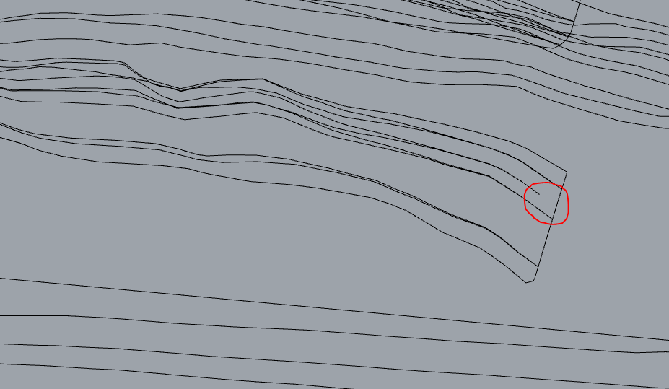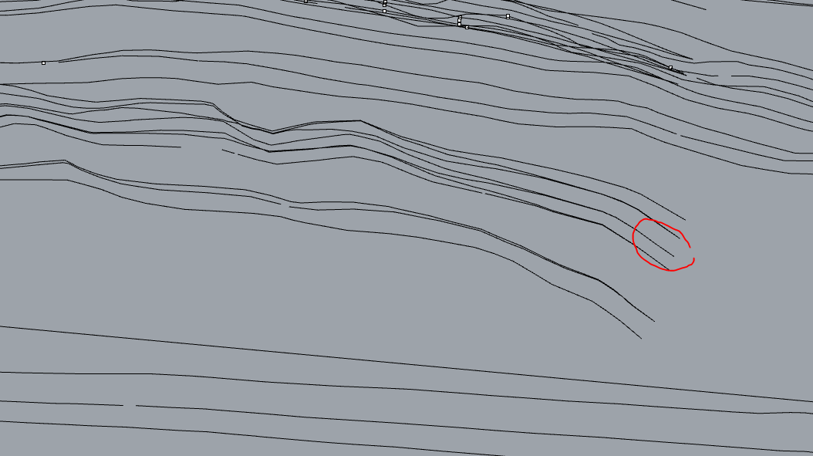

Remove Duplicates
Duplicates elements will cause problems in Ansys Meshing. Remove them either by Edit/Select Objects/Duplicates Objects. Or Manually.

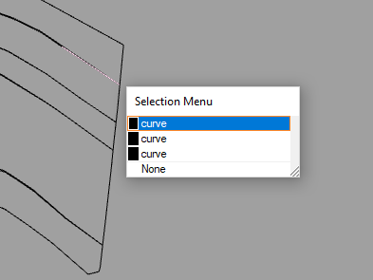
To many curves duplicated on the same segment. Only one curve is needed.

7. Points at the end and start of curves. Select all curves: Curve/Point Object/ Mark Curve Start and Mark Curve End.
Once again delete any duplicates points using: Edit/Select Objects/Duplicates Objects.
Or manually. Make sure all duplicates are remove as it will cause problem during the meshing

Start, end and Intersections points for all curves
The mesh software Ansys ICEM needs to have a point the beginning and end of all objects and at each curve intersections (it will put node there). Any missing curve intersection point will lead to penetrating / overlapping elements and non-manifold vertices.
STEPS:
Create start and end points for all curves: select all curves / Curve / Point Object / Mark Curve Start & End,
create points at intersections: Curve / Curve From Objects / Intersection (or command “Intersection”)

It is important to remove any duplicates points and curves : Edit / Select Objects / Duplicate Objects / DELETE)

Save project
Save as Rhino version 3 (.3dm) – all layers of objects that should be exported, should be visible (light bulb on )!

3D Ansys Meshing

Import Rhino’s project into Ansys
The geometry of Rhinoceros software can be directly imported to Ansys Icem.
STEPS:
In the main menu: File/ Import Geometry / Legacy / Rhino 3DM (choose .3dm; ICEM automatically).

Tolerance
Setting the same Tolerance in the Ansys project that was set in Rhino project.
If Tolerance is not set the same as the Rhino project, the geometry might look normal but zoomed in, it is easy to see that intersection points are not always placed at the exact intersection of the curves. This will cause problem at each intersection during meshing if not addressed before.
STEPS:
In the Main Menu : Settings / Model/Units
Use Rhino Tolerance for Topo Tolerance and Triangulation tolerance.
NOTES:
- A too small topo tolerance may lead to poor tracking of curved surfaces
- A too low triangle tolerance may lead to very poor tracking of the geometry

Repair Geometry
- ​Rotate Geometry to comply with CSMP:
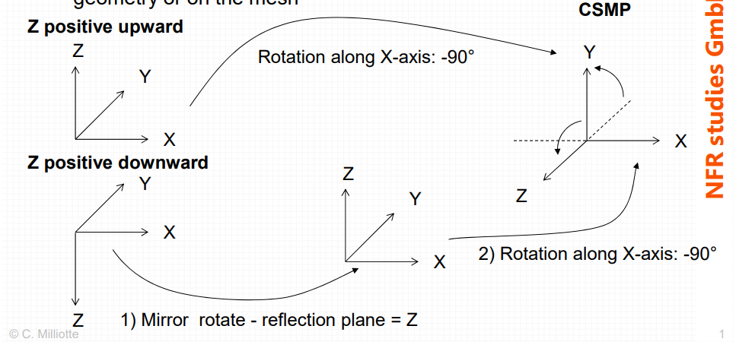
SKUA GOCAD
Figure 3.1 Model rotation from Skua Gocad projection system to CSMP projection system

Do not forget to rotate your mesh​ to comply with CSMP orientation (mirror Z plane + X axis rotation -90deg)!
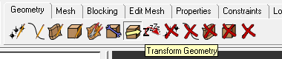
In Geometry Tab choose: Transform Geometry
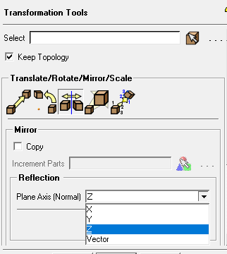
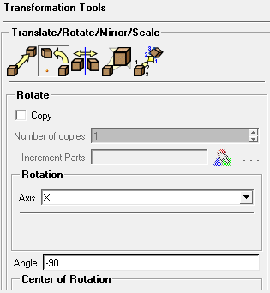
First mirror Z plane:
Figure 3.2. Left Mirror on Z, Right Rotate -90 on x axis.
Select all the Geometry
Choose: Mirror
Plane Axis (normal) : Z
Apply
X axis rotation -90deg:
Select all the Geometry
Choose: Rotate Geometry
Axis : X

- Move Geometry to origin.
If not already placed to the origin in Rhino software it is important to do it in Ansys prior meshing.
Project that have been create with GPS or UTM (uUniversal Transverse Mercator) will have coordinates with extended numbers . By moving the project to the origin XZ direction ….
Example {X=661025.0625, Y=1000, Z=5734804.5 }
The Y direction (depth) can stay the same. It will keep the original depth of the project.
STEPS:
If not already displayed turn on the points of the Geometry. It will make it easier to select the corner of the model.
To obtain the coordinate of the corner use : local coordinate system 
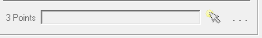

Select the corner you want to bring to the origin. Left-click to select and Middle-click to confirm. Write the coordinates somewhere.
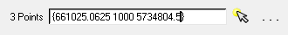
These X and Z coordinates will be subtracted to move the model to the origin.
To move the Geometry :
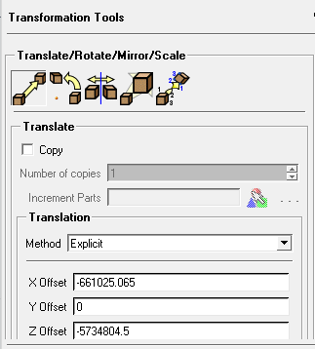
In Geometry Tab choose: Transform Geometry
Choose : Translate Geometry
X offset: -(value X of the corner move from)
Yofset: 0
Zoffset: - (value Z of the corner move from)

It is possible to make small changes to the geometry of the model, if necessary. However, if the geometry requires big changes. It is advised to go back to Rhino, as Ansys has limited capabilities. In the Menu Tab “Geometry” objects

Surface Mesh

In simple case direct volume meshing will be enough. However if after a first try of volume meshing the mesh check indicate to many problem in the 3D mesh, it is recommended to perform a surface mesh. Fix the surface mesh and turned it back to geometry before starting a volume mesh.

Meshing: Global Mesh Setup
In the Mesh Menu Tab, are present all the option to control the meshing. Those option will be described bellow for 2D Meshing.

Global Mesh Setup
- Keep the scale factor to 1.
scale factor multiplies other mesh parameters to globally scale the model. For a list of parameters affected by this scale factor, see the tables in Global Mesh Setup.
Figure 3.3. Global mesh Setup guy.
For example, if the Max Element Size of a given entity is 4 units, and the Global Element Scale Factor is 3.5, then the actual maximum element size used for meshing of that entity will be 4 * 3.5 = 14.0 units. The Global Element Scale Factor can be any positive real number, and it allows you to globally control the mesh size instead of changing the mesh parameters for different entities.
- Max element: if small, mesh will be fine – if large, mesh will be coarse (= max. size a mesh element will have)
- Curvature/proximity based refinement: when enabled, the mesh is automatically refined based on geometry curvature and proximity. This will result in larger elements on flat planar surfaces and smaller elements in areas of high curvature or within small gaps.
This option can be used if needed but it recommended not to use it as much as possible as the grouping of small elements will slow down meshing and CSMP computing. A more homogeneous mesh is preferred.
Figure 3.4. Left Mesh using the Curvature/proximity based refinement. Right: Mesh Not using Curvature/proximity based refinement but a smaller Max element size.

Surface: Mesh type (depending on what kind of mesh elements is wanted),
- All Tri
Figure 3.5. Meshing surface menu.
meshes the geometry with a pure triangular mesh.
- Quad w/one Tri
allows for a Quad Dominant mesh with one tri element per surface. The tri element allows for better transition between uneven mesh distribution on the loop edges. Automatic tri-reduction steps may even remove the tri element.
- Quad Dominant
creates a quad mesh that allows for several transitional triangles. This mesh type is very useful in meshing complicated surfaces where a pure quad mesh may have poor quality.
- All Quad
meshes the geometry with a pure quadrilateral surface mesh.
Mesh Method = Patch Independent recommended (more robust)
- Patch Dependent
This is a free surface mesh generator that meshes closed regions called loops. Loops are created from surfaces or curves, and holes and internal curves are taken into account.
- Patch Independent
Patch independent meshing is best for low quality geometry or surfaces with poor connectivity. It uses the Octree method to create a robust patch independent surface mesh. surfaces or curves, and holes and internal curves are taken into account.

Volume
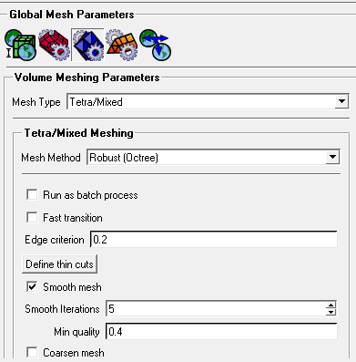
- Edge criterion
determines to what extent a tetra is cut to represent geometry. The entered value is a factor of the tetra edge. After subdivision, if a tetra edge intersects an entity (surface), the tetra will be cut if the subdivision of the edge from the intersection is less than the prescribed value.
The values can range from 0 to 1. A larger value (above 0.5) may be prescribed if you want to ignore inexact duplicates, however geometry may not be properly captured if the value is too large. Increasing the value will increase the nodes moving to fit to the geometry. Reducing the value will increase refinement near entities, and will also reduce non-manifold vertices in trailing edges. The default of 0.2 is adequate for most cases. This value is useful in cases where thin cuts fail or are difficult to setup.
Figure 255: Edge Criterion
Edge criterion = 0.2  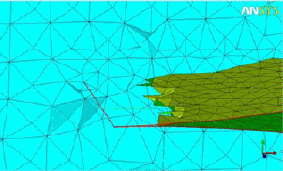 | Edge criterion = 0.01  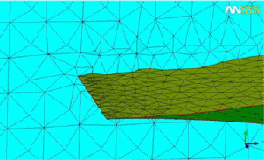

NOTES:
For models with low angle approach between curves , setting a smaller edge criterion can help solve issues in the mesh between the two surfaces.
When a too small edge criterion is choosen (i.e. 0.001), intersections may not get meshed at all.
- Define thin cuts
allows you to resolve gaps based on pairs of surface or curve parts which are close to each other. The thin cut definition prevents surface elements from spanning between nodes on the two parts specified. This helps prevent non-manifold nodes in areas where the mesh size may be larger than the gap.

STEPS:
Clicking the Define thin cuts button will bring up the Thin cuts window where pairs of parts can be selected or entered to define a thin cut “pair”. A part can belong to more than one thin cut pair.
The following limitations apply to the definition of thin cuts:
- If two surfaces approach asymptotically, the thin cut definition may eventually fail.
- If the separation rule of thin cuts is violated at any point, all thin cuts will fail and be deactivated.
Press Add: to adds the thin cut pair selected or entered.

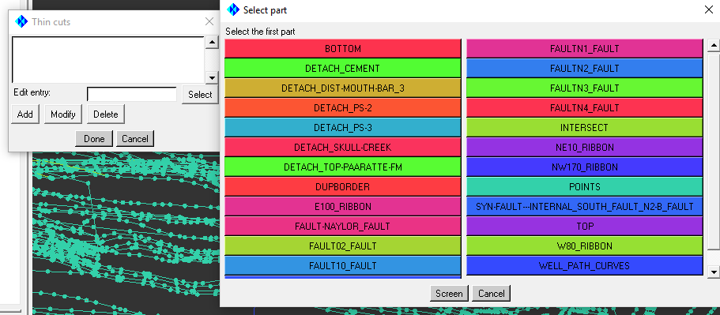

Mesh check
The mesh can be modified Manually checked or fixed without having to re-mesh the entire model.

Check the Mesh : For Surface 2D mesh it is important for CSMP that the mesh pass this checks
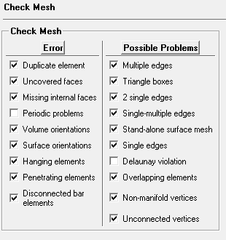
Figure 3.6. Checks for 3D Mesh

For some of the check ansys will provide an automatic fixe. However, it is advice to for first choose to create a subset to visualize the elements that cause the problem.
When a subset is created the elements can be visualize by turning off the mesh and geometry and turn on the subset.
- Duplicate element
locates elements that share all of their nodes with another element of the same type. Duplicate elements should not exist in an ideal mesh.
Note: The deleting of elements during the automatic fix will remove one of the two duplicate elements, thereby eliminating this error without creating a hole in the geometry.
- Uncovered faces
For a 3D mesh, all faces on a volumetric element should either be attached to the face of another volumetric element or to a surface element. This function finds the volume elements that violate this restriction. Usually this indicates a hole in the surface mesh. In the case of a 2D mesh, this function finds edges of mesh elements that are not connected to another element or not capped off by a bar (line) element at the perimeter (single or open edges).

The automatic fix will cover these uncovered faces with triangles (surface mesh). This may or may not be the proper solution. A better method may be to first select the flawed elements and then decide if the uncovered faces are the result of missing surface mesh or the result of a hole. If it is due to missing surface mesh, rerun the check and choose the Fix option. If the error points out a hole in the model, you can attempt to correct the mesh by manually creating elements or merging nodes.
- Missing internal faces
Between every two adjacent volume elements that are in different parts there should be a surface element. This function finds the volume elements that violate this restriction. A mesh with only one volume part will not have missing internal faces. For 2D meshes, this function finds two adjacent surface elements in different parts with no line element between them. The automatic fix will create surface or line elements between these elements.
- Periodic problems
checks surface parts that have periodic faces for inconsistency in the periodicity of the nodes. Errors are reported if periodic matches are missing. Slight offsets in node positions are often repaired automatically during the check process. Remaining errors can be repaired manually using Edit Mesh > Repair Mesh > Make/Remove Periodic.
- Volume orientations
finds elements where the order of the nodes does not define a right-handed element.
Note: This will be automatically corrected when Check/Fix is run.
- Surface orientations
checks for volume elements that share the same surface element. In doing this check, it is required to also check for:
- uncovered faces
missing internal faces

- duplicate elements
This check will not find elements that occupy the same volume but are attached to regions of mesh that are not connected.
- Hanging elements
checks for line elements that have one node connected to surface mesh, and the other node free (unconnected).
- Penetrating elements
checks for surface elements that intersect or pass through other surface elements.
- Disconnected bar elements
checks for bar elements with both nodes unconnected.
- Multiple edges
refers to elements with at least one edge shared among three or more elements. Legitimate multiple edges would be found at a "T" junction, where more than two geometry surfaces meet.
- Triangle boxes
refers to groups of four triangles that form a tetrahedron with no volume element inside. This is best fixed by merging two of the nodes that would collapse the unwanted triangle box.
- 2 single edges
refers to elements with two single edges. These are either corners of baffles or are triangles that are protruding from a surface and are therefore undesirable in the mesh.
- Single-multiple edges
refers to elements that have both single and multiple edges. These elements are probably not wanted.
- Stand-alone surface mesh
refers to surface elements that do not share a face with a volumetric element. This could be an area with an extra surface element to be deleted or a missing volume element to be created.
- Single edges
refers to surface elements with at least one edge that is not shared with any other surface element. This would represent a hanging edge, and the element would be an internal baffle. These may or may not be legitimate. Legitimate single edges would exist where the geometry has a zero thickness baffle with a free or hanging edge.

- Delaunay violation
refers to tri elements with nodes that are within the circumsphere of adjacent elements. These can often be removed by swapping edges of these triangles.

- Overlapping elements
refers to surface elements that occupy part of the same surface area, but do not have the same nodes. This could be surface mesh that folds on to itself. This will also find elements that are at an angle of up to 5 degrees from overlapping each other, as shown in Figure 416: Example of Overlapping Element.

- Non-manifold vertices
refers to vertices whose adjacent elements outer edges do not form a closed loop. Usually indicates elements that jump from one surface to another, forming a "tent like" structure. This would usually pose no problem for mesh quality but will represent a barrier in the free domain that probably should not be there. See the figure in Edit Mesh > Split Mesh.

- Unconnected vertices
refers to vertices that are not connected to any element. These are usually eliminated automatically upon saving the mesh.

NOTES: Visual check of the mesh is as important as automatic checks. Some issues will the mesh will note be detected with the software however those badly meshed areas might cause issues later in the volumetric mesh and the will be harder to fix in 3D.
Example: check the lines mesh (it is easier to see abnormalities in the lines mesh). Any abnormal lines contact between 2 surfaces will need to be fixed manually before meshing in 3D.
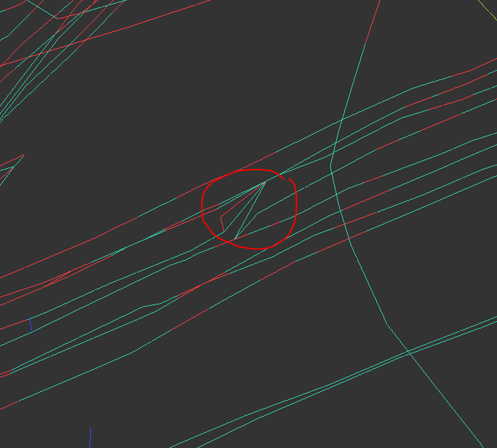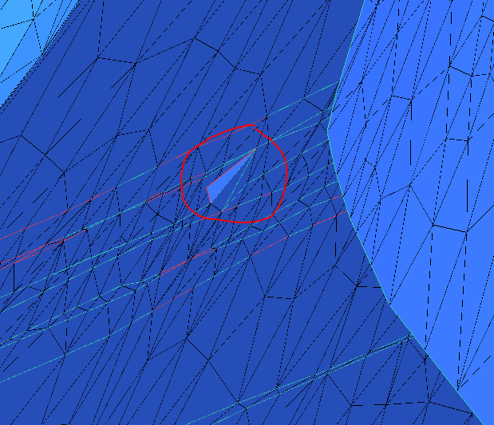
Figure 3.7. left:The lines mesh doesn’t seems correct by visual inspection. Right: indeed, after turning on the shell. On of the element of this surface mesh is misplaced and will have to be fixed manually.

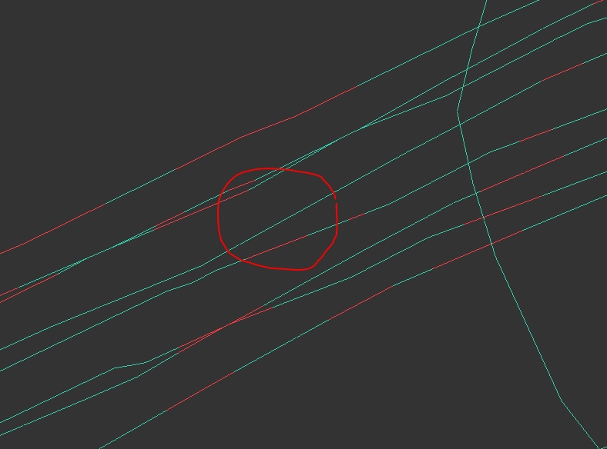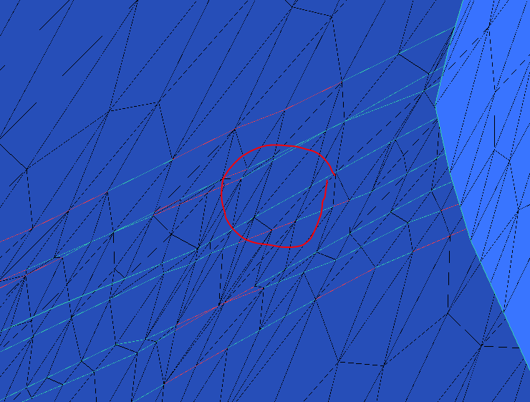
Figure 3.8 Surface Mesh after correction.

Turn surface mesh to Geometry

In order to use the corrected mesh as input for the volumetric mesh. It need to be tuned into facet
STEPS: In Main Menu / Edit/ Mesh to facet
Do you want build sharped features ? YES
Merge close nodes in the Surfaces ? NO

Build Bodies for 3D Meshing
Bodies can be created from surfaces that make up a volume or from a solid volume.
Ansys will create automatically volumes
STEPS:
In the Tab menu Geometry, select create Bodies
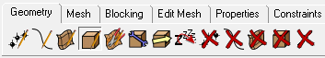
Create a body (geological layer) in between each horizon surfaces.
If a surface (fault) is crossing the entire different bodies will have to be created in each compartment.
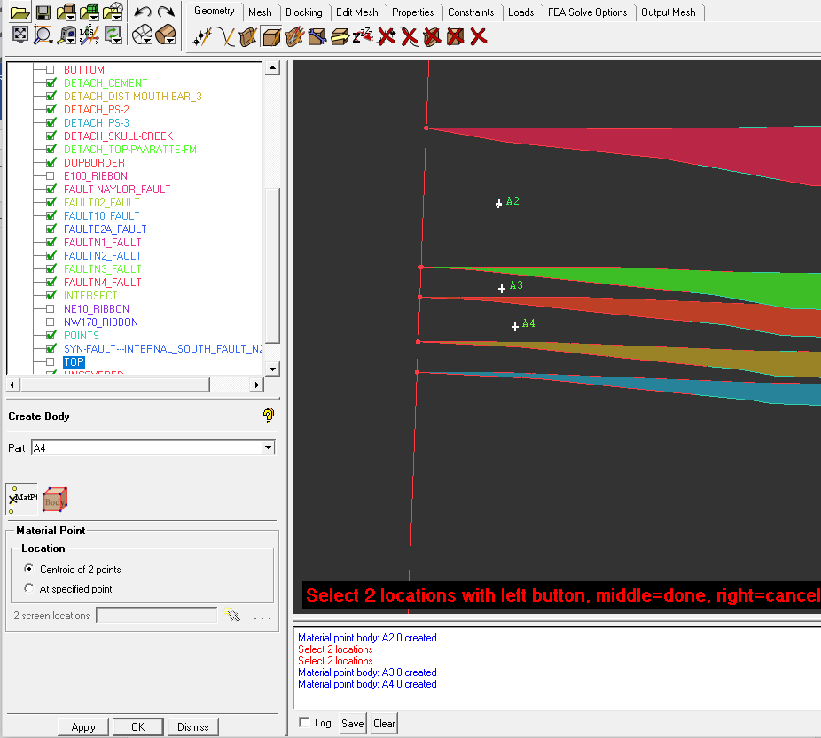
Figure 3.9 bodies add between surface layers

Ansys volumetric meshing Meshing
Using the same settings than the 3D surface meshing, it is possible now to compute the volumetric mesh.

