A semantically-enabled, vendor-independent   
health computing platform

Dr. Koray Atalag PhD (New Zealand)

Thomas Beale (UK)

Dr. Rong Chen, PhD (Sweden)

Tomaž Gornik (Slovenia)

Dr. Sam Heard (Australia)

Dr. Ian McNicoll (UK)

# Executive Summary

openEHR is an open platform-based set of *de facto* standards in which a growing number of governments and industry vendors are investing, in order to realise the goals of semantic e-health.

We believe the activities of openEHR Foundation, its industry partners, and the wider openEHR community (including many universities) are highly relevant to the to development of next generation healthcare IT. The key elements of openEHR’s strategic value to future development are:

* Technically it is a **platform approach**, rather than a set of independent standards or monolithic specification or product;
* It offers the most **comprehensive semantic framework** available in e-health, combining information models, formal clinical modelling, terminology, and a services infrastructure;
* It deals directly with the very difficult challenges of e-health, including **semantic scalability -** handling complex and constantly changing information and clinical workflows, forever;
* It supports the establishment of a **platform-based economic ecosystem**, in which the customer retains control of purchasing at a component level, using platform specifications (information models, APIs, clinical models etc) as conformance points for procurement;
* This in turn **prevents lock-in** on the basis of data format or any other technical element;
* It also **ensures that the customer retains control and ownership of the data**, ensuring it does not incur unexpected costs in the future for its long term use.
* It provides a direct **way for clinical experts to be involved** in the specification and steady state development of the system into the future.

The growing list of openEHR suppliers as well as government-led programmes like Norway and the UK NHS producing clinical models and terminology artefacts for openEHR constitute a good basis for the ecosystem, providing diverse products, services and expertise, all guaranteed to interoperate according to openEHR and other relevant standards such as IHE, HL7 and ISO.

I SUGGEST REPLACING THE FOLLOWING QUOTES WITH SOMETHING FROM GARTNER / NORWAY / ??

“*Although openEHR has been around as a concept for a number of years, it is only in recent months that it’s usage is starting to be adopted into the thinking of central bodies such as the Health and Social Care Information Centre, and it’s practical usage is appearing within real products.”*   
**Richard Jefferson**, Head of Programme Commissioning, **NHS England**

*“The openEHR platform has proven, and been adopted, as a major step forward in the development of IT solutions for healthcare. The “open data, open API” approach is leading edge, and resonates well with the innovative thinking of leading healthcare organisations. The openEHR platform has the ability of providing scalable and adoptable solutions which are very needed to improve global healthcare. There is tremendous amount of potential here.”***Marc Perlman**, Global Vice President, Healthcare and Life Sciences Industry, **Oracle**

# Introduction

The arrival of computers created new possibilities for storing, retrieving and viewing the information within the medical record, by changing the physical nature of records to an electronic format. Electronic Health Records (EHR) have undergone a historical development parallel to that of its paper correlate. As technology progressed and personal computers became more prevalent, efforts in development focused on clinical areas and other areas where departmental or complementary tests are performed, but there was no integration between them and therefore each one ended up being an information silo. The importance of integrating the information generated by various hospital departmental systems made it necessary to connect these systems by means of a common Clinical Data Repository (CDR), leading to the creation of component-based clinical information systems. One of the premises of these new systems was to respect the care process, making medical acts the backbone of the information model. From that time onward, the decentralization of healthcare into care networks has given rise to the need to connect multiple systems, beyond the walls of an institution, and thus enable fluid communication of clinical information.

## The Health Data Management Problem

Over the last 20 years many attempts have been made to solve the ‘wicked’ problem of health data interoperability, and more recently, the ‘semantic’ version of the same. The problem to be solved is essentially:

* semantic interoperability **across and within enterprises**,
* semantic interoperability **between layers of functionality** within a system,
* being able to **compute intelligently** on the data.

Key realities of healthcare that contribute to the health computing challenge include:

* **Massive data richness** – orders of magnitude greater than for financial and most other domains;
* **High rate of change** – requirements for data, clinical processes and workflows, business rules, protocols are constantly changing, making it very hard for standard IT systems to keep up.

A much larger list of concrete needs is implied by this abstract description. Solving these challenges would result in great advances for:

* **shared care**, community care, since health records can be not just shared but treated as a single point of truth;
* **individualised, preventive medicine**, since semantically computable EHR data are amenable to automated evaluation of clinical guidelines;
* **medical research**, since data would be far more computable, and more data per patient could be aggregated from multiple sources;
* **public health**, since aggregation of computable data of large numbers of patients will clearly enable epidemiological functions as well as routine health statistics;
* **cost determination**, re-imbursement, fraud detection and better management of public and private payer funds.

## The Core Challenges

Solution attempts have included many standards and specifications, such as Edifact, HL7v2, DICOM, HL7v3, HL7 CDA, EN/ISO13606, ASTM CCR, SNOMED CT, ICDx, OMG Corbamed and HDTF (RLUS, EIS, CTS2) specifications, and more recently HL7 FHIR. They have also included many implementation technologies, e.g. (free/open) FreeMed, GnuMed, openMRS, Harvard SMART; and of course numerous commercial products and in-house systems.

**None of these are likely to solve the problem on their own**, and attempts to connect them together (typically in government e-health programmes) have been far from successful – the costs of trying to integrate disparate standards have far outweighed the benefits.

From the government / procurement perspective, there are some key realities that are sometimes missed, including the following.

* The **data inside healthcare provider institutions are the most important asset** – either as a productive resource, or at least as an object of risk management. Most today would understand it as both.
* However, **the data are not all produced inside the institution** – lab data often come from external lab companies; the provider obtains or would like to obtain GP data such as medications lists and problem list; a growing amount of health data comes from consumer devices.

Despite many specific advances in ICT, and with a few exceptions (certain centres of excellence), the overall experience for healthcare providers / governments procuring both monolithic one size-fits-all systems, and/or numerous best-of-breed systems remains deeply problematic, with the following issues being common.

* The **main vendor solution rarely supports the data richness actually required by clinicians** – it is well known that many hospitals contain dozens if not hundreds of hidden specialist’s databases, often referred to as the ‘Access database problem'.
* If the institution wants to switch to or add a new vendor, the **changeover costs related to the data alone are enormous** and the risks so great that this consideration alone paralyses them for years with the current ineffective solution.
* **No one vendor can produce all the functionality** the provider requires - even the biggest vendor has a ‘roadmap’ containing numerous features the provider wants today;
* **L**arge procurements always involve time-consuming and **expensive customisation**.
* Procurement of multiple ‘best-of-breed’ solutions for e.g. inpatient, ER, ambulatory etc, come with **huge ongoing cost for data and workflow integration**.
* They **cannot logistically afford to deploy all the functionality they want in one go** – the human costs and challenges of change management not to mention solution integration make this impossible – incremental deployment is actually a practical necessity.
* Asking for even the smallest **changes to the data schema or core functionality often attracts uncontrollable costs** and delays.
* Other data users (e.g. research users, national registries) typically cannot have **access to the data** without the vendor’s say so and price tag.

The end result of many procurements of monolithic solutions is:

* The healthcare provider ends up **losing all control over the data, roll-out** and other aspects of the solution, and in fact becomes an unintended investor in the vendor (without of course obtaining any ownership);
* Arguably worse, the provider institution **loses in-house expertise**, since everything has to be converted to the provider’s way of doing things. If the procurement is for a larger jurisdiction, this can *potentially destroy the independent health informatics capability for a country*.

## The Platform as a Paradigm

A growing segment of the health informatics domain now recognises that the only solution is the use of an open platform, which aligns with a health service’s primary interests which are:

* to avoid procuring massively expensive, inflexible lock-in solutions, and instead procure incrementally, openly and adaptively;
* retain ownership of the data;
* retain control of the choice of platform APIs and other key characteristics.

Achieving this requires an ‘ecosystem’ mindset, whereby different types of economic agents are identified. This idea is illustrated below.

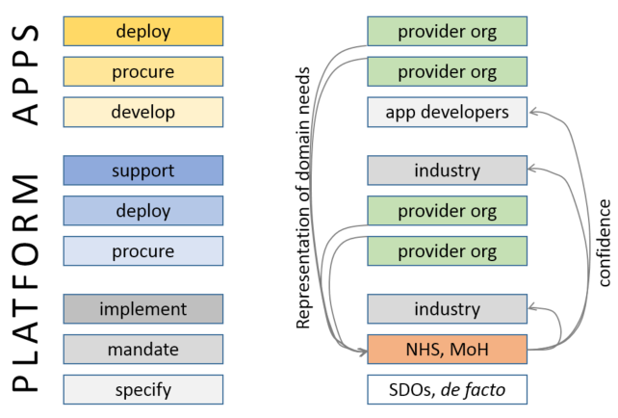

On the left hand side, various business functions in a platform economy are labelled. The strategically important ones are the lowest three: specifier, mandater, implementer.

It has become clear that the specification function can only be done properly as something like a non-profit (usually international) consortium activity, in the manner of Oasis, W3C etc. In e-health two new consortia in the US would seem to bear this out – the [Healthcare Services Platform Consortium](https://healthservices.atlassian.net/wiki/display/HSPC/Healthcare+Services+Platform+Consortium), set up by Harris, Intermountain and Cerner, and the [CommonWell Alliance](http://www.commonwellalliance.org/), set up by various large provider organisations, both specifically around a platform concept.

The US Office of the National Coordinator (ONC) has also understood the significance of the platform idea, and is commissioning programmes based on [the JASON report](http://healthit.gov/sites/default/files/ptp13-700hhs_white.pdf). (The openEHR Foundation was invited to provide input to the ONC hearings on JASON, in late 2014; [report here](http://wolandscat.net/2014/08/12/onc-hearing-on-the-jason-report/).)

In Europe, one of the organisations that has championed the health computing platform concept for over a decade is the openEHR Foundation.

But what is a ‘platform’ in e-Health?

We can say that **a platform isn’t the same thing as a list of standards**. Nothing could be more mistaken. There is a naive view in e-health that SDO-issued standards can be adopted by a country, perhaps with some ‘profiling’ and then unleashed on industry. **Experience in various e-health programmes has shown that this doesn’t work**. Instead, what is needed is a ‘standards factory’ mentality, whereby a national programme creates the standards required over time, piece by piece, and issues them in an ongoing programme that includes provider organisations, clinicians, vendors and other stakeholders. Of course some base level standards are required for things like data types, application interaction and so on. These should mostly be considered to be either to do with information interoperability, platform mechanics, and below that, languages and ontology. These base standards have to be chosen / developed and maintained extremely carefully, and **wrong choices here can sink the whole enterprise**.

The main aim of a health authority standards factory isn’t to just re-issue these base standards, It is to gradually build up an ongoing set of specifications that act as standards over time, defining various APIs in the platform, content types, and eventually, active processes, workflows and business collaboration structures. It needs industry’s help in this, as well as that of clinical and other domain experts. And it’s a never ending enterprise – there will always be new content and workflows to contend with – thus, new APIs, apps and back-end requirements. The deliverable is a **coherent, maintained platform definition**.

The principle here is: **the platform is a process, not a product**. A critical insight here is that a process implies a maintainer: the platform definition must be a living process, in contrast to typical slow *de jure* standardisation processes that work in 3 year cycles.

One of the important sociological angles on the platform concept is **getting buy-in**. If there are (or appear to be) multiple competing platforms that do more or less the same thing, developers will be the ones who decide what gets taken up. So the question is: what works for developers? We can summarise the criteria as follows:

* the platform is easy to understand and well documented
* it is easy to start developing with it, which means available downloads, demonstrator server sites, and SDKs
* it solves more needs rather than less, i.e. a platform that does more, and more flexibly, will gain followers.

Some software platforms are easy to use and bring a modicum of power, e.g. Ruby-on-Rails. Others are super-powerful, but can’t be handled by the average programmer, e.g. Eclipse. Nevertheless, for good or for bad, the overriding factor these days (in which, according to some cynics, nobody has an attention span longer than needed to read a tweet) is **programmer usability**.

In summary:

* the platform concept is both an economic and a technical concept
* it is essential to get the specifications and technical architecture right – poor choices can prevent lift-off
* a platform that is technically good still has to be usable, or developers won’t use it
* open source can help, but isn’t the driver
* *de jure* standards are not always necessary, and are sometimes harmful, if used where not fit for purpose.

Ultimately what matters is that a platform definitions has **industry credibility**. It doesn’t matter too much where it comes from, but it does matter where it is going.

# The openEHR Foundation

The [*open*EHR Foundation](http://www.openehr.org/) was established in 2000 in the UK, and publishes e-heath related [specifications](http://www.openehr.org/programs/specification/releases/currentbaseline), [open source software](https://github.com/openEHR), [domain models (archetypes)](http://www.openehr.org/ckm/) and educational material around a platform architecture. Release 1.0.2 of its information models are widely used in the industry. The Archetype Definition Language (ADL) v1.4 and its associated Archetype Object Model (AOM) specification are ISO standards.

openEHR is a founding member of the Clinical Information Modelling Initiative ([CIMI](http://informatics.mayo.edu/CIMI/index.php/Main_Page)), and [openEHR’s ADL 2 draft standard](http://www.openehr.org/releases/AM/latest/ADL2.html) is the language of CIMI models.

Since 2012, industry interest in openEHR’s open platform health computing approach has grown substantially:

* There are now around 10 ‘[Industry partner’ (financially supporting) vendor companies](http://www.openehr.org/industry_partners/index) (primarily from Europe). These are responsible for openEHR systems running in a growing number of hospitals and health authorities worldwide, as [described here](http://www.openehr.org/who_is_using_openehr/healthcare_providers_and_authorities). These include:
  + Cambio’s COSMIC customers in Sweden, Denmark and UK are using openEHR to integrate [legacy EHR content](http://www.biomedcentral.com/1472-6947/9/33), implement [shared care plans](https://www.researchgate.net/publication/49635217_Modeling_shared_care_plans_using_CONTsys_and_openEHR_to_support_shared_homecare_of_the_elderly) and [treatment compliance checking](http://www.biomedcentral.com/1472-6947/14/39).
  + most of Norway’s hospitals, migrating to DIPS Arena;
  + a growing number of Dutch hospitals and mental health networks use openEHR (Code24 implementation);
  + one of the premier healthcare institutions in South America, Sírio-Libanês in Sao Paolo, Brazil, a HIMSS EMRAM Stage 6 hospital;
  + In Russia, Moscow City has built a city-wide EHR using Marand’s openEHR implenentation to manage all clinical data for 12 million inhabitants. By providing a health data platform to participating vendors, Moscow City ensured all data from newly developed applications are open, pre-integrated and thus interoperable;
  + Numerous other Russian hospitals (Infinnity implementation);
  + Slovenia’s National eHealth backbone runs on a combination of IHE infrastructure and openEHR (Marand), enabling exchange of documents as well as structured health data between the country’s 120 healthcare providers. It also enables centralised eHealth applications managing Immunisations, Prescriptions, Referrals and soon Patient Summaries at the national level;
  + Various major providers in Australia, including Queensland Health (statewide infection control); Northern Territory Health (personal EHR); major GP networks in New South Wales (Ocean Informatics).
* There are active semantic health modelling programmes or projects based on [openEHR archetypes](http://www.openehr.org/ckm/), and using the Ocean Informatics Clinical Knowledge Manager (CKM) in [Australia](http://dcm.nehta.org.au/ckm/) (Nehta), [Brazil](http://www.centerms.org.br:8009/ckm/) MoH, Moscow City, [Norway](http://arketyper.no/ckm/) MoH, [Slovenia](http://ukz.ezdrav.si/ckm/OKM_sl.html) MoH, and [United Kingdom](http://www.clinicalmodels.org.uk/ckm/) NHS.
* The [United Kingdom NHS Health and Social Care Information Centre](http://www.hscic.gov.uk/), responsible for national health information standards recently converted from an ISO 13606–based modelling approach to openEHR, and will be using openEHR archetypes along with SNOMED CT, LOINC and other terminologies. Various openEHR vendors are involved.
* [HANDI-health in the UK](http://handihealth.org/about-2/), a non-profit open health app facilitating organisation, has specified openEHR as the core of its [application platform](http://handihealth.org/introducing-handi-open-platform-demonstrator-handi-hopd/).

openEHR provides standards for:

* Clinical (EHR) and demographic data – the [openEHR Information Models](http://www.openehr.org/programs/specification/releases/currentbaseline)
* Clinical (EHR) and demographic content models, and connection points to terminology – the [openEHR archetypes and templates](http://www.openehr.org/ckm/)
* Guidelines – [GDL language](http://www.openehr.org/releases/CDS/latest/GDL.html)
* Portable Queries – [AQL language](http://www.openehr.org/releases/QUERY/latest/AQL.html)
* Key Services and APIs – including [REST services generated from archetypes](https://dev.ehrscape.com/api-explorer.html).

Unlike *de jure* standards that generally do not work together without significant effort, **openEHR’s technical deliverable is a coherent, self-consistent platform** and clinical models that work with it. It provides ways to import and export data based on other standards but **always guarantees consistent semantics internally**. All openEHR data around the world are based on the same reference model, and are interoperable. This is possible because the clinical and other domain semantics are defined above the software and DB schema level.

The other departure from the world of *de jure* standards is that openEHR is a constant maintainer, and has [issue trackers](https://openehr.atlassian.net/issues/secure/Dashboard.jspa), a large active [wiki](https://openehr.atlassian.net/wiki/dashboard.action), and [discussion lists](http://www.openehr.org/community/mailinglists). openEHR works with *de jure* standards groups, including ISO TC 215, HL7, OMG and CEN, and provides one of the best ways to safely integrate many of the standards issued by these organisations.

## The openEHR Paradigm

The openEHR technical approach is ‘multi-level modelling within a service-oriented software architecture’, in which models built by domain experts are in their own layer.

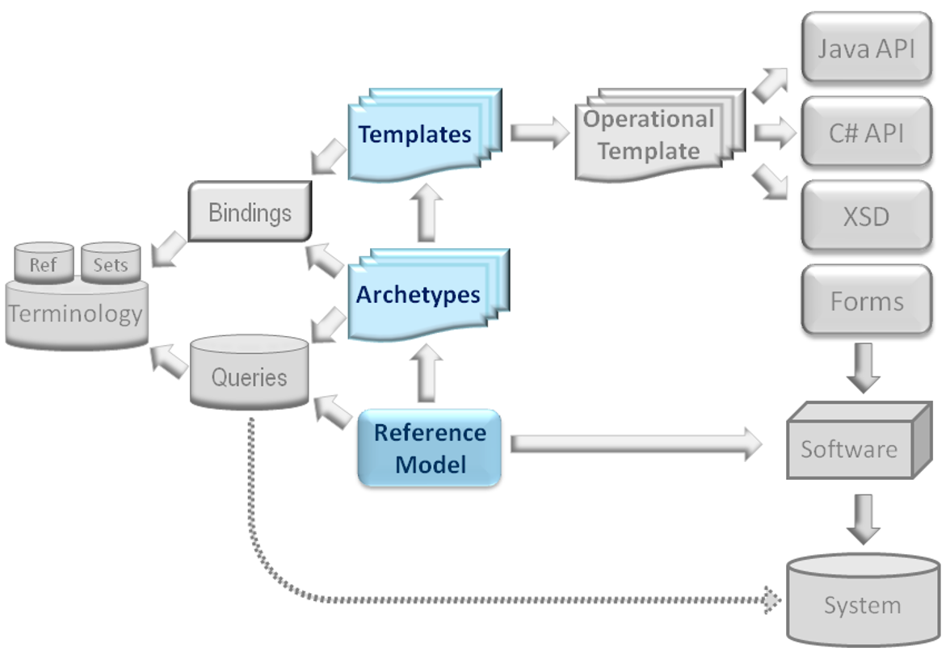

This allows domain experts - clinicians, allied health workers, and other experts - to be directly involved in defining the semantics of clinical information systems, and it also makes using terminology much easier. An international repository of these models, known as 'archetypes' can be seen [here](http://www.openehr.org/ckm/), and the archetype specification is an ISO standard (ISO 13606-2). These are now being used by several national governments as described above.

openEHR also defines specifications for clinical information models, [EHR Extracts](http://www.openehr.org/releases/RM/latest/ehr_extract.html), [demographics](http://www.openehr.org/releases/RM/latest/demographic.html), [data types](http://www.openehr.org/releases/RM/latest/data_types.html) and various kinds of service interfaces. These have been used in hospitals and summary EHR systems in various countries. It has also included a leading edge [Guideline Definition Language (GDL)](http://www.openehr.org/releases/CDS/latest/GDL.html), originally developed by Cambio in Sweden, as a specification.

A second dimension via which the openEHR modelling approach can be viewed is **single-source modelling**. Via this approach, archetypes and templates are definitive models of semantics, without commitment to specific messaging or document standards. Instead, these concrete expressions are now generated artefacts, i.e. **document and message schemas are no longer manually modelled**. Once single-source modelling is established, other outputs including UI forms and software source code. This means that **a model for 'microbiology result' only needs to be done once** to enable reports, UI forms, documents and other message formats to be generated.

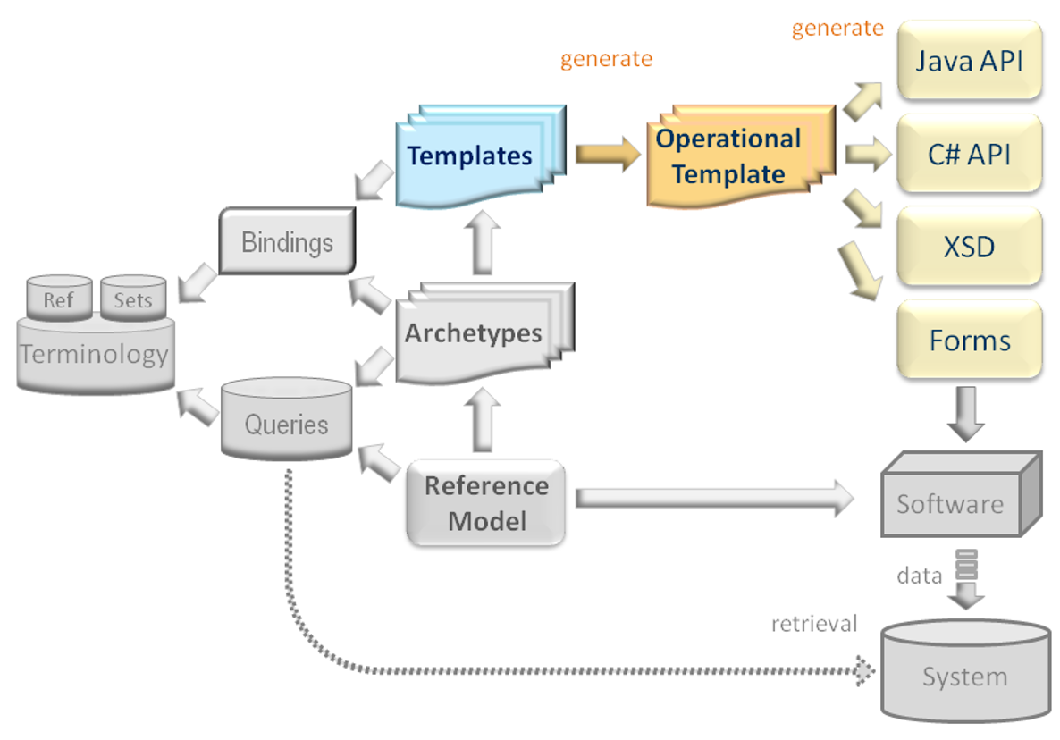

One of the more recently developed types of generated artefact is **RESTful API specifications** for application interfacing, which can be seen online at [Marand’s EhrScape site](https://dev.ehrscape.com/api-explorer.html).

There are some key benefits to openEHR's approach. Firstly, it is **possible to** **build an EHR repository (CDR) independently of content specifications**. In other words, an EHR system doesn't need to know *a priori* about any of the clinical data it will process, such as vital signs, diagnoses or orders. Models for those things are developed separately. Models for data sets and forms are also developed separately, and UI form components are now generated from these definitions. This **enables a new generation of EHR systems that routinely adapts to new requirements** - because that's how the architecture is designed in the first place.

Secondly, building software is now very different. **Significant parts of the software are now generated by tools** from the templates, reducing the amount of work to do, and greatly improving semantic traceability. Model-generated code and UI (user interface) is an area of continual innovation in openEHR, and promises to revolutionise health computing.

Another benefit is **portable queries and decision support logic.** Queries in openEHR are based on content models, not physical database schemas. Coupled with EHR service interface APIs, these are enabling a new class of decision support tools. For a long time, it has been an elusive goal to share decision support logic and modules across organization and country borders. With the [Guideline Definition Language (GDL)](http://www.openehr.org/releases/CDS/latest/GDL.html), it is finally possible to express clinical logic that is truly agnostic to clinical domains, natural languages and reference terminologies.

In clinical terms, **health professionals are now for the first time experiencing direct involvement** in the construction and ongoing development of EHR systems. This means that the quality of the data is better - they designed it, and it also enables applications that work for them to be built.

More information on archetype technology can be found [here](http://www.openehr.org/releases/AM/latest/Overview.html).

# An openEHR-based Ecosystem

The openEHR standards and models only solve part of the overall problem, and are intended to be integrated carefully with specific standards / artefacts to provide an overall working platform. The other key elements include:

* Terminology, including SNOMED CT, LOINC, ICDx, ICF etc
* Coarse grained distribution services, as found in IHE, HL7/HSSP and OMG
* Fine-grained APIs, provided by openEHR, HL7 / FHIR and other sources.

As an overall **development ecosystem**, such a platform can be illustrated as follows.

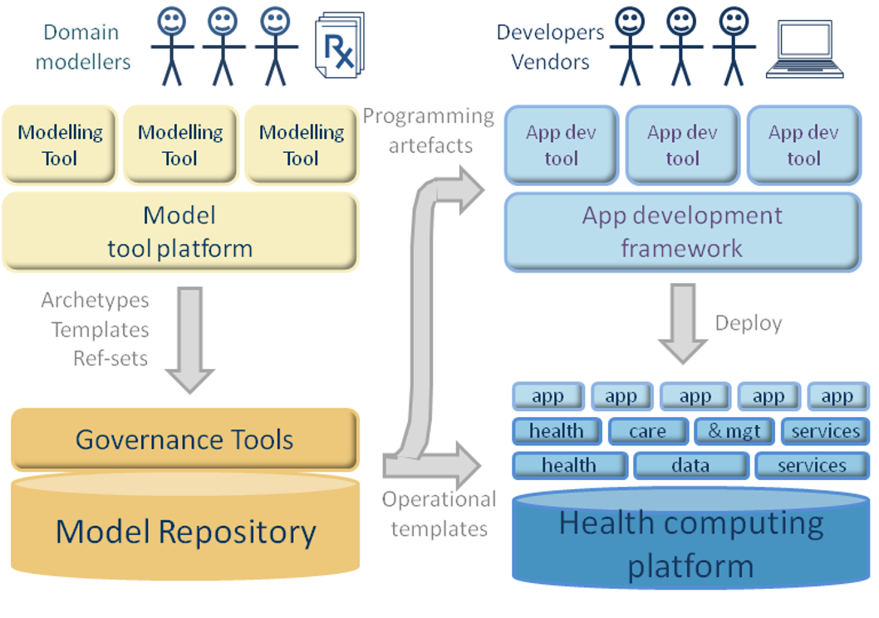

The left hand side consists of managed **semantic modelling** activities, i.e. creation and maintenance of content models (archetypes, templates), terminology subsets, guidelines, query sets and so on. The model repository tool is used to manage e-collaboration and publishing. Thus, the left hand side corresponds to the ‘standards factory’ concept.

The right hand side illustrates the world of **software development** and deployed systems. Unlike in the standard case however, significant use is made of the formal content models, which can be both used to generated forms, document schemas, message definitions (top right), and can also be injected into the running system.

A realistic example of an openEHR-based platform and services is shown below.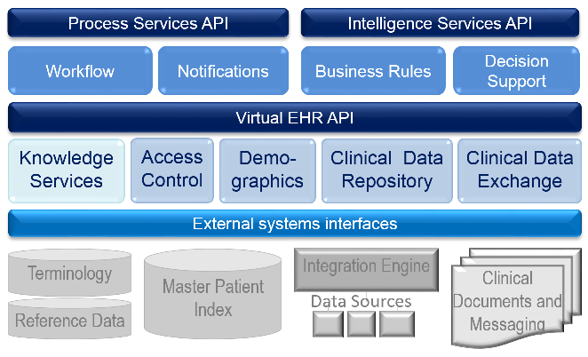

These components can be incrementally deployed over time, starting with core services such as CDR, Demographics, CDE (which may be based on an IHE approach), IHE ATNA system wide audit, notifications (typically integration engine-based) and so on. As time goes on, higher-level process-related services would be added, including scheduling, patient and doctor diary, shared medications list, problem list, e-pharmacy and decision support. Above this, application level services would be added, including various kinds of portal.

The key here is that:

* all interfaces are openly specified and **published**;
* all data are based on the **publicly available** information model specifications;
* all content semantics, terminology use etc are based directly on openly published archetypes;
* decision support logic and queries are based on the archetypes, and can be openly published.

These all act as the ‘control points’ for a procuring healthcare delivery organisation or managing institution or Ministry of Health.

Finally, the **most important characteristic of the platform** from an economic and risk-management point of view is that its components can be provided by different suppliers, and that the customer is in the ‘driving seat’ with respect to choice and timing.

# openEHR in the National Context

openEHR has a potential role in a **national context**, helping to solve a number of problems that have historically plagued national e-health programmes and industry engagement. One issue is being able to define standards for health information and terminology in a **shareable, computable format**, e.g. for things such as e-referral, e-prescription, etc. Secondly, vendors are not easily able to deal with government documentation and data dictionaries, since these artefacts don't connect in any obvious way with their own software development environments.



openEHR helps to solve this problem by providing a product and vendor neutral formal method for defining health data content and terminology subsets, using [**openly available tools**](http://www.openehr.org/downloads/modellingtools) that can generate directly usable software artefacts from content models, enabling vendor developers to consume the specifications and convert them into solution components. This approach enables a level of **traceability** not available with documents and data dictionaries, and integrates terminology and information models in a scalable way. The other key advantage of the approach is that national programmes can **engage clinical professionals** and bodies directly using online tools rather than inefficient meetings.

A new type of **partnership** among government, healthcare professionals, and vendors is possible, which enables a 'standards factory' to be established, that continually creates and maintains formal artefacts made according to national needs, using professional skills, and directly usable by implementers.

In such an environment, the adherence of implemented solutions to national requirements can be far greater than it is today, and **industry-wide interoperability** of key data sets has a much greater chance of being achieved.

# State of the Market

As mentioned above, a [number of vendors have implemented openEHR](http://www.openehr.org/who_is_using_openehr/healthcare_providers_and_authorities), and are making it a strategic part of their product offerings. These vendors all subscribe to the platform idea, and competing on the basis of quality and features rather than the ability to lock in customers.

We know currently of a number of vendors with products that can deal with EHRs for the entire population not just of of thousands, but of milions, along with the typical user loads of very large institutions and health networks.

**Not every possible problem is solved of course, and any procuring agency needs to be conscious of this**. This is an essential part of the platform approach – gradually building in additions and innovations over time. Given the ambition of the different programmes , it is very likely indeed that these programmes would become an active participant in openEHR, and help develop new models, specifications and other components.

The openEHR vendors work on the basis that the customer should:

* own the data;
* own/be able to openly access any semantic models used (archetypes, guidelines, terminology subsets) and
* retain control of the right to state platform-based conformance points to suppliers in procurement.

Interested parties can obtain an initial view of products and systems from the resources mentioned here, i.e. [‘who is using it’ web page](http://www.openehr.org/who_is_using_openehr/healthcare_providers_and_authorities) and the [Industry Partners page](http://www.openehr.org/industry_partners/index).

A further point to make is that the openEHR vendors, academic institutions (UCL (UK), Kyoto, Porto, Linkoping, Valencia Polytechnic, and many others), as well as government-led programmes represent a **significant amount of expert knowledge** in openEHR and other standards, platform thinking, terminology, clinical process and health informatics in general.

# MANAGING CLINICAL DATA – Examples of use

## Medical Device Data Repository

**Semantically enabled** clinical and demographic data is a core strength of openEHR, and similarly a strength of all openEHR supplier offerings. The phases including data collection, semantic conversion, data storage, data accessibility and terminology binding are front-line concerns for openEHR systems.

Further data-related features that are in openEHR and we strongly recommend adopting:

* Full change-set based **versioning**, supporting medico-legal needs and forensic use of data (what was known to whom, when).
* Hashing and **signing** of committed clinical data.
* **Separation of demographic and clinical data** with varying levels of use of subject identifiers in clinical data, as a security measure.

The openEHR Reference Model contain features to enable **large amounts of device data** (typically unchanging ‘normal’ readings generated by bedside monitors) to be mathematically compressed into small amounts of data while retaining the same information. This is more important that it may first appear, because it enables data from multiple different devices to not only be compressed into far smaller amounts of data, but to automatically be added to the main patient EHR in a standard way. So for example, ICU BP readings will be represented in the same semantic fashion as GP or patient-taken readings, and can be returned as part of a series from one query.

Various openEHR vendor companies have built components that deal with device data, including based on the Continua Alliance standards. In addition, most have built data integration for typical devices such as pulse oximeters, and wearable devices. In some cases, these use 3rd party products such as Capsule.

The [openEHR CKM](http://www.openehr.org/ckm/) includes clinical models for:

* pulse oximeter
* BP, including repeating samples and averages and max / min as generated by some devices
* Other standard vital signs
* ECG
* Audiology related
* Recording device meta-data
* Pulmonary function testing
* Many others (see mindmaps in Appendix 1 – all of these data types have been modelled as openEHR archetypes).

## Clinical Decision Support

One of the main barriers to widespread adoption of Clinical Decision Support applications is their **lack of portability** due to the binding of rules to physical data models. openEHR has provided one of the most needed innovations needed to underpin a realistic decision support product market: **portable queries**, i.e. queries that are not related to the physical database schema or model, but instead to the logical content definitions. These are authored in the [Archetype Query Language, a major openEHR specification](http://www.openehr.org/releases/QUERY/latest/AQL.html).

Most of the openEHR vendors have implemented some form of decision support.

In Cambio’s[1] new Clinical Decision Support product line, the clinical logic are exclusively defined by openEHR archetypes and GDL rules. One of the first GDL-based CDS applications, Stroke Prevention CDS was successfully tested in a pilot study at 5 clinics in Östergötland (SE) and received positive feedback from the clinicians. The Stroke Prevention CDS was assessed to [potentially generate substantial cost saving for the society by Swedish agency TLV](http://www.tlv.se/Medicinteknik/Medicinteknikuppdraget/avslutade-halsoekonomiska-bedomningar/TLV-utvarderar-Cosmic-clinical-decision-support/).

Ocean Informatics MultiPrac Infection Control product, [running in over 100 hospitals in Queensland, Australia](http://oceaninformatics.com/case_studies/queensland_health), implements infection and outbreak detection guidelines to generate real-time notifications of outbreak events within a complex physical environment (hospital + surrounding urban areas).

## Order Management

The openEHR specifications include specific features for representing orders (called ‘Instructions’) and order-based actions (‘Actions’). It also defines a **standard state machine** supporting order tracking and Care Plan definition, used to track status of all interventions.

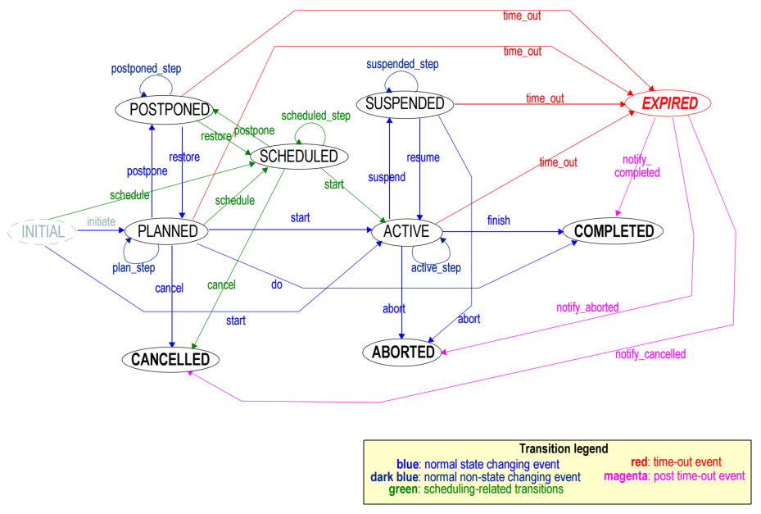

The general approach to implement process based features relies on rule engines, with rules written using the Archetype Query Language embedded in a standard rule language (as found in [Drools](http://www.drools.org/) for example), and notifications, usually implemented with an integration engine.

Some previous work has been done at Karolinska on using openEHR to represent Care Plans for complex cases (mainly oncology / chemotherapy).

As an example, Marand has open sourced in-hospital Medication Management built on these specifications to the NHS OPENeP project, with the first UK Trusts beginning deployment end of 2015. A demo version can be found [here](https://www.ehrscape.com/openep.html).

## Clinical data repository complementing IHE systems

An openEHR structured clinical data repository can be **easily integrated** into an eHealth infrastructure based on IHE, in an architecture like the following.

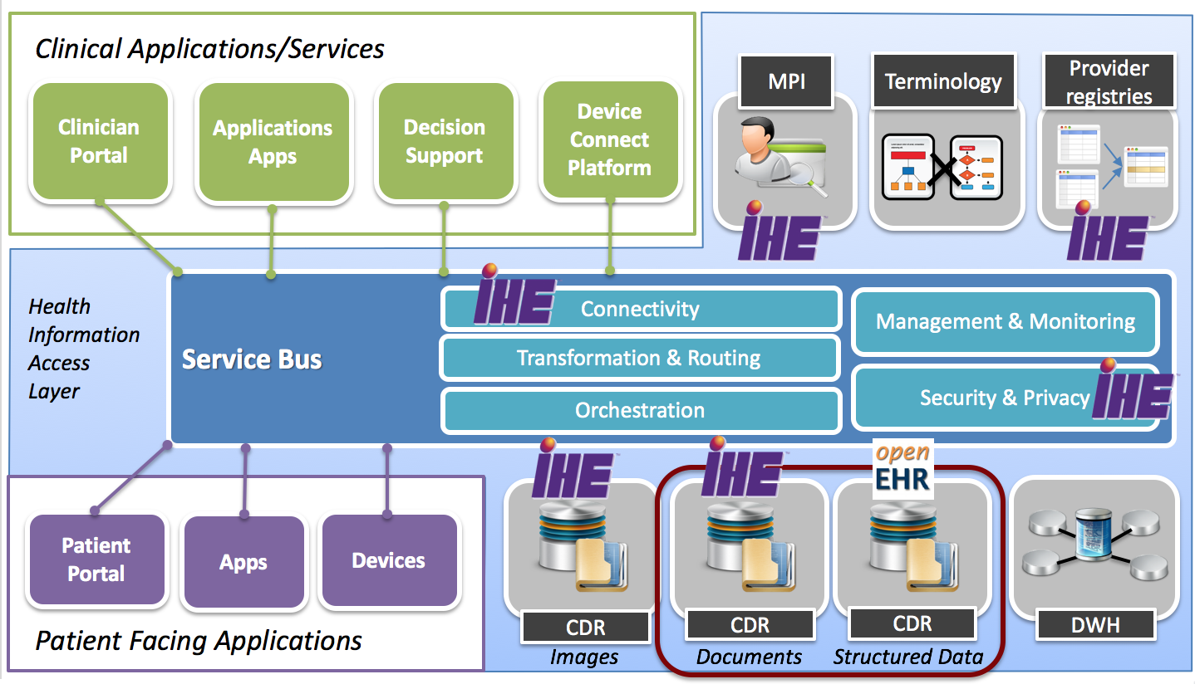

In this case, the standard IHE profiles are used for integration and document exchange, while an openEHR repository stores structured clinical data for querying, decision support and analytics.

## Full blown, agile EHR systems

In today's competitive world, the **need for agility** has forced the program into a niche in which rapid change is now a dominant factor. Because agility is largely about change, the need for mechanisms to support change (as opposed to rigidity) is paramount. Fortunately, modern computing architectures and tools are allowing IT departments to "crack the egg" of the program open to get at the "yolk" inside.

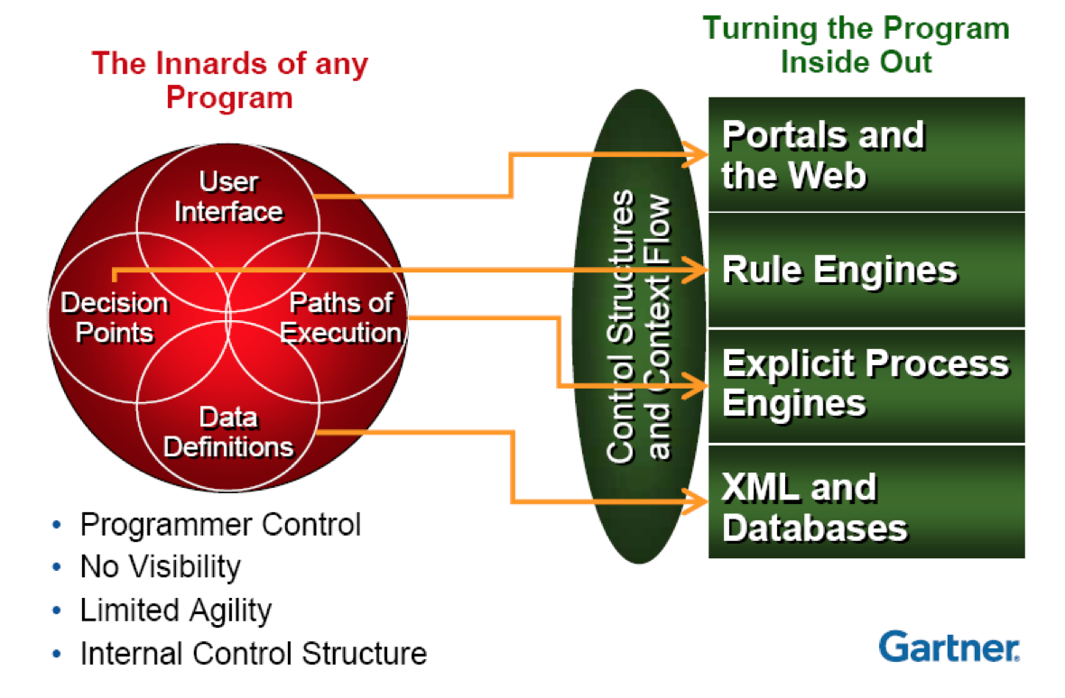

Programs (which are typically made up of data, logic, execution paths and decision points) are now being developed using BPM tools, along with other distributed and loosely coupled technology, to provide a **flexible framework** for how a program functions rather than the rigid containers of the past.

1. **Portals** and user experience on the Web have long ago replaced single-function user interfaces as the primary means of delivering user access.
2. **Rule engines** are now allowing easy access to the decision points in a system that might need to change from time to time.
3. **Explicit process engines** now allow us to form multiple process flows to solve a given set of problems,
4. **Data** has been moved into a more-free-form style using XML and dedicated database systems.

This approach provides agility since the more options you have for altering the way a system works without making it too fragile, the more likely you are to be able to make the proper changes when they are necessary.

Since openEHR platforms can be used to **flexibly store** any clinical data, they are a **prime candidate for the data layer in clinical applications.**

## Ecosystems of Apps

Finally, openEHR platforms facilitate **modular and platform based ecosystems** which create **new business opportunities** for innovation from small, nimble companies, by providing services to store and retrieve data in a secure, semantically coherent manner, so it can be **shared among different systems**.

Such platforms can:

* **Jumpstart development** of standards based EHR systems, apps and enterprise grade solutions
* Stimulate **innovation** and creativity for students, start-ups and SMEs allowing them to compete with bigger players by lowering development cost and leveraging the ecosystem to provide end-to-end solutions
* Provide a **focal point** for individuals and organisations to develop models and software around a clinical problem domain
* Serve as a tool to teach software development, like [**Code4Health**](https://code-4-health.org/) in the UK
* **Create ecosystems** of the best of breed solutions in healthcare based on a vendor-neutral clinical data repository

An integral partof the openEHR methodology to enable ecosystems are RESTful **API specifications** for application interfacing, which can be seen online at the openEHR [EhrScape site](https://dev.ehrscape.com/api-explorer.html).

# Procurement Approach

We recommend procurers to **consider a consortium approach** that involves more than one openEHR vendor, as well as other companies that provide e.g. IHE, lab systems, integration engines, and device interface solutions. The openEHR Foundation includes experts who can help with this, and work broadly on all the key technologies required, including numerous experts.

However, it is essential to **ensure the coherence of the result**, rather than the usual consortium ‘race to integrate everything at the last minute’. The difference must be that the concrete platform definition to be used by the procurer is largely known in advance, and is used as the conformance criteria for consortium participation.

To this end, we would recommend establishing a group or **office dedicated to the platform definition and architecture**, which takes responsibility for how standards are used, integrated, conformance testing, and also what elements of a platform definition are used as requirements in ongoing procurement actions.

We would also recommend that procurers concretely consider supporting local clinical experts to lead clinical modelling activities, in cooperation within the openEHR Community – i.e. development, use and translation of archetypes, guidelines and terminology. The openEHR clinical modelling community includes [over 1200 clinical experts](http://openehr.org/ckm/#userstatistics). The Norwegian Nasional IKT project, which cooperates with the regions may be a useful reference.

We support the idea of a ‘procurement of innovation’, and suggest that this could be used to obtain expertise to flesh out the platform approach, both as a technical concept and as a commercial ecosystem concept (equally important). It is important that procurers can arrive early on at a point where it can see how the whole operation can be long term sustainable, so the critical understanding is **what does the platform look like as a process, in the stable state?** It must be remembered that no technical solution available today solves all the problems of tomorrow, so a key consideration is the *methodology* going foward.

1. http://www.cambio.se/en/