 |  | OpenETCS - WP3
 |  | Extract from Alstom TRB Model
13/10/13
13/10/13 | S. Besure |  |  |  | PF Jauquet |  |  | N. Moussine-Pouchkine
Date | Established |  |  |  | Checked |  |  | Approved | Charleroi
DISTRIBUTION |  |  | Confidentiality Category  Restricted Normal |  |  |  | Control Category  Controlled Not Controlled
CONFIDENTIAL.  All rights reserved.  ALSTOM |  |  |  | Passing on and copying of this document, use and communication of its content are not permitted without prior written authorization |  |  |  |  | OpenETCS_DNOT_0001 | Rel.  A | Lang.  en | N.Shts  274

REVISIONS
Version/  Release | Auteur/  Author | Date  (fr : jj mois. aaaa)  (en : dd Month. yyyy) | Page /  Paragraph | Commentaires/  Comments
1 | S. Besure | 13 octr 2013 | All | Creation

1 Objectives 4
2 DATA FLOW DIAGRAMS 5
3 Data Dictionary 28

Objectives
This document is an extract of Alstom ERTMS Trainborne Specification document (Erreur ! Il n'y a pas de texte répondant à ce style dans ce document.), especially established for the OpenETCS project.

It gives the top level data flow diagrams of Alstom ERTMS Trainborne solution. Some diagrams, not related to ERTMS functions have been voluntarily omitted. The associated data dictionary is also attached.
This extract is intended to serve as a basis for discussions within WP3. It shall remain confidential within the persons involved in the WP3 SSRS Modeling group. It is not released under an Open Source license.

DATA FLOW DIAGRAMS
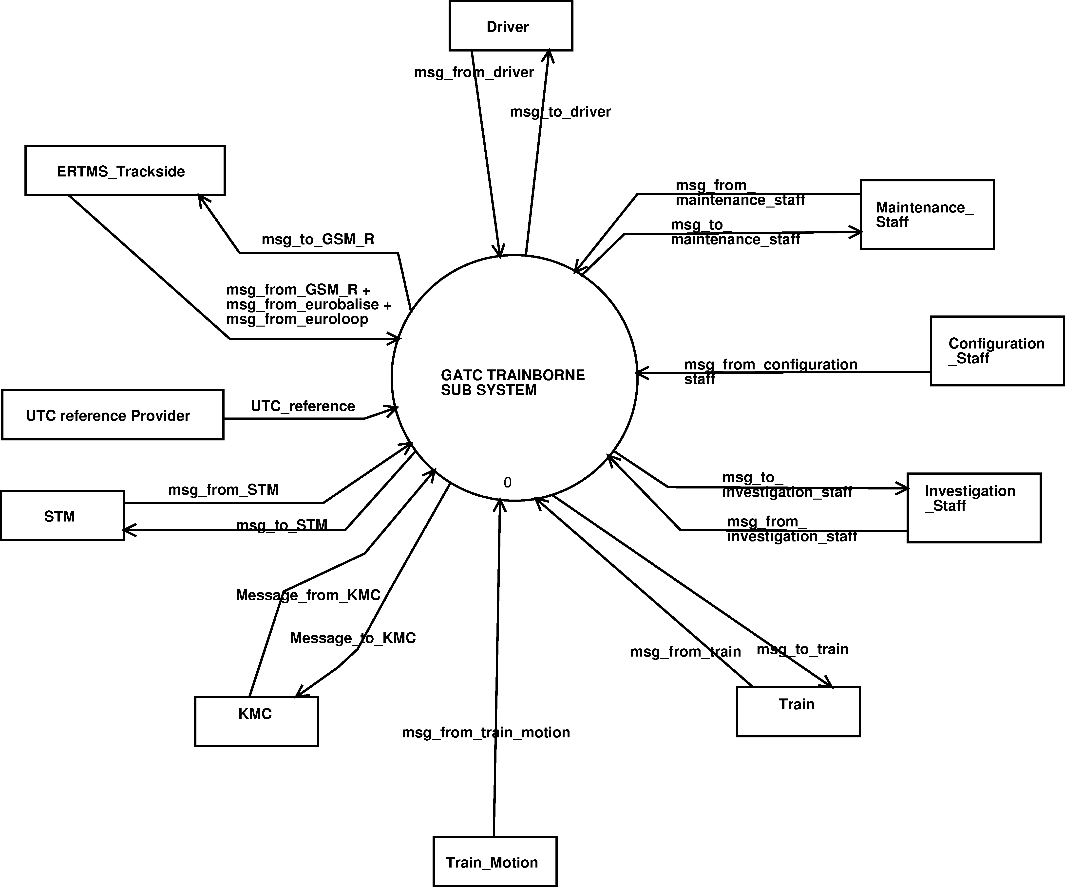
Diagram 1. Board External Interface - dfd Context-Diagram.
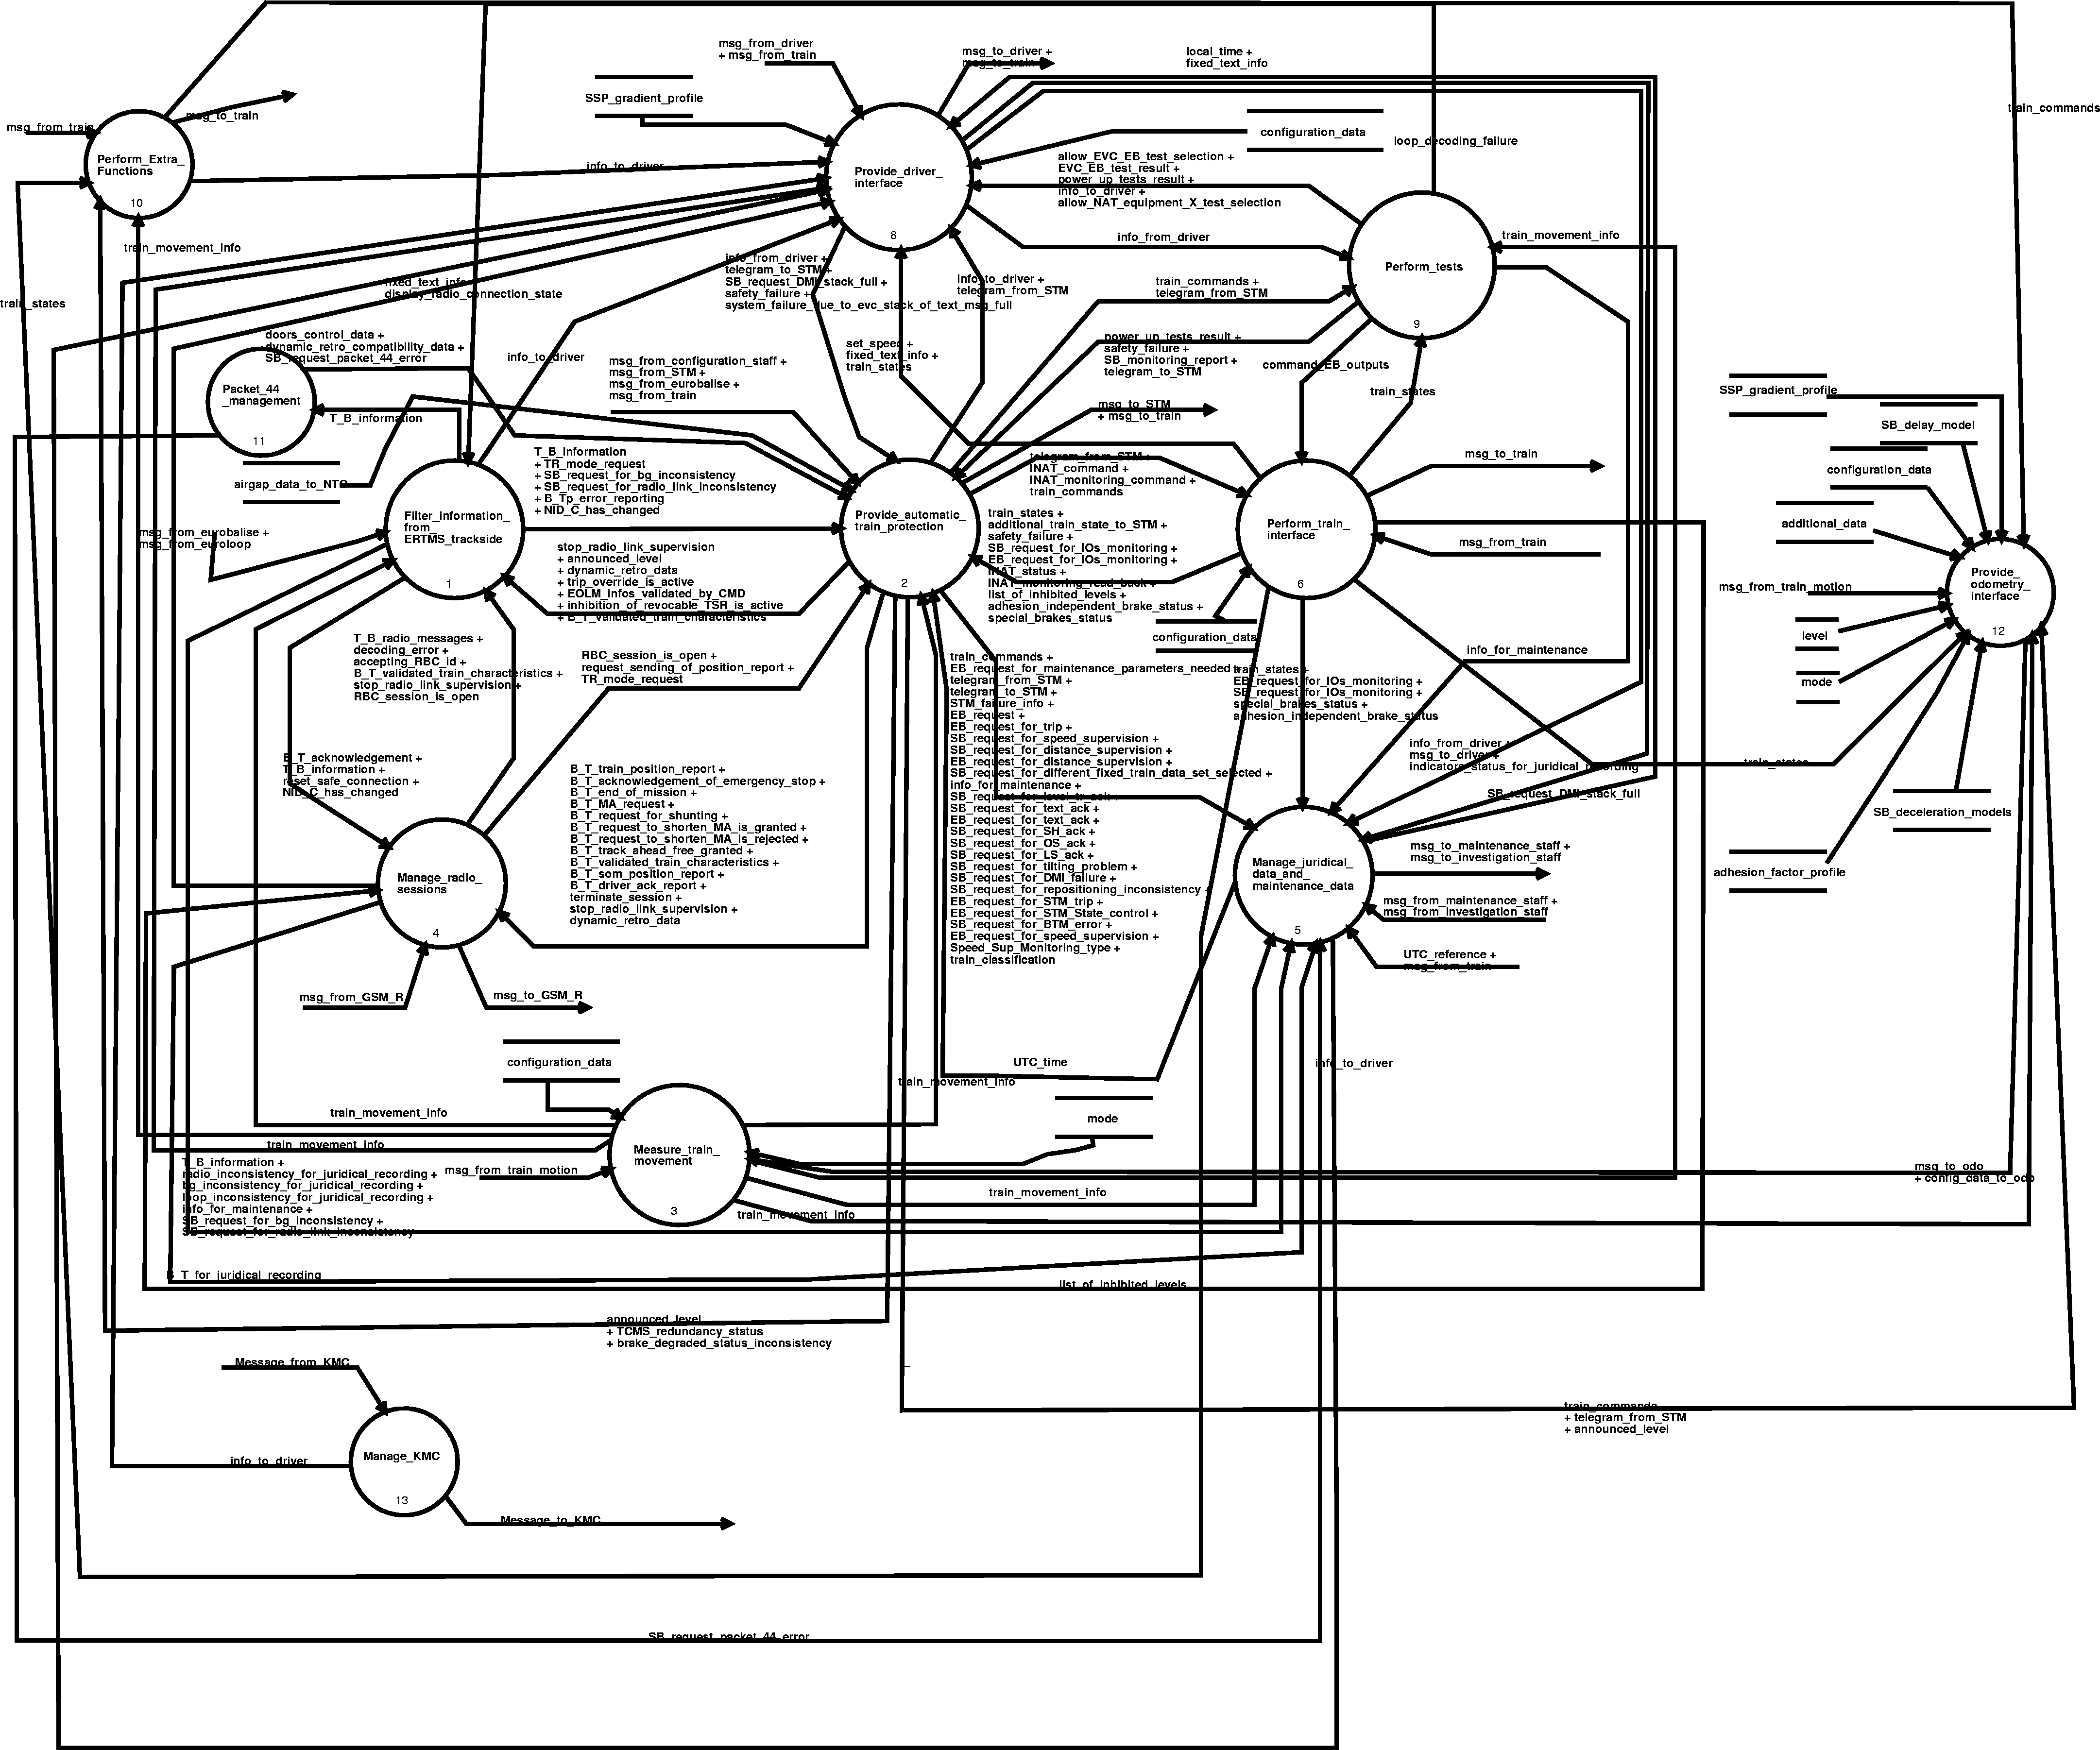
Diagram 2. GATC TRAINBORNE SUB SYSTEM - dfd 0.
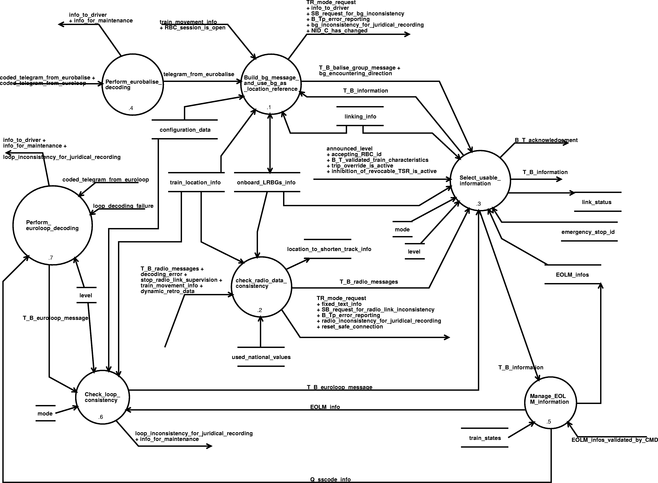
Diagram 3. Filter_information_from_ERTMS_trackside - dfd 1.

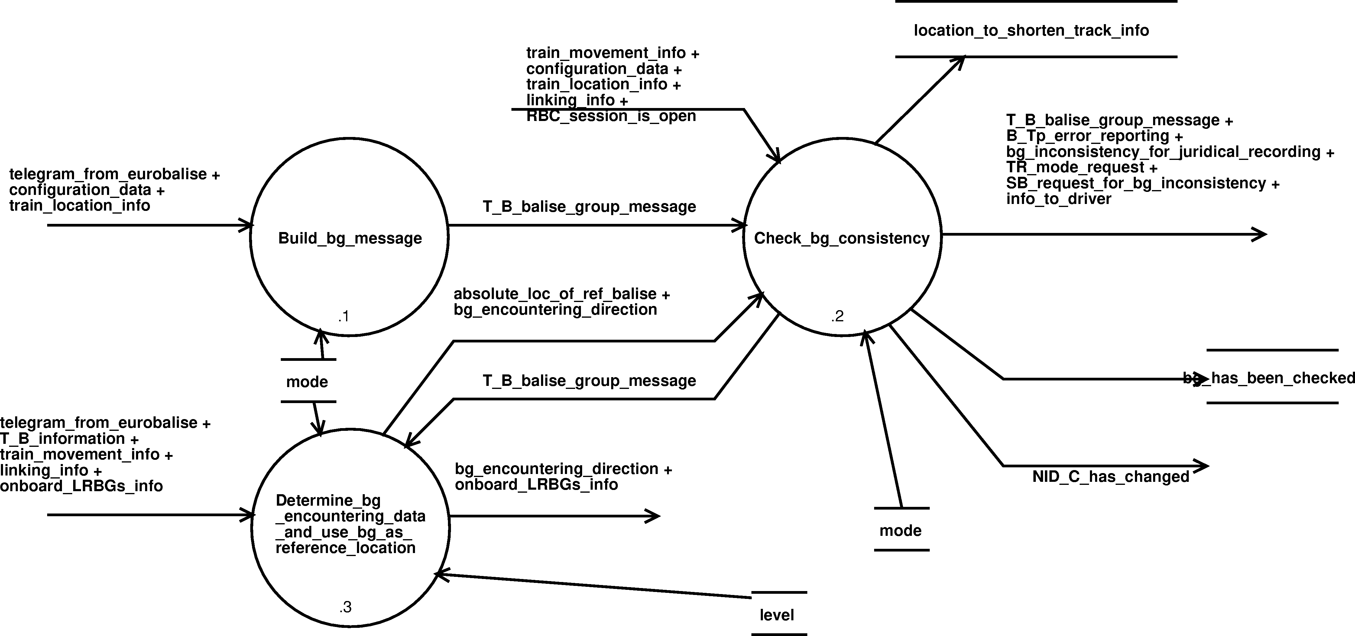
Diagram 4. Build_bg_message_and_use_bg_as_location_reference - dfd 1.1.

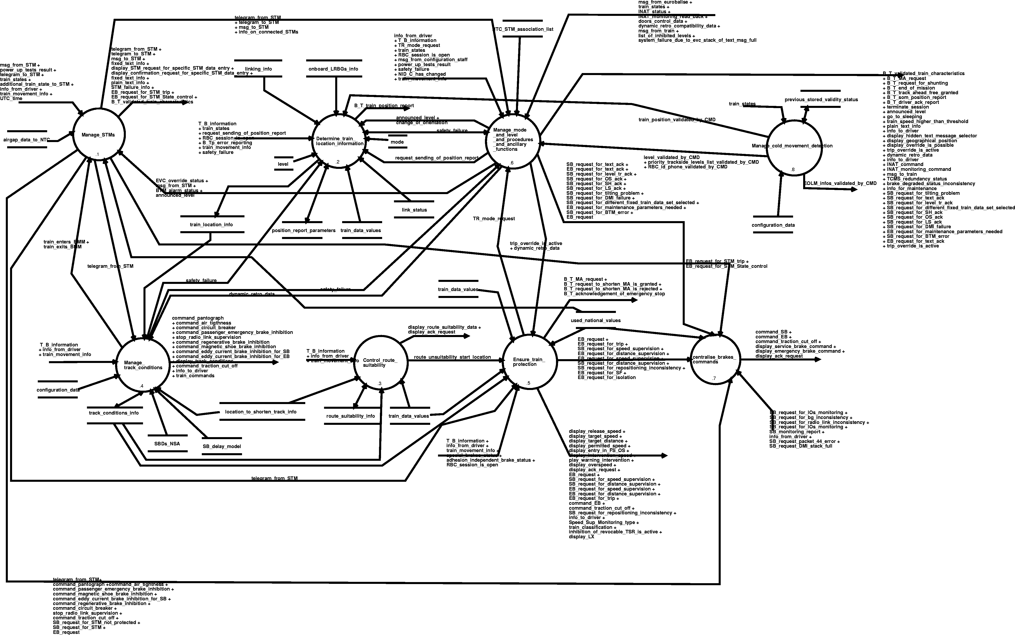
Diagram 5. Provide_automatic_train_protection - dfd 2.
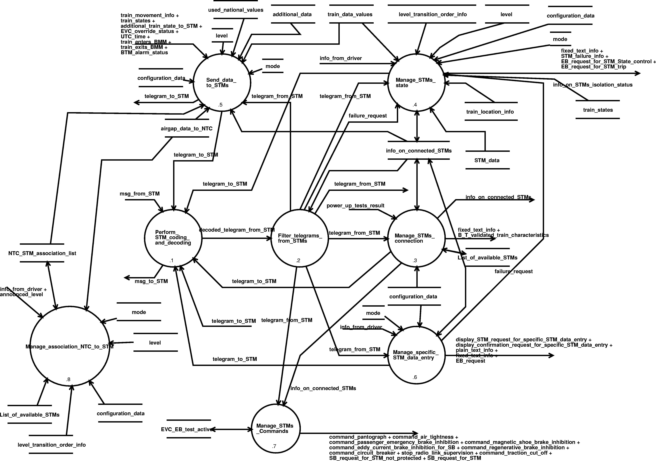
Diagram 6. Manage_STMs - dfd 2.1.
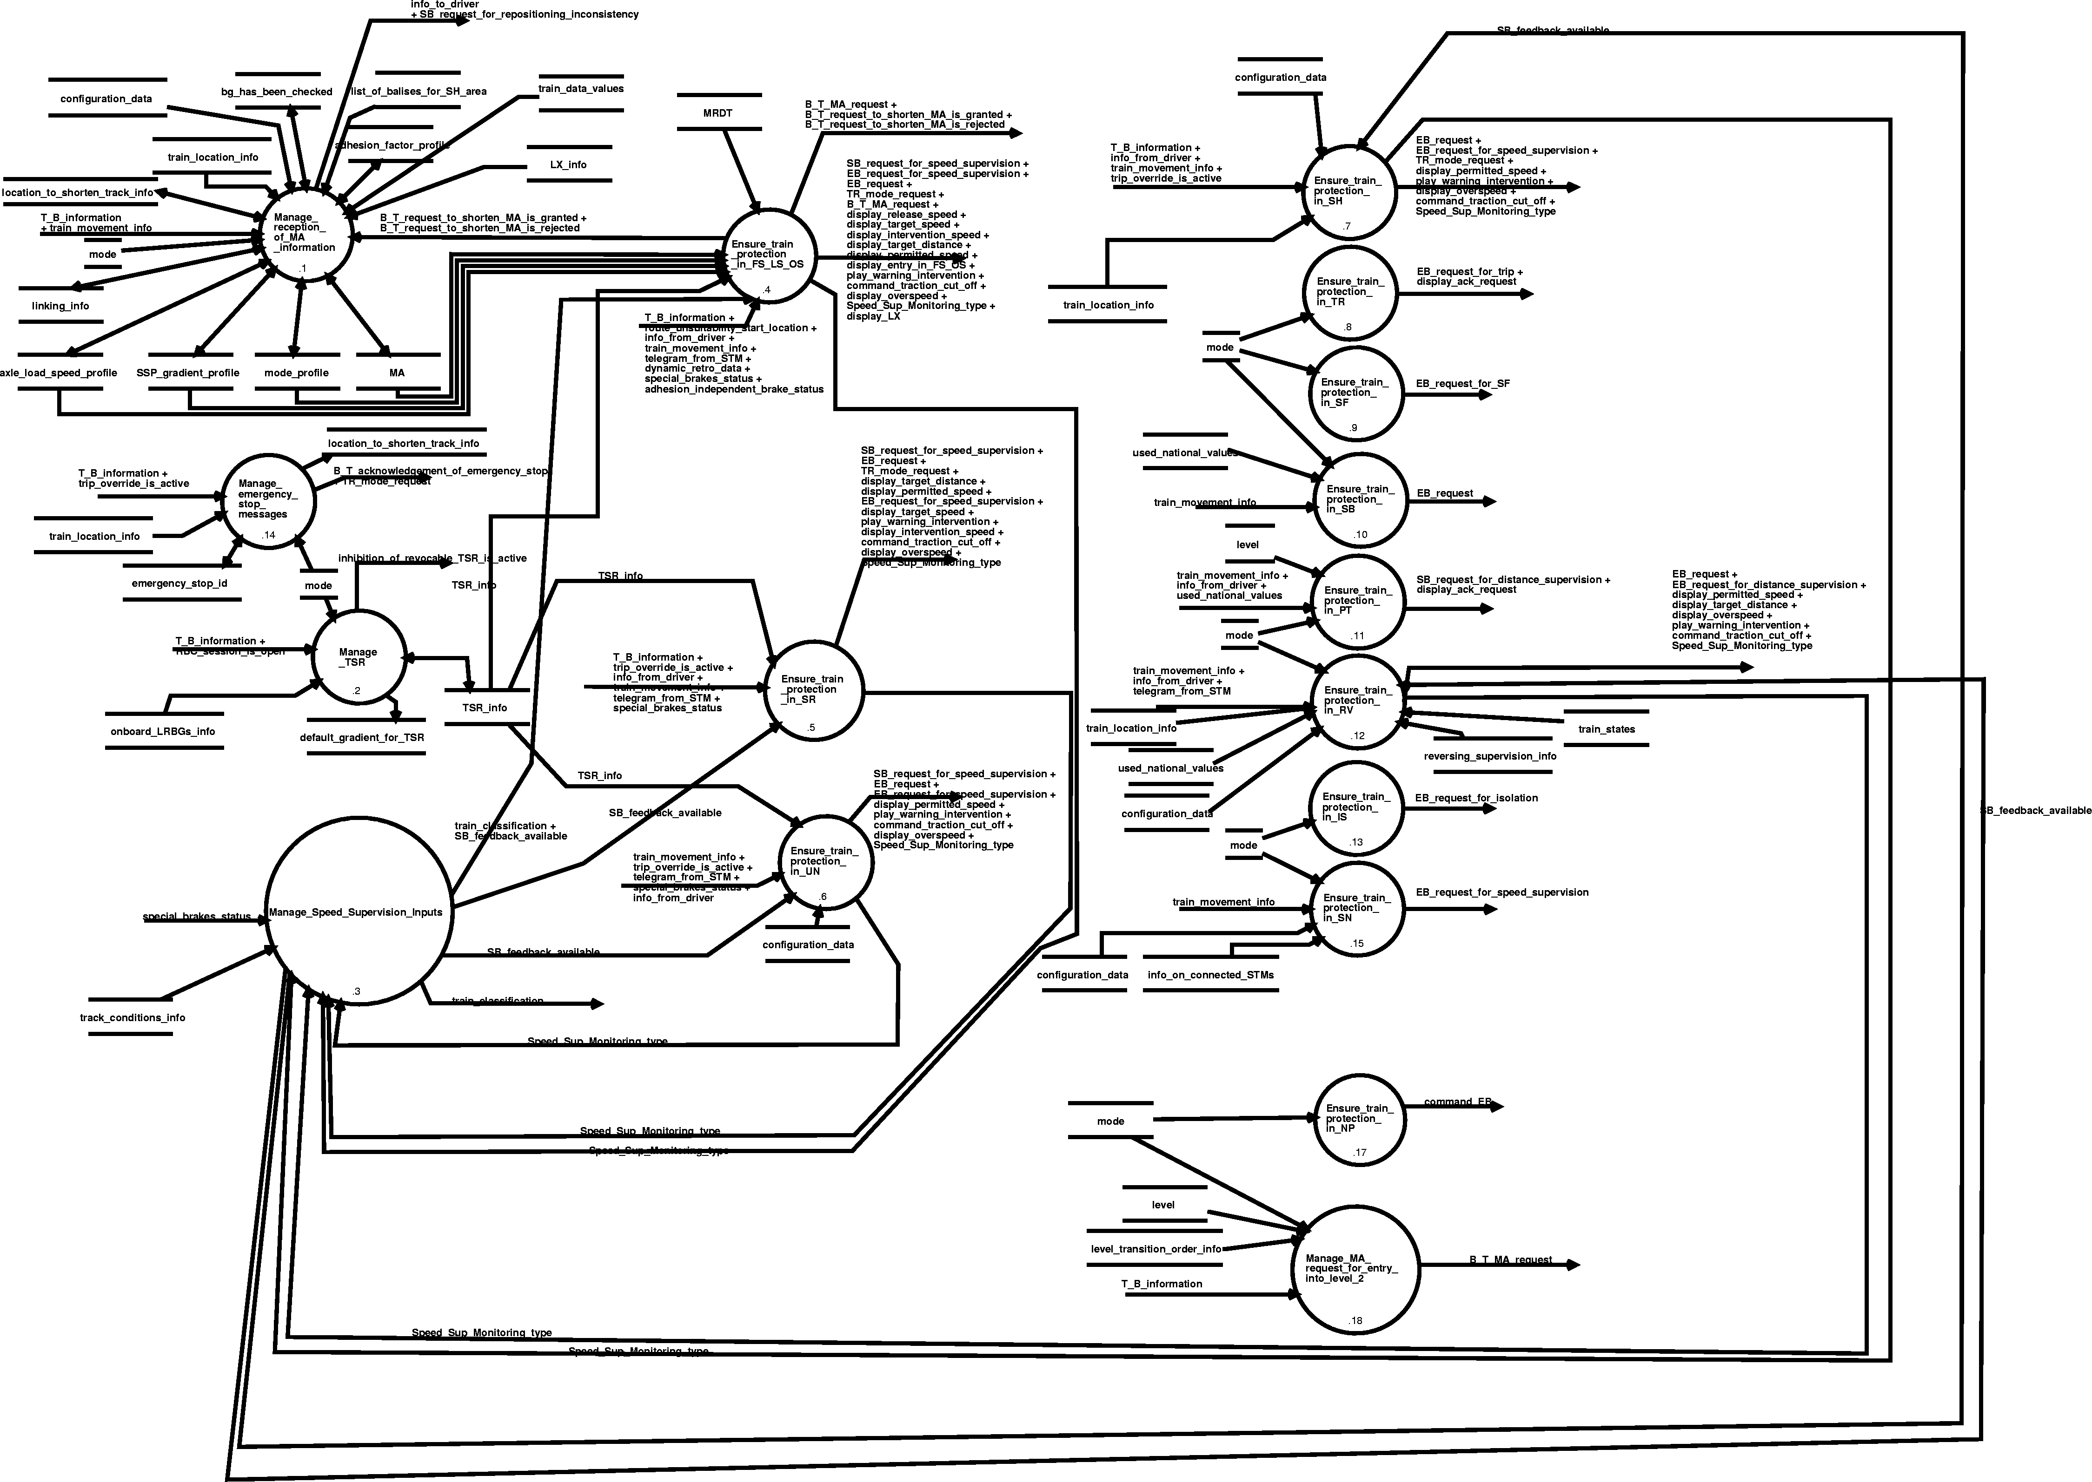
Diagram 7. Ensure_train_protection - dfd 2.5.

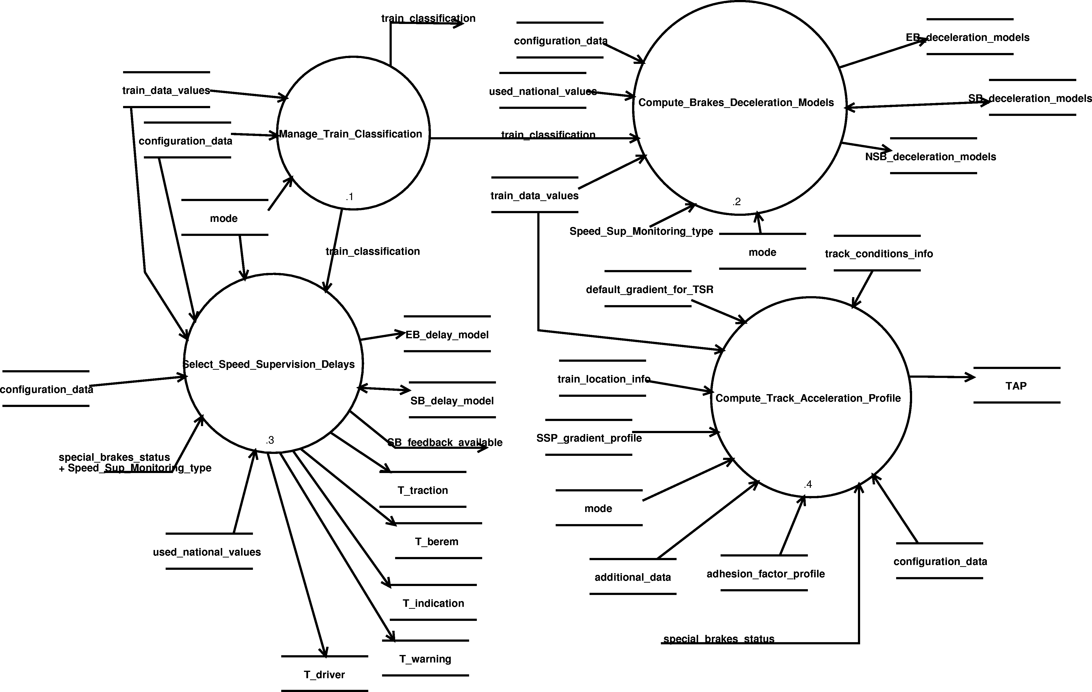
Diagram 8. Manage_Speed_Supervision_Inputs - dfd 2.5.3.
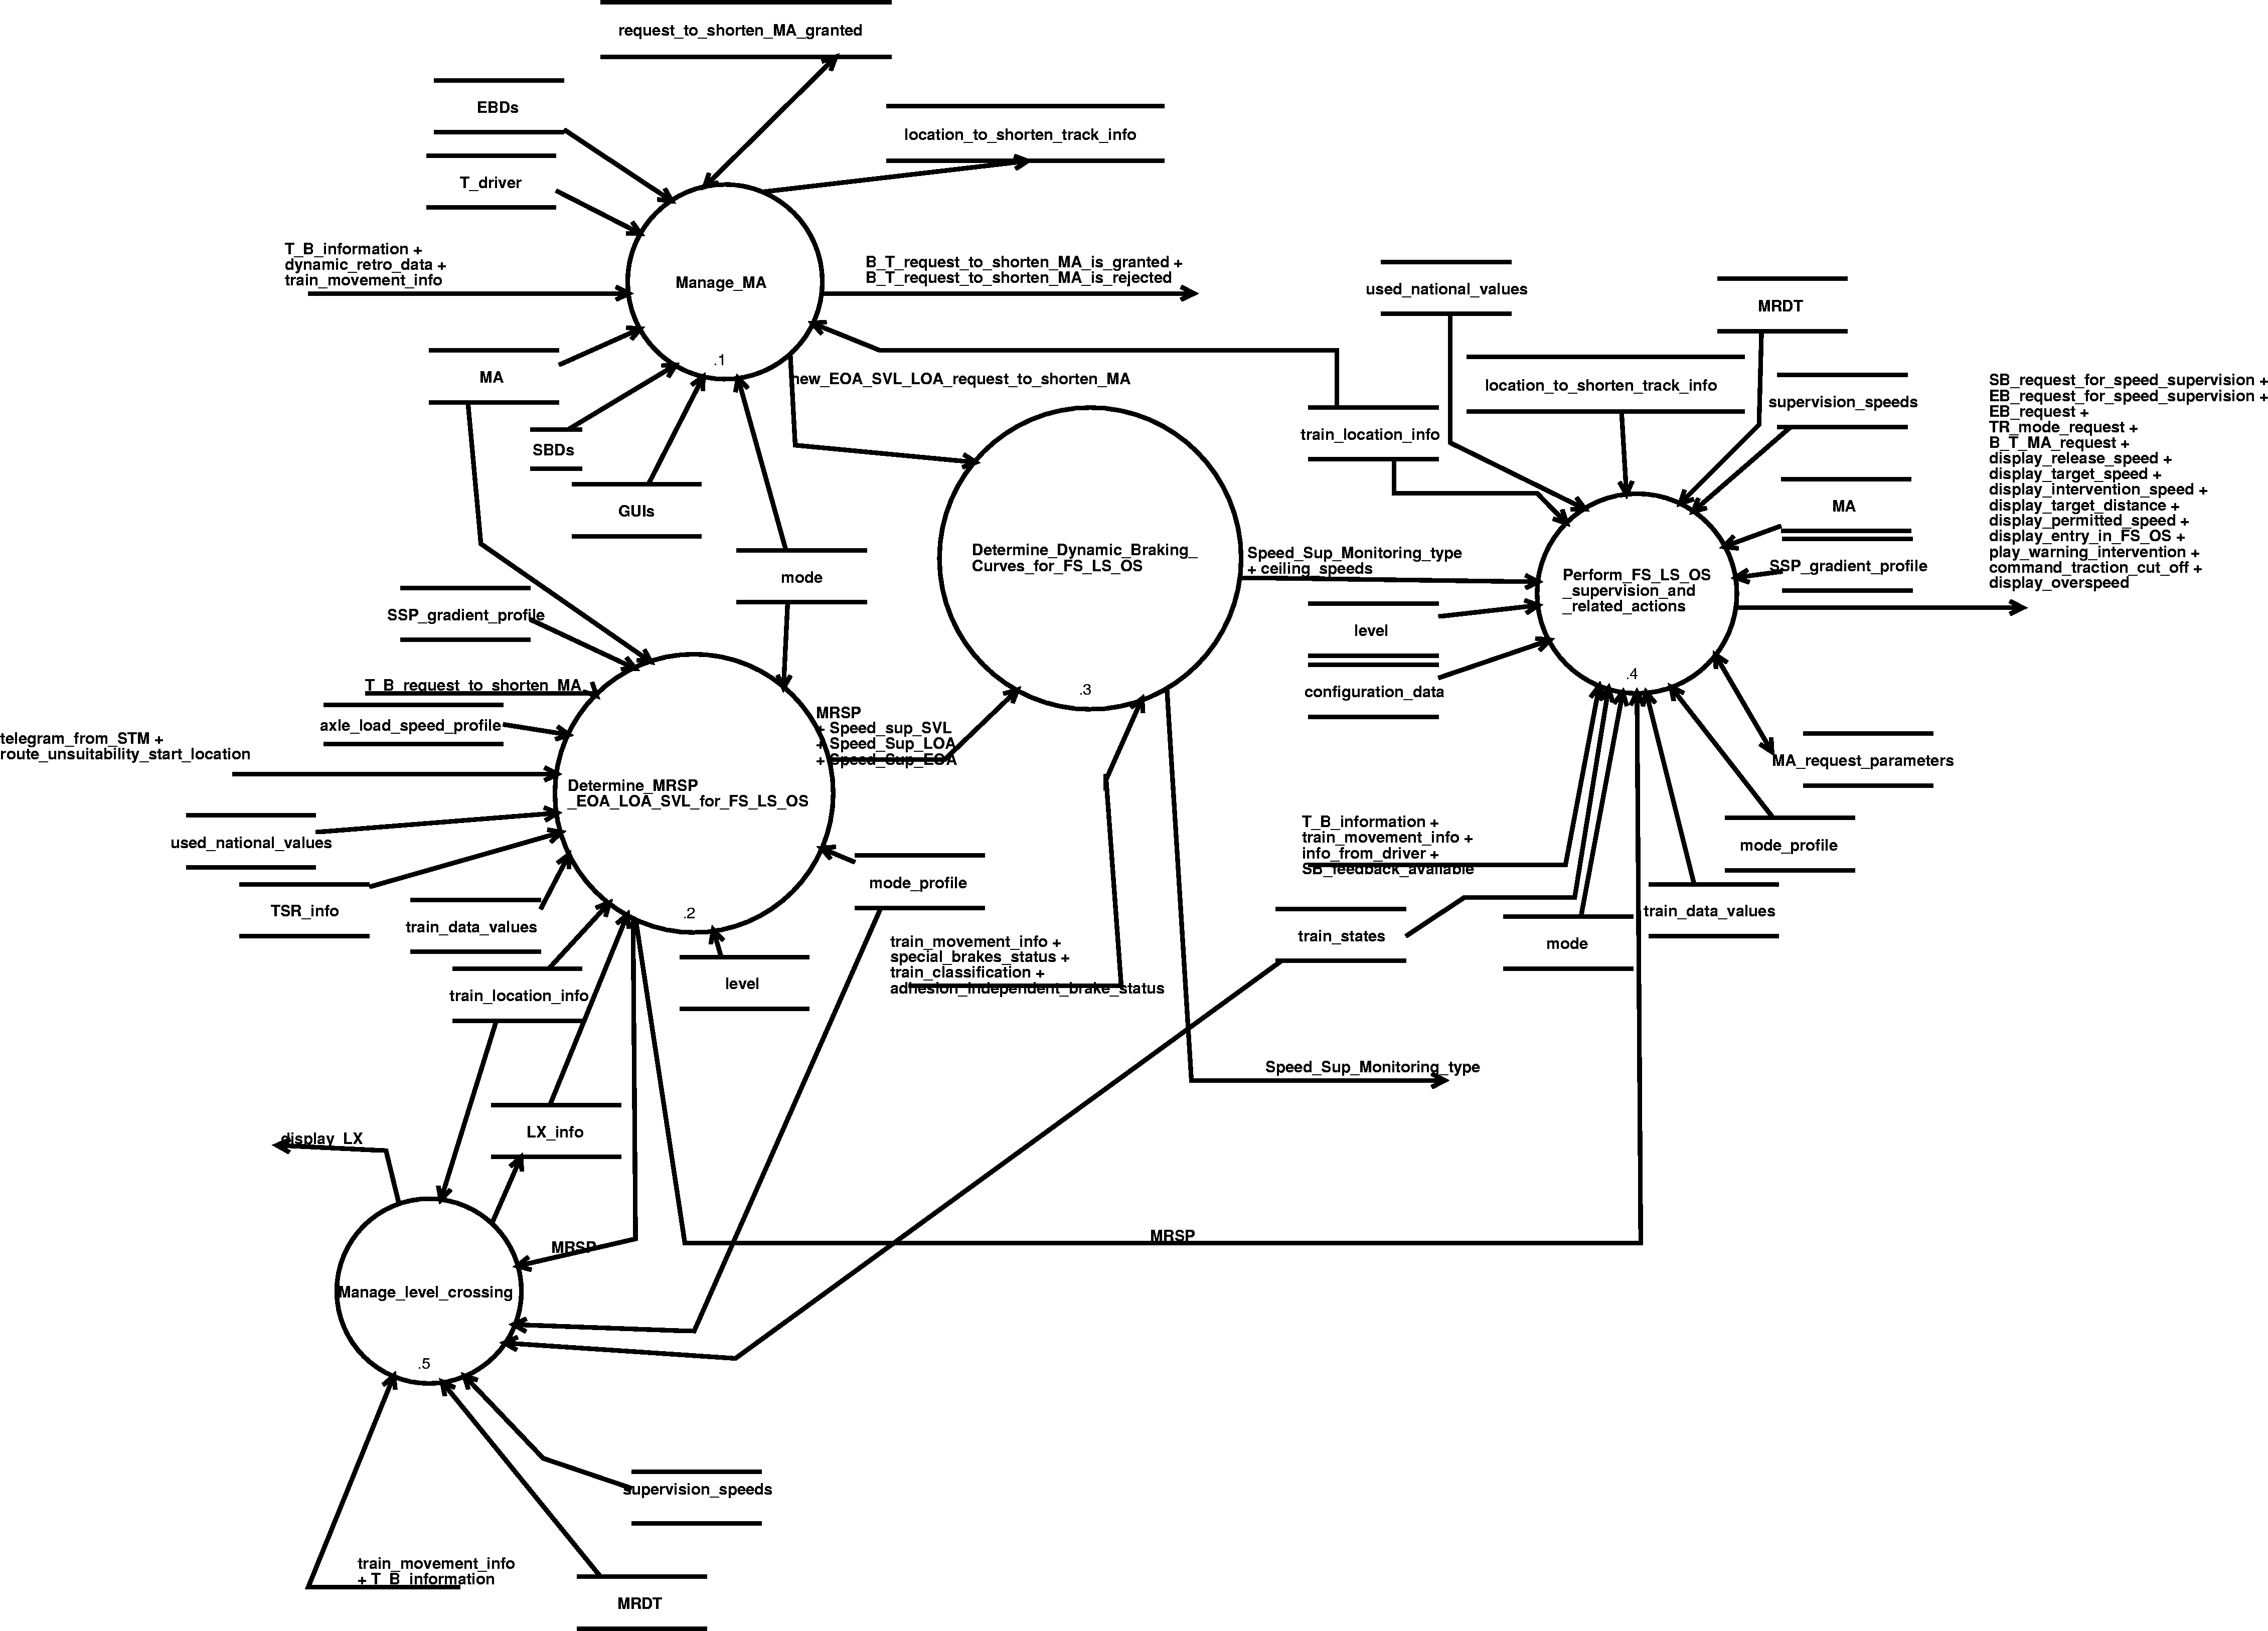
Diagram 9. Ensure_train_protection_in_FS_LS_OS - dfd 2.5.4.

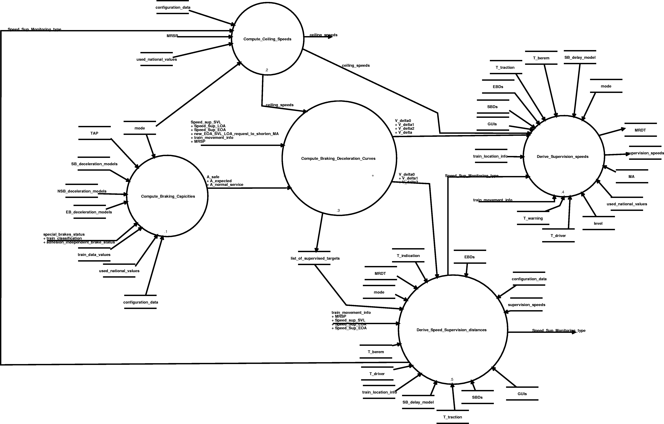
Diagram 10. Determine_Dynamic_Braking_Curves_for_FS_LS_OS - dfd 2.5.4.3.

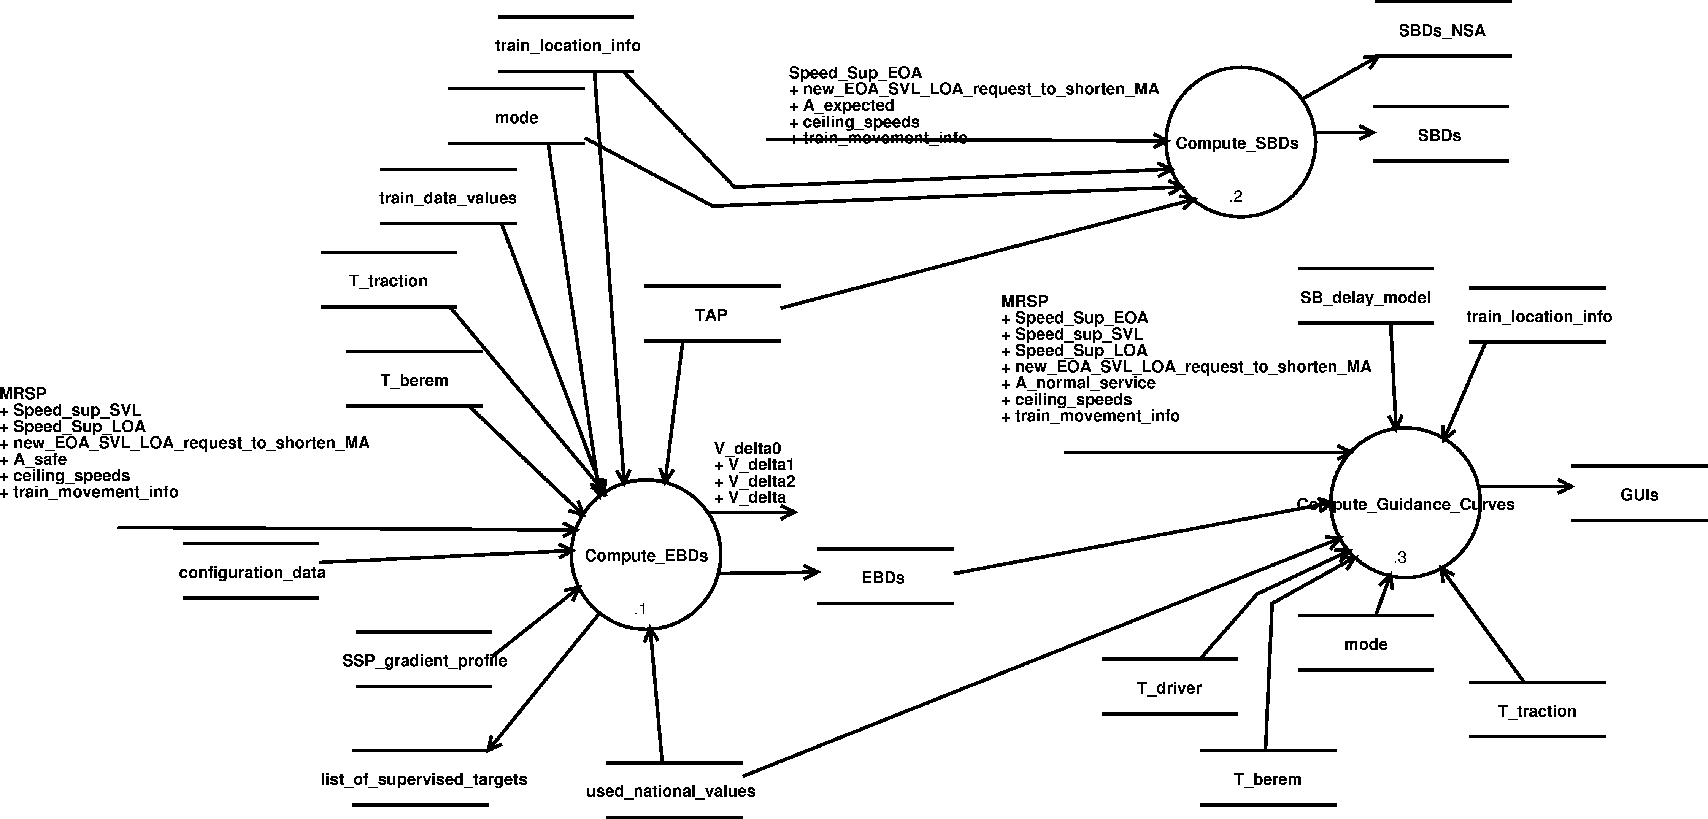
Diagram 11. Compute_Braking_Deceleration_Curves - dfd 2.5.4.3.3.

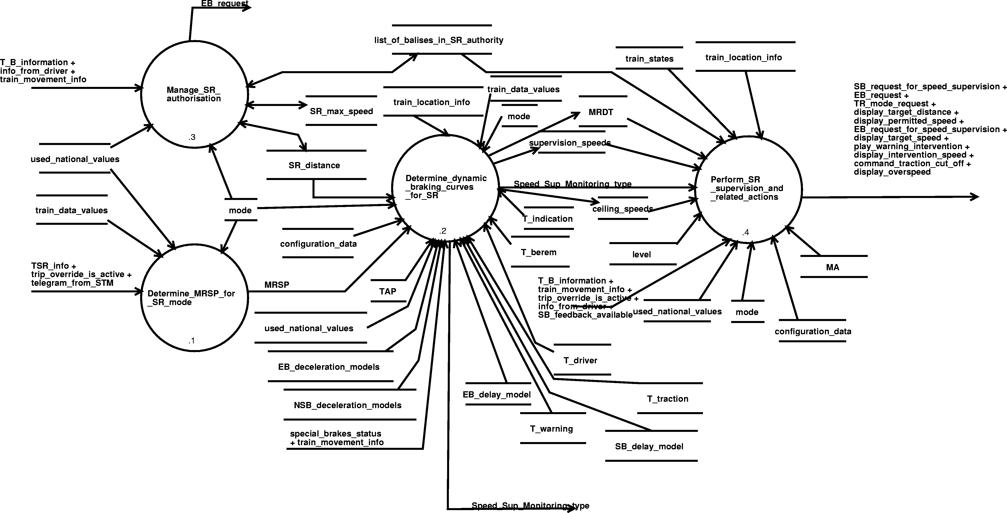
Diagram 12. Ensure_train_protection_in_SR - dfd 2.5.5.

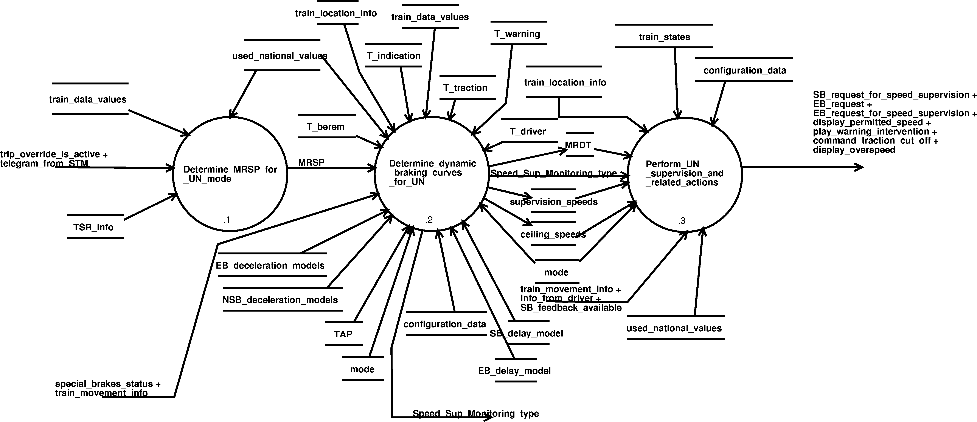
Diagram 13. Ensure_train_protection_in_UN - dfd 2.5.6.

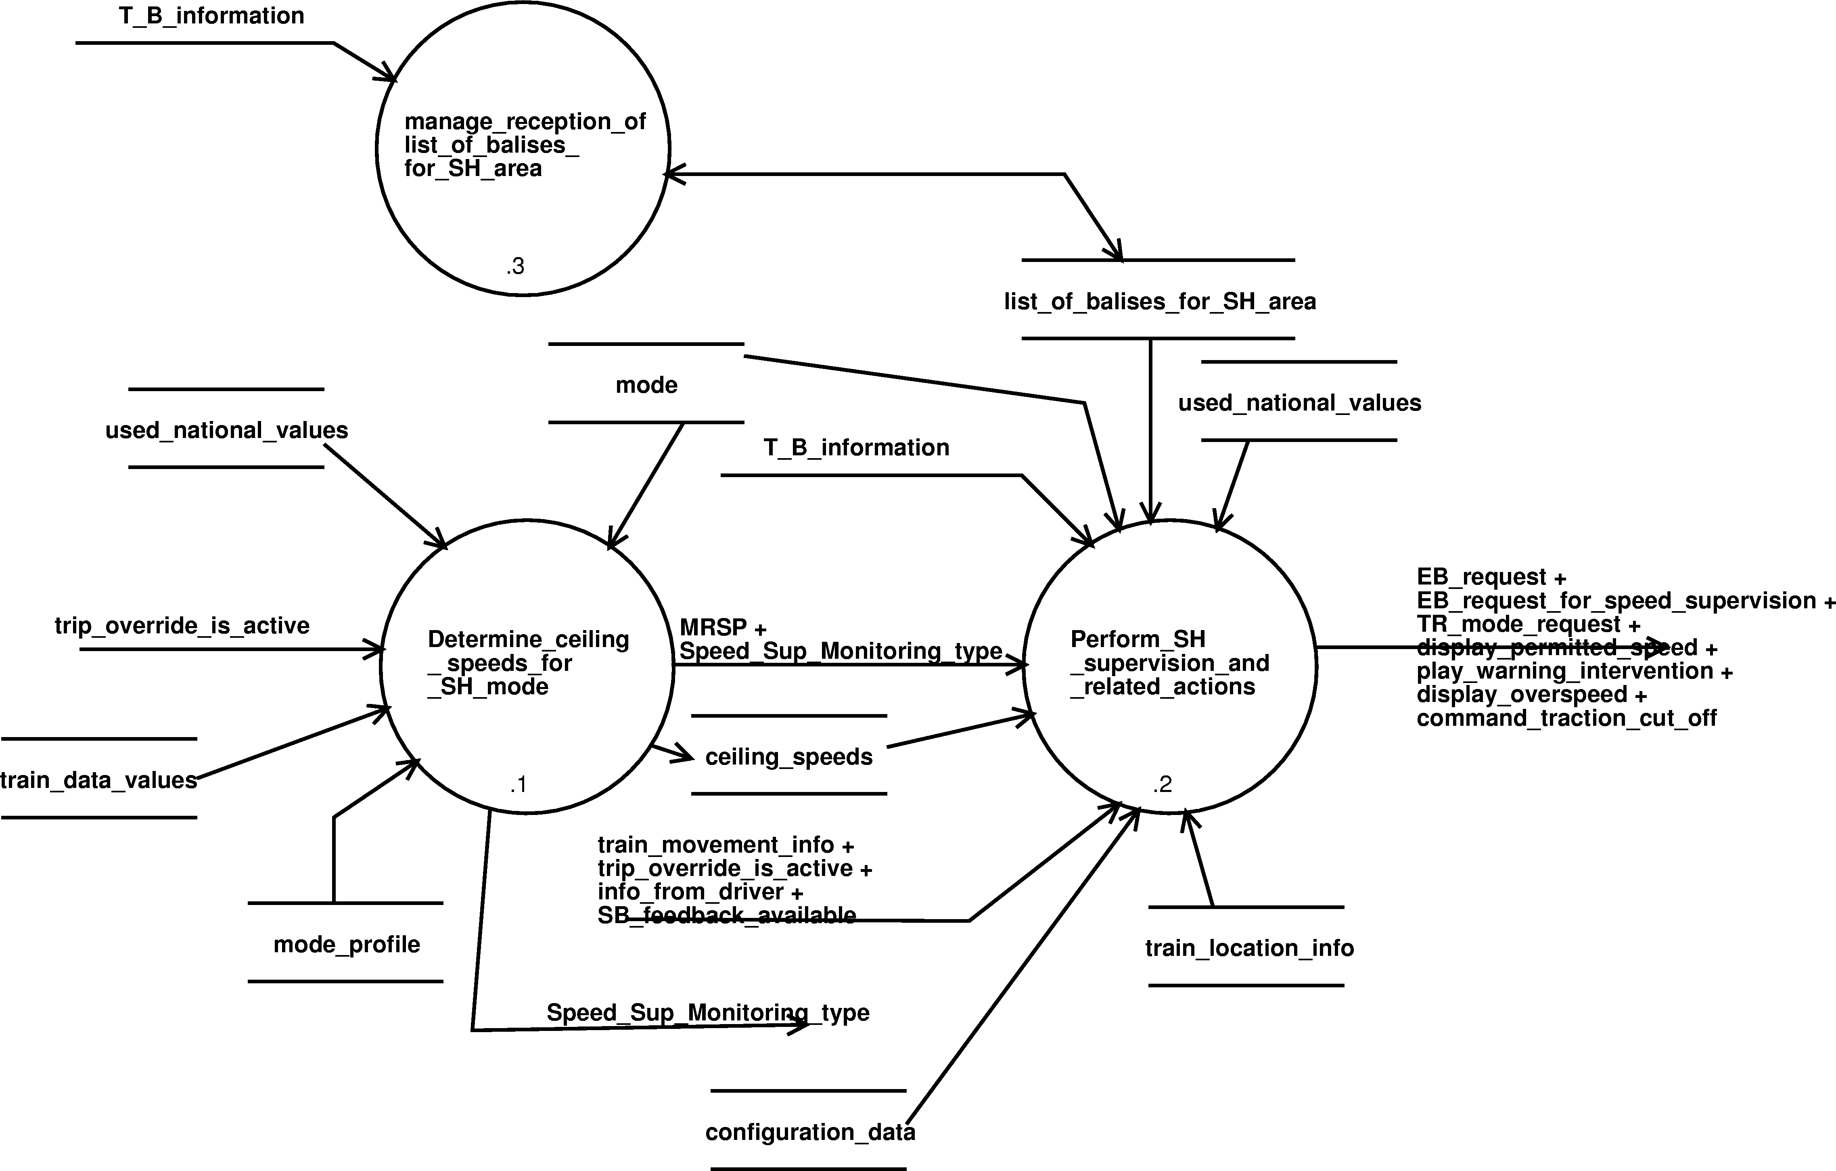
Diagram 14. Ensure_train_protection_in_SH - dfd 2.5.7.

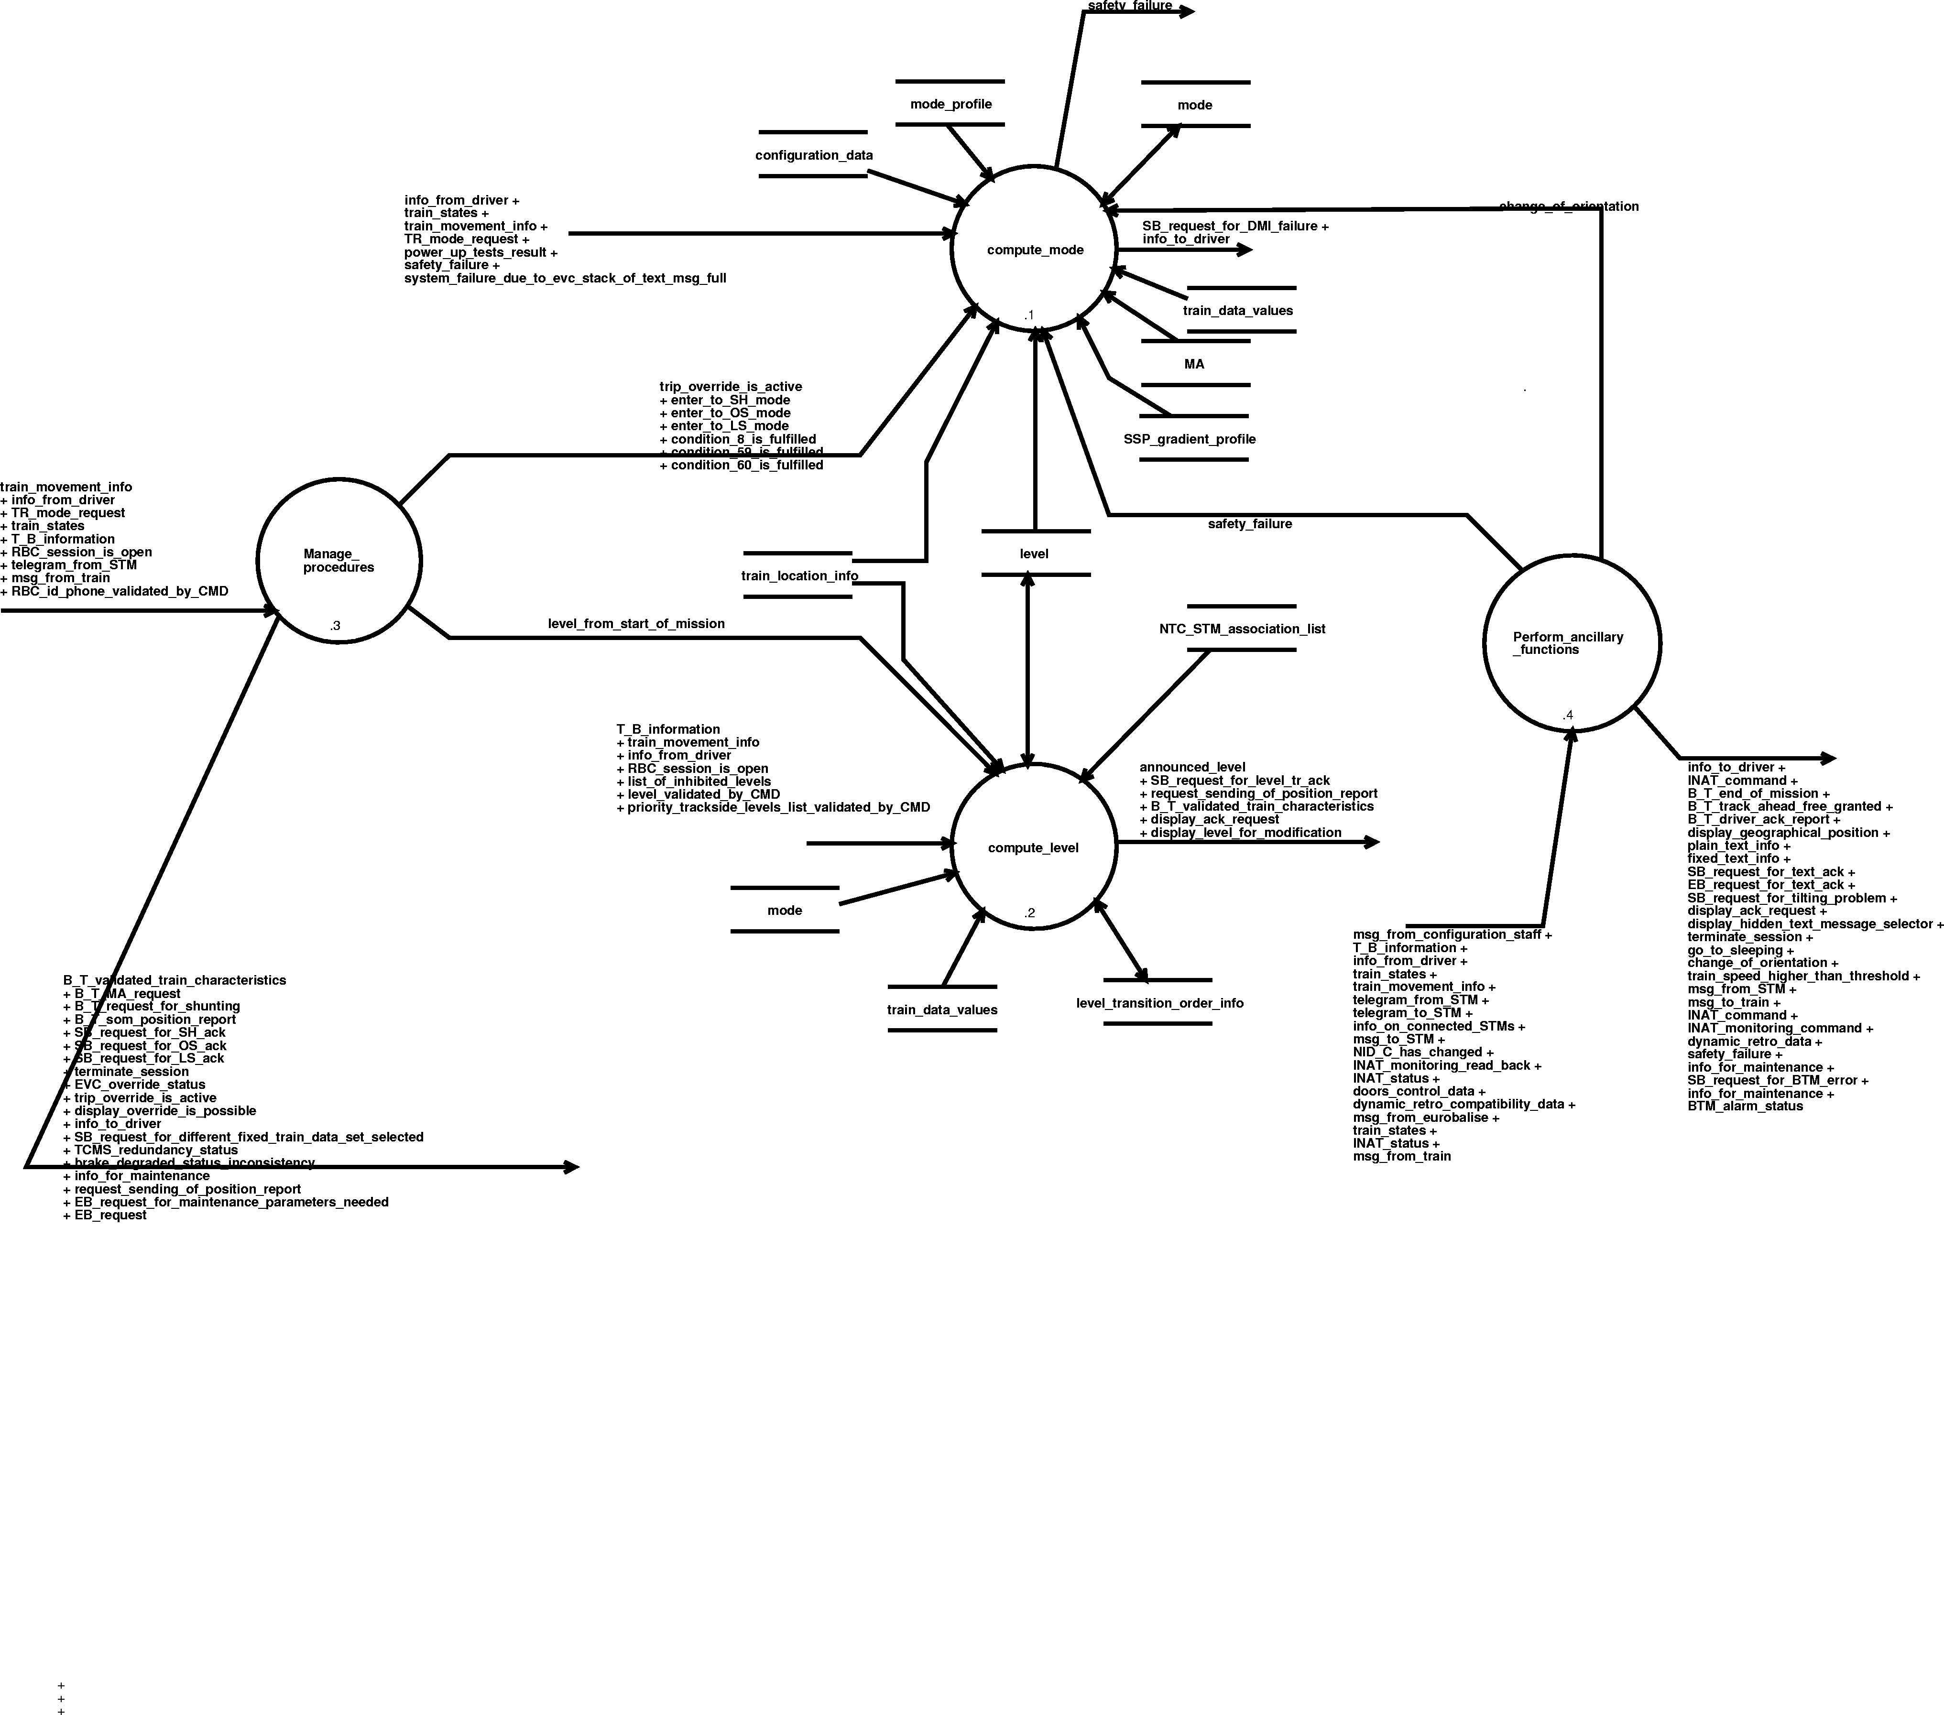
Diagram 15. Manage_mode_and_level_and_procedures_and_ancillary_functions - dfd 2.6.
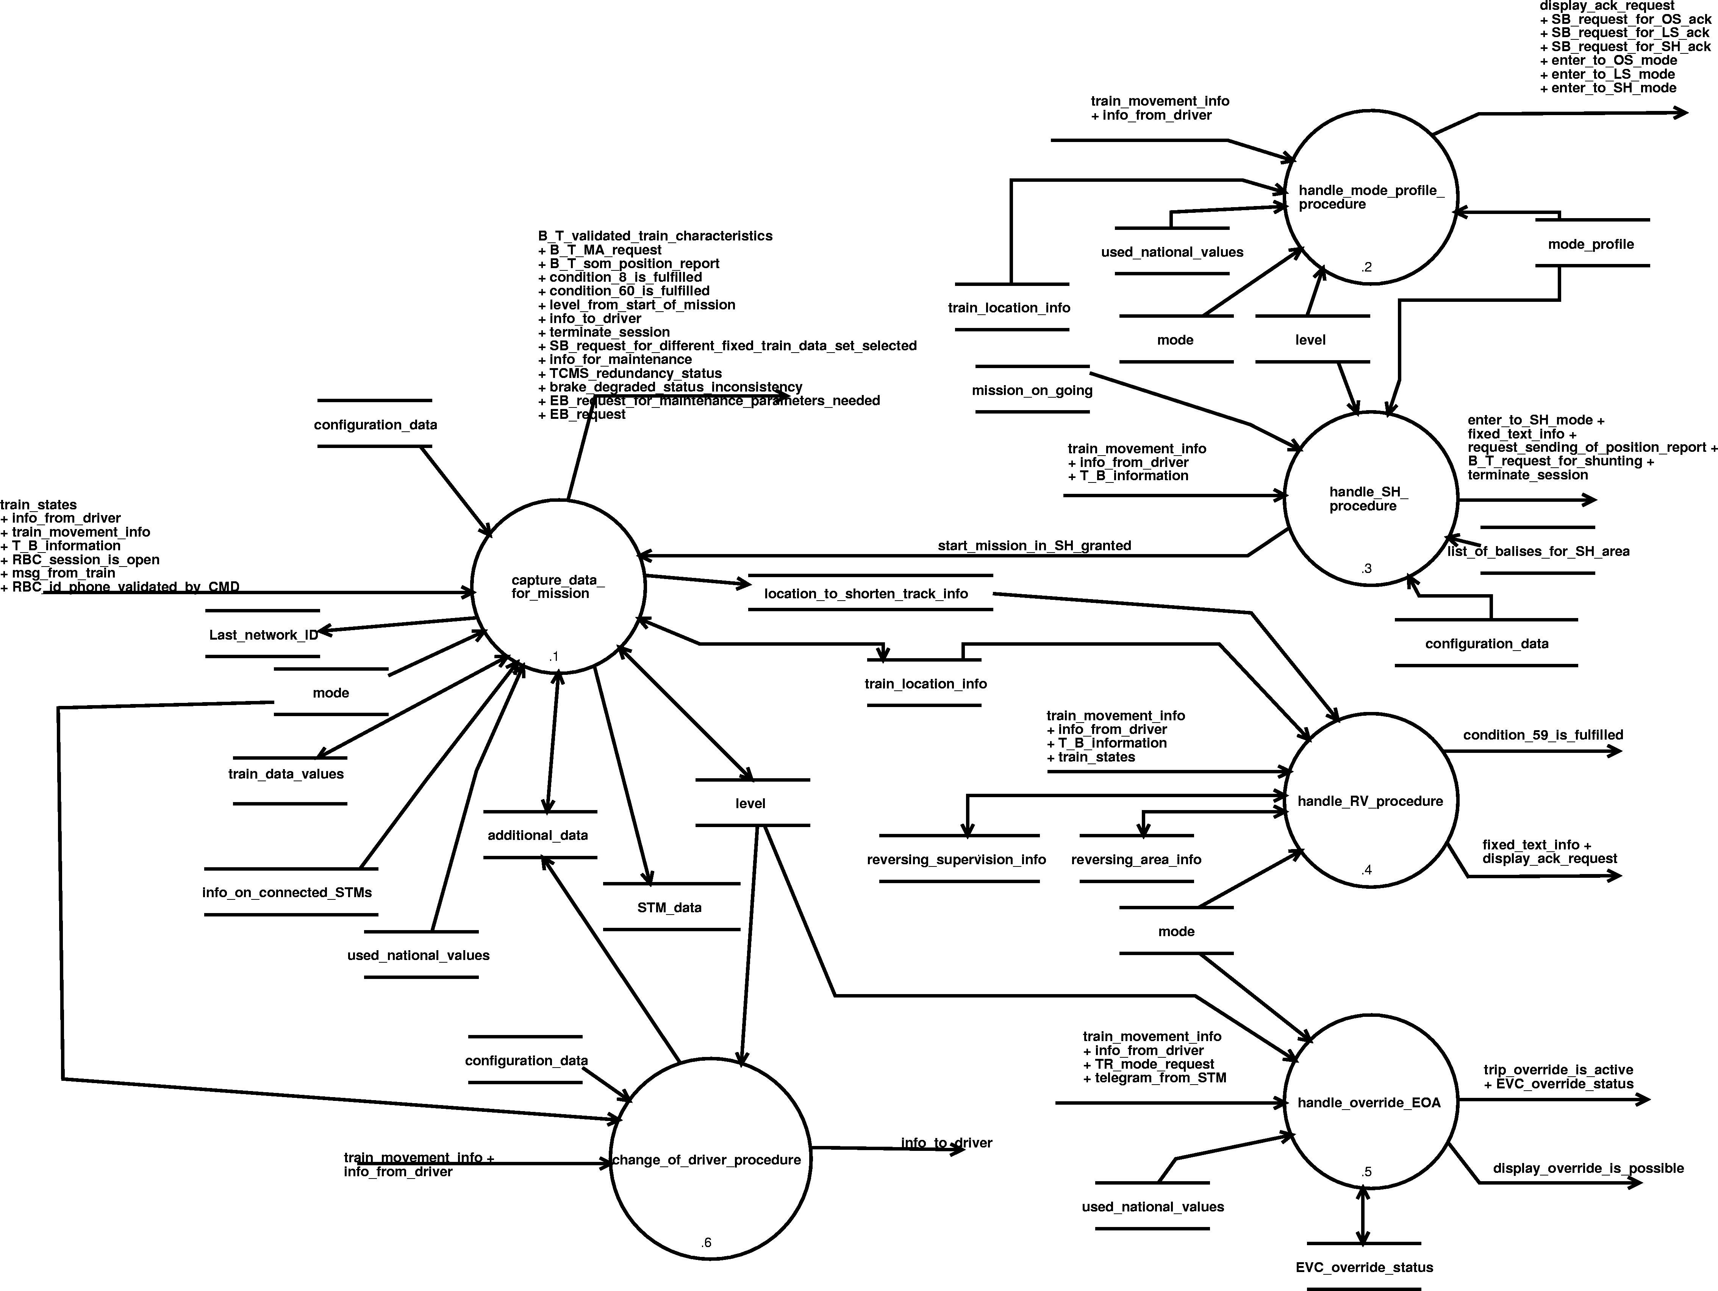
Diagram 16. Manage_procedures - dfd 2.6.3.

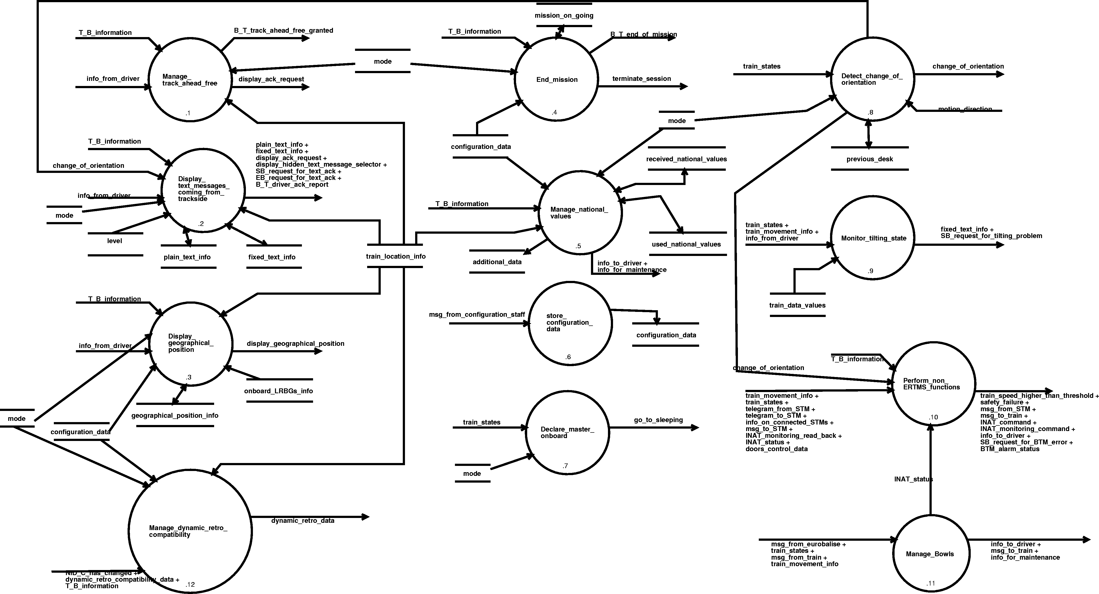
Diagram 17. Perform_ancillary_functions - dfd 2.6.4.
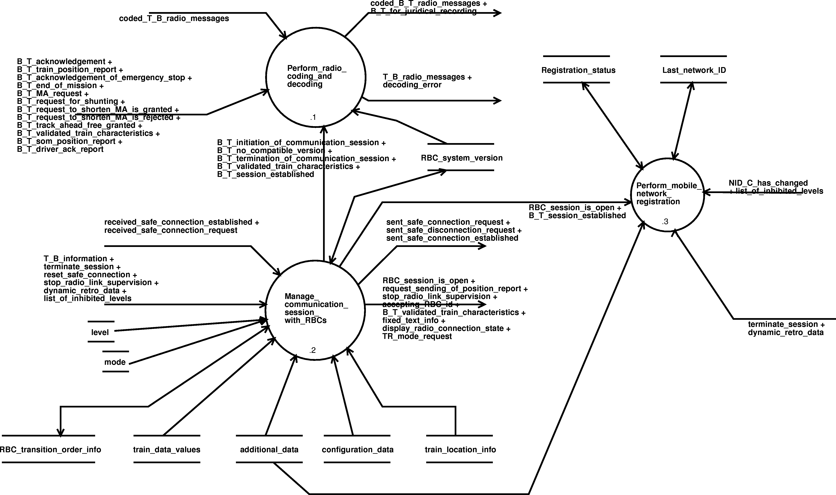
Diagram 18. Manage_radio_sessions - dfd 4.

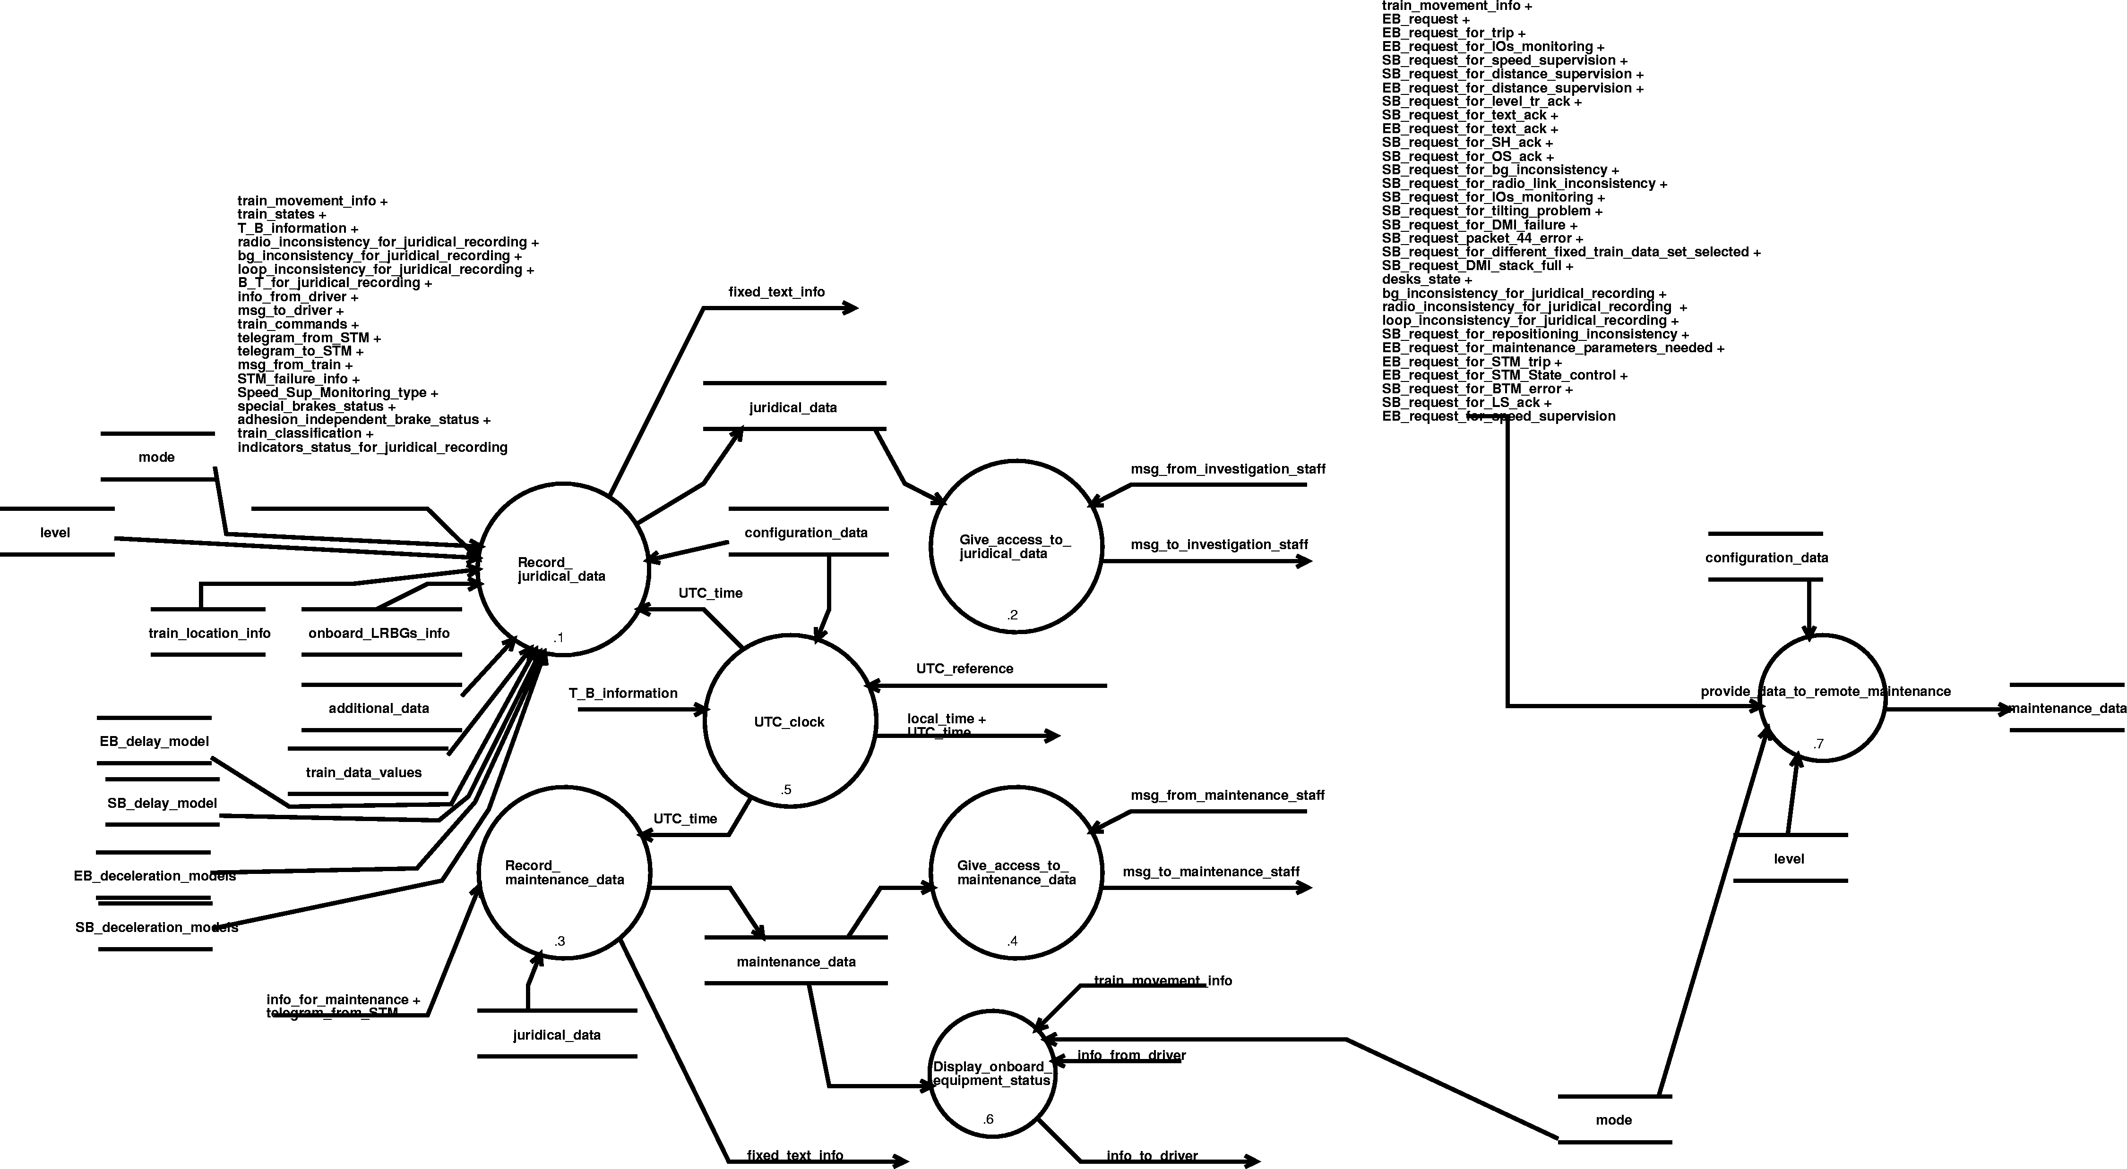
Diagram 19. Manage_juridical_data_and_maintenance_data - dfd 5.

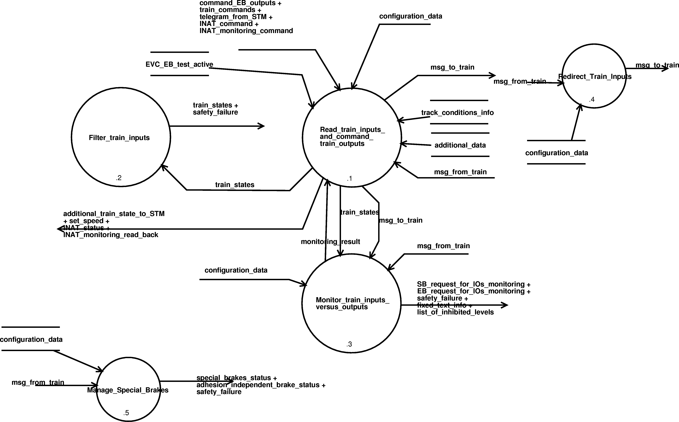
Diagram 20. Perform_train_interface - dfd 6.
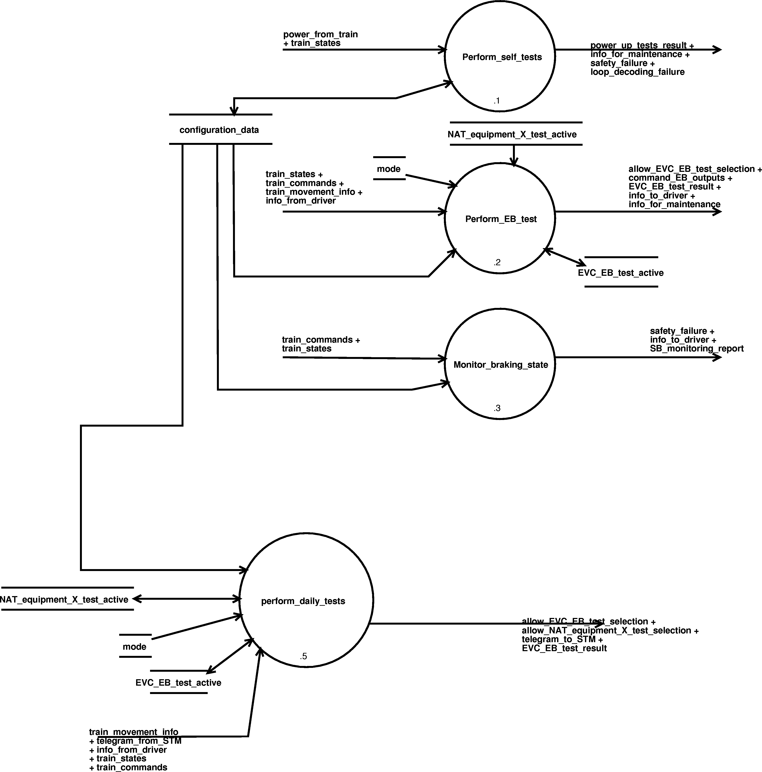
Diagram 21. Perform_tests - dfd 9.
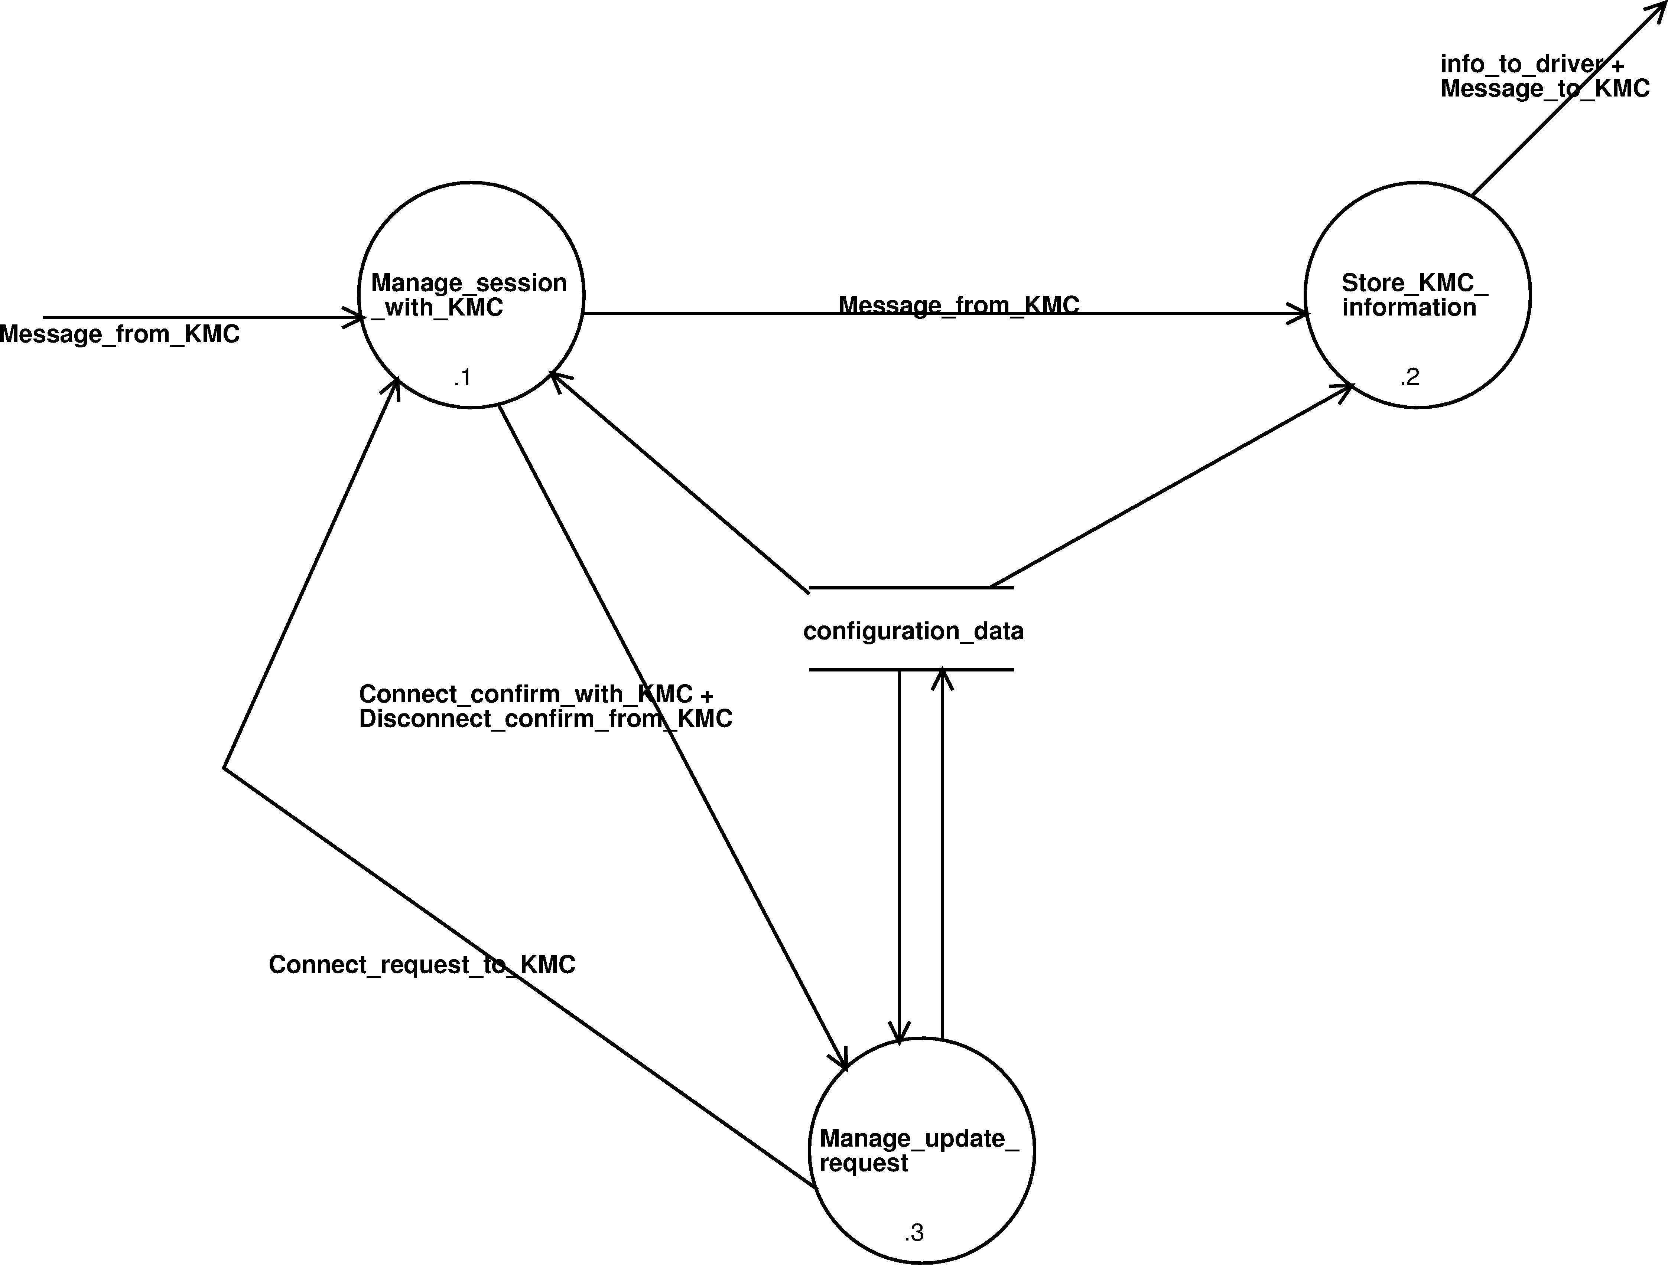
Diagram 22. Manage_KMC - dfd 13.

Data Dictionary
- A_brake_emergency (data flow) =
**.

--------
rate : N/A
range : N/A
resolution : N/A
units : N/A
value names : N/A
description : Value of EB deceleration.

- A_brake_normal_service (data flow) =
**.

--------
rate : N/A
range : N/A
resolution : N/A
units : N/A
value names : N/A
description : Applicable Normal Service brake Model

- A_brake_service (data flow) =
**.

--------
rate : N/A
range : N/A
resolution : N/A
units : N/A
value names : N/A
description : Applicable Service Brake deceleration Model

- A_expected (data flow) =
*not-defined*.

--------
rate : N/A
range : N/A
resolution : N/A
units : N/A
value names : N/A
description :

- A_gradient (data flow) =
**.

--------
rate : N/A
range : N/A
resolution : N/A
units : N/A
value names : N/A
description : Acceleration due to the existing gradient on track (or default TSR one) or to the rotating mass of the train.

- A_normal_service (data flow) =
*not-defined*.

--------
rate : N/A
range : N/A
resolution : N/A
units : N/A
value names : N/A
description :

- A_safe (data flow) =
*not-defined*.

--------
rate : N/A
range : N/A
resolution : N/A
units : N/A
value names : N/A
description :

- absolute_distance_counter (data flow) =
estimated_covered_distance_from_last_reference
+ maximum_covered_distance_from_last_reference
+ minimum_covered_distance_from_last_reference.
--------
rate : Available continously since the power-on of the equipment.
range : N/A
resolution : N/A
units : N/A
value names : N/A
description : This data set represents the covered distance measurement integrating
its associated accuracy under a form of a confidence interval.

- absolute_loc_of_ref_balise (data flow, pel) =
**.

--------
rate : N/A
range : N/A
resolution : N/A
units : N/A
value names : N/A
description : information given by the "absolute distance counter" when the onboard antenna passes on the reference balise of a bg.

- accelerometer_bias (data flow) =
**.

--------
rate : N/A
range : N/A
resolution : N/A
units : N/A
value names : N/A
description : Corrective parameter for the installation' angle of the accelerometer.There is a flag that indicates if this value shall be taken into account or not.

- accepting_RBC_id (data flow, pel) =
**.

--------
rate : N/A
range : N/A
resolution : N/A
units : N/A
value names : N/A
description :
Indicates whether an accepting RBC has been announced or not,
and if yes, gives its identity number.

- activate_functions (data flow) =
function_monitor_pneumatic_insertion +
function_train_speed_above_3km_h +
function_train_tracer +
manage_ERTMS_inhibition +
manage_daily_tests_function +
TBL1_is_active +
inhibit_repositioning_safety_check +
function_display_missed_balise_in_bg +
associate_operational_train_category_to_train_subset +
associate_other_international_train_category_to_brake_type +
speed_and_distance_default_display +
limit_stored_plain_text_msg +
request_overspeed_brake_ack +
enable_specific_stm_kvb_mgmt +
function_activate_basic_speed_hook +
function_report_missed_balise_in_bg +
DMI_SIL2_speed_display +
EVC_SIL2_speed_display +
display_speedometer_in_closed_desk +
permitted_speed_hook_in_UN +
TRN_displayed_as_a_train_data.
--------
rate : N/A
range : N/A
resolution : N/A
units : N/A
value names : N/A
description :

- activate_output_on_DA_state (data flow) =
["TRUE"|"FALSE"]

--------
rate : N/A
range : N/A
resolution : N/A
units : N/A
value names : N/A
description : Indicates if for the corresponding STM, an output has to be activated when this STM enters DA state.

- active_DMI_channel (data flow, pel) =
**.

--------
rate : N/A
range : N/A
resolution : N/A
units : N/A
value names : N/A
description : refer to packet STM-31 in "FFFIS STM Application Layer"

- additional_data (store) =
driver_id
+ level
+ train_running_number
+ 0{RBC_id}2
+ 0{RBC_phone_number}2
+ network_id
+ adhesion_factor.

--------
rate : N/A
range : N/A
resolution : N/A
units : N/A
value names : N/A
description : Additional data described in chapter 3 of SUBSET-026 (paragraph 3.18.4)

- additional_data_values_to_STM (data flow, pel) =
**.

--------
rate : N/A
range : N/A
resolution : N/A
units : N/A
value names : N/A
description : Refer to packet STM-177 FFFIS STM Application Layer.

- additional_train_interface_control_state_to_STM (data flow, pel) =
**.

--------
rate : N/A
range : N/A
resolution : N/A
units : N/A
value names : N/A
description : refer to "FFFIS STM Application Layer" document.

- additional_train_state_to_STM (data flow, pel) =
**.

--------
rate : N/A
range : N/A
resolution : N/A
units : N/A
value names : N/A
description : Refer to FFFIS STM Application Layer.

- adhesion (data flow) =
["SLIPPERY"|"NO_SLIPPERY"].

--------
rate : N/A
range : N/A
resolution : N/A
units : N/A
value names : N/A
description : Adhesion value

- adhesion_factor (data flow, del) =
["SLIPPERY" | "NOT_SLIPPERY"].

--------
rate : N/A
range : N/A
resolution : N/A
units : N/A
value names : N/A
description : track adhesion factor

- adhesion_factor_profile (store, pel) =
**.

--------
full name :
description : adhesion factor profile information which is stored and used onboard.

- adhesion_independent_brake_config (data flow) =
**.

--------
rate : N/A
range : N/A
resolution : N/A
units : N/A
value names : N/A
description : Indicates if an adhesion independent brake is configured or not.

- adhesion_independent_brake_status (data flow) =
**.

--------
rate : N/A
range : N/A
resolution : N/A
units : N/A
value names : N/A
description : indicates the current status of the adhesion independent brake if any configured.

- AG_d_emergencystop (data flow, pel) =
**.

--------
rate : N/A;
range : 0..327670;
resolution : 0.1;
units : m;
value_names : N/A;
component_of : T_B_conditional_emergency_stop;
description : see SRS chapter 7; variable D_EMERGENCYSTOP

- AG_d_ref (data flow, pel) =
**.

--------
full_name : ;
rate : N/A;
range : 0..327670;
resolution : 0.1;
units : m;
value_names : N/A;
component_of : T_B_MA_with_shifted_location_reference;
description : see SRS chapter 7;variable D_REF

- AG_d_sr (data flow, pel) =
**.

--------
rate : N/A;
range : 0..327670;
resolution : 0.1;
units : m;
value_names : N/A;
component_of : T_B_SR_authorisation;
description : see SRS chapter 7;variable D_SR

- AG_d_tafdisplay (data flow, pel) =
**.

--------
rate : N/A
range : 0..327670;
resolution : 0.1;
units : m;
value names : N/A
description : see SRS chapter 7;variable D_TAFDISPLAY
constituent of data/control flow: T_B_track_ahead_free_request;

- AG_emergency_identity_for_acknowledgement (data flow, pel) =
**.

--------
rate : N/A
range : N/A
resolution : N/A
units : N/A
value names : N/A
description : see SRS chapter 7;variable NID_EM
constituent of data/control flow: B_T_acknowledgement_of_emergency_stop

- AG_l_message (data flow, pel) =
**.

--------
full_name : ;
rate : N/A;
range : 0..1023;
resolution : 1;
units : byte;
value_names : N/A;
component_of : N/A;
description : see SRS chapter 7;variable L_MESSAGE

- AG_l_tafdisplay (data flow, pel) =
**.

--------
rate : N/A
range : 0..327660
resolution : 0.1
units : m
value names : N/A
description : see SRS chapter 7;variable L_TAFDISPLAY
constituent of data/control flow: T_B_track_ahead_free_request;

- AG_m_ack (data flow, pel) =
**.

--------
full_name : ;
rate : N/A;
range : 0..1;
resolution : 1;
units : N/A;
value_names : N/A;
component_of : N/A;
description : see SRS chapter 7;varaiable M_ACK

- AG_m_version (data flow, pel) =
**.

--------
full_name : ;
rate : N/A;
range : N/A;
resolution : N/A;
units : N/A;
value_names : N/A;
component_of :
description : see SRS chapter 7; variable M_VERSION
Version of the ETCS language
(M_VERSION : see SRS chapter 7);

- AG_nid_em (data flow, pel) =
**.

--------
full_name : ;
rate : N/A;
range : 0..15;
resolution : 1;
units : N/A;
value_names : N/A;
component_of : N/A;
description : see SRS chapter 7;variable NID_EM

- AG_nid_LRBG (data flow, pel) =
**.

--------
full_name : ;
rate : N/A;
range : 0..16777215;
resolution : 1;
units : N/A;
value_names : N/A;
component_of : N/A;
description : see SRS chapter7;varaiable NID_LRBG

- AG_nid_message (data flow, pel) =
**.

--------
full_name : ;
rate : N/A;
range : 0..255;
resolution : 1;
units : N/A;
value_names : N/A;
component_of : N/A;
description : see SRS chapter 7;varaiable NID_MESSAGE

- AG_nid_textmessage (data flow, pel) =
**.

--------
rate : N/A
range : 0..255;
resolution : 1;
units : N/A
value names : N/A
description : see SRS chapter 7;varaiable NID_TEXTMESSAGE

- AG_q_dir (data flow, pel) =
**.

--------
full_name : ;
rate : N/A;
range : 0..3;
resolution : 1;
units : N/A;
value_names : N/A;
component_of : N/A;
description : see SRS chapter 7;variable Q_DIR

- AG_q_orientation (data flow, del) =
**.

--------
rate : N/A
range : 0..1
resolution : 1
units : N/A
value names : N/A
description : see SRS chapter 7;variable Q_ORIENTATION

- AG_q_scale (data flow, pel) =
**.

--------
full_name : ;
rate : N/A;
range : 0..3;
resolution : 1;
units : N/A;
value_names : N/A;
component_of : N/A;
description : see SRS chapter 7;variable Q_SCALE

- AG_q_status (data flow, del) =
**.

--------
full_name : ;
rate : N/A;
range : 0..3;
resolution : 1;
units : N/A;
value_names : N/A;
component_of : N/A;
description : see SRS chapter 7;variable Q_STATUS

- AG_qualifier_for_emergency_stop_acknowledgement (data flow, pel) =
**.

--------
rate : N/A
range : 0..3
resolution : 1
units : N/A
value names : N/A
description : see SRS chapter 7;variable Q_EMERGENCYSTOP
constituent of data/control flow: B_T_acknowledgement_of_emergency_stop

- AG_t_train (data flow, pel) =
**.

--------
full_name : ;
rate : N/A;
range : 0..42949672.94;
resolution : 0.01;
units : s;
value_names : N/A;
component_of : N/A;
description : see SRS chapter 7;variable T_TRAIN

- AG_t_train_for_acknowledgement (data flow, pel) =
**.

--------
rate : N/A
range : N/A
resolution : N/A
units : N/A
value names : N/A
description : see SRS chapter 7;variable T_TRAIN

constituent of data/control flow: B_T_acknowledgement

- AG_t_train_for_shunting (data flow, pel) =
**.

--------
full_name : ;
rate : N/A;
range : 0..42949672.94;
resolution : 0.01;
units : s;
value_names : N/A;
component_of : N/A;
description : see SRS chapter 7;variable T_TRAIN
constituent of data/control flow: T_B_shunting_authorised
T_B_shunting_refused

- AG_t_train_for_train_data (data flow, pel) =
**.

--------
full_name : ;
rate : N/A;
range : 0..42949672.94;
resolution : 0.01;
units : s;
value_names : N/A;
component_of : N/A;
description : see SRS chapter 7;variable T_TRAINsee SRS;
constituent of data/control flow : T_B_acknowledgement_of_train_characteristics

- AG_track_description_deleted (data flow, del) =
["FALSE"|"TRUE"].

--------
rate : N/A
range : N/A
resolution : N/A
units : N/A
value names : N/A
description :
constituent of data/control flow: B_T_MA_request

- airgap_data_to_NTC (store) =
**.

--------
full name :
description : ETCS data forwarded to STM

- allow_EVC_EB_test_selection (data flow, del) =
["TRUE"|"FALSE"].

--------
rate : N/A
range : N/A
resolution : N/A
units : N/A
value names : N/A
description : indicates whether "EB test" selection by driver is authorised or not.

- allow_NAT_equipment_X_test_selection (data flow) =
["TRUE"|"FALSE"].

--------
rate : N/A
range : N/A
resolution : N/A
units : N/A
value names : N/A
description : indicates whether the NAT X daily test selection by driver is authorised or not.

- allowed_train_inputs (data flow, pel) =
**.

--------
rate : N/A
range : N/A
resolution : N/A
units : N/A
value names : N/A
description : Table that indicates which input relay(s) is related to applicative train inputs.

- allowed_train_outputs (data flow, pel) =
**.

--------
rate : N/A
range : N/A
resolution : N/A
units : N/A
value names : N/A
description : Table that indicates which output relay(s) is related to applicative train outputs.

- Alstom_EBI_derivation (data flow) =
**.

--------
rate : N/A
range : N/A
resolution : N/A
units : N/A
value names : N/A
description : indicates if algorithm of derivation of EBI from EBD takes into account the estimated acceleration OR the max acceleration and the gradient profile.

- announced_level (data flow) =
level.

--------
rate : when a level transition is announced
range : N/A
resolution : N/A
units : N/A
value names : N/A
description : the level announced to the on-board equipment (if any, empty otherwise)

- antenna_configuration (data flow) =
["2 antenna" | "1 antenna" | "1 antenna per cab" ]

--------
rate : N/A
range : N/A
resolution : N/A
units : N/A
value names : N/A
description : Indicates the configuration of the train regards the antenna, i.e. If the train has two antennas, both used for each cab ("2 antennas"), or if the train has only one antenna, used for both cab ("1 antenna"), or if the train has two antennas

- antenna_telepowering_mode (store) =
["ON"|"OFF"]

--------
full name :
description : hold the antenna telepowering mode to use. OFF represents a "continuous wave". "ON" represents the antenna telepowering mode for KER STMs.

- associate_operational_train_category_to_train_subset (data flow) =
["FUNCTION_IS_OFF"|"FUNCTION_IS_ON"].

--------
full_name : ;
rate : N/A;
range : N/A;
resolution : N/A;
units : N/A;
value_names : N/A;
component_of : N/A;
description : indicates if the function allowing to associate a train category in data preparation to a train subset is active or not;

- associate_other_international_train_category_to_brake_type (data flow) =
["FUNCTION_IS_OFF"|"FUNCTION_IS_ON"].

--------
full_name : ;
rate : N/A;
range : N/A;
resolution : N/A;
units : N/A;
value_names : N/A;
component_of : N/A;
description : indicates if the function allowing to associate an other international train category in data preparation to a brake type is active or not;

- avoid_auto_radio_connection_during_SOM (data flow) =
["TRUE"|"FALSE"].

--------
rate : N/A
range : N/A
resolution : N/A
units : N/A
value names : N/A
description : indicates if the radio connection (network registration and/or RBC communication session establishment)shall be avoided during SOM
when stored level is leve2/3 or not.

- axle_load_speed_profile (store, pel) =
**.

--------
full name :
description : "axle load speed profile" information which is stored and used onboard.

- B_T_acknowledgement (data flow) =
B_T_radio_message_header
+ AG_t_train_for_acknowledgement.

--------
rate : N/A
range : N/A
resolution : N/A
units : N/A
value names : N/A
description : acknowledgement of a radio message, see SRS chapter 8, message Id 146
constituent of data/control flow: B_T_for_juridical_recording

- B_T_acknowledgement_of_emergency_stop (data flow) =
B_T_radio_message_header
+ AG_emergency_identity_for_acknowledgement
+ AG_qualifier_for_emergency_stop_acknowledgement
+ 0{B_Tp_position_report}1
+ 0{B_Tp_position_report_based_on_two_balise_groups}1.

--------
rate : N/A
range : N/A
resolution : N/A
units : N/A
value names : N/A
description : acknowledgement of an emergency stop radio message,see SRS chapter 8, message Id 147
constituent of data/control flow: B_T_for_juridical_recording

- B_T_driver_ack_report (data flow) =
B_T_radio_message_header
+ AG_t_train_for_acknowledgement
+ AG_nid_textmessage.

--------
rate : N/A
range : N/A
resolution : N/A
units : N/A
value names : N/A
description : acknowledgement of a text message by the driver, see SRS chapter 8, message Id 158
constituent of data/control flow: B_T_for_juridical_recording

- B_T_end_of_mission (data flow) =
B_T_radio_message_header
+ 0{B_Tp_position_report}1
+ 0{B_Tp_position_report_based_on_two_balise_groups}1.

--------
rate : N/A
range : N/A
resolution : N/A
units : N/A
value names : N/A
description : end of mission report to the RBC,see SRS chapter 8, message ID 150
constituent of data/control flow: B_T_for_juridical_recording

- B_T_for_juridical_recording (data flow) =
B_T_acknowledgement +
B_T_train_position_report +
B_T_acknowledgement_of_emergency_stop +
B_T_end_of_mission +
B_T_MA_request +
B_T_request_for_shunting +
B_T_request_to_shorten_MA_is_granted +
B_T_request_to_shorten_MA_is_rejected +
B_T_track_ahead_free_granted +
B_T_initiation_of_communication_session +
B_T_no_compatible_version +
B_T_termination_of_communication_session +
B_T_validated_train_characteristics +
B_T_session_established +
B_T_som_position_report +
B_T_driver_ack_report.

--------
rate : N/A
range : N/A
resolution : N/A
units : N/A
value names : N/A
description : For juridical purpose, this data flow records all radio messages sent to the RBC

- B_T_initiation_of_communication_session (data flow) =
B_T_radio_message_header
+ 0{B_Tp_position_report}1
+ 0{B_Tp_position_report_based_on_two_balise_groups}1.

--------
rate : N/A
range : N/A
resolution : N/A
units : N/A
value names : N/A
description : "initiation of communication session" message sent to the RBC,see SRS chapter 8, message ID 155
constituent of data/control flow: B_T_for_juridical_recording

- B_T_MA_request (data flow) =
B_T_radio_message_header
+ AG_track_description_deleted
+ 0{B_Tp_position_report}1
+ 0{B_Tp_position_report_based_on_two_balise_groups}1
+ 0{B_Tp_level_2_3_transition_information}1.
--------
rate : N/A
range : N/A
resolution : N/A
units : N/A
value names : N/A
description : "MA request" message sent to the RBC,see SRS chapter 8, message ID 132
constituent of data/control flow: B_T_for_juridical_recording

- B_T_no_compatible_version (data flow) =
B_T_radio_message_header.

--------
rate : N/A
range : N/A
resolution : N/A
units : N/A
value names : N/A
description : radio message sent to the RBC to indicate that the RBC version is not compatible with the onboard version,see SRS chapter 8, message ID 154

constituent of data/control flow: B_T_for_juridical_recording

- B_T_radio_message_header (data flow, pel) =
**.

--------
rate : N/A
range : N/A
resolution : N/A
units : N/A
value names : N/A
description :
contains NID_MESSAGE, L_MESSAGE, T_TRAIN, NID_ENGINE.
Refer to Subset-026, chapter 7 and 8.

- B_T_request_for_shunting (data flow) =
B_T_radio_message_header
+ 0{B_Tp_position_report}1
+ 0{B_Tp_position_report_based_on_two_balise_groups}1.

--------
rate : N/A
range : N/A
resolution : N/A
units : N/A
value names : N/A
description : Shunting request radio message sent to the RBC,see SRS chapter 8, message ID 130
constituent of data/control flow: B_T_for_juridical_recording

- B_T_request_to_shorten_MA_is_granted (data flow, pel) =
**.

--------
rate : N/A
range : N/A
resolution : N/A
units : N/A
value names : N/A
description : radio message sent to inform the RBC about the grant of the "request to shorten MA".
see SRS chapter 8, message ID 137

- B_T_request_to_shorten_MA_is_rejected (data flow, pel) =
**.

--------
rate : N/A
range : N/A
resolution : N/A
units : N/A
value names : N/A
description : radio message sent to inform the RBC about the rejection of the "request to shorten MA".
see SRS chapter 8, message ID 138

- B_T_session_established (data flow) =
B_T_radio_message_header
+ 0{B_Tp_onboard_telephone_numbers}1.

--------
rate : N/A
range : N/A
resolution : N/A
units : N/A
value names : N/A
description : radio message sent to the RBc to inform it about the establishment of a session,see SRS chapter 8, message ID 159
constituent of data/control flow: B_T_for_juridical_recording

- B_T_som_position_report (data flow) =
B_T_radio_message_header
+AG_q_status
+ 0{B_Tp_position_report}1
+ 0{B_Tp_position_report_based_on_two_balise_groups}1
+ 0{B_Tp_error_reporting}1
+ 0{B_Tp_trn}1.

--------
rate : N/A
range : N/A
resolution : N/A
units : N/A
value names : N/A
description : "SoM position report" radio message sent to the RBc at Start of Mission,see SRS chapter 8, message ID 157
constituent of data/control flow: B_T_for_juridical_recording

- B_T_termination_of_communication_session (data flow) =
B_T_radio_message_header.

--------
rate : N/A
range : N/A
resolution : N/A
units : N/A
value names : N/A
description :"termination of communication session" message sent to the RBC,see SRS chapter 8, message ID 156
constituent of data/control flow: B_T_for_juridical_recording

- B_T_track_ahead_free_granted (data flow) =
B_T_radio_message_header
+ 0{B_Tp_position_report}1
+ 0{B_Tp_position_report_based_on_two_balise_groups}1.

--------
rate : N/A
range : N/A
resolution : N/A
units : N/A
value names : N/A
description : radio message sent to the RBC to inform it that the track ahead is free,see SRS chapter 8, message ID 149
constituent of data/control flow: B_T_for_juridical_recording

- B_T_train_position_report (data flow) =
B_T_radio_message_header
+ 0{B_Tp_position_report}1
+ 0{B_Tp_position_report_based_on_two_balise_groups}1
+ 0{B_Tp_onboard_telephone_numbers}1
+ 0{B_Tp_error_reporting}1
+ 0{B_Tp_trn}1.

--------
rate : N/A
range : N/A
resolution : N/A
units : N/A
value names : N/A
description : Train "Position report" radio message sent to the RBC,see SRS chapter 8, message ID 136
constituent of data/control flow: B_T_for_juridical_recording

- B_T_validated_train_characteristics (data flow) =
B_T_radio_message_header
+ 0{B_Tp_position_report}1
+ 0{B_Tp_position_report_based_on_two_balise_groups}1
+ B_Tp_validated_train_characteristics.

--------
rate : N/A
range : N/A
resolution : N/A
units : N/A
value names : N/A
description : "Valid Train data" radio message sent to the RBC when the radio session is established,see SRS chapter 8, message ID 129
constituent of data/control flow: B_T_for_juridical_recording

- B_Tp_error_reporting (data flow, pel) =
**.

--------
rate : N/A
range : N/A
resolution : N/A
units : N/A
value names : N/A
description : error reporting radio message sent to the RBC
See SRS chapter 7, packet from train to track number 4
constituent of data/control flow: B_T_train_position_report

- B_Tp_level_2_3_transition_information (data flow, pel) =
**.

--------
rate : N/A
range : N/A
resolution : N/A
units : N/A
value names : N/A
description : See SRS chapter 7 (v2.3.0) packet from train to track number 9

- B_Tp_onboard_telephone_numbers (data flow, pel) =
**.

--------
rate : N/A
range : N/A
resolution : N/A
units : N/A
value names : N/A
description : telephone numbers of the onboard radio equipment
see SRS chapter 7 packet from train to track number 3
constituent of data/control flow: B_T_session_established
B_T_train_position_report

- B_Tp_position_report (data flow, pel) =
**.

--------
rate : N/A
range : N/A
resolution : N/A
units : N/A
value names : N/A
description : See SRS chapter 7, packet from train to track number 0

- B_Tp_position_report_based_on_two_balise_groups (data flow, pel) =
**.

--------
rate : N/A
range : N/A
resolution : N/A
units : N/A
value names : N/A
description : See SRS chapter 7, packet from train to track number 1

- B_Tp_trn (data flow, pel) =
**.

--------
rate : N/A
range : N/A
resolution : N/A
units : N/A
value names : N/A
description : Train running number radio message sent to the RBC
See SRS chapter 7, packet from train to track number 5
constituent of data/control flow: B_T_train_position_report and B_T_som_position_report

- B_Tp_validated_train_characteristics (data flow, pel) =
**.

--------
rate : N/A
range : N/A
resolution : N/A
units : N/A
value names : N/A
description : See SRS chapter 7, packet from train to track number 11
constituent of data/control flow: B_T_validated_train_characteristics

- bg_encountering_direction (data flow, del) =
["NOMINAL"|"REVERSE"|"UNKNOWN"].

--------
rate : N/A
range : N/A
resolution : N/A
units : N/A
value names : "NOMINAL" = received bg has been passed in nominal direction
"REVERSE" = received bg has been passed in reverse direction
"UNKNOWN" = encountering direction of received bg can not
be determined
description : encountering direction of received bg.

- bg_has_been_checked (store) =
**.

--------
rate : N/A
range : N/A
resolution : N/A
units : N/A
value names : N/A
description : indicates that the related balise group has been received or a reaction occurs on it.

- bg_inconsistency_for_juridical_recording (data flow, pel) =
**.

--------
rate : N/A
range : N/A
resolution : N/A
units : N/A
value names : N/A
description : tells whether a message error, or a linking error has occured.

- big_metal_masses_displayed (data flow, del) =
["NOT_DISPLAYED"|"DISPLAYED"]

--------
rate : N/A
range : N/A
resolution : N/A
units : N/A
value names : N/A
description : Defines if the big metal masses
shall be displayed in the planning area.

- brake_action (data flow, del) =
["NONE"|"APPLY_SB"|"APPLY_EB"|"SYSTEM_FAILURE"].

--------
rate : N/A
range : N/A
resolution : N/A
units : N/A
value names : N/A
description : indicates the brake action to take if the delay expires.

- brake_degraded_status_inconsistency (data flow) =
**.

--------
rate : N/A
range : N/A
resolution : N/A
units : N/A
value names : N/A
description : Indicates if there is an inconsistency in the brake degraded status received from TCMS and driver and which one.

- brake_delay_class_table (data flow, pel) =
**.

--------
rate : N/A
range : N/A
resolution : N/A
units : N/A
value names : N/A
description : Refer to Appendix A - Train Data Entry.

- brake_interface_parameters_to_STM (data flow) =
**.

--------
rate : N/A
range : N/A
resolution : N/A
units : N/A
value names : N/A
description : refer to packet STM-136 in "FFFIS STM Application Layer"

- BTM_alarm_data (data flow, pel) =
**.

--------
rate : N/A
range : N/A
resolution : N/A
units : N/A
value names : N/A
description : Refer to packet STM-47 FFFIS STM Application Layer.

- BTM_alarm_status (data flow, pel) =
**.

--------
rate : N/A
range : N/A
resolution : N/A
units : N/A
value names : N/A
description : status of the BTM alarm (active/inactive).

- button_event_report (data flow, pel) =
**.

--------
rate : N/A
range : N/A
resolution : N/A
units : N/A
value names : N/A
description : refer to FFFIS STM Application Layer packet 34

- carriage_length (data flow) =
**.

--------
rate : N/A
range : N/A
resolution : N/A
units : N/A
value names : N/A
description : length of the engine used to compute the train length

- ceiling_speeds (store) =
**.

--------
rate : N/A
range : N/A
resolution : N/A
units : N/A
value names : N/A
description : Hold the different computed ceiling speeds (EBI,SBI,W,P)

- change_of_orientation (data flow, del) =
["TRUE"|"FALSE"].

--------
rate : N/A
range : N/A
resolution : N/A
units : N/A
value names : N/A
description : indicates whether the orientation has just changed

- change_of_traction_power_displayed (data flow, del) =
["NOT_DISPLAYED"|"DISPLAYED"]

--------
rate : N/A
range : N/A
resolution : N/A
units : N/A
value names : N/A
description : Defines if the change of traction power
shall be displayed in the planning area.

- changing_traction_command (data flow, del) =
["TRUE"|"FALSE"]
--------
rate : N/A
range : N/A
resolution : N/A
units : N/A
value names : N/A
description : indicates if the onbard commands the changing of traction.

- circuit_breaker_open_for_change_of_traction_power (data flow, del) =
["TRUE"|"FALSE"].

--------
rate : N/A
range : N/A
resolution : N/A
units : N/A
value names : TRUE = circuit breaker must be open when train
passes "change traction power" location.
FALSE = circuit breaker must not be open when ....
description : indicates whether the circuit breaker must be open or not when ...

- circuit_breaker_open_for_powerless_section (data flow, del) =
["TRUE"|"FALSE"].

--------
rate : N/A
range : N/A
resolution : N/A
units : N/A
value names : TRUE = circuit breaker must be open when train is
in a "powerless section - switch off main power switch".
FALSE = circuit breaker must not be open when ....
description : indicates whether the circuit breaker must be open or not when ...

- circuit_breaker_open_for_powerless_section_pantograph (data flow, del) =
["FALSE"|"TRUE"]

--------
rate : N/A
range : N/A
resolution : N/A
units : N/A
value names : TRUE = circuit breaker must be open when train is
in a "powerless section - pantograph".
FALSE = circuit breaker must not be open when ....
description : Indicates whether the circuit breaker must be open or not when the train passes a powerless section for pantograph

- circuit_breaker_state (data flow, del) =
["CLOSED"|"OPEN"|"INFO_NOT_AVAILABLE"|"FAIL_STATE"].

--------
rate : N/A
range : N/A
resolution : N/A
units : N/A
value names : N/A
description : Current state of the circuit breaker

- coded_B_T_radio_messages (data flow, pel) =
**.

--------
rate : N/A
range : N/A
resolution : N/A
units : N/A
value names : N/A
description :
Coded Bord to Track radio messages.
For radio messages : refer to SRS Class 1 v2.0.0, chapter 8.

- coded_T_B_radio_messages (data flow, pel) =
**.

--------
rate : N/A
range : N/A
resolution : N/A
units : N/A
value names : N/A
description :
Coded Track to Bord radio messages.
For radio messages : refer to SRS Class 1 v2.0.0, chapter 8.

- coded_telegram_from_eurobalise (data flow, pel) =
**.

--------
rate : N/A
range : N/A
resolution : N/A
units : N/A
value names : N/A
description : telegram which is coded respect to eurobalise coding strategy.

- coded_telegram_from_euroloop (data flow, pel) =
**.

--------
rate : N/A
range : N/A
resolution : N/A
units : N/A
value names : N/A
description : telegram which is coded respect to euroloop coding strategy.

- coded_telegram_from_STM (data flow, pel) =
**.

--------
rate : N/A
range : N/A
resolution : N/A
units : N/A
value names : N/A
description : telegram which is coded respect to STM coding strategy.

- coded_telegram_to_STM (data flow, pel) =
**.

--------
rate : N/A
range : N/A
resolution : N/A
units : N/A
value names : N/A
description : telegram which is coded respect to STM coding strategy.

- cold_movement_detector_state (data flow, del) =
["COLD_MOVE_DETECTED"|"COLD_MOVE_NOT_DETECTED"|"INFO_NOT_AVAILABLE"|"FAIL_STATE"].

--------
rate : N/A
range : N/A
resolution : N/A
units : N/A
value names : N/A
description : Current state of the cold movement detector

- command_air_tightness (data flow) =
["TRUE"|"FALSE"].

--------
rate : N/A
range : N/A
resolution : N/A
units : N/A
value names : TRUE = air thightness inhibted
FALSE = air thightness permitted
description : Inhibition command for the "air tightness system"

- command_air_tigthness (data flow, del) =
["ON"|"OFF"].

--------
rate : N/A
range : N/A
resolution : N/A
units : N/A
value names : N/A
description : Command (on/off) of the air tightness system

- command_circuit_breaker (data flow, del) =
["OPEN"|"CLOSE"].

--------
rate : N/A
range : N/A
resolution : N/A
units : N/A
value names : N/A
description : Command (opening/closing) of the circuit breaker

- command_EB (data flow, del) =
["APPLY"|"DO_NOT_APPLY"].

--------
rate : N/A
range : N/A
resolution : N/A
units : N/A
value names : N/A
description : application command of the emergency brake

- command_EB_for_test (data flow, del) =
["TRUE"|"FALSE"]
--------
rate : N/A
range : N/A
resolution : N/A
units : N/A
value names : N/A
description : indicates if the onboard commands the EB for test.

- command_EB_not_for_test (data flow, del) =
["TRUE"|"FALSE"]
--------
rate : N/A
range : N/A
resolution : N/A
units : N/A
value names : N/A
description : indicates if the onboard commands the EB not for test.

- command_EB_outputs (data flow, del) =
["NO_TEST"|"APPLY_EB_WITH_OUTPUT_EB1"|"RELEASE_EB_WITH_OUTPUT_EB1"|"APPLY_EB_WITH_OUTPUT_EB2"|"RELEASE_EB_WITH_OUTPUT_EB2"].

--------
rate : N/A
range : N/A
resolution : N/A
units : N/A
value names : N/A
description : emergency brake outputs command for tests

- command_eddy_current_brake_inhibition_for_EB (data flow) =
["TRUE"|"FALSE"].

--------
rate : N/A
range : N/A
resolution : N/A
units : N/A
value names : TRUE = Eddy current brake inhibited for the Emergency Brake,
FALSE = Eddy current brake permitted for the Emergency Brake
description : Inhibition command for the "eddy current brake" when Emergency Brake commanded

- command_eddy_current_brake_inhibition_for_SB (data flow, del) =
["TRUE"|"FALSE"].

--------
rate : N/A
range : N/A
resolution : N/A
units : N/A
value names : TRUE = Eddy current brake inhibited for the Service Brake,
FALSE = Eddy current brake permitted for the Service Brake
description : Inhibition command for the "eddy current brake" when Service Brake commanded

- command_magnetic_shoe_brake_inhibition (data flow, del) =
["TRUE"|"FALSE"].

--------
rate : N/A
range : N/A
resolution : N/A
units : N/A
value names : TRUE = Magnetic shoe brake inhibited,
FALSE = Magnetic shoe brake permitted
description : Inhibition command for the "Magnetic shoe brake"

- command_pantograph (data flow, del) =
["RAISE_PANTOGRAPH"|"LOWER_PANTOGRAPH"].

--------
rate : N/A
range : N/A
resolution : N/A
units : N/A
value names : N/A
description : Command (lowering/raising) of the pantograph(s).

- command_passenger_emergency_brake_inhibition (data flow, del) =
["TRUE"|"FALSE"].

--------
rate : N/A
range : N/A
resolution : N/A
units : N/A
value names : TRUE = Passenger emergency brake inhibited,
FALSE = Passenger emergency brake permitted
description : Inhibition command for the "Passenger emergency brake"

- command_regenerative_brake_inhibition (data flow, del) =
["TRUE"|"FALSE"].

--------
rate : N/A
range : N/A
resolution : N/A
units : N/A
value names : TRUE = Regenerative brake inhibited,
FALSE = Regenerative brake permitted
description : Inhibition command for the "Regenerative brake"

- command_SB (data flow, del) =
["APPLY"|"DO_NOT_APPLY"].

--------
rate : N/A
range : N/A
resolution : N/A
units : N/A
value names : N/A
description : application command of the service brake

- command_traction_cut_off (data flow, del) =
["CUT_TRACTION"|"DO_NOT_CUT_TRACTION"].

--------
rate : N/A
range : N/A
resolution : N/A
units : N/A
value names : N/A
description : Command (traction cut/not cut) of the traction engine

- condition_15_is_fulfilled (data flow, del) =
["TRUE" | "FALSE"].

--------
rate : N/A
range : N/A
resolution : N/A
units : N/A
value names : N/A
description : Condition 15 (from SRS, chapter 4.6.3) is fulfilled

- condition_34_is_fulfilled (data flow, del) =
["TRUE" | "FALSE"].

--------
rate : N/A
range : N/A
resolution : N/A
units : N/A
value names : N/A
description : Condition 34 (from SRS, chapter 4.6.3) is fulfilled

- condition_40_is_fulfilled (data flow, del) =
["TRUE" | "FALSE"].

--------
rate : N/A
range : N/A
resolution : N/A
units : N/A
value names : N/A
description : Condition 40 (from SRS, chapter 4.6.3) is fulfilled

- condition_50_is_fulfilled (data flow) =
["TRUE" | "FALSE"].

--------
rate : N/A
range : N/A
resolution : N/A
units : N/A
value names : N/A
description : Condition 50 (from SRS, chapter 4.6.3) is fulfilled

- condition_51_is_fulfilled (data flow, del) =
["TRUE" | "FALSE"].

--------
rate : N/A
range : N/A
resolution : N/A
units : N/A
value names : N/A
description : Condition 51 (from SRS, chapter 4.6.3) is fulfilled

- condition_59_is_fulfilled (data flow, del) =
["TRUE" | "FALSE"].

--------
rate : N/A
range : N/A
resolution : N/A
units : N/A
value names : N/A
description : Condition 59 (from SRS, chapter 4.6.3) is fulfilled

- condition_5_is_fulfilled (data flow, del) =
["TRUE" | "FALSE"].

--------
rate : N/A
range : N/A
resolution : N/A
units : N/A
value names : N/A
description : Condition 5 (from SRS, chapter 4.6.3) is fulfilled

- condition_60_is_fulfilled (data flow, del) =
["TRUE" | "FALSE"].

--------
rate : N/A
range : N/A
resolution : N/A
units : N/A
value names : N/A
description : Condition 60 (from SRS, chapter 4.6.3) is fulfilled

- condition_61_is_fulfilled (data flow, del) =
["TRUE" | "FALSE"].

--------
rate : N/A
range : N/A
resolution : N/A
units : N/A
value names : N/A
description : Condition 61 (from SRS, chapter 4.6.3) is fulfilled

- condition_6_is_fulfilled (data flow, del) =
["TRUE" | "FALSE"].

--------
rate : N/A
range : N/A
resolution : N/A
units : N/A
value names : N/A
description : Condition 6 (from SRS, chapter 4.6.3) is fulfilled

- condition_70_is_fulfilled (data flow) =
["TRUE" | "FALSE"].

--------
rate : N/A
range : N/A
resolution : N/A
units : N/A
value names : N/A
description : Condition 70 (from SRS, chapter 4.6.3) is fulfilled

- condition_71_is_fulfilled (data flow) =
["TRUE" | "FALSE"].

--------
rate : N/A
range : N/A
resolution : N/A
units : N/A
value names : N/A
description : Condition 71 (from SRS, chapter 4.6.3) is fulfilled

- condition_72_is_fulfilled (data flow) =
["TRUE" | "FALSE"].

--------
rate : N/A
range : N/A
resolution : N/A
units : N/A
value names : N/A
description : Condition 72 (from SRS, chapter 4.6.3) is fulfilled

- condition_73_is_fulfilled (data flow) =
["TRUE" | "FALSE"].

--------
rate : N/A
range : N/A
resolution : N/A
units : N/A
value names : N/A
description : Condition 73 (from SRS, chapter 4.6.3) is fulfilled

- condition_74_is_fulfilled (data flow) =
["TRUE" | "FALSE"].

--------
rate : N/A
range : N/A
resolution : N/A
units : N/A
value names : N/A
description : Condition 74 (from SRS, chapter 4.6.3) is fulfilled

- condition_8_is_fulfilled (data flow, del) =
["TRUE" | "FALSE"].

--------
rate : N/A
range : N/A
resolution : N/A
units : N/A
value names : N/A
description : Condition 8 (from SRS, chapter 4.6.3) is fulfilled

- config_data_to_odo (data flow) =
**.

--------
rate : N/A
range : N/A
resolution : N/A
units : N/A
value names : N/A
description : message sent at initialisation of the system to the odometry sub-system

- config_info_for_mgt_in_planning_area (data flow) =
config_info_for_track_conditions_mgt_in_planning_area +
gradient_profile_to_display_in_planning_area +
tip_to_display_in_planning_area +
speed_profile_to_display_on_planning_area.

--------
rate : N/A
range : N/A
resolution : N/A
units : N/A
value names : N/A
description : Configuration info about the management of displays in the planning area

- config_info_for_track_condition_management (data flow) =
N{release_on_tail}N.

--------
rate : N/A
range : N/A
resolution : N/A
units : N/A
value names : N/A
description : Indicates, for each track conditions, if the display has to be stopped
when the min safe FRONT end or the min safe REAR end passes the border of the track conditions area

- config_info_for_track_conditions_mgt_in_planning_area (data flow) =
16{track_condition_displayed}16
+ big_metal_masses_displayed
+ change_of_traction_power_displayed.

--------
rate : N/A
range : N/A
resolution : N/A
units : N/A
value names : N/A
description : configuration information for track conditions management in planning area.
The table {track_condition_displayed} are indexed with the values of
M_TRACKCOND variable;

- config_STM_parameter_info (data flow) =
0 {nid_STM} N +
0 {STM_name} N +
0 {STM_transmission_is_continuous} N +
0 {spec_max_time_for_an_STM_to_enter_an_ordered_state} N +
0 {spec_max_time_for_an_STM_to_enter_DA_state} N +
0 {spec_max_time_for_an_STM_to_send_a_data_request} N +
0 {STM_display_in_NL_authorised} N +
0 {STM_baseline} N +
0 {P16_FA_order_extend_appl_delay} N.

--------
rate : N/A
range : N/A
resolution : N/A
units : N/A
value names : N/A
description : List of possible STMs that can be connected to the trainborne

- configuration_data (store) =
train_configuration_data +
onboard_configuration_data +
maintenance_configuration_data.

--------
full name :
description : configuration data

- configuration_request_from_STM (data flow) =
**.

--------
rate : N/A
range : N/A
resolution : N/A
units : N/A
value names : N/A
description : Request a specific configuration for EVC

- Connect_confirm_with_KMC (data flow) =
**.

--------
rate : N/A
range : N/A
resolution : N/A
units : N/A
value names : N/A
description : Indicates that the connection has been confirmed between EVC and KMC

- Connect_request_to_KMC (data flow) =
**.

--------
rate : N/A
range : N/A
resolution : N/A
units : N/A
value names : N/A
description : Indicates if the request need the connection between EVC and KMC to update the KMD base.

- cylinder_brake_pipe_pressure (data flow) =
**.

--------
rate : N/A
range : N/A
resolution : N/A
units : kpa
value names : N/A
description : Value of the SB cylinder brake pipe pressure.

- D_STMSYS (data flow) =
**.

--------
rate : N/A
range : N/A
resolution : N/A
units : N/A
value names : N/A
description :

- data_stored_status (data flow, del) =
["UNKNOWN"|"INVALID"|"VALID"].

--------
rate : N/A
range : N/A
resolution : N/A
units : N/A
value names : "UNKNOWN" = the status of the data stored is unknown
"INVALID" = the status of the data stored is invalid
"VALID" = the status of the data stored is valid
description : indicates the status of the data stored

- deceleration_class_table (data flow, pel) =
**.

--------
rate : N/A
range : N/A
resolution : N/A
units : N/A
value names : N/A
description : Refer to Appendix A - Train Data Entry.

- deceleration_rate_on_brake_models (store) =
["EB"|"EB_AND_SB"].

--------
rate : N/A
range : N/A
resolution : N/A
units : N/A
value names : N/A
description : Indicates if the deceleration rate factor computed from number of bogies cut out entered by the driver shall apply to the EB or both the EB and the SB

- decoded_telegram_from_STM (data flow) =
header_of_telegram_from_STM +
0 {update_buttons} N +
0 {update_indicator} N +
0 {text_message} N +
0 {delete_text_message} N +
0 {sound_command} N +
0 {diagnostic_message} N +
0 {STM_emergency_and_service_brake_command_to_train_interface} 1 +
0 {STM_additional_train_control_command_to_train_interface} 1 +
0 {STM_emergency_and_service_brake_command_train_interface_to_JRU} 1 +
0 {STM_national_trackside_information_from_STM_to_JRU} N +
0 {STM_MMI_information_to_JRU} N +
0 {STM_MMI_confirmation_for_additional_data_entry_to_JRU} N +
0 {STM_request_for_additional_data_entry} N +
0 {STM_confirmation_for_additional_data_entry} N +
0 {STM_state_report} 1 +
0 {STM_override_activation} 1 +
0 {STM_max_speed} 1 +
0 {STM_system_speed} 1 +
0 {STM_manager_data} 1 +
0 {STM_state_request} 1 +
0 {STM_trip_info} 1 +
0 {specific_STM_data_need} 1 +
0 {specific_STM_data_entry_request} 1 +
0 {end_of_specific_STM_data_entry} 1 +
0 {specific_STM_data_view_values} 1 +
0 {STM_test_request} 1.

--------
rate : N/A
range : N/A
resolution : N/A
units : N/A
value names : N/A
description : Resulting telegram from the STMs, ouptut of the decoding function

- decoding_error (data flow, del) =
["TRUE"|"FALSE"].

--------
rate : N/A
range : N/A
resolution : N/A
units : N/A
value names : N/A
description : indicates if a message cannot be decoded

- default_gradient_for_TSR (store, pel) =
**.

--------
rate : N/A
range : N/A
resolution : N/A
units : N/A
value names : N/A
description : stored default gradient for temporary speed restrictions
(See SRS chapter7, packet from track to train number 141)

- default_values (data flow, pel) =
**.

--------
rate : N/A
range : N/A
resolution : N/A
units : N/A
value names : N/A
description : Default values (as defined in "Subset-026")

- delay_close_circuit_breaker (data flow, cel) =
**.

--------
rate : N/A
range : 0..255;
resolution : 1;
units : s;
value names : N/A
description : time taken by the circuit breaker to close itself

- delay_cut_off (data flow, pel) =
**.

--------
rate : N/A
range : 0..25.5;
resolution : 0.1;
units : s;
value names : N/A
description : Delay to have the traction cut when traction cut off is commanded.

- delay_display_geogr_pos (data flow, pel) =
**.

--------
rate : N/A
range : 0..1023
resolution : 1
units : s
value names : N/A
description : indicates how long the train geographical position information shall be displayed to the driver before beeing removed.

- delay_for_network_registration_during_data_entry (data flow) =
**.

--------
rate : N/A
range : N/A
resolution : N/A
units : N/A
value names : N/A
description : timer delay to exit network registration during data entry (if mobile can not register)

- delay_icon_no_connection (data flow, pel) =
**.

--------
rate : N/A
range : N/A
resolution : N/A
units : N/A
value names : N/A
description : indicates how long the icon "no_connection" shall be displayed before beeing removed.

- delay_lower_panto (data flow, cel) =
**.

--------
rate : N/A
range : 0..255;
resolution : 1;
units : s;
value names : N/A
description : time taken by the pantograph to lower

- delay_open_circuit_breaker (data flow, cel) =
**.

--------
rate : N/A
range : 0..255;
resolution : 1;
units : s;
value names : N/A
description : time taken by the circuit breaker to open itself;

- delay_raise_panto (data flow, cel) =
**.

--------
rate : N/A
range : 0..255;
resolution : 1;
units : s;
value names : N/A
description : time taken by the pantograph to raise

- delay_to_declare_illicit_power (data flow, pel) =
**.

--------
rate : N/A
range : 0..25.5
resolution : 0.1
units : s
value names : N/A
description : delay used for the pneumatic insertion monitoring.

- delete_text_message (data flow, pel) =
**.

--------
rate : N/A
range : N/A
resolution : N/A
units : N/A
value names : N/A
description : refer to FFFIS STM Application Layer packet 39

- desks_state (data flow, del) =
["DESK_A_OPEN"|"DESK_B_OPEN"|"NO_DESK_OPEN"|"DESK_A_&_B_OPEN"|"INFO_NOT_AVAILABLE"|"FAIL_STATE"].

--------
rate : N/A
range : N/A
resolution : N/A
units : N/A
value names : N/A
description : Current stat of the desk (or cab)

- diagnostic_message (data flow, pel) =
**.

--------
rate : N/A
range : N/A
resolution : N/A
units : N/A
value names : N/A
description : refer to FFFIS STM Application Layer packet 77.

- direction_controller_state (data flow, del) =
["FORWARD"|"REVERSE"|"NEUTRAL"|"INFO_NOT_AVAILABLE"|"FAIL_STATE"].

--------
rate : N/A
range : N/A
resolution : N/A
units : N/A
value names : N/A
description : Current state of the direction controller

- Disconnect_confirm_from_KMC (data flow) =
**.

--------
rate : N/A
range : N/A
resolution : N/A
units : N/A
value names : N/A
description : Indicates that the disconnection has been confirmed between EVC and KMC

- display_ack_request (data flow, del) =
["request_SR_ack"|"request_OS_ack"|"request_UN_ack"|"request_RV_ack"|"request_SH_ack"|"request_TRIP_ack"|"request_TRACK_AHEAD_FREE_ack"|
"request_TEXT_MESSAGE_ackn"|"request_BRAKE_COMMAND_RELEASE_ack"|"request_OVERRIDE_ROUTE_UNSUITABILITY_ack"|"request_LEVEL_TRANSITION_ack"|"request_STM_ack"|"request_default_nat_values_used_ack"|"request_ZUB_not_active_ack"|"request_LS_ack"].

--------
rate : N/A
range : N/A
resolution : N/A
units : N/A
value names : N/A
description : indicates the requests for acknowledgement that have to be displayed to the driver

- display_acquisition_of_train_data_required (data flow) =
**.

--------
rate : N/A
range : N/A
resolution : N/A
units : N/A
value names : N/A
description : Acquisition of train data button displayed to driver.

- display_action (data flow, pel) =
fixed_text_info.

--------
rate : N/A
range : N/A
resolution : N/A
units : N/A
value names : N/A
description : Defines a fixed text to be display in case of IO monitoring error detected.

- display_adhesion_factor_for_modification (data flow, pel) =
**.

--------
rate : N/A
range : N/A
resolution : N/A
units : N/A
value names : N/A
description :

- display_confirmation_request_for_specific_STM_data_entry (data flow, pel) =
**.

--------
rate : N/A
range : N/A
resolution : N/A
units : N/A
value names : N/A
description : Entered data to be confirmed by driver

- display_continue_without_radio_session_confirmation (data flow, pel) =
**.

--------
rate : N/A
range : N/A
resolution : N/A
units : N/A
value names : N/A
description : Request sent to the driver to ask him if he wants to continue the start of mission without session or not.

- display_default_nat_value_used (data flow) =
**.

--------
rate : N/A
range : N/A
resolution : N/A
units : N/A
value names : N/A
description : Informs the default national values are now in use.

- display_driver_id_for_modification (data flow, pel) =
**.

--------
rate : N/A
range : N/A
resolution : N/A
units : N/A
value names : N/A
description : modifiable driver identification to display to driver

- display_driver_id_predefined_value (data flow) =
["TRUE"|"FALSE"].

--------
rate : N/A
range : N/A
resolution : N/A
units : N/A
value names : N/A
description : indicates if the predefined value of the driver id (e.g.last one) shall be presented to the driver or not.

- display_EB_test_required (data flow) =
**.

--------
rate : N/A
range : N/A
resolution : N/A
units : N/A
value names : N/A
description : Indicates that the EB test has to be executed

- display_emergency_brake_command (data flow, del) =
["EB_NOT_COMMANDED"|"EB_COMMANDED_AND_RELEASE_IMPOSSIBLE"|"EB_COMMANDED_AND_RELEASE_POSSIBLE"].

--------
rate : N/A
range : N/A
resolution : N/A
units : N/A
value names : N/A
description : emergency brake state and availability to be displayed.

- display_entry_in_FS_OS (data flow, del) =
["ENTRY_IN_FS"|"ENTRY_IN_OS"|"no_display"].

--------
rate : N/A
range : N/A
resolution : N/A
units : N/A
value names : N/A
description : display of the fixed text messages "Entry in FS" and "Entry in OS" when entering
in FS/OS with MA,SSP and gradient info not available for the whole legnth of the train

- display_geographical_position (data flow, pel) =
**.

--------
rate : N/A
range : N/A
resolution : N/A
units : N/A
value names : N/A
description :
Displayed geographical position. It can be :
- a "track kilometer" indication
- a "track kilometer reference" indication, and the distance between this kilometer reference
and the estimated train front end.

- display_hidden_text_message_selector (data flow, pel) =
**.

--------
rate : N/A
range : N/A
resolution : N/A
units : N/A
value names : N/A
description :
possibility for the driver to select a hidden text message.

- display_intervention_speed (data flow) =
**.

--------
rate : N/A
range : N/A
resolution : N/A
units : N/A
value names : N/A
description : intervention speed value, to be displayed to the driver

- display_level_for_modification (data flow, pel) =
**.

--------
rate : N/A
range : N/A
resolution : N/A
units : N/A
value names : N/A
description : levels that can be selected by the driver, and that are displayed to him

- display_LX (data flow) =
**.

--------
rate : N/A
range : N/A
resolution : N/A
units : N/A
value names : N/A
description : Informs the driver that a level crossing is supervised

- display_maintenance_parameters_to_enter (data flow) =
**.

--------
rate : N/A
range : N/A
resolution : N/A
units : N/A
value names : N/A
description : Indicates that maintenance parameters have to be entered

- display_missed_balise_in_bg (data flow) =
**.

--------
rate : N/A
range : N/A
resolution : N/A
units : N/A
value names : N/A
description : Balise detected as missed in a BG displayed to the driver

- display_network_registration_failure (data flow) =
**.

--------
rate : N/A
range : N/A
resolution : N/A
units : N/A
value names : N/A
description : indicates to the driver that a network registration failure occured (because of related timer expiration)

- display_new_nat_values_used (data flow) =
**.

--------
rate : N/A
range : N/A
resolution : N/A
units : N/A
value names : N/A
description : Informs the newly received national values are now in use

- display_onboard_elements_status (data flow, del) =
["OK"|"WARNING"|"DEFECT"|"NOT OK"|"NOT APPLICABLE"]

--------
rate : N/A
range : N/A
resolution : N/A
units : N/A
value names : N/A
description : display the status of the different elements
part of the onboard equipment to the driver.

- display_override_is_possible (data flow, pel) =
**.

--------
rate : N/A
range : N/A
resolution : N/A
units : N/A
value names : N/A
description : info displayed to driver to inform him that he can select Override.

- display_overspeed (data flow) =
**.

--------
rate : N/A
range : N/A
resolution : N/A
units : N/A
value names : N/A
description : information sent to the driver to inform him the train is currently in overspeed.

- display_permitted_speed (data flow, pel) =
**.

--------
rate : N/A
range : N/A
resolution : N/A
units : N/A
value names : N/A
description : permitted speed value, to be displayed to the driver.

- display_radio_connection_state (data flow, del) =
["NO_DISPLAY"|"NO_CONNECTION"|"CALL_PROCEEDING"|"CONNECTION_ESTABLISHED"].

--------
rate : N/A
range : N/A
resolution : N/A
units : N/A
value names : N/A
description : State of the radio connection to display

- display_RBC_data_for_modification (data flow, pel) =
**.

--------
rate : N/A
range : N/A
resolution : N/A
units : N/A
value names : N/A
description : display of a RBC data modification request

- display_red_flag (data flow) =
**.

--------
rate : N/A
range : N/A
resolution : N/A
units : N/A
value names : N/A
description : Informs the driver that the SIL2 mechanism is in default.

- display_release_speed (data flow, pel) =
**.

--------
rate : N/A
range : N/A
resolution : N/A
units : N/A
value names : N/A
description : release speed value, to be displayed to the driver.

- display_repositioning_inconsistency (data flow) =
**.

--------
rate : N/A
range : N/A
resolution : N/A
units : N/A
value names : N/A
description : BG repositioning inconsistency detected displayed to the driver

- display_route_suitability_data (data flow, pel) =
**.

--------
rate : N/A
range : N/A
resolution : N/A
units : N/A
value names : N/A
description : route suitability information to display to driver

- display_SB_applied_until_cab_closure (data flow) =
**.

--------
rate : N/A
range : N/A
resolution : N/A
units : N/A
value names : N/A
description : Informs that service brakes have been applied and will be until the cabin is closed at standstill..

- display_service_brake_command (data flow, del) =
["SB_NOT_COMMANDED"|"SB_COMMANDED_AND_RELEASE_IMPOSSIBLE"|"SB_COMMANDED_AND_RELEASE_POSSIBLE"].

--------
rate : N/A
range : N/A
resolution : N/A
units : N/A
value names : N/A
description : service brake command and availability to be displayed to the driver.

- display_speedometer_in_closed_desk (data flow) =
["FUNCTION_IS_OFF"|"FUNCTION_IS_ON"].

--------
full_name : ;
rate : N/A;
range : N/A;
resolution : N/A;
units : N/A;
value_names : N/A;
component_of : N/A;
description : indicates if the function that displays the train speed in the non active cabin is active or not.

- display_start_request (data flow, pel) =
**.

--------
rate : N/A
range : N/A
resolution : N/A
units : N/A
value names : N/A
description : start of mission request to display to driver

- display_STM_request_for_specific_STM_data_entry (data flow, pel) =
**.

--------
rate : N/A
range : N/A
resolution : N/A
units : N/A
value names : N/A
description : specific STM data entry asked by one STM, to be displayed to the driver

- display_target_distance (data flow, pel) =
**.

--------
rate : N/A
range : N/A
resolution : N/A
units : N/A
value names : N/A
description : target distance value, to be displayed to the driver.

- display_target_speed (data flow, pel) =
**.

--------
rate : N/A
range : N/A
resolution : N/A
units : N/A
value names : N/A
description : target speed value, to be displayed to the driver.

- display_track_conditions (data flow, pel) =
**.

--------
rate : N/A
range : N/A
resolution : N/A
units : N/A
value names : N/A
description :
All track conditions stored onboard, to display to the driver.

- display_train_data_for_modification (data flow, pel) =
**.

--------
rate : N/A
range : N/A
resolution : N/A
units : N/A
value names : N/A
description : train data for modification to display to driver

- display_train_running_number_for_modification (data flow, pel) =
**.

--------
rate : N/A
range : N/A
resolution : N/A
units : N/A
value names : N/A
description : modifiable train running number to display to driver

- dist_desk_antenna (data flow, pel) =
**.

--------
rate : N/A
range : N/A
resolution : N/A
units : N/A
value names : N/A
description :
- distance between antenna 1 and desk A
- distance between antenna 1 and desk B (if relevant)
- distance between antenna 2 and desk A
- distance between antenna 2 and desk B (if relevant).

- DMI_SIL2_speed_display (store) =
["FUNCTION_IS_OFF"|"FUNCTION_IS_ON"].

--------
full_name : ;
rate : N/A;
range : N/A;
resolution : N/A;
units : N/A;
value_names : N/A;
component_of : N/A;
description : indicates if the function that SIL2 speed display is active or not (mastered by the DMI). This function implies a DMI hardware specific architecture

- doors_control_data (data flow) =
**.

--------
rate : N/A
range : N/A
resolution : N/A
units : N/A
value names : N/A
description : Information sent to the doors control function.

- doppler_coeff_A (data flow) =
**.

--------
rate : N/A
range : N/A
resolution : N/A
units : N/A
value names : N/A
description : Calibration coefficient for the doppler A measurement.There is a flag that indicates if this value shall be taken into account or not.

- doppler_coeff_B (data flow) =
**.

--------
rate : N/A
range : N/A
resolution : N/A
units : N/A
value names : N/A
description : Calibration coefficient for the doppler B measurement. There is a flag that indicates if this value shall be taken into account or not.

- driver_acknowledgement (data flow, del) =
["ack_SR"|"ack_OS"|"ack_UN"|"ack_RV"|"ack_SH"|"ack_TRIP"|"ack_TRACK_AHEAD_FREE"|"ack_TEXT_MESSAGE"|
"ack_BRAKE_COMMAND_RELEASE"|"ack_OVERRIDE_ROUTE_UNSUITABILITY"|"ack_START_MISSION"|"ack_LEVEL_TRANSITION"|"ack_STM"].

--------
rate : N/A
range : N/A
resolution : N/A
units : N/A
value names : N/A
description : Driver acknowledgement

- driver_changes_adhesion_factor (data flow, del) =
["SLIPPERY"|"NOT_SLIPPERY"].

--------
rate : N/A
range : N/A
resolution : N/A
units : N/A
value names : N/A
description : see SRS Class 1 v2.0.0, chapter 3.18.4.6.

- driver_confirmation_continue_without_radio_session (data flow, del) =
["YES"|"NO"].

--------
rate : N/A
range : N/A
resolution : N/A
units : N/A
value names : N/A
description : Indicates whether the driver wants or not to continue the start of mission without communication session.

- driver_confirmation_of_specific_STM_data_entry (data flow, pel) =
**.

--------
rate : N/A
range : N/A
resolution : N/A
units : N/A
value names : N/A
description : refer to "FFFIS STM Application Layer"

- driver_enters_driver_id (data flow, pel) =
**.

--------
rate : N/A
range : N/A
resolution : N/A
units : N/A
value names : N/A
description : driver ID entered by driver

- driver_enters_level (data flow, pel) =
**.

--------
rate : N/A
range : N/A
resolution : N/A
units : N/A
value names : N/A
description : level entered by driver

- driver_enters_RBC_data (data flow, pel) =
**.

--------
rate : N/A
range : N/A
resolution : N/A
units : N/A
value names : N/A
description : RBC ID and phone number entered by driver

- driver_enters_SR_data (data flow, pel) =
**.

--------
rate : N/A
range : N/A
resolution : N/A
units : N/A
value names : N/A
description : entered data about SR supervision :
- distance to run in SR mode
- permitted speed for SR mode

- driver_enters_train_data (data flow, pel) =
**.

--------
rate : N/A
range : N/A
resolution : N/A
units : N/A
value names : N/A
description : train data entered by driver

- driver_enters_train_running_number (data flow, pel) =
**.

--------
rate : N/A
range : N/A
resolution : N/A
units : N/A
value names : N/A
description : train running number entered by driver

- driver_entry_for_specific_STM_data (data flow, pel) =
**.

--------
rate : N/A
range : N/A
resolution : N/A
units : N/A
value names : N/A
description : refer to "FFFIS STM Application Layer"

- driver_id (data flow, pel) =
**.

--------
rate : N/A
range : N/A
resolution : N/A
units : N/A
value names : N/A
description :
driver identification number (alphanumeric) and status of this data : ["valid"|"invalid"|"unknown"].

- driver_id_screen_skipped (data flow) =
["TRUE"|"FALSE"].

--------
rate : N/A
range : N/A
resolution : N/A
units : N/A
value names : N/A
description : indicates if the driver id screen shall be skipped during SOM or not.

- driver_interface_data (data flow) =
speed_dial_type +
config_info_for_mgt_in_planning_area.

--------
rate : N/A
range : N/A
resolution : N/A
units : N/A
value names : N/A
description : data about the interface with the driver

- driver_non_leading_request (data flow, del) =
["TRUE"|"FALSE"].

--------
rate : N/A
range : N/A
resolution : N/A
units : N/A
value names : N/A
description : indicates if driver has selected NL mode at start of mission

- driver_request_display_of_geographical_position (data flow, del) =
["TRUE"|"FALSE"].

--------
rate : N/A
range : N/A
resolution : N/A
units : N/A
value names : N/A
description : Indicates if the driver has requested the display of the geographical position

- driver_request_display_of_onboard_elements_status (data flow, del) =
["TRUE"|"FALSE"]

--------
rate : N/A
range : N/A
resolution : N/A
units : N/A
value names : N/A
description : indicates if the driver has requested the
display of the onboard elements status.

- driver_request_display_of_target_information (data flow, del) =
["TRUE"|"FALSE"].

--------
rate : N/A
range : N/A
resolution : N/A
units : N/A
value names : N/A
description : indicates if the driver has requested the display of target information (in OS mode)

- driver_select_change_level (data flow, del) =
["TRUE"|"FALSE"].

--------
rate : N/A
range : N/A
resolution : N/A
units : N/A
value names : N/A
description : indicates if the driver has requested a change of level

- driver_select_display_failure (data flow, del) =
["FALSE"|"TRUE"].

--------
rate : N/A
range : N/A
resolution : N/A
units : N/A
value names : N/A
description : Used by driver to indicate that he/she has detected a display failure.

- driver_select_DMI_close_key (data flow, del) =
["FALSE"|"TRUE"]
--------
rate : N/A
range : N/A
resolution : N/A
units : N/A
value names : N/A
description : indicates if the driver has selected the close key of the DMI.

- driver_select_EVC_EB_test (data flow, del) =
["FALSE"|"TRUE"].

--------
rate : N/A
range : N/A
resolution : N/A
units : N/A
value names : N/A
description : indicates if the driver has requested EB tests

- driver_select_exit_non_leading (data flow, del) =
["TRUE"|"FALSE"].

--------
rate : N/A
range : N/A
resolution : N/A
units : N/A
value names : N/A
description : indicates if the driver has selected the exit from NL mode

- driver_select_exit_shunting (data flow, del) =
["TRUE"|"FALSE"].

--------
rate : N/A
range : N/A
resolution : N/A
units : N/A
value names : N/A
description : indicates if the driver has selected the exit from SH mode

- driver_select_maintenance_status (data flow) =
["FALSE"|"TRUE"].

--------
rate : N/A
range : N/A
resolution : N/A
units : N/A
value names : N/A
description : indicates if the driver has requested to see the maintenance status of the different parts of the EVC.

- driver_select_NAT_equipment_X_test (data flow) =
["FALSE"|"TRUE"].

--------
rate : N/A
range : N/A
resolution : N/A
units : N/A
value names : N/A
description : indicates if the driver has requested the daily test of the national equipment X.

- driver_select_override (data flow, del) =
["TRUE"|"FALSE"].

--------
rate : N/A
range : N/A
resolution : N/A
units : N/A
value names : N/A
description : indicates if the driver has selected the "override" button

- driver_select_start (data flow, del) =
["TRUE"|"FALSE"].

--------
rate : N/A
range : N/A
resolution : N/A
units : N/A
value names : N/A
description : indicates if the driver has selected the "start" button

- driver_select_test_result (data flow) =
["OK"|"NOK"].

--------
rate : N/A
range : N/A
resolution : N/A
units : N/A
value names : N/A
description : indicates the result entered by the driver for the daily test of an ATP.

- driver_select_train_data_acquisition (data flow) =
**.

--------
rate : N/A
range : N/A
resolution : N/A
units : N/A
value names : N/A
description : Indicates if the driver has selected "train data acquisition" during start of mission

- driver_select_train_data_entry (data flow, pel) =
**.

--------
rate : N/A
range : N/A
resolution : N/A
units : N/A
value names : N/A
description : indicates if the driver has selected "train data entry" at start of mission

- driver_select_train_data_set (data flow, pel) =
**.

--------
rate : N/A
range : N/A
resolution : N/A
units : N/A
value names : N/A
description : One of the possible way for the driver to enter
train data is to select the ID of a predefined train data set.

- driver_selection_for_specific_STM_data_entry_to_STM (data flow, pel) =
**.

--------
rate : N/A
range : N/A
resolution : N/A
units : N/A
value names : N/A
description : refer FFFIS STM Application Layer packet 180

- driver_shunting_request (data flow, del) =
["TRUE"|"FALSE"].

--------
rate : N/A
range : N/A
resolution : N/A
units : N/A
value names : N/A
description : indicates if the driver has selected SH button

- driver_STM_selection (data flow, pel) =
**.

--------
rate : N/A
range : N/A
resolution : N/A
units : N/A
value names : N/A
description : STM selected by driver

- driver_validates_driver_id (data flow, pel) =
**.

--------
rate : N/A
range : N/A
resolution : N/A
units : N/A
value names : N/A
description : driver ID validated by driver

- driver_validates_level (data flow, pel) =
**.

--------
rate : N/A
range : N/A
resolution : N/A
units : N/A
value names : N/A
description : level validated by driver

- driver_validates_RBC_data (data flow, pel) =
**.

--------
rate : N/A
range : N/A
resolution : N/A
units : N/A
value names : N/A
description : RBC ID and phone number validated by driver

- driver_validates_train_data (data flow, pel) =
**.

--------
rate : N/A
range : N/A
resolution : N/A
units : N/A
value names : N/A
description : train data validated by driver

- driver_validates_train_running_number (data flow, pel) =
**.

--------
rate : N/A
range : N/A
resolution : N/A
units : N/A
value names : N/A
description : train running number validated by driver

- DV_RS (data flow, pel) =
**.

--------
rate : N/A
range : 0..50
resolution : 0.1
units : km/h
value names : N/A
description : DV_RS is used for calculation of W ceiling speed in release speed section.
initialisation value : 5.0/3.6 (i.e. 5.0 m/s)

- dynamic_retro_compatibility_data (data flow) =
**.

--------
rate : N/A
range : N/A
resolution : N/A
units : N/A
value names : N/A
description : Information sent to the dynamic retro compatibility function.

- dynamic_retro_data (data flow) =
specific_comm_session_validity_delay
+ specific_d_metal_in_level_0
+ specific_no_rel_speed_at_ma_sec_timeout
+ network_id
+ specific_reset_t_nvcontact_at_RBC_border

--------
rate : N/A
range : N/A
resolution : N/A
units : N/A
value names : N/A
description : hold the dynamic retrocompatibility data necessary for other functions

- EB_application_monitoring_timer (data flow, pel) =
**.

--------
rate : N/A
range : 0..255
resolution : 1
units : s
value names : N/A
description : Timer for the monitoring of the emergency brake application

- EB_deceleration_model (data flow) =
A_brake_emergency
+ M_NVEBCL{kdry_rst}M_NVEBCL
+ kwet_rst.

--------
rate : N/A
range : N/A
resolution : N/A
units : N/A
value names : N/A
description : EB Deceleration model (given for each

- EB_deceleration_models (store) =
1{EB_deceleration_model}16.

--------
full name :
description : set of EB deceleration model retrieved from the data preparation.
In case of flexible data entry, only one EB deceleration model is selected.
Otherwise, an EB deceleration model is selected for each combinaison of the special brakes status.

- EB_delay_model (store) =
T_be

--------
full name :
description : applicable model EB delay

- EB_release_monitoring_timer (data flow, pel) =
**.

--------
rate : N/A
range : 0..255
resolution : 1
units : s
value names : N/A
description : Timer for the monitoring of the emergency brake release

- EB_request (data flow, del) =
["EB_REQUESTED"|"EB_NOT_REQUESTED"].

--------
rate : N/A
range : N/A
resolution : N/A
units : N/A
value names : N/A
description : indicates if the emergency brake application is requested (due to RMP, RAP, Standstill supervision)

- EB_request_for_distance_supervision (data flow) =
["FALSE"|"TRUE"].

--------
rate : N/A
range : N/A
resolution : N/A
units : N/A
value names : N/A
description : indicates if the emergency brake application is requested for distance supervision purposes.

- EB_request_for_IOs_monitoring (data flow, del) =
["EB_REQUESTED"|"EB_NOT_REQUESTED"].

--------
rate : N/A
range : N/A
resolution : N/A
units : N/A
value names : N/A
description : indicates if the EB application is requested for IO monitoring

- EB_request_for_isolation (data flow) =
["EB_REQUESTED"|"EB_NOT_REQUESTED"].

--------
rate : N/A
range : N/A
resolution : N/A
units : N/A
value names : N/A
description : indicates if the emergency brake application is requested due to EVC isolated

- EB_request_for_maintenance_parameters_needed (data flow) =
["EB_REQUESTED"|"EB_NOT_REQUESTED"].

--------
rate : N/A
range : N/A
resolution : N/A
units : N/A
value names : N/A
description : indicates if the emergency brake application is requested due to missing maintenance parameters values

- EB_request_for_SF (data flow) =
["EB_REQUESTED"|"EB_NOT_REQUESTED"].

--------
rate : N/A
range : N/A
resolution : N/A
units : N/A
value names : N/A
description : indicates if the emergency brake application is requested due to System Failure

- EB_request_for_speed_supervision (data flow) =
["EB_REQUESTED"|"EB_NOT_REQUESTED"].

--------
rate : N/A
range : N/A
resolution : N/A
units : N/A
value names : N/A
description : indicates if the emergency brake application is requested for speed supervision purposes.

- EB_request_for_STM_State_control (data flow) =
["EB_REQUESTED"|"EB_NOT_REQUESTED"].

--------
rate : N/A
range : N/A
resolution : N/A
units : N/A
value names : N/A
description : indicates if the emergency brake application is requested by the STM State control function

- EB_request_for_STM_trip (data flow) =
["EB_REQUESTED"|"EB_NOT_REQUESTED"].

--------
rate : N/A
range : N/A
resolution : N/A
units : N/A
value names : N/A
description : indicates if the emergency brake application is requested due to STM trip national function

- EB_request_for_text_ack (data flow) =
["EB_REQUESTED"|"EB_NOT_REQUESTED"].

--------
rate : N/A
range : N/A
resolution : N/A
units : N/A
value names : N/A
description : indicates if the emergency brake application is requested due to a not acknowledged text message

- EB_request_for_trip (data flow, del) =
["EB_REQUESTED"|"EB_NOT_REQUESTED"].

--------
rate : N/A
range : N/A
resolution : N/A
units : N/A
value names : N/A
description : indicates if the Eb application is requested due to the trip of the train

- EB_state (data flow, del) =
["EB_NOT_APPLIED"|"EB_APPLIED"|"INFO_NOT_AVAILABLE"|"FAIL_STATE"].

--------
rate : N/A
range : N/A
resolution : N/A
units : N/A
value names : N/A
description : Current state of the emergency brake

- EB_sw_cmd (data flow) =
**.

--------
rate : N/A
range : N/A
resolution : N/A
units : N/A
value names : N/A
description : EB software command (different than the ones of the SIR card)

- EB_sw_cmd_test_result (data flow) =
["NOT_OK"|"OK"].

--------
rate : N/A
range : N/A
resolution : N/A
units : N/A
value names : N/A
description : Result of the EB sw cmd test

- EB_test_activation (data flow, del) =
["AT_POWER_UP_ONLY"|"ON_DRIVER_REQUEST_ONLY"|"AT_POWER_UP_OR_ON_DRIVER_REQUEST"].

--------
rate : N/A
range : N/A
resolution : N/A
units : N/A
value names : N/A
description : indicates when the EB tests can be activated

- EB_test_info (data flow) =
EB_test_activation +
text_display_if_partially_failed.

--------
rate : N/A
range : N/A
resolution : N/A
units : N/A
value names : N/A
description : Information about the EB tests

- EBDs (store) =
**.
--------
full name :
description : Computed EBD dynamic curves

- emergency_stop_id (store, pel) =
**.

--------
full name :
description :
identity of all emergency stop messages that have been accepted by
the onboard to stop the train.

- enable_specific_stm_kvb_mgmt (data flow) =
["FUNCTION_IS_OFF"|"FUNCTION_IS_ON"].

--------
full_name : ;
rate : N/A;
range : N/A;
resolution : N/A;
units : N/A;
value_names : N/A;
component_of : N/A;
description : indicates if the specific management of the STM KVB is active or not;

- end_of_specific_STM_data_entry (data flow, pel) =
**.

--------
rate : N/A
range : N/A
resolution : N/A
units : N/A
value names : N/A
description : refer to packet STM-179 in "FFFIS STM Application Layer"

- engine_length (data flow, pel) =
**.

--------
rate : N/A
range : 0..4095
resolution : 0.01
units : m
value names : N/A
description : length of the engine.

- enter_to_LS_mode (data flow) =
condition_70_is_fulfilled
+ condition_71_is_fulfilled
+ condition_72_is_fulfilled
+ condition_74_is_fulfilled.

--------
rate : N/A
range : N/A
resolution : N/A
units : N/A
value names : N/A
description : Conditions to enter LS mode

- enter_to_OS_mode (data flow) =
condition_40_is_fulfilled
+ condition_15_is_fulfilled
+ condition_34_is_fulfilled
+ condition_73_is_fulfilled.

--------
rate : N/A
range : N/A
resolution : N/A
units : N/A
value names : N/A
description : Conditions to enter OS mode

- enter_to_SH_mode (data flow) =
condition_5_is_fulfilled
+ condition_6_is_fulfilled
+ condition_50_is_fulfilled
+ condition_51_is_fulfilled
+ condition_61_is_fulfilled.

--------
rate : N/A
range : N/A
resolution : N/A
units : N/A
value names : N/A
description : conditions to enter SH mode

- EOLM_info (data flow) =
**.

--------
rate : N/A
range : N/A
resolution : N/A
units : N/A
value names : N/A
description : Identify the packet who announces a loop

- EOLM_infos (store) =
**.

--------
full name :
description : Providing of the SS-code number to the S21 module

- EOLM_infos_validated_by_CMD (data flow) =
**.

--------
rate : N/A
range : N/A
resolution : N/A
units : N/A
value names : N/A
description : Information about the end of loop marker validated by the cold movement detector.

- estimated_covered_distance_from_last_reference (data flow, cel) =
**

--------
rate : Available continously since the power-on of the equipment.
range : -20 000 000.0 .. 20 000 000.0
resolution : 0.01
units : m
value names : N/A
description : Estimated value of the covered distance measurement from the last reference.

- estimated_train_front_end_location (data flow, cel) =
**

--------
rate : Continously available since the power-on of the equipment.
range : -15 000 000.0 .. 15 000 000.0
resolution : 0.01
units : m
value names : N/A
description : Estimated location of the train front end in relation to the location reference of the trakside information.

- EVC_connected_to_SB (data flow, del) =
["TRUE"|"FALSE"].

--------
rate : N/A
range : N/A
resolution : N/A
units : N/A
value names : N/A
description : indicates if the EVC is connected or not to a Service Brake.

- EVC_delay (data flow) =
**.

--------
rate : N/A
range : N/A
resolution : N/A
units : N/A
value names : N/A
description : Delay for the EVC to detect a dynamic curves has been crossed (before application of brake or TCO)

- EVC_EB_test_active (store) =
["ACTIVE"|"NON_ACTIVE"].

--------
rate : N/A
range : N/A
resolution : N/A
units : N/A
value names : N/A
description : indicates that the EB test is running

- EVC_EB_test_result (data flow, del) =
["NOT_OK"|"PARTIALLY_FAILED"|"OK"|"ABORTED"|"IRRELEVANT"].

--------
rate : N/A
range : N/A
resolution : N/A
units : N/A
value names : N/A
description : Result of the EB test

- EVC_override_status (store, del) =
[ "OVERRIDE_ON" | "OVERRIDE_OFF"]

--------
rate : N/A
range : N/A
resolution : N/A
units : N/A
value names : N/A
description : indicates whether the override is active

- EVC_override_status_to_STM (data flow, pel) =
**.

--------
rate : N/A
range : N/A
resolution : N/A
units : N/A
value names : N/A
description : refer to packet STM-7 in "FFFIS STM Application Layer"

- EVC_SIL2_speed_display (store) =
["FUNCTION_IS_OFF"|"FUNCTION_IS_ON"].

--------
full_name : ;
rate : N/A;
range : N/A;
resolution : N/A;
units : N/A;
value_names : N/A;
component_of : N/A;
description : indicates if the function that SIL2 speed display is active or not (mastered by the EVC).

- EVC_status (data flow, pel) =
**.

--------
rate : N/A
range : N/A
resolution : N/A
units : N/A
value names : N/A
description : refer to packet STM-5 in "FFFIS STM Application Layer"

- EVC_validity_delay_function (data flow) =
0 {EVC_validity_is_present} 1 +
0 {n_of_hours_of_EVC_reset_request_anticipation} 1 +
0 {n_of_hours_of_EVC_validity} 1 +
TCO_application_for_EVC_reset

--------
rate : N/A
range : N/A
resolution : N/A
units : N/A
value names : N/A
description : parameters of the function allowing to reset the onboard equipment after a certain delay.

- EVC_validity_is_present (data flow, del) =
["TRUE"|"FALSE"]

--------
rate : N/A
range : N/A
resolution : N/A
units : N/A
value names : N/A
description : "TRUE": the function that detects when the onboard
equipment has to be reseted and sends indications to the driver is activated.
"FALSE": the function is not activated.

- failure_request (data flow, del) =
[ "FALSE" | "TRUE" ].

--------
rate : N/A
range : N/A
resolution : N/A
units : N/A
value names : N/A
description : Indicates whether a FA state order has to be sent to a STM
in case this STM has performed a not allowed action

- fixed_data_set_selection_table (data flow) =
**.

--------
rate : N/A
range : N/A
resolution : N/A
units : N/A
value names : N/A
description : Table that selects the index of a fixed train data set according to several parameters (train configuration, brake degraded status, eurokvb configuration).

- fixed_text_info (store, pel) =
**.

--------
full name :
description :
information about fixed text messages to be displayed to driver.

- fixed_texts_list (data flow, pel) =
**.

--------
rate : N/A
range : N/A
resolution : N/A
units : N/A
value names : N/A
description : List of all fixed text messages.

- fixed_values (data flow, pel) =
**.

--------
rate : N/A
range : N/A
resolution : N/A
units : N/A
value names : N/A
description : fixed values (as defined in "Subset-026")

- force_level_entry_during_SOM (data flow) =
["TRUE"|"FALSE"].

--------
rate : N/A
range : N/A
resolution : N/A
units : N/A
value names : N/A
- description : indicates if the entry of level during SOM shall forced in all the cases (stored level is valid, ...)or not.

- function_activate_basic_speed_hook (data flow) =
["FUNCTION_IS_OFF"|"FUNCTION_IS_ON"].

--------
full_name : ;
rate : N/A;
range : N/A;
resolution : N/A;
units : N/A;
value_names : N/A;
component_of : N/A;
description : indicates if the ERA basic speed hooks are activated (implies the CSG only displayed in FS) or not

- function_display_missed_balise_in_bg (data flow) =
["FUNCTION_IS_OFF"|"FUNCTION_IS_ON"].

--------
full_name : ;
rate : N/A;
range : N/A;
resolution : N/A;
units : N/A;
value_names : N/A;
component_of : N/A;
description : indicates if the function allowing to detect (text msg to driver) a missed balise in a BG is active or not;

- function_monitor_pneumatic_insertion (data flow, del) =
["FUNCTION_IS_OFF"|"FUNCTION_IS_ON"].

--------
full_name : ;
rate : N/A;
range : N/A;
resolution : N/A;
units : N/A;
value_names : N/A;
component_of : N/A;
description : indicates if the function "monitor pneumatic insertion" is active or not;

- function_report_missed_balise_in_bg (data flow) =
["FUNCTION_IS_OFF"|"FUNCTION_IS_ON"].

--------
full_name : ;
rate : N/A;
range : N/A;
resolution : N/A;
units : N/A;
value_names : N/A;
component_of : N/A;
description : indicates if the function that reports a missed balise in a BG to the RBC is active or not

- function_train_speed_above_3km_h (data flow, del) =
["FUNCTION_IS_OFF"|"FUNCTION_IS_ON"].

--------
full_name : ;
rate : N/A;
range : N/A;
resolution : N/A;
units : N/A;
value_names : N/A;
component_of : N/A;
description : indicates if the function "speed threshold" is active or not;

- function_train_tracer (store) =
["FUNCTION_IS_OFF"|"FUNCTION_IS_ON"].

--------
full_name : ;
rate : N/A;
range : N/A;
resolution : N/A;
units : N/A;
value_names : N/A;
component_of : N/A;
description : indicates if the function "train tracer" is active or not;

- G (data flow, pel) =
**.

--------
rate : N/A
range : 9..10;
resolution : 0.01;
units : m/s^2
value names : N/A
initialisation : 9.81;
description : Gravity constant;

- General_header_from_ETCS_to_STM (data flow, pel) =
**.

--------
rate : N/A
range : N/A
resolution : N/A
units : N/A
value names : N/A
description : Refer to FFFIS STM Application Layer : chapter about "Telegram Header".

- General_header_from_STM_to_ETCS (data flow, pel) =
**.

--------
rate : N/A
range : N/A
resolution : N/A
units : N/A
value names : N/A
description : Refer to FFFIS STM Application Layer : chapter about "Telegram Header".

- General_header_from_STM_to_JRU (data flow, pel) =
**.

--------
rate : N/A
range : N/A
resolution : N/A
units : N/A
value names : N/A
description : Refer to FFFIS STM Application Layer : chapter about "Telegram Header".

- geographical_position_info (store, pel) =
**.

--------
full name :
description :
geographical position information.

- go_to_sleeping (data flow, del) =
["GO_TO_SLEEPING"|"DO_NOT_GO_TO_SLEEPING"].

--------
rate : N/A
range : N/A
resolution : N/A
units : N/A
value names : N/A
description : indicates if the EVC requests the other EVC to go to SL mode

- gradient (data flow) =
**.

--------
rate : N/A
range : N/A
resolution : N/A
units : N/A
value names : N/A
description : trackside gradient value (recieevd of default TSR one)

- gradient_profile_to_display_in_planning_area (data flow, del) =
["NOT_DISPLAYED"|"DISPLAYED"]

--------
rate : N/A
range : N/A
resolution : N/A
units : N/A
value names : N/A
description : Defines if the gradient profile shall be displayed in the planning area.

- GUIs (store) =
**.

--------
full name :
description : Computed Guidance dynamic Curves

- header_of_telegram_from_STM (data flow) =
0 {STM_control_connection_from_STM_to_ETCS} 1 +
0 {General_header_from_STM_to_ETCS} 1 +
0 {General_header_from_STM_to_JRU} 1.

--------
rate : N/A
range : N/A
resolution : N/A
units : N/A
value names : N/A
description : header of a telegram coming from STM destinated to ETCS or JRU

- header_of_telegram_to_STM (data flow) =
0 {STM_control_connection_from_ETCS_to_STM_National} 1 +
0 {General_header_from_ETCS_to_STM} 1.

--------
rate : N/A
range : N/A
resolution : N/A
units : N/A
value names : N/A
description : header of a telegram sent to STM, from ETCS

- hook_location (data flow) =
**.

--------
rate : N/A
range : N/A
resolution : N/A
units : N/A
value names : N/A
description : indicates the hook location on the speed bargraph in case of release speed (either at V_perm or at V_release)

- hw_and_sw_versions (data flow) =
**.

--------
rate : N/A
range : N/A
resolution : N/A
units : N/A
value names : N/A
description : Holds the HW and SW version numbers.

- hysteresis_for_speed_threshold (data flow, del) =
**.

--------
full_name : ;
rate : N/A;
range : 0..0.255;
resolution : 0.001;
units : m/s;
value_names : N/A;
component_of : N/A;
description : Hysteresis used to detect when train speed is higher than 3 km/h;

- INAT_antenna_inhibit_read_back_state (data flow, del) =
["NOT INHIBITED"|"INHIBITED"].

--------
rate : N/A
range : N/A
resolution : N/A
units : N/A
value names : N/A
description : transmission to the INAT function of the re-reading of the
antenna inhibition of the national equipment.See paragraph 4.2.2.3.3 of doc ref/28/, input = "Read back of inhibition antenna".

- INAT_antenna_inhibition_command (data flow, del) =
["NOT INHIBIT"|"INHIBIT"].

--------
rate : N/A
range : N/A
resolution : N/A
units : N/A
value names : N/A
description : command received from the INAT function, to inhibit the antenna of a national equipment.
See paragraph 4.2.2.3.2 of doc ref/28/, output = "inhibition antenna".

- INAT_antenna_inhibition_is_used (data flow, del) =
["TRUE"|"FALSE"]

--------
rate : N/A
range : N/A
resolution : N/A
units : N/A
value names : N/A
description : Indication if the inhibitiona of the antenna is used or not for the national equipment.

- INAT_command (data flow) =
1{NID_STM_INAT}8
+1{INAT_STM_activation_command}8
+1{INAT_STM_pulse_activation_command}8
+1{INAT_STM_pulse_deactivation_command}8
+1{INAT_EB_inhibition_command}8
+1{INAT_antenna_inhibition_command}8
+ INAT_portA_activation_command
+ INAT_portB_activation_command
+1{Q_OVREOA_STATUS}8
+1{NID_STM_STATE_ORDER}8

--------
rate : N/A
range : N/A
resolution : N/A
units : N/A
value names : N/A
description : commands received from the National Interface fonction,
and related to national equipments interfaced with this function.

- INAT_data (data flow) =
INAT_monitoring_timer
+ INAT_state_actions_table
+ INAT_EB_inhibition_is_used
+ INAT_antenna_inhibition_is_used
+ INAT_EB_inhibition_delay
+ INAT_vitality_add_delay_for_EB_release
+ INAT_monitoring_timer

--------
rate : N/A
range : N/A
resolution : N/A
units : N/A
value names : N/A
description : onboard parameters related to the INAT function.

- INAT_EB_inhibit_read_back_state (data flow, del) =
["NOT INHIBITED"|"INHIBITED"].

--------
rate : N/A
range : N/A
resolution : N/A
units : N/A
value names : N/A
description : Transmission to the INAT function of the re-reading of the EB inhibition
state of the national equipment.See paragraph 4.2.2.3.3 of doc ref/28/, input = "Read back of inhibition EB".

- INAT_EB_inhibition_command (data flow, del) =
["NOT INHIBIT"|"INHIBIT"]

--------
rate : N/A
range : N/A
resolution : N/A
units : N/A
value names : N/A
description : command received from the INAt function, to inhibit the Emergency Brake of a national equipment.
See paragraph 4.2.2.3.2 of doc ref/28/, output = "inhibition EB".

- INAT_EB_inhibition_delay (data flow, pel) =
**.

--------
rate : N/A
range : 0..2e31 -1
resolution : 1
units : ms
value names : N/A
description : Delay to wait before inhibiting the EB of the national equipment
when this equipment fails.

- INAT_EB_inhibition_is_used (data flow, del) =
["TRUE"|"FALSE"].

--------
rate : N/A
range : N/A
resolution : N/A
units : N/A
value names : N/A
description : Indication if the inhibition of the Eb is used or not for the national equipment.

- INAT_EB_request_state (data flow, del) =
["APPLIED"|"NOT APPLIED"].

--------
rate : N/A
range : N/A
resolution : N/A
units : N/A
value names : N/A
description : Transmission to the INAT function of the state
of the Emergency Brake of the national equipment.See paragraph 4.2.2.3.3 of doc ref/28/, input = "EB request".

- INAT_monitoring_command (data flow, del) =
["NOT ACTIVATED"|"ACTIVATED"]

--------
rate : N/A
range : N/A
resolution : N/A
units : N/A
value names : N/A
description : activates or not the monitoring of the I/O related to the INAT function.

- INAT_monitoring_read_back (data flow, del) =
["FAILED"|"SUCCEED"].

--------
rate : N/A
range : N/A
resolution : N/A
units : N/A
value names : N/A
description : Indicates the result of the I/O monitoring related to the INAT function.

- INAT_monitoring_result (data flow, del) =
1{NID_STM_INAT}8
+ 1{INAT_monitoring_read_back}8
--------
rate : N/A
range : N/A
resolution : N/A
units : N/A
value names : N/A
description : Transmission to the INAt function of the result of the dynamic monitoring.

- INAT_monitoring_timer (data flow) =
**.

--------
rate : N/A
range : N/A
resolution : N/A
units : N/A
value names : N/A
description : If the readback of the monitoring is correct before the expiration of this timer, the monitoring shall be considered as successful.

- INAT_portA_activation_command (data flow) =
["NOT ACTIVATE"|"ACTIVATE"].

--------
rate : N/A
range : N/A
resolution : N/A
units : N/A
value names : N/A
description : This command cut off the 24V that supplies TIU inputs used to know the state(s) of the National equipment(s) considered as STM(s). This commands is common to all STM(s) on INAT.

- INAT_portB_activation_command (data flow) =
["NOT ACTIVATE"|"ACTIVATE"].

--------
rate : N/A
range : N/A
resolution : N/A
units : N/A
value names : N/A
description : This command cut off the 24V that supplies TIU inputs used to know the state(s) of the National equipment(s) considered as STM(s). This commands is common to all STM(s) on INAT.

- INAT_state_actions_table (data flow, pel) =
**.

--------
rate : N/A
range : N/A
resolution : N/A
units : N/A
value names : N/A
description : table indicating the actions to be done on the national equipment activation,
antenna inhibition and EB inhibition depending on the state of this national equipment.

- INAT_status (data flow) =
1{NID_STM_INAT}8
+1{STM_INAT_state}8
+1{INAT_EB_inhibit_read_back_state}8
+1{INAT_antenna_inhibit_read_back_state}8
+1{STM_INAT_AVAILABLE}8
+1{INAT_EB_request_state}8
+1{RESET_ATP}8
+1{STM_present}8
+1{STM_OVERRIDE_ACTIVATION}8
+1{V_STMMAX}8
+1{V_STMSYS}8
+1{D_STMSYS}8
+1{NID_STMSTATEREQUEST}8
+1{NID_STMSTATE}8
--------
rate : N/A
range : N/A
resolution : N/A
units : N/A
value names : N/A
description : Status of the national equipment interfacing with the National
Interface function.

- INAT_STM_activation_command (data flow, del) =
["NOT ACTIVATE"|"ACTIVATE"].

--------
rate : N/A
range : N/A
resolution : N/A
units : N/A
value names : N/A
description : command received from the INAT function,to activate a national equipment. See paragraph 4.2.2.3.2 of doc ref/28/, output = "activation".

- INAT_STM_pulse_activation_command (data flow) =
["NOT ACTIVATE"|"ACTIVATE"].

--------
rate : N/A
range : N/A
resolution : N/A
units : N/A
value names : N/A
description : command received from the INAT function,to activate a national equipment. See paragraph 4.2.2.3.2 of doc ref/28/, output = "activation".
This activation of the national equipment has been made to follow the Emmerich protocl : this activation is reset after a configurable duration.

- INAT_STM_pulse_deactivation_command (data flow) =
["NOT ACTIVATE"|"ACTIVATE"].

--------
rate : N/A
range : N/A
resolution : N/A
units : N/A
value names : N/A
description : command received from the INAT function,to deactivate a national equipment. See paragraph 4.2.2.3.2 of doc ref/28/, output = "deactivation".
This deactivation of the national equipment has been made to follow the Emmerich protocl : this deactivation is reset after a configurable duration.

- INAT_vitality_add_delay_for_EB_release (data flow, pel) =
**.

--------
rate : N/A
range : N/A
resolution : N/A
units : s
value names : N/A
description : delay after which the vitality of a national equipment managed by
the INAT function is checked, in case this national equipment is requesting the brakes application when leaving its supervision area.

- indicators_status_for_juridical_recording (data flow, pel) =
**.

--------
rate : N/A
range : N/A
resolution : N/A
units : N/A
value names : N/A
description : status for indicators relative to output information (ERA_ERTMS_015560 table13)

- info_for_maintenance (data flow, pel) =
**.

--------
rate : N/A
range : N/A
resolution : N/A
units : N/A
value names : N/A
description : usefull information for trainborne maintenance

- info_from_driver (data flow) =
driver_enters_SR_data
+ driver_select_EVC_EB_test
+ driver_select_change_level
+ driver_shunting_request
+ driver_select_exit_shunting
+ driver_non_leading_request
+ driver_select_exit_non_leading
+ driver_select_override
+ driver_select_train_data_entry
+ driver_select_train_data_acquisition
+ driver_select_start
+ driver_STM_selection
+ driver_acknowledgement
+ driver_request_display_of_target_information
+ driver_request_display_of_geographical_position
+ driver_enters_driver_id
+ driver_validates_driver_id
+ driver_enters_level
+ driver_validates_level
+ driver_enters_RBC_data
+ driver_validates_RBC_data
+ driver_enters_train_data
+ driver_validates_train_data
+ driver_enters_train_running_number
+ driver_validates_train_running_number
+ driver_changes_adhesion_factor
+ selected_language
+ selected_hidden_text_message
+ driver_confirmation_of_specific_STM_data_entry
+ driver_confirmation_continue_without_radio_session
+ driver_select_display_failure
+ driver_select_train_data_set
+ driver_entry_for_specific_STM_data
+ driver_request_display_of_onboard_elements_status
+ driver_select_DMI_close_key
+ driver_select_NAT_equipment_X_test
+ driver_select_test_result
+ driver_select_maintenance_status.

--------
rate : N/A
range : N/A
resolution : N/A
units : N/A
value names : N/A
description : This is the raw message from the driver, it shall include all the input from the driver regardless of the mean of communication.

- info_on_connected_STMs (store) =
0{info_on_STM}N.

--------
full name :
description : list of information about STMs plugged to trainborne.

- info_on_STM (data flow) =
STM_ID +
STM_name +
STM_transmission_is_continuous +
STM_state +
STM_state_order +
STM_connection_state +
STM_still_available +
specific_data_need.

--------
rate : N/A
range : N/A
resolution : N/A
units : N/A
value names : N/A
description : information about STMs plugged to trainborne.

- info_on_STMs_isolation_status (store) =
0{STM_isolation_status}12.

--------
rate : N/A
range : N/A
resolution : N/A
units : N/A
value names : N/A
description : list of information about STMs isolation status.

- info_to_driver (data flow) =
announced_level
+ display_route_suitability_data
+ display_ack_request
+ display_track_conditions
+ display_release_speed
+ display_target_speed
+ display_target_distance
+ display_permitted_speed
+ display_entry_in_FS_OS
+ display_service_brake_command
+ display_emergency_brake_command
+ display_driver_id_for_modification
+ display_adhesion_factor_for_modification
+ display_level_for_modification
+ display_RBC_data_for_modification
+ display_train_data_for_modification
+ display_acquisition_of_train_data_required
+ display_train_running_number_for_modification
+ display_start_request
+ display_hidden_text_message_selector
+ display_geographical_position
+ display_override_is_possible
+ trip_override_is_active
+ display_STM_request_for_specific_STM_data_entry
+ display_confirmation_request_for_specific_STM_data_entry
+ display_continue_without_radio_session_confirmation
+ display_onboard_elements_status
+ display_red_flag
+ display_default_nat_value_used
+ display_new_nat_values_used
+ display_SB_applied_until_cab_closure
+ display_repositioning_inconsistency
+ display_missed_balise_in_bg
+ display_network_registration_failure
+ display_maintenance_parameters_to_enter
+ display_EB_test_required
+ display_intervention_speed
+ display_overspeed
+ play_warning_intervention
+ EB_sw_cmd_test_result
+ fixed_text_info
+ level
+ mode
+ plain_text_info
+ display_LX.

--------
rate : N/A
range : N/A
resolution : N/A
units : N/A
value names : N/A
description : This is the raw message to the driver, it shall include all the output to the driver.

- inhibit_repositioning_safety_check (data flow) =
["FUNCTION_IS_OFF"|"FUNCTION_IS_ON"].

--------
full_name : ;
rate : N/A;
range : N/A;
resolution : N/A;
units : N/A;
value_names : N/A;
component_of : N/A;
description : indicates if the function allowing to detect repositioning inconsistency with safety is active or not;

- inhibition_of_revocable_TSR_is_active (data flow) =
["FUNCTION_IS_OFF"|"FUNCTION_IS_ON"].

--------
rate : N/A
range : N/A
resolution : N/A
units : N/A
value names : N/A
description : indicates if the function inhibiting the revocable TSR is active or not;

- input_contacts (data flow, del) =
0{["CLOSED"|"OPEN"]}N.

--------
rate : N/A
range : N/A
resolution : N/A
units : N/A
value names : N/A
description :
There can be O input contacts or 20 (N=20) or 40 (N=40),
depending if trainborne is fitted with appropriate hardware
(nbr of FILIO boards).

- input_MVB (data flow, pel) =
**.

--------
rate : N/A
range : N/A
resolution : N/A
units : N/A
value names : N/A
description : information (array of bits) coming from MVB.

- input_serial_link (data flow) =
**.

--------
rate : N/A
range : N/A
resolution : N/A
units : N/A
value names : N/A
description : info acquired through serial link.

- input_to_monitor (data flow, pel) =
**.

--------
rate : N/A
range : N/A
resolution : N/A
units : N/A
value names : N/A
description : Train inputs pattern to monitor.

- inter_correlation_coeff_A (data flow) =
**.

--------
rate : N/A
range : N/A
resolution : N/A
units : N/A
value names : N/A
description : Calibration coefficient for the inter-correlation of the A sensors. There is a flag that indicates if this value shall be taken into account or not.

- inter_correlation_coeff_B (data flow) =
**.

--------
rate : N/A
range : N/A
resolution : N/A
units : N/A
value names : N/A
description : Calibration coefficient for the inter-correlation of the B sensors.There is a flag that indicates if this value shall be taken into account or not.

- isolation_state (data flow, del) =
["ONBOARD_ISOLATED"|"ONBOARD_NOT_ISOLATED"|"INFO_NOT_AVAILABLE"|"FAIL_STATE"].

--------
rate : N/A
range : N/A
resolution : N/A
units : N/A
value names : N/A
description : Current isolation state of the ETCS onboard equipment

- juridical_data (store, pel) =
**.

--------
full name :
description : data recorder for juridical purpose.

- kind_of_data_entry (data flow) =
["UNISIG_FIXED_TD_SET"|"UNISIG_DYNAMIC_TD_SET"|"AUTOMATIC_SELECTION_FIXED_TD_SET"].

--------
rate : N/A
range : N/A
resolution : N/A
units : N/A
value names : N/A
description : Indicates which kind of data entry procedure should be applied.

- l_engine (store) =
**.

--------
rate : N/A
range : N/A
resolution : N/A
units : N/A
value names : N/A
description : length of the engine used in the train location-position computations

- last_bg_crossed (data flow) =
**.

--------
rate : N/A
range : N/A
resolution : N/A
units : N/A
value names : N/A
description : hold the nid_c and nid_bg of the last BG that the train has crossed.

- Last_network_ID (store) =
NID_MN

--------
full name :
description : see UNISIG variable NID_MN

- level (store) =
["LEVEL0"|"STM"|"LEVEL1"|"LEVEL2"|"LEVEL3"]
+ 0{STM_ID}1
+ data_stored_status.

--------
rate : N/A
range : N/A
resolution : N/A
units : N/A
value names : "LEVEL0" = Trackside is unfitted or in commissioning.
"STM" = Trackside is fitted with a national system.
"LEVEL1" = Trackside is fitted with ERTMS level 1 equipment.
"LEVEL2" = Trackside is fitted with ERTMS level 2 equipment.
"LEVEL3" = Trackside is fitted with ERTMS level 3 equipment.

description : level value and status of the stored value

- level_from_start_of_mission (data flow, del) =
["LEVEL0"|"STM"|"LEVEL1"|"LEVEL2"|"LEVEL3"].

--------
rate : N/A
range : N/A
resolution : N/A
units : N/A
value names : N/A
description :
level which is issued by the "start of mission".

- level_transition_order_info (store, pel) =
**.

--------
full name :
description : stored level transition information

- level_validated_by_CMD (data flow) =
**.

--------
rate : N/A
range : N/A
resolution : N/A
units : N/A
value names : N/A
description : Information about the level data validated by the cold movement detector.

- limit_stored_plain_text_msg (data flow) =
["FUNCTION_IS_OFF"|"FUNCTION_IS_ON"].

--------
full_name : ;
rate : N/A;
range : N/A;
resolution : N/A;
units : N/A;
value_names : N/A;
component_of : N/A;
description : indicates if the limitation to stored undisplayed plain text message received from trackside is active or not;

- link_status (store) =
*link status for each trackisde located info*.

--------
full name : link_status
description :

- linking_info (store, pel) =
**.

--------
full name :
description : linking information

- List_of_available_STMs (store) =
**.

--------
rate : N/A
range : N/A
resolution : N/A
units : N/A
value names : N/A
description : List of available STMs

- list_of_balises_for_SH_area (store, pel) =
**.

--------
full name :
description :
list of balises for SH areas, stored and used onboard.
The train is not allowed to pass these balises if in SH mode.

- list_of_balises_in_SR_authority (store, pel) =
**.

--------
full name :
description : list of balises for SR , stored and used onboard.
The train is not allowed to pass these balises if in SR mode.

- list_of_inhibited_levels (data flow) =
**.

--------
rate : N/A
range : N/A
resolution : N/A
units : N/A
value names : N/A
description : hold the list of inhibited levels and their origin of inhibition (i;e. if the level is inhibited fro driver selection or for trackisde transition or both).

- list_of_supervised_targets (store) =
**.

--------
rate : N/A
range : N/A
resolution : N/A
units : N/A
value names : N/A
description : supervised targets list

- local_time (data flow, pel) =
**.

--------
rate : N/A
range : 0..4294967295
resolution : 1
units : s
value names : N/A
description : local time generated onboard to inform the driver
This is an absolute time, the original date for time o is fixed on the 01/01/2000

- location_to_shorten_track_info (store, pel) =
**.

--------
rate : N/A
range : N/A
resolution : N/A
units : N/A
value names : N/A
description :
location from where MA, track description and linking info must
be deleted (or reset, depending on the data).

- loop_decoding_failure (data flow) =
**.

--------
rate : N/A
range : N/A
resolution : N/A
units : N/A
value names : N/A
description : decoding loop messages reported by an onboard function

- loop_inconsistency_for_juridical_recording (data flow) =
**.

--------
rate : N/A
range : N/A
resolution : N/A
units : N/A
value names : N/A
description : tells whether a message error.

- LX_info (store) =
.

--------
full name :
description : Level crossing specific informations

- M_NVEBCL (data flow) =
**.

--------
rate : N/A
range : N/A
resolution : N/A
units : N/A
value names : N/A
description : confidence level for emergency brake safe deceleration on dry rails.

- MA (store, pel) =
**.

--------
full name :
description : Movement Authority information.

- MA_request_parameters (store, pel) =
**.

--------
full name :
description : MA request parameters are defined in
SRS Class1 v2.0.0, chapter 3.8.2 and chapter 7 (packet 51 Track-to-Train)

- main_brake_pipe_pressure (data flow) =
**.

--------
rate : N/A
range : N/A
resolution : N/A
units : kpa
value names : N/A
description : Value of the SB main brake pipe pressure.

- maintenance_configuration_data (data flow) =
wheel_diameter_A
+ wheel_diameter_B
+ inter_correlation_coeff_A
+ inter_correlation_coeff_B
+ doppler_coeff_A
+ doppler_coeff_B
+ radar_coeff_1
+ radar_coeff_2
+ accelerometer_bias.

--------
rate : N/A
range : N/A
resolution : N/A
units : N/A
value names : N/A
description : Maintenance configuration data

- maintenance_data (store, pel) =
**.

--------
rate : N/A
range : N/A
resolution : N/A
units : N/A
value names : N/A
description : stored usefull information for trainborne maintenance (TBD)

- manage_daily_tests_function (data flow) =
["FUNCTION_IS_OFF"|"FUNCTION_IS_ON"].

--------
full_name : ;
rate : N/A;
range : N/A;
resolution : N/A;
units : N/A;
value_names : N/A;
component_of : N/A;
description : indicates if the function "manage daily tests" is active or not (daily test for EVC and STMs);

- manage_ERTMS_inhibition (data flow) =
["FUNCTION_IS_OFF"|"FUNCTION_IS_ON"].

--------
full_name : ;
rate : N/A;
range : N/A;
resolution : N/A;
units : N/A;
value_names : N/A;
component_of : N/A;
description : indicates if the function "manage ERTMS inhibition" is active or not;

- manage_q_nvsrbktrg_for_ceiling_speed_monitoring (data flow) =
["FALSE"|"TRUE"].

--------
rate : N/A
range : N/A
resolution : N/A
units : N/A
value names : N/A
description : indicates if the value of q_nvsrbktrg (national value) has to be taken into account to determine if service brake can be used in CSM

- max_dist_between_2_balises_of_same_bg (data flow, del) =
**.

--------
rate : N/A
range : 0..100
resolution : 0.01
units : m
value names : N/A
description : maximumdistance between 2 balises of the same BG

- max_front_end_CES_acceptance_distance (data flow) =
**.

--------
rate : N/A
range : N/A
resolution : N/A
units : N/A
value names : N/A
description : see definition of part_of_the_train_to_consider_for_conditional_ES.

- max_safe_active_EUROBALISE_antenna_location (data flow, cel) =
**.

--------
rate : Available continously since the power-on of the equipment.
range : TBD
resolution : TBD
units : m
value names : N/A
description : Maximum safe location of the active EUROBALISE antenna in relation to the location reference of the location info.

- max_safe_train_front_end_location (data flow, cel) =
**

--------
rate : Continously available since the power-on of the equipment.
range : -15 000 000.0 .. +15 000 000.0
resolution : 0.01
units : m
value names : N/A
description : Maximum safe location of the train front end in relation to the location reference of the trakside information.
This data is defined in adding to the estimated train front end location the
upper bound of the confidence interval associated to this location estimate.

- max_time_for_an_STM_to_enter_an_ordered_state (data flow, cel) =
**.

--------
rate : N/A
range : 0..1023
resolution : 0.01
units : s
value names : N/A
description : Maximum time for an STM to enter an ordered state (different from DA state)

- max_time_for_an_STM_to_enter_DA_state (data flow, cel) =
**.

--------
rate : N/A
range : 0..1023
resolution : 0.01
units : s
value names : N/A
description : Maximum time for an STM to enter DA state if ordered

- max_time_for_an_STM_to_send_a_data_request (data flow, cel) =
**.

--------
rate : N/A
range : 0..1023
resolution : 0.01
units : s
value names : N/A
description : maximum time for an STM to stay in DE state

- maximum_covered_distance_from_last_reference (data flow, cel) =
**

--------
rate : Available continously since the power-on of the equipment.
range : -20 000 000.0 .. 20 000 000.0
resolution : 0.01
units : m
value names : N/A
description : Maximum value of the covered distance measurement from the last reference. This data is obtained from
the estimated covered distance in adding the upper bound of the associated confidence interval.

- Message_from_KMC (data flow) =
**.

--------
rate : N/A
range : N/A
resolution : N/A
units : N/A
value names : N/A
description : message received from a KMC

- Message_to_KMC (data flow) =
**.

--------
rate : N/A
range : N/A
resolution : N/A
units : N/A
value names : N/A
description : message sent to a KMC

- min_safe_active_EUROBALISE_antenna_location (data flow, cel) =
**.

--------
rate : Available continously since the power-on of the equipment.
range : TBD
resolution : TBD
units : m
value names : N/A
description : Minimum safe location of the active EUROBALISE antenna in relation to the location reference of the location info.

- min_safe_train_front_end_location (data flow, cel) =
**

--------
rate : Continously available since the power-on of the equipment.
range : -15 000 000.0 .. +15 000 000.0
resolution : 0.01
units : m
value names : N/A
description : Minimum safe location of the train front end in relation to the location reference of the trakside information.
This data is defined in substracting to the estimated train front end location the
lower bound of the confidence interval associated to this location estimate.

- min_safe_train_rear_end_location (data flow, cel) =
**

--------
rate : Available continously since the power-on of the equipment.
range : -15 000 000.0 .. +15 000 000.0
resolution : 0.01
units : m
value names : N/A
description : Minimum safe location of the train rear end in relation to the location reference of the trakside information.
This data is defined in substracting to the minimum safe train front end location the train length.

- minimum_covered_distance_from_last_reference (data flow, cel) =
**

--------
rate : Available continously since the power-on of the equipment.
range : -20 000 000.0 .. 20 000 000.0
resolution : 0.01
units : m
value names : N/A
description : Minimum value of the covered distance measurement from the last reference. This data is obtained from
the estimated covered distance in substracting the lower bound of the associated confidence interval.

- mission_on_going (store) =
["TRUE"|"FALSE"].

--------
rate : N/A
range : N/A
resolution : N/A
units : N/A
value names : N/A
description : Indicates if there is currently an ETCS mission ongoing

- mode (store, del) =
["NO_POWER"|"STAND_BY"|"SHUNTING"|"FULL_SUPERVISION"|"STAFF_RESPONSIBLE"|
"ON_SIGHT"|"SLEEPING"|"NON_LEADING"|"UNFITTED"|"TRIP"|"POST_TRIP"|"FAILURE"|"ISOLATION"|"STM_NATIONAL"|"REVERSING"|"LIMITED_SUPERVISION"]
--------
rate : N/A
range : N/A
resolution : N/A
units : N/A
value names : NO_POWER = The on_board equipment is not powered
STAND_BY = Operational mode to start a mission
SHUNTING = Enables shunting movements
FULL_SUPERVISION = Does a complete supervision of the train movements
STAFF_RESPONSIBLE = Allows the driver to move the train under his own
responsibility in an equipped area
ON_SIGHT = Enables the train to enter into a track section that could
be occupied
SLEEPING = Operational mode for the on-board equipment of a slave engine
that is remote controlled
NON_LEADING = Operational mode for the on-board equipment of a slave engine
that is NOT remote controlled but has its own driver
UNFITED = Used in level 0
TRIP = This mode is enter when an event occurs which leads to train trip reaction
(the train is stopped)
POST_TRIP = Operational mode entered when the driver acknowledges the trip
FAILURE = The equipment is faulty, and this fault affects safety
ISOLATION = The equipment is isolated from the other on-board equipement/systems
STM_NATIONAL = This mode shall enable an STM to access the following resources via the
ERTMS/ETCS on-board equipment; MMI, odometer, train interface and brakes.
No supervision functionality is provided by the ERTMS/ETCS on-board equipment.
REVERSING = The Reversing mode allows the driver to change the direction of movement of the
train and drive from the same cab. This shall be possible only in an area
previously announced by trackside
LIMITED_SUPERVISION = The Limited supervision mode enables the train to be operated in areas where trackside
information can be supplied to realise background supervsion of the train.
description : operational mode of the ERTMS ETCS onboard equipment.

- mode_profile (store, pel) =
**.

--------
full name :
description : mode profile information which is stored and used onboard.

- monitoring_delay (data flow, pel) =
**.

--------
rate : N/A
range : 0..25.5
resolution : 0.1
units : s
value names : N/A
description : delay to detect the presence of the "train inputs pattern".

- monitoring_result (data flow) =
**.

--------
rate : N/A
range : N/A
resolution : N/A
units : N/A
value names : N/A
description : Transmission of the result of the monitoring.

- motion_direction (data flow, del) =
["FROM_CAB_A_TO_CAB_B"|"FROM_CAB_B_TO_CAB_A"|"UNKNOWN"].

--------
rate : N/A
range : N/A
resolution : N/A
units : N/A
value names : N/A
description : Direction of movement of the train

- motion_state (data flow, del) =

["MOTION" | "NO_MOTION" | "UNDETERMINED"]

--------
rate : Continously available since the power-on of the equipment.
range : N/A
resolution : N/A
units : N/A
value names : "MOTION" : the train is in motion.
"NO_MOTION" : The train is at standstill.
"UNDETERMINED" : The movement detected by the sensors is not sufficient to determine if the train moves or not.

description : Train motion state provided by the function handling the MMU equipment
on the basis of the movement detected by the used sensors.

- MRDT (store) =
**.

--------
full name :
description : Most Restrictive Displayed Target

- MRSP (data flow, pel) =
**.

--------
rate : N/A
range : N/A
resolution : N/A
units : N/A
value names : N/A
description : Most Restrictive Speed Profile, used for train speed supervision.

- msg_from_configuration_staff (data flow, pel) =
**.

--------
rate : N/A
range : N/A
resolution : N/A
units : N/A
value names : N/A
description : message received from the configuration staff.

- msg_from_driver (data flow, pel) =
**.
--------
rate : N/A
range : N/A
resolution : N/A
units : N/A
value names : N/A
description : message received from driver.

- msg_from_eurobalise (data flow) =
coded_telegram_from_eurobalise.

--------
rate : N/A
range : N/A
resolution : N/A
units : N/A
value names : N/A
description : message received from an EUROBALISE

- msg_from_euroloop (data flow) =
coded_telegram_from_euroloop.

--------
rate : N/A
range : N/A
resolution : N/A
units : N/A
value names : N/A
description : message received from an EUROLOOP

- msg_from_GSM_R (data flow) =
coded_T_B_radio_messages +
received_safe_connection_request +
received_safe_connection_established.

--------
rate : N/A
range : N/A
resolution : N/A
units : N/A
value names : N/A
description : message received from EURORADIO via GSM-R

- msg_from_investigation_staff (data flow, pel) =
**.

--------
rate : N/A
range : N/A
resolution : N/A
units : N/A
value names : N/A
description : message received from investigation staff

- msg_from_maintenance_staff (data flow, pel) =
**.

--------
rate : N/A
range : N/A
resolution : N/A
units : N/A
value names : N/A
description : This shall be defined according to JRU/MRU interface which is still to be issued

- msg_from_STM (data flow) =
coded_telegram_from_STM.

--------
rate : N/A
range : N/A
resolution : N/A
units : N/A
value names : N/A
description : message received from an STM

- msg_from_train (data flow) =
input_contacts
+ input_MVB
+ input_serial_link.

--------
rate : N/A
range : N/A
resolution : N/A
units : N/A
value names : N/A
description : message received from train interface

- msg_from_train_motion (data flow, pel) =
**.

--------
rate : N/A
range : N/A
resolution : N/A
units : N/A
value names : N/A
description : This msg is representative of the train motion,
which is seen as an input for motion sensors (such as wheel sensors or doppler radar).

- msg_to_driver (data flow, pel) =
**.
--------
rate : N/A
range : N/A
resolution : N/A
units : N/A
value names : N/A
description : message sent to the driver

- msg_to_GSM_R (data flow) =
coded_B_T_radio_messages +
sent_safe_connection_request +
sent_safe_connection_established +
sent_safe_disconnection_request.

--------
rate : N/A
range : N/A
resolution : N/A
units : N/A
value names : N/A
description : EURORADIO message sent via GSM-R

- msg_to_investigation_staff (data flow, pel) =
**.

--------
rate : N/A
range : N/A
resolution : N/A
units : N/A
value names : N/A
description : message sent to investigation staff

- msg_to_maintenance_staff (data flow, pel) =
**.

--------
rate : N/A
range : N/A
resolution : N/A
units : N/A
value names : N/A
description : This shall be defined according to JRU/MRU interface which is still to be issued

- msg_to_odo (data flow) =
**.

--------
rate : N/A
range : N/A
resolution : N/A
units : N/A
value names : N/A
description : message periodically to the odometry sub-system

- msg_to_STM (data flow) =
coded_telegram_to_STM.

--------
rate : N/A
range : N/A
resolution : N/A
units : N/A
value names : N/A
description : message sent to STMs.

- msg_to_train (data flow) =
output_contacts +
output_contact_EB1 +
output_contact_EB2 +
output_MVB +
output_serial_link.

--------
rate : N/A
range : N/A
resolution : N/A
units : N/A
value names : N/A
description : message sent to train interface

- N (data flow, del) =
**.

--------
rate : N/A
range : N/A
resolution : N/A
units : N/A
value names : N/A
description : number of repetition of an item

- n_of_hours_of_EVC_reset_request_anticipation (data flow, pel) =
**.

--------
rate : N/A
range : 0..24
resolution : 1
units : hour
value names : N/A
description : indicates how many hours before the onboard has
to be reseted does the first indication shall be sent to the driver.

- n_of_hours_of_EVC_validity (data flow, pel) =
**.

--------
rate : N/A
range : 0..576
resolution : 1
units : hour
value names : N/A
description : indicates the delay after which one the onboard equipment
has to be reseted (for availability reasons).

- NAT_equipment_X_test_active (store) =
["ACTIVE"|"NON_ACTIVE"].

--------
rate : N/A
range : N/A
resolution : N/A
units : N/A
value names : N/A
description : indicates that the daily test of the national equipment X is running

- national_values_to_STM (data flow, pel) =
**.

--------
rate : N/A
range : N/A
resolution : N/A
units : N/A
value names : N/A
description : Refer to packet STM-178 in "FFFIS STM Application Layer"

- nbr_of_IOs_to_monitor (data flow, del) =
**.

--------
rate : N/A
range : N/A
resolution : N/A
units : N/A
value names : N/A
description : number of IO's pattern that must be monitored

- network_id (data flow) =
**.

--------
rate : N/A
range : N/A
resolution : N/A
units : N/A
value names : N/A
description : Radio network ID

- new_EOA_SVL_LOA_request_to_shorten_MA (data flow, pel) =
**.

--------
rate : N/A
range : N/A
resolution : N/A
units : N/A
value names : N/A
description : New EOA, received in a radio message "request to stop earlier".

- NID_C_has_changed (data flow) =
["TRUE"|"FALSE"].

--------
rate : N/A
range : N/A
resolution : N/A
units : N/A
value names : N/A
description : indicates if the NID_C has changed when reading the balise telegram.

- nid_engine (data flow, pel) =
**.

--------
rate : N/A
range : N/A
resolution : N/A
units : N/A
value names : N/A
description : See SRS chapter 7, variable NID_ENGINE.

- nid_radio (data flow, pel) =
**.

--------
rate : N/A
range : N/A
resolution : N/A
units : N/A
value names : N/A
description : see SRS chapter 7, variable NID_RADIO.

- nid_RBC (data flow, pel) =
**.

--------
rate : N/A
range : N/A
resolution : N/A
units : N/A
value names : N/A
description : See SRS chapter 7, variable NID_RBC.

- nid_STM (data flow, cel) =
**.

--------
rate : N/A
range : 0..255
resolution : 1
units : N/A
value names : N/A
description : identity of an STM, see SRS chapter 7, variable NID_STM

- NID_STM_INAT (data flow, pel) =
**.

--------
rate : N/A
range : 1..8
resolution : 1
units : N/A
value names : N/A
description : Identifier of the national equipment seen by the INAT_Function.

- NID_STM_STATE_ORDER (data flow) =
**.

--------
rate : N/A
range : N/A
resolution : N/A
units : N/A
value names : N/A
description :

- NID_STMSTATE (data flow) =
**.

--------
rate : N/A
range : N/A
resolution : N/A
units : N/A
value names : N/A
description :

- NID_STMSTATEREQUEST (data flow) =
**.

--------
rate : N/A
range : N/A
resolution : N/A
units : N/A
value names : N/A
description :

- nid_xusers_for_alstom_specific_functions (data flow) =
**.

--------
full_name : ;
rate : N/A;
range : N/A;
resolution : N/A;
units : N/A;
value_names : N/A;
component_of : N/A;
description : list of nid_xusers (identifying operator) for which alstom specific functions shall be available

- nid_xusers_for_spanish_doors_function (data flow) =
**.

--------
full_name : ;
rate : N/A;
range : N/A;
resolution : N/A;
units : N/A;
value_names : N/A;
component_of : N/A;
description : list of nid_xusers (identifying operator) for which spanish doors function shall be available;

- NL_input_signal (data flow) =
**.

--------
rate : N/A
range : N/A
resolution : N/A
units : N/A
value names : N/A
description : generic input related to the current state (active or not) of the Non leading input signal.

- Nmax_TSR (data flow, del) =
**.

--------
rate : N/A
range : N/A
resolution : N/A
units : N/A
value names : N/A
description : maximum number of TSRs that can be send within a General Message.

- NSB_deceleration_model (data flow) =
A_brake_normal_service.

--------
rate : N/A
range : N/A
resolution : N/A
units : N/A
value names : N/A
description : Value of Normal Service brake Deceleration.

- NSB_deceleration_models (store) =
1{NSB_deceleration_model}16.

--------
full name :
description : set of NSB (Normal Service brake) deceleration model retrieved from the data preparation.
In case of flexible data entry, only one NSB deceleration model is selected.
Otherwise, a NSB deceleration model is selected for each combinaison of the special brakes status.

- NSB_gradient_correction_factors (data flow) =
**.

--------
rate : N/A
range : N/A
resolution : N/A
units : N/A
value names : N/A
description : corrections factors used to adjust the the gradient deceleration with the NSB model (Kn+/-)

- NTC_STM_association_list (store) =
**.

--------
full name :
description : list of computed association between NTC and STM.

- NTC_STM_lookup_table (data flow) =
**.

--------
rate : N/A
range : N/A
resolution : N/A
units : N/A
value names : N/A
description : Lookup table for association NTC with nid_STM.

- number_of_bogies_per_carriage (store) =
**.

--------
rate : N/A
range : 0..4
resolution : 1
units : N/A
value names : N/A
description : Number of bogies a carriage hold

- number_of_carriages_allowed (store) =
**.

--------
rate : N/A
range : N/A
resolution : N/A
units : N/A
value names : N/A
description : Number of carriages allowed to be enter within the data entry (predefined list)

- odometer_multicast (data flow, pel) =
**.

--------
rate : N/A
range : N/A
resolution : N/A
units : N/A
value names : N/A
description : Refer to FFFIS STM Apllication Layer Packet 8

- odometer_parameters (data flow, pel) =
**.

--------
rate : N/A
range : N/A
resolution : N/A
units : N/A
value names : N/A
description : Refer to FFFIS STM Application Layer packet 9

- onboard_available_ERTMS_levels (data flow, pel) =
**.

--------
rate : N/A
range : N/A
resolution : N/A
units : N/A
value names : N/A
description : List of ERTMS levels the Trainborne is fitted for.

- onboard_configuration_data (store) =
activate_functions +
Alstom_EBI_derivation +
avoid_auto_radio_connection_during_SOM +
brake_delay_class_table +
carriage_length +
config_info_for_track_condition_management +
config_STM_parameter_info +
deceleration_class_table +
deceleration_rate_on_brake_models +
default_values +
delay_display_geogr_pos +
delay_icon_no_connection +
delay_to_declare_illicit_power +
delay_for_network_registration_during_data_entry +
display_driver_id_predefined_value +
driver_id_screen_skipped +
driver_interface_data +
DV_RS +
EB_test_info +
EVC_delay +
EVC_validity_delay_function +
fixed_data_set_selection_table +
fixed_texts_list +
fixed_values +
force_level_entry_during_SOM +
G +
hw_and_sw_versions +
hysteresis_for_speed_threshold +
INAT_data +
kind_of_data_entry +
l_engine +
manage_q_nvsrbktrg_for_ceiling_speed_monitoring +
max_dist_between_2_balises_of_same_bg +
max_front_end_CES_acceptance_distance +
max_time_for_an_STM_to_enter_an_ordered_state +
max_time_for_an_STM_to_enter_DA_state +
max_time_for_an_STM_to_send_a_data_request +
nid_xusers_for_spanish_doors_function +
nid_xusers_for_alstom_specific_functions +
NSB_gradient_correction_factors +
number_of_bogies_per_carriage +
number_of_carriages_allowed +
onboard_available_ERTMS_levels +
onboard_ETCS_id +
onboard_supported_ERTMS_langage_versions +
onboard_telephone_numbers +
overspeed_threshold +
part_of_the_train_to_consider_for_conditional_ES +
planning_area_displaying_modes +
predefined_values_validated +
radio_msg_repetition_delay +
radio_network_id_can_be_changed +
reaction_in_case_of_DMI_failure +
regenerative_brake_used_with_contact_with_catenary +
release_speed_display +
rotating_mass_model +
SB_feedback +
SB_fitted +
Short_number +
specific_brake_models +
speed_threshold +
sets_of_corrections_factors +
special_brakes_interface +
SRS_Brake_Percentage_Def +
STM_manager_data +
STM_functionality_is_used +
summer_winter_table +
t_waitmsg +
tbl1_config_parameters +
traction_cut_off_on_warning +
traindataview_STM_response_timeout +
traindataentry_STM_response_timeout +
train_max_acc_table +
trn_screen_skipped +
type_of_data_entry_behaviour +
use_of_maintenance_parameters_plug +
way_to_command_EB1_and_EB2 +
NTC_STM_lookup_table.

--------
rate : N/A
range : N/A
resolution : N/A
units : N/A
value names : N/A
description : onboard configuration data

- onboard_ETCS_id (data flow, pel) =
**.

--------
rate : N/A
range : N/A
resolution : N/A
units : N/A
value names : N/A
description : refer to variable NID_ENGINE.

- onboard_LRBGs_info (store, pel) =
**.

--------
full name :
description :
relevant information about the 8 last passed LRBGs.

- onboard_supported_ERTMS_langage_versions (data flow, pel) =
**.

--------
rate : N/A
range : N/A
resolution : N/A
units : N/A
value names : N/A
description : refer to SRS chapter 7, variable M_VERSION

- onboard_telephone_numbers (data flow, pel) =
**.

--------
rate : N/A
range : N/A
resolution : N/A
units : N/A
value names : N/A
description : list of onboard radio subscriber numbers;

- output_contact_EB1 (data flow, del) =
["CLOSED"|"OPEN"].

--------
rate : N/A
range : N/A
resolution : N/A
units : N/A
value names : N/A
description : Output contact used to command the Emergency Brakes.

- output_contact_EB2 (data flow, del) =
["CLOSED"|"OPEN"].

--------
rate : N/A
range : N/A
resolution : N/A
units : N/A
value names : N/A
description : Output contact used to command the Emergency Brakes.

- output_contacts (data flow, del) =
0{["CLOSED"|"OPEN"]}N.

--------
rate : N/A
range : N/A
resolution : N/A
units : N/A
value names : N/A
description :
There can be O output contacts or 16 (N=16) or 32 (N=32),
depending if trainborne is fitted with appropriate hardware
(nbr of FILIO boards).

- output_MVB (data flow, pel) =
**.

--------
rate : N/A
range : N/A
resolution : N/A
units : N/A
value names : N/A
description : information (array of bits) sent to MVB.

- output_serial_link (data flow) =
**.

--------
rate : N/A
range : N/A
resolution : N/A
units : N/A
value names : N/A
description : information sent on the serial link to external devices (e.g.TCMS).

- output_to_monitor (data flow, pel) =
**.

--------
rate : N/A
range : N/A
resolution : N/A
units : N/A
value names : N/A
description : train outputs pattern that does trigger an "I/O monitoring".

- overspeed_threshold (data flow) =
**.

--------
rate : N/A
range : N/A
resolution : N/A
units : N/A
value names : N/A
description : delay for extending the indication status

- P16_FA_order_extend_appl_delay (data flow) =
**.

--------
rate : N/A
range : N/A
resolution : N/A
units : N/A
value names : N/A
description : delay parameter of related STM to declare FA in case of disconnection.

- panto_down_for_change_of_traction_power (data flow, del) =
["TRUE"|"FALSE"].

--------
rate : N/A
range : N/A
resolution : N/A
units : N/A
value names : TRUE = panto must be lowered when train passes "change traction power" location.
FALSE = panto must not be lowered when ....
description : indicates if panto must be lowered or not when ...

- panto_down_for_powerless_section (data flow, del) =
["TRUE"|"FALSE"].

--------
rate : N/A
range : N/A
resolution : N/A
units : N/A
value names : TRUE = panto must be lowered when train is
in a "powerless section - lower pantograph".
FALSE = panto must not be lowered when ....
description : indicates if panto must be lowered when ...

- panto_position_method (data flow) =
["NO_WINDOW" | "REAR_END_WINDOW" | "FRONT_END_WINDOW" | "MIXED_END_WINDOW"].

--------
rate : N/A
range : N/A
resolution : N/A
units : N/A
value names : N/A
description : indicates which optimized solution is used for the position of pantos

- panto_window_end_distance (data flow) =
**.

--------
rate : N/A
range : N/A
resolution : N/A
units : N/A
value names : N/A
description : defined the panto window end distance used in the optimized solution for the position of pantos

- panto_window_start_distance (data flow) =
**.

--------
rate : N/A
range : N/A
resolution : N/A
units : N/A
value names : N/A
description : defined the panto window start distance used in the optimized solution for the position of pantos

- pantograph_state (data flow, del) =
["PANTO_UP"|"PANTO_DOWN"|"INFO_NOT_AVAILABLE"|"FAIL_STATE"].

--------
rate : N/A
range : N/A
resolution : N/A
units : N/A
value names : N/A
description : Current state of the pantograph

- part_of_the_train_to_consider_for_conditional_ES (data flow, del) =
["REAR_END"|"MIN_FRONT_END"|"MAX_FRONT_END"].

--------
rate : N/A
range : N/A
resolution : N/A
units : N/A
value names : N/A
description : Defines if the conditional emergency stop has to be consider when the min front end or the rear end of the train has not already passed the stop location or
when the min front end + a parameter (max_front_end_CES_acceptance_distance within configuration_data) and the max front end has not passed the stop location

- permitted_speed_hook_in_UN (data flow) =
["FUNCTION_IS_OFF"|"FUNCTION_IS_ON"].

--------
full_name : ;
rate : N/A;
range : N/A;
resolution : N/A;
units : N/A;
value_names : N/A;
component_of : N/A;
Description : indicates if the function that displays the permitted speed in UN mode is active or not (not compliant ERA if not).

- plain_text_info (store, pel) =
**.

--------
full name :
description :
information about plain text to be displayed to driver.

- planning_area_displaying_modes (data flow) =
**.

--------
rate : N/A
range : N/A
resolution : N/A
units : N/A
value names : N/A
description : list of modes in which the planning area is displayed to the driver (at least the distance scale). In the not listed modes, this planning area is hidden.

- play_warning_intervention (data flow, pel) =
**.

--------
rate : N/A
range : N/A
resolution : N/A
units : N/A
value names : N/A
description : Warning sent to the driver when the Warning curve is passed.

- pneumatic_insertion_state (data flow, del) =
["INSERTED"|"NOT_INSERTED"].

--------
rate : N/A
range : N/A
resolution : N/A
units : N/A
value names : N/A
description : current state of the pneumatic insertion equipment

- position_report_parameters (store, pel) =
**.

--------
full name :
description : position report parameters sent by the RBC,
refer to SRS chapter 7, packet from track to train number 58

- power_from_train (data flow, del) =
["ON"|"OFF"].

--------
rate : N/A
range : N/A
resolution : N/A
units : N/A
value names : N/A
description : indicates whether the ETCS onboard equipment is powered from train or not.

- power_up_tests_result (data flow, del) =
["NOT_OK"|"OK"|"OK_WITH_LOW_AVAILABILITY"|"IRRELEVANT"].

--------
rate : N/A
range : N/A
resolution : N/A
units : N/A
value names : N/A
description : result of the power-up tests

- predefined_values_validated (data flow) =
["FALSE"|"TRUE"].

--------
rate : N/A
range : N/A
resolution : N/A
units : N/A
value names : N/A
description : Indicates if predefined values coming from the plug shall be automatically considered as validated fr om the EVC point of view or not.

- previous_desk (store, pel) =
**.

--------
full name :
description : memorised desk that was previously open

- previous_stored_validity_status (store) =
**.

--------
rate : N/A
range : N/A
resolution : N/A
units : N/A
value names : N/A
description : previous validity status for RBC ID/phone number, ETCS level and train position

- priority_trackside_levels_list_validated_by_CMD (data flow) =
**.

--------
rate : N/A
range : N/A
resolution : N/A
units : N/A
value names : N/A
description : Information about the priority trackside level list validated by the cold movement detector.

- Q_OVREOA_STATUS (data flow) =
**.

--------
rate : N/A
range : N/A
resolution : N/A
units : N/A
value names : N/A
description :

- Q_sscode_info (data flow) =
**.
--------
rate : N/A
range : 0 .. 15
resolution : N/A
units : N/A
value names : N/A
description : the spread spectrum code.

- radar_coeff_1 (data flow) =
**.

--------
rate : N/A
range : N/A
resolution : N/A
units : N/A
value names : N/A
description : Calibration coefficient 1 for the radar drift coreection.There is a flag that indicates if this value shall be taken into account or not.

- radar_coeff_2 (data flow) =
**.

--------
rate : N/A
range : N/A
resolution : N/A
units : N/A
value names : N/A
description : Calibration coefficient 2 for the radar drift coreection. There is a flag that indicates if this value shall be taken into account or not.

- radio_inconsistency_for_juridical_recording (data flow, pel) =
**.

--------
rate : N/A
range : N/A
resolution : N/A
units : N/A
value names : N/A
description : tells whether a message error, or a sequence error, or a radio link error has occured.

- radio_msg_repetition_delay (data flow, pel) =
**.

--------
rate : N/A
range : 0..255
resolution : 1
units : s
value names : N/A
description : When onboard has sent a message to the RBC, and is expecting an answer from RBC,
the value radio_msg_repetition_delay defines the delay before sending
again the same message to the RBC if the RBC does not answer within the delay.

- radio_network_id_can_be_changed (data flow) =
["TRUE"|"FALSE"]

--------
rate : N/A
range : N/A
resolution : N/A
units : N/A
value names : N/A
description : Indicates that the radio network id can be changed or not.

- RBC_id (data flow, pel) =
**.

--------
rate : N/A
range : N/A
resolution : N/A
units : N/A
value names : N/A
description :
RBC ETCS identity number
+ status of this data : ["unknown"|"valid"|"invalid"].

- RBC_id_phone_validated_by_CMD (data flow) =
**.

--------
rate : N/A
range : N/A
resolution : N/A
units : N/A
value names : N/A
description : Information about the RBC id/phone number validated by the cold movement detector.

- RBC_phone_number (data flow, pel) =
**.

--------
rate : N/A
range : N/A
resolution : N/A
units : N/A
value names : N/A
description :
RBC radio subscriber number.
+ status of this data : ["unknown"|"valid"|"invalid"]

- RBC_session_is_open (data flow, del) =
["CLOSED"|"OPEN_BY_ONBOARD"|"OPEN_BY_RBC"].

--------
rate : N/A
value names : N/A
description : Current state of the radio session

- RBC_system_version (store) =
*not-defined*.

--------
full name :
description : Store of the system version of the RBC until the session is opened

- RBC_transition_order_info (store, pel) =
**.

--------
full name :
description : stored order to switch to another RBC at a given location

- reaction_in_case_of_DMI_failure (data flow, del) =
["APPLY_SB"|"ENTRY_IN_SF"|"APPLY_SB_UNTIL_CAB_CLOSURE_AT_STANDSTILL"]

--------
rate : N/A;
range : N/A;
resolution : N/A;
units : N/A;
value names : N/A;
description : indicates which reaction has to be taken
if a DMI failure occurs.

- received_national_values (store, pel) =
**.

--------
rate : N/A
range : N/A
resolution : N/A
units : N/A
value names : N/A
description : national values are define in Subset-026, appendix 3.2 of chapter 3.

- received_safe_connection_established (data flow, del) =
["TRUE"|"FALSE"].

--------
rate : N/A
range : N/A
resolution : N/A
units : N/A
value names : N/A
description : information coming from RBC that indicates if the safe connection is succesfully established

- received_safe_connection_request (data flow, del) =
["TRUE"|"FALSE"].

--------
rate : N/A
range : N/A
resolution : N/A
units : N/A
value names : N/A
description : information coming from RBC that initiates the communication session

- regenerative_brake_used_with_contact_with_catenary (data flow) =
["TRUE"|"FALSE"].

--------
rate : N/A
range : N/A
resolution : N/A
units : N/A
value names : N/A
description : Indicates if power less sections have to be considered as regenerative brake inhibition profiles or not.

- Registration_status (store) =
["REGISTERED"|"NOT_REGISTERED"].

--------
full name : Registration status
description : Indicates if at least one mobile is registered to the radio network

- release_on_tail (data flow, del) =
["TRUE"|"FALSE"].

--------
rate : N/A
range : N/A
resolution : N/A
units : N/A
value names : TRUE = the display has to be stopped when the min safe REAR end of the train passes the border of the track conditions area
FALSE = the display has to be stopped when the min safe FRONT end of the train passes ...
description : Indicates, for one track condition, if the display has to be stopped
when the min safe FRONT end or the min safe REAR end passes ...

- release_speed_colour (data flow) =
["DARK_YELLOW"|"LIGHT_GREY"].

--------
rate : N/A
range : N/A
resolution : N/A
units : N/A
value names : N/A
description : colour used to display release speed on the speed bargraph

- release_speed_display (data flow) =
release_speed_colour +
hook_location.

--------
rate : N/A
range : N/A
resolution : N/A
units : N/A
value names : N/A
description : information to configure the release speed display on the speed bargraph

- request_overspeed_brake_ack (data flow) =
["FUNCTION_IS_OFF"|"FUNCTION_IS_ON"].

--------
full_name : ;
rate : N/A;
range : N/A;
resolution : N/A;
units : N/A;
value_names : N/A;
component_of : N/A;
description : indicates if an acknowledgement of the driver is displayed to the driver and needed in the release condition or not in case of overspeed brake application (both for EB and SB);

- request_sending_of_position_report (data flow, del) =
["FALSE"|"TRUE"].

--------
rate : N/A
range : N/A
resolution : N/A
units : N/A
value names : N/A
description : indicates if the sending of a position report to connected RBC(s) has to be performed

- request_to_shorten_MA_granted (store, del) =
["TRUE"|"FALSE"|"IRRELEVANT"].

--------
rate : N/A
range : N/A
resolution : N/A
units : N/A
value names : TRUE = the request is granted, the train can stop before the new EOA.
FALSE = the request is not granted, the train cannot stop before the new EOA.
IRRELEVANT = no request for the moment.
description : indicates whether the request to shorten MA is granted or not

- RESET_ATP (data flow) =
**.

--------
rate : N/A
range : N/A
resolution : N/A
units : N/A
value names : N/A
description :

- reset_safe_connection (data flow, del) =
["TRUE"|"FALSE"].

--------
rate : N/A
range : N/A
resolution : N/A
units : N/A
value names : N/A
description : indicates if the safe connection has to be released and set-up again.

- reversing_area_info (store, pel) =
**.

--------
full name :
description : stored ifnormation about areas where reversing is permitted

- reversing_supervision_info (store, pel) =
**.

--------
full name :
description : stored information about permitted reversing speed and distance

- rotating_mass_model (data flow) =
**.

--------
rate : N/A
range : N/A
resolution : N/A
units : N/A
value names : N/A
description : Rotating Mass Model of the train

- route_suitability_info (store, pel) =
**.

--------
rate : N/A
range : N/A
resolution : N/A
units : N/A
value names : N/A
description :
All route suitability data, received from trackside.

- route_unsuitability_start_location (data flow, pel) =
**.

--------
rate : N/A
range : N/A
resolution : N/A
units : N/A
value names : N/A
description :
Indicates if a route unsuitability has been detected [YES/NO].
+ If yes, provide also the location where this route unsuitability starts, according to onboard coordinates.

- safety_failure (data flow, pel) =
**.

--------
rate : N/A
range : N/A
resolution : N/A
units : N/A
value names : N/A
description : safety failure reported by an onboard function

- SB_application_monitoring_timer (data flow, pel) =
**.

--------
rate : N/A
range : 0..255
resolution : 1
units : s
value names : N/A
description : timer for the monitoring of the service brake application

- SB_deceleration_model (data flow) =
A_brake_service.

--------
rate : N/A
range : N/A
resolution : N/A
units : N/A
value names : N/A
description : Value of SB Deceleration

- SB_deceleration_models (store) =
1{SB_deceleration_model}16.

--------
full name :
description : set of SB deceleration model retrieved from the data preparation.
In case of flexible data entry, only one SB deceleration model is selected.
Otherwise, a SB deceleration model is selected for each combinaison of the special brakes status.

- SB_delay_model (store) =
T_bs
+ T_bs1
+ T_bs2.

--------
full name :
description : Service Brake Delay Model

- SB_feedback (data flow) =
["NOT_IMPLEMENTED"|"USE_MAIN_BRAKE_PIPE"|"USE_CYLINDER_BRAKE_PIPE"]

--------
rate : N/A
range : N/A
resolution : N/A
units : N/A
value names : N/A
description : SB feedback function implementation (implemented, use th main brake pipe pressure or the cylinder brake pipe pressure).

- SB_feedback_available (data flow) =
["TRUE"|"FALSE"].

--------
rate : N/A
range : N/A
resolution : N/A
units : N/A
value names : N/A
description : indicate if the Service Brake Feedback function is active or not

- SB_fitted (data flow) =
**.

--------
rate : N/A
range : N/A
resolution : N/A
units : N/A
value names : N/A
description : indicate if SB brake are fitted to the train or not.

- SB_monitoring_report (data flow, del) =
["OK"|"NOT_OK"].

--------
rate : N/A
range : N/A
resolution : N/A
units : N/A
value names : N/A
description : report of the service brake monitoring

- SB_release_monitoring_timer (data flow, pel) =
**.

--------
rate : N/A
range : 0..255
resolution : 1
units : s
value names : N/A
description : Timer for the monitoring of the service brake release

- SB_request_DMI_stack_full (data flow) =
["SB_REQUESTED"|"SB_NOT_REQUESTED"].

--------
rate : N/A
range : N/A
resolution : N/A
units : N/A
value names : N/A
description : indicates if the service brake application is requested due to a full stack on the DMI side that let not possible the display of an acknowledgeable text message.

- SB_request_for_bg_inconsistency (data flow, del) =
["SB_REQUESTED"|"SB_NOT_REQUESTED"].

--------
rate : N/A
range : N/A
resolution : N/A
units : N/A
value names : N/A
description : indicates if the service brake application is requested due to BG inconsistency

- SB_request_for_BTM_error (data flow) =
["SB_REQUESTED"|"SB_NOT_REQUESTED"].

--------
rate : N/A
range : N/A
resolution : N/A
units : N/A
value names : N/A
description : indicates if the service brake application is requested due to BTM error reaction

- SB_request_for_different_fixed_train_data_set_selected (data flow) =
["SB_REQUESTED"|"SB_NOT_REQUESTED"].

--------
rate : N/A
range : N/A
resolution : N/A
units : N/A
value names : N/A
description : indicates if the service brake application is requested due to a different fixed train data set selected that would be selected from info on train terface at standstill

- SB_request_for_distance_supervision (data flow) =
["FALSE"|"TRUE"].

--------
rate : N/A
range : N/A
resolution : N/A
units : N/A
value names : N/A
description : indicates if the service brake application is requested for distance supervision purposes.

- SB_request_for_DMI_failure (data flow, del) =
["SB_REQUESTED"|"SB_NOT_REQUESTED"].

--------
rate : N/A
range : N/A
resolution : N/A
units : N/A
value names : N/A
description : indicates if the service brake application is requested due to DMI failure

- SB_request_for_IOs_monitoring (data flow, del) =
["SB_REQUESTED"|"SB_NOT_REQUESTED"].

--------
rate : N/A
range : N/A
resolution : N/A
units : N/A
value names : N/A
description : indicates if the service brake application is requested due to IO monitoring

- SB_request_for_level_tr_ack (data flow, del) =
["SB_REQUESTED"|"SB_NOT_REQUESTED"].

--------
rate : N/A
range : N/A
resolution : N/A
units : N/A
value names : N/A
description : indicates if the service brake application is requested due to a not acknowledged level transition

- SB_request_for_LS_ack (data flow) =
["SB_REQUESTED"|"SB_NOT_REQUESTED"].

--------
rate : N/A
range : N/A
resolution : N/A
units : N/A
value names : N/A
description : indicates if the service brake application is requested due to a not acknowledged LS mode transition

- SB_request_for_OS_ack (data flow, del) =
["SB_REQUESTED"|"SB_NOT_REQUESTED"].

--------
rate : N/A
range : N/A
resolution : N/A
units : N/A
value names : N/A
description : indicates if the service brake application is requested due to a not acknowledged OS mode transition

- SB_request_for_radio_link_inconsistency (data flow, del) =
["SB_REQUESTED"|"SB_NOT_REQUESTED"].

--------
rate : N/A
range : N/A
resolution : N/A
units : N/A
value names : N/A
description : indicates if the service brake application is requested due to radio link inconsistency

- SB_request_for_repositioning_inconsistency (data flow) =
["SB_REQUESTED"|"SB_NOT_REQUESTED"].

--------
rate : N/A
range : N/A
resolution : N/A
units : N/A
value names : N/A
description : indicates if the service brake application is requested due to BG repositioning inconsistency

- SB_request_for_SH_ack (data flow, del) =
["SB_REQUESTED"|"SB_NOT_REQUESTED"].

--------
rate : N/A
range : N/A
resolution : N/A
units : N/A
value names : N/A
description : indicates if the service brake application is requested due to a not acknowledged SH mode transition

- SB_request_for_speed_supervision (data flow, del) =
["SB_REQUESTED"|"SB_NOT_REQUESTED"].

--------
rate : N/A
range : N/A
resolution : N/A
units : N/A
value names : N/A
description : indicates if the service brake application is requested for speed supervision purposes.

- SB_request_for_STM (data flow) =
["TRUE"|"FALSE"].

--------
rate : N/A
range : N/A
resolution : N/A
units : N/A
value names : TRUE = Apply SB,
FALSE = release SB
description : STM SB command for the SB

- SB_request_for_STM_not_protected (data flow) =
["TRUE"|"FALSE"].
--------
rate : N/A
range : N/A
resolution : N/A
units : N/A
value names : TRUE = Apply SB not protected,
FALSE = release SB not protected
description : STM SB not protected command for the SB

- SB_request_for_text_ack (data flow, del) =
["SB_REQUESTED"|"SB_NOT_REQUESTED"].

--------
rate : N/A
range : N/A
resolution : N/A
units : N/A
value names : N/A
description : indicates if the service brake application is requested due to a not acknowledged text message

- SB_request_for_tilting_problem (data flow, del) =
["SB_REQUESTED"|"SB_NOT_REQUESTED"].

--------
rate : N/A
range : N/A
resolution : N/A
units : N/A
value names : N/A
description : indicates if the service brake application is requested due to a tilting problem

- SB_request_packet_44_error (data flow) =
["FALSE"|"TRUE"].

--------
rate : N/A
range : N/A
resolution : N/A
units : N/A
value names : N/A
description : indicates if the service brake application is requested due to a wrong packet 44 received.

- SB_speed_limit_for_deceleration (data flow, cel) =
**.

--------
rate : N/A
range : 0..25,5
resolution : 0,1
units : m/s
value names : N/A
description : speed limit under which the SB state deduced from train acceleration is not used

- SB_state (data flow, del) =
["SB_NOT_APPLIED"|"SB_APPLIED"|"INFO_NOT_AVAILABLE"|"FAIL_STATE"].

--------
rate : N/A
range : N/A
resolution : N/A
units : N/A
value names : N/A
description : Current state of the service brake

- SBDs (store) =
**.

--------
full name :
description : Computed SBD dynamic curves

- SBDs_NSA (store) =
**.

--------
full name :
description : Computed SBD dynamic curves specific for track condition Non Stopping Area

- selected_hidden_text_message (data flow, pel) =
**.

--------
rate : N/A
range : N/A
resolution : N/A
units : N/A
value names : N/A
description :
selection from driver of a hidden text message.

- selected_language (data flow, pel) =
**.

--------
rate : N/A
range : N/A
resolution : N/A
units : N/A
value names : N/A
description :
language in which the fixed text messages shall be displayed.

- sent_safe_connection_established (data flow, del) =
["TRUE"|"FALSE"].

--------
rate : N/A
range : N/A
resolution : N/A
units : N/A
value names : N/A
description : indicates whether the onboard confirms the safe connection when session initiated by RBC

- sent_safe_connection_request (data flow) =
nid_engine
+nid_RBC
+nid_radio.

--------
rate : N/A
range : N/A
resolution : N/A
units : N/A
value names :
"TRUE" : a safe connection is requested.
"FALSE": No safe connection is requested.
description : It indicates whether the onboard requests a safe connection or not.

- sent_safe_disconnection_request (data flow) =
nid_engine
+nid_RBC
+nid_radio.

--------
rate : N/A
range : N/A
resolution : N/A
units : N/A
value names :
"TRUE" : a safe disconnection is requested.
"FALSE": No safe disconnection is requested.
description : It indicates whether the onboard requests a safe connection or not.

- set_speed (data flow, pel) =
**.

--------
rate : N/A
range : N/A
resolution : N/A
units : N/A
value names : N/A
description : target train speed of an external "cruise control" system.
Used by the trainborne only for display to the driver.

- sets_of_corrections_factors (data flow) =
**.

--------
rate : N/A
range : N/A
resolution : N/A
units : N/A
value names : N/A
description : hold the different correction factors applied to E and S brake and delays models and rotating models (include a defaulkt one).

- Short_number (data flow, pel) =
**.

--------
rate : N/A
range : N/A
resolution : N/A
units : N/A
value names : N/A
description : special value for the RBC phone number

- SIL2_failure_detected (store) =
**.

--------
full name : SIL2 failure output
description : output activated when SIL2 verification mechanism has failed.
This information is represented as a store and not a dataflow as this dataflow comes from the appendix J.

- sleeping_state (data flow, del) =
["GO_TO_SLEEPING"|"DO_NOT_GO_TO_SLEEPING"|"INFO_NOT_AVAILABLE"|"FAIL_STATE"].

--------
rate : N/A
range : N/A
resolution : N/A
units : N/A
value names : N/A
description : indicates if the EVC is requested to go to SL mode

- sound_command (data flow, pel) =
**.

--------
rate : N/A
range : N/A
resolution : N/A
units : N/A
value names : N/A
description : refer to FFFIS STM Application Layer packet 46

- spec_max_time_for_an_STM_to_enter_an_ordered_state (data flow) =
**.

--------
rate : N/A
range : 0..1023
resolution : 0.01
units : s
value names : N/A
description : Specific Maximum time for an STM to enter an ordered state (different from DA state)

- spec_max_time_for_an_STM_to_enter_DA_state (data flow) =
**.

--------
rate : N/A
range : 0..1023
resolution : 0.01
units : s
value names : N/A
description : Specific Maximum time for an STM to enter DA state.

- spec_max_time_for_an_STM_to_send_a_data_request (data flow) =
**.

--------
rate : N/A
range : 0..1023
resolution : 0.01
units : s
value names : N/A
description : Specific Maximum time for an STM data request during its data entry

- special_brakes_inhibition_acceleration_profile (data flow) =
**.

--------
rate : N/A
range : N/A
resolution : N/A
units : N/A
value names : N/A
description : Profile that indicates the special brakes inhibition locations further on the track deducetd from track conditions (and current status of the special brakes).

- special_brakes_interface (data flow) =
**.

--------
rate : N/A
range : N/A
resolution : N/A
units : N/A
value names : N/A
description : indicates if special brakees (regenerative, magnetic shoe, electropneumatic and eddy current brakes) influcence the EB, the SB, both EB and SB, or are not interfaced with EB and SB (only used for JRU publish).

- special_brakes_status (data flow) =
**.

--------
rate : N/A
range : N/A
resolution : N/A
units : N/A
value names : N/A
description : Hold the current status (receievd from train interface) of the regenerative, magnetic shoe, eddy current and electropneumatic special brakes.

- specific_brake_models (data flow) =
**.

--------
rate : N/A
range : N/A
resolution : N/A
units : N/A
value names : N/A
description : Hold the different SB/EB specific braking models (different one may be configured to take into account the special brakes effects on the braking models
depending on their current status).

- specific_comm_session_validity_delay (data flow) =
**.

--------
rate : N/A
range : N/A
resolution : N/A
units : N/A
value names : N/A
description : Specific communication session validity delay.

- specific_d_metal_in_level_0 (data flow) =
**.

--------
rate : N/A
range : N/A
resolution : N/A
units : N/A
value names : N/A
description : specific d_metal value to consider in level_0

- specific_data_entry_flag (data flow, pel) =
**.

--------
rate : N/A
range : N/A
resolution : N/A
units : N/A
value names : N/A
description : refer to packet STM-184 in "FFFIS STM Application Layer"

- specific_data_need (store, pel) =
**.

--------
rate : N/A
range : N/A
resolution : N/A
units : N/A
value names : N/A
description : refer to "FFFIS STM Application Layer" packet 181

- specific_no_rel_speed_at_ma_sec_timeout (data flow) =
**.

--------
rate : N/A
range : N/A
resolution : N/A
units : N/A
value names : N/A
description : As indicated by the name.

- specific_reset_t_nvcontact_at_RBC_border (data flow) =
**.

--------
rate : N/A
range : N/A
resolution : N/A
units : N/A
value names : N/A
description : Specific reset of the the T_NVCONTACT timer at RBC border

- specific_STM_data_entry_request (data flow, pel) =
**.

--------
rate : N/A
range : N/A
resolution : N/A
units : N/A
value names : N/A
description : refer to packet STM-179 in "FFFIS STM Application Layer"

- specific_STM_data_need (data flow, pel) =
**.

--------
rate : N/A
range : N/A
resolution : N/A
units : N/A
value names : N/A
description : refer to packet STM-181 in "FFFIS STM Application Layer"

- specific_STM_data_values_request_to_STM (data flow, pel) =
**.

--------
rate : N/A
range : N/A
resolution : N/A
units : N/A
value names : N/A
description : refer to packet STM-182 in "FFFIS STM Application Layer"

- specific_STM_data_view_values (data flow, pel) =
**.

--------
rate : N/A
range : N/A
resolution : N/A
units : N/A
value names : N/A
description : refer to packet STM-183 in "FFIS STM Application Layer"

- specific_STM_data_within_telegram_to_STM (data flow, pel) =
**.

--------
rate : N/A
range : N/A
resolution : N/A
units : N/A
value names : N/A
description : refer to packet STM-180 in "FFFIS STM Application Layer"

- speed_and_distance_default_display (data flow) =
["FUNCTION_IS_OFF"|"FUNCTION_IS_ON"].

--------
full_name : ;
rate : N/A;
range : N/A;
resolution : N/A;
units : N/A;
value_names : N/A;
component_of : N/A;
description : indicates if the speed and distance info are displayed by default (in a mode that can display them when the driver presses a button) is active or not;

- speed_dial_type (data flow, del) =
["250km/h"|"400km/h"].

--------
rate : N/A
range : N/A
resolution : N/A
units : N/A
value names : N/A
description : range of speed on the speed dial.

- speed_profile_to_display_on_planning_area (data flow, del) =
["NOT_DISPLAYED"|"DISPLAYED"]

--------
rate : N/A
range : N/A
resolution : N/A
units : N/A
value names : N/A
description : Defines if the speed profile shall be displayed in the planning area.

- Speed_Sup_EOA (data flow) =
**.

--------
rate : N/A
range : N/A
resolution : N/A
units : N/A
value names : N/A
description : Relevant EOA used for the computation of the dynamic braking curves.

- Speed_Sup_LOA (data flow) =
**.

--------
rate : N/A
range : N/A
resolution : N/A
units : N/A
value names : N/A
description : Relevant LOA used for the computation of the dynamic braking curves.

- Speed_Sup_Monitoring_type (data flow) =
["NONE"|"CSM"|"PIM"|"TSM"|"RSM"].

--------
rate : N/A
range : N/A
resolution : N/A
units : N/A
value names : N/A
description : indicates the current speed supervision monitoring type.

- Speed_sup_SVL (data flow) =
**.

--------
rate : N/A
range : N/A
resolution : N/A
units : N/A
value names : N/A
description : Relevant SVL used for the computation of the dynamic braking curves.

- speed_threshold (data flow, cel) =
**.

--------
rate : N/A
range : 0..25,5
resolution : 0,1
units : m/s
value names : N/A
description :
An onboard function detects if measured train speed is higher or lower
than this speed_threshold.

- SR_distance (store, pel) =
**.

--------
full name :
rate : N/A
range : 0..327670
resolution : 0.1
units : m
value names : N/A
description : allowed distance to run in SR.

- SR_max_speed (store) =
**.

--------
full name :
description : maximum permitted speed for SR mode.

- SRS_Brake_Percentage_Def (data flow) =
["FALSE"|"TRUE"].

--------
rate : N/A
range : N/A
resolution : N/A
units : N/A
value names : N/A
description : Indicates if the brake percentage used in the train data entry by the project respect or not the definition of /52/.
This has an impact on the train classification to consider for the train.

- SSP_gradient_profile (store, pel) =
**.

--------
full name :
description : SSP information and gradient profile information which is stored and used onboard.

- start_mission_in_SH_granted (data flow, del) =
["GRANTED" | "NOT_GRANTED"].

--------
rate : N/A
range : N/A
resolution : N/A
units : N/A
value names : N/A
description : indicates if, in level 2|3, the start of mission in SH mode is granted (or not) by the RBC.

- STM_additional_train_control_command_to_train_interface (data flow, pel) =
**.

--------
rate : N/A
range : N/A
resolution : N/A
units : N/A
value names : N/A
description : refer to "FFFIS STM Application Layer" document.

- STM_baseline (data flow) =
**.

--------
rate : N/A
range : N/A
resolution : N/A
units : N/A
value names : N/A
description : Baseline associated to the nid_stm

- STM_commands_to_train_interface (data flow) =
**.

--------
rate : N/A
range : N/A
resolution : N/A
units : N/A
value names : N/A
description : Refer to FFFIS STM Application layer packet 130

- STM_confirmation_for_additional_data_entry (data flow, pel) =
**.

--------
rate : N/A
range : N/A
resolution : N/A
units : N/A
value names : N/A
description : refer to "FFFIS STM Application Layer" document.

- STM_connection_state (data flow, del) =
["CONNECTED"|"DISCONNECTED"].

--------
rate : N/A
range : N/A
resolution : N/A
units : N/A
value names : N/A
description : Current state of the STM connection

- STM_control_connection_from_ETCS_to_STM_National (data flow, pel) =
**.

--------
rate : N/A
range : N/A
resolution : N/A
units : N/A
value names : N/A
description : Refer to FFFIS STM Application Layer : chapter about "Telegram Header".

- STM_control_connection_from_STM_to_ETCS (data flow, pel) =
**.

--------
rate : N/A
range : N/A
resolution : N/A
units : N/A
value names : N/A
description : Refer to FFFIS STM Application Layer : chapter about "Telegram Header".

- STM_data (store) =
STM_selected_by_driver.

--------
full name :
description : stored data about STM selected by driver

- STM_display_in_NL_authorised (data flow) =
**.

--------
rate : N/A
range : N/A
resolution : N/A
units : N/A
value names : N/A
description : Authorise the STM to display in NL.

- STM_emergency_and_service_brake_command_to_train_interface (data flow, pel) =
**.

--------
rate : N/A
range : N/A
resolution : N/A
units : N/A
value names : N/A
description : refer to FFFIS STM Application Layer packet 128

- STM_emergency_and_service_brake_command_train_interface_to_JRU (data flow, pel) =
**.

--------
rate : N/A
range : N/A
resolution : N/A
units : N/A
value names : N/A
description : refer to "FFFIS STM Application Layer" document.

- STM_failure_info (data flow) =
0 {STM_in_failure} 1.

--------
rate : N/A
range : N/A
resolution : N/A
units : N/A
value names : N/A
description : indicates info about STM failure

- STM_functionality_is_used (data flow, del) =
[ "TRUE" | "FALSE" ].

--------
rate : N/A
range : N/A
resolution : N/A
units : N/A
value names : N/A
description : indicates whether the STM functionalities are used on board

- STM_ID (data flow, pel) =
**.

--------
rate : N/A
range : N/A
resolution : N/A
units : N/A
value names : N/A
description : ID number of the STM.

- STM_in_failure (data flow, del) =
[ "TRUE" | "FALSE" ]

--------
rate : N/A
range : N/A
resolution : N/A
units : N/A
value names : N/A
description : indicates if a STM has gone to FA mode

- STM_INAT_AVAILABLE (data flow, del) =
["TRUE"|"FALSE"].

--------
rate : N/A
range : N/A
resolution : N/A
units : N/A
value names : N/A
description : transmission to the INAT function of the availability state of the national equipment.
See paragraph 4.2.2.3.3 of doc ref/28/, input = "isolation equipment".

- STM_INAT_state (data flow, del) =
["NOT ACTIVATED"|"ACTIVATED"].

--------
rate : N/A
range : N/A
resolution : N/A
units : N/A
value names : N/A
description : Transmission to the INAT function of the state
of the national equipment.See paragraph 4.2.2.3.3 of doc ref/28/, input = "status".

- STM_isolation_status (data flow) =
["STM_ISOLATED"|"STM_NOT_ISOLATED"].

--------
rate : N/A
range : N/A
resolution : N/A
units : N/A
value names : N/A
description : Current isolation state of the STM equipment

- STM_manager_data (data flow, pel) =
**.

--------
rate : N/A
range : N/A
resolution : N/A
units : N/A
value names : N/A
description :
Parameters for connection to STMs :
1 - version of "FFFIS Specific Transmission Module" document supported onboard (SUBSET-035)
2 - version of "FFFIS STM Application Layer" document supported onboard (SUBSET-058)
3 - version of "SRS Class 1" document supported onbard

Refer to FFFIS Apllication Layer packet 1

- STM_max_speed (data flow, cel) =
**.

--------
rate : N/A
range : 0..600
resolution : 5
units : km/h
value names : N/A
description : STM max speed see SUBSET-058

- STM_MMI_confirmation_for_additional_data_entry_to_JRU (data flow, pel) =
**.

--------
rate : N/A
range : N/A
resolution : N/A
units : N/A
value names : N/A
description : refer to "FFFIS STM Application Layer" document.

- STM_MMI_information_to_JRU (data flow, pel) =
**.

--------
rate : N/A
range : N/A
resolution : N/A
units : N/A
value names : N/A
description : refer to "FFFIS STM Application Layer" document.

- STM_name (data flow, pel) =
**.

--------
rate : N/A
range : N/A
resolution : N/A
units : N/A
value names : N/A
description : 16 ASCII characters, name of an STM

- STM_national_trackside_information_from_STM_to_JRU (data flow, pel) =
**.

--------
rate : N/A
range : N/A
resolution : N/A
units : N/A
value names : N/A
description : refer to "FFFIS STM Application Layer" document.

- STM_OVERRIDE_ACTIVATION (data flow) =
**.

--------
rate : N/A
range : N/A
resolution : N/A
units : N/A
value names : N/A
description :

- STM_override_activation (data flow, del) =
[ "TRUE" | "FALSE" ]

--------
rate : N/A
range : N/A
resolution : N/A
units : N/A
value names : N/A
description : indicates whether the national STM override is active

- STM_parameters_data (data flow) =
**.

--------
rate : N/A
range : N/A
resolution : N/A
units : N/A
value names : N/A
description : refer to FFFIS STM Application layer packet 4

- STM_present (data flow) =
**.

--------
rate : N/A
range : N/A
resolution : N/A
units : N/A
value names : N/A
description :

- STM_request_for_additional_data_entry (data flow, pel) =
**.

--------
rate : N/A
range : N/A
resolution : N/A
units : N/A
value names : N/A
description : refer to "FFFIS STM Application Layer" document.

- STM_selected_by_driver (data flow, pel) =
**.

--------
rate : N/A
range : N/A
resolution : N/A
units : N/A
value names : N/A
description : STM selected by driver at start of mission

- STM_specific_brake_control_command (data flow) =
**.

--------
rate : N/A
range : N/A
resolution : N/A
units : N/A
value names : N/A
description : refer to FFFIS STM application layer packet 129

- STM_state (data flow, del) =
["POWER_ON"|"CONFIGURATION"|"DATA_ENTRY"|"COLD_STANDBY"|"HOT_STANDBY"|"DATA_AVAILABLE"|"SHUTDOWN"|"FAILURE"|"UNKNOWN"].

--------
rate : N/A
range : N/A
resolution : N/A
units : N/A
value names : N/A
description : Current state of the STM

- STM_state_order (data flow, del) =
[ "PO" | "CO" | "DE" | "CS" | "HS" | "DA" | "FA" ].

--------
rate : N/A
range : N/A
resolution : N/A
units : N/A
value names : N/A
description : state order sent to the STM

- STM_state_report (data flow, del) =
[ "PO" | "CO" | "DE" | "CS" | "HS" | "DA" | "FA" ].

--------
rate : N/A
range : N/A
resolution : N/A
units : N/A
value names : N/A
description : state report of the STM

- STM_state_request (data flow, del) =
[ "CONFIGURATION" | "DATA_ENTRY" | "COLD_STANDBY" ].

--------
rate : N/A
range : N/A
resolution : N/A
units : N/A
value names : N/A
description : State requested by the STM (See NID_STMSTATEREQUEST in SUBSET-058)

- STM_still_available (data flow, del) =
["YES"|"NO"].

--------
rate : N/A
range : N/A
resolution : N/A
units : N/A
value names : N/A
description : indicates if the STM is still available (i.e. not in FA state and connected to the ETCS)

- STM_system_speed (data flow, cel) =
**.

--------
rate : N/A
range : 0..600
resolution : 5
units : km/h
value names : N/A
description : STM system speed, see SUBSET-058

- STM_test_request (data flow, pel) =
**.

--------
rate : N/A
range : N/A
resolution : N/A
units : N/A
value names : N/A
description : refer to FFFIS STM Application Layer packet STM-19

- STM_transmission_is_continuous (data flow, pel) =
[ "FALSE" | "TRUE" ]

--------
rate : N/A
range : N/A
resolution : N/A
units : N/A
value names : N/A
description : indicates whether an STM transmission is continuous

- STM_trip_info (data flow, pel) =
**.

--------
rate : N/A
range : N/A
resolution : N/A
units : N/A
value names : N/A
description : indicates whether a packet 18 (trip message) is sent by the STM

- stop_radio_link_supervision (data flow, del) =
["TRUE"|"FALSE"].

--------
rate : N/A
range : N/A
resolution : N/A
units : N/A
value names : TRUE : stop the supervision of the radio link
FALSE: supervise radio link if necessary
description : indicate whether the on board equipment has to check the radio transmission loss or not

- summer_winter_table (data flow, pel) =
**.

--------
rate : N/A
range : N/A
resolution : N/A
units : N/A
value names : N/A
description : summer/winter correction timetable.

- supervision_speeds (store) =
**.

--------
full name :
description : Hold the different supervision speeds (EBI,SBI,W,P,P2_LX,P1_LX,GUI_SVL_speed_LX,GUI_EOA_speed_LX) to supervise:

- system_failure_due_to_evc_stack_of_text_msg_full (data flow) =
["TRUE"|"FALSE"].

--------
rate : N/A
range : N/A
resolution : N/A
units : N/A
value names : N/A
description : Indicates if a system failure has to be triggered because of EVC buffer to DMI full.

- T_B_acknowledgement_of_termination_of_communication_session (data flow) =
T_B_radio_message_header.

--------
rate : N/A
range : N/A
resolution : N/A
units : N/A
value names : N/A
description : RBC acknowledgement of termination of communication sessionsee SRS message ID 39
constituent of data/control flow: T_B_radio_messages

- T_B_acknowledgement_of_train_characteristics (data flow) =
T_B_radio_message_header
+AG_t_train_for_train_data.

--------
rate : N/A
range : N/A
resolution : N/A
units : N/A
value names : N/A
description : RBC acknowledgement of train data,see SRS message ID 8
constituent of data/control flow: T_B_radio_messages

- T_B_assignment_of_coordinate_system (data flow) =
T_B_radio_message_header
+AG_q_orientation.

--------
rate : N/A
range : N/A
resolution : N/A
units : N/A
value names : N/A
description : "Assignment of coordinate system" message,see SRS , message ID 45
constituent of data/control flow: T_B_radio_messages

- T_B_balise_group_message (data flow) =
0{telegram_from_eurobalise}8.

--------
rate : N/A
range : N/A
resolution : N/A
units : N/A
value names : N/A
description : BG message.

- T_B_balise_telegram_header (data flow, pel) =
**.

--------
rate : N/A
range : N/A
resolution : N/A
units : N/A
value names : N/A
description : see SRS chapter 8
Note : the header of a balise telegram contains the following ERTMS/ETCS variables
Q_UPDOWN, M_VERSION, N_PIG, N_TOTAL, M_DUP, M_MCOUNT, NID_C, NID_BG, Q_LINK.

- T_B_conditional_emergency_stop (data flow) =
T_B_radio_message_header
+AG_nid_em
+AG_q_scale
+AG_d_emergencystop
+AG_q_dir.

--------
rate : N/A
range : N/A
resolution : N/A
units : N/A
value names : N/A
description : conditional emergency stop message,see SRS message ID 15
constituent of data/control flow: T_B_radio_messages

- T_B_euroloop_header (data flow) =
**.

--------
rate : N/A
range : N/A
resolution : N/A
units : N/A
value names : N/A
description : see SRS
Note : the header of a euroloop message contains the following ERTMS/ETCS variables
Q_UPDOWN, M_VERSION, Q_MEDIA, NID_C, NID_LOOP.

- T_B_euroloop_message (data flow) =
T_B_euroloop_header +
0{T_Bp_national_values}1 +
0{T_Bp_national_values_for_braking_curves}1 +
0{T_Bp_linking}1 +
0{T_Bp_level_1_movement_authority}1 +
0{T_Bp_repositioning_information}1 +
0{T_Bp_gradient_profile}1+
0{T_Bp_international_SSP} 1+
0{T_Bp_track_condition_change_of_traction_power}1 +
0{T_Bp_level_transition_order}1 +
0{T_Bp_session_management}1 +
0{T_Bp_data_used_by_application_outside_ertms}1 +
0{T_Bp_list_of_balises_for_SH_area}1 +
0{T_Bp_axle_load_speed_profile}1 +
0{T_Bp_temporary_speed_restriction}1 +
0{T_Bp_temporary_speed_restriction_revocation}1 +
0{T_Bp_track_condition_big_metal_masses}1 +
0{T_Bp_track_condition}1 +
0{T_Bp_route_suitability_data}1 +
0{T_Bp_adhesion_factor}1 +
0{T_Bp_plain_text_message}1 +
0{T_Bp_fixed_text_message}1 +
0{T_Bp_geographical_position_info}1 +
0{T_Bp_mode_profile}1 +
0{T_Bp_RBC_transition_order}1 +
0{T_Bp_danger_for_shunting_information}1 +
0{T_Bp_EOLM_packet}1 +
0{T_Bp_stop_if_in_SR}1 +
0{T_Bp_reversing_area_info}1 +
0{T_Bp_reversing_supervision_info}1 +
0{T_Bp_default_balise_information}1 +
0{T_Bp_infill_location_reference}1 +
0{T_Bp_radio_infill_area_information}1 +
0{T_Bp_TAF_up_to_level_2_3_transition_location}1 +
0{T_Bp_radio_network_registration}1 +
0{T_Bp_loop_SR_distance_info}1.

--------
rate : N/A
range : N/A
resolution : N/A
units : N/A
value names : N/A
description :
"Euroloop message" is defined in SRS.

- T_B_general_message (data flow) =
T_B_radio_message_header
+0{T_Bp_gradient_profile}N
+0{T_Bp_international_SSP}N
+0{T_Bp_national_values}N
+0{T_Bp_linking}N
+0{T_Bp_track_condition_change_of_traction_power}N
+0{T_Bp_axle_load_speed_profile}N
+0{T_Bp_level_transition_order}N
+0{T_Bp_session_management}N
+0{T_Bp_MA_request_parameters}N
+0{T_Bp_position_report_parameters}N
+0{T_Bp_temporary_speed_restriction}Nmax_TSR
+0{T_Bp_temporary_speed_restriction_revocation}Nmax_TSR
+0{T_Bp_track_condition}N
+0{T_Bp_route_suitability_data}N
+0{T_Bp_adhesion_factor}N
+0{T_Bp_plain_text_message}N
+0{T_Bp_fixed_text_message}N
+0{T_Bp_geographical_position_info}N
+0{T_Bp_RBC_transition_order}N
+0{T_Bp_reversing_area_info}N
+0{T_Bp_reversing_supervision_info}N
+0{T_Bp_train_running_number_from_RBC}N
+0{T_Bp_default_gradient_for_temporary_speed_restriction}N.

--------
rate : N/A
range : N/A
resolution : N/A
units : N/A
value names : N/A
description : General radio message,see SRS chapter 8, message ID 24
constituent of data/control flow: T_B_radio_messages

- T_B_information (data flow) =
T_B_radio_messages +
T_B_balise_group_message +
T_B_euroloop_message

--------
rate : N/A
range : N/A
resolution : N/A
units : N/A
value names : N/A
description : information from track to train, including radio messages, balises messages and euroloop messages.

- T_B_initiation_of_communication_session (data flow) =
T_B_radio_message_header.

--------
rate : N/A
range : N/A
resolution : N/A
units : N/A
value names : N/A
description : message from RBC to initiate the communication session,see SRS message ID 38
constituent of data/control flow: T_B_radio_messages

- T_B_MA_with_shifted_location_reference (data flow) =
T_B_radio_message_header
+AG_q_scale
+AG_d_ref
+T_Bp_level_2_3_movement_authority
+T_Bp_gradient_profile
+T_Bp_international_SSP
+T_Bp_MA_optional_packets.

--------
rate : N/A
range : N/A
resolution : N/A
units : N/A
value names : N/A
description : Movement Authority from trackside with a shifted location reference,see SRS message ID 33
constituent of data/control flow: T_B_radio_messages

- T_B_movement_authority (data flow) =
T_B_radio_message_header
+T_Bp_level_2_3_movement_authority
+T_Bp_gradient_profile
+T_Bp_international_SSP
+T_Bp_MA_optional_packets.

--------
rate : N/A
range : N/A
resolution : N/A
units : N/A
value names : N/A
description : Movement Authority from trackside,see SRS message ID 3
constituent of data/control flow: T_B_radio_messages

- T_B_radio_message_header (data flow) =
AG_nid_message
+AG_l_message
+AG_t_train
+AG_m_ack
+AG_nid_LRBG.

--------
rate : N/A
range : N/A
resolution : N/A
units : N/A
value names : N/A
description : Header of the radio messages, refer to SRS.
Note : the header contains the following variables :
NID_MESSAGE, L_MESSAGE,T_TRAIN, M_ACK, NID_LRBG

- T_B_radio_messages (data flow) =
T_B_SR_authorisation
+ T_B_movement_authority
+ T_B_recognition_of_exit_from_TR_mode
+ T_B_acknowledgement_of_train_characteristics
+ T_B_conditional_emergency_stop
+ T_B_unconditional_emergency_stop
+ T_B_revocation_of_emergency_stop
+ T_B_general_message
+ T_B_shunting_refused
+ T_B_shunting_authorised
+ T_B_RBC_system_version
+ T_B_MA_with_shifted_location_reference
+ T_B_track_ahead_free_request
+ T_B_acknowledgement_of_termination_of_communication_session
+ T_B_initiation_of_communication_session
+ T_B_request_to_shorten_MA
+ T_B_som_position_report_confirmed_by_RBC
+ T_B_train_accepted
+ T_B_assignment_of_coordinate_system
+ T_B_train_rejected.

--------
rate : N/A
range : N/A
resolution : N/A
units : N/A
value names : N/A
description : all radio messages
constituent of data/control flow: T_B_information

- T_B_RBC_system_version (data flow) =
T_B_radio_message_header
+AG_m_version.

--------
rate : N/A
range : N/A
resolution : N/A
units : N/A
value names : N/A
description : system version received from trackside,see SRS message ID 32
constituent of data/control flow: T_B_radio_messages

- T_B_recognition_of_exit_from_TR_mode (data flow) =
T_B_radio_message_header.

--------
rate : N/A
range : N/A
resolution : N/A
units : N/A
value names : N/A
description : recognition of exit from TR mode,see SRS message ID 6
constituent of data/control flow: T_B_radio_messages

- T_B_request_to_shorten_MA (data flow) =
T_B_radio_message_header
+T_Bp_level_2_3_movement_authority
+T_Bp_gradient_profile
+T_Bp_international_SSP
+T_Bp_MA_optional_packets.

--------
rate : N/A
range : N/A
resolution : N/A
units : N/A
value names : N/A
description : new shorter MA with request to shorten the current MA (from trackside),see SRS message ID 9

- T_B_revocation_of_emergency_stop (data flow) =
T_B_radio_message_header
+AG_nid_em.

--------
rate : N/A
range : N/A
resolution : N/A
units : N/A
value names : N/A
description : revocation of an emergency stop received from trackside,see SRS message ID 18
constituent of data/control flow: T_B_radio_messages

- T_B_shunting_authorised (data flow) =
T_B_radio_message_header
+ AG_t_train_for_shunting
+ 0{T_Bp_list_of_balises_for_SH_area}1.

--------
rate : N/A
range : N/A
resolution : N/A
units : N/A
value names : N/A
description : permission received from RBC to go to SH mode,see SRS message ID 28
constituent of data/control flow: T_B_Radio_messages

- T_B_shunting_refused (data flow) =
T_B_radio_message_header
+AG_t_train_for_shunting.

--------
rate : N/A
range : N/A
resolution : N/A
units : N/A
value names : N/A
description : "SH refused" message received from RBC,see SRS message ID 27
constituent of data/control flow: T_B_radio_messages

- T_B_som_position_report_confirmed_by_RBC (data flow) =
T_B_radio_message_header.

--------
rate : N/A
range : N/A
resolution : N/A
units : N/A
value names : N/A
description : reported position validated by RBC,see SRS message ID 43
constituent of data/control flow: T_B_radio_messages

- T_B_SR_authorisation (data flow) =
T_B_radio_message_header
+AG_q_scale
+AG_d_sr
+ 0{T_Bp_list_of_balises_in_SR_authority}1.

--------
rate : N/A
range : N/A
resolution : N/A
units : N/A
value names : N/A
description : "SR authorisation" message,see SRS , message ID 2
constituent of data/control flow: T_B_radio_messages

- T_B_track_ahead_free_request (data flow) =
T_B_radio_message_header
+AG_q_scale
+AG_q_dir
+AG_d_tafdisplay
+AG_l_tafdisplay.

--------
rate : N/A
range : N/A
resolution : N/A
units : N/A
value names : N/A
description : track ahead free request from RBC,see SRS message ID 34
constituent of data/control flow: T_B_radio_messages

- T_B_train_accepted (data flow) =
T_B_radio_message_header.

--------
rate : N/A
range : N/A
resolution : N/A
units : N/A
value names : N/A
description : "train accepted by RBC" message,see SRS message ID 41
constituent of data/control flow: T_B_radio_messages

- T_B_train_rejected (data flow) =
T_B_radio_message_header.

--------
rate : N/A
range : N/A
resolution : N/A
units : N/A
value names : N/A
description : "train rejected" message from RBC,see SRS message ID 40
constituent of data/control flow: T_B_radio_messages

- T_B_unconditional_emergency_stop (data flow) =
T_B_radio_message_header
+AG_nid_em.

--------
rate : N/A
range : N/A
resolution : N/A
units : N/A
value names : N/A
description : unconditional emergency stop message,see SRS message ID 16
constituent of data/control flow: T_B_radio_messages

- T_be (data flow) =
**.

--------
rate : N/A
range : N/A
resolution : N/A
units : N/A
value names : N/A
description : Applicable Emergency Brake equivalent build up time.

- T_berem (store) =
**.

--------
full name :
description : Applicable Model for the remaining EB delay (after traction cut off)

- T_Bp_adhesion_factor (data flow, pel) =
**.

--------
rate : N/A
range : N/A
resolution : N/A
units : N/A
value names : N/A
description : see SRS packet from track to train number 71

- T_Bp_assignment_of_coordinate_system (data flow, pel) =
**.

--------
rate : N/A
range : N/A
resolution : N/A
units : N/A
value names : N/A
description : see SRS chapter 7 packet from track to train number 135
constituent of data/control flow: telegram_from_eurobalise

- T_Bp_axle_load_speed_profile (data flow, pel) =
**.

--------
rate : N/A
range : N/A
resolution : N/A
units : N/A
value names : N/A
description : see SRS packet from track to train number 51

- T_Bp_BG_msg_consistency_reaction_inhibition (data flow) =
**.

--------
rate : N/A
range : N/A
resolution : N/A
units : N/A
value names : N/A
description : see SRS packet from track to train number 145

- T_Bp_danger_for_shunting_information (data flow, pel) =
**.

--------
rate : N/A
range : N/A
resolution : N/A
units : N/A
value names : N/A
description : see SRS packet from track to train number 132.

- T_Bp_data_used_by_application_outside_ertms (data flow, pel) =
**.

--------
rate : N/A
range : N/A
resolution : N/A
units : N/A
value names : N/A
description : see SRS packet number 44, Track to Train.

- T_Bp_default_balise_information (data flow, pel) =
**.

--------
rate : N/A
range : N/A
resolution : N/A
units : N/A
value names : N/A
description : see SRS packet from track to train number 254

- T_Bp_default_gradient_for_temporary_speed_restriction (data flow, pel) =
**.

--------
rate : N/A
range : N/A
resolution : N/A
units : N/A
value names : N/A
description : see Subset-026 chapter 7 packet from track to train number 141

- T_Bp_EOLM_packet (data flow, pel) =
**.

--------
rate : N/A
range : N/A
resolution : N/A
units : N/A
value names : N/A
description : See SRS packet from track to train number 134

- T_Bp_fixed_text_message (data flow, pel) =
**.

--------
rate : N/A
range : N/A
resolution : N/A
units : N/A
value names : N/A
description : see SRS packet from track to train number 76

- T_Bp_geographical_position_info (data flow, pel) =
**.

--------
rate : N/A
range : N/A
resolution : N/A
units : N/A
value names : N/A
description : see SRS packet from track to train number 79

- T_Bp_gradient_profile (data flow, pel) =
**.

--------
rate : N/A
range : N/A
resolution : N/A
units : N/A
value names : N/A
description : See SRS packet from track to train number 21

- T_Bp_infill_location_reference (data flow, pel) =
**.

--------
rate : N/A
range : N/A
resolution : N/A
units : N/A
value names : N/A
description : see SRS packet from track to train number 136

- T_Bp_international_SSP (data flow, pel) =
**.

--------
rate : N/A
range : N/A
resolution : N/A
units : N/A
value names : N/A
description : See SRS packet from track to train number 27

- T_Bp_level_1_movement_authority (data flow, pel) =
**.

--------
rate : N/A
range : N/A
resolution : N/A
units : N/A
value names : N/A
description : See SRS packet from track to train number 12

- T_Bp_level_2_3_movement_authority (data flow, pel) =
**.

--------
rate : N/A
range : N/A
resolution : N/A
units : N/A
value names : N/A
description : See SRS packet from track to train number 15

- T_Bp_level_transition_order (data flow, pel) =
**.

--------
rate : N/A
range : N/A
resolution : N/A
units : N/A
value names : N/A
description : see SRS packet from track to train number 41

- T_Bp_linking (data flow, pel) =
**.

--------
rate : N/A
range : N/A
resolution : N/A
units : N/A
value names : N/A
description : see SRS packet from track to train number 5

- T_Bp_list_of_balises_for_SH_area (data flow, pel) =
**.

--------
rate : N/A
range : N/A
resolution : N/A
units : N/A
value names : N/A
description : see SRS packet from track to train number 49

- T_Bp_list_of_balises_in_SR_authority (data flow, pel) =
**.

--------
rate : N/A
range : N/A
resolution : N/A
units : N/A
value names : N/A
description : see SRS packet from track to train number 63

- T_Bp_loop_SR_distance_info (data flow) =
**.

--------
rate : N/A
range : N/A
resolution : N/A
units : N/A
value names : N/A
description : see SRS chapter 7 packet from track to train number 13

- T_Bp_MA_optional_packets (data flow) =
0{T_Bp_mode_profile}1
+0{T_Bp_national_values}1
+0{T_Bp_linking}1
+0{T_Bp_track_condition_change_of_traction_power}1
+0{T_Bp_level_transition_order}1
+0{T_Bp_axle_load_speed_profile}1
+0{T_Bp_MA_request_parameters}1
+0{T_Bp_position_report_parameters}1
+0{T_Bp_temporary_speed_restriction}Nmax_TSR
+0{T_Bp_track_condition}1
+0{T_Bp_route_suitability_data}1
+0{T_Bp_RBC_transition_order}1
+0{T_Bp_reversing_area_info}1
+0{T_Bp_reversing_supervision_info}1.

--------
rate : N/A
range : N/A
resolution : N/A
units : N/A
value names : N/A
description : Optional packets with a "MA" radio message

- T_Bp_MA_request_parameters (data flow, pel) =
**.

--------
rate : N/A
range : N/A
resolution : N/A
units : N/A
value names : N/A
description : see SRS packet from track to train number 57

- T_Bp_mode_profile (data flow, pel) =
**.

--------
rate : N/A
range : N/A
resolution : N/A
units : N/A
value names : N/A
description : refer to SRS packet from track to train number 80

- T_Bp_national_values (data flow, pel) =
**.

--------
rate : N/A
range : N/A
resolution : N/A
units : N/A
value names : N/A
description : see SRS packet from track to train number 3

- T_Bp_national_values_for_braking_curves (data flow) =
**.

--------
rate : N/A
range : N/A
resolution : N/A
units : N/A
value names : N/A
description : see SRS packet from track to train number 203

- T_Bp_plain_text_message (data flow, pel) =
**.

--------
rate : N/A
range : N/A
resolution : N/A
units : N/A
value names : N/A
description : see SRS packet from track to train number 72

- T_Bp_position_report_parameters (data flow, pel) =
**.

--------
rate : N/A
range : N/A
resolution : N/A
units : N/A
value names : N/A
description : see SRS packet from track to train number 58

- T_Bp_radio_infill_area_information (data flow, pel) =
**.

--------
rate : N/A
range : N/A
resolution : N/A
units : N/A
value names : N/A
description : refer to SRS packet from track to train number 133

- T_Bp_radio_network_registration (data flow) =
**.

--------
rate : N/A
range : N/A
resolution : N/A
units : N/A
value names : N/A
description : see SRS packet from track to train number 45

- T_Bp_RBC_transition_order (data flow, pel) =
**.

--------
rate : N/A
range : N/A
resolution : N/A
units : N/A
value names : N/A
description : see SRS packet from track to train number 131

- T_Bp_repositioning_information (data flow, pel) =
**.

--------
rate : N/A
range : N/A
resolution : N/A
units : N/A
value names : N/A
description : see SRS packet from track to train number 16

- T_Bp_reversing_area_info (data flow, pel) =
**.

--------
rate : N/A
range : N/A
resolution : N/A
units : N/A
value names : N/A
description : see SRS packet from track to train number 138

- T_Bp_reversing_supervision_info (data flow, pel) =
**.

--------
rate : N/A
range : N/A
resolution : N/A
units : N/A
value names : N/A
description : see SRS packet from track to train number 139

- T_Bp_revocable_TSR_from_balise_inhibition (data flow, pel) =
**.

--------
rate : N/A
range : N/A
resolution : N/A
units : N/A
value names : N/A
description : see SRS packet from track to train number 64

- T_Bp_route_suitability_data (data flow, pel) =
**.

--------
rate : N/A
range : N/A
resolution : N/A
units : N/A
value names : N/A
description : see SRS packet from track to train number 70

- T_Bp_session_management (data flow, pel) =
**.

--------
rate : N/A
range : N/A
resolution : N/A
units : N/A
value names : N/A
description : see SRS packet from track to train number 42

- T_Bp_stop_if_in_SR (data flow, pel) =
**.

--------
rate : N/A
range : N/A
resolution : N/A
units : N/A
value names : N/A
description : see SRS packet from track to train number 137

- T_Bp_TAF_up_to_level_2_3_transition_location (data flow, pel) =
**.

--------
rate : N/A
range : N/A
resolution : N/A
units : N/A
value names : N/A
description : see SRS packet from track to train number 90

- T_Bp_temporary_speed_restriction (data flow, pel) =
**.

--------
rate : N/A
range : N/A
resolution : N/A
units : N/A
value names : N/A
description : see SRS packet from track to train number 65

- T_Bp_temporary_speed_restriction_revocation (data flow, pel) =
**.

--------
rate : N/A
range : N/A
resolution : N/A
units : N/A
value names : N/A
description : see SRS packet from track to train number 66

- T_Bp_track_condition (data flow, pel) =
**.

--------
rate : N/A
range : N/A
resolution : N/A
units : N/A
value names : N/A
description : see SRS packet from track to train number 68

- T_Bp_track_condition_big_metal_masses (data flow, pel) =
**.

--------
rate : N/A
range : N/A
resolution : N/A
units : N/A
value names : N/A
description : see SRS packet from track to train number 67

- T_Bp_track_condition_change_of_traction_power (data flow, pel) =
**.

--------
rate : N/A
range : N/A
resolution : N/A
units : N/A
value names : N/A
description : see SRS packet from track to train number 39

- T_Bp_train_running_number_from_RBC (data flow, pel) =
**.

--------
rate : N/A
range : N/A
resolution : N/A
units : N/A
value names : N/A
description : see SRS chapter 7 packet from track to train number 140

- T_bs (data flow) =
**.

--------
rate : N/A
range : N/A
resolution : N/A
units : N/A
value names : N/A
description : Applicable Service Brake equivalent build up time

- T_bs1 (data flow) =
**.

--------
rate : N/A
range : N/A
resolution : N/A
units : N/A
value names : N/A
description : Applicable model SB1 delay (for SBI1)

- T_bs2 (data flow) =
**.

--------
rate : N/A
range : N/A
resolution : N/A
units : N/A
value names : N/A
description : Applicable model SB2 delay (for SBI2)

- T_driver (store) =
**.

--------
full name :
description : Delay between the permitted speed supervision limit and the first brake intervention (SB/EB). SRS fixed value.

- T_indication (store) =
**.

--------
full name :
description : Applicable Model for indication delay.

- T_traction (store) =
**.

--------
full name :
description : Applicable model for the traction cut off delay.

- t_waitmsg (data flow, pel) =
**.

--------
rate : N/A
range : 0..32
resolution : 1
units : s
value names : N/A
description : delay maximum, without receiving message from RBC after t_nvcontact expiration,
before deconnection-reconnection of radio if reaction is service brake

- T_warning (store) =
**.

--------
full name :
description : Delay between the warning speed supervision limit and the first brake intervention (SB/EB). SRS fixed value.

- TAP (store) =
gradient
+ A_gradient
+ adhesion
+ special_brakes_inhibition_acceleration_profile.

--------
full name :
description : Track Acceleration Profile (used in the computation of the dynamic Braking curves)

- tbl1_config_parameters (data flow) =
**.

--------
rate : N/A
range : N/A
resolution : N/A
units : N/A
value names : N/A
description : hold the different config parameters needed by the TBL1+ Applicative Bowl.

- TBL1_is_active (data flow) =
["FUNCTION_IS_OFF"|"FUNCTION_IS_ON"].

--------
full_name : ;
rate : N/A;
range : N/A;
resolution : N/A;
units : N/A;
value_names : N/A;
component_of : N/A;
description : indicates if the function bowl TBL1+ is active or not;

- TCMS_redundancy_status (data flow) =
**.

--------
rate : N/A
range : N/A
resolution : N/A
units : N/A
value names : N/A
description : Indicates about the redundancy status of the redundant media used to transmit the brake degraded status from the TCMS.

- TCO_application_for_EVC_reset (data flow) =
["FALSE"|"TRUE"].

--------
rate : N/A
range : N/A
resolution : N/A
units : N/A
value names : N/A
description : Indicates if traction has to be cut off to stop the train and force its reset.

- telegram_from_eurobalise (data flow) =
T_B_balise_telegram_header +
0{T_Bp_national_values}1 +
0{T_Bp_national_values_for_braking_curves}1 +
0{T_Bp_linking}1 +
0{T_Bp_level_1_movement_authority}1 +
0{T_Bp_repositioning_information}1 +
0{T_Bp_gradient_profile}1+
0{T_Bp_international_SSP} 1+
0{T_Bp_track_condition_change_of_traction_power}1 +
0{T_Bp_level_transition_order}1 +
0{T_Bp_session_management}1 +
0{T_Bp_data_used_by_application_outside_ertms}1 +
0{T_Bp_list_of_balises_for_SH_area}1 +
0{T_Bp_axle_load_speed_profile}1 +
0{T_Bp_temporary_speed_restriction}1 +
0{T_Bp_temporary_speed_restriction_revocation}1 +
0{T_Bp_track_condition_big_metal_masses}1 +
0{T_Bp_track_condition}1 +
0{T_Bp_route_suitability_data}1 +
0{T_Bp_adhesion_factor}1 +
0{T_Bp_plain_text_message}1 +
0{T_Bp_fixed_text_message}1 +
0{T_Bp_geographical_position_info}1 +
0{T_Bp_mode_profile}1 +
0{T_Bp_RBC_transition_order}1 +
0{T_Bp_danger_for_shunting_information}1 +
0{T_Bp_EOLM_packet}1 +
0{T_Bp_stop_if_in_SR}1 +
0{T_Bp_reversing_area_info}1 +
0{T_Bp_reversing_supervision_info}1 +
0{T_Bp_revocable_TSR_from_balise_inhibition}1 +
0{T_Bp_default_balise_information}1 +
0{T_Bp_infill_location_reference}1 +
0{T_Bp_radio_infill_area_information}1 +
0{T_Bp_TAF_up_to_level_2_3_transition_location}1 +
0{T_Bp_radio_network_registration}1 +
0{T_Bp_BG_msg_consistency_reaction_inhibition}1.

--------
rate : N/A
range : N/A
resolution : N/A
units : N/A
value names : N/A
description :
"Telegram from eurobalise" is defined in SRS.

- telegram_from_STM (data flow) =
header_of_telegram_from_STM +
0 {update_buttons} N +
0 {update_indicator} N +
0 {text_message} N +
0 {delete_text_message} N +
0 {sound_command} N +
0 {diagnostic_message} N +
0 {STM_emergency_and_service_brake_command_to_train_interface} 1 +
0 {STM_additional_train_control_command_to_train_interface} 1 +
0 {STM_emergency_and_service_brake_command_train_interface_to_JRU} 1 +
0 {STM_national_trackside_information_from_STM_to_JRU} N +
0 {STM_MMI_information_to_JRU} N +
0 {STM_MMI_confirmation_for_additional_data_entry_to_JRU} N +
0 {STM_request_for_additional_data_entry} N +
0 {STM_confirmation_for_additional_data_entry} N +
0 {STM_state_report} 1 +
0 {STM_override_activation} 1 +
0 {STM_max_speed} 1 +
0 {STM_system_speed} 1 +
0 {STM_manager_data} 1 +
0 {STM_state_request} 1 +
0 {STM_trip_info} 1 +
0 {specific_STM_data_need} 1 +
0 {specific_STM_data_entry_request} 1 +
0 {end_of_specific_STM_data_entry} 1 +
0 {specific_STM_data_view_values} 1 +
0 {STM_test_request} 1 +
0 {configuration_request_from_STM} 1+
0 {STM_parameters_data} 1+
0 {STM_specific_brake_control_command} 1+
0 {STM_commands_to_train_interface} 1 +
0 {specific_data_entry_flag} 1.

--------
rate : N/A
range : N/A
resolution : N/A
units : N/A
value names : N/A
description : telegram from the STMs sent to alls STM-functions

- telegram_to_STM (data flow) =
header_of_telegram_to_STM +
0 {additional_data_values_to_STM} 1 +
0 {train_data_additional_braking_characteristic_to_STM} 1 +
0 {national_values_to_STM} 1 +
0 {odometer_multicast} 1 +
0 {odometer_parameters} 1 +
0 {button_event_report} 1 +
0 {train_interface_cab_control_state_to_STM} 1 +
0 {additional_train_interface_control_state_to_STM} 1 +
0 {train_interface_command_configuration_to_STM} 1 +
0 {driver_selection_for_specific_STM_data_entry_to_STM} 1 +
0 {specific_STM_data_values_request_to_STM} 1 +
0 {STM_state_order} 1 +
0 {EVC_status} 1 +
0 {EVC_override_status_to_STM} 1 +
0 {train_data_to_STM} 1 +
0 {specific_STM_data_within_telegram_to_STM} 1 +
0 {active_DMI_channel} 1 +
0 {brake_interface_parameters_to_STM} 1 +
0 {BTM_alarm_data} 1.

--------
rate : N/A
range : N/A
resolution : N/A
units : N/A
value names : N/A
description : telegram sent to STM

- terminate_session (data flow, del) =
["TRUE"|"FALSE"].

--------
rate : N/A
range : N/A
resolution : N/A
units : N/A
value names : N/A
description : indicates whether the onboard equipment has triggered the termination of the communication session

- text_display_if_partially_failed (data flow, del) =
["FALSE"|"TRUE"].

--------
rate : N/A
range : N/A
resolution : N/A
units : N/A
value names : N/A
description : indicates whether a text has to be displayed in case of EB tests partially failed

- text_message (data flow, pel) =
**.

--------
rate : N/A
range : N/A
resolution : N/A
units : N/A
value names : N/A
description : refer to FFFIS STM Application Layer packet 38.

- tilting_state (data flow, del) =
["OK"|"FAIL_STATE"|"INFO_NOT_AVAILABLE"].

--------
rate : N/A
range : N/A
resolution : N/A
units : N/A
value names : N/A
description : current state of the tilting equipment

- tip_to_display_in_planning_area (data flow, del) =
["NOT_DISPLAYED"|"DISPLAYED"]

--------
rate : N/A
range : N/A
resolution : N/A
units : N/A
value names : N/A
description : Defines if the target indication point shall be displayed in the planning area.

- TR_mode_request (data flow, del) =
["TRIP_MODE_REQUESTED"|"TRIP_MODE_NOT_REQUESTED"].

--------
rate : N/A
range : N/A
resolution : N/A
units : N/A
value names : N/A
description : indicates whether the TR mode is requested or not

- track_condition_displayed (data flow, del) =
["NOT_DISPLAYED"|"DISPLAYED"]

--------
rate : N/A
range : N/A
resolution : N/A
units : N/A
value names : N/A
description : Defines if the related track condition
shall be displayed in the planning area.

- track_conditions_info (store, pel) =
**.

--------
full name :
description :
All track conditions received from trackside.

- traction_cut_off_application_monitoring_timer (data flow, pel) =
**.

--------
rate : N/A
range : 0..255
resolution : 1
units : s
value names : N/A
description : Timer used for the traction cut-off application monitoring

- traction_cut_off_for_change_of_traction_power (data flow, del) =
["FALSE"|"TRUE"].

--------
rate : N/A
range : N/A
resolution : N/A
units : N/A
value names : N/A
description : Indicates whether the traction must be cut off or not when the train passes a "change of traction power" location

- traction_cut_off_for_powerless_section_circuit_breaker (data flow, del) =
["FALSE"|"TRUE"].

--------
rate : N/A
range : N/A
resolution : N/A
units : N/A
value names : N/A
description : Indicates whether the traction must be cut off when the train passes a powerless section for circuit breaker (main switch)

- traction_cut_off_for_powerless_section_pantograph (data flow, del) =
["FALSE"|"TRUE"].

--------
rate : N/A
range : N/A
resolution : N/A
units : N/A
value names : N/A
description : Indicates whether the traction must be cut off when the train passes a powerless section for pantograph

- traction_cut_off_on_warning (data flow) =
["NO"|"YES_WITH_EBI_IMPACT"|"YES_NO_EBI_IMPACT"].

--------
rate : N/A
range : N/A
resolution : N/A
units : N/A
value names : N/A
description : indicates if the traction is cut off when passing the warning supervision speed.
It also indicates if the T_traction is reduced (SRS) or not (and thus impact EBI supervision limit computation).

- traction_cut_off_release_monitoring_timer (data flow, pel) =
**.

--------
rate : N/A
range : 0..255
resolution : 1
units : s
value names : N/A
description : timer used for the traction cut-off release monitoring

- traction_cut_off_state (data flow, del) =
["TRACTION_CUT_OFF_APPLIED"|"TRACTION_CUT_OFF_NOT_APPLIED"|"INFO_NOT_AVAILABLE"|"FAIL_STATE"].

--------
rate : N/A
range : N/A
resolution : N/A
units : N/A
value names : N/A
description : current state of the traction cut-off equipment

- train_acceleration (data flow, cel) =
**

--------
rate : Continously available since the power-on of the equipment.
range : -6.35..6.35
resolution : 0.01
units : m/s2
value names : N/A
description : Train acceleration measurement,which does not take into account the associated accuracy, provided by the function handling the MMU equipment.

- train_adhesion (data flow) =
["SLIP"|"SLIDE"]

--------
rate : Continously available since the power-on of the equipment.
range : N/A
resolution : N/A
units : N/A
value names : N/A
description : Current train adhesion qualifier measured/computed by the odometry subsystem.

- train_classification (data flow) =
["GAMMA"|"LAMBDA"].

--------
rate : N/A
range : N/A
resolution : N/A
units : N/A
value names : N/A
description : Indicates the train classification to consider namely in terms of braking curves computations.

- train_commands (data flow) =
command_pantograph
+ command_circuit_breaker
+ command_air_tigthness
+ command_traction_cut_off
+ command_passenger_emergency_brake_inhibition
+ command_regenerative_brake_inhibition
+ command_magnetic_shoe_brake_inhibition
+ command_eddy_current_brake_inhibition_for_SB
+ command_eddy_current_brake_inhibition_for_EB
+ command_SB
+ command_EB
+ EB_sw_cmd
+ go_to_sleeping
+ mode
+ level
+ train_speed_higher_than_threshold
+ vigilance_disable_order
+ vigilance_reset_order
+ changing_traction_command
+ command_EB_for_test
+ command_EB_not_for_test.

--------
rate : N/A
range : N/A
resolution : N/A
units : N/A
value names : N/A
description : commands sent to the train interface

- train_configuration_data (store) =
0 {activate_output_on_DA_state} N +
adhesion_independent_brake_config +
antenna_configuration +
allowed_train_inputs +
allowed_train_outputs +
EVC_connected_to_SB +
circuit_breaker_open_for_change_of_traction_power +
circuit_breaker_open_for_powerless_section +
circuit_breaker_open_for_powerless_section_pantograph +
cylinder_brake_pipe_pressure +
delay_cut_off +
delay_close_circuit_breaker +
delay_lower_panto +
delay_open_circuit_breaker +
delay_raise_panto +
dist_desk_antenna +
EB_application_monitoring_timer +
EB_release_monitoring_timer +
EB_sw_cmd +
engine_length +
main_brake_pipe_pressure +
NL_input_signal +
panto_down_for_powerless_section +
panto_down_for_change_of_traction_power +
panto_position_method +
panto_window_start_distance +
panto_window_end_distance +
SB_application_monitoring_timer +
SB_release_monitoring_timer +
SB_speed_limit_for_deceleration +
traction_cut_off_application_monitoring_timer +
traction_cut_off_for_powerless_section_pantograph +
traction_cut_off_for_powerless_section_circuit_breaker +
traction_cut_off_for_change_of_traction_power +
traction_cut_off_release_monitoring_timer +
train_IOs_to_monitor +
train_wheel_diameter +
ZUB_vitality.

--------
rate : N/A
range : N/A
resolution : N/A
units : N/A
value names : N/A
description : train configuration data.

- train_data_additional_braking_characteristic_to_STM (data flow, pel) =
**.

--------
rate : N/A
range : N/A
resolution : N/A
units : N/A
value names : N/A
description : Refer to "FFFIS STM Application Layer", packet STM-176

- train_data_to_STM (data flow, pel) =
**.

--------
rate : N/A
range : N/A
resolution : N/A
units : N/A
value names : N/A
description : Refer to packet STM-175 FFFIS STM Application Layer.

- train_data_values (store, pel) =
**.

--------
rate : N/A
range : N/A
resolution : N/A
units : N/A
value names : N/A
description : Refer to list of "train data" defined in Subset-026.

- train_enters_BMM (data flow, pel) =
["TRUE"|"FALSE"].

--------
rate : N/A
range : N/A
resolution : N/A
units : N/A
value names : N/A
description : Flag for the train entering a BMM

- train_exits_BMM (data flow) =
["TRUE"|"FALSE"].

--------
rate : N/A
range : N/A
resolution : N/A
units : N/A
value names : N/A
description : Flag when the train exits a BMM

- train_front_end_versus_LRBG_side (data flow, del) =
["NOMINAL"|"REVERSE"].

--------
rate : N/A
range : N/A
resolution : N/A
units : N/A
value names : N/A
description : side of the LRBG where the estimated front end of the train is located

- train_integrity_state (data flow, del) =
["INTEGRITY_OK"|"INTEGRITY_NOT_OK"|"INFO_NOT_AVAILABLE"|"FAIL_STATE"].

--------
rate : N/A
range : N/A
resolution : N/A
units : N/A
value names : N/A
description : current train integrity state

- train_interface_cab_control_state_to_STM (data flow, pel) =
**.

--------
rate : N/A
range : N/A
resolution : N/A
units : N/A
value names : N/A
description : refer to FFFIS STM Application Layer packet 139

- train_interface_command_configuration_to_STM (data flow, pel) =
**.

--------
rate : N/A
range : N/A
resolution : N/A
units : N/A
value names : N/A
description : refer to packet STM-141 in "FFFIS STM Aplication Layer"

- train_IOs_to_monitor (data flow) =
nbr_of_IOs_to_monitor{
output_to_monitor +
input_to_monitor +
monitoring_delay +
brake_action +
display_action
}nbr_of_IOs_to_monitor.

--------
rate : N/A
range : N/A
resolution : N/A
units : N/A
value names : N/A
description : IOs monitored by the onboard equipment.

- train_location_info (store) =
data_stored_status
+ estimated_train_front_end_location
+ max_safe_train_front_end_location
+ min_safe_train_front_end_location
+ min_safe_train_rear_end_location
+ max_safe_active_EUROBALISE_antenna_location
+ min_safe_active_EUROBALISE_antenna_location
+ train_orientation
+ train_front_end_versus_LRBG_side
+ last_bg_crossed.

--------
full name :
description : information about train location

- train_max_acc_table (data flow) =
**.

--------
rate : N/A
range : N/A
resolution : N/A
units : N/A
value names : N/A
description : Table allowing to define the train max acceleration according to the train length entered by the driver.

- train_movement_info (data flow) =
absolute_distance_counter
+ train_speed
+ train_acceleration
+ motion_direction
+ motion_state
+ train_adhesion.

--------
rate : Continously available since the power-on of the equipment.
range : N/A
resolution : N/A
units : N/A
value names : N/A
description : train movement information provided by the function handling the MMU equipment.

- train_orientation (data flow, del) =
["NOMINAL"|"REVERSE"].

--------
rate : N/A
range : N/A
resolution : N/A
units : N/A
value names : N/A
description : orientation of the train versus the LRBG orientation

- train_position_validated_by_CMD (data flow) =
**.

--------
rate : N/A
range : N/A
resolution : N/A
units : N/A
value names : N/A
description : Flag about the validation of the train position by the cold movement detector

- train_running_number (data flow, pel) =
**.

--------
rate : N/A
range : N/A
resolution : N/A
units : N/A
value names : N/A
description :
train running number (= NID_OPERATIONAL),
and status of this data : ["valid"|"invalid"|"unknown"].

- train_speed (data flow, cel) =
**

--------
rate : Available continously since the power-on of the equipment.
range : 0..600km/h
resolution : 1km/h
units : km/h
value names : N/A
description : Estimated train speed measurement,which does not take into account the associated accuracy.

- train_speed_higher_than_threshold (data flow, del) =
["LOWER"|"HIGHER"].

--------
rate : N/A
range : N/A
resolution : N/A
units : N/A
value names : N/A
description : indicates whether the estimated speed of the train is higher or lower than the speed threshold

- train_states (store) =
power_from_train +
isolation_state +
desks_state +
sleeping_state +
direction_controller_state +
EB_state +
SB_state +
traction_cut_off_state +
pantograph_state +
circuit_breaker_state +
train_integrity_state +
tilting_state +
cold_movement_detector_state +
pneumatic_insertion_state +
info_on_STMs_isolation_status.

--------
rate : N/A
range : N/A
resolution : N/A
units : N/A
value names : N/A
description : states of train equipments

- train_wheel_diameter (data flow, pel) =
**.

--------
rate : N/A
range : N/A
resolution : N/A
units : N/A
value names : N/A
description : Diameter of train wheels

- traindataentry_STM_response_timeout (data flow, cel) =
**.

--------
rate : N/A
range : N/A
resolution : N/A
units : s
value names : N/A
description : timeout : from sending the ETCS Train Data by the ETCS while the NTC data entry procedure is running until reception of NTC data entry request or the End of NTC data entry from STM AND from each sending NTC data by the ETCS until reception

- traindataview_STM_response_timeout (data flow, cel) =
**.

--------
rate : N/A
range : 0..1023
resolution : 1
units : s
value names : N/A
description : timeout from sending the Request for specific NTC data view values until the reception of the values or the No Specific Data View values from the respective STM.

- trip_override_is_active (data flow, del) =
["TRUE"|"FALSE"]

--------
rate : N/A
range : N/A
resolution : N/A
units : N/A
value names : "TRUE" = the trip override function is active
"FALSE" = the trip override function is not active
description : the trip override function is active or not active

- TRN_displayed_as_a_train_data (store) =
["FUNCTION_IS_OFF"|"FUNCTION_IS_ON"].

--------
full_name : ;
rate : N/A;
range : N/A;
resolution : N/A;
units : N/A;
value_names : N/A;
component_of : N/A;
Description : indicates if the function that displays the TRN as a train data in the confirmation screen is active or not.
This implies a return to the TRN entry screen if train data are not confirmed by the driver.

- trn_screen_skipped (data flow) =
["TRUE"|"FALSE"].

--------
rate : N/A
range : N/A
resolution : N/A
units : N/A
value names : N/A
description : indicates if the train running number entry screen shall be skipped during SOM or data entry or not.

- TSR_info (store, pel) =
**.

--------
full name :
description : Temporary Speed Restriction (TSR) information which is stored and used onboard.

- type_of_data_entry_behaviour (data flow) =
["NONE"|"TRAIN_DATA_SET_SELECTION"|"PREDEF_VALUE_FROM_TRAIN_INTERFACE"].

--------
rate : N/A
range : N/A
resolution : N/A
units : N/A
value names : N/A
description : indicates if the data entry is "NONE" --> UNISIG,
"TRAIN_DATA_SET_SELECTION" --> automatic selection of fixed train data set,
"PREDEF_VALUE_FROM_TRAIN_INTERFACE" --> use train interface for predefined value of dynamic data.
.

- update_buttons (data flow, pel) =
**.

--------
rate : N/A
range : N/A
resolution : N/A
units : N/A
value names : N/A
description : refer to FFFIS STM Application Layer packet 32

- update_indicator (data flow, pel) =
**.

--------
rate : N/A
range : N/A
resolution : N/A
units : N/A
value names : N/A
description : refer to FFFIS STM Application Layer packet 35.

- use_of_maintenance_parameters_plug (data flow) =
["TRUE"|"FALSE"].

--------
rate : N/A
range : N/A
resolution : N/A
units : N/A
value names : N/A
description : Indicates if there is a specific maintenance parameters plug available to be loaded or not.

- used_national_values (store, pel) =
**.

--------
rate : N/A
range : N/A
resolution : N/A
units : N/A
value names : N/A
description : national values are define in Subset-026, appendix 3.2 of chapter 3.

- UTC_reference (data flow, pel) =
**.

--------
rate : N/A
range : N/A
resolution : N/A
units : N/A
value names : N/A
description : Reference which allows the UTC clock to generate a time which is "Universal Time Co-ordinated".

- UTC_time (data flow, pel) =
**.

--------
rate : N/A
range : N/A
resolution : N/A
units : N/A
value names : N/A
description : Time which is "Universal Time Co-ordinated".

- V_delta (data flow) =
*not-defined*.

--------
rate : N/A
range : N/A
resolution : N/A
units : N/A
value names : N/A
description :

- V_delta0 (data flow) =
*not-defined*.

--------
rate : N/A
range : N/A
resolution : N/A
units : N/A
value names : N/A
description :

- V_delta1 (data flow) =
*not-defined*.

--------
rate : N/A
range : N/A
resolution : N/A
units : N/A
value names : N/A
description :

- V_delta2 (data flow) =
*not-defined*.

--------
rate : N/A
range : N/A
resolution : N/A
units : N/A
value names : N/A
description :

- V_STMMAX (data flow) =
**.

--------
rate : N/A
range : N/A
resolution : N/A
units : N/A
value names : N/A
description :

- V_STMSYS (data flow) =
**.

--------
rate : N/A
range : N/A
resolution : N/A
units : N/A
value names : N/A
description :

- vigilance_disable_order (data flow, del) =
["TRUE"|"FALSE"]
--------
rate : N/A
range : N/A
resolution : N/A
units : N/A
value names : N/A
description : indicates if the "driver vigilance" device has to be active or not.

- vigilance_reset_order (data flow, del) =
["TRUE"|"FALSE"]
--------
rate : N/A
range : N/A
resolution : N/A
units : N/A
value names : N/A
description : indicates if the "driver vigilance" device has to be reset or not.

- way_to_command_EB1_and_EB2 (data flow, del) =
["SIMULTANEOUS"|"ALTERNATE"].

--------
rate : N/A
range : N/A
resolution : N/A
units : N/A
value names : N/A
description : indicates the way to command the EB :
- simultaneous = EB1 and EB2 commanded simultaneously
- alternate = EB1 and EB2 commanded alternatively

- wheel_diameter_A (data flow) =
**.

--------
rate : N/A
range : N/A
resolution : N/A
units : N/A
value names : N/A
description : Diameter of the wheel where the wheel sensor A is installed.There is a flag that indicates if this value shall be taken into account or not.

- wheel_diameter_B (data flow) =
**.

--------
rate : N/A
range : N/A
resolution : N/A
units : N/A
value names : N/A
description : Diameter of the wheel where the wheel sensor B is installed.There is a flag that indicates if this value shall be taken into account or not.

- ZUB_vitality (data flow) =
**.

--------
rate : N/A
range : N/A
resolution : N/A
units : N/A
value names : N/A
description : generic input related to the current state (active or not) of the ZUB.

