Title and contract N° | WP4 T4.4 | C592
Author s: | Brice Gombault  Cyril Cornu | SYSTEREL  All4tec
Diffusion :
Object : | Safety analyse of Subset 026, Section 3.5, Management of Radio Communication (MoRC).

Contenu
0. Modification History 3
1. Introduction 3
1.1. Purpose 3
1.2. Scope 3
1.3. Assumptions 4
1.4. References 4
1.5. Abbreviation and Glossary 4
2. Methodology 4
2.1. Model Driven Engineering principles for OpenETCS 4
2.2. Model Based Safety Analysis 5
2.3. CENELEC Compliance of MBSA 7
3. System under inspection description 7
3.1. Context and Core Hazard 7
3.1.1. Train System Core Hazard 7
3.1.2. MoRC Core Hazard – The methodology 7
3.1.3. MoRC Core Hazard – Application to the MoRC 8
3.2. Organic Interfaces of the MoRC function 9
3.3. Functional Study 9
Functional decomposition 9
3.3.1. 9
3.3.2. Data handled 10
4. FMEA 15
5. Model Based Safety Analysis 23
5.1. MoRC Functional Model 23
5.2. The Safety Architect tool 23
5.3. FMEA And Local Analysis assumptions 24
5.4. MBSA qualitative results 25
5.4.1. Absence of Registering to the Radio Network signal 26
5.4.2. Absence of Activation mode signal 26
5.4.3. Activation mode erroneous signal 26
5.4.4. Order To MoRC erroneous signal 26
5.5. MBSA quantitative assessment 27
6. Safety Criteria/ Safety requirements from FMEA 27
7. Fulfillement of CENELEC requirements 29
8. Safety Criteria/ Safety requirements from FMEA 52
8.1. Traceability of safety criteria with SRS 53
END OF DOCUMENT 53

Modification History

Issue Number  Date | Section Number | Modification / Description | Author
1A  04-10-13 | All | Creation | B. Gombault
2A  15-10-13 | All | Revised according to comments | B. Gombault
3A  05-11-13 | §4 | Revised according to comments from M. Pokam (refers to safety_analyse_MORC-1_Aebt-comments.docx) | B. Gombault  M. Pokam
4A  14-11-13 | All | Revised according to comments from C. Cornu (refers to MoRC_Systerel_PoC_comments_A4T.xls) and M. Pokam (refers to openETCS-OI_open-Issues_131108.xls) | B. Gombault  C. Cornu  M. Pokam
5A  28-11-13 | All | Document reorganization and revision by C. Cornu  Merge of previous existing parts on Model Based Safety Analysis provided by M. Pokam and C. Cornu | C. Cornu  M. Pokam
6A
05/12/2013

Introduction

Purpose
This document is a Proof of Concept, and aims at describing and supervising the Safety Analysis methodology that will be applied to the Open ETCS project.
This Safety Analysis is specific, and its main concern is to merge the knowledge of the Safety Engineers used to work on such studies with the CENELEC usual approach, with the Model Driven Engineering approach supported by the Open ETCS project.
The goal of this study is:
To identify hazards associated with the EVC Software Management of Radio Communication part, and to provide supporting analysis to demonstrate the reliability of the MoRC and the fulfilment of Tolerable Hazard Rate.

Scope
The scope of this study is limited, as this study is a Proof of Concept. We decided to focus on a single sub-function of the EVC, the Management of the Radio Communication. This function has been modelled by an ETCS expert in the frame of the project, and is described by an Internal Bloc Diagram, part of the complete SysML functional model of the EVC System Requirement Specification.
This model has been designed from the [SRS-Subset26], and from the Inter-Operability specification.
The hardware to be considered here is the European Vital Computer ECU, which hosts the ECU processor.
The Software to be considered here is the Management of Radio communication functional block.
Include:
- ETCS levels 0, 1 and 2
- …

Assumptions
A1 Assumption 1
A2 Assumption 2
…

References
[EN50128] CENELEC Railway Applications – Communication, signalling and processing systems - Software for railway control and protection systems – Octobre 2011 -

[SRS-Subset26] UNISIG System Requirement Specifications Class 1
Ref.: UNISIG subset 026 version 3.3.0
…

Abbreviation and Glossary
 | …
MBD | Model Based Design
MBSA | Model Based Safety Engineering
THR… | Tolerable Hazard Rate

Methodology

Model Driven Engineering principles for OpenETCS
The general notion of model-driven development considers software development as a transformational approach where code is automatically derived from higher-level models. The Meta Meta-model specifies the rules for defining new modelling formalisms. It has to be sufficiently powerful to introduce language elements, syntactic and static semantic rules which are suitable for the domains (in our case, the ETCS domain) to be modelled.
Therefore, the toolchain scope encompasses these MDE principles, and applies them at the very early stage of the Software design. Therefore, the System level specification for the OpenETCS EVC Software will be supported by a functional model based on SysML language, and from which the textual requirements will be issued.
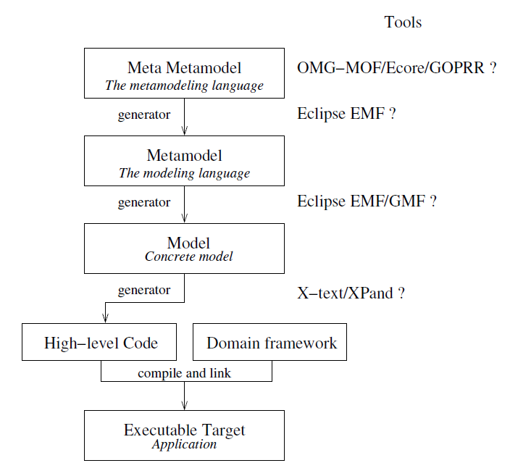
The following scheme gives an overview of the application of model overview to the whole project..

Model Based Safety Analysis
The Safety Analysis for software such as an ETCS EVC can be complicated and complex, and the principles of System Engineering shall apply to this study in order to ensure the suitability and the accuracy of the Safety features evaluated in the study, as well as their THR fulfilment.
The Software Requirement Specification at system level will be supported by a SysML model able to provide the same level of information, related to:
- the sub-systems and their interfaces,
- the messages exchanged through these interfaces and their sequencing,
- all the protocols definition and dynamic behaviors,
- all messages content and data details.
Therefore, and according to the Open ETCS project philosophy, we aim at providing a full integrated tool chain for the overall software design process and V&V. The Safety Analysis related part of V&V will take part in this approach, and we will perform the Safety Analysis on the requirement models, as well as on the design models, for all engineering loops.
This proof of concepts will show how we plan to use commonly MBSA tools and Safety Analysis traditional tools described in standards in order to fulfill the Safety related objectives for an EVCC SIL4 design and development.
The principle for the Safety activities for the overall Open ETCS project is summarized in the following scheme:

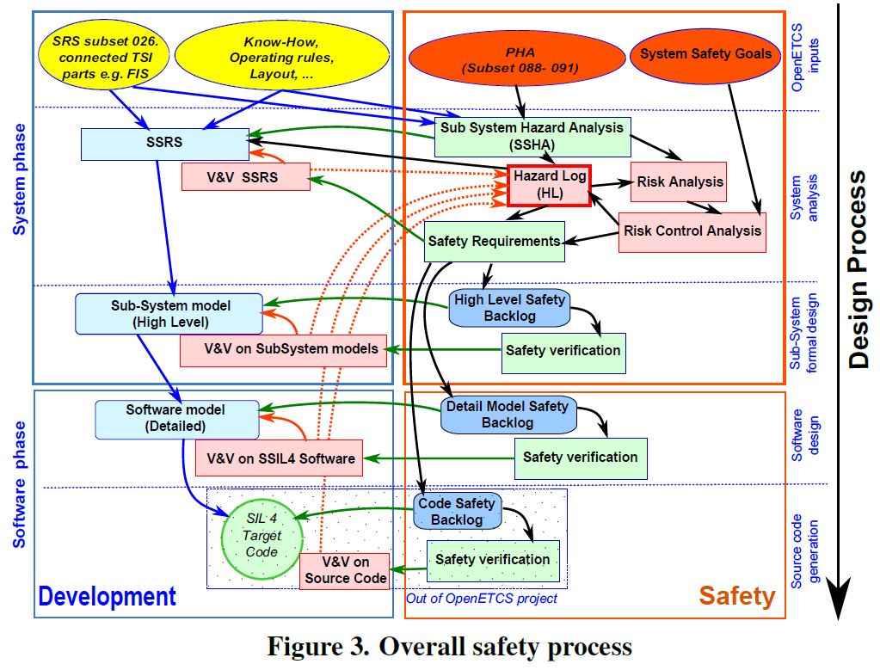

CENELEC Compliance of MBSA
One of the main concerns applying the MBSA to the Open ETCS project is the compliance to the CENELEC standards. Indeed, the integrated processes of MBSA are not described and provided in the standard, and we shall demonstrate that the common requirements applied to the Safety Analysis for designing such EVC software are met.
The methodology for ensuring this CENELEC compliance is to check all the CENELEC requirements that apply to these activities related to the specific system design and architecture definition in a traditional design specification activity, and then to adapt them to the model, and to check if these requirements can be considered in a Model Based approach, and if so, if they are covered. Solutions are proposed in order to fill the requirements not met yet.
The table containing the results of this analysis is described part…$$

System under inspection description
This chapter describes the MoRC function described in the SysML model. The SysML design model has been defined from the SRS subset-026-3, issue 3.3.0, from the Inter-operability specifications, and from Siemens expertize.
$$The traceability with the SRS section is performed using the notation {§x.y.z}.

Context and Core Hazard

Train System Core Hazard
As defined in the SUBSET-088 v2.3.0, the role of ETCS is
To provide the Driver with information to allow him to drive the train safely and to enforce respect of this information.
Thus the Core Hazard at train system level is defined as
Exceedance of the safe speed or distance as advised to ETCS.
The refining of this Core Hazard to our system scope (here the MoRC) leads to a new core hazard to consider for our system considered in this study: the Management of the Radio communication sub-function. This workflow is described in the following part.

MoRC Core Hazard – The methodology
The methodology proposed for refining the MoRC Sub-function core Hazard is the following:
- Realize the functional description and breakdown from our system OBU EVC level, to the basic functional components of our software. This work is supported by the SRS task force, and is currently on going. We use in this Proof Of Concept a SysML model realized with SCADE System, describing the top level of the sub-function Management of Radio Communication.
- Describe the Hardware Structure on which will be implemented the function we want to consider. This step is not relevant in our PoC because the only hardware to consider for this function is the On-board Unit controller supporting the EVC.
- Link this functional description to the System Hazards Analysis that has been written in the frame of SRS System Safety Analysis by ERA group. Indeed, the subset88 fault trees are based on hardware and functional assumptions regarding the OBU EVC design, and it is particularly relevant to plug the gates and the basic events described in the subset88 to the functions and sub-functions described in the SRS SysML model. Plus, it is relevant to gather these HW related assumptions, in order to validate (and then to assess) the safety analysis at the system level (and downer after).
- Define the EVC Kernel basic events described in the System Hazard Analysis as the top event of coming OBU EVC analysis. The components bottom level of the model has also to be clearly defined for the analysis. Depending of the detail of what is considered at the bottom level for this safety analysis (sub-function, message, variable, logical signal…), the study could be an intermediate one, and will be maybe lead to another study at a downer level. If the detail is sufficient enough, then we will be able
- Start the System Safety Analysis thanks to the FMEA from these feared Events defined at EVC Kernel level, going down to the ManagementOfRadioCommunication functional block level.

MoRC Core Hazard – Application to the MoRC
The CORE Hazard described in the subset 88 is the exceedance of the safe speed or distance as advised to ETCS.
This Core Hazard can be refined to the Radio Infill failure that can lead to the System feared event.
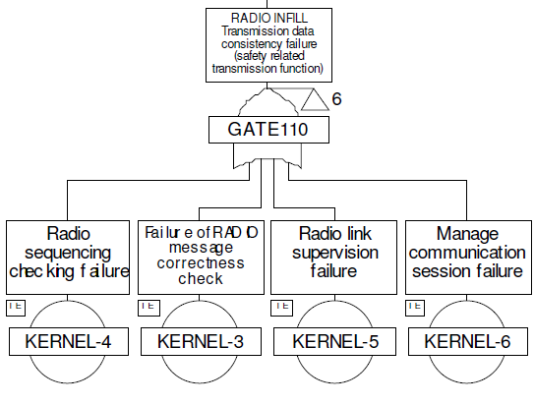

Under the gate 110, related to the feared event “Radio Infill – Transmission data consistency failure (safety related transmission function)”, we understand that 4 basic events can lead to this situation:
- Kernel 4: Radio sequencing checking failure
- Kernel 3: Failure of Radio message correctness check
- Kernel 5: Radio link supervision failure
- Kernel 6: Manage Radio communication failure

We can then assume that the basic event Kernel 6 is directly related to the failure mode of the Radio Management of Communication functional block. Therefore, the basic event Kernel-6 in the System Safety Analysis in the subset88 is the CORE Hazard we want to evaluate in our Proof of Concept:
Manage communication session failure

Organic Interfaces of the MoRC function
The EVC MoRC function interacts with 4 units:
- Mobile Terminal {§3.5.6.1}
- Radio Bloc Centre {§3.5.3.1}
- Radio Infill Unit {§3.5.3.2}
- Driver Module Interface {§3.5.3.8-b}

Functional Study

Functional decomposition

Function Considered | Function as described in the subset 26 | Traceability with subset26 | Role of the function
SessionStateManager | (notify driver) | §3.5.7 | Used to notify the driver of the state of radio communication.
EstablishingACommunicationSession | (establish communication) | §3.5.3 | Used to establish a communication with trackside equipment.
MaintainingACommunicationSession | (maintain communication) | §3.5.4 | Used to maintain the communication with trackside equipment.
TerminatingACommunicationSession | (terminate communication) | part of §3.5.5 | Used to terminate the communication with trackside equipment.
RegisteringToTheRadioNetwork | (register mobile terminal) | §3.5.6 | Used to register the Mobile Terminal to a Radio Network.
RegisteringToTheRadioNetwork | (set-up safe connection) | §3.5.3.7-a | Used to set-up the safe connection according to EURORADIO specification.
RegisteringToTheRadioNetwork | (release safe connection) | §3.5.5 of SRS | Used to release the safe connection according to EURORADIO specification.

Data handled
This chapter describes data used by the MoRC function. These data are created from the information found in the SRS requirements, as well as Siemens expertise on OBU EVC Software design and development. The traceability of the data and messages handled in the function Management of Radio communication

 | Message in SysML Model |  | Variable/data in SysML Model |  | Corresponding data in SRS-Subset26 | Type of signal | Source (input)/ Destination (output) | Signla Description
 | OrderToRM |  | orderFromOnBoard |  | start_of_mission  - train is rejected*  - the driver closes the desk* | Input | EVC | A start of mission occurs.  * If one of these events occurs during Start of Mission, the termination of the communication shall be performed.  {§3.5.3.4-a} {§3.5.5.1-c} {§3.5.5.1-d}
 | OrderToRM |  | orderFromOnBoard |  | end_of_mission | Input | EVC | End of Mission is performed.  {§3.5.3.7-a}
 | OrderToRM |  | messageFromRBC |  | trackside_establishment_request  - accepting RBC | Input | trackside | The establishment of the communication is ordered from trackside (RBC, RIU or balise groups).  {§3.5.3.4-b}  {§3.5.3.7-a}
 | OrderToRM |  | messageFromRBC |  | trackside_terminating_request | Input | trackside | The terminating of the communication is ordered from trackside.  {§3.5.3.7-a} {§3.5.5.1-a}
 | OrderToRM |  | messageFromRBC |  | trackside_terminating_ack | Input | trackside | After reception of Termination_com_session_msg, the trackside considers the communication session terminated and sends an acknowledgement to the on-board.  {§3.5.5.2-b}
 | OBU_Status |  | M_Mode |  | mode_change | Input | EVC | The change of mode has to be reported to the RBC.  {§3.5.3.4-c}
 | OBU_Status |  | M_Level |  | manual_change_level | Input | DMI | The driver has manually changed the level to 2 or 3.  {§3.5.3.4-d}
 | OBU_Status |  | M_Level |  | front_end_change_level | Input | EVC | The train passes a level transition border (from level 2/3 to level 0, NTC, 1) with its front end.  {§3.5.3.7-a}
 |  |  |  |  | front_end_RBC_RBC_border | Input | EVC | The train passes a RBC/RBC border with its front end.  {§3.5.3.7-a}
 | OBU_Status |  | radioHoleStatus |  | end_of_radio_hole | Input | EVC | The train front reaches the end of an announced radio hole.  {§3.5.3.4-e}
 | OBU_Status |  | radioHoleStatus |  | start_of_radio_hole | Input | EVC | The train front reaches the start of an announced radio hole.  {§3.5.3.7-a}
 | OBU_Status |  | SystemVersionIsCompatible |  | trackside_system_version | Input | trackside | The system version from the trackside.  {§3.5.3.7-c} {§3.5.3.8}
 | OrderToRM |  | messageFromRBC |  | init_com_session_msg_in  - time-stamp  - Last Relevant Balise Group | Input | trackside | The message Initiation of communication session from the trackside.  {§3.5.3.10-b} {§3.5.3.11}
 | RadioNetworkIDs |  | radioNetworkID_memorized  radioNetworkID_fromDriver  radioNetworkID_fromTrackside  actualRadioNetworkID |  | radio_network_identity | Input | trackside  DMI | Radio Network identity.  {§3.5.6.1-b}
 | Power Available |  | OBU_Status |  | power-up | Input | EVC | The train is switch-on.  {§3.5.6.1-a}
 | OrderToRM |  | NID_RBC_ID |  | RBC_id | Input | trackside | The identity of the RBC. This data is memorised.  {§3.5.3.5-a} {§3.5.3.5.3-a} {§3.5.3.13} {§3.5.3.16}
 |  |  |  |  | RBC_phone_number | Input | trackside | The telephone number of the RBC. This data is memorised.  {§3.5.3.5-b} {§3.5.3.5.3-b} {§3.5.3.13} {§3.5.3.16}
 | SafeRadioComStatus |  | setupEstablished |  | communication_established | Internal |  | A communication is already established.  {§3.5.3.5.2} {§3.5.3.8} {§3.5.4.1}
 | SafeRadioComStatus |  | mobileHWConnectionStatus |  | communication_lost | Internal |  | Communication session is considered as terminated due to loss of safe radio connection.  {§3.5.3.4-f} {§3.5.4.2}
 | SafeRadioComStatus |  | mobileHWConnectionStatus |  | communication_lost_delay | Internal |  | Maximum time to maintain a communication session in case of failed re-connection attempts  {§3.5.4.1} {§3.5.4.2.1}
 |  |  |  |  | communication_request | Internal |  | The action to be performed (establish/terminate the session).  {§3.5.3.5-c} {§3.5.3.6-c}
 |  |  |  |  | spleeping_units | Internal |  | Used in sleeping mode.  {§3.5.3.5-d} {§3.5.3.5.3-c}
 |  |  |  |  | RIU_id | Internal |  | The identity of the RIU.  {§3.5.3.6-a}
 |  |  |  |  | RIU_phone_number | Internal |  | The telephone number of the RIU.  {§3.5.3.6-b}
 |  |  |  |  | phone_number | Internal |  | The telephone number of the train.  {§3.5.3.8-a}
 |  |  |  |  | supported_versions | Internal |  | List of supported system versions.  {§3.5.3.8}
 |  |  |  |  | max_establishment_try | Internal |  | The number of times to try to establish a safe radio connection.  {§3.5.3.7-a}
 |  |  |  |  | max_repetition_msg | Internal |  | Repetition of radio messages (i.e. excluding the first sending)  {§3.5.5.3.2}
 |  |  |  |  | msg_repetition_delay | Internal |  | Waiting time before radio message repetition.  {§3.5.5.3.1}
 | SafeRadioComStatus |  | mobileHWConnectionStatus |  | radio_connection_status | Internal |  | Status of the connection from EURORADIO  {§3.5.3.7-a}
 | SafeRadioComCmd |  | memorizeTheLastRadioNetworkID |  | last_radio_network_identity | Internal |  | Last Radio Network identity.  {§3.5.6.2}
 | OrderToRBC |  | messageToRBC |  | init_com_session_msg_out  - RBC_id  - RBC_phone_number  - spleeping_units | Output | trackside | The message Initiation of communication session to the trackside.  {§3.5.3.7-b}
 | OrderToRBC |  | messageToRBC |  | termination_com_session_msg | Output | trackside | Termination of communication session message to the trackside.  {§3.5.5.2-a}
 | OrderToRBC |  | messageToRBC |  | version_msg | Output | trackside | The version independent message to the trackside indicates “No compatible version supported”.  {§3.5.3.8-b}
 | RM_Status |  | radioComSessionEstablished |  | session_established_report_msg  - phone_number | Output | trackside | The session established report message to the trackside. The phone_number is only sent when the train establish the communication.  {§3.5.3.8-a} {§3.5.3.9} {§3.5.3.10-c}
 | SafeRadioComCmd |  | requestSetup |  | radio_setup_request | Output | trackside | Request the set-up of a safe radio connection with the trackside.  {§3.5.3.7-a}
 | SafeRadioComCmd |  | releaseSetup |  | radio_release_request | Output | trackside | Request the release of a safe radio connection with the trackside.  {§3.5.5.2-c}
 | SafeRadioComCmd |  | mobileHWCmd |  | radio_network_registration | Output | trackside | Order the registration of a Mobile Terminal.  {§3.5.6.1}
 | RM_Status |  | mobileSWStatus |  | connection_stat_msg  - No Connection  - Connection Lost / Set-Up failed  - Connection Up | Output | DMI | Information to the driver about the status of the safe radio connection.  {§3.5.7}
 | RM_Status |  | mobileSWStatus |  | version_error_flag | Output | DMI | Error flag to inform the driver of a system version error.  {§3.5.3.8-b}

FMEA
The worksheet includes the following columns:
- #: Identification number of the raw of the table,
- Function: Function/sub-function to be analysed,
- Failure mode (and related outputs): The following failure modes are considered for each function:
  - Absence: the function is not carried out on request,
  - Loss: the function was carried out but it stops,
  - Inadvertent: the function is performed when not requested,
  - Degraded: the function does not meet its requirements (corrupted outputs analysis is performed if it is relevant),
Note: for some functions, some of these modes can be not relevant. In this case, the mode is not considered.
- Effect: Direct effect of the failure mode on function outputs and at system level,
- Hazard: Indicate if the hazard identified could happen (Yes or No),
- Detectability: Indicate if the detectable/Undetectable,
- SIL: Deduced Safety Integrity Level of the function. SIL-4 if the Hazard is Yes, else SIL-0,
- Safety Criteria: Safety Criteria defining the need to eliminate or mitigate risks. The measures can be preventive, palliative or corrective,
- Comments: Free comments to clarify the content of the row.

Suppositions on analyse:
- The absence of communication is safety related at system level.

# | Function | Failure mode | Effect | Hazard | Detectability | SIL | Safety Criteria | Comment
1 | register mobile terminal | Absence | The Mobile Terminal is not registered to the radio network. Communication with trackside equipment is not possible. | yes | Detectable | SIL-4 | REQ_FMEA_ID_001
2 | register mobile terminal | Loss | The Mobile Terminal is not registered to the radio network. Communication with trackside equipment is not possible. | yes | Detectable | SIL-4 | REQ_FMEA_ID_002
3 | register mobile terminal | Inadvertent | The Mobile Terminal changes form a radio network to another during an active communication. The active communication with trackside equipment fails. | yes | Detectable | SIL-4 | REQ_FMEA_ID_003
4 | register mobile terminal | Degraded | The data radio_network_registration is corrupted and the radio network does not take it into account.  The Mobile Terminal is not registered to the radio network. Communication with trackside equipment is not possible. | yes | Detectable | SIL-4 | REQ_FMEA_ID_001  REQ_FMEA_ID_002
5 | register mobile terminal | Degraded | The data radio_network_registration is not produced for the good Mobile Terminal.  The Mobile Terminal changes form a radio network to another during an active communication. The active communication with trackside equipment fails. | yes | Detectable | SIL-4 | REQ_FMEA_ID_001  REQ_FMEA_ID_003
6 | set-up safe connection | Absence / Loss | The radio connection is not safe. Corruption of data may occur. | yes | Detectable | SIL-4 | REQ_FMEA_ID_004
7 | set-up safe connection | Inadvertent | An active communication with trackside equipment fails due to the set-up of the safe connection. | yes | Detectable | SIL-4 | REQ_FMEA_ID_005
8 | set-up safe connection | Degraded | The data radio_setup_request is corrupted.  The safe connection configuration is not the same between On-Board and Trackside.  The communication is not possible. | yes | Detectable | SIL-4 | REQ_FMEA_ID_011
9 | establish communication | Absence | Communication with trackside equipment is not performed. | yes | Detectable | SIL-4 | REQ_FMEA_ID_006
10 | establish communication | Loss | Establishment of communication is not complete. | yes | Detectable | SIL-4 | REQ_FMEA_ID_002
11 | establish communication | Inadvertent | An active communication with trackside equipment fails due to the establishment of a new communication. | yes | Detectable | SIL-4 | REQ_FMEA_ID_007
12 | establish communication | Degraded | The communication is not correctly established (wrong system version used) | yes | Detectable | SIL-4 | REQ_FMEA_ID_006  REQ_FMEA_ID_015
13 | establish communication | Degraded | The data init_com_session_msg_out doesn't identify the good trackside equipment to establish the communication.  The communication is not possible if the equipment not exist. Or a communication is established with a wrong equipment. | yes | Detectable | SIL-4 | REQ_FMEA_ID_012
14 |  |  | The order to contact an RBC or RIU is performed too late and data are not received in time. | yes | Detectable | SIL-4 | REQ_FMEA_ID_013  REQ_FMEA_ID_014
15 |  |  | The data session_established_report_msg doesn't identify the good telephone numbers.  The communication is not possible if the trackside is the initiator. | yes | Detectable | SIL-4 | REQ_FMEA_ID_016
16 | maintain communication | Absence / Loss / Inadvertent / Degraded | Communication is lost in case of loss of safe radio connection. | yes | Detectable | SIL-4 | REQ_FMEA_ID_008
17 | terminate communication | Absence / Loss | Communication with another trackside equipment is not possible. | yes | Detectable | SIL-4 | REQ_FMEA_ID_009
18 | terminate communication | Inadvertent | Transmission of data with trackside equipment fails. | yes | Detectable | SIL-4 | REQ_FMEA_ID_002  REQ_FMEA_ID_009
19 | terminate communication | Degraded | The message termination_com_session_msg is corrupted and the trackside does not take it into account.  Another On-Board equipment may cannot initiate a communication session with the trackside due to the network congestion managed by the trackside. | yes | Detectable | SIL-4 | REQ_FMEA_ID_009  REQ_FMEA_ID_017
20 | release safe connection | Absence / Loss / Degraded | Safe connections are still active and new set-up of a safe connection fails due to the communications congestion. | yes | Detectable | SIL-4 | REQ_FMEA_ID_018
21 | release safe connection | Inadvertent | Transmission of data with trackside equipment fails. | yes | Detectable | SIL-4 | REQ_FMEA_ID_010
22 | notify driver | Absence / Loss / Degraded | The driver is not informed of the state of the radio connection or the information is wrong because of the corruption of the data connection_stat_msg. | yes | Detectable | SIL-4 | REQ_FMEA_ID_002
23 | notify driver | Inadvertent | NA | - | - | - | -

Model Based Safety Analysis
From the previous FMEA work realized at the System level, we considered the Failure Mode analysis performed at the sub-system level in order to project this analysis at the downer level: the data exchanged between the different sub-functions considered in the MoRC function.
The tool we used for this approach is the Safety Architect Tool, which allows defining the local analysis for each components of the system we study, and then to generate the propagation of the different failures of these components to the other system component, or towards the entire system itself.

MoRC Functional Model
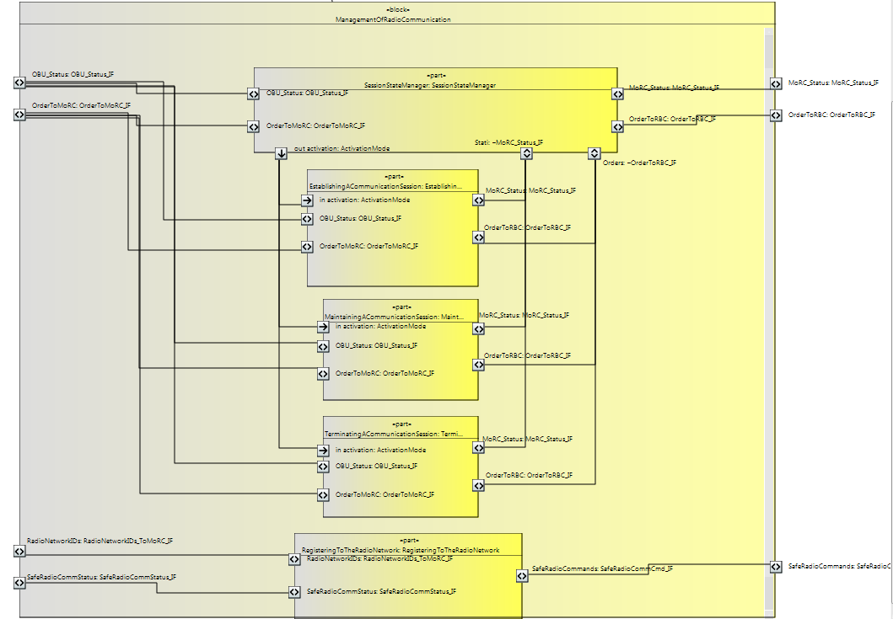
The model this Safety analysis is based on is a SysML model realized with SCADE System, a System Egineering tool. The Internal Bloc Diagram representing the MoRC with a functional description is the following:

The Safety Architect tool
The Safety Architect tool allows importing the previous functional model, and then filling the local Safety Analysis of each elementary block composing the MoRC system.
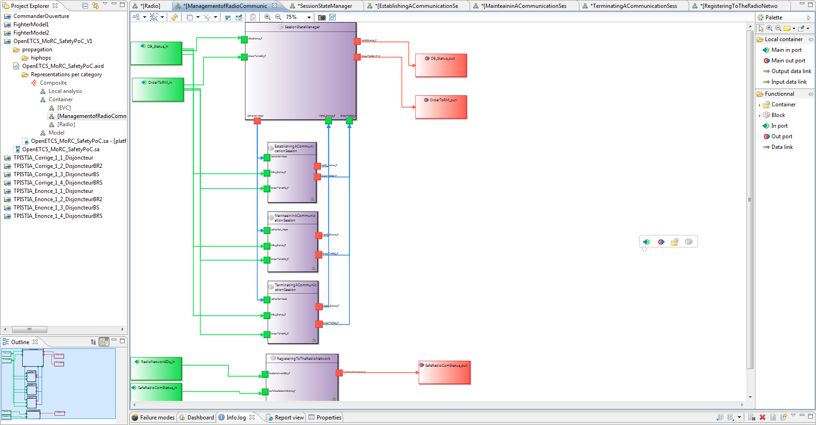
Each purple box on the model corresponds to a function block, interfaced with the other MoRC functional blocks or with the inputs or outputs of the system (here represented as the big green and red boxes on the scheme). The local analysis consists in filling in each block the Failure mode propagation information, linking the input failure modes, or the internal block failure modes, to the Output failure modes, as in the following example:
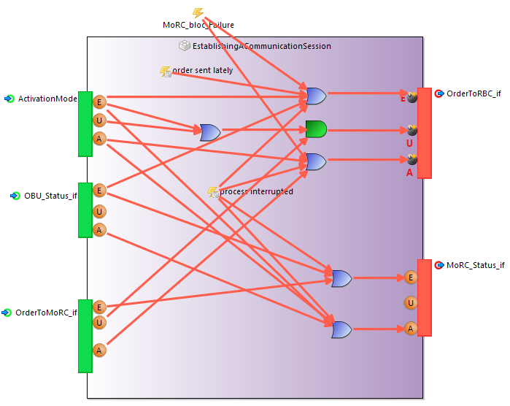

FMEA And Local Analysis assumptions
The local Analysis are considering different assumptionsregarding the functioning of the MoRC software, and the way these functions and sub-function can fail. As these analysis can be locally different between different manufacturers or for different customers, we have emitted numerous assumptions in order to validate with the ERTMS experts that the functioning and the failures for each block are valid.

Assumptions Table
These assumptions that are summarized in the following table:
N° | Assumption | Comments
1 | The SIL4 failure modes considered in the Systerel methodology lead to feared events (in Safety Architect models) considered in the MBSA.
2 | All the failures of the sub-functions "release safe connection" are considered as part of the functional block "Registering to the Radio Network".
3 | The failures "wrong order sent to RBC", "order sent untimely to the RBC" and "no order sent ot the RBC" are consirdered as feared events for the MoRC functional block.
4 | For the functional blocks related to the start, the maintain and the end of the radio communication session, the internal failures "order sent lately" and "process interruption" are considered. The order sent lately leads to an erroneous order sent to the RBC, and the "process interruption" can lead to an erroneous or absent order sent to the RBC, and can lead to a wrong or absent MoRC status.
5 | For the Session manager state, we consider that a spurious "order to RBC" or "Activation Mode" signal can be triggered only by the common occurency of respectively a spurious Order to RBC received or a spurious order to MoRC, and an erroneous OBU status.
6 | Deleted
7 | The Failure of the MoRC functional block can lead to an erroneous or absent failure on the order sent ot the RBC, to an erroneous MoRC status, and to a wrong or absent activation mode signal.
8 | The failure for the functional blocks "Establishing Communication Session", "Maintaining Communication" and "Terminating Communication" are considered in the same way as for the assumption 7.
9 | The failure of the "establishing communication session" leads to feared events through the OrderToRBC signal. The feared events are considered for the failure modes Erroneous, Untimely and Absent.
10 | The failures erroneous and untimely from the Activation mode input leads to an untimely order to RBC if combined with an erroneous status of input OBU status signal.
11 | The failures erroneous and Absent for the flows RadioNetworkIDs_if and SafeRadioCommStatus can lead independantly to respectively an Erroneous or an Absent Failure mode for the SafeRadioCommands.
12 | A spurious Failure mode for the output flow SafeRadioCommands in the functional block RegisteringToTheRadioNetwork can be triggered by either a spurious failure of the Safe_RadioCommStatus input flow, or from an internal failure of the RegisteringToTheRadioNetwork functional block.

Traceability Table:
This table provides the list of failure modes considered within each function block of the model, and their traceability to the assumptions given in the previous part.
Function/sub-function | Failure modes | Effect | Comment
MoRC functional block | wrong order sent to RBC | feared event | ASS3; ASS7
MoRC functional block | order sent untimely to the RBC | feared event | ASS3
MoRC functional block | no order sent at the RBC | feared event | ASS3; ASS7
MoRC functional block | erroneous MoRC status | feared event | ASS7
MoRC functional block | wrong activation mode signal | feared event | ASS7
MoRC functional block | absent activation mode signal | feared event | ASS7
Registering to the Radio Network | Untimely Registration | Untimely SafeRadio Commands | ASS1, ASS12
Registering to the Radio Network | Mobile Terminal Registration loss | Absent Safe Radio Command | ASS11
Registering to the Radio Network | MoRC Block Failure | Absent Safe Radio Command | ASS11
Registering to the Radio Network | Other | Erroneous SafeRadioCommands | ASS11
Registering to the Radio Network | Other | Untimely SafeRadio Commands | ASS12
Registering to the Radio Network | Other | Absent Safe Radio Command | ASS11
Establishing A Communication Session | order sent lately | erroneous order sent to the RBC | ASS4
Establishing A Communication Session | process interruption | erroneous order sent to the RBC | ASS4; ASS8
Establishing A Communication Session | process interruption | absent order sent to the RBC | ASS4; ASS8
Establishing A Communication Session | process interruption | wrong MoRC status | ASS4; ASS8
Establishing A Communication Session | process interruption | absent MoRC status | ASS4
Establishing A Communication Session | other | erroneous order sent to the RBC | ASS8
Establishing A Communication Session | other | absent order sent to the RBC | ASS8
Establishing A Communication Session | other | wrong MoRC status | ASS8
Establishing A Communication Session | other | wrong activation mode signal | ASS8
Establishing A Communication Session | other | absent activation mode signal | ASS8
Maintaining A Communication Session | order sent lately | erroneous order sent to the RBC | ASS4
Maintaining A Communication Session | process interruption | erroneous order sent to the RBC | ASS4
Maintaining A Communication Session | process interruption | absent order sent to the RBC | ASS4
Maintaining A Communication Session | process interruption | wrong MoRC status | ASS4
Maintaining A Communication Session | process interruption | absent MoRC status | ASS4
Maintaining A Communication Session | other | erroneous order sent to the RBC | ASS8
Maintaining A Communication Session | other | absent order sent to the RBC | ASS8
Maintaining A Communication Session | other | wrong MoRC status | ASS8
Maintaining A Communication Session | other | wrong activation mode signal | ASS8
Maintaining A Communication Session | other | absent activation mode signal | ASS8
Terminating A Communication Session | order sent lately | erroneous order sent to the RBC | ASS4
Terminating A Communication Session | process interruption | erroneous order sent to the RBC | ASS4
Terminating A Communication Session | process interruption | absent order sent to the RBC | ASS4
Terminating A Communication Session | process interruption | wrong MoRC status | ASS4
Terminating A Communication Session | process interruption | absent MoRC status | ASS4
Terminating A Communication Session | other | erroneous order sent to the RBC | ASS8
Terminating A Communication Session | other | absent order sent to the RBC | ASS8
Terminating A Communication Session | other | wrong MoRC status | ASS8
Terminating A Communication Session | other | wrong activation mode signal | ASS8
Terminating A Communication Session | other | absent activation mode signal | ASS8
SessionStateManager | spurious Order to RBC received | spurious "order to RBC" signal | ASS5
SessionStateManager | spurious order to MoRC, and an erroneous OBU status | spurious " Activation Mode " signal | ASS5; AS

MBSA qualitative results
The Failure Trees related to the different MoRC Hazards to be considered are given in the following parts. The format used for the fault trees is the All4tec format. The results are given for each Hazards considered at MoRC functional level.

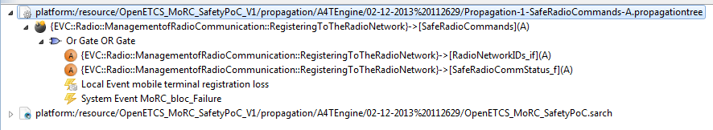
Absence of Registering to the Radio Network signal

Absence of Activation mode signal
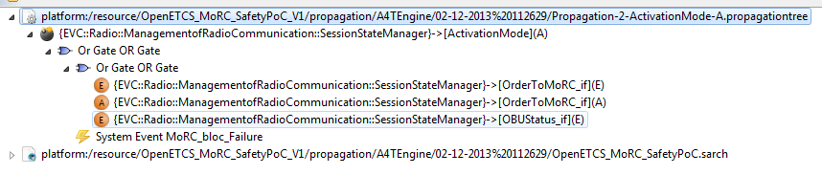

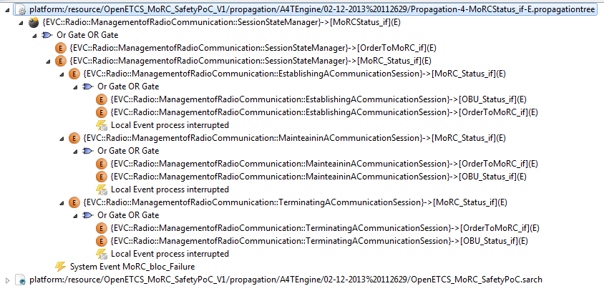
Activation mode erroneous signal

Order To MoRC erroneous signal

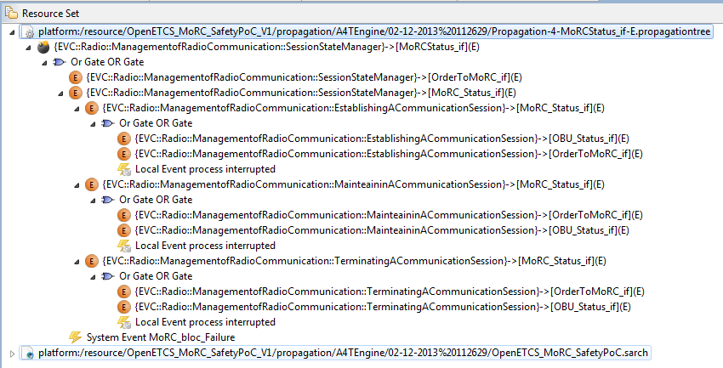
[…] The following fault trees will not be all displayed, as this study is only a proof of concept, and as no quantitative Safety Assessmet is realized yet.

MBSA quantitative assessment
No quantitative assessment is realized in this PoC. This part is to be filled thanks to a fault tree editor not yet choosen.

Fulfillement of CENELEC requirements
This part ensures the traceability and the coverage of the CENELEC EN50128 requirements for the Features addressed to this Management of Radio Communication function.
In the same way as for the previous part,

MBSA Traceability |  | CENELEC
Paragraph | Scope | CENELEC | §/Req | Wording | Coverage of CENELEC | Comments Aebt | Comments A4T | Safety Requirement created | Safety Requirement ID
 | Software - General | 50128 | 7.2.4.2 | The Software Requirements Specification shall express the required properties of the software being developed. These properties shall include:  a) functionality (including capacity and response time performance),  b) robustness and maintainability,  c) safety (including safety functions and their associated software safety integrity levels),  d) efficiency,  e) usability,  f) portability. | To confirm | Uwe’s model does not fulfil this requirement.  Moreover, the generated document from Uwe’s model (MoRC_System-x.pdf) does not address this requirement.  This is in my opinion a tool issue. | I see your point, but I think that we have actually 2 concerns that will be necessary to check out:  - The part of the requirements that will be covered by the SRS model (for me: functionality, safety, robustness and maintainability)  - The part of the requirement that will be covered by the associated document (for me the other points).  I think we are on something new regarding our common application of the standard, and that we have to adapt in order to the Model Driven Engineering our CENELEC requirements. But so far, this requirement is not covered I agree. | Safety requirement 1: Tools used for modelling shall dictate general properties of the function to be modelled to be addressed.  Therefore, the following properties shall be entered:  a) functionality (including capacity and response time performance),  b) robustness and maintainability,  c) safety (including safety functions and their associated software safety integrity levels),  d) efficiency,  e) usability,  f) portability. | REQ_CEN_ID_001
 | Software - General | 50128 | 7.2.4.3 | The software safety integrity level shall be recorded in the Software Requirements Specification. | To confirm | The software safety integrity level of Uwe’s Model is SSIL 4, as determined in Subset 088 & 091  Uwe’s model does not fulfill this requirement.  Moreover, the generated document from Uwe’s model (MoRC_System-x.pdf) does not address this requirement.  This is also a tool issue. | This point is not clear for me, because the SIL4 of the soft is no more on the table, but we should target such a SIL level regarding the Safety activities… Do you think that a tag should be added on each part of the model in order to track the functions SIL levels? | Safety requirement 2: Tools used for modelling shall dictate the software safety integrity level to be addressed. | REQ_CEN_ID_002
 | Software - General | 50128 | 7.2.4.4 | To the extent required by the software safety integrity level, the Software Requirements Specification shall be expressed and structured in such a way that it is  a) complete, clear, precise, unequivocal, verifiable, testable, maintainable and feasible,  b) traceable back to all the input documents. | To confirm | Uwe’s Model has been developed using the Scade notation.  The Scade notation fulfills this requirement. | I think that the traceability is not very consistent so far, but anyway scade diagrams allow doing that.
 | Software - General |  | 7.2.4.5 | The Software Requirements Specification shall include modes of expression and descriptions which are understandable to the responsible personnel involved in the life cycle of the software. | OK | Uwe’s Model has been developed using the Scade notation.  The Scade notation fulfills this requirement.
 | Software - General |  | 7.2.4.6 | The Software Requirements Specification shall identify and document all interfaces with any other system, either within or outside the equipment under control, including operators, wherever a direct connection exists or is planned. | To confirm | Uwe’s model fulfills this requirement.  The generated document from Uwe’s model (MoRC_System-x.pdf) addresses this requirement. | This specific point has to be dealt with carefully (and will need specific modelling methods to be applied).
 | Software - General |  | 7.2.4.7 | All relevant modes of operation shall be detailed in the Software Requirements Specification. | OK | Uwe’s model fulfills this requirement.  The generated document from Uwe’s model (MoRC_System-x.pdf) addresses this requirement.
 | Software - General |  | 7.2.4.8 | All relevant modes of behaviour of the programmable electronics, in particular failure behaviour, shall be documented or referenced (e.g. system level documentation) in the Software Requirements Specification. | NOK | Uwe’s model does not fulfill this requirement.  Moreover, the generated document from Uwe’s model (MoRC_System-x.pdf) does not address this requirement.  In my opinion, I think the all relevant modes of behaviour, in particular failure behaviour of the programmable electronics shall be provided by WP2 or WP5.  A FMEA shall be performed (base on the SSRS) to provide input for each software modelling activity. | I agree with this point, which comes after from my point of view, and which will have to be considered carefully. | Safety requirement 3: all relevant modes of behaviour of the programmable electronics / Hardware, in particular failure behaviour, shall be available before starting with modelling. | REQ_CEN_ID_003
 | Software - General |  | 7.2.4.9 | Any constraints between the hardware and the software shall be documented or referenced (e.g. system level documentation) in the Software Requirements Specification. | NOK | Uwe’s model does not fulfill this requirement.  This input shall be provided by WP2 or WP5. | I 100% agree. | Safety requirement 5: Any constraints between the hardware and the software shall be available before starting with modelling. | REQ_CEN_ID_004
 | Software - General |  | 7.2.4.10 | To the extent required by the description of system documentation, the Software Requirements Specification shall consider the software self-checking and the hardware checking by the software. Software self-checking consists of the detection and reporting by the software of its own failures and errors. | To confirm | The generated document from Uwe’s model (MoRC_System-x.pdf) gives no information according to self-checking capability of functions and hardware checking by functions. | I think we are too early in the modelling process for these self-checking features. In my opinion, a first architecture has to be provided, then to be analysed from a safety point of view, this Safety analysis will lead to safety properties to be filled, heading to self enhancement of the model, using notably these self-checking functions. Then this requirement will be covered.
 | Software - General |  | 7.2.4.11 | The Software Requirements Specification shall include requirements for the periodic testing of functions to the extent required by the System Safety Requirements Specification. | To confirm | The generated document from Uwe’s model (MoRC_System-x.pdf) gives no information according to the periodic testing of functions. | I think that the requirement specifies periodic tests system requirements needed in the SRS, but not the periodic tests facilities themselves. | Safety requirement 7: Each Model shall implement (when applicable) periodic testing functionalities of functions. | REQ_CEN_ID_005
 | Software - General |  | 7.2.4.12 | The Software Requirements Specification shall include requirements to enable all safety functions to be testable during overall system operation to the extent required by the System Safety Requirements Specification. | To confirm | The generated document from Uwe’s model (MoRC_System-x.pdf) gives no information according to the periodic testing of functions.
 | Software - General |  | 7.2.4.13 | All functions to be performed by the software, especially those related to achieving the required system safety integrity level, shall be clearly identified in the Software Requirements Specification. | To confirm | Uwe’s model does not fulfill this requirement.  In the generated document from Uwe’s model (MoRC_System-x.pdf), it is not clear which functions are safety related and which are not safety related.  This is could be perhaps a tool issue. | See comment on §7.2.4.10
 | Software - General |  | 7.2.4.14 | Any non-safety functions which the software is required to perform shall be clearly identified in the Software Requirements Specification. | To confirm | See §7.2.4.13
 | Software - General |  | 7.2.4.15 | The Software Requirement Specification shall be supported by techniques and measures from Table A.2. The selected combination shall be justified as a set satisfying 4.8 and 4.9. | To confirm | Uwe’s Model has been developed using the Scade notation.  The Scade notation is a formal notation.  Plus the tool used allow a generation of the Model documentation in a natural language  Therefore, Uwe’s Model fulfils this requirement.
 | Architecture and Design |  | 7.3.4.2 | The proposed software architecture shall be established and detailed in the Software Architecture Specification. | To confirm | This requirement is not applicable, since a model driven software development is used | Yes, and my point of view on this point is that a part of these CENELECs have to be covered by the SRS model, and another part by the SRS paper, and both SRS parts have to be complementary, and fully covering the CENELECs. So I won’t say inapplicable, but to be adapted
 | Architecture and Design |  | 7.3.4.3 | The Software Architecture Specification shall consider the feasibility of achieving the Software Requirements Specification at the required software safety integrity level. | To confirm | see §7.3.4.2
 | Architecture and Design |  | 7.3.4.4 | The Software Architecture Specification shall identify, analyse and detail the significance of all hardware/software interactions. | To confirm | see §7.3.4.3
 | Architecture and Design |  | 7.3.4.5 | The Software Architecture Specification shall identify all software components and for these components identify  a) whether these components are new or existing,  b) whether these components have been previously validated and if so their validation conditions,  c) the software safety integrity level of the component. | To Confirm | Uwe’s model does not fulfill this requirement.  In the generated document from Uwe’s model (MoRC_System-x.pdf), it is not clear which components (Block Diagrams) are new or existing and theirs safety integrity level.  This is could be perhaps also a tool issue. | To me, this is a point to take care about right now (consider the software facilities to implement that, for instance add a specific slot in the Blocks stereotypes in SysML BDDs or IBDs), but the real activity is coming after. | Safety requirement 9: Tools used for modelling shall dictate this requirement to be addressed. | REQ_CEN_ID_006
 | Architecture and Design |  | 7.3.4.6 | Software components shall  a) cover a defined subset of software requirements,  b) be clearly identified and independently versioned inside the configuration management system. | To Confirm |  | Important point! To be considered now, because I am not sure that configuration management is integrated neither in SCADE or Papyrus. | Safety requirement 10: Each component (Block Diagrams) shall be independently versioned inside the configuration management system. | REQ_CEN_ID_007
 | Architecture and Design |  | 7.3.4.7 | The use of pre-existing software shall be subject to the following restrictions.  a) For all software safety integrity levels the following information shall clearly be identified and documented:  - the requirements that the pre-existing software is intended to fulfil;  - the assumptions about the environment of the pre-existing software;  - interfaces with other parts of the software.  b) For all software safety integrity levels the pre-existing software shall be included in the validation process of the whole software.  c) For software safety integrity levels SIL 3 or SIL 4, the following precautions shall be taken:  - an analysis of possible failures of the pre-existing software and their consequences on the whole software shall be carried out;  - a strategy shall be defined to detect failures of the pre-existing software and to protect the system from these failures;  - the verification and validation process shall ensure  1) that the pre-existing software fulfils the allocated requirements,  2) that failures of the pre-existing software are detected and the system where the pre-existing software is integrated into is protected from these failures,  3) that the assumptions about the environment of the pre-existing software are fulfilled.  d) The pre-existing software shall be accompanied by a sufficiently precise (e.g. limited to the used functions) and complete description (i.e. functions, constraints and evidence). The description shall include hardware and/or software constraints of which the integrator must be aware and take into consideration during application. In particular it forms the vehicle for informing the integrator of what the software was designed for, its properties, behaviour and characteristics. | To Confirm | Not applicable for Uwe’s.  We suppose that, all components (Block Diagrams) have been new developed | I would say adaptable rather than not applicable (expressing the constraints, properties, behaviour can be done in the blocks, and the rest can be covered by the model itself).
 | Architecture and Design |  | 7.3.4.8 | The use of existing verified software components developed according to the EN 50128:2011 in the design is to be preferred wherever possible. | To Confirm | See §7.3.4.7 | The components modeled by Uwe are corresponding to already existing components in Siemens. The connection and the traceability to what has been already produced will be complicated for intellectual properties reasons.
 | Architecture and Design |  | 7.3.4.9 | Where the software consists of components of different software safety integrity levels then all of the software components shall be treated as belonging to the highest of these levels unless there is evidence of independence between the higher software safety integrity level components and the lower software safety integrity level components. This evidence shall be recorded in the Software Architecture Specification. | To Confirm | See 7.3.4.5
 | Architecture and Design |  | 7.3.4.10 | The Software Architecture Specification shall describe the strategy for the software development to the extent required by the software safety integrity level. The Software Architecture Specification shall be expressed and structured in such a way that it is  a) complete, consistent, clear, precise, unequivocal, verifiable, testable, maintainable and feasible,  b) traceable back to the Software Requirements Specification. | To Confirm | The Scade notation is clear, precise, and unequivocal. SCADE Suite Semantic Checker allows checking the correctness of an interface description. SCADE LifeCycle Requirements Management Gateway allows establishing traceability with System Requirements. | Depends on which SCADE we consider.
 | Architecture and Design |  | 7.3.4.11 | Measures for handling faults shall be included in the Software Architecture Specification in order to achieve the balance between the fault avoidance and fault handling strategies. | To Confirm | See 7.3.4.14
 | Architecture and Design |  | 7.3.4.12 | The Software Architecture Specification shall justify that the techniques, measures and tools chosen form a set which satisfies the Software Requirements Specification at the required software safety integrity level. | To Confirm | SCADE Suite is a COTS tool that comes with an EN 50128 certificate at SIL 3/4. | Yes, but be careful, SCADE System used for design Uwe’s model so far is not SCADE Suite, and I guess that this part of the tool is not concerned by this SIL3/4 certification.
 | Architecture and Design |  | 7.3.4.13 | The Software Architecture Specification shall take into account the requirements from 8.4.8 when the software is configured by applications data or algorithms. | To Confirm | Uwe’s model does not fulfill this requirement.  In the generated document from Uwe’s model (MoRC_System-x.pdf), it is not clear whether the model (s) can be configured or not or how it can be configured.  This is could be perhaps also a tool issue. | Right. This is a real modelling concern to consider from now. | Safety requirement 9: Tools used for modelling shall dictate this requirement to be addressed. | REQ_CEN_ID_008
 | Architecture and Design |  | 7.3.4.14 | The Software Architecture Specification shall choose techniques and measures from Table A.3. The selected combination shall be justified as a set satisfying 4.8 and 4.9. | To Confirm | For a SIL4 function, following techniques / measures are highly recommended by the EN 50128:2011  1) Defensive programming: Uwe’s model does not make use this technique.  2) Error detecting codes: Uwe’s model does not make use this technique.  3) Diverse programming: Uwe’s model does not make use this technique (NB: Defensive programming techniques can be modeled in Scade language.)  4) Fully defined interface: Uwe’s model makes use this technique.  5) Modelling: is implemented  6) Structured Methodology: SCADE Suite, including Design Verifier, relies on formal methods for structured specification and validation of functional and safety requirements. |  | Safety requirement 10: Tools used for modelling shall provided all the techniques listed above | REQ_CEN_ID_009
 | Interface |  | 7.3.1 | The description of interfaces shall address  a) pre/post conditions,  b) definition and description of all boundary values for all specified data,  c) behaviour when the boundary value is exceeded,  d) behaviour when the value is at the boundary,  e) For time-critical input and output data:  1) time constraints and requirements for correct operation,  2) management of exceptions.  f) allocated memory for the interface buffers and the mechanisms to detect that the memory cannot be allocated or all buffers are full, where applicable,  g) existence of synchronization mechanisms between functions (see e).  All data from and to the interfaces shall be defined for the whole range of values defined by the type of the data, including the ranges which are not used when processed by the functions:  a) definition and description of all equivalence classes for all specified data and each software function using them,  b) definition of unused or forbidden equivalence classes | To Confirm | Uwe’s model does not fulfill this requirement.  Moreover, the generated document from Uwe’s model (MoRC_System-x.pdf) does not address this requirement.  This could be also a tool issue. | I think that a part of this requirement will be covered by the model, and the other one by the SRS paper. Anyway, system environment will mostlikely be modelled, in order to consider these interfaces. | Safety requirement 11: Tools used for modelling shall dictate this requirement to be addressed. | REQ_CEN_ID_010
 | Design |  | 7.3.4.21 | The input documents shall be available, although not necessarily finalised, prior to the start of the design process. | To Confirm | Subset 026 is available, but SSRS must be available
 |  |  | 7.3.4.22 | The Software Design Specification shall describe the software design based on a decomposition into components with each component having a Software Component Design Specification and a Software Component Test Specification. | To Confirm | The Scade notation is well-adapted to provide decomposition of the software in Modules (they are “operators” in Scade).
 |  |  | 7.3.4.23 | The Software Design Specification shall address  a) software components traced back to software architecture and their safety integrity level,  b) interfaces of software components with the environment,  c) interfaces between the software components,  d) data structures,  e) allocation and tracing of requirements on components,  f) main algorithms and sequencing.  g) error reporting mechanisms | To Confirm | SCADE Requirements Management Gateway can be used to exhibit traceability.
 |  |  | 7.3.4.24 | The Software Design Specification shall choose techniques and measures from Table A.4. The selected combination shall be justified as a set satisfying 4.8 and 4.9. | To Confirm | For a SIL4 function, following techniques / measures are highly recommended by the EN 50128:2011  1) Modular approach: Uwe’s model makes use this technique (Scade notation is highly modular).  2) Design and Coding standards: Design standards can be enforced by the SCADE tool. OpenETCS must define a Design and Coding standards.  3) Strongly typed programming language: The Scade language is strongly typed.  Formal methods: SCADE Suite, including Design Verifier, relies on formal methods for specification and validation of functional and safety requirements.  4) Modelling: is implemented | The point on the design and coding standard has to be discussed. If we consider the coding phase as between the model and the code generation, this phase is documented by scade. If not, we have to take care of that from now. | Safety requirement 12: Tools used for modelling shall provided all the techniques listed above | REQ_CEN_ID_011
 |  |  | 7.3.4.25 | Coding standards shall be developed and specify | To Confirm |  | See my previous remark. | Safety requirement 13: OpenETCS must define a Design and Coding standards. The coding standard shall be appropriate for SIL 4 software development. | REQ_CEN_ID_012
 |  |  | 7.3.4.26 | The selection of a coding standard shall be justified to the extent required by the software safety integrity level. | To Confirm | See 7.3.4.25
 |  |  | 7.3.4.27 | The coding standards shall be used for the development of all software and be referenced in the Software Quality Assurance Plan. | To Confirm | See 7.3.4.25
 |  |  | 7.3.4.28 | In accordance with the required software safety integrity level the design method chosen shall possess features that facilitate  a) abstraction, modularity and other features which control complexity,  b) the clear and precise expression of:  1) functionality,  2) information flow between components,  3) sequencing and time related information,  4) concurrency,  5) data structure and properties,  c) human comprehension,  d) verification and validation,  e) software maintenance. | To Confirm | The Scade notation has all the needed characteristics and thus allows producing designs that meet those standards. |  | Safety requirement 14: Tools used for modelling shall provide all the techniques and methods listed above | REQ_CEN_ID_013
 | component Design |  | 7.4.4.2 | For each software component, the following information shall be available  a) author,  b) configuration history, and  c) short description.  The configuration history shall include a precise identification of the current and all previous versions of the component, specifying the version, date and author, and a description of the changes made from the previous version. | To Confirm | Uwe’s model does not fulfill point (b) of this requirement.  Moreover, the generated document from Uwe’s model (MoRC_System-x.pdf) does not address this point.  This could be a tool issue. |  | Safety requirement 15: Tools used for modelling shall provide the features listed above | REQ_CEN_ID_014
 |  |  | 7.4.4.3 | The Software Component Design Specification shall address  a) identification of all lowest software units (e.g. subroutines, methods, procedures) traced back to the upper level,  b) their detailed interfaces with the environment and other components with detailed inputs and outputs,  c) their safety integrity level without any further apportionment within the component itself,  d) detailed algorithms and data structures. | To Confirm | SCADE Suite Editor is used to provide identification of the components, the call tree, the interfaces to the environment, and other modules, the detailed algorithms and data structures.  Uwe’s model therefore fulfills this requirement.
 |  |  | 7.4.4.4 | Each Software Component Design Specification shall be readable, understandable and testable | To Confirm | The Scade notation is readable, understandable, and testable. Uwe’s model therefore fulfills this requirement.
 |  |  | 7.4.4.5 | The size and complexity of each developed Software Component shall be balanced. | To Confirm | Uwe’s model therefore fulfills this requirement.
 |  |  | 7.4.4.6 | The Software Component Design Specification shall choose techniques and measures from Table A.4. The selected combination shall be justified as a set satisfying 4.8 and 4.9. | To Confirm | See 7.3.4.24

Safety Criteria/ Safety requirements

New Safety criteria edited from FMEA
REQ_FMEA_ID_001
The Mobile Terminal shall be safely registered to a Radio Network.

REQ_FMEA_ID_002
The driver shall be safely informed of the state of the radio communication (resulting of the different steps: registration of the Mobile Terminal to the Radio Network, establishment of the communication, end of communication).

REQ_FMEA_ID_003
If a communication through a Radio Network is active, registration of the associated Mobile Terminal to another Radio Network mustn’t be performed.
REQ_FMEA_ID_004
A safety protocol shall be used to performed communication between Mobile Terminal and Radio Network.
REQ_FMEA_ID_005
If a communication with trackside equipment is active, set-up of safe radio connection with another trackside equipment mustn’t be performed. Exception in case of handover with RBC.
REQ_FMEA_ID_006
Communication session with trackside equipment shall be safely established.
REQ_FMEA_ID_007
Establishment of communication session shall be performed when no communication is active. Exception in case of handover with RBC.
REQ_FMEA_ID_008
Communication session shall be safely maintained.
REQ_FMEA_ID_009
Terminate a communication session shall be safely defined.
REQ_FMEA_ID_010
The release of the safe radio connection with trackside shall be performed only when the communication session is terminated.
REQ_FMEA_ID_011
The compatibility and coherence of the safety protocol used to perform communication between Mobile Terminal and Radio Network shall be the verified.
REQ_FMEA_ID_012
The integrity and authenticity of the order message to contact a RBC or a RIU shall be guaranteed.
REQ_FMEA_ID_013
The freshness of the order message to contact a RBC or a RIU shall be guaranteed.
REQ_FMEA_ID_014
The order message to contact a RBC or a RIU shall be send in a safety defined time.
REQ_FMEA_ID_015
The compatibility and coherence of system version between On-Board and Trackside shall be verified. In case of error On-Board and Trackside shall be informed.
REQ_FMEA_ID_016
The integrity and authenticity of the session establishment report message sent to a RBC or a RIU shall be guaranteed.
REQ_FMEA_ID_017
The integrity and authenticity of the Termination of communication session message shall be guaranteed.
REQ_FMEA_ID_018
At the end of a communication session, the release of the safe connection shall be performed.

New Safety criteria edited from CENELEC coverage study
REQ_CEN_ID_001
Tools used for modelling shall dictate general properties of the function to be modelled to be addressed.
Therefore, the following properties shall be entered:
a) functionality (including capacity and response time performance),
b) robustness and maintainability,
c) safety (including safety functions and their associated software safety integrity levels),
d) efficiency,
e) usability,
f) portability.
REQ_CEN_ID_002
Tools used for modelling shall dictate the software safety integrity level to be addressed.
REQ_CEN_ID_003
all relevant modes of behaviour of the programmable electronics / Hardware, in particular failure behaviour, shall be available before starting with modelling.
REQ_CEN_ID_004
Any constraints between the hardware and the software shall be available before starting with modelling.
REQ_CEN_ID_005
Each Model shall implement (when applicable) periodic testing functionalities of functions..
REQ_CEN_ID_006
Tools used for modelling shall dictate this requirement to be addressed.
REQ_CEN_ID_007
Each component (Block Diagrams) shall be independently versioned inside the configuration management system.
REQ_CEN_ID_008
Tools used for modelling shall dictate this requirement to be addressed.
REQ_CEN_ID_009
Tools used for modelling shall provided all the techniques listed above:
1) Defensive programming: Uwe’s model does not make use this technique.
2) Error detecting codes: Uwe’s model does not make use this technique.
3) Diverse programming: Uwe’s model does not make use this technique (NB: Defensive programming techniques can be modeled in Scade language.)
4) Fully defined interface: Uwe’s model makes use this technique.
5) Modelling: is implemented
6) Structured Methodology: SCADE Suite, including Design Verifier, relies on formal methods for structured specification and validation of functional and safety requirements.
REQ_CEN_ID_010
Tools used for modelling shall dictate this requirement to be addressed.
REQ_CEN_ID_011
Tools used for modelling shall provided all the techniques listed above:
1) Modular approach: Uwe’s model makes use this technique (Scade notation is highly modular).
2) Design and Coding standards: Design standards can be enforced by the SCADE tool. OpenETCS must define a Design and Coding standards.
3) Strongly typed programming language: The Scade language is strongly typed.
Formal methods: SCADE Suite, including Design Verifier, relies on formal methods for specification and validation of functional and safety requirements.
4) Modelling: is implemented
REQ_CEN_ID_012
OpenETCS must define a Design and Coding standards. The coding standard shall be appropriate for SIL 4 software development.
REQ_CEN_ID_013
Tools used for modelling shall provide all the techniques and methods listed above:
a) abstraction, modularity and other features which control complexity,
b) the clear and precise expression of:
1) functionality,
2) information flow between components,
3) sequencing and time related information,
4) concurrency,
5) data structure and properties,
c) human comprehension,
d) verification and validation,
e) software maintenance.
REQ_CEN_ID_014
Tools used for modelling shall provide the features listed above:
a) author,
b) configuration history, and
c) short description.
The configuration history shall include a precise identification of the current and all previous versions of the component, specifying the version, date and author, and a description of the changes made from the previous version.

Coverage of pre-existing Safety Requirements
No object. This part will be relevant for the first official document of the Safety Analysis. This proof of concept considers no pre-existing Safety requirements to cover in the present Safety Analysis.

Traceability of safety criteria with SRS

Safety criteria | SRS section
REQ_FMEA_ID_001 | §3.5.6; §3.5.6.1; §3.5.6.3; §3.5.6.5; §3.5.6.6; §3.5.6.7
REQ_FMEA_ID_002 | §3.5.3.8-b; §3.5.7; §3.5.7.1; §3.5.7.2;
REQ_FMEA_ID_003 | §3.5.6.5
REQ_FMEA_ID_004 | §3.5.1.1; §3.5.2.2
REQ_FMEA_ID_005 | §3.5.3.5.2
REQ_FMEA_ID_006 | §3.5.3, §3.5.3.2, §3.5.3.4.1, §3.5.3.5.2, §3.5.3.7, §3.5.3.8
REQ_FMEA_ID_007 | §3.5.3.5.2
REQ_FMEA_ID_008 | §3.5.4
REQ_FMEA_ID_009 | §3.5.5
REQ_FMEA_ID_010 | §.3.5.5.2-c

Conclusion

[to be filled]

END OF DOCUMENT

