OPENETCS
Safety analyse: calculate of train position and orientation function

Confidentiality | Reference | Version | Pages Number | Last modification
Confidentiel | C592_ASSC693_ASS | 3A2A | 27 | 29/08/201414/08/2014

 | Name | Visa | Date
Writer | O. Hervillard
Verification
Approbation
Summary
1. preamble 4
1.1. Object 4
1.2. History 4
1.3. Diffusion 4
1.4. Applicable documents 4
1.5. Reference documents 4
1.6. Terminology and abbreviation 4
2. METHODOLOGY 5
2.1. FMEA 5
3. calculate train position and orientation function 7
3.1. Function description 7
3.2. Safety objectives 7
3.2.1. Boundary Hazard 7
3.2.2. Safety hypothesis 8
3.3. Manage Location Related Information 8
3.3.1. Process description 8
3.3.2. Safety requierement identifiers 9
3.3.3. AMDE 10
3.3.4. Safety requirement 17
3.4. Manage Train Position 18
3.4.1. Process description 18
3.4.1. Safety requierement identifiers 19
3.4.2. AMDE 20
3.4.3. Safety requirement 26

Figures
fig. 1: Fault Tree, SUBSET-088 8
fig. 2: Manage Train Position Process 19

- preamble
  - Object
This document aims to describe safety analysesfor the function “calculate train position and orientation”.
The scope of safety analyses is:
- The description of the function;
- The failure mode and effects analysis of the function ;
- The definition of safety requirements
  - History
Indice  Date | Autor | Chapter | Modifications
1A | O. Hervillard | Tous | Création du document
  - Diffusion
Name | Society
Équipe projet C592 | SYSTEREL
  - Applicable documents
No apply
  - Reference documents
Doc | Title | Reference
[R1] | WP3-Initial-Architecture.di | SysML model
[R2] | ETCS Application Level 1 - Safety Analysis  Part 1 - Functional Fault Tree | SUBSET-088 v2.3.0
  - Terminology and abbreviation
FMEA | Failure mode and effects analysis
BH | Boundary Hazard
LRBG | Last Relevant Balise Group

- METHODOLOGY
This chapter aims to explain the FMEA method realized for the safety analysis of the calculate train position and orientation function.
  - FMEA
FMEA is a hazard evaluation method based on studies (research and evaluation), for each unique function, of failure modes.
For each failure mode studied, effects on others functions / sub-functions, system effects and safety requirments linked are defined.
Analysis is performed in table format:

N° | Function | Failure mode | Effect | Gravity | Boundary Hazard | Safety requierement | Current action | Recommanded action | Comment

For each function, these parameters must be identified:
- failures mode;
- direct effects of the failure mode on the outputs of the system;
- their gravity (Gr.);
- their safety requierements;
- boundary Hazard;
- current action to counter the failure mode;
- recommanded action to counter the failure mode;
- free comment to clarify the contents.

The following failure modes are considered for each function:
- erroneous data (authenticity error);
- crosstalk (authenticity error);
- corrupted data (incl. ill-formed data, ambiguous data, etc);
- stale data;
- absence (no execution of the function, no update of a data, absence of a data, etc);
- presence (presence of a function, presence of a data).

The following levels of gravity are defined:
- 0, if there is no impact on the safety of the whole system, or if the system is safer under these conditions;
- 1, if there is an impact on the safety of one channel, and the safety of the whole system is then reduced;
- 2, if the conditions lead to a BH.
If level of gravity is 2, safety requirements must be defined to delete the failure mode.
- calculate train position and orientation function

  - Function description
The function “Calculate train position and orientation” receives information from LRBG passed and from odometry data. During a trip and with this information, the function determines the train position and orientation. We consider the function only at Level 1 of ERTMS, thus no communication radio is involved between trackside and on-board.
The function is composed of two processus:
- Manage Balise Information, which manages information from balises and determines the train orientation;
- Manage Train Position, which calculates train position and orientation according to manage balise information data.

Functional analyses presented in this document are based on SysML model from [R1].
  - Safety objectives
    - Boundary Hazard

A Boundary Hazard (BH) expresses the conditions on the interfaces that could lead to a hazard. For
Calculate train position and orientation process, one Boundary Hazard was identified:
BH_1: Incorrect determination of train location reference to LRBG.

This Boundary Hazard is identified in [R2] and in the following fault tree:
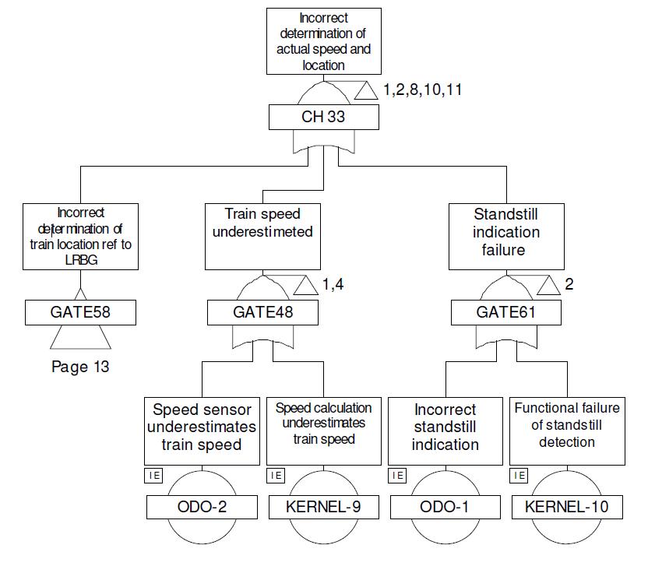

- Fault Tree, [R2]
    - Safety hypothesis

- Analysis presented in this document are focusing on safety accepts and not on security accepts. In other words, malicious acts are not considered.
  - Manage Location Related Information
    - Process description

This process has five modules:
- PerformEuroBaliseDecoding;
- BuildBGMessage;
- CheckBGConsistency;
- DetermineBGorientation_LRBG;
- SelectUsableInfo;

PerformEuroBaliseDecoding module has for aim to collect data from balise transmission module, to create the TelegramHeader from these data and to give driver information (If an invalid balise has been received the BTM will pass the Balise information to this function, in this situation the driver has to be informed).

BuildBGMessage has for aim to create “balise group message” from TelegramHeader, balises information, train information and odometry information.

CheckBGConsistency has for aim to check the BG message.

DetermineBGorientation_LRBG has for aim to determine the train orientation from checked BG message

SelectUsableInfo ?

    - Safety requierment identifiers

All the safety requirments identified within this document are recapped in §3.4. Identifiers are noted as [MTP_ASS_XXX], XXX is the identifier number of the requirement and MLRI for Manage Location Related Information.
    - AMDE

N° | Function | Failure mode | Effect | Gravity | Boundary Hazard | Safety requierement | Current action | Recommanded action | Comment
 | PerformEuroBaliseDecoding | Absence | Impossibility to calculate the position and the orientation of train. | 1 |  | MLRI_ASS_005 | CheckBGConsistency
 |  | Loss | Missing output data or wrong output data | 2 |  | MLRI_ASS_002  MLRI_ASS_005 | CheckBGConsistency
 |  | Loss | Impossibility to calculate the position and the orientation of train. | 1 |  | MLRI_ASS_005 | CheckBGConsistency
 |  | Inadvertance | Stale data used. | 2 |  | MLRI_ASS_001MLRI_ASS_005  MLRI_ASS_006
 |  |  | Non-existent error detected. | 0 |  |  |  |  | Available impact
 |  | Degraded | Missing output data or wrong output data | 2 |  | MLRI_ASS_002 MLRI_ASS_005 | CheckBGConsistency
 |  | Degraded | Stale data used. | 2 |  | MLRI_ASS_001 MLRI_ASS_005  MLRI_ASS_006
 |  | Non-stop | Stale data used. Wrong output data | 2 |  | MLRI_ASS_002 MLRI_ASS_005  MLRI_ASS_006
 |  | Non-stop | Non-existent error detected | 0 |  |  |  |  | Available impact
 | BuildBGMessage | Absence | No message available, impossibility to calculate the position and the orientation of train. | 1 |  | MLRI_ASS_005 | CheckBGConsistency
 |  | Loss | Incomplete message or with error, impossibility to calculate the position and the orientation of train. | 2 |  | MLRI_ASS_003 MLRI_ASS_005 | CheckBGConsistency
 |  | Inadvertance | Stale data used. | 2 |  | MLRI_ASS_002 MLRI_ASS_005  MLRI_ASS_006
 |  | Inadvertance | Non-existent error detected | 0 |  |  |  |  | Available impact
 |  | Degraded | Wrong output data | 2 |  | MLRI_ASS_005
 |  |  | Stale data used. | 2 |  | MLRI_ASS_005  MLRI_ASS_006
 |  |  | Incomplete message or with error. | 2 |  | MLRI_ASS_003 MLRI_ASS_005
 |  | Non-stop | Stale data used. | 2 |  | MLRI_ASS_002MLRI_ASS_005  MLRI_ASS_006
 |  | Non-stop | Non-existent error detected | 0 |  |  |  |  | Available impact
 | CheckBGConsistency | Absence | Existent error no detected | 2 |  | MLRI_ASS_005
 |  | Absence | Impossibility to calculate the position and the orientation of train. | 0 |  |  |  |  | Available impact
 |  | Loss | Message unchecked. Existent error no detected. | 2 |  | MLRI_ASS_004 MLRI_ASS_005
 |  | Inadvertance | Stale data used. | 1 |  | MLRI_ASS_003 MLRI_ASS_005  MLRI_ASS_006
 |  | Inadvertance | Non-existent error detected | 0 |  |  |  |  | Available impact
 |  | Degraded | Existent error no detected | 2 |  | MLRI_ASS_005
 |  | Degraded | Introduction of error. | 2 |  | MLRI_ASS_005
 |  | Degraded | Non-existent error detected. | 0 |  |  |  |  | Available impact
 |  | Non-stop | Non-existent error detected. | 0 |  |  |  |  | Available impact
 |  | Non-stop | Stale data used for the train position and orientation calculation. | 2 |  | MLRI_ASS_003  MLRI_ASS_004  MLRI_ASS_006
 | DetermineBGorientation_LRBG | Absence | Impossibility to calculate the train orientation. | 1 |  | MLRI_ASS_005
 |  | Loss | Incomplete calculation of orientation | 2 |  | MLRI_ASS_005
 |  |  | Wrong orientation calculation | 2 |  | MLRI_ASS_005
 |  | Inadvertance | Stale data used. | 2 |  | MLRI_ASS_004  MLRI_ASS_006
 |  |  | Impossibility to calculate the train orientation. Non-existent error detected. | 0 |  |  |  |  | Available impact
 |  |  | Wrong orientation calculation. | 2 |  | MLRI_ASS_005
 |  | Degraded | Wrong orientation calculation. | 2 |  | MLRI_ASS_005
 |  |  | Wrong input data used. | 2 |  | MLRI_ASS_004 MLRI_ASS_005  MLRI_ASS_006
 |  |  | Incomplete orientation calculation. | 2 |  | MLRI_ASS_005
 |  | Non-stop | Stale data used | 2 |  | MLRI_ASS_004 MLRI_ASS_005  MLRI_ASS_006
 |  | Non-stop | Non-existent error detected. | 0 |  |  |  |  | Available impact

    - Safety requirement
The purpose of this chapter is to resume safety requirements linked with the calculate train position and orientation function.
Safety requirements are identified below:

# | Safety requierement
MLRI_ASS_001 | PerformEuroBaliseDecoding process must be able to check :  - The good definition (parameters values and file format requierement)  - completeness;  - data integrity;  - version;  of these input data.
MLRI_ASS_002 | BuildBGMessage process must be able to check :  - The good definition (parameters values and file format requierement)  - completeness ;  - data integrity ;  - version,  Of these input data.
MLRI_ASS_003 | CheckBGConsistency process should be able to check :  - The good definition (parameters values and file format requierement)  - completeness ;  - data integrity ;  - version,  Of these input data.
MLRI_ASS_004 | DetermineBGorientation_LRBG process should be able to check :  - The good definition (parameters values and file format requierement)  - completeness ;  - data integrity ;  - version,  Of these input data.
MLRI_ASS_005 | As explain in the SUBSET-091, onboard equipments must have a failure rate < 10-9 f/h. Thus, SIL 4 process should be applicable for :  - PerformEuroBaliseDecoding ;  - BuildBGMessage ;  - CheckBGConsistency ;  - DetermineBGorientation_LRBG.  Process.
MLRI_ASS_006 | To avoid using stale data, input data of each module should be deleted at the end of the process.

  - Manage Train Position
    - Process description

This process has three modules:
- ValidDataDirect module;
- CalculateTrainPosition module;
- ManagePositionReport module.

ValidDataDirect module has for aim to check input data whose will be sent to CalculateTrainPosition module.

CalculateTrainPosition has for aim to calculate train position from balises information, train information and odometry information.

ManagePositionReport has for aim to manage errors during the calcul of the train position. This module generates a rapport with parameters used for the position calculation, train position, train information and errors detected.
Rapport must include at least information identified in: 3.6.5.1.2/subset-06-3.

This process is described on the following figure:

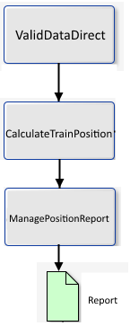

- Manage Train Position Process

    - Safety requirment identifiers

All the safety requirments identified within this document are recapped in §5. Identifiers are noted as [MTP_ASS_XXX], XXX is the identifier number of the requirement (MTP for Manage Train Position).
    - AMDE
N° | Function | Failure mode | Effect | Gravity | Boundary Hazard | Safety requierement | Current action | Recommanded action | Comments
 | Calculate Train Position | Absence | Train position information unavailable. | 1 |  | MTP_ASS_004 | Manage Position Report
 | Calculate Train Position |  | No calculation of train position, stale data of train position used by others modules. | 2 | BH_1 | MTP_ASS_002 MTP_ASS_003  MTP_ASS_004 MTP_ASS_006
 | Calculate Train Position | Loss | Incomplete data of train position. Stale data used by Manage Position Report. | 2 | BH_1 | MTP_ASS_002 MTP_ASS_004  MTP_ASS_007
 |  | Loss | Train position information unavailable or with partial information. | 1 |  | MTP_ASS_002 MTP_ASS_004  MTP_ASS_006 | Manage Position Report
 |  | Inadvertance | Stale data used, wrong calculation of train position. | 2 | BH_1 | MTP_ASS_001 MTP_ASS_004  MTP_ASS_006 MTP_ASS_007 | Manage Position Report
 |  |  | Input data unavailable. Impossibility to calcul train position. | 0 |  | MTP_ASS_004 |  |  | Availabilyt impact
 |  | Degraded | Wrong train position information. | 2 | BH_1 | MTP_ASS_004  MTP_ASS_007 | Manage Position
 |  | Degraded | Train position information unavailable or with partial information. Stale data used by the module Manage Position Report. | 1 |  | MTP_ASS_002 MTP_ASS_004  MTP_ASS_005 MTP_ASS_006  MTP_ASS_007 |  |  | Availabilyt impact
 |  | Non-stop | Input data unavailable to calculate train position. Nonexistent errors detected. | 0 |  | MTP_ASS_004 |  |  | Availabilyt impact
 |  | Non-stop | Stale data used, wrong train position calculated. | 2 | BH_1 | MTP_ASS_001 MTP_ASS_004  MTP_ASS_006 MTP_ASS_007 | Manage Position Report
 | Manage Position Report | Absence | No detection of errors | 2 | BH_1 | MTP_ASS_004
 |  |  | Train position information not saved. | 1 |  | MTP_ASS_004 |  |  | Impact sur la disponibilité
 |  | Loss | No detection of errors | 2 | BH_1 | MTP_ASS_004
 |  |  | Train position information not saved. | 1 |  | MTP_ASS_004  MTP_ASS_006
 |  | Inadvertance | Nonexistent errors detected. | 0 |  | MTP_ASS_004 |  |  | Impact sur la disponibilité
 |  |  | Stale input data used, wrong train position information. | 2 | BH_1 | MTP_ASS_002  MTP_ASS_007
 |  | Degraded | No detection of errors | 2 | BH_1 | MTP_ASS_004
 |  |  | Nonexistent errors detected. | 0 |  | MTP_ASS_004 |  |  | Impact sur la disponibilité
 |  |  | Train position information not saved. | 1 |  | MTP_ASS_004
 |  |  | Wrong train position information. | 2 | BH_1 | MTP_ASS_004
 |  | Non-stop | Nonexistent errors detected. | 0 |  | MTP_ASS_004 |  |  | Impact sur la disponibilité
 |  | Non-stop | Stale date used, wrong train position information. | 2 | BH_1 | MTP_ASS_004  MTP_ASS_007
 | ValidDataDirect | Absence | Stale date used by CalculateTrainPosition module. Wrong train position information. | 2 | BH_1 | MTP_ASS_001 MTP_ASS_004  MTP_ASS_006 MTP_ASS_007 | Manage Position Report
 |  | Absence | Data unavailable  for module Calculate Train Position, calculate of train position impossible. | 1 |  | MTP_ASS_004 MTP_ASS_005 | Manage Position Report
 |  | Loss | Stale date used by CalculateTrainPosition module. Wrong train position information. | 2 | BH_1 | MTP_ASS_001 MTP_ASS_004  MTP_ASS_005 MTP_ASS_007 | Manage Position Report
 |  | Loss | Data unavailable  for module Calculate Train Position, calculate of train position impossible. | 1 |  | MTP_ASS_004 MTP_ASS_005 | Manage Position Report
 |  | Inadvertance | Manage Position Report : Nonexistent errors detected. | 1 |  | MTP_ASS_001 MTP_ASS_004  MTP_ASS_005MTP_ASS_007 | Manage Position Report |  | Availability impact
 |  | Inadvertance | Calculate train position: Stale date used by CalculateTrainPosition module. Wrong train position information. | 2 | BH_1 | MTP_ASS_001 MTP_ASS_004  MTP_ASS_005 MTP_ASS_007 | Manage Position Report
 |  | Degraded | Calculate train position: Stale date used by CalculateTrainPosition module. Wrong train position information. | 2 | BH_1 | MTP_ASS_001 MTP_ASS_004  MTP_ASS_005 MTP_ASS_007 | Manage Position Report
 |  | Degraded | Input data unavailable for CalculateTrainPosition. Impossibility to calcul train position. | 1 |  | MTP_ASS_001 MTP_ASS_004  MTP_ASS_005 MTP_ASS_007 | Manage Position Report
 |  | Non-stop | Calculate train position : Stale date used, Wrong train position information. | 2 | BH_1 | MTP_ASS_001 MTP_ASS_004  MTP_ASS_005 MTP_ASS_007 | Manage Position Report

    - Safety requirement
The purpose of this chapter is to resume safety requirements linked with the calculation train position and orientation function.
Safety requirements are identified below:

# | Safety requierement
MTP_ASS_001 | CalculateTrainPosition process must be able to check :  - The good definition (parameters values and file format requirement)  - completeness ;  - data integrity ;  - version,  Of these input data.
MTP_ASS_002 | ManagePositionReport process must be able to check :  - The good definition (parameters values and file format requirement)  - completeness ;  - data integrity ;  - version,  Of these input data.
MTP_ASS_003 | ValidDataDirect process should be able to check :  - The good definition (parameters values and file format requirement)  - completeness ;  - data integrity ;  - version,  Of these input data.
MTP_ASS_004 | As explain in the SUBSET-091, onboard equipments must have a failure rate < 10-9 f/h. Thus, SIL 4 process should be applicable for :  - Calculate Train Position ;  - Manage Position Report ;  - ValidDataDirect.  Process.
MTP_ASS_005 | ManagePositionReport report should contains as minimum information describe in the Subset-06-3 chapter 3.6.5.1.2
MTP_ASS_006 | ManagePositionReport should be able to indentify this kind of error :  - Input data unavalaible for the CalculateTrainPosition module;  - Stale data used by CalculateTrainPosition  - Failure of CalculateTrainPosition and ValidDataDirect.
MTP_ASS_007 | To avoid using stale data, input data of CalculateTrainPosition and ManagePositionReport process should be deleted at the end of ManagePositionReport process.

FIN DE DOCUMENT

