openQCM Aerosol
User Manual

PM Sampler with QCM-D Technology
openQCM-pm-monitor desktop application

Software version: 1.0.0
Document revision: 1.0
Date: 2026

Novaetech S.r.l.
openqcm.com

Table of Contents
Table of Contents 2
1. Introduction 5
1.1 What openQCM-pm-monitor Does 5
Main Capabilities 5
1.2 Hardware and Software Requirements 5
1.3 Conventions Used in This Manual 6
2. Installation 7
2.1 System Requirements 7
2.2 Installing the Teensy USB Serial Driver 7
2.3 Installing the Application 7
2.4 First Launch 7
3. Graphical User Interface Overview 9
3.1 General Layout 9
Plot Control 11
3.2 The Metric Bar 12
3.3 Main Tabs: Monitoring, Sweep, Console 12
Monitoring Tab 12
Sweep Tab 13
Console Tab 13
3.4 Status Indicators 13
4. Basic Operating Procedure 15
4.1 Connecting to the Device 15
4.2 Selecting the Crystal (5 MHz / 10 MHz) 16
4.3 Finding the Resonance Peak (Find Peak) 16
4.4 Starting Continuous Monitoring (Start Monitor) 18
4.5 Stopping Monitoring 20
5. Particulate Matter Concentration Measurement (Cycle) 21
5.1 Concept: REFERENCE → PUMP ON → WAITING → loop 21
5.2 Configuring Cycle Times 21
5.3 Flow Calibration: Analytical and Calibrated Modes 22
Analytical (πD²/4) 22
Calibrated (K·v) 22
Performing a Flow Calibration 22
5.4 Starting a Cycle (Start Cycle) 24
5.5 Reading the Per-Cycle Plots 25
5.6 Saving Data and CSV File Format 27
5.7 Best Practices for Reliable Measurements 27
6. Temperature Control (TEC) 29
6.1 When to Activate the TEC 29
6.2 Setting the Setpoint 29
6.3 Status Meaning 30
6.4 Resetting in Case of Error 31
7. Reading and Exporting Data 32
7.1 Where the CSV Files Are Saved 32
7.2 Monitoring CSV (per-sweep) 32
7.3 Per-Cycle CSV (one row per completed cycle) 32
7.4 Opening CSV Files in Excel, Origin, and pandas 33
Microsoft Excel 33
OriginLab 33
Python pandas 33
7.5 Glossary of Columns and Units 34
Monitoring CSV 34
Per-Cycle CSV 34
8. Diagnostic Tools 35
8.1 The Sweep Tab 35
8.2 The Console Tab 35
8.3 Reading the TEC Status 36
9. Troubleshooting 37
9.1 The Serial Port Is Not Detected 37
9.2 Persistent TEC Error 37
9.3 Peak Not Found During Find Peak 37
9.4 The Pump Does Not Start 37
9.5 Flow Velocity Is Zero During a Cycle 38
9.6 CSV Saving Is Interrupted 38
10. Appendix A — Physical Specifications 39
10.1 The Sauerbrey Equation 39
10.2 Dissipation and Q-Factor 39
10.3 Flow Rate, Volume and Concentration 39
11. Appendix B — Credits and License 41
11.1 Credits 41
11.2 License 41
11.3 Contact 41
12. Step-by-Step Procedures 42
12.1 Procedure 1 — First Power-On and Connection 42
12.2 Procedure 2 — Running Find Peak 42
12.3 Procedure 3 — A 30-Minute Monitoring Session 42
12.4 Procedure 4 — A Complete PM Sampling Cycle 43
12.5 Procedure 5 — Flow Calibration with a Reference Flow Meter 43
12.6 Procedure 6 — Reading a Completed Cycle in Excel 43
12.7 Procedure 7 — Solving a TEC Error 44
13. Glossary 45
13.1 QCM and QCM-D 45
13.2 AT-cut, Resonance Frequency, Dissipation 45
13.3 5 MHz versus 10 MHz Crystals 45
13.4 Sauerbrey Equation 45
13.5 Q-Factor and −3 dB Bandwidth 45
13.6 TEC and Setpoint 45
13.7 ppm (Parts Per Million) 45
13.8 Volumetric Flow versus Velocity 46
13.9 Particulate Matter (PM, µg/m³) 46
13.10 Measurement Cycle: Reference, Pump, Waiting 46
14. List of Figures 47
15. List of Tables 48

1. Introduction

1.1 What openQCM-pm-monitor Does
openQCM-pm-monitor is a Windows desktop application for the real-time sampling and quantification of atmospheric particulate matter (PM). The software drives the openQCM Aerosol head, an inertial sampler that channels ambient air through a nozzle onto a quartz crystal. Particles deposit on the crystal surface by inertial impaction, and the resulting frequency shift of the crystal — measured continuously through a frequency-sweep technique — is converted into deposited mass through the Sauerbrey equation. Combined with the volumetric air flow drawn through the head, the deposited mass yields the airborne particulate concentration in micrograms per cubic meter (µg/m³).
The application provides a guided workflow for laboratory technicians: connect to the instrument, select the crystal, locate the resonance peak, and run either a continuous monitoring session or an automated sampling cycle. All acquisitions are saved to disk as comma-separated value (CSV) files, ready to be opened in Microsoft Excel, Origin, or imported with Python pandas.

Main Capabilities
- Serial connection to the openQCM Aerosol head over USB.
- Automatic identification of the crystal resonance peak (Find Peak), based on amplitude and phase response.
- Real-time display of resonance frequency, dissipation, deposited mass, PM concentration, air velocity, volumetric flow rate, and crystal temperature.
- Automated sampling cycle (REFERENCE on the first cycle, then PUMP ON / WAITING loop) with median-based filtering on the last third of each timed phase.
- Two flow-determination modes: Analytical (πD²/4) and Calibrated (K·v) using a reference flow meter.
- Closed-loop temperature stabilization of the crystal through an integrated TEC controller; the TEC is automatically enabled at cycle start and disabled at cycle stop.
- Continuous CSV logging of raw sweep data and per-cycle results, with self-describing column headers (unit suffix in each name).
- Diagnostic tools: live sweep visualization (amplitude + phase) and a serial console for advanced commands.

1.2 Hardware and Software Requirements
The application requires the following:
Component | Requirement
Operating system | Microsoft Windows 10 or 11 (64-bit)
RAM | 4 GB minimum, 8 GB recommended
Free disk space | 200 MB for the application; additional space for CSV data
USB port | One free USB 2.0 (or higher) port
Driver | Teensyduino USB Serial driver (provided in the installation package)
Display resolution | 1280 × 720 minimum; 1920 × 1080 recommended
Hardware | openQCM Aerosol head with Teensy 4.0 firmware v0.2.2-PM or later
Crystal | AT-cut quartz crystal, 5 MHz or 10 MHz nominal frequency
Table 1 — Minimum and recommended requirements for openQCM-pm-monitor.

1.3 Conventions Used in This Manual
The following typographic conventions are used throughout the manual:
- Bold indicates the name of a button, menu item, panel, tab, or field as it appears in the user interface (e.g., click Start Monitor).
- Italic indicates emphasis, file or folder names, and the first occurrence of a domain term.
- Monospaced text indicates a literal value, a CSV column header, a serial command, or a file path.
Callout boxes alert you to important information:
NOTE
Provides supplementary information that helps you understand a feature.

TIP
Suggests a best practice for obtaining better results.

CAUTION
Indicates an action that may produce unreliable measurements if performed incorrectly.

WARNING
Indicates an action that may damage the instrument or cause data loss.

NOTE
For technical questions, consult the README.md in the GitHub repository (https://github.com/openQCM/openQCM-pm-monitor) or contact Novaetech S.r.l.

2. Installation

2.1 System Requirements
Before installing the application, verify that your computer meets the minimum requirements listed in section 1.2. The application is distributed as a stand-alone Windows executable; no Python interpreter or additional runtime is required on the user side.

2.2 Installing the Teensy USB Serial Driver
The openQCM Aerosol head communicates with the host PC through a Teensy 4.0 microcontroller, which appears as a virtual serial (COM) port. On Windows 10 and 11, the driver is normally installed automatically the first time the device is plugged in. If the device is not recognized, install the driver manually as follows:
- Disconnect the openQCM Aerosol head from the USB port.
- Open the Teensyduino driver folder shipped with the application (typically drivers\teensy\).
- Right-click the file serial_install.exe and choose Run as administrator.
- Follow the on-screen instructions and accept all prompts.
- Reconnect the device to the USB port. Windows should now recognize the new COM port.
- Open Device Manager and expand Ports (COM & LPT). A new entry such as USB Serial Device (COMx) should be visible. Take note of the COM number.
NOTE
The COM port number depends on your system. It may change if you connect the device to a different USB port.

2.3 Installing the Application
The application is delivered as a single self-contained executable named openQCM-pm-monitor.exe. To install it:
- Copy the entire installation folder to a writable location on your local disk (for example, C:\openQCM-pm-monitor).
- Verify that the folder contains the executable and a sub-folder named data\. The data folder will hold all the CSV files produced by the program.
- (Optional) Right-click the executable and choose Send to → Desktop (create shortcut).
CAUTION
Do not place the application inside Program Files unless you have administrator rights. The program writes log and data files in the same folder where the executable is located, and Windows protects Program Files against writes by standard users.

2.4 First Launch
Double-click the executable to launch openQCM-pm-monitor for the first time. The main window opens and shows the empty Monitoring tab. All indicators are dimmed because the device is not yet connected.
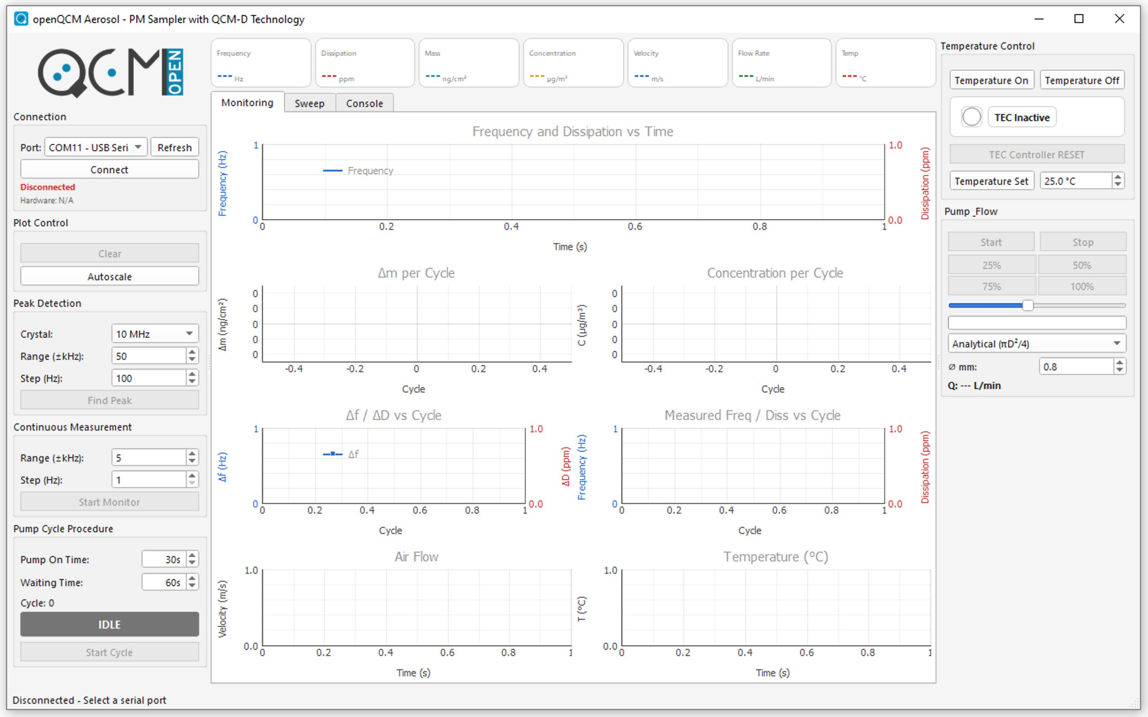
Figure 1 — Initial screen of openQCM-pm-monitor immediately after launch, before any device is connected.
If a Windows SmartScreen or antivirus prompt appears the first time, choose the option to run the application anyway. The executable is unsigned but safe.
TIP
Pin the application to the Windows taskbar so you can launch it quickly during routine operations.

3. Graphical User Interface Overview

3.1 General Layout
The main window is organized as a single resizable frame with three vertical panels and a header bar of metric cards on top. The window title shows the application name ("openQCM Aerosol — PM Sampler with QCM-D Technology").
- Left panel — groups the controls used to set up an acquisition: Connection, Plot Control, Peak Detection, Continuous Measurement, and Pump Cycle Procedure.
- Central panel — contains three tabs (Monitoring, Sweep, Console) where data is plotted in real time and where you interact with the live measurement.
- Right panel — groups the hardware controls: Temperature Control (TEC) and Pump _Flow.
All three panels remain visible at all times. The central plotting area expands automatically when the window is enlarged. A status line at the bottom of the window reports the current connection state and TEC status.
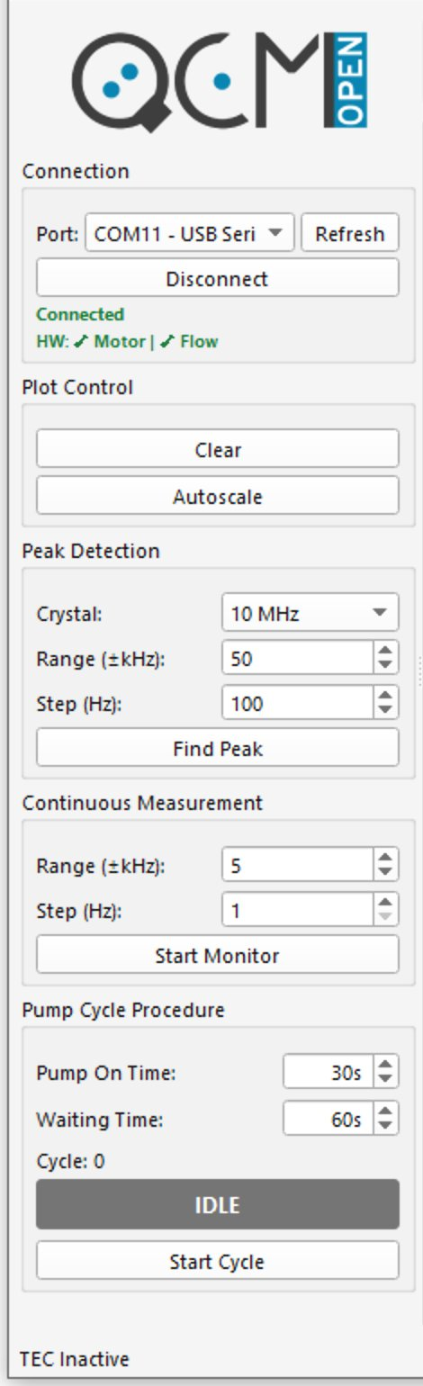
Figure 2 — The left panel, with the Connection, Plot Control, Peak Detection, Continuous Measurement, and Pump Cycle Procedure groups.
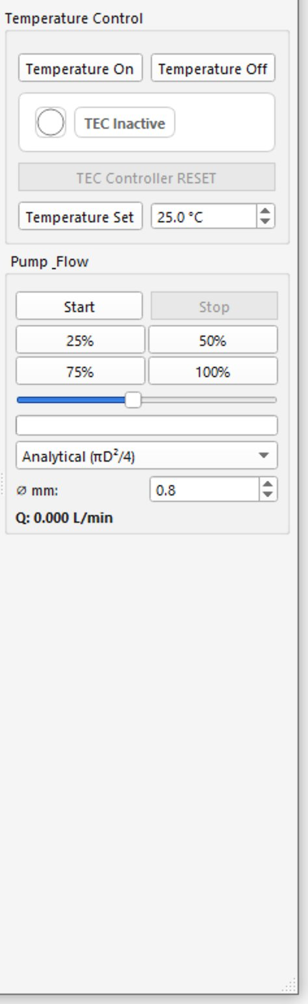
Figure 3 — The right panel, with the Temperature Control and Pump _Flow groups.

Plot Control
The Plot Control group provides two convenience actions for all the real-time plots: Clear empties the plot buffers without affecting CSV logging, and Autoscale resets the axes to the full range of the data currently displayed. Both buttons can be used at any time, including during an active monitoring session or cycle.

3.2 The Metric Bar
A horizontal bar at the top of the window shows seven numeric cards. Each card displays a single live value with its unit of measurement and is updated several times per second when the device is acquiring. Before the first measurement, the Frequency card shows the nominal frequency of the selected crystal ("10M Hz" or "5M Hz"); the other cards display dashes. Mass and Concentration are updated only at the end of each completed cycle, not in real time.
Figure 4 — Detail of the seven metric cards displayed at the top of the main window.
Card | Quantity | Unit | Description
Frequency | Resonance frequency of the crystal | Hz | Live fundamental frequency. Decreases as mass deposits.
Dissipation | Energy loss factor | ppm | Width of the resonance peak relative to its center frequency.
Mass | Surface mass density | ng/cm² | Mass deposited per unit area, computed by the Sauerbrey equation.
Concentration | PM concentration in air | µg/m³ | Result of the most recent completed sampling cycle.
Velocity | Air velocity in the sampling line | m/s | Reading of the FS3000 air-velocity sensor.
Flow Rate | Volumetric flow | L/min | Velocity multiplied by the cross-section of the sampling channel.
Temp | Crystal temperature | °C | Temperature measured at the crystal mount.
Table 2 — Quantities displayed in the seven metric cards of the top bar.

3.3 Main Tabs: Monitoring, Sweep, Console

Monitoring Tab
The Monitoring tab is organized as a grid of six plots:
- Frequency and Dissipation vs Time (top, full width) — the live time-series of the resonance frequency (blue, left axis) and dissipation (red, right axis), with a rolling window of approximately one hour.
- Δm per Cycle — bar chart of the deposited mass for each completed cycle.
- Concentration per Cycle — bar chart of the airborne PM concentration for each completed cycle.
- Δf / ΔD vs Cycle — frequency variation and dissipation variation per cycle, useful for diagnostic purposes.
- Measured Freq / Diss vs Cycle — long-term trend of the resonance frequency and dissipation values across all completed cycles.
- Air Flow and Temperature (°C) — live time-series of the air velocity (m/s) measured by the FS3000 sensor and of the crystal temperature.
During an active sampling cycle, a colored status bar at the bottom of the Pump Cycle Procedure group displays the current phase (REFERENCE, PUMP ON, or WAITING) and the time remaining.

Sweep Tab
The Sweep tab shows the result of the most recent Find Peak operation as two stacked plots:
- Amplitude Response (top, blue trace) — the gain in dB as a function of frequency. The detected resonance peak is marked with a star, and a vertical dashed red line indicates its position.
- Phase Response (bottom, green trace) — the phase shift in degrees over the same frequency range. A square marker on the phase peak provides an independent cross-check of the resonance position.
The Sweep tab is read-only and is used for diagnostic purposes.

Console Tab
Provides a serial console connected to the Teensy microcontroller. Each transmitted command is logged with a timestamp and a TX→ marker; each reply is logged with an RX← marker. A drop-down keeps the history of the most recent commands. The Console tab is intended for advanced diagnostic use only.
All real-time plots support a custom right-click context menu with the following options: Auto-scale, Reset Zoom, Pan Mode, and Select Mode.
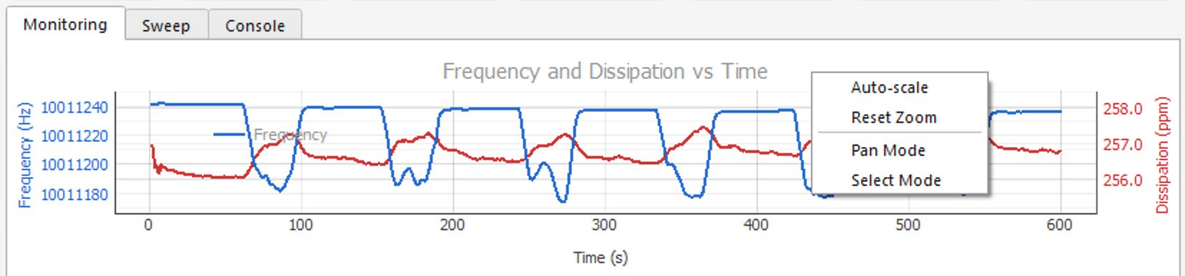
Figure 5 — The right-click context menu available on every real-time plot.

3.4 Status Indicators
Several indicators inform you about the current state of the system:
Indicator | Location | Meaning
Connection status | Connection group, left panel | Connected (green) when the serial link is active; Disconnected (red) otherwise. Hardware sub-line lists the Motor and Flow checks.
TEC status | Temperature Control, right panel | TEC Inactive (gray), Approaching (yellow), In target (blue), Error (red).
Cycle status bar | Bottom of Pump Cycle Procedure | Colored label showing the current cycle phase (IDLE, REFERENCE, PUMP ON, WAITING) and a countdown for timed phases.
Window status line | Bottom of the main window | Reports the connection state and the TEC status, e.g. "Disconnected — Select a serial port" or "TEC In target".
Table 3 — Status indicators visible in the main window.

4. Basic Operating Procedure
This chapter describes the standard sequence of operations to be followed each time you start a measurement session, from connecting the device to acquiring continuous data. Section 5 covers the additional steps required to perform a particulate matter sampling cycle.

4.1 Connecting to the Device
Connect the device before starting any acquisition:
- Plug the openQCM Aerosol head into a USB port of the host computer.
- Wait a few seconds for Windows to enumerate the device.
- Launch openQCM-pm-monitor. In the Connection group of the left panel, open the Port drop-down menu.
- Select the COM port assigned to the device. If you do not know which one to choose, click Refresh to refresh the list of available ports.
- Click Connect. The button label changes to Disconnect, a green Connected label appears, and a sub-line HW: ✓ Motor | ✓ Flow confirms that both the pump motor and the air-velocity sensor are responding.
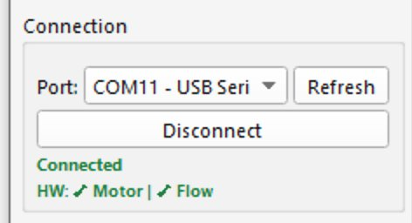
Figure 6 — The Connection group with the COM port selected and the Connected status indicator visible.
NOTE
Once connected, the application reads the firmware version from the device and prints it on the status bar. Make sure the firmware is v0.2.2-PM or later.
WARNING
Do not unplug the USB cable while the application is connected. Always click Disconnect first.

4.2 Selecting the Crystal (5 MHz / 10 MHz)
openQCM-pm-monitor supports two crystal frequencies: 5 MHz and 10 MHz. The choice has a direct impact on sensitivity. Selecting the wrong value produces incorrect mass and concentration values.
- In the Peak Detection group of the left panel, locate the Crystal drop-down.
- Select 5 MHz or 10 MHz, matching the crystal physically installed in the head.
TIP
10 MHz crystals are roughly four times more sensitive than 5 MHz crystals (the Sauerbrey constant scales with the square of the fundamental frequency). Use 10 MHz crystals for low-mass deposits and fine particulate matter; use 5 MHz crystals when a wider mass range is required.

4.3 Finding the Resonance Peak (Find Peak)
Before any meaningful frequency measurement, the application must locate the precise resonance frequency of the crystal currently installed. This is done with the Find Peak procedure, which performs a frequency sweep around the nominal value, computes both the amplitude and the phase response, and detects the peak using a peak-finding algorithm with prominence threshold and phase-derivative cross-check.
- Make sure the device is connected and the correct crystal frequency is selected.
- In the Peak Detection group, optionally adjust the two sweep parameters: Range (±kHz) (default 50 kHz, the half-width of the swept range around the nominal frequency) and Step (Hz) (default 100 Hz, the resolution of the sweep). Wider ranges and finer steps take longer; the defaults are a good starting point.
- Click Find Peak. The application performs a sweep that typically lasts a few seconds.
- When the sweep completes, the central panel switches automatically to the Sweep tab, where the amplitude curve is shown above the phase curve. A star marks the detected peak in the amplitude plot, a square marks the corresponding peak in the phase plot, and a vertical dashed red line indicates the resonance frequency on both plots.
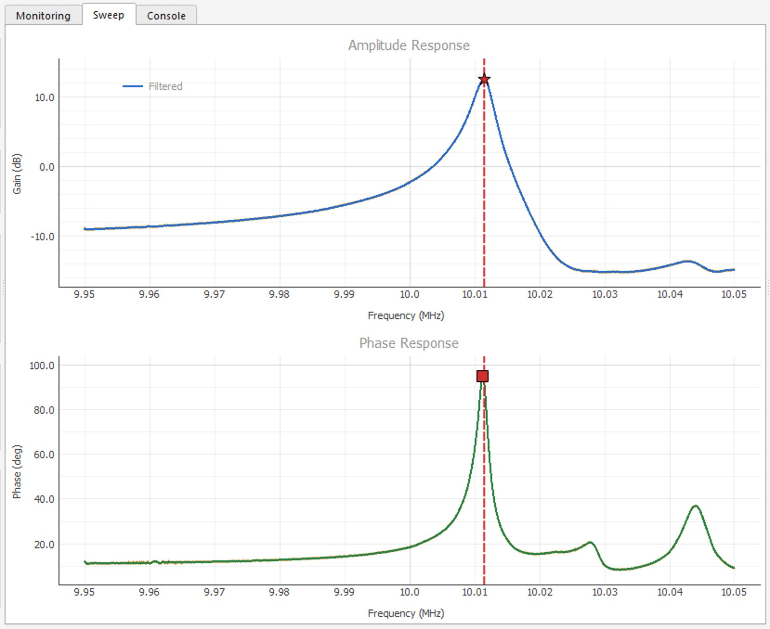
Figure 7 — The Sweep tab after a successful Find Peak: amplitude response (blue) above with a star marker on the resonance peak, phase response (green) below with a square marker, and a vertical dashed red line indicating the resonance frequency.
NOTE
After Find Peak, the detected resonance frequency becomes the reference value for all subsequent monitoring and cycle measurements. The frequency value shown on the metric card is the live measured frequency, smoothed by a trimmed mean over the last ten sweeps.
CAUTION
If the amplitude curve is very flat or noisy, or if the peak is at the edge of the swept range, the detection may be unreliable. Increase the Range value and try again. See section 9.3 for troubleshooting.

4.4 Starting Continuous Monitoring (Start Monitor)
Continuous monitoring records frequency, dissipation, temperature, velocity, and flow rate at the highest available rate, without driving the pump and without performing automatic concentration calculation. Use this mode for stability checks, baseline evaluation, or unattended observation of the crystal.
- Verify that Find Peak has been performed successfully.
- In the Continuous Measurement group, optionally adjust the Range (±kHz) (default 5 kHz) and Step (Hz) (default 1 Hz) parameters. These define a narrower, finer sweep centered on the resonance peak that is repeated several times per second to track the frequency in real time.
- Click Start Monitor. A file-save dialog appears, prompting you for the location of the CSV log file.
- Choose the destination folder (the default is the data\ sub-folder next to the executable) and confirm. The application begins recording.
- Observe the live plots in the Monitoring tab. The metric cards update several times per second.
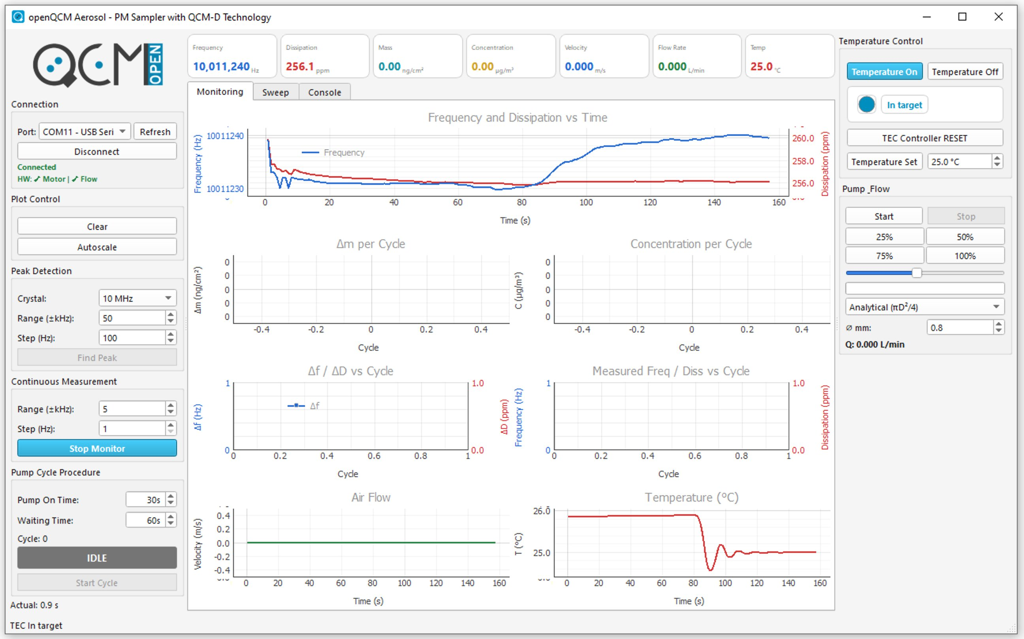
Figure 8 — The Monitoring tab during an active monitoring session, with frequency and dissipation plots scrolling in real time.
TIP
If you intend to leave the system unattended, disable Windows sleep mode and screen saver. Acquisition may be interrupted if the host suspends USB power.

4.5 Stopping Monitoring
- Click Stop Monitor in the Continuous Measurement group.
- The application closes the CSV file and flushes any pending data to disk.
- The metric cards stop updating.
WARNING
Do not close the application window while a monitoring session is active. Always stop the acquisition first; otherwise the last seconds of data may be lost.

5. Particulate Matter Concentration Measurement (Cycle)

5.1 Concept: REFERENCE → PUMP ON → WAITING → loop
A sampling cycle is an automated measurement sequence that produces one PM concentration value per cycle. The very first cycle of a session begins with a REFERENCE phase to establish the baseline; from the second cycle onwards, only PUMP ON and WAITING are executed, because the WAITING phase of the previous cycle already provides the new reference. The phases are:
- REFERENCE — performed only once, at the start of the first cycle. The pump is off and the application accumulates sweeps for the duration of the Waiting Time. The median of the last third of the samples is taken as the baseline frequency f₀ and dissipation D₀.
- PUMP ON — the pump is activated and ambient air is drawn through the head for the duration of Pump On Time. Particles deposit on the crystal and the resonance frequency drops. The application records the air velocity throughout this phase to compute the sampled volume from the actual pump-on duration.
- WAITING — the pump is stopped for the duration of Waiting Time and the system stabilizes. The median of the last third of the samples is taken as the measured frequency f and dissipation D. The frequency drop Δf = f − f₀ and the dissipation change ΔD = D − D₀ are used to compute the deposited mass (Sauerbrey) and, combined with the sampled volume, the airborne concentration.
After the WAITING phase, the just-measured (f, D) values become the new reference (f₀, D₀) for the next cycle, and the loop continues directly from PUMP ON. This means that, except for the initial baseline, every cycle returns a value every Pump On Time + Waiting Time.
NOTE
When you start a cycle, the application automatically begins recording. Two CSV files are created: a per-sweep raw file (suffixed _raw.csv) and a per-cycle results file.
NOTE
When you click Start Cycle, the application also automatically enables the TEC at the current setpoint. When you click Stop Cycle, the TEC is automatically disabled.

5.2 Configuring Cycle Times
Two timing parameters control the duration of each phase, both editable in the Pump Cycle Procedure group:
Parameter | Description | Default | Typical range
Pump On Time | Duration of the PUMP ON phase. Defines how long the pump draws air through the crystal during each cycle. | 30 s | 10 s – 30 min
Waiting Time | Duration of the WAITING phase, and of the initial REFERENCE phase of the first cycle. Allows the crystal to settle before the median value is computed. | 60 s | 30 s – 5 min
Table 4 — Configurable cycle timing parameters.
TIP
For fine particulate matter (PM2.5 and below), use a longer Pump On Time (several minutes) so that enough mass deposits on the crystal to exceed the noise floor. For PM10 and indoor air, the default 30 s is often sufficient when the concentration is high.
CAUTION
Very long pumping times in a polluted environment may saturate the crystal: when too much mass deposits, the Sauerbrey equation loses its linear validity. Inspect the crystal periodically and replace it before saturation.

5.3 Flow Calibration: Analytical and Calibrated Modes
The application offers two ways to determine the volumetric air flow drawn by the pump. The mode is selected from the drop-down at the bottom of the Pump _Flow group; the resulting flow rate is shown live in the Q label below the drop-down.

Analytical (πD²/4)
The flow rate is computed from the air velocity reported by the FS3000 sensor and the geometric cross-section of the sampling channel: Q = v × π·D² / 4, where D is the inner diameter of the nozzle (in millimetres), entered in the Ø mm field below the drop-down. The default diameter is 0.8 mm. This mode requires no external instrument and provides a quick estimate. It is the default mode.

Calibrated (K·v)
The flow rate is computed as Q = K · v, where K is a user-supplied calibration factor that must be determined against a reference flow meter. This mode is recommended whenever a reference flow meter is available and traceable PM concentration measurements are required.
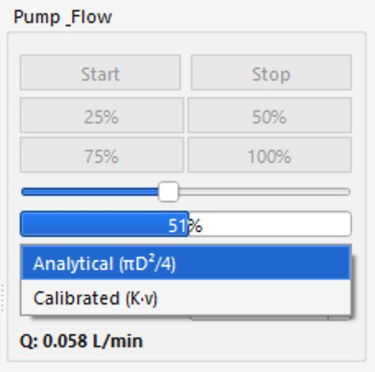
Figure 9 — The Flow calibration drop-down of the Pump _Flow panel, showing the Analytical (πD²/4) and Calibrated (K·v) modes.

Performing a Flow Calibration
- Connect a reference flow meter inline with the air intake of the openQCM Aerosol head.
- In the Pump _Flow panel, select Analytical (πD²/4) and click Start to run the pump at a known speed (for example by clicking one of the preset buttons 25%, 50%, 75%, or 100%).
- Wait for the readings of both the application (Q label) and the reference flow meter to stabilize (typically 30 seconds).
- Read the reference value (in L/min). Switch the drop-down to Calibrated (K·v) and enter the calibration factor that gives the reference value with the velocity currently shown by the application.
- Click Stop to halt the pump.
NOTE
The calibration factor is persistent across sessions. Repeat the calibration whenever you replace the pump, change the inlet line, or modify the inlet geometry.

5.4 Starting a Cycle (Start Cycle)
- Verify that the device is connected and Find Peak has been performed.
- In the Pump Cycle Procedure group, set the Pump On Time and the Waiting Time.
- In the Pump _Flow panel, select the desired flow mode (Analytical or Calibrated) and verify the geometry parameters.
- In the Temperature Control panel, set the desired temperature setpoint. The TEC will be enabled automatically when the cycle starts.
- Click Start Cycle. A save dialog appears for the per-cycle CSV file. Choose a destination and confirm. A second CSV file with the suffix _raw.csv is created automatically alongside the per-cycle one.
- The cycle starts. The status label at the bottom of the Pump Cycle Procedure group shows the current phase (REFERENCE on the first cycle, then PUMP ON, then WAITING, repeating) and the time remaining.
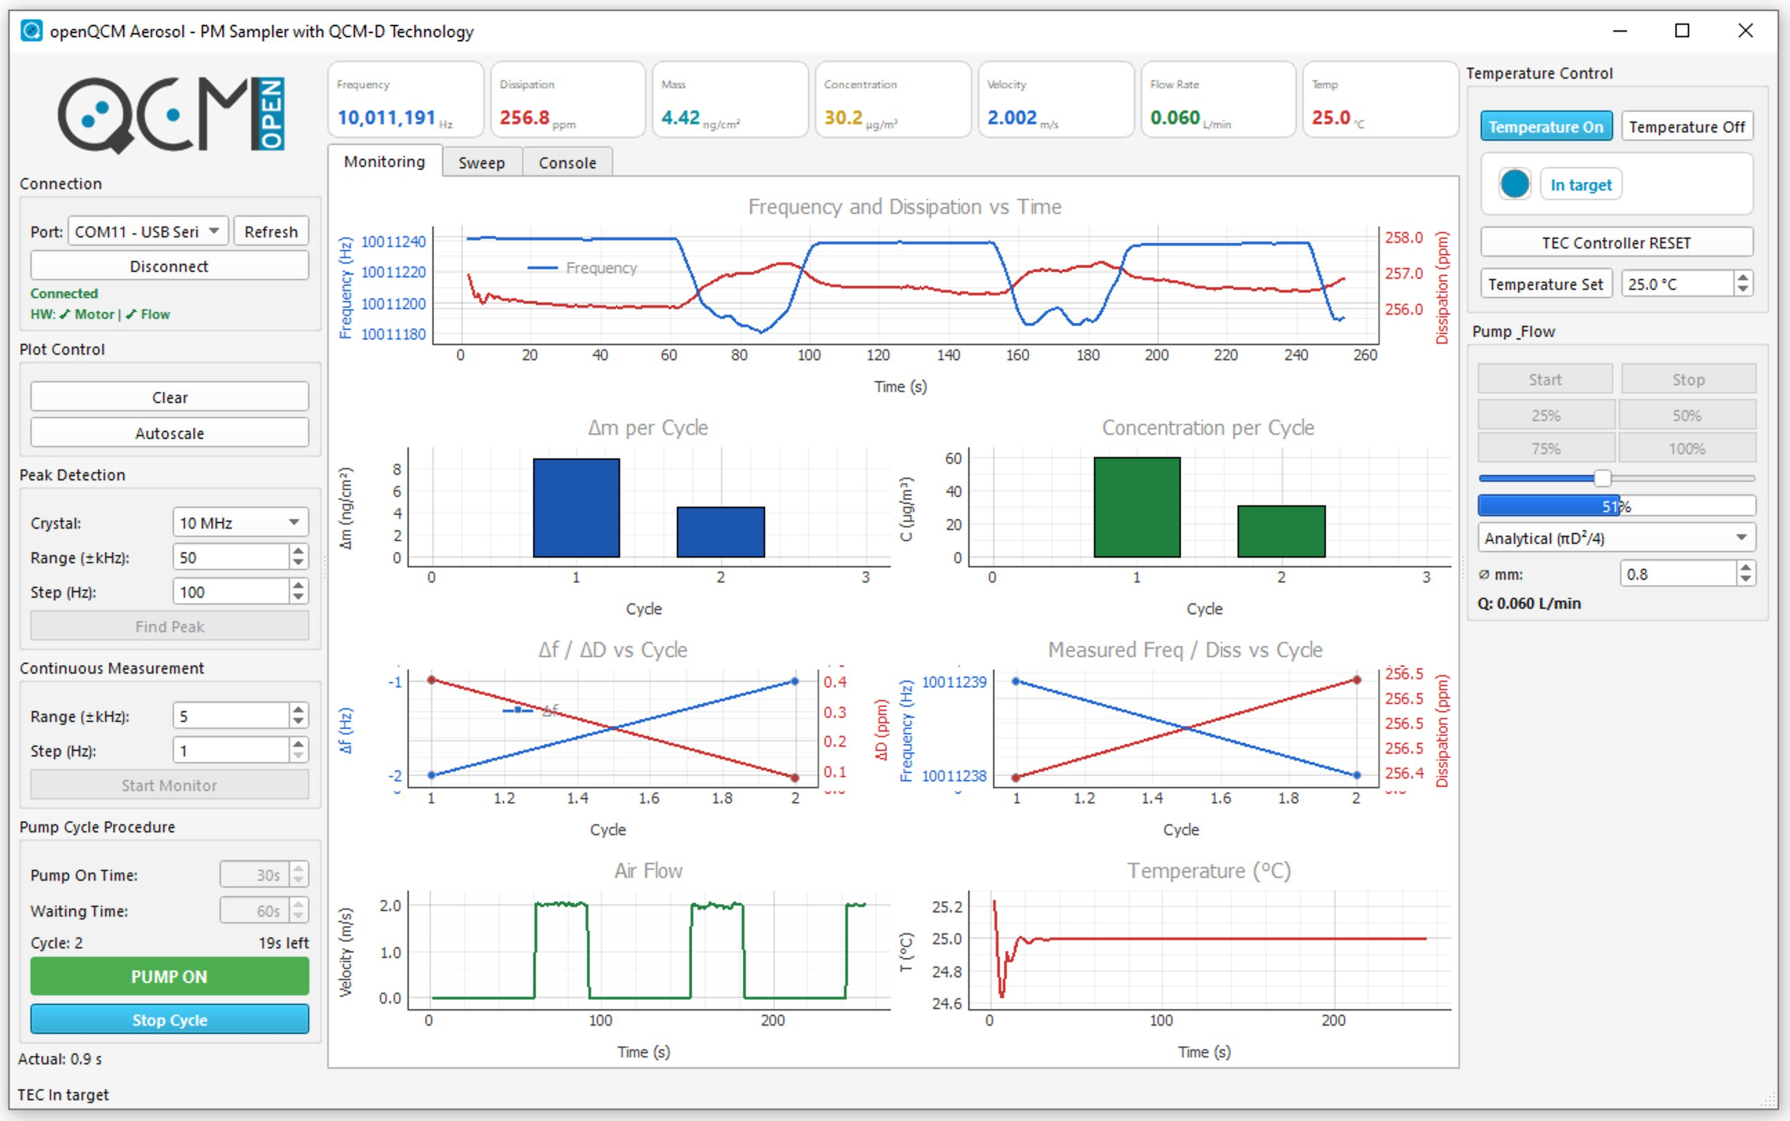
Figure 10 — The Monitoring tab during an active cycle: the PUMP ON status label with countdown is visible at the bottom of the left panel, while the lower plots already display the previously completed cycles.
CAUTION
While a cycle is active, all manual pump controls (Start, Stop, preset buttons, and the speed slider) are automatically disabled to prevent interference with the cycle. They become active again only after the cycle ends or is stopped.
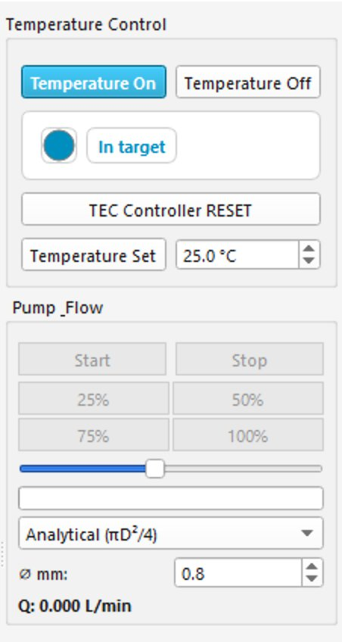
Figure 11 — The Pump _Flow panel with all controls disabled while a sampling cycle is active.
WARNING
Do not disconnect the USB cable, do not remove the crystal, and do not stop the application during an active cycle. Doing so corrupts the cycle CSV file and produces invalid concentration values.
To end a cycle session, click Stop Cycle in the Pump Cycle Procedure group. The application closes the CSV files and the TEC is automatically disabled.

5.5 Reading the Per-Cycle Plots
When a cycle completes, the per-cycle plots in the Monitoring tab are updated. Four plots show the cycle-level results:
- Δm per Cycle — bar chart of the deposited mass per cycle, in nanograms per square centimeter (ng/cm²). Computed by the Sauerbrey equation from the frequency drop measured between the new reference and the WAITING phase of the current cycle.
- Concentration per Cycle — bar chart of the airborne PM concentration, in micrograms per cubic meter (µg/m³). Computed by dividing the deposited mass (times the active area of the crystal) by the volume of air aspirated during the PUMP ON phase.
- Δf / ΔD vs Cycle — frequency variation (blue, left axis) and dissipation variation (red, right axis) per cycle, useful for diagnostic purposes.
- Measured Freq / Diss vs Cycle — long-term trend of the median frequency and dissipation values across all the cycles of the current session.
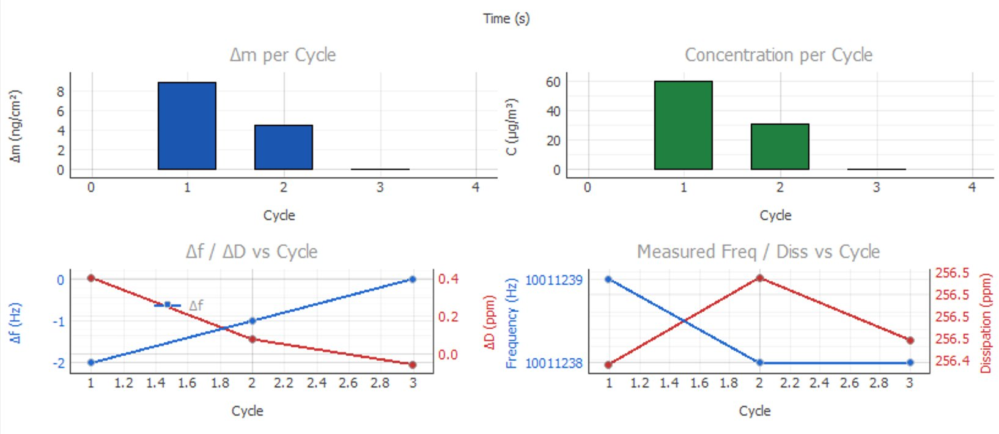
Figure 12 — The four per-cycle plots: Δm per Cycle, Concentration per Cycle, Δf / ΔD vs Cycle, and Measured Freq / Diss vs Cycle.

5.6 Saving Data and CSV File Format
Each cycle session saves data into two distinct CSV files: the per-cycle results file (one row per completed cycle) and a raw monitoring file (one row per sweep, suffixed _raw). A standalone monitoring session saves a single CSV file with the same per-sweep structure. All files use UTF-8 encoding, comma as field separator, and a single header row whose column names embed the SI unit as a suffix.
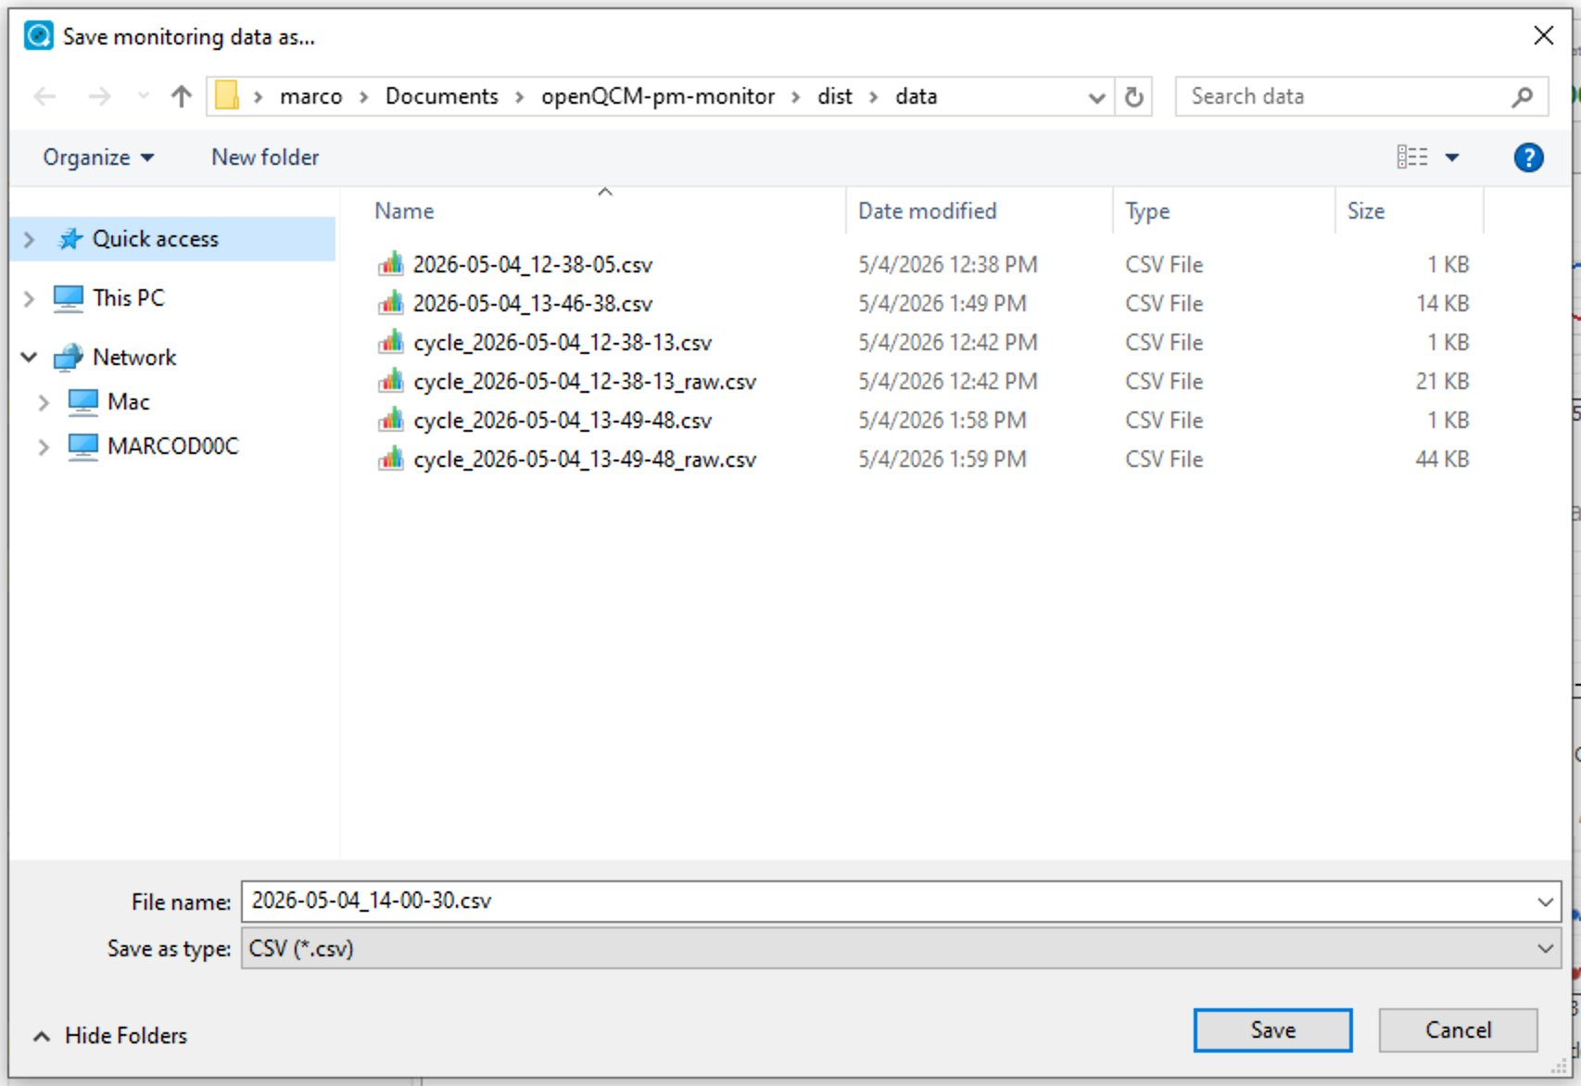
Figure 13 — The Save monitoring data as… dialog with the data folder selected as the destination.
File naming conventions:
File | Default name pattern
Standalone monitoring | YYYY-MM-DD_HH-MM-SS.csv
Per-cycle results | cycle_YYYY-MM-DD_HH-MM-SS.csv
Raw sweeps during a cycle | cycle_YYYY-MM-DD_HH-MM-SS_raw.csv
Table 5 — Default file-naming convention for the CSV output files.

5.7 Best Practices for Reliable Measurements
- Always perform a Find Peak immediately after installing or changing the crystal.
- Allow the TEC to reach the target temperature (status In target) before starting any cycle.
- Discard the first cycle of every session: it serves as a thermal stabilization run.
- Run at least three consecutive cycles and take the average to reduce statistical noise.
- Replace the crystal whenever the cumulative deposited mass exceeds 100 µg/cm².
- Keep the air intake of the head at the same height as the area whose air you want to characterize.
- Calibrate the flow against a reference flow meter once per measurement campaign.
TIP
Keep a written log of the crystal serial number, the date of installation, and the cumulative deposited mass. Crystals are consumables.

6. Temperature Control (TEC)

6.1 When to Activate the TEC
The crystal resonance frequency is sensitive to temperature. Even small temperature drifts (a few tenths of a degree Celsius) translate into frequency shifts large enough to bias the deposited-mass measurement. The thermoelectric cooler (TEC) integrated in the openQCM Q-1 PM Aerosol Head stabilizes the crystal mount at a programmable setpoint and removes the bulk of the thermal drift.
Activate the TEC in the following cases:
- The ambient temperature varies by more than ±1 °C during the planned measurement session.
- Sub-microgram-per-cubic-meter PM concentration values are required.
- Long unattended monitoring sessions (more than one hour).
- Comparative measurements where reproducibility is more important than absolute values.
NOTE
If the TEC is left inactive, the application still records the temperature value but applies no temperature compensation.

6.2 Setting the Setpoint
To activate the TEC and choose the target temperature:
- In the Temperature Control group of the right panel, click in the Temperature Set field.
- Type the desired setpoint, in degrees Celsius, and press Enter.
- Click Temperature On. The status changes from TEC Inactive to Approaching, and the indicator turns yellow.
- Wait until the status changes to In target (blue). The TEC is now actively stabilizing the crystal.
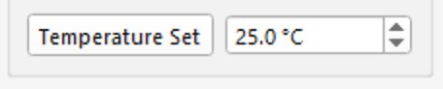
Figure 14 — Detail of the Temperature Set field, used to enter the desired setpoint in degrees Celsius.
TIP
A setpoint slightly above ambient room temperature (e.g., 25 °C in a 20 °C room) is generally easier to reach and more stable than a setpoint below room temperature, because the TEC is operating in heating mode.
NOTE
When you click Start Cycle, the application enables the TEC automatically at the current setpoint. You do not need to click Temperature On manually before starting a cycle.
CAUTION
Avoid setpoints below the dew point of the surrounding air, otherwise condensation may form on the crystal and ruin the measurement.

6.3 Status Meaning
The Temperature Control group shows a colored circle indicator next to a label with one of the following four states:
State | Color | Meaning
TEC Inactive | Gray | TEC disabled. The crystal is at ambient temperature and no temperature stabilization is performed.
Approaching | Yellow | TEC enabled. The crystal is moving towards the setpoint but the temperature is not yet stable.
In target | Blue | TEC enabled. The crystal temperature is within the tolerance band of the setpoint.
Error | Red | The TEC controller (MTD415T) has reported a fault. Acquisition continues but no temperature stabilization is in effect.
Table 6 — States of the TEC status indicator.
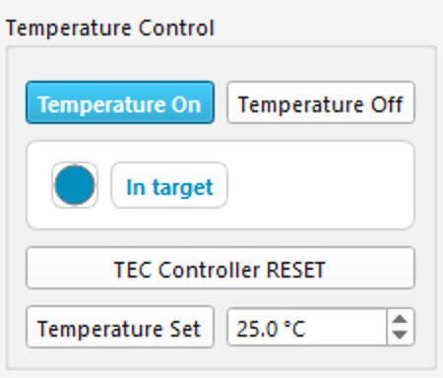
Figure 15 — The Temperature Control panel showing the TEC in In target state (blue indicator).

6.4 Resetting in Case of Error
If the TEC enters Error state, follow these steps to recover:
- Note the error description shown in the tooltip of the status indicator.
- Click TEC Controller RESET in the Temperature Control group.
- Wait a few seconds. If the cause of the error has been removed, the status returns to TEC Inactive.
- Re-enter the setpoint and click Temperature On.
- If the error persists, switch to the Console tab and read the MTD415T error register, as described in section 8.3.
WARNING
A persistent TEC error usually indicates a hardware problem (broken thermistor, disconnected Peltier cell, or insufficient cooling). Stop the measurement and inspect the device before continuing.

7. Reading and Exporting Data

7.1 Where the CSV Files Are Saved
By default, all CSV files produced by the application are saved into a data folder created next to the executable (for example Documents\openQCM-pm-monitor\dist\data when the application is installed in the user's Documents folder). The save dialog always opens with this folder preselected so that you can store all your acquisitions in a consistent location.
TIP
Create a sub-folder per measurement campaign or per day, so that the data folder remains organized and CSV files do not pile up.

7.2 Monitoring CSV (per-sweep)
The monitoring CSV file contains one row per acquired sweep (typically one or two per second) and is created in two situations: when you click Start Monitor for a standalone monitoring session, and automatically as a _raw.csv companion file during a sampling cycle. The header row is:
date, time, relative_time_s, frequency_Hz, dissipation_ppm, velocity_m_s, temperature_C
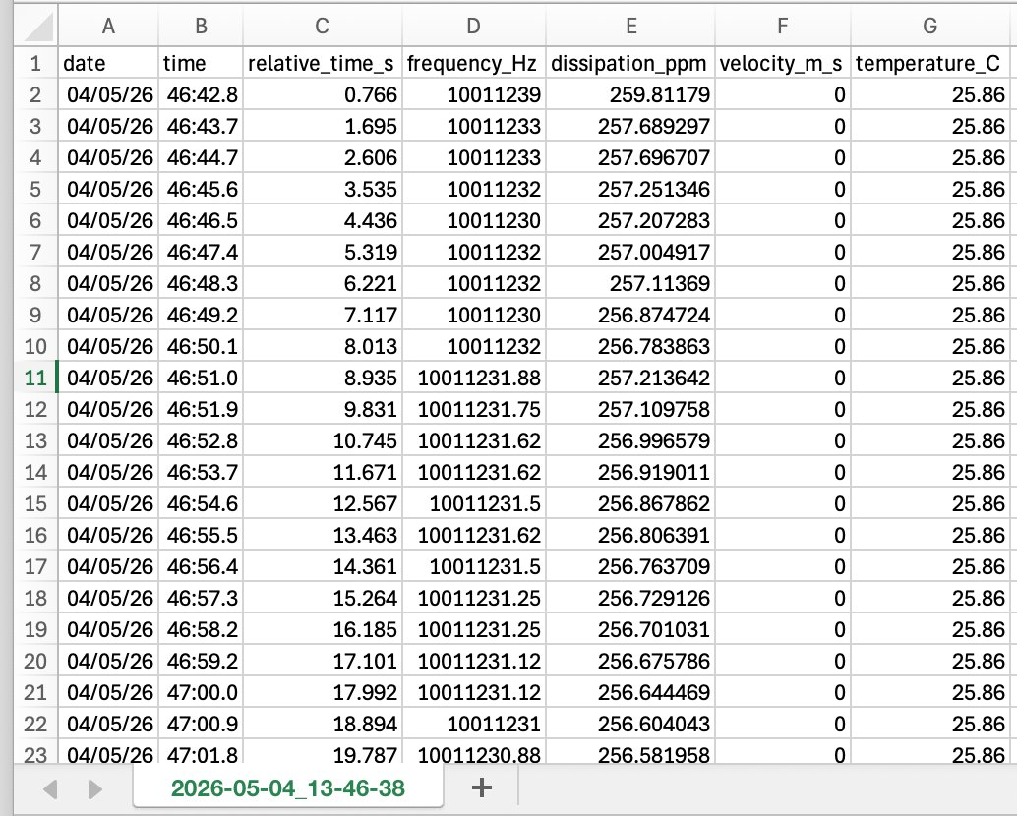
Figure 16 — An example monitoring CSV file opened in Microsoft Excel, with the seven columns visible.

7.3 Per-Cycle CSV (one row per completed cycle)
The per-cycle CSV file contains one row per completed cycle, written at the end of each WAITING phase. The header row is:
date, time, cycle, frequency_Hz, dissipation_ppm, velocity_m_s, temperature_C, delta_f_Hz, delta_d_ppm, delta_m_ng_cm2, volume_cm3, concentration_ug_m3
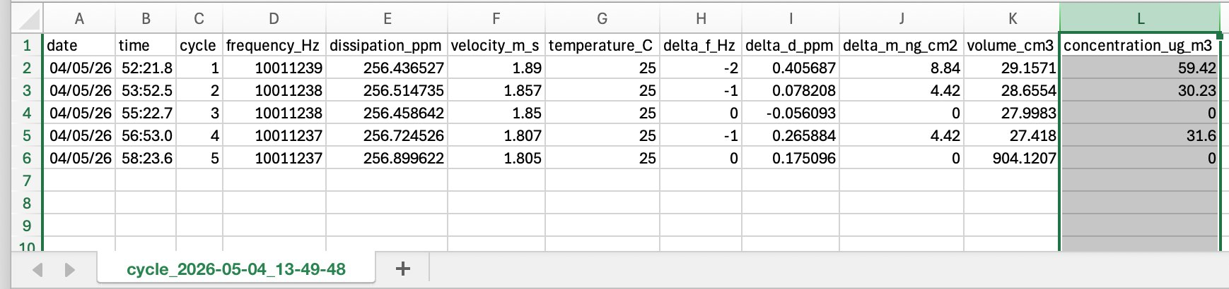
Figure 17 — An example per-cycle CSV file opened in Excel, with the concentration_ug_m3 column highlighted.

7.4 Opening CSV Files in Excel, Origin, and pandas

Microsoft Excel
- Open Excel and choose File → Open.
- Browse to the data\ folder and select the CSV file.
- Excel may show a Text Import Wizard. Choose Delimited, then Comma as the separator.
- Confirm to load the file into a worksheet.
NOTE
If your regional settings use a comma as decimal separator, Excel may misinterpret the numeric values. In that case, import the file with Data → From Text/CSV and explicitly select the locale (English – United States).

OriginLab
- In Origin, select File → Import → Single ASCII (or Multi ASCII for batches).
- Choose the CSV file. In the import options, set the delimiter to Comma and the number of header lines to 1.
- Confirm. The columns are now available for plotting.

Python pandas
import pandas as pd
df = pd.read_csv("data/cycle_2026-05-04_10-30-15.csv")
print(df.head())

7.5 Glossary of Columns and Units
All column names embed the SI unit as a suffix, so the file is self-describing in any tool (Excel, pandas, R, MATLAB) without the need for an external legend.

Monitoring CSV
Column | Unit | Description
date | YYYY-MM-DD | Local date of the sample.
time | HH:MM:SS.fff | Local time of the sample, millisecond precision.
relative_time_s | s | Seconds since the start of the monitoring session.
frequency_Hz | Hz | Resonance frequency of the crystal, smoothed by a trimmed mean over the last ten sweeps.
dissipation_ppm | ppm | Dissipation D = Δf₋₃dB / f₀ × 10⁶.
velocity_m_s | m/s | Air velocity reported by the FS3000 sensor (point velocity, not volumetric flow).
temperature_C | °C | Temperature read from the sweep metadata.
Table 7 — Columns of the monitoring CSV file.

Per-Cycle CSV
Column | Unit | Description
date | YYYY-MM-DD | Local date of the cycle finalisation.
time | HH:MM:SS.fff | Local time of the cycle finalisation.
cycle | count | Sequential cycle number, starting at 1.
frequency_Hz | Hz | Measured frequency: median over the last third of the WAITING-phase samples.
dissipation_ppm | ppm | Measured dissipation: median over the same samples.
velocity_m_s | m/s | Average velocity during the PUMP ON phase.
temperature_C | °C | Last temperature reading at finalisation.
delta_f_Hz | Hz | f − f₀ : measured frequency minus reference frequency.
delta_d_ppm | ppm | D − D₀ : measured dissipation minus reference dissipation.
delta_m_ng_cm2 | ng/cm² | Sauerbrey mass: Δm = − Δf · C × 10⁹.
volume_cm3 | cm³ | Sampled air volume: V = Q · t_pump (measured pump-on duration).
concentration_ug_m3 | µg/m³ | Final airborne PM concentration: C = (Δm · A_quartz) / V.
Table 8 — Columns of the per-cycle CSV file.

8. Diagnostic Tools

8.1 The Sweep Tab
The Sweep tab in the central panel shows the gain and phase curves obtained during the most recent Find Peak operation. It is a diagnostic view: it does not update during a regular monitoring session, but it is extremely useful to verify the quality of the resonance peak.
Inspect the Sweep tab in the following situations:
- After installing a new crystal, to verify that the resonance peak is well-defined on both the amplitude and the phase response.
- After a sequence of unstable measurements, to check whether the crystal is still in good condition.
- Before reporting a problem to support, so you can attach a screenshot of the curves.
TIP
A clean, sharp peak on both plots indicates a healthy crystal. Multiple peaks, very wide peaks, strongly asymmetric peaks, or a phase peak that does not align with the amplitude peak suggest that the crystal is contaminated, damaged, or that the sample is liquid (the head is intended for dry aerosols only).

8.2 The Console Tab
The Console tab provides a direct serial interface to the Teensy microcontroller. It is intended for advanced diagnostic use, for example to query the firmware version or to read the TEC error register.
- Switch to the Console tab in the central panel.
- Type a command in the input field at the bottom and press Enter (or click Send). The Send button is next to a Clear button which clears the console output area.
- The command is logged with a TX→ marker and a timestamp; the device reply is logged on a separate line with an RX← marker.
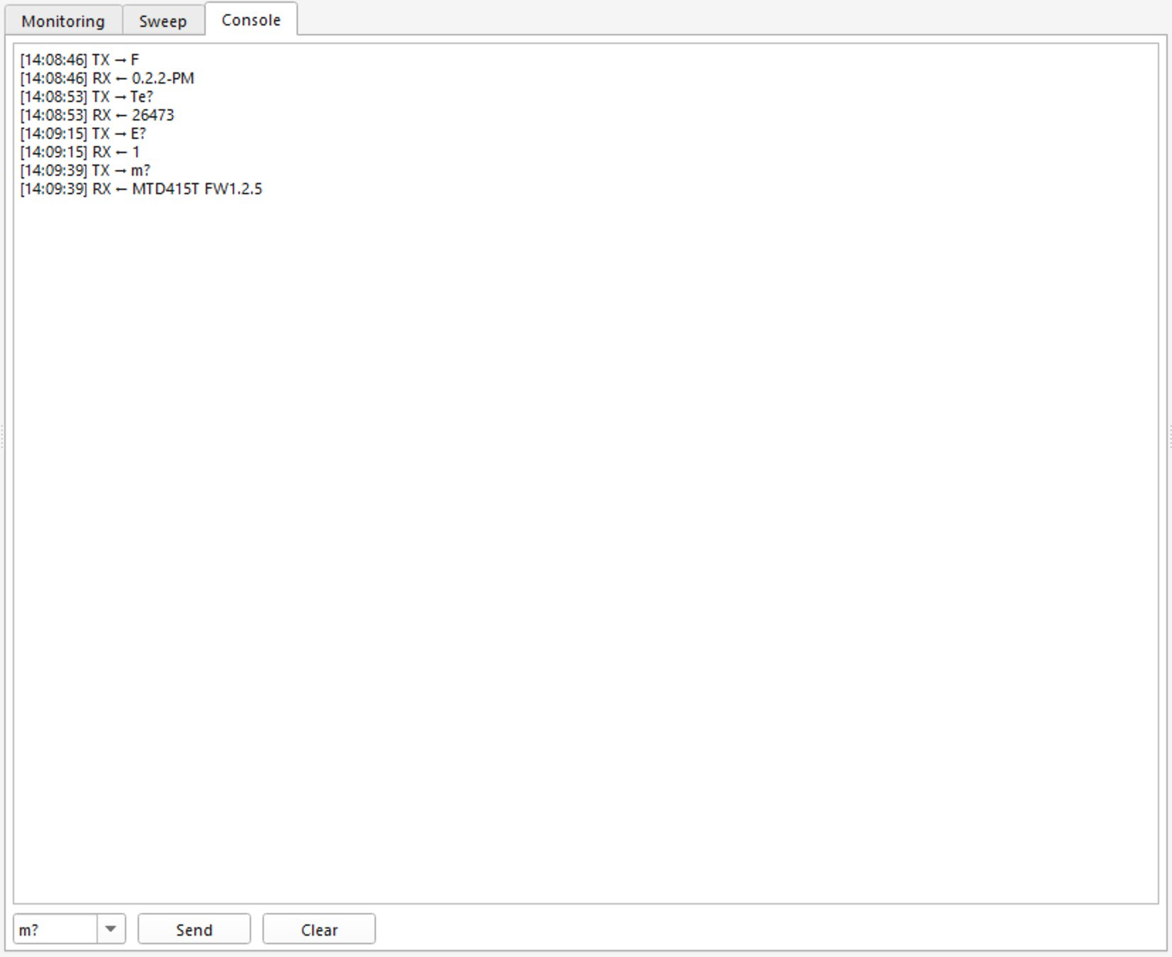
Figure 18 — The Console tab with example commands sent to the Teensy and the corresponding replies.
WARNING
Sending arbitrary commands to the device may interfere with an active monitoring session or cycle. Use the console only when no measurement is running. The complete command set is documented in the firmware source code; refer to the project README for the current version.

8.3 Reading the TEC Status
The MTD415T temperature controller exposes an error register that describes any anomalous condition (over-temperature, sensor open, current limit, and so on). When the TEC is enabled, the application polls this register periodically in the background; the result is reflected in the colored TEC status indicator. If a hardware fault is suspected, technical support may ask you to read the error register directly through the Console tab.
- Make sure no cycle or monitoring session is running.
- Switch to the Console tab and send the firmware-specific commands provided by support; the reply will contain the value of the error register.
- If the cause is transient (for example, a brief over-temperature), reset the TEC as described in section 6.4.
- If the cause is persistent, escalate to support with the value you have read.

9. Troubleshooting
This chapter lists the most common issues you may encounter and explains how to solve them. If a problem persists after trying the suggested actions, consult the README in the GitHub repository or contact Novaetech S.r.l.

9.1 The Serial Port Is Not Detected
Symptoms: the Port drop-down is empty or does not list the device.
- Verify that the USB cable is connected at both ends and is data-capable (not a charge-only cable).
- Click Refresh next to the Port drop-down.
- Open the Windows Device Manager and check that the device appears under Ports (COM & LPT).
- If the device appears with a yellow warning icon, reinstall the Teensyduino driver as described in section 2.2.
- Try a different USB port, preferably a port directly on the computer rather than through a USB hub.

9.2 Persistent TEC Error
Symptoms: the TEC status indicator is red and does not return to blue after a TEC Controller RESET.
- Read the MTD415T error register through the console (section 8.3).
- Verify that the setpoint is reasonable (typically between 5 °C and 50 °C).
- Allow the head to cool down for several minutes if it has been operating at high current.
- Inspect the device for blocked ventilation or excessive ambient heat.
- If the error persists, the thermistor or Peltier cell may be damaged. Stop measuring and contact support.

9.3 Peak Not Found During Find Peak
Symptoms: the Find Peak operation completes but no peak marker is shown, or the marker is at the edge of the sweep range.
- Verify that the correct crystal frequency (5 MHz or 10 MHz) is selected.
- Increase the sweep span (for example, to 100 kHz).
- Check that the crystal is correctly seated in its mount and that the contacts are clean.
- If the device has just been powered on, wait a few minutes for the electronics to warm up, then repeat Find Peak.
- Replace the crystal if the curve looks flat or noisy and the previous bullets did not help.

9.4 The Pump Does Not Start
Symptoms: clicking Start (or starting a cycle) does not produce any audible pump activity, and the velocity card stays at 0 m/s.
- Verify that the device is connected and the Connection group shows Connected with the HW: ✓ Motor check active.
- Check that the speed slider is not at zero (use one of the preset percentage buttons to be sure).
- Ensure that no cycle is already active (if it is, the manual pump controls are intentionally disabled — see section 5.4).
- Listen for any unusual noise: a stuck pump may indicate a mechanical obstruction in the air path.
- Power-cycle the device by disconnecting and reconnecting the USB cable.

9.5 Flow Velocity Is Zero During a Cycle
Symptoms: the velocity card stays at 0 m/s during the PUMP ON phase, and the resulting concentration is zero or absurdly large.
- Verify that the air intake of the head is not obstructed.
- Check that the FS3000 sensor connector is firmly plugged on the device main board (the HW: ✓ Flow check should be active).
- Switch to Analytical mode and observe whether the velocity reading recovers (this isolates the issue from the calibration).
- Try increasing the pump speed via the slider or one of the preset buttons.
CAUTION
If a single cycle reports a velocity of zero, discard that cycle. The concentration value is invalid because the sampled volume is unknown.

9.6 CSV Saving Is Interrupted
Symptoms: the CSV file ends abruptly and is missing the last seconds of data; or the application crashes during saving.
- Make sure the destination folder is on a local disk and not on a network drive that may disconnect.
- Check that you have write permission and enough free space.
- Do not open the CSV file in Excel while the acquisition is still running. Excel locks the file and can prevent further writing.
- Always click Stop Monitor or wait for the cycle to end before closing the application.
WARNING
If the application crashes, the most recent CSV file may be left without its closing rows. Most analysis tools accept truncated CSV files, but the last few seconds of data are lost.

10. Appendix A — Physical Specifications
This appendix collects the physical formulas used by the application. They are reported here for reference; the user does not need to apply them manually.

10.1 The Sauerbrey Equation
The Sauerbrey equation relates the change in resonance frequency of a quartz crystal to the surface mass density deposited on its active electrode:
Δm = − Δf · C × 10⁹
where:
- Δm is the surface mass density change, in ng/cm².
- Δf is the resonance frequency shift, in Hz (negative when mass deposits).
- C is the Sauerbrey constant of the crystal, in s·cm² (Hz⁻¹·cm²).
The application uses the following Sauerbrey constants:
- C₅MHz = 17.7 × 10⁻⁹ Hz⁻¹·cm² (5 MHz crystal).
- C₁₀MHz = 4.42 × 10⁻⁹ Hz⁻¹·cm² (10 MHz crystal).
Because C scales as the inverse of the square of the fundamental frequency, a 10 MHz crystal is roughly four times more sensitive to the same deposited mass than a 5 MHz crystal.
NOTE
The Sauerbrey equation assumes that the deposited material behaves as a rigid layer — a good approximation for solid airborne particles in dry air.

10.2 Dissipation and Q-Factor
Dissipation is computed from the half-power bandwidth of the resonance peak. If Δf₃dB is the width of the peak between the two −3 dB points and f₀ is the resonance frequency:
D = Δf₃dB / f₀
Q = f₀ / Δf₃dB = 1 / D
The application reports D in parts per million (ppm = D × 10⁶) for readability. Higher dissipation values indicate a softer or more lossy deposit.

10.3 Flow Rate, Volume and Concentration
In Analytical mode, volumetric flow rate is computed from the air velocity v and the inner diameter D of the sampling channel:
Q = v × π·D² / 4
In Calibrated mode, a user-supplied calibration factor K replaces the geometric term:
Q = K × v
The total air volume sampled during a cycle is computed from the actual measured pump-on duration:
V = Q · t_pump
Concentration is finally:
C = (Δm · A_quartz) / V
where C is the airborne PM concentration in µg/m³, Δm is the surface mass density measured on the crystal, and A_quartz is the active area of the crystal exposed to the impacting jet.

11. Appendix B — Credits and License

11.1 Credits
openQCM-pm-monitor is developed by Novaetech S.r.l. (Pompeii, Italy) as part of the openQCM open-source project. The application builds on the experience accumulated through several generations of the openQCM Quartz Crystal Microbalance with Dissipation device.
The team gratefully acknowledges:
- PJRC Teensy 4.0 USB development board, used as the embedded controller.
- Renesas FS3000 air-velocity sensor, used for the velocity-to-flow conversion.
- Thorlabs MTD415T temperature controller, used for crystal temperature stabilisation.
- Analog Devices AD9851 DDS and AD8302 gain/phase detector, used for the sweep electronics.
- All researchers and laboratories who contributed feedback during the early-access program.

11.2 License
Refer to the LICENSE file in the source repository for the current licensing terms. The application is distributed in source form on GitHub at https://github.com/openQCM/openQCM-pm-monitor; a Windows binary (openQCM-pm-monitor.exe) is provided as a one-file PyInstaller build that requires no installer.

11.3 Contact
For technical questions and commercial inquiries:
- Novaetech S.r.l. — Pompeii (NA), Italy
- Web: https://openqcm.com
- Repository: https://github.com/openQCM/openQCM-pm-monitor

12. Step-by-Step Procedures
This chapter collects the seven most common operational procedures in a single place, so that an operator can follow them as a checklist. Each procedure lists its prerequisites and the expected result.

12.1 Procedure 1 — First Power-On and Connection
Prerequisites:
- openQCM-pm-monitor installed on a Windows 10/11 PC.
- Teensy USB serial driver installed.
- openQCM Aerosol head with a quartz crystal already mounted.
Steps:
- Plug the device into a USB port and wait until Windows finishes enumerating it.
- Launch the application by double-clicking the executable.
- In the Connection group, click Refresh, then select the COM port assigned to the device.
- Click Connect and verify that the hardware status indicator turns green.
- Read the firmware version on the status bar; verify that it is v0.2.2-PM or later.
Expected result: the device is connected and ready to operate.

12.2 Procedure 2 — Running Find Peak
Prerequisites: device connected (Procedure 1 completed).
Steps:
- In the Peak Detection group, select 5 MHz or 10 MHz to match the installed crystal.
- Leave the sweep span at the default 50 kHz, or increase it if the crystal is unfamiliar.
- Click Find Peak and wait for the sweep to complete (5–10 seconds).
- Switch to the Sweep tab and verify that a clean, sharp peak is detected, with a reasonable −3 dB bandwidth.
Expected result: the application has identified the resonance frequency and is ready for monitoring.

12.3 Procedure 3 — A 30-Minute Monitoring Session
Prerequisites: Find Peak completed (Procedure 2).
Steps:
- (Recommended) Activate the TEC at 25 °C and wait for the In target state.
- In the Continuous Measurement group, click Start Monitor.
- Choose a destination folder and a file name in the save dialog. Confirm.
- Observe the Monitoring tab and verify that the frequency and dissipation plots are scrolling smoothly.
- Wait 30 minutes.
- Click Stop Monitor.
Expected result: a CSV file (named monitor_*.csv) is saved in the chosen folder, with one row per sample for the entire 30-minute window.

12.4 Procedure 4 — A Complete PM Sampling Cycle
Prerequisites: Find Peak completed; flow calibration performed (Procedure 5) if Calibrated mode is used.
Steps:
- Activate the TEC and wait for the In target state.
- In the Pump Cycle Procedure group, set the Pumping time (e.g., 5 min) and the Waiting time (e.g., 1 min).
- In the Pump & Flow panel, choose Analytical or Calibrated flow mode.
- Click Start Cycle. Choose a destination folder and a file name for the per-cycle CSV file.
- Watch the cycle phase bar evolve: REFERENCE → PUMP ON → WAITING.
- When the cycle completes, observe the Δm/cycle and Concentration/cycle plots.
- Run two or three additional cycles to obtain a meaningful average.
Expected result: the per-cycle CSV file (cycle_*.csv) contains one row per completed cycle, including the concentration_ug_m3 column.

12.5 Procedure 5 — Flow Calibration with a Reference Flow Meter
Prerequisites: a traceable reference flow meter compatible with the air intake.
Steps:
- Connect the reference flow meter inline with the air intake of the head.
- Switch to Analytical mode in the Pump & Flow panel.
- Set the pump PWM to 60% and click Start.
- Wait 30 seconds for both readings (application and reference) to stabilize.
- Read the reference value (in L/min) and switch to Calibrated mode.
- Enter the reference value in the corresponding field and click Apply.
- Stop the pump.
Expected result: the calibration factor is stored. From now on, all cycles run in Calibrated mode use this factor automatically.

12.6 Procedure 6 — Reading a Completed Cycle in Excel
Prerequisites: a per-cycle CSV file produced by Procedure 4.
Steps:
- Open Microsoft Excel.
- Choose Data → From Text/CSV and select the cycle_*.csv file in the data folder.
- In the import dialog, set the file origin to Unicode (UTF-8) and the delimiter to comma.
- Click Load. The CSV is imported as a worksheet table.
- Highlight the concentration_ug_m3 column to focus on the cycle results.
Expected result: the file is opened correctly and the concentration values can be plotted directly with Excel charts.

12.7 Procedure 7 — Solving a TEC Error
Prerequisites: TEC status is red (Error).
Steps:
- Hover over the status indicator to read the error description in the tooltip.
- Click TEC Controller RESET.
- If the status returns to TEC Inactive, re-enter the setpoint and click Temperature On.
- If the error persists, allow the head to cool down for several minutes (the cause may be transient over-temperature) and try again.
- If the error still persists, switch to the Console tab and read the MTD415T error register following the indications of technical support (see section 8.3).
- Take corrective action depending on the cause: reduce the setpoint, improve ventilation around the head, or contact support if the fault is hardware-related.
Expected result: the TEC returns to In target, or you have a clear hardware fault to report to support.

13. Glossary
This glossary collects, in plain language, the technical terms used throughout this manual. Definitions are written for laboratory operators rather than for software developers.

13.1 QCM and QCM-D
QCM (Quartz Crystal Microbalance) is a measurement technique that uses the change in resonance frequency of a piezoelectric quartz crystal as a sensitive scale for tiny amounts of mass deposited on its surface. QCM-D (QCM with Dissipation) extends QCM by also measuring how much energy is dissipated by the deposited layer, which provides additional information about its rigidity.

13.2 AT-cut, Resonance Frequency, Dissipation
AT-cut is the orientation in which the quartz crystal is sliced from the original mineral. AT-cut crystals have a frequency that is almost independent of temperature within a wide temperature range, which is why they are used for QCM.
The resonance frequency is the frequency at which the crystal oscillates most efficiently. It is the fundamental quantity measured by openQCM-pm-monitor.
Dissipation is a measure of how much the resonance peak broadens. A narrow peak means low dissipation (a rigid, lossless deposit); a wide peak means high dissipation (a soft, lossy deposit).

13.3 5 MHz versus 10 MHz Crystals
5 MHz and 10 MHz are the two nominal fundamental frequencies of the crystals supported by the application. A 10 MHz crystal is roughly four times more sensitive to the same deposited mass than a 5 MHz crystal, but it also saturates four times sooner. Use 10 MHz for low concentrations and short cycles, and 5 MHz when a wider mass range is needed.

13.4 Sauerbrey Equation
An empirical formula that converts a frequency drop into a deposited surface mass density. It is the basis of every QCM mass measurement. See Appendix A for the full expression.

13.5 Q-Factor and −3 dB Bandwidth
The Q-factor expresses the sharpness of the resonance peak: a high Q means a narrow, sharp peak; a low Q means a wide, smooth peak. The −3 dB bandwidth is the width of the peak measured at half of the maximum power. Dissipation in this manual is computed from this bandwidth.

13.6 TEC and Setpoint
TEC stands for Thermoelectric Cooler. It is a solid-state device, based on the Peltier effect, which moves heat from one face to the other when current flows through it. In the openQCM Aerosol Head, the TEC stabilizes the crystal mount at the setpoint — the target temperature chosen by the user.

13.7 ppm (Parts Per Million)
Parts per million is a unit used to express very small relative quantities. A dissipation of 38 ppm means that the −3 dB bandwidth of the peak is 38 millionths of the resonance frequency.

13.8 Volumetric Flow versus Velocity
Air velocity (m/s) is the speed at which the air molecules travel across the sampling channel. Volumetric flow rate (L/min) is the volume of air that crosses the channel in a unit of time. Velocity and flow rate are related by the cross-sectional area of the channel.

13.9 Particulate Matter (PM, µg/m³)
Particulate Matter (PM) is the technical name for solid or liquid particles suspended in air. Concentration is expressed in micrograms of particulate matter per cubic meter of air (µg/m³). Common size fractions are PM10 (particles up to 10 µm in diameter) and PM2.5 (up to 2.5 µm).

13.10 Measurement Cycle: Reference, Pump, Waiting
In this manual, a measurement cycle is the structured sequence of phases used by the application to compute one PM concentration value. The three phases are REFERENCE (baseline reading with the pump off), PUMP_ON (active sampling with the pump running), and WAITING (final stabilization before reading the deposited mass). See section 5 for details.

14. List of Figures
Figure 1 — Initial screen of openQCM-pm-monitor immediately after launch, before any device is connected.
Figure 2 — The left panel, with the Connection, Plot Control, Peak Detection, Continuous Measurement, and Pump Cycle Procedure groups.
Figure 3 — The right panel, with the Temperature Control and Pump _Flow groups.
Figure 4 — Detail of the seven metric cards displayed at the top of the main window.
Figure 5 — The right-click context menu available on every real-time plot.
Figure 6 — The Connection group with the COM port selected and the Connected status indicator visible.
Figure 7 — The Sweep tab after a successful Find Peak: amplitude response (blue) above with a star marker on the resonance peak, phase response (green) below with a square marker, and a vertical dashed red line indicating the resonance frequency.
Figure 8 — The Monitoring tab during an active monitoring session, with frequency and dissipation plots scrolling in real time.
Figure 9 — The Flow calibration drop-down of the Pump _Flow panel, showing the Analytical (πD²/4) and Calibrated (K·v) modes.
Figure 10 — The Monitoring tab during an active cycle: the PUMP ON status label with countdown is visible at the bottom of the left panel, while the lower plots already display the previously completed cycles.
Figure 11 — The Pump _Flow panel with all controls disabled while a sampling cycle is active.
Figure 12 — The four per-cycle plots: Δm per Cycle, Concentration per Cycle, Δf / ΔD vs Cycle, and Measured Freq / Diss vs Cycle.
Figure 13 — The Save monitoring data as… dialog with the data folder selected as the destination.
Figure 14 — Detail of the Temperature Set field, used to enter the desired setpoint in degrees Celsius.
Figure 15 — The Temperature Control panel showing the TEC in In target state (blue indicator).
Figure 16 — An example monitoring CSV file opened in Microsoft Excel, with the seven columns visible.
Figure 17 — An example per-cycle CSV file opened in Excel, with the concentration_ug_m3 column highlighted.
Figure 18 — The Console tab with example commands sent to the Teensy and the corresponding replies.

15. List of Tables
Table 1 — Minimum and recommended requirements for openQCM-pm-monitor.
Table 2 — Quantities displayed in the seven metric cards of the top bar.
Table 3 — Status indicators visible in the main window.
Table 4 — Configurable cycle timing parameters.
Table 5 — Default file-naming convention for the CSV output files.
Table 6 — States of the TEC status indicator.
Table 7 — Columns of the monitoring CSV file.
Table 8 — Columns of the per-cycle CSV file.

