**60x/1.4 - PCO.Edge4.2**

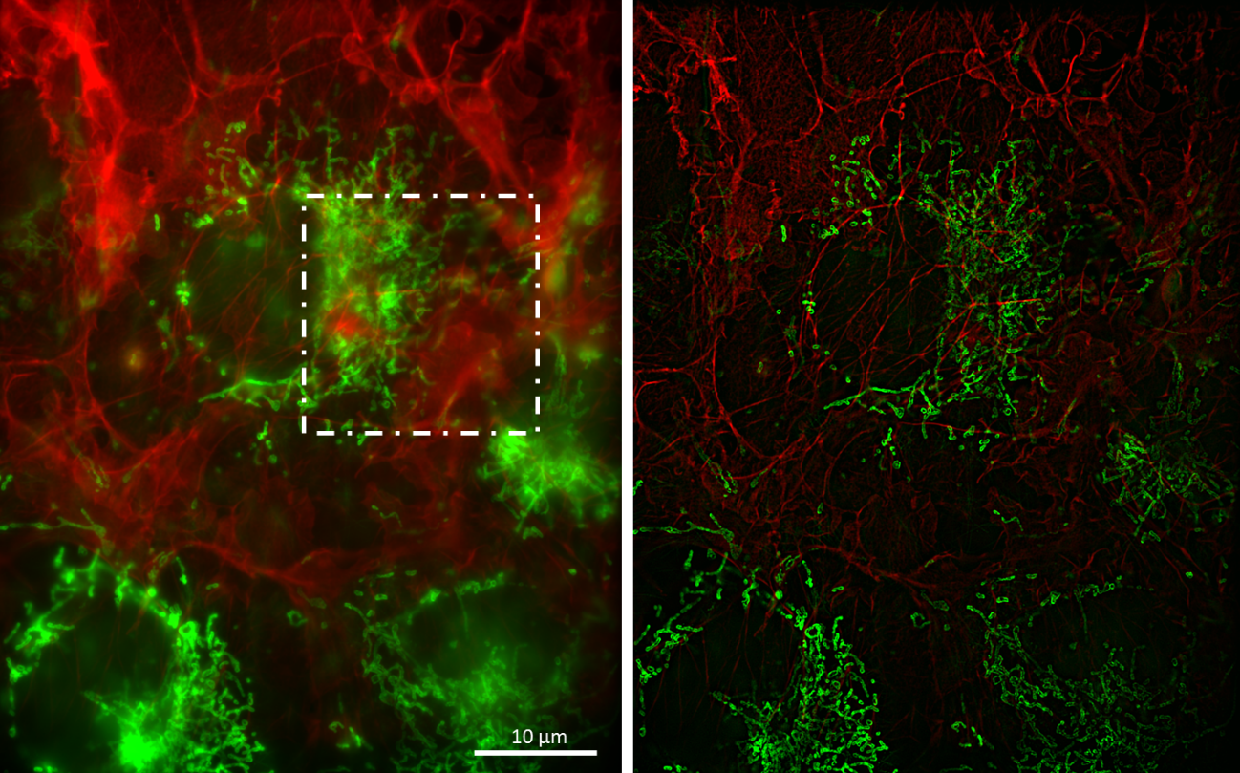

Crop:

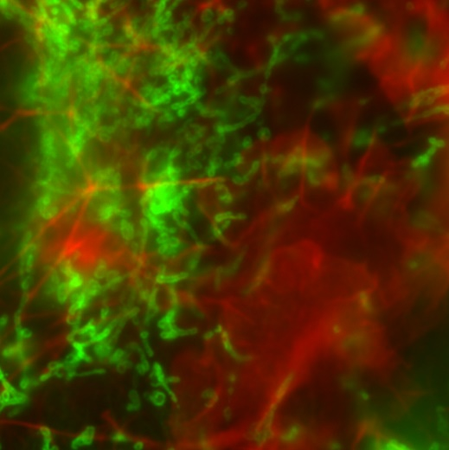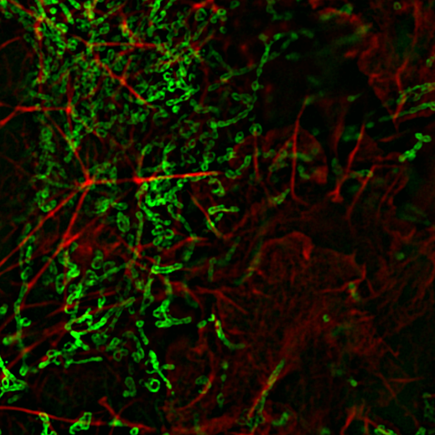

Gatta-Cells 4c, Zelltyp: COS-7, Lableling: Mitochondria (AF488), Actin (SiR)

|  |  |  |
| --- | --- | --- |
|  | 488nm | 635nm |
| Laser Leistung | 60mW | 40mW |
| Beleuchtungszeit | 200ms | 200ms |
| Verbesserung | 1.5x | 1.65x |