**SIMMO-Project**

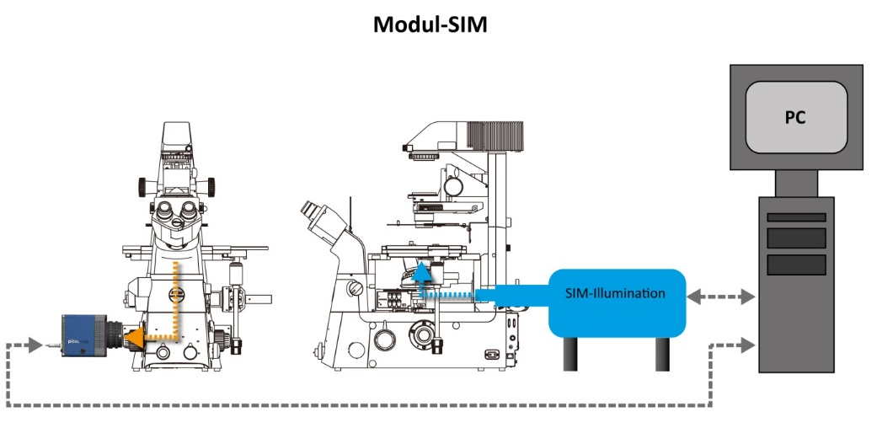

**Description**

The SIMMO project is a government funded research project between the Leibniz Institute of Photonic Technology, Jena, Germany (Dr. Garwe / Prof. Dr. Heintzmann) and PCO AG (Dr. Holst). The goal is the development of a structured-illumination based microscope sub-system, which easily can be attached to commercial microscopes. The starting point is based on a SIM system like in the publication, “UC2 - A Versatile and customizable low-cost 3D-printed Optical Open-Standard for microscopic imaging”[1], which is DMD based, and we plan to improve that further to achieve a reliable not too expensive SIM system. This microscopic sub-system should be flexible, easy to apply, and it should have the following key parameters:

* Resolution improvement should be moderate, minimum a factor of 1.5
* SIM results image rate should be better than 10 fps (this implies if 9 images have to be taken, that the camera has to run faster than 100 fps)
* Resolution of the camera should be equal or better than 2k x 2k pixel leading to ~3kx3k SIM images
* Image sensor diagonal should be larger than 18 mm
* As a start the system should have one wavelength, but the possibilities to add 1 or 2 wavelengths will be investigated with the help of a modular design
* The system should be operative with minimum adjustment requirements

The focus of the whole system is not to achieve the maximum possible resolution improvement, but a fair priced reliable fluorescence microscope sub-system, which improves the focal plane image quality and can compete either with “spinning disk confocal” systems in terms of z-resolution and speed, as well as with software solutions with mystic image processing like “Thunder”. It is furthermore capable of ROI-based illumination (possibly suitable for FRAP experiments).

**Technical Challenge**

**SIM illumination**

In principle three possible pathways to get the structured light into the focal plane with different impacts on complexity and cost and performance (this strongly depends on how much the system will be optimized for a specific type of microscope stands):

1. The structure light can be coupled in using the emission pathway to the camera, such that a potential SIMMO system would be connect to the camera output as a box like for example a spinning disk system. This solution would be the most flexible (in terms of microscopes), but also the most expensive, because it involves a lot of additional optics, filters, maybe even specific notch filters, which only would allow for certain distinct excitation wavelengths. This possibility would create the highest risk to meet the envisioned pricing. But this would have all elements in one box, which can be connected and controlled by a computer with specific software.
2. For microscopes like the Nikon microscopes with 2 filter turrets, it would be possible to couple in the excitation light using the upper turret, and guiding the emission to the camera using the lower turret, but for this we would have to design a special optical insert to the turret, which we are not sure if this could be a mechanical reliable option, since the design of the turrets is not made for that possibility, as far as we see and know. This would result in a SIM illumination box and an additional camera with synchronization between them and communication connections to a computer, which again with corresponding software would control the system.
3. The third possibility would be using the epi-fluorescence pathway to couple in the structured light (which in our opinion would be the most elegant way to go). This can be realized in two different ways:
   * By replacing the epi-fluorescence insert of the microscope, which usually connects to external light sources, and replacing it with a special SIM illumination insert, which is dedicated for the specific microscope stand.
   * By connecting to the epi-fluorescence insert of the microscope, which usually connects to external light sources, if the optical quality allows to do that, this again would be the maximum flexible solution, because the SIM illumination would then just connect like other light sources to the epi-fluorescence input and can possibly even be switched to by existing flip-mirror technology.  
       
     Both solution would allow to use the optical filter system in place, and would be the most flexible in terms of spectral combinations. But they require better information of the mechanical structure and optical parameters of the “to be used microscope for optimization”, therefore this solution is maximum optimized for a specific microscope brand.

**SIM Detection – Camera**

We plan to optimize an sCMOS camera for the SIMMO system, which is currently under development, and will have a larger and faster sCMOS image sensor, with the following key parameters:

|  |  |
| --- | --- |
| resolution | 4344 x 2368 pixel |
| Pixel size | 4.6 µm x 4.6 µm |
| active area | 20.0 mm x 10.9 mm |
| Diagonal | 22.8 mm |
| Readout noise | 0.7 e- @ 5 fps 1.0 e- @ 120 fps |
| Shutter type | Rolling shutter |
| Quantum efficiency | > 85 % |
| Frame ratemax (full) | 120 fps |
| Fullwell capacity | 19600 e- |
| Dynamic range | 1 : 28000 |
| A/D bit depth | 16 bit |
| Power consumption | 2 W |

The camera will be optimum synchronized with the SIM illumination to achieve the most efficient and fast image rate. Further it is planned to investigate the influence of image compression on the speed and the quality of the image reconstruction.

It is not yet decided whether two computer communication paths will be used (likely for the beginning) or one such that the SIM illumination communicates via the camera with the computer, such that the SIMMO system only has one communication interface.

**Business Idea**

I don’t dare to call it a business plan, since we start with the research project to figure out if the ideas, which we have, are working out. The SIMMO systems should be placed as competition to spinning disk confocal systems, and should allow to upgrade the performance of existing microscopes. Further it should be appealing to institutes, labs and smaller facilities, which have to act more price conscious.

The plan is, in case the SIMMO system reaches the projected performance. Then right after project end it will be analyzed, if for serial production we can achieve a system cost, that allows to sell the SIMMO system for an end-user price in the range of 100 000 .. 120 000 € (this would include a proper margin for re-sellers or distributors). If this can be done, the SIMMO system will be further optimized to create about 5 – 10 prototypes with the year after project end (22/23). These prototypes will be placed in the labs of key scientists and some microscope facilities (or for example, if Nikon is interested, will be presented at Nikon Imaging Centers with introduction workshops). This phase should be used to do the final optimization steps. And this phase should be finished until summer 2024. Assuming positive feedback, the SIMMO system should be introduced to the market in 2024, the market introduction can be planned from 2023 to 2024. We think after a ramp-up of 1..2 years with appr. 10 – 20 sold systems per year, it should be possible to sell 50 .. 100 systems per year worldwide.

**For Nikon**

We would like to collaborate with Nikon due to good experiences in the past with Nikon (pco.flim system and integration into NIS Elements AR). In case Nikon is interested, we would

***offer:***

* To design and optimize the first version of the SIMMO system for Nikon inverse microscopes
* At the moment we prefer possibility 3´for the SIM illumination, this would make the first SIMMO system only operative in conjunction with Nikon microscopes
* We would help Nikon to integrate all the necessary algorithms and calculations and software controls into the NIS Elements software

For the project we would require some support, therefore we

***ask for:***

* Loan of a Nikon microscope until the end of the project (started in April 2020 until march 2022)
* Information (dimensions, optical quality) about the optical pathway of the epi-fluorescence incoupling
* Integration of the SIMMO system into NIS Elements, if the SIMMO performance is good enough

In case Nikon likes the idea more and the system performance will be as expected, we are open to discuss if the systems should be made for Nikon microscopes exclusively, but this would be matter of negotiations.

1. <https://www.biorxiv.org/content/10.1101/2020.03.02.973073v1>