Modular and open-source system for structured illumination microscopy

Haoran Wang, Peter T. Brown, Jessica Ullom, Douglas P. Shepherd, Rainer Heintzmann, Benedict Diederich

Abstract

Introduction

Microscopy, a fundamental technique essential for delving into the micrometer and even nanometer scales, serves as a vital tool in scientific researches. Fluorescence microscopy, in particular, holds significant prominence in the realm of biological research. Along with the increasement of research varieties, the required imaging resolution is increasing steadily. However, the resolution of microscopes is inherently confined by the diffraction limit, commonly known as the Abbe limit. Over the past two decades, numerous research groups have endeavoured to overcome this limitation through innovative approaches, including single molecule localization techniques such as STORM and PALM, as well as ground state depletion methods like STED.

Among these varied techniques, structured illumination microscopy (SIM) is also trying to improve the imaging resolution of fluorescence microscopy. Operating under widefield imaging, SIM offers distinct advantages, including low photon dosage and compact raw data size. This technique, while being a branch of fluorescence microscopy, has proven to be a valuable tool, enabling researchers to explore biological interactions with finer detail and higher efficiency.

However, for super-resolution microscope, complexity and cost are always the big shortages. Due to the complicated optical path of the super-resolution illumination, it restricts the possibility of building a super-resolution microscope as nonspecialist in optics. For the long-standing biological research groups, normally they obtain several fluorescence microscopes, which is in good condition but due to the fast iteration of modern microscopes, it is hardly to find a proper illumination extension to update the imaging ability. Therefore, the expensive microscope body will be shelved at the timepoint when a better resolution microscope be required.

In this paper, we present a dual-coloured structured illumination extension designed for general application on epi-fluorescence microscopes. The extension package encompasses both hardware and software components. On the hardware front, we introduce an open-sourced illumination extension that enhances the image resolution with factor of 1.75x comparing to general widefield microscopy. Moreover, we provide a Python-based software interface, enabling seamless communication with the hardware and efficient data processing. Furthermore, the extension utilizes cost-effective components, allowing for a substantial reduction in the overall cost. The final setup can be assembled for roughly 2k euros, making this advanced imaging technology affordable and attainable for a broader range of research laboratories.

* Motivation
  + Why SIM?
    - SR, but fast enough to be compatible w/ live cells/most fluorescent samples
    - no photophysics requirements
  + Compare current systems (On chip, SLM, DMD, etc. w.r.t problems)
  + Resecure your old microscope
* Problems
  + too expensive = not only SIM setup/module, but usually need to renew whole microscopy setup (legacy hardware)
  + too expensive to use in “far away places” (i.e. one confocal in whole subsahara africa…)
  + not portable (?)
  + Optics expertise required
  + System integration lacking if home build system
* Here/Solution:
  + Present an adaptable blueprint to replicate a system that requires little optical expertise => protocol?
  + Customizable setup
  + based on open-source tools
  + low effort to replicate (e.g. limited numbers of externa/Thorlabs parts)
  + multiple colours
  + universal compatibility (e.g. Nikon, Zeiss\*, Olympus\* .. \*=> theoretically, not tested yet)
  + system integration using python
  + limitations:
    - not necessarily fast
    - new pixel scheme/mechanism
    - resolution vs. optical sectioning
    - color multiplexing limited to ~2-3 wavelengths

Method

SLM

One of the essential keywords for super-resolution is illumination beam shaping. Methods like STED and SIM rely on spatial light modulator (SLM) to manipulate the light wavefront irradiated onto the sample. Traditionally, liquid crystal on silicon (LCoS) has been a popular choice for beam shaping. However, complex manufacturing process and low production volume contribute to the relatively high cost of LCoS devices. In contrast, digital mirror device (DMD) have gained widespread usage in commercial video projectors due to their cost-effectiveness. DMDs offer advantages such as lower price point and rapid refresh rate, thanks to their mechanical properties.

In our setup, a DMD evaluation module DLP4710EVM-G2 is utilized as SLM. Notably, a research group has endeavoured to disassemble this evaluation module and reused the DMD for wavefront shaping. Following their design, we took out the DMD sensor chip and integrated it onto a 3D printed part implementing to a kinematic mirror mount for fine position adjustment.

In recent publications, researchers have demonstrated successful applications of DMDs in microscopy. Notably, these studies utilized DMDs that were rotated along the diagonal axis. Consequently, in their setups, the rotation axis needs to be positioned vertically on the optical table. Illumination light was directed from the flipping corner of a single micromirror. Specifically, the DMD chip employed in this application was the DLP4710 from Texas Instruments, which incorporates an innovative flip technique known as Tilt-and-Roll Pixel (TRP). The DMD chip flips towards two adjacent edges, and thus the DMD should be integrated into the setup with an ordinary manner with light illuminating the chip from the side.

Write some advantages of TRP?

Followed with the mathematical calculation of Peter? Or put it into result

Ray optics + case

In optical laboratories, the optical elements are mounted usually with optomechanics. For one full setup, a large number of optomechanical parts are required in order to keep the relative position of different components. This gives rise to increase the invest to build a certain setup. To minimize costs and reduce the overall size of the setup, optical components are mounted onto an acrylic glass, which is processed using a laser cutter in combination with 3D printed parts and standard aluminium profiles. The 6mm black acrylic glass serves also as an enclosure for laser safety purpose. The fixation holes are precalculated and cut on the baseplate which is similar to the holes on the optical table.

Generally, there are two different types of mounting parts in use. Namely, the aluminium profile for the elements which need to adjust the relative distance, such as laser collimator lens and telescope. Besides, is the other fully 3D printed basement holds the parts which need fine angle adjustment such as mirror and DMD chip.

Typically, two distinct types of mounting parts are employed. Firstly, aluminium profiles are applied to elements requiring precise adjustment of relative distance, such as laser collimator lenses and telescope. The optomechanical cage system is connected to a 3D printed part shown as in Fig. xxx and it hooks to the profile sidely. It enables fast swapping as well as adjusting of the elements. Secondly, a fully 3D printed base accommodates parts needing fine angle adjustments, including mirrors and DMD chip.

Description of the setup

In this configuration, two single-mode fiber coupled diode lasers operating at wavelengths of 488nm and 635nm are utilized. Their output is regulated through TTL signals generated by an ESP32 microcontroller. The incident angle of both paths is optimized for the two laser wavelengths sequentially.

The optical setup, illustrated in Fig.xxx, follows a specific pathway: The laser light, once decoupled from the fiber, is collimated using a 50mm achromatic lens. Subsequently, the light is directed by mirrors onto the active region of the DMD chip. Behind the DMD, a 1:1 telescope and a fourier mask are employed to eliminate the 0th order light. Finally, a tube lens focuses the illumination pattern onto the back focal plane of the microscope objective.

ImSwitch

To control the hardware, an open-sourced control platform ImSwitch is used. ImSwitch is a python-based software designed to controlling the microscopes. A user interface for this setup is implemented in ImSwitch to synchronize different hardware parts. After capture the images, thanks to the existing SIM reconstruction algorithm, real time reconstruction can be done direct after the data is captured by the hardware.

In this setup, the hardware is managed through the use of an open-source control platform called ImSwitch. ImSwitch is a Python-based software specifically designed for microscope control. Within this framework, a user interface has been created to synchronize various hardware components. Once the images are captured, the existing SIM reconstruction algorithm enables real-time processing which simplifies the procedure of experiment pipeline.

Motorized focus adjustment

The microscope body in use on a manual microscope which requires focus adjustment per hand. In order to increase the automation of the setup and against the drift of focus, a step motor is applied to the focus adjustment knob as shown in Fig.xxx.

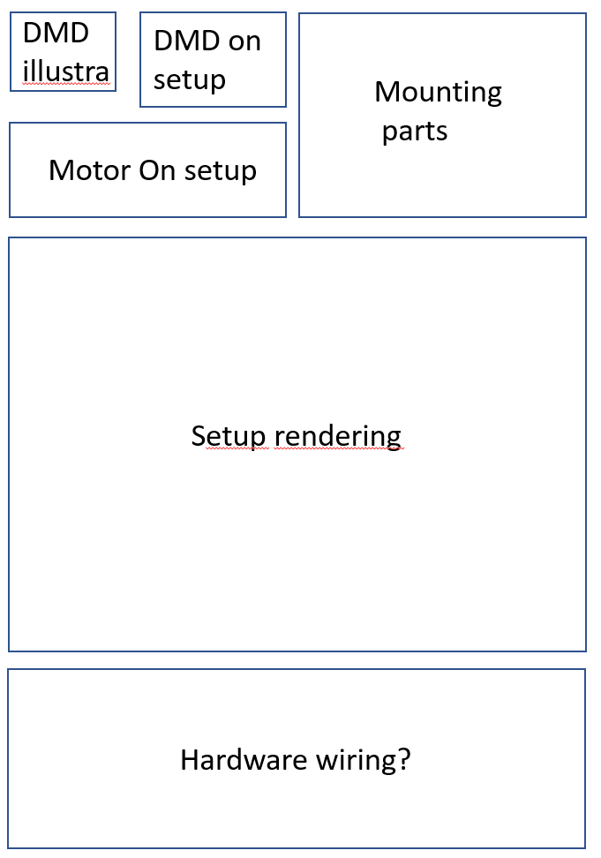

Fig. 1

* New DMD
  + Introduce the new TRP format and tell that it’s the replacement for the “old” pixel scheme
    - todo: timeline for others being deprecated?
  + Compare “old” pixel assignment and TRP
    - “edge” (TRP) versus “corner” illumination (old)
    - new design simplifies mounting, since no longer need to mount DMD rotated at 45 degree angle
    - on/off directions now along different axes
  + Theoretical description; Mathematical model; What’s the difference
    - corner illumination pixels
    - only approximate solutions to joint blaze/diffraction conditions exist, so need new math to handle this case
    - TRP makes more difficult to use on/off mirrors for different colors
  + How to use with multiple colours
    - simulation tools/scripts
    - maybe provide the diffraction solution explorer python GUI with paper
  + Maximum efficiency
  + Implications for other “coherent” microscopy methods
* Two colour SIM setup
  + sketch optical diagram
  + “calculation-driven” design; i.e. calculate angle for new wavelength and adjust 3D laser cutting files “automatically”
  + calculate angles and briefly describe selection of the components
  + Adaptation to different microscopy bodies (e.g. Tubelens + Sampling)

Results

DMD simulation

Some experiments have been done to verify the setup. Firstly, some simulation of the new working principle DMD has been done.

Resolution validation of the setup

The illumination extension is built according to the calculated incident angle of the simulation. The setup is mounted to a Nikon Ti2A microscope body and used with 60x/1.4 NA objective for testing. Firstly, the maximal resolution of the setup has been measured with ArgoLight slide. On the calibration slide, there are a pattern of line pairs with increased distance. After the reconstruction of the data, the line pairs with 120nm distance can be clearly separated, which corresponding to 1.5x resolution enhancement. Based on the result, a fixed sample with multiple fluorescence labelling is used with the setup and the results are shown as in Fig. xxx. Compared to the widefield, the reconstructed image shows a good optical sectioning ability and the cell structure is clearer. The resolution is validated with fourier ring correlation method. It shows the result of xxx v.s xxx nm which is 1.75x better than the widefield.

Critic for 1.5 enhancement

But the setup is limited by the camera sensor chip as well…….

If 1.5 optoval inside, the imaing quality is decreasing.

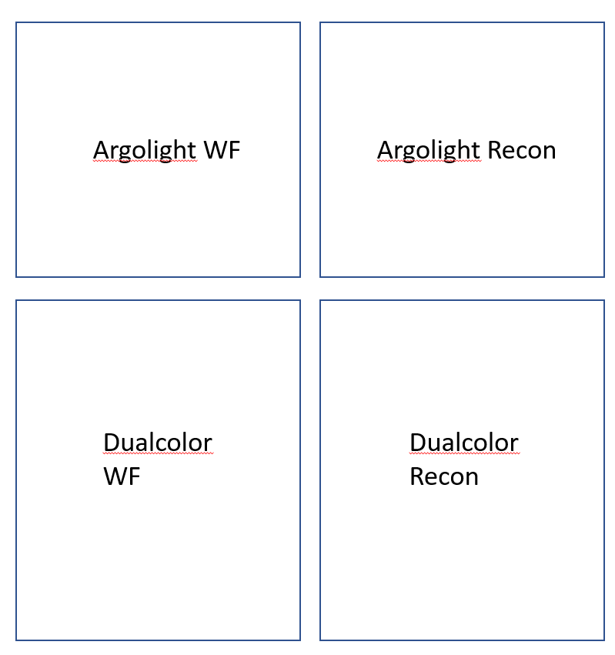

Further ability of the setup

After the validation experiment, there are also some following experiment showing the possibility with the setup to do live cell imaging, z-stack imaging and even real time reconstruction. The results are illustrated in Figure xxx.

* Validation of DMD
  + Efficiency
  + Diffraction: Theory vs. Reality
    - discuss manufacturing tolerances of angles
* Mechanical setup and selection of components
  + Control flow chart
  + DMD Evaluation board:
    - Limitations
    - How to control (e.g. using HDMI, limitations)
  + Lasers
    - Single-mode fiber-coupled lasers + control
  + Housing/Manufacturing
    - “sweet spot” between costs, stability, performance
    - 3D printing, laser cutting, Thorlabs parts
  + Final assembly
    - on Nikon Ti-e 2
    - Zeiss Axiovert ?
* Software
  + Soft- Hardware synchronization
  + GUI to collect and simultaneously reconstruct data in “realtime” => ImSwitch + Napari plugin from Peter
* Experimental results
  + Resolution calibration using Beads/Argolight
  + Multicolour results using dual-stained “Gattacells”
  + Live Imaging? Timelapse
  + Z sectioning
  + large FOV, increased resolution (e.g. 20x/NA0.75)
  + real time reconstruction?

Discussion

In this paper, we present an illumination extension kit designed for structured illumination microscopy. The kit is integrated into a standard commercial fluorescence microscope body to assess its imaging capabilities. Through a series of experiments, consistently reliable results were obtained. The finalized setup remarkably improves resolution, surpassing that of a traditional widefield microscope by a factor of 1.75x.

This extension kit can be effortlessly affixed to microscope bodies with an epi-fluorescence port, enhancing its versatility. The accompanying software simplifies adaptation and usage, making it accessible to users of all levels of expertise.

Moreover, the entire project has been open-sourced, allowing for collaborative contributions. There is a step by step demonstration of building the extension setup with the following link:

Shortage

With the current configuration, in order to get an acceptable result, the single exposure time needs to be longer than 50ms due to the limit of the laser power. According to the properties of the DMD evaluation board, DMD's speed limit has not yet been fully realized. An upgrade to a higher power laser holds the potential to further enhance the setup's operation speed, pushing the boundaries of its performance once again.

* Resolution improvements vs. optical sectioning
* adaptability for different microscopy manufacturers
* Software integration
* speed limitations
* possible to extend to 3D SIM?

Some thoughts:

Github repository:

* Alignment / Build Tutorial:
  + step by step guid á la <https://beniroquai.github.io/tutorials/uc2-tutorial-minibox/>
  + BOM
  + Software installation
  + Calibration points (e.g. compare camera)

TODO’s

Haoran Figures determination

Peter

Rainer

Douglas

Benedict

What is he best order of each part