# A Liposome synthesis

## A.1 Introduction

Liposomes (or lipid vesicles) have been emerged as one of the most advantageous delivery vehicles for the various drugs. They are the spherical structures composed of either a single lipid bilayer or multiple layers separated by aqueous phase. Liposomes can entrap hydrophilic agents into their inner aqueous core and lipophilic ones within the lipid bilayer region(s) [1]. In general, the entrapment efficacy of liposomes for lipophilic agents is always higher than hydrophilic. The reason behind the vesicles formation is the accumulation of lipid molecules that yield entropically favorable conditions of minimal free energy in an energetically favorable manner [2]. Liposome size and size distribution are two important factors for *in vivo* applications. It has been shown that liposomes of size in the range of 100­ to 150 nm have higher potential in order to target them to the tumor sites through the enhanced permeation and retention (EPR) mechanism [3]. To date, there have been several conventional methods developed (e.g., thin film hydration, reverse phase evaporation, ethanol injection) for the liposomes synthesis but most of them involve complex and tedious technique. Here, we present an inexpensive, simple, and rapid approach for preparing monodisperse liposomes. Liposomes can be observed within just 15 min and have a long shelf life. The principle of vesicles formation is based on the diffusion driven process of two miscible phases [4, 5]. The process involves the self-assembly of lipids into liposomes as ethanol speedily diffuses into the aqueous phase. In this method, the size of the liposome can be easily controlled by regulating the temperature parameter.

## A.2 Vesicle preparation

The main components of the experimental are: a small diameter capillary, long needles with glass syringes, and sealants such as paraffin film or wax (Figure A.1). Using syringe-needle assembly, water is first filled up to about 4 cm from the closed end. Lipid phase containing a mixture of lipid-ethanol and water (volumetric ratio of ethanol and water is one) is taken in another syringe and filled up to 4 cm by leaving a small air gap (about 5 mm) between the two phases. In this way, the overall ethanol proportion in the whole solution is maintained at 25% (by volume). However, it can be taken around 30% (by volume) but above this, the vesicle could no longer be retained as small globular shapes appear. The two miscible phases are brought into contact by removing the air gap through another syringe-needle assembly. After generating the interface, the open end of the capillary is sealed with paraffin film or wax. The capillary set up is then kept in an incubator where the temperature is set above the lipid phase transition temperature.

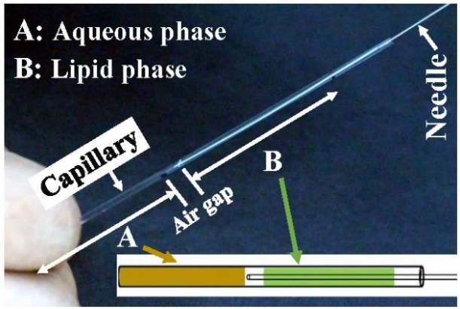

Figure A.1: Capillary setup. The two phases (aqueous and lipid phases) are filled one by one in one end closed glass capillary with keeping a small air gap between them. The air gap is removed using a thin, long needle. Thereafter, the open end is sealed with a sealant.

# B Microfluidic device for generating solute gradients

## B.1 Introduction

There are numerous proposed ways available in the literature for generating a linear chemical gradient. Out of the passive ways of generating steady solute gradient, one is by contacting the source and sink in a controlled manner using chambers. The present study uses a simple and novel passive diffusion-based device which is hydrostatically equilibrated for generating a steady chemical gradient. Hydrostatic equilibration plays a crucial role in alleviating pressure effects which can arise due to many reasons such as the use of PDMS as fabricating material, irregular punching of the reservoir, clogging of channel etc. By hydrostatic equilibration, we could get rid of unwanted convectional flow in the setup. The device as shown in Figure B.1 is a T-shaped microchannel. Either side of the main channel has a reservoir. To acquire hydrostatic equilibration and eventually generate steady gradient, initially the device is filled with water, and all the air bubbles are removed.

The small reservoir connected to the vertical or T-channel is not punched initially because punching at initial state leads to unwanted flow in the vertical channel. This is punctured with a very thin needle to inject the solute having an average dye concentration. It is important that the puncturing should be done very gently so that the thin needle on removal seals back the PDMS channel which is further sealed using vacuum grease to make it full proof. The rationale behind injecting an average solute concentration from the vertical channel is to stimulate the formation of a solute gradient. Further, it also helps in sustaining the linear solute gradient for the much longer duration. Then, the right reservoir is gently filled with an aqueous dye. A very thin layer liquid connecting right and left reservoirs is maintained. The thin film between two reservoirs is important in hydrostatic equilibration. We have taken unduly care to avoid rigorous mixing of two fluids.

***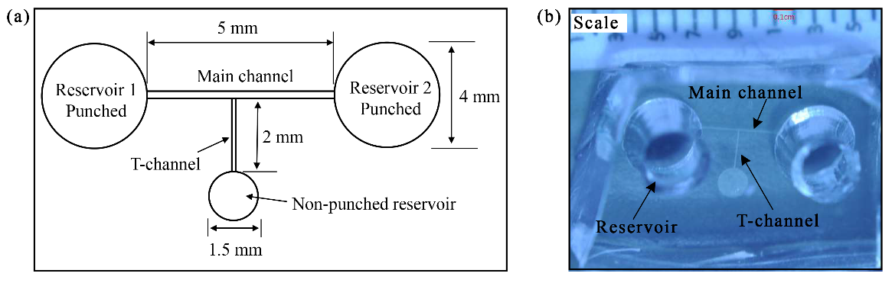*References**

Figure B.1. (a) Representation of the T-shaped microfluidic channel. (b) Snapshot of the fabricated channel. Each division in the scale is 1 mm.

|  |  |
| --- | --- |
| [1] | V. P. Torchilin, "Recent advances with liposomes as pharmaceutical carriers," *Nat. Rev. Drug Discov.,* vol. 4, pp. 145-160, 2005. |
| [2] | D. A. Balazs and W. T. Godbey, "Liposomes for use in gene delivery," *J. Drug Deliv.,* vol. 2011, 2010. |
| [3] | C. Dhand, M. P. Prabhakaran, R. W. Beuerman, R. Lakshminarayanan, N. Dwivedi, and S. Ramakrishna, "Role of size of drug delivery carriers for pulmonary and intravenous administration with emphasis on cancer therapeutics and lung-targeted drug delivery," *RSC Adv.,* vol. 4, pp. 32673-32689, 2014. |
| [4] | S. M. Phapal and P. Sunthar, "Influence of micro-mixing on the size of liposomes self-assembled from miscible liquid phases," *Chem. Phys. Lipids,* vol. 172, pp. 20-30, 2013. |
| [5] | S. M. Phapal, C. Has and P. Sunthar, "Spontaneous formation of Single Component Liposomes from a Solution," *Chem. Phys. Lipids,* vol. 205, pp. 25-33, 2017. |
|  |  |
|  |  |
|  |  |
|  |  |
|  |  |