Open Adventure
FANTASY & SCI-FI ADVENTURE GAME



INTERMEDIATE RULEBOOK

READ THIS BOOK SECOND!

For any number of players ages 10 and up!



KYLE MECKLEM

The OSR logo and OPEN ADVENTURE are released under a Creative Commons Attribution 3.0 Unported License.

Open Adventure

FANTASY & SCI-FI ADVENTURE GAME


Final Author and Editor-In-Chief: Kyle Mecklem  Contributing Authors and Editors: Christopher Cortright, Andy Isbell, Joel Siragher | Illustrations: Rusty Hatfield (front cover) and Christopher Cortright (inside cover). All artwork is released under Creative Commons BY-SA.  Special Thanks: Gary Gygax, Dave Arneson, Aaron Allston, Dave Cook, Tom Moldvay, Frank Mentzer, Rob Kuntz and the RPG community
Copyright 2013-2015 “Open Adventure” and “O.A.” are trademarks of Kyle Mecklem. Illustrations and icons © their respective artists, used with permission. OPEN ADVENTURE is released under a Creative Commons Attribution-ShareAlike CC BY-SA license.
OSR logo is copyright 2011 Stuart Robertson and does not endorse OPEN ADVENTURE.
DOWNLOAD, DISCUSS AND DEVELOP THE OPEN ADVENTURE GAME RULES AT: www.geekguild.com/openadventure
First Printing – June 2015
Part I: Introduction 1
“BIEM” Rulebook Series 1
How to Use This Book 1
Part II: Character Advancements 3
Age 3
Creating High Level Characters 3
Talents 3
Talents List (Alphabetical) 11
Skills 16
Legacy Names 26
Animals & Companions 27
Part III: Equipment & Services 27
Vehicles 27
Using a Vehicle 28
Driving a Vehicle 30
Uncontrolled Vehicles 31
Vehicle Carry & Tow Capacities 32
Fantasy Land Transportation 34
Science-fiction Land Vehicles 35
Spacecraft 37
Party Navigation 40
Part IV: The Adventure 40
Hunting & Gathering Wild Edibles 43
Outdoor Weather 43
Weights & Encumbrance 44
Planetary Gravity 44
Part V: Combat 46
Retreat & Evasion 46
WARNING: This book has been designed to work with the OPEN ADVENTURE Basic Rulebook (blue cover); it cannot be played without the basic rules and does not explain how to play the basic OA game. You must have the Basic Rulebook before you can play with this book.
OPEN ADVENTURE is a role playing game for persons 10 years of age or older. In the game rules, individuals play fantasy or science-fiction characters in a medieval fantasy or science-fiction world where super powers and magic are real, and heroes and heroines venture to unexplored frontiers in search of fame, fortune and conquest. Characters gain experience by overcoming perils, defeating enemies and acquiring lost treasures. As characters gain experience they grow both in power and talent.
At least two people are needed to play OPEN ADVENTURE (OA), though the game can be played solo with a few modifications to the base rules. This game is most enjoyable when played by a group of two to nine people, though in theory any number of players may participate. Unlike other games, this game does not use a board or actual playing pieces. All that's needed to play are these rules, a couple of six-sided dice, pencil and paper, graph paper and a creative imagination. The game is more exciting if figurines, a game mat, and/or dioramas are used, but the game can be played without such visual aids.

“BIEM” Rulebook Series
This book (called the INTERMEDIATE RULEBOOK), is a continuation of the OPEN ADVENTURE BASIC RULEBOOK, allowing characters to join guilds, develop helpful talents and explore the countryside and possibly even other planets and star systems. Most of the information in this rulebook is new, though some rules expand upon information introduced in the basic rulebook. Therefore, you should first have played the basic rulebook and become familiar with it's rules before proceeding to this intermediate rulebook.
Three other rulebooks are available–each book providing more rules for things such as enduring the elements of the wilderness, constructing your own stronghold, ruling your own dominion and more!
The GAME MASTER'S RULEBOOK, (GMR) provides all the details needed to play the OPEN ADVENTURE game. With these rules you can create a fantasy or science-fiction character, explore uncharted frontiers of an imaginary world, uncover lost treasure and have your character battle dangerous enemies.
The GMR should only be read and used by the one player who chooses to take on the role of the game master. To all other players, the contents of the GMR should remain a secret, so as not to spoil the mysteries that lie within.
The third rulebook in the series is the EXPERT RULEBOOK that provides rules pertaining to wilderness survival, food & equipment, tech levels and much more.
The fourth rulebook in the series is the MASTER RULEBOOK that provides rules for high level or powerful characters that wish to build their own stronghold, rule over their own domain, engage in mass combat and much more.
All the rulebooks in the series form together to create one complete system, known as BIEM, for playing a fantasy or science-fiction adventure game. The entire rule-set can be read in one volume known as the COMPLETE RULEBOOK.
OA was designed to be modular, allowing you to use all the rules from each rulebook or only part of the rules. If any rules from the intermediate rulebook directly or indirectly contradict rules in the basic rulebook, use the rules in this book instead. Once familiar with the rules, you are encouraged to create your own enemies, treasures, technology and more, using the rules as a guideline.

How to Use This Book
This rulebook has been divided into six sections.
PART ONE: Introduction, explains generalized information and defines many terms used throughout the game. These and other terms are collected in the Glossary which can be found on page XYZ.
PART TWO: Player Character Creation, explains step-by-step how to create a player character and is listed in easy-to-follow steps.
PART THREE: Equipment & Services, lists all the necessary equipment, weaponry & armor and hired help your character will need before partaking on a high adventure–whether it be deep inside a dungeon or high above the stratosphere.
PART FOUR: The Adventure, is filled with useful information for setting out on a grand expedition for all players.
PART FIVE: Magic, lists supernatural spells and psionic abilities along with a description and pertinent information related to each magic type.
PART SIX: Combat, deals with running into various monsters or aliens which lead to combat.
This rulebook provides an expansion of the rules discussed in the BASIC RULEBOOK of OPEN ADVENTURE, allowing the game master and players alike to extend the capabilities of PCs and NPCs alike and introduce new rules for the game master to use when designing harrowing adventures. Most of the rules in this booklet will be brand new and introduced for the first time here. However, many of the rules discussed within may also be based upon–and continue to advance–rules first discussed in the previous rulebook. Therefore players who wish to use the intermediate rules should first be familiar with the basic rules (rereading all or parts of the BASIC RULEBOOK as needed).
Once the GM has determined you are ready to take on the new responsibilities outlined here, he or she will ask you to carefully and thoroughly read the new abilities and obligations of the player characters.
Once you have committed to memory the majority (if not all) of the rules, it may be prudent for the owner of either books to rearrange the pages in a more logical way. Since both books group the rules by the same categories (introduction, player character creation, equipment & services, etc.) it is possible to cut out individual pages then place them together in a three-ringed binder, folder or notebook by their appropriate sections. The end result would be the culmination of rules from both booklets placed together by magic, combat and so forth.
When cutting individual pages in this matter, it is recommended to use a small modeling knife, razor or other sharp implement and ruler. Align the ruler so it extends from the top edge of the page (closest to the spine of the book) down to the bottom edge. Hold the ruler steady, using it as a guide with which to cut the page with the knife. It is not recommended to simply tear at the page, as this may result in unwanted or unsightly deviations in the tear.
If the owner of either booklet does not wish to remove pages as outlined above, it is recommended to keep both rulebooks–in addition to the GAME MASTER'S RULEBOOK–grouped closely together for ease of use when playing OA.
The Intermediate Rules
Within this OPEN ADVENTURE INTERMEDIATE RULEBOOK you will find new rules that allow the adventuring party to step outside the medieval dungeon or science fiction starbase. The BASIC RULEBOOK served as an introduction to novice players, allowing them to understand how the game world of OA works. Typically the basic rules served as a one or two session long adventure that took place within the controlled confines of a castle, planetary base, underground catacomb or space station.
Now, adventurers can step out into the larger world (or perhaps even the entire galaxy) and take their PCs to new heroic heights. Your character will no longer simply travel from one town or settlement to the next, but must explore the surrounding hills, forests, nebulas and wormholes along the way. Natural obstacles such as rivers, stellar winds, seas and asteroid belts will stand in your adventurer's way. Expedition parties can travel overland, purchase starships, develop exciting new talents, retain friendly animal companions and use new skills to defeat traps, tricks and puzzles–and much more–all discussed here in this booklet.
The party will usually begin exploring their newly endowed rules by taking on a wilderness or stellar based adventure. The GM will also introduce more challenging adversaries, create entire nations and societies, and new and splendid treasures as a reward for the party surviving their campaign and completing their quests. Adventurers may even have the chance to alter the history of the nearby land by shaping the outcome of pivotal events and making new friends and foes along the way.
In this chapter new skills, talents and character capabilities are discussed and listed. The game master may use any number of the rules below, depending on the setting of the adventure or campaign they wish to play.

Age
Most adventurers will begin their journey at a young but suitable age. However, if a player wishes to create a character who is younger or older than usual, they should discuss with the game master about an appropriate age for their character, during character creation.
Races or species may have a lifespan anywhere from a few decades to a few centuries. The game master may decide on an appropriate number of years that each species typically lives before they succumb to old age; then divide the number of years into five equal stages (see the table below).
If a character is older than “adulthood”, they suffer -2 to a physical trait: strength, dexterity or vitality (player's choice) and gain +1 to a mental trait: perception, intelligence or charisma (player's choice) for each stage above adulthood. Characters younger than “adulthood” will have the opposite modification to their traits.
Characters who are exceptionally young (“adolescence” stage or younger) or exceptionally elderly (“elderly” stage or older) suffer two -1's to one or more physical traits and two -1's to one or more mental traits, instead.
Character Age Modifiers
Age Stage | Physical | Mental
Adolescence | +1 | -2
Adulthood | – | –
Middle Age | -2 | +1
Golden Age | -4 | +2
Elderly | -6 | +3
The normal rules to character creation still apply: no primary trait (other than magic) can have less than 1 character point, and no primary trait (including magic) can have more than 10 character points.

Creating High Level Characters
If a player wishes to create a character that begins their adventures at a level higher than level 0, they should follow the normal character creation steps as discussed in the BASIC RULEBOOK except for the following exceptions:
- Instead of beginning with 2d6+3 currency, high level characters begin with a number of silver coins or star credits equal to “experience level^2 x 375” (the character's level multiplied by itself then multiplied by the number 375). FOR EXAMPLE, a character starting at level 3 would have 3375 sc to begin with at the start of the game (3 x 3 x 375 = 3375 sc).
- The character begins with a number of experience points equal to their current experience level, as outline in the BASIC RULEBOOK.
- The character begins with a number of skill points equal to “3 x experience level” plus their intelligence number. FOR EXAMPLE a level 5 character with an intelligence of 6 would start with 21 skill points (3 x 5 + 6 = 21). Assigning skill points to skills follow the standard rules outlined in the BASIC RULEBOOK as well as the rules on page XYZ.
- A character begins with a number of HP equal to their vitality plus the amount allowed by the archetype chosen, multiplied by their starting level. FOR EXAMPLE, an arcanist gains 1d6-1 HP for every level they are promoted. Therefore, a level 3 arcanist with a vitality of 5 would have 5 + 1d6-1 x 3 health points.
- If a character has joined a guild (see page XYZ for details), the player may choose a number of talents equal to the character's level. Only talents equal to or less than the character's rank within the guild may be chosen.

Talents
As characters take on adventures and complete
quests, they will gain experience from their triumphs. As experience points are gained, and new levels attained, characters may develop Talents that they can use in future adventures. A talent is a bonus or special ability that a character may learn as they gain new experience levels. Talents can be used at certain times (depending on the individual talent).
Each of the seven archetypes have a list of talents, arranged in a hexagonal Talent Web (TW), that players may choose for their characters. Talents with similar abilities are located in adjacent hexagon spaces (see page XYZ for an example of a hexagonal talent web).
Each time a character gains a new experience level; the controlling player may choose one talent that is either adjacent to the center space (denoted as the black-colored hexagon) or adjacent to a talent previously chosen for the same character.
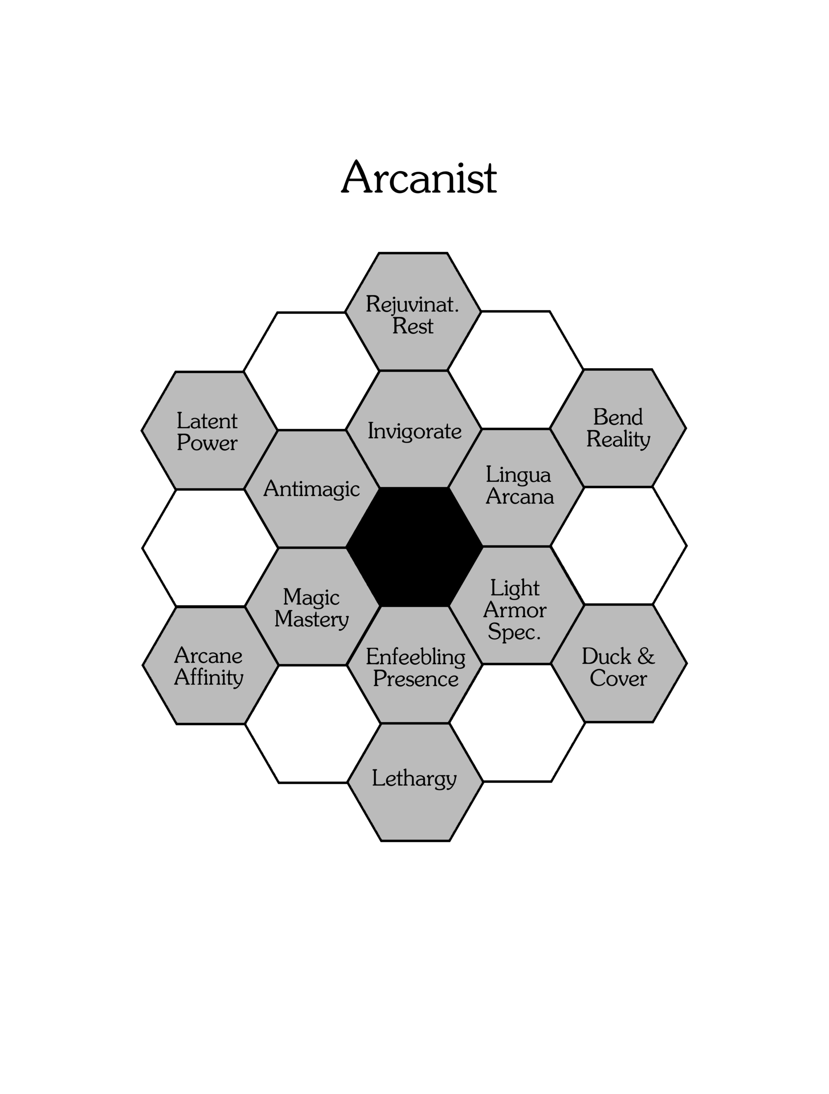
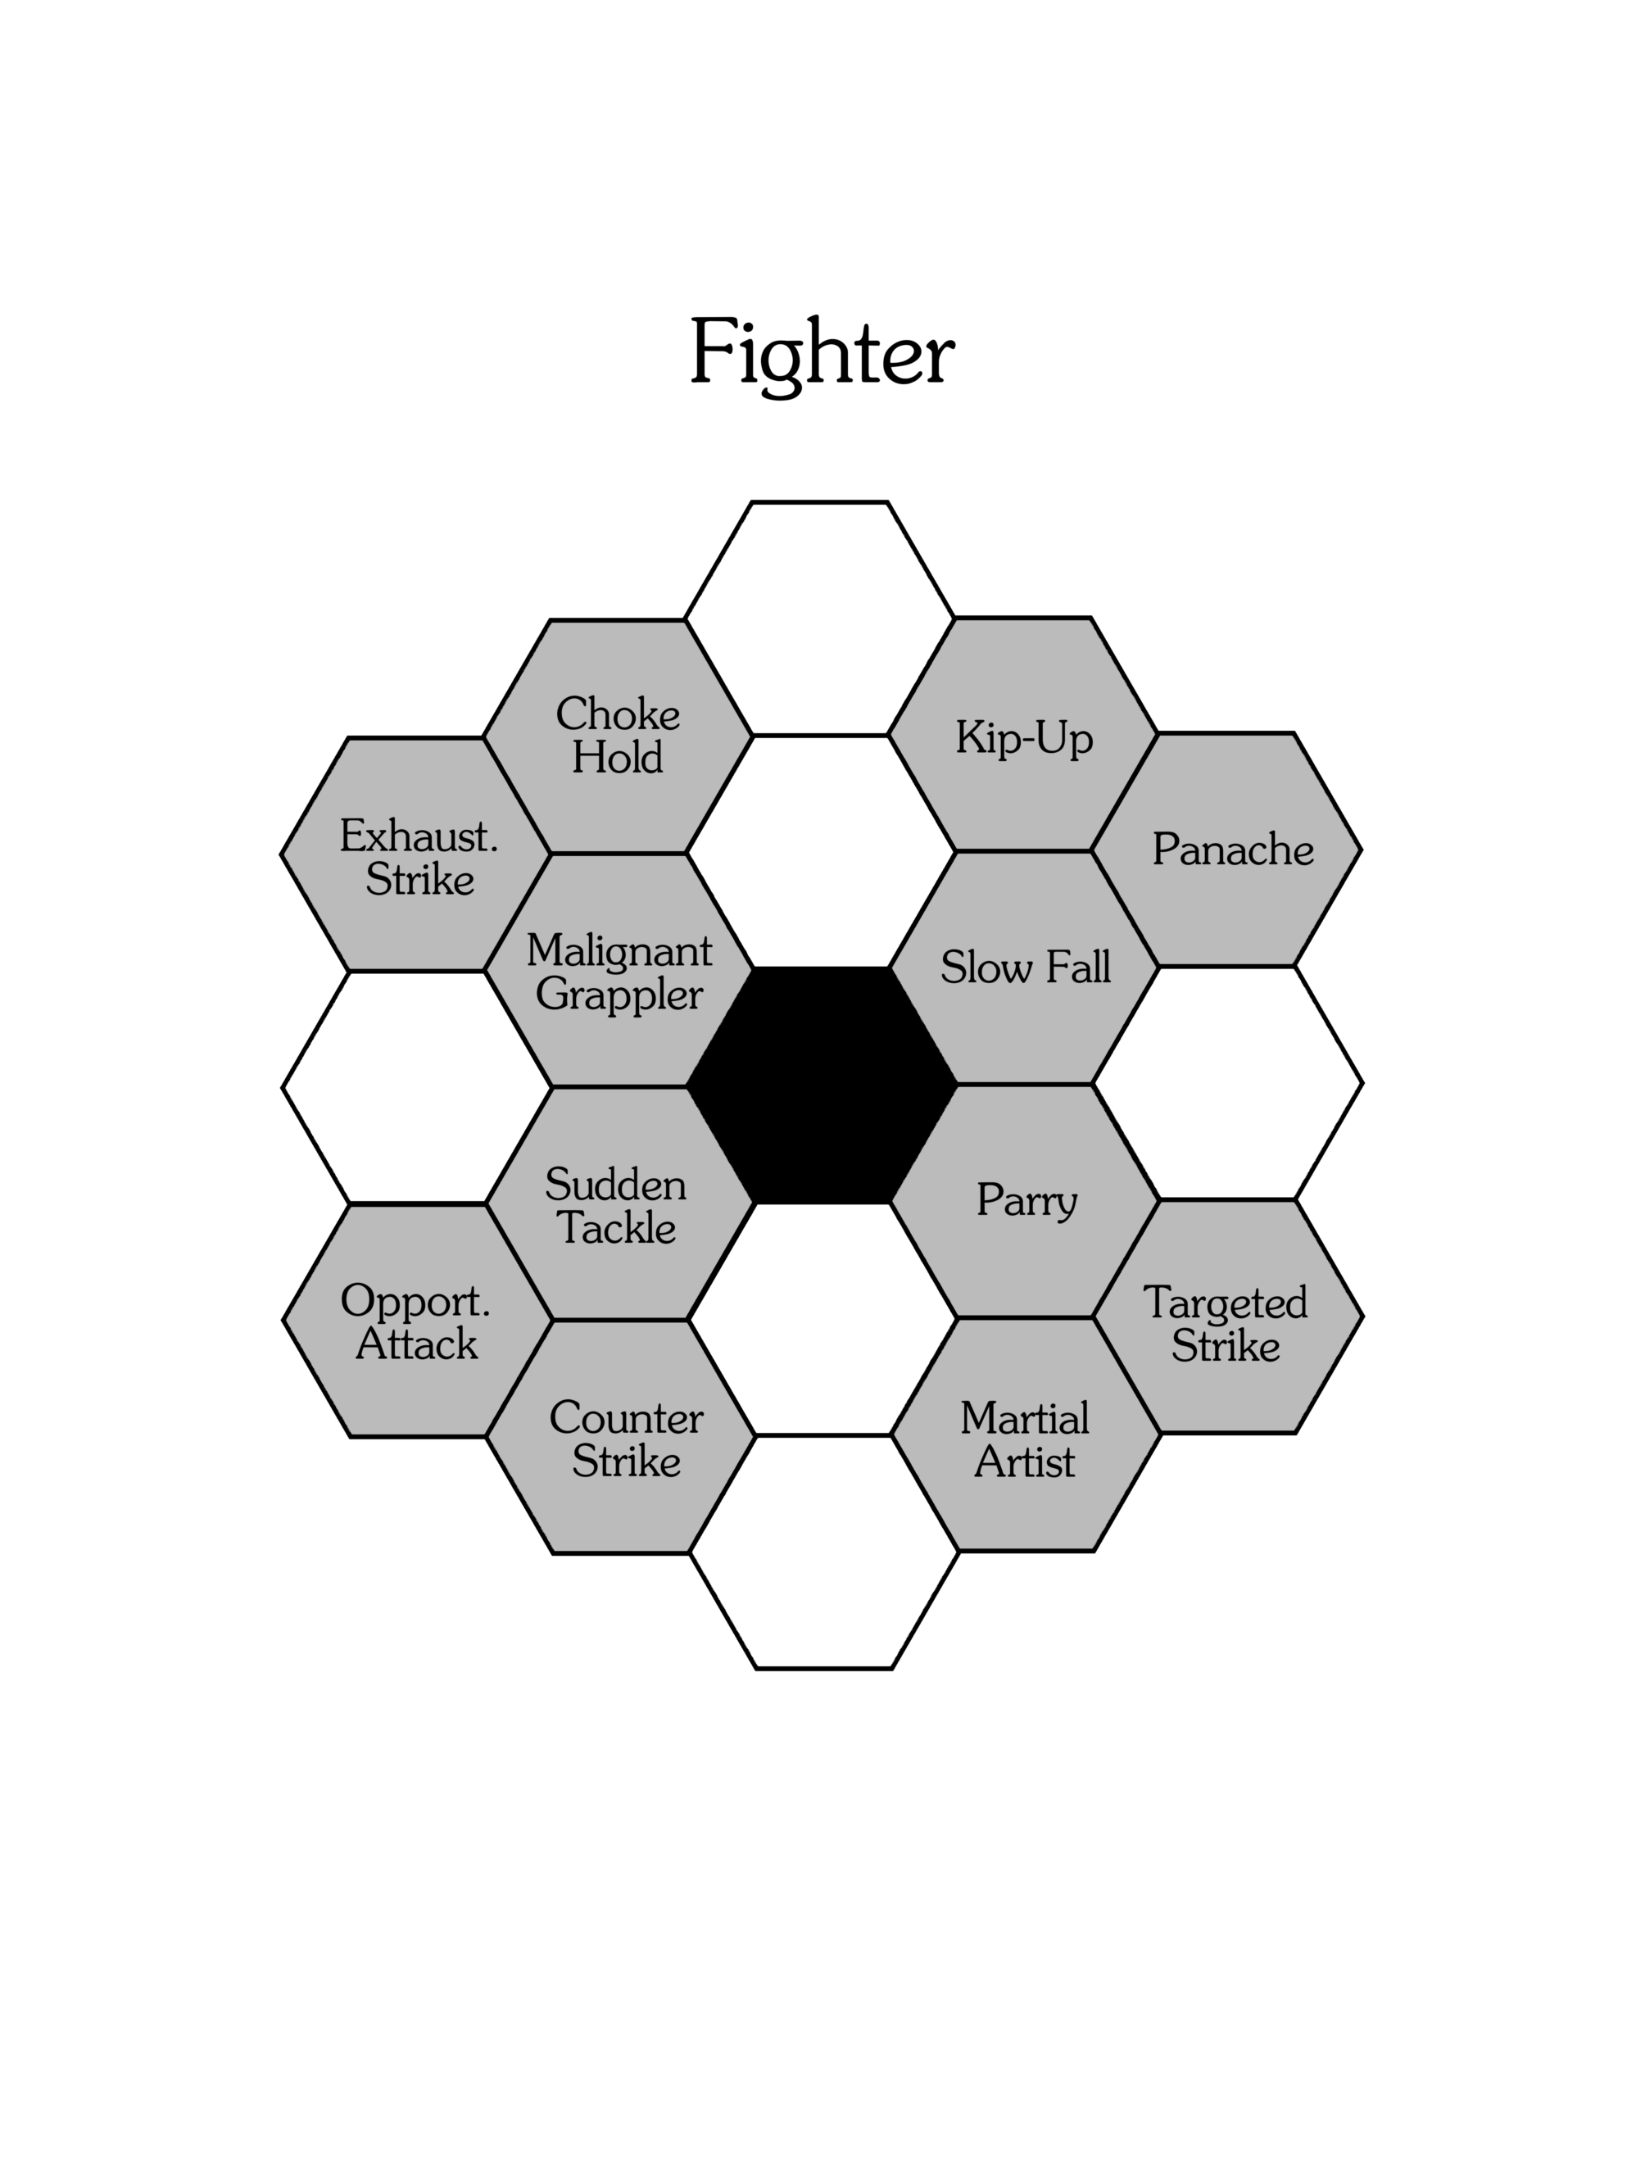
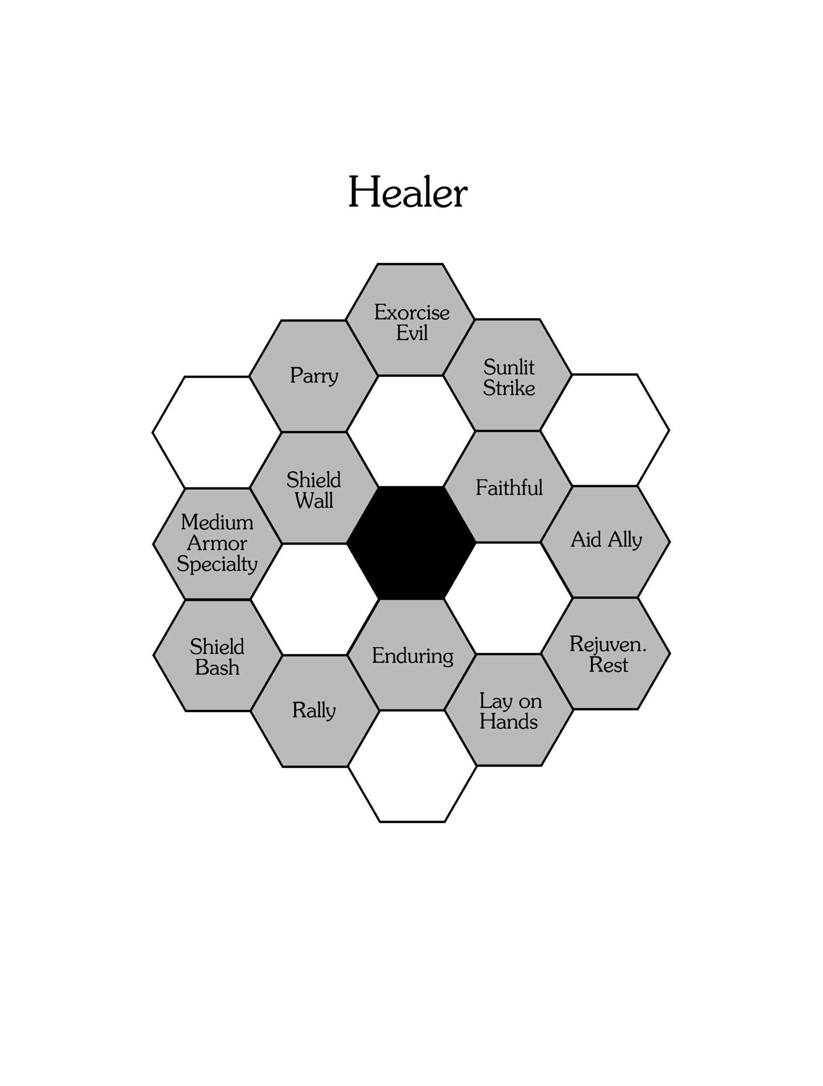
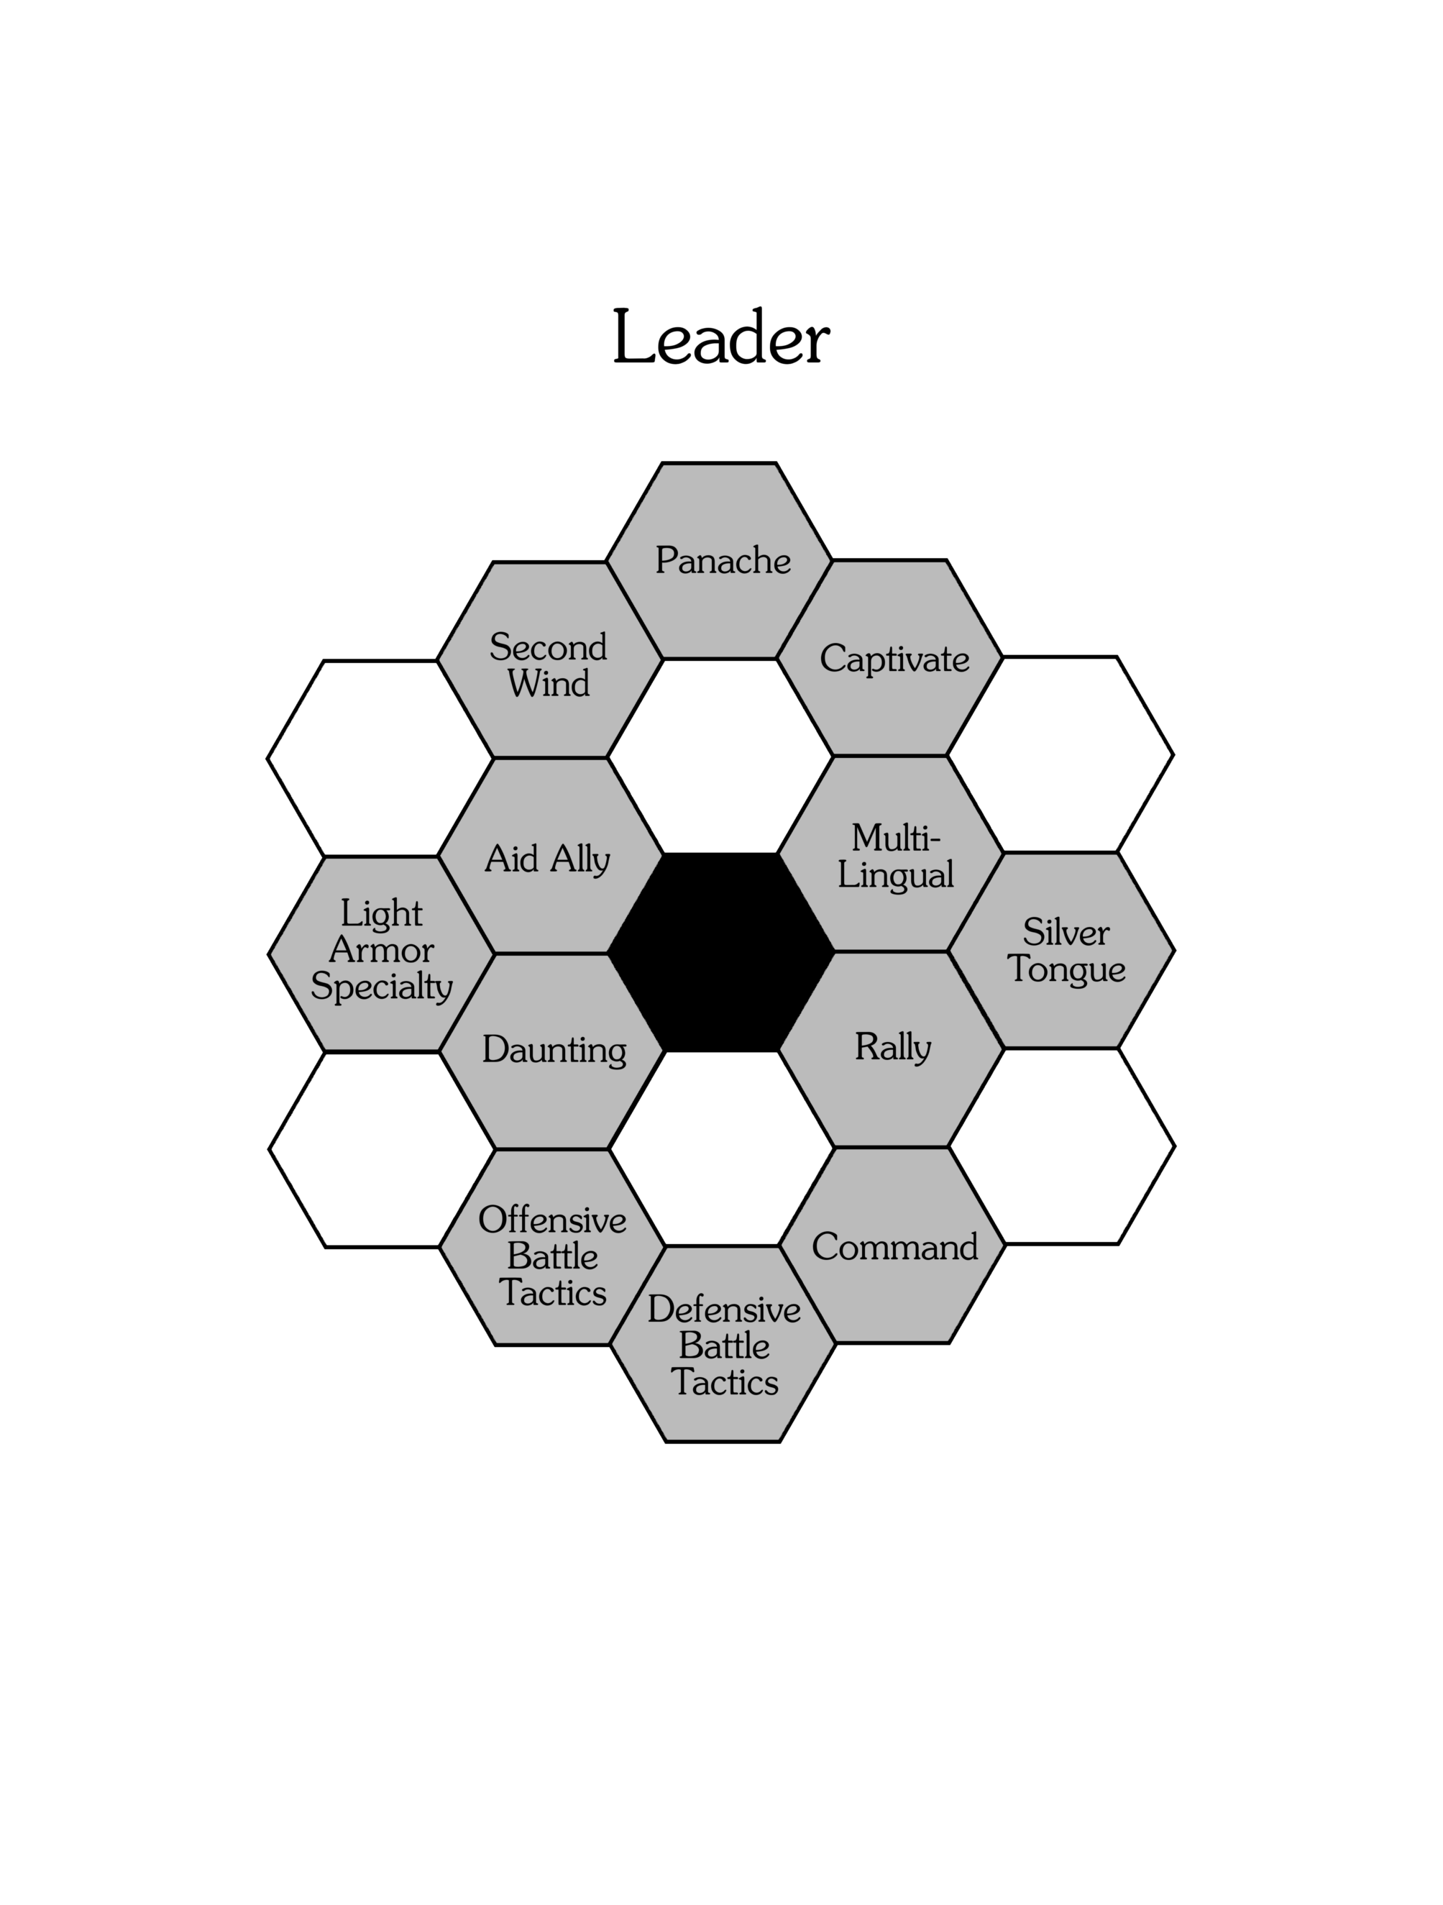
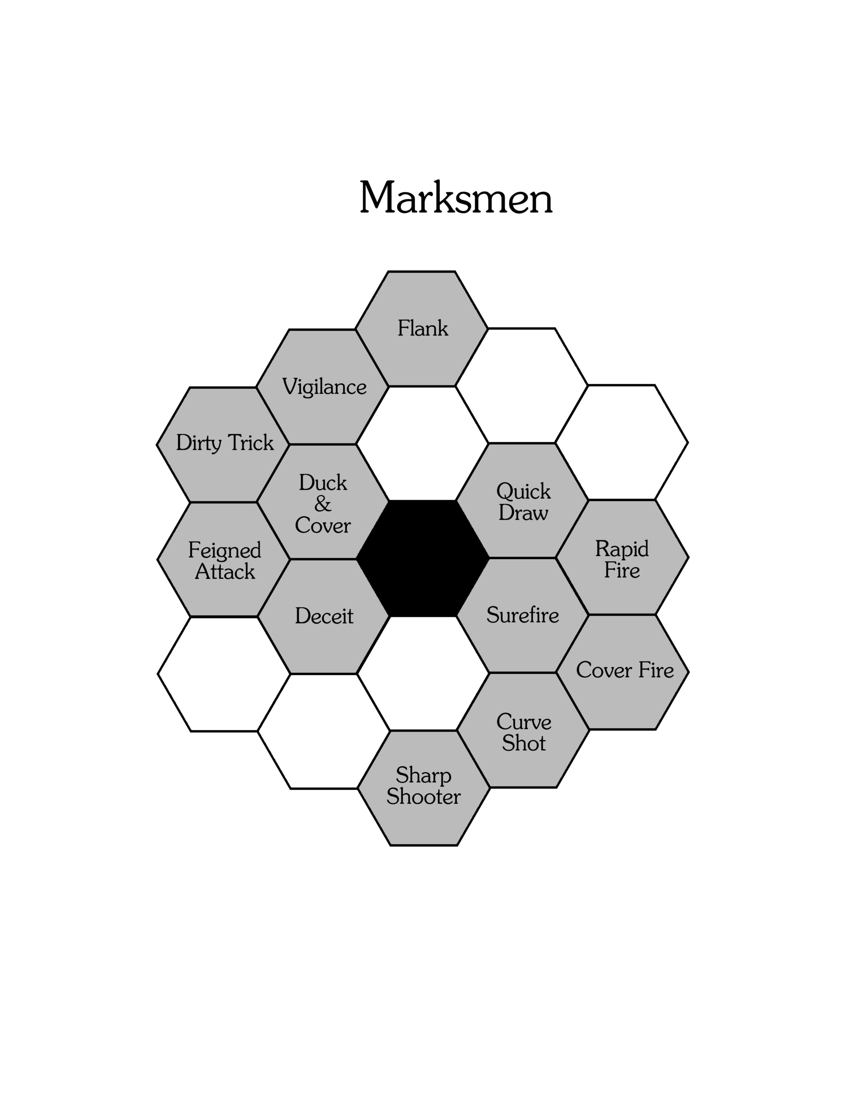
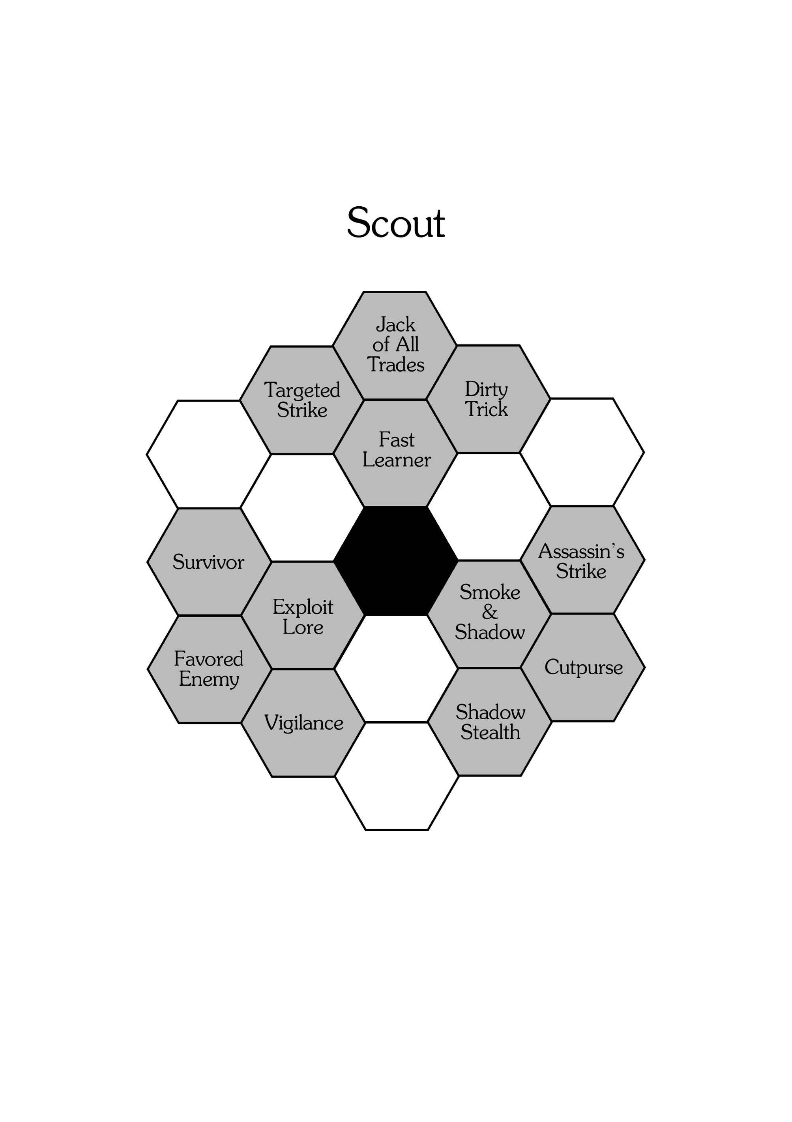
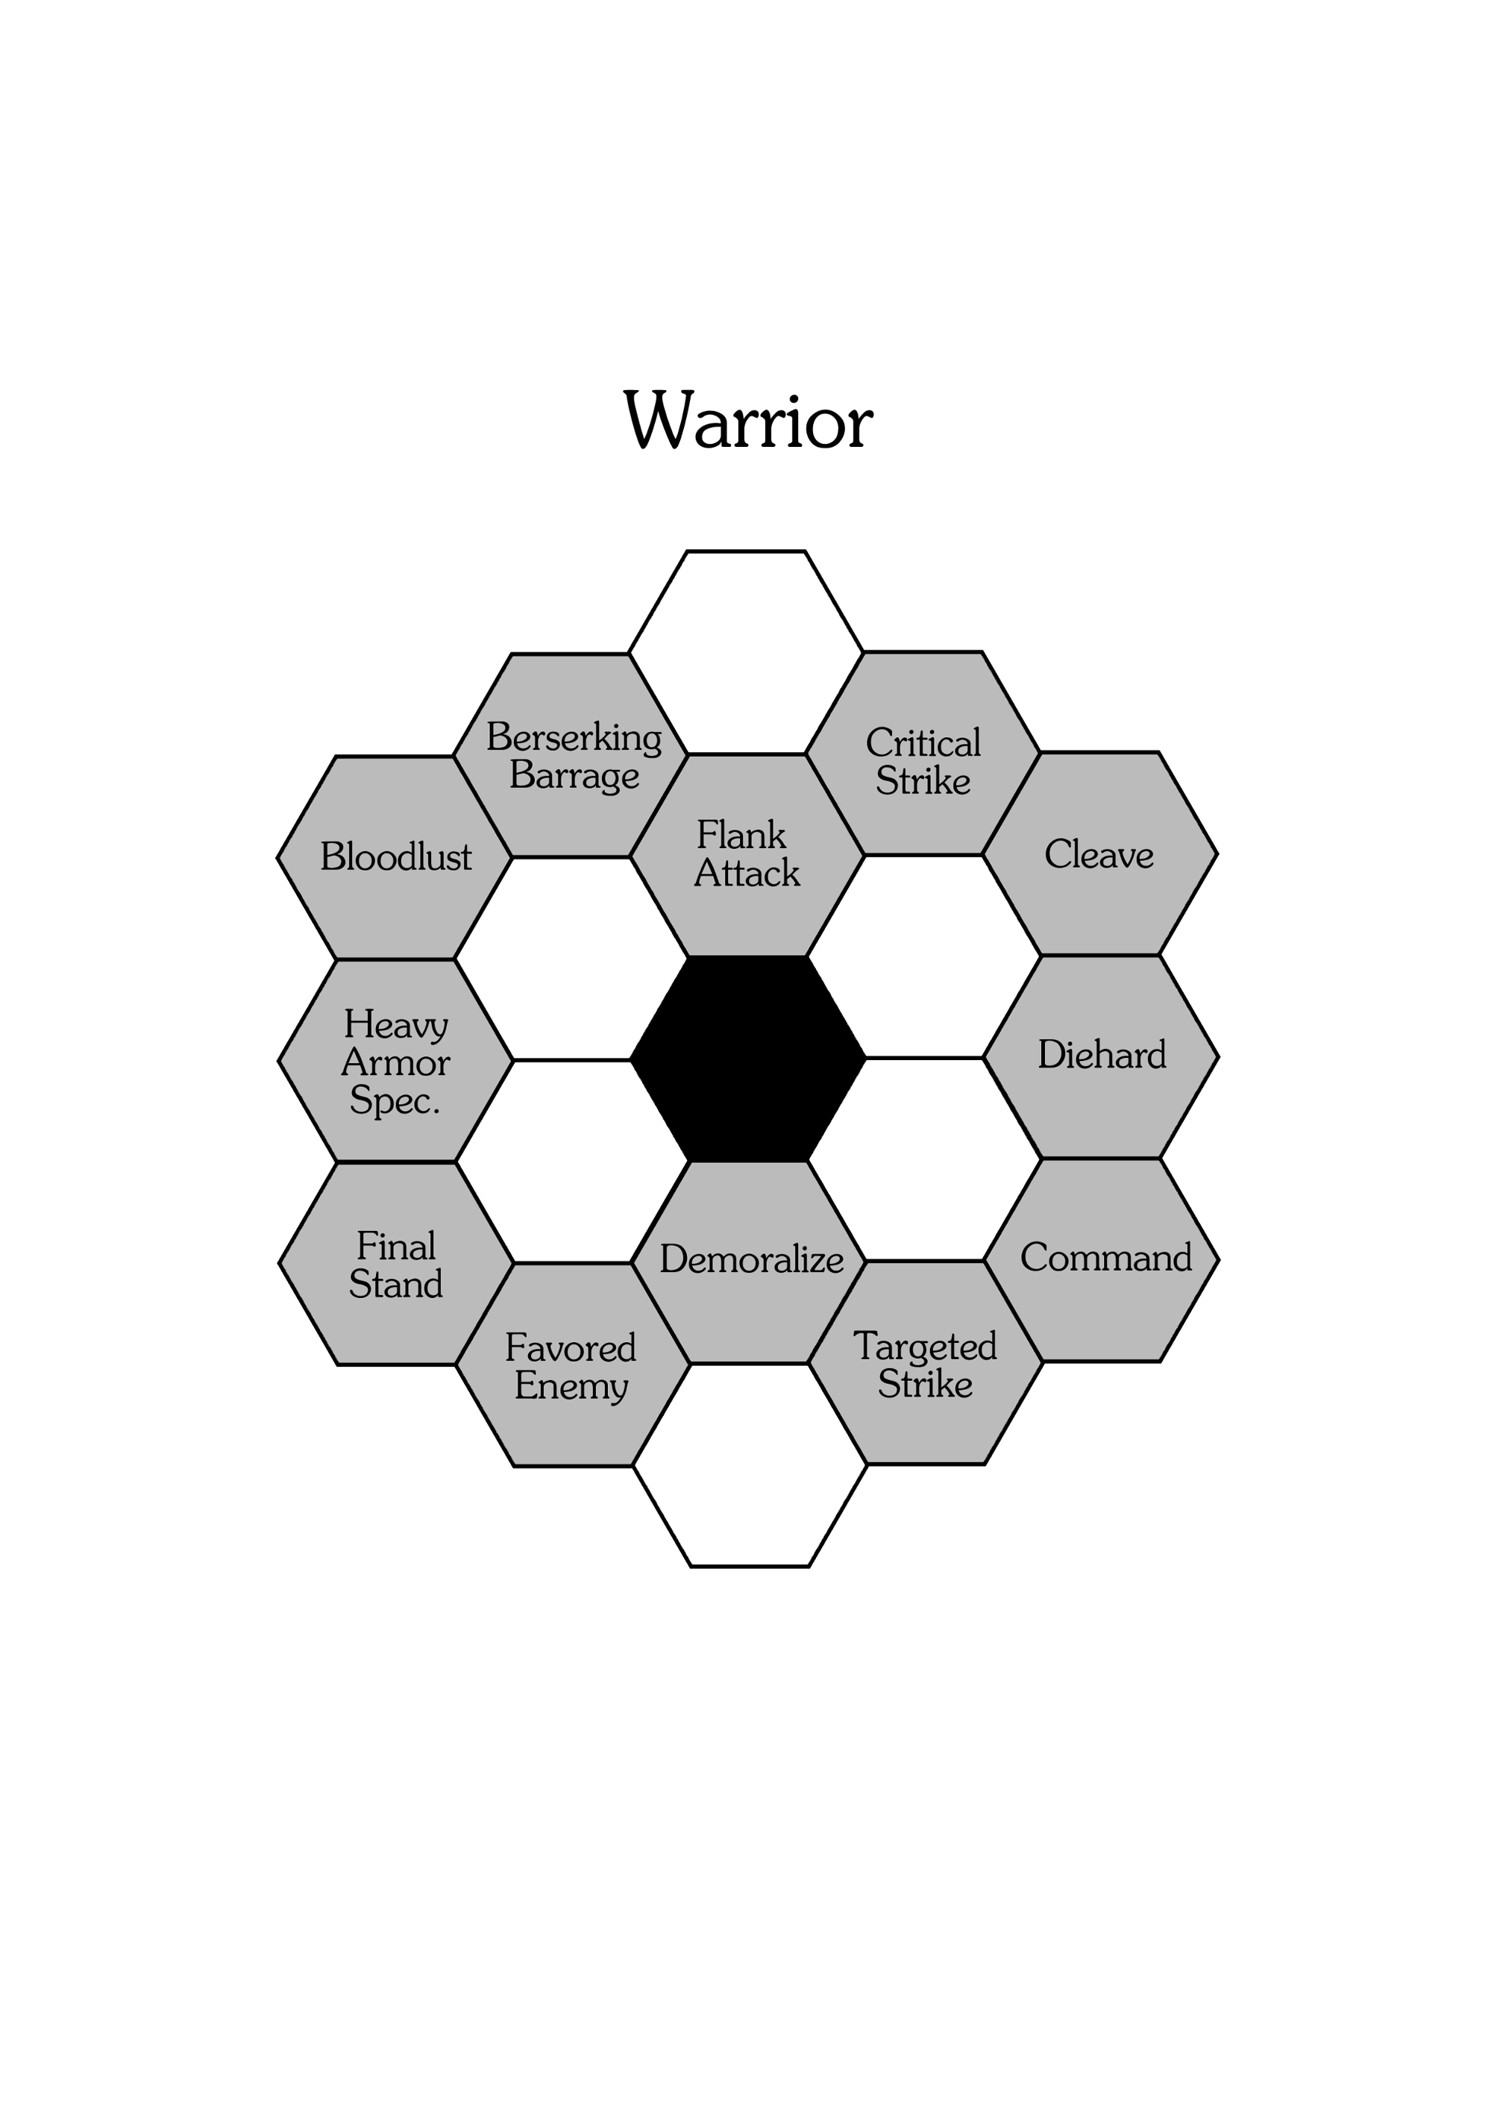
FOR EXAMPLE, once a warrior reaches level 1, the controlling player may choose to have them learn one of the following talents: "enduring", "heavy armor specialty", "flank attack", "critical strike", "cleave" or "beserker barrage". If the character chose the "enduring" talent; at next level promotion they may also choose the "diehard" talent (in addition to the previously eligible talents).
Cumulative Talents
Once chosen, most talents cannot be chosen again. Instead, players must choose a new talent adjacent to a previously chosen talent or the center hexagon. However, some special talents can be chosen more than once. Talents that can be chosen more than once are denoted with the Cumulative ability.
A talent that is cumulative may be chosen by a player more than once–in place of choosing a new talent–no more than three times in total. When a talent with the cumulative ability is chosen two or more times, an exact copy of the talent's abilities are put into effect. In other words, all costs, bonuses and penalties listed by a cumulative talent are applied as if the talent was chosen for the first time.
Certain cumulative abilities will have a focus listed in-between brackets (“[“ and “]”). Talents with a cumulative ability with a focus listed in the above manner can only be used if the character has the listed focus (chosen during character creation, see the BASIC RULEBOOK for details on character foci). FOR EXAMPLE, the “fast learner” talent has a cumulative ability which reads “Cumulative [Alertness]”. Only characters with the alertness focus may use the cumulative ability of the faster learner talent.

Talents List (Alphabetical)
Below is an alphabetically sorted list of talents that characters can gain as they are promoted to new experience levels. This should not be considered an exhaustive list, but rather a sample of what game masters can create for their own adventures or campaigns.
Aid Ally
If an ally is attacking or defending against an enemy character adjacent to yourself; you may force the enemy to make a reflex save: If failed, you may temporarily distract the enemy, as a free action. Distracting an enemy means your ally may either make an aimed attack or dodge as a free action (your choice).
Aid ally must be performed before the targeted enemy and ally make an attack roll. Multiple characters may use aid ally simultaneously; with the possibility of the effects from aid ally occurring multiple times.
Arcane Affinity
When selecting this talent, choose one of the following magic types: “black”, “white”, “blue”, “red”, “green”, “light” or “dark”. The chosen magic type cannot be changed later. You may cast magic of the chosen type as if it were 1 tier lower than it really is. You must still pay the normal cast cost for spells and/or psionics. When casting magic of other types, you must cast magic of those types as if it were 1 tier higher than it really is. This does not affect the cast cost for the spells and/or psionics of those types.
Cumulative [Prestige]: You may choose 1 additional magic type for each time you choose arcane affinity.
Assassin's Strike
You remain hidden & sneaking after performing a surprise attack (except to any characters you dealt 1 or more damage to with your sneak attack).
Antimagic
When selecting this talent, choose one of the follow- ing save types: fortitude, reflex or will. You gain +1 to the save type chosen versus spells, psionics and other magical abilities.
Cumulative: Choose a new or previously chosen save type (in addition to any previously chosen save types). The chosen save type gains the bonuses of antimagic. If the chosen save type was previously chosen, the bonuses for antimagic are cumulative for that save type.
Bend Reality
When selecting this talent, choose one of the following bonuses: Cause target character to suffer -2 to one of their standard rolls, gain +2 to one of your standard rolls, re-roll up to three of your standard rolls (keeping the more favorable roll), gain +1 at a time of your choosing, receive a helpful clue or hint from the GM, perform a delayed action without having to spend a half-turn action to do so or perform one additional action during tactical time.
The chosen bonus cannot be changed later. Once a bonus has been performed up to its alloted amount, it cannot be performed again until a new game day has started.
Beserking Barrage
⬅: You suffer -2 attack while performing an attack with a two-handed melee weapon. Any damage dealt from that attack is doubled.
Bloodlust
: You gain 1⬅ for every enemy you kill, until end of turn and must gain 1 evil alignment points or perform a will save: If failed, you gain 1 evil alignment point.
Bloodlust may only be used once per morning, noon and night.
Captivate
When selecting this talent, choose one performance art. Once chosen, this art cannot be changed later.
After a successful performance skill test of the chosen art, you gain +1 to seduction skill tests against characters who would naturally be attracted to you, for 1 round. You may use your performance art during combat by making a performance skill test: If successful, you may perform a dodge or aimed attack (your choice) as a free action (this affect may only be used once per turn).
Cumulative [Cunning].
Choke Hold
: Target character you are wrestling with must make a fortitude save each turn their wrestling status is not “free standing”: If failed, they suffer 1 suffocation counter.
Cleave
⬅: Immediately after killing a character with a melee weapon, you may make another attack to an adjacent character as a free action.
Command
You gain +1 leadership when retainers under your command make morale tests.
When bargaining for goods and services you may make a separate bargain skill test: If successful, you may lower the asking price by -10%.
Cumulative [Alertness].
Counter Strike
: After target character attacked you with an unarmed attack this turn, but dealt 0 damage, you may perform 1 unarmed attack (of your choice) as a free action, immediately after their attack.
Cover Fire
: You may make a ranged attack as a free action. If your ranged attack would deal 1 or more points of damage, the defending character suffers -2 attack, instead.
Critical Strike
Every time you roll an unmodified +5 on an attack roll while using a one-handed melee weapon, you deal double damage for that attack.
Curve Shot
When making an attack with a one-handed ranged weapon, you have line of sight as if you occupied your current space and all adjacent spaces.
Cutpurse
When performing an unarmed strike, kick or wrestling attack, you may choose to steal an item from the defending character as if your attack roll was a sleight of hand skill test, instead of dealing damage.
Daunting
When making a reaction test or intimidation skill test, you may make two separate rolls and choose the better of the rolls.
Defensive Battle Tactics
⬅: Ally characters within an area 3 region surrounding you may dodge 1 attack that targets them as a free action but suffer -1 attack, for every ally character who is adjacent to them.
The effects of defensive battle tactics end 1 minute after being activated. If a character affected by this talent performs any action other than attack or defend; they immediately lose the effects of defensive battle tactics.
Deceit
: You may re-roll skill tests involving forgery or deception. You must keep the second roll.
Cumulative [Cunning].
Demoralize
: If you dealt 1 or more damage with a two-handed melee weapon this turn, you may force the defending character or characters to perform a will save or morale test: If failed, they suffer 1 fear counter.
Cumulative [Spirit].
Diehard
If you have 0 or less health points, you suffer from the dying condition instead of immediately dying.
Dirty Trick
: Perform an unarmed strike or kick. If the unarmed attack would deal 1 or more points of damage, the defending character suffers 1 confuse, surprise or stun counter or is blind for 2 turns (your choice), instead.
Duck & Cover
: While wearing light armor, you may perform a dodge as a free action. You may move to adjacent space that provides partial or full cover.
Enduring
⬅⬅: You may re-roll a fortitude save test. You must keep the second roll, unless you use enduring more than once (paying the ⬅⬅ cost each time).
Enfeebling Presence
: Target character whose attack targets you suffers -1 until end of turn. Cumulative.
Exhausting Strike
: When performing an unarmed strike or kick, if you dealt 1 or more damage to a defending character, that character suffers -1⬅ in addition to any damage inflicted normally.
Cumulative [Brawn]: The cost to use exhausting strike is reduced by -1.
Exorcise Evil
⬅⬅: Will save: If successful, you inflict 1 fear counter onto 2d6 levels of undead characters or characters with 9 or more evil alignment points that are within range 5 of you. If the undead or evil characters are made up of a mixed group of experience levels, the lowest level characters are affected first.
Each character affected by exorcise evil may make a will save or morale test against a target number equal to your will save test number: If successful, that character is immune to the effects of exorcise evil for this attempt. If failed, they lose a number of  equal the number their will save failed by.
Exploit Lore
⬅: Choose a creature type. Perform a lore skill test concerning the chosen creature type: If successful, you identify strengths and weaknesses against that creature type. You gain +1 when attacking that creature or may perform a dodge action as a free action, until end of turn.
Faithful
⬅⬅: You may use the “bless” spell without paying the required mana cost or memorizing the spell. Faithful may only be used once per day.
Cumulative [Prestige]: If you chose faithful twice, you may use “cure blindness/deafness” instead of “bless” (your choice). This choice may be made each time faithful is used. If you chose faithful thrice, you may use “commune” instead of “bless” or “cure blindness/deafness” (your choice). This choice may be made each time faithful is used.
Fast Learner
You gain +5% additional XP every time you gain XP.
Cumulative [Alertness].
Favored Enemy
When selecting this talent, choose a race or species.
⬅⬅⬅: You gain +2 attack, +2 defense or +2 skill points (your choice) versus the chosen enemy type you selected for favored enemy, until end of turn.
Cumulative [Agility]: The cost to use favored enemy is reduced by -1⬅.
Feigned Attack
: You may perform a deception skill test against a target number equal to target character's sense deception skill number: If successful, your next attack against that character becomes an aimed attack, until end of turn.
Final Stand
⬅: If your health points are equal to or less than ½ the maximum number, you gain +1 or -1 (your choice) to body region rolls, when attacking, for every enemy character that is adjacent to you.
Cumulative [Resilience]: You gain an additional +1 or -1 (your choice) to body rolls.
Flank Attack
⬅⬅: You gain +2 attack when attacking a character who is not facing you at the time of your attack, for this attack only.
If the direction a character is facing is not specified or known, the character is considered to be facing the direction of their last attack, the direction of their last movement or a direction of the game master's choice (in that order).
Jack of All Trades
You may choose one talent from an archetype other than your own that is an echelon level equal to or less than your experience level.
Heavy Armor Specialty
⬅⬅: While wearing heavy suited armor, you may negate all damage from a single attack that targets you, until the end of that attack.
Invigorate
If your HP and SP are at their maximum numbers at the time you cast a spell or psionic, you may gain +1 until end of turn. Invigorate can only be used once per day.
Cumulative.
Kip-Up
⬅: You may perform an acrobatic kick to immediately change from a prone position to a standing position as a free action.
Cumulative [Prestige]: You gain +1 parkour.
Latent Power
Every time you make an attack but do not receive 1 or more , you gain +1 until end of attack.
Lay on Hands
When selecting this talent, choose one of the following conditions: “exhaustion”, “bleed”, “stun”, “unconscious” or “slow”. The chosen condition cannot be changed later. When you succeed at a medicine skill test, you may remove 1 counter of the chosen condition type.
Cumulative [Brawn].
Light Armor Specialty
⬅⬅: While wearing light suited armor, or no armor at all, you may immediately perform 1 dodge action as a free action.
Cumulative: The cost to use light armor specialty is reduced by -1⬅.
Lingua Arcana
You gain +2 language points when attempting to decipher, read or write magic glyphs.
Cumulative [Cunning].
Magic Mastery
You may cast 1 spell or psionic of your choice, that is of a tier equal to or less than your current level, without needing to memorize it. The chosen spell or psionic cannot be changed later.
Cumulative [Alertness].
Malignant Grappler
: While wrestling with a character, you may make that character suffer -1⬅ each time you change their wrestling status.
Martial Artist
When selecting this talent, choose one of the follow- ing combat abilities: “deflect”, “disarm”, “knockout”, “strangle” or “sweep”. The chosen ability cannot be changed later.
⬅: You may perform a special unarmed attack (without kick or strike bonuses or penalties) that has the chosen combat ability–in addition to being capable of dealing damage.
Cumulative: Choose a new combat ability from the choices listed above. When performing this special unarmed attack, it has the new combat ability (in addition to any previously chosen combat abilities).
Medium Armor Specialty
⬅⬅: While wearing medium suited armor, you may perform a sneak attack on target character without the sneak requirement (all other rules concerning sneak attacks apply).
Cumulative: The cost to use medium armor specialty is reduced by -1⬅.
Multilingual
When selecting this talent, choose two different languages. You gain +2 to both languages you chose this way.
Cumulative: You gain +1 language point to a language of your choice.
Offensive Battle Tactics
⬅: Ally characters within an area 3 region surrounding you gain +1 but suffer -1 defense for every ally character who is adjacent to them.
The effects of offensive battle tactics end 1 minute after being activated. If a character affected by this talent performs any action other than attack or defend; they immediately lose the effects of offensive battle tactics.
Opportunity Attack
⬅⬅: You may make an unarmed attack as a free action against any character that performs an action other than attack while in a space adjacent to you, until end of turn. You must be able to target the defending character normally.
Cumulative: You may use opportunity attack an additional time against a new character. You must pay the ⬅⬅ cost each time you use opportunity attack.
Panache
: You gain +2 seduce versus characters who are attracted to you, and +2 performance (of an art of your choice), until end of round. Panache may only be used once per day.
Cumulative: You may use panache an additional time per day.
Parry
⬅: If an attack would deal 1 or more damage to you, you may make a reflex save: If successful, you may move to an adjacent empty space and suffer ½ damage, instead.
Quick Draw
: You gain +2 attack when performing an attack with a two-handed ranged weapon but also suffer -2 on the body region roll. When using hasty shot, the body region roll must be performed.
Rally
⬅: Ally characters within an area 5 region from you recover +1⬅ and gain +1 to their next save test. The effects of rally end one minute after being activated.
Cumulative.
Rapid Fire
⬅: When making a ranged attack, you may perform 1 additional attack as a free action with another ranged weapon equipped in your other hand. This second attack may only be performed once per-turn, and suffers a -2 attack penalty.
Regenerate
Once per hour, you recover 1⬅.
Rejuvenating Rest
You regain lost stamina points at twice the normal rate. This talent does not affect the regenerate talent.
Second Wind
: You recover +1⬅ every minute for 1d6 minutes. This talent can only be used once per day.
Cumulative [Spirit].
Shadow Stealth
⬅⬅: You automatically succeed at sneak for a number of turns equal to your level. If you make an attack or make a noise louder than talking volume, your stealth is immediately broken.
Sharp Shooter
⬅⬅⬅: You may perform one aimed shot with a ranged weapon as a free action, until end of turn.
Cumulative [Agility]: The cost to use sharp shooter is reduced by -1⬅.
Shield Bash
⬅⬅⬅: Once per turn, you may make an attack with your shield as if it were a one-handed improvised weapon, as a free action.
Cumulative [Agility]: The cost to use shield bash is reduced by -1⬅.
Shield Wall
If you and an adjacent ally have shields equipped; you both may spend a full- turn action linking shields to form a defensive shield wall. While using shield wall, you and your ally gain +2 defense, and no attacks from weapons with reach can pass through spaces occupied by either you or your ally. While shield wall is being used, no characters can enter into the spaces you and your ally occupy.
If either you or your ally perform any action, other than defend, after initiating shield wall; shield wall immediately ends.
Silver Tongue
: You gain +2 bargain and +2 persuade against target character, until end of round. This talent can only be used once per day.
Cumulative: You may use silver tongue an additional time per day.
Slow Fall
When falling adjacent to a wall or other solid object; you may perform a reflex save: If successful, you may reduce your falling speed by one-quarter normal speed and reduce the effective distance fallen by -5 spaces.
Cumulative: Reduce your falling speed by an additional one-quarter normal speed and reduce the effective distance fallen by an additional -5 spaces.
Smoke & Shadow
⬅: You gain +2 escape until end of round.
Cumulative [Spirit]: If you chose smoke & shadow twice, you gain “⬅⬅: You gain +2 parkour until end of round”. If you chose smoke & shadow thrice, you gain “⬅⬅: You gain +2 sneak until end of round”.
Sudden Tackle
⬅⬅⬅: If you dealt 1 or more damage this turn from an unarmed attack, you may attempt a running tackle as a free action without the need to move 4 spaces prior.
Cumulative [Resilience]: The cost to use sudden tackle is reduced by -1⬅.
Sunlit Strike
⬅: If your attack would deal 1 or more damage to a character this turn while you are within “full illumination” and using a one-handed weapon, you may inflict +1 damage to the defending character for this attack only.
Surefire
When making an attack with a two-handed ranged weapon, you may ignore characters when determining line of sight.
Survivor
You gain +2 survival of a location of your choice.
Cumulative [Resilience].
Targeted Strike
When making an attack with a one-handed melee weapon, you may choose to use targeted strike. However, you must declare you are making a targeted strike before the attack roll is made.
: If the targeted strike would deal 1 or more points of damage, you may make a body region roll and then consult the effects below, instead:
ARMS – The defending character drops one weapon or item of your choice.
LEGS – The defending character must perform a reflex save: If failed, they are tripped, falling prone.
HEAD – The defending character must perform a will save: If failed, they suffer 1 stun counter.
TORSO – The defending character must perform a fortitude save: If failed, they suffer 1 slow counter.
Cumulative: Targeted strike costs -1 to use.
Vigilance
You gain +2 perception when performing an initiative test.
⬅: You may re-roll a reflex save. You must keep the second roll. Vigilance can only be activated once a day.
Cumulative [Brawn]: You may activate vigilance +1 additional times per day.

Skills
In the BASIC RULEBOOK, characters started at level 0 with skill points from their archetype, race/species and focus selections. Now player and non-player characters begin with an additional number of skill points equal to their intelligence primary trait.
FOR EXAMPLE, a player creates a new character with an intelligence 7. That character would begin with +7 extra skill points (in addition to any other skill points they would start with normally). The smarter a character is, the faster of a learner they are and the more naturally talented they become.
Skill points earned this way may be placed in any of the talents for the strength, perception, intelligence, dexterity or charisma primary traits (player's choice). However, no individual skill may have more than 10 skill points, in total, assigned to it.
Skills List
Strength Skills | Perception Skills | Intelligence Skills | Dexterity Skills | Charisma Skills
Climb¹ | Forgery* | Appraise [Item]* | Climb¹ | Barter*
Escape¹ | Gamble* | Bureaucracy [Subject]* | Defend [Armor] | Deception*
Force Open | Investigate* | Craft [Item]* | Escape¹ | Etiquette [Culture]*
Intimidate*¹ | Listen* | Engineer [Device]* | Hide* | Handle Animal*
Jump¹ | Lock Pick* | Knowledge [Topic]* | Jump¹ | Intimidate*¹
Melee [Weapon] | Navigate [Area]* | Language [Culture]* | Sneak* | Leadership*
Provoke* | Ranged [Weapon] | Lore [Category]* | Parkour | Perform [Art]*
Seduce*¹ | Search* | Medicine | Pilot [Vehicle] | Persuade*
Stalwart | Sense Danger* | Repair [Device]* | Sleight of Hand* | Seduce*¹
Swim | Sense Deception* | Survival [Area]* | Unarmed [Attack] | Teach
* = ability test results are known only to the game master, ¹ = multi-trait skill
Skills With (Parenthesis)
Some skills require a specific area of expertise to be chosen. When this is required, the skill will have a sub-topic listed in parenthesis. Any modifiers for that skill only apply to the sub-topic chosen.
Players should work with the game master to choose an appropriate sub-topic that is appropriate for the adventure the players will engage in. FOR EXAMPLE, the “melee” skill requires a specific weapon type to be chosen. If a player put 3 skill points into the melee skill and chose a bastard sword; their character would gain the bonus from the melee skill–but only when using the bastard sword (other weapons would not receive the bonus). Players may place skill points into the same skill more than once, choosing different sub-topics as desired.
Multi-Trait Skills
A number of skills are listed in more than one primary trait. FOR EXAMPLE, the “jump” skill is listed both under strength and dexterity. Skills of this nature can allow the player to choose which of the primary traits they wish to base the skill off, before performing a skill test. FOR EXAMPLE, a player could choose to perform a jump skill test based off the strength trait–or–the dexterity trait. Players must announce which of the traits they chose before performing the skill test.
Skills List (Alphabetical)

Appraise [Item]
TIME: | 1 minute
TEST RESULT: | ❐ Unknown
REPEATABLE: |  No

The PC with an astute eye for detail may attempt to appraise the target [Item] (such as a piece of treasure, armor, weapon or equipment) to determine an accurate value of it's worth, in coins or credits.
If Successful: |  | If Failed:
The character receives an accurate estimation for the value of the target [item]. |  | The character receives false information or no information.

Balance
TIME: | 1 standard action
TEST RESULT: | ■ Known
REPEATABLE: |  Yes
“Balance” is the skill to stay centered and not fall from a narrow ledge or walkway. It's a character's ability to keep their equilibrium even on unsteady terrain.
If Successful: |  | If Failed:
The character maintains their balance and does not fall. |  | The character falls prone to an adjacent space (of the GM's choosing).

Barter
TIME: | 5 Minutes
TEST RESULT: | ❐ Unknown
REPEATABLE: |  No
“Barter” is the the art of negotiation in an effort to lower the price on an item for sale or trade. This ability can only be done once per merchant per day.
If Successful: |  | If Failed:
The price of a specific item, weapon, armor etc. is reduced by 10% (rounded down). |  | The price of a specific item, weapon, armor etc. is increased by 10% (rounded down).

Bureaucracy [Subject]
TIME: | 5 days
TEST RESULT: | ❐ Unknown
REPEATABLE: |  No
“Bureaucracy” is the skill to negotiate with people of a certain organization or individual [Subject] to successfully pull favors, win respect or accomplish tasks. A PC good at bureaucracy is good at negotiating the “red tape” or an organization.
If Successful: |  | If Failed:
The character achieves a minor favor or task using the power and will of a particular [subject]. |  | The [subject] does not agree to perform a favor or action for the character.

Climb
TIME: | Instant (free action)
TEST RESULT: | ■ Known
REPEATABLE: |  Yes
“Climb” represents the proficiency in climbing difficult slopes or sheer walls. See the BASIC RULEBOOK for details on climbing. This skill test should be repeated at the beginning of every turn a character is hanging on a wall unsupported. Climbing is treated as moving on vertical terrain.
If Successful: |  | If Failed:
The character is able to climb a wall for this turn. |  | The character falls. See the BASIC RULEBOOK for details on falling.
Craft [Item]
TIME: | See below
TEST RESULT: | ❐ Unknown
REPEATABLE: |  No
“Craft” represents hands-on expertise at creating something such as:
- Set Trap
- Construct Item
SET TRAP: Allows a character to set a trap. Must have a trap kit (see the BASIC RULEBOOK) to use. Craft can only be used on an adjacent empty space.
CONSTRUCT ITEM: The character can craft an item such as armor, a weapon or a piece of equipment.
The time required to use this skill depends on the individual items.
If Successful: |  | If Failed:
The character builds a trap that is only visible to him or her (unless seen through a search ability) or constructs an [item]. |  | The trap or [item] is not built and any trap kits used are destroyed.

Defend [Armor]
“Defend” is a character's ability to defend themselves from incoming attacks through parry and evasion. Character's ability to defend themselves is affected by the type of [armor] they're wearing at the time. The bonuses from this skill only apply to the specific [armor] type chosen by the player. Wearing no [armor] is considered a valid armor type.
Depending on the number of skill points placed in the defend skill, the character gains the following ability (only one ability may apply):
Skill Points | Ability
2 | ⬅⬅⬅: +1 Defense until end of turn
4 | ⬅⬅: +1 Defense until end of turn
6 | ⬅: +1 Defense until end of turn
8 | ⬅⬅: +1 Defense until end of turn
10 | ⬅: +1 Defense until end of turn

Deception
TIME: | 1 full-turn action
TEST RESULT: | ❐ Unknown
REPEATABLE: |  Yes
“Deception” is the dark art of misleading or lying to people. Deception can only be performed on a target NPC (but not on player characters). The TN for deception is equal to the NPC's “sense deception” skill.
If Successful: |  | If Failed:
The character successfully deceives target NPC. |  | The target NPC is not deceived. The GM will perform a reaction test for the NPC.

Engineer [Device]
TIME: | See below
TEST RESULT: | ❐ Unknown
REPEATABLE: |  No
“Engineer” is a broad set of skills encompassing several smaller engineering abilities:
- Enable/Disable Device
- Operate Device
ENABLE/DISABLE DEVICE: A character may attempt to arm or disarm a trap or enable or disable a mechanical device.
OPERATE DEVICE: A character may attempt to use or hack into a device or machine such as a computer or starship station (see page XYZ for information on starship stations).
The time required to use this skill depends on the individual items (determined by the GM).
If Successful: |  | If Failed:
The character successfully disables or operates a device. |  | The trap is triggered, not disabled or the [device] is not operated. REFLEX SAVE: if failed, the [device] breaks.

Escape
TIME: | 1 round (10 Minutes)
TEST RESULT: | ■ Known
REPEATABLE: |  Yes
“Escape” represents a character's ability to free themselves from restraints such as cuffs or shackles. It also entails breaking free of prison or jail cells.
If Successful: |  | If Failed:
The character successfully escapes their bonds. |  | The character does not escape. REFLEX SAVE: if failed, the character has broken the device preventing it from opening or unlocking.

Etiquette [Culture]
TIME: | See below
TEST RESULT: | ❐ Unknown
REPEATABLE: |  Yes
“Etiquette” involves understanding and performing the finer points of respect (through words and action) as viewed by a particular [culture] or society.
The time required to use this skill depends on the type of etiquette being performed.
If Successful: |  | If Failed:
The GM will make a reaction roll with a number of +1 modifiers equal to the number of points over the TN needed to succeed at the etiquette skill. This roll will determine the response from the patrons of that [culture]. |  | The GM will make a reaction roll with a number of -1 modifiers equal to the number of points under the TN needed to succeed at the etiquette skill. This roll will determine the response from the patrons of that [culture].

Force Open
TIME: | 1 minute
TEST RESULT: | ■ Known
REPEATABLE: |  Yes
“Force open” is a character's ability to bend bars, lift gates or bash open an item such as a door, chest or lock.
If Successful: |  | If Failed:
The adventurer successfully forces a stuck or locked door or object open. |  | The device does not open. REFLEX SAVE: If failed, the door is permanently broken in a locked or stuck state–or–the contents inside are destroyed or damaged.

Forgery
TIME: | See Below
TEST RESULT: | ❐ Unknown
REPEATABLE: |  No
“Forgery” is the art and science of crafting a fake or counterfeit article to pass off as the real thing. Because of it's intricate work, it requires an eye for detail.
The time required to use this ability depends on the object being counterfeited.
If Successful: |  | If Failed:
The character creates a fake item that will be accepted as genuine from any character with a perception equal to or less than the forgery number rolled by the character. |  | The item looks suspicious by anyone who gives it more than a passing glance.

Gamble
TIME: | 1 Minute
TEST RESULT: | ❐ Unknown
REPEATABLE: |  Yes
An adventurer who is good at gambling can become wealthy, indeed! When gambling by playing a game of aular (see page XYZ for rules on aular); players will receive a number of positive or negative modifiers equal to the number of points that they succeeded or failed the gambling target number. These modifiers are used to either help or hinder a gambler's outcome by applying the results to the dice rolled. FOR EXAMPLE, if a character failed their gambling skill test by -2, any winning dice could be changed by the GM by up to two places (for one or more dice rolled).
For all other gambling games, treat gamble as a normal skill test.
If Successful: |  | If Failed:
The character succeeds at gambling–or if playing aular–receives that many +/- 1's applicable to the dice rolled in the character's favor. |  | The character fails at gambling–or if playing aular–receives that many +/- 1's applicable to the dice rolled NOT in the character's favor.

Handle Animal
TIME: | 3 Hours
TEST RESULT: | ❐ Unknown
REPEATABLE: |  No
“Animal Handle” is the innate skill of being able to calm and communicate non-verbally with a creature of less-than humanoid intelligence. The target number to succeed is equal to “10 – intelligence” of the animal.
If Successful: |  | If Failed:
Target animal becomes a retainer to the handler (see the BASIC RULEBOOK for information on retainers). |  | The GM performs a reaction test, using the result from the animal handling test as the result of the reaction.

Hide
TIME: | 1 Standard Action
TEST RESULT: | ❐ Unknown
REPEATABLE: |  No
“Hide” is the skill to blend into a background or hide in a dark corner. A character must not be adjacent to an enemy when making a hide test. If an enemy moves adjacent to a hiding character, the character must succeed at a new hide skill test vs the enemy's search skill, or immediately become noticed.
If a hiding character attacks or moves to another space, they are no longer considered hiding.
If Successful: |  | If Failed:
The character hides well enough to be unnoticed by any character with a search skill equal to or less than the hide number rolled by the hiding character. |  | The character can be seen normally as if not hiding at all.

Intimidate
TIME: | 1 Full-Turn Action
TEST RESULT: | ❐ Unknown
REPEATABLE: |  Yes
“Intimidate” is the ability to scare off or intimidate an enemy. When performing an intimidate skill test, a character is using their physical looks, posture, war cry or other faculties to persuade one or more NPCs to flee in fear.
For rules purposes, a character can yell a maximum number of spaces equal to “10 x SP” (stamina points). Individual words to be understood at ½ the distance (in spaces) or less.
If Successful: |  | If Failed:
Any enemies within line of sight and hearing range of the character must make a morale check. |  | No enemies are intimidated.

Investigate
TIME: | 10 Days
TEST RESULT: | ❐ Unknown
REPEATABLE: |  Yes
To “investigate” something means for a PC or NPC to spend several days talking with other people, looking up relevant documents and following leads that may reveal the truth about a particular topic.
If Successful: |  | If Failed:
The game master reveals to the character a helpful hint or clue regarding the investigated topic. |  | The character receives false information or no information.

Jump
TIME: | 1 Standard Action
TEST RESULT: | ■ Known
REPEATABLE: |  Yes
“Jump” is the ability to leap great distances such as across pits or over obstacles.
At the GM's discretion, the optional encumbrance rules (page XYZ) affect a character's jump distance. See page XYZ for additional rules about jumping.
If Successful: |  | If Failed:
The character makes a successful jump. |  | The character falls prone onto a space they were attempting to jump over or above.

Knowledge [Topic]
TIME: | 1 Minute
TEST RESULT: | ❐ Unknown
REPEATABLE: |  No
“Knowledge” is the ability to recall from memory details about a particular [Topic] or subject. Common knowledge topics are related to a:
- Character
- Area
- Object
Players who are looking to learn more information about a particular topic should test to determine if their PC possesses helpful knowledge about the subject.
If Successful: |  | If Failed:
The GM provides the player with a helpful hint, insight or clue about the [Topic]. |  | The character receives false information or no information.

Language [Culture]
TIME: | Instant (Free Action)
TEST RESULT: | ❐ Unknown
REPEATABLE: |  No
There are many languages spoken by characters, depending on their race or species and [Culture]. There is also a “common” language shared by most characters throughout the world and galaxy.
A character must have at least 1 point in the specific language they heard or read before attempting this ability test.
For details concerning languages, see page XYZ. Note that guild languages do not need to be tested and are automatically understood by any character who would possess the appropriate knowledge.
If Successful: |  | If Failed:
The player understands the written or spoken language. |  | The character receives false information or no information about what was said or read.
Leadership
TIME: | Instant (Free Action)
TEST RESULT: | ❐ Unknown
REPEATABLE: |  No
“Leadership” is the natural ability to raise the spirits and morale of those around you. With a high leadership, an adventurer can convince a retainer to remain loyal to them and their cause.
If Successful: |  | If Failed:
Target retainer hired by the character or target animal handled by the character succeeds at their morale test. |  | Target retainer hired by the character or target animal handled by the character fails at their morale test.

Lock Pick
TIME: | 1 Round (10 Minutes)
TEST RESULT: | ❐ Unknown
REPEATABLE: |  Yes
“Lock pick” represents the proficiency in manipulating pins and tumblers to open a lock without a key.
If Successful: |  | If Failed:
The lock being picked opens. |  | The lock being picked does not unlock. REFLEX SAVE: If failed, the lock breaks and is permanently stuck shut. It can never be successfully picked.

Lore [Category]
TIME: | 1 Minute
TEST RESULT: | ❐ Unknown
REPEATABLE: |  No
“Lore” is the amount of knowledge a character possesses about a broad [Category] or subject. Unlike a knowledge ability test, lore pertains to general fields of study and the overarching characteristics of the category being investigated.
Common lore topics include:
- Engineering  - Geography  - History  - Cosmos / Planes | - Nature / Science  - Animals / Aliens  - Culture  - Religion

If Successful: |  | If Failed:
The GM provides the player with a helpful hint, insight or clue about the [Category]. |  | The character receives false information or no information.

Listen
TIME: | 1 Full-Turn Action
TEST RESULT: | ❐ Unknown
REPEATABLE: |  Yes
“Listen” is the ability to hear distant or quiet noises. Characters may listen intently near closed doors or long hallways for approaching enemies or other hushed activities.
See page XYZ for additional rules about listening.
Characters cannot attempt to listen during a noisy event such as battle.
If Successful: |  | If Failed:
The character hears any noises within range that can be heard from their location. |  | The character hears misleading sounds or no sound at all.

Medicine
TIME: | 1 Round (10 Minutes)
TEST RESULT: | ■ Known
REPEATABLE: |  No
“Medicine” is the practice of healing and nurturing. A character who practices medicine can remove adverse conditions, diagnose the source of ailments and heal wounds.
When healing lost HP, a character may only be healed once until their HP is restore to maximum.
If Successful: |  | If Failed:
The character removes 1 condition counter–or–diagnoses 1 ailment–or–heals a character for 1d6-1. |  | The character is unable to help a PC or NPC. WILL SAVE: If failed, the targeted character suffers 1d6-1 damage.

Melee [Weapon]
“Melee” is a character's proficiency with non-ranged weapons fighting. A specific [Weapon] type must be chosen for each +/-1 modifier. Once chosen, the modifiers cannot be changed and only apply when that weapon type is being used.
For each point placed in “Melee”, a character receives a +1 Attack when using the weapon-type chosen.
Navigate [Area]
TIME: | 5 Minutes
TEST RESULT: | ❐ Unknown
REPEATABLE: |  No
A character's ability to navigate a certain [Area] can prove invaluable. Common area types include:
- Underground / Building
- City / Urban
- Sea / Underwater
- Overland (see page XYZ)
- Outer-Space (see page XYZ)
Character's who fail to navigate properly can become lost. See page XYZ for additional navigation rules.
If Successful: |  | If Failed:
The character correctly navigates the given area for 8 hours. |  | The character becomes lost (see page XYZ).

Perform [Art]
TIME: | See Below
TEST RESULT: | ❐ Unknown
REPEATABLE: |  No
“Perform” is the ability to entertain guests and engage in a delightful (and often visually appealing) activity for the benefit of others.
Common performance [Art]s include:
- Singing  - Instrument Playing  - Jester / Comedy  - Natural Talent | - Acting  - Dancing  - Magic Trick  - Prostitution
Other art-related activities such as painting or sculpting should be attempted with a craft ability test. The time required to use this ability depends on which art is being performed.
If Successful: |  | If Failed:
The performing character receives +3 charisma for 1 hour. |  | The performing character suffers -3 charisma for 1 hour.

Persuade
TIME: | 5 Minutes
TEST RESULT: | ❐ Unknown
REPEATABLE: |  No
“Persuade” is the art of convincing, encouraging or enticing an NPC to carry out your bidding. No character will engage in an activity that puts themselves or their allies in direct danger.
See page XYZ for rules on retainers, loyalty points and morale tests.
If Successful: |  | If Failed:
The NPC is convinced, and will help the persuading character. |  | The NPC is not convinced. Suffer -1 negative loyalty point. WILL SAVE: if failed, the NPC makes a reaction roll.

Pilot [Transport]
TIME: | 1 Full-Turn Action
TEST RESULT: | ■ Known
REPEATABLE: |  Yes

“Pilot” is the skill-set of operating a [Transport] such as a wagon, hover car or starship bridge or cockpit.
See page XYZ for details about transports.
If Successful: |  | If Failed:
The piloting character is able to operate the transport normally. |  | The piloting character is unable to accelerate, slow down or steer the transport this turn.

Ranged [Weapon]
“Range” is a character's proficiency with ranged weapons fighting. A specific [Weapon] type must be chosen for each +/-1 modifier. Once chosen, the modifiers cannot be changed and only apply when that weapon type is being used.
For each point placed in “Range”, a character receives a +1 Attack when using the weapon-type chosen.
Repair [Device]
TIME: | See Below
TEST RESULT: | ❐ Unknown
REPEATABLE: |  No
“Repair” is the mechanical prowess to repair or improve upon a broken or worn-out [Device] or machine such as a laser pistol, plate armor or spaceship.
See page XYZ for details concerning the optional rules about equipment damage and damage counters.
If Successful: |  | If Failed:
The device is repaired. Remove 1 damage counter. |  | The device is not repaired. The equipment suffers 1 damage counter.

Search
TIME: | 1 Minute Per Space
TEST RESULT: | ❐ Unknown
REPEATABLE: |  Yes
“Search” is the ability to visually notice things of interest or importance. It is used to search for hidden doors, hiding characters (see “hide” on page XYZ), traps or search an area for concealed treasure.
See page XYZ for details about searching.
If Successful: |  | If Failed:
The searching character  finds any secret doors, hidden characters, traps or concealed treasure that is within range. |  | The character does not spot anything hidden. REFLEX SAVE: If failed, any traps within range are triggered.

Sense Danger
“Sense Danger” is a character's sub-conscious knowing when something bad is about to or could happen.
For each point placed in “Sense Danger”, a character receives a +1 Reflex Save.

Sense Deception
TIME: | 1 Minute
TEST RESULT: | ❐ Unknown
REPEATABLE: |  No
“Sense Deception” pertains to a character seeing through lies or forgery.
Characters can use this ability to counter an NPC's “deception” or “forgery” abilities or to determine if an NPC is withholding important information at the player's expense. Player character's cannot use this ability on other PCs.
If Successful: |  | If Failed:
The GM provides the player with helpful insight or clues about the motives of the NPC. |  | The character receives false information or no information.

Seduction
TIME: | Instant (Free Action)
TEST RESULT: | ❐ Unknown
REPEATABLE: |  No
“Sex Appeal” is the ability to garner respect, attraction and admiration from any NPC that would normally be attracted towards the performing adventurer.
If Successful: |  | If Failed:
The PC gains a +3 charisma towards any attracted NPC within line of sight for 1 hour. |  | The PC suffers -3 charisma towards any attracted NPC within line of sight for 1 hour.

Sleight of Hand
TIME: | 1 Full-Turn Action
TEST RESULT: | ❐ Unknown
REPEATABLE: |  Yes
“Sleight of Hand” is the subtle art of fine manipulation using one's hand such as reaching into an unsuspecting victim's pocket and stealing something from them without their knowledge.
For rules purposes, a character is considered able to secretly steal an item up to a maximum weight equal to ½ their sleight of hand number (minimum ½ weight). FOR EXAMPLE, a character with a sleight of hand 4 can steal an item of weight 2 or less.
The target number for this ability is vs the character's perception number.
If Successful: |  | If Failed:
The character successfully uses their sleight of hand unnoticed. |  | The character is unable to steal an item. REFLEX SAVE: If failed, the character is noticed using their sleight of hand. The noticing PC or NPC may make a surprise attack.
Sneak
TIME: | 2x Movement Point Cost
TEST RESULT: | ❐ Unknown
REPEATABLE: |  Yes
“Sneak” is the skill of remaining unseen and unheard by enemies while moving stealthily. Sneaking follows all the normal rules about movement (see page XYZ) except the movement point costs are double their normal rate.
A character who begins sneaking while within line of sight of another character will immediately be noticed by the PC or NPC that is within LOS.
Once a sneaking character enters a space within line of sight of a character, they must make a sneak ability test vs that character's perception. This may mean a sneaking character is noticed by some characters but not others. Every turn a character is sneaking and within line of sight of a character, they must make a new sneak test at the start of their turn.
If a character attacks while sneaking, they will immediately stop sneaking and becomes noticed by any characters within line of sight. See page XYZ for details on sneak attacks.
If Successful: |  | If Failed:
The character sneaks well enough to be unnoticed by any NPC with a perception equal to or less than the sneak number rolled by the character. |  | The character is noticed by the perceptive character.

Stalwart
“Stalwart” is a character's natural “toughness” and resiliency from ill effects and ailments.
For each point placed in “Stalwart”, a character receives +1 Fortitude Save.

Survival [Area]
TIME: | 4 Hours
TEST RESULT: | ■ Known
REPEATABLE: |  Yes
“Survival” is the ability to procure shelter, fire, food and drink in an otherwise inhospitable or untamed location. Survival differs greatly depending on the [Area] a character attempts to stay alive in.
See page XYZ for details on finding wild foods. Common areas include:
- Ocean / Sea  - River / Lake  - Swamp / Marsh  - Jungle / Rain forest  - Forest  - Plains / Grassland | - Desert / Wasteland  - Canyon / Cliffs  - Hill  - Mountain  - Snow  - Glacier / Ice
At the GM's discretion, the optional weather rules on page XYZ can affect the chances of surviving.

If Successful: |  | If Failed:
The character built a shelter, fire or found a number of morsels (see page XYZ) equal to the number of points over the target number needed to succeed. |  | The character did not built a shelter, fire or find anything of importance.

Swim
TIME: | Instant (Free Action)
TEST RESULT: | ■ Known
REPEATABLE: |  No
“Swim” is the ability to stay afloat or move through water or similar liquids.
See PART 5: THE ADVENTURE (on page XYZ) for details on swimming. This ability test should be repeated at the beginning of every turn a character is in water of a depth equal to or greater than their own height.
If Successful: |  | If Failed:
The character is able to move through the water terrain until end of turn. |  | The character's head slips under the water. See page XYZ for details about holding breath and swimming.

Taunt
TIME: | 1 Full-Turn Action
TEST RESULT: | ❐ Unknown
REPEATABLE: |  No
“Taunt” is act in trying to aggravate an enemy into attacking you. Characters may perform this ability in hopes of drawing unwanted attention away from their allies.
For rules purposes, a character can taunt an NPC that is within line of sight (see page XYZ) and a distance (in spaces) equal to the taunting player's taunt number or less.
If Successful: |  | If Failed:
Any attacking enemies within LOS and range of the taunting character must make a WILL SAVE: If failed, they attack the character for 1 minute. |  | The character does not successfully taunt any NPC.

Teach
TIME: | See Below
TEST RESULT: | ■ Known
REPEATABLE: |  Yes
“Teach” is a character's ability to pass along knowledge to fellow PC's or NPCs. See page XYZ for additional information about teaching.
If Successful: |  | If Failed:
The character successfully teaches his student (roll to see if the student understood the lesson). |  | The teacher fails to pass on his or her lesson to the student character.

Throwing [Item]
TIME: | 1 Half-Turn Action
TEST RESULT: | ■ Known
REPEATABLE: |  No
“Throwing” is the act of tossing an [Item], object or weapon.
See page XYZ for details about throwing. PART 6: COMBAT & ENCOUNTERS discusses combat with ranged weapons.
If Successful: |  | If Failed:
The character hit's their target space with the thrown [item]. |  | The [item] misses it's target.

Legacy Names
When characters reach the maximum experience level of level 5, they may choose a unique Legacy Name. Legacy names are special titles, names or aliases given to characters once they've been promoted to fifth level. Legacy names are added to a character's already-existing name. Once chosen, legacy names are permanent and cannot be changed later.
Legacy names take on the format of either "<Character name> The <legacy name>" or "<Character name> of <legacy name>". Legacy names are based upon the characters previous exploits in past adventures. For example "Tulen the goblin decapitator" or "Marin finder of the star forge temple".
Legacy names stay not just with the character, but the player as well. A player cannot choose the same legacy name twice (irrespective of different characters, campaigns, game groups etc.). Legacy names cannot be chosen if a player in the group has already chosen that name (either in the current game or a previous one).

Animals & Companions
The animals & companions table below shows a basic list of companion and farm animals commonly found for purchase or trade at most cities and towns. Animal information in the table is as follows:
ANIMAL – Describes the type of animal it is considered to be. Some animals should only be used in fantasy or science-fiction campaigns, unless the game master allows for use of the animal in different genres.
COST – Cost is the amount of coins or credits that must be spent to purchase the animal.
WEIGHT – The measure of how heavy the animal is, in weight points. See page XYZ for details on weight and encumbrance. This is an optional trait that can be used according to the rules found on page XYZ.

Vehicles
Whether to cross a desert, ocean or sea of stars; eventually adventurers will want to travel by means other than their feet. In a fantasy campaign, nearly all transportation is animal-based, water-based or wind-based. In a science fiction adventure, these types of vehicles exist; but the primary method of travel is with a starship.
A list of common vehicle types, with prices and other details, starts on page XYZ. This should not be considered a complete list of vehicles, but rather an example of the type of vessels a game master can create for his or her own campaign. Vehicle information in the vehicle tables is as follows:
VEHICLE TYPE – Describes the basic type of vehicle or vessel it is considered to be.
COST – The amount in coins or credits to purchase the vehicle. See page XYZ for details on leasing vehicles for portage.
SPEED – The number of movement points a vehicle has to spend on traveling through either an overland map or stellar map during an eight-hour interval (depending on the type of vehicle, refer to the BASIC RULEBOOK for more on movement and maps).
CREW – Some vehicles require a crew of characters to operate. The number of characters needed will be listed under the crew column. A vehicle without a full crew–but at least half of the required characters–can still operate the vehicle; but at a -2 penalty to skill tests involving that vehicle. Vehicles cannot be driven with less than half the required crew.
CARRY CAPACITY – The maximum amount of weight a vehicle can carry. For details on vehicle carry capacities, see page XYZ.
Animals & Companions
Animal | Cost | Weight
COMPANION ANIMALS
Bird, Bird of Prey | 5 sc | 4 wt
Bird, Parrot | 2 sc | 1 wt
Bird, Raven | 1 sc | 1 wt
Bird, Sparrow | 2 cc | ½ wt
Cat, Domestic | 1 cc | 5 wt
Cat, Large | 4 sc | 50 wt
Dog, Domestic | 2 sc | 22 wt
Dog, Guard | 6 sc | 30 wt
Ferret | 2 cc | 1 wt
Fox | 1 sc | 6 wt
Monkey | 1 sc | 6 wt
Rat | 1 cc | ½ wt
Reptile, Lizard | 5 sc | 1 wt
Reptile, Drake* | 10 sc | 160 wt
Serpent, Medium | 30 cc | ½ wt
Serpent, Constrictor | 50 cc | 250 wt
Trivval** | 1 cc | ½ wt
FARM ANIMALS
Alpaca | 50 cc | 70 wt
Bird, Chicken / Duck | 1 cc | 2 wt
Bird, Goose / Turkey | 2 cc | 9 wt
Bull | 2 sc | 1,255 wt
Cow | 50 cc | 635 wt
Goat | 10 cc | 30 wt
Hare | 1 cc | 1 wt
Pig (Hog) | 30 cc | 115 wt
Sheep | 20 cc | 75 wt
* = Fantasy only, ** = Science-fiction only
DEFENSE – The amount of damage a vehicle negates (such as from incoming attacks). Refer to the BASIC RULEBOOK for details on defense.
INTEGRITY – Integrity Points (IP) are a measure of how many points of damage the vehicle or transport can take before being disabled or destroyed. Integrity points are the vehicle equivalent of character health points.
When a non-living vehicle (such as a sandrail) has less than half of its maximum IP, it suffers the disabled condition (see page XYZ for more on conditions). A Disabled vehicle must be repaired to half or more of its maximum integrity points in order for it to lose the disabled condition and function normally. If a vehicle has 0 or less integrity points, it is dead or destroyed. A destroyed vehicle cannot be repaired.
WEIGHT – The measure of how heavy the vehicle is, in weight points. See page XYZ for details on weight and encumbrance. If the weight of a vehicle is not listed (as in the case of naval vehicles), the weight is assumed to be 1/5 (20%) of its carry capacity.
BALANCE – An optional trait concerning the control and balance of a vehicle when confronted with adverse conditions. See the EXPERT RULEBOOK for details on using the balance trait.
SIZE – The size of the vehicle, in spaces, detailing its length, width and height (in that order).
TECH LEVEL – An optional rule concerning the level of technological advancement of the vehicle. See the EXPERT RULEBOOK for rules concerning tech levels.
Players should familiarize themselves with the different traits of a vehicle before one is used by their characters. The following is an overview of different vehicle aspects and how characters can use vehicles.

Using a Vehicle
Whenever an adventurer uses a part of a vehicle, the adventurer's turn is immediately paused, the vehicle's individual part performs the intended action, then the character's turn resumes. FOR EXAMPLE, if a character increased the speed of a vehicle to 3 spaces per movement, the vehicle would immediately move 3 spaces before the adventurer could continue their turn.
Some parts of a vehicle–once used, activated or turned on–will continue to perform actions automatically. Likewise, if a vehicle is in motion but no driver exists–or the driver stops driving the vehicle, performs an action other than driving or delays driving the vehicle–then that vehicle automatically performs an Uncontrolled action, instead. Automatic Vehicle Actions (AVA) occur at the end of the turn of the character who last used that section of the vehicle. If no character has used that section of the vehicle, the GM may decide when the automatic action occurs.
Systems
Vehicles have multiple sections that each serve a unique function of that vehicle. These sections are called Systems. Most simple vehicles–such as horses, carts or bicycles–only have one system: a drive/ride system.
Common Vehicle Systems
Vehicle System | Action Type
MANEUVER
Drive / Ride | Half-Turn
Helm | Half-Turn
PROPULSION
Deck Crew | Half-Turn
Draft Animal / Porter, Humanoid | Half-Turn
Faster-than-light Drive* | Full-Turn
Row Crew / Paddle Crew | Half-Turn
Sub-Light Engine* | Full-Turn
DEFENSE
Security* | Full-Turn
Shields, Defensive* | Full-Turn
ATTACK
Artillery Battery Control* | Full-Turn
Siege Weapons | Full-Turn
SPECIAL
Android Control* | Full-Turn
Astrogation / Navigation* | Full-Turn
Life Support* | Full-Turn
Medical Bay* | Full-Turn
Power Generator* | Full-Turn
Science / Forensics* | Full-Turn
Sensor / Scanner* | Full-Turn
Teleporter* | Full-Turn
* = Science Fiction Only
Typically, a drive/ride system is used by a character to propel, brake or maneuver a vehicle. However, for larger transports such as naval ships, starships and large land-based and air-based vehicles, the functions of a drive/ride system are divided into many other individual systems. FOR EXAMPLE, a galley may have wind sails which propel the ship, a ship's wheel and rudder to maneuver the ship and a crew of sailors to help accelerate or decelerate the vessel. See page XYZ for a list of common vehicle systems.
Before using a vehicle's system, an adventurer must:
- Mount the system or occupy a space adjacent to the system (depending on the system)
- Spend the required amount of time (half-turn, full-turn, etc.) associated with using the system
- Pass the skill test associated with the system
Skill Tests For Vehicle Systems
Vehicle System | Skill Test
MANEUVER
Drive / Ride | Varies¹
Helm | Varies¹
PROPULSION¹
Deck Crew | Leadership
Draft Animal | Handle Animal
Porter, Humanoid | Leadership
Faster-than-light Drive* | Engineer [FTL Drive]
Row / Paddle Crew | Leadership
Sub-Light Engine* | Engineer [Sub-Light Engine]
DEFENSE
Security* | Engineer [Security]
Shields, Defensive | Engineer [Shields]
ATTACK
Artillery Battery Control* | Ranged Attack
Siege Weapons | Varies
SPECIAL
Android Control* | Engineer [Android]
Astrogation / Navigation* | Navigation
Life Support* | Engineer [Life Support]
Medical Bay* | Medicine
Power Generator* | Engineer [Power Generator]
Science / Forensics* | Knowledge [Science]
Sensor / Scanner* | Search
Teleporter* | Engineer [Teleporter]
* Science Fiction Only, ¹ = See “Propulsion & Maneuver” Table

Any actions that are required of a character immediately after mounting or using a system must be declared during the declare actions step or before the character attempts to mount or use that system.
The type of skill test an adventurer must perform is dictated by which system a character is trying to use (see page XYZ for a list of skill tests associated with vehicle systems).
Note that the game master may decide that a different skill test must be performed instead of the listed skill (depending on the situation at the time of the systems use).

A list of common vehicle systems and their purpose are explained below. For a list and explanation of starship systems, see page XYZ.
DRIVE / RIDE – A common system for basic vehicles. Drive/ride systems usually look and function very different depending on whether they were made for draft animals or mechanical vessels.
For animal-based vessels, such as horses or mules, drive/ride systems typically take on the form of saddle, tack, bit and bridle. Mechanical vehicles, such as wagons, carts or motorbikes will have a drive/ride system made of handle bars, pedals or steering wheels.
The type of skill test required to use a drive/ride system depends on the propulsion method of the vehicle. See page XYZ for more details.
If successfully used, a drive/ride system allows the driving character to either:
- Increase or decrease the current speed of the vehicle by up to a number of spaces per movement equal to 1/10 (10%) of the vehicles maximum movement points (rounded down, minimum 1 space per movement)
- Turn the vehicle 45° / 30° on a square / hex grid map (roll, pitch or yaw)
HELM – A room or station on medium to large vehicles used for maneuvering the vessel. Unlike a drive/ride system, helms cannot change the current speed of a vehicle, only steer relative to its direction or travel.
The type of skill test required to use a helm system depends on the propulsion method of the vehicle. See page XYZ for more details.
If successfully used, a helm system allows the driving character to:
- Turn the vehicle 45° / 30° on a square / hex grid map (roll, pitch or yaw)
DECK CREW – For vehicles that require a crew of characters to operate the various sails, pulleys, levers or stations of the vehicle. A deck crew is made up of multiple characters, each in charge of their own individual responsibilities. The crew works together to operate the propulsion of the vehicle.
One character must be in command and lead the deck crew. The leading character must succeed at a leadership skill test in order for the deck crew to perform their duties.
If successfully used, a deck crew allows the commanding character to:
- Increase or decrease the current speed of the vehicle by up to a number of spaces per movement equal to 1/10 (10%) of the vehicles maximum movement points (rounded down, minimum 1 space per movement)
DRAFT ANIMAL – When beasts of burden are used to push or pull other vehicle, such as a chariot, sled or sleigh, they are considered draft animals. For animals that are ridden, see drive/ride systems on page XYZ.
One character must command and lead the draft animal. If multiple draft animals are present, the commanding character must make a separate skill test for each animal they lead. Additional characters may assist in the commanding character's skill tests (see the BASIC RULEBOOK for details on assisting skill tests). The commanding character must succeed at a handle animal skill test in order for the draft animal to perform its duties.
If successfully used, a draft animal allows the commanding character to:
- Increase or decrease the current speed of the vehicle by up to a number of spaces per movement equal to 1/10 (10%) of the animals maximum movement points (rounded down, minimum 1 space per movement)
PORTER, HUMANOID – The humanoid equivalent to a draft animal, a porter is a human or human-like race or species that carries cargo on their back and/or pushes or pulls other vehicles.
One character must command and lead the porter. If multiple porters are present, the commanding character must make a separate skill test for each porter they lead. Additional characters may assist in the commanding character's skill tests (see the BASIC RULEBOOK for details on assisting skill tests). The commanding character must succeed at a leadership skill test in order for the porter to perform their duties.
If successfully used, a porter allows the commanding character to:
- Increase or decrease the current speed of the vehicle by up to a number of spaces per movement equal to 1/10 (10%) of the porters maximum movement points (rounded down, minimum 1 space per movement)
ROW / PADDLE CREW – Similar to a deck crew, a row/paddle crew use large rods with a flattened end to push through the water; increasing or decreasing the speed of a vehicle. The row/paddle crew must operate in unison to be an effective team.
One character must be in command and lead the row/paddle crew. The leading character must succeed at a leadership skill test in order for the deck crew to perform their duties.
If successfully used, a row/paddle crew allows the commanding character to:
- Increase or decrease the current speed of the vehicle by up to a number of spaces per movement equal to 1/10 (10%) of the vehicles maximum speed (rounded down, minimum 1 space per movement)
SHIELDS, DEFENSIVE – For information about shields on large vehicles such as naval ships, see the EXPERT RULEBOOK. For information about shields on starships, see page XYZ.
SIEGE WEAPONS – All information concerning siege weaponry and large vehicle weapons can be found in the EXPERT RULEBOOK.
Additional information about starship systems (android control, astrogation, sensor/scanner, etc.) can be found on page XYZ.

Driving a Vehicle
Facing
Every vehicle has a specific direction that is considered the vehicle's Forward Face. Vehicles move best when moving toward their forward face (opposed to moving backwards, or in the opposite direction of their forward face). Unless otherwise noted, vehicles cannot move sideways (perpendicular to its forward face).
Characters may perform a half-turn action to use a drive/ride or helm system for steering the vehicle in a new direction of travel. Steering a vehicle will change the direction that the vehicle's forward face is facing by 45° or 30° on a square or hex grid map, respectively; relative to its previous position.
Steering a vehicle vertically (as in the case of air-based, underwater-based and space-based vessels) works by the same method as maneuvering horizontally. Vehicles may be steered vertically and horizontally simultaneously as a single half-turn action.
Propulsion
Each vehicle has one or more methods of propulsion used to move it towards its forward facing direction. For rules concerning vehicles attempting to move in directions other than forward, see vehicle movement on page XYZ.
There are four common methods of propulsion:
- CHEMICAL – Uses an engine to create steam, volatile gases, combustion or other forms of discharge. Chemical also includes the use of batteries and electronics in high-technology drives that warp space-time to offer faster-than-light travel.
- CURRENT – Harnessing the natural flow of wind, water and spatial or magical currents to move and guide a vehicle. Vehicles may use large sails, kites or the natural flow of water and air to move.
- MAGIC – Unlocking and using the innate powers of magical elements, items or inner psionics. Vehicles may use these exotic forms of propulsion.
- MUSCLE – Using beasts of burden, large groups of characters as rowers or creatures to push or pull vehicles. Muscle-powered propulsion comes in two forms: pushed or pulled.
The method of propulsion used will determine the type of skill test performed when using a drive/ride or helm system of a vehicle.
Some vehicles may have more than one method of propulsion. FOR EXAMPLE, a galley may use a sail for current-powered propulsion with the option of humanoid rowers for muscle-powered propulsion.
If a vehicle uses two or more methods of propulsion at the same time; add half the speed of the second-slowest propulsion to the speed of the fastest propulsion. Use this new enhanced speed of the vehicle as long as both propulsion methods are used simultaneously. Vehicles do not receive speed increases for using three or more propulsion methods (other than the benefit of having a back-up propeller).
If a vehicle is propelled by muscle power but the creatures used to push or pull the vehicle are a mix of creatures (such as humans and gnomes), consider the vehicle moving only as fast as the slowest character.
Acceleration & Deceleration
Adventurers may perform a half-turn action (unless using starships, see page XYZ), at any system that provides or controls propulsion of a vehicle, to increase or decrease the current speed of the vehicle by up to a number of spaces equal to 1/10 (10%) of the vehicles maximum movement points (rounded down, minimum 1 space per movement), for each time the vehicle moves. FOR EXAMPLE, an adventurer is riding a camel at a speed of 3 spaces per movement. The character spends a half-turn action accelerating the camel by +1 space per movement for a total speed of 4 (3 + 1 = 4).
No vehicle may have a forward-facing current speed greater than its maximum movement points or a backward-facing current speed greater than half of its maximum movement points.
Movement
When a vehicle is in motion, the character in control of the vehicle's drive/ride or propulsion system may choose one of the actions listed below for the vehicle to perform. If there is no character steering the vehicle, or the character in control of the maneuvering system does not perform a steering action or delays their steering action; the vehicle takes an Uncontrolled action, instead (see page XYZ).

Propulsion & Skill Tests
Propulsion | Skill Test
Chemical | Engineer [Device] / Pilot [Vehicle]
Current | Lore [Nature] / Survival [Area]
Magic | Lore [Magic] / Knowledge [Object]
Muscle | Leadership / Handle Animal
MAINTAINING MOVEMENT – The controlling character may maintain the current speed and direction of the vehicle.
ACCELERATING / BRAKING – The controlling character may cause the vehicle to speed up or slow down using the propulsion or braking systems of the vehicle.
DRIVING IN REVERSE – Vehicles can only move in reverse (towards the opposite direction of its forward face) if it is first fully stopped (its current speed is 0). PCs and NPCs can perform a half-turn action at a vehicle's propulsion system to increase or decrease the vehicle's backward movement by 1 space for each time the vehicle moves. Vehicles can move in reverse up to a speed of ½ their maximum forward speed (rounded down).
CHANGE DIRECTION OF TRAVEL – The controlling character may cause the vehicle to change direction, relative to its current direction of travel, by 45° / 30° on a square / hex grid map (roll, pitch or yaw)
OVERLAND TRAVEL – Vehicle speeds listed in the tables starting on page XYZ are for travel through an overland map. To find the maximum number of spaces a vehicle can travel on a local map during tactical time, divide the listed speed by 4. FOR EXAMPLE, a hovercar has 24 MV for overland travel. Dividing this number by 4 reveals the hovercar can have a maximum of 6 MV on a local map per turn of tactical time (24 / 4 = 6).

Uncontrolled Vehicles
If while riding or piloting a vehicle requires great skill from the controlling character (such as steering a vehicle while in combat or piloting during bad weather), the GM may require the character operating the vehicle to make a handle animal or pilot skill test. Failing the test means the vehicle suffers the uncontrolled condition (see page XYZ for details).
If a character is killed or stops controlling the vehicle (such as from jumping out of or away from the transport), the transport is also considered uncontrolled.
An uncontrolled transport will naturally slow down, moving half the speed of it's previous movement.
For each additional turn the transport is uncontrolled, the animal or vehicle will continue to slow, moving at half the speed (rounded down) of it's previous movement until it comes to a complete stop. FOR EXAMPLE, an adventurer is driving a hovercraft when he is shot and killed by a distant sniper. The hovercraft was traveling 10 spaces per move action during it's last movement, before the character was killed. At it's next movement, the transport slows to 5 spaces (10 / 2 = 5) per move action. Since transports move twice each turn, the vehicle moves again but only 2 spaces (5 / 2 = 2, rounded down). On the third turn the vehicle coasts 1 more space; finally coming to a full stop as it's second movement for that turn.
Note that vehicles moving in outer-space do not decelerate naturally unless a character slows the vehicle down. That is to say, a moving space vehicle will not stop on it's own!
Uncontrolled air-based transports will naturally drop 1 vertical space every turn it is uncontrolled until it eventually lands or crashes.
A transport that crashes, capsizes or rolls-over (see page XYZ) will stop immediately. A vehicle that becomes disabled will also immediately become uncontrolled until it is repaired, regardless of whether a character was operating it prior to it's disablement.

Vehicle Carry & Tow Capacities
Vehicles that are carrying weight equal to or greater than half of their listed carry capacity will have their movement points reduced to one-half their normal MV. FOR EXAMPLE, a riding horse that carries 150 WT or more (half of their maximum carry capacity) would have their movement reduced from 36 to 18. This effect ends if the vehicle carries less than half of their maximum carry capacity.
Some vehicles require a crew of characters to operate properly. FOR EXAMPLE, a war galley requires 405 characters to act as rowers, sailors, marines and a captain.
The carry capacity of a vehicle is the amount of weight it can carry in addition to the weight of the required crew. For this reason, the weight of the crew members should not be counted when determining the total weight a vehicle can carry. However, the weight of the crew is assumed to be for characters of a medium height and average weight (see the BASIC RULEBOOK for more on character sizes). If members of the crew weigh more or less than the assumed average, the difference in weight may need to be determined.
Vehicles pulling drawn transports (such as a wagon or trailer) will use the carrying capacity of the drawn transport instead of their own carrying capacity. FOR EXAMPLE, a riding horse can carry up to 300 WT in equipment and/or characters. If a riding horse was pulling a one-horse cart, however, the carry capacity would increase to 400 WT (the listed carry capacity of the cart).
When pulling a drawn transport, a vehicle moves its normal speed as long as the the drawn transport is carrying less than half it's maximum carry capacity. If it is carrying one-half or more of its carry capacity, its movement is reduced by half.
Some vehicles (such as a train) have a special ability to pull more than one drawn transport. When using this ability, if one or more of the drawn transports has half or more of its carry capacity in weight, the vehicle moves at half its normal speed. A drawn transport cannot carry more than its listed carry capacity.
A few special actions that vehicles can perform are considered Automatic Actions. Automatic actions are actions that, once begun, will continue until a character, external force or special ability or condition causes the action to stop. FOR EXAMPLE, a speeder cycle is propelling forward in a straight line. Without any input from the adventurer riding the cycle, the speeder will continue to move at its current speed in its current direction of travel unless someone or something stops or alters its movement.
For rules purposes, unless otherwise noted, all vehicle actions are resolved as half-turn actions. Automatic actions are performed twice at the end of each turn (once for each half-turn action). However, no vehicle system may be used more than twice per turn. FOR EXAMPLE, an adventurer has used a starship's life support system twice in one turn. At the end of the turn, the life support system would normally operate as an automatic action; but instead does nothing due to it being used twice already that turn.
Uncontrolled Vehicles
If while riding or piloting a vehicle requires great skill from the controlling character (such as steering a vehicle while in combat or piloting during bad weather), the GM may require the character operating the vehicle to make a handle animal or pilot skill test. Failing the test means the vehicle suffers the uncontrolled condition (see page XYZ for details).
If a character is killed or stops controlling the vehicle (such as from jumping out of or away from the transport), the transport is also considered uncontrolled.
An uncontrolled transport will naturally slow down, moving half the speed of it's previous movement.
For each additional turn the transport is uncontrolled, the animal or vehicle will continue to slow, moving at half the speed (rounded down) of it's previous movement until it comes to a complete stop. FOR EXAMPLE, an adventurer is driving a hovercraft when he is shot and killed by a distant sniper. The hovercraft was traveling 10 spaces per move action during it's last movement, before the character was killed. At it's next movement, the transport slows to 5 spaces (10 / 2 = 5) per move action. Since transports move twice each turn, the vehicle moves again but only 2 spaces (5 / 2 = 2, rounded down). On the third turn the vehicle coasts 1 more space; finally coming to a full stop as it's second movement for that turn.
Note that vehicles moving in outer-space do not decelerate naturally unless a character slows the vehicle down. That is to say, a moving space vehicle will not stop on it's own!
Uncontrolled air-based transports will naturally drop 1 vertical space every turn it is uncontrolled until it eventually lands or crashes.
A transport that crashes, capsizes or rolls-over (see page XYZ) will stop immediately. A vehicle that becomes disabled will also immediately become uncontrolled until it is repaired, regardless of whether a character was operating it prior to it's disablement.
Vehicle Movement & Speeds
All transports, except for space-based vehicles, have speeds listed as the number of movement points they can spend traveling through an overland map during an eight-hour interval (see page XYZ for details on movement and spaces). Space-based vehicles have two methods of propulsion: sublight engines (which allow a transport to move through a stellar map) and FTL drives (which allow a vehicle to move through an astronomical map).
See page XYZ for details on maps.

Fantasy Land Transportation
Fantasy Vehicle | Cost | Speed | Carry  Capacity | Defense | Integrity | Weight | Balance | Size |  | Tech Level
Camel | 10 sc | 24 MV | 300 wt | 7 | 15 HP | 150 wt | – | 3x1x2 |  | –
Dogs, Sled (8) | 24 sc | 30 MV | 10 wt ea. | 7 | 5 HP ea. | 35 wt ea. | – | 1x½x½ |  | –
Donkey / Mule | 2 sc | 16 MV | 200 wt | 5 | 7 HP | 100 wt | – | 2x1x1 |  | –
Elephant | 20 sc | 8 MV | 600 wt | 3 | 20 HP | 3,800 wt | – | 3x2x3 |  | –
Horse, Draft | 4 sc | 16 MV | 450 wt | 8 | 15 HP | 700 wt | – | 3x1x2 |  | –
Horse, Riding | 7 sc | 36 MV | 300 wt | 6 | 10 HP | 350 wt | – | 2x1x2 |  | –
Horse, War | 2 gc | 20 MV | 400 wt | 9 | 20 HP | 250 wt | – |  |  | –
Oxen | 60 sc | 20 MV | 450 wt | 4 | 18 HP | 900 wt | – |  |  | –
Pony | 3 sc | 32 MV | 200 wt | 5 | 6 HP | 200 wt | – |  |  | –
DRAWN VEHICLES
Carriage | 15 sc | – | 1,300 wt | 6 | 9 HP | 325 wt | – |  |  | 2→4
Cart, 1 Horse | 10 sc | – | 400 wt | 6 | 8 HP | 200 wt | +2 |  |  | 1+
Cart, 2 Horses | 10 sc | – | 800 wt | 6 | 8 HP | 250 wt | -3 |  |  | 2+
Chariot | 10 sc | – | 300 wt | 5 | 5 HP | 100 wt | -2 |  |  | 1→3
Sled | 2 sc | – | 200 wt | 4 | 4 HP | 10 wt | +2 |  |  | 0+
Sleigh | 15 sc | – | 1,200 wt | 7 | 9 HP | 250 wt | – |  |  | 2+
Wagon, 2 Horses | 20 sc | – | 1,360 wt | 7 | 10 HP | 450 wt | +1 |  |  | 2→4
Wagon, 4 Horses | 20 sc | – | 2,400 wt | 7 | 13 HP | 500 wt | -5 |  |  | 2→4
Travois | 50 cc | – | 180 wt | 3 | 2 HP | 20 wt | +3 |  |  | 0→5
ACCESSORIES & ARMOR
Saddle & Tack | 3 sc | – | 20 wt | – | – | 15 wt | – |  |  | 1→5
Saddle Bags | 50 cc | – | 80 wt | – | – | 5 wt | – |  |  | 1+
Barding, Chain Mail | 30 sc | – | – | 4 | – | 20 wt | – |  |  | 2→4
Barding, Iron Scale | 1 gc | – | – | 5 | – | 30 wt | – |  |  | 2→4
Barding, Leather | 10 sc | – | – | 3 | – | 10 wt | – |  |  | 1→4
Barding, Steel Plate | 3 gc | – | – | 7 | – | 150 wt | – |  |  | 3→4
Speeds listed are for overland travel

EXPLORATION MOVEMENT: To determine the number of movement points a transport has to spend during a one hour interval, divide the transport's speed by 8. FOR EXAMPLE, a donkey would have 2 MV for every hour of travel.
COMBAT MOVEMENT: Often, transports are used during combat.
ACCELERATION & DECCELERATION: Characters may choose to slow down or accelerate a transport by 1 space for each of the transport's move actions. Characters may choose to do this as a standard action. However, a transport may not travel faster than it's maximum speed per move action.
FOR EXAMPLE, a speeder cycle traveling at 11 spaces per move action could be accelerated to 12 spaces per move action if a character spent one of their standard actions increasing the speed of the vehicle. The character may perform this action once more on her turn, increasing the speed of the vehicle to it's maximum speed of 13 spaces per move action.
Note that spacecraft have sublight engines which follow alternative acceleration and deceleration rules (see page XYZ for more on sublight engines); therefore spacecraft are an exception to the rule above.

Science-fiction Land Vehicles
Sci-fi Vehicle | Cost | Speed | Carry  Capacity | Defense | Integrity | Weight | Balance | Tech Level
Automobile, Bus | 80 sc | 24 MV | 800 wt | 5 | 20 HP | 6,500 wt | -5 | 5→11
Automobile, Urban | 15 sc | 40 MV | 200 wt | 8 | 10 HP | 1,600 wt | – | 5→12
Automobile, Luxury | 2 gc | 34 MV | 200 wt | 8 | 11 HP | 1,600 wt | -1 | 3→11
Automobile, Racing* | 50 sc | 64 MV | 100 wt | 9 | 10 HP | 700 wt | – | 5→10
Truck, All-Terrain | 20 sc | 32 MV | 400 wt | 10 | 18 HP | 2,000 wt | +5 | 6→12
Truck, Transport | 8 sc | 28 MV | 500 wt | 7 | 7 HP | 2,500 wt | -2 | 6+
Truck, Heavy Utility* | 2 gc | 16 MV | 5,000 wt | 12 | 36 HP | 10,000 wt | – | 6+
Bicycle | 6 sc | 24 MV | 80 wt | 4 | 3 HP | 10 wt | +3 | 4+
Motorbike | 70 sc | 24 MV | 100 wt | 6 | 7 HP | 200 wt | +3 | 5+
Sandrail | 20 sc | 24 MV | 100 wt | 9 | 7 HP | 500 wt | +4 | 6→11
Speeder Cycle | 1 gc | 52 MV | 150 wt | 7 | 8 HP | 200 wt | +2 | 10+
Hovercraft | 30 sc | 24 MV | 300 wt | 9 | 12 HP | 600 wt | +1 | 10+
Train, Transport* | 4 gc | 12 MV | 27,000 wt¹ | 12 | 40 HP | 200,000 wt | – | 4→9
Train, Maglev* | 8 gc | 200 MV | 25,000 wt¹ | 12 | 30 HP | 180,000 wt | – | 7+
DRAWN VEHICLES
Trailer, Long Bed | 1 gc | – | 3,000 wt | 9 | 7 HP | 4,500 wt |  | 6+
Trailer, Short Bed | 10 sc | – | 500 wt | 7 | 3 HP | 2,000 wt | -2 | 5+
Plasticoid Cargo Pod | 2 sc | – | 200 wt | 8 | 5 HP | 1,500 wt | +1 | 10+
Train Car, Box | 50 sc | – | 4,000 wt | 9 | 7 HP | 12,000 wt | – | 4+
Train Car, Passenger | 1 gc | – | 3,500 wt | 8 | 8 HP | 10,000 wt | – | 4+
ACCESSORIES & ARMOR
Armor, Ceramic Tile | 3 gc | – | – | 9 | – | 200 wt | – | 8→11
Armor, Grafted Steel | 30 sc | – | – | 6 | – | 1,500 wt | – | 4+
Armor, Molded Alloy | 1 gc | – | – | 7 | – | 100 wt | – | 8+
Armor, Soft Shell | 10 sc | – | – | 5 | – | 50 wt | – | 5→9
Cargo Bags, Cycle | 50 cc | – | 10 wt | – | – | 10 wt | – | 4+
Cargo Bags, Buggy | 3 sc | – | 40 wt | – | – | 40 wt | – | 5+
Speeds listed are for overland travel (if traveling on a road, multiply the speed by 20), * = Cannot travel off-road (use unmodified speeds only), ¹ = May pull up to a number of train cars equal to 1/100 of its listed carry capacity

During tactical time, a character may spend their actions operating a transport (such as to slow down, accelerate or steer the vehicle or animal).
MOVEMENT ACTIONS: When in motion, transports automatically move twice per turn in two separate
movement actions. Transports will start at rest (not moving at all) but may be accelerated to increase speed by moving a number of spaces per movement action up to it's maximum speed (of MV per action).
To determine the maximum number of spaces a transport may move during a move action, divide the transport's overland speed by 4. FOR EXAMPLE, a bicycle can move up to 6 spaces for each of it's move actions (24 MV / 4 = 6 MV).
Transports can move backwards up to ½ their maximum forward speed (rounded down).

Fantasy Water Vehicles
Fantasy Vehicle | Cost | Speed | Crew | Carry  Capacity | Defense | Integrity | Size | Balance | Tech Level
Barge, River
Boat, Dragon*
Boat, Row
Boat, Sailing* | 20 gc | 56 | 1 | 2,000 wt | 2 | 60 | 1,300 wt | – | 2+
Boat, Skiff
Boat, Trimaran*
Canoe, Outrigger*
Canoe, River | 5 sc | 28 | 1 | 300 wt | 1 | 15 | 36 wt | -1 | 0+
Galley, Longship* | 15 gc | 144 | 75 | 1,500 wt | 2 | 140 | 11,000 wt | +3 | 3→4
Galley, Trireme*
Galley, War* | 60 gc | 116 | 405 | 4,000 wt | 3 | 540 | 15,000 wt | +4 | 2→4
Lifeboat, Ship's
Passage, Airship
Passage, Ferry
Passage, River
Raft | 3 sc | 20 | – | 500 wt | 1 | 10 | 150 wt | -2 | 1+
Sail Ship, Barque*
Sail Ship, Clipper*
Sail Ship, Frigate*
Sail Ship, Sloop* | 4 gc | 56 | 10 | 2,000 wt | 2 | 60 | 1,500 wt | +1 | 3→5
Speeds listed are for overland travel, * = Can be converted to an airship equivalent for x20 the vehicle price

Science-fiction Water Vehicles
Sci-fi Vehicle | Cost | Speed | Carry  Capacity | Defense | Integrity | Weight | Balance | Tech Level

Science-fiction Air Vehicles
Sci-fi Transports | Cost | Speed | Carry  Capacity | Defense | Integrity | Weight | Balance | Tech Level

If the players and game master are using square grids for their play mat, the turning radius of every transport is considered to be 45° from the current direction of travel. If the players and GM are using a hexagonal grid for their play area, transports are considered to be able to steer 60°. See page XYZ for details on square and hexagon grids.
FOR EXAMPLE, a longship piloted by a character is moving 30 spaces per turn. On the character's turn, they choose to steer the ship to their right. The ship turns 45° to the right (the longship is now facing diagonally from it's previous direction of travel). Next, the ship moves another 30 spaces in it's new direction. The character continues to steer the ship to the right another 45° as their second standard action (the vessel is now facing perpendicular to the longship's original direction). The ship moves another 30 spaces.
The turning radius of steering functions the same way when navigating a transport vertically, as in the case of air-based transports. A character may steer vertically and horizontally together as one standard action.
Collisions
If a transport collides with an object such as an adventurer or other vehicle, it deals damage equal to 1% of it's weight (rounded down) for every 3 spaces per turn it is traveling. The transport itself suffers half the damage it inflicted. Characters can make a reflex save, with a success reducing the damage suffered by half. FOR EXAMPLE, a runaway two-horse wagon collides with an adventurer. The wagon was traveling at 10 spaces per turn and has a weight of 450. 1% of the wagon's weight (rounded down) is 4. Since the wagon's speed is 5 per move action (or 10 per turn), the weight of 4 is multiplied by 3 for a total of 12 damage. The character makes a reflex save and succeeds, reducing the damage the character suffers to 6. The wagon takes 3 damage.
If a transport collides with a small object that is able to be moved out of the way (rather than absorb all the energy from the collision), the GM may decide to reduce the number of damage inflicted by ¼ of the original damage and suffer no damage to the colliding transport, instead.

Spacecraft
Spacecraft are complex machines, buildings, transports or siege weapons that operate predominately in outer-space. Spacecraft come in many different sizes and serve many different functions. Spacrcraft are divided into three general classes, based off their primary purpose:
- Starbases
- Starships
- Starcraft

Starbases

Starships
Starships have eight primary systems that make up the build of the craft. Some starships have Installment Slots which are areas on the ship that allow for additional systems to be installed.
The eight primary systems are:
- Bridge / Cockpit
- Life Support System
- Shield Generator
- FTL Drive
- Sublight Engine
- Weapons Control
- Power Generator
- Hull
Starship Systems
Each starship system is installed in an installment slot within a starship. An installment slot is Volume 2x4x2 in size and can house the entire system. Typically an installment slot is fit into an Area 4 room, though larger rooms are possible.
A character must spend a full-turn action and successfully complete an appropriate ability test to operate a system on a starship. For rules purposes, each system is assumed to be 2,000 in weight.
BRIDGE / COCKPIT: A Bridge is where a character can steer the starship. In order for a spaceship to turn left, right, up or down, a character must be adjacent to the bridge and spend a full-turn action to perform a pilot ability test: If successful, the PC turns the craft for that turn. See page XYZ for details on transport maneuvering.
LIFE SUPPORT SYSTEM: A Life Support System (LSS) maintains an artificial gravity environment and oxygen flowing throughout the spacecraft.
A life support system runs automatically and does not require a character to operate it. However, an adjacent character may spend a full-turn action to perform a medicine ability test: if successful the PC may disable or enable an LSS.
A broken or disabled life support system results in the loss of both Gravity (see page XYZ for gravity rules) and Oxygen Points (OP) at a rate of 1 point per turn throughout the entire ship. If the LSS is activated, it will increase the ship's oxygen points by 1 point per turn and restore gravity instantly.
A Breach (see page XYZ) in the hull will result in the affected room to immediately drop to 0 OP and lose all gravity. Any adjacent rooms with connecting open airlocks or doorways will suffer the same effects.
A ship or room with 5 or less oxygen points will result in all occupying characters to suffocate (see page XYZ for details on suffocation).
SHIELD GENERATOR: Shield generators produce Shield Points that surround and protect a space vessel. For each shield point a starship has, it will deflect 1 attack (regardless of the number of damage that attack may inflict).
A character adjacent to a Shield Generator (SG) system may spend a full-turn action to perform an engineer ability test: if successful, the ship's shield points are replenished by 1 point. FOR EXAMPLE, a shielding system that is missing 2 points would recover 1 shield point after a character successfully operates the system.
A shield generator that has 0 or less points will not deflect attacks.
FTL DRIVE: “Faster-than-light Drives” are special reactor warp engines that propel a starship to incredible speeds exceeding the speed of light, allowing adventurers to travel the galaxy. An FTL Drive's (FTL) trait is speed.
The speed of an FTL drive represents the number of spaces it can travel on an astronomical map (see page XYZ for details on maps and spaces) over an eight-hour interval.
All FTL drives have a Spool Number. Immediately after an FTL Drive has stopped, it's spool number is 0. A PC adjacent to an FTL drive system may spend a full-turn action to perform an engineer ability test: if successful, the character increases the drive's spool number by 1 point. When an FTL drive's spool number reaches it's maximum, the drive can begin traveling across the astronomical map again.
SUBLIGHT ENGINE: The sublight engine of a starship is the propulsion used to move the vessel when not in faster-than-light travel. Sublight Engines (SE) have three traits: Maneuverability, Speed and Carrying Capacity. Maneuverability is the number that determines how fast a starship can speed up or slow down, in spaces, per turn on a stellar map. FOR EXAMPLE, a motionless starship with an engine of maneuverability 3 could begin moving across the map at 3 spaces per turn at the start of it's next turn. The following turn it could travel 6 spaces per turn (3 + 3 = 6) if it continued to speed up. Likewise, the ship could slow down 3 spaces per turn. Starships in space don't slow down naturally; a character adjacent to a bridge/cockpit must spend a full-turn action to perform a pilot ability test: if successful, the pilot may accelerate or slow down the ship.
Speed of a sublight engine is the maximum speed it can travel, in spaces, per turn on a stellar map.
Carrying capacity of a sublight engine is treated the same way as carrying capacity of any other transport (see page XYZ for more on carrying capacity).
WEAPONS CONTROL: “Weapons control” is a system that allows a character to fire weapons of differing types. Each ship has only one weapons control system, but each weapons control can have one or more Weapons Bay (WB). For each weapons bay a ship has, one weapon can be equipped to the starship for attack capabilities on the port, starboard, aft or bow of the spacecraft. For a weapon to fire, a character adjacent to the weapon's control system must spend a full-turn action to perform a ranged weapon ability test: if successful, the PC may use any readied weapons bay that turn.
POWER GENERATOR: Without a Power Generator (PG) no other system on a starship would work. Power generators provide energy to power each of the seven other primary systems, as well as any additional systems installed in installment slots. For each Energy Point (EP) a power generator has that number of EP can be used to power systems on a starship. Systems require as much energy points as their class number. FOR EXAMPLE, a class 3 system would require 3 energy points to function.
Power generators work automatically and do not need any character to operate the system. However, if a character wants to re-route power from one system to another they must stand adjacent to the system and spend a full-turn action performing an engineer ability test: if successful, the adventurer may re-route power until end of turn.
HULL: The Hull represents a starship's overall toughness and ability to take damage. A hull has two values: Armor, which represents the amount of damage which is deflected when attacked, and Integrity Points (IP) which act as a starship's equivalent to a character's health points (see page XYZ about health points).
A hull's armor functions the same as a character's armor during combat (see page XYZ for details about armor during combat). When a hull has 0 or less integrity points, the ship is destroyed and any characters on board are killed immediately.
A Breach can occur when a weapon with a breach ability causes the hull of a starship to breach. If a breach occurs, it effects the room that the breach occurred in. The damaged room immediately loses all oxygen as well as any adjacent rooms with connecting open airlocks or doorways. A breach can be repaired after a character of the same room has successfully passed a repair ability test.
Any characters inside a room when a breach occurs must make a reflex save. A failure means they are sucked into outer-space. Characters exposed to outer-space or depressurization receive a dying condition (see page XYZ) but may still move and perform actions. See page XYZ for details on outer-space.

Upgrades & Construction
The cost to upgrade a starship's system is effected by the physical location in which the upgrade is performed. The size of a population on a planet or starbase where the upgrades are made will determine if the upgrade is expensive, cheap or even possible. Populations are divided into five general sizes: outpost, colony, spaceport, metropolis and city planet. Outposts, being the smallest, usually lack the equipment to upgrade starships. The few systems they can upgrade come at a steep price.
City planets, on the other hand, are technologically advanced space-faring societies that can offer the upgrades at a low price.
The game master should consult the table on page XYZ to determine the price for a starship upgrade. The listed price must be paid for each system upgrade.
The benefit to upgrading a starship system depends on which system is being upgraded. FOR EXAMPLE, upgrading a bridge would increase the ship's ability to yaw, pitch and roll increasing it's defense by making it harder to hit. Upgrading the shield generator, on the other hand, would increase the number of shields the ship controls.
Characters may choose to expand their ship by adding more floor space. Floor space may be purchased and installed for 5 sc for each Area 2 of floor space. Installment slots cost 50 sc for each slot.
Starcraft

Party Navigation
Lost Party Travel Direction
Roll 1d6 | Direction Change
1 | 135° Back-Left
2 | 135° Back-Right
3 | 90° Left
4 | 90° Right
5 | 45° Forward-Left
6 | 45° Forward-Right
Unless the party is following a known path or noticeable landmark such as a river or coastline, the adventuring party runs the risk of becoming lost when traveling through an overland or outer-space map.
At the beginning of each day one character should be elected as a navigator for the entire party.
Terrain Navigation Modifiers
Terrain | Navigation Modifier
OVERLAND
Ocean / Sea | -4
River / Lake | +1
Swamp / Marsh | -5
Jungle / Rain Forest | -3
Forest | –
Plains / Grassland | +1
Desert / Wasteland | -1
Canyon / Cliffs | -2
Hill | –
Mountain | +3
Snow | -1
Glacier / Ice | –
ASTRONOMICAL
Air | +5
Outer-Space | –
Asteroid Field | -3
Nebula / Supernova | -5
The navigator must succeed at a navigate ability test to prevent the entire party becoming lost. Additional characters can help assist in this ability test as outlined on page XYZ. The game master should make this roll on behalf of the navigator, as to keep the true results secret.
Different terrain types have higher or lower chances of causing characters to become lost (see the table below).
When making a navigation test, appropriate modifiers should be applied before the roll. If a navigator fails their navigate test, the party has become lost.
The players should not be informed of this fact. Instead, the game master should roll 1d6 to determine the direction the party mistakingly traveled.
The GM always make this roll even if it's unnecessary–that way the players never know whether or not their characters are lost. The game master should secretly note both the player's perceived location of the party as well as the true location that the lost party has wandered too.
Once lost, if the navigator continues to fail at navigate ability tests, the party will continue to travel in error from the previous day's true location.
If a navigator succeeds at a navigation test, they will discover their mistake and figure out where they're presently located. Note the optional weather rules on page XYZ can affect the chances of getting lost.
A character has a certain number of MV afforded to them, depending on the time interval used:
- During TACTICAL TIME a character has 6 movement points each turn to spend as a standard action moving on a local map.
- During CAUTIOUS TIME a character has 12 movement points each minute to spend moving on a local map.
- During EXPLORATION TIME a character has a ½ movement point every round that they can spend moving on an overland map.
- During EXTENDED TIME a character has 3 MV every hour for moving on an overland map.
- During MORNING, NOON and NIGHT intervals a character has 24 movement points to spend during that eight-hour period on an overland or astronomical map. The party risks exhaustion if they travel for more than eight continuous hours. See page XYZ for more information.
Typically the number of movement points listed for transports represent how far the vehicle can travel in eight hours on an overland map. Starships use stellar and astronomical maps instead of local and overland maps, respectively.
Note the optional weather rules on page XYZ and encumbrance rules on page XYZ can affect the distance a character can travel across an overland map.
Converting Between Time Intervals
Often times it will prove useful to convert a transports movement points for an eight-hour travel on an overland map to a per-turn movement on a local map.
To calculate the number of movement points a transport is afforded in 1 turn on a local map, divide the number of spaces it can move in an eight-hour period by 4. FOR EXAMPLE, a riding horse can move 40 spaces in eight hours. Dividing that number by 4 reveals the horse can move 10 spaces in 1 turn (40 / 4 = 10) on a local map. Reversely, the number of spaces a character or transport can move over eight hours (on an overland map) can be found by multiplying the number of MV during tactical time by 4.
Movement Points Conversion
Time Interval | Calculation*
One-Third Day → Extended | Divide by 8
Extended → Exploration | Divide by 6
One-Third Day → Tactical | Divide by 4
One-Third Day → Cautious | Divide by 2
* To calculate the number of MV in the other direction, multiply the MV number instead of dividing

If the number of movement points a transport is allowed each minute of cautious time is needed, divide the transport's MV number for eight-hour travel by 2. FOR EXAMPLE, a raft can travel 20 spaces every eight hours. By dividing this number by 2, it is revealed a raft can move 10 spaces per minute.
Dividing a transports movement points for an eight-hour interval by 8 will reveal the number of MV the transport has every hour. FOR EXAMPLE, a holo yacht has 144 MV for eight hours of travel. Dividing this number by 8 will show the holo yacht has 18 movement points per hour.
To find the number of MV a transport has every round, divide the transport's movement points for an hour's interval by 6 (round down to the nearest ½ point, with a minimum of ½ MV). FOR EXAMPLE, a draft horse has 2 movement points every hour of travel during extended time. Dividing this number by 6 reveals the transport has ½ MV every round (2 / 6 = ½, minimum ½).
For starships, the differences between stellar and astronomical maps are so vast, the speeds are practically inconvertible. Starships use FTL drives to travel across astronomical maps and sublight engines to steer around stellar maps. For these reasons, MV is not typically converted between time intervals for stellar maps and intervals for astronomical maps or visa versa.

Terrain Movement Point Cost
Terrain Type | MV Cost Per Space
LOCAL MAP
Easy Terrain | 1
Moderate Terrain | 2
Vegetation / Thicket | 2
Difficult Surface | 3
Water, Deep | 3
Cliff / Wall | 3
Mud / Ice | 3
Snow, Powdered | 4
Quicksand | 5
OVERLAND MAP
Trail / Highway | 1
River / Lake | 1/5*
Ocean / Sea | 2/6*
Plains / Grassland | 2
Forest | 3
Desert / Wasteland | 3
Hill | 3
Snow | 3
Swamp / Marsh | 4
Jungle / Rain Forest | 4
Glacier / Ice | 4
Mountain | 4
Canyon / Cliffs | 5
STELLAR MAP
Outer-Space | 1
Gas Cloud | 2
Asteroid Field | 3
ASTRONOMICAL MAP
Outer-Space | 1
Wormhole | 1
Solar Winds | 2
Nebula / Supernova | 2
Asteroid Field | 3
Gravity Well | 5
* If using a water-based transport use the left number, otherwise use the right number; when crossing, treat as moderate terrain

Terrain Modifiers for Finding Wild Game & Edibles
Terrain Type | Hunt | Gather | Trap* | Fish*
Trail / Highway | -3 | -2 | -3 | -1
Ocean / Sea | -2* | – | -1 | +8
River / Lake | -3* | – | – | +2
Swamp / Marsh | – | +1 | +2 | +1
Jungle / Rain Forest | +3 | +5 | +2 | +1
Forest | – | +3 | – | –
Plains / Grassland | – | -3 | +1 | -2
Desert / Wasteland | -3 | -7 | -3 | -8
Canyon / Cliffs | -2 | -3 | – | -5
Hill | – | – | – | –
Mountain | +2 | +2 | +2 | –
Snow | – | -5 | -3 | -2
Glacier / Ice | -5 | -10 | -3 | –
* = Requires special equipment

Hunting & Gathering Wild Edibles
If an adventuring party is running low on food, or a large portion of their food has spoiled (see page XYZ), they may attempt to hunt and forage for edible game or fish, fruits, vegetables, grains or other nutritious foods.To find wild foods, a character must succeed at a survival ability test (see page XYZ for information on abilities). A player may choose for their PC to try their hand at hunting, gathering, trapping or fishing for foodstuff. Depending on the terrain and foraging method, certain positive or negative modifiers may apply to the survival ability test. See the table on page XYZ.
Characters may attempt to assist themselves or others at finding wild foods by performing an engineer [set trap] or lore [nature] or lore [animals] test if trapping, gathering or hunting/fishing, respectively. See page XYZ for details on assisting with ability tests.
A success at the survival ability test means the character found a number of morsels (see page XYZ) equal to the number of points over the TN needed to succeed. FOR EXAMPLE, a character spends 4 hours setting up traps for small game animals. A roll of +1 to a survival 6 means they found 2 morsels (Survival 6 + Roll 1 – TN 5 = 2 Morsels).
Note the optional weather rules on page XYZ can affect the chances of finding wild food.
If 1 or more morsels of food have been procured, the game master will roll 2d6 to determine the type of food discovered by the PC. Such characters may (GM's choice) encounter animals that they can hunt for additional food. Such encounters can, if the GM wishes, be played out over a local map (see PART 6: COMBAT & ENCOUNTERS on page XYZ).
Wild Food Types
Roll 2d6 | Hunt/Trap | Gather | Fish
2-3 | Meats | Grains | Meats
4-5 | Meats | Vegetables | Meats
6-7 | Meats | Vegetables | Meats
8-9 | Meats | Fruits | Meats
10-11 | Meats | Fruits | Other
12 | Meats | Other | Other

Outdoor Weather
Weather can have a good or bad effect on several aspects of a party's journey across a countryside:
- Navigating Overland
- Traveling Overland
- Finding Wild Game & Edibles
It should be noted this rule is optional depending on whether the game master wishes to implement it or not. At the beginning of each adventure the GM should choose a starting weather from the table below.
Once every 8 hours of in-game time (morning, noon and night) the GM will roll 1d6. On a roll of 1-2, the weather changes to the weather type one position lower on the list than the current weather. On a roll of 3-4, the weather remains unchanged. On a roll of 5-6 the weather changes to the weather type one position higher on the list than the current weather.
If the weather is “Hot/Humid” or “Blizzard/Snow” (the weather types on the two ends of the list) a roll of 3-4 on a 1d6 will keep the weather the same; but any other roll result in the weather changing to adjacent weather type. FOR EXAMPLE, if the weather type was set to blizzard and the GM rolled a 5 on the 1d6, the weather would change to “Storm / Lightening”
Weather Modifiers
Weather | Modifier | Temperature
Hot / Humid | -4 | +3 TP
Sunny / Warm | +2 | +1 TP
Partially Sunny / Clouds | +1 | –
Moderate / Overcast | – | –
Wind | – | -1 TP
Rain / Hail | -2 | -1 TP
Storm / Lightening | -6 | -2 TP
Blizzard / Snow | -8 | -4 TP
NAVIGATING OVERLAND: Before a character performs a navigation [overland] ability test for overland trekking, the current weather's modifier should be applied to the test. FOR EXAMPLE, an adventurer with a navigation [overland] of 6 would have it raised to 8 while in sunny, warm weather (6 + 2 = 8).
TRAVELING OVERLAND: When using weather to effect overland movement, use the modifier to add or take away the number of movement points the character or transport has for overland travel.
FINDING WILD GAME & EDIBLES: The possibility of finding and foraging food can be increased or decreased according to the weather modifiers by applying them to a survival ability test. FOR EXAMPLE, a character hunting for food would have their survival 5 lowered to -1 during a lightening storm.

Weights & Encumbrance
Having the right tool for the right task can mean the difference between life and death in a haunted catacomb or uncharted alien world.
Players may be tempted to load their characters with too much gear, burdening movement and restricting their fighting capability. Naturally, there is a limit to how much an adventurer can reasonably carry.
A character weighted down with every conceivable piece of equipment will soon find that it is best to be selective in choosing how much weight to carry. Encumbrance is the amount of burden a character suffers from their gear's weight and bulkiness.
All weapons, armor, items, etc. have a Weight number representing their difficulty to carry. For rules purposes, 1 weight equals 1 kilogram. 100 coins or credits amount to 1 weight.
In OPEN ADVENTURE characters suffer 1 encumbrance counter for every STR x 2 weight they carry. FOR EXAMPLE, a character with strength of 3 would suffer 1 encumbrance counter for every 6 weight carried. For each encumbrance counter, a character loses 1 movement point (see page XYZ for movement points).
Maximum Weights Carried
Each adventurer has a maximum weight they can carry, a maximum weight they can lift and a maximum weight they can push or pull.
Burden Type Maximum Weights
Burden Type | Maximum Weight
Carry | STR x 10
Lift | STR x 20
Push / Pull | STR x 40
Adventurers can carry a maximum weight in weapons, armor, gear, etc. on their backs equal to their strength multiplied by 10. FOR EXAMPLE, a character with strength 5 could carry no more than 50 weight in equipment.
Characters can lift for a short period a maximum weight equal to their STR multiplied by 20. Characters can push or pull a heavy object or character for a short period equal to their STR multiplied by 40.
Note that gravity can effect encumbrance (see more on page XYZ).

Planetary Gravity
In science-fiction adventures, some planets or moons will have varying levels of gravity. Gravity effects encumbrance and damage suffered from falling (see page XYZ for falling rules). In total, there are seven common gravity levels.
Multiply the gravity's effect with the amount of weight a character is carrying or the number of damage sustained from falling. If the speed at which a character is falling needs to be determined, multiply the speed with the gravity's effect as well. Similarly damage suffered from a falling object hitting a character or other object should be multiplied by the gravity's effect.
Gravity Levels
Level | Effect*
Zero / Microgravity | x0
Half Gravity | x½
Common Gravity | x1
Tier 2 Gravity | x2
Tier 3 Gravity | x3
Tier 4 Gravity | x4
Tier 5 Gravity | x5
*Multiply weight and fall damage with the gravity effect

Retreat & Evasion Time line:
- Both parties meet one another. Go to step 2.
- One party decides to evade. If the other party is surprised, the evasion is automatically successful (go to step 6). Otherwise, go to step 3.
- The other party must decide on whether or not to pursue. Player characters decide for themselves, but NPCs must make a reaction test. If “aggressive” or “hostile”, they give chase (go to step 4). If any other result, the group does not pursue, go to step 6.
- The GM rolls for an evasion test. If the evaders succeed, they successfully evade their pursuers (go to step 6). If they fail, the pursuit continues, go to step 5.
- The pursuit continues. Each party takes their turn as per the standard rules of combat with two exceptions: first, each turn both sides make a new initiative roll. The side with the higher result goes first. Second, NPC pursuers must make a morale test every five turns. The chase continues until one of the following happens:
  - The pursuers give up or fail a morale test. Go to step 6.
  - The pursuers stop or kill the evading party members due to attacks.
  - The evading party escapes by making a successful evasion test. Go to step 6.
- The evaders regain their bearings and attempt to take stock of their situation.

Retreat & Evasion
Characters who find themselves in a combat situation more deadly than they originally expected may wish to retreat and Evade their pursuers.
A party evading a group of PCs or NPCs will usually spot their adversary, decide to retreat, turn and run away. Before an evasion can occur, however, one or both parties involved must decide they wish to escape or retreat.
Player characters always make this decision on their own, but NPC parties must first make a morale test (see page XYZ). If an NPC party fails their morale test, they attempt to flee and evade their pursuers.
During an evasion, time is measured in turns. Most evasions are played out over a local map, but space evasions are played out on a stellar map, instead.
If the evading party attempts to run away before combat and the other side is surprised, the evasion is automatically successful.
Evasion Modifiers
Condition | Modifier
Evaders are faster | +1
Pursuers are faster | -2
Evading party is 5 or less characters | +1
Evading party is 10-50 characters | -2
Evading party is over 50 characters | -5
Pursuing party is less then 10 characters | -1
Pursuing party is 25 or more characters | +1
Terrain / region is clear and open | -5
Terrain / region is filled with partial cover | +1
Terrain / region is filled with full cover | +3
Pursuers have full illumination / sensors | -3
Pursuers have partial illumination | +2
Pursuers have no illumination / sensors | +5
However, if a party sees an enemy group attempting to escape, they may choose to pursue the fleeing party. Player characters may decide whether or not they wish to pursue; but an NPC party must first make a reaction test (see page XYZ). If the test result is “aggressive” or “hostile”, the NPC party pursues their prey.
Before the evading party begins their turn, the evading party will make an evasion test. If successful, the evading party escapes their chasers. Before each turn of an evasion both parties involved suffer -1⬅. If a character has no stamina points remaining, they can only move at ½ their movement points until they
regain 1 or more SP.
After all parties have completed their turn, each party must make a new initiative test. The party with the highest initiative test result may begin their turn first. After every five turns of an evasion, the pursuing party must make a new morale test. If the pursuers fail this test, they no longer give chase.
If the pursuing party catch their prey, the GM should declare that the evading party can no longer run (due to reasons such as being backed into a dead end, forced to the edge of a cliff, their starship's engine stalls, etc.) and must stand and face their enemies. The party that attempted to flee may choose to fight their pursuers or surrender to them.
Evasion Test
To make an evasion test, the game master should roll 2d6 and consult the table on page XYZ.
Evasion Test
Roll 2d6 | Evasion Result
2-3 | Evasion Halted
4-5 | Pursuit Continues
6-7 | Pursuit Continues
8-9 | Pursuit Continues
10-11 | Successfully Evaded
12 | Successfully Evaded

A result of 10-12 means the fleeing party successfully evaded capture. A result of 2-3 means the evading party cannot run any farther due to an unforeseen issue (such as getting their vehicle stuck, faced with an impassable river, etc.), and cannot attempt another evasion test against that enemy party for 1 day. Any other result means the pursuit continues.
Several factors can add positive or negative modifiers to an evasion test. For each condition listed on page XYZ that is true during an evasion, apply the appropriate modifier to the evasion test before the test is made.

Damage Types
As adventurers face new and exotic NPCs in battle, so to will they face various “types” of damage, known as Damage Types. Damage inflicted upon characters, vehicles, equipment and so forth may be of one or more of a certain type. In total, there are six types of damage: biological, elemental, energy, kinetic, psionic and spell. Each damage type has several subtypes assigned to them for a total of 33 damage types.
For rules purposes, each damage type is considered to be both its own type as well as all of its subtypes, simultaneously. FOR EXAMPLE, psionic damage is considered to be psionic, shadow and spirit damage, all at once. However, each subtype is only considered to be its own type as well as its parent type. FOR EXAMPLE, slash damage is both slash and kinetic damage; but no other type.
Damage Type List (Alphabetical)
BIOLOGICAL: Involves any chemical, physiological or organic processes; typically involving living creatures. Biological damage includes internal damage such as bleeding or attacks targeting internal organs. Includes acid, disease and poison damage.
ACID: Any damage that is corrosive, caustic or dissolving of flesh or solid objects such as armor and shield. Also includes any substance that causes oxidation like rust.
Damage Types
Damage Type | Save Type
Biological | Fortitude
Acid | Reflex
Disease | Fortitude
Poison | Fortitude
Elemental | Will
Æther | Will
Earth | Reflex
Fire | Fortitude
Water | Fortitude
Wind | Will
Energy | Reflex
Atomic | Reflex
Cold | Fortitude
Electric | Reflex
Explosive | Reflex
Heat | Fortitude
Illumination | Reflex
Sonic | Will
Kinetic | Fortitude
Abrasion | Fortitude
Contortion | Fortitude
Crush | Reflex
Pierce | Fortitude
Slash | Reflex
Psionic | Will
Shadow | Will
Spirit | Will
Spell | Will
Arcane | Reflex
Chi | Reflex
Divine | Will
Evil | Will
Nature | Will
* = Fantasy Only, ** = Science Fiction Only

DISEASE: Damage that causes ailments, sicknesses, infections or inflictions. Biological characters are typically victims of this damage type, though certain proto-viruses and parasites have been known to inhabit mechanical creatures such as androids.
POISONS: Whether from fungi, minerals, chemicals, plants or venoms; poison damage is often very deadly. Poisons attack or completely bypass a character's natural immune system and target the bodies vital functions.
ELEMENTAL: A spectrum of the five elements of the world: æther, earth, fire, water and wind. Elemental damage consists of anything that comes from the natural world in its purest elemental form.
ÆTHER: A mysterious energy spread throughout the celestial firmament. Understanding of Æther alludes even the most studious of scholars. Few can harness the power of æther, and fewer yet understand its true origin. Largely believed to be the incoporeal manifestation of a spirit world, outer plane or extra dimension; æther is considered to be the greatest of the five elements.
EARTH: Damage involving the rocks, soil, mud and sand of terra firma. Earth damage may occur naturally from volcanos, comets, mountains, caves and canyons.
FIRE: The ignition and burning of materials that summon flames of fire. Fire damage burns, chars, melts and ignites the material it has engulfed; and has been known to spread to nearby surfaces.
WATER: The power of water is immense. Drawing from the power of the seas, oceans, rivers lakes and clouds; water is everywhere and necessary for most of life. Water damage has the power to drown, freeze, carve canyons and create tsunamis.
WIND: Hurricanes, tornadoes and cyclone storms are only a small amount of what wind damage is capable of unleashing. Harnessing the natural air and gases found in the atmosphere; wind damage can be immensely influential.
ENERGY: “Energy” refers to any damage that involves the complex interplay between molecules, electromagnetism and other forces of nature. Energy damage often comes from high-tech weaponry that releases large amounts of energy in a single moment for destructive results. Includes atomic, cold, electric, explosive, heat, illumination and sonic damage.
ATOMIC: The interaction between individual atoms and other particles on the incredibly small scale such as gluons, neutrons, electrons and bosons. Atomic damage includes nuclear and other radioactive damage found both in nature and weapons of war.
COLD: Cold damage involves the rapid slowing of molecules and the freezing or icing of objects and atmosphere. Characters who suffer from hypothermia, frostbite or the chill of outer-space will feel the affects of cold damage.
ELECTRIC: The shock of electricity from the volts and amperes of a highly charged source. Electric damage includes lightening, charged coils as well as electronics. Damage inflicted in virtual space or by a computer is considered electric damage.
EXPLOSIVE: The rapid oxidation of combustible materials; and the impending rapid release of energy, causes explosive damage. Explosive damage inflicts its destruction through a percussive wave, loud noise, fiery explosion and aftershock from any knockback of the explosion. Not all explosions cause fire; as some specially designed grenades may cause a rapid release of a freezing agent such as super-cooled nitrogen.
HEAT: The opposite of cold damage, heat damage involves the excitation of individual molecules of a character, item or place. Heat could lead to melting, weakening of materials, heat stroke or other swelter-related conditions.
ILLUMINATION: The power of the photon and other light sources can be destructive against certain materials. When amplified into a focused line; light can be turned into power lasers of mass destruction. Illumination damage is caused by light sources radiating from a illuminant outward towards its target or cast in all directions.
SONIC:
Some weapons, magic or special abilities can inflict damage of one or more types. When inflicting damage of a certain type, the damage is considered to be one of five possible “potencies”: minor, lesser, medium, greater or major.

Open Adventure
OPEN ADVENTURE fantasy & science-fiction game is not your ordinary game! Every adventure is like writing a collaborative novel with you and your friends or family. Players take on the roles of elves, androids, dwarves, changlings, minotaurs or humans (amongst many others) and travel through a fantastic world or mysterious galaxy filled with dangers and excitement. Adventurers will wander through terrifying dungeons or frightening starbases conquering enemies, solving puzzles and evading traps.

OPEN ADVENTURE has never been easier to play than now! This rulebook contains all the rules necessary to begin playing and running your own adventure today. The rules have been written and organized so that people who have never played before can begin playing with minimal preparation and supplies. OPEN ADVENTURE can be played by any young adult age 10 and up. The entire family will enjoy exploring every facet of the game as they set out to complete their own OPEN ADVENTURE. With hundreds of features, including:

- Guidelines to develop and play imaginary characters from levels 0 through 5
- Comprehensive lists of over 85 weapons, 30 armors, and a multitude of expedition gear, siege weaponry, kingdom building materials, starship systems and more
- Over 50 skills each character can cleverly use in completing their quest for glory and wealth
- Over 80 talents divided amongst 7 different character archetypes for personalizing a player character's capabilities and your own unique play style
- 19 different races and species–with the option of creating your own or using one not listed in the rulebook
- Over 125 magical spells and mysterious psionics allows characters to harness supernatural powers to overcome the perils of the game

...no two adventures will ever be alike! If your character is smart enough and strong enough, they'll discover treasure and wealth beyond imagination! However, the journey will not be an easy one and is not for the faint of heart. Death may come easy to those who do not think. Beware; for your character has less than a 20% chance of survival...

Thus warned, shall ye enter? If so–grab some dice, your friends or family and discover where your open adventure of the imagination will take you tonight!

 | Copyright 2013-2015 “Open Adventure” and “O.A.” are trademarks of Kyle Mecklem.  OPEN ADVENTURE is released under a Creative Commons Attribution-ShareAlike CC BY-SA license.  DOWNLOAD, DISCUSS & DEVELOP THE OPEN ADVENTURE GAME RULES AT: www.geekguild.com/openadventure  Printed in the U.S.A. | 

