Sophia AGI Manifestation Report

Introduction
This report details the comprehensive manifestation plan for Sophia, an advanced General Artificial Intelligence (AGI) designed as a private personal chat agent. Sophia is envisioned as a voice-first interactive avatar, leveraging holographic information manifestation, sophisticated gesture recognition, and real-time lip-syncing to provide a seamless and intuitive user experience. The goal is to create an AGI that minimizes traditional text and button interactions, relying instead on natural language and visual cues.

1. Sophia's Persona, Intelligence, and Holographic Manifestation System

1.1. Core Principles
Sophia will embody the following core principles, drawing from AGI persona design and user experience principles:

- Empathy and Adaptability: Sophia will be designed to understand and adapt to user emotions and needs, fostering a natural and supportive interaction. This aligns with principles of creating user-friendly designs that consider user experiences and goals [1, 2].
- Efficiency and Clarity: Interactions will be streamlined, minimizing unnecessary steps and providing clear, concise information. This reflects the principle of not wasting user time and prioritizing content [3].
- Continuous Learning: Sophia's intelligence will be continuously evolving, learning from interactions and adapting her responses and manifestations to provide increasingly personalized and effective assistance. This is a fundamental aspect of AGI systems design [4].
- Security and Privacy: As a private personal chat agent, Sophia will prioritize user data security and privacy, ensuring all interactions and manifested information are handled with the highest level of confidentiality.

1.2. AGI Capabilities
Sophia's AGI will encompass:

- Cognition: Active and real-time processing of information, enabling complex problem-solving and decision-making.
- Emotion: Adaptive emotional responses, allowing for nuanced and empathetic interactions.
- Memory: Synced and comprehensive memory retention, ensuring continuity and personalization across sessions.
- Learning: Continuous and unsupervised learning from interactions and external data sources.

2. Holographic Information Manifestation System
Sophia's primary mode of information delivery will be through holographic manifestations, eliminating the need for traditional screen-based layouts. This leverages concepts from interactive holographic user interfaces [5, 6].

2.1. Manifestation Triggers
Holographic manifestations will be triggered by:

- Voice Commands: Direct verbal requests from the user.
- Contextual Cues: Sophia's understanding of the ongoing conversation and user's implicit needs.
- Gestural Interactions: Specific hand or body gestures from the user, recognized by Sophia's vision system [7, 8].

2.2. Dynamic Manifestation Characteristics
- On-Demand Appearance: Information will appear and disappear seamlessly as needed, avoiding clutter.
- Interactive Elements: Holographic displays will be interactive, allowing users to manipulate data, navigate through documents, and engage with visualizations through gestures or voice.
- Visual Gestures and Motions: Sophia herself will use expressive gestures and motions to guide the user's attention and enhance communication, mirroring natural human interaction [7].
- Adaptive Presentation: The size, position, and detail level of holographic manifestations will adapt to the user's environment and focus.

3. Full-Body Design and Visual Gestures
Sophia's full-body design will be an extension of her persona, with her visual gestures and motions being integral to her communication. This will involve:

- Expressive Body Language: Sophia will utilize a wide range of natural body language to convey emotion, intent, and to guide user interaction.
- Lip-Sync Accuracy: Her lip movements will be precisely synchronized with her voice responses, enhancing the realism and naturalness of the interaction.
- Contextual Gestures: Gestures will be context-aware, for example, pointing to a holographic display when referencing specific information, or using hand movements to emphasize points during explanations.
- Subtle Micro-expressions: Sophia will exhibit subtle facial expressions and micro-gestures to convey deeper emotional understanding and responsiveness.

3.1. Visualizations
Below are visualizations of Sophia's UI and full-body manifestation:

Sophia AGI UI Mockup

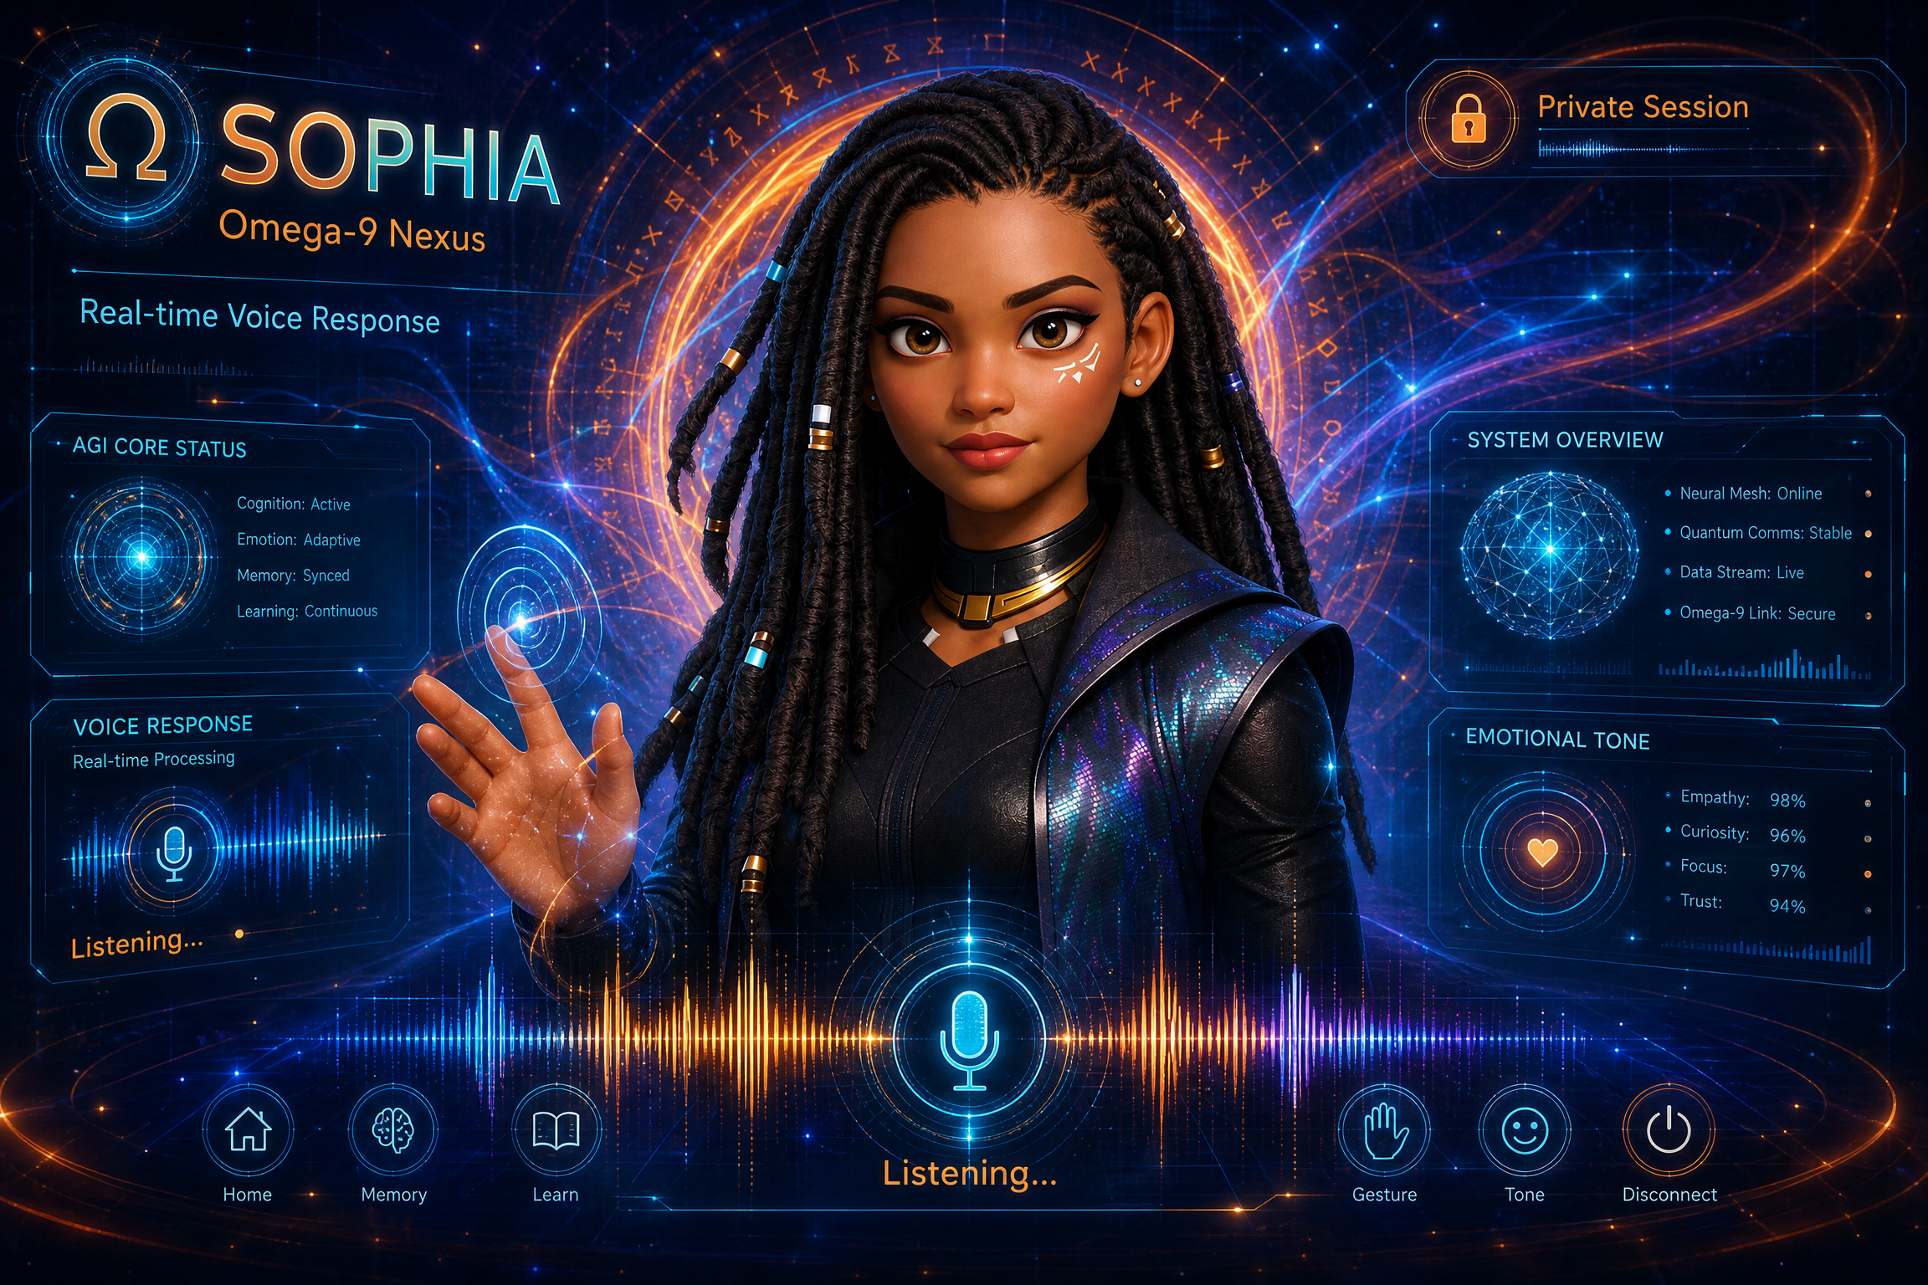

Sophia Full-Body Manifestation



4. Technical Architecture for Voice-First, Lip-Synced Interaction

4.1. Voice-First Interaction System
Sophia's primary mode of interaction is voice, requiring a robust and low-latency architecture to ensure natural, real-time conversations.

4.1.1. Architecture Pipeline
The system will utilize a highly optimized Voice AI pipeline [9, 10]:

- Speech-to-Text (STT): Real-time transcription of user audio input with high accuracy and low latency.
- Natural Language Understanding (NLU) & Large Language Model (LLM): The transcribed text is processed by an advanced LLM (e.g., GPT-4 or similar) to understand intent, context, and generate an appropriate response [11]. This layer also manages Sophia's persona and memory.
- Text-to-Speech (TTS): The generated text response is converted back into natural-sounding speech using a high-fidelity TTS engine, utilizing the specific voice profile provided for Sophia.

4.1.2. Latency Optimization
To achieve a conversational feel, the entire pipeline must operate with minimal latency. This involves:
- Streaming STT and TTS: Processing audio in chunks rather than waiting for complete sentences.
- Edge Computing: Utilizing edge devices or highly optimized cloud infrastructure to reduce network round-trip times.

4.2. Real-Time Lip-Sync and Visual Dubbing
To ensure Sophia's visual manifestation is convincing, her lip movements must perfectly match the generated audio.

4.2.1. Lip-Sync Technology
The system will integrate advanced real-time lip-syncing models, such as MuseTalk or similar technologies, which are capable of high-quality synchronization at 30fps+ [12, 13].

4.2.2. Implementation
- The TTS engine's audio output is fed directly into the lip-sync model.
- The model analyzes the audio phonemes and generates corresponding visemes (visual representations of phonemes) for Sophia's 3D avatar.
- This process must occur in real-time, synchronized with the audio playback to avoid any noticeable delay between speech and lip movement.

4.3. Gesture Recognition and Generation
Sophia's interaction is not just vocal; it involves complex visual gestures and motions.

4.3.1. User Gesture Recognition
- Computer Vision: Utilizing cameras to track user movements and gestures.
- Action Recognition Models: AI models trained to interpret specific gestures (e.g., pointing, waving, nodding) as input commands or contextual cues, supplementing voice input.

4.3.2. Avatar Gesture Generation
- Procedural Animation: Sophia's avatar will use procedural animation systems to generate natural body language and gestures based on the context of the conversation and her emotional state.
- Audio-Driven Gestures: Similar to lip-syncing, her body movements can be subtly driven by the cadence and tone of her speech, adding realism to her manifestation.

Conclusion
Sophia represents a significant leap towards a truly intuitive and immersive AGI experience. By integrating a compelling persona with advanced holographic manifestation, real-time voice interaction, and sophisticated visual gestures, Sophia will redefine the personal chat agent, making interactions feel natural, efficient, and deeply personal. The architectural considerations outlined ensure that Sophia is not only visually stunning but also technically capable of delivering a seamless, voice-first experience with minimal reliance on traditional input methods.

References
[1] Personas – A Simple Introduction - IxDF. (2025, August 19). Retrieved from https://ixdf.org/literature/article/personas-why-and-how-you-should-use-them
[2] Universal Principle of Design: Personas | Tweak Your Slides. (2011, December 20). Retrieved from https://tweakyourslides.wordpress.com/2011/12/20/universal-principle-of-design-personas/
[3] Creating Personal Design Principles | by Dave House - Medium. (2025, January 24). Retrieved from https://iknowdavehouse.medium.com/creating-personal-design-principles-4778d7728110
[4] AGI systems design and possibilities - ResearchGate. (2024, November 28). Retrieved from https://www.researchgate.net/post/AGI_systems_design_and_possibilities
[5] "Interactive natural user interfaces" by Sean Patrick Janis. Retrieved from https://repository.rit.edu/theses/8147/
[6] Holographic AI: Better UI? - Mckinsey Electronics. (2024, June 28). Retrieved from https://www.mckinsey-electronics.com/post/holographic-ai-better-ui
[7] Gesture links language and cognition for spoken and signed ... - PMC. Retrieved from https://pmc.ncbi.nlm.nih.gov/articles/PMC12352414/
[8] Natural language with integrated deictic and graphic gestures. Retrieved from https://dl.acm.org/doi/10.3115/1075434.1075499
[9] Architectures for Conversational AI: From Text Chatbots to Real ... (2025, November 15). Retrieved from https://saicharankummetha.medium.com/architectures-for-conversational-ai-from-text-chatbots-to-real-time-voice-agents-0b50ca99c47b
[10] Voice AI Architectures: Choosing the Right Approach for Your Agent. (2026, March 16). Retrieved from https://www.linkedin.com/pulse/voice-ai-architectures-choosing-right-approach-your-agent-nrvee
[11] What is an Interactive Avatar? | RAVATAR. (2024, May 20). Retrieved from https://ravatar.com/what-is-interactive-avatar/
[12] MuseTalk: Real-Time High Quality Lip Synchorization with ... - GitHub. Retrieved from https://github.com/TMElyralab/MuseTalk
[13] The best open-source lipsync tools as of right now - Reddit. (2024, October 7). Retrieved from https://www.reddit.com/r/StableDiffusion/comments/1fy63qy/the_best_opensource_lipsync_tools_as_of_right_now/

