Aspose Words for Java Component Restful APIs for Cloud

Version 1.0

**July 22, 2016**

**Author: Abdul Basit Ali**

Table of Contents

**1.** **Restful APIs for Cloud using Java Component** 2

**1.1.** **Objective** 2

**1.2.** **Explored APIs** 2

**1.3.** **Used Tools and Technologies** 2

**2.** **Steps to Download and Run the Project** 2

**3.** **Challenges Faced** 5

# **Restful APIs for Cloud using Java Component**

Restful APIs expose the document conversion feature and document protection functionality to consume in rest client applications.

## **Objective**

The objective was to develop given below Restful APIs for the given assignment.

* PUT /words/convert
* POST /words/{name}/protect
* GET /words/{name}/protect
* Development of rest web client to test the APIs.

## **Explored APIs**

Following APIs have been explored and used within this assignment.

* Aspose.Words for Java
* Aspose for Cloud
* Aspose Storage

## **Used Tools and Technologies**

Following tools have been used in the implementation.

* Netbeans
* Eclipse
* Maven
* Postman Rest Client
* GIT
* Jersey Library

# **Steps to Download and Run the Project**

1. Go to GIT repository on the link below to download or clone the project to your local repository.

<https://github.com/openair/AsposeWord>

1. Open the downloaded project in your favorite IDE (Netbeans or Eclipse) and build the maven project to install dependencies.
2. Upon successful run, the project shows the default page of the restful API web client.

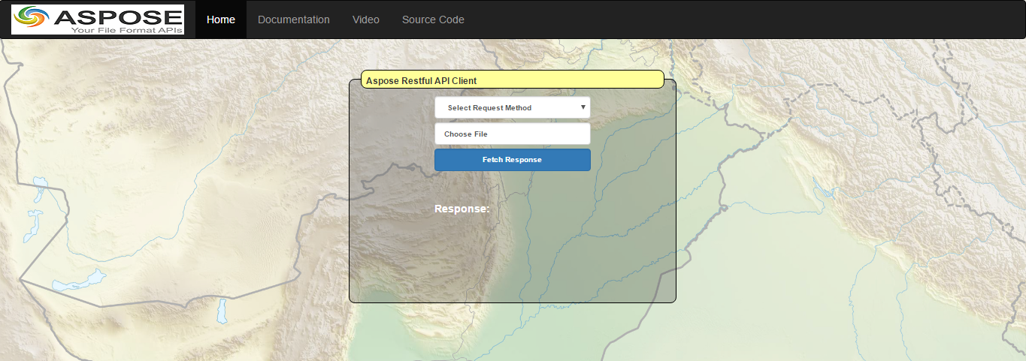

1. Click on the tabs to view project documentation, video and source code.
2. Select rest request method from the dropdown box.

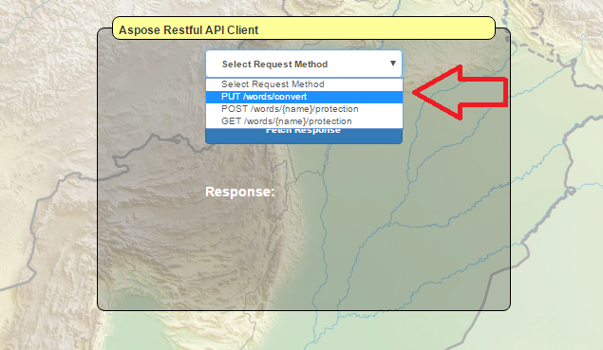

1. **For, PUT /words/convert** request you need to copy source document path in the “Choose File” text field along with desired conversion format from “Select Conversion Format” dropdown box underneath.

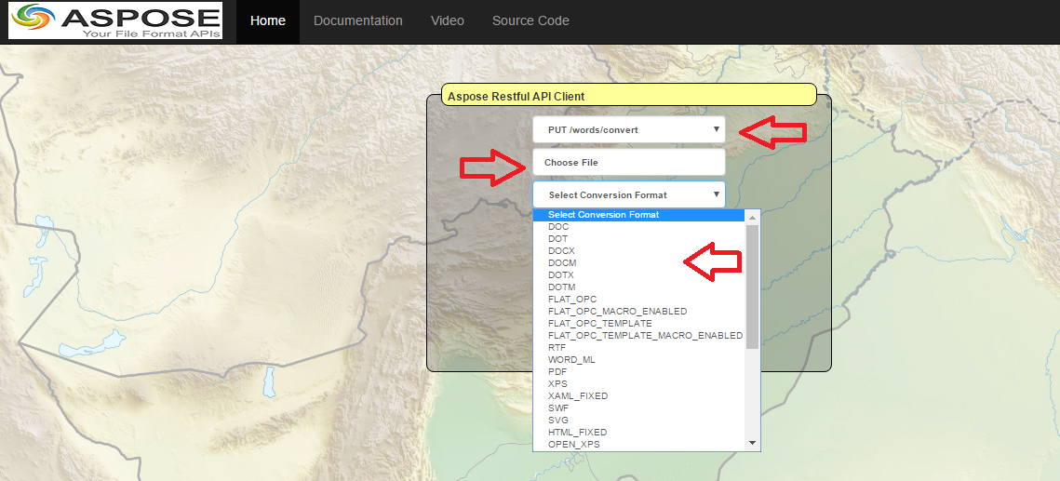

1. After a bit processing, document will be converted to desired format and saved in the source file directory. A response message will also be displayed at the bottom of the section.

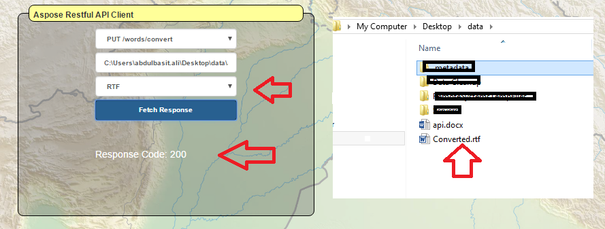

1. **For POST /words/{name}/protection**, you only need to provide source file full path. It will add protection to the file and save in the source directory folder.

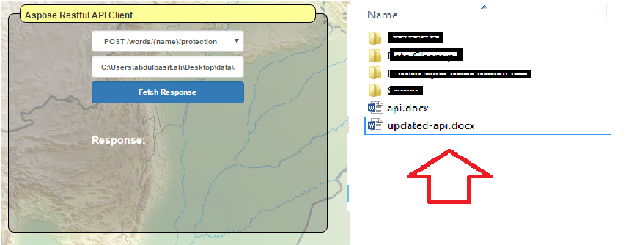

1. **For GET /words/{name}/protection,** you only need to provide source full file path and it will get the protection type on the file.

# **Challenges Faced**

* Applying protection on cloud always gave response to “NoProtetion”. However, while debugging this issue, the formed request body shown protection type “READ_ONLY”.

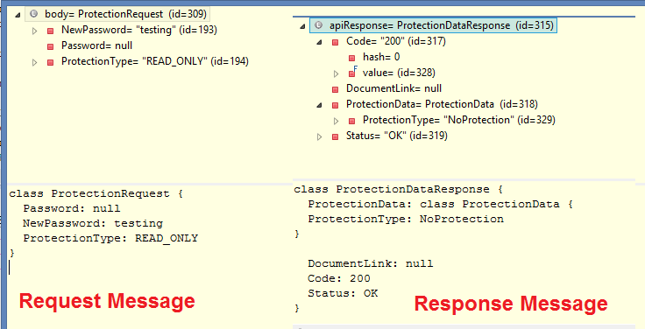

* Did not find test scenarios to check file protection or file storage on cloud environment. There may be some test files placed on cloud storage to test method requests on Swagger UI.