Open Badge Factory
Wordpress Plugin

Table of Contents
Pre-requirements 2
Installing the plugin 2
Method 1: Installing the plugin from the Wordpress admin panel 2
Method 1: Fixing directory permissions 2
Method 2: Manually installing the plugin using FTP and SSH 3
Setting up the plugin 3
Creating an awarding rule 4

Pre-requirements
To use the Open Badge Factory wordpress plugin, you need an account on http://openbadgefactory.com.

Installing the plugin

There are two methods to install the plugin.

If possible, use the first and easiest method. If for some reason the first method does not work, then the second method may be your only choice.

Method 1: Installing the plugin from the Wordpress admin panel

If your wordpress installation support it, the easiest way to install a plugin is via the admin panel.

- First go to your WordPress Admin Panel. ( http:// your wordpress site /wp-admin)
- Click on Plugins > Add New
- Click on upload
- Click on Choose File and select the obf-wp.zip you have downloaded.
- Click on Install Now
- If wordpress asks for FTP username and password check Method1: Fixing directory permissions
- Proceed to step Setting up the plugin

Method 1: Fixing directory permissions
If your wordpress asks for FTP username or password when installing the plugin, it's recommended to fix the issue. Below are instructions to fix the issue. If installing the plugin went fine, then skip to Setting up the plugin.
If you are familiar with SSH and the linux console, these instructions should help you fix the permissions.
First thing you should do, is locate your wordpress directory. In many cases wordpress is located in /var/www/html. In your wordpress directory you need to change the owner of wp-content/plugins and wp-content/uploads directories to your web-server user (usually www-data or httpd).
When assuming your wordpress is in /var/www/html and your user is www-data, you would run a command ”chown -R www-data /var/www/html/wp-content/plugins”.

On systems with sudo, and wordpress in /var/www/html:
HTTPDUSER=`ps aux | grep -E '[a]pache|[h]ttpd|[_]www|[w]ww-data|[n]ginx' | grep -v root | head -1 | cut -d\ -f1`
echo Httpd user is $HTTPDUSER . Lets set plugin directory permissions
sudo chown -R $HTTPDUSER /var/www/html/wp-content/uploads
sudo chown -R $HTTPDUSER /var/www/html/wp-content/plugins

Method 2: Manually installing the plugin using FTP and SSH

This five-step process shows an example of how to upload and unpack the Open Badge Factory wordpress plugin to the '/wp-content/plugins/' directory of your WordPress
installation

- Upload obf-wp.zip using your favourite FTP-client (FileZilla is a good choice) to your Wordpress server. Preferably store it in your user's home directory.
- Connect to your server using an SSH-client. (PuTTy on windows or ”ssh” on OS X or Linux -terminal)
- Go to your wordpress directory (”cd /var/www/html/” if your wordpress directory is in /var/www/html/.)
- ”cd wp-content/plugins/”
- unzip ~/obf-wp.zip
- Make sure obf/pki directory is writeable by the web-server user. (”chown www-data:www.data obf/pki”)
- Proceed to step Setting up the plugin

Setting up the plugin

- Activate the plugin through the Plugins menu in WordPress
- Get the Open Badge Factory API certificate from Open Badge Factory (Admin tools > Api Key > Generate certificate signing request token)
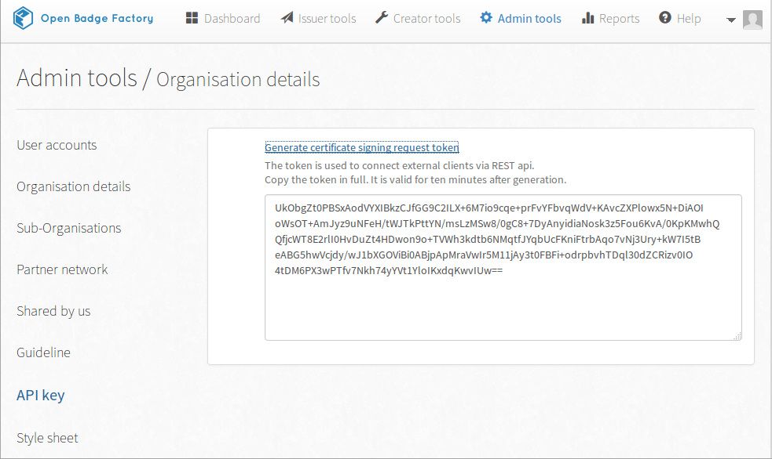
- Enter the generated Open Badge Factory API key in your wordpress' Open Badge Factory > OBF Integration -page to enable badge sharing.
- Set up awarding rules for your badges in your wordpress' Open Badge Factory > Awarding Rules -page.

Creating an awarding rule
To create badge awarding rules you should have Open Badge Factory -wordpress plugin set up and a badge or badges created at Open Badge Factory.
If everything is set up, you should have a Open Badge Factory > Awarding Rules -menu item in your wordpress admin dashboard.
Awarding Rules -page contains all the ready to be issued badges you've created in Open Badge Factory. If a badge you have created isn't visible, make sure it is not set as a draft.
If you open an awarding rule for editing, you can choose from multiple earning options. The most flexible earning option is using required steps. You can add one or multiple steps a user needs to complete in order to earn the badge.
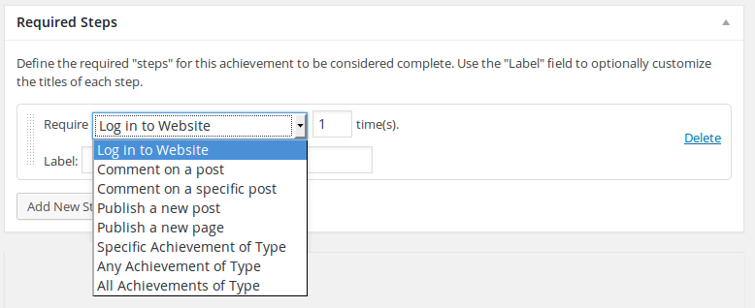
After you save an awarding rule, the badge associated with the awarding rule will be automatically awarded to users who complete the required steps.

