Semantic Data Model for Analytics and Automation Applications in Buildings
(This foreword is not part of this standard. It is merely informative and does not contain requirements necessary for conformance to the standard. It has not been processed according to the ANSI requirements for a standard and may contain material that has not been subject to public review or a consensus process. Unresolved objectors on informative material are not offered the right to appeal at ASHRAE or ANSI.)
FOREWORD
The motivation for this standard is to facilitate the deployment and use of software tools that leverage the data available from building automation systems to improve building system operation in a variety of ways. This standard builds upon standards and tools developed by the World Wide Web Consortium (W3C). Using those general tools, this standard defines modeling constructs for use in creating machine-readable representations of building systems, the building spaces that they serve, and the measurement and control points used to provide a safe and comfortable environment for the building occupants. The result is a searchable knowledge graph that can be used to automate the data mapping and configuration needed to deploy analytical, management, and control tools for the built environment.

1 PURPOSE
The purpose of this standard is to define formal knowledge concepts and a methodology to apply them to create interoperable, machine-readable semantic frameworks for representing building automation and control data, and other building system information.

2 SCOPE
This standard provides a comprehensive way to apply semantic formalisms to represent the context of building system data and relationships between the associated building mechanical system components so that software applications can find and understand the information in an automated way. It is intended to facilitate the development and implementation of building analytics tools and enterprise knowledge applications that can implement many building system functions, including:
- automated fault detection and diagnostics,
- building system commissioning,
- digital twins,
- optimization of energy use, and
- smart grid interactions.

3 DEFINITIONS

3.1 Terms Defined for this Standard
Connectable: an abstract class that represents a thing (Equipment or DomainSpace) that can be connected via connection points and connections.
Connection: the modeling construct used to represent a physical thing (e.g., pipe, duct, or conductor) that is used to convey some Medium (e.g., water, air, or electricity) between two Connectable things.
ConnectionPoint: an abstract modeling construct used to represent the fact that one Connectable thing can be connected to another Connectable thing using a Connection. It is the abstract representation of the flange, wire terminal, or other physical feature where a connection is made.
Domain: a categorization of building service or specialization used to characterize equipment or spaces in a building. Example domains include HVAC, lighting, and plumbing.
DomainSpace: a portion or the entirety of a PhysicalSpace that is associated with a Domain, such as lighting, HVAC, or physical security. DomainSpaces can be combined to form a Zone.
Equipment: the modeling construct used to represent a device designed to accomplish a specific task. Examples include a pump, fan, heat exchanger, luminaire, temperature sensor, or flow meter. A piece of equipment can contain another piece of equipment. For example, an air handling unit can contain a cooling coil.
Medium: a substance used to convey mass, energy, or information through Equipment or a System. Examples include air, water, refrigerant, and electricity.
PhysicalSpace: an architectural concept that represents a room, a collection of rooms such as a floor, a part of a room, or any physical space that might not even be thought of as a room, such as a patio.
System: a logical grouping (collection) of Equipment for some functional purpose. Examples of possible systems include an air distribution system, or a hot water system. Systems can contain other Systems. A System does not participate in connections.
Zone: a collection of DomainSpaces of a specific domain that are grouped together from the perspective of building services or controls.

3.2 Abbreviations and Acronyms Used in this Standard

Acronym | Definition
AHU | Air Handling Unit
ANSI | American National Standards Institute
ASHRAE | American Society of Heating, Refrigerating and Air-Conditioning Engineers
BACnet | Building Automation and Control Networks
CDL | Control Description Language
HVAC | Heating, Ventilation, and Air Conditioning
IFC | Industry Foundation Class
IRI | Internationalized Resource Identifier
LAN | Local Area Network
LL | Line-Line
LN | Line-Neutral
OWL | Web Ontology Language
PM | Particulate Matter
PoE | Power over Ethernet
QUDT | Quantities, Units, Dimensions, and Types
RDF | Resource Description Framework
RDFS | RDF Schema
SHACL | Shapes Constraint Language
SPARQL | SPARQL Protocol and RDF Query Language
USB | Universal Serial Bus
VAV | Variable Air Volume
W3C | World Wide Web Consortium

4 CONCEPTUAL FRAMEWORK FOR SEMANTIC MODELING OF BUILDING SYSTEMS AND DATA
This standard defines modeling constructs for use in creating a machine-readable representation of building systems, the building spaces that they serve, and the measurement and control points used to provide a safe and comfortable environment for the building occupants. The standard can be considered a toolkit of semantic building blocks and rules for using them to create a semantic model of a particular building or campus of buildings. The resulting model provides a way for software applications to determine the relationships between the mechanical equipment in the building (i.e., AHU 1 gets chilled water from CH 3 and provides conditioned air to VAV Boxes 12 through 15 serving rooms on the third floor) and the meaning of measurements that are available (i.e., T16 is a temperature sensor measuring the temperature of the air stream exiting AHU 1).
The model does not directly contain telemetric data about the real-time operation or past operation of the building systems. It does provide information about the meaning or context of that data and defines external references that are used to point to a source of the data values, thus enabling analytics applications to find them. If the data source is a BACnet building automation and control system, the external reference contains the necessary information for analytic software to learn which BACnet device, object, and property corresponds to the desired piece of information. This enables construction of a BACnet message used to read the value.
These capabilities are achieved by applying concepts, standards, and query tools developed and deployed for information and data science applications outside the building domain. A primary commercial driver for developing these standards and tools is the Semantic Web, an extension of the World Wide Web that was created to make the semantic meaning of data accessible from the Internet machine readable.
This standard uses Resource Description Framework (RDF) (W3C) and its extended schema (RDFS) to represent the semantic ideas in the model. RDF is a general method for representing semantic ideas as of a triple. A triple consists of a subject, a predicate, and either a literal or an object. For example:
Jane hasFriend Dave
Jane hasSupervisor Mary
In this example, Jane is the subject of both triples, there are two different predicates, hasFriend and hasSupervisor, and there are two different objects, Dave and Mary. The number of triples is expanded as needed to capture the desired information. The collection of triples represents a directed multi-graph that can be searched or queried to answer questions or to infer information that may not be explicit in the graph. Figure 4-1 is a graph that corresponds to this example.
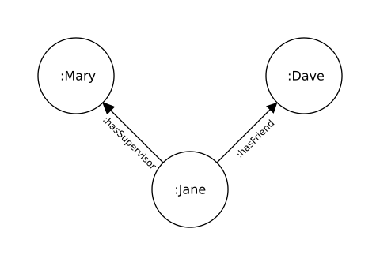
Figure 4-1. Example triple graph.
This standard defines subjects, predicates, and objects relevant to the building space that are used to build a multi-graph representing a specific building or group of buildings. A compelling advantage of this graph-based approach is the ability to combine semantic graphs derived from complementary semantic models that apply to the same building. This makes it possible to take advantage of the combined information from distinct domains. For example, a RealEstateCore model that captures how spaces are assigned to different tenants in a building linked to the spaces represented in a Standard 223 model results in a semantic model containing the combined information. In a similar way, it is possible to link information from a computerized maintenance management system or an asset management system to the semantic graph of a Standard 223 model by adding a triple that binds a piece of equipment to its representation in the other system.
A model constructed from this standard describes the topology of the equipment and spaces in a building but not the geometric details. Linking a Standard 223 model with an RDF representation of a building information model would add that geometric information.
Another advantage of using RDF to model building systems is that a query language standard, SPARQL (W3C SPARQL), exists and tools that implement SPARQL are readily available. A building analytics tool developer needs only to create a library of queries relevant to their application, and use these queries to interrogate any Standard 223 conformant model to find what they need from that building for their application.
Using RDF also provides a way to build conformance constraints into this standard in a way that enables conformance to be algorithmically verified. This is done by using a different W3C standard, Shapes Constraints Language (SHACL) (W3C SHACL). SHACL defines a way to constrain the construction of RDF graphs through the application of custom developed rules called shapes. The normative constraints described in this standard are formalized in SHACL shapes. The description of each concept defined in this standard includes a table that lists related conformance constraints defined by these SHACL shapes. Readily available SHACL reasoners check whether or not a particular model instance conforms to the shapes defined in this standard.
The concepts and relations mentioned below were designed to aid in standard development using RDF and SHACL exclusively and avoiding any dependence on OWL axioms. This approach was chosen to avoid some of the shortcomings of using OWL in industrial settings, such as the open world assumption, the many flavors of OWL and their support, and the sometimes counterintuitive implications of OWL reasoning for non-ontologists. (For example, if an instance satisfies the OWL axioms for a class, then it is inferred to be an instance of that class). The use of SHACL shapes to define constraints and inferencing rules is a more intuitive way to define intended model behavior and to verify conformance to the standard. The two most-used OWL inferences, supporting symmetric and inverse relations, are redefined in this standard using SHACL rules.

4.1 Conformance Constraints and Validation
In this standard, SHACL shapes are used to define conformance constraints. When a SHACL reasoner is applied to a model, discrepancies from the conformance constraints result in a message from the reasoner with one of three levels of severity (sh:severity).
A message with a severity sh:Info means that a model construct is incomplete.
A message with a severity sh:Warning means that a model construct is used in an unexpected way.
A message with a severity sh:Violation means a model construct is invalid and does not comply with the standard.

4.2 Deriving Implicit Information from Inference Rules
SHACL is used in this standard to derive implicit information via a process called inferencing. Inference rules are used to define how new triples are generated. The triples generated from this inference process enhance the ability to make useful queries without the burden of a modeler crafting each one. The goal is to make model development easier without sacrificing the utility application developers need to find what they are looking for. The description of each concept defined in this standard with related inference rules includes a table that lists the relevant SHACL shapes that specify the inferencing.

4.3 Textual Serialization
The normative content of this standard is documented in an RDF model textualized using Turtle (see Clause Annex A). All models conforming to this standard shall be textualized using Turtle.
The Turtle serialization format specifies that IRIs may be written as relative or absolute IRIs or prefixed names. The prefix label is defined by using the “@prefix” directive followed by a colon followed by a partial IRI. The encoding examples used in this document assume the following prefix statements:
@prefix s223: <http://data.ashrae.org/standard223#> .
@prefix bacnet: <https://data.ashrae.org/bacnet/> .
@prefix qudt: <http://qudt.org/schema/qudt/> .
A prefixed name is turned into an IRI by concatenating the IRI associated with the prefix and the local part. The ‘@prefix’ directive associates a prefix label with an IRI, e.g., s223:Equipment expands to <http://data.ashrae.org/standard223#Equipment>. The scope of a prefix label is only within the Turtle file that it appears. It is encouraged to use the prefix statements above when exchanging models.

4.4 Units of Measure
Because this standard includes references to measurements of physical properties, it is necessary to provide a model representation of units of measure as well as what those units are quantifying (e.g. temperature, power, etc.). This standard builds upon the “Quantities, Units, Dimensions, and Types” (QUDT) ontology which is an open-source model expressed in RDF/SHACL. The QUDT model is documented at https://qudt.org. The key concepts used here are the classes qudt:Unit and qudt:QuantityKind. The 223 standard is compatible with Version 3.1.1 of QUDT and is expected to be compatible with all newer versions as well.

4.5 Namespace
Because it is anticipated that models conforming to this standard will be combined with other semantic models, it is necessary to define a namespace for the concepts defined by this standard to avoid any possible ambiguities that might arise from a similar name used in the complementary model. In this standard and all conforming models, the prefix “s223:” shall be used in the name of each concept (class and relation) defined by this standard, e.g., s223:Equipment.

4.6 s223:Concept
All classes and relations defined in the 223 standard are subclasses of s223:Concept.
Related Constraints
Description | Link
Ensure that all instances of an s223 class use only the relations defined for that class. Note that this only applies to QUDT relations. | Link
Ensure that all instances of an s223 class use only the relations defined for that class. Note that this only applies to s223 relations. | Link
If the relation hasProperty is present, it shall associate the concept with a Property. | Link
Incompatible Medium. Case1: An entity with a pure medium and an associated Property with a different pure medium. | Link
Incompatible Medium. Case2: An entity with a pure medium and an associated Property with constituents. | Link
Incompatible Medium. Case3: An entity with constituents and an associated Property with a pure medium. | Link
Incompatible Medium. Case4: An entity with constituents and an associated Property with constituents. | Link

Related Inference Rules
Description | Link
Add an rdfs:label if it is missing. | Link
Declare the inverse triples for relations that have defined inverse relations | Link
Declare the inverse triples for symmetric relations | Link

4.6.1 s223:Class
This is a modeling construct. All classes defined in the 223 standard are instances of s223:Class.
Related Constraints
Description | Link
A Class shall be associated with at least one label using the relation rdfs:label. | Link
Every SHACL property shape must have an rdfs:comment. | Link
Every SPARQLConstraint must have an rdfs:comment. | Link
Every SPARQLRule must have an rdfs:comment. | Link
Every TripleRule must have an rdfs:comment. | Link
Every class of the 223 standard must also be an instance of sh:NodeShape. | Link
Every class of the 223 standard must be a direct or indirect subclass of s223:Concept. | Link
Every class of the 223 standard must have an rdfs:comment. | Link

4.6.1.1 s223:AbstractClass
This is a modeling construct. Instances of abstract classes cannot be created. All abstract classes in this standard have a more specific subclass.

4.6.2 s223:Relation
A Relation associates the subject and the object in an RDF triple, the predicate portion of a (subject, predicate, object) triple.
Related Constraints
Description | Link
A Relation shall be associated with at least one label using the relation rdfs:label. | Link

4.6.2.1 s223:RelationWithInverse
An RelationWithInverse is modeling construct used to define symmetric behavior for certain relations in the standard such as connectedTo and connectedFrom.
Related Constraints
Description | Link
An RelationWithInverse shall be associated with exactly one other RelationWithInverse using the relation inverseOf. | Link

4.6.2.1.1 s223:inverseOf
A Relation that associates Relations that are inverses of one another, such as connectedTo and connectedFrom.

4.6.2.2 s223:SymmetricRelation
A modeling construct used to define symmetric behavior for certain relations in the standard such as cnx, connected, and pairedConnectionPoint.

4.7 s223:hasProperty
A Relation that associates a Concept with a Property.

5 EQUIPMENT
This clause is the top level of the hierarchical structure of the portion of the model that represents the characteristics and features of physical equipment that make up the building systems being modeled. Equipment can be connected to other Equipment or DomainSpaces (see Clause 6.5). Equipment can optionally contain other pieces of equipment, providing a way to represent its constituent parts within the model (see Clause 5.2). Equipment can also be grouped together to define a System (see Clause 7).

5.1 s223:Equipment
Equipment is the modeling construct used to represent a thing designed to accomplish a specific task, or a complex thing that contains component pieces of Equipment that are connected to each other and work together to accomplish a task. Equipment can have Connections and ConnectionPoints through which one or more kinds of medium (see Clause 10.12.1) might flow. Examples of possible Equipment include a Pump, Fan, AirHeatExchanger, Luminaire, and Sensor, as well as more complex things like a heat pump, a chilled water plant, or a utility meter. Equipment is distinct from a System, which is simply a logical grouping or collection of (only) Equipment.
In common usage, terms like equipment and system have a variety of ambiguous and possibly conflicting interpretations. A semantic model is an attempt to eliminate such ambiguities and conflicts. If the thing being modeled involves Connections and ConnectionPoints, it must be modeled as Equipment and not a System. Thus, a model of a chilled water plant that includes external connections to things beyond the plant must be modeled as Equipment. Any contained Equipment within the chilled water plant (i.e., the pumps, valves, filters, and other things) may alternatively or in addition be logically grouped and modeled as a System.
The graphical depiction of Equipment used in this document is a round-cornered rectangle as shown in Figure 5-1.

Figure 5-1. Graphical Depiction of Equipment.
Related Constraints
Description | Link
Disallow contained equipment from having external incoming connections. | Link
Disallow contained equipment from having external outgoing connections. | Link
If the relation actuatedByProperty is present it shall associate the Equipment with a ActuatableProperty. Note that any Equipment may use this relation, not just Actuator. | Link
If the relation contains is present it shall associate the Equipment with either Equipment or Junction. | Link
If the relation executes is present it shall associate the Equipment with a Function. | Link
If the relation hasPhysicalLocation is present it shall associate the Equipment with a PhysicalSpace. | Link
If the relation hasRole is present it shall associate the Equipment with a EnumerationKind-Role. | Link
Warning about a subClass of Equipment of type A containing something that is in the same subClass branch. | Link

Related Inference Rules
Description | Link
For equipment contained within another piece of equipment use the mapsTo relation to infer a Medium from the containing equipment. | Link
For equipment containing another piece of equipment, use the mapsTo relation to infer a Medium from the contained equipment. | Link

5.2 Equipment Containment
A piece of equipment can only contain other pieces of equipment. For example, a fan can be contained by an air handling unit. The relation contains is used to describe a piece of equipment containing another piece of equipment (see Clause 5.3). The relationship mapsTo relates a ConnectionPoint of a contained Equipment to the ConnectionPoint of a containing Equipment (see Clause 6.2.5). For example, the air inlet to a heating coil contained in a fan coil unit may map to the air inlet of the fan coil unit. Any air connection to the fan coil unit inlet is supplying air to the inlet of the heating coil as well.
Multiple pieces of equipment contained by the same piece of equipment may connect to each other, however, they may not connect to equipment that are not also contained. To indicate how a contained piece of equipment connects to an external piece of equipment, the relationship mapsTo is used. MapsTo will relate the connection point of a contained equipment to the connection point of the containing equipment, then the connection point of the containing equipment may connect to the external equipment.
It may be desirable for a piece of containing equipment to have a Property that has a value representing something that is associated with a contained piece of equipment. For example, consider a fan coil unit that contains a fan and a coil. The fan may have a Property that represents the speed of the fan. To make this fan speed visible as a Property of the fan coil unit, a fan speed Property would be added to the fan coil unit and its value would be an internal reference (see Clause 11.20) to the speed Property of the contained motor.

5.3 s223:contains
A Relation that associates a piece of Equipment with its component pieces of Equipment, or a PhysicalSpace (see Clause 8.1.1) with its component PhysicalSpaces.

5.4 s223:hasRole
A Relation that associates a role with of a piece of Equipment, a Connection, ConnectionPoint, or System within a building (e.g., a heating coil might be associated with Role-Heating). Possible values are defined in EnumerationKind-Role (see Clause 10.11).

5.5 s223:hasPhysicalLocation
A Relation that associates a piece of Equipment with its physical location (i.e., in a PhysicalSpace). The physical location of a piece of Equipment is not necessarily the same as the location affected by the operation of the Equipment. For example, an air handler may physically be located on the roof, but its effect is to provide conditioned air to a Zone or DomainSpace within the building. By following the path of connections, it can be determined what other equipment or spaces are possibly impacted by the Equipment.

5.6 s223:Sensor
A Sensor observes an ObservableProperty (see Clause 11.3) which may be quantifiable (see Clause 11.7), such as a temperature, flow, or concentration, or enumerable (see Clause 11.8), such as an occupancy state.
If a Sensor observes a QuantifiableObservableProperty relative to an assumed or common reference point, it can be modeled with only an observation location. For example:
@prefix : <http://example.com/> .
:example1 a s223:TemperatureSensor ;
s223:hasObservationLocation :location1 ;
qudt:hasQuantityKind quantitykind:Temperature .
If a Sensor observes a QuantifiableObservableProperty relative to a unique or specified reference point, it can be modeled with an observation location and a reference location, and indicating the difference between two values by setting isDeltaQuantity to true. For example:
@prefix : <http://example.com/> .
:example2 a s223:TemperatureSensor ;
s223:hasObservationLocation :location1 ;
s223:hasReferenceLocation :location2 ;
qudt:hasQuantityKind quantitykind:Temperature ;
qudt:isDeltaQuantity true .
Related Constraints
Description | Link
A Sensor can be associated with a maximum of one Connectable, Connection, or ConnectionPoint using the relation hasReferenceLocation. | Link
A Sensor shall be associated with exactly 1 of Connectable, Connection, or ConnectionPoint using the relation hasObservationLocation. | Link
A Sensor shall be associated with exactly 1 of QuantifiableObservableProperty or EnumeratedObservableProperty using the relation observes. | Link
A Sensor shall be associated with exactly one ObservableProperty using the relation observes. | Link
A Sensor shall be associated with exactly one location using the relation hasObservationLocation. | Link
If a Sensor measures a differential property, it shall be associated with exactly 1 of Connectable, Connection, or ConnectionPoint using the relation hasReferenceLocation. | Link
If the relation hasMeasurementResolution is present it shall associate a Sensor with a QuantifiableProperty. | Link
s223: If the hasReferenceLocation relation exists, the observed Property shall have isDeltaQuantity true. | Link
s223: If the observed Property has isDeltaQuantity true, the Sensor shall have a hasReferenceLocation relation. | Link

Related Inference Rules
Description | Link
Infer the hasObservationLocation relation for a Sensor from the Property that it is observing, only if that Property is associated with a single entity. | Link

5.6.1 s223:ConcentrationSensor
A Sensor that observes a QuantifiableObservableProperty that represents a concentration of a miscible constituent in a medium, in contrast to a ParticulateSensor that observes a QuantifiableObservableProperty that represents an amount of a particulate in a medium (see Clause 5.6.7). The 223 standard does not constrain the Unit or QuantityKind reported by a ConcentrationSensor, but possible QuantityKinds include Concentration (moles per volume), Density (mass per volume), MoleFraction, and VolumeFraction.

5.6.2 s223:ElectricCurrentSensor
A Sensor that observes a QuantifiableObservableProperty that represents a measure of electric current.
Related Constraints
Description | Link
An ElectricCurrentSensor shall always observe a QuantifiableObservableProperty that has a QuantityKind of ElectricCurrent. | Link

5.6.3 s223:FlowSensor
A Sensor that observes a QuantifiableObservableProperty that represents a measure of flow of fluid, typically with a QuantityKind of VolumeFlowRate.

5.6.4 s223:HumiditySensor
A Sensor that observes a QuantifiableObservableProperty that represents a measure of relative or absolute humidity.
Related Constraints
Description | Link
A HumiditySensor shall always observe a QuantifiableObservableProperty that has a QuantityKind of either RelativeHumidity or AbsoluteHumidity. | Link

5.6.5 s223:LightSensor
A Sensor that observes a QuantifiableObservableProperty that represents an attribute of light, as specified by the QuantityKind of the Property being observed, as described below.

5.6.5.1 s223:IlluminanceSensor
A LightSensor that observes a QuantifiableObservableProperty that represents an illuminance, defined as the areal density of the luminous flux incident at a point on a surface.
Related Constraints
Description | Link
An IlluminanceSensor shall observe a QuantifiableObservableProperty that has a QuantityKind of Illuminance. | Link

5.6.5.2 s223:CorrelatedColorTemperatureSensor
A LightSensor that observes a QuantifiableObservableProperty that represents a correlated color temperature (CCT) of a light source, defined as the absolute temperature of a blackbody whose chromaticity most nearly resembles that of the light source.
Related Constraints
Description | Link
A CorrelatedColorTemperatureSensor shall always observe a QuantifiableObservableProperty that has a QuantityKind of CorrelatedColorTemperature. | Link

5.6.5.3 s223:DuvSensor
A LightSensor that observes a QuantifiableObservableProperty that represents a Duv of a light source, defined as the distance between the chromaticity of the light source and a blackbody radiator of equal correlated color temperature (CCT).
Related Constraints
Description | Link
A DuvSensor shall always observe a QuantifiableObservableProperty that has a QuantityKind of Duv. | Link

5.6.6 s223:OccupancySensor
A Sensor that observes an ObservableProperty that represents an attribute of occupancy in a space.

5.6.6.1 s223:OccupantMotionSensor
An OccupancySensor that observes a ObservableProperty that represents motion within a sensing region.
Related Constraints
Description | Link
An OccupantMotionSensor shall always observe an EnumeratedObservableProperty that has an EnumerationKind of Occupancy-Motion. | Link

5.6.6.2 s223:OccupantPresenceSensor
An OccupancySensor that observes a ObservableProperty that represents presence within a sensing region.
Related Constraints
Description | Link
An OccupantPresenceSensor shall always observe an EnumeratedObservableProperty that has an EnumerationKind of Occupancy-Presence. | Link

5.6.6.3 s223:OccupantCountSensor
An OccupancySensor that observes a QuantifiableObservableProperty that represents a population, usually of humans, within a sensing region.
Related Constraints
Description | Link
An OccupantCountSensor shall always observe a QuantifiableObservableProperty that has a QuantityKind of Population and a Unit of NUM. | Link

5.6.7 s223:ParticulateSensor
A Sensor that observes a QuantifiableObservableProperty that represents an amount of a particulate in a medium, in contrast to a ConcentrationSensor that observes a QuantifiableObservableProperty that represents a concentration of a miscible constituent in a medium (see Clause 5.6.1). The 223 standard does not constrain the Unit or QuantityKind reported by a ParticulateSensor, but possible QuantityKinds include Density (mass per volume), ParticleNumberDensity (count per volume), and DimensionlessRatio (with units such as PPM or PPB). Some particulate sensors may claim to report a raw count of particles, for which a QuantityKind of Count could be used, but the required context for such a measurement should be provided in the sensor’s documentation to specify if it in fact measures a count per volume (e.g., ParticleNumberDensity), time (e.g., CountRate or ParticleCurrent), or some other combination. Explicitly declaring the QuantityKind of a sensor’s output is preferable to relying on implicit assumptions.
Related Constraints
Description | Link
If the relation ofSubstance is present it shall associate the ParticulateSensor with a Substance-Particulate. | Link

5.6.8 s223:PressureSensor
A Sensor that observes a QuantifiableObservableProperty that represents a measure of pressure.
Related Constraints
Description | Link
A PressureSensor shall always observe a QuantifiableObservableProperty that has a QuantityKind of Pressure. | Link

5.6.8.1 s223:GaugePressureSensor
A PressureSensor that observes a QuantifiableObservableProperty that represents a measure of pressure relative to atmospheric pressure. Such sensors are commonly used to monitor compressed gas cylinders, for example, where a gauge reading of zero signifies that the measured pressure is equal to the atmospheric pressure, not a vacuum.
Related Constraints
Description | Link
A GaugePressureSensor shall always observe a QuantifiableObservableProperty that has a QuantityKind of GaugePressure. | Link
A GaugePressureSensor shall always observe a QuantifiableObservableProperty that has a value of true for qudt:isDeltaQuantity. | Link

5.6.9 s223:TemperatureSensor
A Sensor that observes a QuantifiableObservableProperty that represents a measure of temperature.
Related Constraints
Description | Link
A TemperatureSensor shall always observe a QuantifiableObservableProperty that has a QuantityKind of Temperature. | Link

5.6.10 s223:VoltageSensor
A Sensor that observes a QuantifiableObservableProperty that represents a measure of voltage.
Related Constraints
Description | Link
A VoltageSensor shall always observe a QuantifiableObservableProperty that has a QuantityKind of Voltage. | Link

5.6.11 s223:hasMeasurementResolution
A Relation that associates a Sensor with the QuantifiableProperty whose value indicates the smallest recognizable change in engineering units that the Sensor is able to measure.

5.6.12 s223:observes
A Relation that associates a Sensor with one ObservableProperty (see Clause 11.3) which is used by the sensor to generate a measurement value (e.g., a temperature) or a simple observation of a stimulus causing a reaction (e.g., a current binary switch that closes a dry contact when a fan is powered on).

5.6.13 s223:hasObservationLocation
A Relation that associates a Sensor with the topological location where it is observing a Property (see Clause 5.6.12). The observation location shall be a Connectable (see Clause 6.1), Connection (see Clause 6.3), or ConnectionPoint (see Clause 6.2).

5.6.14 s223:hasReferenceLocation
A Relation that associates a differential sensor with the topological location of the baseline (reference) Property (see Clause 5.6.12).

5.7 s223:Actuator
A piece of Equipment that receives control signals and electrically, pneumatically, or hydraulically makes changes in the physical world, such as the position of a valve or damper.
Related Constraints
Description | Link
An Actuator shall be associated with at least one ActuatableProperty using the relation actuatedByProperty. | Link
If the relation actuates is present it shall associate the Actuator with a piece of Equipment. | Link

5.7.1 s223:actuates
A Relation that associates an Actuator with the Equipment that it actuates.

5.7.2 s223:actuatedByProperty
A Relation that associates a piece of Equipment with the ActuatableProperty that it responds to. If the Equipment is an Actuator (a subclass of Equipment), actuatedByProperty is a required relation. An Actuator may also identify another piece of Equipment being actuated. (see Clause 5.7.1).

5.8 s223:Controller
A piece of equipment for regulation of a system or component in normal operation, which executes one or more Functions.
Related Constraints
Description | Link
If the relation executes is present it shall associate the Controller with a Function. | Link

5.8.1 s223:Function
A Function is used to model transfer and/or transformation of information (i.e., Property). It has relations to input Properties and output Properties. The actual algorithms that perform the transformations are described in CDL and are out of scope of the 223 standard.
Related Constraints
Description | Link
A Function must be associated with at least one Property using either the relation hasInput or hasOutput. | Link
If the relation hasInput is present it shall associate a Function with a Property. | Link
If the relation hasOutput is present it shall associate a Function with a Property. | Link

5.8.1.1 s223:hasInput
A Relation that associates a Function (see Clause 5.8.1) with a Property (see Clause 11.1) that is used as input to the Function.

5.8.1.2 s223:hasOutput
A Relation that associates a Function (see Clause 5.8.1) with a Property (see Clause 11.1) that is calculated by the Function.

5.8.2 s223:executes
A Relation that associates a Controller (see Clause 5.8) with the Functions (see Clause 5.8.1) that it executes.

6 CONNECTION
This clause is the top level of the hierarchical structure of the portion of the model that represents the characteristics and features of connections that provide a means for a medium such as air, water, or electricity, to flow from one ConnectionPoint to another. Examples of connections are ducts, pipes, and conductors.

6.1 s223:Connectable
Connectable is an abstract class representing a thing such as, Equipment (see Clause 5.1), DomainSpace (see Clause 8.2.1), or Junction (see Clause 6.4) that can be connected via connection points and connections.
Related Constraints
Description | Link
If a Connectable has connected or connectedTo (i.e. high-level connection specification), it must also have the supporting cnx relations (low-level connection specification). | Link
If the relation cnx is present it shall associate the Connectable with a ConnectionPoint. | Link
If the relation connectedFrom is present it shall associate the Connectable with a Connectable. | Link
If the relation connectedThrough is present it shall associate the Connectable with a Connection. | Link
If the relation connectedTo is present it shall associate the Connectable with a Connectable. | Link
If the relation connected is present it shall associate the Connectable with a Connectable. | Link
If the relation hasConnectionPoint is present it shall associate the Connectable with a ConnectionPoint. | Link

Related Inference Rules
Description | Link
Infer the cnx relation using isConnectionPointOf. | Link
Infer the cnx relationship using hasConnectionPoint. | Link
Infer the connectedFrom relations using connectsThrough and connectsFrom. | Link
Infer the connectedThrough relation using hasConnectionPoint and connectsThrough | Link
Infer the connectedTo relation using connectsThrough and connectsTo. | Link
Infer the connected relation for BiDirectional connections | Link
Infer the connected relation for BiDirectional connections | Link
Infer the connected relation using connectedFrom | Link
Infer the connected relation using connectedTo | Link
Infer the hasConnectionPoint relation using cnx | Link

6.2 s223:ConnectionPoint
A ConnectionPoint is an abstract modeling construct used to represent the fact that one connectable thing can be connected to another connectable thing using a Connection. It is the abstract representation of the flange, wire terminal, or other physical feature where a connection is made. Equipment, DomainSpaces and Junctions can have one or more ConnectionPoints (see Clause 6.1).
A ConnectionPoint is constrained to relate to a specific medium such as air, water, or electricity which determines what other things can be connected to it. For example, constraining a ConnectionPoint to be for air means it cannot be used for an electrical connection.
A ConnectionPoint belongs to exactly one connectable thing (see Clause 6.1).
ConnectionPoints are represented graphically in this standard by a triangle with the point indicating a direction of flow, or a diamond in the case of a bidirectional flow as shown in Figure 6-1.
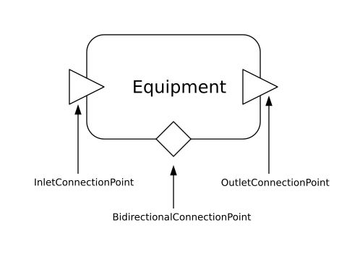
Figure 6-1. Graphical Representation of a ConnectionPoint.
Related Constraints
Description | Link
A ConnectionPoint can be associated with at most one other ConnectionPoint using the inverse of relation mapsTo | Link
A ConnectionPoint can be associated with at most one other ConnectionPoint using the relation mapsTo | Link
A ConnectionPoint must not have both a mapsTo and a connectsThrough relation. | Link
A ConnectionPoint shall be associated with at most one Connectable using the cnx relation. | Link
A ConnectionPoint shall be associated with at most one Connection using the cnx relation | Link
A ConnectionPoint shall be associated with at most one Connection using the relation connectsThrough. | Link
A ConnectionPoint shall be associated with exactly one Connectable using the relation isConnectionPointOf. | Link
A ConnectionPoint shall be associated with exactly one Substance-Medium using the relation hasMedium. | Link
Ensure that the Medium identified by a ConnectionPoint via the hasMedium relation is compatible with the Medium identified by the entity identified by the mapsTo relation. | Link
If a ConnectionPoint mapsTo another ConnectionPoint, the respective Equipment should have a contains relation. | Link
If a ConnectionPoint lacks a connectsThrough and mapsTo relation, and is not associated with a Junction or Equipment that is contained by an Equipment, then suggest that the ConnectionPoint probably needs an association with a Connection. | Link
If a ConnectionPoint lacks a connectsThrough and mapsTo relation, but is associated with a Junction or Equipment that is contained by an Equipment, then suggest that the ConnectionPoint might need a mapsTo relation to a ConnectionPoint of the containing Equipment. | Link
If the relation hasElectricalPhase is present it shall associate the ConnectionPoint with an ElectricalPhaseIdentifier or ElectricalVoltagePhases. | Link
If the relation hasRole is present it shall associate the ConnectionPoint with an EnumerationKind-Role. | Link
Subclasses of ConnectionPoint are Disjoint. An instance of a subclass of ConnectionPoint cannot be an instance of multiple such subclasses. | Link

Related Inference Rules
Description | Link
Infer the hasElectricalPhase value from any connected Conductor. | Link

6.2.1 s223:BidirectionalConnectionPoint
A BidirectionalConnectionPoint is a ConnectionPoint for which a medium (Substance-Medium) is expected to flow either into or out of the associated Connectable.
Related Constraints
Description | Link
If the relation mapsTo is present it shall associate the BidirectionalConnectionPoint with a BidirectionalConnectionPoint. | Link
If the relation pairedConnectionPoint is present it shall associate the BidirectionalConnectionPoint with a ConnectionPoint. | Link

6.2.2 s223:InletConnectionPoint
An InletConnectionPoint is a ConnectionPoint for which a medium (Substance-Medium) is expected to flow into the associated Connectable.
Related Constraints
Description | Link
Ensure an InletConnectionPoint has a mapsTo relation to its containing Equipment if it has an external Connection | Link
If the relation mapsTo is present it shall associate the InletConnectionPoint with an InletConnectionPoint. | Link
If the relation pairedConnectionPoint is present it shall associate the InletConnectionPoint with an OutletConnectionPoint or BidirectionalConnectionPoint. | Link

6.2.3 s223:OutletConnectionPoint
An OutletConnectionPoint is a ConnectionPoint for which a medium (Substance-Medium) is expected to flow out of the associated Connectable.
Related Constraints
Description | Link
Ensure an OutletConnectionPoint has a mapsTo relation to its containing Equipment if it has an external Connection | Link
If the relation mapsTo is present it shall associate the OutletConnectionPoint with an OutletConnectionPoint. | Link
If the relation pairedConnectionPoint is present it shall associate the OutletConnectionPoint with an InletConnectionPoint or BidirectionalConnectionPoint. | Link

6.2.4 s223:pairedConnectionPoint
A Relation that associates two ConnectionPoints where an InletConnectionPoint shares the same Substance-Medium with an OutletConnectionPoint.

6.2.5 s223:mapsTo
A Relation that associates a ConnectionPoint of a Connectable with a corresponding ConnectionPoint of the one containing it (see Clause 5.2). The associated ConnectionPoints shall have a compatible medium (see Clause 10.12.1).

6.2.6 s223:hasMedium
The relation hasMedium is used to indicate what medium is flowing through the connection (e.g., air, water, electricity). The possible values are defined in Substance-Medium (see Clause 10.12.1).

6.3 s223:Connection
A Connection is the modeling construct used to represent the thing (e.g., pipe, duct, conductor, or free space) that is used to convey some Medium (e.g., water, air, electricity, light, wi-fi) between two connectable things. All connections have two or more connection points bound to either Equipment (see Clause 5.1), DomainSpace (see Clause 8.2.1), or Junction (see Clause 6.4). See Figure 6-2. If the direction of flow is constrained, that constraint is indicated by using one or more InletConnectionPoints (see Clause 6.2.2) to represent the inflow points and OutletConnectionPoints (see Clause 6.2.3) to represent the outflow points.
A Connection may contain branches or intersections. These may be modeled using Junctions if it is necessary to identify a specific intersection. (see Clause 6.4).
The constraint to maintain compatible mediums among a Connection and all of its associated ConnectionPoints gives rise to multiple validation test cases, where the specified medium might be a pure medium, or a mixture with constituents. See Clause 10.12.1 for more details.
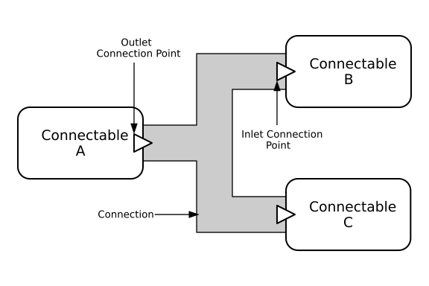
Figure 6-2. Graphical Depiction of Connection.
Related Constraints
Description | Link
A Connection must only have a cnx relation with a ConnectionPoint | Link
A Connection shall be associated with exactly one Substance-Medium using the relation hasMedium. | Link
A Connection shall have two or more cnx relations to connection points | Link
A Connection shall have two or more connectsAt relations to connection points | Link
If the relation connectsFrom is present it shall associate the Connection with a Connectable. | Link
If the relation connectsTo is present it shall associate the Connection with a Connectable. | Link
If the relation hasRole is present it shall associate the Connection with an EnumerationKind-Role. | Link
If the relation hasThermodynamicPhase is present it shall associate the Connection with at most one EnumerationKind-ThermodynamicPhase. | Link
Incompatible Medium. Case 1: A Connection with a pure medium and an associated ConnectionPoint with a pure medium. | Link
Incompatible Medium. Case 2: A Connection with constituents and an associated ConnectionPoint with a pure medium. | Link
Incompatible Medium. Case 3: Connection with a pure medium and an associated ConnectionPoint with constituents. | Link
Incompatible Medium. Case 4: A Connection with constituents and an associated ConnectionPoint with constituents. | Link
Incompatible Medium. Case 5: Two ConnectionPoints with pure mediums. | Link
Incompatible Medium. Case 6: Two ConnectionPoints, one with a medium with constituents and one with a pure medium. | Link
Incompatible Medium. Case 7: Two ConnectionPoints with mediums with constituents. | Link
You need either an InletConnectionPoint and an OutletConnectionPoint, or at least one BidirectionalConnectionPoint and another ConnectionPoint of any type. | Link

Related Inference Rules
Description | Link
Infer cnx relation using the relation connectsAt. | Link
Infer cnx relation using the relation connectsThrough. | Link
Infer the connectsAt relation using the relation cnx. | Link
Infer the connectsFrom relation using the relation connectsAt. | Link
Infer the connectsTo relation using the relation connectsAt. | Link

6.3.1 s223:Pipe
A Connection that is used primarily to transport liquids and gases such as water, sewage, natural gas, and compressed air.

6.3.2 s223:Duct
A Connection that is used to transport air such as supply, return, and exhaust in HVAC (Heating, Ventilation, and Air Conditioning) systems.

6.3.3 s223:Conductor
A Connection that represents one or more wires used to convey electricity, with the electricity conceptualized as flowing through a Conductor like water through a pipe. Each instance of Conductor applies to no more than one electrical circuit.
Related Constraints
Description | Link
A Conductor shall be associated with exactly one Constituent-Electricity using the relation hasMedium. | Link
Ensure the electrical phase is the same as all connected ConnectionPoints | Link
If the relation hasElectricalPhase is present it shall associate the Conductor with a single ElectricalPhaseIdentifier or ElectricalVoltagePhases value. | Link

Related Inference Rules
Description | Link
Infer the hasElectricalPhase value from any connected ConnectionPoints. | Link

6.4 s223:Junction
A Junction is a modeling construct used when a branching point within a Connection (see Clause 6.3) is of significance, such as specifying the observation location of a Sensor, or when a modeler wants to expose a branch point within a containing piece of Equipment. When a Junction is used, what might have been modeled as a single, branched Connection is separated into three or more separate connections, all tied together with the Junction and its associated connection points.
Junction is a subClassOf Connectable, which gives it the ability to have connection points, but unlike Equipment (and like Connection) it is not allowed to change the Medium that passes through it. This is why Junction is a sibling class to Equipment and not a subclass. This constraint to maintain compatible mediums among a Junction and all of its associated ConnectionPoints gives rise to multiple validation test cases, where the specified medium might be a pure medium, or a mixture with constituents. See Clause 10.12.1 for more details.
Related Constraints
Description | Link
A Junction shall be associated with exactly one Substance-Medium using the relation hasMedium. | Link
A Junction shall have at least two ConnectionPoints including (a) at least one inlet and one outlet, or (b) at least one bidirectional connection point. | Link
Incompatible Medium. Case 2: A Junction with constituents and an associated ConnectionPoint with a pure medium. | Link
Incompatible Medium. Case 3: Junction with a pure medium and an associated ConnectionPoint with constituents | Link
Incompatible Medium. Case 6: Two ConnectionPoints, one with a medium with constituents and one a pure medium. | Link
Incompatible Medium. Case 7: Two ConnectionPoints with mediums with constituents. | Link
Incompatible Medium. Case1: A Junction with a pure medium and an associated ConnectionPoint with a pure medium. | Link
Incompatible Medium. Case4: Junction with constituents and an associated ConnectionPoint with constituents. | Link
Incompatible Medium. Case5: Two ConnectionPoints with pure mediums. | Link
This Junction is not used to model significant details of a branching point in a connection, and may not be required. | Link

6.5 Relations Describing Connectedness
The collection of relations defined for Connectable, ConnectionPoint, and Connection is intended to facilitate model queries that answer questions about how equipment is connected and to what it is connected. These relations are shown in Figure 6-3.
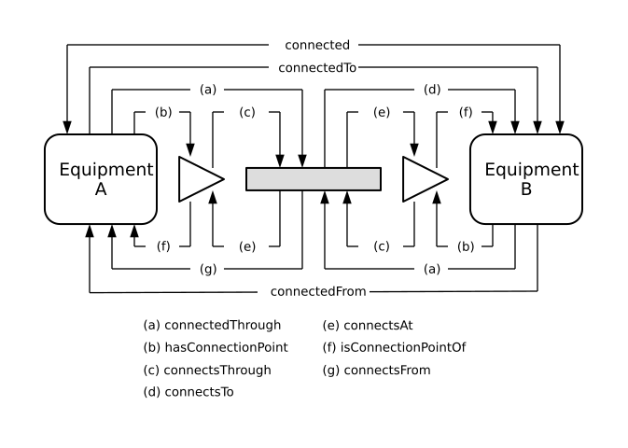
Figure 6-3. Connection Relations.
It is not necessary for a model developer to create each of these relations individually. A model can be created using a simpler construct shown in Figure 6-4 using the cnx relation. Inference rules can then be applied to generate the complete set shown in Figure 6-3. The intent is to simplify model development without losing the connectedness relationships that facilitate model queries.
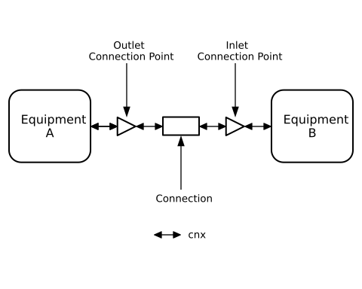
Figure 6-4. CNX Relations.

6.5.1 s223:connected
The relation connected indicates that two connectable things are connected without regard to the direction of flow.

6.5.2 s223:connectedTo
The relation connectedTo indicates that connectable things are connected with a specific direction of flow. A is connectedTo B, means a direction of flow from A to B. The inverse direction is indicated by connectedFrom (see Clause 6.5.3).

6.5.3 s223:connectedFrom
The relation connectedFrom indicates that connectable things are connected with a specific direction of flow. B is connectedFrom A, means that the direction of flow is from A to B. The inverse direction is indicated by connectedTo (see Clause 6.5.2).

6.5.4 s223:connectedThrough
A Relation that associates a Connectable thing with a Connection, without regard to the direction of flow. It is used to discover what connection links two connectable things.

6.5.5 s223:connectsTo
A Relation that associates a Connection with a Connectable thing, with an implied direction of flow. A connectsTo B indicates a flow from A to B.

6.5.6 s223:connectsFrom
A Relation that associates a Connectable thing with a Connection, with an implied direction of flow. B connectsFrom A indicates a flow from A to B.

6.5.7 s223:connectsThrough
A Relation that associates a ConnectionPoint with a Connection, without regard to the direction of flow.

6.5.8 s223:connectsAt
A Relation that associates a Connection with a specific ConnectionPoint.

6.5.9 s223:hasConnectionPoint
One of two Relations that associates Connectable thing with a ConnectionPoint. It is the inverse of the relation isConnectionPointOf (see Clause 6.5.10).

6.5.10 s223:isConnectionPointOf
One of two Relations that associates a ConnectionPoint with a Connectable thing. It is the inverse of the relation hasConnectionPoint (see Clause 6.5.9).

6.5.11 s223:cnx
A Relation that associates adjacent entities in a connection path, comprised of Equipment-ConnectionPoint-Connection-ConnectionPoint-Equipment sequences.

6.6 s223:hasMedium
The relation hasMedium is used to indicate what medium is flowing through the connection (e.g., air, water, electricity). The possible values are defined in Substance-Medium (see Clause 10.12.1).

7 SYSTEM
A System is a logical grouping of one or more pieces of Equipment or other Systems defined by the modeler for some functional purpose. Examples of possible systems are an air distribution system, or a hot water system. Systems can be associated with other Systems or Equipment using the relation hasMember (see Clause 7.2) A System may be associated with an EnumerationKind-Role (see Clause 10.11).

7.1 s223:System
A logical grouping of one or more Equipment or other Systems for some functional purpose.
Related Constraints
Description | Link
A System may be defined with a number of connection points that are the “boundary” of the equipment. The hasBoundaryConnectionPoint relation is used to reference those connection points of its equipment that must be connected, but in the context of validating the model with the system by itself, the “dangling connection point” should not generate a validation error. | Link
A System may be defined with a number of connection points that are the “boundary” of the equipment. The hasOptionalConnectionPoint relation is used to reference those connection points of its equipment that may not be connected, the “dangling connection point” should not generate a validation error. | Link
A System shall be associated with at least one instance of Equipment or System using the relation hasMember. | Link
Ensure that the boundary ConnectionPoints of a System belong to only members of that System | Link
If the relation hasRole is present, it shall associate the System with an EnumerationKind-Role. | Link

Related Inference Rules
Description | Link
Infer the hasBoundaryConnectionPoint relation using hasOptionalConnectionPoint. | Link

7.2 s223:hasMember
A Relation that associates a System with its component Equipment and/or Systems.

7.3 s223:hasBoundaryConnectionPoint
The hasBoundaryConnectionPoint relation means the ConnectionPoint represents the boundary of a System (see Clause 7.1) defined by the modeler, such as a model fragment provided by the vendor of a collection of equipment intended for integration with another model. The presence of this relation is used to indicate that such a “dangling connection point” should not generate a validation error in a non-integrated context but should generate an error in an integrated context.

7.4 s223:hasOptionalConnectionPoint
The hasOptionalConnectionPoint relation means the ConnectionPoint represents the boundary of a System (see Clause 7.1) defined by the modeler, such as a model fragment provided by the vendor of a collection of equipment intended for integration with another model. The presence of this relation is used to indicate that such a “dangling connection point” should not generate a validation error in an integrated or non-integrated context.

8 SPACE
There are two types of spaces: PhysicalSpaceand DomainSpace. PhysicalSpaces represent the building from the architectural and occupant perspective. A PhysicalSpace may represent a room (e.g., an office or conference room), a part of a room (e.g., a foyer), a collection of rooms (e.g., a floor or the entire building), or any other physical region in a building (e.g., a patio or a roof), or a whole campus.
A DomainSpace is a subclass of Connectable (see Clause 6.1) that represents some portion of a PhysicalSpace that is affected by a building service associated with a particular domain (e.g., HVAC, lighting, see Clause 10.5). DomainSpaces can be viewed as the endpoints of building services.
DomainSpaces can represent an entire PhysicalSpace or a portion of a PhysicalSpace, and thus PhysicalSpaces enclose DomainSpaces. An instance of a PhysicalSpace may enclose DomainSpaces from different domains, and may also enclose multiple DomainSpaces of the same domain. For example, a PhysicalSpace may represent an office that encloses a single HVAC DomainSpace and multiple lighting DomainSpaces. This would indicate a single HVAC service is provided to the office, along with multiple lighting services (e.g., one that provides lighting to the area of the office that receives daylight, and another that provides lighting to the area of the office that does not receive daylight). Multiple DomainSpaces of the same domain may overlap. For example, a DomainSpace affected by lighting devices that provide general lighting service to a room may overlap with the DomainSpace affected by the lighting devices that provide emergency lighting service to a room.

8.1 Physical Space

8.1.1 s223:PhysicalSpace
A PhysicalSpace is an architectural concept representing a room, a part of a room, a collection of rooms, or any other physical region in a building. PhysicalSpaces may be grouped to define larger PhysicalSpaces using the relation contains (see Clause 5.3).
Related Constraints
Description | Link
If the relation contains is present it shall associate the PhysicalSpace with a PhysicalSpace. | Link
If the relation encloses is present it shall associate the PhysicalSpace with a DomainSpace. | Link

8.1.2 s223:encloses
A Relation that associates a PhysicalSpace with one or more DomainSpaces.

8.1.3 s223:OutdoorPhysicalSpace
A PhysicalSpace that is outside of the building where, for example, outdoor ambient properties might be measured, within a suitably defined DomainSpace.

8.2 Domain Space

8.2.1 s223:DomainSpace
A DomainSpace represents some portion of a PhysicalSpace that is affected by a building service associated with a domain. DomainSpaces may represent an entire PhysicalSpace or any portion of a PhysicalSpace (see Clause 8.1.1). Multiple DomainSpaces of the same domain may overlap, and DomainSpaces of different domains may also overlap. DomainSpaces may be grouped into Zones using the relation hasDomainSpace (see Clause 9.2).
Related Constraints
Description | Link
A DomainSpace must be enclosed by a PhysicalSpace. | Link
A DomainSpace shall be associated with exactly one EnumerationKind-Domain using the relation hasDomain. | Link

Related Inference Rules
Description | Link
Infer a hasDomain relation by checking any enclosing Zone to determine the domain. | Link

8.2.2 s223:hasDomain
A Relation that associates a Zone or DomainSpace with an EnumerationKind-Domain (e.g., Domain-HVAC, Domain-Lighting).

9 ZONE
A Zone is a logical grouping of one or more DomainSpaces of a specific domain for some building service or control-related purpose. Multiple Zones of the same domain may overlap. For example, a Zone that defines DomainSpaces that are subject to an occupancy-control strategy may overlap with a Zone that defines DomainSpaces that are subject to a supervisory scheduled-control strategy.

9.1 s223:Zone
A logical grouping of one or more DomainSpaces for a specific domain for some building service or control-related purpose. Zones may be grouped into ZoneGroups (see Clause 9.3).
Related Constraints
Description | Link
A Zone shall be associated with at least one DomainSpace using the relation hasDomainSpace. | Link
A Zone shall be associated with exactly one EnumerationKind-Domain using the relation hasDomain. | Link
The associated domain of a Zone and the Domain of the DomainSpaces it contains must be the same. | Link

Related Inference Rules
Description | Link
If an instance of Zone matches the constraints defined by g36:Zone, it will be declared as an instance of that class. | Link
Infer a hasDomain relation by checking any enclosed DomainSpaces to determine the domain. | Link
Infer a hasDomain relation by checking any enclosing ZoneGroup to determine the domain. | Link

9.2 s223:hasDomainSpace
A Relation that associates a Zone with its component DomainSpaces.

9.3 s223:ZoneGroup
A logical grouping of one or more Zones (e.g., to define a supervisory building control strategy that overrides one or more system controls).
Related Constraints
Description | Link
A ZoneGroup shall be associated with at least one Zone using the relation hasZone. | Link
A ZoneGroup shall be associated with exactly one EnumerationKind-Domain using the relation hasDomain. | Link

Related Inference Rules
Description | Link
If an instance of ZoneGroup matches the constraints defined by g36:ZoneGroup, it will be declared as an instance of that class. | Link
Infer a hasDomain relation by checking any enclosed Zones to determine the domain. | Link

9.4 s223:hasZone
A Relation that associates a ZoneGroup with its component Zones.

10 ENUMERATIONS
Enumerations are sets of values that are closed (they cannot take on values outside of what is explicitly listed in the definition) and named (each value has a unique name). The values within an enumeration share a “kind,” which communicates how the enumerations are intended to be used.
The standard uses enumerations to convey groups of useful values for describing attributes of things e.g., Properties, Equipment.

10.1 s223:EnumerationKind
This is the encapsulating class for all EnumerationKinds. EnumerationKinds define the (closed) set of permissible values for a given purpose. For example, the DayOfWeek EnumerationKind enumerates the days of the week and allows no other values.
EnumerationKinds are arranged in a class hierarchy tree, with the root class named EnumerationKind. Each subclass is named starting with its immediate superclass, followed by a hyphen and a name that is unique among the sibling classes. Each class is also an instance of itself. This unusual modeling pattern was used to achieve:
- The ability to set an EnumerationKind value that is more general, or not yet fully specified at the time of modeling, such as s223:Electricity-AC without having to state exactly what voltage or frequency it is.
- The ability to use the sh:class SHACL predicate at any level in the EnumerationKind hierarchy to constrain a value in the s223 specification, even if it is a more general one such as s223:Electricity-AC in the above example.
Certain validation constraints exist in the standard that evaluate compatibility of EnumerationKinds. Two values are deemed compatible if they are the same, if one is a direct ancestor (or descendant) of the other, or if they are mixtures sharing at least one constituent.

10.2 s223:EnumerationKind-Aspect
Aspect enumerations provide context to the meaning of a Property that would otherwise not be apparent.

10.2.1 Equipment Information
These aspects are used on properties that provide static information about something e.g., a System, or Equipment. These aspects are typically used on properties of type Property. The property value is typically stored as a string.
Aspect Equipment Information Enumerations
Enumeration | Description
Aspect-CatalogNumber | The property value is a name or other identifier of the product’s manufacturer.
Aspect-Manufacturer | The property value is a name or other identifier of the product’s manufacturer.
Aspect-Model | The property value is a model identifier of the product.
Aspect-SerialNumber | The property value is the serial number assigned by the manufacturer to the system or equipment.

10.2.2 Equipment Operation
These aspects are used on properties that provide dynamic information about something e.g., a System, or Equipment. These aspects are typically used on properties of type EnumerableProperty and subtypes thereof.
Aspect Equipment Operation Enumerations
Enumeration | Description
Aspect-Alarm | The property value indicates whether an alarm condition is active or provides details about an active alarm.
Aspect-Fault | The property value is a fault indicator or code that signals a malfunction or issue with the system or equipment.
Aspect-OperatingMode | The property value is the current intended mode of operation, such as ‘Automatic’, ‘On’, or ‘Off’.
Aspect-OperatingStatus | The property value is the current operational status of the system or equipment, such as ‘Running,’ ‘Stopped,’ or ‘Maintenance Mode.’

10.2.3 Operational Limits
These aspects are used on properties that define the range of another Property. These aspects are used on properties of type QuantifiableObservableProperty.
Aspect Operational Limits Enumerations
Enumeration | Description
Aspect-Maximum | The property value is a highest specified or observed value. (Examples: upper limit of the specified operating voltage range; maximum measured temperature.)
Aspect-Minimum | The property value is a lowest specified or observed value. (Examples: lower limit of the specified operating voltage range; minimum measured temperature.)
Aspect-Nominal | The property value is a value that is expected or desired under normal operating conditions, but may not reflect the actual value at all times. (Example: nominal voltage.)
Aspect-Rated | The property value indicates a limit for continuous safe operation set by the manufacturer, but may not reflect the actual value at all times (Example: rated voltage)

10.2.4 Control Parameters
These aspects are used on properties that define the limits for control and alarm algorithms. These aspects are used on properties of type QuantifiableActuatableProperty.
Aspect Control Parameters Enumerations
Enumeration | Description
Aspect-Deadband | The property value is a range around a setpoint where no control action is taken to avoid unnecessary corrections.
Aspect-HighLimit | The property value is an upper threshold used in a control or alarm detection algorithm.
Aspect-LowLimit | The property value is a lower threshold used in a control or alarm detection algorithm.
Aspect-Setpoint | The property value is a target value for a control algorithm.
Aspect-Threshold | The property value is a threshold used in a control algorithm.

10.2.5 Delta Quantities
These aspects are used on properties to modify the quantity kind. These aspects are used on properties of type QuantifiableProperty and subtypes thereof.
Aspect Delta Quantities Enumerations
Enumeration | Description
Aspect-Delta | The property value is a differential value (e.g., pressure difference) instead of an absolute value.

10.3 s223:EnumerationKind-Binary
This class and its enumerated subclasses represent common binary values.
EnumerationKind-Binary Enumerations
Enumeration
Binary-Logical
Binary-OnOff
Binary-Position

10.3.1 s223:Binary-Logical
This class and its enumerated subclasses represent the possible values of a logical Property i.e., True or False.
Binary-Logical Enumerations
Enumeration
Logical-True
Logical-False

10.3.2 s223:Binary-OnOff
This class and its enumerated subclasses represent basic operational states i.e., On and Off.
Binary-OnOff Enumerations
Enumeration
OnOff-Off
OnOff-On

10.3.3 s223:Binary-Position
This class and its enumerated subclasses represent basic positional states i.e., Closed and Open.
Binary-Position Enumerations
Enumeration
Position-Closed
Position-Open

10.4 s223:EnumerationKind-DayOfWeek
This class and its enumerated subclasses represent the days of the week, according to the Gregorian calendar i.e., Monday, Tuesday, Wednesday, Thursday, Friday, Saturday, and Sunday. The Weekend and Weekday EnumerationKinds define subsets of this EnumerationKind for Mon-Fri and Sat, Sun, respectively.
EnumerationKind-DayOfWeek Enumerations
Enumeration
DayOfWeek-Weekday
DayOfWeek-Weekend

10.4.1 s223:DayOfWeek-Weekday
This class and its enumerated subclasses represent weekdays, according to the Gregorian calendar i.e., Monday, Tuesday, Wednesday, Thursday, and Friday.
DayOfWeek-Weekday Enumerations
Enumeration
Weekday-Friday
Weekday-Monday
Weekday-Thursday
Weekday-Tuesday
Weekday-Wednesday

10.4.2 s223:DayOfWeek-Weekend
This class and its enumerated subclasses represent weekend days, according to the Gregorian calendar i.e., Saturday and Sunday.
DayOfWeek-Weekend Enumerations
Enumeration
Weekend-Saturday
Weekend-Sunday

10.5 s223:EnumerationKind-Domain
This class and its enumerated subclasses represent building systems and services e.g., HVAC, Lighting, and Plumbing.
EnumerationKind-Domain Enumerations
Enumeration
Domain-ConveyanceSystems
Domain-Electrical
Domain-FireProtection
Domain-HVAC
Domain-Lighting
Domain-Networking
Domain-Occupancy
Domain-PhysicalSecurity
Domain-Plumbing
Domain-Refrigeration

10.6 s223:EnumerationKind-ElectricalPhaseIdentifier
This class and its enumerated subclasses represent all possible electrical phases for AC electricity service.
EnumerationKind-ElectricalPhaseIdentifier Enumerations
Enumeration
ElectricalPhaseIdentifier-A
ElectricalPhaseIdentifier-AB
ElectricalPhaseIdentifier-ABC
ElectricalPhaseIdentifier-B
ElectricalPhaseIdentifier-BC
ElectricalPhaseIdentifier-C
ElectricalPhaseIdentifier-CA

10.6.1 s223:hasElectricalPhase
A Relation that associates an AC electricity Substance-Medium with its electrical phase identifier.

10.7 s223:EnumerationKind-ElectricalVoltagePhases
This class and its enumerated subclasses represent all possible phase pairs for AC electricity service voltages.
EnumerationKind-ElectricalVoltagePhases Enumerations
Enumeration
ElectricalVoltagePhases-ABLineLineVoltage
ElectricalVoltagePhases-ANLineNeutralVoltage
ElectricalVoltagePhases-BCLineLineVoltage
ElectricalVoltagePhases-BNLineNeutralVoltage
ElectricalVoltagePhases-CALineLineVoltage
ElectricalVoltagePhases-CNLineNeutralVoltage

10.8 s223:EnumerationKind-Numerical
Numerical enumeration kinds are used to support the definitions of the Electricity medium. The enumerations instances in these classes have names that are recognizable by humans but are just a string for a computer application. To avoid the need to parse strings, each of these enumeration kinds have properties associated with the enumeration that represent electrical phase, voltage, and frequency. The purpose of these properties is to enable a machine to query them and obtain the same information that a person would associate with the string.
Related Constraints
Description | Link
An EnumerationKind-Numerical can be associated with a decimal value using the relation hasValue. | Link
An EnumerationKind-Numerical shall be associated with at least one QuantityKind using the relation hasQuantityKind. | Link
An EnumerationKind-Numerical shall be associated with at least one Unit using the relation hasUnit. | Link

10.8.1 s223:Numerical-Frequency
This class and its enumerated subclasses represent common frequencies for AC electricity service.
Numerical-Frequency Enumerations
Enumeration
Frequency-50Hz
Frequency-60Hz

Related Constraints
Description | Link
A Numerical-Frequency shall have a QuantityKind of Frequency | Link
A Numerical-Frequency shall have a Unit of Hertz | Link

10.8.2 s223:Numerical-LineLineVoltage
This class and its enumerated instances represent common line-line voltages for AC electricity service.
Numerical-LineLineVoltage Enumerations
Enumeration
LineLineVoltage-10000V
LineLineVoltage-190V
LineLineVoltage-208V
LineLineVoltage-220V
LineLineVoltage-240V
LineLineVoltage-3000V
LineLineVoltage-3300V
LineLineVoltage-380V
LineLineVoltage-400V
LineLineVoltage-415V
LineLineVoltage-4160V
LineLineVoltage-480V
LineLineVoltage-6000V
LineLineVoltage-600V
LineLineVoltage-6600V

Related Constraints
Description | Link
A Numerical-LineLineVoltage shall have a Numerical-Voltage | Link

10.8.3 s223:Numerical-LineNeutralVoltage
This class and its enumerated subclasses represent common line-neutral voltages for AC electricity service.
Numerical-LineNeutralVoltage Enumerations
Enumeration
LineNeutralVoltage-110V
LineNeutralVoltage-120V
LineNeutralVoltage-127V
LineNeutralVoltage-139V
LineNeutralVoltage-1730V
LineNeutralVoltage-1900V
LineNeutralVoltage-208V
LineNeutralVoltage-219V
LineNeutralVoltage-230V
LineNeutralVoltage-2400V
LineNeutralVoltage-240V
LineNeutralVoltage-24V
LineNeutralVoltage-277V
LineNeutralVoltage-3460V
LineNeutralVoltage-347V
LineNeutralVoltage-3810V
LineNeutralVoltage-5770V

Related Constraints
Description | Link
A Numerical-LineNeutralVoltage shall have a Numerical-Voltage | Link

10.8.4 s223:Numerical-NumberOfElectricalPhases
This class and its enumerated subclasses represent all possible service phases for AC electricity service i.e., one or single-phase, and three-phase. The s223:hasNumberOfElectricalPhases relation points to one of the values of this enumeration.
Numerical-NumberOfElectricalPhases Enumerations
Enumeration
NumberOfElectricalPhases-SinglePhase
NumberOfElectricalPhases-ThreePhase

10.8.5 s223:Numerical-Voltage
This class and its enumerated subclasses represent common voltages for electricity service.
Numerical-Voltage Enumerations
Enumeration
Voltage-0V
Voltage-10000V
Voltage-110V
Voltage-120V
Voltage-127V
Voltage-12V
Voltage-139V
Voltage-1730V
Voltage-1900V
Voltage-190V
Voltage-208V
Voltage-219V
Voltage-220V
Voltage-230V
Voltage-2400V
Voltage-240V
Voltage-24V
Voltage-277V
Voltage-2V
Voltage-3000V
Voltage-3300V
Voltage-3460V
Voltage-347V
Voltage-380V
Voltage-3810V
Voltage-3V
Voltage-400V
Voltage-415V
Voltage-4160V
Voltage-480V
Voltage-48V
Voltage-5770V
Voltage-5V
Voltage-6000V
Voltage-600V
Voltage-6600V
Voltage-6V
Voltage-DCVoltage (see Clause 10.8.5.1)
Voltage-PoE (see Clause 10.8.5.2)

Related Constraints
Description | Link
A Numerical-Voltage shall have a QuantityKind of Voltage | Link
A Numerical-Voltage shall have a Unit of Volts | Link

10.8.5.1 s223:Voltage-DCVoltage
This class and its enumerated subclasses represent all possible DC voltage polarities (i.e., positive, negative, and zero) for DC electricity service.
Voltage-DCVoltage Enumerations
Enumeration
DCVoltage-DCNegativeVoltage (see Clause 10.8.5.1.1)
DCVoltage-DCPositiveVoltage (see Clause 10.8.5.1.2)
DCVoltage-DCZeroVoltage

Related Constraints
Description | Link
A DC-Voltage shall have a Numerical-Voltage | Link

10.8.5.1.1 s223:DCVoltage-DCNegativeVoltage
This class and its enumerated subclasses represent common negative voltages for DC electricity service.
DCVoltage-DCNegativeVoltage Enumerations
Enumeration
DCNegativeVoltage-12.0V
DCNegativeVoltage-190.0V
DCNegativeVoltage-2.5V
DCNegativeVoltage-24.0V
DCNegativeVoltage-3.0V
DCNegativeVoltage-380.0V
DCNegativeVoltage-48.0V
DCNegativeVoltage-5.0V
DCNegativeVoltage-6.0V

10.8.5.1.2 s223:DCVoltage-DCPositiveVoltage
This class and its enumerated subclasses represent common positive voltages for DC electricity service.
DCVoltage-DCPositiveVoltage Enumerations
Enumeration
DCPositiveVoltage-12.0V
DCPositiveVoltage-190.0V
DCPositiveVoltage-2.5V
DCPositiveVoltage-24.0V
DCPositiveVoltage-3.0V
DCPositiveVoltage-380.0V
DCPositiveVoltage-48.0V
DCPositiveVoltage-5.0V
DCPositiveVoltage-6.0V
DCPositiveVoltage-PoE

10.8.5.2 s223:Voltage-PoE
This class represents the standardized 44-57VDC range that is produced by PoE Power Sourcing Equipment

10.8.6 s223:hasFrequency
A Relation that associates an AC electricity Substance-Medium with its electrical frequency.

10.8.7 s223:hasVoltage
A Relation that associates an electricity Substance-Medium with an electrical voltage.

10.9 s223:EnumerationKind-Occupancy
This class and its enumerated subclasses represent the occupancy status of a space within a building, i.e., the state of being used or occupied by a human being. Some occupancy enumerations have subclasses for more specific use.
EnumerationKind-Occupancy Enumerations
Enumeration
Occupancy-Occupied
Occupancy-Unoccupied

10.9.1 s223:Occupancy-Motion
This class and its enumerated subclasses represent the detection of motion in a space.
Occupancy-Motion Enumerations
Enumeration
Motion-False
Motion-True

10.9.2 s223:Occupancy-Presence
This class and its enumerated subclasses represent the detection of physical presence in a space.
Occupancy-Presence Enumerations
Enumeration
Presence-False
Presence-True

10.10 s223:EnumerationKind-ThermodynamicPhase
This class and its enumerated subclasses represent thermodynamic phases, also referred to as states of matter.
EnumerationKind-Thermodynamic-Phase Enumerations
Enumeration
ThermodynamicPhase-Gas (see Clause 10.10.1)
ThermodynamicPhase-Liquid (see Clause 10.10.2)
ThermodynamicPhase-Solid
ThermodynamicPhase-Vapor

10.10.1 s223:ThermodynamicPhase-Gas
This class and its enumerated subclasses represent gas in various thermodynamic states.
ThermodynamicPhase-Gas Enumerations
Enumeration
Gas-SuperHeated

10.10.2 s223:ThermodynamicPhase-Liquid
This class and its enumerated subclasses represent liquid in various thermodynamic states.
ThermodynamicPhase-Liquid Enumerations
Enumeration
Liquid-SubCooled

10.10.3 s223:hasThermodynamicPhase
A Relation that associates a Medium with its thermodynamic phases.

10.11 s223:EnumerationKind-Role
This class and its enumerated subclasses represent roles played by entities, such as cooling, generator, relief, and return. These enumeration kinds are intended to indicate the capability of an entity to play a given role, rather than the role being actively played at any given point in time. For example, a reversible piece of equipment might play a role of Role-Cooling at one time, and Role-Heating at another time. Such an entity would be modeled using the hasRole relation with both role values. The active role at a particular time can be modeled as a Property with an ExternalReference to telemetry data.
EnumerationKind-Role Enumerations
Enumeration
Role-Condenser
Role-Cooling
Role-Dehumidifying
Role-Discharge
Role-Economizer
Role-Evaporator
Role-Exhaust
Role-Expansion
Role-Generator
Role-HeatRecovery
Role-HeatTransfer
Role-Heating
Role-Load
Role-OutdoorAirIntake
Role-Primary
Role-Recirculating
Role-Relief
Role-Return
Role-Secondary
Role-Supply
Role-Ventilating

10.12 s223:EnumerationKind-Substance
This class and its enumerated subclasses represent things that are produced, conveyed, sensed, controlled, or consumed. Its enumerated subclasses differentate between mediums, particulates, and soot.
EnumberationKind-Substance Enumerations
Enumeration
Substance-Medium (see Clause 10.12.1)
Substance-Particulate (see Clause 10.12.2)
Substance-Soot (see Clause 10.12.3)

Related Constraints
Description | Link
If a substance has a constituent, that constituent may not itself have constituents. | Link
If the relation composedOf is present, it shall associate an EnumerationKind-Substance with one or more Properties that identify and characterize its constituents. The Property identifies the constituent using the relation ofConstituent. If appropriate, a QuantifiableProperty may be used to also specify the amount of the constituent using the relations qudt:hasQuantityKind, qudt:hasUnit, and qudt:hasValue. For example, see Clause 10.12.1.2.1.2.1. | Link

10.12.1 s223:Substance-Medium
This class and its enumerated subclasses represent substances that facilitate the conveyance of matter, energy, or information. It is used to qualify Connections and ConnectionPoints with the relation hasMedium (see Clause 6.6).
Substance-Medium is also the root of the medium hierarchy that is used to ensure compatibility of different medium designations. For example, Fluid-Water and Water-ChilledWater are alternative but compatible ways of identifying what is flowing in a pipe, using different degrees of specificity. Water-ChilledWater and Water-HotWater are not compatible. Compatibility is determined by testing if one medium is a subclass of the other. This gets a bit more complicated in the case of mixtures, where at least one of the constituents of a mixture must be compatible with at least one of the constituents of the other medium.
Testing for medium compatibility is done in the context of entities that have a hasMedium relation, such as
- Connection and its associated ConnectionPoints. See Clause 6.3.
- Junction and its associated ConnectionPoints See Clause 6.4.
- Filter and its associated ConnectionPoints. See Clause 12.34.
- Any Concept that has a hasMedium relation, compared with an associated Property with an ofMedium relation. See Clause 4.6.
These tests are listed in the constraint tables for the respective classes listed above, identified as Case 1, Case 2, etc.
Substance-Medium Enumerations
Enumeration
Medium-Constituent (see Clause 10.12.1.1)
Medium-Mix (see Clause 10.12.1.2)
Medium-ThermalContact

10.12.1.1 s223:Medium-Constituent
This class and its enumerated subclasses represent substances that may be combined to form a Medium-Mix. Constituents are distinguished from Medium-Mix and its subclasses in that constituents cannot use the composedOf relation to reference a concentration of other constituents.
Medium-Constituent Enumerations
Enumeration
Constituent-CO2
Constituent-CO
Constituent-Electricity (see Clause 10.12.1.1.1)
Constituent-EM (see Clause 10.12.1.1.2)
Constituent-Glycol
Constituent-H2O
Constituent-H2S
Constituent-CH4
Constituent-NOX (see Clause 10.12.1.1.3)
Constituent-O3
Constituent-Radon
Constituent-SO2
Constituent-VolatileOrganicCompounds

10.12.1.1.1 s223:Constituent-Electricity
This class and its enumerated subclasses represent common forms of electrical energy, including AC, DC, and electrical communication signals.
Constituent-Electricity Enumerations
Enumeration
Electricity-AC (see Clause 10.12.1.1.1.1)
Electricity-DC (see Clause 10.12.1.1.1.2)
Electricity-Earth
Electricity-Neutral
Electricity-Signal (see Clause 10.12.1.1.1.3)

10.12.1.1.1.1 s223:Electricity-AC
This class and its enumerated subclasses represent common AC electricity services.
Electricity-AC Enumerations
Enumeration
AC-10000VLL-1Ph-60Hz
AC-10000VLL-3Ph-60Hz
AC-10000VLL-5770VLN-1Ph-60Hz
AC-10000VLL-5770VLN-3Ph-60Hz
AC-110VLN-1Ph-50Hz
AC-120VLN-1Ph-60Hz
AC-127VLN-1Ph-50Hz
AC-139VLN-1Ph-50Hz
AC-1730VLN-1Ph-60Hz
AC-1900VLN-1Ph-60Hz
AC-190VLL-110VLN-1Ph-50Hz
AC-190VLL-110VLN-3Ph-50Hz
AC-190VLL-1Ph-50Hz
AC-190VLL-3Ph-50Hz
AC-208VLL-120VLN-1Ph-60Hz
AC-208VLL-120VLN-3Ph-60Hz
AC-208VLL-1Ph-60Hz
AC-208VLL-3Ph-60Hz
AC-208VLN-1Ph-60Hz
AC-219VLN-1Ph-60Hz
AC-220VLL-127VLN-1Ph-50Hz
AC-220VLL-127VLN-3Ph-50Hz
AC-220VLL-1Ph-50Hz
AC-220VLL-3Ph-50Hz
AC-230VLN-1Ph-50Hz
AC-2400VLN-1Ph-60Hz
AC-240VLL-120VLN-1Ph-60Hz
AC-240VLL-139VLN-1Ph-50Hz
AC-240VLL-139VLN-3Ph-50Hz
AC-240VLL-1Ph-50Hz
AC-240VLL-1Ph-60Hz
AC-240VLL-208VLN-120VLN-1Ph-60Hz
AC-240VLL-208VLN-120VLN-3Ph-60Hz
AC-240VLL-3Ph-50Hz
AC-240VLL-3Ph-60Hz
AC-240VLN-1Ph-50Hz
AC-24VLN-1Ph-50Hz
AC-24VLN-1Ph-60Hz
AC-277VLN-1Ph-60Hz
AC-3000VLL-1730VLN-1Ph-60Hz
AC-3000VLL-1730VLN-3Ph-60Hz
AC-3000VLL-1Ph-60Hz
AC-3000VLL-3Ph-60Hz
AC-3300VLL-1900VLN-1Ph-60Hz
AC-3300VLL-1900VLN-3Ph-60Hz
AC-3300VLL-1Ph-60Hz
AC-3300VLL-3Ph-60Hz
AC-3460VLN-1Ph-60Hz
AC-347VLN-1Ph-60Hz
AC-380VLL-1Ph-60Hz
AC-380VLL-219VLN-1Ph-60Hz
AC-380VLL-219VLN-3Ph-60Hz
AC-380VLL-3Ph-60Hz
AC-3810VLN-1Ph-60Hz
AC-400VLL-1Ph-50Hz
AC-400VLL-230VLN-1Ph-50Hz
AC-400VLL-230VLN-3Ph-50Hz
AC-400VLL-3Ph-50Hz
AC-415VLL-1Ph-50Hz
AC-415VLL-240VLN-1Ph-50Hz
AC-415VLL-240VLN-3Ph-50Hz
AC-415VLL-3Ph-50Hz
AC-4160VLL-1Ph-60Hz
AC-4160VLL-2400VLN-1Ph-60Hz
AC-4160VLL-2400VLN-3Ph-60Hz
AC-4160VLL-3Ph-60Hz
AC-480VLL-1Ph-60Hz
AC-480VLL-277VLN-1Ph-60Hz
AC-480VLL-277VLN-3Ph-60Hz
AC-480VLL-3Ph-60Hz
AC-5770VLN-1Ph-60Hz
AC-6000VLL-1Ph-60Hz
AC-6000VLL-3460VLN-1Ph-60Hz
AC-6000VLL-3460VLN-3Ph-60Hz
AC-6000VLL-3Ph-60Hz
AC-600VLL-1Ph-60Hz
AC-600VLL-347VLN-1Ph-60Hz
AC-600VLL-347VLN-3Ph-60Hz
AC-600VLL-3Ph-60Hz
AC-6600VLL-1Ph-60Hz
AC-6600VLL-3810VLN-1Ph-60Hz
AC-6600VLL-3810VLN-3Ph-60Hz
AC-6600VLL-3Ph-60Hz

Related Constraints
Description | Link
An AC electricity medium shall have a frequency | Link
An AC electricity medium shall have a number of electrical phases. | Link
An AC electricity medium shall have a voltage. | Link

10.12.1.1.1.1.1 s223:hasNumberOfElectricalPhases
A Relation that associates an AC electricity Substance-Medium with its number of electrical phases.

10.12.1.1.1.1.2 1-Phase 3-Wire (LLN) 120V/240V
A 1-phase (also referred to as split-phase), 3-wire, 120V/240V transformer, the 3 electricity services it is capable of providing, and their associated mediums.
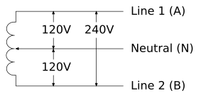
Figure 10-1. 1-Phase 3-Wire (LLN) 120V/240V
Medium | # wires | L-L | L-N | Countries | Phase Possibilities
AC-240VLL-120VLN-1Ph-60Hz | 3 | 240 | 120 | US, Canada | ABN
AC-240VLL-1Ph-60Hz | 2 | 240 | - | US, Canada | AB
AC-120VLN-1Ph-60Hz | 2 | - | 120 | US, Canada | AN, BN

10.12.1.1.1.1.3 3-Phase 3-Wire (LLL) 480V Delta
A 3-phase, 3-wire, 480V Delta transformer, the 2 AC electricity services it is capable of providing, and their associated mediums.
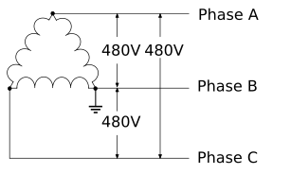
Figure 10-2. 3-Phase 3-Wire (LLL) 480V Delta
Medium | # wires | L-L | L-N | Countries | Phase Possibilities
AC-480VLL-3Ph-60Hz | 3 | 480 | - | US | ABC
AC-480VLL-1Ph-60Hz | 2 | 480 | - | US | AB, BC, AC

10.12.1.1.1.1.4 3-Phase 4-Wire (LLLN) 347V/600V Wye
A 3-phase, 4-Wire, 347V/600V Wye transformer, the 3 AC electricity services it is capable of providing, and their associated mediums.
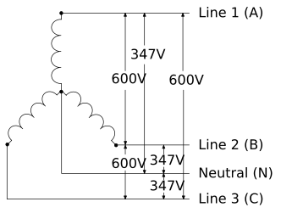
Figure 10-3. 3-Phase 4-Wire (LLLN) 347V/600V Wye
Medium | # wires | L-L | L-N | Countries | Phase Possibilities
AC-600VLL-347VLN-3Ph-60Hz | 3 | 600 | 347 | US, Canada | ABCN
AC-600VLL-1Ph-60Hz | 2 | 600 | - | US, Canada | AB, BC, AC
AC-347VLN-1Ph-60Hz | 2 | - | 347 | US, Canada | AN, BN, CN

10.12.1.1.1.1.5 3-Phase 4-Wire (LLLN) 120V/208V/240V High Leg Delta
A 3-Phase, 4-Wire, 120V/208V/240V High Leg Delta transformer, the 6 AC electricity services it is capable of providing, and their associated mediums.
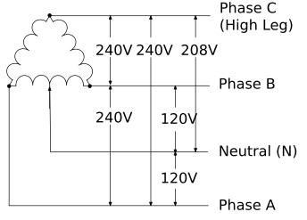
Figure 10-4. 3-Phase 4-Wire (LLLN) 120V/208V/240V High Leg Delta
Medium | # wires | L-L | L-N | Countries | Phase Possibilities
AC-240VLL-208VLN-120VLN-3Ph-60Hz | 4 | 240 | 208, 120 | US | ABCN
AC-240VLL-208VLN-120VLN-1Ph-60Hz | 4 | 240 | 208, 120 | US | ACN, BCN
AC-240VLL-120VLN-1Ph-60Hz | 3 | 240 | 120 | US | ABN
AC-240VLL-3Ph-60Hz | 3 | 240 | - | US | ABC
AC-240VLL-1Ph-60Hz | 2 | 240 | - | US | AB, BC, AC
AC-120VLN-1Ph-60Hz | 2 | - | 120 | US | AN, BN

10.12.1.1.1.1.6 3-Phase 4-Wire (LLLN) 120V/208V Wye
A 3-phase, 4-wire 120V/208V Wye transformer, the 5 AC electricity services it is capable of providing, and their associated mediums.
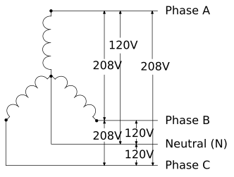
Figure 10-5. 3-Phase 4-Wire (LLLN) 120V/208V Wye
Medium | # wires | L-L | L-N | Countries | Phase Possibilities
AC-208VLL-120VLN-3Ph-60Hz | 4 | 208 | 120 | US, Canada | ABCN
AC-208VLL-120VLN-1Ph-60Hz | 4 | 208 | 120 | US, Canada | ABN, BCN, ACN
AC-208VLL-3Ph-60Hz | 3 | 208 | - | US, Canada | ABC
AC-208VLL-1Ph-60Hz | 2 | 208 | - | US, Canada | AB, BC, AC
AC-120VLN-1Ph-60Hz | 2 | - | 120 | US, Canada | AN, BN, CN

10.12.1.1.1.1.7 3-Phase 4-Wire (LLLN) 230V/400V Wye
A 3-phase, 4-wire 230V/400V Wye transformer, the 5 AC electricity services it is capable of providing, and their associated mediums.
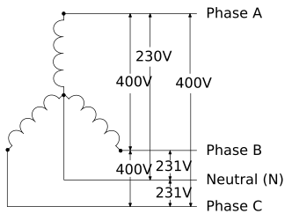
Figure 10-6. 3-Phase 4-Wire (LLLN) 230V/400V Wye
Medium | # wires | L-L | L-N | Countries | Phase Possibilities
AC-400VLL-230VLN-3Ph-50Hz | 4 | 400 | 230 | EU | ABCN
AC-400VLL-230VLN-1Ph-50Hz | 4 | 400 | 230 | EU | ABN, BCN, ACN
AC-400VLL-3Ph-50Hz | 3 | 400 | - | EU | ABC
AC-400VLL-1Ph-50Hz | 2 | 400 | - | EU | AB, BC, AC
AC-230VLN-1Ph-50Hz | 3 | - | 230 | EU | AN, BN, CN

10.12.1.1.1.1.8 3-Phase 4-Wire (LLLN) 240V/415V Wye
A 3-phase, 4-wire, 240V/415V Wye transformer, the 5 AC electricity services it is capable of providing, and their associated mediums.
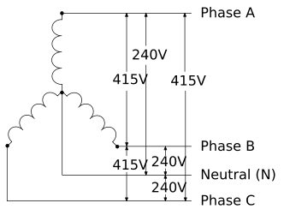
Figure 10-7. 3-Phase 4-Wire (LLLN) 240V/415V Wye
Medium | # wires | L-L | L-N | Countries | Phase Possibilities
AC-415VLL-240VLN-3Ph-50Hz | 4 | 415 | 240 | Australia | ABCN
AC-415VLL-240VLN-1Ph-50Hz | 3 | 415 | 240 | Australia | ABN, BCN, ACN
AC-415VLL-3Ph-50Hz | 3 | 415 | - | Australia | ABC
AC-415VLL-1Ph-50Hz | 2 | 415 | - | Australia | AB, BC, AC
AC-240VLN-1Ph-50Hz | 2 | - | 240 | Australia | AN, BN, CN

10.12.1.1.1.2 s223:Electricity-DC
This class and its enumerated subclasses represent common DC electricity services.
Electricity-DC Enumerations
Enumeration
DC-12V
DC-24V
DC-380V
DC-48V
DC-5V
DC-6V
DC-PoE

Related Constraints
Description | Link
A DC electricity medium shall have one or two reference voltages. | Link

10.12.1.1.1.2.1 s223:DC-12V
This class and its enumerated subclasses represent all polarities of 12 volt DC electricity.
DC-12V Enumerations
Enumeration
12V-12V-Neg
12V-12V-Pos
12V-6V-Neg-6V-Pos

10.12.1.1.1.2.2 s223:DC-24V
This class and its enumerated subclasses represent all polarities of 24 volt DC electricity.
DC-24V Enumerations
Enumeration
24V-12V-Neg-12V-Pos
24V-24V-Neg
24V-24V-Pos

10.12.1.1.1.2.3 s223:DC-380V
This class and its enumerated subclasses represent all polarities of 380 volt DC electricity.
DC-380V Enumerations
Enumeration
380V-190V-Neg-190V-Pos
380V-380V-Neg
380V-380V-Pos

10.12.1.1.1.2.4 s223:DC-48V
This class and its enumerated subclasses represent all polarities of 48 volt DC electricity.
DC-48V Enumerations
Enumeration
48V-24V-Neg-24V-Pos
48V-48V-Neg
48V-48V-Pos

10.12.1.1.1.2.5 s223:DC-5V
This class and its enumerated subclasses represent all polarities of 5 volt DC electricity.
DC-5V Enumerations
Enumeration
5V-2.5V-Neg-2.5V-Pos
5V-5V-Neg
5V-5V-Pos

10.12.1.1.1.2.6 s223:DC-6V
This class and its enumerated subclasses represent all polarities of 6 volt DC electricity.
DC-6V Enumerations
Enumeration
6V-3V-Neg-3V-Pos
6V-6V-Neg
6V-6V-Pos

10.12.1.1.1.2.7 s223:DC-PoE
This class and its enumerated subclasses represent standardized types of PoE DC electricity.
DC-PoE Enumerations
Enumeration
PoE-802.3af-1
PoE-802.3at-2
PoE-802.3bt-3
PoE-802.3bt-4

10.12.1.1.1.3 s223:Electricity-Signal
This class and its enumerated subclasses represent the use of electricity for creating communication signals, and common communication protocols.
Electricity-Signal Enumerations
Enumeration
Signal-EIA485
Signal-WiredEthernet (see Clause 10.12.1.1.1.3.1)
Signal-IEC14908
Signal-Modulated (see Clause 10.12.1.1.1.3.2)
Signal-USB

10.12.1.1.1.3.1 s223:Signal-WiredEthernet
This class and its enumerated subclasses represent common wired Ethernet protocols.
Signal-WiredEthernet Enumerations
Enumeration
WiredEthernet-Cat1
WiredEthernet-Cat2
WiredEthernet-Cat3
WiredEthernet-Cat4
WiredEthernet-Cat5
WiredEthernet-Cat5e
WiredEthernet-Cat6
WiredEthernet-Cat6a
WiredEthernet-Cat7
WiredEthernet-Cat7a
WiredEthernet-Cat8

10.12.1.1.1.3.2 s223:Signal-Modulated
This class and its enumerated subclasses represent common analog communication protocols.
Signal-Modulated Enumerations
Enumeration
Modulated-0-10V
Modulated-4-20mA

10.12.1.1.2 s223:Constituent-EM
This class and its enumerated subclasses represent electromagnetic energy at commonly defined frequency ranges.
Constituent-EM Enumerations
Enumeration
EM-Light (see Clause 10.12.1.1.2.1)
EM-Microwave
EM-RF (see Clause 10.12.1.1.2.2)

10.12.1.1.2.1 s223:EM-Light
This class and its enumerated subclasses represent light at commonly defined frequency or wavelength ranges.
EM-Light Enumerations
Enumeration
Light-Infrared (see Clause 10.12.1.1.2.1.1)
Light-Ultraviolet
Light-Visible

10.12.1.1.2.1.1 s223:Light-Infrared
This class and its enumerated subclasses represent the use of electromagnetic energy in the infrared frequency range for multiple purposes, including communication signals.
Light-Infrared Enumerations
Enumeration
Infrared-Signal (see Clause 10.12.1.1.2.1.1.1)

10.12.1.1.2.1.1.1 s223:Infrared-Signal
This class and its enumerated subclasses represent common infrared communication protocols.
Infrared-Signal Enumerations
Enumeration
Signal-FiberEthernet (see Clause 10.12.1.1.2.1.1.1.1)

10.12.1.1.2.1.1.1.1 s223:Signal-FiberEthernet
This class and its enumerated subclasses represent common fiber Ethernet communication protocols.
Signal-FiberEthernet Enumerations
Enumeration
FiberEthernet-OM1
FiberEthernet-OM2
FiberEthernet-OM3
FiberEthernet-OM4
FiberEthernet-OM5
FiberEthernet-OS1
FiberEthernet-OS2
Signal-FiberEthernet

10.12.1.1.2.2 s223:EM-RF
This class and its enumerated subclasses represent the use electromagnetic energy in the radio frequency range for multiple purposes, including communication signals.
EM-RF Enumerations
Enumeration
RF-Signal

10.12.1.1.3 s223:Constituent-NOX
This class and its enumerated subclasses represent common Nitrogen Oxides (NOx).
Constituent-NOX Enumerations
Enumeration
NOX-NO
NOX-NO2

10.12.1.2 s223:Medium-Mix
This class and its subclasses represent substances that are composed of constituents. The components of a Medium-Mix can be modeled using the relations composedOf and ofConstituent. See Figure 10-8a and Figure 10-8b.
Figure 10-8a shows GlycolSolution-30Percent, itself a subclass of Water-GlycolSolution, Fluid-Water, and Mix-Fluid, with a Water Concentration property referencing 70% Constituent-H2O by the relation ofConstituent and a Glycol Concentration property referencing 30% Constituent-Glycol also by the relation ofConstituent.
Figure 10-8b shows PowerAndSignal-PoE, itself a subclass of Mix-PowerAndSignal, composed of a Power Property referencing Electricity-DC and a Communications Property referencing Signal-WiredEthernet.
Medium-Mix Enumerations
Enumeration
Mix-Fluid (see Clause 10.12.1.2.1)
Mix-PowerAndSignal (see Clause 10.12.1.2.2)
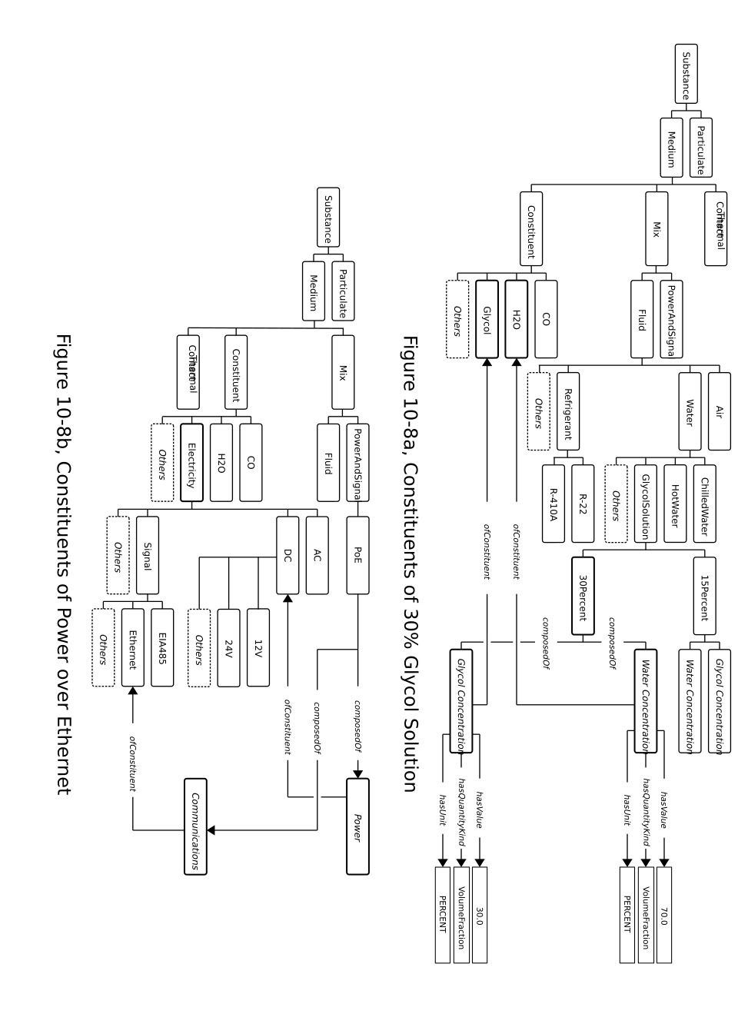
Figure 10-8.

10.12.1.2.1 s223:Mix-Fluid
This class and its enumerated subclasses represent substances that are commonly used to convey liquids or gases.
Mix-Fluid Enumerations
Enumeration
Fluid-Air
Fluid-NaturalGas
Fluid-Oil
Fluid-Refrigerant (see Clause 10.12.1.2.1.1)
Fluid-Water (see Clause 10.12.1.2.1.2)

10.12.1.2.1.1 s223:Fluid-Refrigerant
This class and its enumerated subclasses represent commonly used refrigerants.
Fluid-Refrigerant Enumerations
Enumeration
Refrigerant-R-123
Refrigerant-R-134A
Refrigerant-R-22
Refrigerant-R-290
Refrigerant-R-404A
Refrigerant-R-407C
Refrigerant-R-410A
Refrigerant-R-600A
Refrigerant-R-717
Refrigerant-R-744

10.12.1.2.1.2 s223:Fluid-Water
This class and its enumerated subclasses represent water and aqueous solutions in various states.
Fluid-Water Enumerations
Enumeration
Water-ChilledWater
Water-GlycolSolution (see Clause 10.12.1.2.1.2.1)
Water-HotWater
Water-Steam

10.12.1.2.1.2.1 s223:Water-GlycolSolution
This class and its enumerated subclasses represent common concentrations of water-glycol solution.
Water-GlycolSolution Enumerations
Enumeration
GlycolSolution-15Percent
GlycolSolution-30Percent

Related Constraints
Description | Link
If the relation hasFreezingPoint is used, the object shall be a QuantifiableProperty with a QuantityKind of Temperature. | Link
One of the constituents of a Water-GlycolSolution shall be Constituent-Glycol. | Link
One of the constituents of a Water-GlycolSolution shall be Constituent-H2O. | Link
There shall be at least two QuantifiableProperties that characterize the constituents of a Water-GlycolSolution. | Link

10.12.1.2.1.2.1.1 s223:hasFreezingPoint
The relation hasFreezingPoint is used to associate a freezing point with a glycol solution, but could be used with other Mediums as appropriate.

10.12.1.2.2 s223:Mix-PowerAndSignal
This class and its enumerated subclasses represent substances that are used to convey the combination of electrical power and electrical communication signals.
Mix-PowerAndSignal Enumerations
Enumeration
PowerAndSignal-PoE

10.12.2 s223:Substance-Particulate
This class and its enumerated subclasses represent common size thresholds of interest for particulate matter that is suspended in a medium in a way that maintains the physical and chemical properties of the medium.
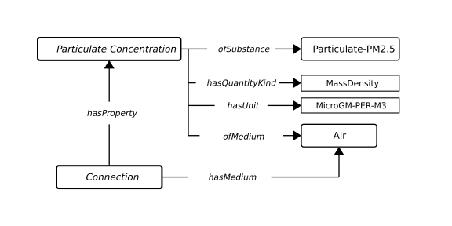
Figure 10-9. Particulate Concentration
Figure 10-9 shows an instance of a Connection with hasMedium referencing Fluid-Air that has a Property Particulate Concentration of particles with a diameter of 2.5 micrometres (0.0025 mm) or smaller in units of micrograms per cubic meter.
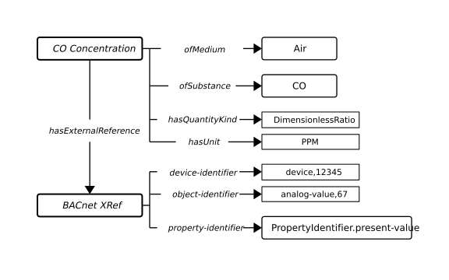
Figure 10-10. Carbon Monoxide Concentration
Figure 10-10 shows an instance of a Property CO Concentration with ofSubstance referencing carbon monoxide Constituent-CO and ofMedium referencing Fluid-Air measured in parts-per-million. This figure also shows that the value of this Property can be obtained by using the BACnet protocol via the external reference to get the present-value of analog-value,67 in the device with an instance number 12345.
Substance-Particulate Enumerations
Enumeration
Particulate-PM1.0
Particulate-PM10.0
Particulate-PM2.5

10.12.3 s223:Substance-Soot
Carbon particles resulting from the incomplete combustion of hydrocarbons. Soot is considered a hazardous substance with carcinogenic properties.

11 PROPERTIES AND VALUES
Things have properties, and properties have values.

11.1 s223:Property
An attribute, quality, or characteristic of a feature of interest.
The Property class is the parent of all variations of a Property, which are: ActuatableProperty - subclass of Property that can be modified by user or machine outside of the model (typically command); ObservableProperty - subclass of Property that are observed (typically measures); EnumerableProperty - subclass of Property defined by EnumerationKind; QuantifiableProperty - subclass of Property defined by numerical values.
And their subclass combinations : QuantifiableActuatableProperty, QuantifiableObservableProperty, EnumeratedObservableProperty, EnumeratedActuatableProperty.
A QuantifiableProperty (or subClass thereof) shall always be associated with a Unit and a QuantityKind, either explicitly from the Property, or through the associated Value. If the Unit is defined, the SHACL reasoner (if invoked) will figure out and assert a QuantityKind if it is unambiguous.
Enumerable properties shall be associated with an EnumerationKind. Different flavors of properties are shown in Figure 11-1.
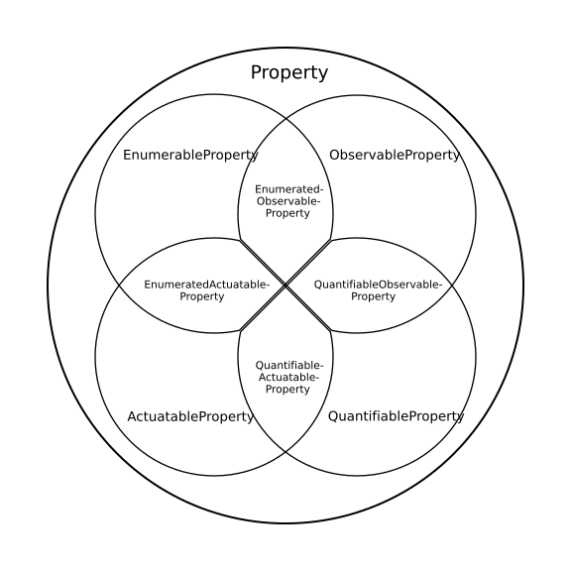
Figure 11-1. Different flavors of Properties
A Property instance that is not an instance of one of the subclasses is unconstrained with respect to its value.
Related Constraints
Description | Link
A Property can be associated with at most one EnumerationKind-Substance using the relation ofSubstance. | Link
A Property can be associated with at most one Function using the inverse relation hasOutput. | Link
A Property can be associated with at most one Substance-Medium using the relation ofMedium. | Link
A Property can use at most one relation hasValue if it is required to provide a static value in the model. It is not meant for real-time value (see Clause 11.19). | Link
A Property cannot be declared an instance of both an ActuatableProperty and an ObservableProperty. | Link
A Property must not be observed (set) by more than one entity. | Link
A Property must not have both a hasExternalReference and a hasValue relation. | Link
A Property must not have both a hasInternalReference and a hasExternalReference relation. | Link
A Property must not have both a hasInternalReference and a hasValue relation. | Link
If a Property has an ofSubstance relation, it should also have an ofMedium relation. | Link
If an incoming relation composedOf exists, then the Property must have a declared substance using the relation ofConstituent. | Link
If the relation hasAspect is present, it shall associate the Property with an EnumerationKind. | Link
If the relation hasExternalReference is present it shall associate the Property with an ExternalReference. | Link
If the relation hasInternalReference is present it shall associate the Property with at most one other Property. | Link

11.2 s223:ActuatableProperty
The term “actuatable” implies that writing to the ActuatableProperty value will directly trigger a physical actuation by either an Actuator or Equipment. In contrast, the term “observable” (see Clause 11.3) implies that reading the ObservableProperty value will return the result of a physical observation.
Related Constraints
Description | Link
An ActuatableProperty normally is referred to by Equipment using the relation actuatedByProperty. | Link

11.3 s223:ObservableProperty
The term “observable” implies that reading the ObservableProperty value will return the result of a physical observation, usually by a Sensor. In contrast, the term “actuatable” (see Clause 11.2) implies that writing to the ActuatableProperty value will directly trigger a physical actuation.
Related Constraints
Description | Link
An ObservableProperty is usually referred to by a Sensor using the relation observes. | Link

11.4 s223:EnumerableProperty
An EnumerableProperty is a Property with an enumerated (fixed) set of possible values.
Related Constraints
Description | Link
An EnumerableProperty shall be associated with exactly one EnumerationKind using the relation hasEnumerationKind. | Link
Checks for valid enumeration value consistent with the stated EnumerationKind. | Link

11.4.1 s223:hasEnumerationKind
A Relation that associates an EnumerableProperty with a class of enumeration values. This is used to, for example, identify what kind of substance is transported along a Connection or which day of the week a setpoint is active.

11.5 s223:QuantifiableProperty
This class is for quantifiable values that describe an object (System, Equipment, etc.) that are typically static (hasValue). That is, they are neither measured nor specified in the course of operations.
Related Constraints
Description | Link
A QuantifiableProperty can be associated with a QuantifiableProperty using the relation hasDeadband. | Link
A QuantifiableProperty can be associated with a QuantifiableProperty using the relation hasSetpoint. | Link
A QuantifiableProperty can be associated with aQuantifiableProperty using the relation hasThreshold. | Link
A QuantifiableProperty can be associated with an EnumerableProperty using the relation hasAlarmStatus. | Link
A QuantifiableProperty can be associated with an optional Boolean flag using the relation isDeltaQuantity. If the relation isDeltaQuantity has a value of true, the associated value should be interpreted as a difference reading, such as a temperature difference. This is needed to distinguish between a temperature reading and a temperature difference reading, which affects unit conversion calculations. | Link
A QuantifiableProperty can be associated with at most one Unit using the relation hasUnit. | Link
A QuantifiableProperty shall be associated with a QuantityKind using the relation hasQuantityKind. | Link
A QuantifiableProperty should use s223:hasValue instead of qudt:value. | Link
Checks for consistent dimension vectors for a QuantityKind and the Unit | Link
Normally, a QuantifiableProperty is associated with a static decimal value using hasValue, along with a single Unit and QuantityKind. However, in some cases, a QuantifiableProperty may instead be associated with a QuantityValue using the relation quantityValue. This allows the QuantityValue to express multiple equivalent combinations of Unit and value. | Link
This QuantifiableProperty and the Setpoint associated with it have non-commensurate QuantityKinds. | Link
This QuantifiableProperty and the associated deadband use non-commensurate Units. | Link
This QuantifiableProperty and the associated setpoint use non-commensurate Units. | Link
This QuantifiableProperty and the associated threshold use non-commensurate Units. | Link
This QuantifiableProperty and the deadband associated with it have non-commensurate QuantityKinds. | Link
This QuantifiableProperty and the threshold associated with it have non-commensurate QuantityKinds. | Link
This QuantifiableProperty cannot have a value without a Unit. | Link
This QuantifiableProperty uses a different Unit than the deadband associated with it. | Link
This QuantifiableProperty uses a different Unit than the setpoint associated with it. | Link
This QuantifiableProperty uses a different Unit than the threshold associated with it. | Link

Related Inference Rules
Description | Link
Infer the hasAspect s223:Aspect-Deadband for properties referred to by hasDeadband | Link
Infer the hasAspect s223:Aspect-Setpoint for properties referred to by hasSetpoint | Link
Infer the hasAspect s223:Aspect-Threshold for properties referred to by hasThreshold | Link
Infer the hasQuantityKind relation if it is unambiguous. | Link

11.5.1 s223:hasAlarmStatus
A Relation that associates an EnumerableProperty that describes an Alarm or Status with a QuantifiableProperty.

11.5.2 s223:hasDeadband
This relation binds a control setpoint to the QuantifiableProperty indicating the range of values within which a sensed variable can vary without indicating a condition has changed.

11.5.3 s223:hasSetpoint
A Relation that associates a control setpoint with the QuantifiableProperty indicating the desired value which the control process is trying to maintain.

11.5.4 s223:hasThreshold
A Relation that associates a threshold with the QuantifiableProperty indicating a specific value at which an action may be taken, distinguished from an offset or a range.

11.6 s223:QuantifiableActuatableProperty
This class is for instances of QuantifiableProperty for which numerical values are specified to be modifiable by a user or a machine outside of the model, like a setpoint.

11.7 s223:QuantifiableObservableProperty
This class is for instances of QuantifiableProperty for which numerical values are observed, like a temperature reading or a voltage measure.
Related Constraints
Description | Link
A QuantifiableObservableProperty can be associated with zero or more QuantifiableProperty(s) indicating the desired value(s) which the control process is trying to maintain using the relation hasSetpoint. | Link

11.8 s223:EnumeratedObservableProperty
An EnumeratedObservableProperty is a Property with an enumerated (fixed) set of possible values that cannot be changed (can only be observed).

11.9 s223:EnumeratedActuatableProperty
An EnumeratedActuatableProperty is a Property with an enumerated (fixed) set of possible values that can be changed (actuated).

11.10 s223:hasValue
A Relation that associates something with a fixed value, as opposed to a computed, measured, or externally derived value.

11.11 qudt:hasUnit
A reference to the unit of measure of a QuantifiableProperty of interest.

11.12 qudt:hasQuantityKind
A reference to the QuantityKind of a QuantifiableProperty of interest, e.g., quantitykind:Temperature.

11.13 s223:hasAspect
hasAspect is used to establish the context of a Property. The value must be an instance of EnumerationKind. For example, if a Property has a Temperature value of 45.3, the hasAspect relation is used to state what that represents, such as a Temperature limit during working hours, etc. A Property can have any number of hasAspect relations as needed to establish the context.

11.14 s223:ofSubstance
A Relation that associates a Property being observed by a Sensor with the EnumerationKind-Substance it characterizes within a specific Substance-Medium. For example, to denote the concentration of a Substance in a Medium, ofSubstance is used. Typically, there is also an ofMedium relation between the observed Property and the Medium, (see Figures 10-9 and 10-10). For example, to represent the concentration of CO2 in air, we use ofSubstance to relate to CO2 and ofMedium to relate to air. The term ofSubstance is broad enough to include situations where a sensor is used to detect constituents that should not be present in a medium, such as ammonia in air. Therefore, ofSubstance is used to indicate the substance of interest, while ofConstituent would indicate a constituent that is normally present in the composition of the mix.

11.15 s223:ofMedium
A Relation that associates a Property with the specific Medium it describes. A Property corresponding to the temperature of a medium would be associated with this medium using the relation ofMedium.

11.16 s223:ofConstituent
A Relation that associates a Property that characterizes a Medium-Mix with one of the constituents of that mix. (e.g., Fluid-Water composedOf Property ofConstituent Constituent-H2O.

11.17 s223:composedOf
The relation composedOf is used to indicate what substances constitute a material. Allowable values are instances of Property that in turn identify constituents defined in Medium-Constituent (see Clause 10.12.1.1) via the relation ofConstituent.

11.18 s223:ExternalReference
ExternalReference is an abstract class that represents a thing that contains API or protocol parameter values necessary to associate a Property with a value.

11.18.1 s223:BACnetExternalReference
An ExternalReference that contains BACnet protocol parameter values necessary to associate a Property with a value.
Related Constraints
Description | Link
If the relation device-identifier is present it associates the external reference with a BACnet device having the specific device identifier. | Link
If the relation device-name is present it associates the external reference with a BACnet device having the specific device name. | Link
If the relation object-identifier is present it associates the external reference with the BACnet object having the specific object identifier. | Link
If the relation object-name is present it associates the external reference with the BACnet object having the specific object name. | Link
If the relation priority-for-writing is present it provides the priority for writing values to the object. | Link
If the relation property-array-index is present it provides the index for reading items from a property that is an array. | Link
If the relation property-identifier is present it is either a decimal number or exactly equal to the ASHRAE 135-2024 Clause 21 identifier text of BACnetPropertyIdentifier. If it is omitted, it defaults to “present-value” except for BACnet File objects, where absence of property-identifier refers to the entire content of the file accessed with Stream Access. | Link

11.18.1.1 bacnet:device-name
The name of the BACnet device being referenced, more formally the Object_Name property of the device object within the BACnet device. See ASHRAE 135-2024 Clause 12.11.2.

11.18.1.2 bacnet:device-identifier
The Object_Identifier property of the device object within the BACnet device. See ASHRAE 135-2024 Clause 12.11.1.

11.18.1.3 bacnet:object-name
The Object_Name property of the object being referenced. For example, for the object name of an Analog Value Object, see ASHRAE 135-2024 Clause 12.4.2.

11.18.1.4 bacnet:object-identifier
The Object_Identifier property of the object being referenced. For example, for the object identifier of an Analog Value Object, see ASHRAE 135-2024 Clause 12.4.1.

11.18.1.5 bacnet:property-identifier
The Object_Identifier Property of the object being referenced. For example, for the object identifier of an Analog Value Object, see ASHRAE 135-2024 Clause 12.4.1.

11.18.1.6 bacnet:property-array-index
If the property identified is of datatype array, this optional property of type Unsigned shall indicate the array index of the element of the Property referenced by the ReadProperty service or the Read Access Specification of the ReadPropertyMultiple service. If the bacnet:property-array-index is omitted, this shall mean that the entire array shall be referenced. See ASHRAE 135-2024 Clause 15.5.1.1.3 and Clause 15.7.1.1.1.

11.18.1.7 bacnet:priority-for-writing
This parameter shall be an integer in the range 1..16, which indicates the priority assigned to the WriteProperty service. If an attempt is made to write to a commandable property without specifying the bacnet:priority-for-writing, a default priority of 16 (the lowest priority) shall be assumed. If an attempt is made to write to a property that is not commandable with a specified priority, the priority shall be ignored. See ASHRAE 135-2024 Clause 15.9.1.1.5.

11.19 s223:hasExternalReference
A Relation that associates a Property with an external telemetry source.

11.20 s223:hasInternalReference
A Relation that associates a Property with another equivalent Property. For example, a Property that represents a Zone temperature could have at most one hasInternalReference relation to another Property that is a temperature measurement from one room in the zone (see Figure 11-2).
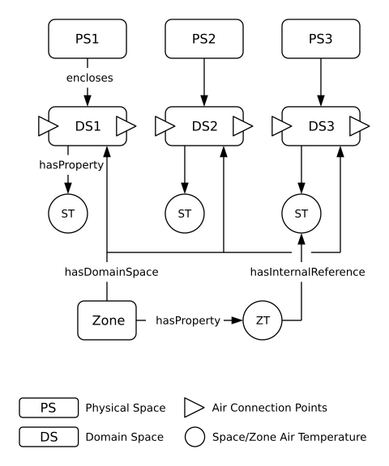
Figure 11-2. Zone Internal Reference.
Another use of hasInternalReference is to make a Property of a piece of equipment visible as a Property of a piece of containing equipment (see Clause 5.2). This is illustrated in Figure 11-3.
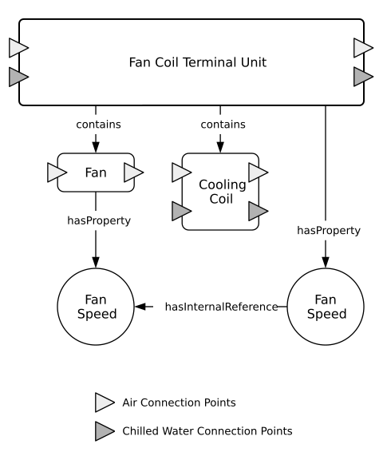
Figure 11-3. Equipment Containment.
Note that the hasInternalReference relation is transitive.

12 REFERENCE FOR EQUIPMENT
This section contains component model templates for equipment that is commonly found in buildings.

12.1 s223:AirHandlingUnit
A piece of Equipment consisting of a fan or fans and other equipment necessary to perform one or more of the following functions: circulating, filtration, heating, cooling, heat recovery, humidifying, dehumidifying, and mixing of air.
Related Constraints
Description | Link
An AirHandlingUnit shall have at least one inlet using the medium Fluid-Air. | Link
An AirHandlingUnit shall have at least one outlet using the medium Fluid-Air. | Link

Related Inference Rules
Description | Link
If an instance of s223:AirHandlingUnit matches the constraints defined by g36:DualFanDualDuctAirHandlingUnit, it will be declared as an instance of that class. | Link
If an instance of s223:AirHandlingUnit matches the constraints defined by g36:MultipleZoneVAVAirHandlingUnit and has a common economizer/minimum outdoor air damper, it will be declared as an instance of this class. | Link
If an instance of s223:AirHandlingUnit matches the constraints defined by g36:MultipleZoneVAVAirHandlingUnit and has a relief damper, it will be declared as an instance of this class. | Link
If an instance of s223:AirHandlingUnit matches the constraints defined by g36:MultipleZoneVAVAirHandlingUnit and has a relief fan, it will be declared as an instance of this class. | Link
If an instance of s223:AirHandlingUnit matches the constraints defined by g36:MultipleZoneVAVAirHandlingUnit and has a return fan, it will be declared as an instance of this class. | Link
If an instance of s223:AirHandlingUnit matches the constraints defined by g36:MultipleZoneVAVAirHandlingUnit, it will be declared as an instance of that class. | Link
If an instance of s223:AirHandlingUnit matches the constraints defined by g36:MultipleZoneVAVAirHandlingUnit-OADandAFMS, it will be declared as an instance of that class. | Link
If an instance of s223:AirHandlingUnit matches the constraints defined by g36:MultipleZoneVAVAirHandlingUnit-OADandDP, it will be declared as an instance of that class. | Link
If an instance of s223:AirHandlingUnit matches the constraints defined by g36:SingleZoneVAVAirHandlingUnit and has a relief fan, it will be declared as an instance of this class. | Link
If an instance of s223:AirHandlingUnit matches the constraints defined by g36:SingleZoneVAVAirHandlingUnit and has a return fan, it will be declared as an instance of that class. | Link
If an instance of s223:AirHandlingUnit matches the constraints defined by g36:SingleZoneVAVAirHandlingUnit, it will be declared as an instance of that class. | Link
If an instance of s223:AirHandlingUnit matches the constraints defined by g36:SingleZoneVAVAirHandlingUnit-WithReliefDamperFan, it will be declared as an instance of that class. | Link

12.2 s223:AirHeatExchanger
A piece of Equipment that transfers heat from one air stream to another while keeping the two media separate.
Related Constraints
Description | Link
An AirHeatExchanger shall have at least two air inlets, each paired with an outlet. | Link
An AirHeatExchanger shall have at least two air outlets, each paired with an inlet. | Link
An AirHeatExchanger shall have no BidirectionalConnectionPoints. | Link

Related Inference Rules
Description | Link
Infer the hasRole s223:Role-HeatTransfer relation for every instance of the listed targetClass values. | Link

12.3 s223:Battery
A piece of Equipment that stores a defined amount of chemical energy that can be converted to electrical energy via a chemical process. This process, typically referred to as discharging, produces a specific electrical voltage and current.
Related Constraints
Description | Link
A Battery shall have at least one outlet or bidirectional ConnectionPoint using the medium Electricity. | Link

12.4 s223:Boiler
A piece of Equipment that uses fuel or electricity to heat water or other fluids and supply steam or hot water for heating, humidification, or other applications.
Related Constraints
Description | Link
A Boiler shall have at least one inlet using the medium Fluid-Water. | Link
A Boiler shall have at least one outlet using the medium Fluid-Water. | Link

12.5 s223:ChilledBeam
A piece of Equipment with a colder surface temperature where air passes through, and air movement is induced in the room to achieve cooling. Cooling medium is generally water.
Related Constraints
Description | Link
A ChilledBeam shall be associated with the Role-Cooling using the relation hasRole | Link
A ChilledBeam shall have at least one bidirectional connection point using the medium Fluid-Air. | Link
A ChilledBeam shall have at least one inlet using the medium Fluid-Water. | Link
A ChilledBeam shall have at least one outlet using the medium Fluid-Water. | Link

Related Inference Rules
Description | Link
A ChilledBeam must always have the role Role-Cooling | Link
Infer the hasRole s223:Role-HeatTransfer relation for every instance of the listed targetClass values. | Link

12.6 s223:Chiller
A piece of Equipment that removes heat from a liquid coolant via a vapor-compression, adsorption refrigeration, or absorption refrigeration cycles.
Related Constraints
Description | Link
A Chiller shall have at least one inlet using the medium Fluid-Water. | Link
A Chiller shall have at least one outlet using the medium Fluid-Water. | Link

12.7 s223:ClothesWasher
A piece of Equipment that automatically cleans a load of textiles (e.g., clothing, bedding).
Related Constraints
Description | Link
A ClothesWasher shall have at least one inlet using the medium Constituent-Electricity. | Link
A ClothesWasher shall have at least one inlet using the medium Fluid-Water. | Link
A ClothesWasher shall have at least one outlet using the medium Fluid-Water. | Link

12.8 s223:CoffeeMaker
A piece of Equipment that automatically brews coffee.
Related Constraints
Description | Link
A CoffeeMaker shall have at least one inlet using the medium Constituent-Electricity. | Link

12.9 s223:Coil
A piece of Equipment consisting of a pipe or tube that is formed into a helical or serpentine shape, may or may not be finned, and is used in cooling or heating equipment.
A Coil shall conform to exactly one of the following patterns:
- Pattern 1:
  - The Coil has exactly two inlet connection points using the medium Mix-Fluid, with exactly one being Fluid-Air.
  - The Coil has exactly two outlet connection points using the medium Mix-Fluid, with exactly one being Fluid-Air.
- Pattern 2:
  - The Coil has exactly one inlet connection point using the medium Mix-Fluid.
  - The Coil has exactly one outlet connection point using the medium Mix-Fluid.
  - The Coil has one or two bidirectional connection points using the medium Mix-Fluid or Medium-ThermalContact.
- Pattern 3:
  - The Coil has exactly three bidirectional connection points using the medium Mix-Fluid or Medium-ThermalContact.
Related Constraints
Description | Link
Pattern 1: A Coil shall have two inlets using the medium Mix-Fluid. | Link
Pattern 1: A Coil shall have two outlets using the medium Mix-Fluid. | Link
Pattern 1: For one of the two inlets the Fluid is Air. | Link
Pattern 1: For one of the two outlets the Fluid is Air. | Link
Pattern 2: A Coil shall have one inlet using the medium Mix-Fluid. | Link
Pattern 2: A Coil shall have one or two bidirectionals using the medium Mix-Fluid or Medium-ThermalContact. | Link
Pattern 2: A Coil shall have one outlet using the medium Mix-Fluid. | Link
Pattern 3: A Coil shall have three bidirectionals using the medium Mix-Fluid or Medium-ThermalContact. | Link

Related Inference Rules
Description | Link
Infer the hasRole s223:Role-HeatTransfer relation for every instance of the listed targetClass values. | Link

12.9.1 s223:CoolingCoil
A Coil that is specifically used to cool air.
Related Constraints
Description | Link
A cooling coil shall be related to the role ‘Role-Cooling’ using the relation ‘hasRole’. | Link

Related Inference Rules
Description | Link
A CoolingCoil must always have the role Role-Cooling | Link
If an instance of s223:CoolingCoil matches the constraints defined by g36:ChilledWaterCoil, it will be declared as an instance of that class. | Link

12.9.2 s223:HeatingCoil
A Coil that is specifically used to heat air.
Related Constraints
Description | Link
A heating coil shall be related to the role ‘Role-Heating’ using the relation ‘hasRole’. | Link

Related Inference Rules
Description | Link
Heating coils must always have the role Role-Heating | Link
If an instance of s223:HeatingCoil matches the constraints defined by g36:HotWaterCoil, it will be declared as an instance of that class. | Link

12.10 s223:Compressor
A piece of Equipment that mechanically increases the pressure of a gas.
Related Constraints
Description | Link
A Compressor shall have at least one inlet. | Link
A Compressor shall have at least one outlet. | Link

12.11 s223:Computer
A piece of Equipment that can be programmed to automatically carry out sequences of arithmetic or logical operations (computation). Modern digital electronic computers can perform generic sets of operations known as programs. These programs enable computers to perform a wide range of tasks.
Related Constraints
Description | Link
A Computer shall have at least one inlet using the medium Constituent-Electricity. | Link

12.11.1 s223:PersonalComputer
A Computer designed primarily used by a single person.
Related Constraints
Description | Link
A PersonalComputer shall have at least one inlet using the medium Constituent-Electricity. | Link

12.11.2 s223:ServerComputer
A Computer that is primarily used by multiple people, or for the execution of tasks not directly coupled to human interaction.
Related Constraints
Description | Link
A ServerComputer shall have at least one inlet using the medium Constituent-Electricity. | Link

12.12 s223:ComputerPrinter
A piece of Equipment that processes an input electrical or RF signal, typically from a Computer, and outputs a durable representation of information, typically text and/or graphics, typically on paper.
Related Constraints
Description | Link
A ComputerPrinter shall have at least one inlet using the medium Constituent-Electricity. | Link
A ComputerPrinter shall have at least one inlet using the medium Electricity-Signal or EM-RF. | Link

12.13 s223:CoolingTower
A piece of Equipment that uses atmospheric air to cool warm water, generally by direct contact via evaporation.
Related Constraints
Description | Link
A CoolingTower shall have at least one inlet using the medium Fluid-Water. | Link
A CoolingTower shall have at least one outlet using the medium Fluid-Water. | Link

12.14 s223:CopyMachine
A piece of Equipment that processes an input of one or more durable representation(s) of information, typically text and/or graphics and typically on paper, and outputs one or more reproductions of the information for each input, typically on paper.
Related Constraints
Description | Link
A CopyMachine shall have at least one inlet using the medium Constituent-Electricity. | Link

12.15 s223:Damper
A piece of Equipment inserted into an air distribution system permitting modification of the air resistance of the system and consequently changing the airflow rate or shutting off the airflow.
Related Constraints
Description | Link
A Damper shall have at least one inlet using the medium Fluid-Air. | Link
A Damper shall have at least one outlet using the medium Fluid-Air. | Link

Related Inference Rules
Description | Link
If an instance of s223:Damper matches the constraints defined by g36:Damper, it will be declared as an instance of that class. | Link
If an instance of s223:Damper matches the constraints defined by g36:TwoPositionDamper, it will be declared as an instance of that class. | Link

12.16 s223:Dishwasher
A piece of Equipment that automatically cleans dishware, cookware, and cutlery.
Related Constraints
Description | Link
A Dishwasher shall have at least one inlet using the medium Constituent-Electricity. | Link
A Dishwasher shall have at least one inlet using the medium Fluid-Water. | Link
A Dishwasher shall have at least one outlet using the medium Fluid-Water. | Link

12.17 s223:Door
A piece of Equipment consisting of hinged, sliding, or revolving barrier at the entrance to a building or room.
Related Constraints
Description | Link
A Door shall have at least two bidirectional connection points using the medium Fluid-Air. | Link

12.18 s223:ElectricityBreaker
A piece of equipment that automatically opens an electric circuit automatically at a predetermined overcurrent, so as to prevent damage to the circuit, the equipment connected to the circuit, and the building containing the circuit.
Related Constraints
Description | Link
An ElectricityBreaker shall have at least one inlet using the medium Constituent-Electricity. | Link
An ElectricityBreaker shall have at least one outlet using the medium Constituent-Electricity. | Link

12.19 s223:ElectricClothesDryer
A piece of Equipment that automatically removes moisture from a load of textiles (e.g., clothing, bedding), typically after they are washed in a ClothesWasher.
Related Constraints
Description | Link
A ElectricClothesDryer shall have at least one inlet using the medium Constituent-Electricity. | Link

12.20 s223:ElectricCooktop
A piece of Equipment with a flat surface containing one or more heat sources designed for cooking with pots and pans.
Related Constraints
Description | Link
A ElectricCooktop shall have at least one inlet using the medium Constituent-Electricity. | Link

12.21 s223:ElectricEnergyConverter
A piece of Equipment that converts one form of electric power to another form of electric power.
Related Constraints
Description | Link
A ElectricEnergyConverter shall have at least two connection points using the medium Constituent-Electricity. | Link

12.21.1 s223:ElectricEnergyDCDCConverter
An ElectricEnergyConverter that transforms direct current (DC) electric power from one voltage to another voltage.
Related Constraints
Description | Link
An ElectricEnergyDCDCConverter shall have at least two connection points using the medium Electricity-DC. | Link

12.21.2 s223:ElectricEnergyInverter
An ElectricEnergyConverter that tranforms direct current (DC) electric power to alternating current (AC) electric power, or vice versa.
Related Constraints
Description | Link
An ElectricEnergyInverter shall have at least one connection point that uses the medium Electricity-AC. | Link
An ElectricEnergyInverter shall have at least one connection point that uses the medium Electricity-DC. | Link

12.21.3 s223:ElectricEnergyTransformer
An ElectricEnergyConverter that transforms alternating current (AC) electric power from one voltage to another voltage.
Related Constraints
Description | Link
An ElectricEnergyTransformer shall have at least two connection points using the medium Electricity-AC. | Link

12.22 s223:ElectricityMeter
A piece of Equipment that contains at least one VoltageSensor and one ElectricCurrentSensor, and reports one or more properties of electricity. Example reported properties include the following QuantityKinds: Voltage, ElectricCurrent, ActiveEnergy, ActivePower, ReactivePower, ApparentPower, PowerFactor, and Frequency with unit Hertz. An ElectricityMeter may optionally contain a Function that represents the mathematical calculations of the reported properties of electricity.
Related Constraints
Description | Link
An ElectricityMeter shall contain a VoltageSensor and ElectricCurrentSensor with the same observation location. | Link
An ElectricityMeter shall contain at least one ElectricCurrentSensor. | Link
An ElectricityMeter shall contain at least one VoltageSensor. | Link
An ElectricityMeter shall contain at least two Sensors. | Link
Placeholder: The medium observed by the sensors contained by an ElectricityMeter shall be within the Constituent-Electricity hierarchy. | Link
The observation location of the contained VoltageSensor(s) and ElectricCurrentSensor(s) shall be a single instance of either a Connection or a ConnectionPoint. | Link

12.23 s223:ElectricityOutlet
A piece of Equipment that contains one or more receptacles for connecting electrical equipment to electrical power, typically via a plug and cord. Not to be confused with an OutletConnectionPoint with the medium Constituent-Electricity.
Related Constraints
Description | Link
An ElectricityOutlet shall have at least one outlet using the medium Constituent-Electricity. | Link
An ElectricityOutlet shall have exactly one inlet using the medium Constituent-Electricity. | Link

12.24 s223:ElectricOven
A piece of Equipment with an enclosed chamber designed for baking, roasting, and other cooking methods that rely on circulating heat.
Related Constraints
Description | Link
A ElectricOven shall have at least one inlet using the medium Constituent-Electricity. | Link

12.25 s223:ElectricResistanceElement
A piece of Equipment that provides electrical resistance heating, for example an electric heating coil within a Fan Coil Unit. It shall have one electricity InletConnectionPoint, and fit one of the following two patterns:
- Pattern 1: An ElectricResistanceElement shall have exactly one Bidirectional ConnectionPoint using the medium Mix-Fluid.
- Pattern 2: An ElectricResistanceElement shall have one inlet and one outlet using the medium Mix-Fluid.
Related Constraints
Description | Link
An ElectricResistanceElement shall have at least one inlet using the medium Constituent-Electricity. | Link
An ElectricResistanceElement shall have the role Role-Heating. | Link
Pattern 1: An ElectricResistanceElement shall have exactly one Bidirectional ConnectionPoint using the medium Mix-Fluid. | Link
Pattern 2: An ElectricResistanceElement shall have one inlet using the medium Mix-Fluid. | Link
Pattern 2: An ElectricResistanceElement shall have one outlet using the medium Mix-Fluid. | Link

Related Inference Rules
Description | Link
If an instance of s223:ElectricResistanceElement matches the constraints defined by g36:ElectricHeatingCoil, it will be declared as an instance of that class. | Link
Infer the hasRole s223:Role-HeatTransfer relation for every instance of the listed targetClass values. | Link

12.26 s223:ElectricWaterDispenser
A piece of Equipment that dispenses water and optionally heats and/or cools the water prior to dispensing.
Related Constraints
Description | Link
An ElectricWaterDispenser shall have at least one inlet using the medium Constituent-Electricity. | Link
An ElectricWaterDispenser shall have at least one inlet using the medium Fluid-Water. | Link

12.27 s223:ElectronicDisplay
A piece of Equipment that receives an input electrical signal and outputs information, typically text and/or graphics, in a visual form.
Related Constraints
Description | Link
A ElectronicDisplay shall have at least one inlet using the medium Constituent-Electricity. | Link
A ElectronicDisplay shall have at least one inlet using the medium Electricity-Signal. | Link

12.27.1 s223:Monitor
An ElectronicDisplay designed primarily for the output of visual information supplied by a Computer.

12.27.2 s223:Television
An ElectronicDisplay that is designed primarily for the output of visual information supplied by a media broadcaster, and that typically has an integral tuner that is capable of selecting a single channel for display from the available input channel range.

12.28 s223:Elevator
A piece of Equipment that vertically transports people or freight between floors or levels of a building via a vertical shaft commonly referred to as a hoistway. The people or freight are typically situated on a platform, or in a container commonly referred to as a car, cab, cabin, cage, or carriage.
Related Constraints
Description | Link
A Elevator shall have at least one inlet using the medium Constituent-Electricity. | Link

12.29 s223:Escalator
A piece of Equipment that vertically transports people between floors or levels of a building via a moving staircase.
Related Constraints
Description | Link
A Escalator shall have at least one inlet using the medium Constituent-Electricity. | Link

12.30 s223:EthernetSwitch
A piece of Equipment that connects electrical equipment, such as Computers and Wi-Fi access points, to an Ethernet network so they can communicate with each other and, optionally, to the Internet.
Related Constraints
Description | Link
An EthernetSwitch shall have at least one inlet using the medium Constituent-Electricity. | Link
An EthernetSwitch shall have at least two BidirectionalConnectionPoints using the medium Signal-Ethernet. | Link

12.31 s223:Fan
A piece of Equipment that causes a gas (e.g., air) to flow.
Related Constraints
Description | Link
A Fan shall have at least one inlet using the medium Fluid-Air. | Link
A Fan shall have at least one outlet using the medium Fluid-Air. | Link

Related Inference Rules
Description | Link
If an instance of s223:Fan matches the constraints defined by g36:Fan, it will be declared as an instance of that class. | Link
If an instance of s223:Fan matches the constraints defined by g36:FanWithVFD, it will be declared as an instance of that class. | Link

12.32 s223:FanCoilUnit
A piece of Equipment consisting of a Coil and a Fan that regulates the temperature of one or more spaces.
Related Constraints
Description | Link
A FanCoilUnit shall be associated with at least 1 Coil using the relation contains. | Link
A FanCoilUnit shall be associated with at least 1 Fan using the relation contains. | Link
A FanCoilUnit shall have at least one inlet using the medium Fluid-Air. | Link
A FanCoilUnit shall have at least one outlet using the medium Fluid-Air. | Link
A FanCoilUnit shall have the role Role-Heating or Role-Cooling. | Link

12.33 s223:FiberEthernetOutlet
A piece of Equipment that contains one or more receptacles for connecting electrical equipment to a fiber Ethernet communication network, typically via a fiber Ethernet cable.
Related Constraints
Description | Link
A FiberEthernetOutlet shall have at least one outlet using the medium Signal-FiberEthernet. | Link
A FiberEthernetOutlet shall have exactly one inlet using the medium Signal-FiberEthernet. | Link

12.34 s223:Filter
A piece of Equipment that removes contaminants from gases or liquids. See Clause 10.12.1 for more details on validating compatible mediums upstream and downstream of a Filter.
Related Constraints
Description | Link
A Filter shall have at least one inlet ConnectionPoint. | Link
A Filter shall have at least one outlet. | Link
Incompatible Medium. Case 1: Associated ConnectionPoints with two pure mediums. | Link
Incompatible Medium. Case 2: Associated ConnectionPoints, one with a pure medium and one with a medium having constituents.. | Link
Incompatible Medium. Case 3: Associated ConnectionPoints with mediums having constituents. | Link

12.35 s223:FlushToilet
A piece of Equipment that collects human waste (i.e., urine and/or feces, and sometimes toilet paper) in a chamber containing water, and contains an integral manual or automatic actuator that triggers the release of an additional volume of water that flushes everything from the chamber into a drainage system that typically carries the mixture to a sewer system or septic tank.
Related Constraints
Description | Link
A FlushToilet shall have at least one inlet using the medium Fluid-Water. | Link
A FlushToilet shall have at least one outlet using the medium Fluid-Water. | Link

12.36 s223:Freezer
A piece of Equipment that maintains an internal temperature below the freezing point of water.
Related Constraints
Description | Link
A Freezer shall have at least one inlet using the medium Constituent-Electricity. | Link

12.37 s223:FumeHood
A piece of Equipment that is typically mounted over a work area (e.g., a space, table, or shelf) and conducts unwanted gases away from the area.
Related Constraints
Description | Link
A FumeHood shall have at least one inlet using the medium Fluid-Air. | Link
A FumeHood shall have at least one outlet using the medium Fluid-Air. | Link

12.38 s223:Furnace
A piece of Equipment that converts fuel or electrical energy into heat.
Related Constraints
Description | Link
A Furnace shall have at least one inlet using the medium Fluid-Air. | Link
A Furnace shall have at least one outlet using the medium Fluid-Air. | Link

12.39 s223:Generator
A piece of Equipment that converts non-electric energy into electric energy.
Related Constraints
Description | Link
A Generator shall be associated with at least one ConnectionPoint using the relation hasConnectionPoint. | Link
A Generator shall have at least one outlet using the medium Constituent-Electricity. | Link

12.40 s223:HeatPump
A piece of Equipment that heats or cools spaces by transferring thermal energy from one thermal environment to another using a reversible refrigeration cycle.

12.40.1 s223:AirToAirHeatPump
A HeatPump that transfers thermal energy between two bodies of air.
Related Constraints
Description | Link
An AirToAirHeatPump shall have at least two inlets using the medium Fluid-Air. | Link
An AirToAirHeatPump shall have at least two outlets using the medium Fluid-Air. | Link

12.40.2 s223:GroundToAirHeatPump
A HeatPump that transfers thermal energy between air and the ground.
Related Constraints
Description | Link
A GroundToAirHeatPump shall have at least one BidirectionalConnectionPoint using Medium-ThermalContact. | Link
A GroundToAirHeatPump shall have at least one inlet using the medium Fluid-Air. | Link
A GroundToAirHeatPump shall have at least one outlet using the medium Fluid-Air. | Link

12.40.3 s223:WaterToAirHeatPump
A HeatPump that transfers thermal energy between air and a body of water.
Related Constraints
Description | Link
A WaterToAirHeatPump shall have at least one inlet using the medium Fluid-Air. | Link
A WaterToAirHeatPump shall have at least one inlet using the medium Fluid-Water. | Link
A WaterToAirHeatPump shall have at least one outlet using the medium Fluid-Air. | Link
A WaterToAirHeatPump shall have at least one outlet using the medium Fluid-Water | Link

12.40.4 s223:WaterToWaterHeatPump
A HeatPump that transfers thermal energy between two flows of water.
Related Constraints
Description | Link
A WaterToWaterHeatPump shall have at least two inlets using the medium Fluid-Water. | Link
A WaterToWaterHeatPump shall have at least two outlets using the medium Fluid-Water. | Link

12.41 s223:Humidifier
A piece of equipment that adds moisture to a gas (e.g., air).

12.42 s223:Humidistat
A piece of equipment that measures the relative humidity of the air and then uses this information to automatically adjust the amount of moisture in air.

12.43 s223:HydronicHeatExchanger
A piece of equipment that transfers heat from one liquid stream to another while keeping the two media separate.
Related Constraints
Description | Link
A HydronicHeatExchanger shall have at least two liquid inlets, each paired with an outlet. | Link
A HydronicHeatExchanger shall have at least two liquid outlets, each paired with an inlet. | Link
A HydronicHeatExchanger shall have no BidirectionalConnectionPoints. | Link
A HydronicHeatExchanger shall have no ConnectionPoints using the medium Fluid-Air. | Link

Related Inference Rules
Description | Link
Infer the hasRole s223:Role-HeatTransfer relation for every instance of the listed targetClass values. | Link

12.44 s223:IceMaker
A piece of Equipment that makes ice.
Related Constraints
Description | Link
An IceMaker shall have at least one inlet using the medium Constituent-Electricity. | Link
An IceMaker shall have at least one inlet using the medium Fluid-Water. | Link

12.45 s223:Luminaire
A piece of Equipment consisting of a light source(s) and ballast(s) or driver(s) (when applicable), together with the parts designed to distribute the light, to position and protect the light source(s), and to connect the light source(s) to the power supply. Also known as a light fixture.
Related Constraints
Description | Link
A Luminaire shall have at least one inlet using the medium Constituent-Electricity. | Link
A Luminaire shall have at least one outlet using the medium EM-Light. | Link

12.46 s223:MicrowaveOven
An ElectricOven that cooks food by exposing it to electromagnetic radiation in the microwave frequency range.
Related Constraints
Description | Link
A MicrowaveOven shall have at least one inlet using the medium Constituent-Electricity. | Link

12.47 s223:Motor
A piece of Equipment that converts electrical energy into mechanical energy.
Related Constraints
Description | Link
A Motor shall have at least one inlet using the medium Constituent-Electricity. | Link

12.48 s223:PhotovoltaicModule
A piece of equipment that converts sunlight into electricity.
Related Constraints
Description | Link
A PhotovoltaicModule shall have at least one inlet using the medium EM-Light. | Link
A PhotovoltaicModule shall have at least one outlet using the medium Constituent-Electricity. | Link

12.49 s223:PowerOverEthernetSwitch
A piece of Equipment that connects and is capable of powering electrical equipment, such as computers and Wi-Fi access points, to an Ethernet network so they can communicate with each other and, optionally, to the Internet.
Related Constraints
Description | Link
A PowerOverEthernetSwitch shall have at least one BidirectionalConnectionPoint using the medium PowerAndSignal-PoE. | Link
A PowerOverEthernetSwitch shall have at least one inlet using the medium Constituent-Electricity. | Link

12.50 s223:Pump
A piece of Equipment that imparts energy to a fluid, drawing a fluid into itself through an inlet port, and forcing the fluid out through an outlet port.
Related Constraints
Description | Link
A Pump shall have at least one inlet using the medium Fluid-Water, Fluid-Oil or Fluid-Refrigerant. | Link
A Pump shall have at least one outlet using the medium Fluid-Water, Fluid-Oil or Fluid-Refrigerant. | Link
The non-electrical ConnectionPoints of a Pump must have compatible Media. | Link

12.51 s223:RadiantHeater
A piece of Equipment with heating or cooling surface that delivers 50% or more of its heat transfer by radiation. A RadiantHeater shall:
- Have the role Role-Heating.
- Have at least one outlet connection point using the medium Light-Infrared.
- Conform to exactly one of the following patterns:
  - Pattern 1:
    - Exactly one inlet connection point using the medium Constituent-Electricity or Fluid-NaturalGas.
  - Pattern 2:
    - Exactly one inlet connection point using the medium Fluid-Water.
    - Exactly one outlet connection point using the medium Fluid-Water.
Related Constraints
Description | Link
A RadiantHeater shall have at least one outlet connection point using the medium Light-Infrared. | Link
A radiant heater shall have the role Role-Heating. | Link
Pattern 1: A radiant heater shall have at least one inlet using the medium Constituent-Electricity or Fluid-NaturalGas. | Link
Pattern 2: A radiant heater shall have an inlet using the medium Fluid-Water. | Link
Pattern 2: A radiant heater shall have an outlet using the medium Fluid-Water. | Link

Related Inference Rules
Description | Link
Infer the hasRole s223:Role-HeatTransfer relation for every instance of the listed targetClass values. | Link

12.52 s223:Radiator
A piece of Equipment that provides primarily convective heating to a room using electricity, steam, or water (e.g., electric baseboard heaters, heated floors, or traditional radiators).
Related Constraints
Description | Link
A Radiator shall have at least one bidirectional connection point using the medium Fluid-Air. | Link
A Radiator shall have at least one inlet using the medium Electricity or inlet and outlet of Water. | Link
Radiators shall have the role Role-Heating. | Link

Related Inference Rules
Description | Link
Infer the hasRole s223:Role-HeatTransfer relation for every instance of the listed targetClass values. | Link

12.53 s223:Refrigerator
A piece of Equipment that maintains an internal temperature below the surrounding ambient temperature but above the freezing point of water.
Related Constraints
Description | Link
A Refrigerator shall have at least one inlet using the medium Constituent-Electricity. | Link

12.54 s223:RFOutlet
A piece of Equipment that contains one or more receptacles for connecting electrical equipment to a radio frequency (RF) communication network, via, for example, a coaxial cable.
Related Constraints
Description | Link
A RFOutlet shall have at least one outlet using the medium RF-Signal. | Link
A RFOutlet shall have exactly one inlet using the medium RF-Signal. | Link

12.55 s223:Sink
A piece of Equipment for manually washing hands, dishes, or other items that receives as an input hot or cold water dispensed from one or two Faucets, and is designed to hold a specific volume of water and release the held water through a Drain.
Related Constraints
Description | Link
A Sink shall have at least one inlet using the medium Fluid-Water. | Link
A Sink shall have at least one outlet using the medium Fluid-Water. | Link

12.56 s223:SolarThermalCollector
A piece of Equipment that converts sunlight into thermal energy.
Related Constraints
Description | Link
A SolarThermalCollector shall have at least one inlet using the medium EM-Light. | Link
A SolarThermalCollector shall have at least one outlet using the medium Fluid-Water. | Link

12.57 s223:TerminalUnit
A piece of Equipment that modulates the volume of air delivered to a space.
Related Constraints
Description | Link
A TerminalUnit shall have at least one inlet ConnectionPoint using the medium Fluid-Air. | Link
A TerminalUnit shall have at least one outlet ConnectionPoint using the medium Fluid-Air. | Link

12.57.1 s223:DualDuctTerminal
A TerminalUnit that mixes two independent sources of primary air.
Related Constraints
Description | Link
A DualDuctTerminal shall have at least two inlets using the medium Fluid-Air. | Link

Related Inference Rules
Description | Link
If an instance of s223:DualDuctTerminal matches the constraints defined by g36:DualDuctTerminalWithDischargeSensor, it will be declared as an instance of that class. | Link
If an instance of s223:DualDuctTerminal matches the constraints defined by g36:DualDuctTerminalWithInletSensors, it will be declared as an instance of that class. | Link

12.57.2 s223:FanPoweredTerminal
A TerminalUnit that contains a fan, and optionally has supplemental heating or cooling. Airflow may pass through or be parallel to the fan.
Related Constraints
Description | Link
A FanPoweredTerminal shall be associated with at least one Fan by using the relation contains. | Link

Related Inference Rules
Description | Link
If an instance of s223:FanPoweredTerminal matches the constraints defined by g36:FanPoweredTerminal, it will be declared as an instance of that class. | Link

12.57.3 s223:SingleDuctTerminal
A TerminalUnit unit that has one ducted air inlet and a damper for regulating the flow of air.
Related Constraints
Description | Link
A SingleDuctTerminal shall be associated with at least one Damper using the relation contains. | Link

Related Inference Rules
Description | Link
If an instance of s223:SingleDuctTerminal matches the constraints defined by g36:VAVTerminalCoolingOnly, it will be declared as an instance of that class. | Link
If an instance of s223:SingleDuctTerminal matches the constraints defined by g36:VAVTerminalWithReheat, it will be declared as an instance of that class. | Link

12.58 s223:ThermalEnergyStorageUnit
A device that stores thermal energy.
Related Constraints
Description | Link
A Thermal Energy Storage Unit shall have at least two connection points. | Link

12.59 s223:Thermostat
A piece of Equipment that maintains temperature at a fixed or adjustable setpoint.

12.60 s223:Turbine
A piece of Equipment that converts mechanical energy into electric energy.
Related Constraints
Description | Link
A Turbine shall be associated with at least one ConnectionPoint using the relation hasConnectionPoint. | Link
A Turbine shall have at least one outlet using the medium Constituent-Electricity. | Link

12.61 s223:USBOutlet
A piece of Equipment that contains one or more receptacles for connecting electrical equipment to a USB communication network, typically via a USB cable.
Related Constraints
Description | Link
A USBOutlet shall have at least one outlet using the medium Signal-USB. | Link
A USBOutlet shall have exactly one inlet using the medium Signal-USB. | Link

12.62 s223:Valve
A piece of Equipment that can be adjusted to allow, regulate, or stop the flow of fluid in a pipe or a duct.
Related Constraints
Description | Link
A Valve shall have at least one inlet and one outlet or two bidirectional connection points. | Link

Related Inference Rules
Description | Link
If an instance of s223:Valve matches the constraints defined by g36:ChilledWaterValve, it will be declared as an instance of that class. | Link
If an instance of s223:Valve matches the constraints defined by g36:HotWaterValve, it will be declared as an instance of that class. | Link

12.62.1 s223:Drain
A Valve that allows, regulates, or stops the flow of water from a Sink, Shower, Bathtub, or other plumbing service equipment into a plumbing drainage system that typically carries the mixture to a sewer system or septic tank.
Related Constraints
Description | Link
A Drain shall have at least one inlet using the medium Fluid-Water. | Link
A Drain shall have at least one outlet using the medium Fluid-Water. | Link

12.62.2 s223:Faucet
A Valve that allows, regulates, or stops the flow of hot or cold water from a plumbing supply system into a Sink, Shower, Bathtub, or other plumbing service equipment.
Related Constraints
Description | Link
A Faucet shall have at least one inlet using the medium Fluid-Water. | Link
A Faucet shall have at least one outlet using the medium Fluid-Water. | Link

12.62.3 s223:ThreeWayValve
A Valve that can divert a fluid in one of three directions.
Related Constraints
Description | Link
A ThreeWayValve shall have at least three ConnectionPoints using the relation hasConnectionPoint. | Link

12.62.4 s223:TwoWayValve
A Valve that can divert a fluid in one of two directions.
Related Constraints
Description | Link
A TwoWayValve shall have at least one inlet. | Link
A TwoWayValve shall have at least one outlet. | Link

12.63 s223:VariableFrequencyDrive
A piece of Equipment that varies its output frequency to vary the rotating speed and torque of a motor, given a fixed input frequency. Used with fans or pumps to vary the flow in the system as a function of a maintained pressure.
Related Constraints
Description | Link
A VariableFrequencyDrive shall have at least one inlet using the medium Constituent-Electricity. | Link
A VariableFrequencyDrive shall have at least one outlet using the medium Constituent-Electricity. | Link
If the relation connectedTo is present it shall associate the VariableFrequencyDrive with a Equipment. | Link

12.64 s223:WaterOutlet
A piece of Equipment that contains one or more pipe fittings for connecting plumbing equipment (e.g., Faucet) to a plumbing system.
Related Constraints
Description | Link
A WaterOutlet shall have at least one outlet using the medium Fluid-Water. | Link
A WaterOutlet shall have exactly one inlet using the medium Fluid-Water. | Link

12.65 s223:Window
A piece of Equipment that provides a pathway for EM-Light or Fluid-Air (or both) to flow from a room to another room or the building exterior through a vertical or nearly vertical area of the room envelope.
Related Constraints
Description | Link
A Window shall have at least one inlet using the medium EM-Light or Fluid-Air. | Link
A Window shall have at least one outlet using the medium EM-Light or Fluid-Air. | Link

12.66 s223:WindowShade
A piece of Equipment that can be adjusted to allow, regulate, or stop the flow of light through a Window.

12.67 s223:WiredEthernetOutlet
A piece of Equipment that contains one or more receptacles for connecting electrical equipment to a wired Ethernet communication network, typically via a wired Ethernet cable.
Related Constraints
Description | Link
A WiredEthernetOutlet shall have at least one outlet using the medium Signal-WiredEthernet. | Link
A WiredEthernetOutlet shall have exactly one inlet using the medium Signal-WiredEthernet. | Link

Annex A - RDF REPRESENTATION OF THIS STANDARD (NORMATIVE)
The text of this standard was generated from an RDF Model. An electronic repository containing a normative Turtle representation of the model can be found at https://data.ashrae.org/bacnet/223p/223p.ttl. A user may wish to use electronic tools to browse and study the details of the standard, use the equipment types defined in the standard to build a building-specific information model, apply the SHACL constraints to test a building specific model for conformance to the standard, or other uses.

Annex B - ASHRAE GUIDELINE 36 EXTENSION (INFORMATIVE)
This extension uses the concepts defined in the 223 standard to model the ASHRAE Guideline 36 data requirements for air-side equipment, defined in Section 4 of ASHRAE Guideline 36-2024. These requirements are modeled as classes that use SHACL constraints to define how the equipment should be modeled in 223, focusing on the data points needed for Guideline 36 control sequences. These classes can be used to ensure that a model has the metadata necessary to support Guideline 36 sequences. They can be used to validate existing models against the requirements of Guideline 36 or to support modeling of compliant systems. They can also be used to create templates or support tooling that creates models to match the defined constraints. We have also included SHACL inference rules to infer labels for equipment within an existing 223 model, where modeling of the equipment satisfies the constraints defined for the Guideline 36 classes. This can support querying and semantic interoperability between models created with and without use of this extension. Additionally, this section includes example models of the systems presented in the Informative Appendix A of Guideline 36. This content is intended to serve as an example of how the 223 standard can be extended to create higher level classes specific to an application, that can be useful for both validation and inference. It is also intended to provide examples of how equipment can be modeled using 223.

Annex B.1 Model Components
This section describes the classes representing common components used in this extension. These components are not directly defined within Section 4 of Guideline 36, but are shared between the many systems described. For example, g36:VAVTerminalCoolingOnly (see Clause Annex B.2.1), g36:VAVTerminalWithReheat (see Clause Annex B.3.1), g36:FanPoweredTerminal (see Clause Annex B.4.1), g36:DualDuctTerminalWithInletSensors (see Clause Annex B.5.1), and g36:DualDuctTerminalWithDischargeSensor (see Clause Annex B.6.1) all share requirements for what properties a Zone must have. The Guideline 36 classes defined in subsequent sections are composed of the following components.

Annex B.1.1 g36:Damper
A damper with an analog or two binary position command properties.
Related Constraints
Description | Link
A damper shall have at least one analog damper command property or at least two binary damper command properties using the relation hasProperty. | Link

Annex B.1.2 g36:DamperAnnotation
Related Inference Rules
Description | Link
If an instance of s223:Damper matches the constraints defined by g36:Damper, it will be declared as an instance of that class. | Link

Annex B.1.3 g36:TwoPositionDamper
A damper that can take two positions: fully open and fully closed.
Related Constraints
Description | Link
A Two Position Damper shall have at least one open-and-close damper command property using the relation hasProperty. | Link

Annex B.1.4 g36:TwoPositionDamperAnnotation
Related Inference Rules
Description | Link
If an instance of s223:Damper matches the constraints defined by g36:TwoPositionDamper, it will be declared as an instance of that class. | Link

Annex B.1.5 g36:HotWaterCoil
A hot water coil connected to a control valve.
Related Constraints
Description | Link
The HotWaterCoil shall be connected to a HotWaterValve using the relation connectedTo. | Link

Annex B.1.6 g36:HotWaterCoilAnnotation
Related Inference Rules
Description | Link
If an instance of s223:HeatingCoil matches the constraints defined by g36:HotWaterCoil, it will be declared as an instance of that class. | Link

Annex B.1.7 g36:ElectricHeatingCoil
An electrical heating element with an analog heating command.
Related Constraints
Description | Link
An electric heating coil shall have at least one analog heating command property using a relation hasProperty. | Link

Annex B.1.8 g36:ElectricHeatingCoilAnnotation
Related Inference Rules
Description | Link
If an instance of s223:ElectricResistanceElement matches the constraints defined by g36:ElectricHeatingCoil, it will be declared as an instance of that class. | Link

Annex B.1.9 g36:HotWaterValve
A valve that controls the flow of hot water through a hot water coil.
Related Constraints
Description | Link
A HotWaterValve shall have at least one analog valve command property or at least two binary valve command properties using the relation hasProperty. | Link

Annex B.1.10 g36:HotWaterValveAnnotation
Related Inference Rules
Description | Link
If an instance of s223:Valve matches the constraints defined by g36:HotWaterValve, it will be declared as an instance of that class. | Link

Annex B.1.11 g36:ChilledWaterCoil
A cooling coil with a connected chilled water valve.
Related Constraints
Description | Link
The ChilledWaterCoil shall be connected to a ChilledWaterValve using the relation connectedTo. | Link

Annex B.1.12 g36:ChilledWaterCoilAnnotation
Related Inference Rules
Description | Link
If an instance of s223:CoolingCoil matches the constraints defined by g36:ChilledWaterCoil, it will be declared as an instance of that class. | Link

Annex B.1.13 g36:ChilledWaterValve
A valve that controls the flow of chilled water through a chilled water coil.
Related Constraints
Description | Link
A ChilledWaterValve shall have at least one analog valve command property or at least two binary valve command properties using the relation hasProperty. | Link

Annex B.1.14 g36:ChilledWaterValveAnnotation
Related Inference Rules
Description | Link
If an instance of s223:Valve matches the constraints defined by g36:ChilledWaterValve, it will be declared as an instance of that class. | Link

Annex B.1.15 g36:Zone
A thermal zone with the points required for Guideline 36 control sequences. It is a collection of s223:DomainSpace instances.
Related Constraints
Description | Link
A Zone shall have a zone temperature setpoint adjustment property using the relation hasProperty, if applicable. | Link
A Zone shall have at least a zone CO2 concentration property using the relation hasProperty, if applicable control is used. | Link
A Zone shall have at least one Domain-HVAC using the relation hasDomain. | Link
A Zone shall have at least one binary zone occupancy property using the relation hasProperty | Link
A Zone shall have at least one window switch on-off property using the relation hasProperty. | Link

Annex B.1.16 g36:ZoneAnnotation
Related Inference Rules
Description | Link
If an instance of Zone matches the constraints defined by g36:Zone, it will be declared as an instance of that class. | Link

Annex B.1.17 g36:ZoneGroup
A ZoneGroup is a grouping of zones that may be scheduled together. Zone groupings must be assigned based on rules in Clause 3.1.3 of Guideline 36.
Related Constraints
Description | Link
A ZoneGroup shall contain at least one Zone using the relation contains. | Link
A ZoneGroup shall have the Domain HVAC using the relation hasDomain. | Link

Annex B.1.18 g36:ZoneGroupAnnotation
Related Inference Rules
Description | Link
If an instance of ZoneGroup matches the constraints defined by g36:ZoneGroup, it will be declared as an instance of that class. | Link

Annex B.1.19 g36:Fan
A fan with a start/stop command.
Related Constraints
Description | Link
A Fan shall have at least one Start/Stop command using the relation hasProperty. | Link

Annex B.1.20 g36:FanAnnotation
Related Inference Rules
Description | Link
If an instance of s223:Fan matches the constraints defined by g36:Fan, it will be declared as an instance of that class. | Link

Annex B.1.21 g36:FanWithVFD
A fan controlled by a VFD.
Related Constraints
Description | Link
A fan with VFD shall have at least one fan speed command using the relation hasProperty. | Link

Annex B.1.22 g36:FanWithVFDAnnotation
Related Inference Rules
Description | Link
If an instance of s223:Fan matches the constraints defined by g36:FanWithVFD, it will be declared as an instance of that class. | Link

Annex B.2 VAV Terminal Unit - Cooling Only
This section describes the VAV Terminal Unit - Cooling Only class defined by this extension. Constraints are based on Guideline 36 Section 4.1.

Annex B.2.1 g36:VAVTerminalCoolingOnly
An air-terminal unit assembly having one ducted air inlet and a damper for regulating the airflow rate.
Related Constraints
Description | Link
The VAVTerminalCoolingOnly OutletConnectionPoint shall have at least one discharge airflow property using the relation hasProperty. | Link
The VAVTerminalCoolingOnly connects to Domain Space in a g36:Zone | Link
The VAVTerminalCoolingOnly shall contain exactly one Damper using the relation contains. | Link

Annex B.2.2 g36:VAVTerminalCoolingOnlyAnnotation
Related Inference Rules
Description | Link
If an instance of s223:SingleDuctTerminal matches the constraints defined by g36:VAVTerminalCoolingOnly, it will be declared as an instance of that class. | Link

Annex B.2.3 Example VAV Terminal Unit - Cooling Only
VAV Terminal Unit - Cooling Only based on Figure A-1. Link to Model
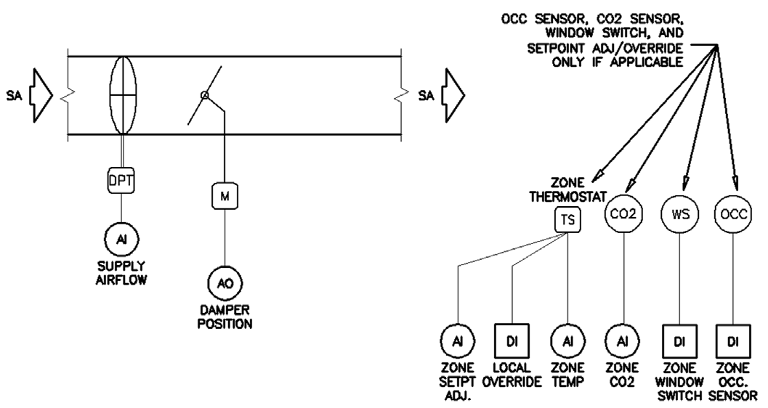
Figure Annex B-1. Guideline 36 Figure A-1.

Annex B.3 VAV Terminal Unit with Reheat
This section describes the VAV Terminal Unit with Reheat described in Section 4.2 and Appendix A, Figure A-2 (ASHRAE Guideline 36-2024)

Annex B.3.1 g36:VAVTerminalWithReheat
An air-terminal unit assembly having one ducted air inlet, a damper, and a reheat coil for regulating the airflow rate and discharge air temperature.
Related Constraints
Description | Link
The VAVTerminalWithReheat OutletConnectionPoint shall have at least one discharge air temperature property using the relation hasProperty. | Link
The VAVTerminalWithReheat connects to Domain Space in a g36:Zone | Link
The VAVTerminalWithReheat shall contain at least one hot water coil or at least one electric heating coil for heating using the relation contains. | Link

Annex B.3.2 g36:VAVTerminalWithReheatAnnotation
Related Inference Rules
Description | Link
If an instance of s223:SingleDuctTerminal matches the constraints defined by g36:VAVTerminalWithReheat, it will be declared as an instance of that class. | Link

Annex B.3.3 Example VAV Terminal Unit With Reheat
VAV Terminal Unit With Reheat based on Figure A-2. Link to Model 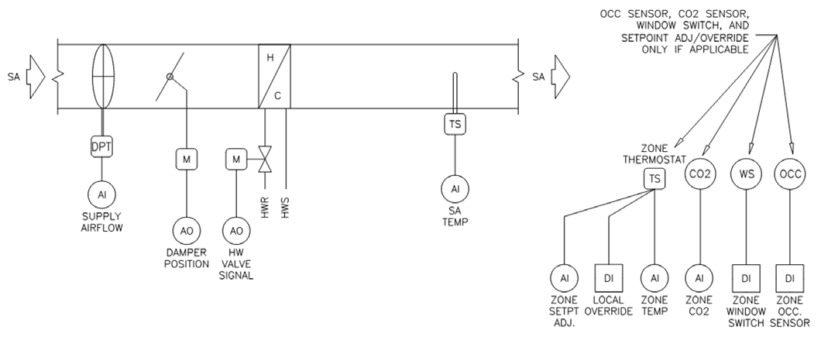

Annex B.4 Fan Powered Terminal Unit
This section describes the classes and example model of the Fan Powered Terminal Unit (Series or Parallel, Constant or Variable Speed Fan) described in Section 4.3.

Annex B.4.1 g36:FanPoweredTerminal
An air terminal containing a fan. Airflow may pass through or be parallel to the fan. These units may also have supplemental heating or cooling.
Related Constraints
Description | Link
A FanPoweredTerminal shall contain at least one hot water coil or at least one electric heating coil for heating using the relation contains. | Link
A FanPoweredTerminal shall have exactly one Damper using the relation contains. | Link
A FanPoweredTerminal shall have exactly one Fan or FanWithVFD using the relation contains. | Link
The FanPoweredTerminal InletConnectionPoint shall have at least one supply airflow property using the relation hasProperty. | Link
The FanPoweredTerminal OutletConnectionPoint shall have at least one discharge air temperature property using the relation hasProperty. | Link

Annex B.4.2 g36:FanPoweredTerminalAnnotation
Related Inference Rules
Description | Link
If an instance of s223:FanPoweredTerminal matches the constraints defined by g36:FanPoweredTerminal, it will be declared as an instance of that class. | Link

Annex B.4.3 Example Fan Powered Terminal Unit
Example Fan Powered Terminal Unit based on Figure A-3. Link to Model 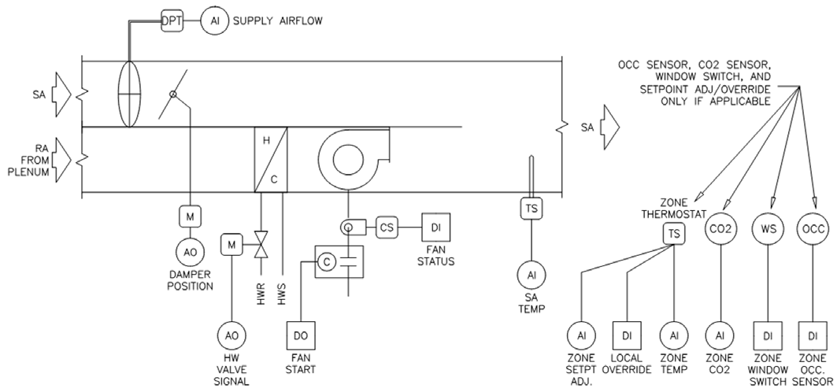

Annex B.4.4 Example Parallel Fan Powered Terminal Unit
Example Parallel Fan Powered Terminal Unit based on Figure A-4. Link to Model 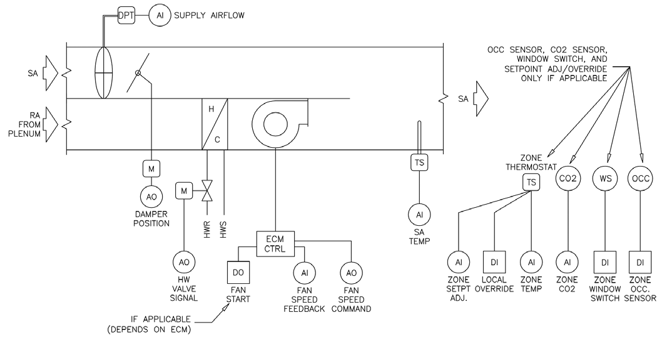

Annex B.5 Dual Duct Terminal Unit with Inlet Sensors
This section describes the classes and example model of the Dual Duct Terminal Unit with InleI at Sensors described in Section 4.4 and Appendix A, Figure A-7 (ASHRAE Guideline 36-2024)

Annex B.5.1 g36:DualDuctTerminalWithInletSensors
A dual duct air terminal mixes two independent sources of primary air. This terminal uses two inlet sensors.
Related Constraints
Description | Link
DualDuctTerminalWithInletSensors shall contain 1 damper that has the Role Cooling using the relation contains. | Link
DualDuctTerminalWithInletSensors shall contain 1 damper that has the Role Heating using the relation contains. | Link
DualDuctTerminalWithInletSensors shall contain 2 dampers using the relation contains | Link
The DualDuctTerminalWithInletSensors InletConnectionPoint shall have at least one cooling supply airflow property using the relation hasProperty. | Link
The DualDuctTerminalWithInletSensors InletConnectionPoint shall have at least one heating supply airflow property using the relation hasProperty. | Link

Annex B.5.2 g36:DualDuctTerminalWithInletSensorsAnnotation
Related Inference Rules
Description | Link
If an instance of s223:DualDuctTerminal matches the constraints defined by g36:DualDuctTerminalWithInletSensors, it will be declared as an instance of that class. | Link

Annex B.5.3 Example Dual Duct Terminal Unit With Inlet Sensors
Dual Duct Terminal Unit based on Figure A-7. Link to Model 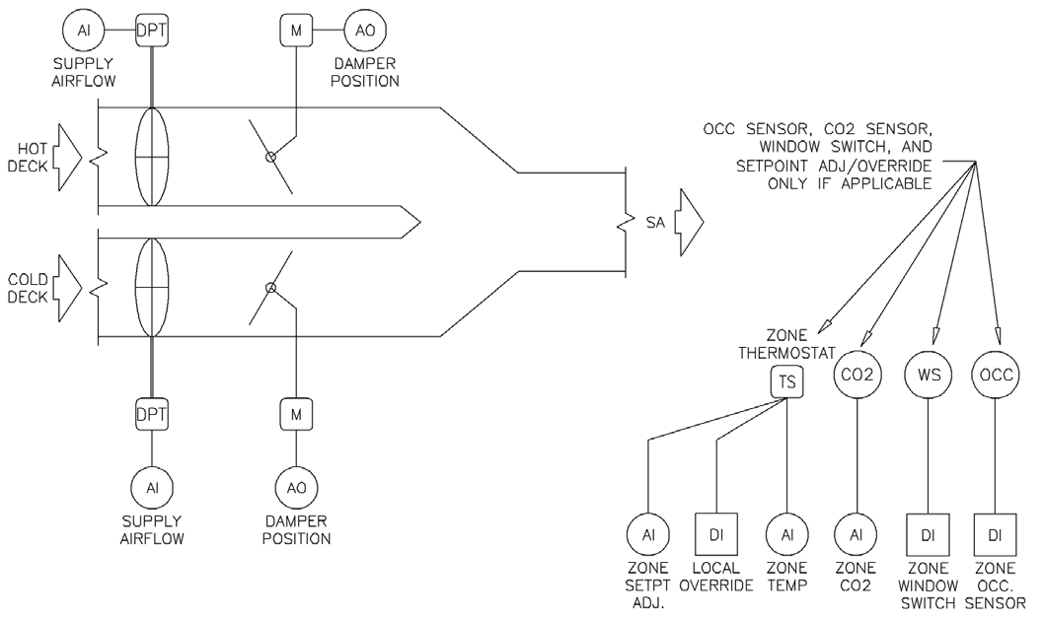

Annex B.6 Dual Duct Terminal Unit with Discharge Sensor
This section describes the classes and example model of the Dual Duct Terminal Unit with Discharge Sensor described in Section 4.5 and Appendix A, Figure A-8 (ASHRAE Guideline 36-2024)

Annex B.6.1 g36:DualDuctTerminalWithDischargeSensor
A dual duct air terminal mixes two independent sources of primary air. This terminal uses one discharge sensor.
Related Constraints
Description | Link
In the DualDuctTerminalWithDischargeSensor, one Damper has Role Cooling using the relation hasRole. | Link
In the DualDuctTerminalWithDischargeSensor, one Damper has Role Heating using the relation hasRole. | Link
The DualDuctTerminalWithDischargeSensor OutletConnectionPoint shall have at least one discharge airflow property using the relation hasProperty. | Link
The DualDuctTerminalWithDischargeSensor shall contain 2 dampers using the relation contains. | Link

Annex B.6.2 g36:DualDuctTerminalWithDischargeSensorAnnotation
Related Inference Rules
Description | Link
If an instance of s223:DualDuctTerminal matches the constraints defined by g36:DualDuctTerminalWithDischargeSensor, it will be declared as an instance of that class. | Link

Annex B.6.3 Example Dual Duct Terminal Unit With Discharge Sensors
Dual Duct Terminal Unit With Discharge Sensors based on Figure A-8. Link to Model 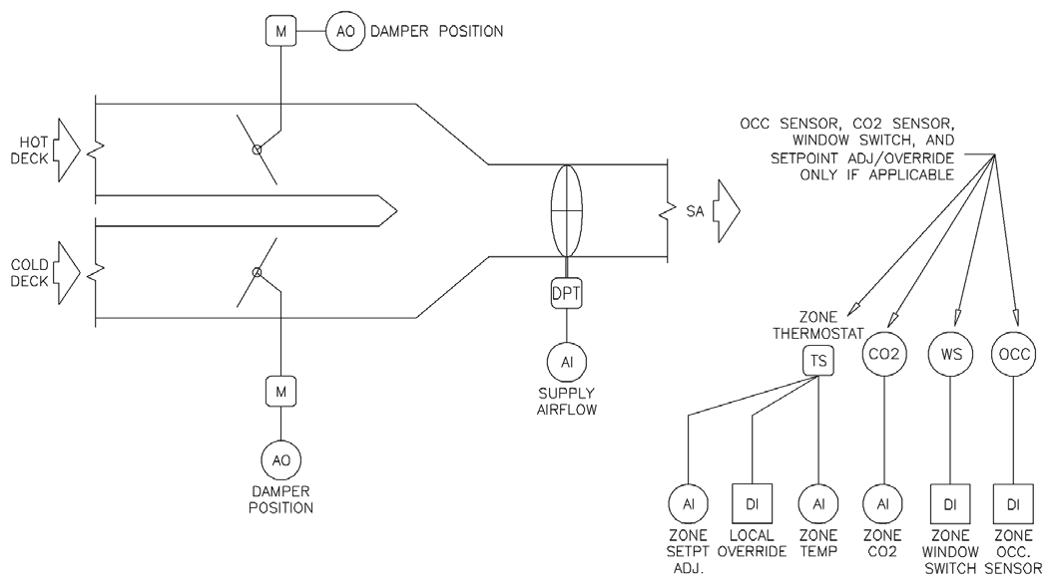

Annex B.7 Multiple Zone VAV Air Handling Unit
This section describes the classes and example model of the Multiple Zone VAV Air Handling Unit described in Section 4.6 and Appendix A, Figures A-9 and A-10 (ASHRAE Guideline 36-2024)

Annex B.7.1 Example Multiple Zone VAV Air Handling Unit
Multiple Zone VAV Air Handling Unit based on Figure A-9. Link to Model. 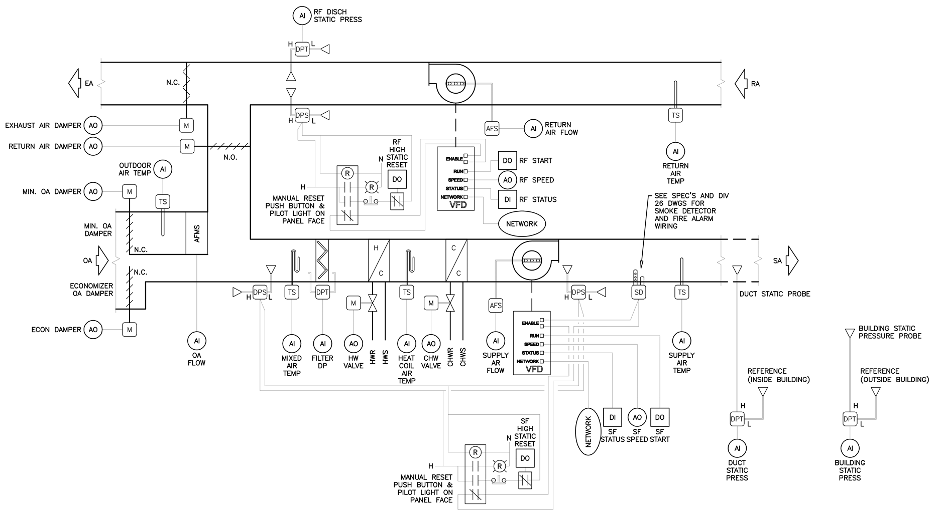

Annex B.7.2 g36:MultipleZoneVAVAirHandlingUnit
An assembly consisting of sections containing a fan or fans and other necessary equipment to perform one or more of the following functions: circulating, filtration, heating, cooling, heat recovery, humidifying, dehumidifying, and mixing of air. It is usually connected to an air-distribution system. This air handling unit serves multiple zones.
Related Constraints
Description | Link
One MultipleZoneVAVAirHandlingUnit InletConnectionPoint shall have at least one outdoor air temperature property using the relation hasProperty. | Link
One MultipleZoneVAVAirHandlingUnit InletConnectionPoint shall have at least one return air temperature property using the relation hasProperty. | Link
One MultipleZoneVAVAirHandlingUnit OutletConnectionPoint shall have at least one supply air temperature property using the relation hasProperty. | Link
The MultipleZoneVAVAirHandlingUnit shall contain at least one ChilledWaterCoil for cooling using the relation contains. | Link
The MultipleZoneVAVAirHandlingUnit shall contain at least one HotWaterCoil or at least one ElectricHeatingCoil for heating using the relation contains. | Link
The MultipleZoneVAVAirHandlingUnit OutletConnectionPoint shall have at least one supply duct static pressure property using the relation hasProperty. | Link
The MultipleZoneVAVAirHandlingUnit shall contain at least one return air damper using the relation contains. | Link
The MultipleZoneVAVAirHandlingUnit shall contain at least one supply fan with a VFD that has the role Supply using the relation contains | Link

Annex B.7.3 g36:MultipleZoneVAVAirHandlingUnitAnnotation
Related Inference Rules
Description | Link
If an instance of s223:AirHandlingUnit matches the constraints defined by g36:MultipleZoneVAVAirHandlingUnit, it will be declared as an instance of that class. | Link

Annex B.7.4 g36:MultipleZoneVAVAirHandlingUnit-CommonDamper
For units with a common economizer/minimum OA damper, include the following points
Related Constraints
Description | Link
For units with a common economizer/minimum OA damper, MultipleZoneVAVAirHandlingUnit InletConnectionPoint must have at least one outdoor airflow property. | Link
For units with a common economizer/minimum OA damper, must have exactly one economizer/minimum outdoor air damper. | Link

Annex B.7.5 g36:MultipleZoneVAVAirHandlingUnit-CommonDamperAnnotation
Related Inference Rules
Description | Link
If an instance of s223:AirHandlingUnit matches the constraints defined by g36:MultipleZoneVAVAirHandlingUnit and has a common economizer/minimum outdoor air damper, it will be declared as an instance of this class. | Link

Annex B.7.6 g36:MultipleZoneVAVAirHandlingUnit-OADandAFMS
A unit with a separate minimum outdoor air damper and AFMS
Related Constraints
Description | Link
For units with a separate minimum outdoor air damper and AFMS, MultipleZoneVAVAirHandlingUnit must contain a modulating outdoor air damper with a minimum airflow property. | Link

Annex B.7.7 g36:MultipleZoneVAVAirHandlingUnit-OADandAFMSAnnotation
Related Inference Rules
Description | Link
If an instance of s223:AirHandlingUnit matches the constraints defined by g36:MultipleZoneVAVAirHandlingUnit-OADandAFMS, it will be declared as an instance of that class. | Link

Annex B.7.8 g36:MultipleZoneVAVAirHandlingUnit-OADandDP
A unit with a separate minimum outdoor air damper and DP sensor
Related Constraints
Description | Link
For units with a separate minimum outdoor air damper and DP sensor, MultipleZoneVAVAirHandlingUnit must contain a two-position outdoor air damper with a differential pressure property. | Link

Annex B.7.9 g36:MultipleZoneVAVAirHandlingUnit-OADandDPAnnotation
Related Inference Rules
Description | Link
If an instance of s223:AirHandlingUnit matches the constraints defined by g36:MultipleZoneVAVAirHandlingUnit-OADandDP, it will be declared as an instance of that class. | Link

Annex B.7.10 g36:MultipleZoneVAVAirHandlingUnit-WithReliefDamper
A unit with an actuated relief damper but no relief fan
Related Constraints
Description | Link
For units with actuated relief dampers but no relief fan, the MultipleZoneVAVAirHandlingUnit must be connectedTo at least one VAV, which connectedTo at least one HVAC DomainSpace, which is contained by at least one Zone, which has a building static pressure property. | Link
For units with actuated relief dampers but no relief fan, the MultipleZoneVAVAirHandlingUnit must contain a relief air damper with an analog damper command property. | Link

Annex B.7.11 g36:MultipleZoneVAVAirHandlingUnit-WithReliefDamperAnnotation
Related Inference Rules
Description | Link
If an instance of s223:AirHandlingUnit matches the constraints defined by g36:MultipleZoneVAVAirHandlingUnit and has a relief damper, it will be declared as an instance of this class. | Link

Annex B.7.12 g36:MultipleZoneVAVAirHandlingUnit-WithReliefFan
A unit with a relief fan
Related Constraints
Description | Link
For units with both a relief air damper and a relief fan, the MultipleZoneVAVAirHandlingUnit must have a relief air damper with a two-position damper command property. | Link
For units with both a relief air damper and a relief fan, the MultipleZoneVAVAirHandlingUnit must have a relief fan with a VFD. | Link

Annex B.7.13 g36:MultipleZoneVAVAirHandlingUnit-WithReturnFan
A unit with a return fan
Related Constraints
Description | Link
For units with a return fan, if airflow tracking logic is used, the OutletConnectionPoint of the return fan in the MultipleZoneVAVAirHandlingUnit must have a return airflow property. | Link
For units with a return fan, if airflow tracking logic is used, the OutletConnectionPoint of the supply fan in the MultipleZoneVAVAirHandlingUnit must have a supply airflow property. | Link
For units with a return fan, if direct building pressure logic is used, the MultipleZoneVAVAirHandlingUnit must be connectedTo at least one VAV, which connectedTo at least one HVAC DomainSpace, which is contained by at least one Zone, which has a building static pressure property. | Link
For units with a return fan, if direct building pressure logic is used, the OutletConnectionPoint of the return fan in the MultipleZoneVAVAirHandlingUnit must have a return fan discharge static pressure property. | Link
For units with a return fan, the MultipleZoneVAVAirHandlingUnit must contain an exhaust air damper. | Link
For units with a return fan, the MultipleZoneVAVAirHandlingUnit must indeed contain a return fan. | Link

Annex B.7.14 g36:SingleZoneVAVAirHandlingUnit-WithReliefDamper
A SingleZoneVAVAirHandlingUnit with a relief air damper and no relief fan
Related Constraints
Description | Link
the SingleZoneVAVAirHandlingUnit contains a relief air damper with a modulating actuator. | Link

Annex B.8 Dual Fan Dual Duct Air Handling Unit
This section describes the classes and example model of the Dual Fan Dual Duct Air Handling Unit described in Section 4.7 and Appendix A, Figure A-11 (ASHRAE Guideline 36-2024)

Annex B.8.1 g36:DualFanDualDuctAirHandlingUnit
DualFanDualDuctAirHandlingUnit
Related Constraints
Description | Link
A DualFanDualDuctAirHandlingUnit OutletConnectionPoint shall have at least one supply air temperature property using the relation hasProperty. | Link
A DualFanDualDuctAirHandlingUnit OutletConnectionPoint shall have at least one supply duct static pressure property using the relation hasProperty. | Link
The DualFanDualDuctAirHandlingUnit shall contain at least one HotWaterCoil or at least one ElectricHeatingCoil for heating using the relation contains. | Link
The DualFanDualDuctAirHandlingUnit shall contain at least one supply fan with a VFD that has the role Supply using the relation contains. | Link

Annex B.8.2 g36:DualFanDualDuctAirHandlingUnitAnnotation
Related Inference Rules
Description | Link
If an instance of s223:AirHandlingUnit matches the constraints defined by g36:DualFanDualDuctAirHandlingUnit, it will be declared as an instance of that class. | Link

Annex B.8.3 Example Dual Fan Dual Duct Air Handling Unit.
Dual Fan Dual Duct Air Handling Unit based on Figure A-11. Link to Model 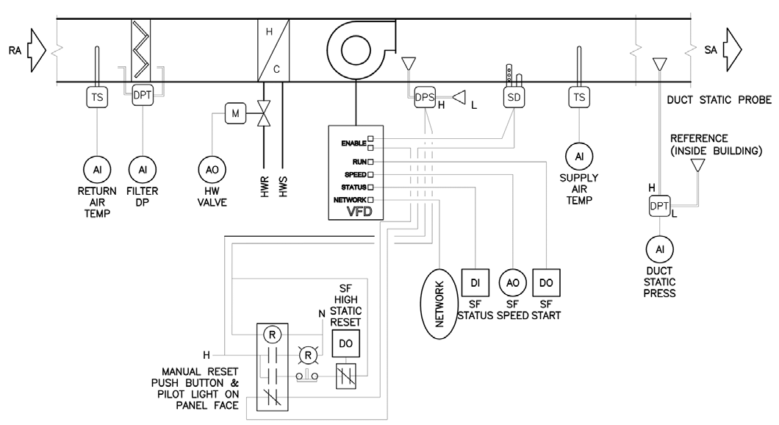

Annex B.9 Single Zone VAV Air Handling Unit
This section describes the classes and example model of the Single Zone VAV Air Handling Unit described in Section 4.8 and Appendix A, Figure A-12 (ASHRAE Guideline 36-2024)

Annex B.9.1 g36:SingleZoneVAVAirHandlingUnit
An assembly consisting of sections containing a fan or fans and other necessary equipment to perform one or more of the following functions: circulating, filtration, heating, cooling, heat recovery, humidifying, dehumidifying, and mixing of air. It is usually connected to an air-distribution system. This air handling unit that serves one zone only.
Related Constraints
Description | Link
A SingleZoneVAVAirHandlingUnit OutletConnectionPoint shall have at least one supply air temperature property using the relation hasProperty. | Link
The SingleZoneVAVAirHandlingUnit shall contain at least one ChilledWaterCoil for cooling using the relation contains. | Link
The SingleZoneVAVAirHandlingUnit shall contain at least one HotWaterCoil or at least one ElectricHeatingCoil for heating using the relation contains. | Link
The SingleZoneVAVAirHandlingUnit shall contain at least one supply fan with a VFD that has the role Supply using the relation contains. | Link
The SingleZoneVAVAirHandlingUnit shall have at least one outdoor air damper using the relation contains. | Link
The SingleZoneVAVAirHandlingUnit shall have at least one return air damper using the relation contains. | Link

Annex B.9.2 g36:SingleZoneVAVAirHandlingUnitAnnotation
Related Inference Rules
Description | Link
If an instance of s223:AirHandlingUnit matches the constraints defined by g36:SingleZoneVAVAirHandlingUnit, it will be declared as an instance of that class. | Link

Annex B.9.3 g36:SingleZoneVAVAirHandlingUnit-NoReliefFan

Annex B.9.4 g36:SingleZoneVAVAirHandlingUnit-NoReliefFanAnnotation

Annex B.9.5 g36:SingleZoneVAVAirHandlingUnit-WithReliefFan
A SingleZoneVAVAirHandlingUnit with a relief fan and relief dampers
Related Constraints
Description | Link
For the case where the SingleZoneVAVAirHandlingUnit has both a relief air damper and a relief fan, the SingleZoneVAVAirHandlingUnit must be connectedTo at least one VAV, which is connectedTo at least one HVAC DomainSpace or Zone, which has a building static pressure property. | Link
For the case where the SingleZoneVAVAirHandlingUnit has both a relief air damper and a relief fan, the SingleZoneVAVAirHandlingUnit must indeed have a relief air damper with a two-position damper command property. | Link
For the case where the SingleZoneVAVAirHandlingUnit has both a relief air damper and a relief fan, the SingleZoneVAVAirHandlingUnit must indeed have a relief fan. | Link

Annex B.9.6 g36:SingleZoneVAVAirHandlingUnit-WithReliefFanAnnotation
Related Inference Rules
Description | Link
If an instance of s223:AirHandlingUnit matches the constraints defined by g36:SingleZoneVAVAirHandlingUnit and has a relief fan, it will be declared as an instance of this class. | Link

Annex B.9.7 g36:SingleZoneVAVAirHandlingUnit-WithReturnFan
A SingleZoneVAVAirHandlingUnit with a Return fan
Related Constraints
Description | Link
For the case where the SingleZoneVAVAirHandlingUnit has a return fan, the SingleZoneVAVAirHandlingUnit must contain an exhaust air damper with either an analog or two-position damper command property. | Link
For the case where the SingleZoneVAVAirHandlingUnit has a return fan, the SingleZoneVAVAirHandlingUnit must indeed contain a return fan. | Link

Annex B.9.8 g36:SingleZoneVAVAirHandlingUnit-WithReturnFanAnnotation
Related Inference Rules
Description | Link
If an instance of s223:AirHandlingUnit matches the constraints defined by g36:SingleZoneVAVAirHandlingUnit and has a return fan, it will be declared as an instance of that class. | Link

Annex B.9.9 Example Single Zone VAV Air Handling Unit Unit
Single Zone VAV Air Handling Unit Unit based on Figure A-12. Link to Model 