OpenModelica Users Guide

Version 2015-03-10
for OpenModelica 1.9.2

March 2015

Peter Fritzson
Adrian Pop, Adeel Asghar, Willi Braun, Jens Frenkel,
Lennart Ochel, Martin Sjölund, Per Östlund, Peter Aronsson,
Mikael Axin, Bernhard Bachmann, Vasile Baluta, Robert Braun, Lena Buffoni, David Broman, Stefan Brus, Francesco Casella, Filippo Donida, Atiyah Elsheikh, Anand Ganeson, Mahder Gebremedhin, Pavel Grozman, Daniel Hedberg, Michael Hanke, Alf Isaksson, Kim Jansson, Daniel Kanth, Tommi Karhela, Juha Kortelainen, Abhinn Kothari, Petter Krus, Alexey Lebedev, Oliver Lenord, Ariel Liebman, Rickard Lindberg, Håkan Lundvall, Abhir Raj Metkar, Eric Meyers, Tuomas Miettinen, Afshin Moghadam, Kenneth Nealy, Nemer, Hannu Niemistö, Peter Nordin, Kristoffer Norling, Arunkumar Palanisamy, Karl Pettersson, Pavol Privitzer, Jhansi Reddy, Reino Ruusu, Per Sahlin,Wladimir Schamai, Gerhard Schmitz, Alachew Shitahun, Anton Sodja, Ingo Staack, Kristian Stavåker, Sonia Tariq, Mohsen Torabzadeh-Tari, Parham Vasaiely, Marcus Walter, Volker Waurich, Niklas Worschech, Robert Wotzlaw, Azam Zia

Copyright by:

Open Source Modelica Consortium
Copyright © 1998-CurrentYear, Open Source Modelica Consortium (OSMC), c/o Linköpings universitet, Department of Computer and Information Science, SE-58183 Linköping, Sweden
All rights reserved.
THIS PROGRAM IS PROVIDED UNDER THE TERMS OF GPL VERSION 3 LICENSE OR THIS OSMC PUBLIC LICENSE (OSMC-PL). ANY USE, REPRODUCTION OR DISTRIBUTION OF THIS PROGRAM CONSTITUTES RECIPIENT'S ACCEPTANCE OF THE OSMC PUBLIC LICENSE OR THE GPL VERSION 3, ACCORDING TO RECIPIENTS CHOICE.
The OpenModelica software and the OSMC (Open Source Modelica Consortium) Public License (OSMC-PL) are obtained from OSMC, either from the above address, from the URLs: http://www.openmodelica.org or http://www.ida.liu.se/projects/OpenModelica, and in the OpenModelica distribution. GNU version 3 is obtained from: http://www.gnu.org/copyleft/gpl.html.
This program is distributed WITHOUT ANY WARRANTY; without even the implied warranty of MERCHANTABILITY or FITNESS FOR A PARTICULAR PURPOSE, EXCEPT AS EXPRESSLY SET FORTH IN THE BY RECIPIENT SELECTED SUBSIDIARY LICENSE CONDITIONS OF OSMC-PL.
See the full OSMC Public License conditions for more details.

This document is part of OpenModelica: http://www.openmodelica.org
Contact: OpenModelica@ida.liu.se

Modelica® is a registered trademark of the Modelica Association, http://www.Modelica.org
Mathematica® is a registered trademark of Wolfram Research Inc, www.wolfram.com

Table of Contents

Table of Contents 3
Preface 7
Chapter 1 Introduction 9
1.1 System Overview 10
1.2 Interactive Session with Examples 11
1.2.1 Starting the Interactive Session 12
1.2.2 Using the Interactive Mode 12
1.2.3 Trying the Bubblesort Function 14
1.2.4 Trying the system and cd Commands 15
1.2.5 Modelica Library and DCMotor Model 15
1.2.6 The val() function 18
1.2.7 BouncingBall and Switch Models 18
1.2.8 Clear All Models 20
1.2.9 VanDerPol Model and Parametric Plot 20
1.2.10 Using Japanese or Chinese Characters 21
1.2.11 Scripting with For-Loops, While-Loops, and If-Statements 22
1.2.12 Variables, Functions, and Types of Variables 23
1.2.13 Getting Information about Error Cause 24
1.2.14 Alternative Simulation Output Formats 24
1.2.15 Using External Functions 25
1.2.16 Using Parallel Simulation via OpenMP Multi-Core Support 25
1.2.17 Loading Specific Library Version 25
1.2.18 Calling the Model Query and Manipulation API 25
1.2.19 Quit OpenModelica 27
1.2.20 Dump XML Representation 27
1.2.21 Dump Matlab Representation 27
1.3 Summary of Commands for the Interactive Session Handler 28
1.4 Running the compiler from command line 29
1.5 References 30
Chapter 2 OMEdit – OpenModelica Connection Editor 31
2.1 Starting OMEdit 31
2.1.1 Microsoft Windows 31
2.1.1 Linux 31
2.1.2 Mac OS X 31
2.2 MainWindow & Browsers 32
2.2.1 Search Browser 33
2.2.2 Libraries Browser 34
2.2.3 Documentation Browser 35
2.2.4 Variables Browser 35
2.2.5 Messages Browser 36
2.3 Perspectives 37
2.3.1 Welcome Perspective 37
2.3.2 Modeling Perspective 37
2.3.3 Plotting Perspective 38
2.4 Modeling a Model 39
2.4.1 Creating a New Modelica class 39
2.4.2 Opening a Modelica File 39
2.4.3 Opening a Modelica File with Encoding 40
2.4.4 Model Widget 40
2.4.5 Adding Component Models 41
2.4.6 Making Connections 41
2.5 Simulating a Model 41
2.5.1 General Tab 41
2.5.2 Output Tab 41
2.5.3 Simulation Flags Tab 42
2.6 Plotting the Simulation Results 42
2.6.1 Types of Plotting 43
2.7 Re-simulating a Model 43
2.8 How to Create User Defined Shapes – Icons 43
2.9 Settings 44
2.9.1 General 45
2.9.2 Libraries 45
2.9.3 Modelica Text Editor 45
2.9.4 Graphical Views 46
2.9.5 Simulation 46
2.9.6 Messages 46
2.9.7 Notifications 47
2.9.8 Line Style 47
2.9.9 Fill Style 47
2.9.10 Curve Style 47
2.9.11 Figaro 47
2.9.12 Debugger 48
2.9.13 FMI 48
2.10 The Equation-based Debugger 48
2.10.1 Enable Tracing Symbolic Transformations 48
2.10.2 Load a Model to Debug 48
2.10.3 Simulate and Start the Debugger 49
2.10.4 Use the Transformation Debugger for Browsing 49
2.11 The Algorithmic Debugger 50
2.11.1 Adding Breakpoints 50
2.11.2 Start the Algorithmic Debugger 51
2.11.3 Debug Configurations 52
2.11.4 Attach to Running Process 52
2.11.5 Using the Algorithmic Debugger Window 53
Chapter 3 2D Plotting 55
3.1 Example 55
3.2 Plotting Commands and their Options 56
Chapter 4 OMNotebook with DrModelica and DrControl 58
4.1 Interactive Notebooks with Literate Programming 58
4.1.1 Mathematica Notebooks 58
4.1.2 OMNotebook 58
4.2 DrModelica Tutoring System – an Application of OMNotebook 59
4.3 DrControl Tutorial for Teaching Control Theory 65
4.3.1 Feedback Loop 65
4.3.2 Mathematical Modeling with Characteristic Equations 68
4.4 OpenModelica Notebook Commands 74
4.4.1 Cells 74
4.4.2 Cursors 74
4.4.3 Selection of Text or Cells 75
4.4.4 File Menu 75
4.4.5 Edit Menu 76
4.4.6 Cell Menu 76
4.4.7 Format Menu 77
4.4.8 Insert Menu 77
4.4.9 Window Menu 78
4.4.10 Help Menu 78
4.4.11 Additional Features 78
4.5 References 79
Chapter 5 Functional Mock-up Interface - FMI 81
5.1 FMI Import 81
5.2 FMI Export 82
Chapter 6 Optimization with OpenModelica 84
6.1 Builtin Dynamic Optimization with OpenModelica and IpOpt 84
6.1.1 Compiling the Modelica code 85
6.1.2 An Example 86
6.1.3 Different Options for the Optimizer IPOPT 87
6.2 Dynamic Optimization with OpenModelica and CasADi 88
6.2.1 Compiling the Modelica code 88
6.2.2 An example 89
6.2.3 Generated XML for Example 90
6.2.4 XML Import to CasADi via OpenModelica Python Script 94
6.3 Parameter Sweep Optimization using OMOptim 95
6.3.1 Preparing the Model 95
6.3.2 Set problem in OMOptim 96
6.3.3 Results 100
6.3.4 Window Regions in OMOptim GUI 101
Chapter 7 MDT – The OpenModelica Development Tooling Eclipse Plugin 103
7.1 Introduction 103
7.2 Installation 103
7.3 Getting Started 104
7.3.1 Configuring the OpenModelica Compiler 104
7.3.2 Using the Modelica Perspective 104
7.3.3 Selecting a Workspace Folder 104
7.3.4 Creating one or more Modelica Projects 104
7.3.5 Building and Running a Project 104
7.3.6 Switching to Another Perspective 105
7.3.7 Creating a Package 106
7.3.8 Creating a Class 106
7.3.9 Syntax Checking 107
7.3.10 Automatic Indentation Support 108
7.3.11 Code Completion 108
7.3.12 Code Assistance on Identifiers when Hovering 109
7.3.13 Go to Definition Support 109
7.3.14 Code Assistance on Writing Records 109
7.3.15 Using the MDT Console for Plotting 110
Chapter 8 Modelica Performance Analyzer 112
8.1 Example Report Generated for the A Model 113
8.1.1 Information 113
8.1.2 Settings 113
8.1.3 Summary 113
8.1.4 Global Steps 114
8.1.5 Measured Function Calls 114
8.1.6 Measured Blocks 114
8.1.7 Genenerated XML for the Example 115
Chapter 9 MDT Debugger for Algorithmic Modelica 117
9.1 The Eclipse-based Debugger for Algorithmic Modelica 117
9.1.1 Starting the Modelica Debugging Perspective 118
9.1.2 Debugging OpenModelica 122
9.1.3 The Debugging Perspective 122
Chapter 10 Modelica3D 124
10.1 Windows 124
10.2 MacOS 125
Chapter 11 Simulation in Web Browser 127
Chapter 12 Interoperability – C and Python 129
12.1 Calling External C functions 129
12.2 Calling Python Code 130
Chapter 13 OpenModelica Python Interface and PySimulator 132
13.1 OMPython – OpenModelica Python Interface 132
13.1.1 Features of OMPython 132
13.1.2 Using OMPython 132
13.1.3 Implementation 136
13.1.4 API – List of Commands 140
13.2 PySimulator 161
Chapter 14 Modelica and Python Scripting API 163
14.1 OpenModelica Modelica Scripting Commands 163
14.1.1 OpenModelica Basic Commands 163
14.2 OpenModelica System Commands 165
14.3 All OpenModelica API Calls 165
14.3.1 Examples 173
14.4 OpenModelica Python Scripting Commands 177
Chapter 15 Frequently Asked Questions (FAQ) 178
15.1 OpenModelica General 178
15.2 OMNotebook 178
15.3 OMDev - OpenModelica Development Environment 179
Index 211

Preface
This users guide provides documentation and examples on how to use the OpenModelica system, both for the Modelica beginners and advanced users.

Introduction
The OpenModelica system described in this document has both short-term and long-term goals:
- The short-term goal is to develop an efficient interactive computational environment for the Modelica language, as well as a rather complete implementation of the language. It turns out that with support of appropriate tools and libraries, Modelica is very well suited as a computational language for development and execution of both low level and high level numerical algorithms, e.g. for control system design, solving nonlinear equation systems, or to develop optimization algorithms that are applied to complex applications.
- The longer-term goal is to have a complete reference implementation of the Modelica language, including simulation of equation based models and additional facilities in the programming environment, as well as convenient facilities for research and experimentation in language design or other research activities. However, our goal is not to reach the level of performance and quality provided by current commercial Modelica environments that can handle large models requiring advanced analysis and optimization by the Modelica compiler.
The long-term research related goals and issues of the OpenModelica open source implementation of a Modelica environment include but are not limited to the following:
- Development of a complete formal specification of Modelica, including both static and dynamic semantics. Such a specification can be used to assist current and future Modelica implementers by providing a semantic reference, as a kind of reference implementation.
- Language design, e.g. to further extend the scope of the language, e.g. for use in diagnosis, structural analysis, system identification, etc., as well as modeling problems that require extensions such as partial differential equations, enlarged scope for discrete modeling and simulation, etc.
- Language design to improve abstract properties such as expressiveness, orthogonality, declarativity, reuse, configurability, architectural properties, etc.
- Improved implementation techniques, e.g. to enhance the performance of compiled Modelica code by generating code for parallel hardware.
- Improved debugging support for equation based languages such as Modelica, to make them even easier to use.
- Easy-to-use specialized high-level (graphical) user interfaces for certain application domains.
- Visualization and animation techniques for interpretation and presentation of results.
- Application usage and model library development by researchers in various application areas.
The OpenModelica environment provides a test bench for language design ideas that, if successful, can be submitted to the Modelica Association for consideration regarding possible inclusion in the official Modelica standard.
The current version of the OpenModelica environment allows most of the expression, algorithm, and function parts of Modelica to be executed interactively, as well as equation models and Modelica functions to be compiled into efficient C code. The generated C code is combined with a library of utility functions, a run-time library, and a numerical DAE solver.

System Overview
The OpenModelica environment consists of several interconnected subsystems, as depicted in Figure 1-1-1 below.

- 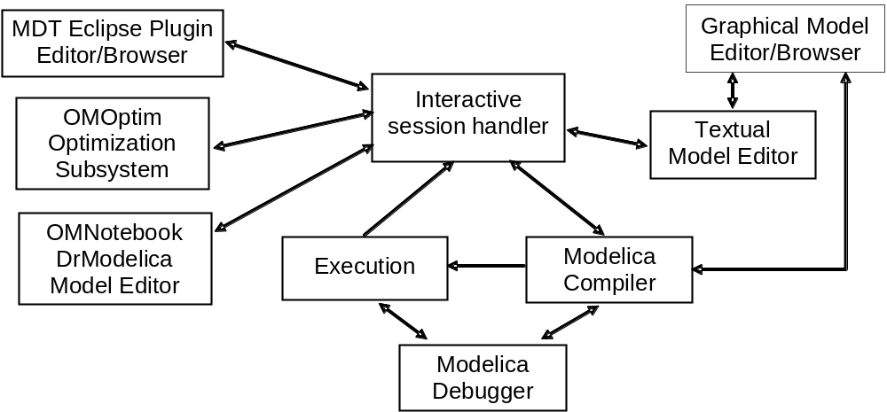
Figure 1-1-1. The architecture of the OpenModelica environment. Arrows denote data and control flow. The interactive session handler receives commands and shows results from evaluating commands and expressions that are translated and executed. Several subsystems provide different forms of browsing and textual editing of Modelica code. The debugger currently provides debugging of an extended algorithmic subset of Modelica
The following subsystems are currently integrated in the OpenModelica environment:
- An interactive session handler, that parses and interprets commands and Modelica expressions for evaluation, simulation, plotting, etc. The session handler also contains simple history facilities, and completion of file names and certain identifiers in commands.
- A Modelica compiler subsystem, translating Modelica to C code, with a symbol table containing definitions of classes, functions, and variables. Such definitions can be predefined, user-defined, or obtained from libraries. The compiler also includes a Modelica interpreter for interactive usage and constant expression evaluation. The subsystem also includes facilities for building simulation executables linked with selected numerical ODE or DAE solvers.
- An execution and run-time module. This module currently executes compiled binary code from translated expressions and functions, as well as simulation code from equation based models, linked with numerical solvers. In the near future event handling facilities will be included for the discrete and hybrid parts of the Modelica language.
- Eclipse plugin editor/browser. The Eclipse plugin called MDT (Modelica Development Tooling) provides file and class hierarchy browsing and text editing capabilities, rather analogous to previously described Emacs editor/browser. Some syntax highlighting facilities are also included. The Eclipse framework has the advantage of making it easier to add future extensions such as refactoring and cross referencing support.
- OMNotebook DrModelica model editor. This subsystem provides a lightweight notebook editor, compared to the more advanced Mathematica notebooks available in MathModelica. This basic functionality still allows essentially the whole DrModelica tutorial to be handled. Hierarchical text documents with chapters and sections can be represented and edited, including basic formatting. Cells can contain ordinary text or Modelica models and expressions, which can be evaluated and simulated. However, no mathematical typesetting facilities are yet available in the cells of this notebook editor.
- Graphical model editor/browser OMEdit. This is a graphical connection editor, for component based model design by connecting instances of Modelica classes, and browsing Modelica model libraries for reading and picking component models. The graphical model editor also includes a textual editor for editing model class definitions, and a window for interactive Modelica command evaluation.
- Optimization subsystem OMOptim. This is an optimization subsystem for OpenModelica, currently for design optimization choosing an optimal set of design parameters for a model. The current version has a graphical user interface, provides genetic optimization algorithms and Pareto front optimization, works integrated with the simulators and automatically accesses variables and design parameters from the Modelica model.
- Dynamic Optimization subsystem. This is dynamic optimization using collocation methods, for Modelica models extended with optimization specifications with goal functions and additional constraints. This subsystem is integrated with in the OpenModelica compiler.
- Modelica equation model debugger. The equation model debugger shows the location of an error in the model equation source code. It keeps track of the symbolic transformations done by the compiler on the way from equations to low-level generated C code, and also explains which transformations have been done.
- Modelica algorithmic code debugger. The algorithmic code Modelica debugger provides debugging for an extended algorithmic subset of Modelica, excluding equation-based models and some other features, but including some meta-programming and model transformation extensions to Modelica. This is a conventional full-feature debugger, using Eclipse for displaying the source code during stepping, setting breakpoints, etc. Various back-trace and inspection commands are available. The debugger also includes a data-view browser for browsing hierarchical data such as tree- or list structures in extended Modelica.

Interactive Session with Examples
The following is an interactive session using the interactive session handler in the OpenModelica environment, called OMShell – the OpenModelica Shell). Most of these examples are also available in the OpenModelica notebook UsersGuideExamples.onb in the testmodels (C:/OpenModelica/share/doc/omc/testmodels/) directory, see also Chapter 4.

Starting the Interactive Session
The Windows version which at installation is made available in the start menu as OpenModelica->OpenModelica Shell which responds with an interaction window:
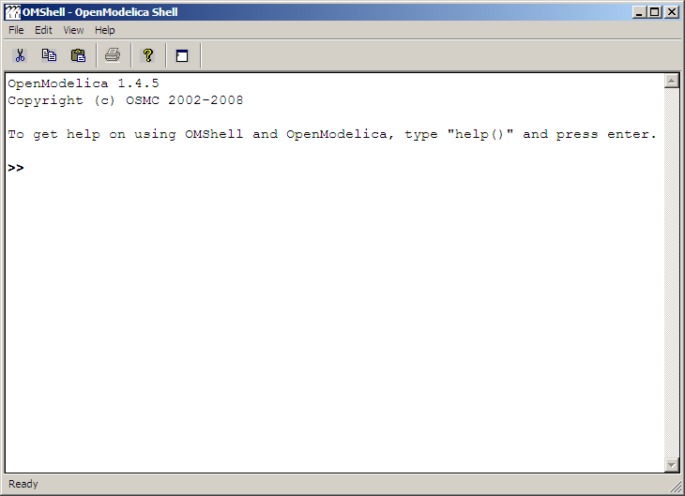
We enter an assignment of a vector expression, created by the range construction expression 1:12, to be stored in the variable x. The value of the expression is returned.
>> x := 1:12
{1, 2, 3, 4, 5, 6, 7, 8, 9, 10, 11, 12}

Using the Interactive Mode
When running OMC in interactive mode (for instance using OMShell) one can make use of some of the compiler debug trace flags defined in section 2.1.2 in the System Documentation. Here we give a few example sessions.

Example Session 1

OpenModelica 1.9.2
Copyright (c) OSMC 2002-2015
To get help on using OMShell and OpenModelica, type "help()" and press enter.

>> model A Integer t = 1.5; end A; //The type is Integer but 1.5 is of Real Type
{A}

>> instantiateModel(A)
"
Error: Type mismatch in modifier, expected type Integer, got modifier =1.5 of type Real
Error: Error occured while flattening model A

Example Session 2

OpenModelica 1.9.2
Copyright (c) OSMC 2002-2014
To get help on using OMShell and OpenModelica, type "help()" and press enter.

>> setDebugFlags("dump")
true
---DEBUG(dump)---
IEXP(Absyn.CALL(Absyn.CREF_IDENT("setDebugFlags", []), FUNCTIONARGS(Absyn.STRING("dump"), )))
---/DEBUG(dump)---
"
---DEBUG(dump)---
IEXP(Absyn.CALL(Absyn.CREF_IDENT("getErrorString", []), FUNCTIONARGS(, )))
---/DEBUG(dump)—

>> model B Integer k = 10; end B;
{B}
---DEBUG(dump)---
Absyn.PROGRAM([
Absyn.CLASS("B", false, false, false, Absyn.R_MODEL, Absyn.PARTS([Absyn.PUBLIC([Absyn.ELEMENTITEM(Absyn.ELEMENT(false, _, Absyn.UNSPECIFIED , "component", Absyn.COMPONENTS(Absyn.ATTR(false, false, Absyn.VAR, Absyn.BIDIR, []),Integer,[Absyn.COMPONENTITEM(Absyn.COMPONENT("k",[], SOME(Absyn.CLASSMOD([], SOME(Absyn.INTEGER(10))))), NONE())]), Absyn.INFO("", false, 1, 9, 1, 23)), NONE))])], NONE()), Absyn.INFO("", false, 1, 1, 1, 30))
],Absyn.TOP)
---/DEBUG(dump)---
"
---DEBUG(dump)---
IEXP(Absyn.CALL(Absyn.CREF_IDENT("getErrorString", []), FUNCTIONARGS(, )))
---/DEBUG(dump)—

>> instantiateModel(B)
"fclass B
Integer k = 10;
end B;
"
---DEBUG(dump)---
IEXP(Absyn.CALL(Absyn.CREF_IDENT("instantiateModel", []), FUNCTIONARGS(Absyn.CREF(Absyn.CREF_IDENT("B", [])), )))
---/DEBUG(dump)---
"
---DEBUG(dump)---
IEXP(Absyn.CALL(Absyn.CREF_IDENT("getErrorString", []), FUNCTIONARGS(, )))
---/DEBUG(dump)—

>> simulate(B, startTime=0, stopTime=1, numberOfIntervals=500, tolerance=1e-4)
record SimulationResult
resultFile = "B_res.plt"
end SimulationResult;
---DEBUG(dump)---
#ifdef __cplusplus
extern "C" {
#endif
#ifdef __cplusplus
}
#endif
IEXP(Absyn.CALL(Absyn.CREF_IDENT("simulate", []), FUNCTIONARGS(Absyn.CREF(Absyn.CREF_IDENT("B", [])), startTime = Absyn.INTEGER(0), stopTime = Absyn.INTEGER(1), numberOfIntervals = Absyn.INTEGER(500), tolerance = Absyn.REAL(0.0001))))
---/DEBUG(dump)---
"
---DEBUG(dump)---
IEXP(Absyn.CALL(Absyn.CREF_IDENT("getErrorString", []), FUNCTIONARGS(, )))
---/DEBUG(dump)--

Example Session 3

OpenModelica 1.9.2
Copyright (c) OSMC 2002-2014
To get help on using OMShell and OpenModelica, type "help()" and press enter.

>> model C Integer a; Real b; equation der(a) = b; der(b) = 12.0; end C;
{C}

>> instantiateModel(C)
"
Error: Illegal derivative. der(a) where a is of type Integer, which is not a subtype of Real
Error: Wrong type or wrong number of arguments to der(a)'.
Error: Error occured while flattening model C
Error: Illegal derivative. der(a) where a is of type Integer, which is not a subtype of Real
Error: Wrong type or wrong number of arguments to der(a)'.
Error: Error occured while flattening model C

Trying the Bubblesort Function
Load the function bubblesort, either by using the pull-down menu File->Load Model, or by explicitly giving the command:
>> loadFile("C:/OpenModelica1.9.2/share/doc/omc/testmodels/bubblesort.mo")
true
The function bubblesort is called below to sort the vector x in descending order. The sorted result is returned together with its type. Note that the result vector is of type Real[:], instantiated as Real[12], since this is the declared type of the function result. The input Integer vector was automatically converted to a Real vector according to the Modelica type coercion rules. The function is automatically compiled when called if this has not been done before.
>> bubblesort(x)
{12.0,11.0,10.0,9.0,8.0,7.0,6.0,5.0,4.0,3.0,2.0,1.0}
Another call:
>> bubblesort({4,6,2,5,8})
{8.0,6.0,5.0,4.0,2.0}
It is also possible to give operating system commands via the system utility function. A command is provided as a string argument. The example below shows the system utility applied to the UNIX command cat, which here outputs the contents of the file bubblesort.mo to the output stream. However, the cat command does not boldface Modelica keywords – this improvement has been done by hand for readability.
>> cd("C:/OpenModelica1.9.2/share/doc/omc/testmodels/")
>> system("cat bubblesort.mo")
function bubblesort
input Real[:] x;
output Real[size(x,1)] y;
protected
Real t;
algorithm
y := x;
for i in 1:size(x,1) loop
for j in 1:size(x,1) loop
if y[i] > y[j] then
t := y[i];
y[i] := y[j];
y[j] := t;
end if;
end for;
end for;
end bubblesort;

Trying the system and cd Commands
Note: Under Windows the output emitted into stdout by system commands is put into the winmosh console windows, not into the winmosh interaction windows. Thus the text emitted by the above cat command would not be returned. Only a success code (0 = success, 1 = failure) is returned to the winmosh window. For example:
>> system("dir")
0
>> system("Non-existing command")
1
Another built-in command is cd, the change current directory command. The resulting current directory is returned as a string.
>> cd()
" C:/OpenModelica1.9.2/share/doc/omc/testmodels/"

>> cd("..")
" C:/OpenModelica1.9.2/share/doc/omc/"

>> cd("C:/OpenModelica1.9.2/share/doc/omc/testmodels/")
" C:/OpenModelica1.9.2/share/doc/omc/testmodels/"

Modelica Library and DCMotor Model
We load a model, here the whole Modelica standard library, which also can be done through the File->Load Modelica Library menu item:
>> loadModel(Modelica)
true
We also load a file containing the dcmotor model:
>> loadFile("C:/OpenModelica1.9.2/share/doc/omc/testmodels/dcmotor.mo")
true
It is simulated:
>> simulate(dcmotor,startTime=0.0,stopTime=10.0)
record
resultFile = "dcmotor_res.plt"
end record
We list the source code of the model:
>> list(dcmotor)
"model dcmotor
Modelica.Electrical.Analog.Basic.Resistor r1(R=10);
Modelica.Electrical.Analog.Basic.Inductor i1;
Modelica.Electrical.Analog.Basic.EMF emf1;
Modelica.Mechanics.Rotational.Inertia load;
Modelica.Electrical.Analog.Basic.Ground g;
Modelica.Electrical.Analog.Sources.ConstantVoltage v;

equation
connect(v.p,r1.p);
connect(v.n,g.p);
connect(r1.n,i1.p);
connect(i1.n,emf1.p);
connect(emf1.n,g.p);
connect(emf1.flange_b,load.flange_a);
end dcmotor;
"
We test code instantiation of the model to flat code:
>> instantiateModel(dcmotor)
"fclass dcmotor
Real r1.v "Voltage drop between the two pins (= p.v - n.v)";
Real r1.i "Current flowing from pin p to pin n";
Real r1.p.v "Potential at the pin";
Real r1.p.i "Current flowing into the pin";
Real r1.n.v "Potential at the pin";
Real r1.n.i "Current flowing into the pin";
parameter Real r1.R = 10 "Resistance";
Real i1.v "Voltage drop between the two pins (= p.v - n.v)";
Real i1.i "Current flowing from pin p to pin n";
Real i1.p.v "Potential at the pin";
Real i1.p.i "Current flowing into the pin";
Real i1.n.v "Potential at the pin";
Real i1.n.i "Current flowing into the pin";
parameter Real i1.L = 1 "Inductance";
parameter Real emf1.k = 1 "Transformation coefficient";
Real emf1.v "Voltage drop between the two pins";
Real emf1.i "Current flowing from positive to negative pin";
Real emf1.w "Angular velocity of flange_b";
Real emf1.p.v "Potential at the pin";
Real emf1.p.i "Current flowing into the pin";
Real emf1.n.v "Potential at the pin";
Real emf1.n.i "Current flowing into the pin";
Real emf1.flange_b.phi "Absolute rotation angle of flange";
Real emf1.flange_b.tau "Cut torque in the flange";
Real load.phi "Absolute rotation angle of component (= flange_a.phi = flange_b.phi)";
Real load.flange_a.phi "Absolute rotation angle of flange";
Real load.flange_a.tau "Cut torque in the flange";
Real load.flange_b.phi "Absolute rotation angle of flange";
Real load.flange_b.tau "Cut torque in the flange";
parameter Real load.J = 1 "Moment of inertia";
Real load.w "Absolute angular velocity of component";
Real load.a "Absolute angular acceleration of component";
Real g.p.v "Potential at the pin";
Real g.p.i "Current flowing into the pin";
Real v.v "Voltage drop between the two pins (= p.v - n.v)";
Real v.i "Current flowing from pin p to pin n";
Real v.p.v "Potential at the pin";
Real v.p.i "Current flowing into the pin";
Real v.n.v "Potential at the pin";
Real v.n.i "Current flowing into the pin";
parameter Real v.V = 1 "Value of constant voltage";
equation
r1.R * r1.i = r1.v;
r1.v = r1.p.v - r1.n.v;
0.0 = r1.p.i + r1.n.i;
r1.i = r1.p.i;
i1.L * der(i1.i) = i1.v;
i1.v = i1.p.v - i1.n.v;
0.0 = i1.p.i + i1.n.i;
i1.i = i1.p.i;
emf1.v = emf1.p.v - emf1.n.v;
0.0 = emf1.p.i + emf1.n.i;
emf1.i = emf1.p.i;
emf1.w = der(emf1.flange_b.phi);
emf1.k * emf1.w = emf1.v;
emf1.flange_b.tau = -(emf1.k * emf1.i);
load.w = der(load.phi);
load.a = der(load.w);
load.J * load.a = load.flange_a.tau + load.flange_b.tau;
load.flange_a.phi = load.phi;
load.flange_b.phi = load.phi;
g.p.v = 0.0;
v.v = v.V;
v.v = v.p.v - v.n.v;
0.0 = v.p.i + v.n.i;
v.i = v.p.i;
emf1.flange_b.tau + load.flange_a.tau = 0.0;
emf1.flange_b.phi = load.flange_a.phi;
emf1.n.i + v.n.i + g.p.i = 0.0;
emf1.n.v = v.n.v;
v.n.v = g.p.v;
i1.n.i + emf1.p.i = 0.0;
i1.n.v = emf1.p.v;
r1.n.i + i1.p.i = 0.0;
r1.n.v = i1.p.v;
v.p.i + r1.p.i = 0.0;
v.p.v = r1.p.v;
load.flange_b.tau = 0.0;
end dcmotor;
"
We plot part of the simulated result:
>> plot({load.w,load.phi})
true

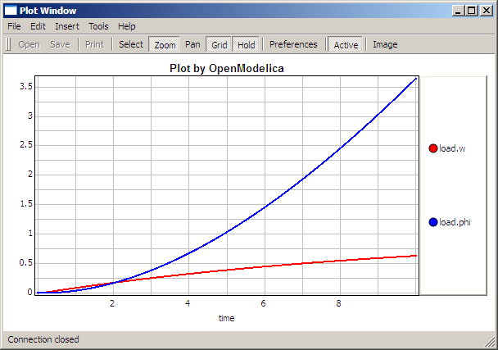

The val() function
The val(variableName,time) scription function can be used to retrieve the interpolated value of a simulation result variable at a certain point in the simulation time, see usage in the BouncingBall simulation below.

BouncingBall and Switch Models
We load and simulate the BouncingBall example containing when-equations and if-expressions (the Modelica keywords have been bold-faced by hand for better readability):
>> loadFile("C:/OpenModelica1.9.2/share/doc/omc/testmodels/BouncingBall.mo")
true
>> list(BouncingBall)
"model BouncingBall
parameter Real e=0.7 "coefficient of restitution";
parameter Real g=9.81 "gravity acceleration";
Real h(start=1) "height of ball";
Real v "velocity of ball";
Boolean flying(start=true) "true, if ball is flying";
Boolean impact;
Real v_new;
equation
impact=h <= 0.0;
der(v)=if flying then -g else 0;
der(h)=v;
when {h <= 0.0 and v <= 0.0,impact} then
v_new=if edge(impact) then -e*pre(v) else 0;
flying=v_new > 0;
reinit(v, v_new);
end when;
end BouncingBall;"
Instead of just giving a simulate and plot command, we perform a runScript command on a .mos (Modelica script) file sim_BouncingBall.mos that contains these commands:
loadFile("BouncingBall.mo");
simulate(BouncingBall, stopTime=3.0);
plot({h,flying});
The runScript command:
>> runScript("sim_BouncingBall.mos")
"true
record
resultFile = "BouncingBall_res.plt"
end record
true
true"
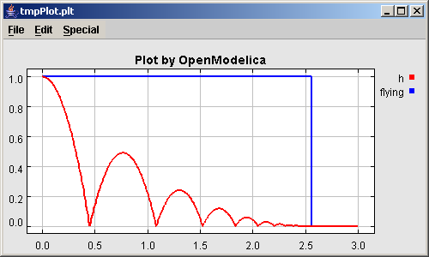
We enter a switch model, to test if-equations (e.g. copy and paste from another file and push enter):
>> model Switch
Real v;
Real i;
Real i1;
Real itot;
Boolean open;
equation
itot = i + i1;
if open then
v = 0;
else
i = 0;
end if;
1 - i1 = 0;
1 - v - i = 0;
open = time >= 0.5;
end Switch;
Ok
>> simulate(Switch, startTime=0, stopTime=1);
Retrieve the value of itot at time=0 using the val(variableName,time) function:
>> val(itot,0)
1
Plot itot and open:
>> plot({itot,open})
true

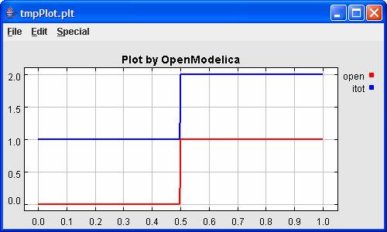
We note that the variable open switches from false (0) to true (1), causing itot to increase from 1.0 to 2.0.

Clear All Models
Now, first clear all loaded libraries and models:
>> clear()
true
List the loaded models – nothing left:
>> list()
""

VanDerPol Model and Parametric Plot
We load another model, the VanDerPol model (or via the menu File->Load Model):
>> loadFile("C:/OpenModelica1.9.2/share/doc/omc/testmodels/VanDerPol.mo"))
true
It is simulated:
>> simulate(VanDerPol)
record
resultFile = "VanDerPol_res.plt"
end record
It is plotted:
plotParametric(x,y);
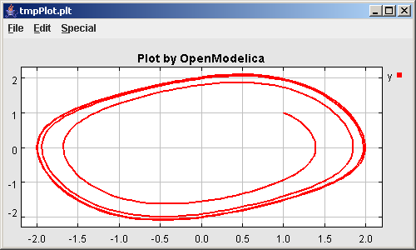
Perform code instantiation to flat form of the VanDerPol model:
>> instantiateModel(VanDerPol)
"fclass VanDerPol
Real x(start=1.0);
Real y(start=1.0);
parameter Real lambda = 0.3;
equation
der(x) = y;
der(y) = -x + lambda * (1.0 - x * x) * y;
end VanDerPol;
"

Using Japanese or Chinese Characters
Japenese, Chinese, and other kinds of UniCode characters can be used within quoted (single quote) identifiers, see for example the variable name to the right in the plot below:

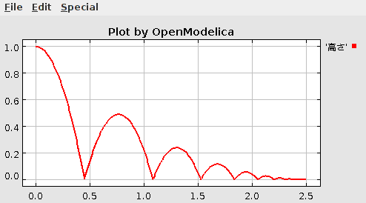

Scripting with For-Loops, While-Loops, and If-Statements
A simple summing integer loop (using multi-line input without evaluation at each line into OMShell requires copy-paste as one operation from another document):
>> k := 0;
for i in 1:1000 loop
k := k + i;
end for;
>> k
500500
A nested loop summing reals and integers::
>> g := 0.0;
h := 5;
for i in {23.0,77.12,88.23} loop
for j in i:0.5:(i+1) loop
g := g + j;
g := g + h / 2;
end for;
h := h + g;
end for;
By putting two (or more) variables or assignment statements separated by semicolon(s), ending with a variable, one can observe more than one variable value:
>> h;g
1997.45
1479.09
A for-loop with vector traversal and concatenation of string elements:
>> i:="";
lst := {"Here ", "are ","some ","strings."};
s := "";
for i in lst loop
s := s + i;
end for;
>> s
"Here are some strings."
Normal while-loop with concatenation of 10 "abc " strings:
>> s:="";
i:=1;
while i<=10 loop
s:="abc "+s;
i:=i+1;
end while;
>> s
"abc abc abc abc abc abc abc abc abc abc "
A simple if-statement. By putting the variable last, after the semicolon, its value is returned after evaluation:
>> if 5>2 then a := 77; end if; a
77
An if-then-else statement with elseif:
>> if false then
a := 5;
elseif a > 50 then
b:= "test"; a:= 100;
else
a:=34;
end if;
Take a look at the variables a and b:
>> a;b
100
"test"

Variables, Functions, and Types of Variables
Assign a vector to a variable:
>> a:=1:5
{1,2,3,4,5}
Type in a function:
>> function MySqr input Real x; output Real y; algorithm y:=x*x; end MySqr;
Ok
Call the function:
>> b:=MySqr(2)
4.0
Look at the value of variable a:
>> a
{1,2,3,4,5}
Look at the type of a:
>> typeOf(a)
"Integer[]"
Retrieve the type of b:
>> typeOf(b)
"Real"

What is the type of MySqr? Cannot currently be handled.
>> typeOf(MySqr)
Error evaluating expr.
List the available variables:
>> listVariables()
{currentSimulationResult, a, b}
Clear again:
>> clear()
true

Getting Information about Error Cause
Call the function getErrorString() in order to get more information about the error cause after a simulation failure:
>> getErrorString()

Alternative Simulation Output Formats
There are several output format possibilities, with mat being the default. plt and mat are the only formats that allow you to use the val() or plot() functions after a simulation. Compared to the speed of plt, mat is roughly 5 times for small files, and scales better for larger files due to being a binary format. The csv format is roughly twice as fast as plt on data-heavy simulations. The plt format allocates all output data in RAM during simulation, which means that simulations may fail due applications only being able to address 4GB of memory on 32-bit platforms. Empty does no output at all and should be by far the fastest. The csv and plt formats are suitable when using an external scripts or tools like gnuplot to generate plots or process data. The mat format can be post-processed in MATLAB or Octave.
simulate(... , outputFormat="mat")
simulate(... , outputFormat="csv")
simulate(... , outputFormat="plt")
simulate(... , outputFormat="empty")
It is also possible to specify which variables should be present in the result-file. This is done by using POSIX Extended Regular Expressions. The given expression must match the full variable name (^ and $ symbols are automatically added to the given regular expression).
// Default, match everything
simulate(... , variableFilter=".*")
// match indices of variable myVar that only contain the numbers using combinations
// of the letters 1 through 3
simulate(... , variableFilter="myVar\\[[1-3]*\\]")
// match x or y or z
simulate(... , variableFilter="x|y|z")

Using External Functions
See Chapter 12 for more information about calling functions in other programming languages.

Using Parallel Simulation via OpenMP Multi-Core Support
Faster simulations on multi-core computers can be obtained by using a new OpenModelica feature that automatically partitions the system of equations and schedules the parts for execution on different cores using shared-memory OpenMP based execution. The speedup obtained is dependent on the model structure, whether the system of equations can be partitioned well. This version in the current OpenModelica release is an experimental version without load balancing. The following command, not yet available from the OpenModelica GUI, will run a parallel simulation on a model:
omc +d=openmp model.mo

Loading Specific Library Version
There exist many different versiosn of Modelica libraries which are not compatible. It is possible to keep multiple versions of the same library stored in the directory given by calling getModelicaPath(). By calling loadModel(Modelica,{"3.2"}), OpenModelica will search for a directory called "Modelica 3.2" or a file called "Modelica 3.2.mo". It is possible to give several library versions to search for, giving preference for a pre-release version of a library if it is installed. If the searched version is "default", the priority is: no version name (Modelica), main release version (Modelica 3.1), pre-release version (Modelica 3.1Beta 1) and unordered versions (Modelica Special Release).
The loadModel command will also look at the uses annotation of the top-level class after it has been loaded. Given the following package, Complex 1.0 and ModelicaServices 1.1 will also be loaded into the AST automatically.
package Modelica
annotation(uses(Complex(version="1.0"), ModelicaServices(version="1.1")))
end Modelica;

Calling the Model Query and Manipulation API
In the OpenModelica System Documentation, an external API (application programming interface) is described which returns information about models and/or allows manipulation of models. Calls to these functions can be done interactively as below, but more typically by program clients to the OpenModelica Compiler (OMC) server. Current examples of such clients are the OpenModelica MDT Eclipse plugin, OMNotebook, the OMEdit graphic model editor, etc. This API is untyped for performance reasons, i.e., no type checking and minimal error checking is done on the calls. The results of a call is returned as a text string in Modelica syntax form, which the client has to parse. An example parser in C++ is available in the OMNotebook source code, whereas another example parser in Java is available in the MDT Eclipse plugin.
Below we show a few calls on the previously simulated BouncingBall model. The full documentation on this API is available in the system documentation. First we load and list the model again to show its structure:
>>loadFile("C:/OpenModelica1.9.2/share/doc/omc/testmodels/BouncingBall.mo")
true
>>list(BouncingBall)
"model BouncingBall
parameter Real e=0.7 "coefficient of restitution";
parameter Real g=9.81 "gravity acceleration";
Real h(start=1) "height of ball";
Real v "velocity of ball";
Boolean flying(start=true) "true, if ball is flying";
Boolean impact;
Real v_new;
equation
impact=h <= 0.0;
der(v)=if flying then -g else 0;
der(h)=v;
when {h <= 0.0 and v <= 0.0,impact} then
v_new=if edge(impact) then -e*pre(v) else 0;
flying=v_new > 0;
reinit(v, v_new);
end when;
end BouncingBall;
"
Different kinds of calls with returned results:
>>getClassRestriction(BouncingBall)
"model"
>>getClassInformation(BouncingBall)
{"model","","",{false,false,false},{"writable",1,1,18,17}}
>>isFunction(BouncingBall)
false
>>existClass(BouncingBall)
true
>>getComponents(BouncingBall)
{{Real,e,"coefficient of restitution", "public", false, false, false,
"parameter", "none", "unspecified"},
{Real,g,"gravity acceleration",
"public", false, false, false, "parameter", "none", "unspecified"},
{Real,h,"height of ball", "public", false, false, false,
"unspecified", "none", "unspecified"},
{Real,v,"velocity of ball",
"public", false, false, false, "unspecified", "none", "unspecified"},
{Boolean,flying,"true, if ball is flying", "public", false, false,
false, "unspecified", "none", "unspecified"},
{Boolean,impact,"",
"public", false, false, false, "unspecified", "none", "unspecified"},
{Real,v_new,"", "public", false, false, false, "unspecified", "none",
"unspecified"}}
>>getConnectionCount(BouncingBall)
0
>>getInheritanceCount(BouncingBall)
0
>>getComponentModifierValue(BouncingBall,e)
0.7
>>getComponentModifierNames(BouncingBall,e)
{}
>>getClassRestriction(BouncingBall)
"model"
>>getVersion() // Version of the currently running OMC
"1.9.2"

Quit OpenModelica
Leave and quit OpenModelica:
>> quit()

Dump XML Representation
The command dumpXMLDAE dumps an XML representation of a model, according to several optional parameters.
dumpXMLDAE(modelname[,asInSimulationCode=<Boolean>] [,filePrefix=<String>] [,storeInTemp=<Boolean>] [,addMathMLCode =<Boolean>])
This command dumps the mathematical representation of a model using an XML representation, with optional parameters. In particular, asInSimulationCode defines where to stop in the translation process (before dumping the model), the other options are relative to the file storage: filePrefix for specifying a different name and storeInTemp to use the temporary directory. The optional parameter addMathMLCode gives the possibility to don't print the MathML code within the xml file, to make it more readable. Usage is trivial, just: addMathMLCode=true/false (default value is false).

Dump Matlab Representation
The command export dumps an XML representation of a model, according to several optional parameters.
exportDAEtoMatlab(modelname);
This command dumps the mathematical representation of a model using a Matlab representation. Example:
$ cat daequery.mos
loadFile("BouncingBall.mo");
exportDAEtoMatlab(BouncingBall);
readFile("BouncingBall_imatrix.m");

$ omc daequery.mos
true
"The equation system was dumped to Matlab file:BouncingBall_imatrix.m"
"
% Incidence Matrix
% ====================================
% number of rows: 6
IM={[3,-6],[1,{'if', 'true','==' {3},{},}],[2,{'if', 'edge(impact)' {3},{5},}],[4,2],[5,{'if', 'true','==' {4},{},}],[6,-5]};
VL = {'foo','v_new','impact','flying','v','h'};

EqStr = {'impact = h <= 0.0;','foo = if impact then 1 else 2;','when {h <= 0.0 AND v <= 0.0,impact} then v_new = if edge(impact) then (-e) * pre(v) else 0.0; end when;','when {h <= 0.0 AND v <= 0.0,impact} then flying = v_new > 0.0; end when;','der(v) = if flying then -g else 0.0;','der(h) = v;'};

OldEqStr={'fclass BouncingBall','parameter Real e = 0.7 "coefficient of restitution";','parameter Real g = 9.81 "gravity acceleration";','Real h(start = 1.0) "height of ball";','Real v "velocity of ball";','Boolean flying(start = true) "true, if ball is flying";','Boolean impact;','Real v_new;','Integer foo;','equation',' impact = h <= 0.0;',' foo = if impact then 1 else 2;',' der(v) = if flying then -g else 0.0;',' der(h) = v;',' when {h <= 0.0 AND v <= 0.0,impact} then',' v_new = if edge(impact) then (-e) * pre(v) else 0.0;',' flying = v_new > 0.0;',' reinit(v,v_new);',' end when;','end BouncingBall;',''};"

Summary of Commands for the Interactive Session Handler
The following is the complete list of commands currently available in the interactive session hander.
simulate(modelname) Translate a model named modelname and simulate it.
simulate(modelname[,startTime=<Real>][,stopTime=<Real>][,numberOfIntervals
=<Integer>][,outputInterval=<Real>][,method=<String>]
[,tolerance=<Real>][,fixedStepSize=<Real>]
[,outputFormat=<String>]) Translate and simulate a model, with optional start time, stop time, and optional number of simulation intervals or steps for which the simulation results will be computed. More intervals will give higher time resolution, but occupy more space and take longer to compute. The default number of intervals is 500. It is possible to choose solving method, default is “dassl”, “euler” and “rungekutta” are also available. Output format “mat” is default. “plt” and “mat” (MATLAB) are the only ones that work with the val() command, “csv” (comma separated values) and “empty” (no output) are also available (see chapter 1.2.14).
plot(vars) Plot the variables given as a vector or a scalar, e.g. plot({x1,x2}) or plot(x1).
plotParametric(var1, var2) Plot var2 relative to var1 from the most recently simulated model, e.g. plotParametric(x,y).
cd() Return the current directory.
cd(dir) Change directory to the directory given as string.
clear() Clear all loaded definitions.
clearVariables() Clear all defined variables.
dumpXMLDAE(modelname, ...) Dumps an XML representation of a model, according to several optional parameters.
exportDAEtoMatlab(name) Dumps a Matlab representation of a model.
instantiateModel(modelname)Performs code instantiation of a model/class and return a string containing the flat class definition.
list() Return a string containing all loaded class definitions.
list(modelname) Return a string containing the class definition of the named class.
listVariables() Return a vector of the names of the currently defined variables.
loadModel(classname) Load model or package of name classname from the path indicated by the environment variable OPENMODELICALIBRARY.
loadFile(str) Load Modelica file (.mo) with name given as string argument str.
readFile(str) Load file given as string str and return a string containing the file content.
runScript(str) Execute script file with file name given as string argument str.
system(str) Execute str as a system(shell) command in the operating system; return integer success value. Output into stdout from a shell command is put into the console window.
timing(expr) Evaluate expression expr and return the number of seconds (elapsed time) the evaluation took.
typeOf(variable) Return the type of the variable as a string.
saveModel(str,modelname) Save the model/class with name modelname in the file given by the string argument str.
val(variable,timePoint) Return the (interpolated) value of the variable at time timePoint.
help() Print this helptext (returned as a string).
quit() Leave and quit the OpenModelica environment

Running the compiler from command line
The OpenModelica compiler can also be used from command line, in Windows cmd.exe.

Example Session 1 – obtaining information about command line parameters
C:\dev> C:\OpenModelica1.9.2 \bin\omc -h
OpenModelica Compiler 1.9.2
Copyright © 2015 Open Source Modelica Consortium (OSMC)
Distributed under OMSC-PL and GPL, see www.openmodelica.org
Usage: omc [Options] (Model.mo | Script.mos) [Libraries | .mo-files]
...

Example Session 2 - create an TestModel.mo file and run omc on it
C:\dev> echo model TestModel parameter Real x = 1; end TestModel; > TestModel.mo
C:\dev> C:\OpenModelica1.9.2 \bin\omc TestModel.mo
class TestModel
parameter Real x = 1.0;
end TestModel;
C:\dev>

Example Session 3 - create an script.mos file and run omc on it
Create a file script.mos using your editor containing these commands:
// start script.mos
loadModel(Modelica); getErrorString();
simulate(Modelica.Mechanics.MultiBody.Examples.Elementary.Pendulum); getErrorString();
// end script.mos
C:\dev> notepad script.mos
C:\dev> C:\OpenModelica1.9.2 \bin\omc script.mos
true
""
record SimulationResult
resultFile = "C:/dev/Modelica.Mechanics.MultiBody.Examples.Elementary.Pendulum_res.mat",
simulationOptions = "startTime = 0.0, stopTime = 5.0, numberOfIntervals = 500, tolerance = 1e-006, method = 'dassl', fileNamePrefix = 'Modelica.Mechanics.MultiBody.Examples.Elementary.Pendulum', options = '', outputFormat = 'mat', variableFilter = '.*', cflags = '', simflags = ''",
messages = "",
timeFrontend = 1.245787339209033,
timeBackend = 20.51007138993843,
timeSimCode = 0.1510248469321959,
timeTemplates = 0.5052317333954395,
timeCompile = 5.128213942691722,
timeSimulation = 0.4049189573103951,
timeTotal = 27.9458487395605
end SimulationResult;
""
In order to obtain more information from the compiler one can use the command line options +showErrorMessages +d=failtrace when running the compiler:
C:\dev> C:\OpenModelica1.9.2 \bin\omc +showErrorMessages +d=failtrace script.mos

References
Peter Fritzson, Peter Aronsson, Håkan Lundvall, Kaj Nyström, Adrian Pop, Levon Saldamli, and David Broman. The OpenModelica Modeling, Simulation, and Software Development Environment. In Simulation News Europe, 44/45, December 2005. See also: http://www.openmodelica.org.
Peter Fritzson. Principles of Object-Oriented Modeling and Simulation with Modelica 2.1, 940 pp., ISBN 0-471-471631, Wiley-IEEE Press, 2004.
The Modelica Association. The Modelica Language Specification Version 3.0, Sept 2007. http://www.modelica.org.

OMEdit – OpenModelica Connection Editor
OMEdit – OpenModelica Connection Editor is the new Graphical User Interface for graphical model editing in OpenModelica. It is implemented in C++ using the Qt 4.8 graphical user interface library and supports the Modelica Standard Library version 3.1 that is included in the latest OpenModelica installation. This chapter gives a brief introduction to OMEdit and also demonstrates how to create a DCMotor model using the editor.
OMEdit provides several user friendly features for creating, browsing, editing, and simulating models:
- Modeling – Easy model creation for Modelica models.
- Pre-defined models – Browsing the Modelica Standard library to access the provided models.
- User defined models – Users can create their own models for immediate usage and later reuse.
- Component interfaces – Smart connection editing for drawing and editing connections between model interfaces.
- Simulation – Subsystem for running simulations and specifying simulation parameters start and stop time, etc.
- Plotting – Interface to plot variables from simulated models.

Starting OMEdit

Microsoft Windows
OMEdit can be launched using the executable placed in OpenModelicaInstallationDirectory/bin/OMEdit/OMEdit.exe. Alternately, choose OpenModelica > OpenModelica Connection Editor from the start menu in Windows. A splash screen similar to the one shown in Figure 2-2 will appear indicating that it is starting OMEdit.

Linux
Start OMEdit by either selecting the corresponding menu application item or typing “OMEdit” at the shell or command prompt.

Mac OS X
?? fill in

Figure 2-2: OMEdit Splash Screen.

MainWindow & Browsers
The MainWindow contains several dockable browsers,
- Search Browser
- Libraries Browser
- Documentation Browser
- Variables Browser
- Messages Browser
Figure 2-3 shows the MainWindow and browsers.
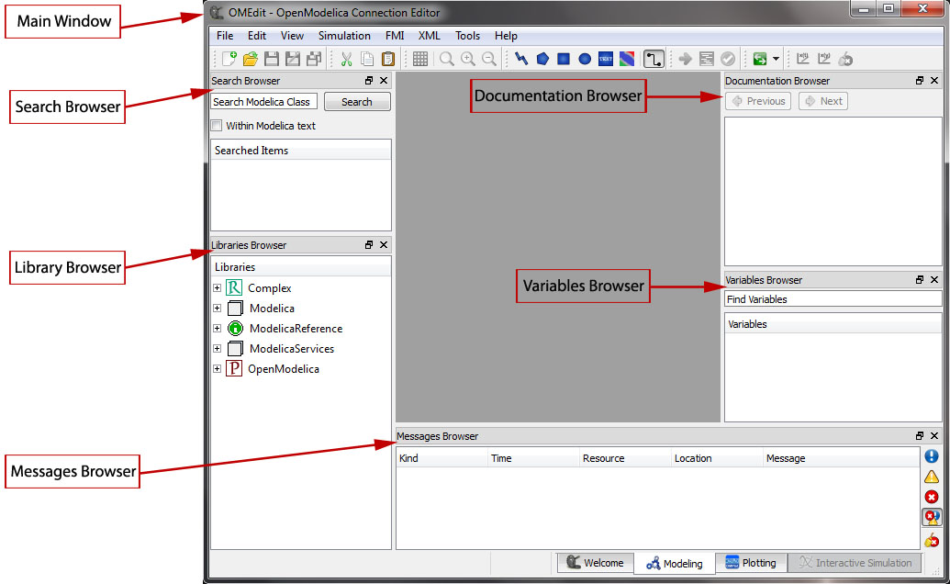
Figure 2-3: OMEdit MainWindow and Browsers.
The default location of the browsers are shown in Figure 2-3. All browsers except for Message Browser can be docked into left or right column. The Messages Browser can be docked into left,right or bottom areas. If you want OMEdit to remember the new docked position of the browsers then you must enable Preserve User's GUI Customizations option, see section 2.9.1.

Search Browser
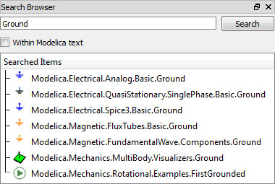
Figure 2-4: Search Browser.
To view the Search Browser click Edit->Search Browser or press keyboard shortcut Ctrl+Shift+F. The loaded Modelica classes can be searched by typing any part of the class name. It is also possible to search the Modelica class if one knows the text string that is used within it but Within Modelica text checkbox should be checked for this feature to work.

Libraries Browser
To view the Libraries Browser click View->Windows->Libraries Browser. Shows the list of loaded Modelica classes. Each item of the Libraries Browser has right click menu for easy manipulation and usage of the class. The classes are shown in a tree structure with name and icon. The protected classes are not shown by default. If you want to see the protected classes then you must enable the Show Protected Classes option, see section 2.9.1.
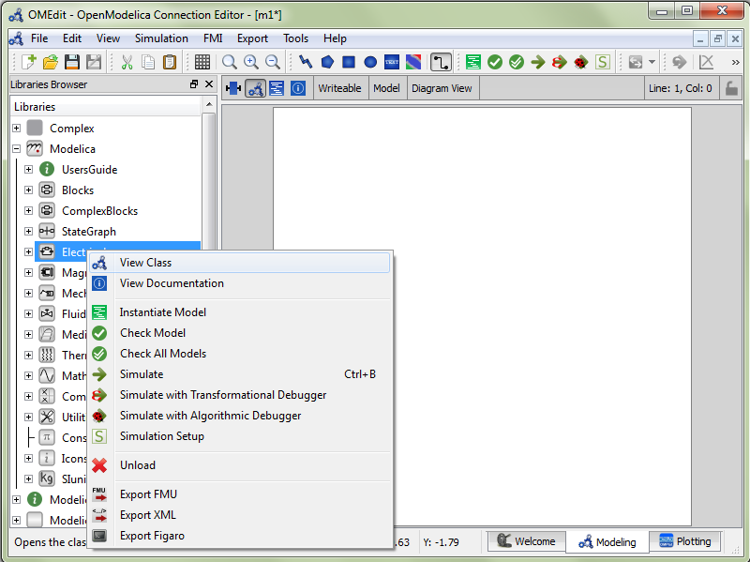
Figure 2-5: Libraries Browser.

Documentation Browser
Displays the HTML documentation of Modelica classes. It contains the navigation buttons for moving forward and backward. To see documentation of any class, right click the Modelica class in Libraries Browser and choose View Documentation.
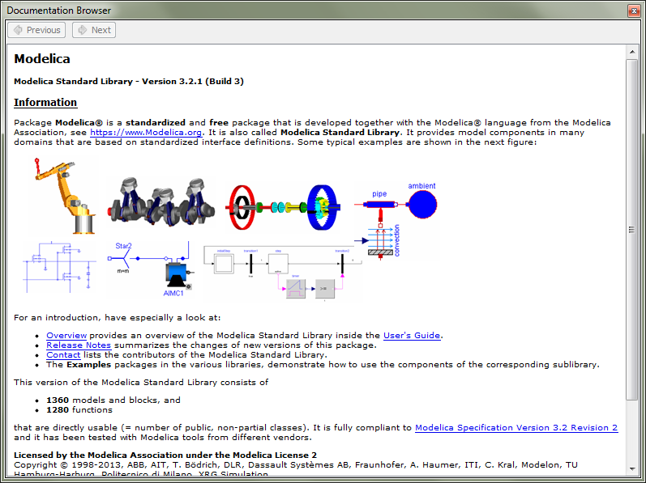
Figure 2-6: Documentation Browser.

Variables Browser
The class variables are structured in the form of the tree and are displayed in the Variables Browser. Each variable has a checkbox. Ticking the checkbox will plot the variable values. There is a find box on the top for filtering the variable in the tree. The filtering can be done using Regular Expression, Wildcard and Fixed String. The complete Variables Browser can be collapsed and expanded using the Collapse All and Expand All buttons.
The browser allows manipulation of changeable parameters for re-simulation. See section 2.7. It also displays the unit and description of the variable.
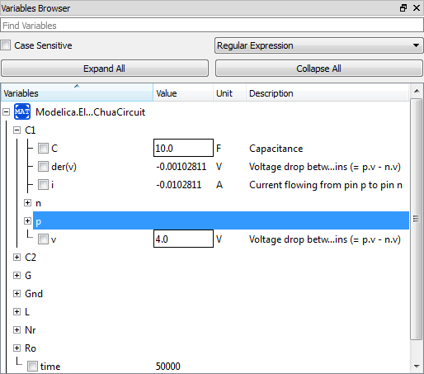
Figure 2-7: Variables Browser.

Messages Browser
Shows the list of errors. Following kinds of error can occur,
- Syntax
- Grammar
- Translation
- Symbolic
- Simulation
- Scripting
See section 2.9.6 for Messages Browser options.

Perspectives
The perspective tabs are loacted at the bottom right of the MainWindow,
- Welcome Perspective
- Modeling Perspective
- Plotting Perspective

Welcome Perspective
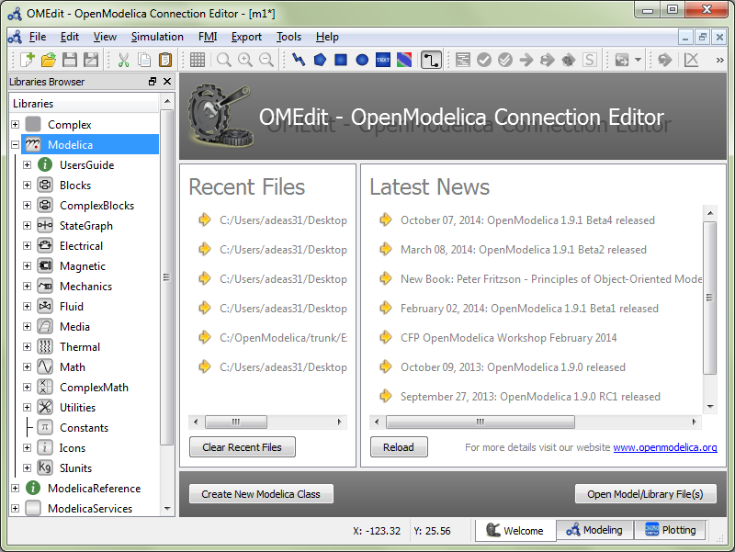
Figure 2-8: OMEdit Welcome Perspective.
The Welcome Perspective shows the list of recent files and the list of latest news from openmodelica.org. See Figure 2-8. The orientation of recent files and latest news can be horizontal or vertical. User is allowed to show/hide the latest news. See section 2.9.1.

Modeling Perspective
The Modeling Perpective provides the interface where user can create and design their models. See Figure 2-9.
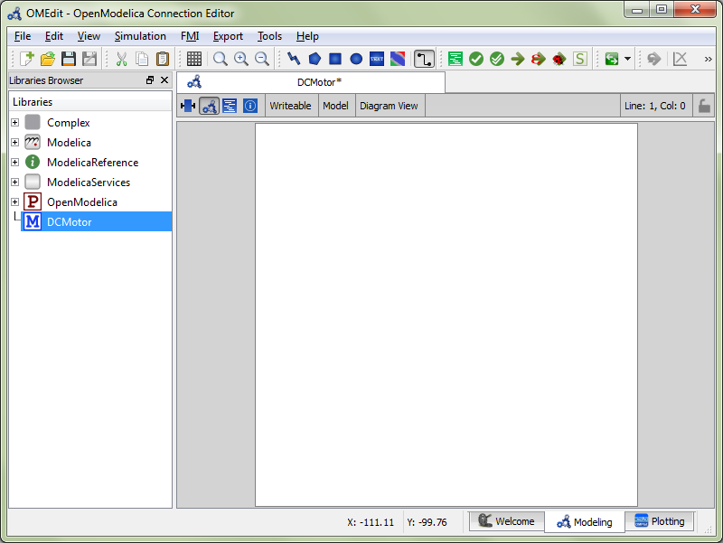
Figure 2-9: OMEdit Modeling Perspective.
The Modeling Perspective interface can be viewed in two different modes, the tabbed view and subwindow view, see section 2.9.1.

Plotting Perspective
The Plotting Perspective shows the simulation results of the models. Plotting Perspective will automatically become active when the simulation of the model is finished successfully. It will also become active when user opens any of the OpenModelica’s supported result file. Similar to Modeling Perspective this perspective can also be viewed in two different modes, the tabbed view and subwindow view, see section 2.9.1.
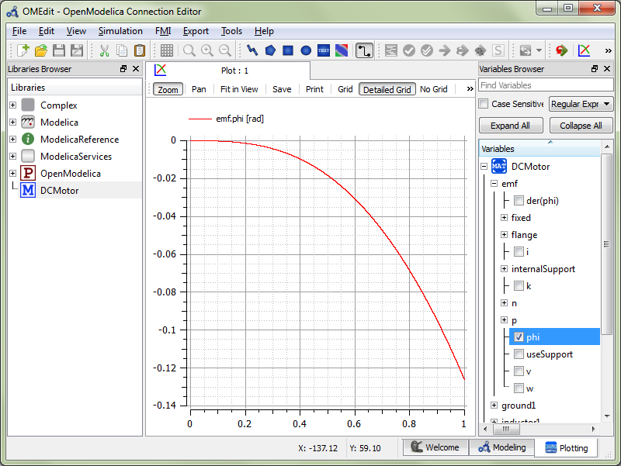
Figure 2-10: OMEdit Plotting Perspective.

Modeling a Model

Creating a New Modelica class
Creating a new Modelica class in OMEdit is rather straightforward. Choose any of the following methods,
- Select File > New Modelica Class from the menu.
- Click on New Modelica Class toolbar button.
- Click on the Create New Modelica Class button available at the left bottom of Welcome Perspective.
- Press Ctrl+N.

Opening a Modelica File
Choose any of the following methods to open a Modelica file,
- Select File > Open Model/Library File(s) from the menu.
- Click on Open Model/Library File(s) toolbar button.
- Click on the Open Model/Library File(s) button available at the right bottom of Welcome Perspective.
- Press Ctrl+O.

Opening a Modelica File with Encoding
Select File > Open/Convert Modelica File(s) With Encoding from the menu. It is also possible to convert files to UTF-8.

Model Widget
For each Modelica class one Model Widget is created. It has a statusbar and a view area. The statusbar contains buttons for navigation between the views and labels for information. The view area is used to display the icon, diagram and text layers of Modelica class. See Figure 2-11.
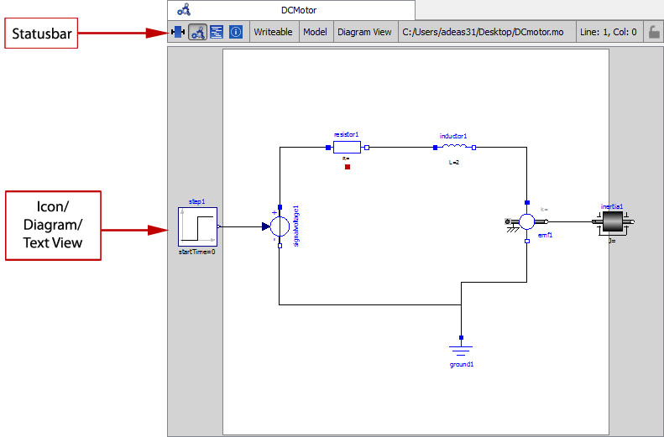
Figure 2-11: Model Widget showing the Diagram View.

Adding Component Models
Drag the models from the Libraries Browser and drop them on either Diagram or Icon View of Model Widget.

Making Connections
In order to connect one component model to another the user first needs to enable the connect mode from the toolbar. See Figure 2-12.
Figure 2-12: Connect/Unconnect Mode toolbar button.

Simulating a Model
The OMEdit Simulation Dialog can be launched by,
- Selecting Simulation > Simulation Setup from the menu. (requires a model to be active in ModelWidget)
- Clicking on the Simulation Setup toolbar button. (requires a model to be active in ModelWidget)
- Right clicking the model from the Libraries Browser and choosing Simulation Setup.

General Tab
- Start Time – the simulation start time.
- Stop Time – the simulation stop time.
- Method – the simulation solver. See Appendix C for solver details.
- Tolerance – the simulation tolerance.
- Compiler Flags (Optional) – the optional C compiler flags.
- Number of Processors – the number of processors used to build the simulation.
- Launch Transformational Debugger – launches the transformational debugger.
- Launch Algorithmic Debugger – launches the algorithmic debugger.

Output Tab
- Number of Intervals – the simulation number of intervals.
- Output Format – the simulation result file output format.
- File Name (Optional) – the simulation result file name.
- Variable Filter (Optional).
- Protecetd Variables – adds the protected variables in result file.
- Store Variables at Events – adds the variables at time events.
- Show Generated File – displays the generated files in a dialog box.

Simulation Flags Tab
- Model Setup File (Optional) – specifies a new setup XML file to the generated simulation code.
- Initialization Method (Optional) – specifies the initialization method.
- Equation System Initialization File (Optional) – specifies an external file for the initialization of the model.
- Equation System Initialization Time (Optional) – specifies a time for the initialization of the model.
- Clock (Optional) – the type of clock to use.
- Linear Solver (Optional) – specifies the linear solver method.
- Non Linear Solver (Optional) – specifies the nonlinear solver.
- Linearization Time (Optional) – specifies a time where the linearization of the model should be performed.
- Output Variables (Optional) – outputs the variables a, b and c at the end of the simulation to the standard output.
- Profiling – creates a profiling HTML file.
- CPU Time – dumps the cpu-time into the result file.
- Enable All Warnings – outputs all warnings.
- Logging (Optional)
- DASSL Solver Information – prints additional information about dassl solver.
- Debug – prints additional debug information.
- Dynamic State Selection Information – outputs information about dynamic state selection.
- Jacobians Dynamic State Selection Information – outputs jacobain of the dynamic state selection.
- Event Iteration – additional information during event iteration.
- Verbose Event System – verbose logging of event system.
- Initialization – prints additional information during initialization.
- Jacobians Matrix – outputs the jacobian matrix used by dassl.
- Non Linear Systems – logging for nonlinear systems.
- Verbose Non Linear Systems – verbose logging of nonlinear systems.
- Jacobians Non Linear Systems – outputs the jacobian of nonlinear systems.
- Initialization Residuals – outputs residuals of the initialization.
- Simulation Process – additional information about simulation process.
- Solver Process – additional information about solver process.
- Final Initialization Solution – final solution of the initialization.
- Timer/Event/Solver Statistics – additional statistics about timer/events/solver.
- Util.
- Zero Crossings – additional information about the zerocrossings.
- Additional Simulation Flags (Optional) – specify any other simulation flag.

Plotting the Simulation Results
Successful simulation of model produces the result file which contains the instance variables that are candidate for plotting. Variables Browser will show the list of such instance variables. Each variable has a checkbox, checking it will plot the variable. See Figure 2-10.

Types of Plotting
The plotting type depends on the active Plot Window. By default the plotting type is Time Plot.

Time Plot
Plots the variable over the simulation time. You can have multiple Time Plot windows by clicking on New Plot Window toolbar button. See Figure 2-13.

Figure 2-13: New Plot Window toolbar button.

Plot Parametric
Draws a two-dimensional parametric diagram, between variables x and y, with y as a function of x. You can have multiple Plot Parametric windows by clicking on the New Plot Parametric toolbar button. See Figure 2-14.

Figure 2-14: New Plot Parametric toolbar button.

Re-simulating a Model
The Variables Browser allows manipulation of changeable parameters for re-simulation as shown in Figure 2-7. After changing the parameter values user can click on the Re-simulate toolbar button, , or right click the model in Variables Browser and choose Re-simulate from the menu.
Figure 2-15: Re-simulate toolbar button.

How to Create User Defined Shapes – Icons
Users can create shapes of their own by using the shape creation tools available in OMEdit.
- Line Tool – Draws a line. A line is created with a minimum of two points. In order to create a line, the user first selects the line tool from the toolbar and then click on the Icon/Diagram View; this will start creating a line. If a user clicks again on the Icon/Diagram View a new line point is created. In order to finish the line creation, user has to double click on the Icon/Diagram View.
- Polygon Tool – Draws a polygon. A polygon is created in a similar fashion as a line is created. The only difference between a line and a polygon is that, if a polygon contains two points it will look like a line and if a polygon contains more than two points it will become a closed polygon shape.
- Rectangle Tool – Draws a rectangle. The rectangle only contains two points where first point indicates the starting point and the second point indicates the ending the point. In order to create rectangle, the user has to select the rectangle tool from the toolbar and then click on the Icon/Diagram View, this click will become the first point of rectangle. In order to finish the rectangle creation, the user has to click again on the Icon/Diagram View where he/she wants to finish the rectangle. The second click will become the second point of rectangle.
- Ellipse Tool – Draws an ellipse. The ellipse is created in a similar way as a rectangle is created.
- Text Tool – Draws a text label.
- Bitmap Tool – Draws a bitmap container.
The shape tools are located in the toolbar. See Figure 2-16.
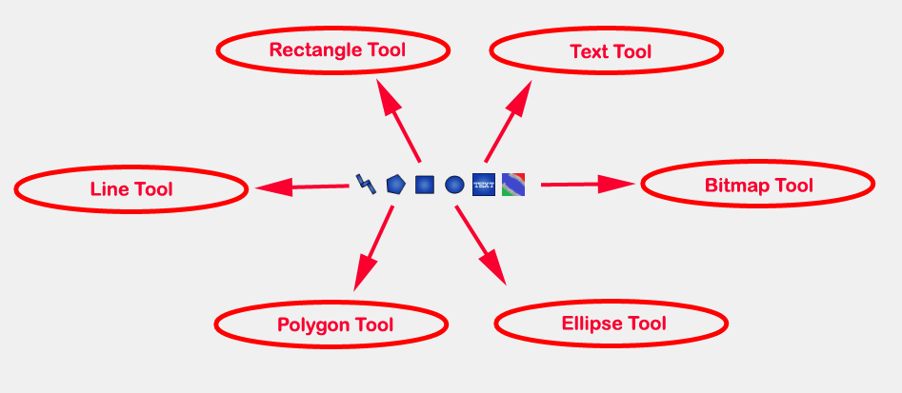
Figure 2-16: User defined shapes.
The user can select any of the shape tools and start drawing on the Icon/Diagram View. The shapes created on the Diagram View of Model Widget are part of the diagram and the shapes created on the Icon View will become the icon representation of the model.
For example, if a user creates a model with name testModel and add a rectangle using the rectangle tool and a polygon using the polygon tool, in the Icon View of the model. The model’s Modelica Text will appear as follows:
model testModel
annotation(Icon(graphics = {Rectangle(rotation = 0, lineColor = {0,0,255}, fillColor = {0,0,255}, pattern = LinePattern.Solid, fillPattern = FillPattern.None, lineThickness = 0.25, extent = {{ -64.5,88},{63, -22.5}}),Polygon(points = {{ -47.5, -29.5},{52.5, -29.5},{4.5, -86},{ -47.5, -29.5}}, rotation = 0, lineColor = {0,0,255}, fillColor = {0,0,255}, pattern = LinePattern.Solid, fillPattern = FillPattern.None, lineThickness = 0.25)}));
end testModel;
In the above code snippet of testModel, the rectangle and a polygon are added to the icon annotation of the model. Similarly, any user defined shape drawn on a Diagram View of the model will be added to the diagram annotation of the model.

Settings
OMEdit allows users to save several settings which will be remembered across different sessions of OMEdit. The Options Dialog can be used for reading and writing the settings.

General
- General
- Language – Sets the application language.
- Working Directory – Sets the application working directory.
- Toolbar Icon Size – Sets the size for toolbar icons.
- Preserve User’s GUI Customizations – If true then OMEdit will remember its windows and toolbars positions and sizes.
- Libraries Browser
- Library Icon Size – Sets the size for library icons.
- Show Protected Classes – Sets the application language.
- Modeling View Mode
- Tabbed View/SubWindow View – Sets the view mode for modeling.
- Plotting View Mode
- Tabbed View/SubWindow View – Sets the view mode for plotting.
- Default View
- Icon View/DiagramView/Modelica Text View/Documentation View – If no preferredView annotation is defined then this setting is used to show the respective view when user double clicks on the class in the Libraries Browser.
- Enable Auto Save
- Auto Save interval – Sets the auto save interval value. The minimum possible interval value is 60 seconds.
- Enable Auto Save for single classes – Enables the auto save for one class saved in one file.
- Enable Auto Save for one file packages – Enables the auto save for packages saved in one file.
- Welcome Page
- Horizontal View/Vertical View – Sets the view mode for welcome page.
- Show Latest News – if true then displays the latest news.

Libraries
- System Libraries – The list of system libraries that should be loaded every time OMEdit starts.
- Force loading of Modelica Standard Library – If true then Modelica and ModelicaReference will always load even if user has removed them from the list of system libraries.
- User Libraries – The list of user libraries/files that should be loaded every time OMEdit starts.

Modelica Text Editor
- General
- Enable Syntax Highlighting – Enable/Disable the syntax highlighting for the Modelica Text Widget.
- Enable Line Wrapping – Enable/Disable the line wrapping for the Modelica Text Widget.
- Fonts and Colors
- Font Family – Contains the names list of available fonts.
- Font Size – Sets the font size.
- Items – List of categories used of syntax highlighting the code.
- Item Color – Sets the color for the selected item.
- Preview – Shows the demo of the syntax highlighting.

Graphical Views
- Extent
- Left – Defines the left extent point for the view.
- Bottom – Defines the bottom extent point for the view.
- Right – Defines the right extent point for the view.
- Top – Defines the top extent point for the view.
- Grid
- Horizontal – Defines the horizontal size of the view grid.
- Vertical – Defines the vertical size of the view grid.
- Component
- Scale factor – Defines the initial scale factor for the component dragged on the view.
- Preserve aspect ratio – If true then the component’s aspect ratio is preserved while scaling.

Simulation
- Simulation
- Matching Algorithm – sets the matching algorithm for simulation.
- Index Reduction Method – sets the index reduction method for simulation.
- OMC Flags – sets the omc flags for simulation.
- Save class before simulation – if ture then always saves the class before running the simulation.
- Output
- Structured – Shows the simulation output in the form of tree structure.
- Formatted Text – Shows the simulation output in the form of formatted text.

Messages
- General
- Output Size - Specifies the maximum number of rows the Messages Browser may have. If there are more rows then the rows are removed from the beginning.
- Reset messages number before simulation – Resets the messages counter before starting the simulation.
- Font and Colors
- Font Family – Sets the font for the messages.
- Font Size – Sets the font size for the messages.
- Notification Color – Sets the text color for notification messages.
- Warning Color – Sets the text color for warning messages.
- Error Color – Sets the text color for error messages.

Notifications
- Notifications
- Always quit without prompt – If true then OMEdit will quit without prompting the user.
- Show item dropped on itself message – If true then a message will pop-up when a class is dragged and dropped on itself.
- Show model is defined as partial and component will be added as replaceable message – If true then a message will pop-up when a partial class is added to another class.
- Show component is declared as inner message – If true then a message will pop-up when an inner component is added to another class.
- Show save model for bitmap insertion message – If true then a message will pop-up when user tries to insert a bitmap from a local directory to an unsaved class.

Line Style
- Line Style
- Color – Sets the line color.
- Pattern – Sets the line pattern.
- Thickness – Sets the line thickness.
- Start Arrow – Sets the line start arrow.
- End Arrow – Sets the line end arrow.
- Arrow Size – Sets the start and end arrow size.
- Smooth – If true then the line is drawn as a Bezier curve.

Fill Style
- Fill Style
- Color – Sets the fill color.
- Pattern – Sets the fill pattern.

Curve Style
- Curve Style
- Pattern – Sets the curve pattern.
- Thickness – Sets the curve thickness.

Figaro
- Figaro
- Figaro Database File – the Figaro database file path.
- Figaro Mode –
- Figaro Options File – the Figaro options file path.
- Figaro Process – the Figaro process location.

Debugger
- Algorithmic Debugger
- GDB Path – the gnu debugger path
- GDB Command Timeout – timeout for gdb commands.
- Display C frames – if true then shows the C stack frames.
- Display unknown frames – if true then shows the unknown stack frames. Unknown stack frames means frames whose file path is unknown.
- Clear old output on a new run – if true then clears the output window on new run.
- Clear old log on new run – if true then clears the log window on new run.
- Transformational Debugger
- Always show Transformational Debugger after compilation – if true then always open the Transformational Debugger window after model compilation.
- Generate operations in the info xml – if true then adds the operations information in the info xml file.

FMI
- Export
- Version 1.0 – Sets the FMI export version to 1.0
- Version 2.0 – Sets the FMI export version to 2.0

The Equation-based Debugger
This section gives a short description how to get started using the equation-based debugger in OMEdit.

Enable Tracing Symbolic Transformations
This enables tracing symbolic transformations of equations. It is optional but strongly recommended in order to fully use the debugger. The compilation time overhead from having this tracing on is less than 1%, however, in addition to that, some time is needed for the system to write the xml file containing the transformation tracing information.
Enable +d=infoXmlOperations in Tools->Options->Simulation (see section 2.9.5) OR alternatively click on the checkbox Generate operations in the info xml in Tools->Options->Debugger (see section 2.9.12) which performs the same thing.
This adds all the transformations performed by OpenModelica on the equations and variables stored in the model_info.xml file. This is necessary for the debugger to be able to show the whole path from the source equation(s) to the position of the bug.

Load a Model to Debug
Load an interesting model. We will use the package https://openmodelica.org/svn/OpenModelica/trunk/testsuite/openmodelica/debugging/Debugging.mo since it contains suitable, broken models to demonstrate common errors.

Simulate and Start the Debugger
Select and simulate the model as usual. For example, if using the Debugging package, select the model Debugging.Chattering.ChatteringEvents1. If there is an error, you will get a clickable link that starts the debugger. If the user interface is unresponsive or the running simulation uses too much processing power, click cancel simulation first.
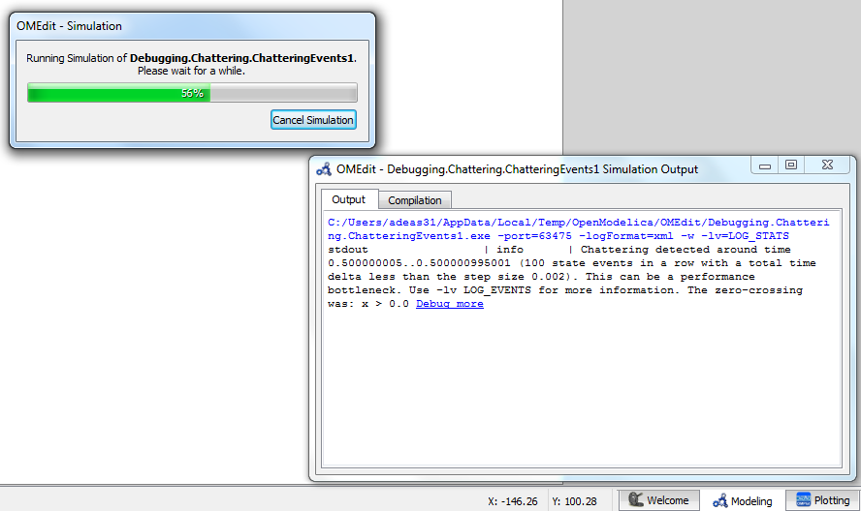
Figure 2-17. Simulating the model.

Use the Transformation Debugger for Browsing
Use the transformation debugger. It opens on the equation where the error was found. You can browse through the dependencies (variables that are defined by the equation, or the equation is dependent on), and similar for variables. The equations and variables form a bipartite graph that you can walk.
If the +d=infoXmlOperations was used or you clicked the “generate operations” button, the operations performed on the equations and variables can be viewed. In the example package, there are not a lot of operations because the models are small.
Try some larger models, e.g. in the MultiBody library or some other library, to see more operations with several transformation steps between different versions of the relevant equation(s). If you do not trigger any errors in a model, you can still open the debugger, using File->Open Transformations File (model_info.xml).
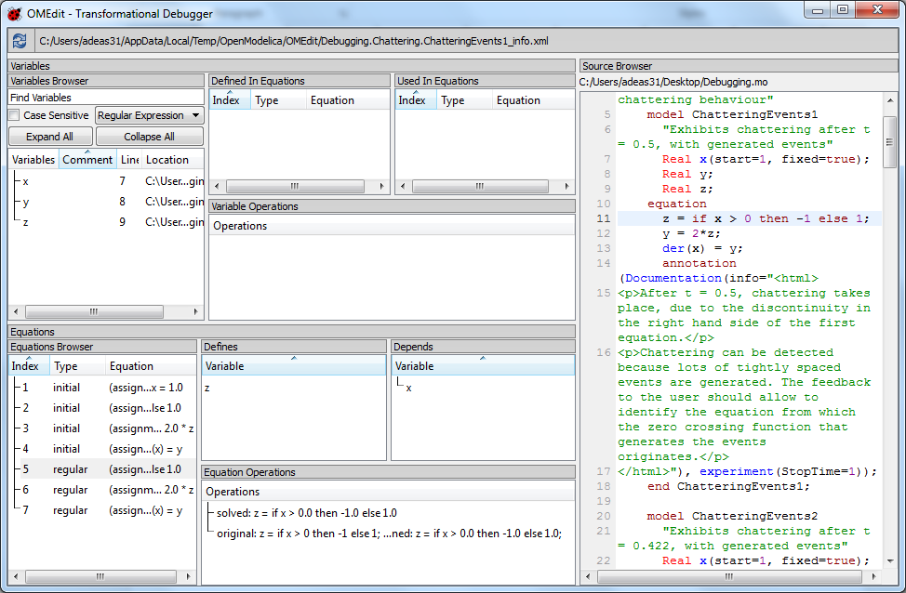
Figure 2-18. Transfomation Debugger.

The Algorithmic Debugger
This section gives a short description how to get started using the algorithmic debugger in OMEdit. See section 2.9.12 for further details of debugger options/settings. The Algorithmic Debugger window can be launched from Tools->Windows->Algorithmic Debugger.

Adding Breakpoints
There are two ways to add the breakpoints,
- Click directly on the line number in Text View, a red circle is created indicating a breakpoint as shown in Figure 2-19.
- Open the Algorithmic Debugger window and add a breakpoint using the right click menu of Breakpoints Browser window.
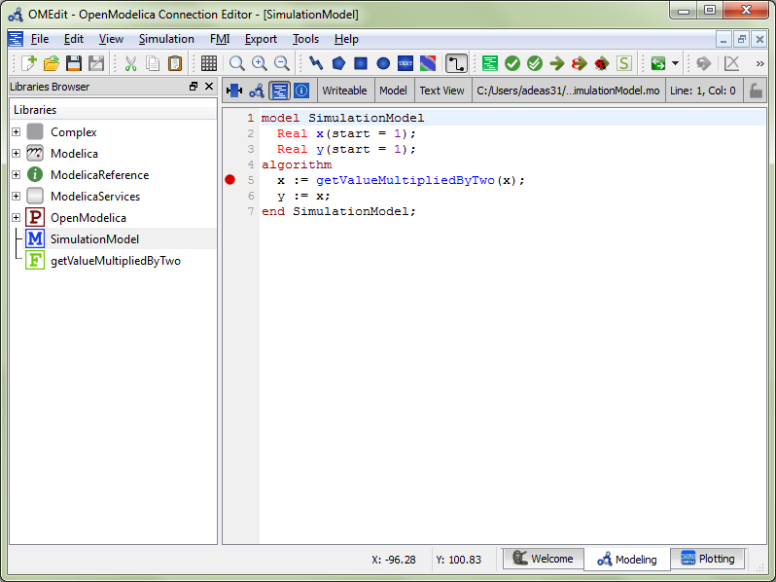
Figure 2-19: Adding breakpoint in Text View.

Start the Algorithmic Debugger
You should add breakpoints before starting the debugger because sometimes the simulation finishes quickly and you won’t get any chance to add the breakpoints.
There are four ways to start the debugger,
- Open the Simulation Setup and click on Launch Algorithmic Debugger before pressing Simulate.
- Right click the model in Libraries Browser and select Simulate with Algorithmic Debugger.
- Open the Algorithmic Debugger window and from menu select Debug->Debug Configurations (see section 2.11.3).
- Open the Algorithmic Debugger window and from menu select Debug->Attach to Running Process (see section 2.11.4).

Debug Configurations
If you already have a simulation executable with debugging symbols outside of OMEdit then you can use the Debug->Debug Configurations option to load it.
The debugger also supports MetaModelica data structures so one can debug omc executable. Select omc executable as program and write the name of the mos script file in Arguments.
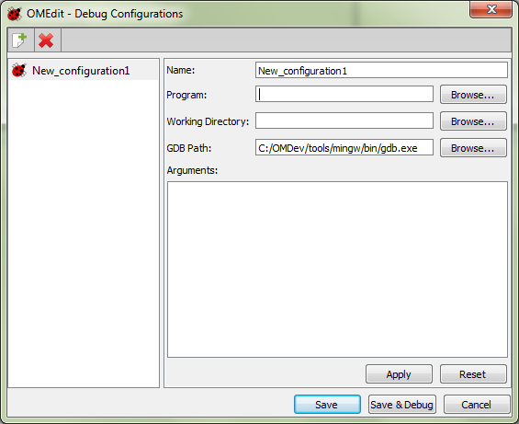
Figure 2-20: Debug Configurations.

Attach to Running Process
If you already have a running simulation executable with debugging symbols outside of OMEdit then you can use the Debug->Attach to Running Process option to attach the debugger with it. Figure 2-21 shows the Attach to Running Process dialog. The dialog shows the list of processes running on the machine. The user selects the program that he/she wish to debug. OMEdit debugger attaches to the process.
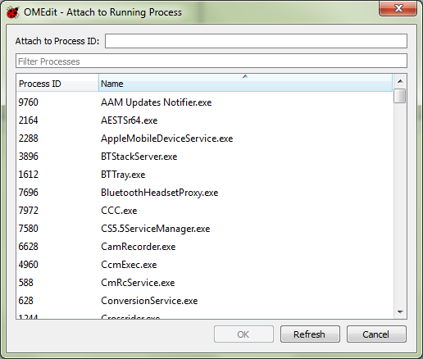
Figure 2-21: Attach to Running Process.

Using the Algorithmic Debugger Window
Figure 2-22 shows the Algorithmic Debugger window. The window contains the following browsers,
- Stack Frames Browser – shows the list of frames. It contains the program context buttons like resume, interrupt, exit, step over, step in, step return. It also contains a threads drop down which allows switching between different threads.
- BreakPoints Browser – shows the list of breakpoints. Allows adding/editing/removing breakpoints.
- Locals Browser – Shows the list of local variables with values. Select the variable and the value will be shown in the bottom right window. This is just for convenience because some variables might have long values.
- Debugger CLI – shows the commands sent to gdb and their responses. This is for advanced users who want to have more control of the debugger. It allows sending commands to gdb.
- Output Browser – shows the output of the debugged executable.
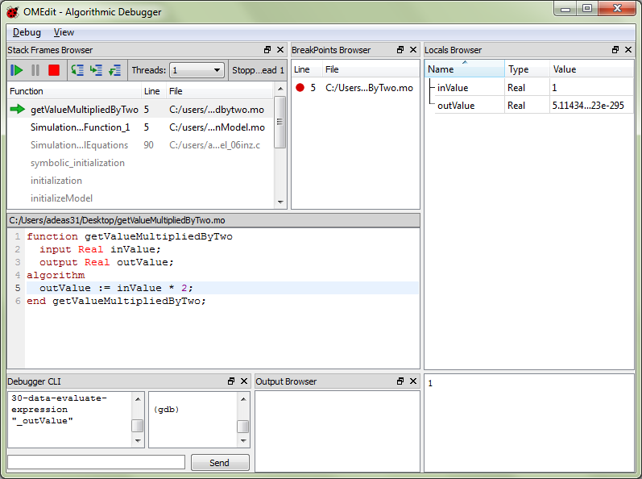
Figure 2-22: Algorithmic Debugger.

2D Plotting
This chapter covers the 2D plotting available in OpenModelica via OMNotebook, OMShell and command line script. The plotting is based on OMPlot application.

Example
class HelloWorld
Real x(start = 1);
parameter Real a = 1;
equation
der(x) = - a * x;
end HelloWorld;
To create a simple time plot the above model HelloWorld is simulated. To reduce the amount of simulation data in this example the number of intervals is limited with the argument numberOfIntervals=10. The simulation is started with the command below.
simulate(HelloWorld, startTime=0, stopTime=4, numberOfIntervals=10);
When the simulation is finished the file HelloWorld res.plt contains the simulation data. The contents of the file is the following (some formatting has been applied).
0 1
4.440892098500626e-013 0.9999999999995559
0.4444444444444444 0.6411803884299349
0.8888888888888888 0.411112290507163
1.333333333333333 0.2635971381157249
1.777777777777778 0.1690133154060587
2.222222222222222 0.1083680232218813
2.666666666666667 0.06948345122279623
3.111111111111112 0.04455142624447787
3.555555555555556 0.02856550078454138
4 0.01831563888872685
Diagrams are now created with the new OMPlot program by using the following command.
plot(x);
seems to correspond well with the data.
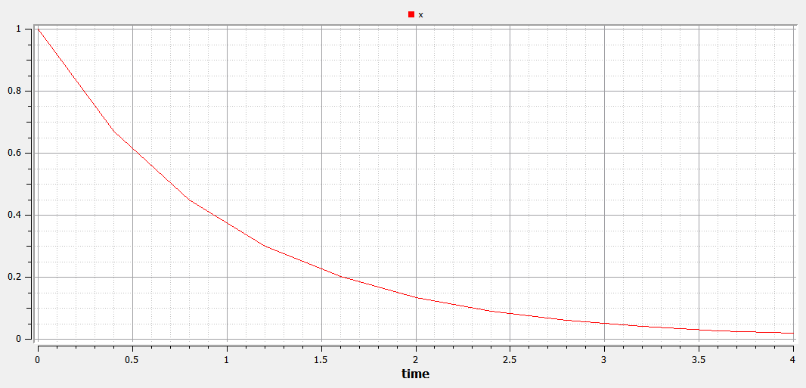
Figure 3-23: Simple 2D plot of the HelloWorld example.
By re-simulating and saving results at many more points, e.g. using the default 500 intervals, a much smoother plot can be obtained.
simulate(HelloWorld, startTime=0, stopTime=4, numberOfIntervals=500);
plot(x);
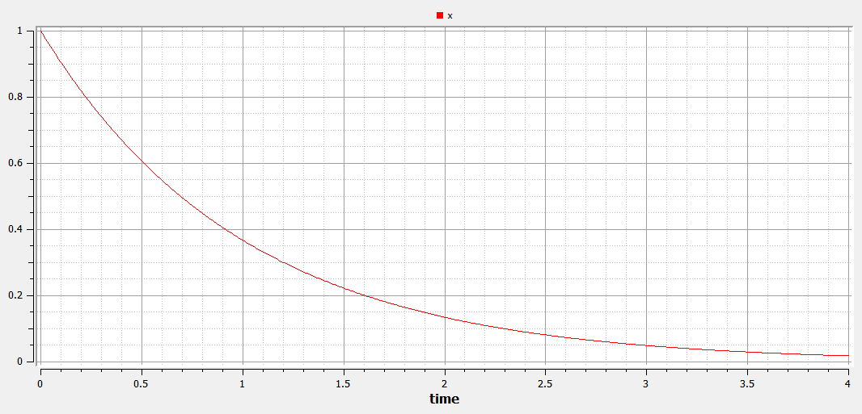
Figure 3-24: Simple 2D plot of the HelloWorld example with larger number of points.

Plotting Commands and their Options
All of these commands can have any number of optional arguments to further customize the the resulting diagram. The available options and their allowed values are listed below.
Command | Description
plot(x) | Creates a diagram with data from the last simulation that had a variable named x.
plot({x,y,..., z}) | Like the previous command, but with several variables.
plotParametric(x, y) | Creates a parametric diagram with data from the last simulated variables named x and y.
plotParametric(x, {y1,y2}) | Like the previous command, but with several variables.
plotAll() | Creates a diagram with all variables from the last simulated model as functions of time.

Option | Default value | Description
fileName | The result of the last simulation | The name of the result-file containing the variables to plot
grid | true | Determines whether or not a grid is shown in the diagram.
title | “” | This text will be used as the diagram title.
logX | false | Determines whether or not the horizontal axis is logarithmically scaled.
logY | false | Determines whether or not the vertical axis is logarithmically scaled.
xLabel | “time” | This text will be used as the horizontal label in the diagram.
yLabel | “” | This text will be used as the vertical label in the diagram.
xRange | {0, 0} | Determines the horizontal interval that is visible in the diagram. {0, 0} will select a suitable range.
yRange | {0, 0} | Determines the vertical interval that is visible in the diagram. {0, 0} will select a suitable range.
curveWidth | 1.0 | Defines the width of the curve.
curveStyle | 1 | Defines the style of the curve.  SolidLine=1, DashLine=2, DotLine=3, DashDotLine=4, DashDotDotLine=5, Sticks=6, Steps=7.
legendPosition | “top” | Defines the position of the legend in the diagram. Possible values are left, right, top, bottom and none.
externalWindow | false | Opens a new OMPlot window if set to true otherwise update the current opened window.

OMNotebook with DrModelica and DrControl
This chapter covers the OpenModelica electronic notebook subsystem, called OMNotebook, together with the DrModelica tutoring system for teaching Modelica, and DrControl for teaching control together with Modelica. Both are using such notebooks.

Interactive Notebooks with Literate Programming
Interactive Electronic Notebooks are active documents that may contain technical computations and text, as well as graphics. Hence, these documents are suitable to be used for teaching and experimentation, simulation scripting, model documentation and storage, etc.

Mathematica Notebooks
Literate Programming (Knuth 1984) is a form of programming where programs are integrated with documentation in the same document. Mathematica notebooks (Wolfram 1997) is one of the first WYSIWYG (What-You-See-Is-What-You-Get) systems that support Literate Programming. Such notebooks are used, e.g., in the MathModelica modeling and simulation environment, e.g. see Figure 4-25below and Chapter 19 in (Fritzson 2004)

OMNotebook
The OMNotebook software (Axelsson 2005, Fernström 2006) is a new open source free software that gives an interactive WYSIWYG (What-You-See-Is-What-You-Get) realization of Literate Programming, a form of programming where programs are integrated with documentation in the same document.
The OMNotebook facility is actually an interactive WYSIWYG (What-You-See-Is-What-You-Get) realization of Literate Programming, a form of programming where programs are integrated with documentation in the same document. OMNotebook is a simple open-source software tool for an electronic notebook supporting Modelica.
A more advanced electronic notebook tool, also supporting mathematical typesetting and many other facilities, is provided by Mathematica notebooks in the MathModelica environment, see Figure 4-25.
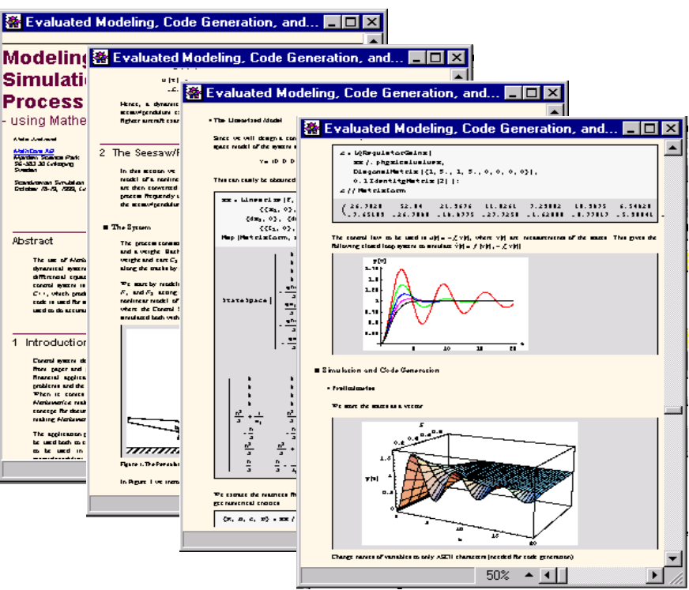
Figure 4-25. Examples of Mathematica notebooks in the MathModelica modeling and simulation environment.
Traditional documents, e.g. books and reports, essentially always have a hierarchical structure. They are divided into sections, subsections, paragraphs, etc. Both the document itself and its sections usually have headings as labels for easier navigation. This kind of structure is also reflected in electronic notebooks. Every notebook corresponds to one document (one file) and contains a tree structure of cells. A cell can have different kinds of contents, and can even contain other cells. The notebook hierarchy of cells thus reflects the hierarchy of sections and subsections in a traditional document such as a book.

DrModelica Tutoring System – an Application of OMNotebook
Understanding programs is hard, especially code written by someone else. For educational purposes it is essential to be able to show the source code and to give an explanation of it at the same time.
Moreover, it is important to show the result of the source code’s execution. In modeling and simulation it is also important to have the source code, the documentation about the source code, the execution results of the simulation model, and the documentation of the simulation results in the same document. The reason is that the problem solving process in computational simulation is an iterative process that often requires a modification of the original mathematical model and its software implementation after the interpretation and validation of the computed results corresponding to an initial model.
Most of the environments associated with equation-based modeling languages focus more on providing efficient numerical algorithms rather than giving attention to the aspects that should facilitate the learning and teaching of the language. There is a need for an environment facilitating the learning and understanding of Modelica. These are the reasons for developing the DrModelica teaching material for Modelica and for teaching modeling and simulation.
An earlier version of DrModelica was developed using the MathModelica (now Wolfram SystemModeler) environment. The rest of this chapter is concerned with the OMNotebook version of DrModelica and on the OMNotebook tool itself.
DrModelica has a hierarchical structure represented as notebooks. The front-page notebook is similar to a table of contents that holds all other notebooks together by providing links to them. This particular notebook is the first page the user will see (Figure 4-26).
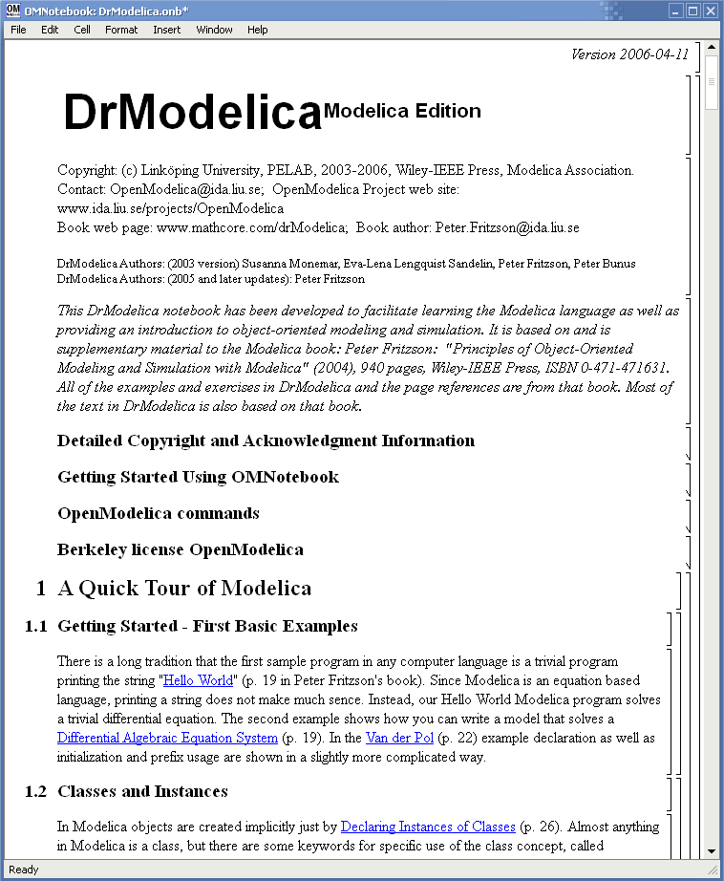
Figure 4-26. The front-page notebook of the OMNotebook version of the DrModelica tutoring system.
In each chapter of DrModelica the user is presented a short summary of the corresponding chapter of the book “Principles of Object-Oriented Modeling and Simulation with Modelica 2.1” by Peter Fritzson. The summary introduces some keywords, being hyperlinks that will lead the user to other notebooks describing the keywords in detail.
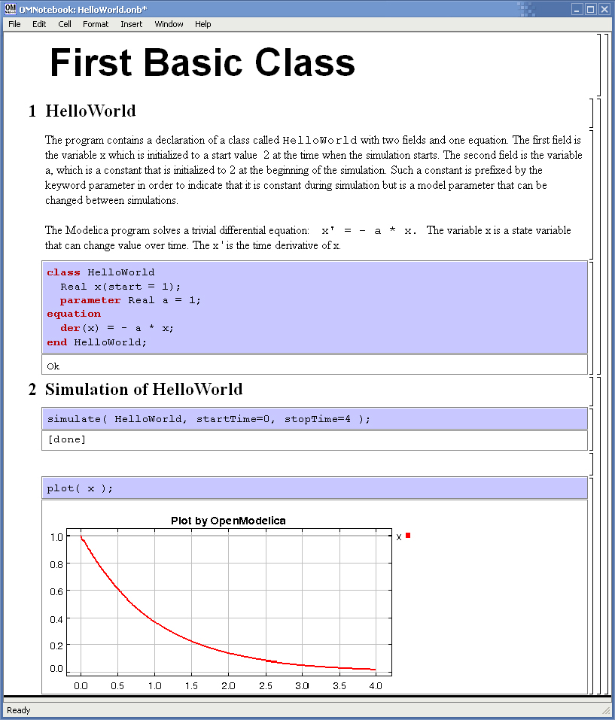
Figure 4-27. The HelloWorld class simulated and plotted using the OMNotebook version of DrModelica.
Now, let us consider that the link “HelloWorld” in DrModelica Section is clicked by the user. The new HelloWorld notebook (see Figure 4-27), to which the user is being linked, is not only a textual description but also contains one or more examples explaining the specific keyword. In this class, HelloWorld, a differential equation is specified.
No information in a notebook is fixed, which implies that the user can add, change, or remove anything in a notebook. Alternatively, the user can create an entirely new notebook in order to write his/her own programs or copy examples from other notebooks. This new notebook can be linked from existing notebooks.
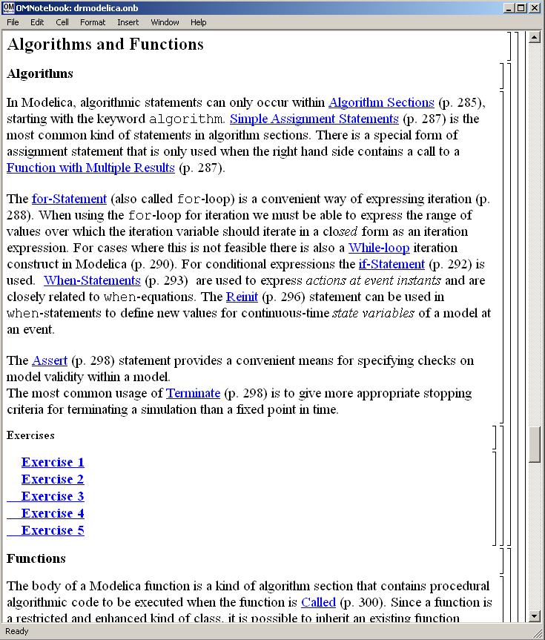
Figure 4-28. DrModelica Chapter on Algorithms and Functions in the main page of the OMNotebook version of DrModelica.
When a class has been successfully evaluated the user can simulate and plot the result, as previously depicted in Figure 4-27 for the simple HelloWorld example model.
After reading a chapter in DrModelica the user can immediately practice the newly acquired information by doing the exercises that concern the specific chapter. Exercises have been written in order to elucidate language constructs step by step based on the pedagogical assumption that a student learns better “using the strategy of learning by doing”. The exercises consist of either theoretical questions or practical programming assignments. All exercises provide answers in order to give the user immediate feedback.
Figure 4-28 shows part of Chapter 9 of the DrModelica teaching material. Here the user can read about language constructs, like algorithm sections, when-statements, and reinit equations, and then practice these constructs by solving the exercises corresponding to the recently studied section.

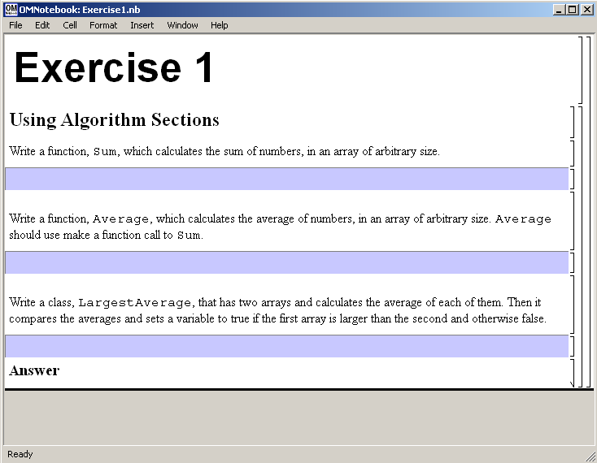
Figure 4-29. Exercise 1 in Chapter 9 of DrModelica
Exercise 1 from Chapter 9 is shown in Figure 4-29. In this exercise the user has the opportunity to practice different language constructs and then compare the solution to the answer for the exercise. Notice that the answer is not visible until the Answer section is expanded. The answer is shown in Figure 4-30.

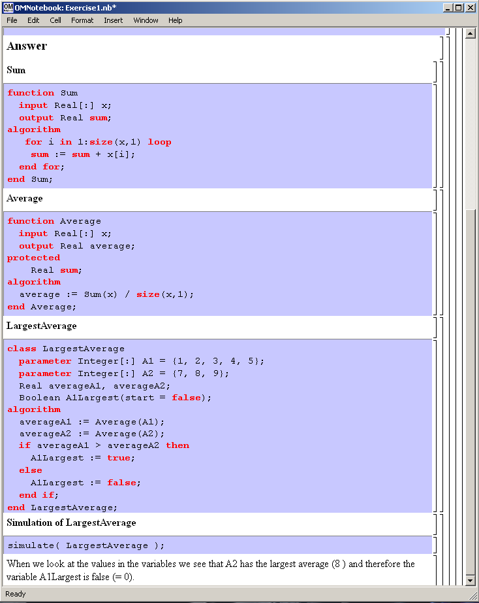
Figure 4-30. The answer section to Exercise 1 in Chapter 9 of DrModelica.

DrControl Tutorial for Teaching Control Theory
DrControl is an interactive OMNotebook document aimed at teaching control theory. It is included in the OpenModelica distribution and appears under the directory OpenModelica1.9.2/share/ omnotebook/drcontrol.
The front-page of DrControl resembles a linked table of content that can be used as a navigation center. The content list contains topics like:
- Getting started
- The control problem in ordinary life
- Feedback loop
- Mathematical modeling
- Transfer function
- Stability
- Example of controlling a DC-motor
- Feedforward compensation
- State-space form
- State observation
- Closed loop control system.
- Reconstructed system
- Linear quadratic optimization
- Linearization
Each entry in this list leads to a new notebook page where either the theory is explained with Modelica examples or an exercise with a solution is provided to illustrate the background theory. Below we show a few sections of DrControl.

Feedback Loop
One of the basic concepts of control theory is using feedback loops either for neutralizing the disturbances from the surroundings or a desire for a smoother output.
In Figure 4-31, control of a simple car model is illustrated where the car velocity on a road is controlled, first with an open loop control, and then compared to a closed loop system with a feedback loop. The car has a mass m, velocity y, and aerodynamic coefficient α. The θ is the road slope, which in this case can be regarded as noise.
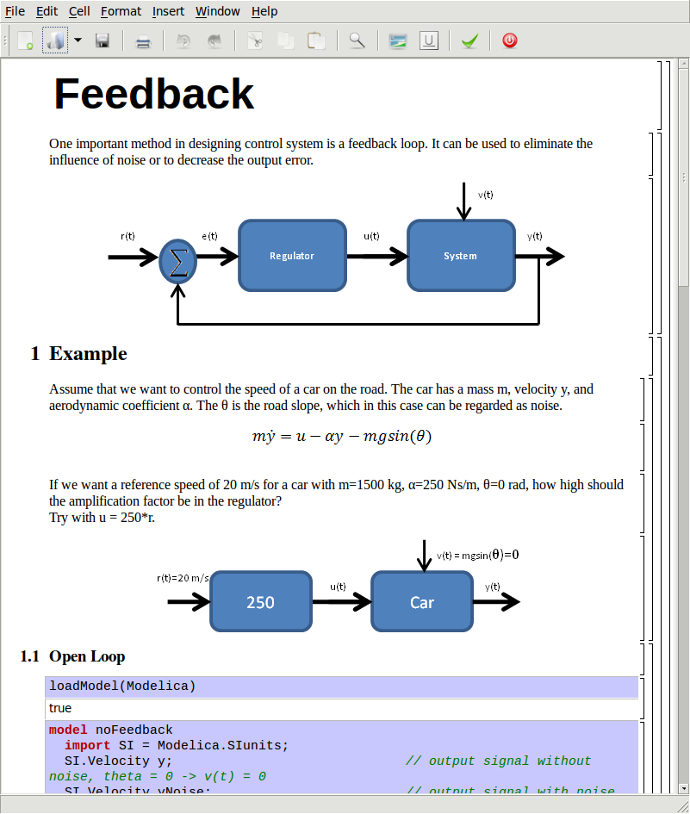
Figure 4-31. Feedback loop
Lets look at the Modelica model for the open loop controlled car:

model NoFeedback
import SI = Modelica.SIunits;
SI.Velocity y "No noise";
SI.Velocity yNoise "With noise";
parameter SI.Mass m = 1500;
parameter Real alpha = 200;
parameter SI. ngle theta = 5*3.14/180;
parameter SI.Acceleration g = 9.82;
SI.Force u;
SI.Velocity r = 20 "Reference signal";
equation
m*der(y)=u - alpha*y;
m*der(yNoise)= u - alpha*yNoise –
m*g*sin(theta);
u = 250A*r;
end NoFeedback;
By applying a road slope angle different from zero the car velocity is influenced which can be regarded as noise in this model. The output signal in Figure 4-32 is stable but an overshoot can be observed compared to the reference signal. Naturally the overshoot is not desired and the student will in the next exercise learn how to get rid of this undesired behavior of the system.

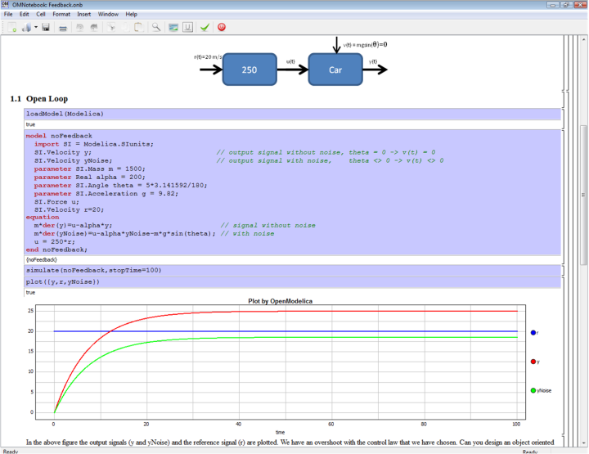
Figure 4-32. Open loop control example.
The closed car model with a proportional regulator is shown below:

model WithFeedback
import SI = Modelica.SIunits;
SI.Velocity y "Output, No noise";
SI.Velocity yNoise "Output With noise";
parameter SI.Mass m = 1500;
parameter Real alpha = 250;
parameter SI.Angle theta = 5*3.14/180;
parameter SI.Acceleration g = 9.82;
SI.Force u;
SI.Force uNoise;
SI.Velocity r = 20 "Reference signal";
equation
m*der(y) = u - alpha*y;
m*der(yNoise) = uNoise - alpha*yNois –
m*g*sin(theta);
u = 5000*(r - y);
uNoise = 5000*(r - yNoise);
end WithFeedback;
By using the information about the current level of the output signal and re-tune the regulator the output quantity can be controlled towards the reference signal smoothly and without an overshoot, as shown in Figure 4-33.
In the above simple example the flat modeling approach was adopted since it was the fastest one to quickly obtain a working model. However, one could use the object oriented approach and encapsulate the car and regulator models in separate classes with the Modelica connector mechanism in between.
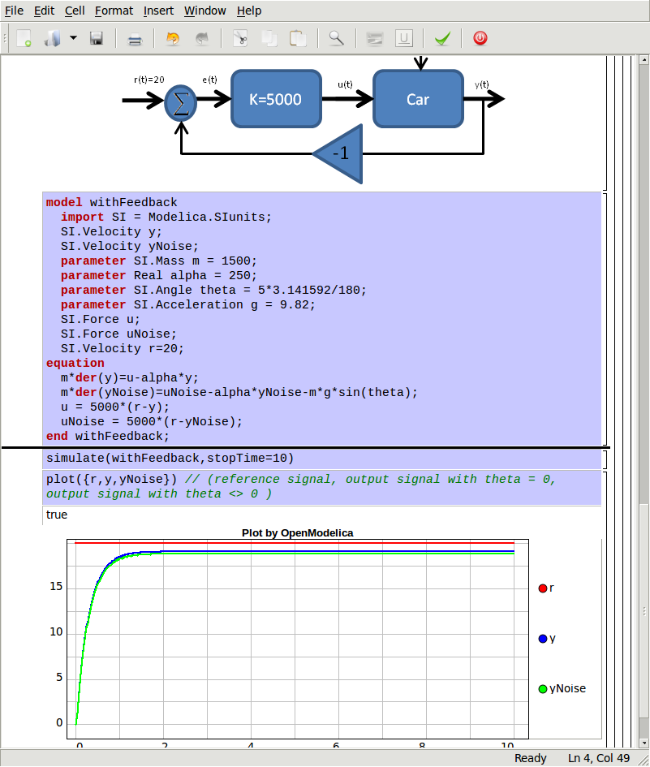
Figure 4-33. Closed loop control example.

Mathematical Modeling with Characteristic Equations
In most systems the relation between the inputs and outputs can be described by a linear differential equation. Tearing apart the solution of the differential equation into homogenous and particular parts is an important technique taught to the students in engineering courses, also illustrated in Figure 4-34.

Now let us examine a second order system:

model NegRoots
Real y;
Real der_y;
parameter Real a1 = 3;
parameter Real a2 = 2;
equation
der_y = der(y);
der(der_y) + a1*der_y + a2*y = 1;
end NegRoots;
Choosing different values for a₁ and a₂ leads to different behavior as shown in Figure 4-35 and Figure 4-36.

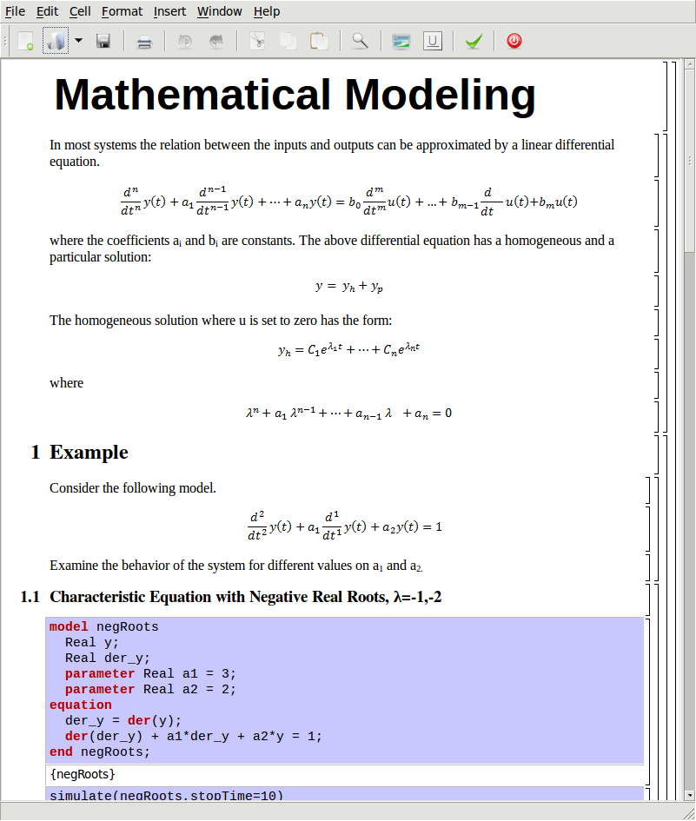
Figure 4-34. Mathematical modeling with characteristic equation.
In the first example the values of a₁ and a₂ are chosen in such way that the characteristic equation has negative real roots and thereby a stable output response, see Figure 4-35.

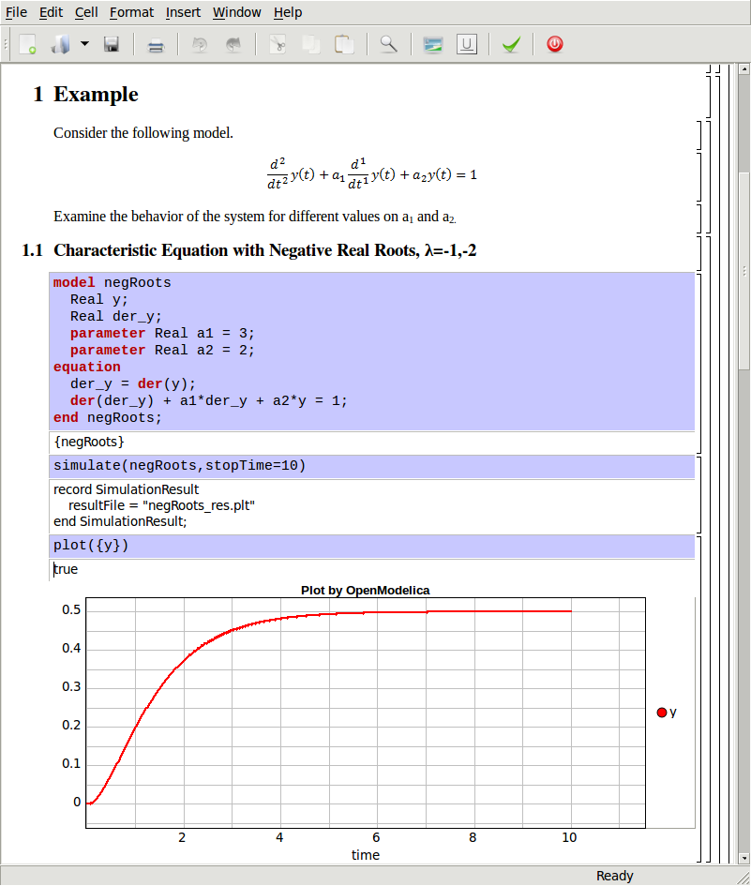
Figure 4-35. Characteristic eq. with real negative roots.
The importance of the sign of the roots in the characteristic equation is illustrated in Figure 4-35 and Figure 4-36, e.g., a stable system with negative real roots and an unstable system with positive imaginary roots resulting in oscillations.
model NegRoots
Real y;
Real der_y;
parameter Real a1 = -2;
parameter Real a2 = 10;
equation
der_y = der(y);
der(der_y) + a1*der_y + a2*y = 1;
end NegRoots;

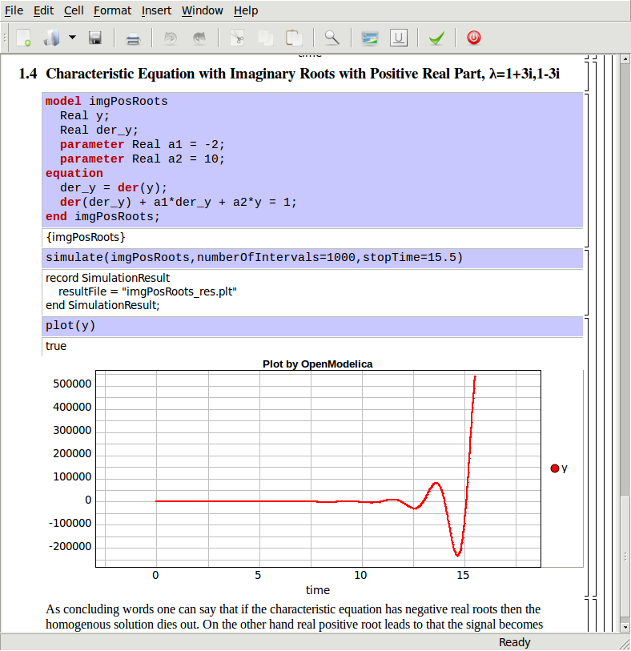
Figure 4-36. Characteristic eq. with positive imaginary roots.
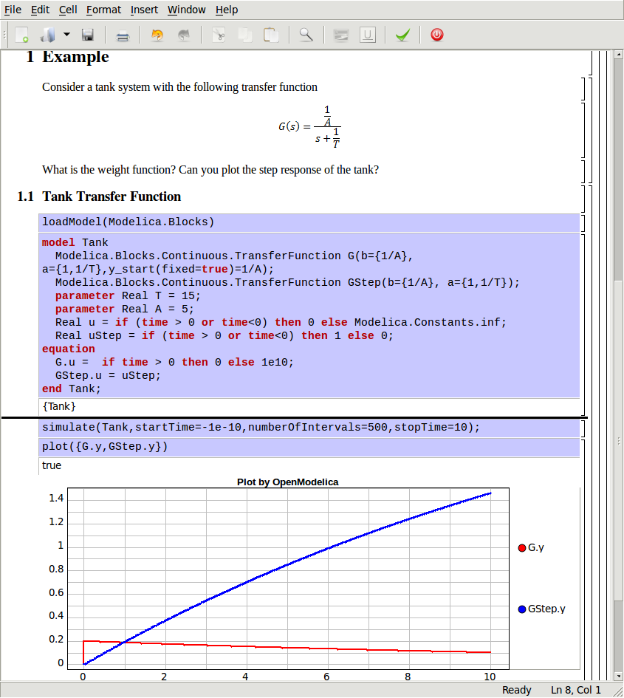
Figure 4-37. Step and pulse (weight function) response.

The theory and application of Kalman filters is also explained in the interactive course material.

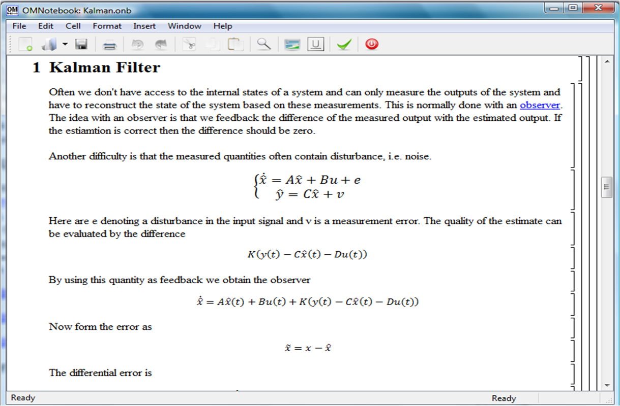
Figure 4-38. Theory background about Kalman filter.
In reality noise is present in almost every physical system under study and therefore the concept of noise is also introduced in the course material, which is purely Modelica based.

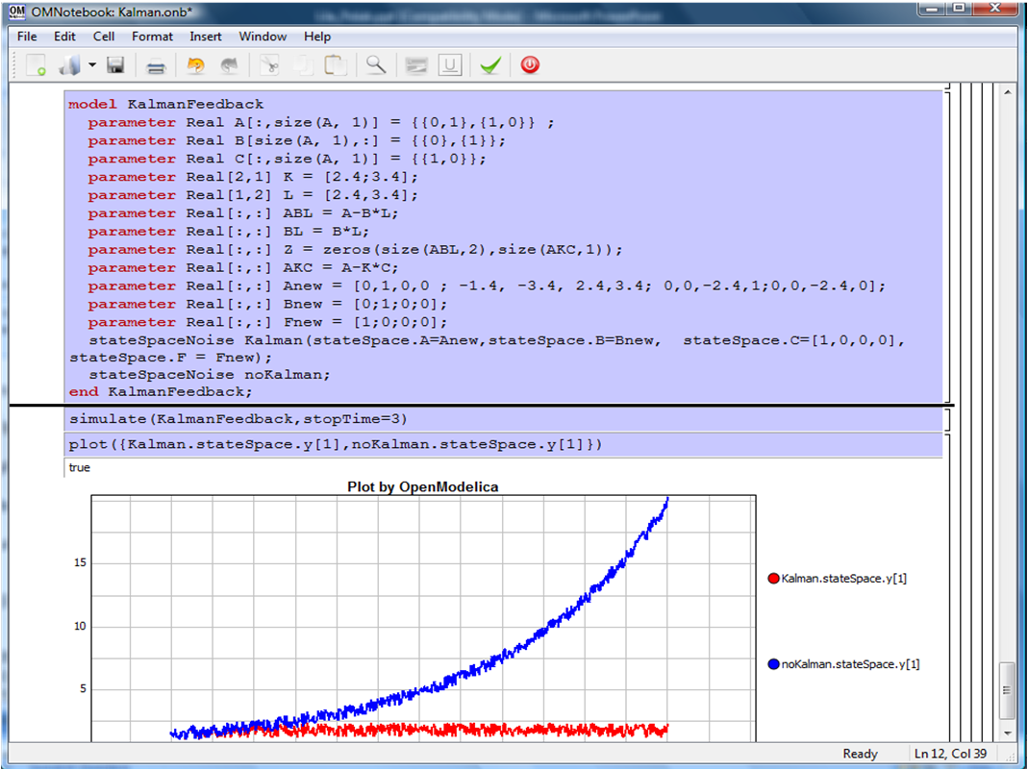
Figure 4-39. Comparison of a noisy system with feedback link in DrControl.

OpenModelica Notebook Commands
OMNotebook currently supports the commands and concepts that are described in this section.

Cells
Everything inside an OMNotebook document is made out of cells. A cell basically contains a chunk of data. That data can be text, images, or other cells. OMNotebook has four types of cells: headercell, textcell, inputcell, and groupcell. Cells are ordered in a tree structure, where one cell can be a parent to one or more additional cells. A tree view is available close to the right border in the notebook window to display the relation between the cells.
- Textcell – This cell type is used to display ordinary text and images. Each textcell has a style that specifies how text is displayed. The cell´s style can be changed in the menu Format->Styles, example of different styles are: Text, Title, and Subtitle. The Textcell type also has support for following links to other notebook documents.
- Inputcell – This cell type has support for syntax highlighting and evaluation. It is intended to be used for writing program code, e.g. Modelica code. Evaluation is done by pressing the key combination Shift+Return or Shift+Enter. All the text in the cell is sent to OMC (OpenModelica Compiler/interpreter), where the text is evaluated and the result is displayed below the inputcell. By double-clicking on the cell marker in the tree view, the inputcell can be collapsed causing the result to be hidden.
- Groupcell – This cell type is used to group together other cell. A groupcell can be opened or closed. When a groupcell is opened all the cells inside the groupcell are visible, but when the groupcell is closed only the first cell inside the groupcell is visible. The state of the groupcell is changed by the user double-clicking on the cell marker in the tree view. When the groupcell is closed the marker is changed and the marker has an arrow at the bottom.

Cursors
An OMNotebook document contains cells which in turn contain text. Thus, two kinds of cursors are needed for positioning, text cursor and cell cursor:
- Textcursor – A cursor between characters in a cell, appearing as a small vertical line. Position the cursor by clicking on the text or using the arrow buttons.
- Cellcursor – This cursor shows which cell currently has the input focus. It consists of two parts. The main cellcursor is basically just a thin black horizontal line below the cell with input focus. The cellcursor is positioned by clicking on a cell, clicking between cells, or using the menu item Cell->Next Cell or Cell->Previous Cell. The cursor can also be moved with the key combination Ctrl+Up or Ctrl+Down. The dynamic cellcursor is a short blinking horizontal line. To make this visible, you must click once more on the main cellcursor (the long horizontal line). NOTE: In order to paste cells at the cellcursor, the dynamic cellcursor must be made active by clicking on the main cellcursor (the horizontal line).

Selection of Text or Cells
To perform operations on text or cells we often need to select a range of characters or cells.
- Select characters – There are several ways of selecting characters, e.g. double-clicking on a word, clicking and dragging the mouse, or click followed by a shift-click at an adjacent positioin selects the text between the previous click and the position of the most recent shift-click.
- Select cells – Cells can be selected by clicking on them. Holding down Ctrl and clicking on the cell markers in the tree view allows several cells to be selected, one at a time. Several cells can be selected at once in the tree view by holding down the Shift key. Holding down Shift selects all cells between last selected cell and the cell clicked on. This only works if both cells belong to the same groupcell.

File Menu
The following file related operations are available in the file menu:
- Create a new notebook – A new notebook can be created using the menu File->New or the key combination Ctrl+N. A new document window will then open, with a new document inside.
- Open a notebook – To open a notebook use File->Open in the menu or the key combination Ctrl+O. Only files of the type .onb or .nb can be opened. If a file does not follow the OMNotebook format or the FullForm Mathematica Notebook format, a message box is displayed telling the user what is wrong. Mathematica Notebooks must be converted to fullform before they can be opened in OMNotebook.
- Save a notebook – To save a notebook use the menu item File->Save or File->Save As. If the notebook has not been saved before the save as dialog is shown and a filename can be selected. OMNotebook can only save in xml format and the saved file is not compatible with Mathematica. Key combination for save is Ctrl+S and for save as Ctrl+Shift+S. The saved file by default obtains the file extension .onb.
- Print – Printing a document to a printer is done by pressing the key combination Ctrl+P or using the menu item File->Print. A normal print dialog is displayed where the usually properties can be changed.
- Import old document – Old documents, saved with the old version of OMNotebook where a different file format was used, can be opened using the menu item File->Import->Old OMNotebook file. Old documents have the extension .xml.
- Export text – The text inside a document can be exported to a text document. The text is exported to this document without almost any structure saved. The only structure that is saved is the cell structure. Each paragraph in the text document will contain text from one cell. To use the export function, use menu item File->Export->Pure Text.
- Close a notebook window – A notebook window can be closed using the menu item File->Close or the key combination Ctrl+F4. Any unsaved changes in the document are lost when the notebook window is closed.
- Quitting OMNotebook – To quit OMNotebook, use menu item File->Quit or the key combination Crtl+Q. This closes all notebook windows; users will have the option of closing OMC also. OMC will not automatically shutdown because other programs may still use it. Evaluating the command quit() has the same result as exiting OMNotebook.

Edit Menu
- Editing cell text – Cells have a set of of basic editing functions. The key combination for these are: Undo (Ctrl+Z), Redo (Ctrl+Y), Cut (Ctrl+X), Copy (Ctrl+C) and Paste (Ctrl+V). These functions can also be accessed from the edit menu; Undo (Edit->Undo), Redo (Edit->Redo), Cut (Edit->Cut), Copy (Edit->Copy) and Paste (Edit->Paste). Selection of text is done in the usual way by double-clicking, triple-clicking (select a paragraph), dragging the mouse, or using (Ctrl+A) to select all text within the cell.
- Cut cell – Cells can be cut from a document with the menu item Edit->Cut or the key combination Ctrl+X. The cut function will always cut cells if cells have been selected in the tree view, otherwise the cut function cuts text.
- Copy cell – Cells can be copied from a document with the menu item Edit->Copy or the key combination Ctrl+C. The copy function will always copy cells if cells have been selected in the tree view, otherwise the copy function copy text.
- Paste cell – To paste copied or cut cells the cell cursor must be selected in the location where the cells should be pasted. This is done by clicking on the cell cursor. Pasteing cells is done from the menu Edit->Paste or the key combination Ctrl+V. If the cell cursor is selected the paste function will always paste cells. OMNotebook share the same application-wide clipboard. Therefore cells that have been copied from one document can be pasted into another document. Only pointers to the copied or cut cells are added to the clipboard, thus the cell that should be pasted must still exist. Consequently a cell can not be pasted from a document that has been closed.
- Find – Find text string in the current notebook, with the options match full word, match cell, search within closed cells. Short command Ctrl+F.
- Replace – Find and replace text string in the current notebook, with the options match full word, match cell, search+replace within closed cells. Short command Ctrl+H.
- View expression – Text in a cell is stored internally as a subset of HTML code and the menu item Edit->View Expression let the user switch between viewing the text or the internal HTML representation. Changes made to the HTML code will affect how the text is displayed.

Cell Menu
- Add textcell – A new textcell is added with the menu item Cell->Add Cell (previous cell style) or the key combination Alt+Enter. The new textcell gets the same style as the previous selected cell had.
- Add inputcell – A new inputcell is added with the menu item Cell->Add Inputcell or the key combination Ctrl+Shift+I.
- Add groupcell – A new groupcell is inserted with the menu item Cell->Groupcell or the key combination Ctrl+Shift+G. The selected cell will then become the first cell inside the groupcell.
- Ungroup groupcell – A groupcell can be ungrouped by selecting it in the tree view and using the menu item Cell->Ungroup Groupcell or by using the key combination Ctrl+Shift+U. Only one groupcell at a time can be ungrouped.
- Split cell – Spliting a cell is done with the menu item Cell->Split cell or the key combination Ctrl+Shift+P. The cell is splited at the position of the text cursor.
- Delete cell – The menu item Cell->Delete Cell will delete all cells that have been selected in the tree view. If no cell is selected this action will delete the cell that have been selected by the cellcursor. This action can also be called with the key combination Ctrl+Shift+D or the key Del (only works when cells have been selected in the tree view).
- Cellcursor – This cell type is a special type that shows which cell that currently has the focus. The cell is basically just a thin black line. The cellcursor is moved by clicking on a cell or using the menu item Cell->Next Cell or Cell->Previous Cell. The cursor can also be moved with the key combination Ctrl+Up or Ctrl+Down.

Format Menu
- Textcell – This cell type is used to display ordinary text and images. Each textcell has a style that specifies how text is displayed. The cells style can be changed in the menu Format->Styles, examples of different styles are: Text, Title, and Subtitle. The Textcell type also have support for following links to other notebook documents.
- Text manipulation – There are a number of different text manipulations that can be done to change the appearance of the text. These manipulations include operations like: changing font, changing color and make text bold, but also operations like: changing the alignment of the text and the margin inside the cell. All text manipulations inside a cell can be done on single letters, words or the entire text. Text settings are found in the Format menu. The following text manipulations are available in OMNotebook:
> Font family
> Font face (Plain, Bold, Italic, Underline)
> Font size
> Font stretch
> Font color
> Text horizontal alignment
> Text vertical alignment
> Border thickness
> Margin (outside the border)
> Padding (inside the border)

Insert Menu
- Insert image – Images are added to a document with the menu item Insert->Image or the key combination Ctrl+Shift+M. After an image has been selected a dialog appears, where the size of the image can be chosen. The images actual size is the default value of the image. OMNotebook stretches the image accordantly to the selected size. All images are saved in the same file as the rest of the document.
- Insert link – A document can contain links to other OMNotebook file or Mathematica notebook and to add a new link a piece of text must first be selected. The selected text make up the part of the link that the user can click on. Inserting a link is done from the menu Insert->Link or with the key combination Ctrl+Shift+L. A dialog window, much like the one used to open documents, allows the user to choose the file that the link refers to. All links are saved in the document with a relative file path so documents that belong together easily can be moved from one place to another without the links failing.

Window Menu
- Change window – Each opened document has its own document window. To switch between those use the Window menu. The window menu lists all titles of the open documents, in the same order as they were opened. To switch to another document, simple click on the title of that document.

Help Menu
- About OMNotebook – Accessing the about message box for OMNotebook is done from the menu Help->About OMNotebook.
- About Qt – To access the message box for Qt, use the menu Help->About Qt.
- Help Text – Opening the help text (document OMNotebookHelp.onb) for OMNotebook can be done in the same way as any OMNotebook document is opened or with the menu Help->Help Text. The menu item can also be triggered with the key F1.

Additional Features
- Links – By clicking on a link, OMNotebook will open the document that is referred to in the link.
- Update link – All links are stored with relative file path. Therefore OMNotebook has functions that automatically updating links if a document is resaved in another folder. Every time a document is saved, OMNotebook checks if the document is saved in the same folder as last time. If the folder has changed, the links are updated.
- Evaluate several cells – Several inputcells can be evaluated at the same time by selecting them in the treeview and then pressing the key combination Shift+Enter or Shift+Return. The cells are evaluated in the same order as they have been selected. If a groupcell is selected all inputcells in that groupcell are evaluated, in the order they are located in the groupcell.
- Command completion – Inputcells have command completion support, which checks if the user is typing a command (or any keyword defined in the file commands.xml) and finish the command. If the user types the first two or three letters in a command, the command completion function fills in the rest. To use command completion, press the key combination Ctrl+Space or Shift+Tab. The first command that matches the letters written will then appear. Holding down Shift and pressing Tab (alternative holding down Ctrl and pressing Space) again will display the second command that matches. Repeated request to use command completion will loop through all commands that match the letters written. When a command is displayed by the command completion functionality any field inside the command that should be edited by the user is automatically selected. Some commands can have several of these fields and by pressing the key combination Ctrl+Tab, the next field will be selected inside the command.
> Active Command completion: Ctrl+Space / Shift+Tab
> Next command: Ctrl+Space / Shift+Tab
> Next field in command: Ctrl+Tab’
- Generated plot – When plotting a simulation result, OMC uses the program Ptplot to create a plot. From Ptplot OMNotebook gets an image of the plot and automatically adds that image to the output part of an inputcell. Like all other images in a document, the plot is saved in the document file when the document is saved.
- Stylesheet –OMNotebook follows the style settings defined in stylesheet.xml and the correct style is applied to a cell when the cell is created.
- Automatic Chapter Numbering – OMNotebook automatically numbers different chapter, subchapter, section and other styles. The user can specify which styles should have chapter numbers and which level the style should have. This is done in the stylesheet.xml file. Every style can have a <chapterLevel> tag that specifies the chapter level. Level 0 or no tag at all, means that the style should not have any chapter numbering.
- Scrollarea – Scrolling through a document can be done by using the mouse wheel. A document can also be scrolled by moving the cell cursor up or down.
- Syntax highlighter – The syntax highlighter runs in a separated thread which speeds up the loading of large document that contains many Modelica code cells. The syntax highlighter only highlights when letters are added, not when they are removed. The color settings for the different types of keywords are stored in the file modelicacolors.xml. Besides defining the text color and background color of keywords, whether or not the keywords should be bold or/and italic can be defined.
- Change indicator – A star (*) will appear behind the filename in the title of notebook window if the document has been changed and needs saving. When the user closes a document that has some unsaved change, OMNotebook asks the user if he/she wants to save the document before closing. If the document never has been saved before, the save-as dialog appears so that a filename can be choosen for the new document.
- Update menus – All menus are constantly updated so that only menu items that are linked to actions that can be performed on the currently selected cell is enabled. All other menu items will be disabled. When a textcell is selected the Format menu is updated so that it indicates the text settings for the text, in the current cursor position.

References
Eric Allen, Robert Cartwright, Brian Stoler. DrJava: A lightweight pedagogic environment for Java. In Proceedings of the 33rd ACM Technical Symposium on Computer Science Education (SIGCSE 2002) (Northern Kentucky – The Southern Side of Cincinnati, USA, February 27 – March 3, 2002).
Ingemar Axelsson. OpenModelica Notebook for Interactive Structured Modelica Documents. Final thesis, LITH-IDA-EX–05/080–SE, Linköping University, Linköping, Sweden, October 21, 2005.
Anders Fernström, Ingemar Axelsson, Peter Fritzson, Anders Sandholm, Adrian Pop. OMNotebook – Interactive WYSIWYG Book Software for Teaching Programming. In Proc. of the Workshop on Developing Computer Science Education – How Can It Be Done?. Linköping University, Dept. Computer & Inf. Science, Linköping, Sweden, March 10, 2006.
Anders Fernström. Extending OMNotebook – An Interactive Notebook for Structured Modelica Documents. Final thesis, LITH-IDA-EX--06/057—SE, Dept. Computer and Information Science, Linköping University, Sweden, September 4, 2006.
Peter Fritzson. Principles of Object Oriented Modeling and Simulation with Modelica 2.1, 940 pages, ISBN 0-471-471631, Wiley-IEEE Press. Feb. 2004.
Knuth, Donald E. Literate Programming. The Computer Journal, NO27(2), pp. 97–111, May 1984.
Eva-Lena Lengquist-Sandelin, Susanna Monemar, Peter Fritzson, and Peter Bunus. DrModelica – A Web-Based Teaching Environment for Modelica. In Proceedings of the 44th Scandinavian Conference on Simulation and Modeling (SIMS’2003), available at www.scan-sims.org. Västerås, Sweden. September 18-19, 2003.
The Modelica Association. The Modelica Language Specification Version 3.0, Sept 2007. http://www.modelica.org.
Stephen Wolfram. The Mathematica Book. Wolfram Media Inc, 1997.

Functional Mock-up Interface - FMI
The new standard for model exchange and co-simulation with Functional Mockup Interface (FMI) allows export of pre-compiled models, i.e., C-code or binary code, from a tool for import in another tool, and vice versa. The FMI standard is Modelica independent. Import and export works both between different Modelica tools, or between certain non-Modelica tools. OpenModelica supports FMI 1.0 & 2.0,
- Model Exchange
- Co-Simulation (under development)

FMI Import
To import the FMU package use the OpenModelica command importFMU,
function importFMU
input String filename "the fmu file name";
input String workdir = "<default>" "The output directory for imported FMU files. <default> will put the files to current working directory.";
input Integer loglevel = 3 "loglevel_nothing=0;loglevel_fatal=1;loglevel_error=2;loglevel_warning=3;loglevel_info=4;loglevel_verbose=5;loglevel_debug=6";
input Boolean fullPath = false "When true the full output path is returned otherwise only the file name.";
input Boolean debugLogging = false "When true the FMU's debug output is printed.";
input Boolean generateInputConnectors = true "When true creates the input connector pins.";
input Boolean generateOutputConnectors = true "When true creates the output connector pins.";
output String generatedFileName "Returns the full path of the generated file.";
end importFMU;
The command could be used from command line interface, OMShell, OMNotebook or MDT. The importFMU command is also integrated with OMEdit. Select FMI > Import FMU the FMU package is extracted in the directory specified by workdir, since the workdir parameter is optional so if its not specified then the current directory of omc is used. You can use the cd() command to see the current location.
The implementation supports FMI for Model Exchange 1.0 & 2.0 and FMI for Co-Simulation 1.0 stand-alone. The support for FMI Co-Simulation is still under development.
The FMI Import is currently a prototype. The prototype has been tested in OpenModelica with several examples. It has also been tested with example FMUs from FMUSDK and Dymola. A more fullfleged version for FMI Import will be released in the near future.

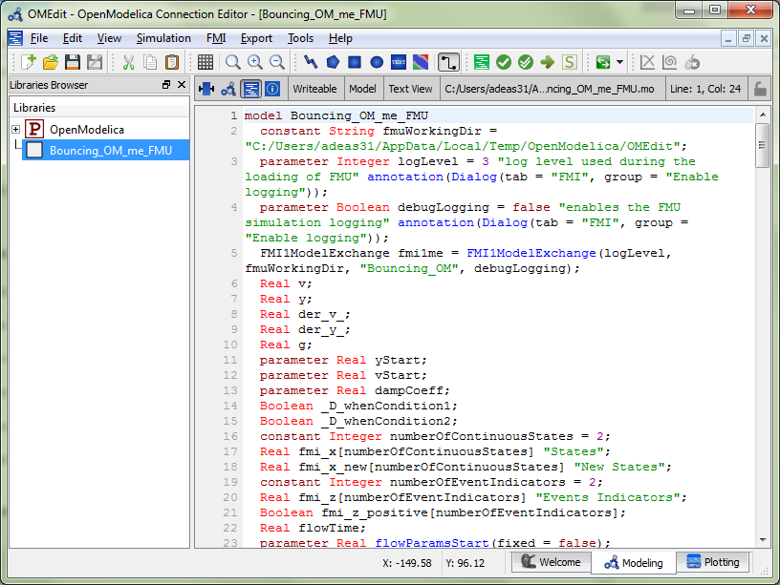
Figure 5-40: Example of FMU Import in OpenModelica where a bouncing ball model is imported.

FMI Export
To export the FMU use the OpenModelica command translateModelFMU(ModelName) from command line interface, OMShell, OMNotebook or MDT. The export FMU command is also integrated with OMEdit. Select FMI > Export FMU the FMU package is generated in the current directory of omc. You can use the cd() command to see the current location. You can set which version of FMI to export through OMEdit settings, see section 2.9.13.
After the command execution is complete you will see that a file ModelName.fmu has been created. As depicted in Figure 6-2, we first changed the current directory to C:/OpenModelica1.7.0/bin , then we loaded a Modelica file with BouncingBall example model and finally created an FMU for it using the translateModelFMU call.
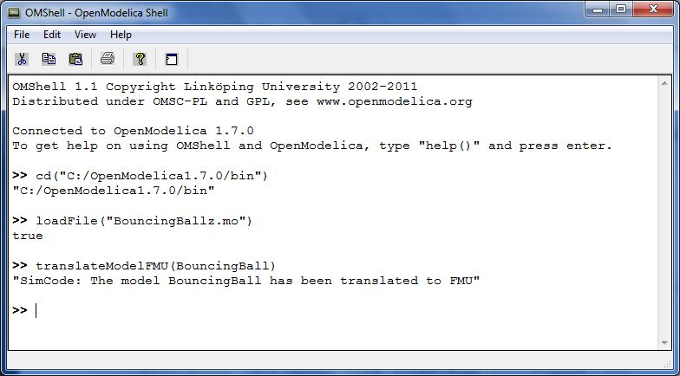
Figure 5-41: OMShell screenshot for creating an FMU
A log file for FMU creation is also generated named ModelName_FMU.log. If there are some errors while creating FMU they will be shown in the command line window and logged in this log file as well.

Optimization with OpenModelica
The following facilities for model-based optimization are provided with OpenModelica:
- Builtin dynamic optimization with OpenModelica and IpOpt using dynamic optimization, Section 6.1 This is the recommended way of performing dynamic optimization with OpenModelica.
- Dynamic optimization with OpenModelica by automatic export of the problem to CasADi, Section 6.2. Use this if you want to employ the CasADi tool for dynamic optimization.
- Classical parameter sweep based design optimization, Section 6.3. Use this if you have a static optimization problem.

Builtin Dynamic Optimization with OpenModelica and IpOpt
Note: this is a very short preliminary decription which soon will be considerably improved.
OpenModelica provides builtin dynamic optimization of models by using the powerful symbolic machinery of the OpenModelica compiler for more efficient and automatic solution of dynamic optimization problems.
The builtin dynamic optimization allows users to define optimal control problems (OCP) using the Modelica language for the model and the optimization language extension called Optimica (currently partially supported) for the optimization part of the problem. This is used to solve the underlying dynamic optimization model formulation using collocation methods, using a single execution instead of multiple simulations as in the parameter-sweep optimization described in Section 6.3.
For more detailed information regarding background and methods, see the papers:
- Bernhard Bachmann, Lennart Ochel, Vitalij Ruge, Mahder Gebremedhin, Peter Fritzson, Vaheed Nezhadali, Lars Eriksson, Martin Sivertsson. Parallel Multiple-Shooting and Collocation Optimization with OpenModelica. In Proceedings of the 9th International Modelica Conference (Modelica'2012), Munich, Germany, Sept.3-5, 2012.
- Vitalij Ruge, Willi Braun, Bernhard Bachmann, Andrea Walther and Kshitij Kulshreshtha. Efficient Implementation of Collocation Methods for Optimization using OpenModelica and ADOL–C. In Proceedings of the 10th International Modelica Conference (Modelica'2014), Munich, Germany, March.10-12, 2014.
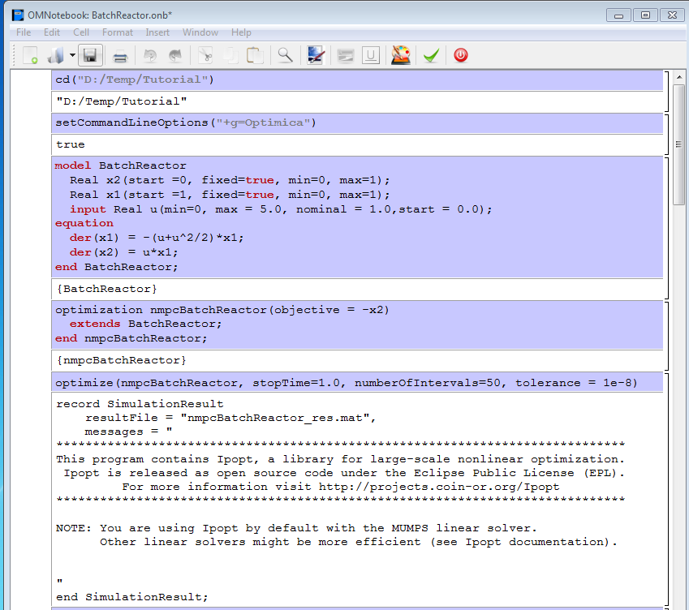
Figure 6-42: OMNotebook screenshot for dynamic optimization.

Compiling the Modelica code
Before starting the optimization the model should be symbolically instantiated by the compiler in order to get a single flat system of equations. The model variables should also be scalarized. The compiler frontend performs this, including syntax checking, semantics and type checking, simplification and constant evaluation etc. are applied. Then the complete flattened model can be used for initialization, simulation and last but not least for model-based dynamic optimization.
The OpenModelica command optimize(ModelName) from OMShell, OMNotebook or MDT runs immediately the optimization. The generated result file can be read in and visualized with OMEdit or within OMNotebook.

// name: BatchReactor.mos

setCommandLineOptions("+g=Optimica");
getErrorString();

loadFile("BatchReactor.mo");
getErrorString();

optimize(nmpcBatchReactor, numberOfIntervals=16, stopTime=1, tolerance=1e-8);
getErrorString();

An Example
In this section, a simple optimal control problem will be solved. When formulating the optimization problems, models are expressed in the Modelica language and optimization specifications. The optimization language specification allows users to formulate dynamic optimization problems to be solved by a numerical algorithm. It includes several constructs including a new specialized class optimization, a constraint section, startTime, finalTime etc. See the optimal control problem for batch reactor model below.

optimization BatchReactor(objective=-x2(finalTime),
startTime = 0, finalTime =1)
Real x1(start =1, fixed=true, min=0, max=1);
Real x2(start =0, fixed=true, min=0, max=1);
input Real u(min=0, max=5);
equation
der(x1) = -(u+u^2/2)*x1;
der(x2) = u*x1;
end BatchReactor;

Create a new file named BatchReactor.mo and save it in you working directory. Notice that this model contains both the dynamic system to be optimized and the optimization specification.
Once we have formulated the undelying optimal control problems, we can run the optimization by using OMShell, OMNotebook , MDT, OMEdit or command line terminals similar as described in Figure 6-42.
The control and state trajectories of the optimization results are shown in Figure 6-43.

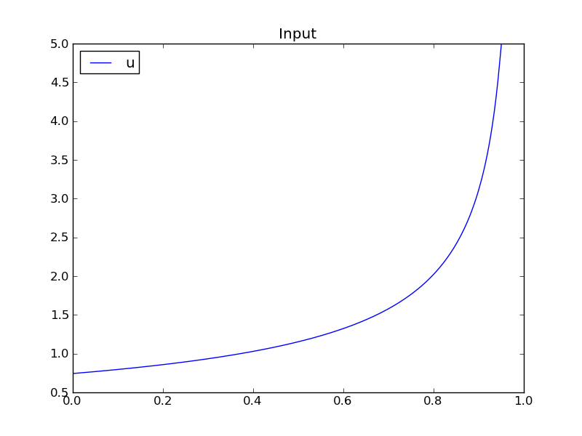
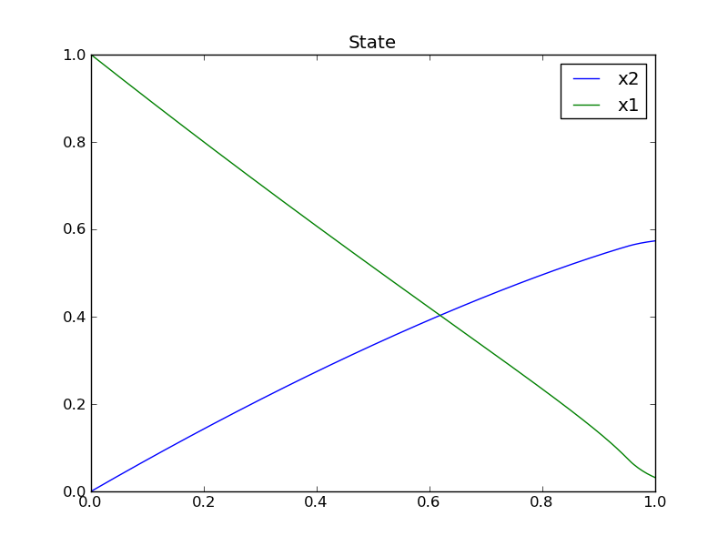
Figure 6-43: Optimization results for Batch Reactor model – state and control variables.

Different Options for the Optimizer IPOPT

Compiler options

numberOfIntervals |  | collocation intervals
startTime, stopTime |  | time horizon
tolerance = 1e-8 | e.g. 1e-8 | solver tolerance
simflags | all run/debug options
Run/debug options

-lv | LOG_IPOPT | console output
-ipopt_hesse | CONST,BFGS,NUM | hessian approximation
-ipopt_max_iter | number e.g. 10 | maximal number of iteration for ipopt
externalInput.csv |  | input guess

Figure 6-44: Compiler options for IpOpt.

Dynamic Optimization with OpenModelica and CasADi
OpenModelica coupling with CasADi supports dynamic optimization of models by OpenModelica exporting the optimization problem to CasADi which performs the optimization. In order to convey the dynamic system model information between Modelica and CasADi, we use an XML-based model exchange format for differential-algebraic equations (DAE). OpenModelica supports export of models written in Modelica and the Optimization language extension using this XML format, while CasADi supports import of models represented in this format. This allows users to define optimal control problems (OCP) using Modelica and Optimization language specifications, and solve the underlying model formulation using a range of optimization methods, including direct collocation and direct multiple shooting.

Compiling the Modelica code
Before exporting a model to XML, the model should be symbolically instantiated by the compiler in order to get a single flat system of equations. The model variables should also be scalarized. The compiler frontend performs this, including syntax checking, semantics and type checking, simplification and constant evaluation etc. are applied. Then the complete flattened model is exported to XML code. The exported XML document can then be imported to CasADi for model-based dynamic optimization.
The OpenModelica command translateModelXML(ModelName) from OMShell, OMNotebook or MDT exports the XML. The export XML command is also integrated with OMEdit. Select XML > Export XML the XML document is generated in the current directory of omc. You can use the cd() command to see the current location. After the command execution is complete you will see that a file ModelName.xml has been exported. As depicted in Figure 6-45, we first changed the current directory to C:/OpenModelica1.9.2/bin, and then we loaded a Modelica file with BatchReactor example model and finally exported an XML for it using the translateModelXML call.
Assuming that the model is defined in the modelName.mo, the model can also be exported to an XML code using the following steps from the terminal window:
- Go to the path where your model file found(C:/<%path to modelName .mo file%>).
- Go to omc path (<%path to omc%>/omc) and write the flag +s +g=Optimica +simCodeTarget=XML <%your.mo file name%>.mo>

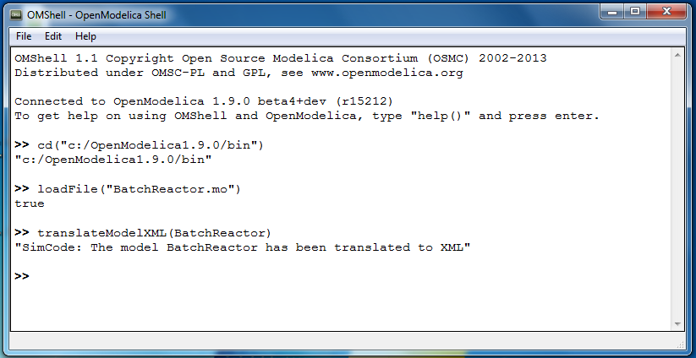
Figure 6-45: OMShell screenshot for exporting an XML.

An example
In this section, a simple optimal control problem will be solved. When formulating the optimization problems, models are expressed in the Modelica language and optimization specifications. The optimization language specification allows users to formulate dynamic optimization problems to be solved by a numerical algorithm. It includes several constructs including a new specialized class optimization, a constraint section, startTime, finalTime etc. See the optimal control problem for batch reactor model below.

optimization BatchReactor(objective=-x2(finalTime),
startTime = 0, finalTime =1)
Real x1(start =1, fixed=true, min=0, max=1);
Real x2(start =0, fixed=true, min=0, max=1);
input Real u(min=0, max=5);
equation
der(x1) = -(u+u^2/2)*x1;
der(x2) = u*x1;
end BatchReactor;
Create a new file named BatchReactor.mo and save it in you working directory. Notice that this model contains both the dynamic system to be optimized and the optimization specification.
One we have formulated the undelying optimal control problems, we can export the XML by using OMShell, OMNotebook , MDT, OMEdit or command line terminals which are described in Section 6.2.4 .
To export XML using terminals as depicted in Figure 6-46, we first changed the current directory to C:/TestCases, and run command ../Dev/OpenModleica/build/bin omc +s +g=Optimica +simCodeTarget=XML BatchReactor.mo. This will generate an XML file under C:/TestCases directory named BatchReactor.xml shown in Section 6.2.3 that contains a symbolic representation of the optimal control problem and can be inspected in a standard XML editor.

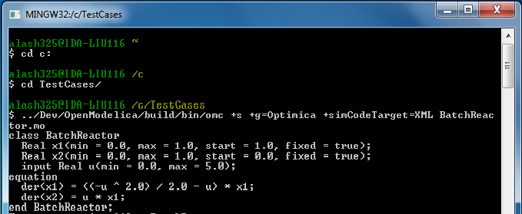
Figure 6-46: Terminal screenshot for exporting an XML.

Generated XML for Example
<?xml version="1.0" encoding="UTF-8"?>
<OpenModelicaModelDescription
xmlns:exp="https://svn.jmodelica.org/trunk/XML/daeExpressions.xsd"
xmlns:equ="https://svn.jmodelica.org/trunk/XML/daeEquations.xsd"
xmlns:fun="https://svn.jmodelica.org/trunk/XML/daeFunctions.xsd"
xmlns:opt="https://svn.jmodelica.org/trunk/XML/daeOptimization.xsd"
xmlns:xsi="http://www.w3.org/2001/XMLSchema-instance"
fmiVersion="1.0"
modelName="BatchReactor"
modelIdentifier="BatchReactor"
guid="{d06ca497-3a14-4c61-ab0a-ee9f3edfca73}"
generationDateAndTime="2012-05-18T17:47:35"
variableNamingConvention="Structured"
numberOfContinuousStates="2"
numberOfEventIndicators="0">
<VendorAnnotations>
<Tool name="OpenModelica Compiler 1.8.1+ (r11925)">
</Tool>
</VendorAnnotations>
<ModelVariables>
<ScalarVariable name="finalTime" valueReference="0"
variability="parameter" causality="internal" alias="noAlias">
<Real relativeQuantity="false" start="1.0" free="false"
initialGuess="0.0" />
<QualifiedName>
<exp:QualifiedNamePart name="finalTime"/>
</QualifiedName>
<isLinear>true</isLinear>
<isLinearTimedVariables>
<TimePoint index="0" isLinear="true"/>
</isLinearTimedVariables>
<VariableCategory>independentParameter</VariableCategory>
</ScalarVariable>
<ScalarVariable name="startTime" valueReference="1"
variability="parameter" causality="internal" alias="noAlias">
<Real relativeQuantity="false" start="0.0" free="false"
initialGuess="0.0" />
<QualifiedName>
<exp:QualifiedNamePart name="startTime"/>
</QualifiedName>
<isLinear>true</isLinear>
<isLinearTimedVariables>
<TimePoint index="0" isLinear="true"/>
</isLinearTimedVariables>
<VariableCategory>independentParameter</VariableCategory>
</ScalarVariable>
<ScalarVariable name="x1" valueReference="2" variability="continuous"
causality="internal" alias="noAlias">
<Real relativeQuantity="false" min="0.0" max="1.0" start="1.0"
fixed="true" />
<QualifiedName>
<exp:QualifiedNamePart name="x1"/>
</QualifiedName>
<VariableCategory>state</VariableCategory>
</ScalarVariable>
<ScalarVariable name="x2" valueReference="3"
variability="continuous" causality="internal" alias="noAlias">
<Real relativeQuantity="false" min="0.0" max="1.0" start="0.0"
fixed="true" />
<QualifiedName>
<exp:QualifiedNamePart name="x2"/>
</QualifiedName>
<VariableCategory>state</VariableCategory>
</ScalarVariable>
<ScalarVariable name="der(x1)" valueReference="4"
variability="continuous" causality="internal" alias="noAlias">
<Real relativeQuantity="false" />
<QualifiedName>
<exp:QualifiedNamePart name="x1"/>
</QualifiedName>
<VariableCategory>derivative</VariableCategory>
</ScalarVariable>
<ScalarVariable name="der(x2)" valueReference="5"
variability="continuous" causality="internal" alias="noAlias">
<Real relativeQuantity="false" />
<QualifiedName>
<exp:QualifiedNamePart name="x2"/>
</QualifiedName>
<VariableCategory>derivative</VariableCategory>
</ScalarVariable>
<ScalarVariable name="u" valueReference="6"
variability="continuous" causality="input" alias="noAlias">
<Real relativeQuantity="false" min="0.0" max="5.0"/>
<QualifiedName>
<exp:QualifiedNamePart name="u"/>
</QualifiedName>
<VariableCategory>algebraic</VariableCategory>
</ScalarVariable>
</ModelVariables>
<equ:BindingEquations>
<equ:BindingEquation>
<equ:Parameter>
<exp:QualifiedNamePart name="startTime"/>
</equ:Parameter>
<equ:BindingExp>
<exp:IntegerLiteral>0</exp:IntegerLiteral>
</equ:BindingExp>
</equ:BindingEquation>
<equ:BindingEquation>
<equ:Parameter>
<exp:QualifiedNamePart name="finalTime"/>
</equ:Parameter>
<equ:BindingExp>
<exp:IntegerLiteral>1</exp:IntegerLiteral>
</equ:BindingExp>
</equ:BindingEquation>
</equ:BindingEquations>
<equ:DynamicEquations>
<equ:Equation>
<exp:Sub>
<exp:Der>
<exp:Identifier>
<exp:QualifiedNamePart name="x2"/>
</exp:Identifier>
</exp:Der>
<exp:Mul>
<exp:Identifier>
<exp:QualifiedNamePart name="u"/>
</exp:Identifier>
<exp:Identifier>
<exp:QualifiedNamePart name="x1"/>
</exp:Identifier>
</exp:Mul>
</exp:Sub>
</equ:Equation>
<equ:Equation>
<exp:Sub>
<exp:Der>
<exp:Identifier>
<exp:QualifiedNamePart name="x1"/>
</exp:Identifier>
</exp:Der>
<exp:Mul>
<exp:Sub>
<exp:Div>
<exp:Neg>
<exp:Pow>
<exp:Identifier>
<exp:QualifiedNamePart name="u"/>
</exp:Identifier>
<exp:RealLiteral>2.0</exp:RealLiteral>
</exp:Pow>
</exp:Neg>
<exp:RealLiteral>2.0</exp:RealLiteral>
</exp:Div>
<exp:Identifier>
<exp:QualifiedNamePart name="u"/>
</exp:Identifier>
</exp:Sub>
<exp:Identifier>
<exp:QualifiedNamePart name="x1"/>
</exp:Identifier>
</exp:Mul>
</exp:Sub>
</equ:Equation>
</equ:DynamicEquations>
<equ:InitialEquations>
<equ:Equation>
<exp:Sub>
<exp:Identifier>
<exp:QualifiedNamePart name="x1"/>
</exp:Identifier>
<exp:RealLiteral>1.0</exp:RealLiteral>
</exp:Sub>
</equ:Equation>
<equ:Equation>
<exp:Sub>
<exp:Identifier>
<exp:QualifiedNamePart name="x2"/>
</exp:Identifier>
<exp:RealLiteral>0.0</exp:RealLiteral>
</exp:Sub>
</equ:Equation>
</equ:InitialEquations>
<opt:Optimization>
<opt:ObjectiveFunction>
<exp:Neg>
<exp:TimedVariable timePointIndex = "0" >
<exp:Identifier>
<exp:QualifiedNamePart name="x2"/>
</exp:Identifier>
</exp:TimedVariable>
</exp:Neg>
</opt:ObjectiveFunction>
<opt:IntervalStartTime>
<opt:Value>0.0</opt:Value>
<opt:Free>false</opt:Free>
<opt:InitialGuess>0.0</opt:InitialGuess>
</opt:IntervalStartTime>
<opt:IntervalFinalTime>
<opt:Value>1.0</opt:Value>
<opt:Free>false</opt:Free>
<opt:InitialGuess>1.0</opt:InitialGuess>
</opt:IntervalFinalTime>
<opt:TimePoints>
<opt:TimePoint index = "0" value = "1.0">
<opt:QualifiedName>
<exp:QualifiedNamePart name="x2"/>
</opt:QualifiedName>
</opt:TimePoint>
</opt:TimePoints>
<opt:Constraints>
</opt:Constraints>
</opt:Optimization>
<fun:FunctionsList>
</fun:FunctionsList>
</OpenModelicaModelDescription>

XML Import to CasADi via OpenModelica Python Script
The symbolic optimal control problem representation (or just model description) contained in BatchReactor.xml can be imported into CasADi in the form of the SymbolicOCP class via OpenModelica python script.
The SymbolicOCP class contains symbolic representation of the optimal control problem designed to be general and allow manipulation. For a more detailed description of this class and its functionalities, we refer to the API documentation of CasADi.
The following step compiles the model to an XML format, imports to CasADi and solves an optimization problem in windows PowerShell:
- Create a new file named BatchReactor.mo and save it in you working directory.
E.g. C:\OpenModelica1.9.2\share\casadi\testmodel
- Perform compilation and generate the XML file
  - Go to your working directory
E.g. cd C:\OpenModelica1.9.2\share\casadi\testmodel
  - Go to omc path from working directory and run the following command
E.g. ..\..\..\bin\omc +s +g=Optimica +simCodeTarget=XML BatchReactor.mo
3. Run defaultStart.py python script from OpenModelica optimization directory
E.g. Python.exe ..\share\casadi\scripts defaultStart.py BatchReactor.xml

The control and state trajectories of the optimization results are shown in Figure 6-47.

Figure 6-47: Optimization results for Batch Reactor model – state and control variables.

Parameter Sweep Optimization using OMOptim
OMOptim is a tool for parameter sweep design optimization of Modelica models. By optimization, one should understand a procedure which minimizes/maximizes one or more objective functions by adjusting one or more parameters. This is done by the optimization algorithm performing a parameter swep, i.e., systematically adjusting values of selected parameters and running a number of simulations for different parameter combinations to find a parameter setting that gives an optimal value of the goal function.
OMOptim 0.9 contains meta-heuristic optimization algorithms which allow optimizing all sorts of models with following functionalities:
- One or several objectives optimized simultaneously
- One or several parameters (integer or real variables)
However, the user must be aware of the large number of simulations an optimization might require.

Preparing the Model
Before launching OMOptim, one must prepare the model in order to optimize it.

Parameters
An optimization parameter is picked up from all model variables. The choice of parameters can be done using the OMOptim interface.
For all intended parameters, please note that:
- The corresponding variable is constant during all simulations. The OMOptim optimization in version 0.9 only concerns static parameters’ optimization i.e. values found for these parameters will be constant during all simulation time.
- The corresponding variable should play an input role in the model i.e. its modification influences model simulation results.

Constraints
If some constraints should be respected during optimization, they must be defined in the Modelica model itself.
For instance, if mechanical stress must be less than 5 N.m⁻², one should write in the model:
assert( mechanicalStress < 5, “Mechanical stress too high”);
If during simulation, the variable mechanicalStress exceeds 5 N.m⁻², the simulation will stop and be considered as a failure.

Objectives
As parameters, objectives are picked up from model variables. Objectives’ values are considered by the optimizer at the final time.

Set problem in OMOptim

Launch OMOptim
OMOptim can be launched using the executable placed in OpenModelicaInstallationDirectory/bin/ OMOptim/OMOptim.exe. Alternately, choose OpenModelica > OMOptim from the start menu.

Create a new project
To create a new project, click on menu File -> New project
Then set a name to the project and save it in a dedicated folder. The created file created has a .min extension. It will contain information regarding model, problems, and results loaded.

Load models
First, you need to load the model(s) you want to optimize. To do so, click on Add .mo button on main window or select menu Model -> Load Mo file…
When selecting a model, the file will be loaded in OpenModelica which runs in the background.
While OpenModelica is loading the model, you could have a frozen interface. This is due to multi-threading limitation but the delay should be short (few seconds).
You can load as many models as you want.
If an error occurs (indicated in log window), this might be because:
- Dependencies have not been loaded before (e.g. modelica library)
- Model use syntax incompatible with OpenModelica.
Dependencies
OMOptim should detect dependencies and load corresponding files. However, it some errors occur, please load by yourself dependencies. You can also load Modelica library using Model->Load Modelica library.
When the model correctly loaded, you should see a window similar to Figure 6-48.
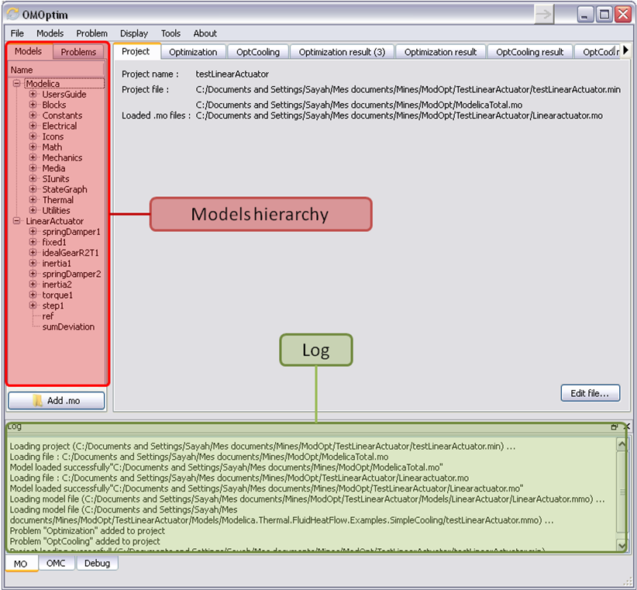
Figure 6-48. OMOptim window after having loaded model.

Create a new optimization problem
Problem->Add Problem->Optimization
A dialog should appear. Select the model you want to optimize. Only Model can be selected (no Package, Component, Block…).
A new form will be displayed. This form has two tabs. One is called Variables, the other is called Optimization.

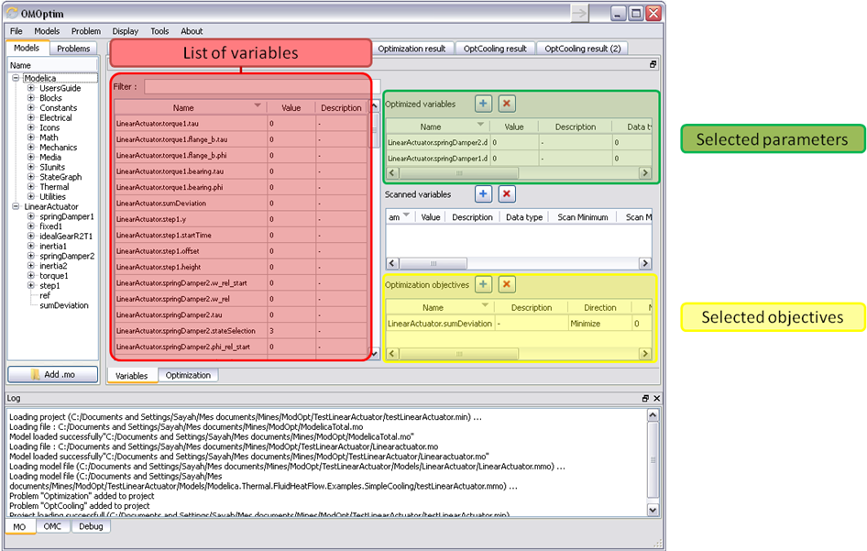
Figure 6-49. Forms for defining a new optimization problem.
List of Variables is Empty
If variables are not displayed, right click on model name in model hierarchy, and select Read variables.

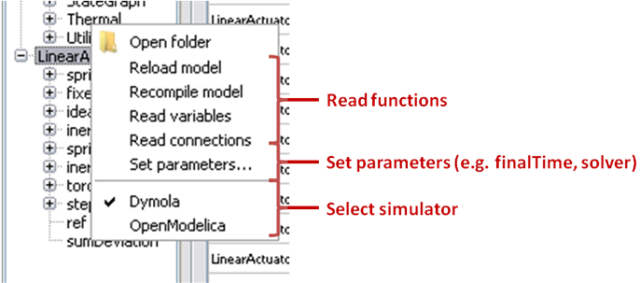
Figure 6-50. Selecting read variables, set parameters, and selecting simulator.

Select Optimized Variables
To set optimization, we first have to define the variables the optimizer will consider as free i.e. those that it should find best values of. To do this, select in the left list, the variables concerned. Then, add them to Optimized variables by clicking on corresponding button ().
For each variable, you must set minimum and maximum values it can take. This can be done in the Optimized variables table.

Select objectives
Objectives correspond to the final values of chosen variables. To select these last, select in left list variables concerned and click button of Optimization objectives table.
For each objective, you must:
- Set minimum and maximum values it can take. If a configuration does not respect these values, this configuration won’t be considered. You also can set minimum and maximum equals to “-“ : it will then
- Define whether objective should be minimized or maximized.
This can be done in the Optimized variables table.

Select and configure algorithm
After having selected variables and objectives, you should now select and configure optimization algorithm. To do this, click on Optimization tab.
Here, you can select optimization algorithm you want to use. In version 0.9, OMOptim offers three different genetic algorithms. Let’s for example choose SPEA2Adapt which is an auto-adaptative genetic algorithm.
By clicking on parameters… button, a dialog is opened allowing defining parameters. These are:
- Population size: this is the number of configurations kept after a generation. If it is set to 50, your final result can’t contain more than 50 different points.
- Off spring rate: this is the number of children per adult obtained after combination process. If it is set to 3, each generation will contain 150 individual (considering population size is 50).
- Max generations: this number defines the number of generations after which optimization should stop. In our case, each generation corresponds to 150 simulations. Note that you can still stop optimization while it is running by clicking on stop button (which will appear once optimization is launched). Therefore, you can set a really high number and still stop optimization when you want without losing results obtained until there.
- Save frequency: during optimization, best configurations can be regularly saved. It allows to analyze evolution of best configurations but also to restart an optimization from previously obtained results. A Save Frequency parameter set to 3 means that after three generations, a file is automatically created containing best configurations. These files are named iteraion1.sav, iteration2.sav and are store in Temp directory, and moved to SolvedProblems directory when optimization is finished.
- ReinitStdDev: this is a specific parameter of EAAdapt1. It defines whether standard deviation of variables should be reinitialized. It is used only if you start optimization from previously obtained configurations (using Use start file option). Setting it to yes (1) will, in most of cases, lead to a spread research of optimized configurations, forgetting parameters’ variations’ reduction obtained in previous optimization.
Use start file
As indicated before, it is possible to pursue an optimization finished or stopped. To do this, you must enable Use start file option and select file from which optimization should be started. This file is an iteration_.sav file created in previous optimization. It is stored in corresponding SolvedProblems folder (iteration10.sav corresponds to the tenth generation of previous optimization).
Note that this functionality can only work with same variables and objectives. However, minimum, maximum of variables and objectives can be changed before pursuing an optimization.

Launch
You can now launch Optimization by clicking Launch button.

Stopping Optimization
Optimization will be stopped when the generation counter will reach the generation number defined in parameters. However, you can still stop the optimization while it is running without loosing obtained results. To do this, click on Stop button. Note that this will not immediately stop optimization: it will first finish the current generation.
This stop function is especially useful when optimum points do not vary any more between generations. This can be easily observed since at each generation, the optimum objectives values and corresponding parameters are displayed in log window.

Results
The result tab appear when the optimization is finished. It consists of two parts: a table where variables are displayed and a plot region.

Obtaining all Variable Values
During optimization, the values of optimized variables and objectives are memorized. The others are not. To get these last, you must recomputed corresponding points. To achieve this, select one or several points in point’s list region and click on recompute.
For each point, it will simulate model setting input parameters to point corresponding values. All values of this point (including those which are not optimization parameters neither objectives).

Window Regions in OMOptim GUI
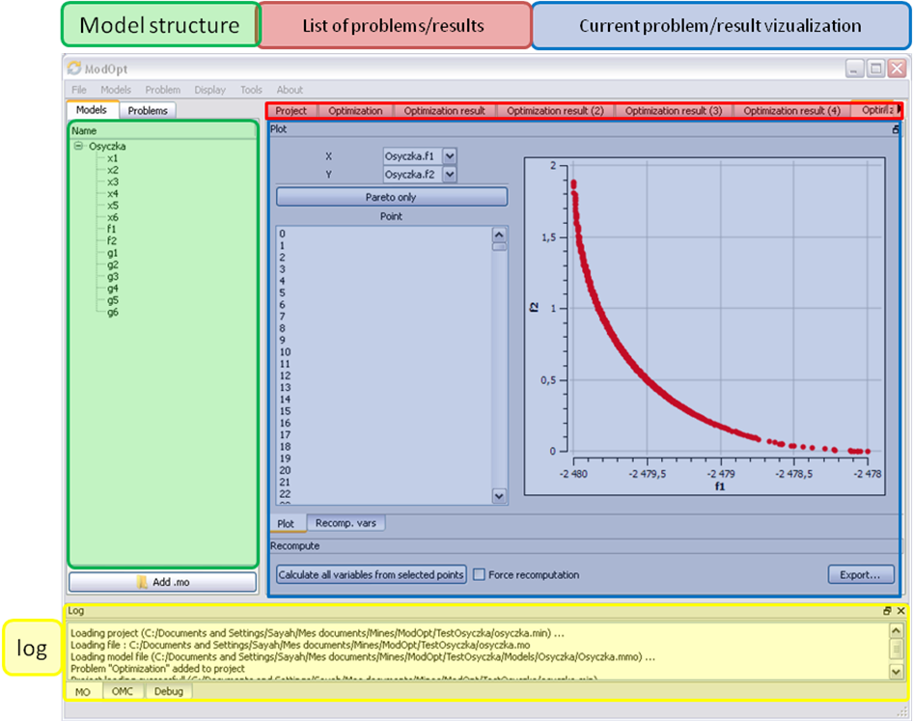
Figure 6-51. Window regions in OMOptim GUI.

MDT – The OpenModelica Development Tooling Eclipse Plugin

Introduction
The Modelica Development Tooling (MDT) Eclipse Plugin as part of OMDev – The OpenModelica Development Environment integrates the OpenModelica compiler with Eclipse. MDT, together with the OpenModelica compiler, provides an environment for working with Modelica and MetaModelica development projects. This plugin is primarily intended for tool developers rather than application Modelica modelers.
The following features are available:
- Browsing support for Modelica projects, packages, and classes
- Wizards for creating Modelica projects, packages, and classes
- Syntax color highlighting
- Syntax checking
- Browsing of the Modelica Standard Library or other libraries
- Code completion for class names and function argument lists
- Goto definition for classes, types, and functions
- Displaying type information when hovering the mouse over an identifier.

Installation
The installation of MDT is accomplished by following the below installation instructions. These instructions assume that you have successfully downloaded and installed Eclipse (http://www.eclipse.org).
- Start Eclipse
- Select Help->Software Updates->Find and Install... from the menu
- Select ‘Search for new features to install’ and click ‘Next’
- Select ‘New Remote Site...’
- Enter ‘MDT’ as name and ‘http://www.ida.liu.se/labs/pelab/modelica/OpenModelica/MDT’ as URL and click ‘OK’
- Make sure ‘MDT’ is selected and click ‘Finish’
- In the updates dialog select the ‘MDT’ feature and click ‘Next’
- Read through the license agreement, select ‘I accept...’ and click ‘Next’
- Click ‘Finish’ to install MDT

Getting Started

Configuring the OpenModelica Compiler
MDT needs to be able to locate the binary of the compiler. It uses the environment variable OPENMODELICAHOME to do so.
If you have problems using MDT, make sure that OPENMODELICAHOME is pointing to the folder where the Open Modelica Compiler is installed. In other words, OPENMODELICAHOME must point to the folder that contains the Open Modelica Compiler (OMC) binary. On the Windows platform it’s called omc.exe and on Unix platforms it’s called omc.

Using the Modelica Perspective
The most convenient way to work with Modelica projects is to use to the Modelica perspective. To switch to the Modelica perspective, choose the Window menu item, pick Open Perspective followed by Other... Select the Modelica option from the dialog presented and click OK..

Selecting a Workspace Folder
Eclipse stores your projects in a folder called a workspace. You need to choose a workspace folder for this session, see Figure 5-7-52

Figure 5-7-52. Eclipse Setup – Switching Workspace.

Creating one or more Modelica Projects
To start a new project, use the New Modelica Project Wizard. It is accessible through File->New-> Modelica Project or by right-clicking in the Modelica Projects view and selecting New->Modelica Project.

Figure 5-7-53. Eclipse Setup – creating a Modelica project in the workspace.
You need to disable automatic build for the project(s) (Figure 5-7-54).

Figure 5-7-54. Eclipse Setup – disable automatic build for the projects.
Repeat the procedure for all the projects you need, e.g. for the exercises described in the MetaModelica users guide: 01_experiment, 02a_exp1, 02b_exp2, 03_assignment, 04a_assigntwotype, etc.
NOTE: Leave open only the projects you are working on! Close all the others!

Building and Running a Project
After having created a project, you eventually need to build the project (Figure 7-55).
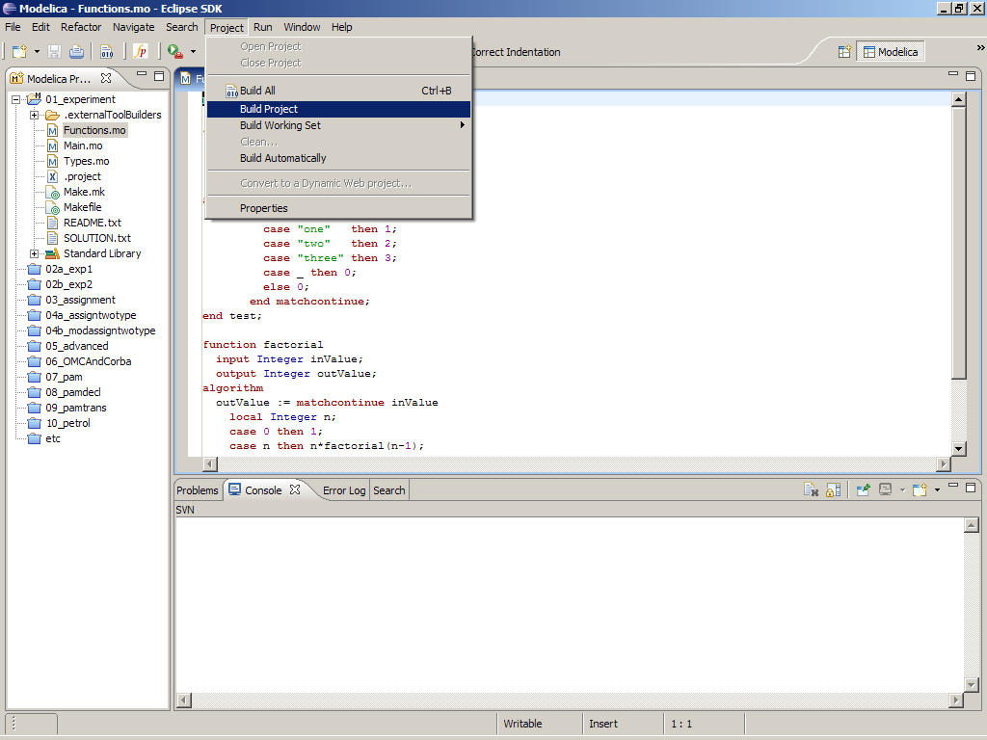
Figure 7-55. Eclipse MDT – Building a project.
There are several options: building, building from scratch (clean), running, see Figure 7-56.
??missing figure
Figure 7-56. Eclipse – building and running a project.
You may also open additional views, e.g as in Figure 7-57.
??missing figure
Figure 7-57. Eclipse – Opening views.

Switching to Another Perspective
If you need, you can (temporarily) switch to another perspective, e.g. to the Java perspective for working with an OpenModelica Java client as in Figure 7-58.
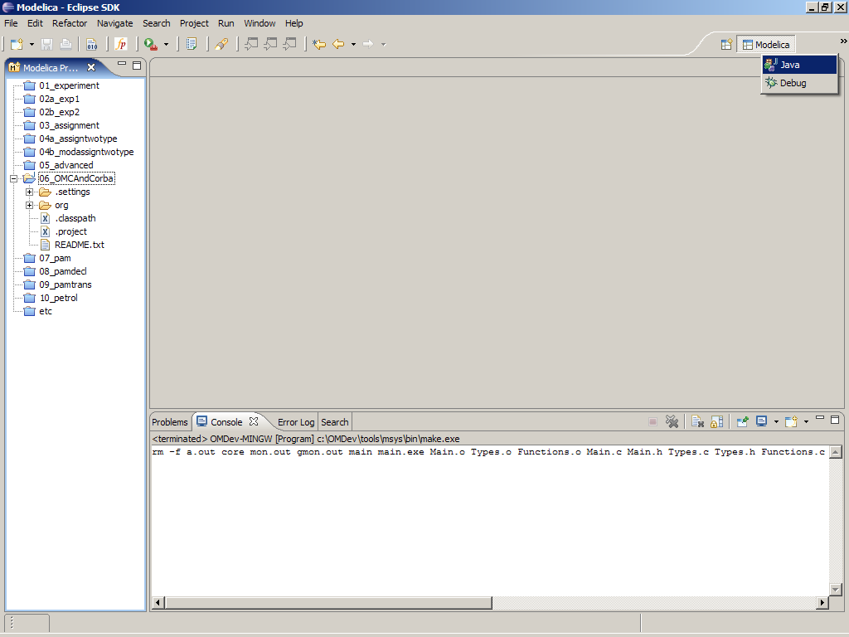
Figure 7-58. Eclipse – Switching to another perspective – e.g. the Java Perspective.

Creating a Package
To create a new package inside a Modelica project, select File->New->Modelica Package. Enter the desired name of the package and a description of what it contains. Note: for the exercises we already have existing packages.
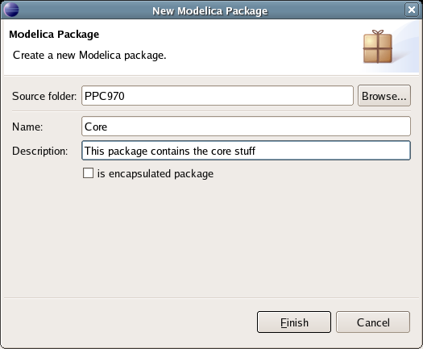
Figure 7-59. Creating a new Modelica package.

Creating a Class
To create a new Modelica class, select where in the hierarchy that you want to add your new class and select File->New->Modelica Class. When creating a Modelica class you can add different restrictions on what the class can contain. These can for example be model, connector, block, record, or function. When you have selected your desired class type, you can select modifiers that add code blocks to the generated code. ‘Include initial code block’ will for example add the line ‘initial equation’ to the class.
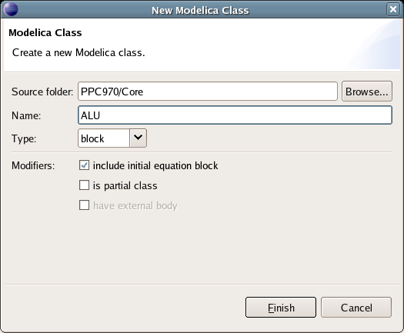
Figure 7-60. Creating a new Modelica class.

Syntax Checking
Whenever a build command is given to the MDT environment, modified and saved Modelica (.mo) files are checked for syntactical errors. Any errors that are found are added to the Problems view and also marked in the source code editor. Errors are marked in the editor as a red circle with a white cross, a squiggly red line under the problematic construct, and as a red marker in the right-hand side of the editor. If you want to reach the problem, you can either click the item in the Problems view or select the red box in the right-hand side of the editor.

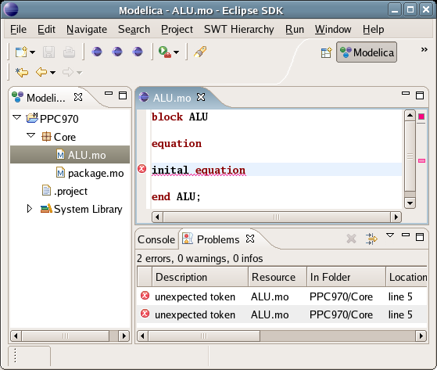
Figure 7-61. Syntax checking.

Automatic Indentation Support
MDT currently has support for automatic indentation. When typing the Return (Enter) key, the next line is indented correctly. You can also correct indentation of the current line or a range selection using CTRL+I or “Correct Indentation” action on the toolbar or in the Edit menu.

Code Completion
MDT supports Code Completion in two variants. The first variant, code completion when typing a dot after a class (package) name, shows alternatives in a menu. Besides the alternatives, Modelica documentation from comments is shown if is available. This makes the selection easyer.
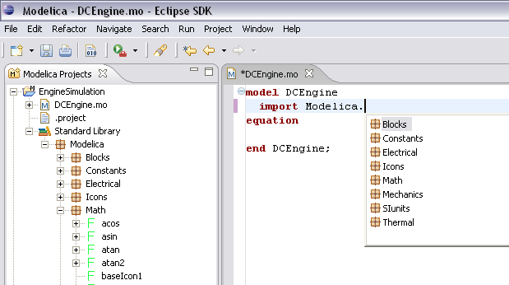
Figure 7-62. Code completion when typing a dot.
The second variant is useful when typing a call to a function. It shows the function signature (formal parameter names and types) in a popup when typing the parenthesis after the function name, here the signature Real sin(SI.Angle u) of the sin function:

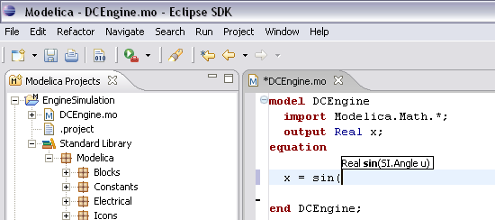
Figure 7-63. Code completion at a function call when typing left parenthesis.

Code Assistance on Identifiers when Hovering
When hovering with the mouse over an identifier a popup with information about the identifier is displayed. If the text is too long, the user can press F2 to focus the popup dialog and scroll up and down to examine all the text. As one can see the information in the popup dialog is syntax-highlighted.
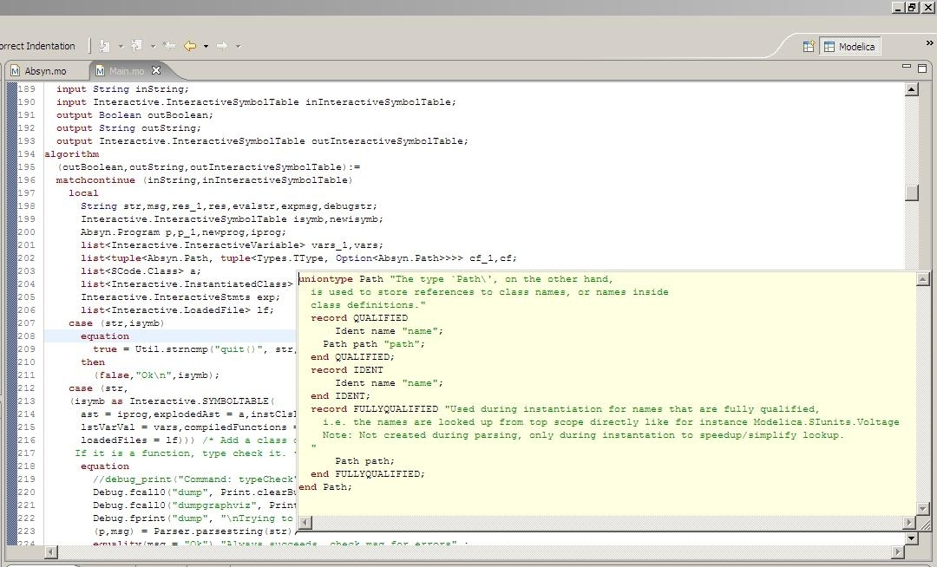
Figure 7-64. Displaying information for identifiers on hovering

Go to Definition Support
Besides hovering information the user can press CTRL+click to go to the definition of the identifier. When pressing CTRL the identifier will be presented as a link and when pressing mouse click the editor will go to the definition of the identifier.

Code Assistance on Writing Records
When writing records, the same functionality as for function calls is used. This is useful especially in MetaModelica when writing cases in match constructs.
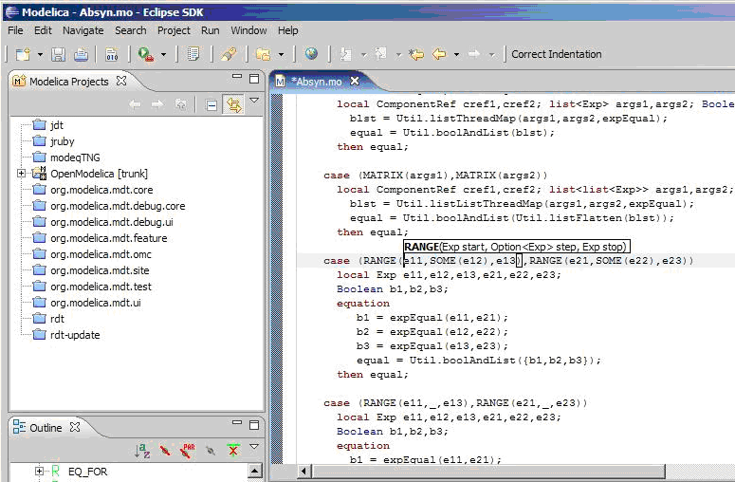
Figure 7-65. Code assistance when writing cases with records in MetaModelica.

Using the MDT Console for Plotting
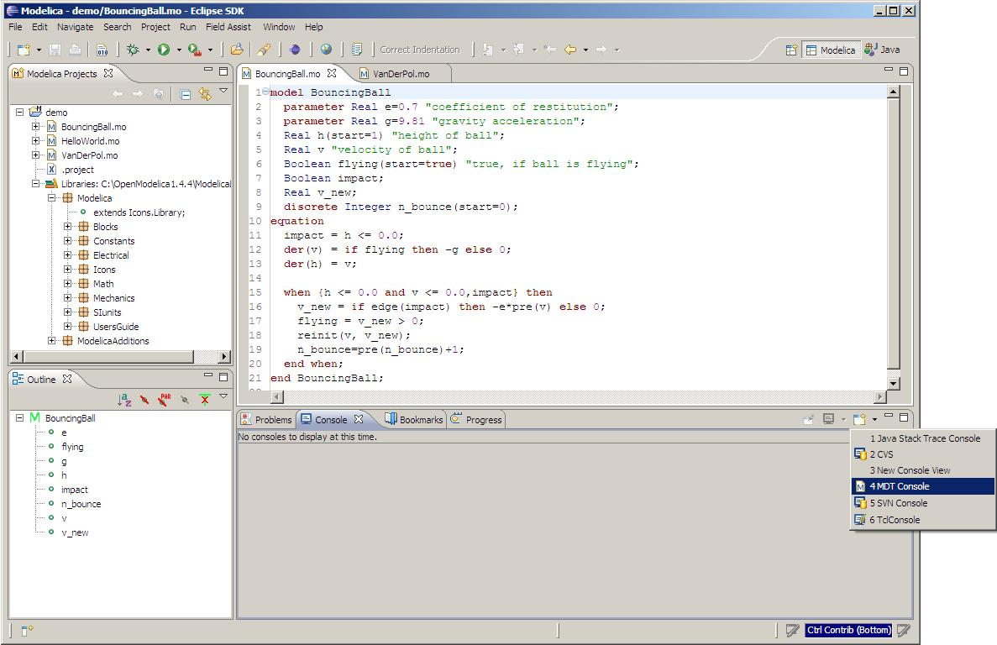
Figure 7-66. Activate the MDT Console
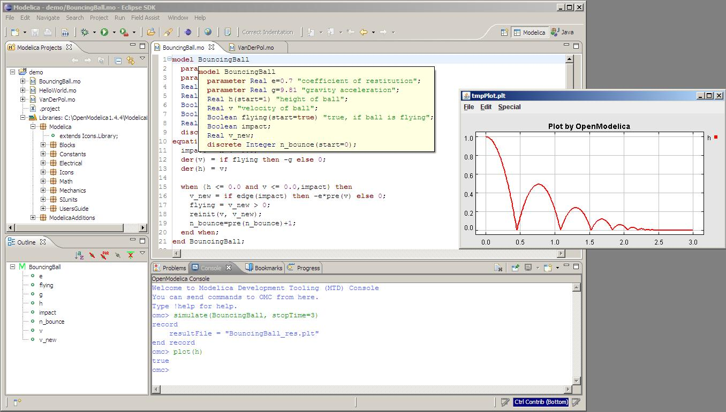
Figure 7-67. Simulation from MDT Console

Modelica Performance Analyzer
A common problem when simulating models in an equation-based language like Modelica is that the model may contain non-linear equation systems. These are solved in each time-step by extrapolating an initial guess and running a non-linear system solver. If the simulation takes too long to simulate, it is useful to run the performance analysis tool. The tool has around 5~25% overhead, which is very low compared to instruction-level profilers (30x-100x overhead). Due to being based on a single simulation run, the report may contain spikes in the charts.
When running a simulation for performance analysis, execution times of user-defined functions as well as linear, non-linear and mixed equation systems are recorded.
To start a simulation in this mode, just use the measureTime flag of the simulate command.
simulate(modelname, measureTime = true)
The generated report is in HTML format (with images in the SVG format), stored in a file modelname_prof.html, but the XML database and measured times that generated the report and graphs are also available if you want to customize the report for comparison with other tools.
Below we use the performance profiler on the simple model A:
model A
function f
input Real r;
output Real o := sin(r);
end f;
String s = "abc";
Real x = f(x) "This is x";
Real y(start=1);
Real z1 = cos(z2);
Real z2 = sin(z1);
equation
der(y) = time;
end A;
We simulate as usual, but set measureTime=true to activate the profiling:
simulate(A, measureTime = true)

// // record SimulationResult
// resultFile = "A_res.mat",
// messages = "Time measurements are stored in A_prof.html (human-readable) and A_prof.xml (for XSL transforms or more details)"
// end SimulationResult;

Example Report Generated for the A Model

Information
All times are measured using a real-time wall clock. This means context switching produces bad worst-case execution times (max times) for blocks. If you want better results, use a CPU-time clock or run the command using real-time priviliges (avoiding context switches).
Note that for blocks where the individual execution time is close to the accuracy of the real-time clock, the maximum measured time may deviate a lot from the average.
For more details, see the generated file A_prof.xml, shown in Section 8.1.7 below.

Settings
The settings for the simulation are summarized in the table below:

Name | Value
Integration method | euler
Output format | mat
Output name | A_res.mat
Output size | 24.0 kB
Profiling data | A_prof.data
Profiling size | 27.3 kB

Summary
Execution times for different activities:

Task | Time | Fraction
Pre-Initialization | 0.000401 | 19.17%
Initialization | 0.000046 | 2.20%
Event-handling | 0.000036 | 1.72%
Creating output file | 0.000264 | 12.62%
Linearization | 0.000000 | 0.00%
Time steps | 0.001067 | 51.00%
Overhead | 0.000273 | 13.05%
Unknown | 0.000406 | 0.24%
Total simulation time | 0.002092 | 100.00%

Global Steps
 | Steps | Total Time | Fraction | Average Time | Max Time | Deviation
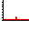 | 499 | 0.001067 | 51.00% | 2.13827655310621e-06 | 0.000006611 | 2.09x

Measured Function Calls
 | Name | Calls | Time | Fraction | Max Time | Deviation
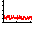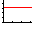 | A.f | 1506 | 0.000092990 | 4.45% | 0.000000448 | 6.26x

Measured Blocks
 | Name | Calls | Time | Fraction | Max Time | Deviation
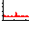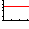 | residualFunc3 | 2018 | 0.000521137 | 24.91% | 0.000035456 | 136.30x
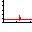 | residualFunc1 | 1506 | 0.000393709 | 18.82% | 0.000002735 | 9.46x

Equations
Name | Variables
SES_ALGORITHM 0
SES_SIMPLE_ASSIGN 1 | der(y)
residualFunc3 | z2, z1
residualFunc1 | x

Variables
Name | Comment
y
der(y)
x | This is x
z1
z2
s

Genenerated XML for the Example

<!DOCTYPE doc (View Source for full doctype...)>
- <simulation>
- <modelinfo>
<name>A</name>
<prefix>A</prefix>
<date>2011-03-07 12:55:53</date>
<method>euler</method>
<outputFormat>mat</outputFormat>
<outputFilename>A_res.mat</outputFilename>
<outputFilesize>24617</outputFilesize>
<overheadTime>0.000273</overheadTime>
<preinitTime>0.000401</preinitTime>
<initTime>0.000046</initTime>
<eventTime>0.000036</eventTime>
<outputTime>0.000264</outputTime>
<linearizeTime>0.000000</linearizeTime>
<totalTime>0.002092</totalTime>
<totalStepsTime>0.001067</totalStepsTime>
<numStep>499</numStep>
<maxTime>0.000006611</maxTime>
</modelinfo>
- <profilingdataheader>
<filename>A_prof.data</filename>
<filesize>28000</filesize>
- <format>
<uint32>step</uint32>
<double>time</double>
<double>cpu time</double>
<uint32>A.f (calls)</uint32>
<uint32>residualFunc3 (calls)</uint32>
<uint32>residualFunc1 (calls)</uint32>
<double>A.f (cpu time)</double>
<double>residualFunc3 (cpu time)</double>
<double>residualFunc1 (cpu time)</double>
</format>
</profilingdataheader>
- <variables>
- <variable id="1000" name="y" comment="">
<info filename="a.mo" startline="8" startcol="3" endline="8" endcol="18" readonly="writable" />
</variable>
- <variable id="1001" name="der(y)" comment="">
<info filename="a.mo" startline="8" startcol="3" endline="8" endcol="18" readonly="writable" />
</variable>
- <variable id="1002" name="x" comment="This is x">
<info filename="a.mo" startline="7" startcol="3" endline="7" endcol="28" readonly="writable" />
</variable>
- <variable id="1003" name="z1" comment="">
<info filename="a.mo" startline="9" startcol="3" endline="9" endcol="20" readonly="writable" />
</variable>
- <variable id="1004" name="z2" comment="">
<info filename="a.mo" startline="10" startcol="3" endline="10" endcol="20" readonly="writable" />
</variable>
- <variable id="1005" name="s" comment="">
<info filename="a.mo" startline="6" startcol="3" endline="6" endcol="19" readonly="writable" />
</variable>
</variables>
- <functions>
- <function id="1006">
<name>A.f</name>
<ncall>1506</ncall>
<time>0.000092990</time>
<maxTime>0.000000448</maxTime>
<info filename="a.mo" startline="2" startcol="3" endline="5" endcol="8" readonly="writable" />
</function>
</functions>
- <equations>
- <equation id="1007" name="SES_ALGORITHM 0">
<refs />
</equation>
- <equation id="1008" name="SES_SIMPLE_ASSIGN 1">
- <refs>
<ref refid="1001" />
</refs>
</equation>
- <equation id="1009" name="residualFunc3">
- <refs>
<ref refid="1004" />
<ref refid="1003" />
</refs>
</equation>
- <equation id="1010" name="residualFunc1">
- <refs>
<ref refid="1002" />
</refs>
</equation>
</equations>
- <profileblocks>
- <profileblock>
<ref refid="1009" />
<ncall>2018</ncall>
<time>0.000521137</time>
<maxTime>0.000035456</maxTime>
</profileblock>
- <profileblock>
<ref refid="1010" />
<ncall>1506</ncall>
<time>0.000393709</time>
<maxTime>0.000002735</maxTime>
</profileblock>
</profileblocks>
</simulation>

MDT Debugger for Algorithmic Modelica
The algorithmic code debugger, used for the algorithmic subset of the Modelica language as well as the MetaModelica language is described in Section 9.1. Using this debugger replaces debugging of algorithmic code by primitive means such as print statements or asserts which is complex, time-consuming and error- prone. The usual debugging functionality found in debuggers for procedural or traditional object-oriented languages is supported, such as setting and removing breakpoints, stepping, inspecting variables, etc. The debugger is integrated with Eclipse.

The Eclipse-based Debugger for Algorithmic Modelica
The debugging framework for the algorithmic subset of Modelica and MetaModelica is based on the Eclipse environment and is implemented as a set of plugins which are available from Modelica Development Tooling (MDT) environment. Some of the debugger functionality is presented below. In the right part a variable value is explored. In the top-left part the stack trace is presented. In the middle-left part the execution point is presented.
The debugger provides the following general functionalities:
- Adding/Removing breakpoints.
- Step Over – moves to the next line, skipping the function calls.
- Step In – takes the user into the function call.
- Step Return – complete the execution of the function and takes the user back to the point from where the function is called.
- Suspend – interrupts the running program.
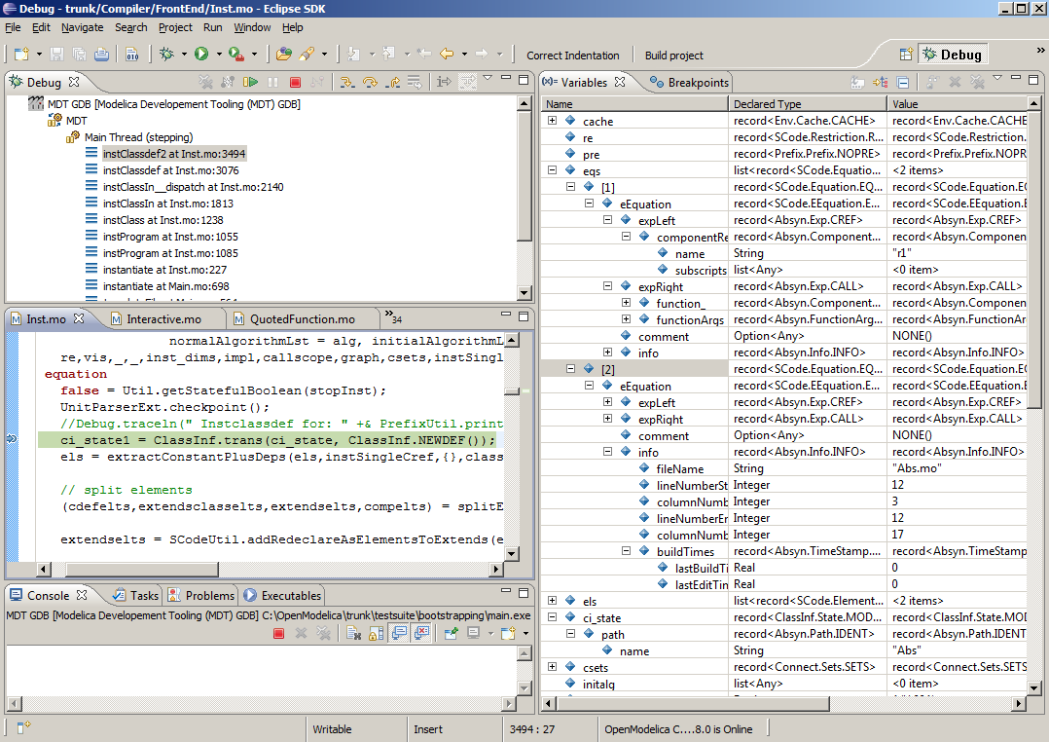
Figure 9-68. Debugging functionality.

Starting the Modelica Debugging Perspective
To be able to run in debug mode, one has to go through the following steps:
- create a mos file
- setting the debug configuration
- setting breakpoints
- running the debug configuration
All these steps are presented below using images.

Create mos file
In order to debug Modelica code we need to load the Modelica files into the OpenModelica Compiler. For this we can write a small script file like this,

setCommandLineOptions({"+d=rml,noevalfunc","+g=MetaModelica"});
setEnvironmentVar("MODELICAUSERCFLAGS","-g");
loadFile("HelloWorld.mo");
getErrorString();
HelloWorld(120.0);
getErrorString();
So lets say that we want to debug HelloWorld.mo. For that we must load it into the compiler using the script file. Put all the Modelica files there in the script file to be loaded. We should also initiate the debugger by calling the starting function, in the above code HelloWorld(120.0);

Setting the debug configuration
While the Modelica perspective is activated the user should click on the bug icon on the toolbar and select Debug in order to access the dialog for building debug configurations.
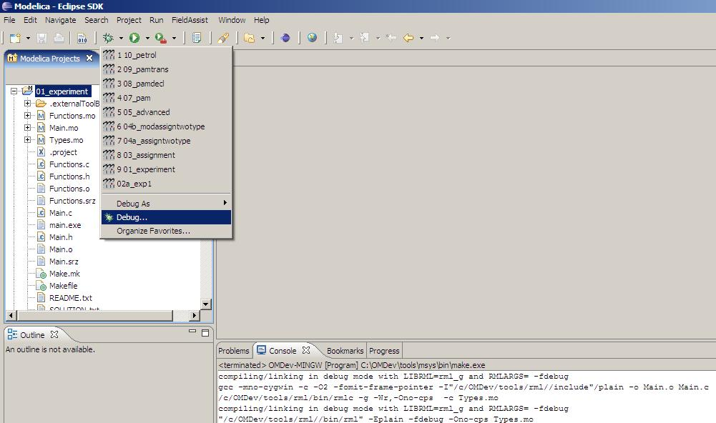
Figure 9-69. Accessing the debug configuration dialog.
To create the debug configuration, right click on the classification Modelica Development Tooling (MDT) GDB and select New as in figure below. Then give a name to the configuration, select the debugging executable to be executed and give it command line parameters. There are several tabs in which the user can select additional debug configuration settings like the environment in which the executable should be run.
Note that we require Gnu Debugger (GDB) for debugging session. We must specify the GDB location, also we must pass our script file as an argument to OMC.
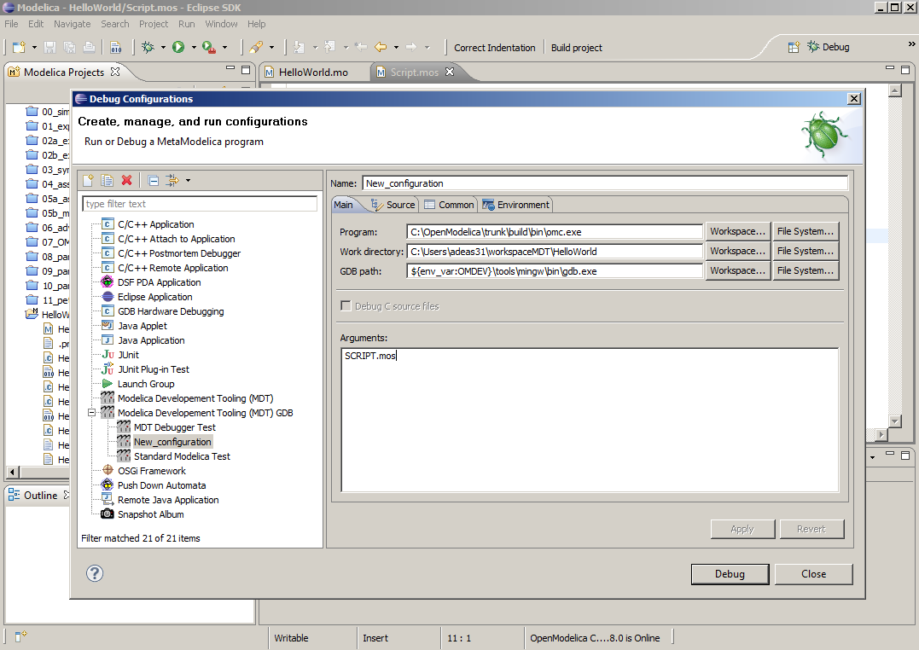
Figure 9-70. Creating the Debug Configuration.

Setting/Deleting Breakpoints
The Eclipse interface allows to add/remove breakpoints. At the moment only line number based breakpoints are supported. Other alternative to set the breakpoints is; function breakpoints.
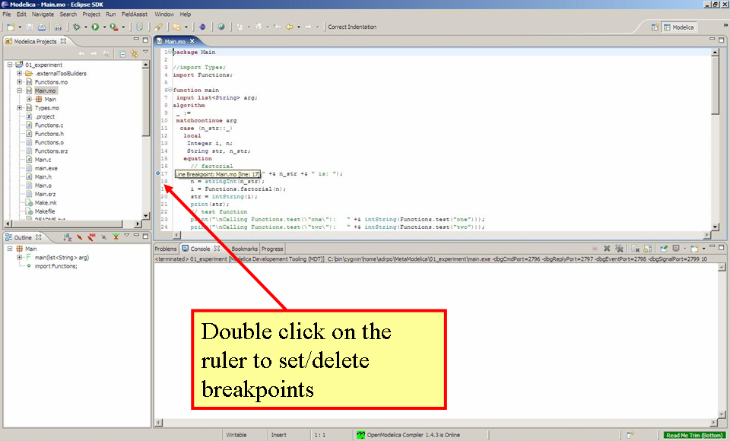
Figure 9-71. Setting/deleting breakpoints.

Starting the debugging session and enabling the debug perspective
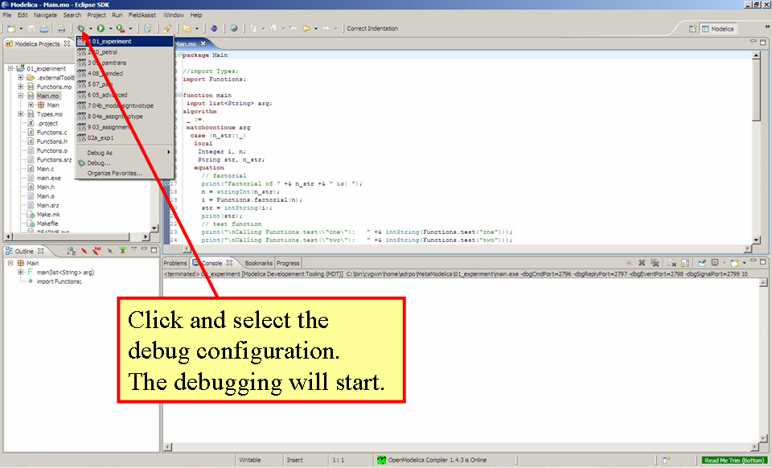
Figure 9-72. Starting the debugging session.

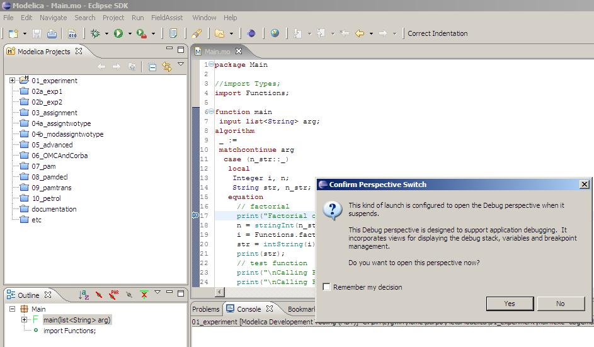
Figure 9-73. Eclipse will ask if the user wants to switch to the debugging perspective.

Debugging OpenModelica
- Compile and create OpenModelica executable as usual.
- Go to /trunk/Compiler/boot
- Now run make –f Makefile.omdev.mingw (choose the right make file depending on your platform), this will create a bootstrapped omc and will replace the omc executable in /trunk/build/bin.
- Now in the debug configuration as explained in Section 9.1.1.2 choose omc executable as the program.

The Debugging Perspective
The debug view primarily consists of two main views:
- Stack Frames View
- Variables View
The stack frame view, shown in the figure below, shows a list of frames that indicates how the flow had moved from one function to another or from one file to another. This allows backtracing of the code. It is very much possible to select the previous frame in the stack and inspect the values of the variables in that frame. However, it is not possible to select any of the previous frame and start debugging from there. Each frame is shown as <function_name at file_name:line_number>.
The Variables view shows the list of variables at a certain point in the program, containing four colums:
- Name – the variable name.
- Declared Type – the Modelica type of the variable.
- Value – the variable value.
- Actual Type – the mapped C type.
By preserving the stack frames and variables it is possible to keep track of the variables values. If the value of any variable is changed while stepping then that variable will be highlighted yellow (the standard Eclipse way of showing the change).
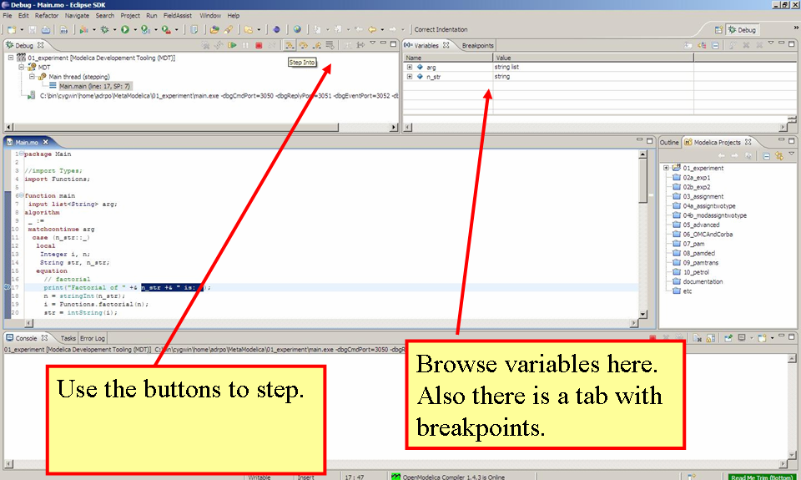
Figure 9-74. The debugging perspective.
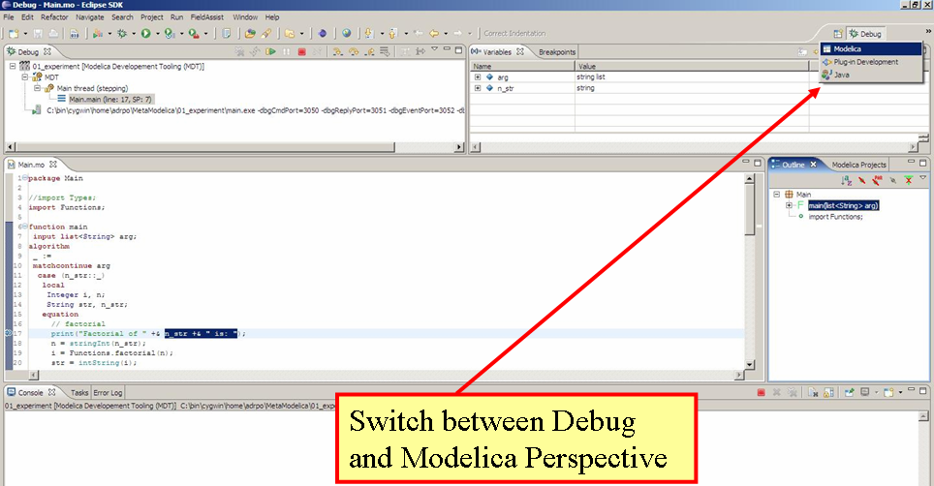
Figure 9-75. Switching between perspectives.

Modelica3D
Modelica3D is a lightweight, platform independent 3D-visualisation library for Modelica. Read more about the Modelica3D library here https://mlcontrol.uebb.tu-berlin.de/redmine/projects/modelica3d-public.

Windows
In order to run Modelica3D on windows you need following softwares;
- Python – Install python from http://www.python.org/download/. Python2.7.3 is recommended.
- PyGTK – Install GTK+ for python from http://ftp.gnome.org/pub/GNOME/binaries/win32/pygtk/2.24/. Download the all-in-one package. Recommmended is pygtk-all-in-one-2.24.2.win32-py2.7.msi.
Run the Modelica3D server by executing the dbus-server.py script located at OPENMODELICAHOME/lib/omlibrary-modelica3d/osg-gtk.
python dbus-server.py
This will start the Modelica3D server and on success you should see the output,
Running dbus-server...
Now run the simulation. The following commands will load the Modelica3D library and simulates the DoublePendulum example,
loadModelica3D(); getErrorString();
loadString("model DoublePendulum
extends Modelica.Mechanics.MultiBody.Examples.Elementary.DoublePendulum;
inner ModelicaServices.Modelica3D.Controller m3d_control;
end DoublePendulum;"); getErrorString();
simulate(DoublePendulum); getErrorString();
If everything goes fine a visualization window will pop-up. To visualize any models from the MultiBody library you can use this script and change the extends to point to the model you want. Note that you will need to add visualisers to your model similarly to what Modelica.MultiBody library has. See some documentation of the visualizers available here: https://build.openmodelica.org/Documentation/Modelica.Mechanics.MultiBody.Visualizers.html

loadModelica3D(); getErrorString();
loadString("
model Visualize_MyModel
inner ModelicaServices.Modelica3D.Controller m3d_control;
extends MyModel;
end Visualize_MyModel;
");
simulate(Visualize_MyModel); getErrorString();

MacOS
On MacOS you can use the 3d visualization like this. Note that on your system the paths used here might vary. In one terminal type:
# start the dbus server (you only need to do this once)
> sudo launchctl load -w /opt/openmodelica/Library/LaunchDaemons/org.freedesktop.dbus-system.plist
> launchctl load -w /opt/openmodelica/Library/LaunchAgents/org.freedesktop.dbus-session.plist
# export python path
> export PYTHONPATH=/opt/openmodelica/Library/Frameworks/Python.framework/Versions/2.7/lib/python2.7/site-packages:$PYTHONPATH
# run the dbus-server.py
# go to your openmodelica installation /lib/omlibrary-modelica3d/osg-gtk
> python dbus-server.py
In another terminal type:
> cat > modelica3d.mos
loadModelica3D();getErrorString();
loadString("model DoublePendulum
extends Modelica.Mechanics.MultiBody.Examples.Elementary.DoublePendulum;
inner ModelicaServices.Modelica3D.Controller m3d_control;
end DoublePendulum;");getErrorString();
instantiateModel(DoublePendulum); getErrorString();
simulate(DoublePendulum); getErrorString();
CTRL+D
> omc modelica3d.mos

Simulation in Web Browser
OpenModelica can simulate in a web browser on a client computer by model code being compiled to efficient Javacript code.

For more information, see https://github.com/tshort/openmodelica-javascript

Below used on the MSL MultiBody RobotR3.fullRobot example model.

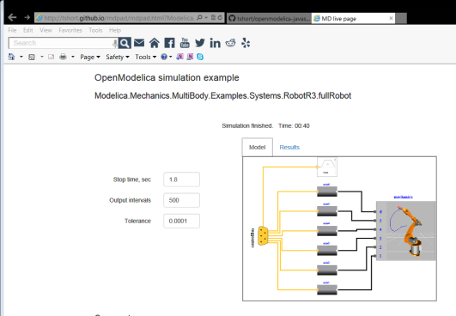

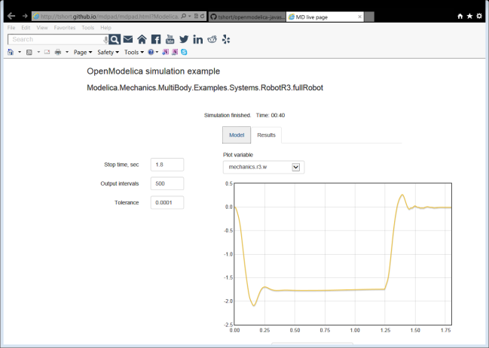

Interoperability – C and Python
Below is information and examples about the OpenModelica external C interfaces, as well as examples of Python interoperability.

Calling External C functions
The following is a small example (ExternalLibraries.mo) to show the use of external C functions:

model ExternalLibraries
Real x(start=1.0),y(start=2.0);
equation
der(x)=-ExternalFunc1(x);
der(y)=-ExternalFunc2(y);
end ExternalLibraries;
function ExternalFunc1
input Real x;
output Real y;
external
y=ExternalFunc1_ext(x) annotation(Library="libExternalFunc1_ext.o",
Include="#include \"ExternalFunc1_ext.h\"");
end ExternalFunc1;

function ExternalFunc2
input Real x;
output Real y;
external "C" annotation(Library="libExternalFunc2.a",
Include="#include \"ExternalFunc2.h\"");
end ExternalFunc2;
These C (.c) files and header files (.h) are needed:
/* file: ExternalFunc1.c */
double ExternalFunc1_ext(double x)
{
double res;
res = x+2.0*x*x;
return res;
}

/* Header file ExternalFunc1_ext.h for ExternalFunc1 function */
double ExternalFunc1_ext(double);

/* file: ExternalFunc2.c */
double ExternalFunc2(double x)
{
double res;
res = (x-1.0)*(x+2.0);
return res;
}

/* Header file ExternalFunc2.h for ExternalFunc2 */
double ExternalFunc2(double);
The following script file ExternalLibraries.mos will perform everything that is needed, provided you have gcc installed in your path:
loadFile("ExternalLibraries.mo");
system("gcc -c -o libExternalFunc1_ext.o ExternalFunc1.c");
system("gcc -c -o libExternalFunc2.a ExternalFunc2.c");
simulate(ExternalLibraries);
We run the script:
>> runScript("ExternalLibraries.mos");
and plot the results:
>> plot({x,y});
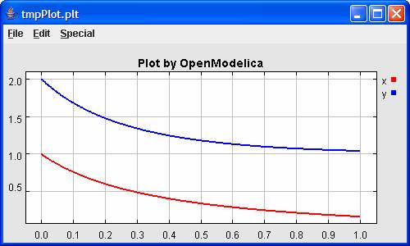

Calling Python Code
This section describes a simple-minded approach to calling Python code from OpenModelica. For a description of Python scripting with OpenModelica, see Chapter 13.
The interaction with Python can be perfomed in four different ways whereas one is illustrated below. Assume that we have the following Modelica code (CalledbyPython.mo):
model CalledbyPython
Real x(start=1.0),y(start=2.0);
parameter Real b = 2.0;
equation
der(x) = -b*y;
der(y) = x;
end CalledbyPython;
In the following Python (.py) files the above Modelica model is simulated via the OpenModelica scripting interface.
# file: PythonCaller.py
#!/usr/bin/python
import sys,os
global newb = 0.5
os.chdir(r'C:\Users\Documents\python')
execfile('CreateMosFile.py')
os.popen(r"C:\OpenModelica1.4.5\bin\omc.exe CalledbyPython.mos").read()
execfile('RetrResult.py')

# file: CreateMosFile.py
#!/usr/bin/python
mos_file = open('CalledbyPython.mos',’w’,1)
mos_file.write("loadFile(\"CalledbyPython.mo\");\n")
mos_file.write("setComponentModifierValue(CalledbyPython,b,$Code(="+str(newb)+")
);\n")
mos_file.write("simulate(CalledbyPython,stopTime=10);\n")
mos_file.close()

# file: RetrResult.py
#!/usr/bin/python
def zeros(n): #
vec = [0.0]
for i in range(int(n)-1): vec = vec + [0.0]
return vec
res_file = open("CalledbyPython_res.plt",'r',1)
line = res_file.readline()
size = int(res_file.readline().split('=')[1])
time = zeros(size)
y = zeros(size)
while line != ['DataSet: time\n']: line = res_file.readline().split(',')[0:1]
for j in range(int(size)): time[j]=float(res_file.readline().split(',')[0])
while line != ['DataSet: y\n']: line=res_file.readline().split(',')[0:1]
for j in range(int(size)): y[j]=float(res_file.readline().split(',')[1])
res_file.close()
A second option of simulating the above Modelica model is to use the command buildModel instead of the simulate command and setting the parameter value in the initial parameter file, CalledbyPython_init.txt instead of using the command setComponentModifierValue. Then the file CalledbyPython.exe is just executed.
The third option is to use the Corba interface for invoking the compiler and then just use the scripting interface to send commands to the compiler via this interface.
The fourth variant is to use external function calls to directly communicate with the executing simulation process.

OpenModelica Python Interface and PySimulator
This chapter describes the OpenModelica Python integration facilities.
- OMPython – the OpenModelica Python scripting interface, see Section 13.1.
- PySimulator – a Python package that provides simulation and post processing/analysis tools integrated with OpenModelica, see Section 13.2.

OMPython – OpenModelica Python Interface
OMPython – OpenModelica Python API is a free, open source, highly portable Python based interactive session handler for Modelica scripting. It provides the modeler with components for creating a complete Modelica modeling, compilation and simulation environment based on the latest OpenModelica library standard available. OMPython is architectured to combine both the solving strategy and model building. So domain experts (people writing the models) and computational engineers (people writing the solver code) can work on one unified tool that is industrially viable for optimization of Modelica models, while offering a flexible platform for algorithm development and research. OMPython v2.0 is not a standalone package, it depends upon the OpenModelica installation.
OMPython v2.0 is implemented in Python using the OmniORB and OmniORBpy – high performance CORBA ORBs for Python and it supports the Modelica Standard Library version 3.2 that is included in the latest OpenModelica (version 1.9.2) installation.

Features of OMPython
OMPython provides user friendly features like,
- Interactive session handling, parsing, interpretation of commands and Modelica expressions for evaluation, simulation, plotting, etc.
- Interface to the latest OpenModelica API calls.
- Optimized parser results that give control over every element of the output.
- Helper functions to allow manipulation on Nested dictionaries.
- Easy access to the library and testing of OpenModelica commands.

Using OMPython
The third party library of OMPython can be created by changing directory to,
OpenModelicaInstallationDirectory/share/omc/scripts/PythonInterface/
And running the command,
python setup.py install
This will install the OMPython library into your Python’s third party libraries directory. Now OMCSession can be imported from OMPython and used within Python.

Test Commands
To test the command outputs, simply create an OMCSession object by importing from the OMPython library within Python interepreter. The module allows you to interactively send commands to the OMC server and display their output.
To get started, create an OMCSession object:
C:\>python
>>> from OMPython import OMCSession
>>> OMPython = OMCSession()
Get the currently running OMC version
>>> OMPython.execute("getVersion()")
'"1.9.2+dev (r24159)"\n'
Get the current directory.
>>> OMPython.execute("cd()")
'"C:/Users/alash325"\n'
Load Modelica library:
>>> OMPython.execute("loadModel(Modelica)")
True
Load a modelica model:
>>> OMPython.execute("loadFile(\"C:/Dev/OpenModelica/Examples/BouncingBall.mo\")")
True
We give the command to flatten a model:
>>> OMPython.execute("instantiateModel(BouncingBall)”)
'"class BouncingBall\n parameter Real e = 0.7 "coefficient of restitution";\n
parameter Real g = 9.81 "gravity acceleration";\n Real h(start = 1.0) "height
of ball";\n Real v "velocity of ball";\n Boolean flying(start = true) "true,
if ball is flying";\n Boolean impact;\n Real v_new;\n Integer
foo;\nequation\n impact = h <= 0.0;\n foo = if impact then 1 else 2;\n
der(v) = if flying then -g else 0.0;\n der(h) = v;\n when {h <= 0.0 and v <=
0.0, impact} then\n v_new = if edge(impact) then (-e) * pre(v) else 0.0;\n
flying = v_new > 0.0;\n reinit(v, v_new);\n end when;\nend
BouncingBall;\n"\n'
We get the name and other properties of a class:
>>> OMPython.execute(“getClassNames()”)
{'SET1': {}, 'SET2': {'Set1': ['BouncingBall']}}
>>> OMPython.execute(“isPartial(BouncingBall)”)
false
>>> OMPython.execute(“isPackage(BouncingBall)”)
false
>>> OMPython.execute(“isModel(BouncingBall)”)
true
>>> OMPython.execute(“checkModel(BouncingBall)”)
'"Check of BouncingBall completed successfully.\n\n\nClass BouncingBall
has 6 equation(s) and 6 variable(s).\n1 of these are trivial
equation(s).\n"\n'

>>> OMPython.execute(“getClassRestriction(BouncingBall)”)
'"model"\n'
>>> OMPython.execute(“getClassInformation(BouncingBall)”)
{'SET4': {}, 'SET1': {'Set1': [-100.0, -100.0, 100.0, 100.0, True, 0.1, 2.0,
2.0]}, 'SET2': {'Elements': {'Line3': {'Properties': {'Values': [False, 0,
'LinePattern.Dot', 0.25, 3, 'Smooth.None'], 'Subset1': {'Set1': [0, -100],
'Set2': [0, -30]}, 'Set1': [0.0, 0.0], 'Set2': [127, 0, 0], 'Set3':
['Arrow.None', 'Arrow.None']}}, 'Line2': {'Properties': {'Values': [True, 0,
'LinePattern.Solid', 0.25, 3, 'Smooth.None'], 'Subset1': {'Set1': [70, 0],
'Set2': [90, 0]}, 'Set1': [0.0, 0.0], 'Set2': [0, 0, 255], 'Set3':
['Arrow.None', 'Arrow.None']}}, 'Line1': {'Properties': {'Values': [True, 0,
'LinePattern.Solid', 0.25, 3, 'Smooth.None'], 'Subset1': {'Set1': [-90, 0],
'Set2': [-70, 0]}, 'Set1': [0.0, 0.0], 'Set2': [0, 0,255], 'Set3'
['Arrow.None', 'Arrow.None']}}, 'Text2': {'Properties': {'Values': [True, 0,
'LinePattern.Solid', 'FillPattern.None', 0.25, '"%name"', 0,
'TextAlignment.Center'], 'Subset1': {'Set1': [-152, 87], 'Set2': [148, 47]},
'Set1': [0.0, 0.0], 'Set2': [0, 0, 255], 'Set3': [0, 0, 0]}}, 'Text1':
{'Properties': {'Values': [True, 0, 'LinePattern.Solid', 'FillPattern.None',
0.25, 0, 'TextAlignment.Center'], 'Subset1': {'Set1': [-144, -40], 'Set2':
[142, -72]}, 'Set1': [0.0,0.0], 'Set2': [0, 0, 0], 'Results': {'"R': '%R"'}}},
'Rectangle1': {'Properties': {'Values': [True, 0, 'LinePattern.Solid',
'FillPattern.Solid', 0.25, 'BorderPattern.None', 0], 'Subset1': {'Set1': [-70,
30], 'Set2': [70, -30]}, 'Set1': [0.0, 0.0], 'Set2': [0, 0, 255], 'Set3':
[255, 255, 255]}}}}, 'SET3': {'Elements': {'Line3': {'Properties': {'Values':
[False, 0, 'LinePattern.Dot', 0.25, 3, 'Smooth.None'], 'Subset1': {'Set1': [0,
-100], 'Set2': [0, -30]}, 'Set1': [0.0, 0.0],'Set2': [127, 0, 0], 'Set3':
['Arrow.None', 'Arrow.None']}}, 'Line2': {'Properties': {'Values': [True, 0,
'LinePattern.Solid', 0.25, 3, 'Smooth.None'], 'Subset1': {'Set1': [70, 0],
'Set2': [90, 0]}, 'Set1': [0.0, 0.0], 'Set2': [0, 0, 255],'Set3':
['Arrow.None', 'Arrow.None']}}, 'Line1': {'Properties': {'Values': [True, 0,
'LinePattern.Solid', 0.25, 3, 'Smooth.None'], 'Subset1': {'Set1': [-90,
0],'Set2': [-70, 0]}, 'Set1': [0.0, 0.0], 'Set2': [0, 0, 255], 'Set3':
['Arrow.None', 'Arrow.None']}}, 'Text2': {'Properties': {'Values': [True, 0,
'LinePattern.Solid', 'FillPattern.None', 0.25, '"%name"', 0
'TextAlignment.Center'], 'Subset1': {'Set1': [-152, 87], 'Set2': [148, 47]},
'Set1': [0.0, 0.0], 'Set2': [0, 0, 255], 'Set3': [0, 0, 0]}}, 'Text1':
{'Properties': {'Values': [True, 0, 'LinePattern.Solid', 'FillPattern.None',
0.25, 0, 'TextAlignment.Center'], 'Subset1': {'Set1': [-144, -40], 'Set2':
[142, -72]}, 'Set1': [0.0, 0.0], 'Set2': [0, 0, 0], 'Results': {'"R':
'%R"'}}}, 'Rectangle1': {'Properties': {'Values': [True, 0,
'LinePattern.Solid', 'FillPattern.Solid', 0.25, 'BorderPattern.None',
0],'Subset1': {'Set1': [-70, 30], 'Set2': [70, -30]}, 'Set1': [0.0, 0.0],
'Set2': [0, 0, 255], 'Set3': [255, 255, 255]}}}, 'Set1': [-100.0, -100.0,
100.0, 100.0, True, 0.1,2.0, 2.0], 'Set2': ['"model"', '""', False, False,
False, '"C:/Dev/OpenModelica/Examples/BouncingBall.mo"', False, 1, 1, 23,
17]}}
>>> OMPython.execute(“getConnectionCount(BouncingBall)”)
0
>>> OMPython.execute(“getInheritanceCount(BouncingBall)”)
0
>>> OMPython.execute(“getComponentModifierValue(BouncingBall,e)”)
7.5
The common combination of a simulation followed by getting a value and doing a plot:
>>> OMPython.execute(“simulate(BouncingBall, stopTime=3.0)”);
{'SimulationOptions': {'options': "''", 'cflags': "''", 'simflags': "''",
'variableFilter': "'.*'", 'outputFormat': "'mat'", 'method': "'dassl'",
'stopTime': 3.0, 'startTime': 0.0, 'numberOfIntervals': 500, 'tolerance': 1e-
06, 'fileNamePrefix': "'BouncingBall'"}, 'SimulationResults': {'timeCompile':
3.022411668585939,'timeBackend': 0.01062840294955596, 'messages': '""',
'timeFrontend': 0.01682653265860022, 'timeSimulation': 0.2781055999108373,
'timeTemplates': 0.04694975100793849, 'timeSimCode': 0.002148411220572541,
'timeTotal': 3.37801918685201, 'resultFile':
'"C:/Users/alash325/BouncingBall_res.mat"'}, 'SET1': {}, 'SET2': {'Set1':
['BouncingBall']}}
>>> OMPython.execute(“val(h , 2.0)”)
0.04239430772884123
>>> OMPython.execute(“plot(h)”)
True

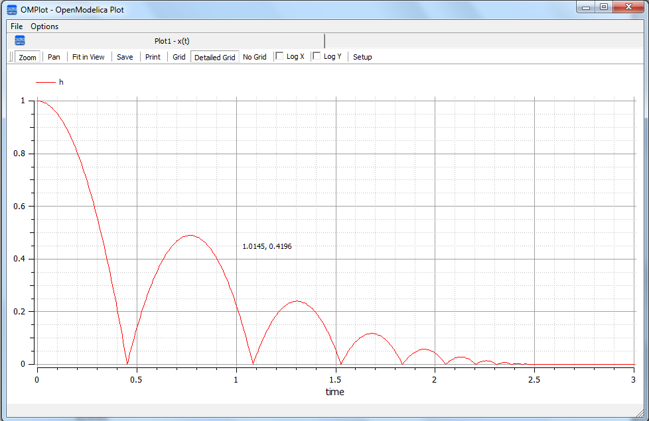

>>> OMPython.execute("plotAll()")
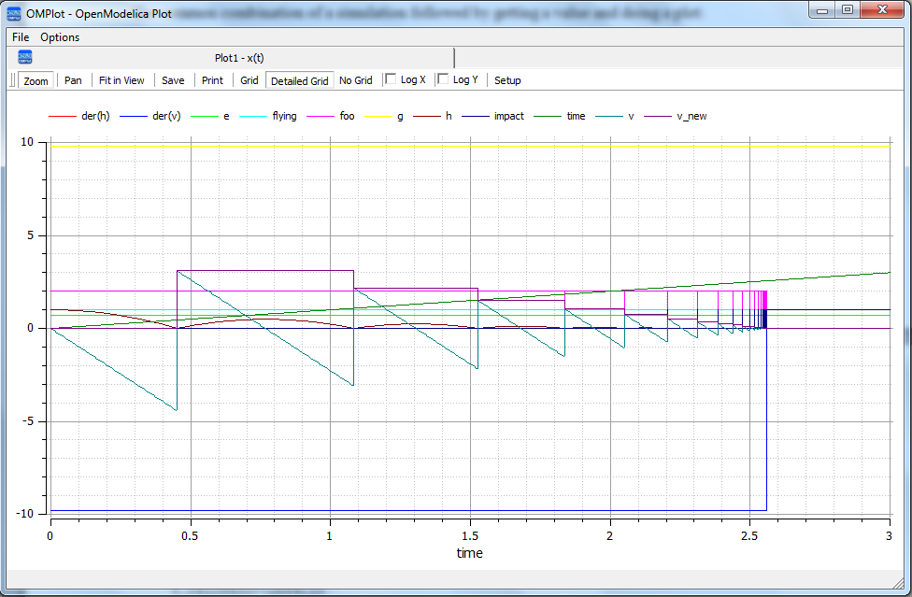

>>> OMPython.execute("quit()")
'quit requested, shutting server down\n'

Import As Library
To use the module from within another python program, simply import OMCSession from within the using program. Make use of the execute() function of the OMPython library to send commands to the OMC server.
For example:
answer = OMPython.execute(cmd)
Full example:
# test.py
from OMPython import OMCSession
OMPython = OMCSession()
cmds =
["loadModel(Modelica)",
"model test end test;",
"loadFile(\"C:/Dev/OpenModelica/Examples/BouncingBall.mo\")",
"getIconAnnotation(Modelica.Electrical.Analog.Basic.Resistor)",
"getElementsInfo(Modelica.Electrical.Analog.Basic.Resistor)",
"simulate(BouncingBall)",
"plot(h)"]
for cmd in cmds:
answer = OMPython.execute(cmd)
print "\nResult:\n%s"%answer

Implementation

Client Implementation
The OpenModelica Python API Interface – OMPython, attempts to mimic the OMShell's style of operations.
OMPython is designed to,
- Initialize the CORBA communication.
- Send commands to the Omc server via the CORBA interface.
- Receive the string results.
- Use the Parser module to format the results.
- Return or display the results.

Parser Implementation
Since the results of OMC are retrieved in a String format over CORBA, some housekeeping has to be done to make sure the results are usable in Python easily.
The Parser is designed to do the following,

- Analyze the result string for categorical data.
- Group each category under a category name.
- Type cast the data within these categories.
- Build a suitable data structure to hold these data so that the results can be easily accessed and used.
Understanding the Parsed output
Each command in OpenModelica produces a result that can be categorized according to the statistics of the pattern of data presented in the text. Grammar based parsers were found to be tedious to use because of the complexity of the patterns of data.
The parser just type casts the data without "curly brackets" to the appropriate data type and displays it as the result.
For example:
>> getVectorizationLimit()
<< 20
>> getNthInheritedClass(Modelica.Electrical.Analog.Basic.Resistor,1)
<< Modelica.Electrical.Analog.Interfaces.OnePort
However, multiple data types packed within a pair of quotations is always treated as a full string.
For example:
>> getModelicaPath()
<< "C:/OpenModelica1.8.0/lib/omlibrary"

The Dictionary data type in Python
Dictionaries are found to be a useful datatype to pack data with different datatypes. Dictionaries in Python are indexed by Keys unlike the sequences, which are indexed by a range of numbers.
It is best to think of dictionaries as an unordered set of key:value pairs, with the requirement that the keys are always unique. The common operation on dictionaries is to store a value associated with a key and retrieve the value using the key. This provides us the flexibility of creating keys at runtime and accessing these values using their keys later. All data within the dictionary are stored inside a named dictionary. An empty dictionary is represented by a pair of braces {}.
From the reply of the OMC, the complicated result strings are usually the ones found within the curly braces, in order to make a meaningful categorization of the data within these brackets and to avoid the potential complexities due to creating Dynamic variables, we introduce the following notations that can be used within dictionaries,
- SET
- Set
- Subset
- Element
- Results
- Values
SET
A SET (note the capital letters) is used to group data that belong to the first set of balanced curly brackets. According to the needed semantics of the results, a SET can contain Sets, Subsets, Elements, Values and Results. A SET can also be empty, denoted by {}. The SETs are named with an increasing index starting from 1(one). This feature was planned to eliminate the need for dynamic variable creation and having duplicate Keys. The SET belongs within the dictionary, result.
For example:
>> strtok("abcbdef","b")
<< {'SET1': {'Values': ['"a","c","def"']}}
The command strtok tokenizes the string "abcbdef" at every occurrence of b and produces a SET with values "a", "c", "def".
Set
A set is used to group all data within the a SET that is enclosed within a pair of balanced {}s. A Set can contain only Values and Elements. A set can also be empty, it can be depicted as {{}}, the outer brackets compose a SET, the inner brackets are the Set within the SET.
Subset
A Subset is a two-level deep set that is found within a SET. A subset can contain multiple Sets within its enclosure.
For example:
{SET1 {Subset1{Set1},{Set2},{Set3}}}
Element
Elements are the data which are grouped within a pair of Parenthesis ( ). As observed from the results string, elements have an element name that describes the data within them, so elements can be grouped by their names. Also, many elements have the same names, so they are indexed by increasing numbers starting from 1(one). Elements have the special property of having one or more Sets and Subsets within them. However, they are in turn enclosed within the SET.
For example:
>> getClassAttributes(test.mymodel)
<< {'SET1': {'Elements': {'rec1': {'Properties': {'Results': {'comment': None, 'res
triction': 'MODEL', 'startLine': 1, 'partial': False, 'name': '"mymodel"', 'enca
psulated': False, 'startColumn': 14, 'readonly': '"writable"', 'endColumn': 69,
'file': '"<interactive>"', 'endLine': 1, 'final': False}}}}}}
The result contains, a SET with a Element named rec1 which has Properties which are Results (see below) of the element.
Results
Data that is related by the assignment operator "=", within the SETs are denoted as Results. These assignments cannot be assigned to their actual values unless they are related by a Name = Value relationship. So, they form the sub-dictionary called Results within the Element (for example). Then these values can be related by the key:value pair relationship.
For example:
>> getClassAttributes(test.mymodel)
<< {'SET1': {'Elements': {'rec1': {'Properties': {'Results': {'comment': None, 'res
triction': 'MODEL', 'startLine': 1, 'partial': False, 'name': '"mymodel"', 'enca
psulated': False, 'startColumn': 14, 'readonly': '"writable"', 'endColumn': 69,
'file': '"<interactive>"', 'endLine': 1, 'final': False}}}}}}
Values
Data within any or all of SETs, Sets, Elements and Subsets that are not assignments and separated by commas are grouped together into a list called "Values". The Values list may also be empty, due to Python's representation of a null string "" as {}. Although a Null string is still a Null value, sometimes it is possible to observe data grouped into Values to look like Sets within the Values list.
For example:
>> getNthConnection(Modelica.Electrical.Analog.Examples.ChuaCircuit,2)
<< {'SET1': {'Set1': ['G.n', 'Nr.p', {}]}}

The Simulation Results
The OMPython.execute(“simulate(BouncingBall)”) command produces output that has no SET or Set data in it. Instead, for simplicity, it has two dictionaries namely, SimulationResults and SimulationOptions within the result dictionary.
For example:
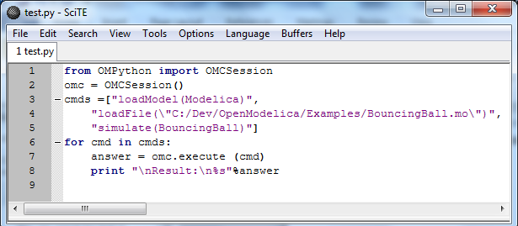

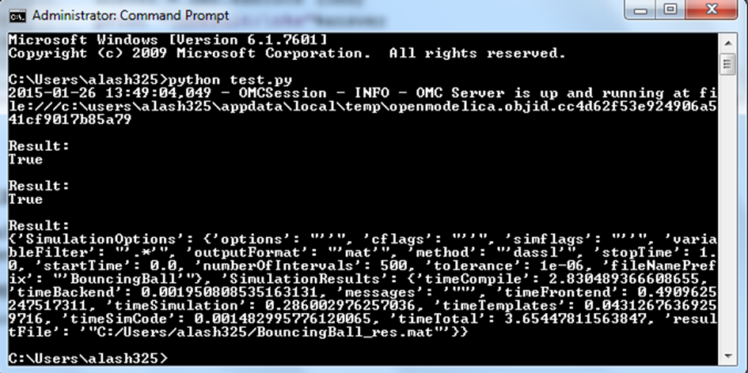

Record Construction
The OpenModelica commands that produce output with Record constructs also do not have SET or Set data within them. The results of the output are packed within the RecordResults dictionary.
For example:
OMPython.execute("checkSettings()")
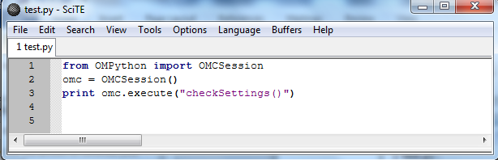
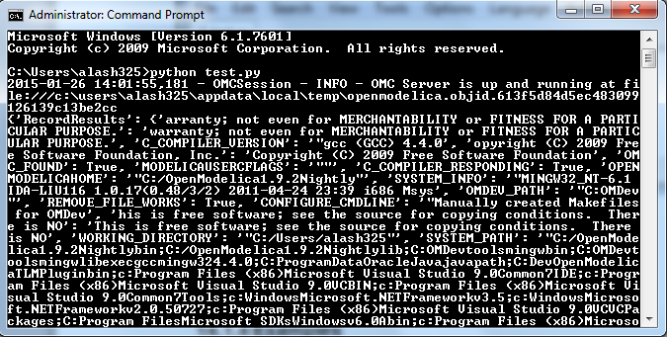

API – List of Commands
The following table contains brief descriptions of the API/ commands that are available in the OpenModelica environment, which can be called using Python or Modelica scripting.

Command | Description
simulate | Simulates a model.  Interface:  function simulate  input TypeName className;  input Real startTime=0;  input Real stopTime=1;  input Integer numberOfIntervals=500;  input Real tolerance=1e-4;  input String method=”dassl”; See Appendix C for solver details.  input String outputFormat=”mat”; {mat, plt, csv, empty}  input String fileNamePrefix=””;  input String variableFilter=””;  input String cflags=””;  input String simflags=””;  ouput SimulationResult simRes;  end simulate;  SimulationResult:  Record SimulationResult  String resultFile;  String simulationOptions;  String messages;  Real timeFrontend;  Real timeBackend;  Real timeSimCode;  Real timeTemplates;  Real timeCompile;  Real timeSimulation;  Real timeTotal;  End SimulationResult;
appendEnvironmentVar | Appends a variable to the environment variables list.  Interface:  function appendEnvironmentVar  input String var;  input String value;  output String result "returns \"error\" if the variable could not be appended";  end appendEnvironmentVar;
basename | Returns the base name (file part) of a file path. Similar to basename(3), but with the safety of Modelica strings.  Interface:  function basename  input String path;  output String basename;  end basename;
cd | change directory to the given path (which may be either relative or absolute) returns the new working directory on success or a message on failure if the given path is the empty string, the function simply returns the current working directory.  Interface:  function cd  input String newWorkingDirectory = "";  output String workingDirectory;  end cd;
checkAllModelsRecursive | Checks all models recursively and returns number of variables and equations.  Interface:  function checkAllModelsRecursive  input TypeName className;  input Boolean checkProtected = false "Checks also protected classes if true";  output String result;  end checkAllModelsRecursive;
checkModel | Checks a model and returns number of variables and equations.  Interface:  function checkModel  input TypeName className;  output String result;  end checkModel;
checkSettings | Display some diagnostics.  Interface:  function checkSettings  output CheckSettingsResult result;  end checkSettings;  CheckSettingsResult:  String OPENMODELICAHOME,OPENMODELICALIBRARY,OMC_PATH;  Boolean OMC_FOUND;  String MODELICAUSERCFLAGS,WORKING_DIRECTORY;  Boolean CREATE_FILE_WORKS,REMOVE_FILE_WORKS;  String OS, SYSTEM_INFO,SENDDATALIBS,C_COMPILER;  Boolean C_COMPILER_RESPONDING;  String CONFIGURE_CMDLINE;  end CheckSettingsResult;
clear | Clears everything: symboltable and variables.  Interface:  function clear  output Boolean success;  end clear;
clearMessages | Clears the error buffer.  Interface:  function clearMessages  output Boolean success;  end clearMessages;
clearVariables | Clear all user defined variables.  Interface:  function clearVariables  output Boolean success;  end clearVariables;
closeSimulationResultFile | Closes the current simulation result file. Only needed by Windows. Windows cannot handle reading and writing to the same file from different processes. To allow OMEdit to make successful simulation again on the same file we must close the file after reading the Simulation Result Variables. Even OMEdit only use this API for Windows.  Interface:  function closeSimulationResultFile  output Boolean success;  end closeSimulationResultFile;
codeToString | Interface:  function codeToString  input $Code className;  output String string;  end codeToString;
compareSimulationResults | Compares simulation results.  Interface:  function compareSimulationResults  input String filename;  input String reffilename;  input String logfilename;  input Real refTol;  input Real absTol;  input String[:] vars;  output String result;  end compareSimulationResults;
deleteFile | Deletes a file with the given name.  Interface:  function deleteFile  input String fileName;  output Boolean success;  end deleteFile;
dirname | Returns the directory name of a file path. Similar to dirname(3), but with the safety of Modelica strings.  Interface:  function dirname  input String path;  output String dirname;  end dirname;
dumpXMLDAE | Outputs the DAE system corresponding to a specific model.  Interface:  function dumpXMLDAE  input TypeName className;  input String translationLevel = "flat";  input Boolean addOriginalIncidenceMatrix = false;  input Boolean addSolvingInfo = false;  input Boolean addMathMLCode = false;  input Boolean dumpResiduals = false;  input String fileNamePrefix = "<default>" "this is the className in string form by default";  input Boolean storeInTemp = false;  output String result[2] "Contents, Message/Filename; why is this an array and not 2 output arguments?";  end dumpXMLDAE;
echo | echo(false) disables Interactive output, echo(true) enables it again.  Interface:  function echo  input Boolean setEcho;  output Boolean newEcho;  end echo;
generateCode | The input is a function name for which C-code is generated and compiled into a dll/so.  Interface:  function generateCode  input TypeName className;  output Boolean success;  end generateCode;
generateHeader | Interface:  function generateHeader  input String fileName;  output Boolean success;  end generateHeader;
generateSeparateCode | Interface:  function generateSeparateCode  output Boolean success;  end generateSeparateCode;
getAlgorithmCount | Counts the number of Algorithm sections in a class.  Interface:  function getAlgorithmCount  input TypeName class_;  output Integer count;  end getAlgorithmCount;
getAlgorithmItemsCount | Counts the number of Algorithm items in a class.  Interface:  function getAlgorithmItemsCount  input TypeName class_;  output Integer count;  end getAlgorithmItemsCount;
getAnnotationCount | Counts the number of Annotation sections in a class.  Interface:  function getAnnotationCount  input TypeName class_;  output Integer count;  end getAnnotationCount;
getAnnotationVersion | Returns the current annotation version.  Interface:  function getAnnotationVersion  output String annotationVersion;  end getAnnotationVersion;
getAstAsCorbaString | Print the whole AST on the CORBA format for records, e.g.  record Absyn.PROGRAM  classes = ...,  within_ = ...,  globalBuildTimes = ...  end Absyn.PROGRAM;  Interface:  function getAstAsCorbaString  input String fileName = "<interactive>";  output String result "returns the string if fileName is interactive; else it returns ok or error depending on if writing the file succeeded";  end getAstAsCorbaString;
getClassComment | Returns the class comment.  Interface:  function getClassComment  input TypeName cl;  output String comment;  end getClassComment;
getClassNames | Returns the list of class names defined in the class.  Interface:  function getClassNames  input TypeName class_ = $Code(AllLoadedClasses);  input Boolean recursive = false;  input Boolean qualified = false;  input Boolean sort = false;  input Boolean builtin = false "List also builtin classes if true";  input Boolean showProtected = false "List also protected classes if true";  output TypeName classNames[:];  end getClassNames;
getClassesInModelicaPath | Interface:  function getClassesInModelicaPath  output String classesInModelicaPath;  end getClassesInModelicaPath;
getCompileCommand | Interface:  function getCompileCommand  output String compileCommand;  end getCompileCommand;
getDocumentationAnnotation | Returns the documentaiton annotation defined in the class.  Interface:  function getDocumentationAnnotation  input TypeName cl;  output String out[2] "{info,revision}";  end getDocumentationAnnotation;
getEnvironmentVar | Returns the value of the environment variable.  Interface:  function getEnvironmentVar  input String var;  output String value "returns empty string on failure";  end getEnvironmentVar;
getEquationCount | Counts the number of Equation sections in a class.  Interface:  function getEquationCount  input TypeName class_;  output Integer count;  end getEquationCount;
getEquationItemsCount | Counts the number of Equation items in a class.  Interface:  function getEquationItemsCount  input TypeName class_;  output Integer count;  end getEquationItemsCount;
getErrorString | Returns the current error message. [file.mo:n:n-n:n:b] Error: message  Interface:  function getErrorString  output String errorString;  end getErrorString;
getImportCount | Counts the number of Import sections in a class.  Interface:  function getImportCount  input TypeName class_;  output Integer count;  end getImportCount;
getInitialAlgorithmCount | Counts the number of Initial Algorithm sections in a class.  Interface:  function getInitialAlgorithmCount  input TypeName class_;  output Integer count;  end getInitialAlgorithmCount;
getInitialAlgorithmItemsCount | Counts the number of Initial Algorithm items in a class.  Interface:  function getInitialAlgorithmItemsCount  input TypeName class_;  output Integer count;  end getInitialAlgorithmItemsCount;
getInitialEquationCount | Counts the number of Initial Equation sections in a class.  Interface:  function getInitialEquationCount  input TypeName class_;  output Integer count;  end getInitialEquationCount;
getInitialEquationItemsCount | Counts the number of Initial Equation items in a class.  Interface:  function getInitialEquationItemsCount  input TypeName class_;  output Integer count;  end getInitialEquationItemsCount;
getInstallationDirectoryPath | This returns OPENMODELICAHOME if it is set; on some platforms the default path is returned if it is not set.  Interface:  function getInstallationDirectoryPath  output String installationDirectoryPath;  end getInstallationDirectoryPath;
getLanguageStandard | Returns the current Modelica Language Standard in use.  Interface:  function getLanguageStandard  output String outVersion;  end getLanguageStandard;
getMessagesString | see getErrorString()  Interface:  function getMessagesString  output String messagesString;  end getMessagesString;
getMessagesStringInternal | {{[file.mo:n:n-n:n:b] Error: message, TRANSLATION, Error, code}}  Interface:  function getMessagesStringInternal  output ErrorMessage[:] messagesString;  end getMessagesStringInternal;
getModelicaPath | Get the Modelica Library Path.  Interface:  function getModelicaPath  output String modelicaPath;  end getModelicaPath;
getNoSimplify | Returns true if noSimplify flag is set.  Interface:  function getNoSimplify  output Boolean noSimplify;  end getNoSimplify;
getNthAlgorithm | Returns the Nth Algorithm section.  Interface:  function getNthAlgorithm  input TypeName class_;  input Integer index;  output String result;  end getNthAlgorithm;
getNthAlgorithmItem | Returns the Nth Algorithm Item.  Interface:  function getNthAlgorithmItem  input TypeName class_;  input Integer index;  output String result;  end getNthAlgorithmItem;
getNthAnnotationString | Returns the Nth Annotation section as string.  Interface:  function getNthAnnotationString  input TypeName class_;  input Integer index;  output String result;  end getNthAnnotationString;
getNthEquation | Returns the Nth Equation section.  Interface:  function getNthEquation  input TypeName class_;  input Integer index;  output String result;  end getNthEquation;
getNthEquationItem | Returns the Nth Equation Item.  Interface:  function getNthEquationItem  input TypeName class_;  input Integer index;  output String result;  end getNthEquationItem;
getNthImport | Returns the Nth Import as string.  Interface:  function getNthImport  input TypeName class_;  input Integer index;  output String out[3] "{\"Path\",\"Id\",\"Kind\"}";  end getNthImport;
getNthInitialAlgorithm | Returns the Nth Initial Algorithm section.  Interface:  function getNthInitialAlgorithm  input TypeName class_;  input Integer index;  output String result;  end getNthInitialAlgorithm;
getNthInitialAlgorithmItem | Returns the Nth Initial Algorithm Item.  Interface:  function getNthInitialAlgorithmItem  input TypeName class_;  input Integer index;  output String result;  end getNthInitialAlgorithmItem;
getNthInitialEquation | Returns the Nth Initial Equation section.  Interface:  function getNthInitialEquation  input TypeName class_;  input Integer index;  output String result;  end getNthInitialEquation;
getNthInitialEquationItem | Returns the Nth Initial Equation Item.  Interface:  function getNthInitialEquationItem  input TypeName class_;  input Integer index;  output String result;  end getNthInitialEquationItem;
getOrderConnections | Returns true if orderConnections flag is set.  Interface:  function getOrderConnections  output Boolean orderConnections;  end getOrderConnections;
getPackages | Returns the list of packages defined in the class.  Interface:  function getPackages  input TypeName class_ = $Code(AllLoadedClasses);  output TypeName classNames[:];  end getPackages;
getPlotSilent | Returns true if plotSilent flag is set.  Interface:  function getPlotSilent  output Boolean plotSilent;  end getPlotSilent;
getSettings | Interface:  function getSettings  output String settings;  end getSettings;
getShowAnnotations | Interface:  function getShowAnnotations  output Boolean show;  end getShowAnnotations;
getSourceFile | Returns the filename of the class.  Interface:  function getSourceFile  input TypeName class_;  output String filename "empty on failure";  end getSourceFile;
getTempDirectoryPath | Returns the current user temporary directory location.  Interface:  function getTempDirectoryPath  output String tempDirectoryPath;  end getTempDirectoryPath;
getVectorizationLimit | Interface:  function getVectorizationLimit  output Integer vectorizationLimit;  end getVectorizationLimit;
getVersion | Returns the version of the Modelica compiler.  Interface:  function getVersion  input TypeName cl = $Code(OpenModelica);  output String version;  end getVersion;
help | Display the OpenModelica help text.  Interface:  function help  output String helpText;  end help;
iconv | The iconv() function converts one multibyte characters from one character  set to another.  See man(3) iconv for more information.  Interface:  function iconv  input String string;  input String from;  input String to = "UTF-8";  output String result;  end iconv;
importFMU | Imports the Functional Mockup Unit.  Example command:  importFMU("A.fmu");  Interface:  function importFMU  input String filename "the fmu file name";  input String workdir = "./" "The output directory for imported FMU files. <default> will put the files to current working directory.";  output Boolean success "Returns true on success";  end importFMU;
instantiateModel | Instantiates the class and returns the flat Modelica code.  Interface:  function instantiateModel  input TypeName className;  output String result;  end instantiateModel;
isModel | Returns true if the given class has restriction model.  Interface:  function isModel  input TypeName cl;  output Boolean b;  end isModel;
isPackage | Returns true if the given class is a package.  Interface:  function isPackage  input TypeName cl;  output Boolean b;  end isPackage;
isPartial | Returns true if the given class is partial.  Interface:  function isPartial  input TypeName cl;  output Boolean b;  end isPartial;
list | Lists the contents of the given class, or all loaded classes.  Pretty-prints a class definition.  Syntax  list(Modelica.Math.sin)  list(Modelica.Math.sin,interfaceOnly=true)  Interface:  function list  input TypeName class_ = $Code(AllLoadedClasses);  input Boolean interfaceOnly = false;  input Boolean shortOnly = false "only short class definitions";  output String contents;  end list;
listVariables | Lists the names of the active variables in the scripting environment.  Interface:  function listVariables  output TypeName variables[:];  end listVariables;
loadFile | load file (*.mo) and merge it with the loaded AST.  Interface:  function loadFile  input String fileName;  output Boolean success;  end loadFile;
loadFileInteractive | Interface:  function loadFileInteractive  input String filename;  output TypeName names[:];  end loadFileInteractive;
loadFileInteractiveQualified | Interface:  function loadFileInteractiveQualified  input String filename;  output TypeName names[:];  end loadFileInteractiveQualified;
loadModel | Loads a Modelica library.  Syntax  loadModel(Modelica)  loadModel(Modelica,{"3.2"})  Interface:  function loadModel  input TypeName className;  input String[:] priorityVersion = {"default"};  output Boolean success;  end loadModel;
loadString | Parses the data and merges the resulting AST with the loaded AST. If a filename is given, it is used to provide error-messages as if the string was read in binary format from a file with the same name. The file is converted to UTF-8 from the given character set.  Interface:  function loadString  input String data;  input String filename = "<interactive>";  input String encoding = "UTF-8";  output Boolean success;  end loadString;
parseFile | Interface:  function parseFile  input String filename;  output TypeName names[:];  end parseFile;
parseString | Interface:  function parseString  input String data;  input String filename = "<interactive>";  output TypeName names[:];  end parseString;
plot | Launches a plot window using OMPlot. Returns true on success. Don't require sendData support.  Example command sequences:  simulate(A);plot({x,y,z});  simulate(A);plot(x, externalWindow=true);  simulate(A,fileNamePrefix="B");  simulate(C);plot(z,"B.mat",legend=false);  Interface:  function plot  input VariableNames vars "The variables you want to plot";  input Boolean externalWindow = false "Opens the plot in a new plot window";  input String fileName = "<default>" "The filename containing the variables. <default> will read the last simulation result";  input String title = "Plot by OpenModelica" "This text will be used as the diagram title.";  input Boolean legend = true "Determines whether or not the variable legend is shown.";  input Boolean grid = true "Determines whether or not a grid is shown in the diagram.";  input Boolean logX = false "Determines whether or not the horizontal axis is logarithmically scaled.";  input Boolean logY = false "Determines whether or not the vertical axis is logarithmically scaled.";  input String xLabel = "time" "This text will be used as the horizontal label in the diagram.";  input String yLabel = "" "This text will be used as the vertical label in the diagram.";  input Real xRange[2] = {0.0,0.0} "Determines the horizontal interval that is visible in the diagram. {0,0} will select a suitable range.";  input Real yRange[2] = {0.0,0.0} "Determines the vertical interval that is visible in the diagram. {0,0} will select a suitable range.";  output Boolean success "Returns true on success";  output String[:] result "Returns list i.e {\"_omc_PlotResult\", \"<fileName>\", \"<title>\", \"<legend>\", \"<grid>\", \"<PlotType>\", \"<logX>\", \"<logY>\", \"<xLabel>\", \"<yLabel>\", \"<xRange>\", \"<yRange>\", \"<PlotVariables>\"}";  end plot;
plotAll | Works in the same way as plot(), but does not accept any variable names as input. Instead, all variables are part of the plot window.  Example command sequences:  simulate(A);  plotAll();  simulate(A);  plotAll(externalWindow=true);  simulate(A,fileNamePrefix="B");  simulate(C);  plotAll(x,"B.mat");  Interface:  function plotAll  input Boolean externalWindow = false "Opens the plot in a new plot window";  input String fileName = "<default>" "The filename containing the variables. <default> will read the last simulation result";  input String title = "Plot by OpenModelica" "This text will be used as the diagram title.";  input Boolean legend = true "Determines whether or not the variable legend is shown.";  input Boolean grid = true "Determines whether or not a grid is shown in the diagram.";  input Boolean logX = false "Determines whether or not the horizontal axis is logarithmically scaled.";  input Boolean logY = false "Determines whether or not the vertical axis is logarithmically scaled.";  input String xLabel = "time" "This text will be used as the horizontal label in the diagram.";  input String yLabel = "" "This text will be used as the vertical label in the diagram.";  input Real xRange[2] = {0.0,0.0} "Determines the horizontal interval that is visible in the diagram. {0,0} will select a suitable range.";  input Real yRange[2] = {0.0,0.0} "Determines the vertical interval that is visible in the diagram. {0,0} will select a suitable range.";  output Boolean success "Returns true on success";  output String[:] result "Returns list i.e {\"_omc_PlotResult\", \"<fileName>\", \"<title>\", \"<legend>\", \"<grid>\", \"<PlotType>\", \"<logX>\", \"<logY>\", \"<xLabel>\", \"<yLabel>\", \"<xRange>\", \"<yRange>\", \"<PlotVariables>\"}";  end plotAll;
plotParametric | Launches a plotParametric window using OMPlot. Returns true on success.  Example command sequences:  simulate(A);plotParametric2(x,y);  simulate(A);plotParametric2(x,y, externalWindow=true);  Interface:  function plotParametric  input VariableName xVariable;  input VariableName yVariable;  input Boolean externalWindow = false "Opens the plot in a new plot window";  input String fileName = "<default>" "The filename containing the variables. <default> will read the last simulation result";  input String title = "Plot by OpenModelica" "This text will be used as the diagram title.";  input Boolean legend = true "Determines whether or not the variable legend is shown.";  input Boolean grid = true "Determines whether or not a grid is shown in the diagram.";  input Boolean logX = false "Determines whether or not the horizontal axis is logarithmically scaled.";  input Boolean logY = false "Determines whether or not the vertical axis is logarithmically scaled.";  input String xLabel = "time" "This text will be used as the horizontal label in the diagram.";  input String yLabel = "" "This text will be used as the vertical label in the diagram.";  input Real xRange[2] = {0.0,0.0} "Determines the horizontal interval that is visible in the diagram. {0,0} will select a suitable range.";  input Real yRange[2] = {0.0,0.0} "Determines the vertical interval that is visible in the diagram. {0,0} will select a suitable range.";  output Boolean success "Returns true on success";  output String[:] result "Returns list i.e {\"_omc_PlotResult\", \"<fileName>\", \"<title>\", \"<legend>\", \"<grid>\", \"<PlotType>\", \"<logX>\", \"<logY>\", \"<xLabel>\", \"<yLabel>\", \"<xRange>\", \"<yRange>\", \"<PlotVariables>\"}";  end plotParametric;
plotParametric2 | Plots the y-variables as a function of the x-variable.  Example command sequences:  simulate(A);  plotParametric2(x,y);  simulate(A,fileNamePrefix="B");  simulate(C);  plotParametric2(x,{y1,y2,y3},"B.mat");  Interface:  function plotParametric2  input VariableName xVariable;  input VariableNames yVariables;  input String fileName = "<default>";  output Boolean success "Returns true on success";  end plotParametric2;
readFile | The contents of the given file are returned. Note that if the function fails, the error message is returned as a string instead of multiple output or similar.  Interface:  function readFile  input String fileName;  output String contents;  end readFile;
readFileNoNumeric | Returns the contents of the file, with anything resembling a (real) number stripped out, and at the end adding:  Filter count from number domain: n.  This should probably be changed to multiple outputs; the filtered string and an integer.  Does anyone use this API call?  Interface:  function readFileNoNumeric  input String fileName;  output String contents;  end readFileNoNumeric;
readFilePostprocessLineDirective | Searches lines for the #modelicaLine directive. If it is found, all lines up until the next #modelicaLine or #endModelicaLine are put on a single file, following a #line linenumber "filename" line. This causes GCC to output an executable that we can set breakpoints in and debug.  Note: You could use a stack to keep track of start/end of #modelicaLine and match them up. But this is not really desirable since that will cause extra breakpoints for the same line (you would get breakpoints before and after each case if you break on a match-expression, etc).  Interface:  function readFilePostprocessLineDirective  input String fileName;  output String out;  end readFilePostprocessLineDirective;
readFileShowLineNumbers | Prefixes each line in the file with <n>:, where n is the line number.  Note: Scales O(n^2)  Interface:  function readFileShowLineNumbers  input String fileName;  output String out;  end readFileShowLineNumbers;
readSimulationResult | Reads a result file, returning a matrix corresponding to the variables and size given.  Interface:  function readSimulationResult  input String filename;  input VariableNames variables;  input Integer size = 0 "0=read any size... If the size is not the same as the result-file, this function fails";  output Real result[:,:];  end readSimulationResult;
readSimulationResultSize | The number of intervals that are present in the output file.  Interface:  function readSimulationResultSize  input String fileName;  output Integer sz;  end readSimulationResultSize;
readSimulationResultVars | Returns the variables in the simulation file; you can use val() and plot() commands using these names.  Interface:  function readSimulationResultVars  input String fileName;  output String[:] vars;  end readSimulationResultVars;
Regex | Sets the error buffer and returns -1 if the regex does not compile.  The returned result is the same as POSIX regex():  The first value is the complete matched string  The rest are the substrings that you wanted.  For example:  regex(lorem," \([A-Za-z]*\) \([A-Za-z]*\) ",maxMatches=3)  => {" ipsum dolor ","ipsum","dolor"}  This means if you have n groups, you want maxMatches=n+1  Interface:  function regex  input String str;  input String re;  input Integer maxMatches = 1 "The maximum number of matches that will be returned";  input Boolean extended = true "Use POSIX extended or regular syntax";  input Boolean caseInsensitive = false;  output Integer numMatches "-1 is an error, 0 means no match, else returns a number 1..maxMatches";  output String matchedSubstrings[maxMatches] "unmatched strings are returned as empty";  end regex;
regexBool | Returns true if the string matches the regular expression.  Interface:  function regexBool  input String str;  input String re;  input Boolean extended = true "Use POSIX extended or regular syntax";  input Boolean caseInsensitive = false;  output Boolean matches;  end regexBool;
regularFileExists | The contents of the given file are returned.  Note that if the function fails, the error message is returned as a string instead of multiple output or similar.  Interface:  function regularFileExists  input String fileName;  output Boolean exists;  end regularFileExists;
reopenStandardStream | Interface:  function reopenStandardStream  input StandardStream _stream;  input String filename;  output Boolean success;  end reopenStandardStream;
runScript | Runs the mos-script specified by the filename.  Interface:  function runScript  input String fileName "*.mos";  output String result;  end runScript;
Save | Interface:  function save  input TypeName className;  output Boolean success;  end save;
saveAll | Save the entire loaded AST to file.  Interface:  function saveAll  input String fileName;  output Boolean success;  end saveAll;
saveModel | Save class definition in a file.  Interface:  function saveModel  input String fileName;  input TypeName className;  output Boolean success;  end saveModel;
saveTotalModel | Save total class definition into file of a class.  Inputs: String fileName; TypeName className  Outputs: Boolean res;  Interface:  function saveTotalModel  input String fileName;  input TypeName className;  output Boolean success;  end saveTotalModel;
saveTotalSCode | Interface:  function saveTotalSCode  input String fileName;  input TypeName className;  output Boolean success;  end saveTotalSCode;
setAnnotationVersion | Sets the annotation version.  Interface:  function setAnnotationVersion  input String annotationVersion;  output Boolean success;  end setAnnotationVersion;
setCXXCompiler | Interface:  function setCXXCompiler  input String compiler;  output Boolean success;  end setCXXCompiler;
setClassComment | Sets the class comment.  Interface:  function setClassComment  input TypeName class_;  input String filename;  output Boolean success;  end setClassComment;
setCommandLineOptions | The input is a regular command-line flag given to OMC, e.g. +d=failtrace or +g=MetaModelica.  Interface:  function setCommandLineOptions  input String option;  output Boolean success;  end setCommandLineOptions;
setCompileCommand | Interface:  function setCompileCommand  input String compileCommand;  output Boolean success;  end setCompileCommand;
setCompiler | Interface:  function setCompiler  input String compiler;  output Boolean success;  end setCompiler;
setCompilerFlags | Interface:  function setCompilerFlags  input String compilerFlags;  output Boolean success;  end setCompilerFlags;
setCompilerPath | Interface:  function setCompilerPath  input String compilerPath;  output Boolean success;  end setCompilerPath;
setDebugFlags | example input: failtrace,-noevalfunc  Interface:  function setDebugFlags  input String debugFlags;  output Boolean success;  end setDebugFlags;
setEnvironmentVar | Interface:  function setEnvironmentVar  input String var;  input String value;  output Boolean success;  end setEnvironmentVar;
setIndexReductionMethod | example input: dummyDerivative  Interface:  function setIndexReductionMethod  input String method;  output Boolean success;  end setIndexReductionMethod;
setInstallationDirectoryPath | Sets the OPENMODELICAHOME environment variable. Use this method instead of setEnvironmentVar.  Interface:  function setInstallationDirectoryPath  input String installationDirectoryPath;  output Boolean success;  end setInstallationDirectoryPath;
setLanguageStandard | Sets the Modelica Language Standard.  Interface:  function setLanguageStandard  input String inVersion;  output Boolean success;  end setLanguageStandard;
setLinker | Interface:  function setLinker  input String linker;  output Boolean success;  end setLinker;
setLinkerFlags | Interface:  function setLinkerFlags  input String linkerFlags;  output Boolean success;  end setLinkerFlags;
setModelicaPath | See loadModel() for a description of what the MODELICAPATH is used for.  Interface:  function setModelicaPath  input String modelicaPath;  output Boolean success;  end setModelicaPath;
setNoSimplify | Sets the noSimplify flag.  Interface:  function setNoSimplify  input Boolean noSimplify;  output Boolean success;  end setNoSimplify;
setOrderConnections | Sets the orderConnection flag.  Interface:  function setOrderConnections  input Boolean orderConnections;  output Boolean success;  end setOrderConnections;
setPastOptModules | example input: lateInline,inlineArrayEqn,removeSimpleEquations  Interface:  function setPastOptModules  input String modules;  output Boolean success;  end setPastOptModules;
setPlotCommand | Interface:  function setPlotCommand  input String plotCommand;  output Boolean success;  end setPlotCommand;
setPlotSilent | Sets the plotSilent flag.  Interface:  function setPlotSilent  input Boolean silent;  output Boolean success;  end setPlotSilent;
setPreOptModules | example input: removeFinalParameters,removeSimpleEquations,expandDerOperator  Interface:  function setPreOptModules  input String modules;  output Boolean success;  end setPreOptModules;
setShowAnnotations | Interface:  function setShowAnnotations  input Boolean show;  output Boolean success;  end setShowAnnotations;
setSourceFile | Interface:  function setSourceFile  input TypeName class_;  input String filename;  output Boolean success;  end setSourceFile;
setTempDirectoryPath | Interface:  function setTempDirectoryPath  input String tempDirectoryPath;  output Boolean success;  end setTempDirectoryPath;
setVectorizationLimit | Interface:  function setVectorizationLimit  input Integer vectorizationLimit;  output Boolean success;  end setVectorizationLimit;
solveLinearSystem | Solve A*X = B, using dgesv or lp_solve (if any variable in X is integer). Returns for solver dgesv: info>0: Singular for element i. info<0: Bad input.  Interface:  function solveLinearSystem  input Real[size(B, 1),size(B, 1)] A;  input Real[:] B;  input LinearSystemSolver solver = LinearSystemSolver.dgesv;  input Integer[:] isInt = {-1} "list of indices that are integers";  output Real[size(B, 1)] X;  output Integer info;  end solveLinearSystem;
strictRMLCheck | Checks if any loaded function.  Interface:  function strictRMLCheck  output String message "empty if there was no problem";  end strictRMLCheck;
stringReplace | Interface:  function stringReplace  input String str;  input String source;  input String target;  output String res;  end stringReplace;
Strtok | Splits the strings at the places given by the token, for example:  strtok("abcbdef","b") => {"a","c","def"}  Interface:  function strtok  input String string;  input String token;  output String[:] strings;  end strtok;
System | Similar to system(3). Executes the given command in the system shell.  Interface:  function system  input String callStr "String to call: bash -c $callStr";  output Integer retval "Return value of the system call; usually 0 on success";  end system;
translateGraphics | Interface:  function translateGraphics  input TypeName className;  output String result;  end translateGraphics;
typeNameString | Interface:  function typeNameString  input TypeName cl;  output String out;  end typeNameString;
typeNameStrings | Interface:  function typeNameStrings  input TypeName cl;  output String out[:];  end typeNameStrings;
typeOf | Interface:  function typeOf  input VariableName variableName;  output String result;  end typeOf;
uriToFilename | Handles modelica:// and file:// URI's. The result is an absolute path on the local system. The result depends on the current MODELICAPATH. Returns the empty string on failure.  Interface:  function uriToFilename  input String uri;  output String filename;  end uriToFilename;
val | Works on the filename pointed to by the scripting variable currentSimulationResult. The result is the value of the variable at a certain time point. For parameters, any time may be given. For variables the startTime<=time<=stopTime needs to hold. On error, nan (Not a Number) is returned and the error buffer contains the message.  Interface:  function val  input VariableName var;  input Real time;  output Real valAtTime;  end val;
verifyCompiler | Interface:  function verifyCompiler  output Boolean compilerWorks;  end verifyCompiler;
visualize | Uses the 3D visualization package, SimpleVisual.mo, to visualize the model. See chapter 3.4 (3D Animation) of the OpenModelica System Documentation for more details. Writes the visulizations objects into the file "model_name.visualize".  Example command sequence:  simulate(A,outputFormat="mat");  visualize(A);  visualize(A,"B.mat");  visualize(A,"B.mat", true);  Interface:  function visualize  input TypeName className;  input Boolean externalWindow = false "Opens the visualize in a new window";  input String fileName = "<default>" "The filename containing the variables. <default> will read the last simulation result";  output Boolean success "Returns true on success";  end visualize;
writeFile | Write the data to file. Returns true on success.  Interface:  function writeFile  input String fileName;  input String data;  input Boolean append = false;  output Boolean success;  end writeFile;

PySimulator
PySimulator provides a graphical user interface for performing analyses and simulating different model types (currently Functional Mockup Units and Modelica Models are supported), plotting result variables and applying simulation result analysis tools like Fast Fourier Transform.

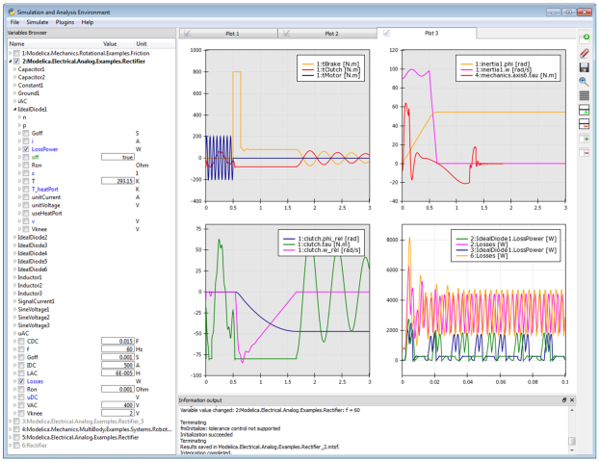
Figure 13-76: OMShell screenshot for creating an FMU

Read more about the PySimulator here https://github.com/PySimulator/PySimulator.

Modelica and Python Scripting API
The following are short summaries of OpenModelica scripting commands. These commands are useful for loading and saving classes, reading and storing data, plotting of results, and various other tasks.
The arguments passed to a scripting function should follow syntactic and typing rules for Modelica and for the scripting function in question. In the following tables we briefly indicate the types or character of the formal parameters to the functions by the following notation:
- String typed argument, e.g. "hello", "myfile.mo".
- TypeName – class, package or function name, e.g. MyClass, Modelica.Math.
- VariableName – variable name, e.g. v1, v2, vars1[2].x, etc.
- Integer or Real typed argument, e.g. 35, 3.14, xintvariable.
- options – optional parameters with named formal parameter passing.

OpenModelica Modelica Scripting Commands
The following are brief descriptions of the scripting commands available in the OpenModelica environment.

OpenModelica Basic Commands
This is a selection of the most common commands related to simulation and plotting:

checkModel(className) | Checks a model and returns number of variables and equations. Inputs: TypeName className; Outputs: String res;
clear() | Clears everything in OpenModelica compiler and interpreter workspace: symboltable and variables. Outputs: Boolean res;
getMessagesString() | Returns the current error message. Outputs: String messagesString;
help() | Display the OpenModelica help text.  Outputs: String helpText;
importFMU(fileName, workDir) | Imports a Functional Mockup Unit. Inputs: String filename; String workdir "./" "The output directory for imported FMU files. <default> will put the files to current working directory."; Outputs: Boolean res;
instantiateModel(className) | Flatten model, resulting in a .mof file of flattened Modelica. Inputs: TypeName className; Outputs: String res;
list(className) | Print class definition. Inputs: TypeName className;  Outputs: String classDef;
listVariables() | Print user defined variables. Outputs: VariableName res;
loadFile(fileName) | Load models from file.  Inputs: String fileName; Outputs: Boolean res;
loadModel(className) | Load the file corresponding to the class, using the Modelica class name to file name mapping to locate the file.  Inputs: TypeName className; Outputs: Boolean res;
plot(variable, options) | Plot variable, which is a single variable name.  Inputs: VariableName variable; String title; Boolean legend; Boolean gridLines;  Real xrange[2] i.e. {xmin,xmax};  Real yrange[2] i.e. {ymin,ymax};  Outputs: Boolean res;
plot(variables, options) | Plot variables, which is a vector of variable names.  Inputs: VariableName variables; String title; Boolean legend; Boolean gridLines;  Real xrange[2] i.e. {xmin,xmax};  Real yrange[2] i.e. {ymin,ymax};  Outputs: Boolean res;
plotParametric(variables1,  variables2, options) | Plot each pair of corresponding variables from the vectors of variables variables1, variables2 as a parametric plot.  Inputs: VariableName variables1[:]; VariableName variables2[size(variables1,1)]; String title; Boolean legend; Boolean gridLines; Real range[2,2]; Outputs: Boolean res;
readFile(fileName) | The contents of the given file are returned. Note that if the function fails, the error message is returned as a string instead of multiple outputs or similar.  Inputs: String fileName; Outputs: String content;
save(className) | Save class definition.  Inputs: TypeName className Outputs: Boolean res;
saveAll(fileName) | Save the entire loaded AST (Abstract Syntax Tree internal representation of all loaded models) as text to a file.  Inputs: String fileName; Outputs: Boolean res;
saveModel(fileName, className) | Save class definition in a file. Inputs: String fileName; TypeName className Outputs: Boolean res;
saveTotalModel(fileName, className) | Save total class definition into file of a class. Inputs: String fileName; TypeName className Outputs: Boolean res;
setDebugFlags(debugFlags) | Inputs: String debugFlags; Outputs: Boolean res;
setInitXmlStartValue(fileName, variableName, startValue, outputFile) | Sets the parameter start value in the model_init.xml file. No need to recompile the model. Inputs: String fileName; String variableName; String startValue; String outputFile; Outputs: Boolean success;
simulate(className, options) | Simulate model, optionally setting simulation values.  Inputs: TypeName className; Real startTime;  Real stopTime; Integer numberOfIntervals;  Real outputInterval; String method;  Real tolerance; Real fixedStepSize;  Outputs: SimulationResult simRes;
typeOf(variableName) | Inputs: VariableName variableName; Outputs: String res;
val(var, timepoint) | Returns the value of the variable at a certain time point.  Inputs: VariableName var; Real timepoint; Outputs: Real valAtTime;

OpenModelica System Commands
This is a selection of common OpenModelica commands related to the operating system:

cd(dir) | Change directory. Inputs: String dir;  Outputs: Boolean res;
deleteFile(fileName) | Deletes a file with the given name. Inputs: String fileName; Outputs: Boolean res;
dirName(path) | Returns the directory name of a file path. Inputs: String path; Outputs: String dirName;
runScript(fileName) | Executes the script file given as argument.  Inputs: String fileName; Outputs: Boolean res;
setLanguageStandard(  inVersion) | Sets the Modelica Language Standard. Inputs: String inVersion; Outputs: Boolean res;
setModelicaPath(  modelicaPath) | Sets the modelica path. See loadModel() for a description of what the MODELICAPATH is used for.  Inputs: String modelicaPath; Outputs: Boolean res;
system(fileName) | Execute system command. Inputs: String fileName; Outputs: Integer res;
writeFile(fileName, data, optional) | Write the data to file. Returns true on success.  Inputs: String fileName; String data; Boolean append; Outputs: Boolean res;

All OpenModelica API Calls

All OpenModelica API commands shown in alphabetic order:

appendEnvironmentVar(var, value) | Appends a variable to the environment variables list. Inputs: String var; String value; Outputs: String res;
baseName(path) | Returns the base name (file part) of a file path.  Inputs: String path; Outputs: String basename;
cd(dir) | Change directory. Inputs: String dir;  Outputs: Boolean res;
checkAllModelsRecursive(  className, protected) | Checks all models recursively and returns number of variables and equations. Inputs: TypeName className;  Boolean protected Outputs: String res;
checkModel(className) | Checks a model and returns number of variables and equations. Inputs: TypeName className; Outputs: String res;
checkSettings() | Display some diagnostics. Outputs: CheckSettingsResult res;
clear() | Clears everything: symboltable and variables.  Outputs: Boolean res;
clearMessages() | Clears the error buffer. Outputs: Boolean res;
clearVariables() | Clear all user defined variables. Outputs: Boolean res;
codeToString(className) | Converts to a string after encoding. Inputs: $Code className; Outputs: String res;
compareSimulationResults(  fileName, refFileName, logFileName, refTol, absTol,vars) | Compares simulation results. Inputs: String fileName; String refFileName; String logFileName; Real refTol; Real absTol; String[:] vars; Outputs: String res;
deleteFile(fileName) | Deletes a file with the given name. Inputs: String fileName; Outputs: Boolean res;
dirName(path) | Returns the directory name of a file path. Inputs: String path; Outputs: String dirName;
dumpXMLDAE(className) | Outputs the DAE system corresponding to a specific model. Inputs: TypeName className; Outputs: String res;
echo(setEcho) | echo (false) disables Interactive output, echo(true) enables it again. Inputs: Boolean setEcho; Outputs: Boolean newEcho;
generateCode(className) | Generate C-code and compiled into a dll. Inputs: TypeName className; Outputs: Boolean res;
generateHeader(fileName) | Generates a C header file containing the external C interface of the MetaModelica uniontypes in the loaded files. This C interface is called by the parser to build nodes for the abstract syntax tree. Inputs: String fileName; Outputs: Boolean res;
getAlgorithmCount(className) | Counts the number of Algorithm sections in a class. Inputs: TypeName className; Outputs: Integer count;
getAlgorithmItemsCount(  className) | Counts the number of Algorithm items in a class. Inputs: TypeName className; Outputs: Integer count;
getAnnotationCount(  className) | Counts the number of Annotation sections in a class. Inputs: TypeName className; Outputs: Integer count;
getAnnotationVersion() | Returns the current annotation version. Outputs: String annotationVersion;
getAstAsCorbaString(  fileName) | Print the whole AST on the CORBA format for records. Inputs: String fileName; Outputs: String res;
getClassComment(className) | Returns the class comment. Inputs: TypeName className; Outputs: String comment;
getClassNames(fileName) | Returns the list of class names defined in the class. Inputs: String fileName; Outputs: TypeName classNames;
getClassRestriction(className) | Returns the type of class. Inputs: TypeName className; Outputs: String restriction;
getClassInformation(className) | Returns the list containing the information of the class. Inputs: TypeName className; Outputs: String information;
getClassesInModelicaPath() | Outputs: String classesInModelicaPath;
getCompileCommand() | Outputs: String compileCommand;
getIconAnnotation(className) | Returns the icon representation of the class. Inputs: TypeName className; Outputs: String out;
getDiagramAnnotation(className) | Returns the diagram representation of the class. Inputs: TypeName className; Outputs: String out;
getParameterName(className) | Returns the list of parameters present in the class. Inputs: TypeName className; Outputs: String out;
getParameterValue(className, parameter) | Returns the parameter value. Inputs: TypeName className; String parameter; Outputs: String value;
getComponentModifierNames(className) | Returns the list of component modifiers present in the class. Inputs: TypeName className; Outputs: String out;
getComponentModifierValue(className, modifier) | Returns the component modifier value. Inputs: TypeName className; String modifier; Outputs: String value;
getExtendsModifierNames(className) | Returns the list of extends modifiers present in the class. Inputs: TypeName className; Outputs: String out;
getExtendsModifierValue(className, modifier) | Returns the extends modifier value. Inputs: TypeName className; String modifier; Outputs: String value;
getDocumentationAnnotation (className) | Returns the documentation annotation defined in the class. Inputs: TypeName className; Outputs: String out[2] "{info,revision}";
getEnvironmentVar(var) | Returns the value of the environment variable. Inputs: String var; Outputs: String value;
getEquationCount(className) | Counts the number of Equation sections in a class. Inputs: TypeName className; Outputs: Integer count;
getEquationItemsCount(  className) | Counts the number of Equation items in a class. Inputs: TypeName className; Outputs: Integer count;
getErrorString() | Returns the current error message. Outputs: String errorString;
getImportCount (className) | Counts the number of Import sections in a class. Inputs: TypeName className; Outputs: Integer count;
getInitialAlgorithmCount(  className) | Counts the number of Initial Algorithm sections in a class. Inputs: TypeName className; Outputs: Integer count;
getInitialAlgorithmItemsCount(className) | Counts the number of Initial Algorithm items in a class. Inputs: TypeName className; Outputs: Integer count;
getInitialEquationCount(  className) | Counts the number of Initial Equation sections in a class. Inputs: TypeName className; Outputs: Integer count;
getInitialEquationItemsCount (className) | Counts the number of Initial Equation items in a class. Inputs: TypeName className; Outputs: Integer count;
getInstallationDirectoryPath () | Returns OPENMODELICAHOME if it is set; on some platforms the default path is returned if it is not set. Outputs: String installationDirectoryPath;
getLanguageStandard() | Returns the current Modelica Language Standard in use. Outputs: String outVersion;
getMessagesString() | Returns the current error message. Outputs: String messagesString;
getMessagesStringInternal() | Returns Error: message, TRANSLATION, Error, code. Outputs: ErrorMessage[:] messagesString;
getModelicaPath() | Get the Modelica Library Path. Outputs: String modelicaPath;
getNoSimplify() | Returns true if noSimplify flag is set. Outputs: Boolean res;
getNthAlgorithm(className, index) | Returns the Nth Algorithm section. Inputs: TypeName className; Integer index; Outputs: String res;
getNthAlgorithmItem(  className, index) | Returns the Nth Algorithm Item. Inputs: TypeName className; Integer index; Outputs: String res;
getNthAnnotationString (className, index) | Returns the Nth Annotation section as string. Inputs: TypeName className; Integer index; Outputs: String res;
getNthEquation(className, index) | Returns the Nth Equation section. Inputs: TypeName className; Integer index; Outputs: String res;
getNthEquationItem(  className) | Returns the Nth Equation Item. Inputs: TypeName className; Integer index; Outputs: String res;
getNthImport(className, index) | Returns the Nth Import as string. Inputs: TypeName className; Integer index; Outputs: String out[3] "{\"Path\",\"Id\",\"Kind\"}";
getNthInitialAlgorithm(  className, index) | Returns the Nth Initial Algorithm section. Inputs: TypeName className; Integer index; Outputs: String res;
getNthInitialAlgorithmItem(  className, index) | Returns the Nth Initial Algorithm Item. Inputs: TypeName className; Integer index; Outputs: String res;
getNthInitialEquation(  className, index) | Returns the Nth Initial Equation section. Inputs: TypeName className; Integer index; Outputs: String res;
getNthInitialEquationItem(  className, index) | Returns the Nth Initial Equation Item. Inputs: TypeName className; Integer index; Outputs: String res;
getOrderConnections() | Returns true if orderConnections flag is set.  Outputs: Boolean isOrderConnections;
getPackages(className) | Returns the list of packages defined in the class. Inputs: TypeName className = $Code(AllLoadedClasses); Outputs: TypeName classNames[:];
getPlotSilent() | Returns true if plotSilent flag is set.  Outputs: Boolean isPlotSilent;
getSettings() | Returns the settings. Outputs: String settings;
getShowAnnotations() | Outputs: Boolean show;
getSourceFile(className) | Returns the filename of the class. Inputs: TypeName className; Outputs: String filename;
getTempDirectoryPath() | Returns the current user temporary directory location.  Outputs: String tempDirectoryPath;
getVectorizationLimit() | Outputs: Integer vectorizationLimit;
getVersion(c1) | Returns the version of the Modelica compiler. Inputs: TypeName c1 = $Code(OpenModelica); Outputs: String version;
help() | Display the OpenModelica help text.  Outputs: String helpText;
iconv(string, from, to) | Converts one multibyte characters from one character set to another. Inputs: String string; String from; String to; Outputs: String res;
importFMU(fileName, workDir) | Imports the Functional Mockup Unit. Inputs: String filename; String workdir "./" "The output directory for imported FMU files. <default> will put the files to current working directory."; Outputs: Boolean res;
instantiateModel(className) | Instantiate model, resulting in a .mof file of flattened Modelica. Inputs: TypeName className; Outputs: String res;
isModel(className) | Returns true if the given class has restriction model.  Inputs: TypeName className; Outputs: Boolean res;
isPackage(className) | Returns true if the given class is a package.  Inputs: TypeName className; Outputs: Boolean res;
isPartial(className) | Returns true if the given class is partial.  Inputs: TypeName className; Outputs: Boolean res;
list(className) | Print class definition. Inputs: TypeName className;  Outputs: String classDef;
listVariables() | Print user defined variables. Outputs: VariableName res;
loadFile(fileName) | Load models from file.  Inputs: String fileName; Outputs: Boolean res;
loadFileInteractive(  fileName) | Outputs the class names in the parsed file (top level only). Used by OpenModelica MDT. Inputs: String fileName; Outputs: TypeName names[:];
loadFileInteractiveQualified(fileName) | Output all the class names in the parsed file fully qualified. Inputs: String fileName; Outputs: TypeName names[:];
loadModel(className) | Load the file corresponding to the class, using the Modelica class name to file name mapping to locate the file.  Inputs: TypeName className; Outputs: Boolean res;
loadString(data) | Parses the data and merges the resulting AST with the loaded AST. Inputs: String data; Outputs: TypeName names[:];
parseFile(filename) | Parses the file and returns a list of the classes found in the file. Inputs: String filename; Outputs: TypeName names[:];
parseString(data) | Parses the string data and returns the list of classes found in data. Inputs: String data; Outputs: TypeName names[:];
plot(variable, options) | Plots variable, which is a single variable name.  Inputs: VariableName variable; String title; Boolean legend; Boolean gridLines;  Real xrange[2] i.e. {xmin,xmax};  Real yrange[2] i.e. {ymin,ymax};  Outputs: Boolean res;
plot(variables, options) | Plots variables, which is a vector of variable names.  Inputs: VariableName variables; String title; Boolean legend; Boolean gridLines;  Real xrange[2] i.e., {xmin,xmax};  Real yrange[2] i.e., {ymin,ymax};  Outputs: Boolean res;
plotAll(options) | Plot all variables; It does not accept any variable names as input .  Inputs: String title; Boolean legend; Boolean gridLines; Real xrange[2] i.e., {xmin,xmax};  Real yrange[2] i.e., {ymin,ymax};  Outputs: Boolean res;
plotParametric(variables1,  variables2, options) | Plot each pair of corresponding variables from the vectors of variables variables1, variables2 as a parametric plot.  Inputs: VariableName variables1[:]; VariableName variables2[size(variables1,1)]; String title; Boolean legend; Boolean gridLines; Real range[2,2]; Outputs: Boolean res;
readFile(fileName) | The contents of the given file are returned. Note that if the function fails, the error message is returned as a string instead of multiple outputs or similar.  Inputs: String fileName; Outputs: String content;
readFileNoNumeric(fileName) | Returns the contents of the file, with anything resembling a (real) number stripped out, and at the end adding: Inputs: String fileName; Outputs: String content;
readFilePostprocessLineDirective(fileName) | Searches lines for the #modelicaLine directive. Inputs: String fileName; Outputs: String res;
readFileShowLineNumbers(  fileName) | Prefixes each line in the file with <n>: where n is the line number.  Note: Scales O(n^2)  Inputs: String fileName; Outputs: String res;
readSimulationResult(  fileName, variables, size) | Reads the simulation result for a list of variables and returns a matrix of values (each column as a vector or values for a variable.) Size of result is also given as input. Inputs: String fileName; VariableName variables[:]; Integer size;  Outputs: Real res[size(variables,1),size)];
readSimulationResultSize(  fileName) | The number of intervals that are present in the output file. Inputs: String fileName; Outputs: Integer size;
readSimulationResultVars(  fileName) | Returns the variables in the simulation file; you can use val() and plot() commands using these names. Inputs: String fileName; Outputs: String[:] vars;
regex(string, re, options) | Sets the error buffer and returns -1 if the regular expression does not compile. Inputs: String string; String re; Integer maxMatches; Boolean extended; Boolean caseInsensitive; Outputs: Integer numMatches; String matchedSubstrings[maxMatches];
regexBool(string, re, options) | Returns true if the string matches the regular expression.  Inputs: String string; String re; Boolean extended; Boolean caseInsensitive; Outputs: Boolean matches;
regularFileExists(fileName) | Returns the content of the given files. Note that if the function fails, the error message is returned as a string instead of multiple outputs or similar.  Inputs: String fileName; Outputs: Boolean res;
reopenStandardStream(  _stream, fileName) | Executes the script file given as argument.  Inputs: String fileName; StandardStream _stream; Outputs: Boolean res;
runScript(fileName) | Executes the script file given as argument.  Inputs: String fileName; Outputs: Boolean res;
save(className) | Save class definition.  Inputs: TypeName className Outputs: Boolean res;
saveAll(fileName) | Save the entire loaded AST to file.  Inputs: String fileName; Outputs: Boolean res;
saveModel(fileName, className) | Save class definition in a file. Inputs: String fileName; TypeName className Outputs: Boolean res;
saveTotalModel(fileName, className) | Save total class definition into file of a class. Inputs: String fileName; TypeName className Outputs: Boolean res;
saveTotalSCode(fileName, className) | Inputs: String fileName; TypeName className Outputs: Boolean res;
setAnnotationVersion(  annotationVersion) | Sets the annotation version. Inputs: String annotationVersion; Outputs: Boolean res;
setCXXCompiler(compiler) | Inputs: String compiler; Outputs: Boolean res;
setClassComment(className, fileName) | Sets the class comment. Inputs: String fileName; TypeName className Outputs: Boolean res;
saveTotalModel(fileName, className) | Save total class definition into file of a class. Inputs: String fileName; TypeName className Outputs: Boolean res;
setCompileCommand(  compileCommand) | Sets the default Compilation command. Inputs: String compileCommand; Outputs: Boolean res;
setCompiler(compiler) | Sets the default C Compiler. Inputs: String compiler; Outputs: Boolean res;
setCompilerFlags(  compilerFlags) | Sets the compiler flags that are used while compiling the simulation executable. Inputs: String compilerFlags; Outputs: Boolean res;
setCompilerPath(  compilerPath) | Sets the default compiler location. Inputs: String compilerPath; Outputs: Boolean res;
setComponentModifierValue(className, modifier, value) | Sets the component modifier value. Inputs: TypeName className; String modifier; String value; Outputs: Boolean result;
setDebugFlags(debugFlags) | Sets the debug flags. For details run “omc +help=debug” on the command line interface. Inputs: String debugFlags; Outputs: Boolean res;
setEnvironmentVar(var, value) | Sets an environment variable. Inputs: String var; String value; Outputs: Boolean res;
setExtendsModifierValue(className, modifier, value) | Sets the extends modifier value. Inputs: TypeName className; String modifier; String value; Outputs: Boolean result;
setIndexReductionMethod(  method) | Sets the index reduction method e.g setIndexReductionMethod ("dynamicStateSelection"). Inputs: String method; Outputs: Boolean res;
setInitXmlStartValue(fileName, variableName, startValue, outputFile) | Sets the parameter start value in the model_init.xml file. No need to recompile the model. Inputs: String fileName; String variableName; String startValue; String outputFile; Outputs: Boolean success;
setInstallationDirectoryPath (debugFlags) | Sets the OPENMODELICAHOME environment variable.  Inputs: String installationDirectoryPath; Outputs: Boolean res;
setLanguageStandard(  inVersion) | Sets the Modelica Language Standard. Inputs: String inVersion; Outputs: Boolean res;
setLinker(linker) | Sets the linker.  Inputs: String linker; Outputs: Boolean res;
setLinkerFlags(linkerFlag) | Sets the linker flag.  Inputs: String linkerFlag; Outputs: Boolean res;
setModelicaPath(  modelicaPath) | Sets the modelica path. See loadModel() for a description of what the MODELICAPATH is used for.  Inputs: String modelicaPath; Outputs: Boolean res;
setNoSimplify(noSimplify) | Sets the noSimplify flag.  Inputs: Boolean noSimplify; Outputs: Boolean res;
setOrderConnections(  debugFlags) | Sets orderering for connect equation. If set, the compiler will order connect equations alphabetically.  Inputs: Boolean orderConnections; Outputs: Boolean res;
setParameterValue(className, parameter, value) | Sets the parameter value in the class, i.e., updates the parameter definition equation. Inputs: TypeName className; String parameter; String value; Outputs: Boolean result;
setPlotSilent(silent) | Sets the plotSilent flag. If the flag is true show the OMPlot window and pass the arguments to it. If the flag is false don’t show OMPlot and just output the list of arguments. The false case is used in OMNotebook where the plot window is not shown; instead the arguments are read and an embedded plot window is created.  Inputs: Boolean silent; Outputs: Boolean res;
setPostOptModules(modules) | Sets the post optimization modules to use in the compiler back end. Use the command "omc +help=optmodules" for more information. Example: setPostOptModules("lateInline", "inlineArrayEqn","removeSimpleEquations") Inputs: String module1, module2, …; Outputs: Boolean res;
setPreOptModules(module) | Sets the pre optimization modules to use in the back end. Use the command line command "omc +help=optmodules" for more information. Inputs: String module; Outputs: Boolean res;
setShowAnnotations() | Show annotations in the flattened code. Inputs: Boolean show; Outputs: Boolean res;
setSourceFile(className, fileName) | Sets the output file name for the specified class. Inputs: TypeName className; String fileName; Outputs: Boolean res;
setTempDirectoryPath(tempDirectoryPath) | Sets the current user's temporary directory path. This is not the same as the current user's working directory which is set by the cd() command. Inputs: String tempDirectoryPath; Outputs: Boolean res;
setVectorizationLimit(  vectorizationLimit) | Sets scalarization limit. Arrays of size above this limit will not be scalarized, i.e., expanded to a set of scalar elements.  Inputs: Integer scalarizationLimit; Outputs: Boolean res;
simulate(className, options) | Simulate model, optionally setting simulation values.  Inputs: TypeName className; Real startTime;  Real stopTime; Integer numberOfIntervals;  Real outputInterval; String method;  Real tolerance; Real fixedStepSize;  Outputs: SimulationResult simRes;
stringReplace(str, source, target) | Relace source with target within str producing res.  Inputs: String str; String source; String target; Outputs: String res;
strtok() | Splits the strings at the places given by the token, for example: strtok("abcbdef","b") => {"a","c","def"}  Inputs: String string; String token; Outputs: String[:] strings;
system(fileName) | Execute system command. Inputs: String fileName; Outputs: Integer res;
typeNameString(c1) | Converts the qualified class name to string. Inputs: TypeName c1; Outputs: String out;
typeNameStrings(c1) | Converts the qualified class name to strings. Inputs: TypeName c1; Outputs: String out[:];
typeOf(variableName) | Inputs: VariableName variableName; Outputs: String res;
uriToFilename(uri) | Handles modelica:// and file:// URI's. The result is an absolute path on the local system. The result depends on the current MODELICAPATH. Returns the empty string on failure.  Inputs: String uri; Outputs: String fileName;
val(var, time) | Returns the value of the variable at a certain time point.  Inputs: VariableName var; Real time; Outputs: Real valAtTime;
writeFile(fileName, data, optional) | Write the data to file. Returns true on success.  Inputs: String fileName; String data; Boolean append; Outputs: Boolean res;

Examples
The following is an interactive session with the OpenModelica environment including some of the abovementioned commands and examples. First we start the system, and use the command line interface from OMShell, OMNotebook, or command window of some of the other tools. The system responds with a header line:
OpenModelica 1.9.0

We type in a very small model:
>> model test "Testing OpenModelica Scripts" Real x, y; equation x = 5.0; y = 6.0; end test;
{test}
We give the command to flatten a model:
>> instantiateModel(test)
"class test
Real x;
Real y;
equation
x = 5.0;
y = 6.0;
end test;
"
A range expression is typed in:
>> a:=1:10
{1,2,3,4,5,6,7,8,9,10}
It is multiplied by 2:
>> a*2
{2,4,6,8,10,12,14,16,18,20}
The variables are cleared:
>> clearVariables()
true
We print the loaded class test from its internal representation:
>> list(test)
"class test \"Testing OpenModelica Scripts\"
Real x;
Real y;
equation
x = 5.0;
y = 6.0;
end test;
"
We get the name and other properties of a class:
>> getClassNames()
{test}
>> getClassComment(test)
"Testing OpenModelica Scripts"
>> isPartial(test)
false
>> isPackage(test)
false
>> isModel(test)
true
>> checkModel(test)
"Check of test completed successfully.
Class test has 2 equation(s) and 2 variable(s).
2 of these are trivial equation(s).
"
>> clear()
true
>> getClassNames()
{}
The common combination of a simulation followed by getting a value and doing a plot:
>> simulate(test, stopTime=3.0);
>> val(x , 2.0)
5.0
>> plot(y)

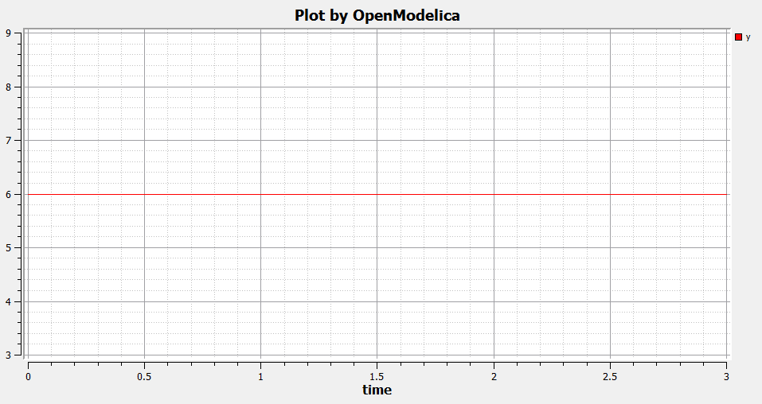
>> plotAll()
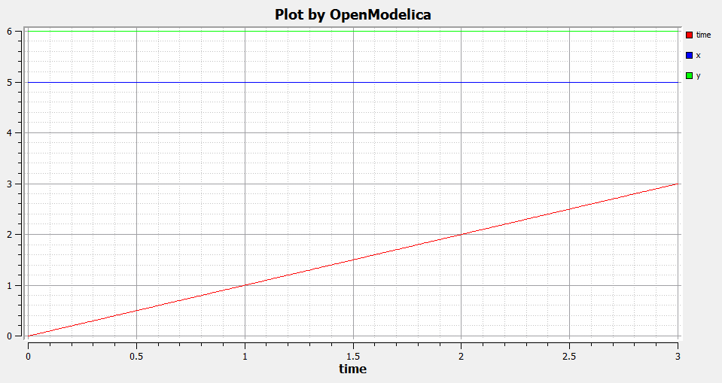

VanDerPol Model and Parametric Plot
>> loadFile("C:/OpenModelica1.9.0/share/doc/omc/testmodels/VanDerPol.mo")
true
>> instantiateModel(VanDerPol)
"class VanDerPol \"Van der Pol oscillator model\"
Real x(start = 1.0);
Real y(start = 1.0);
parameter Real lambda = 0.3;
equation
der(x) = y;
der(y) = lambda * (1.0 - x ^ 2.0) * y - x;
end VanDerPol;
"
>> simulate(VanDerPol);
>> plotParametric(x,y)

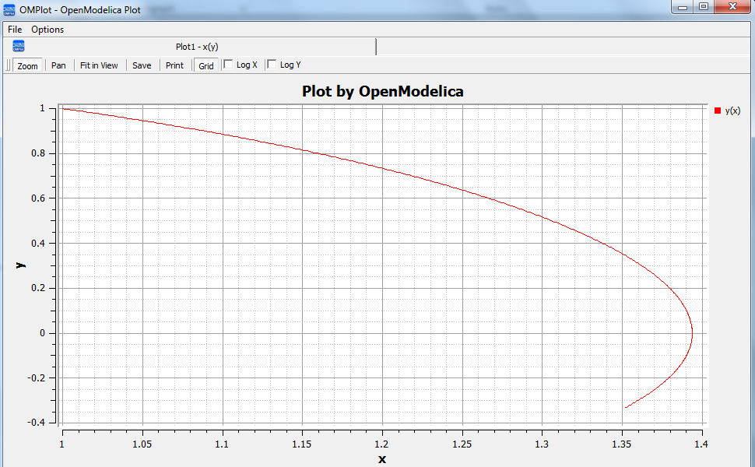

Interactive Function Calls, Reading, and Writing
We enter an assignment of a vector expression, created by the range construction expression 1:12, to be stored in the variable x. The type and the value of the expression is returned.
>> x := 1:12
{1, 2, 3, 4, 5, 6, 7, 8, 9, 10, 11, 12}
The function bubblesort is called to sort this vector in descending order. The sorted result is returned together with its type. Note that the result vector is of type Real[:], instantiated as Real[12], since this is the declared type of the function result. The input Integer vector was automatically converted to a Real vector according to the Modelica type coercion rules.
>> bubblesort(x)
{12, 11, 10, 9, 8, 7, 6, 5, 4, 3, 2, 1}
Now we want to try another small application, a simplex algorithm for optimization. First read in a small matrix containing coefficients that define a simplex problem to be solved:
>> a := read("simplex_in.txt")
{{-1,-1,-1, 0, 0, 0, 0, 0, 0},
{-1, 1, 0, 1, 0, 0, 0, 0, 5},
{ 1, 4, 0, 0, 1, 0, 0, 0, 45},
{ 2, 1, 0, 0, 0, 1, 0, 0, 27},
{ 3,-4, 0, 0, 0, 0, 1, 0, 24},
{ 0, 0, 1, 0, 0, 0, 0, 1, 4}}
Then call the simplex algorithm implemented as the Modelica function simplex1. This function returns four results, which are represented as a tuple of four return values:
>> simplex1(a)
Tuple: 4
Real[8]: {9, 9, 4, 5, 0, 0, 33, 0}
Real: 22
Integer: 9
Integer: 3
It is possible to compute an expression, e.g. 12:-1:1, and store the result in a file using the write command:
>> write(12:-1:1,"test.dat")
We can read back the stored result from the file into a variable y:
>> y := read("test.dat")
Integer[12]: {12, 11, 10, 9, 8, 7, 6, 5, 4, 3, 2, 1}
It is also possible to give operating system commands via the system utility function. A command is provided as a string argument. The example below shows system applied to the Linux command cat, which here outputs the contents of the file bubblesort.mo to the output stream.
>> system("cat bubblesort.mo")
function bubblesort
input Real[:] x;
output Real[size(x,1)] y;
protected
Real t;
algorithm
y := x;
for i in 1:size(x,1) loop
for j in 1:size(x,1) loop
if y[i] > y[j] then
t := y[i];
y[i] := y[j];
y[j] := t;
end if;
end for;
end for;
end bubblesort;
Another built-in command is cd, the change current directory command. The resulting current directory is returned as a string.
>> cd("..")
"/home/petfr/modelica"

OpenModelica Python Scripting Commands
The OpenModelica Python API Interface—OMPython, attempts to mimic the Modelica scripting commands available in the OpenModelica environment, see the table in Section 13.1.4 for available Python scripting commands. To test the command outputs, see some test examples described in section 13.1.

Frequently Asked Questions (FAQ)
Below are some frequently asked questions in three areas, with associated answers.

OpenModelica General
- Q: OpenModelica does not read the MODELICAPATH environment variable, even though this is part of the Modelica Language Specification.
- A: Use the OPENMODELICALIBRARY environment variable instead. We have temporarily switched to this variable, in order not to interfere with other Modelica tools which might be installed on the same system. In the future, we might switch to a solution with a settings file, that also allows the user to turn on the MODELICAPATH functionality if desired.
- Q: How do I enter multi-line models into OMShell since it evaluates when typing the Enter/Return key?
- A: There are basically three methods: 1) load the model from a file using the pull-down menu or the loadModel command. 2) Enter the model/function as one (possibly long) line. 3) Type in the model in another editor, where using multiple lines is no problem, and copy/paste the model into OMShell as one operation, then push Enter. Another option is to use OMNotebook instead to enter and evaluate models.

OMNotebook
- Q: OMNotebook hangs, what to do?
- A: It is probably waiting for the omc.exe (compiler) process. (Under windows): Kill the processes omc.exe, g++.exe (C-compiler), as.exe (assembler), if present. If OMNotebook then asks whether to restart OMC, answer yes. If not, kill the process OMNotebook.exe and restart manually.
- Q: After a previous session, when starting OMNotebook again, I get a strange message.
- A: You probably quit the previous OpenModelica session in the wrong way, which left the process omc.exe running. Kill that process, and try starting OMNotebook again.
- Q: I copy and paste a graphic figure from Word or some other application into OMNotebook, but the graphic does not appear. What is wrong?
- A: OMNotebook supports the graphic picture formats supported by Qt 4, including the .png, .bmp (bitmap) formats, but not for example the gif format. Try to convert your picture into one of the supported formats, (e.g. in Word, first do paste as bitmap format), and then copy the converted version into a text cell in OMNotebook.
- Q: I select a cell, copy it (e.g. Ctrl-C), and try to paste it at another place in the notebook. However, this does not work. Instead some other text that I earlier put on the clipboard is pasted into the nearest text cell.
- A: The problem is wrong choice of cursor mode, which can be text insertion or cell insertion. If you click inside a cell, the cursor become vertical, and OMNotebook expects you to paste text inside the cell. To paste a cell, you must be in cell insertion mode, i.e., click between two cells (or after a cell), you will get a vertical line. Place the cursor carefully on that vertical line until you see a small horizontal cursor. Then you should past the cell.
- Q: I am trying to click in cells to place the vertical character cursor, but it does not seem to react.
- A: This seems to be a Qt feature. You have probably made a selection (e.g. for copying) in the output section of an evaluation cell. This seems to block cursor position. Click again in the output section to disable the selection. After that it will work normally.
- Q: I have copied a text cell and start writing at the beginning of the cell. Strangely enough, the font becomes much smaller than it should be.
- A: This seems to be a Qt feature. Keep some of the old text and start writing the new stuff inside the text, i.e., at least one character position to the right. Afterwards, delete the old text at the beginning of the cell.

OMDev - OpenModelica Development Environment
- Q: I get problems compiling and linking some files when using OMDev with the MINGW (Gnu) C compiler under Windows.
- A: You probably have some Logitech software installed. There is a known bug/incompatibility in Logitech products. For example, if lvprcsrv.exe is running, kill it and/or prevent it to start again at reboot; it does not do anything really useful, not needed for operation of web cameras or mice.

- Major OpenModelica Releases
This Appendix lists the most important OpenModelica releases and a brief description of their contents. Right now the versions from 1.3.1 to 1.9.2 are described.

  - OpenModelica 1.9.2, February 2015
The most important enhancements in the OpenModelica 1.9.2 release:
- The OpenModelica compiler has moved to a new development and release platform: the bootstrapped OpenModelica compiler. This gives advantages in terms of better programmability, maintenance, debugging, modularity and current/future performance increases.
- The OpenModelica graphic connection editor OMEdit has become 3-5 times faster due to faster communication with the OpenModelica compiler linked as a DLL. This was made possible by moving to the bootstrapped compiler.
- Further improved simulation coverage for a number of libraries.
- OMEdit graphic connection editor improvements
    - OpenModelica Compiler (OMC)
This release mainly includes improvements of the OpenModelica Compiler (OMC), including, but not restricted to the following:
- The OpenModelica compiler has moved to a new development and release platform: the bootstrapped OpenModelica compiler. This gives advantages in terms of better programmability, maintenance, debugging, modularity and current/future performance increases.
- Further improved simulation coverage for a number of libraries compared to 1.9.1 (Oct 25, 2014). For example:
  - MSL 3.2.1 100% compilation, 97% simulation (3% increase)
  - MSL Trunk 99% compilation (1% increase), 93% simulation (3% increase)
  - ModelicaTest 3.2.1 99% compilation (2% increase), 95% simulation (6% increase)
  - ThermoSysPro 100% compilation, 80% simulation (17% increase)
  - ThermoPower 97% compilation (5% increase), 85% simulation (5% increase)
  - Buildings 80% compilation (1% increase), 73% simulation (1% increase)
- Further enhanced OMC compiler front-end coverage, scalability, speed and memory.
- Better initialization.
- Improved tearing.
- Improved non-linear, linear and mixed system solving.
- Common subexpression elimination support - drastically increases performance of some models.
    - OpenModelica Notebook (OMNotebook)
No changes apart from bug fixing.
    - OpenModelica Shell (OMShell)
No changes.
    - OpenModelica Eclipse Plug-in (MDT)
No changes apart from bug fixing.
    - OpenModelica Development Environment (OMDev)
No changes apart from bug fixing.
    - Graphic Editor OMEdit
- The OpenModelica graphic connection editor OMEdit has become 3-5 times faster due to faster communication with the OpenModelica compiler linked as a DLL. This was made possible by moving to the bootstrapped compiler.
- Enhanced simulation setup window in OMEdit, which among other things include better support for integration methods and dassl options.
- Support for running multiple simultaneous simulation.
- Improved handling of modifiers.
- Re-simulate with changed options, including history support and re-simulating with previous options possibly edited.
- More user friendly user interface by improved connection line drawing, added snap to grid for icons and conversion of icons from PNG to SVG, and some additional fixes.
    - Optimization
Some smaller improvements of the Dynamic Optimization module with collocation, using Ipopt.
    - FMI Support
Further improved for FMI 2.0 model exchange import and export, now compliant according to the FMI compliance tests. FMI 1.0 support has been further improved.

  - OpenModelica 1.9.1, October 2014
The most important enhancements in the OpenModelica 1.9.1 release:
- Improved library support.
- Further enhanced OMC compiler front-end coverage and scalability
- Significant improved simulation support for libraries using Fluid and Media.
- Dynamic model debugger for equation-based models integrated with OMEdit.
- Dynamic algorithm model debugger with OMEdit; including support for MetaModelica when using the bootstrapped compiler.
New features: Dynamic debugger for equation-based models; Dynamic Optimization with collocation built into OpenModelica, performance analyzer integrated with the equation model debugger.
    - OpenModelica Compiler (OMC)
This release mainly includes improvements of the OpenModelica Compiler (OMC), including, but not restricted to the following:
- Further improved OMC model compiler support for a number of libraries including MSL 3.2.1, ModelicaTest 3.2.1, PetriNet, Buildings, PowerSystems, OpenHydraulics, ThermoPower, and ThermoSysPro.
- Further enhanced OMC compiler front-end coverage, scalability, speed and memory.
- Better coverage of Modelica libraries using Fluid and Media.
- Automatic differentiation of algorithms and functions.
- Improved testing facilities and library coverage reporting.
- Improved model compilation speed by compiling model parts in parallel (bootstrapped compiler).
- Support for running model simulations in a web browser.
- New faster initialization that handles over-determined systems, under-determined systems, or both.
- Compiler back-end partly redesigned for improved scalability and better modularity.
- Better tearing support.
- The first run-time Modelica equation-based model debugger, not available in any other Modelica tool, integrated with OMEdit.
- Enhanced performance profiler integrated with the debugger.
- Improved parallelization prototype with several parallelization strategies, task merging and duplication, shorter critical paths, several scheduling strategies.
- Some support for general solving of mixed systems of equations.
- Better error messages.
- Improved bootstrapped OpenModelica compiler.
- Better handling of array subscripts and dimensions.
- Improved support for reduction functions and operators.
- Better support for partial functions.
- Better support for function tail recursion, which reduces memory usage.
- Partial function evaluation in the back-end to improve solving singular systems.
- Better handling of events/zero crossings.
- Support for colored Jacobians.
- New differentiation package that can handle a much larger number of expressions.
- Support for sparse solvers.
- Better handling of asserts.
- Improved array and matrix support.
- Improved overloaded operators support.
- Improved handling of overconstrained connection graphs.
- Better support for the cardinality operator.
- Parallel compilation of generated code for speeding up compilation.
- Split of model files into several for better compilation scalability.
- Default linear tearing.
- Support for impure functions.
- Better compilation flag documentation.
- Better automatic generation of documentation.
- Better support for calling functions via instance.
- New text template based unparsing for DAE, Absyn, SCode, TaskGraphs, etc.
- Better support for external objects.
- Improved C++ runtime.
- Improved testing facilities.
- New unit checking implementation.
- Support for model rewriting expressions via rewriting rules in an external file.
    - OpenModelica Notebook (OMNotebook)
No changes apart from bug fixing.
    - OpenModelica Shell (OMShell)
No changes.
    - OpenModelica Eclipse Plug-in (MDT)
No changes apart from bug fixing.
    - OpenModelica Development Environment (OMDev)
No changes apart from bug fixing.
    - Graphic Editor OMEdit
- Convenient editing of model parameter values and re-simulation without recompilation after parameter changes.
- Improved plotting.
- Better handling of flags/units/resources/crashes.
- Run-time Modelica equation-based model debugger that provides both dynamic run-time debugging and debugging of symbolic transformations.
- Run-time Modelica algorithmic code debugger; also MetaModelica debugger with the bootstrapped OpenModelica compiler.
    - Optimization
A builtin integrated Dynamic Optimization module with collocation, using Ipopt, is now available.
    - FMI Support
Support for FMI 2.0 model exchange import and export has been added. FMI 1.0 support has been further improved.
  - OpenModelica 1.9.0, October 2013
The three most important enhancements in the OpenModelica 1.9.0 release:
- OpenModelica compiler support for most of the Fluid library.
- Support for the significantly updated library MSL 3.2.1 final version.
- Significantly enhanced graphical user interface in OMEdit.
New features: integration of the PySimulator analysis package; Dynamic Optimization with CasADi.
    - OpenModelica Compiler (OMC)
This release mainly includes improvements of the OpenModelica Compiler (OMC), including, but not restricted to the following:
- A more stable and complete OMC model compiler. The 1.9.0 final version simulates many more models than the previous 1.8.1 version and OpenModelica 1.9.0 beta versions.
- Much better simulation support for MSL 3.2.1, now 270 out of 274 example models compile (98%) and 247 (90%) simulate, compared to 30% simulating in the 1.9.0 beta1 release.
- Much better simulation for the ModelicaTest 3.2.1 library, now 412 out of 428 models compile (96%), and 380 (88%) simulate, compared to 32% in November 2012.
- Improved tearing algorithm for the compiler backend. Tearing is by default used.
- Much faster matching and dynamic state selection algorithms for the compiler backend.
- New index reduction algorithm implementation.
- New default initialization method that symbolically solves the initialization problem much faster and more accurately. This is the first version that in general initialize hybrid models correctly.
- Better class loading from files. The package.order file is now respected and the file structure is more thoroughly examined.
- Basic support for pure/impure functions.
- It is now possible to translate the error messages in the omc kernel.
- Enhanced ModelicaML version with support for value bindings in requirements-driven modeling available for the latest Eclipse and Papyrus versions. GUI specific adaptations. Automated model composition workflows (used for model-based design verification against requirements) are modularized and have improved in terms of performance.
- FMI for co-simulation with OMC as master. Improved FMI import/export, model exchange.
- Checking (when possible) that variables have been assigned to before they are used in algorithmic code.
- Full version of Python scripting.
- 3D graphics visualization using the Modelica3D library.
- The PySimulator package from DLR for additional analysis is integrated with OpenModelica (see Modelica2012 paper), and included in the OpenModelica distribution.
- Prototype support for uncertainty computations, special feature enabled by special flag.
- Parallel algorithmic Modelica support (ParModelica) for efficient portable parallel algorithmic programming based on the OpenCL standard, for CPUs and GPUs.
- Support for optimization of semiLinear according to MSL 3.3 chapter 3.7.2.5 semiLinear.
    - OpenModelica Notebook (OMNotebook)
The DrModelica interactive document has been updated and the models tested. Almost all models now simulate with OpenModelica.
    - OpenModelica Shell (OMShell)
No changes.
    - OpenModelica Eclipse Plug-in (MDT)
Enhanced debugger for algorithmic Modelica code, supporting both standard Modelica algorithmic code called from simulation models, and MetaModelica code.
    - OpenModelica Development Environment (OMDev)
Migration of version handling and configuration management from CodeBeamer to Trac.
    - Graphic Editor OMEdit
- General GUI: backward and forward navigation support in Documentation view, enhanced parameters window with support for Dialog annotation. Most of the images are converted from raster to vector graphics i.e PNG to SVG.
- Libraries Browser: better loading of libraries, library tree can now show protected classes, show library items class names as middle ellipses if the class name text is larger, more options via the right click menu for quick usage.
- ModelWidget: add the partial class as a replaceable component, look for the default component prefixes and name when adding the component.
- GraphicsView: coordinate system manipulation for icon and diagram layers. Show red box for models that do not exist. Show default graphical annotation for the components that doesn’t have any graphical annotations. Better resizing of the components. Properties dialog for primitive shapes i.e Line, Polygon, Rectangle, Ellipse, Text and Bitmap.
- File Opening: open one or more Modelica files, allow users to select the encoding while opening the file, convert files to UTF-8 encoding, allow users to open the OpenModelica result files.
- Variables Browser: find variables in the variables browser, sorting in the variables browser.
- Plot Window: clear all curves of the plot window, preserve the old selected variable and update its value with the new simulation result.
- Simulation: support for all the simulation flags, read the simulation output as soon as is is obtained, output window for simulations, options to set matching algorithm and index reduction method for simulation. Display all the files generated during the simulation is now supported. Options to set OMC command line flags.
- Options: options for loading libraries via loadModel and loadFile each time GUI starts, save the last open file directory location, options for setting line wrap mode and syntax highlighting.
- Modelica Text Editor: preserving user customizations, new search & replace functionality, support for comment/uncomment.
- Notifications: show custom dialogs to users allowing them to choose whether they want to see this dialog again or not.
- Model Creation: Better support for creating new classes. Easy creation of extends classes or nested classes.
- Messages Widget: Multi line error messages are now supported.
- Crash Detection: The GUI now automatically detects the crash and writes a stack trace file. The user is given an option to send a crash report along with the stack trace file and few other useful files via email.
- Autosave: OMEdit saves the currently edited model regularly, in order to avoid losing edits after GUI or compiler crash. The save interval can be set in the Options menu.
    - Optimization
Dynamic optimization with XML export to the CaSAdi package is now integrated with OpenModelica. Moreover, a native integrated Dynamic Optimization prototype using Ipopt is now in the OpenModelica release, but currently needs a special flag to be turned on since it needs more testing and refinement before being generally made available.
    - FMI Support
FMI co-simulation with OpenModelica as master. Improved FMI Import and export for model exchange. Simulation of multiple instances of the FMU is now possible. Partial support for FMI 2.0 model exchange.
  - OpenModelica 1.8.1, March 2012
The OpenModelica 1.8.1 release has a faster and more stable OMC model compiler. It flattens and simulates more models than the previous 1.8.0 version. Significant flattening speedup of the compiler has been achieved for certain large models. It also contains a New ModelicaML version with support for value bindings in requirements-driven modeling and importing Modelica library models into ModelicaML models. A beta version of the new OpenModelica Python scripting is also included.
    - OpenModelica Compiler (OMC)
This release includes bug fixes and improvements of the flattening frontend part of the OpenModelica Compiler (OMC) and several improvements of the backend, including, but not restricted to:
- A faster and more stable OMC model compiler. The 1.8.1 version flattens and simulates more models than the previous 1.8.0 version.
- Support for operator overloading (except Complex numbers).
- New ModelicaML version with support for value bindings in requirements-driven modeling and importing Modelica library models into ModelicaML models.
- Faster plotting in OMNotebook. The feature sendData has been removed from OpenModelica. As a result, the kernel no longer depends on Qt. The plot3() family of functions have now replaced to plot(), which in turn have been removed. The non-standard visualize() command has been removed in favour of more recent alternatives.
- Store OpenModelica documentation as Modelica Documentation annotations.
- Re-implementation of the simulation runtime using C instead of C++ (this was needed to export FMI source-based packages).
- FMI import/export bug fixes.
- Changed the internal representation of various structures to share more memory. This significantly improved the performance for very large models that use records.
- Faster model flattening, Improved simulation, some graphical API bug fixes.
- More robust and general initialization, but currently time-consuming.
- New initialization flags to omc and options to simulate(), to control whether fast or robust initialization is selected, or initialization from an external (.mat) data file.
- New options to API calls list, loadFile, and more.
- Enforce the restriction that input arguments of functions may not be assigned to.
- Improved the scripting environment. cl := $TypeName(Modelica);getClassComment(cl); now works as expected. As does looping over lists of typenames and using reduction expressions.
- Beta version of Python scripting.
- Various bugfixes.
- NOTE: interactive simulation is not operational in this release. It will be put back again in the near future, first available as a nightly build. It is also available in the previous 1.8.0 release.
    - OpenModelica Notebook (OMNotebook)
Faster and more stable plottning.
    - OpenModelica Shell (OMShell)
No changes.
    - OpenModelica Eclipse Plug-in (MDT)
Small fixes and improvements.
    - OpenModelica Development Environment (OMDev)
No changes.
    - Graphic Editor OMEdit
Bug fixes.
    - New OMOptim Optimization Subsystem
Bug fixes.
    - FMI Support
Bug fixes.
  - OpenModelica 1.8, November 2011
The OpenModelica 1.8 release contains OMC flattening improvements for the Media library – it now flattens the whole library and simulates about 20% of its example models. Moreover, about half of the Fluid library models also flatten. This release also includes two new tool functionalities – the FMI for model exchange import and export, and a new efficient Eclipse-based debugger for Modelica/MetaModelica algorithmic code.
    - OpenModelica Compiler (OMC)
This release includes bug fixes and improvements of the flattening frontend part of the OpenModelica Compiler (OMC) and several improvements of the backend, including, but not restricted to:
- A faster and more stable OMC model compiler. The 1.8.1 version flattens and simulates more models than the previous 1.7.0 version.
- Flattening of the whole Media library, and about half of the Fluid library. Simulation of approximately 20% of the Media library example models.
- Functional Mockup Interface FMI 1.0 for model exchange, export and import, for the Windows platform.
- Bug fixes in the OpenModelica graphical model connection editor OMEdit, supporting easy-to-use graphical drag-and-drop modeling and MSL 3.1.
- Bug fixes in the OMOptim optimization subsystem.
- Beta version of compiler support for a new Eclipse-based very efficient algorithmic code debugger for functions in MetaModelica/Modelica, available in the development environment when using the bootstrapped OpenModelica compiler.
- Improvements in initialization of simulations.
- Improved index reduction with dynamic state selection, which improves simulation.
- Better error messages from several parts of the compiler, including a new API call for giving better error messages.
- Automatic partitioning of equation systems and multi-core parallel simulation of independent parts based on the shared-memory OpenMP model. This version is a preliminary experimental version without load balancing.
    - OpenModelica Notebook (OMNotebook)
No changes.
    - OpenModelica Shell (OMShell)
Small performance improvements.
    - OpenModelica Eclipse Plug-in (MDT)
Small fixes and improvements. MDT now also includes a beta version of a new Eclipse-based very efficient algorithmic code debugger for functions in MetaModelica/Modelica.
    - OpenModelica Development Environment (OMDev)
Third party binaries, including Qt libraries and executable Qt clients, are now part of the OMDev package. Also, now uses GCC 4.4.0 instead of the earlier GCC 3.4.5.
    - Graphic Editor OMEdit
Bug fixes. Access to FMI Import/Export through a pull-down menu. Improved configuration of library loading. A function to go to a specific line number. A button to cancel an on-going simulation. Support for some updated OMC API calls.
    - New OMOptim Optimization Subsystem
Bug fixes, especially in the Linux version.
    - FMI Support
The Functional Mockup Interface FMI 1.0 for model exchange import and export is supported by this release. The functionality is accessible via API calls as well as via pull-down menu commands in OMEdit.

  - OpenModelica 1.7, April 2011
The OpenModelica 1.7 release contains OMC flattening improvements for the Media library, better and faster event handling and simulation, and fast MetaModelica support in the compiler, enabling it to compiler itself. This release also includes two interesting new tools – the OMOpttim optimization subsystem, and a new performance profiler for equation-based Modelica models.
    - OpenModelica Compiler (OMC)
This release includes bug fixes and performance improvements of the flattening frontend part of the OpenModelica Compiler (OMC) and several improvements of the backend, including, but not restricted to:
- Flattening of the whole Modelica Standard Library 3.1 (MSL 3.1), except Media and Fluid.
- Progress in supporting the Media library, some models now flatten.
- Much faster simulation of many models through more efficient handling of alias variables, binary output format, and faster event handling.
- Faster and more stable simulation through new improved event handling, which is now default.
- Simulation result storage in binary .mat files, and plotting from such files.
- Support for Unicode characters in quoted Modelica identifiers, including Japanese and Chinese.
- Preliminary MetaModelica 2.0 support. (use setCommandLineOptions({"+g=MetaModelica"}) ). Execution is as fast as MetaModelica 1.0, except for garbage collection.
- Preliminary bootstrapped OpenModelica compiler: OMC now compiles itself, and the bootstrapped compiler passes the test suite. A garbage collector is still missing.
- Many bug fixes.
    - OpenModelica Notebook (OMNotebook)
Improved much faster and more stable 2D plotting through the new OMPlot module. Plotting from binary .mat files. Better integration between OMEdit and OMNotebook, copy/paste between them.
    - OpenModelica Shell (OMShell)
Same as previously, except the improved 2D plotting through OMPlot.
    - OpenModelica Eclipse Plug-in (MDT)
Same as previously.
    - OpenModelica Development Environment (OMDev)
No changes.
    - Graphic Editor OMEdit
Several enhancements of OMEdit are included in this release. Support for Icon editing is now available. There is also an improved much faster 2D plotting through the new OMPlot module. Better integration between OMEdit and OMNotebook, with copy/paste between them. Interactive on-line simulation is available in an easy-to-use way.
    - New OMOptim Optimization Subsystem
A new optimization subsystem called OMOptim has been added to OpenModelica. Currently, parameter optimization using genetic algorithms is supported in this version 0.9. Pareto front optimization is also supported.
    - New Performance Profiler
A new, low overhead, performance profiler for Modelica models has been developed.
  - OpenModelica 1.6, November 2010
The OpenModelica 1.6 release primarily contains flattening, simulation, and performance improvements regarding Modelica Standard Library 3.1 support, but also has an interesting new tool – the OMEdit graphic connection editor, and a new educational material called DrControl, and an improved ModelicaML UML/Modelica profile with better support for modeling and requirement handling.
    - OpenModelica Compiler (OMC)
This release includes bug fix and performance improvemetns of the flattening frontend part of the OpenModelica Compiler (OMC) and some improvements of the backend, including, but not restricted to:
- Flattening of the whole Modelica Standard Library 3.1 (MSL 3.1), except Media and Fluid.
- Improved flattening speed of a factor of 5-20 compared to OpenModelica 1.5 for a number of models, especially in the MultiBody library.
- Reduced memory consumption by the OpenModelica compiler frontend, for certain large models a reduction of a factor 50.
- Reorganized, more modular OpenModelica compiler backend, can now handle approximately 30 000 equations, compared to previously approximately 10 000 equations.
- Better error messages from the compiler, especially regarding functions.
- Improved simulation coverage of MSL 3.1. Many models that did not simulate before are now simulating. However, there are still many models in certain sublibraries that do not simulate.
- Progress in supporting the Media library, but simulation is not yet possible.
- Improved support for enumerations, both in the frontend and the backend.
- Implementation of stream connectors.
- Support for linearization through symbolic Jacobians.
- Many bug fixes.
    - OpenModelica Notebook (OMNotebook)
A new DrControl electronic notebook for teaching control and modeling with Modelica.
    - OpenModelica Shell (OMShell)
Same as previously.
    - OpenModelica Eclipse Plug-in (MDT)
Same as previously.
    - OpenModelica Development Environment (OMDev)
Several enhancements. Support for match-expressions in addition to matchcontinue. Support for real if-then-else. Support for if-then without else-branches. Modelica Development Tooling 0.7.7 with small improvements such as more settings, improved error detection in console, etc.
    - New Graphic Editor OMEdit
A new improved open source graphic model connection editor called OMEdit, supporting 3.1 graphical annotations, which makes it possible to move models back and forth to other tools without problems. The editor has been implemented by students at Linköping University and is based on the C++ Qt library.
  - OpenModelica 1.5, July 2010
This OpenModelica 1.5 release has major improvements in the OpenModelica compiler frontend and some in the backend. A major improvement of this release is full flattening support for the MultiBody library as well as limited simulation support for MultiBody. Interesting new facilities are the interactive simulation and the integrated UML-Modelica modeling with ModelicaML. Approximately 4 person-years of additional effort have been invested in the compiler compared to the 1.4.5 version, e.g., in order to have a more complete coverage of Modelica 3.0, mainly focusing on improved flattening in the compiler frontend.
    - OpenModelica Compiler (OMC)
This release includes major improvements of the flattening frontend part of the OpenModelica Compiler (OMC) and some improvements of the backend, including, but not restricted to:
- Improved flattening speed of at least a factor of 10 or more compared to the 1.4.5 release, primarily for larger models with inner-outer, but also speedup for other models, e.g. the robot model flattens in approximately 2 seconds.
- Flattening of all MultiBody models, including all elementary models, breaking connection graphs, world object, etc. Moreover, simulation is now possible for at least five MultiBody models: Pendulum, DoublePendulum, InitSpringConstant, World, PointGravityWithPointMasses.
- Progress in supporting the Media library, but simulation is not yet possible.
- Support for enumerations, both in the frontend and the backend.
- Support for expandable connectors.
- Support for the inline and late inline annotations in functions.
- Complete support for record constructors, also for records containing other records.
- Full support for iterators, including nested ones.
- Support for inferred iterator and for-loop ranges.
- Support for the function derivative annotation.
- Prototype of interactive simulation.
- Prototype of integrated UML-Modelica modeling and simulation with ModelicaML.
- A new bidirectional external Java interface for calling external Java functions, or for calling Modelica functions from Java.
- Complete implementation of replaceable model extends.
- Fixed problems involving arrays of unknown dimensions.
- Limited support for tearing.
- Improved error handling at division by zero.
- Support for Modelica 3.1 annotations.
- Support for all MetaModelica language constructs inside OpenModelica.
- OpenModelica works also under 64-bit Linux and Mac 64-bit OSX.
- Parallel builds and running test suites in parallel on multi-core platforms.
- New OpenModelica text template language for easier implementation of code generators, XML generators, etc.
- New OpenModelica code generators to C and C# using the text template language.
- Faster simulation result data file output optionally as comma-separated values.
- Many bug fixes.
It is now possible to graphically edit models using parts from the Modelica Standard Library 3.1, since the simForge graphical editor (from Politecnico di Milano) that is used together with OpenModelica has been updated to version 0.9.0 with a important new functionality, including support for Modelica 3.1 and 3.0 annotations. The 1.6 and 2.2.1 Modelica graphical annotation versions are still supported.
    - OpenModelica Notebook (OMNotebook)
Improvements in platform availability.
- Support for 64-bit Linux.
- Support for Windows 7.
- Better support for MacOS, including 64-bit OSX.
    - OpenModelica Shell (OMShell)
Same as previously.
    - OpenModelica Eclipse Plug-in (MDT)
Minor bug fixes.
    - OpenModelica Development Environment (OMDev)
Minor bug fixes.
  - OpenModelica 1.4.5, January 2009
This release has several improvements, especially platform availability, less compiler memory usage, and supporting more aspects of Modelica 3.0.
    - OpenModelica Compiler (OMC)
This release includes small improvements and some bugfixes of the OpenModelica Compiler (OMC):
- Less memory consumption and better memory management over time. This also includes a better API supporting automatic memory management when calling C functions from within the compiler.
- Modelica 3.0 parsing support.
- Export of DAE to XML and MATLAB.
- Support for several platforms Linux, MacOS, Windows (2000, Xp, Vista).
- Support for record and strings as function arguments.
- Many bug fixes.
- (Not part of OMC): Additional free graphic editor SimForge can be used with OpenModelica.
    - OpenModelica Notebook (OMNotebook)
A number of improvements, primarily in the plotting functionality and platform availability.
- A number of improvements in the plotting functionality: scalable plots, zooming, logarithmic plots, grids, etc.
- Programmable plotting accessible through a Modelica API.
- Simple 3D visualization.
- Support for several platforms Linux, MacOS, Windows (2000, Xp, Vista).
    - OpenModelica Shell (OMShell)
Same as previously.
    - OpenModelica Eclipse Plug-in (MDT)
Minor bug fixes.
    - OpenModelica Development Environment (OMDev)
Same as previously.
  - OpenModelica 1.4.4, Feb 2008
This release is primarily a bug fix release, except for a preliminary version of new plotting functionality available both from the OMNotebook and separately through a Modelica API. This is also the first release under the open source license OSMC-PL (Open Source Modelica Consortium Public License), with support from the recently created Open Source Modelica Consortium. An integrated version handler, bug-, and issue tracker has also been added.
    - OpenModelica Compiler (OMC)
This release includes small improvements and some bugfixes of the OpenModelica Compiler (OMC):
- Better support for if-equations, also inside when.
- Better support for calling functions in parameter expressions and interactively through dynamic loading of functions.
- Less memory consumtion during compilation and interactive evaluation.
- A number of bug-fixes.
    - OpenModelica Notebook (OMNotebook)
Test release of improvements, primarily in the plotting functionality and platform availability.
- Preliminary version of improvements in the plotting functionality: scalable plots, zooming, logarithmic plots, grids, etc., currently available in a preliminary version through the plot2 function.
- Programmable plotting accessible through a Modelica API.
    - OpenModelica Shell (OMShell)
Same as previously.
    - OpenModelica Eclipse Plug-in (MDT)
This release includes minor bugfixes of MDT and the associated MetaModelica debugger:
    - OpenModelica Development Environment (OMDev)
Extended test suite with a better structure. Version handling, bug tracking, issue tracking, etc. now available under the integrated Codebeamer
  - OpenModelica 1.4.3, June 2007
This release has a number of significant improvements of the OMC compiler, OMNotebook, the MDT plugin and the OMDev. Increased platform availability now also for Linux and Macintosh, in addition to Windows. OMShell is the same as previously, but now ported to Linux and Mac.
    - OpenModelica Compiler (OMC)
This release includes a number of improvements of the OpenModelica Compiler (OMC):
- Significantly increased compilation speed, especially with large models and many packages.
- Now available also for Linux and Macintosh platforms.
- Support for when-equations in algorithm sections, including elsewhen.
- Support for inner/outer prefixes of components (but without type error checking).
- Improved solution of nonlinear systems.
- Added ability to compile generated simulation code using Visual Studio compiler.
- Added "smart setting of fixed attribute to false. If initial equations, OMC instead has fixed=true as default for states due to allowing overdetermined initial equation systems.
- Better state select heuristics.
- New function getIncidenceMatrix(ClassName) for dumping the incidence matrix.
- Builtin functions String(), product(), ndims(), implemented.
- Support for terminate() and assert() in equations.
- In emitted flat form: protected variables are now prefixed with protected when printing flat class.
- Some support for tables, using omcTableTimeIni instead of dymTableTimeIni2.
- Better support for empty arrays, and support for matrix operations like a*[1,2;3,4].
- Improved val() function can now evaluate array elements and record fields, e.g. val(x[n]), val(x.y) .
- Support for reinit in algorithm sections.
- String support in external functions.
- Double precision floating point precision now also for interpreted expressions
- Better simulation error messages.
- Support for der(expressions).
- Support for iterator expressions such as {3*i for i in 1..10}.
- More test cases in the test suite.
- A number of bug fixes, including sample and event handling bugs.
    - OpenModelica Notebook (OMNotebook)
A number of improvements, primarily in the platform availability.
- Available on the Linux and Macintosh platforms, in addition to Windows.
- Fixed cell copying bugs, plotting of derivatives now works, etc.
    - OpenModelica Shell (OMShell)
Now available also on the Macintosh platform.
    - OpenModelica Eclipse Plug-in (MDT)
This release includes major improvements of MDT and the associated MetaModelica debugger:
- Greatly improved browsing and code completion works both for standard Modelica and for MetaModelica.
- Hovering over identifiers displays type information.
- A new and greatly improved implementation of the debugger for MetaModelica algorithmic code, operational in Eclipse. Greatly improved performance – only approx 10% speed reduction even for 100 000 line programs. Greatly improved single stepping, step over, data structure browsing, etc.
- Many bug fixes.
    - OpenModelica Development Environment (OMDev)
Increased compilation speed for MetaModelica. Better if-expression support in MetaModelica.
  - OpenModelica 1.4.2, October 2006
This release has improvements and bug fixes of the OMC compiler, OMNotebook, the MDT plugin and the OMDev. OMShell is the same as previously.
    - OpenModelica Compiler (OMC)
This release includes further improvements of the OpenModelica Compiler (OMC):
- Improved initialization and index reduction.
- Support for integer arrays is now largely implemented.
- The val(variable,time) scripting function for accessing the value of a simulation result variable at a certain point in the simulated time.
- Interactive evalution of for-loops, while-loops, if-statements, if-expressions, in the interactive scripting mode.
- Improved documentation and examples of calling the Model Query and Manipulation API.
- Many bug fixes.
    - OpenModelica Notebook (OMNotebook)
Search and replace functions have been added. The DrModelica tutorial (all files) has been updated, obsolete sections removed, and models which are not supported by the current implementation marked clearly. Automatic recognition of the .onb suffix (e.g. when double-clicking) in Windows makes it even more convenient to use.
    - OpenModelica Eclipse Plug-in (MDT)
Two major improvements are added in this release:
- Browsing and code completion works both for standard Modelica and for MetaModelica.
- The debugger for algorithmic code is now available and operational in Eclipse for debugging of MetaModelica programs.
    - OpenModelica Development Environment (OMDev)
Mostly the same as previously.
  - OpenModelica 1.4.1, June 2006
This release has only improvements and bug fixes of the OMC compiler, the MDT plugin and the OMDev components. The OMShell and OMNotebook are the same.
    - OpenModelica Compiler (OMC)
This release includes further improvements of the OpenModelica Compiler (OMC):
- Support for external objects.
- OMC now reports the version number (via command line switches or CORBA API getVersion()).
- Implemented caching for faster instantiation of large models.
- Many bug fixes.
    - OpenModelica Eclipse Plug-in (MDT)
Improvements of the error reporting when building the OMC compiler. The errors are now added to the problems view. The latest MDT release is version 0.6.6 (2006-06-06).
    - OpenModelica Development Environment (OMDev)
Small fixes in the MetaModelica compiler. MetaModelica Users Guide is now part of the OMDev release. The latest OMDev was release in 2006-06-06.
  - OpenModelica 1.4.0, May 2006
This release has a number of improvements described below. The most significant change is probably that OMC has now been translated to an extended subset of Modelica (MetaModelica), and that all development of the compiler is now done in this version..
    - OpenModelica Compiler (OMC)
This release includes further improvements of the OpenModelica Compiler (OMC):
- Partial support for mixed system of equations.
- New initialization routine, based on optimization (minimizing residuals of initial equations).
- Symbolic simplification of builtin operators for vectors and matrices.
- Improved code generation in simulation code to support e.g. Modelica functions.
- Support for classes extending basic types, e.g. connectors (support for MSL 2.2 block connectors).
- Support for parametric plotting via the plotParametric command.
- Many bug fixes.
    - OpenModelica Shell (OMShell)
Essentially the same OMShell as in 1.3.1. One difference is that now all error messages are sent to the command window instead of to a separate log window.
    - OpenModelica Notebook (OMNotebook)
Many significant improvements and bug fixes. This version supports graphic plots within the cells in the notebook. Improved cell handling and Modelica code syntax highlighting. Command completion of the most common OMC commands is now supported. The notebook has been used in several courses.
    - OpenModelica Eclipse Plug-in (MDT)
This is the first really useful version of MDT. Full browsing of Modelica code, e.g. the MSL 2.2, is now supported. (MetaModelica browsing is not yet fully supported). Full support for automatic indentation of Modelica code, including the MetaModelica extensions. Many bug fixes. The Eclipse plug-in is now in use for OpenModelica development at PELAB and MathCore Engineering AB since approximately one month.
    - OpenModelica Development Environment (OMDev)
The following mechanisms have been put in place to support OpenModelica development.
- A separate web page for OMDev (OpenModelica Development Environment).
- A pre-packaged OMDev zip-file with precompiled binaries for development under Windows using the mingw Gnu compiler from the Eclipse MDT plug-in. (Development is also possible using Visual Studio).
- All source code of the OpenModelica compiler has recently been translated to an extended subset of Modelica, currently called MetaModelica. The current size of OMC is approximately 100 000 lines All development is now done in this version.
- A new tutorial and users guide for development in MetaModelica.
- Successful builds and tests of OMC under Linux and Solaris.

  - OpenModelica 1.3.1, November 2005
This release has several important highlights.
This is also the first release for which the New BSD (Berkeley) open-source license applies to the source code, including the whole compiler and run-time system. This makes is possible to use OpenModelica for both academic and commercial purposes without restrictions.
    - OpenModelica Compiler (OMC)
This release includes a significantly improved OpenModelica Compiler (OMC):
- Support for hybrid and discrete-event simulation (if-equations, if-expressions, when-equations; not yet if-statements and when-statements).
- Parsing of full Modelica 2.2
- Improved support for external functions.
- Vectorization of function arguments; each-modifiers, better implementation of replaceable, better handling of structural parameters, better support for vector and array operations, and many other improvements.
- Flattening of the Modelica Block library version 1.5 (except a few models), and simulation of most of these.
- Automatic index reduction (present also in previous release).
- Updated User's Guide including examples of hybrid simulation and external functions.
    - OpenModelica Shell (OMShell)
An improved window-based interactive command shell, now including command completion and better editing and font size support.
    - OpenModelica Notebook (OMNotebook)
A free implementation of an OpenModelica notebook (OMNOtebook), for electronic books with course material, including the DrModelica interactive course material. It is possible to simulate and plot from this notebook.
    - OpenModelica Eclipse Plug-in (MDT)
An early alpha version of the first Eclipse plug-in (called MDT for Modelica Development Tooling) for Modelica Development. This version gives compilation support and partial support for browsing Modelica package hierarchies and classes.
    - OpenModelica Development Environment (OMDev)
The following mechanisms have been put in place to support OpenModelica development.
- Bugzilla support for OpenModelica bug tracking, accessible to anybody.
- A system for automatic regression testing of the compiler and simulator, (+ other system parts) usually run at check in time.
- Version handling is done using SVN, which is better than the previously used CVS system. For example, name change of modules is now possible within the version handling system.

- Contributors to OpenModelica
This Appendix lists the individuals who have made significant contributions to OpenModelica, in the form of software development, design, documentation, project leadership, tutorial material, promotion, etc. The individuals are listed for each year, from 1998 to the current year: the project leader and main author/editor of this document followed by main contributors followed by contributors in alphabetical order.
  - OpenModelica Contributors 2014
Peter Fritzson, PELAB, Linköping University, Linköping, Sweden.
Adrian Pop, PELAB, Linköping University, Linköping, Sweden.
Adeel Asghar, PELAB, Linköping University, Linköping, Sweden.
Willi Braun, Fachhochschule Bielefeld, Bielefeld, Germany.
Jens Frenkel, TU Dresden, Dresden, Germany.
Lennart Ochel, Fachhochschule Bielefeld, Bielefeld, Germany.
Martin Sjölund, PELAB, Linköping University, Linköping, Sweden.
Per Östlund, PELAB, Linköping University, Linköping, Sweden.
Peter Aronsson, MathCore Engineering AB, Linköping, Sweden.
Bernhard Bachmann, Fachhochschule Bielefeld, Bielefeld, Germany.
Vasile Baluta, PELAB, Linköping University, Linköping, Sweden.
Robert Braun, IEI, Linköping University, Linköping, Sweden.
David Broman, PELAB, Linköping University, Linköping, Sweden.
Stefan Brus, PELAB, Linköping University, Linköping, Sweden.
Lena Buffoni, PELAB, Linköping University, Linköping, Sweden.
Francesco Casella, Politecnico di Milano, Milan, Italy.
Filippo Donida, Politecnico di Milano, Milan, Italy.
Mahder Gebremedhin, PELAB, Linköping University, Linköping, Sweden.
Pavel Grozman, Equa AB, Stockholm, Sweden.
Michael Hanke, NADA, KTH, Stockholm.
Daniel Hedberg, MathCore Engineering AB, Linköping, Sweden.
Zoheb Hossain, PELAB, Linköping University, Linköping, Sweden.
Alf Isaksson, ABB Corporate Research, Västerås, Sweden.
Daniel Kanth, Bosch-Rexroth, Lohr am Main, Germany.
Tommi Karhela, VTT, Espoo, Finland.
Petter Krus, IEI, Linköping University, Linköping, Sweden.
Juha Kortelainen, VTT, Espoo, Finland.
Abhinn Kothari, PELAB, Linköping University, Linköping, Sweden.
Alexey Lebedev, Equa Simulation AB, Stockholm, Sweden.
Oliver Lenord, Siemens PLM, California, USA.
Ariel Liebman, Energy Users Association of Australia, Victoria, Australia.
Henrik Magnusson, Linköping, Sweden.
Abhi Raj Metkar, CDAC, Trivandrum, Kerala, India.
Eric Meyers, Pratt & Whitney Rocketdyne, Palm City, Florida, USA.
Tuomas Miettinen, VTT, Espoo, Finland.
Afshin Moghadam, PELAB, Linköping University, Linköping, Sweden.
Maroun Nemer, CEP Paristech, Ecole des Mines, Paris, France.
Hannu Niemistö, VTT, Espoo, Finland.
Peter Nordin, IEI, Linköping University, Linköping, Sweden.
Arunkumar Palanisamy, PELAB, Linköping University, Linköping, Sweden.
Karl Pettersson, IEI, Linköping University, Linköping, Sweden.
Pavol Privitzer, Institute of Pathological Physiology, Praha, Czech Republic.
Jhansi Remala, PELAB, Linköping University, Linköping, Sweden.
Reino Ruusu, VTT, Espoo, Finland.
Per Sahlin, Equa Simulation AB, Stockholm, Sweden.
Wladimir Schamai, EADS, Hamburg, Germany.
Gerhard Schmitz, University of Hamburg, Hamburg, Germany.
Alachew Shitahun, PELAB, Linköping University, Linköping, Sweden.
Anton Sodja, University of Ljubljana, Ljubljana, Slovenia
Ingo Staack, IEI, Linköping University, Linköping, Sweden.
Kristian Stavåker, PELAB, Linköping University, Linköping, Sweden.
Sonia Tariq, PELAB, Linköping University, Linköping, Sweden.
Hubert Thierot, CEP Paristech, Ecole des Mines, Paris, France.
Mohsen Torabzadeh-Tari, PELAB, Linköping University, Linköping, Sweden.
Parham Vasaiely, EADS, Hamburg, Germany.
Niklas Worschech, Bosch-Rexroth, Lohr am Main, Germany.
Robert Wotzlaw, Goettingen, Germany.
Azam Zia, PELAB, Linköping University, Linköping, Sweden.
  - OpenModelica Contributors 2013
Peter Fritzson, PELAB, Linköping University, Linköping, Sweden.
Adrian Pop, PELAB, Linköping University, Linköping, Sweden.
Adeel Asghar, PELAB, Linköping University, Linköping, Sweden.
Willi Braun, Fachhochschule Bielefeld, Bielefeld, Germany.
Jens Frenkel, TU Dresden, Dresden, Germany.
Lennart Ochel, Fachhochschule Bielefeld, Bielefeld, Germany.
Martin Sjölund, PELAB, Linköping University, Linköping, Sweden.
Per Östlund, PELAB, Linköping University, Linköping, Sweden.
Peter Aronsson, MathCore Engineering AB, Linköping, Sweden.
Bernhard Bachmann, Fachhochschule Bielefeld, Bielefeld, Germany.
Vasile Baluta, PELAB, Linköping University, Linköping, Sweden.
Robert Braun, IEI, Linköping University, Linköping, Sweden.
David Broman, PELAB, Linköping University, Linköping, Sweden.
Stefan Brus, PELAB, Linköping University, Linköping, Sweden.
Lena Buffoni, PELAB, Linköping University, Linköping, Sweden.
Francesco Casella, Politecnico di Milano, Milan, Italy.
Filippo Donida, Politecnico di Milano, Milan, Italy.
Mahder Gebremedhin, PELAB, Linköping University, Linköping, Sweden.
Pavel Grozman, Equa AB, Stockholm, Sweden.
Michael Hanke, NADA, KTH, Stockholm.
Daniel Hedberg, MathCore Engineering AB, Linköping, Sweden.
Zoheb Hossain, PELAB, Linköping University, Linköping, Sweden.
Alf Isaksson, ABB Corporate Research, Västerås, Sweden.
Daniel Kanth, Bosch-Rexroth, Lohr am Main, Germany.
Tommi Karhela, VTT, Espoo, Finland.
Petter Krus, IEI, Linköping University, Linköping, Sweden.
Juha Kortelainen, VTT, Espoo, Finland.
Abhinn Kothari, PELAB, Linköping University, Linköping, Sweden.
Alexey Lebedev, Equa Simulation AB, Stockholm, Sweden.
Oliver Lenord, Siemens PLM, California, USA.
Ariel Liebman, Energy Users Association of Australia, Victoria, Australia.
Henrik Magnusson, Linköping, Sweden.
Abhi Raj Metkar, CDAC, Trivandrum, Kerala, India.
Eric Meyers, Pratt & Whitney Rocketdyne, Palm City, Florida, USA.
Tuomas Miettinen, VTT, Espoo, Finland.
Afshin Moghadam, PELAB, Linköping University, Linköping, Sweden.
Maroun Nemer, CEP Paristech, Ecole des Mines, Paris, France.
Hannu Niemistö, VTT, Espoo, Finland.
Peter Nordin, IEI, Linköping University, Linköping, Sweden.
Arunkumar Palanisamy, PELAB, Linköping University, Linköping, Sweden.
Karl Pettersson, IEI, Linköping University, Linköping, Sweden.
Pavol Privitzer, Institute of Pathological Physiology, Praha, Czech Republic.
Jhansi Remala, PELAB, Linköping University, Linköping, Sweden.
Reino Ruusu, VTT, Espoo, Finland.
Per Sahlin, Equa Simulation AB, Stockholm, Sweden.
Wladimir Schamai, EADS, Hamburg, Germany.
Gerhard Schmitz, University of Hamburg, Hamburg, Germany.
Alachew Shitahun, PELAB, Linköping University, Linköping, Sweden.
Anton Sodja, University of Ljubljana, Ljubljana, Slovenia
Ingo Staack, IEI, Linköping University, Linköping, Sweden.
Kristian Stavåker, PELAB, Linköping University, Linköping, Sweden.
Sonia Tariq, PELAB, Linköping University, Linköping, Sweden.
Hubert Thierot, CEP Paristech, Ecole des Mines, Paris, France.
Mohsen Torabzadeh-Tari, PELAB, Linköping University, Linköping, Sweden.
Parham Vasaiely, EADS, Hamburg, Germany.
Niklas Worschech, Bosch-Rexroth, Lohr am Main, Germany.
Robert Wotzlaw, Goettingen, Germany.
Azam Zia, PELAB, Linköping University, Linköping, Sweden.
  - OpenModelica Contributors 2012
Peter Fritzson, PELAB, Linköping University, Linköping, Sweden.
Adrian Pop, PELAB, Linköping University, Linköping, Sweden.
Adeel Asghar, PELAB, Linköping University, Linköping, Sweden.
Willi Braun, Fachhochschule Bielefeld, Bielefeld, Germany.
Jens Frenkel, TU Dresden, Dresden, Germany.
Lennart Ochel, Fachhochschule Bielefeld, Bielefeld, Germany.
Martin Sjölund, PELAB, Linköping University, Linköping, Sweden.
Per Östlund, PELAB, Linköping University, Linköping, Sweden.
Peter Aronsson, MathCore Engineering AB, Linköping, Sweden.
David Akhvlediani, PELAB, Linköping University, Linköping, Sweden.
Mikael Axin, IEI, Linköping University, Linköping, Sweden.
Bernhard Bachmann, Fachhochschule Bielefeld, Bielefeld, Germany.
Vasile Baluta, PELAB, Linköping University, Linköping, Sweden.
Robert Braun, IEI, Linköping University, Linköping, Sweden.
David Broman, PELAB, Linköping University, Linköping, Sweden.
Stefan Brus, PELAB, Linköping University, Linköping, Sweden.
Francesco Casella, Politecnico di Milano, Milan, Italy.
Filippo Donida, Politecnico di Milano, Milan, Italy.
Mahder Gebremedhin, PELAB, Linköping University, Linköping, Sweden.
Pavel Grozman, Equa AB, Stockholm, Sweden.
Michael Hanke, NADA, KTH, Stockholm.
Daniel Hedberg, MathCore Engineering AB, Linköping, Sweden.
Zoheb Hossain, PELAB, Linköping University, Linköping, Sweden.
Alf Isaksson, ABB Corporate Research, Västerås, Sweden.
Daniel Kanth, Bosch-Rexroth, Lohr am Main, Germany.
Tommi Karhela, VTT, Espoo, Finland.
Petter Krus, IEI, Linköping University, Linköping, Sweden.
Juha Kortelainen, VTT, Espoo, Finland.
Abhinn Kothari, PELAB, Linköping University, Linköping, Sweden.
Alexey Lebedev, Equa Simulation AB, Stockholm, Sweden.
Oliver Lenord, Siemens PLM, California, USA.
Ariel Liebman, Energy Users Association of Australia, Victoria, Australia.
Henrik Magnusson, Linköping, Sweden.
Abhi Raj Metkar, CDAC, Trivandrum, Kerala, India.
Eric Meyers, Pratt & Whitney Rocketdyne, Palm City, Florida, USA.
Tuomas Miettinen, VTT, Espoo, Finland.
Afshin Moghadam, PELAB, Linköping University, Linköping, Sweden.
Maroun Nemer, CEP Paristech, Ecole des Mines, Paris, France.
Hannu Niemistö, VTT, Espoo, Finland.
Peter Nordin, IEI, Linköping University, Linköping, Sweden.
Arunkumar Palanisamy, PELAB, Linköping University, Linköping, Sweden.
Karl Pettersson, IEI, Linköping University, Linköping, Sweden.
Pavol Privitzer, Institute of Pathological Physiology, Praha, Czech Republic.
Jhansi Remala, PELAB, Linköping University, Linköping, Sweden.
Reino Ruusu, VTT, Espoo, Finland.
Per Sahlin, Equa Simulation AB, Stockholm, Sweden.
Wladimir Schamai, EADS, Hamburg, Germany.
Gerhard Schmitz, University of Hamburg, Hamburg, Germany.
Alachew Shitahun, PELAB, Linköping University, Linköping, Sweden.
Anton Sodja, University of Ljubljana, Ljubljana, Slovenia
Ingo Staack, IEI, Linköping University, Linköping, Sweden.
Kristian Stavåker, PELAB, Linköping University, Linköping, Sweden.
Sonia Tariq, PELAB, Linköping University, Linköping, Sweden.
Hubert Thierot, CEP Paristech, Ecole des Mines, Paris, France.
Mohsen Torabzadeh-Tari, PELAB, Linköping University, Linköping, Sweden.
Parham Vasaiely, EADS, Hamburg, Germany.
Niklas Worschech, Bosch-Rexroth, Lohr am Main, Germany.
Robert Wotzlaw, Goettingen, Germany.
Azam Zia, PELAB, Linköping University, Linköping, Sweden.
  - OpenModelica Contributors 2011
Peter Fritzson, PELAB, Linköping University, Linköping, Sweden.
Adrian Pop, PELAB, Linköping University, Linköping, Sweden.
Willi Braun, Fachhochschule Bielefeld, Bielefeld, Germany.
Jens Frenkel, TU Dresden, Dresden, Germany.
Martin Sjölund, PELAB, Linköping University, Linköping, Sweden.
Per Östlund, PELAB, Linköping University, Linköping, Sweden.
Peter Aronsson, MathCore Engineering AB, Linköping, Sweden.
Adeel Asghar, PELAB, Linköping University, Linköping, Sweden.
David Akhvlediani, PELAB, Linköping University, Linköping, Sweden.
Mikael Axin, IEI, Linköping University, Linköping, Sweden.
Bernhard Bachmann, Fachhochschule Bielefeld, Bielefeld, Germany.
Vasile Baluta, PELAB, Linköping University, Linköping, Sweden.
Robert Braun, IEI, Linköping University, Linköping, Sweden.
David Broman, PELAB, Linköping University, Linköping, Sweden.
Stefan Brus, PELAB, Linköping University, Linköping, Sweden.
Francesco Casella, Politecnico di Milano, Milan, Italy.
Filippo Donida, Politecnico di Milano, Milan, Italy.
Anand Ganeson, PELAB, Linköping University, Linköping, Sweden.
Mahder Gebremedhin, PELAB, Linköping University, Linköping, Sweden.
Pavel Grozman, Equa AB, Stockholm, Sweden.
Michael Hanke, NADA, KTH, Stockholm.
Daniel Hedberg, MathCore Engineering AB, Linköping, Sweden.
Zoheb Hossain, PELAB, Linköping University, Linköping, Sweden.
Alf Isaksson, ABB Corporate Research, Västerås, Sweden.
Kim Jansson, PELAB, Linköping University, Linköping, Sweden.
Daniel Kanth, Bosch-Rexroth, Lohr am Main, Germany.
Tommi Karhela, VTT, Espoo, Finland.
Joel Klinghed, PELAB, Linköping University, Linköping, Sweden.
Petter Krus, IEI, Linköping University, Linköping, Sweden.
Juha Kortelainen, VTT, Espoo, Finland.
Abhinn Kothari, PELAB, Linköping University, Linköping, Sweden.
Alexey Lebedev, Equa Simulation AB, Stockholm, Sweden.
Oliver Lenord, Siemens PLM, California, USA.
Ariel Liebman, Energy Users Association of Australia, Victoria, Australia.
Rickard Lindberg, PELAB, Linköping University, Linköping, Sweden
Håkan Lundvall, PELAB, Linköping University, Linköping, Sweden.
Henrik Magnusson, Linköping, Sweden.
Abhi Raj Metkar, CDAC, Trivandrum, Kerala, India.
Eric Meyers, Pratt & Whitney Rocketdyne, Palm City, Florida, USA.
Tuomas Miettinen, VTT, Espoo, Finland.
Afshin Moghadam, PELAB, Linköping University, Linköping, Sweden.
Maroun Nemer, CEP Paristech, Ecole des Mines, Paris, France.
Hannu Niemistö, VTT, Espoo, Finland.
Peter Nordin, IEI, Linköping University, Linköping, Sweden.
Kristoffer Norling, PELAB, Linköping University, Linköping, Sweden.
Lennart Ochel, Fachhochschule Bielefeld, Bielefeld, Germany.
Karl Pettersson, IEI, Linköping University, Linköping, Sweden.
Pavol Privitzer, Institute of Pathological Physiology, Praha, Czech Republic.
Reino Ruusu, VTT, Espoo, Finland.
Per Sahlin, Equa Simulation AB, Stockholm, Sweden.
Wladimir Schamai, EADS, Hamburg, Germany.
Gerhard Schmitz, University of Hamburg, Hamburg, Germany.
Klas Sjöholm, PELAB, Linköping University, Linköping, Sweden.
Anton Sodja, University of Ljubljana, Ljubljana, Slovenia
Ingo Staack, IEI, Linköping University, Linköping, Sweden.
Kristian Stavåker, PELAB, Linköping University, Linköping, Sweden.
Sonia Tariq, PELAB, Linköping University, Linköping, Sweden.
Hubert Thierot, CEP Paristech, Ecole des Mines, Paris, France.
Mohsen Torabzadeh-Tari, PELAB, Linköping University, Linköping, Sweden.
Parham Vasaiely, EADS, Hamburg, Germany.
Niklas Worschech, Bosch-Rexroth, Lohr am Main, Germany.
Robert Wotzlaw, Goettingen, Germany.
Björn Zachrisson, MathCore Engineering AB, Linköping, Sweden.
Azam Zia, PELAB, Linköping University, Linköping, Sweden.
  - OpenModelica Contributors 2010
Peter Fritzson, PELAB, Linköping University, Linköping, Sweden.
Adrian Pop, PELAB, Linköping University, Linköping, Sweden.
Martin Sjölund, PELAB, Linköping University, Linköping, Sweden.
Per Östlund, PELAB, Linköping University, Linköping, Sweden.
Peter Aronsson, MathCore Engineering AB, Linköping, Sweden.
Adeel Asghar, PELAB, Linköping University, Linköping, Sweden.
David Akhvlediani, PELAB, Linköping University, Linköping, Sweden.
Bernhard Bachmann, Fachhochschule Bielefeld, Bielefeld, Germany.
Vasile Baluta, PELAB, Linköping University, Linköping, Sweden.
Simon Björklén, PELAB, Linköping University, Linköping, Sweden.
Mikael Blom, PELAB, Linköping University, Linköping, Sweden.
Robert Braun, IEI, Linköping University, Linköping, Sweden.
Willi Braun, Fachhochschule Bielefeld, Bielefeld, Germany.
David Broman, PELAB, Linköping University, Linköping, Sweden.
Stefan Brus, PELAB, Linköping University, Linköping, Sweden.
Francesco Casella, Politecnico di Milano, Milan, Italy.
Filippo Donida, Politecnico di Milano, Milan, Italy.
Henrik Eriksson, PELAB, Linköping University, Linköping, Sweden.
Anders Fernström, PELAB, Linköping University, Linköping, Sweden.
Jens Frenkel, TU Dresden, Dresden, Germany.
Pavel Grozman, Equa AB, Stockholm, Sweden.
Michael Hanke, NADA, KTH, Stockholm.
Daniel Hedberg, MathCore Engineering AB, Linköping, Sweden.
Alf Isaksson, ABB Corporate Research, Västerås, Sweden.
Kim Jansson, PELAB, Linköping University, Linköping, Sweden.
Daniel Kanth, Bosch-Rexroth, Lohr am Main, Germany.
Tommi Karhela, VTT, Espoo, Finland.
Joel Klinghed, PELAB, Linköping University, Linköping, Sweden.
Petter Krus, IEI, Linköping University, Linköping, Sweden.
Juha Kortelainen, VTT, Espoo, Finland.
Alexey Lebedev, Equa Simulation AB, Stockholm, Sweden.
Magnus Leksell, Linköping, Sweden.
Oliver Lenord, Bosch-Rexroth, Lohr am Main, Germany.
Ariel Liebman, Energy Users Association of Australia, Victoria, Australia.
Rickard Lindberg, PELAB, Linköping University, Linköping, Sweden
Håkan Lundvall, PELAB, Linköping University, Linköping, Sweden.
Henrik Magnusson, Linköping, Sweden.
Eric Meyers, Pratt & Whitney Rocketdyne, Palm City, Florida, USA.
Hannu Niemistö, VTT, Espoo, Finland.
Peter Nordin, IEI, Linköping University, Linköping, Sweden.
Kristoffer Norling, PELAB, Linköping University, Linköping, Sweden.
Lennart Ochel, Fachhochschule Bielefeld, Bielefeld, Germany.
Atanas Pavlov, Munich, Germany.
Karl Pettersson, IEI, Linköping University, Linköping, Sweden.
Pavol Privitzer, Institute of Pathological Physiology, Praha, Czech Republic.
Reino Ruusu, VTT, Espoo, Finland.
Per Sahlin, Equa Simulation AB, Stockholm, Sweden.
Wladimir Schamai, EADS, Hamburg, Germany.
Gerhard Schmitz, University of Hamburg, Hamburg, Germany.
Klas Sjöholm, PELAB, Linköping University, Linköping, Sweden.
Anton Sodja, University of Ljubljana, Ljubljana, Slovenia
Ingo Staack, IEI, Linköping University, Linköping, Sweden.
Kristian Stavåker, PELAB, Linköping University, Linköping, Sweden.
Sonia Tariq, PELAB, Linköping University, Linköping, Sweden.
Mohsen Torabzadeh-Tari, PELAB, Linköping University, Linköping, Sweden.
Niklas Worschech, Bosch-Rexroth, Lohr am Main, Germany.
Robert Wotzlaw, Goettingen, Germany.
Björn Zachrisson, MathCore Engineering AB, Linköping, Sweden.
  - OpenModelica Contributors 2009
Peter Fritzson, PELAB, Linköping University, Linköping, Sweden.
Adrian Pop, PELAB, Linköping University, Linköping, Sweden.
Peter Aronsson, MathCore Engineering AB, Linköping, Sweden.
David Akhvlediani, PELAB, Linköping University, Linköping, Sweden.
Bernhard Bachmann, Fachhochschule Bielefeld, Bielefeld, Germany.
Vasile Baluta, PELAB, Linköping University, Linköping, Sweden.
Constantin Belyaev, Bashpromavtomatika Ltd., Ufa, Russia
Simon Björklén, PELAB, Linköping University, Linköping, Sweden.
Mikael Blom, PELAB, Linköping University, Linköping, Sweden.
Willi Braun, Fachhochschule Bielefeld, Bielefeld, Germany.
David Broman, PELAB, Linköping University, Linköping, Sweden.
Stefan Brus, PELAB, Linköping University, Linköping, Sweden.
Francesco Casella, Politecnico di Milano, Milan, Italy
Filippo Donida, Politecnico di Milano, Milan, Italy
Henrik Eriksson, PELAB, Linköping University, Linköping, Sweden.
Anders Fernström, PELAB, Linköping University, Linköping, Sweden.
Jens Frenkel, TU Dresden, Dresden, Germany.
Pavel Grozman, Equa AB, Stockholm, Sweden.
Michael Hanke, NADA, KTH, Stockholm
Daniel Hedberg, MathCore Engineering AB, Linköping, Sweden.
Alf Isaksson, ABB Corporate Research, Västerås, Sweden
Kim Jansson, PELAB, Linköping University, Linköping, Sweden.
Daniel Kanth, Bosch-Rexroth, Lohr am Main, Germany
Tommi Karhela, VTT, Espoo, Finland.
Joel Klinghed, PELAB, Linköping University, Linköping, Sweden.
Juha Kortelainen, VTT, Espoo, Finland
Alexey Lebedev, Equa Simulation AB, Stockholm, Sweden
Magnus Leksell, Linköping, Sweden
Oliver Lenord, Bosch-Rexroth, Lohr am Main, Germany
Håkan Lundvall, PELAB, Linköping University, Linköping, Sweden.
Henrik Magnusson, Linköping, Sweden
Eric Meyers, Pratt & Whitney Rocketdyne, Palm City, Florida, USA.
Hannu Niemistö, VTT, Espoo, Finland
Kristoffer Norling, PELAB, Linköping University, Linköping, Sweden.
Atanas Pavlov, Munich, Germany.
Pavol Privitzer, Institute of Pathological Physiology, Praha, Czech Republic.
Per Sahlin, Equa Simulation AB, Stockholm, Sweden.
Gerhard Schmitz, University of Hamburg, Hamburg, Germany
Klas Sjöholm, PELAB, Linköping University, Linköping, Sweden.
Martin Sjölund, PELAB, Linköping University, Linköping, Sweden.
Kristian Stavåker, PELAB, Linköping University, Linköping, Sweden.
Mohsen Torabzadeh-Tari, PELAB, Linköping University, Linköping, Sweden.
Niklas Worschech, Bosch-Rexroth, Lohr am Main, Germany
Robert Wotzlaw, Goettingen, Germany
Björn Zachrisson, MathCore Engineering AB, Linköping, Sweden
  - OpenModelica Contributors 2008
Peter Fritzson, PELAB, Linköping University, Linköping, Sweden.

Adrian Pop, PELAB, Linköping University, Linköping, Sweden.
Peter Aronsson, MathCore Engineering AB, Linköping, Sweden.
David Akhvlediani, PELAB, Linköping University, Linköping, Sweden.
Bernhard Bachmann, Fachhochschule Bielefeld, Bielefeld, Germany.
Vasile Baluta, PELAB, Linköping University, Linköping, Sweden.
Mikael Blom, PELAB, Linköping University, Linköping, Sweden.
David Broman, PELAB, Linköping University, Linköping, Sweden.
Henrik Eriksson, PELAB, Linköping University, Linköping, Sweden.
Anders Fernström, PELAB, Linköping University, Linköping, Sweden.
Pavel Grozman, Equa AB, Stockholm, Sweden.
Daniel Hedberg, MathCore Engineering AB, Linköping, Sweden.
Kim Jansson, PELAB, Linköping University, Linköping, Sweden.
Joel Klinghed, PELAB, Linköping University, Linköping, Sweden.
Håkan Lundvall, PELAB, Linköping University, Linköping, Sweden.
Eric Meyers, Pratt & Whitney Rocketdyne, Palm City, Florida, USA.
Kristoffer Norling, PELAB, Linköping University, Linköping, Sweden.
Anders Sandholm, PELAB, Linköping University, Linköping, Sweden.
Klas Sjöholm, PELAB, Linköping University, Linköping, Sweden.
Kristian Stavåker, PELAB, Linköping University, Linköping, Sweden.
Simon Bjorklén, PELAB, Linköping University, Linköping, Sweden.
Constantin Belyaev, Bashpromavtomatika Ltd., Ufa, Russia
  - OpenModelica Contributors 2007
Peter Fritzson, PELAB, Linköping University, Linköping, Sweden.

Adrian Pop, PELAB, Linköping University, Linköping, Sweden.
Peter Aronsson, MathCore Engineering AB, Linköping, Sweden.
David Akhvlediani, PELAB, Linköping University, Linköping, Sweden.
Bernhard Bachmann, Fachhochschule Bielefeld, Bielefeld, Germany.
David Broman, PELAB, Linköping University, Linköping, Sweden.
Henrik Eriksson, PELAB, Linköping University, Linköping, Sweden.
Anders Fernström, PELAB, Linköping University, Linköping, Sweden.
Pavel Grozman, Equa AB, Stockholm, Sweden.
Daniel Hedberg, MathCore Engineering AB, Linköping, Sweden.
Ola Leifler, IDA, Linköping University, Linköping, Sweden.
Håkan Lundvall, PELAB, Linköping University, Linköping, Sweden.
Eric Meyers, Pratt & Whitney Rocketdyne, Palm City, Florida, USA.
Kristoffer Norling, PELAB, Linköping University, Linköping, Sweden.
Anders Sandholm, PELAB, Linköping University, Linköping, Sweden.
Klas Sjöholm, PELAB, Linköping University, Linköping, Sweden.
William Spinelli, Politecnico di Milano, Milano, Italy
Kristian Stavåker, PELAB, Linköping University, Linköping, Sweden.
Stefan Vorkoetter, MapleSoft, Waterloo, Canada.
Björn Zachrisson, MathCore Engineering AB, Linköping, Sweden.
Constantin Belyaev, Bashpromavtomatika Ltd., Ufa, Russia
  - OpenModelica Contributors 2006
Peter Fritzson, PELAB, Linköping University, Linköping, Sweden.
Peter Aronsson, MathCore Engineering AB, Linköping, Sweden.
Adrian Pop, PELAB, Linköping University, Linköping, Sweden.
David Akhvlediani, PELAB, Linköping University, Linköping, Sweden.
Bernhard Bachmann, Fachhochschule Bielefeld, Bielefeld, Germany.
David Broman, PELAB, Linköping University, Linköping, Sweden.
Anders Fernström, PELAB, Linköping University, Linköping, Sweden.
Elmir Jagudin, PELAB, Linköping University, Linköping, Sweden.
Håkan Lundvall, PELAB, Linköping University, Linköping, Sweden.
Kaj Nyström, PELAB, Linköping University, Linköping, Sweden.
Lucian Popescu, MathCore Engineering AB, Linköping, Sweden.
Andreas Remar, PELAB, Linköping University, Linköping, Sweden.
Anders Sandholm, PELAB, Linköping University, Linköping, Sweden.
  - OpenModelica Contributors 2005
Peter Fritzson, PELAB, Linköping University, Linköping, Sweden.
Peter Aronsson, PELAB, Linköping University and MathCore Engineering AB, Linköping, Sweden.
Adrian Pop, PELAB, Linköping University, Linköping, Sweden.
Håkan Lundvall, PELAB, Linköping University, Linköping, Sweden.
Ingemar Axelsson, PELAB, Linköping University, Linköping, Sweden.
David Broman, PELAB, Linköping University, Linköping, Sweden.
Daniel Hedberg, MathCore Engineering AB, Linköping, Sweden.
Håkan Lundvall, PELAB, Linköping University, Linköping, Sweden.
Kaj Nyström, PELAB, Linköping University, Linköping, Sweden.
Lucian Popescu, MathCore Engineering AB, Linköping, Sweden.
Levon Saldamli, PELAB, Linköping University, Linköping, Sweden.
  - OpenModelica Contributors 2004
Peter Fritzson, PELAB, Linköping University, Linköping, Sweden.
Peter Aronsson, Linköping University, Linköping, Sweden.
Bernhard Bachmann, Fachhochschule Bielefeld, Bielefeld, Germany.
Peter Bunus, PELAB, Linköping University, Linköping, Sweden.
Daniel Hedberg, MathCore Engineering AB, Linköping, Sweden.
Håkan Lundvall, PELAB, Linköping University, Linköping, Sweden.
Emma Larsdotter Nilsson, PELAB, Linköping University, Linköping, Sweden.
Kaj Nyström, PELAB, Linköping University, Linköping, Sweden.
Adrian Pop, PELAB, Linköping University, Linköping, Sweden.
Lucian Popescu, MathCore Engineering AB, Linköping, Sweden.
Levon Saldamli, PELAB, Linköping University, Linköping, Sweden.
  - OpenModelica Contributors 2003
Peter Fritzson, PELAB, Linköping University, Linköping, Sweden.
Peter Aronsson, Linköping University, Linköping, Sweden.
Levon Saldamli, PELAB, Linköping University, Linköping, Sweden.
Peter Bunus, PELAB, Linköping University, Linköping, Sweden.
Vadim Engelson, PELAB, Linköping University, Linköping, Sweden.
Daniel Hedberg, Linköping University, Linköping, Sweden.
Eva-Lena Lengquist-Sandelin, PELAB, Linköping University, Linköping, Sweden.
Susanna Monemar, PELAB, Linköping University, Linköping, Sweden.
Adrian Pop, PELAB, Linköping University, Linköping, Sweden.
Erik Svensson, MathCore Engineering AB, Linköping, Sweden.
  - OpenModelica Contributors 2002
Peter Fritzson, PELAB, Linköping University, Linköping, Sweden.
Levon Saldamli, PELAB, Linköping University, Linköping, Sweden.
Peter Aronsson, Linköping University, Linköping, Sweden.
Daniel Hedberg, Linköping University, Linköping, Sweden.
Henrik Johansson, PELAB, Linköping University, Linköping, Sweden
Andreas Karström, PELAB, Linköping University, Linköping, Sweden
  - OpenModelica Contributors 2001
Peter Fritzson, PELAB, Linköping University, Linköping, Sweden.
Levon Saldamli, PELAB, Linköping University, Linköping, Sweden.
Peter Aronsson, Linköping University, Linköping, Sweden.
  - OpenModelica Contributors 2000
Peter Fritzson, PELAB, Linköping University, Linköping, Sweden.
  - OpenModelica Contributors 1999
Peter Fritzson, PELAB, Linköping University, Linköping, Sweden
–
Peter Rönnquist, PELAB, Linköping University, Linköping, Sweden.
  - OpenModelica Contributors 1998
Peter Fritzson, PELAB, Linköping University, Linköping, Sweden.
David Kågedal, PELAB, Linköping University, Linköping, Sweden.
Vadim Engelson, PELAB, Linköping University, Linköping, Sweden.
- Integration Methods
SimulationRuntime\IntegrationAlgorithms\IntegrationAlgorithms.pdf

Index

literate programming 58

http://www.mathworks.com/products/matlab/
http://www.gnu.org/software/octave/
http://en.wikipedia.org/wiki/Regular_expression

