1CLIMSOFT Version 4  
Technical Requirements

Written by   
Rafael Posada, SASSCAL/DWD   
(on behalf of the CLIMSOFT Technical Advisory Group)

Version 1.0

6th May 2015

|  |
| --- |
| *Edited by:* Ian Edwards |

1CLIMSOFT is a Climate Data Management System written by Samuel Machua & Albert Mhanda with development supported by [Kenya Meteorological Service](http://www.meteo.go.ke/), [Zimbabwe Meteorological Service](http://www.weather.co.zw/), [ACMAD](http://www.acmad.net/new/), [UK Met Office](http://www.metoffice.gov.uk/) and the [World Meteorological Organisation](http://www.wmo.int/pages/index_en.html).

Contents

New Data Model 3

1. General Remarks 5

2. Mandatory CDMS Recommendations from WMO 5

3. Database Entities 7

observationInitial/observtionFinal 7

dataForm 8

Station 8

obsElement 8

obsDateTime 9

obsLevel 9

upperAirObs 9

stationLocationHistory 10

stationElement 10

physicalFeature 11

stationIdAlias 12

instrument 12

4. User Requirements from workshop 12

Key Entry 12

Quality Control 13

Products 14

User Configuration 15

Sequencers 15

Monitoring 15

Uploading data into the database 16

Data ingestion and import 16

Data extract and retrieving products 16

Data transmission and decoding 16

Flags and meta data to improve the record validation process 17

Language – Translations 17

Other suggestions for improvement 17

Wider issues of concern 17

5. Others considerations 17

# New Data Model

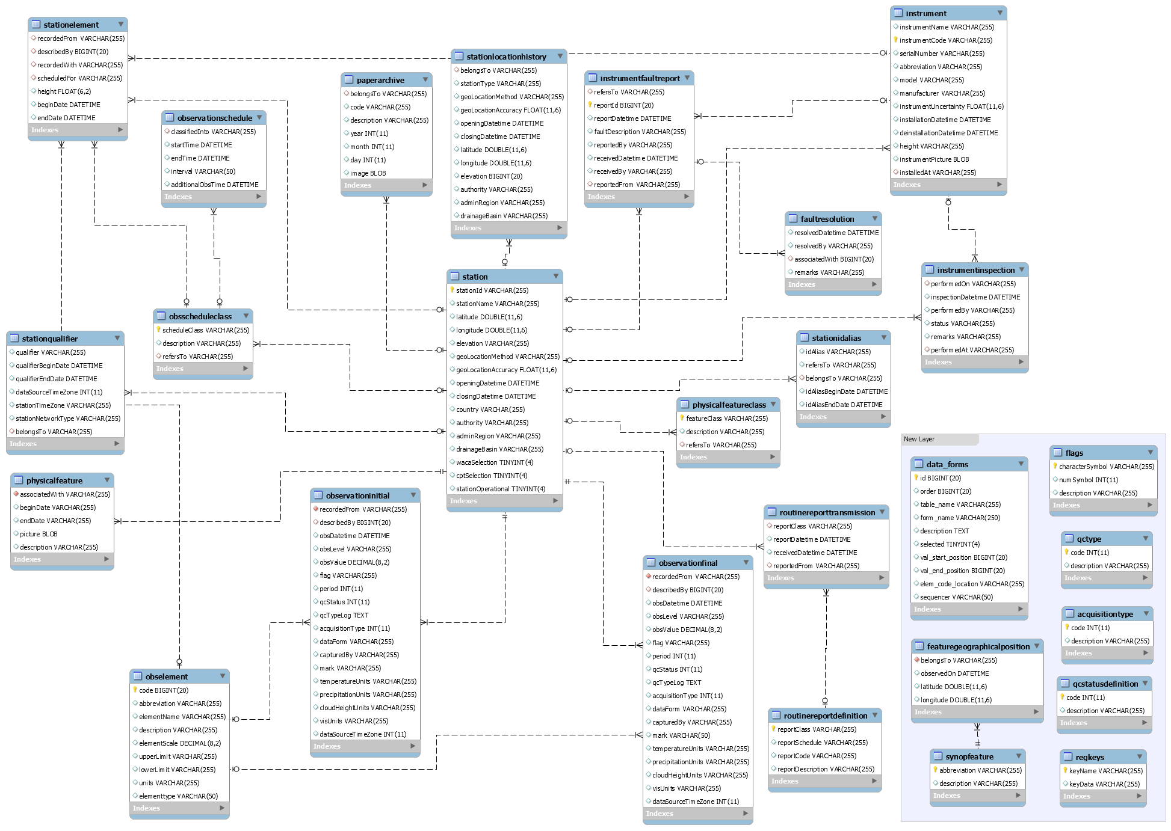



Figure 1.1. The new Entity Relationship Diagram (ERD) proposed by Albert Mhanda for CLIMSOFT v4 during the CLIMSOFT Meeting in MetOffice (December 2014).

# 1. General Remarks

1. There **shall** be only one database in MySQL, instead of three in MS-Access.
2. CLIMSOFT **shall** have the ability to make backups, and guidance on backing up **will** be provided as business rules with we recommendation that the Data Manager be responsible for the location, frequency and type of backups.
3. Additional tools, e.g. MySQL Workbench, **shall not** be required to use and administer CLIMSOFT. However, advanced administrators may choose additional tools for performing non-standard and unsupported tasks (e.g. creating new, non-standard database roles).
4. CLIMSOFT **shall** be “easy-to-use” software. Documentation is very important, but it **shall** be easy to start using CLIMSOFT without going through all the documentation (it **shall** be “intuitive”).
5. stationElement and observation entities (observationFinal and observationInitial) **should** be related in a way that observations can only be inserted when the stationElement for the corresponding station has been defined. This would prevent users from entering observations until the correct metadata is in place. This would ensure that, for instance, a station with no thermometer cannot be linked to temperature observations. The developers **should** look at this issue in detail. One option if the stationElement is not defined is that CLIMSOFT could give a warning/opportunity to enter the corresponding metadata, whilst data entry could be allowed to proceed.
6. When having data from different data sources (e.g. GHCN, FAO, CDIAC, etc.), it is necessary to store the name of the source, when and how the data were accessed, etc. The acquisitionType entity **shall** be used for this purpose. The acquisitionType attribute of observation entities **shall** be used as a foreign key that links to the acquisitionType entity. This entity **shall** then include the name of the source, the date of accessing the data, and the origin of the data (e.g. FTP address). Pre-defined acquisition types **shall** include Key Entry and Automatic Weather Station (AWS).
7. The Regional Climate Centres (RCC) **should** develop training material based in the WMO Recommendations/documents. This should be part of the “Demonstration Phase” of the RCC.
8. The CLIMSOFT data model **should** maintain consistency in naming entities and attributes by using camelCase. Example: stationElement **should** be used instead of station_element or StationElement.
9. Date/time attributes **shall** be of type DATE/TIME instead of TEXT.
10. The codebase **shall** include inline documentation and there **shall** be a Developer’s Guide that documents the required coding standards and gives details of how to get set up as a contributor.

# 2. Mandatory CDMS Recommendations from WMO[1]

1. Data Dictionary (Section 4.2.1.1) – **out of scope**  
   Not a priority, but keep it in mind. There is something done on that in the European Climate Assessment and Dataset (ECA&D), see <http://eca.knmi.nl/dailydata/datadictionary.php>
2. Data processing (Section 4.3.1.8) – **out of scope**  
   Not a priority, but keep in mind. This may be covered by the new entities related to “instrument”
3. Network (Section 4.3.1.10)  
   A single station can belong to more than one network. The stationqualifier entity **shall** be used to record station qualifies that are locally set, and also information of station network(s) that can be globally set. Note that the attributes of stationqualifier should be reviewed, e.g. the stationTimeZone is currently repeated for each record.Guidance to the NMHS **should** to be given in relation to the use of Networks
4. Data Discovery metadata (Section 4.3.2) – **out of scope**Metadata would be outside the data model. It is necessary to identify someone that has done rhis already and share it through the WIS.
5. Business Rules (Section 5.1.1.1)  
   Business Rules **shall** be taken into account documenting how the software works.
6. WMO messages (Section 5.1.1.2)  
   WMO messages (e.g BUFR, SYNOP, etc.) are outside of the data model, but it **should** be possible to import these and other source by extending the data model through a plug-in. QC **should** also be considered.
7. Status log (Section 5.1.1.6)  
   Some form of status log **should** be implemented allowing full tracking and undo capabilities. This is already implemented in CLIMSOFT 3.2.
8. Heuristic checks (Section 5.3.1.3) – **out of scope of data model**  
   The software could facilitate heuristic (and statistical) checks, allowing changes to be made. The software couldtrack each change (e.g. recording a decision to add 0.1 degree to every temperature measurement from a particular instrument). Currently the description of a change can be recorded through the qcTypeLog TEXT attribute in the observation entities.
9. Data governance, controlled access to data and systems (Section 3.2.1.1)  
   CLIMSOFT **shall** define database roles to control access and enable data governance. Users with the appropriate privileges **shall** be able to create new database users and assign database roles. The generic roles that have currently been discussed include are: Admin, User-management, Observer (metadata editor only), Key-entry (data entry only) and QC. The appropriate assignment of roles **will** be determined by local practices, e.g. the policies in one country may grant a Station Manager the Admin role, whereas in other locations they may be granted a selection of the other roles.
10. Managed change (Section 3.2.2.2) – **out of scope**  
    The NHMS **will** create System Management Guidelines / Best Practices documents for this issue.
11. Standard normal of the WMO (Section 4.4)  
    A new entity **shall** be created to including the WMO standards and estimations. Rules on the calculation of these products are in WMO documents (see Section 4.4). A business rule **should** be recommended outlining the responsibility for updating normals. Normals are currently calculated as part of product creation and are not currently stored.
12. Discovery metadata catalog (8.2.1.1) – **out of scope**  
    This requirement is part of an overall CDMS system, but is out of scope for CLIMSOFT. The European Climate Assessment and Dataset (ECA&D) already has this kind of information. It can be used as a template. See also the “Diagram of station data against time” created by Rwanda Meteorology Agency, http://www.meteorwanda.gov.rw/index.php?id=55
13. Scheduling (Section 9.2.1.1)  
    Additional documentation **should** be created on this issue (including recommendations for ingestion, products and backup). Scheduling is available in CLIMSOFT 3.2 under the AWS Real Time Interface. See requirement 1.2 for discussion of the creation and scheduling of backups.

# 3. Database Entities

## observationInitial/observtionFinal

1. Data model **shall** contain two observation tables: observationInitial (no QC values) and observationFinal (QC values).
2. Observations **shall** initially be stored in the observationsInitial table. observationsInitial **shall** contain a complete audit trail with a new record being created for each modification to the observation. The current final record **shall** be stored only in the observationFinal table. If a final observation is modified further, then the original record **shall** be moved to observationInitial and a new record **shall** be created in observationFinal.

### flag

1. Flags M, T, E and G **shall** be retained. M **shall** be used only for Key-Entry.
2. A reference entity **shall** describe the flags but **shall** not be related to other entities of the database.
3. No flag **will** indicate the original value
4. flag **shall** be of type VARCHAR(1)
5. The documentation of CLIMSOFT **shall** include which equations/formulas have been used by CLIMSOFT to generate values (e.g. relative humidity).
6. The NHMS **will** record the equations/formulas that have been used by the NHMS to generate a value.

### period

1. period attribute **shall** specify the time period used to retrieve the observed value (e.g. 24, 72, etc.)
2. period **should** to be saved in hours

### qcStatus

1. Three levels of QC **shall** be available:

0 🡪 No QC check  
1 🡪 QC check and no changes made  
2 🡪 QC check and value modified

### qcTypeLog

1. The qcTypeLog attribute **shall** be renamed “qcTypeId”

### acquisitionType

1. An acquisitionType reference entity **shall** describe the different acquisition types.
2. The acquisitionType attribute **shall** specify the source where the data came from (e.g. GHCN, SASSCAL, etc.)
3. A business rule **should** be recommended that specifies a list of priorities for import data into the observationFinal table. This is to avoid that there will be more than one record for the same date/time, station and element. The highest priority **should** be for the values coming from a Key Entry.

### capturedBy

1. The capturedBy attribute in the observation entities **shall** only be available to someone with the correct privileges or an administrator.
2. Values recorded in this attribute **shall** be the user’s database username. A business rule may give suggestions on usernames being created as nickname (e.g. operator1).

## dataForm

1. The data model **shall** have a reference table to describe the different forms that are available.

## Station

### stationId

1. stationId **shall** used instead of id
2. A review **shall** be conducted of the attributes in the station, stationLocationHistory and stationqualifier entities (see also section 2.3). E.g. Consider whether the latitude and longitude of the current station should be stored in the station entity or in the stationLocationHistory entity.

## obsElement

1. The software **shall** continue to keep a meaningful name of each element
2. Commas and semicolons **shall** be removed from element names and descriptions. Underscore **shall** be used instead.

### elementId

1. The code attribute **shall** be renamed elementId.

### abbreviation

1. The abbreviation attribute **shall** be unique (e.g. the element PRECIP currently appears two times in the table, once corresponding to code 5, and again as code 104.
2. The description for each element **shall** be reviewed and where possible improved.
3. The list of available elements **should** be reviewed, this may be postponed until a future version.

### units

1. Observations **shall** always be stored in the same units as defined. A capability **shall** exist to convert among units, when the observations are entered in other units.

### elementType

1. This attribute **should** be used as a descriptor of atmospheric, terrestrial or oceanic, following the nomenclature given by the Essential Climate Variables (ECV) of GCOS.

### total

1. The total attribute **shall** be removed from the obsElement entity, since it is used for QC but it is not a qualifier of the observation.

### selected

1. The selected attribute **shall** be removed from the obsElement entity, since it is not a qualifier of the observation.

## obsDateTime

1. The obsDateTime entity **shall** be removed

## obsLevel

1. The obsLevel entity **shall** be removed

## upperAirObs

1. A new entity **shall** be created for upper air observations. The obsLevel attribute won’t be represented in the observation entities. A further review **shall** be conducted on how to design the new entity. Example given by Steve Palmer:

upperAirObs  
describedBy  
uAObsDateTime  
obsLevel  
obsLocationLat  
obsLocationLon  
QCStatus  
QCFlag

recordedFrom  
describedBy  
upperAirObsDateTime  
obsLevel  
obsLocationLat  
obsLocationLon  
QCStatus  
QCFlag

## stationLocationHistory

1. The stationLocation entity **shall** be renamed stationLocationHistory.

### elevation

1. The type of the elevation attribute **shall** be changed to FLOAT

## stationElement

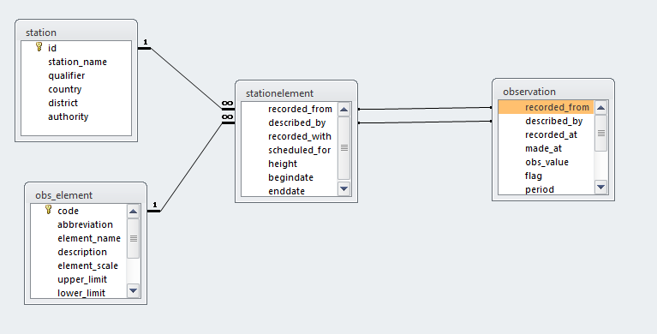

Figure 3.1 - Proposed data model for the stationElement and related entities

1. The relationship proposed in Figure 3.2 **shall** be investigated to determine whether the recordedFrom and describedBy foreign keys in the stationElement entity could form composite primary key that is then linked to the observation entities as shown. If this cannot be implemented, a business rule **shall** be document that recommendeds that the stationElement exists before importing the observations for a given element into the observation entities.
2. If an instrument is not known, a user **shall** still be able to record the obsValue. The information for the instrument **shall** be recorded as unknown. See section 1.5 for a more detailed discussion of the desired behaviour.

### height

1. The height attribute **shall** be removed from the stationElement entity. The height will be available from the instrument entity.

## physicalFeature

1. The physicalFeature entity **should** be used to record the operator of the weather station. This **should** be considered a business rule.
2. WMO Recommendation section: 4.3.1.6 - Local environment  
   The feature entity **shall** cover the local environment of the station.
3. WMO Recommendation section: 5.4.1.1 - Siting Classification  
   The feature entity **shall** include an attribute including the WMO index for the convenience of an installation site. The **shall** be stored in the description attribute in physicalFeature entity.
4. WMO Recommendation section: 4.3.1.2 - Station overview  
   A new attribute called restriction **shall** be created in the stationLocationHistory entity of type VARCHAR that covers the user restrictions for a specific station. A value of NULL **shall** be used to indicate that there are no restrictions.
5. WMO Recommendation - section 4.3.1.5 – Location  
   A new attribute in the physicalFeature entity **shall** be included to store whether the station is set up in local time or in UTC. The key entry should also have the option to set up this variable. The observation entities **shall** always save the observation values in UTC, therefore the timeZoneattribute **shall** be removed from the observation entities.
6. In order to make sure that the observations are entered in UTC, a new entity with all the time zones **shall** be created. The downloadable files of <http://timezonedb.com/download> can be used as a template.
7. The stationQualifier entity **should** be related to the new entity through the attributes stationTimeZone and dataSourceTimeZone.

### beginDate

1. beginDate **shall** have type Date/time instead of VARCHAR

### endDate

1. endDate **shall** have type Date/time instead of VARCHAR

### description

1. A recommendation for a business rule **should** be created with suggestions on how to handle the description.

## stationIdAlias

1. Data from the different sources **will** be organised before entering them into the CLIMSOFT observations, when data is available for the same station from different sources.
2. A reference table **shall** be included with a description of each stationId class.

## instrument

1. New instrument entities such as: instrumentInspection, instrumentFaultReport and faultResolution **shall** be created to meet the recommendations of the WMO (monitoring metadata)
2. WMO Recommendation section: 4.3.1.7 - SensorThe instrument entity **shall** cover the sensor metadata, e.g. serialNumber”
3. WMO Recommendation**:** section 5.4.4.2 - Measurements  
   Uncertainties of the instruments **shall** be recorded. WMO recommends keeping the information of the processes, software, governance mechanisms and data analysis used to understand and record the uncertainty inherent in observation measurements and processes. This **shall** be covered by the instrumentUncertainty attribute of the instrument entity
4. WMO Recommendation**:** section 4.3.17 - Sensor  
   The new instrumentInspection entity **shall** cover the status of the sensor through the status attribute. Valid options **shall** include operational, not operational etc.

### instrumentId

1. instrumentId **shall** be used as the id attribute instead id.

### description

1. A description column **shall** be added.

# 4. User Requirements from workshop[2]

## Key Entry

1. The description of the forms **shall** be improved (e.g. Hourly data for one element, Daily data for one element, Daily data for several elements, Daily upper air data for several elements). Previously the descriptions were inconsistent.

The user **shall** be given a choice of how to enter decimal values. Some users consider that there is an error when using Key Entry because decimal values cannot be entered (e.g. 15.2). CLIMSOFT expects the value to be entered according to a scale factor (e.g. 152) in order to reduce keying errors. See Figure 4.1. There **shall** be an option to allow users to enter values using either method. There **should** be an option to allow the user to enter data in other units if the conversion is known, due to requirement 1.4 that the system shall be intuitive and easy to use. The data in the database **shall** be store in the recorded units (e.g. degrees C). A review **should** be conducted to consider what should happen if a user changes the scale factor for an element, changes the units (e.g. from inches to cm), or changes the instrument and best practice recommendations **should** be given.  
  


**Figure 4.1 – Some users expect to be able to enter decimal values are unaware of the element scale** factor.

1. Detailed documentation on installation and solutions to common problems **shall** be provided.



**Figure 4.2 – A local set up problem relating to the location of the help file.**

1. A search tool **shall** be included in the Key-entry forms, so that the users can find the record of a specific station and date easily.

## Quality Control

1. An option **shall** be included to allow a user to give the radius in km (in addition to degrees) when searching to Neighbouring Values.
2. When no QC errors are found, a cryptic dialog is currently displayed. The software **shall** improve the provided when no QC errors are found.

  
**Figure 4.3 The message given in CLIMSOFT 3.2 when no QC errors are found**

1. QC was by date and performed on all stations. The software **shall** give the option of QC checks for each station separately.
2. Graphics **shall** be created for QC checks (using another language such as R)
3. The Select Dialog **shall** be improved so that it looks similar to the “Update Main Database” option. It **shall** include options for:
   * making QC for a station
   * selecting more than one element at a time, and even all of them

## Products

1. An investigation **shall** be made into why only the tabulated data and backup files were generated successfully from this section for some users.
2. The following errors **shall** be investigated and resolved in the latest version:   
   - For the inventory, an error message about too few parameters was returned.





**Figure 4.4 Run time errors**

* For the graphs, an error message that no data has been selected even when this has been done was returned.



**Figure 4.5 User’s report that the no data message is seen even when data is selected.**

1. The Instat export option **shall** be improved with the option of “Daily for Instat” in “tabulated data”, the columns headings will be renamed for the years as y’year’, e.g. y2014. The data file retrieved from CLIMSOFT **shall** not need further editing for Instat.
2. R and/or python **shall** be used to improve the products of CLIMSOFT.
3. The developers **shall** collaborate with University of Reading and the AMI Team in Kenya, who are currently working on creating R-code to produce CLIMSOFT products, and providing R code to produce products.
4. The message “No QC errors found” **shall** instead be “No QC data found”
5. Extraction in Rclimdex and CPT formats **shall** be included which is on the ACMAD's version on CLIMSOFT in the next online version (suggestion from CLIMSOFT Training in Tschad, January 2015):

**A. Mhanda:** It was agreed that all the features available in the ACMAD version of CLIMSOFT that are not available in CLIMSOFT 3.2 (i.e. output for CPT, RClimDex etc) will be available in CLIMSOFT version 4, in addition to all the features currently in version 3.2.

**B. Lamptey:** There should be one standard version of Climsoft (not ACMAD version and another version). So, implementing the agreement in version 4, as agreed, will take care of this (Agreement with Albert).

## User Configuration

1. The user password **shall** be strengthened (e.g require a minimum of characters)
2. When an administrator creates users they **shall** see a list of users. There **shall** be a role that can be assigned that grants permissions to allow a given user to also be used to give role privileges.

## Sequencers

1. A sequence interface **shall** be created so that the administrator can customize the order that the elements are displayed in when you move on to the next page of a form (e.g. which element should come next or which day will come next for hourly).
2. MonitoringThe administrator, or another user with the correct role **shall** be able to access the capturedBy values so that he/she can monitor the entries of each user of the system. Guidance should be provided on how this information should be protected/used. For example, in Germany it would not be legal to collect this information, therefore potentially this option should not be enabled by default.

## Uploading data into the database

1. A tool **shall** be created to change the obsValues of the observationFinal entity for the Administrator and the QC operators in response to user’s feedback that it is too difficult to change values in the main database. This used to be achieve by exporting, modifying, and then importing csv files.
2. Issue tracking software **will** be used as a help desk to ensure that bugs can be reported by users.

## Data ingestion and import

1. It **shall** be possible to import CLICOM data from .csv files that do not have “flag columns” after each observation value.
2. A tool **shall** be created to import data from the NOAA-ftp
3. The software **shall** **not** assist with making it possible to see the folders and files located on servers (i.e. outside of the localhost) when Windows Explorer pops up to select an importable file. This is a configuration issue for the NHMS.

## Data extract and retrieving products

1. Previously data exports automatically opened in Excel and users were unsure where the file had been saved. The software **shall** require a location and file name to be provided before the data is exported. A default location and file name may be suggested.

## Data transmission and decoding

1. *A simple interface for observers* ***could*** *be provided that facilitates quick data entry and transmission for use for aeronautical Met services. They should not be allowed to modify scale, limits and other methods/functions of the forms (suggestion from CLIMSOFT Training in Tschad, January 2015):*

***A. Mhanda:*** *It would be useful to provide a facility for the generation of the routine meteorological message for aviation (i.e.) the METAR message from key-entry forms in real time. I think it would be fairly straightforward to develop a module for encoding the METAR message in traditional alphanumeric code or XML for most of the elements required in the message. Though it would be possible to compute the Pressure reduced to mean sea level (QNH) automatically given the required barometric correction for temperature and height of the barometer above the runway, it would probably be safer to have the observer calculate the QNH according to local procedure to avoid blaming the CLIMSOFT software for calculating any wrong value for QNH.*

***B. Lamptey:*** *agree with Albert on Point 1. Everything should be done at the station and only entered into Climsoft.*

1. Automatic cloud codes for generation of BUFR and CREX message **could** be created (suggestion from CLIMSOFT training in Tschad, January 2015):

***A. Mhanda:*** *A standard form for entering many meteorological parameters observed at the same time, in real-time, would be required for the whole of RA I. This would be suitable for real-time synoptic observations. There is already such a form designed for the Caribbean. At the suggestion of Joyce Banda of ZIMMET but now at ACMAD, a similar form [form_synoptic_2_zim] was customized for Zimbabwe with automatic calculation of dewpoint temperature, RH, geopotential and mean sea level pressure pressure. After finishing entering the observation values, at the click of a button, data from that form will be automatically transferred to the TDCF form that will also be launched automatically. From the latter form, all the values required for TDCF would be encoded automatically into CREX or BUFR depending on the option selected. Since there is a standard TDCF template for RA I, I think it will be possible to use one standard synoptic form for real-time observations for TDCF in RA I. In other words, this will allow direct key-entry of data from observation registers without the need to transcribe the observed values to a monthly climate return.*

***B. Lamptey:*** *I think a general form could be designed for the whole of RA1, as the elements required by WMO are known. If a particular country needs customization, they could submit a request to the Climsoft Team.*

## Flags and meta data to improve the record validation process

1. The new version **shall** improve the metadata of the Instruments

## Language – Translations

1. The software **shall** provide translation for French users and **shall** have the capability to be easily extended to other languages (suggestion from CLIMSOFT Training in Tschad, January 2015):

## Other suggestions for improvement

1. Archiving procedures **shall** be improved following on from the work in CLIMSOFT version 2. Guidance **shall** be provided on backups with corresponding recommendations for business rules.
2. Users **shall** have the option to generate summaries as products (e.g. decadal values).

## Wider issues of concern

1. Videos **could** be released in French and Portuguese. The video in French will be available in March.
2. Guidance **shall** be given on using CLIMSOFT (e.g. creating documentation specifying where and/or how the data are located). This may be specific for each NMHS.

# 5. Others considerations

1. A decision **shall** be taken on whether the latitude and longitude should be saved in one single entity (stationLocationHistory), then the current coordinates can be retrieved by a simple query.
2. Version 4 **will not** rename the attributes that are foreign keys (e.g. recordedFrom is still used in the observationInitial entity instead of sharing the primary key’s name stationId).
3. The names of the attributes and entities **shall** follow the same camelCase standard: first word beginning with a lower case letter and any other word after beginning in capital letter. (e.g. elementType instead of elementtype).
4. The tables and queries that were already not in us in CLIMSOFT v3.2 **shall** be removed (please refer to the extended document: CLIMSOFT_v4_technical_requirements_draft_v4.docx, where queries and tables are listed).
5. An arrow **should** be included that allows sorting the fields (just like it does the access database, Figure 5.1) for some of the forms available in CLIMSOFT (see Figure 4)

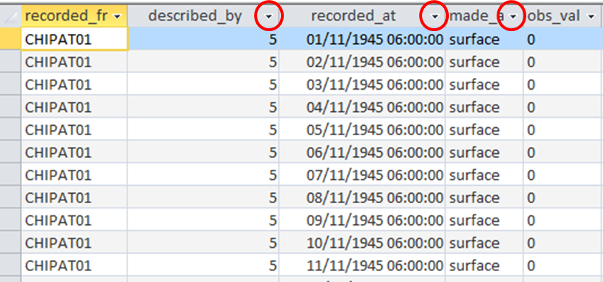

Figure 5.1 Example of a database in access (attributes from the observation entity)

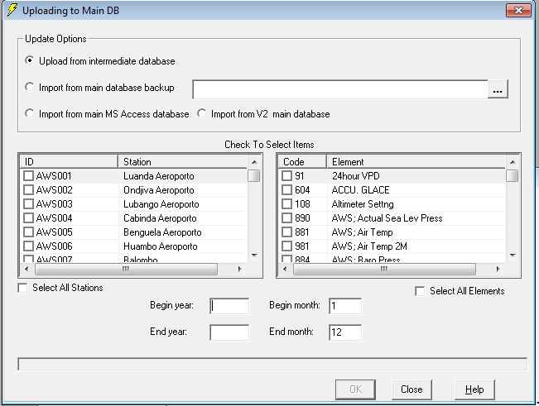

Figure 5.2 Example of a CLIMSOFT form where the "sort arrows" could be inserted

1. When the user uses the “tab” key of the keyboard the cursor **shall** automatically be placed in the field immediately after the previous one. This principal **shall** also be added to the developer’s guide as part of the development coding practive.

1. See “WMO CDMS Specifications v1.2”
2. These user requirements are based on the performance of Climsoft v3.2 and were obtained from questionnaires, University of Kenya and CLIMSOFT Training in Tschad.