|  |
| --- |
| download |
| Proposal for the system upgrade and Support of the Child Helpline System for Childline Kenya . |
| **November, 2021** |
|  |
|  |
| SUBMITTED BY    **BITZ IT CONSULTING LIMITED**  **Trio Complex, Thika Road Tel: + (254) 720 055 067**  **Email:** [**james.nganga@bitz-itc.com**](mailto:james.nganga@bitz-itc.com) **,** [**info@bitz-itc.com**](mailto:info@bitz-itc.com) **, Website:** [**http://www.bitz-itc.com**](http://www.bitz-itc.com) |

# Phase 2

_____________________________________________

Design, Develop, Deploy and Support the Child Helpline

Annex A: Cover Letter

Annex B: Introduction and Background

Annex C: Scope and Features

Annex D: Breakdown of Fees

# ANNEX B

## Introduction

Child helplines operate in most countries in Eastern and Southern Africa as part of the global partnership to end Violence Against Children which aims to end abuse, exploitation, trafficking and all forms of violence against and torture of children.

Many helplines depend on outdated technology and haven’t been upgraded or updated, and lack integration to widely used platforms such as social media.

This has led to many child helplines operating far below their potential, leading to many children not being provided with critical services and support in a timely manner.

## Background

One of the key components of Child Protection systems is the reporting mechanism by adults and children on incident or risk of any abuse, violence and exploitation happening against any child. ChildLine Kenya was established in 2008 as an initiative of Ministry of Health and Social Welfare (MoHSW) and was initially funded by Global Fund and UNICEF with the objective of handling violence against children’s cases in Lesotho. Currently Ministry of Social Development (MoSD) is managing the Child Helpline.

Stressors from the COVID-19 pandemic on children and families, compounded by security, health and financial factors, have increase the risks of intimate partner violence and violence against children. In addition, containment measures can further aggrevate situations of children who are already exposed to abusive, neglectful and unsupportive environments. Children’s sources of support outside the family, including child protective services and school, are likely to be out of reach for some, if not all, of the time. Frequent national lockdowns have shut some children in whilst simultaneously shutting child protective services out, and has compromised access to social, educational and health provisions. Other children such as those on the street situations or on the move, maybe even more deprived and isolated from assistance, as may those living in residential care institutions or in detention.

In the last 2-3 years, UNICEF ESARO in its role of technical support and coordination realized that a number of countries in the region are faced with similar challenges. ESARO in collaboration with KCO, TCO and UCO, assessed various Helplines used within these countries and identified an estimate of 60-80% overlap. It proposed that under the technical guidance of ESARO a generic modular and replicable helpline system is developed and thereafter customized for Kenya, Tanzania and Uganda for their own country specific context.

# ANNEX C

## Scope and Features of the Proposed CRM

* Setup configure and deploy a turn-key helpline software solution with case distribution, routing, case escalation roles and based permissions / access. The solution is expected to be multi-channel, including voice, SMS and social media channels e.g. Facebook with ability to provide distributed and remote terminals.
* Design develop and deploy a Helpline dashboard to provide real time call and case analytics for the supervisor and operators as well as Performance Management Data based on Key Performance Indicators (KPIs) for individual agents and the help desk as a whole.
* Design and develop end-user training manuals, reference manuals and quick guide reference cards.
* Design and develop technical system documentation such as system architecture and technical specifications documentation, system manuals including quick troubleshooting guides and summaries, system administration manuals / guides, configuration, backup and restore procedures / manuals.
* Plan and conduct training for the Helpline Agents, Helpline Supervisors, and other relevant staff identified in each country.
* Plan and conduct training for local helpline / government and UNICEF CO nominated IT focal points.
* Provide technical support and ongoing routine maintenance for the Helpline, including regular software updates / upgrades, network maintenance and troubleshooting, as defined in the SLA.
* Design and implement security protocols for call and case data and design and setup remote backup, restore and recovery plans, procedures and systems based on the country specific FRDs.

The features of the proposed Call Center System incorporates innovations in technology to address the main services offered by a generic VAC and other queues support center. The new system features address Case Management (Capture & Track) as well as the underlying communication between the Call Center and the general public. Overall, the proposed features are selected with the objective of improvement across the case management process chain – from data capture, escalation, resolution and information sharing. The new features will incorporate best-practice to ensure continuity across users and across various communication channels.

## Graphical representation of the features

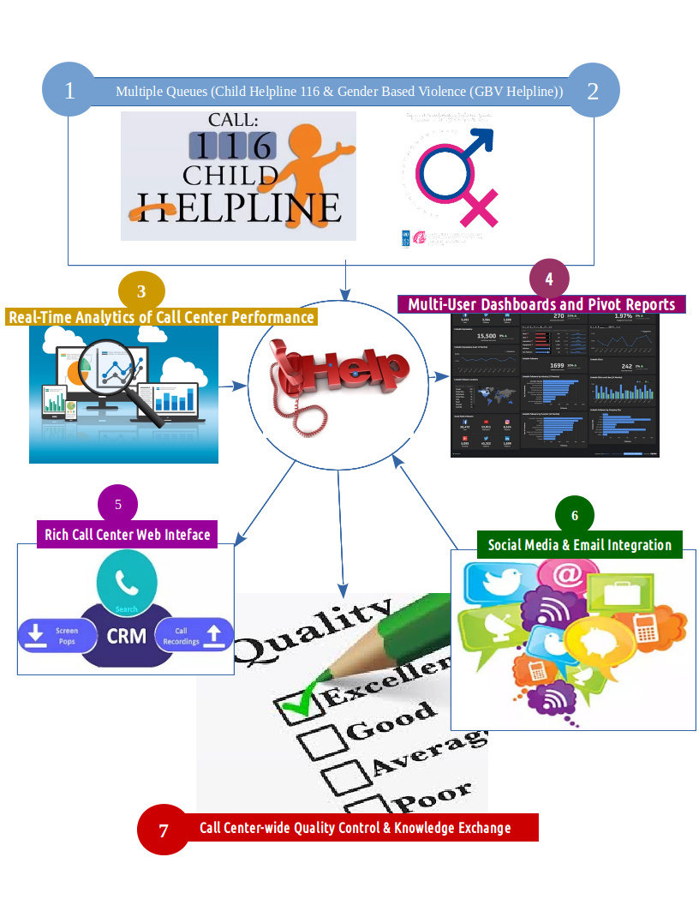

The following are the main modules of the proposed system. Detailed features have been captured in the mock up screens and the FRD document on the Indexes of this proposal.

## 1. Contact Relationship Management (CRM) Module

The current Call Center solution deployed within the Child Helpline services has often linked incoming calls and case identification, using a single unique number for both events. The objective of the CRM feature is to provide a fine-grained separation of **Calls** and **Cases**. This separation provides the Helpline with an end-to-end contact management that references a telephone number against incoming calls and related cases. The CRM will hold names, customer type (Client, Partner, Staff), email, social media, and address information of a given telephone number, or related numbers. The CRM will also provide extractable reports on telephone interactions of customer with the Helpline, also called Call Detail Records (CDR), and related cases. Additional activities that will be executed on the CRM interface include:

## 2. Case Management System (CMS) Module

The CMS is main **Data Capture** User Interface (UI) used within the Call Center to capture details of VAC and GBV incidences. The CMS captures incident details from an incoming call on a toll free phone line, or through designated walk-in district/Partner centers. The data is captured using **Case Forms** and include:

* Details of person reporting (Reporter)
* Details of the Victim (Client),
* Details of the Person deemed responsible for committing VAC incident (Perpetrator)
* Action taken, Resolution or Services Offered (Counseling, Referral/Escalation)
* Status of the case reported whether Closed, referred, Escalated

**Case Creation:**

Case creation will be available from two options:

1. **Walk-in Case Creation:** This option will be available to create a Case that originates from Walk-In to District Centers or even a walk – in to the call center
2. **Call Pop Form Case Creation:** This is a continuation from an incoming call that the Agent decided met the threshold (not Silent nor Blank). Historical data regarding the calling number's interactions with Helpline services is displayed to the Agent. This feature is available to Agents who are manning live-calls. Whenever a new call gets answered by Call Center Agents (Counselors), the CMS triggers a form to be used by the Agent to capture caller details. The Call Pop up Form provides the Agent with option of creating case or disposing the inbound call in case it is deemed to be a silent or a blank call.

During Case creation it is important to note that **Prank Callers** will be identified by Agent anytime during the call period and Case Form can be disposed subsequently.

**Call Pop Form Transfer:** This feature is available on Case Creation steps that originated from a telephone call, allowing Agents to have the option of transferring an incoming call to another Agent, or escalate to a superior, based on defined *Transfer* reasons such as language and an escalation.

3. Communication Module (Telephony Services / Call Center)The telephony system accessible by the free phone 116 represents the single largest source for reporting incidences of VAWG to the Helpline. The objective is to make the internal and external user experience more friendly, reduce the abandonment rate and improve data capture accuracy on the CRM. **Interactive Voice Response (IVR)** will be greatly enhanced as a feature in the telephony services, both for external and internal clients, staff and Partners. The following are the features that will be integrated in the telephony component of Helpline Call Center

* **Real-time Call QA:** This feature allows Call Center Supervisors the opportunity to monitor performance of the Agents with regard to telephone etiquette and data capture for a live/on-going call. This feature will empower the Supervisor to '*Whisper*' directly to the Agent and help improve the overall quality of services offered on the phone - counseling, follow-ups and general information.
* **Multi-Lingual IVR:** The automated audio prompts that callers hear when they call 116 will be made available in other languages and local ethnic dialects. **English** will be the default language and will be complimented by language data captured in the **CRM** for incoming telephone number.
* **IVR Data Collection:** This feature allows Partners (Police, Probation, Children Officers and other government agencies) and field-based staff (Caseworkers, etc.) the opportunity to use the free phone 116 line to provide data update on on-going cases within the CRM. This will be a custom deigned IVR menu only accessible to CRM-registered contacts identified as Partners.
* **IVR Outbound Notification:** Proactive notification will be made available to field-based Partners and staff to notify them of cases that require their urgent attention. This will help accelerate case resolutions, especially escalated cases. This feature can also be used to inform Clients of on-going case status as a means to improve communication between Call Center and the clients.
* **Call Transfer:** This feature will be provided together with Call Pop Form Transfer, allowing Agents to transfer an on-going call to fellow Agent or to a superior. The reasons for transfer will be identified and captured in the CRM for quality purposes.
* **Caller Filtering (Prank or Hoax Callers):** This will be a built-in feature that will be employed at the System level to help mitigate **notorious pranksters**. In the event that a given telephone is identified as having been **prank/hoax call**, subsequent calls by the number will trigger a set of warnings before attempting to connect with Agent. If certain threshold is reached, then the telephone number will experience delays in getting connected to Agent, or can be out rightly black-listed from calling into the service. Agents will be trained to ensure that **blank calls**, which are affected at the telecoms level, are not classified for black-listing.
* **Region or location recognition:** A proposed feature in the new system is to identify the location from where the call is coming from. This is possible by probing the Telkom data which would reveal the region from where the call is emanating from. This data is very helpful for stakeholders to know the best suited language to engage with the caller and also to identify the areas are more prone to which kind of abuses. The communication module requests a subscriber’s location from the Gateway Mobile Location Center (GMLC). If the location is obtained, flash it on the case registration form. If the above is provided, there will be a provision on the Pop up screen on the navigation of the caller through the Telco’s towers / base stations. However we must stress that all this is dependent on the Communication Authority of the country where the system is being deployed to give permission to identify the location of the caller as this is not normally allowed to organizations or the public.

## 4. Email Notifications

The email is still regarded as one of the most important communication tool within any organization. The objective is to allow pro-active sending out of customer-defined reports to recipients. This reporting feature is ideal communication tool for repetitive reports that include:

* **Periodic Reports:** Daily, Weekly, Monthly, Quarterly and Annual Reports on Calls and/or Cases to relevant recipients.
* **Case Notifications on Escalation**: Case Escalations from the Call Center CMS will be complimented with email notification to escalation contact. This is ideal for escalations to field-based Caseworkers and Partners (Police, Prisons, etc.)
* **Attachments** will include plain files (PDF) and audios (MP3)

## 6. Quality Assurance (QA)

QA represents internal assessment of people and processes that interact within the Call Center system. The Agent etiquette to callers, the professionalism and ethics demonstrated can only be captured through peer-review. The QA module will allow Call Center Management (Call Center Supervisor and Caseworker Manager) to undertake periodic peer-review of Agents and Caseworkers with regard to defined metrics. A QA score will represent the performance of Agents and Caseworkers, or any other role that interacts with CMS at data capture level. Quality Index (QI) will be displayed on the **Wall Display Visual Dashboard** while Agents will have access to own QI for any QA undertaken by their superior. The overall quality metrics will include call handling, case status and data accuracy, which are the major areas that represent service convergence.

## 7. Integrated Services & Features

The proposed CRM and Call Center will incorporate emerging communication technologies to enhance reach and relevance, while underscoring the disruption caused by mobile telephony technology. The following are proposed features that will be included:

* **Tele-Working:** This feature option will empower Agents to be able to work outside of the designated physical Call Center. This module will seek to enhance quality and quantity of available workforce by eliminating the need to commute to the physical Call Center, and tap into distributed workforce that is hitherto hard-to-reach. Teleworkers will require to use their mobile telephony handsets and have access to the Customer Relationship Management System (CRM) UI for data entry purposes.
* **External Web Interface:** This feature has been necessitated by the growing need to share information without compromising the database. The external web interface will be a publicly accessible web portal that will display aggregate data on current CRM efforts as extracted from the database. The content to be displayed will be determined by the Helpline Management, with the following as datasets available:

1. Hotspots represented as maps and tables
2. Government + Partner efforts (Activities Map)
3. Monthly Reports

Partners Information

# ANNEX D

## User Interactions and Prototype Example.

Main Dashboard

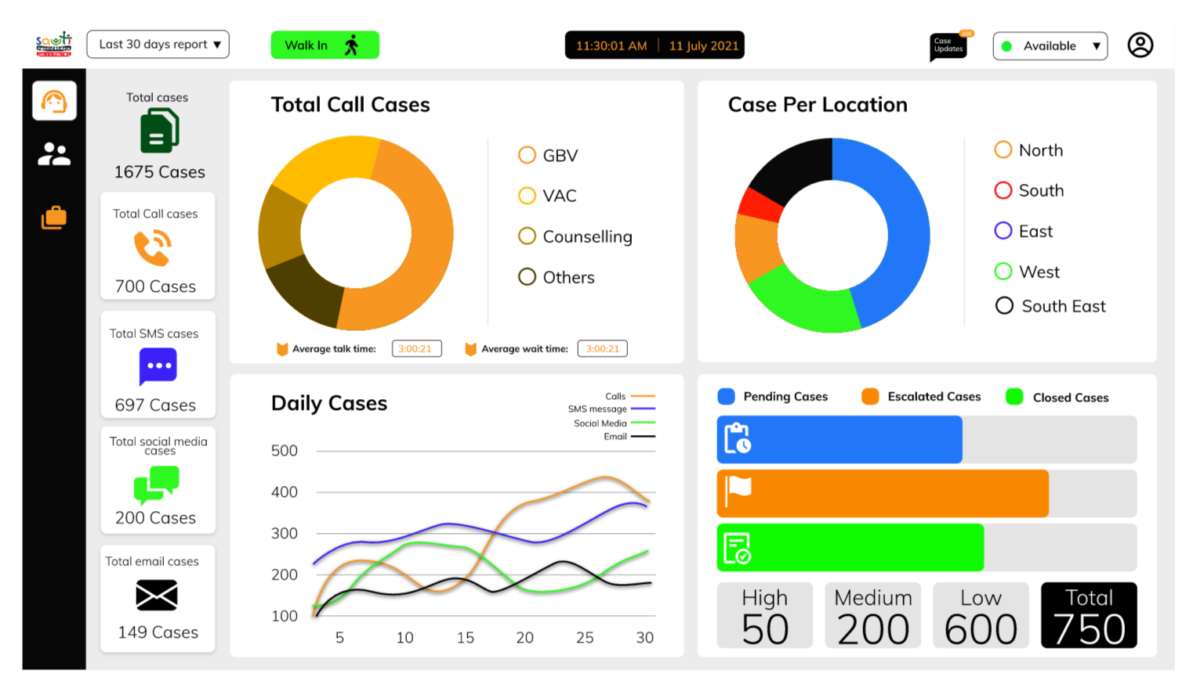

Call Popup



Reporter Capture Screen

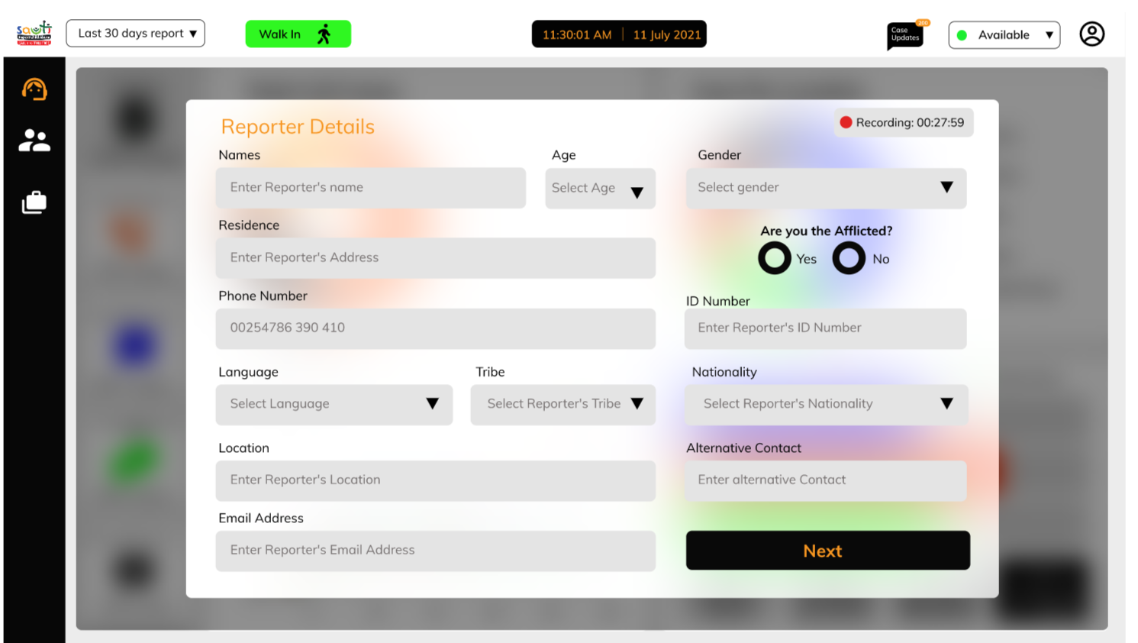

Case Details

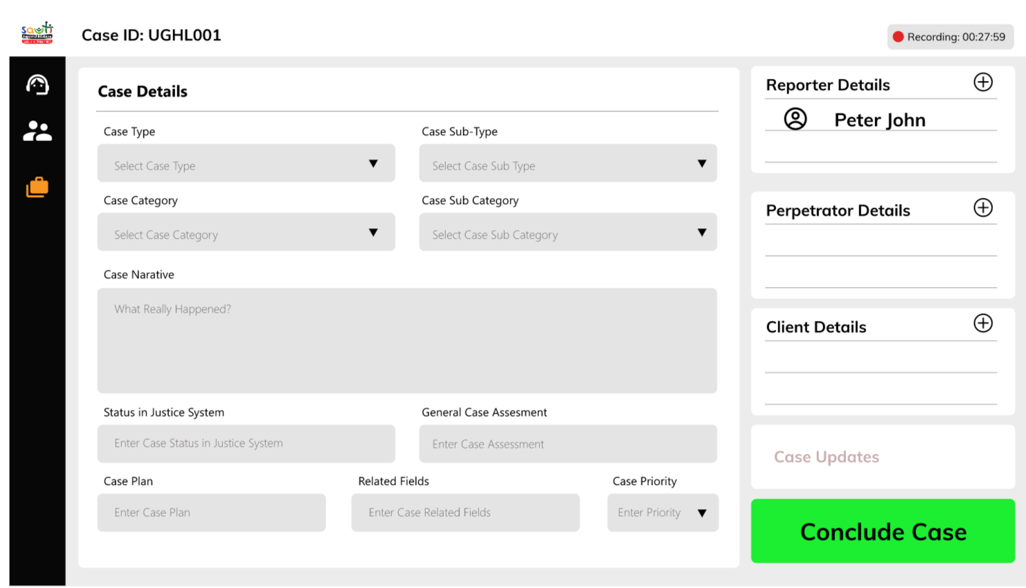

Perpetrator Details

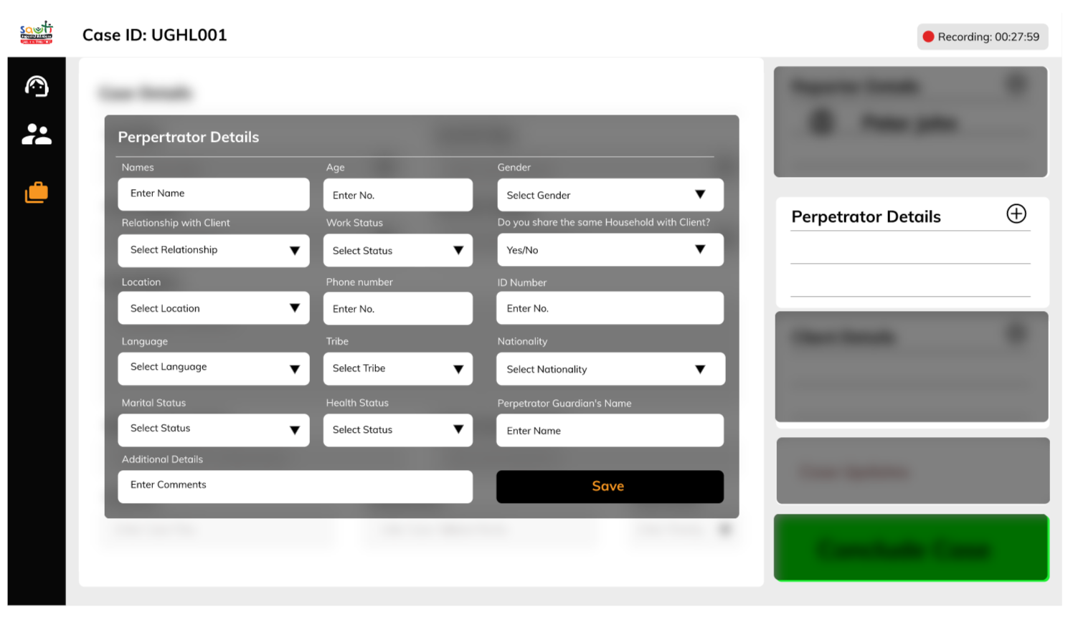

# ANNEX D

Summary of Fees

