|  |
| --- |
|  |
| |  |  |  | | --- | --- | --- | | 75 | Date: | February 2015 | |
| ADL and AML Non-normative Examples    Version: 1.0  **OMG Document Number: health/2014-10-01**  **Standard document URL: http://www.omg.org/spec/AML/1.0**  Original File: N/A |

# AML and ADL Examples

The following section gives examples of AML and their ADL equivalents to illustrate the relationship between ADL and AML. These are valid OpenEHR ADL archetypes that have been converted into AML.

## AOM Structures Basic Examples

### Misc AOM Note Types Example

Test various AOM C_OBJECT types together, toensure co-existence within the same object structure.

#### Misc AOM Note Types ADL Diagram

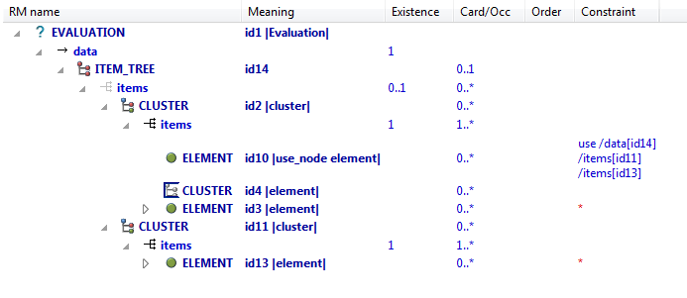

#### Misc AOM Note Types ADL

EVALUATION[id1] matches { -- Evaluation

data matches {

ITEM_TREE[id14] matches {

items matches {

CLUSTER[id2] matches { -- cluster

items matches {

use_node ELEMENT[id10] /data[id14]/items[id11]/items[id13] -- /data[id14]/items[cluster]/items[element]

allow_archetype CLUSTER[id4] matches { -- element

include

archetype_id/value matches {/.*/}

}

ELEMENT[id3] -- element

}

}

CLUSTER[id11] matches { -- cluster

items matches {

ELEMENT[id13] -- element

}

}

}

}

}

}

#### Misc AOM Note Types AML

### Structure Test1 Example

Demonstrate simple RM structure hierarchy in an archetype.

#### Structure Test1 ADL Diagram

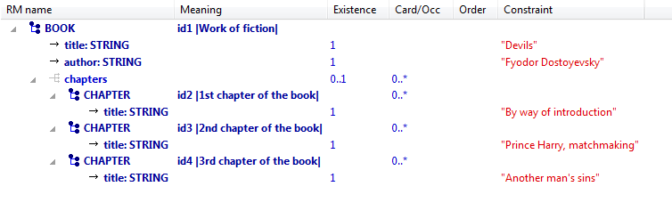

#### Structure Test1 ADL

BOOK[id1] matches { -- Work of fiction

title matches {"Devils"}

author matches {"Fyodor Dostoyevsky"}

chapters matches {

CHAPTER[id2] matches { -- 1st chapter of the book

title matches {"By way of introduction"}

}

CHAPTER[id3] matches { -- 2nd chapter of the book

title matches {"Prince Harry, matchmaking"}

}

CHAPTER[id4] matches { -- 3rd chapter of the book

title matches {"Another man's sins"}

}

}

}

#### Structure Test1 AML