TD with Swift integration

- director uninstall --purge
Since the database schema has changed to accomodate configuring image stores and archival of policies, the current TD installation needs to be uninstalled with the –purge ption
- Configure the image stores via menu: Settings

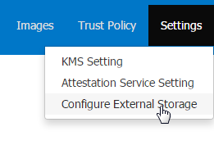
- Here you can configure one of three extrernal stores: Glance/Swift/Docker. You can choose among the deployable artifcats for each store.
- Once you enter the name of the store and the connector and click next, you'll need to enter the details for the connection properties. These properties were earlier configured in the dirtector.env file

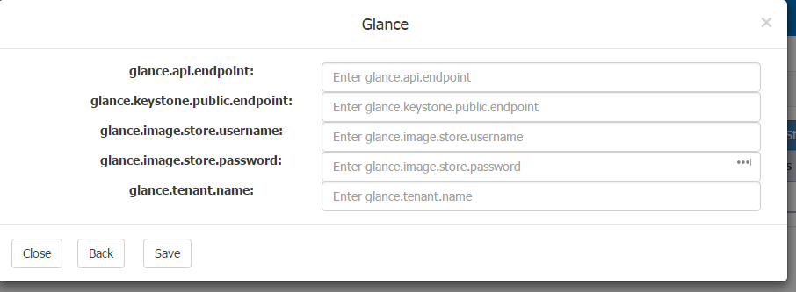

- Confgure at least one swift and one glance store to check the swift intgration.
- Once you have created a policy, earlier you only had a choice to upload a TARball. Now you can choose among 4 choices

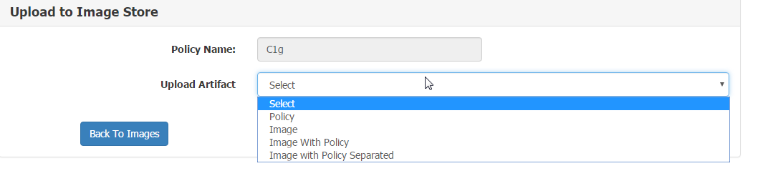

- For example:
If you select Policy as an upload artifact, only Swift stores would be displayed in the following drop down box.
If Image upload oprion is chosen, only Glance stores would be displayed
If Image with policy is chosen, only glance stores that support Tarball as an artifact would be displayed
If Image with policy separated is selected, 2 drop down boxes: one for policy store and one for image stores are displayed.
- We have changed the icon that showed status of the policy upload. Earlier in the GA build, a
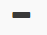
dash icon suggested no upload has been performed for the image

tick icon suggested image was uploaded.

Now we have replaced thses with the following:

the first icon is the image upload history icon. Once you click on it, you can viw the uploads
that was occurred for this image in a modal pop up.

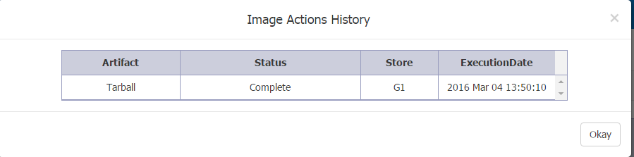

This will show all the upload statuses: success and failures

PA changes:
Use case:
User uploads the image along with the policy as a Tarball to Glance.
In this case we set the mtwilson_trustpolicy_location = tar.
PA picks up the policy that is inside the tarball and uses it.

Now the updates the policy in TD and then uploads only to Swift. In this case, we will update the :
mtwilson_trustpolicy_location = swift:http://<SWIFT_HOST_IP>/<Location_of_Policy>

Now during launch PA will check the valud of the mtwilson_trustpolicy_location and download the policy from Swift and ignore the policy inside the tarball.

