Study guide

Click and type Code/Version eg DOCS1000 (ver1)

Click and type Title

Course Coordinator: Click and type name/s

## Template for producing a print *Study guide*

Document Services created two templates containing styles and features that suit the delivery of printed learning materials; that is, *Study guide* template and *Readings* template (including *Readings* template example). This template has been designed for consistency of quality and appearance, but also to be simple to use.

We suggest that you adhere to the styles defined below where possible, as it will maintain the integrity of the design and the readability of the text. To apply a style, simply select the text that you want to change and click the appropriate style from the **Quick Style gallery**.

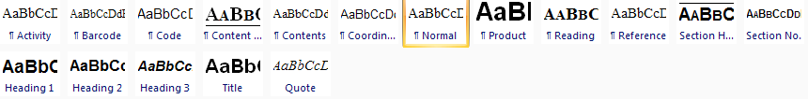

### Cover page styles

These styles are set for you and do not need to be applied throughout the template. It is only necessary for you click in these fields and key in the appropriate information.

Product

Code

Title

Coordinator

### Contents page

Content Heading

Contents

### Styles used to guide a student through the structure of a course

|  |  |
| --- | --- |
| **Section Number** | Usually a *Study guide* is divided into sections, topics, modules or weeks. Use this style for each major division of your *Study guide.*  **You may want each major section or topic of your *Study guide* to fall on a right-hand page (an odd-numbered page), which is a convention in design practice.** |
| **Section Heading** | Style follows immediately after a Section Number |
| **Normal** | Defined for easy readability. |
| **Heading 1** | Use Heading 1 for the main heading within a major division. |
| **Heading 2** | Use Heading 2 to divide the discussion under Heading 1. |
| **Heading 3** | Use Heading 3 to further subdivide the discussion under Heading 2, if necessary. |
| **Reading** | Use this style for Readings/References Heading. |
| **Reference** | Immediately following a ‘Reading Heading’ use this style for bibliography or reference list. |
| **Quote** | Italic and centered. |
| **Activity** | Indented |
| **Barcode** | Used at the back of the booklet to identify product code eg DOCS1000/SG/01/VER1 (Only used for external courses) |

PLEASE DELETE THIS PAGE

Contents

When you have completed writing your Study guide you will need to complete your Table of Contents. *Click and delete this instruction

1st column - enter topic/module or week no. 2nd column - enter topic heading - 3rd column - enter page number. *Click and delete this instruction

|  |  |  |
| --- | --- | --- |
|  |  |  |

An individual page needs to be created as a Divider page for each Section/Topic/Week etc.*Click and delete this instruction.

Section 1 [can be topic/module, week etc]