ANGRYVIPER IDE

User's Guide
Revision History

Revision | Description of Change | Date
1.0 | Created | 2/2018

Table of Contents
1.0 References 4
2.0 Introduction 4
2.1 Overview 5
3.0 OpenCPI XML Editors 7
3.1 Creating Assets 7
3.1.1 OpenCPI Libraries 9
3.2 Form Based Graphical Editors 9
3.3 Graphical Drag-and-Drop Editors 11
3.3.1 Adding Components to an Application 12
3.3.2 Connecting Application Components 15
3.3.3 Assembly Editor 17
4.0 How to use the ANGRYVIPER Perspective to Build Assets and Run Tests 18
4.1 Introduction 18
4.2 Building with the Operations Panel 19
4.3 Build Status Panel 21
4.4 Testing with the Operations Panel 21
4.5 Building from the OpenCPI Projects View 23
4.6 Additional Notes About the ANGRYVIPER Perspective 24
4.6.1 The Execution Configuration 24
4.6.2 XML Editors Modify Existing XML Files 24
4.6.3 Warning About a Non OpenCPI Project 25
4.6.4 The Perspective is Not in Sync with the Workspace or the File System 25
Appendix A Eclipse Basics 26
A-1: Starting the IDE 26
A-2. How to Import an Existing Project into the Workspace 29
A-3. How to Create a New OpenCPI Project 31
A-4. Eclipse Basic Concepts 32
Appendix B Addition Plugins for the IDE 33
B-1 TM Terminal 4.0. 33
B-2 ANSI Escape in Console Plugin 33

1.0 References

Some familiarity with the Eclipse IDE or similar development environment is assumed. If this is not the case Appendix A provides basic information to get you started. The document begins with the assumption that OpenCPI and the ANGRYVIPER IDE are installed on a development machine and the Eclipse workspace has been established.

Title | Published By | Link
Installation Guide | ANGRYVIPER Team | RPM_Installation_Guide.pdf
Acronyms and Definitions | ANGRYVIPER Team | Acronyms_and_Definitions.pdf
OpenCPI Website | OpenCPI | https://www.opencpi.org/
Getting Started Guide | ANGRYVIPER Team
OpenCPI  Component Development  Guide | ANGRYVIPER Team | OpenCPI_Component  _Development.odt
OpenCPI  Application Development  Guide | ANGRYVIPER Team | OpenCPI_Application  _Development.odt

2.0 Introduction

The ANGRYVIPER IDE consists of the Eclipse IDE for C/C++ developers and a custom plugin that supports development in OpenCPI. It is currently delivered in a complete package that includes the Eclipse Neon release plus the plugin and its dependencies. In the future ANGRYVIPER will provide the plugin and its dependencies to be dropped in an existing Eclipse installation.

The ANGRYVIPER IDE is installed in /opt/opencpi/gui. The command ocpigui is provided to start the IDE.

2.1 Overview

By default Eclipse opens in the selected workspace and displays the C/C++ perspective.

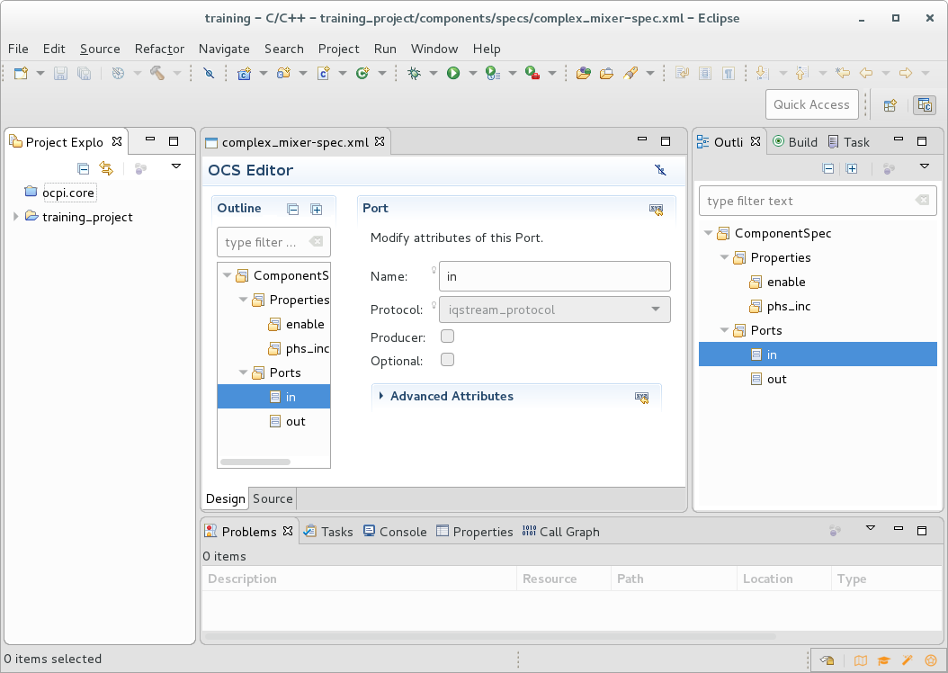
Figure 1: ANGRYVIPER IDE showing the C/C++ Perspective

Figure 2 below illustrates the new ANGRYVIPER Perspective. This perspective is tailored to develop and build OpenCPI assets. It consists of five views and the Eclipse editor panel. The Eclipse Project Explorer and Console views are included with three new custom panels:

OpenCPI Projects View – an explorer providing a flattened view of the projects and assets. Currently it only supports asset selection to either add assets to the Operations view or build them directly.

ANGRYVIPER Operations View – provides platform selection and controls to build assets and to build and run tests.

Build Status View – provides a graphical view of build/run execution configurations and execution status. The user can also re-run builds and tests using this view.
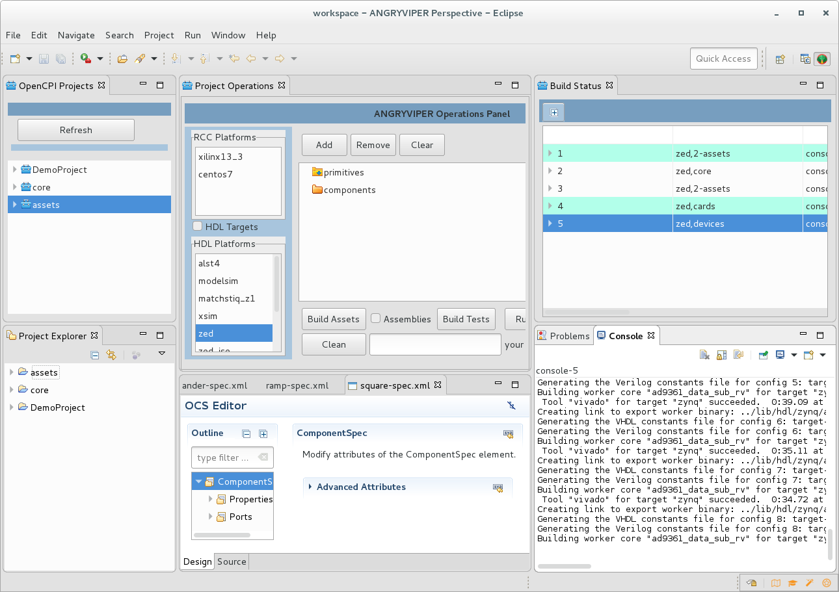Figure 2: ANGRYVIPER IDE showing the ANGRYVIPER Perspective

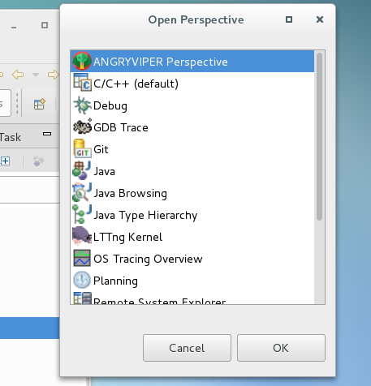
How to use this perspective is explained further in section 4.0 below.

Add Perspective icon

To open the perspective and add it to the perspectives tool bar, click the add perspective icon and select it from the perspective list. Eclipse will switch to the perspective and add the ANGRYVIPER icon to the perspectives tool bar. Once done simply click the perspectives tool bar selections to change between perspectives.
Note that Eclipse allows you to rearrange the views in the perspective and add views to it. Eclipse saves rearranged perspective and will open it that way in the future. The layout above was selected as the default because it gives the developer just about everything needed create and build assets.

3.0 OpenCPI XML Editors

There are two implementations of the XML editors in the ANGRYVIPER plugin. The component editors are form based while the application and assembly editors have a graphical object drag and drop feature as well as the form based feature.

3.1 Creating Assets

The IDE supports the creation of the following OpenCPI assets provides graphical editors to populate their XML files:

- Component Spec – OCS Editor
- Protocol Spec – OPS Editor
- RCC Application Worker – OWD RCC Editor
- HDL Application Worker – OWD HDL Editor
- HDL Primitive Library
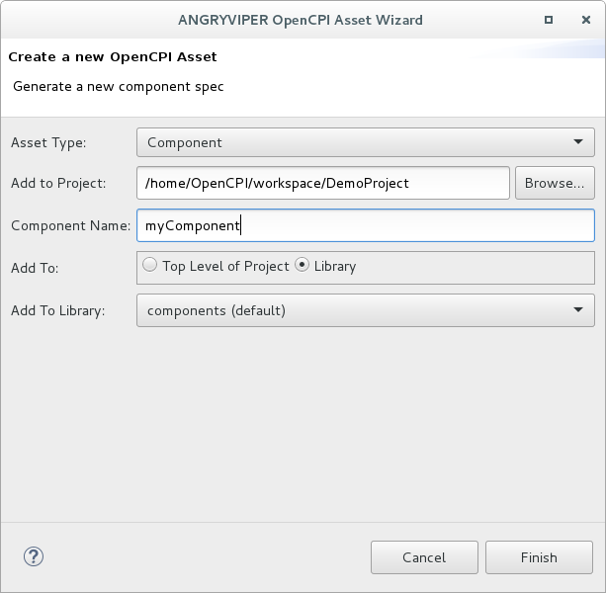
Figure 3: OpenCPI Asset Wizard
- HDL Assembly (OHAD)
- HDL Platform
- OpenCPI Application (OAS)

Use the OpenCPI Asset Wizard to create these assets and begin their respective XML files. There are two ways to access the wizard:

- File-→new → other → ANGRYVIPER, select OpenCPI Asset Wizard.

- With cursor in the Eclipse Project Explorer view, right-click to get a selection context menu, select new-→ OpenCPI Asset Wizard.

The wizard provides simple forms to create the asset. Fill in the required inputs and click finish. If the project or a sub-element in the project tree is selected then the wizard will default to that project. The asset directory is created in its appropriate place within the project and all required framework and build files as well as skelleton source files are created by the IDE. If the new asset has an associated XML file then respective XML editor panel opens to be used to further populate the XML file.

The wizard also supports the creation of high-level assets such as OpenCPI projects and libraries.

If an error occurs the wizard will present a dialog panel explaining the problem. Errors occur when the framework cannot support the asset creation or there are file system issues. Click OK to close the dialog. A second dialog appears that will clean up artifacts of the creating process. Click OK to this dialog to avoid further complications.

Figures 4 and 5 below provide examples of the Component editors in use. To see these editors, use the Eclipse Project Explorer to navigate into the OpenCPI Core and Assets projects and open the various asset XML files. The following list provides an example for each graphical editor:

- core→specs-→iqstream_protocol.xml
- core →components-→specs-→bias_spec.xml
- core →components-→bias_cc.rcc-→bias.xml
- core →components-→bias_param.hdl-→bias_param.xml
- assets → hdl→assemblies→ cic_int_dc_offset_iq_imbalance_mixer_cic_dec
- –> cic_int_dc_offset_iq_imbalance_mixer_cic_dec.xml
- assets → hdl→platforms → matchstiq_z1 → matchstiq_z1.xml
- assets → applications → cic_int_dc_offset_iq_imbalance_mixer_cic_dec
- → cic_int_dc_offset_iq_imbalance_mixer_cic_dec_mathcstiq_z1.xml
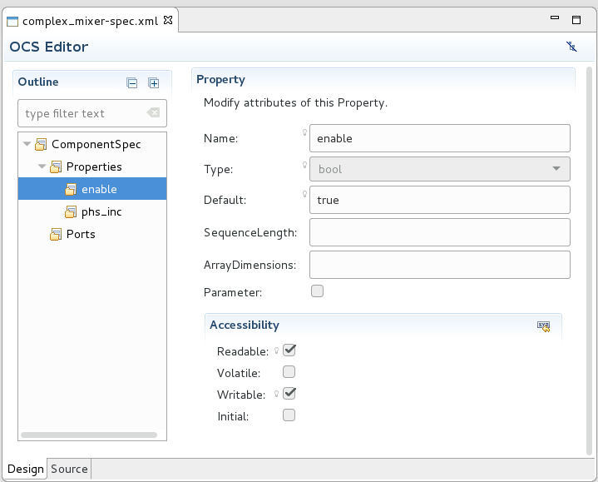
Figure 4: OpenCPI Component Spec Editor

3.1.1 OpenCPI Libraries
An OpenCPI project can have one or more libraries. The typical guidelines are as follows:
- A project anticipated to have a single component library, name the library components. All component and worker assets will reside in the top level components directory. When using the OpenCPI asset wizard to create a library the default name provided is components.
- A Project anticipated to have multiple libraries, give these libraries a name other than components. These libraries will be placed in a top level components as sub-directories named after the library. The user will be given the option to create component specifications and workers in these sub-directory libraries.

3.2 Form Based Graphical Editors

The OWD HDL Editor presented below is an example of the form based editor. Like other XML editors it has a source and design tab. The source tab presents a text editor and as shown below, the design tab presents the form editor.
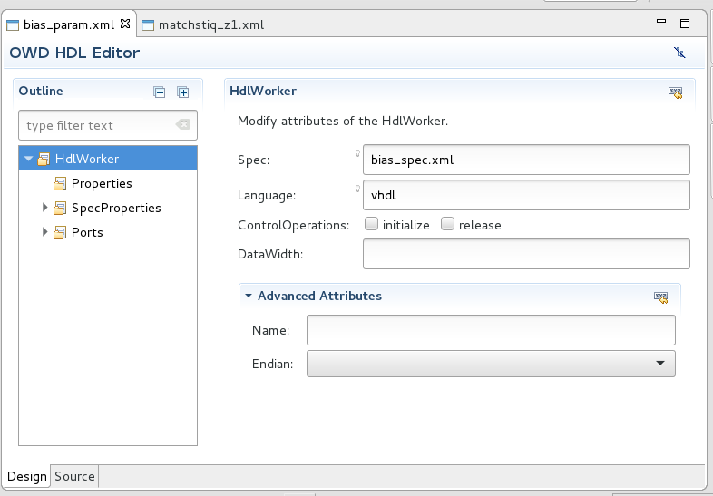
Figure 5: OpenCPI Worker Description Editor

The graphical editor has two panels: the outline panel and the form-input panel. The outline panel is used to navigate the XML elements for this worker. These are the top-level HdlWorker element and Property, SpecProperty and port (StreamInterface) child elements. Select the element in the outline to add a new one or select an existing one; the form for that element opens. This is shown above for the HdlWorker element and Figure 4 shows an enable property.

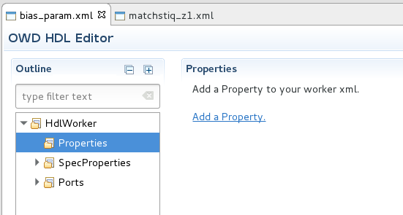
In the adjacent example a property element is added to the worker - select the Properties element in the outline, right click → Add Property. The form to populate the new element appears as shown in Figure 6 below.
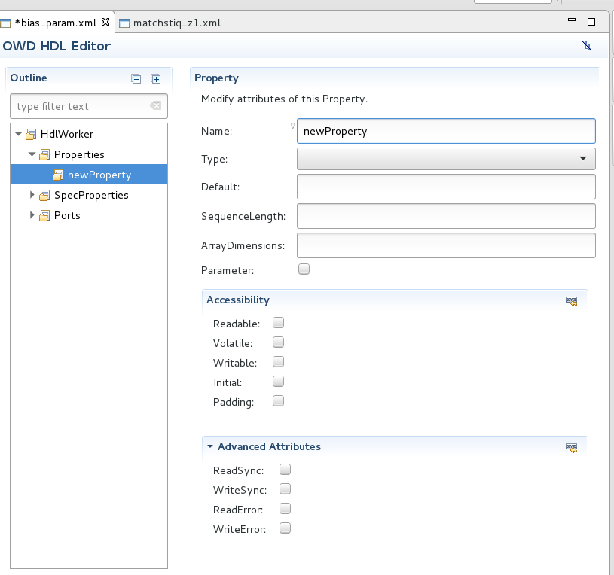
Figure 6: HDL Worker Property Element Form
Select the source tab to see how the new element is added to the XML file. To remove an element: select it, right click-→ select Delete. The source file may also be edited and those changes will appear in the design view.

See the Component Development Guide for more detailed information about the XML files these editors support. Note that these editors provide a basic capability to create these files.

3.3 Graphical Drag-and-Drop Editors

The ANGRYVIPER IDE Application and Assembly Editors provide a drag-and-drop interface to generate the respective XML files. As an example, the Application Editor is used to create a new simple application. To start, use the Asset Wizard to create a new application as shown below. Click Finish and the Application Editor opens as shown in Figure 7 below.

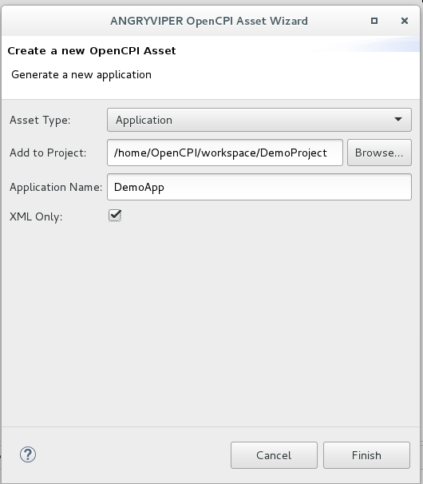

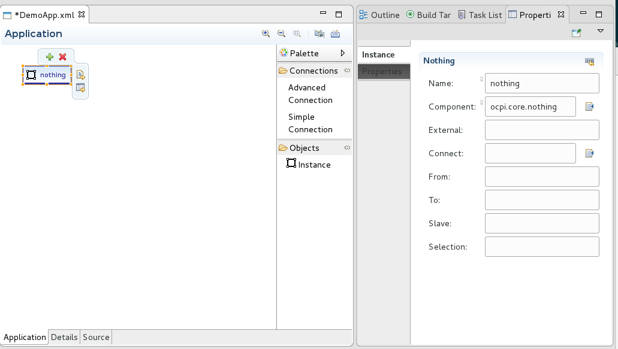
Figure 7: Application Design Panel and Properties View

3.3.1 Adding Components to an Application

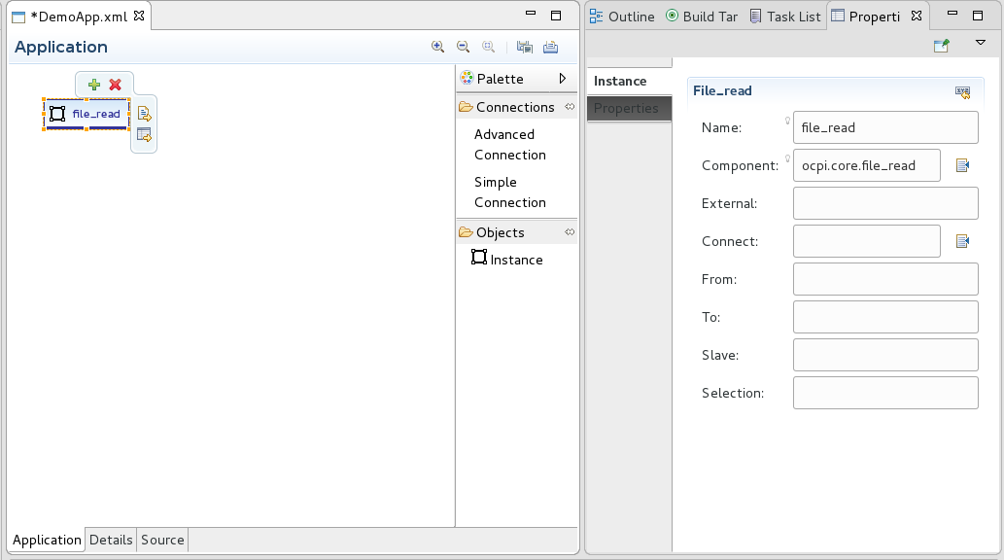
Applications are constructed using OpenCPI Component Specifications (OCS). When the editor opens, the Application tab is presented with the “nothing” instance in the panel. To select a OCS for this instance click the nothing instance and additional controls appear as shown in Figure 7 above.

Select the bottom right icon to see the Properties View form to further populate the instance. To find the desired OCS, go to the Properties View and click on the list icon next to the component text box. A listing of all component specifications found in the environment is displayed. The ocpi.core.file_read was selected and now the display appears as shown above.

The next example adds the ramp-spec (mentioned in the Getting Started Guide DemoProject example) to the application using drag-and-drop. Use the Project Explorer to select a component OCS XML file, left click/hold and drag the file to the Application panel then release the mouse button. Shown below, the “ramp” component is now in the application. Another method to do this is to similarly drag-and-drop the instance object from the Palette into the Application panel then select the component via the Properties View as demonstrated in the example above.
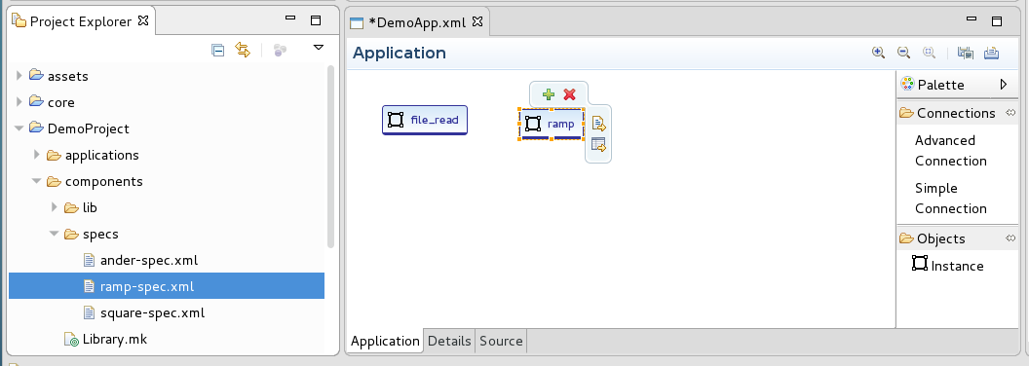
The third method to construct an application is to use the Details tab. This tab presents a form-based editor similar to the component and worker editors described above. The application Details panel is shown in Figure 8 below. Select the Instances element, click Add an Instance, and a form opens to populate the new instance as shown in Figure 9 below.
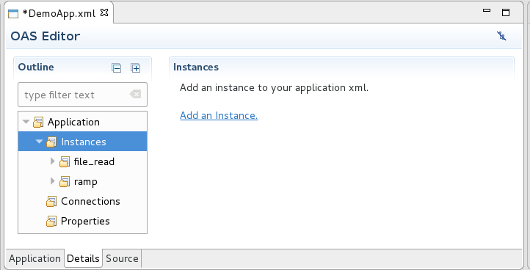
Figure 8: Third Method to Add a Component Instance to the Application.

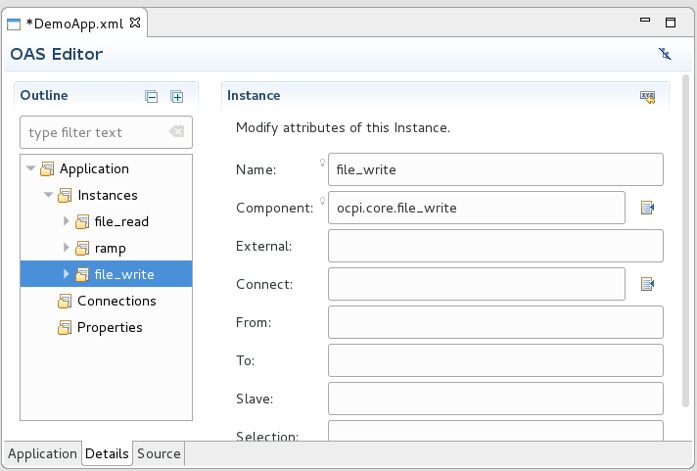
Figure 9: Select File Write as the New Component

Click the list icon next to the Component text box input to the components list. Here the file_write component was selected. The next Figure shows the current design view of the Application.
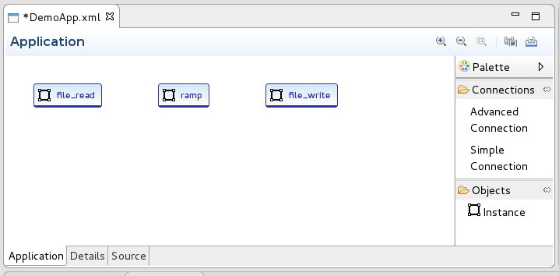

3.3.2 Connecting Application Components

There are two ways to specify a connection between components in an application or assembly. Components with single input and output ports may be connected by a Simple Connection. Components with multiple ports on a given interface (in or out) must be connected by an Advanced Connection (the XML for these must specify the name of the port that is being connected).

The tools available in the Application Editor as the following:

- Select simple or advanced connection from the palette (behaves like a button). Move the cursor to the source component (out port), click while on it, then move the cursor to the receiving component (in) and click again while on it.

- Select the details tab and either update the instance element for simple connections or add connections by selection and adding advanced connection elements.

- Edit the XML source directly.

The following Figures demonstrate a simple connection.

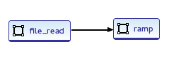

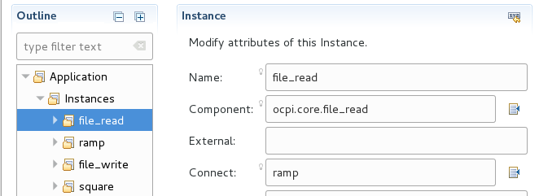

Advanced connections are easily created using the Application tab (the Detail panel is not as nice). To make an advanced connection while in the Application tab, select Advanced Connection in the Palette, move the cursor to the source component then click it, move the cursor to the destination component and click it. A pop up form panel appears with inputs to complete the connect as shown below:

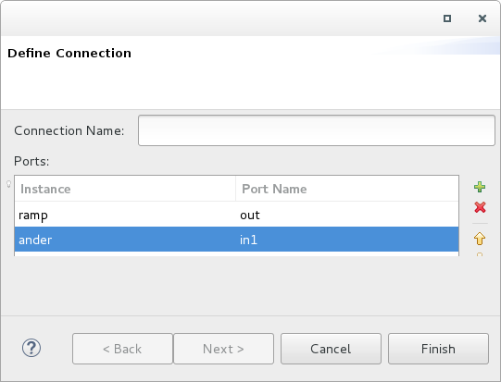
Advanced connections can be named (optional). The ports section opens with default port names out and in. Click on the in port name and update it to the correct port (in1) as shown above. The following series of Figures show the advanced connection in the three editor views:
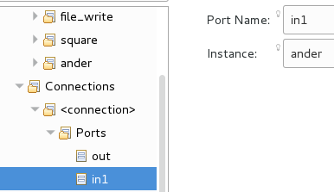
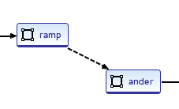

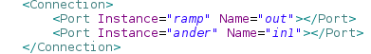

See the Application Development Guide for detailed information about the Application and Assembly XML files. Note that the Application and Assembly editors provide a basic capability to create the respective XML files.

3.3.3 Assembly Editor

The HDL Assembly Editor operates similarly to the Application Editor. The difference is that assemblies are built with Application Workers. The drag-and-drop feature works with OpenCPI Worker Description (OWD) XML files just as the application editor operates with OCS XML files. Note that the worker choices originate from open projects in the workspace. The Figure below shows the square.hdl worker added to an assembly via drag-and-drop.
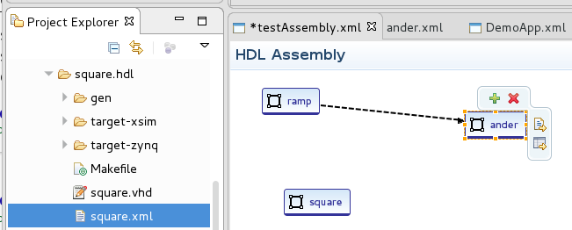

4.0 How to use the ANGRYVIPER Perspective to Build Assets and Run Tests

New to the version 1.3 IDE, the ANGRYVIPER perspective can be used to build assets and run tests. Add this perspective to the Perspectives tool bar by clicking the add perspective icon and select it from the list. Eclipse switches to the perspective and adds its icon to the Perspectives tool bar as shown below. Once done simply click the tool bar icons to switch perspectives.

ANGRYVIPER Perspective Icon
Add Perspective icon
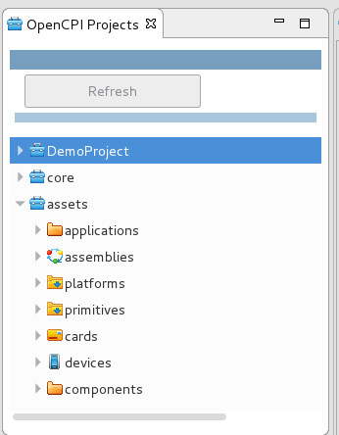

4.1 Introduction

The OpenCPI Projects View provides navigation into a flattened view of OpenCPI projects. It is used to select assets. Selections made in this panel can be added to the Operations View or built directly via right-click on a selection of assets. Build or clean can be executed from any level in the tree from entire projects to individual assets like workers and applications.

4.2 Building with the Operations Panel

The ANGRYVIPER Operations View allows builds for RCC/HDL Platform or HDL Target based on selections in the view. One to many platforms may be selected for a build. Assets selected in the OpenCPI Projects view are added to this panel by the Add button. A build or clean execution is initiated by the Build/Clean buttons. Once initiated an execution configuration is established. The user may re-run the configuration as either a build or clean from this panel or the Status Monitor View.

In Figure 10 below, the following high level assets were added to the build panel in the following order:
- Core Primitives
- Assets Primitives
- Core Components
- Assets Components
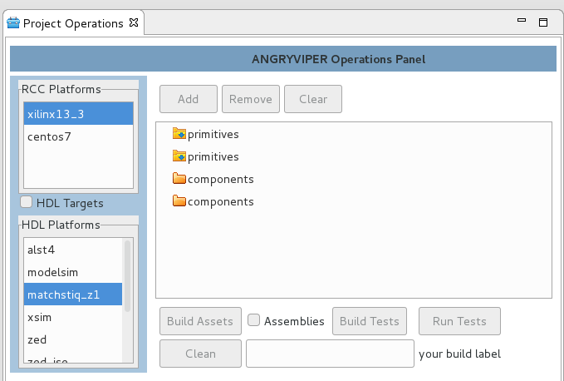
Figure 10: A build configuration setup in the Operations Panel

Click the Build Assets button then an execution configuration is constructed that will build these assets in the order shown for the xilinx13_3 RCC platform and the matchstiq_z1 HDL platform. Shown in Figure 11 below, a status bar for the execution is created and a process is kicked off to build each asset in order. The Status Bar is shown in white which indicates it is running and a console is added to the Consoles View that shows the output of the executing command.

The remove button removes selected assets in the panel and clear removes them all. The default configuration does not build assemblies. This only comes into play when building projects. Build Tests is provided to build all tests at a higher level such as the components library. This option is available because dependencies for the test (the workers and their dependencies) need to be built before tests can be built. Individual tests can be build by either the Build Assets or Build Tests buttons. Run Tests will run only individual tests listed in the panel. A build label may be specified, this label will appear in the status bar.

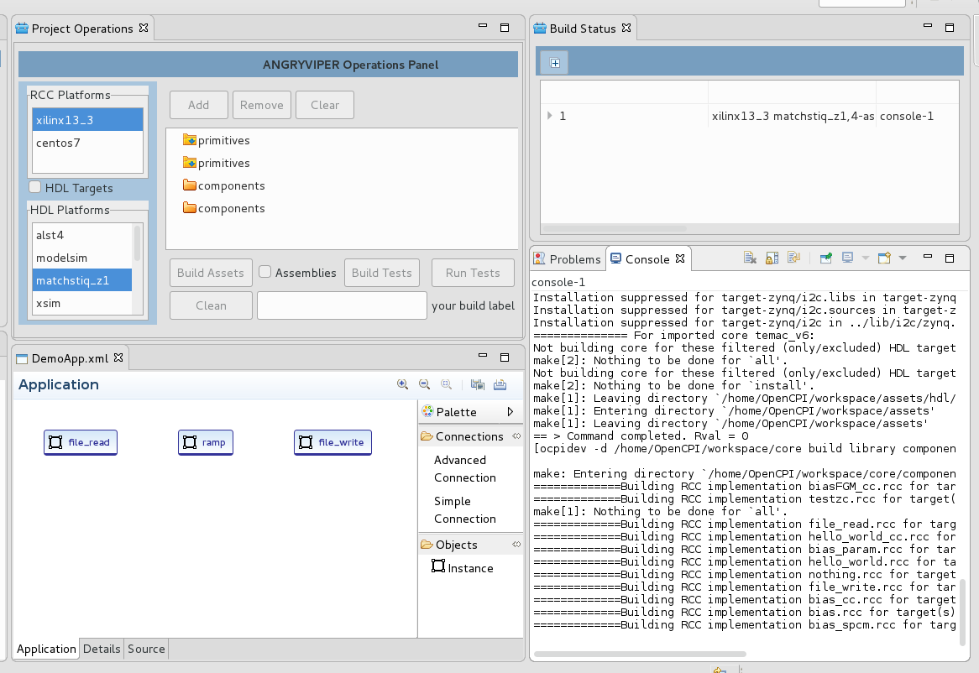
Figure 11: The build Executing, status monitor display and Console

4.3 Build Status Panel
Each execution configuration has a coresponding status bar in the Build Status View. Build status is represented by the color of the bar:
- white - indicates an active execution,
- green - indicates successful completion,
- red - indicates a failure,
- yellow - indicates an execution stopped by the user.

The status bar expands to provide details about the execution and the sequence in which they occurred. In an active execution this list is dynamic; rows are added as the execution proceeds. Figure 12 below demonstrates the status bar for a build that has completed successfully and the expanded view.

Using right click on a bar several actions can be selected: build, clean, run, stop, delete. An inactive execution can be rerun as a build or a clean. Similarly the user may stop an active build. Also, upon selecting a build status bar the console for that build is brought into view.
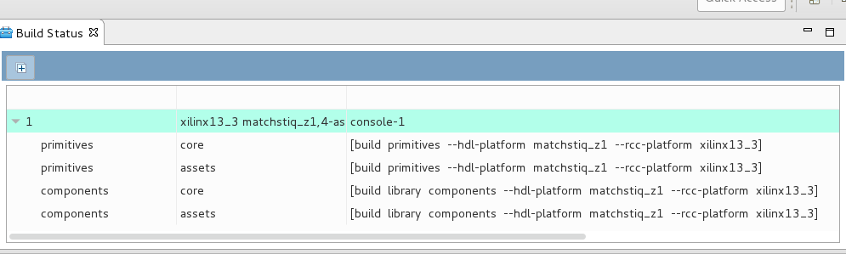
Figure 12: Expanded View of a Successful Build Execution

4.4 Testing with the Operations Panel
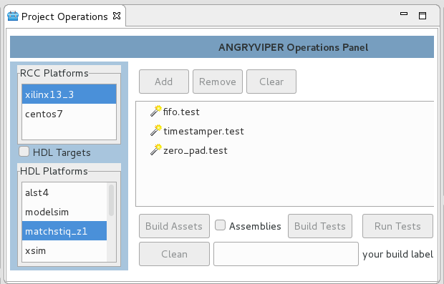
The Operations Panel provides the ability to build and run individual component tests. In the adjacent example three tests were selected from the util_comps component library (in the assets project). These will be build for xlinx and Matchstiq.

The Figure below shows the status bar for this build configuration (number 2). Tests can take a long time build.

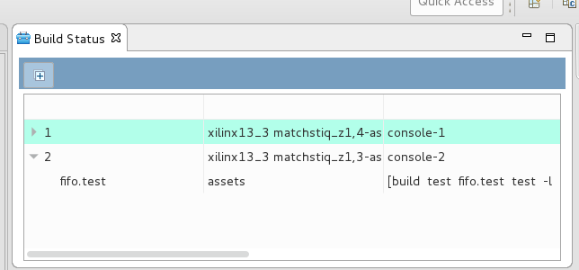

The Run Tests button gives the ability to run component tests for selected platforms. The Figure below shows fifo.test running in simulation. When the test completes the status bar will turn green or red relating success or failure. The user may re-run the test from via the status bar or the operations panel. Note that the odd symbols shown in the console are ANSI color escape sequences. See appendix B for a plugin the displays these a little better.
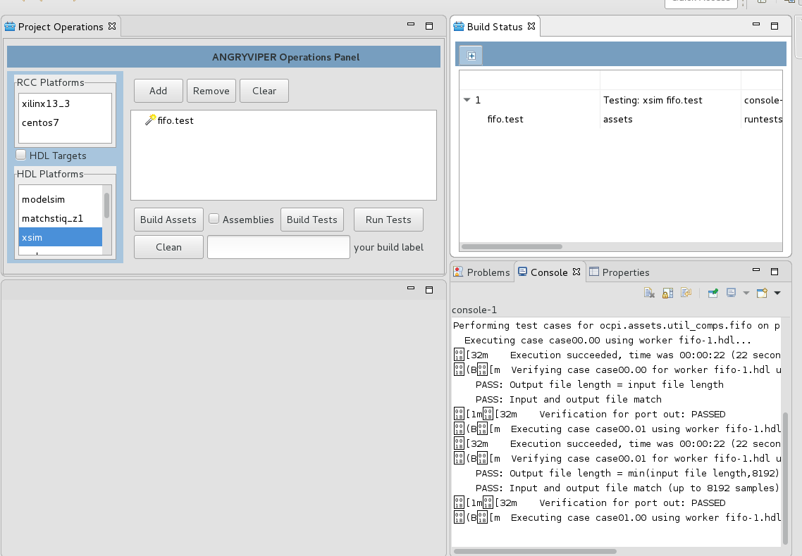
Figure 13: Test Execution, status, and console

4.5 Building from the OpenCPI Projects View

Simple controls are provided in the OpenCPI Projects View to build and clean. Select one or more assets in the view, right-click then select build or clean from the context menu. An execution configuration is constructed from the selections, the platform selections and other inputs from the Operations panel. The Figure below demonstrates a launch from the OpenCPI Projects View and the status bar for the build. Figure 14 below shows the status of the completed build.

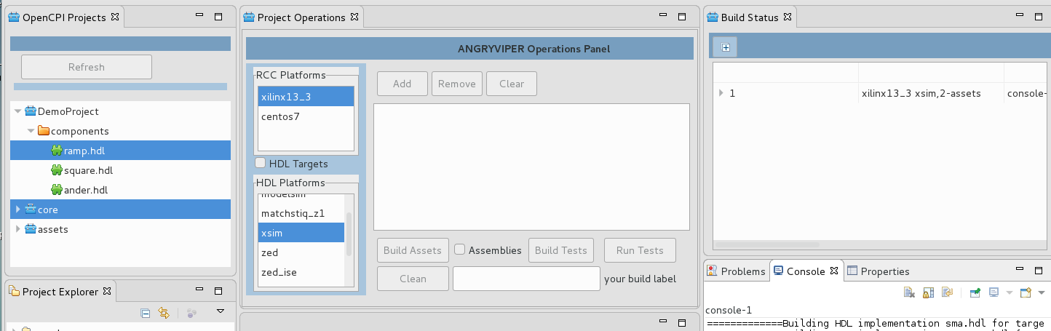
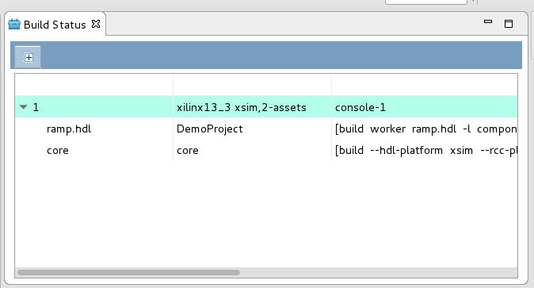
Figure 14: Completed Status of the Build Launched from the OpenCPI Projects View

4.6 Additional Notes About the ANGRYVIPER Perspective

The ANGRYVIPER Team hopes to continue to add capabilities to the OpenCPI Projects View to further support OpenCPI operations such as create/remove assets, open asset editors, etc. The goal for Version 1.3 was to provide build and test capabilities. The explanations below discuss a few things under the hood that can cause the user pause.

4.6.1 The Execution Configuration

The execution configuration provides a means to associate and manage resources tied to the execution. These are:
- The selected assets and platforms
- The execution number
- The Status bar
- The console

The ANGRYVIPER Perspective allows limitless execution configurations however it only allows so many to exist at once since they tie together Eclipse resources such as the consoles. The current limit is twenty-five. When the limit is met, the user will get a pop-up dialog that instructs the user to delete some status bars to free up resources. This is the only way to free up resources other than closing and re-launching Eclipse. The Status view allows multiple selections for this reason. Once done execution numbers will continue to increase but consoles will be reused.

4.6.2 XML Editors Modify Existing XML Files

The following editors will modify existing XML files when they are opened with the editor. The version 1.3 IDE will indicate this is occurring and why; however it will only do it once per Eclipse session.

OCS Editor - The component spec editor corrects the primitive type attribute in the property element.
OAS Editor - The application editor adds a name attribute to the instance element to better support presentation.
HDL Platform Editor – This editor adds an extension element to the signal element to support presentation of signal direction and name. The extension element is ignored by the OpenCPI Framework.

The modifications do not have to be saved.

4.6.3 Warning About a Non OpenCPI Project

The ANGRYVIPER Perspective obtains asset information from the top level project.xml files. If an Eclipse workspace project is encountered that does not have a project.xml it is assumed the project is not an OpenCPI project. This is communicated in a console. If the project is an OpenCPI project then something is wrong in the project file structure that doesn't allow project.xml to be generated.

4.6.4 The Perspective is Not in Sync with the Workspace or the File System

The OpenCPI Projects View does not track changes to the Workspace or the files system (yet). This means changes made via the Eclipse Project Explorer or the Asset Wizard will not be presented in the view until it is refreshed. Additionally, assets created or removed via command line will not be presented in either the Eclipse Project Explorer or OpenCPI Projects View until both views are refreshed. Note: Do not Delete a Project using Project Explored or Shell Command. Use the ocpidev command to delete a project. This ensures project registration information remains up to date.

Appendix A Eclipse Basics

The ANGRYVIPER IDE depends on an OpenCPI installation. It is assumed that a development machine has been set up with a complete OpenCPI installation and the ANGRYVIPER IDE is installed. It is also assumes that there have been user copies of the ocpi.core and ocpi.assets projects created (as discussed in the Getting Started Guide). For this appendix both projects were created in a workspace directory that will be used as the Eclipse “Workspace”.

A central abstraction for Eclipse is “the workspace.” This is a directory Eclipse uses to maintain state and projects. When Eclipse opens it prompts the user to select a workspace. By default it will create directory is named workspace in the user's home directory. In this example a directory named “workspace” has already been created in /home/OpenCPI and the core and assets projects are registered there.

A-1: Starting the IDE
In the terminal window enter ocpigui & This will bring up the Eclipse Launcher window shown below.

Select browse, navigate to /home/OpenCPIworkspace then click OK.
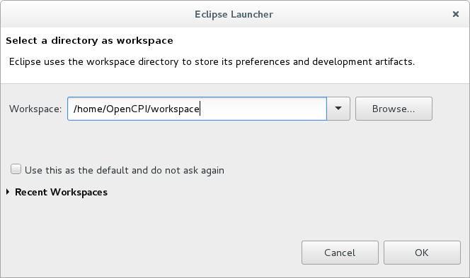
Figure 15: Eclipse Launcher Screen

Since this is a new workspace, when Eclipse completes start-up it presents the Welcome screen as shown in the Figure 16 below. If you are new to Eclipse, this is a good screen to explore; keep the Always show welcome on start up checkbox checked and go through these items. For now we will move on to the workbench – click the workbench arrow button in the upper right corner.

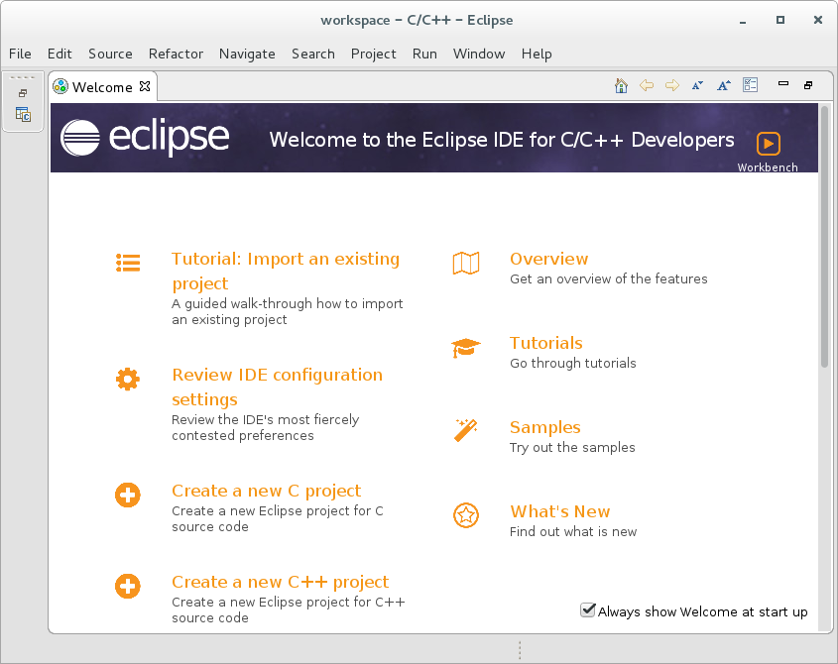
Figure 16: Welcome Screen - Has good Overview Material

When the workbench opens, Eclipse defaults to the C/C++ perspective as show in Figure 17 below.

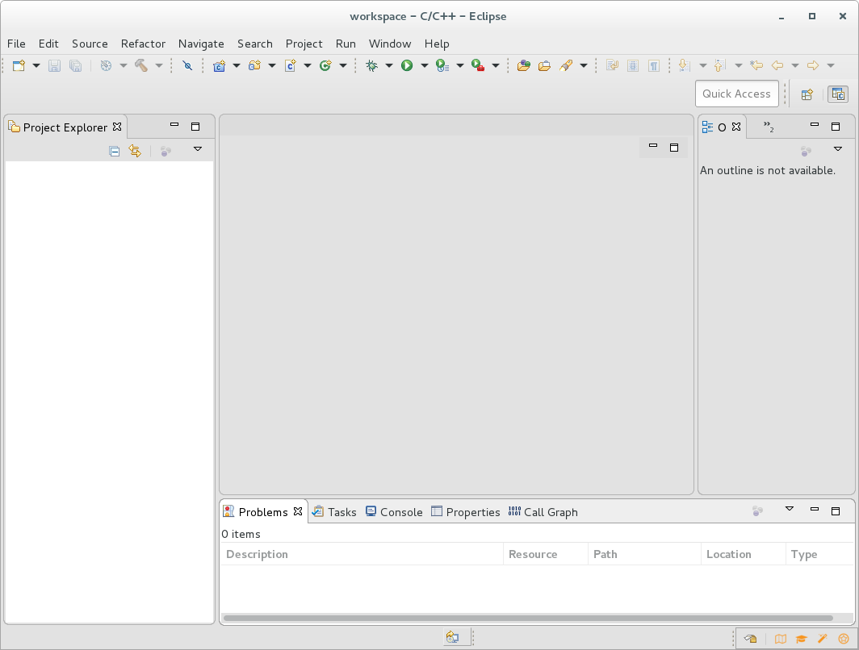
Figure 17: The Default C/C++ Perspective

Notice that the core and assets projects are not shown in the Project Explorer view even though they were placed in the workspace folder. They need to be imported into the workspace.

A-2. How to Import an Existing Project into the Workspace

Place the cursor in the Eclipse Project Explorer panel, right click-→import-→General → Existing Projects into Workspace.

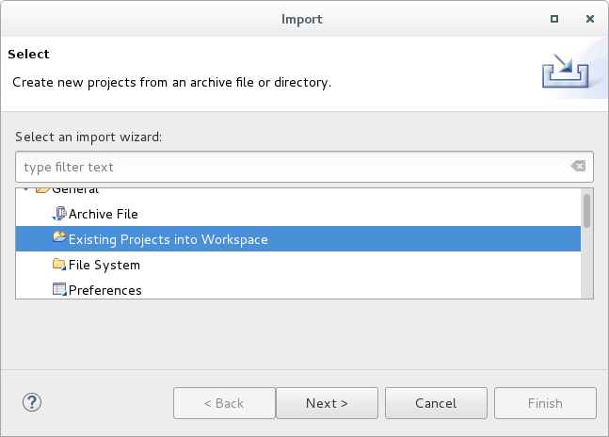
Figure 18: Select Import Existing Projects

The import project wizard opens. Shown in Figure 19 below, click browse for the Select root directory input, navigate to /home/OpenCPI/workspace, click ok. Eclipse indicates both the core and assets projects will be imported. The warning is due to the RemoteSystemsTempFiles project which Eclipse automatically sets up. No further inputs are needed. Click Finish.

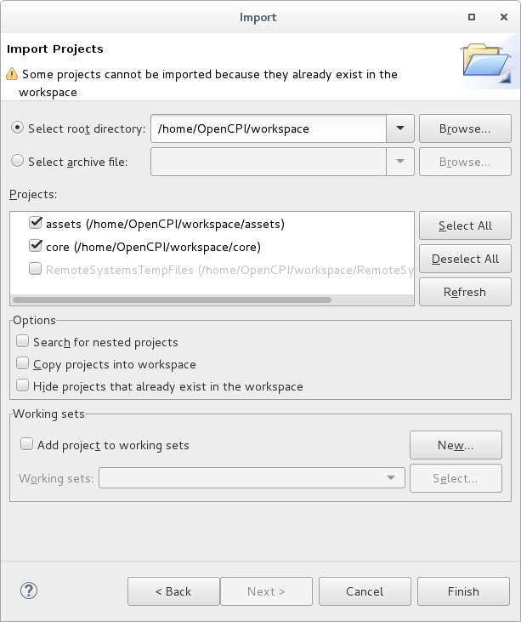
Figure 19: Import Projects Wizard

The core and assets projects will now be listed in the Project Explorer (Figure 20 below). Expand them to see their content. This view represents the file system. The Project Explorer panel provides navigation and controls to work with projects, folders, and files.

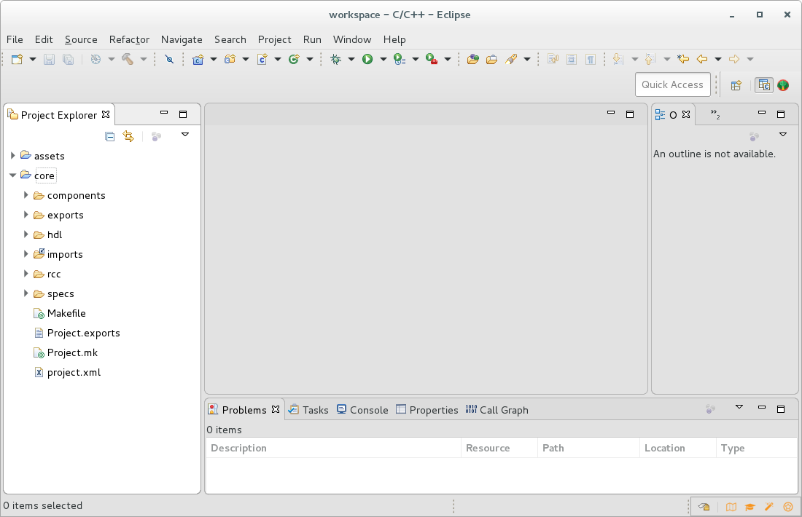
Figure 20: Eclipse Showing the Imported core and assets Projects

A-3. How to Create a New OpenCPI Project

This example demonstrates Setting up the DemoProject discussed in the Getting Started Guide. Place the cursor in the Project Explorer panel, right-click-→ New → OpenCPI Asset Wizard. This wizard is used to create the currently supported OpenCPI assets (see Section 3). Select Project in the Asset Type dropdown, enter “DemoProject” as the Project Name. Click Finish and the new project is added and shown in the Project Explorer panel.

Next add the components library: in the Project Explorer panel, right-click-→ New → OpenCPI Asset Wizard; select Library. Enter “components” for the library name then click finish. The new DemoProject is now ready for component specs, workers, and other OpenCPI assets. Section 3 of this document provides more examples of using the OpenCPI Asset Wizard and the XML file editors.
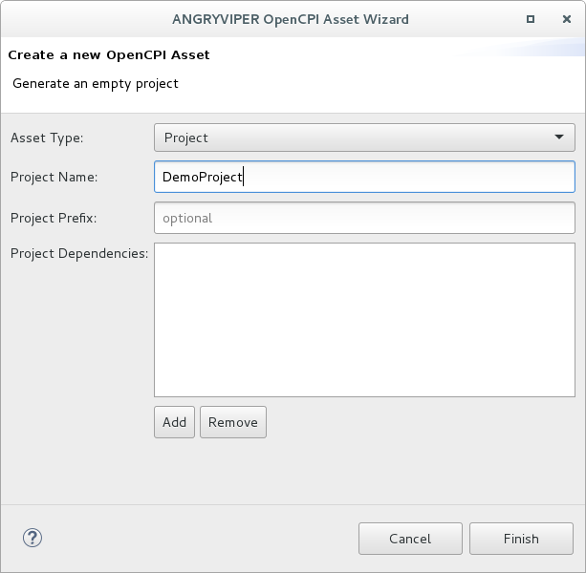
Figure 21: OpenCPI Asset Wizard being used to Create a OpenCPI Project

A-4. Eclipse Basic Concepts

Perspectives – Eclipse uses Perspectives to provide various sets of tools that together focus on a given perspective into the development environment. A perspective consists of a workbench layout of a complimentary set of Eclipse views of views. A view is a workbench panel that provides a specific capability. For example, the Eclipse Project Explorer View provides a graphical view of the file system and the ability to navigate through it and act upon it. The Window link at the top of the UI provides navigation to to the available perspectives, and views, as well as workbench window controls and user Preferences. One final note: the user can rearrange a perspective layout, add or remove views, and modify panel sizes and that this state is saved as the user's new default for that perspective.

Editors and Toolchains – Review the Workbench Overview panel and look over C/C++ Development documentation.

Appendix B Addition Plugins for the IDE

If the development machine has access to the internet or a mirrored Eclipse Marketplace, consider the following software to enhance the ANGRYVIPER IDE experience. The Marketplace link is located under the Help link in the top navigation bar. The Marketplace makes it very easy to search, browse and review software. Using the IDE navigate to Help → Eclipse Marketplace. Search for the packages below; it's a simple Install button click to get the package.

B-1 TM Terminal 4.0.

Search for Terminal in the Marketplace to see a number of available terminal packages. The TM Terminal 4 has been used successfully by the ANGRYVIPER team. Click the install button to install the product. Typically an agreement must be excepted to continue.

B-2 ANSI Escape in Console Plugin

While not entirely effective this seems to be the only product available to deal with the ANSI color escape sequences in the Eclipse Console View (seen when running tests). Search for ANSI Escape and install. You might like it.

When the framework creates a new application if populates the application with one instance element. This is done so a new application skelleton can be built and run.
Component Specifications as extracted from the OpenCPI development environment. Worker Descriptions are extracted from the Eclipse workspace. If desired workers are missing, import and open the project then refresh assets using the OpenCPI Projects view.
An execution configuration consists of the selection of assets, the platform/target selections to which to build or run against, the associated status bar and the associated Eclipse console.
You may see an exception stacktrace written to the terminal window. This is not understood but is expected when the GUI is started after a fresh installation. It appears to be related to loading the ANGRYVIPER plugin for the first time.
An Eclipse perspective is a layout of selected views. Eclipse has a number of perspectives tailored to development objectives. To see a listing navigate to Window-→ Perspective → Open Perspective. A view is an individual panel like “Project Explorer”. A listing of views can be seen by navigating to Window → Show View.

