ANGRYVIPER IDE

User's Guide
Revision History

Revision | Description of Change | Date
1.0 | Created | 2/2018
2.0 | Revision for v-1.4 | 9/2018

Table of Contents
1.0 References 4
2.0 Introduction 4
2.1 New Features in the 1.4 Release 5
2.1.1 Views in IDE 5
2.1.2 ANGRYVIPER Wizard 5
3.0 Overview 6
3.1 ANGRYVIPER Perspectives 7
3.2 Customizing Perspective Layout 7
3.3 Unit Test Panel Layout 9
4.0 OpenCPI XML Editors 12
4.1 Form Based Graphical Editors 12
4.2 Graphical Drag-and-Drop Editors 17
4.2.1 Adding Components to an Application 18
4.2.2 Connecting Application Components 20
4.2.3 Assembly Editor 22
5.0 How to use the ANGRYVIPER Perspective to Build Assets and Run Tests 23
5.1 Introduction 23
5.2 Building with the Operations Panel 23
5.3 Build Status Panel 26
5.4 Testing with the Operations Panel 26
5.5 Building from the OpenCPI Projects View 28
5.6 Additional Notes About the ANGRYVIPER Perspective 29
5.6.1 The Execution Configuration 29
5.6.2 XML Editors Modify Existing XML Files 29
5.6.3 Warning About a Non OpenCPI Project 30
5.6.4 The Perspective is Not in Sync with the Workspace or the File System 30
Appendix A Eclipse Basics 31
A-1: Starting the IDE 31
A-2. How to Import an Existing Project into the Workspace 38
A-3. How to Create a New OpenCPI Project 40
A-4. Eclipse Basic Concepts 41
Appendix B Addition Plugins for the IDE 42
B-1 TM Terminal 4.0. 42
B-2 ANSI Escape in Console Plugin 42

1.0 References

Some familiarity with the Eclipse IDE or similar development environment is assumed. If this is not the case Appendix A provides basic information to get you started. The document begins with the assumption that OpenCPI and the ANGRYVIPER IDE are installed on a development machine and the Eclipse workspace has been established.

Title | Published By | Link
Installation Guide | ANGRYVIPER Team | RPM_Installation_Guide.pdf
Acronyms and Definitions | ANGRYVIPER Team | Acronyms_and_Definitions.pdf
OpenCPI Website | OpenCPI | https://www.opencpi.org
Getting Started Guide | ANGRYVIPER Team | https://opencpi.github.io/Getting_Started.pdf
OpenCPI Component Development Guide | ANGRYVIPER Team | https://opencpi.github.io/OpenCPI_Component_Development.pdf
OpenCPI Application Development Guide | ANGRYVIPER Team | https://opencpi.github.io/OpenCPI_Application_Development.pdf
Table 1: Links for Documentation and Guides

2.0 Introduction
The ANGRYVIPER IDE consists of the Eclipse IDE for C/C++ developers and a custom plugin that supports development in OpenCPI. If the ANGRYVIPER OpenCPI RPMs are accessible, a complete IDE installation is available in an angryviper-ide RPM (follow the link in Table 1: RPM_Installation_ Guide and go to section 6.1).

An alternative method is to obtain the plugin from GitHub and drop it into an existing Eclipse installation. This method is described in the RPM_Installation_Guide (Appendix D) which may also be viewed from the link provided in Table 1.

If this IDE was installed be RPM, the installation is located in /opt/opencpi/gui and the command ocpigui is provided to start the IDE. If IDE is constructed using the plugin method, simply starting your Eclipse provides the IDE.

2.1 New Features in the 1.4 Release
For this release the IDE has expanded features in the OpenCPI Projects View to support the OpenCPI work flow:

- Asset Creation and Deletion
- OpenCPI Project Registration
- Displays all supported assets and opens asset XML editors
- A Context menu that provides useful options based on the selected asset
- The ANGRYVIPER Assets Wizard is now integrated into the ANGRYVIPER Perspective so it does not need to be refreshed when assets are created.
- The IDE now fully supports component unit test creation and execution. Unit test creation is added to the Assets Wizard and a unit test editor now supports test XML. Finally a full feature unit test control panel is integrated into the Operations View to give test build and run capability.

3.0 Overview
The face of the ANGRYVIPER IDE is now the ANGRYVIPER Perspective. This section provides an overview of the perspective layout and how to set it up in a new IDE installation.

3.1 ANGRYVIPER Perspective
The Figure below illustrates the new ANGRYVIPER Perspective. It consists of five views and the Eclipse editor panel.

ANGRYVIPER Operation View
OpenCPI Project View
Build Status View

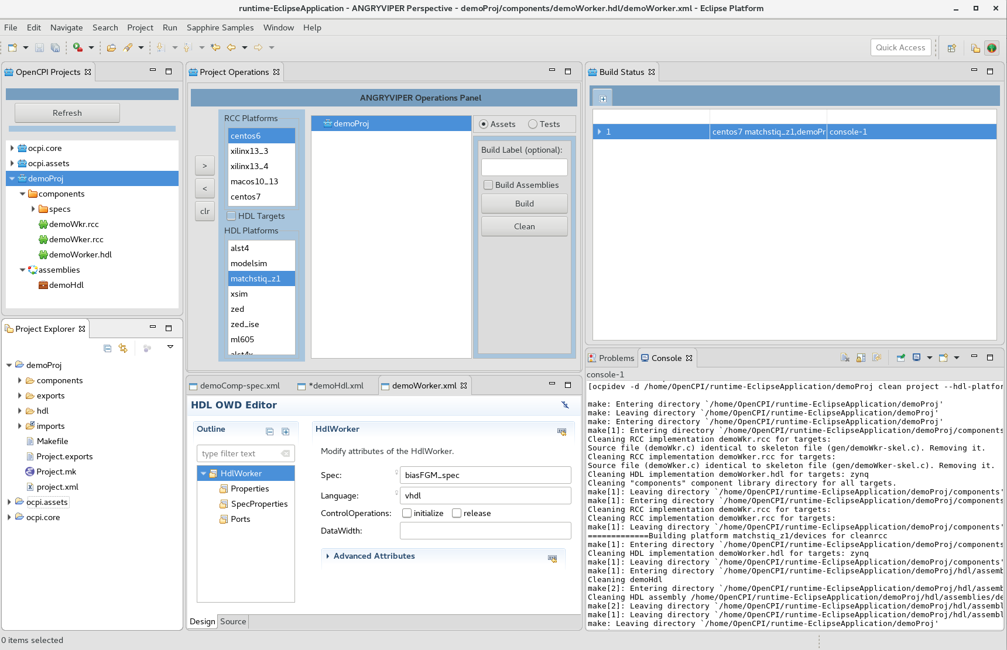

Console View
Eclipse Text Editor Panel
Eclipse Project Explorer View

The full descriptions of these views are provided in Section 4. Brief summaries of each view follow:

OpenCPI Projects View – an explorer providing a flattened view of the projects and assets. In the 1.4 release this view has become the primary tool to find and open asset XML files and its context menu has a rich set of features: asset wizard, open, build, clean, delete, and project registration. To open the menu simply right-click anywhere in this view.
ANGRYVIPER Operations View – provides platform selection and controls to build assets and run tests. The ANGRYVIPER Operations View layout has changed to provide a full feature application unit testing capability in addition to building and cleaning assets. This required a new control panel and the user toggles between building and testing controls.

Build Status View – provides a graphical view of build/run execution configurations and execution status. The user can also re-run builds and tests using this view. The resulting color after build process in this view convey meaning as follows:
- white - indicates an active execution,
- green - indicates successful completion,
- red - indicates a failure,
- yellow - indicates an execution stopped by the user.

Project Explorer View – provides a view into a projects file system. This view primarily supports code development. It is included in the perspective for reasons provided in section 4.

Eclipse Editor Panel – Asset and text editors open in this panel.

Eclipse Console View – shows the various ocpidev command executions based on user requests as well as the end result of the requests.

In a new Eclipse installation the current default behavior is Eclipse opens in the selected workspace and displays the C/C++ perspective shown below. The ANGRYVIPER Perspective must be added to the Eclipse perspectives tool bar for regular use.
Open Perspective Icon
Perspective Tool Bar
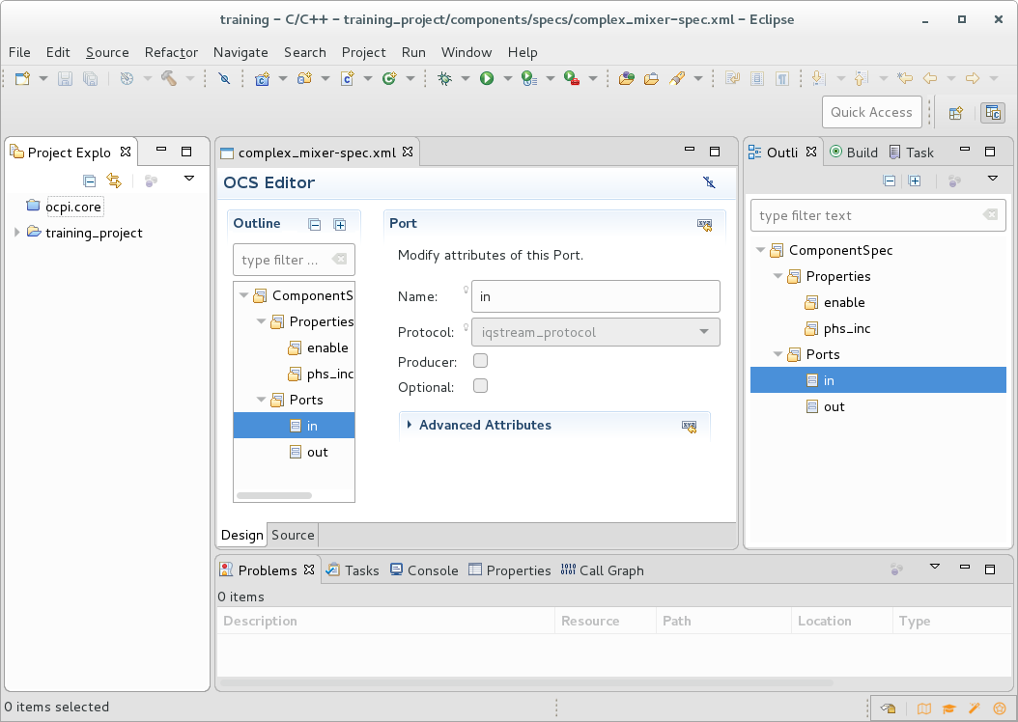Figure 1: ANGRYVIPER IDE showing th C/C++ Perspective

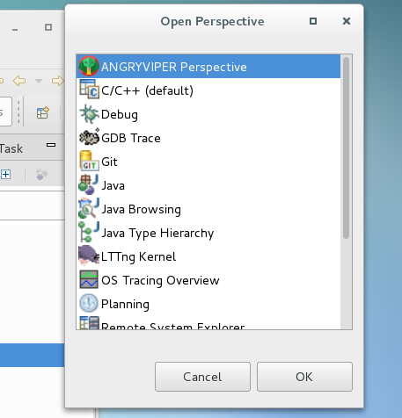
To open the perspective and add it to the perspectives tool bar, click the open perspective icon and select it from the perspective list.

Eclipse will switch to the perspective and add the ANGRYVIPER icon to the perspectives tool bar. Once done, simply click the perspectives tool bar selections to change between perspectives.

If “ANGRYVIPER Perspective” is not shown in this Open Perspective window, please make sure av.proj.ide.plugin is installed in your Eclipse installation.

Eclipse allows the user to rearrange the views in the perspective and add views to it. Eclipse saves rearranged perspective and will open that saved perspective for future use (as long as the workspace is preserved). The ANGRYVIPER perspective default layout was selected because it a core complement of tools to accomplish OpenCPI operations.
To see a listing of Eclipse perspectives, navigate to Window-→ Perspective → Open Perspective. A view is an individual panel like “Project Explorer”. A listing of views can be seen by navigating to Window → Show View.

4.0 ANGRYVIPER IDE Overview and Features

4.1 Overview
The ANGRYVIPER Perspective now provides most OpenCPI project features for the user. It is now the main display for the IDE. This section provides feature details for each of the eclipse views that make up the perspective.

4.2 OpenCPI Projects View Features
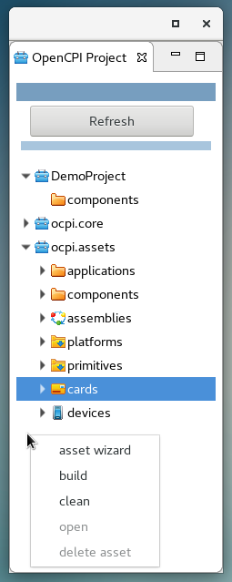
The OpenCPI Projects View provides navigation into a flattened view of OpenCPI projects. It currently displays OpenCPI projects and a subset of the OpenCPI assets that it supports.

A right-click context menu provides features appropriate to the selected asset. Through it the user has the following core features:
- asset wizard – opens the asset wizard
- build
- clean
- open – when enabled opens the assets XML file in the respective editor. Double click an individual asset performs the open as well.
- delete asset – remove the asset and its respective artifacts.

Build or clean can be executed from any level in the tree from entire projects to individual assets like workers and applications.

Context features are added to the menu based on the current [single] selection:

- project selected – register or unregister depending on the registration state of the project
- components selected – new component, new protocol, new worker, new unit test
- applications, assemblies, primitives selected – create a new respective asset.

It is also used to select assets to be added to the Operations View.

4.2.1 Building from the OpenCPI Projects View

Select one or more assets in the view, right-click then select build or clean from the context menu. An execution configuration is constructed from the selections, the platform selections and other inputs from the Operations panel. The Figure below demonstrates a launch from the OpenCPI Projects View and the status bar for the build.
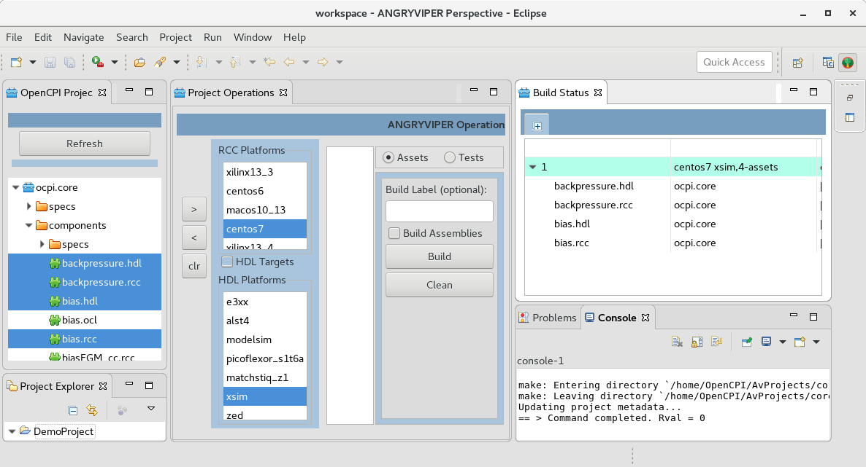

4.3 Operations View Features

The ANGRYVIPER Operations View is used to build OpenCPI assets and to build and run application component unit tests. This panel has two modes of operation. The assets mode provide asset build and clean operations and the test mode supports unit test operations.

Core features of the panel are:
- add selections in the Projects view to the operations panel ( > button)
- remove selected assets from the panel ( < button)
- clear the panel ( clr button)
- make RCC/HDL Platform build selections or HDL Target Selections
- execute build or clean on the assets in the operations panel in the order they appear
- build and run unit tests

To add assets to the operations panel, select one or more assets in the projects panel (use the CTRL or SHIFT keys similarly was working with an email app) and press the add button. One to many platforms may be selected for a build.

The operations panel opens in assets mode by default. The radio buttons on the top of the build controls section toggle control for building assets and running unit tests.

4.3.1 Assets Mode
A build or clean execution is initiated by the Build/Clean buttons. Once initiated an execution configuration is established. The user may re-run the configuration as either a build or clean from this panel or the Status Monitor View.

Figure 10 below demonstrates a build executed from the operations panel. The a status bar for the completed build is expanded to show the build order. The console view lists each ocpidev build command and output from the command. If the execution configuration is rerun the corresponding status bar and console will show the progress of the execution. Building assets can occur at all level of of an OpenCPI project (project, second level asset folders, and individual assets).

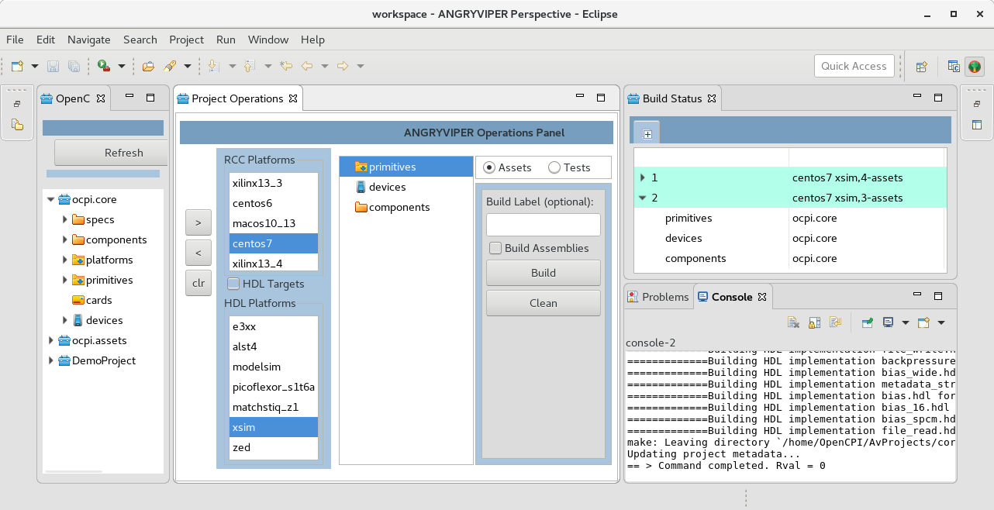
Figure 10: A build configuration setup in the Operations Panel

4.3.2 Unit Test Mode
The Unit Tests panel shown below supports most of the features for the unit testing of workers which is described in the OpenCPI Component Development Guide. Reference the guide for a complete description of the unit test of workers and details regarding the five phases of unit testing, which are: Generate, Build, Prepare, Run, Verify. The Tests panel shows support for these phases, (currently, no discrete support for Build phase) and provides three buttons that conveniently combine unit test phases that are commonly performed based during the development and debugging of a unit test.

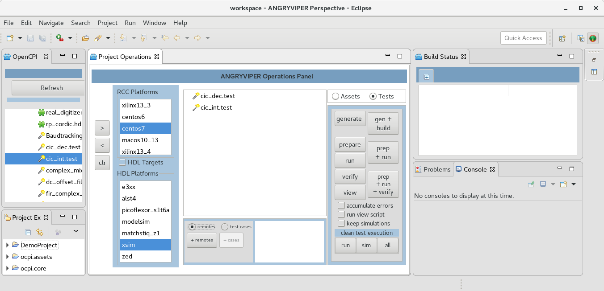
The follow is a list of Tests features and the equivalent development guide operation or argument:
- View button = view operation
- run view script = View=1
- accumulate errors = TestAccumulateErrors=1
- keep simulations = KeepSimulations=1
- test cases = Cases
- remotes = OCPI_REMOTE_TEST_SYSTEMS
The ability to clean the various content of a unit test is provided in the form of the “run” content, “sim” (simulations data) or “all” (gen/ and run/). WARNING: “simulation” directories may become quite large and consume an alarming amount of storage.
Similar to Assets Mode, Unit Test Mode constructs and executes ocpidev command strings to perform the various phases of unit testing. Building of unit tests is possible via the Assets or Tests panel, but only the Tests panel supports the other phases of unit test. Any test listed in the Operations Panel is executed in sequence. Prior to execution of a Tests phase, the user must have selected the desired RCC/HDL Platforms, “test cases” and “remotes”. Multiple platforms, “test cases” and “remotes” may be highlighted but only one project for a remote system can be active. For example:

- Valid :192.168.2.9=root=root=/mnt/ocpi_core:192.168.2.10=root=root=/mnt/ocpi_assets
- Invalid :192.168.2.9=root=root=/mnt/ocpi_core:192.168.2.9=root=root=/mnt/ocpi_assets

The bottom panel is used to enter remote systems and test cases. The remote/test cases radio button toggle the two operations. Click the +remotes button to add a remote system via a pop-up dialog. In the example below two remotes are available; the remote selected is placed in the next run. Test cases are added and selected in the same manner. Multiple entries may be selected for a run. The list panel has a right-click menu with edit and delete options for selected entries.

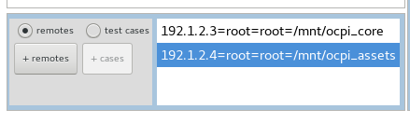
4.4 Build Status View Features
Each execution configuration has a corresponding status bar in the Build Status View. Build status is represented by the color of the bar:
- white - indicates an active execution,
- green - indicates successful completion,
- red - indicates a failure,
- yellow - indicates an execution stopped by the user.
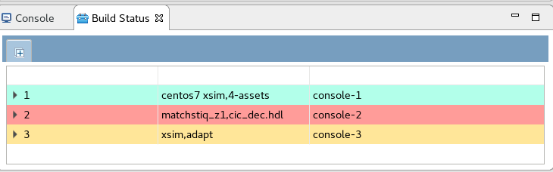

The status bar expands to provide details about the execution and the sequence in which they occurred. In an active execution this list is dynamic; rows are added as the execution proceeds. Figure 12 below demonstrates the status bar for a build that has completed successfully and the expanded view.
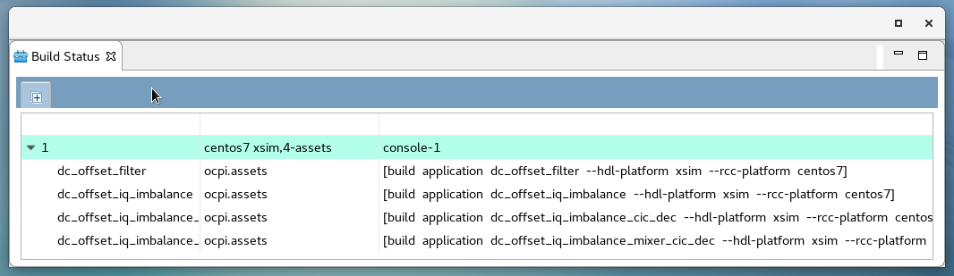
Figure 12: Expanded View of a Successful Build Execution
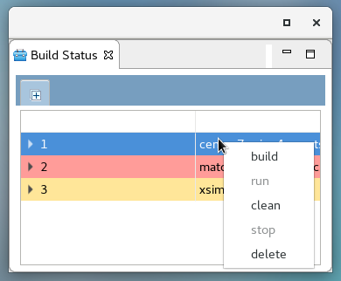
Using right click on a bar several actions can be selected: build, clean, run, stop, delete. For example, an inactive build execution can be rerun as a build or a clean. Similarly the user may stop an active execution. Finally an inactive status bar can be deleted. Also, upon selecting a build status bar the console for that build is brought into view.

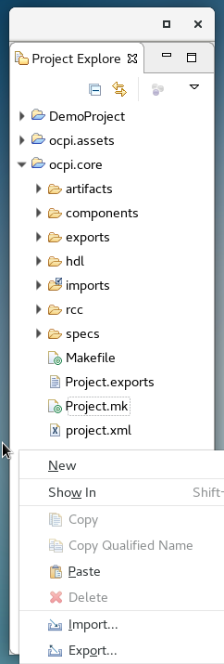
4.5 Eclipse Project Explorer View
The Eclipse Project explorer is provided in the ANGRYVIPER Perspective because it provides a file system view of the projects. This view has a right-click context menu that provides workspace features such as project import, workspace/project refresh, access to the ANGRYVIPER Assets Wizard (via the New selection). It is view eclipse provides in the C/C++ Perspective and it is best suited to support code development. It can however be used to open OpenCPI XML files in an XML editor and it opens supported assets in the respective graphical editor. Finally and unfortunately it is the only view that currently supports drag and drop into the Application and Assembly editors. Most of the core OpenCPI asset management features are now implemented in the OpenCPI Projects View.

Caution:

Do not delete OpenCPI assets by deleting their top level folders in this view. Use the asset delete provided in the OpenCPI Projects view as it executes the underlying ocpidev delete command that completely removes the asset from the framework infrastructure.

4.6 Eclipse Console View
The IDE leverages The Eclipse Console View to allow the user to readily see execution output for multiple build and test runs. The IDE supports a notice console and up to twenty-five execution consoles.

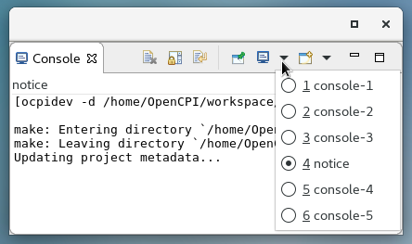
There are some useful features in the view tool bar. These are clear, scroll lock and display selected console. Display selected console provides a useful way to see the notice console covered by an active build console.

Note that execution configurations clear the respective console and bring them to view when they are re-run.

4.6.1 Notice Console
The notice console is used to communicate messages typically seen in a log. These are messages about issues in reading the environment, output of ocpidev create, delete messages, and resource issues. View the notice console if something unexpected happens and the IDE doesn’t indicate a problem via a pop-up dialog.
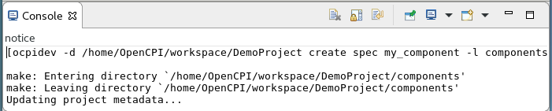

4.6.2 Execution Consoles
Execution consoles provide build and run commands and their output. The IDE supports up to twenty-five active execution configurations at a time and each configuration gets its own console. The Figure below shows a console for a build that was successful.
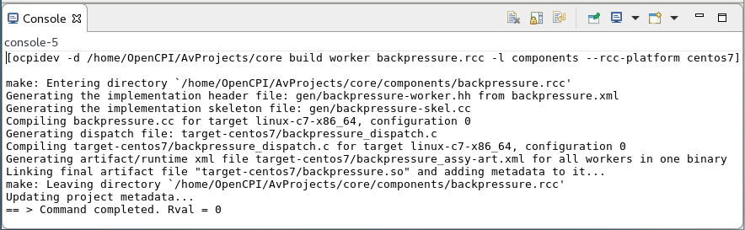

4.7 ANGRYVIPER OpenCPI Asset Wizard
The asset wizard provides a simple tool to create a number of OpenCPI Assets. It provides a simple form for the required and optional parameters to create the asset (accomplished by ocpidev create). Upon completion, the asset and follow-on OpenCPI framework folders and files are created and the new asset is displayed in the project views. If an XML editor is provided in the IDE then the respective editor is opened to further populate the XML specification. Figure 13 shows all the available assets in the drop down list that the wizard support to create.

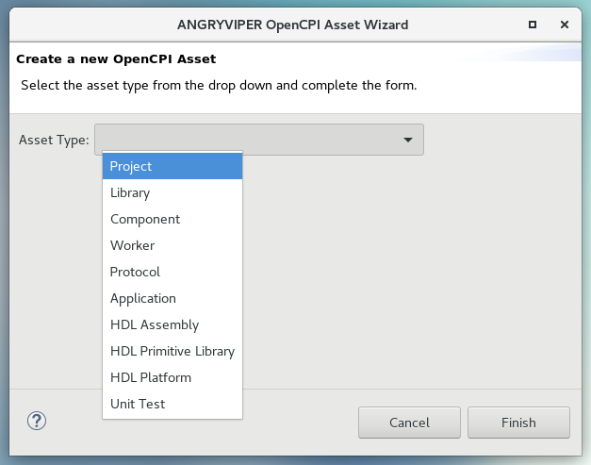Figure 13: OpenCPI Asset Creation Wizard

This OpenCPI asset creation wizard may be selected from the context menu obtained by right-click anywhere in OpenCPI Projects View. It is also found under the new selection (or new → Other) in the Eclipse Project Explorer view context menu. It is similarly found under the File tab in the top Eclipse tool bar.

Caution:

There are some dependencies to create assets. An OpenCPI project must be open in the workspace before any other assets can be created. Also, a components library must be establish before components and workers can be created.

4.8 OpenCPI Asset XML Editors
The IDE supports the creation of the following OpenCPI assets and provides graphical editors to populate their XML files:

- Component Spec – OCS Editor
- Protocol Spec – OPS Editor
- RCC Application Worker – OWD RCC Editor
- HDL Application Worker – OWD HDL Editor
- HDL Assembly – OHAD Editor
- OpenCPI Application – OAS Editor
- HDL Platform
- Component Unit Tests

There are two implementations of the XML editors in the ANGRYVIPER plugin. The component editors are form based while the application and assembly editors are diagram based and also support the form based feature.

4.8.1 Form Based Graphical Editors
The OWD HDL Editor presented below is an example of the form based editor. Like other XML editors it has a source and design tab. The source tab presents a text editor and as shown below, the design tab presents the form editor.

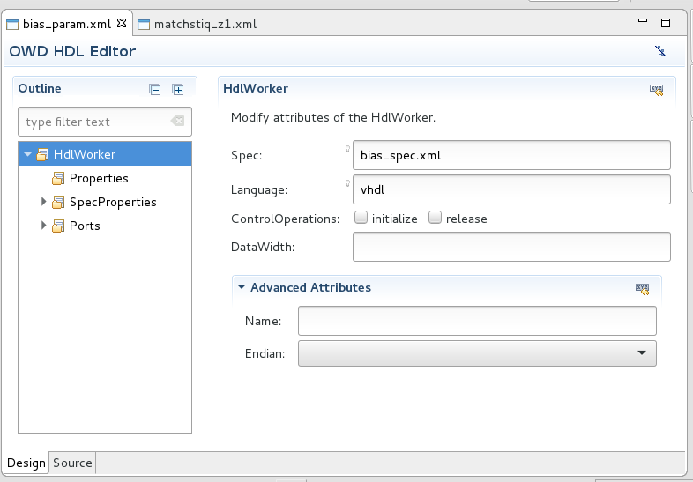
The graphical editor has two panels: the outline panel and the form-input panel. The outline panel is used to navigate the XML elements for this worker. These are the top-level HdlWorker element and Property, SpecProperty and port (StreamInterface) child elements. Select the element in the outline to add a new one or select an existing one to see or and modify it.

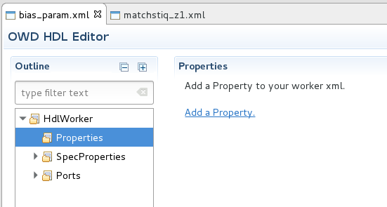
In the adjacent example a property element is added to the worker. Select the Properties element in the outline, right click → Add Property. The form to populate the new element appears as shown in Figure 6 below.

The Figure below demonstrates the property form.
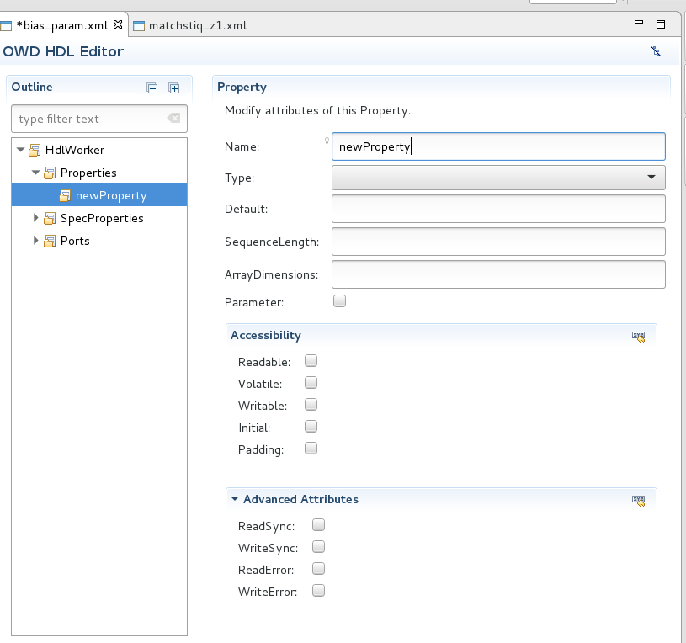
Figure 1: HDL Worker Property Element Form

Select the source tab to see how the new element is added to the XML file. To remove an element: select it, right click-→ select Delete. The source file may also be edited and those changes will appear in the design view.

See the Component Development Guide for more detailed information about the XML files these editors support. Note that these editors provide a basic capability to create these files.

4.8.2 Graphical Drag-and-Drop Editors

The ANGRYVIPER IDE Application and Assembly Editors provide a diagram interface to generate the respective XML files. An example is shown below. This editor is described in detail in section 5.

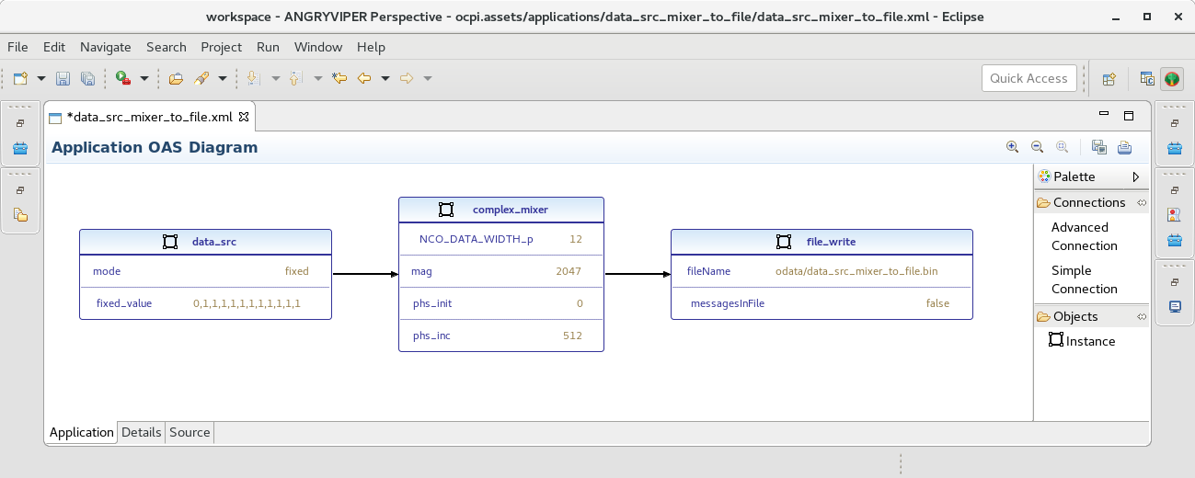

4.8.3 Asset XML Examples
The following list provides OpenCPI asset XML to examine in its respective editor. Use the OpenCPI Projects View to navigate into the OpenCPI Core and Assets projects and open the various asset XML files by doubling clicking the asset.

- OPS Editor: core→specs-→iqstream_protocol.xml
- OCS Editor: core →components-→specs-→bias_spec.xml
- OWD RCC Editor: core →components-→bias_cc.rcc
- OWD HDL Editor: core →components-→bias_param.hdl
- OHAD Editor: assets → assemblies→ cic_int_dc_offset_iq_imbalance_mixer_cic_dec
- OAS Editor: assets → applications → data_src_mixer_to_file
- Platform Worker Editor: assets →platforms → matchstiq_z1
- Unit Test Editor: core → components → metadata_stressor.test

4.9 Additional Notes About the ANGRYVIPER Perspective

The ANGRYVIPER Team hopes to continue to add capabilities to the OpenCPI Projects View to further support OpenCPI operations. The goal for Version 1.4 was to provide a good complement of features. This section provides a brief discussions to make the user aware of a number of issues that may occur when using the IDE.

4.6.1 The Execution Configuration

The execution configuration provides a means to associate and manage resources tied to the execution. These are:
- The selected assets and platforms
- The execution number
- The Status bar
- The console

The ANGRYVIPER Perspective allows limitless execution configurations however it only allows so many to exist at once since they tie together Eclipse resources such as the consoles. The current limit is twenty-five. When the limit is met, the user will get a pop-up dialog that instructs the user to delete some status bars to free up resources. This is the only way to free up resources other than closing and re-launching Eclipse. The Status view allows multiple selections for this reason. Once done execution numbers will continue to increase but consoles will be reused.

4.6.2 XML Editors Modify Existing XML Files

The following editors will modify existing XML files when they are opened with the editor. The version 1.4 IDE will indicate this is occurring and why; however it will only do it once per Eclipse session.

OCS Editor - The component spec editor corrects the primitive type attribute in the property element.
OAS Editor - The application editor adds a name attribute to the instance element to better support presentation.
HDL Platform Editor – This editor adds an extension element to the signal element to support presentation of signal direction and name. The extension element is ignored by the OpenCPI Framework.

The modifications do not have to be saved.

4.6.3 Warning About a Non OpenCPI Project

The ANGRYVIPER Perspective obtains asset information from the top level project.xml files. If an Eclipse workspace project is encountered that does not have a project.xml file, it is assumed the project is not an OpenCPI project. This is communicated in the notice console. If the project is an OpenCPI project then something is wrong in the project file structure that doesn't allow project.xml to be generated.

4.6.4 The Perspective is Not in Sync with the Workspace or the File System

The OpenCPI Projects View does not track changes to the Workspace or the files system (yet). This means changes made to a project outside of the IDE will be apparent in the project explorers nor seen in current asset lists within the IDE. This means assets created or removed via command line will not be presented in either the Eclipse Project Explorer or OpenCPI Projects Views until both views are refreshed. Note: Do not Delete a Project using Project Explorer or Shell Command. Use the ocpidev command to delete a project. This ensures project registration information remains up to date.

Ctrl + Click on the desire page number for quick navigation around the document.
An execution configuration consists of the selection of assets, the platform/target selections to which to build or run against, the associated status bar and the associated Eclipse console. The configuration persists to allow efficient reuse.

