Appendix A Eclipse Basics

A central abstraction for Eclipse is “the workspace.” This is a directory Eclipse uses to maintain state and projects. When Eclipse opens it prompts the user to select a workspace with the following dialog preset for a default directory name in the users home directory. If the workspace directory doesn’t exist yet it will be created. This directory path name can be changed. The Browse button allows navigation to another location to either create the workspace or select an existing workspace directory.
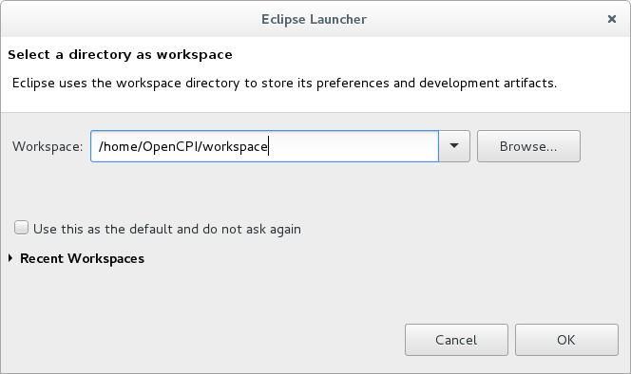
Figure 15: Eclipse Launcher Screen

Since this is a new workspace, when Eclipse completes start-up it presents the Welcome screen as shown in the Figure 16 below. If you are new to Eclipse or an IDE of this type, this is a good screen to explore. Overview gives basic concepts and definitions such as Tool Bars, Perspectives, and Views. The other selections provide how-to instruction. To continue to see this screen when Eclipse opens keep the Always show welcome on start up check box checked and go through these items. For now, move on to the workbench: click the workbench arrow button in the upper right corner.

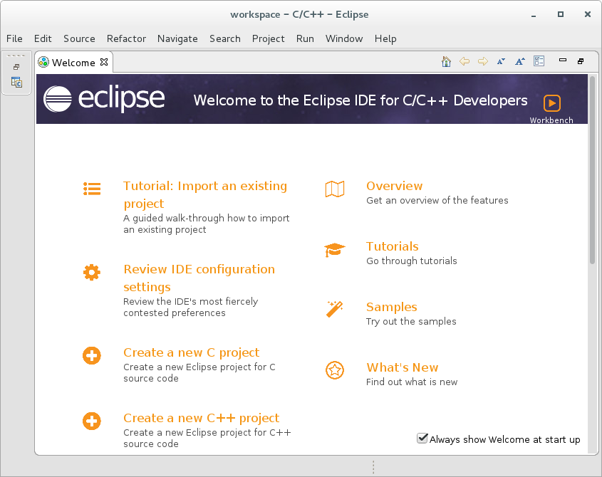
Figure 16: Welcome Screen - Has good Overview Material

When the workbench first opens, the IDE defaults to the C/C++ perspective as show in Figure 17 below. Section 3 above explains how to open the ANGRYVIPER perspective. How to use the IDE for OpenCPI development is explained in Section 5 above. One final note: Even if eclipse projects are placed in the workspace directory Eclipse will not bring them into the workspace. Projects must be imported or locally created to be appear in the Project Explorer View. OpenCPI projects will not appear in the OpenCPI Projects View unless they are open projects.

Main Menu Bar Perspective Switcher

Main Tool Bar
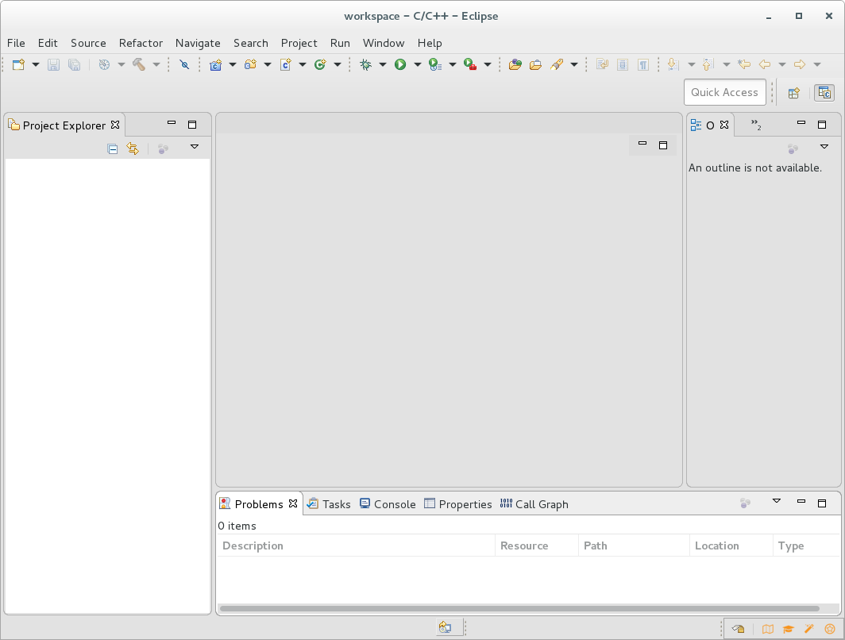
Figure 17: The Default C/C++ Perspective

A-4. Eclipse Basic Concepts
Eclipse uses Perspectives to provide various sets of tools that together focus on a given perspective of development. A perspective consists of a workbench layout of a complimentary set of Eclipse views. A view is a workbench panel that provides a specific capability. For example, the Eclipse Project Explorer View provides a graphical view of the file system and the ability to navigate through and act upon it.

The Window tab in the Main Menu Bar at the top of the window provides navigation to to the available perspectives, and views, as well as workbench window controls and user Preferences. One final note: the user can rearrange a perspective layout, add or remove views, and modify panel sizes. These setting are saved and become default layout for that perspective.

Projects must be imported to appear in the workspace. The Eclipse Project Explorer provides these controls via a context menu that is opened by right-click when the cursor is in the view. This menu provides access to create new things in the workspace or project, controls to open or closed a project and to remove files, folders, and projects from the workspace. Caution: using Project Explorer to delete OpenCPI assets can cause problems; deleting/renaming source files is okay. It is okay to remove a project from the workspace (delete is used) however don’t remove OpenCPI project contents from the file system unless it has been unregistered. The OpenCPI Projects View or the ocpidev command should be used to delete OpenCPI projects and assets.

Editors and Tool chains – Review the Workbench Overview panel and look over C/C++ Development documentation.

Appendix B Addition Plugins for the IDE

If the development machine has access to the internet or a mirrored Eclipse Marketplace, consider the following software to enhance the ANGRYVIPER IDE experience. The Marketplace link is located under the Help link in the top navigation bar. The Marketplace makes it very easy to search, browse and review software. Using the IDE navigate to Help → Eclipse Marketplace. Search for the packages below; it's a simple Install button click to get the package.

B-1 TM Terminal 4.0.

Search for Terminal in the Marketplace to see a number of available terminal packages. The TM Terminal 4 has been used successfully by the ANGRYVIPER team. Click the install button to install the product. Typically an agreement must be excepted to continue.

B-2 ANSI Escape in Console Plugin

While not entirely effective this seems to be the only product available to deal with the ANSI color escape sequences in the Eclipse Console View (seen when running tests). Search for ANSI Escape and install. You might like it.

An Eclipse perspective is a layout of selected views. Eclipse has a number of perspectives tailored to development objectives. To see a listing navigate to Window-→ Perspective → Open Perspective. A view is an individual panel like “Project Explorer”. A listing of views can be seen by navigating to Window → Show View.

