5.0 OpenCPI Development Workflow Using the IDE

5.1 Introduction
The IDE supports a number of OpenCPI workflow concepts beginning with setting up the OpenCPI core and assets projects and getting them built to support new project development. This section demonstrates a number of the fundamentals discussed in sections 4 and 5 of the Getting Started Guide.
http://opencpi.github.io/Getting_Started.pdf. This includes creating the DemoProject and then a number of assets that go in the project as described in the document. Additionally the IDE provides a good way to look at existing assets OpenCPI XML specifications.

5.2 OpenCPI the Core and Assets Projects
A number of existing projects and provided in OpenCPI release 1.4 for use in development. If they are to be used, they need to be set up in the development environment, registered, and imported into the IDE and built for the desired platforms to further support new development. Procedure:

- Select a place in the file system to put these projects; create the folder if necessary.
- Execute the project copy script ocpi-copy-projects to load these projects in desired folder and register them in that location. This script is interactive or arguments may be supplied.
- Import the desired projects into eclipse. This demonstration depicts importing the core and assets projects. Place the cursor in the Eclipse Project Explorer panel, right click-→import-→General → Existing Projects into Workspace. This opens the import wizard.

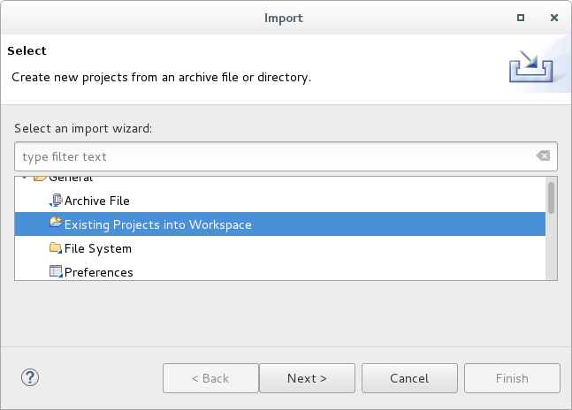
Figure 11: Select Import Existing Projects
- In the wizard, click browse for the Select root directory input, navigate to and select the folder holding these projects and select the check-boxes on the desired projects to import as shown below. Click finish and the projects are brought into the Eclipse workspace and appear in the Eclipse Project Explore View.
- Click Refresh in the OpenCPI Projects View to update that view with the imported projects.

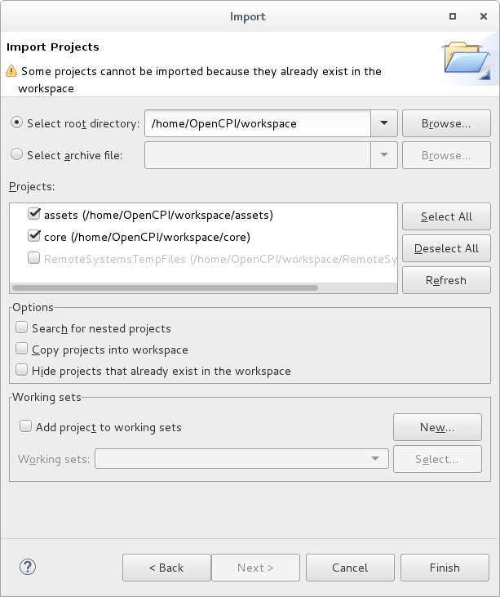
Figure 19: Import Projects Wizard

5.2.1 Build the projects for the desired RCC and HDL platforms.
There are a number of ways to build existing projects in the IDE because builds can be kicked off concurrently. If time is not an issue, put the core and assets projects in the operations panel (core first followed by assets), select the platforms to which to build to and launch the build (press build). Core will be built followed by assets.

Concurrent building saves time. Key things to know:
- HDL Libraries in the core project must be build before starting a build on the assets project primitives.
- A projects primitives must be built first.
- HDL card and device libraries (cards and devices) can be built concurrently after primitives.
- Core components and asset primitives can be built concurrently after core HDL libraries are built.
- Follow this sequence to build HDL libraries in the assets project.
- Once a projects components are built it is recommended a top level project build is executed to ensure all build artifacts and exported properly for dependent projects.
- Assemblies may be built concurrently.

The following examples demonstrate executing builds using the IDE.

- Select the platforms for the build. In the example RCC platform centos7 and HDL platform xsim are selected.
- Expand the ocpi.core project in the OpenCPI Projects view, select primitives, right click, select build. The build status entry appears. It turns green when the build completes successfully.
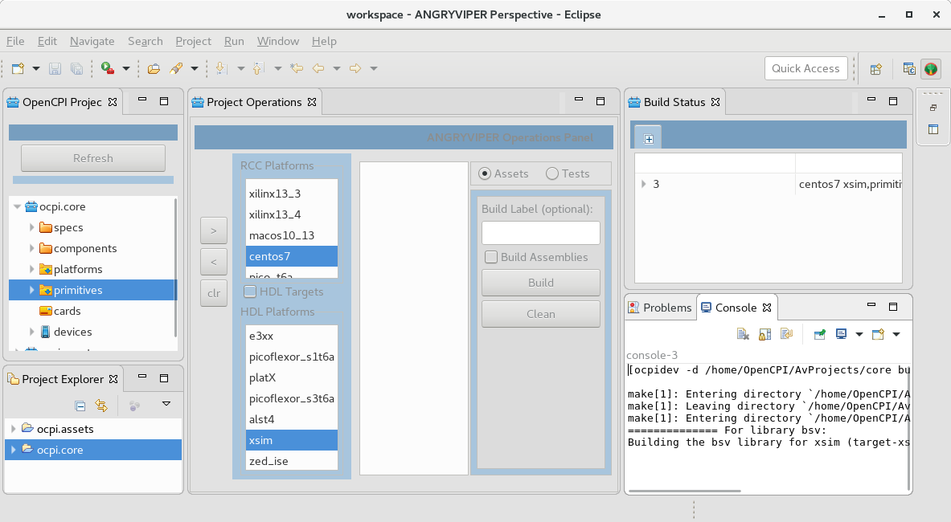

- Select devices (the core projects has no cards at this time), right click, select build.

- Similarly start builds for the core projects components and the assets project primitives.
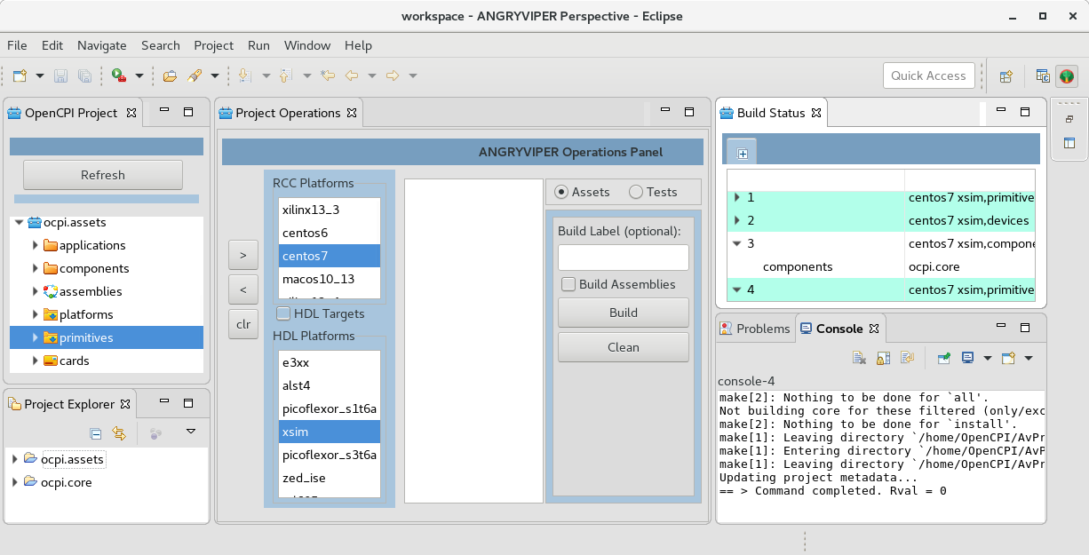
- Complete a top level build for the core project. In this example the core project is built from the Operations Panel.

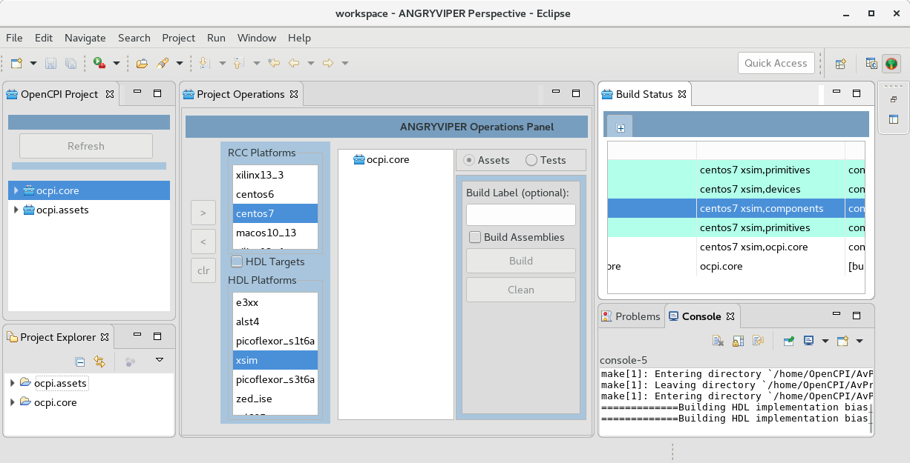
- Complete building the assets project following a similar process.

5.3 Creating New Projects and Libraries
To create a new project, place the cursor in the OpenCPI Projects panel, right click, select asset wizard. Select asset type Project from the drop-down. Note all registered OpenCPI projects have the core project dependency by default. The example below shows a new project called DemoProject will be created and it will additionally have the assets project as a dependency so it can use components contained in it.
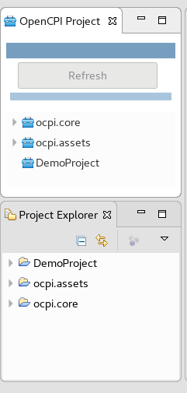
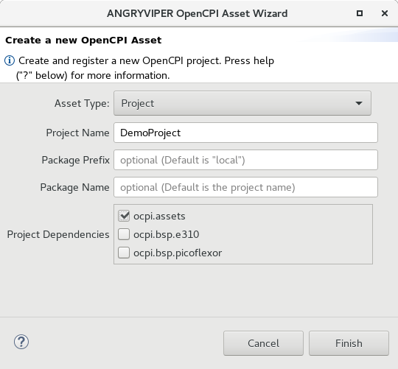

Click finish. When this completes the new project was created, registered, and is displayed in the OpenCPI Projects and the Eclipse Project Explorer views.

Next a components library is added to DemoProject. Select the project in the OpenCPI Projects View, right click, open the assets wizard and select asset type Library. The wizard will create the components library by default. If multiple libraries are anticipated then name this library accordingly and it will be placed in a top level components folder. This example uses one components library. Click finish. When the wizard completes, the components library is created and appears in the project explorers as shown below.

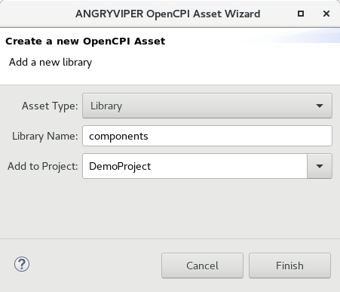
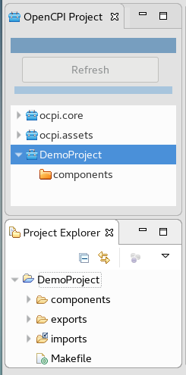

5.3.1 More on OpenCPI Projects
In OpenCPI, package-ids are assigned to projects and other shared assets in the project such as its libraries. Now the project wizard provides inputs for the project package-id: package-prefix and package-name. The project package-id is package-prefix.package-name. This becomes a unique identifier to the project and its shared assets. The project wizard screen explains this more.

In the new project example above no inputs were provided for package-prefix and package-name so the defaults are used and the assigned package-id is local.DemoProject. This can be seem in the project registry. To view project registry in a terminal window use the command: ocpidev show registry. The result is shown below:

-----------------------------------------------------------------------------------
| Project Package-ID | Path to Project | Valid/Exists |
| ------------------ | --------------- | ------------ |
| ocpi.assets | /home/OpenCPI/AvProjects/assets | True |
| local.DemoProject | /home/OpenCPI/workspace/DemoProject | True |
| ocpi.bsp.picoflexor | /home/OpenCPI/AvProjects/bsp_picoflexor | True |
| ocpi.core | /home/OpenCPI/AvProjects/core | True |
| ocpi.bsp.e310 | /home/OpenCPI/AvProjects/bsp_e310 | True |
-----------------------------------------------------------------------------------

5.3.2 Project Registration
By registering a project, a user is publishing his/her project so that it can be referenced/searched by any user or project using that same project registry. The default project registry is located at /opt/opencpi/project-registry. The registration features are provided to support bringing in an external OpenCPI project or a project location needs to change. Examples:
To rename a project: unregister it, change its name with Project Explorer, refresh OpenCPI Projects, re-register it.
To move a project: unregister it then delete it from the workspace (use Eclipse Project Explorer, don’t delete it from the file system). Move it, import it back into the workspace, then refresh OpenCPI Projects. Now re-register it.

5.3.3 Errors in Creating New Project
If an error occurs, the wizard will present a dialog panel explaining the problem. Errors occur when the framework cannot support the asset creation or there are file system issues. Click OK to close the dialog. If the framework fails to create an asset it automatically cleans remnant artifacts off the file system.

5.3.4 OpenCPI Libraries
An OpenCPI project can have one or more libraries. The typical guidelines are as follows:
- A project anticipated to have a single component library, name the library components. All component and worker assets will reside in the top level components directory. When using the OpenCPI asset wizard to create a library the default name provided is components.
- A Project anticipated to have multiple libraries, give these libraries a name other than components. These libraries will be placed in a top level components as sub-directories named after the library. The user will be given the option to create component specifications and workers in these sub-directory libraries.
- Once an option is selected it cannot be changed without a lot manipulation.

5.4 Creating Components, Protocols and Workers
Some fundamentals:

- Protocols used to specify expected data for component ports.
- Protocols and component can exist in in either the top level specs folder of the project or in a library specs folder.
- The top level specs folder is intended to hold more global protocols and components that can be reused in library component specifications.
- Workers may only reside in a library.

The IDE’s Asset Wizard provides an easy way to create this class of assets and locate them in their proper place. Protocols and components simply need a name and where to put them. Workers need a name, component specification, and the implementation language.

5.4.1 Component Example from the Getting Started Guide
In this example the ramp component is created using the IDE. Procedure:

- Open the asset wizard: OpenCPI Projects, select DemoProject/components, right-click, select component from the context menu. Fill in the name as shown below.
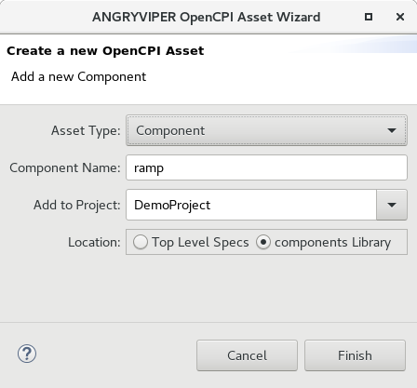
- Once the OCS Editor opens: select Ports in the outline, click the Add a Port link and the port form appears.

- Name the port “in” and select restream_protocol from the drop-down.

- Similarly add the out port.

The figure below shows the port form for the ramp “in” port.

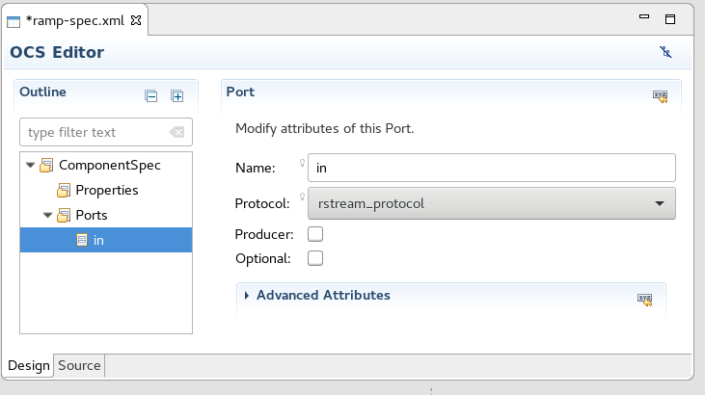

5.4.2 Worker Example from the Getting Started Guide
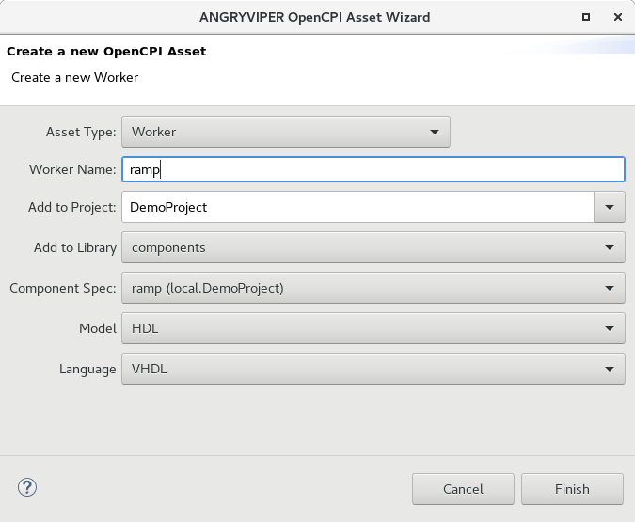
In this example the ramp HDL worker is created. Procedure:

- Open the asset wizard: OpenCPI Projects, select ramp-spec.xml located in DemoProject/
components/specs.
- Right-click, select worker from the context menu. Fill in the name and select the VHDL language as shown below.

- Once the HDL OWD Editor opens verify the spec and language entries and save both files (eclipse floppy disks icon in the tool bar at the top). Next the in and out StreamInterfaces are added.
- Select Ports in the HDL OWD Editor outline, click the Add a StreamInterface link and the StreamInterface form appears.
- Set the port name and data width as shown in the figure below.
- Similarly create the out port. The ramp worker is done.
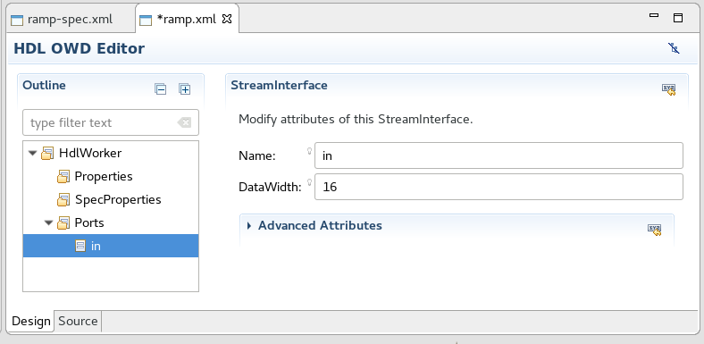

5.5 Creating Applications and Assemblies
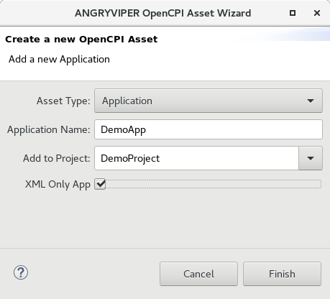
The ANGRYVIPER IDE Application and Assembly Editors provide a drag-and-drop interface to generate the respective XML files. As an example, the Application Editor is used to create the DemoApp application described in the Getting Started Guide. To start, use the Asset Wizard to create a new application as shown here. Click Finish and the Application Editor opens as shown in Figure 7 below.

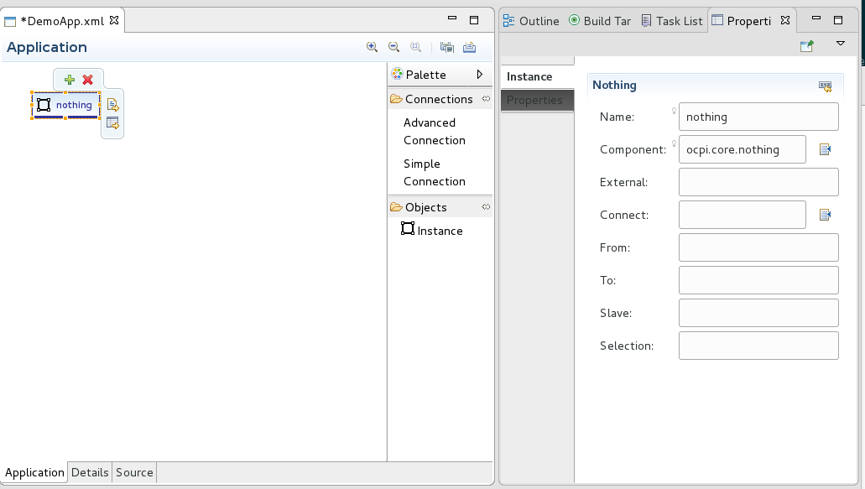
Figure 2: Application Design Panel and Properties View

3.3.1 Adding Components to an Application

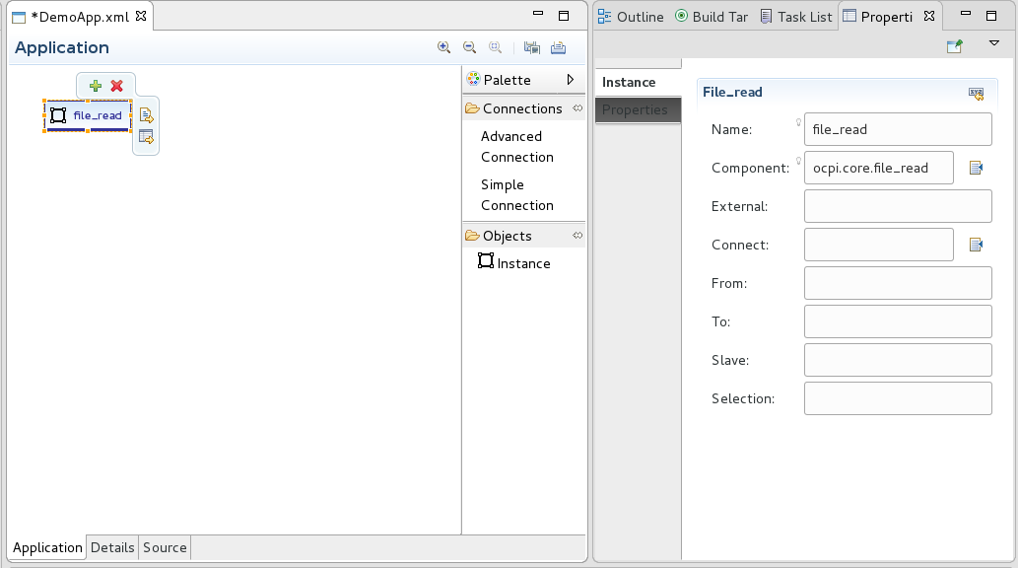
Applications are constructed using OpenCPI Component Specifications (OCS) referred to as components. When the editor opens, the Application tab is presented with the “nothing” instance in the panel. To select a OCS for this instance click the nothing instance and additional controls appear as shown in Figure 7 above.

Select the bottom right icon to see the Properties View form to further populate the instance. To find the desired OCS, go to the Properties View and click on the list icon next to the component text box. A listing of all component specifications found in the environment is displayed. The ocpi.core.file_read component was selected and now the display appears as shown above.

The next example adds the local.DemoProject.ramp component to the application using drag-and-drop. Use the Eclipse Project Explorer to select a component OCS XML file, left click/hold and drag the file to the Application panel then release the mouse button. Shown below, the “ramp” component is now in the application. Another method to do this is to similarly drag-and-drop the instance object from the Palette into the Application panel then select the component via the Properties View as demonstrated in the example above.
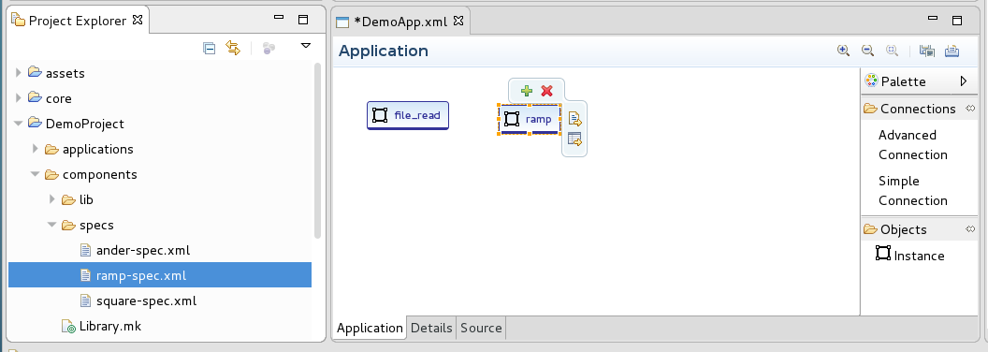

The third method to construct an application is to use the Details tab. This tab presents a form-based editor similar to the component and worker editors described above. The application Details panel is shown in Figure 8 below. Select the Instances element, click Add an Instance, and a form opens to populate the new instance as shown in Figure 9 below. Note that component choices originate from from the current project and its project dependencies.
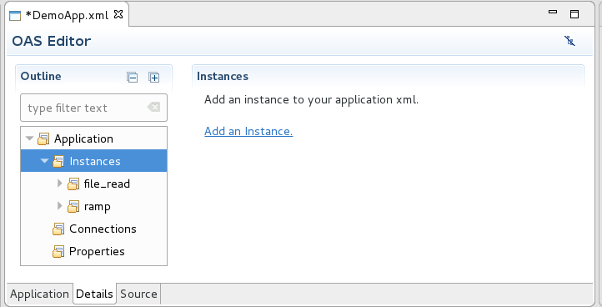
Figure 8: Third Method to Add a Component Instance to the Application.

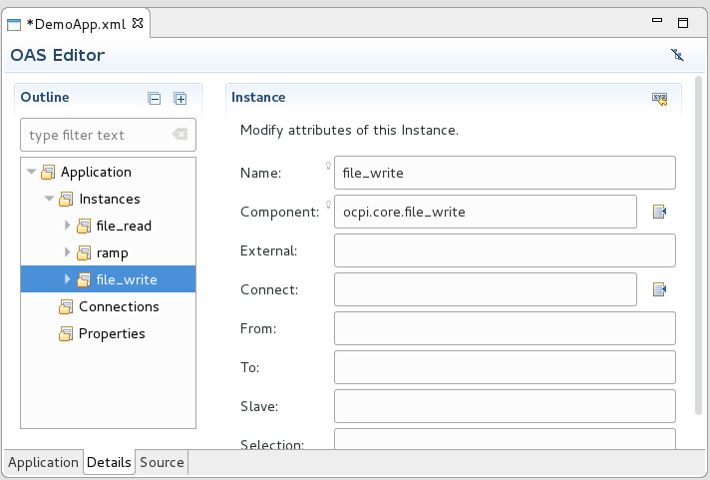
Figure 9: Select File Write as the New Component

Click the list icon next to the Component text box input to the components list. Here the file_write component was selected. The next Figure shows the current design view of the Application.
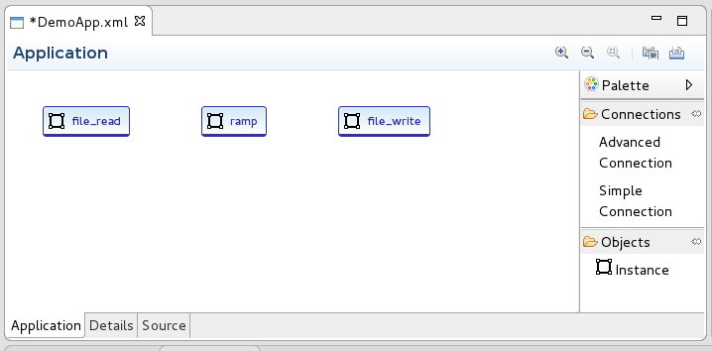

3.3.2 Connecting Application Components

There are two ways to specify a connection between components in an application or assembly. Components with single input and output ports may be connected by a Simple Connection. Components with multiple ports on a given interface (in or out) must be connected by an Advanced Connection (the XML for these must specify the name of the port that is being connected).

The tools available in the Application Editor are the following:

- Select simple or advanced connection from the palette (behaves like a button). Move the cursor to the source component, click while on it, then move the cursor to the receiving component and click again while on it.

- Using the details tab, a simple connection is added by filling in the “Connect” input. Complex connects must be added clicking Connections in the outline then click the Add a Connection link. Complex connections are completed by adding port elements out of file_read and in to ramp.

- Edit the XML source directly.

The following Figures demonstrate a simple connection.

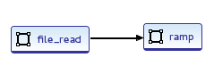

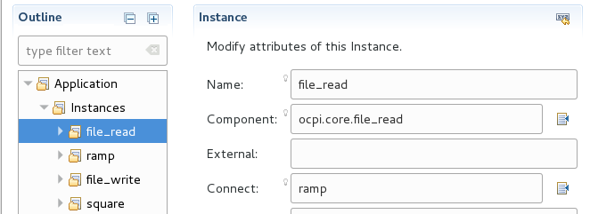

Advanced connections are easily created using the Application tab (the Detail panel is not as nice). To make an advanced connection while in the Application tab, select Advanced Connection in the Palette, move the cursor to the source component then click it, move the cursor to the destination component and click it. A pop up form panel appears with inputs to complete the connect as shown below:

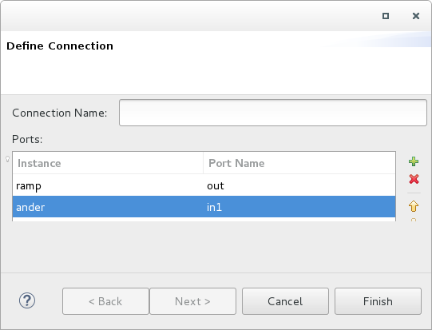
Advanced connections can be named (optional). The ports section opens with default port names out and in. Click on the in port name and update it to the correct port (in1) as shown above. The following series of Figures show the advanced connection in the three editor views:
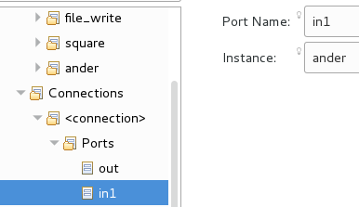
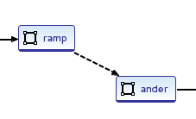

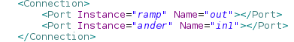

See the Application Development Guide for detailed information about the Application and Assembly XML files. Note that the Application and Assembly editors provide a basic capability to create the respective XML files.

3.3.3 Assembly Editor

The HDL Assembly Editor operates similarly to the Application Editor. The difference is that assemblies are built with application workers while applications are buit with components. The drag-and-drop feature works with OpenCPI Worker Description (OWD) XML files just as the application editor operates with OCS XML files. Note the the Eclipse Project Explorer must be used for the current drag and drop feature; it is currently not supported in the OpenCPI Projects View. The Figure below shows the square.hdl worker added to an assembly via drag-and-drop. Also note that worker choices originate from registered OpenCPI projects.
.

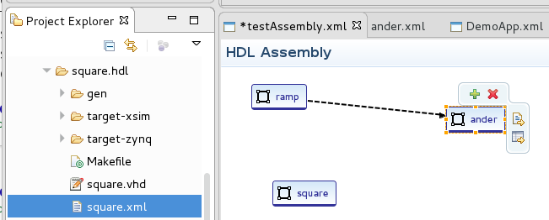

5.6 Creating Component Unit Tests
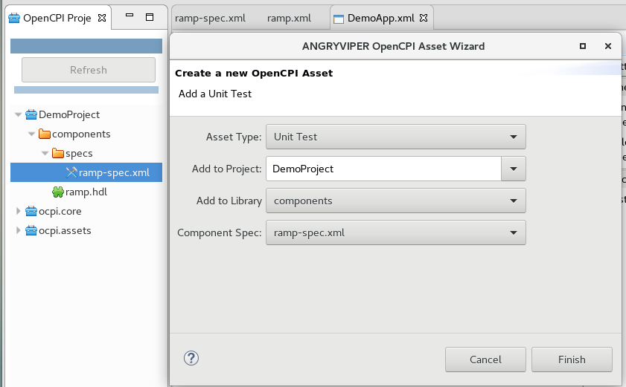
Creating a unit test using the ANGRYVIPER Asset Wizard is demonstrated in this section. Using the OpenCPI Projects View, navigate to DemoProject→ components → specs and select ramp-spec.xml. Right-click, select new unit test from the context menu. The asset wizard opens with all inputs preset for the ramp-spec selection as shown below. Click finish.
When the action completes, the unit test editor opens in the editor panel as shown below. Unit testing requires an in-depth knowledge on how to implement them, so this will not be addressed here. Refer to the OpenCPI Component Development Guide to learn about them. The editor supports most aspects of developing unit test XML.

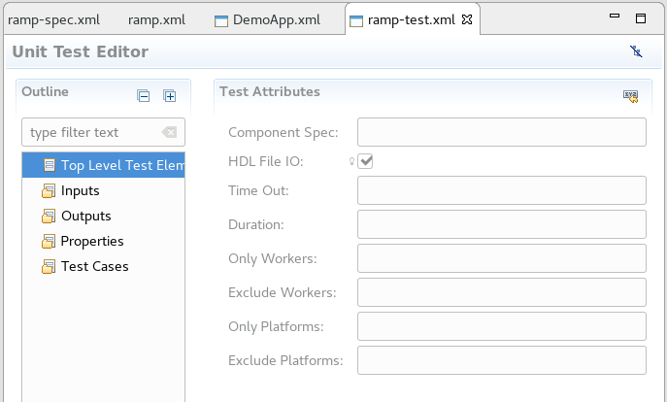

Note that there are a number of cases where one attribute out of a set may go in there test XML element. This is very prevalent for the input, output, and test case elements. In this implementation of the editor, once an attribute out of the set is added, the inputs for other possible choices are disabled. The figure below demonstrates this behavior. An input element can either have a name or a port and the source data from them can either be a script or a file, so once filled in the other inputs are disabled. Simply clear the input to start over (use backspace or select-delete).
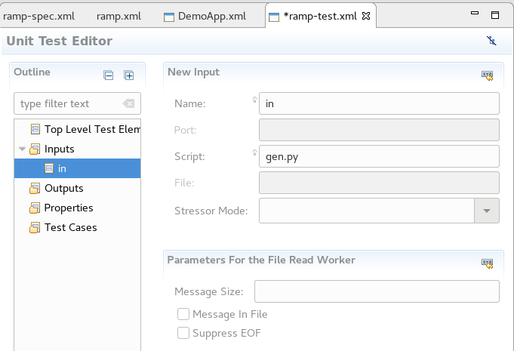

When the framework creates a new application if populates the application with one instance element. This is done so a new application skeleton can be built and run.
The OpenCPI Projects view does not support drag and drop (yet).

