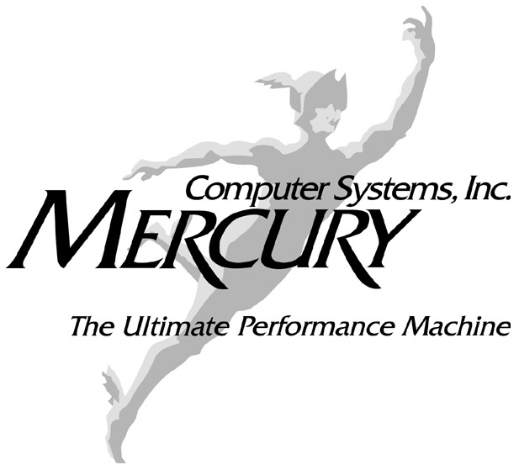

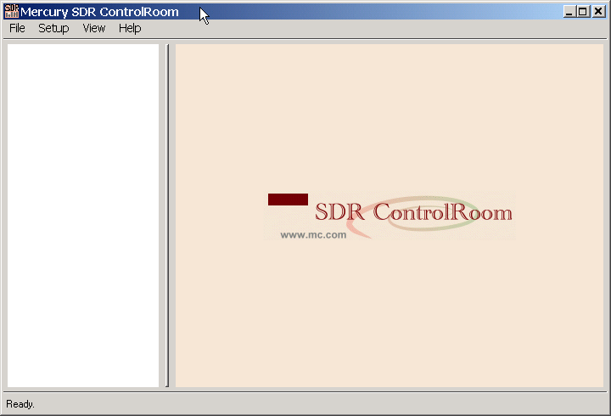
SCA Core Framework Analysis Tool

Introduction
SDR ControlRoom™ is an analysis tool for use in a Software Communications Architecture (SCA) environment. It enables in-depth examination of the file and system constructs in a Core Framework (CF) and it affords the user a window into actual transactions occurring in a system. It serves as a preliminary check of CF interactions with the Operating Environment and can be used as a part of a first-order compliance validation, although it is in no way a formal compliance test. Table 1 lists the currently defined (SCA 2.2) CF interfaces touched by SDRControlRoom.

Table 1: Core Framework Interfaces
SCA Interface | SCAControlRoom Usage | Explanation
3.1.3.1 Base Application Interfaces
3.1.3.1.1 Port | NO
3.1.3.1.2 LifeCycle. | NO
3.1.3.1.3 TestableObject | NO
3.1.3.1.4 PortSupplier. | NO
3.1.3.1.5 PropertySet. | ☑
3.1.3.1.6 Resource | ☑
3.1.3.1.7 ResourceFactory. | NO
3.1.3.2 Framework Control Interfaces
3.1.3.2.1 Application. | ☑ | Shows and allows configuring an application’s properties. Allows starting and stopping the application.
3.1.3.2.2 ApplicationFactory. | ☑ | Allows creating application instances, as well as the un-installation of the application factory.
3.1.3.2.3 DomainManager. | ☑ | Shows installed application factories, running applications, available device managers, and the file system.
3.1.3.2.4 Device. | ☑ | Shows device state and properties. Allows starting and stopping the device.
3.1.3.2.5 LoadableDevice. | NO
3.1.3.2.6 ExecutableDevice | NO
3.1.3.2.7 AggregateDevice | NO
3.1.3.2.8 DeviceManager. | ☑ | Shows available devices, services, and the file system.
3.1.3.3 Framework Services Interfaces
3.1.3.3.1 File. | ☑ | Allows reading and showing (text) files.
3.1.3.3.2 FileSystem | ☑ | Allows browsing the file system.
3.1.3.3.3 FileManager. | ☑ | Shows mounted file systems and their contents.
3.1.3.3.4 Timer. | NO

Installation

Requirements
Windows (XP, XP-Pro, Windows 2000)
CORBA Name server installed and running
Core Framework installed and running
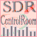
Copy the ControlRoom.zip file to a convenient directory, unzip it, then click on the icon ……

Command Summary
The four basic command tabs are File, Setup, View and Help, explained below.

File Menu
The “Exit” option in the “File” menu ends the SDR ControlRoom application.

Setup Menu

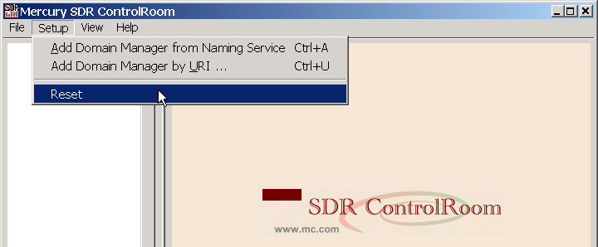
The Setup menu enables adding Domain Managers which are to be monitored. Domain Managers can be added by their “Object URI” or via their binding in the Naming Service.
The “Reset” option removes all Domain Managers from the current view..

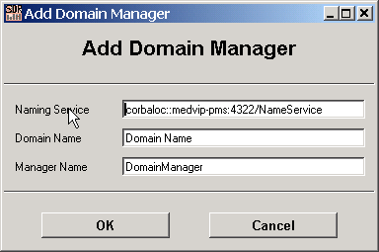
To add a Domain Manager by its binding in the Naming Service, enter the Naming Service’s URI, the Domain Name (the name of the Naming Context) and the Domain Manager’s name (the name of the binding in the Naming Context) in the respective field.
The Naming Service’s URI can be of the “IOR:”, “corbaloc:” or “corbaname:” style.

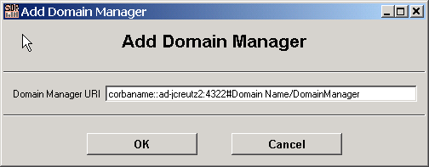
To add a Domain Manager by its “Object URI”, enter the URI in this dialog. The URI can be of the “IOR:”, “corbaloc:” or “corbaname:” style.

View Menu
The “Refresh” option in the “View” menu updates the currently-active element.
Updates in the domain are not actively tracked. E.g., if properties change, or if applications are started due to events outside the SDR ControlRoom application, these updates are not automatically reflected.
An element’s attributes and properties are updated every time they are selected (i.e., clicked on) in the left-hand tree view. E.g., to update an application’s properties, simply click on the application, even if it is already selected.
An element’s “sub-elements” (i.e., those listed as child nodes in the left-hand tree view) are updated only when “Refresh” is chosen from the “View” menu.
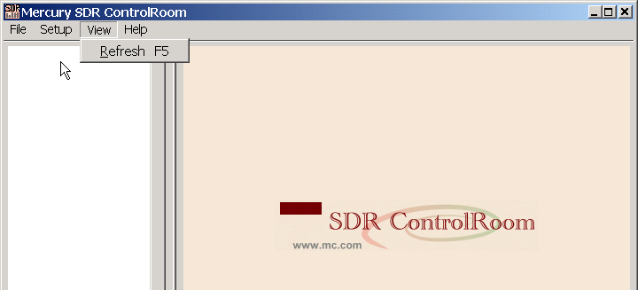

- If a Domain Manager has been selected, its list of application factories, applications, device managers and its File Manager is updated.
- If an Application has been selected, its list of components is updated.
- If a Device Manager has been selected, its list of registered devices, services, and the File System are updated.
- If a File Manager has been selected, its list of mounted file systems is updated.
- If a File System or a directory has been selected, its list of subdirectories is updated.

Pressing the F5 key has the same effect as choosing “Refresh”.

Help Menu
Shows the “About SDR ControlRoom” message.

SDR ControlRoom System Views

Domain Manager

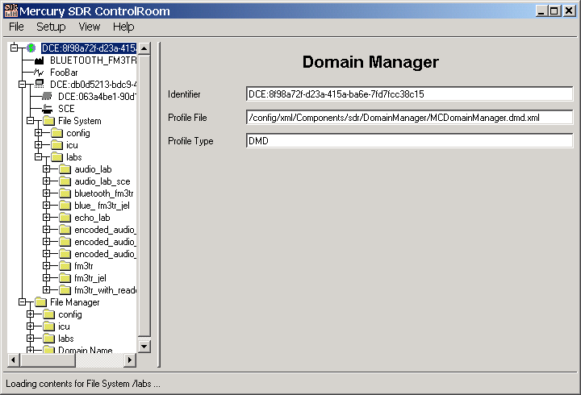
Shows all installed application factories, running applications, device managers, and the file manager.

ApplicationFactory
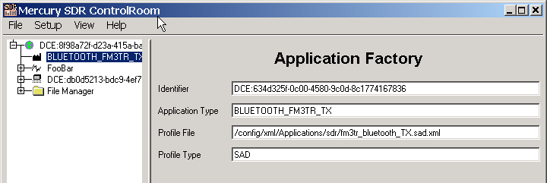
Shows an Application Factory’s attributes. Properties can be configured one at a time by editing their respective fields, and pressing the Enter key.

Application Factory Create/Uninstall
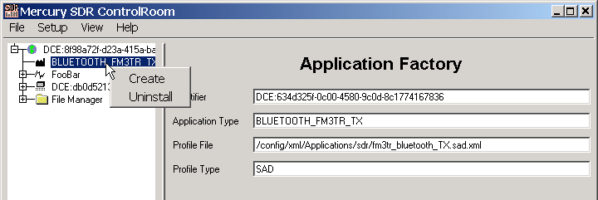
Right-clicking on the application factory allows one to create application instances with an empty set of properties and device assignments, or to uninstall the application factory. Shows the attributes and properties of the application. Properties can be configured one at a time by editing their respective fields, and pressing the Enter key.

Application

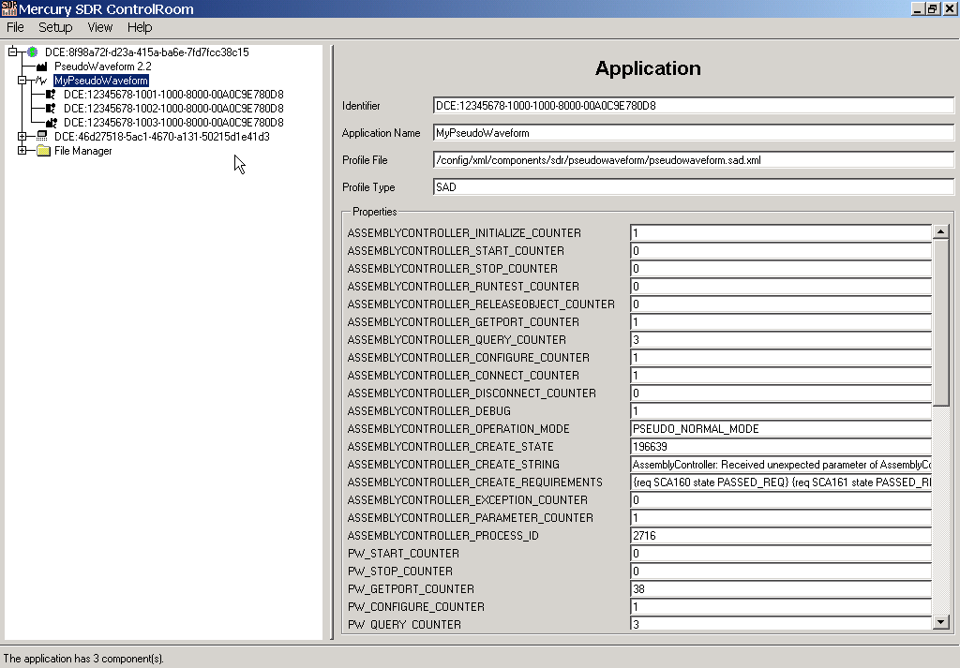

The application's resources and resource factories are shown in the left-hand view. Shows the application's attributes and properties. Properties can be configured one at a time by editing their respective fields, and pressing the Enter key.

Device Manager
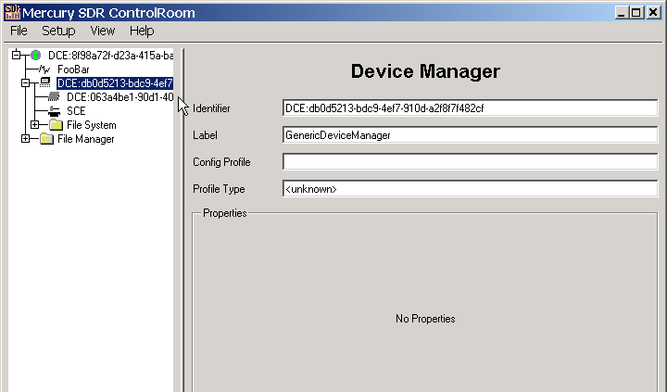
Shows the attributes and properties of the Device Manager. Properties can be configured one at a time by editing their respective fields, and pressing the Enter key.
Registered devices, services, and the Device Manager’s file system are listed in the left-hand pane.

Resource
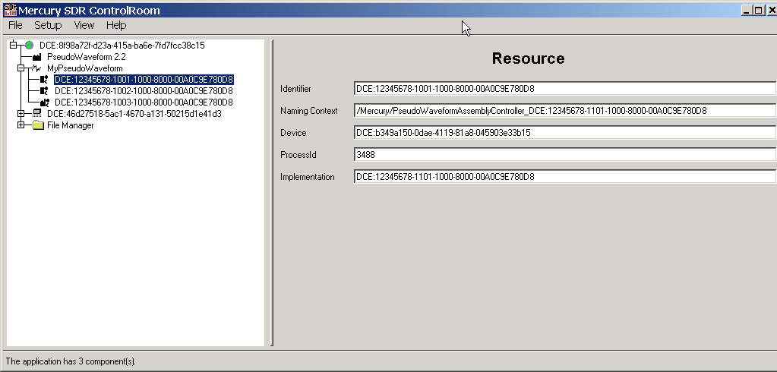
Shows the resource's identifier, Naming Context, Device Id, Process Id, and Implementation Id.

Device
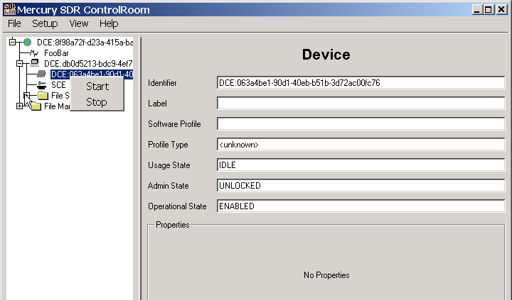
Shows the state of the device and its properties. Properties can be configured one at a time by editing their respective fields, and pressing the Enter key. Right-clicking on the device allows one to start and stop the device.

Service

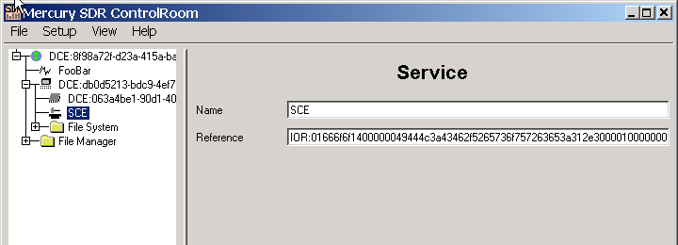
Shows the name and the object reference of the service.

Directories
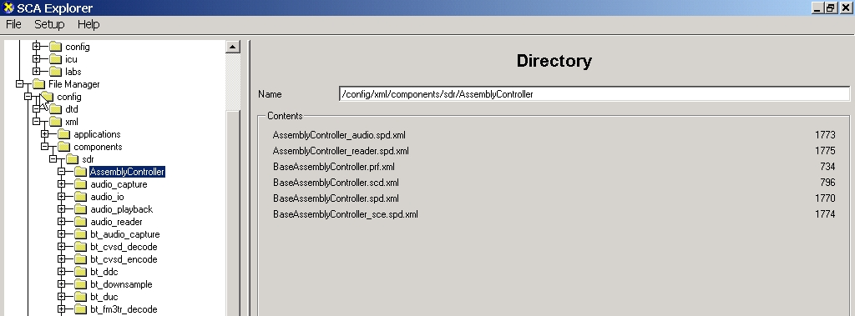
Shows directory contents.
Double-clicking on a file downloads the file, and shows the file’s contents in a separate window. This should only be attempted with text files.
Right-clicking on a file with the “.sad” extension allows one to install an application, calling the Domain Manager’s installApplication() operation with this file name as the profile.

Domain Manager
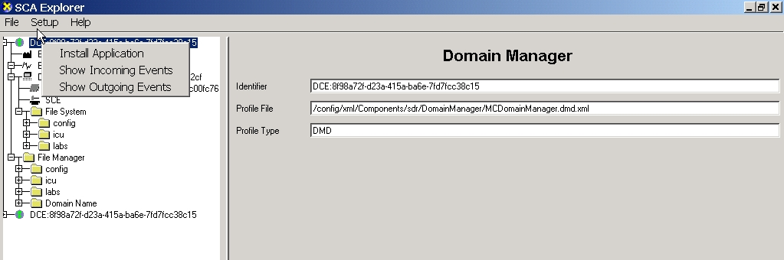
Right-click on the Domain Manager to install an application or to open the incoming or outgoing event logs.
When installing an application, you will be prompted for a ZIP file. The software will upload all of the ZIP file’s contents to the core framework’s file system, and then call the domain manager installApplication() operation, passing any file with the “.sad” extension as the profile name.

Event Logs
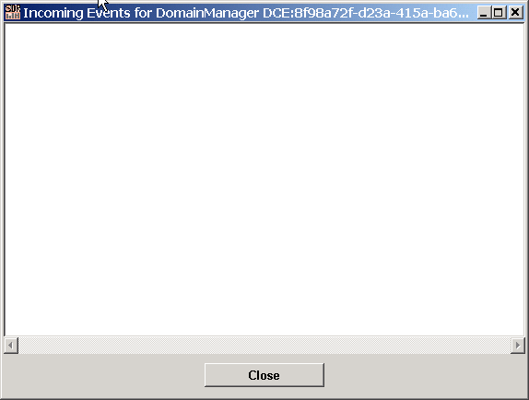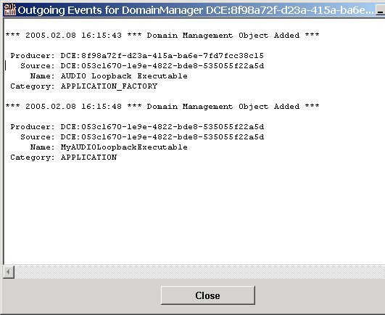
The Incoming and Outgoing Event Logs capture messages to and from the CF. Past events are not shown, only events that arrive after opening the event log.

