Code Generator Design

This document describes the code generator (src/codegen/codegen.java) used to convert the class description file (src/codegen/llrp.xml) into Java class files. For the moment, all classes described herein are defined as private classes within codegen.java.

The XMLInterpreter Class
The XMLInterpreter class extends the org.xml.sax.helpers.DefaultHandler class. The parse() method will parse through an XML file with the given filename. The startElement() method is called whenever a start tag is encountered, and the endElement() method is called whenever an end tag is encountered. In this fashion, the entire llrp.xml file is parsed; the actions taken in startElement() and endElement() depend upon the element type being started or ended.
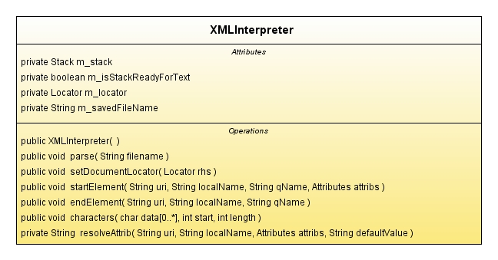
Figure 1: The XMLInterpreter Class

In general, when startElement() is called with uri=”XXX”, an object of type XXX is instantiated and pushed onto m_stack. When endElement() is called with uri=”XXX”, an object of type XXX is popped from the stack and added to the next object on the stack.

The classGenerator Classes
The classGenerator class contains logic to output a java class file. The message and param classes contain some specialization methods to distinguish Message class definitions from Parameter class definitions. A message object is created whenever a <message> start tag is encountered in the class description file. A param object is created whenever a <param> start tag is encountered in the class description file. The genCode() method (called when a </message> or </param> end tag is encountered) generates java code for the class to standard output, after redirecting standard output to a newly create java file.

The addField() method allows for field-derived classes to be added as components to the current class.

The genDecls() method outputs class member declaration code by calling genDecl() on each component field as follows:

private void genDecls()
{
System.out.println(" // member variables");
int i;
for(i=0; i<fields.size(); i++)
fields.get(i).genDecl();
System.out.println("");
}
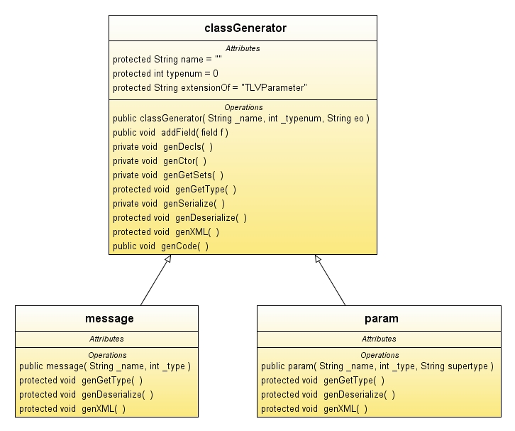
Figure 2: The classGenerator Classes

The genCtor() method outputs class constructor code by calling genCtorInfo() on each component field as follows:

private void genCtor()
{
System.out.println(" public " + name + "()");
System.out.println(" {");
int i;
for(i=0; i<fields.size(); i++)
fields.get(i).genCtorInfo();
System.out.println(" }\n");
}

The genGetSets() method outputs member accessor/mutator code by calling genGetSet() on each component field as follows:

private void genGetSets()
{
System.out.println(" // accessors and mutators");
int i;
for(i=0; i<fields.size(); i++)
fields.get(i).genGetSet();
System.out.println("");
}

The genGetType() method is specialized by the message and param classes. For the message class, genGetType() is defined as follows:

protected void genGetType()
{
System.out.println(" public int getMessageType() {return "+typenum+";}");
}

For the param class, genGetType() is defined as follows:

protected void genGetType()
{
System.out.println(" public int getParamType() {return "+typenum+";}");
}

The genSerialize() method outputs code for the serializeBody() method by calling the genSerialize() method on all component fields as follows:

private void genSerialize()
{
System.out.println(" public void serializeBody(DataOutputStream out) throws IOException\n {");
int i;
for(i=0; i<fields.size(); i++)
fields.get(i).genSerialize();
System.out.println(" }\n");
}

The genDeserialize() and genXML() methods are specialized by the message and param classes. The genDeserialize() method outputs code for the deserializeBody() method, and the genXML() method outputs code for the toXML() method.

The field-derived Classes
The field-derived classes hold information about individual fields encountered while parsing the class description file (llrp.xml). These classes are added to message or param objects (via the addField() method) as they are parsed within a <message> or <param> element.

The field class contains these abstract methods that must be defined by all deriving classes:
- genDecl(): Generate declaration information for a field. A field defined by <bytefield name=”FOO”/> would generate “ byte _FOO = 0;” as declaration information.
- genGetSet(): Generate accessor/mutator information for a field. A field defined by <intfield name=”SPAM”/> would generate “ public void setSPAM(int x) {_SPAM=x;}” followed by “ public int getSPAM() {return _SPAM;}” as accessor/mutator information.
- genSerialize(): Generate serialization information for a field. A field defined by <shortfield name=”SS”/> would generate “ out.writeShort(_SS);” as serialization information.
- genDeserialize(): Generate deserialization information for a field. A field defined by <shortfield name=”SS”/> would generate “ _SS = in.readShort();” as deserialization information.
- genXML(): Generate information related to outputting the class contents as an XML string.

In addition, the field class has two methods (with empty definitions) that are extendible by deriving classes:
- genDeserializeFixup(): For parameter fields, allows the parameter field data to be recognized and processed.
- genCtorInfo(): For parameter or array fields, allows parameter member variables (or lists) to be initialized in the constructor.

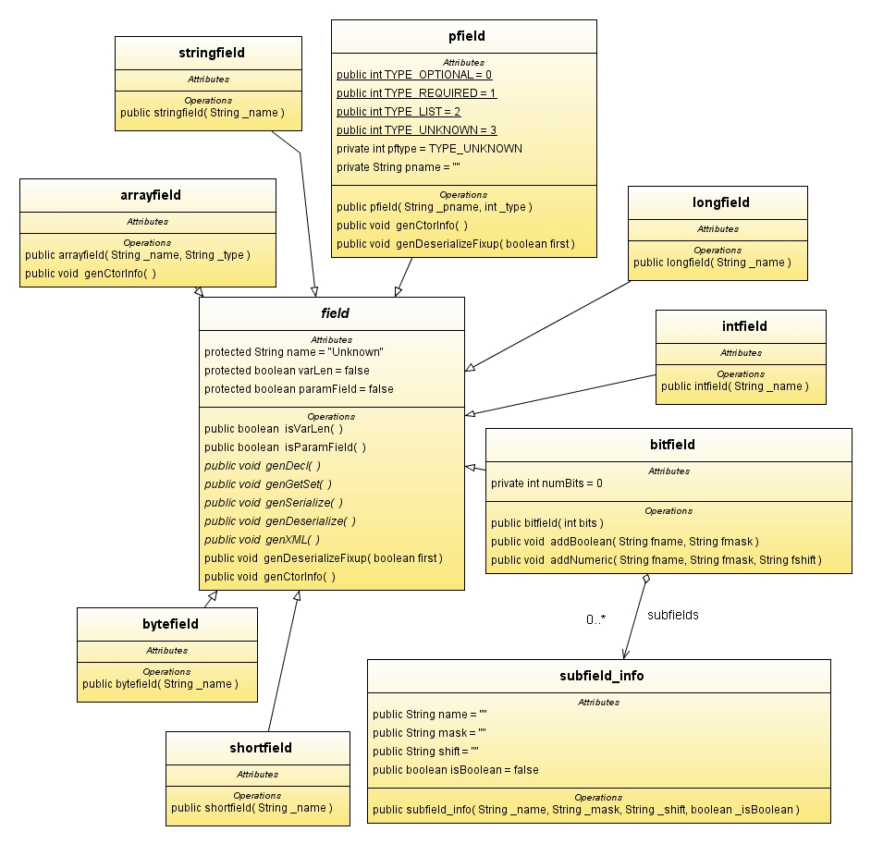
Figure 3: The field Class and field-derived Classes

The bytefield class
The bytefield class corresponds to the <bytefield> element in the class description language. The bytefield constructor requires only a String “name” parameter.

Method | Output String
genDecl() | private byte _FOO = 0;
genGetSet() | public void setFOO(byte b) {_FOO=b;}  public void setFOO(String s) {_FOO=Byte.parseByte(s);}  public byte getFOO() {return _FOO;}
genSerialize() | out.writeByte(_FOO);
genDeserialize() | _FOO = in.readByte();
genXML() | sb.append(indent+" <FOO value=\""+_FOO+"\"/>\n");
Sample bytefield method outputs for <bytefield name="FOO"/>

The shortfield class
The shortfield class corresponds to the <shortfield> element in the class description language. The shortfield constructor requires only a String “name” parameter.

Method | Output String
genDecl() | private short _FOO = 0;
genGetSet() | public void setFOO(short b) {_FOO=b;}  public void setFOO(String s) {_FOO=Short.parseShort(s);}  public short getFOO() {return _FOO;}
genSerialize() | out.writeShort(_FOO);
genDeserialize() | _FOO = in.readShort();
genXML() | sb.append(indent+" <FOO value=\""+_FOO+"\"/>\n");
Sample shortfield method outputs for <shortfield name="FOO"/>

The intfield class
The intfield class corresponds to the <intfield> element in the class description language. The intfield constructor requires only a String “name” parameter.

Method | Output String
genDecl() | private int _FOO = 0;
genGetSet() | public void setFOO(int b) {_FOO=b;}  public void setFOO(String s) {_FOO=Integer.parseInt(s);}  public int getFOO() {return _FOO;}
genSerialize() | out.writeInt(_FOO);
genDeserialize() | _FOO = in.readInt();
genXML() | sb.append(indent+" <FOO value=\""+_FOO+"\"/>\n");
Sample intfield method outputs for <intfield name="FOO"/>

The longfield class
The longfield class corresponds to the <longfield> element in the class description language. The longfield constructor requires only a String “name” parameter.

Method | Output String
genDecl() | private long _FOO = 0;
genGetSet() | public void setFOO(long b) {_FOO=b;}  public void setFOO(String s) {_FOO=Long.parseLong(s);}  public long getFOO() {return _FOO;}
genSerialize() | out.writeLong(_FOO);
genDeserialize() | _FOO = in.readLong();
genXML() | sb.append(indent+" <FOO value=\""+_FOO+"\"/>\n");
Sample longfield method outputs for <longfield name="FOO"/>

The stringfield class
The stringfield class corresponds to the <stringfield> element in the class description language. The stringfield constructor requires only a String “name” parameter.

Method | Output String
genDecl() | private String _FOO = “”;
genGetSet() | public void setFOO(String b) {_FOO=b;}  public String getFOO() {return _FOO;}
genSerialize() | out.writeUTF(_FOO);
genDeserialize() | _FOO = in.readUTF();
genXML() | sb.append(indent+" <FOO value=\""+_FOO+"\"/>\n");
Sample stringfield method outputs for <stringfield name="FOO"/>

The arrayfield class
The arrayfield class corresponds to the <arrayfield> element of the class description language. The arrayfield constructor requires a String “name” parameter and a String “type” parameter.

Method | Output String
genDecl() | private ArrayList<Integer> FOOElements = null;
genCtorInfo() | FOOElements = new ArrayList<Integer>();
genGetSet() | public int getFOOCount() {return FOOElements.size();}  public void addFOOElement(int x) {FOOElements.add(x);}  public void addFOOElement(String x){FOOElements.add((int)Integer.parseInt(x));}  public int getFOOElement(int index) {return FOOElements.get(index).intValue();}
genSerialize() | out.writeShort((short)FOOElements.size());  {  int i;  for(i=0;i<FOOElements.size();i++)  out.writeInt(FOOElements.get(i).intValue());  }
genDeserialize() | {  int cnt = in.readShort();  int i;  for(i=0;i<cnt;i++)  addFOOElement(in.readInt());  }
genXML() | {  int i;  for(i=0;i<FOOElements.size();i++)  sb.append(indent+" <FOOElement value=\""+FOOElements.get(i)+"\"/>\n");  }
Sample arrayfield method outputs for <arrayfield name="FOO" type=”int”/>

The pfield class
The pfield class corresponds to the <pfield> element of the class description language. It is used to track information about a field whose type involves an LLRP parameter. The pfield constructor requires a String “pname” parameter, which identifies the LLRP parameter type being used for the field, and an int “type” parameter, which can be one of TYPE_OPTIONAL, TYPE_REQUIRED, or TYPE_LIST. Some output samples for <pfield> elements are given in the next 3 tables.

Method | Output String
genDecl() | private LLRPStatus _LLRPStatusParam = null;
genCtorInfo() | _LLRPStatusParam = new LLRPStatus();
genGetSet() | public void setLLRPStatusParam(LLRPStatus p) {_LLRPStatusParam = p;}  public LLRPStatus getLLRPStatusParam() {return _LLRPStatusParam;}
genSerialize() | if(_LLRPStatusParam!=null) _LLRPStatusParam.serialize(out);
genDeserialize() | _LLRPStatusParam = (LLRPStatus) Parameter.deserialize(in);
genDeserializeFixup() | if(LLRPStatus.class.isInstance(p))  setLLRPStatusParam((LLRPStatus)p);
genXML() | if(_LLRPStatusParam!=null) _LLRPStatusParam.toXML(sb, indent+" ");
Sample pfield method outputs for <pfield name="LLRPStatus" type=”required”/>

Since the sample above involved a “required” <pfield>, an object is instantiated in the constructor. Also, required <pfield> elements have two possible methods of deserialization. If there are no optional pfields or variable length pfield lists in the parent message/param object/element, then the genDeserialize() output will be used for deserialization. If there are optional pfields or variable length pfield lists in the parent message/param, then the genDeserializeFixup output will be used for deserialization.

Method | Output String
genDecl() | private LLRPStatus _LLRPStatusParam = null;
genCtorInfo()
genGetSet() | public void setLLRPStatusParam(LLRPStatus p) {_LLRPStatusParam = p;}  public LLRPStatus getLLRPStatusParam() {return _LLRPStatusParam;}
genSerialize() | if(_LLRPStatusParam!=null) _LLRPStatusParam.serialize(out);
genDeserialize()
genDeserializeFixup() | if(LLRPStatus.class.isInstance(p))  setLLRPStatusParam((LLRPStatus)p);
genXML() | if(_LLRPStatusParam!=null) _LLRPStatusParam.toXML(sb, indent+" ");
Sample pfield method outputs for <pfield name="LLRPStatus" type=”optional”/>

Since the sample above involves an “optional” <pfield>, no object is instantiated in the constructor, leaving the member variable set to null. Also, genDeserialize() is not used since the presence of this <pfield> means that the parent message/param object contains optional parameter fields.

Method | Output String
genDecl() | private ArrayList<Custom> _CustomParams = null;
genCtorInfo() | _CustomParams = new ArrayList<Custom>();
genGetSet() | public int getNumCustomParams() { return _CustomParams.size();}  public void addCustomParam(Custom p) {_CustomParams.add(p);}  public Custom getCustomParam(int idx) {return _CustomParams.get(idx);}
genSerialize() | {  int i;  for(i=0; i<_CustomParams.size(); i++)  _CustomParams.get(i).serialize(out);  }
genDeserialize()
genDeserializeFixup() | else if(Custom.class.isInstance(p))  addCustomParam((Custom)p);
genXML() | {  int i;  for(i=0;i<_CustomParams.size();i++)  _CustomParams.get(i).toXML(sb, indent+" ");  }
Sample pfield method outputs for <pfield name="Custom" type=”list”/>

Since the sample above involves a variable length list of parameter fields, an empty list is instantiated in the constructor. Also, genDeserialize() is not used since the parent message/param object contains a variable length parameter field list.

The bitfield class
The bitfield class corresponds to the <bitfield> element of the class description language. The bitfield constructor takes an integer “bits” parameter, signifying the bit-width of the bitfield. Acceptable values for “bits” are 8, 16 and 32. Any unused bits in the bitfield will be set to 0.

Just as a <bitfield> element is composed of <Boolean> and <numeric> elements, a bitfield object is composed of subfield_info objects. The subfield_info object can either represent a <boolean> element or a <numeric> element from the class description language.

If a <bitfield> element was defined as follows:

<bitfield bits="8">
<numeric name="MB" mask="0x03" shift="6"/>
<boolean name="Match" mask="0x20"/>
</bitfield>

then the following table would describe the method outputs for the corresponding bitfield object:

Method | Output String
genDecl() | private int _MB = 0;  private boolean _Match = false;
genGetSet() | public void setMB(int i) {_MB = i;}  public void setMB(String s) {_MB = Integer.parseInt(s);}  public int getMB() {return _MB;}  public void setMatch(boolean b) {_Match = b;}  public void setMatch(String s) {_Match = Boolean.parseBoolean(s);}  public boolean getMatch() {return _Match;}
genSerialize() | byte x = 0;  x = (byte) (x | ((_MB & 0x03) << 6));  if (_Match) x = (byte) (x | 0x20);  out.writeByte(x);
genDeserialize() | byte x = in.readByte();  _MB = ( (x >> 6) & 0x03);  _Match = ( (x & 0x20) != 0);
genXML() | sb.append(indent+" <MB value=\""+_MB+"\"/>\n");  sb.append(indent+" <Match value=\""+_Match+"\"/>\n");
Sample bitfield method outputs for <bitfield> definition given above

