OpenCredo Cloud Storage v.1.0
This document assumes that the reader has at least a basic understanding of storage in the cloud and Spring-Integration. Please refer to Amazon Simple Storage Service (Amazon S3), Windows Azure online storage and Spring-Integration for details.

OpenCredo-Cloud-Storage is motivated by the following goals:
- To provide a simple Spring template style model for implementing applications interacting with cloud storage from JavaTM.
- To be able to change cloud storage provider with minimal effort.
- To facilitate interaction with cloud storage from Spring Integration.

OpenCredo Cloud storage consist of four parts: 'cloud-storage-template', 'cloud-storage-s3', 'cloud-storage-azure' and 'cloud-storage-spring-integration-support'. The diagram below shows how those parts fit together.
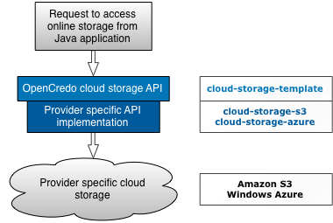
cloud-storage-spring-integration-support is not shown on the diagram above because it is an extension specifically for Java applications that use Spring-Integration and will be discussed later in this document.

Naming conventions in OpenCredo Cloud Storage projects
Different cloud providers use different names for similar concepts in the cloud storage domain. OpenCredo tried to unify such names so as to provide a common abstract. The following taxonomy will be extensively used in this reference documentation:
- container (bucket in Amazon S3) – Think of this as a folder or directory on “disk” in cloud storage with one restriction; a container can't contain other containers.
- blob or container-object – Something that can be added(saved)/retrieved/deleted from a container. A file in a folder or directory is similar to a blob in a container.

OpenCredo Cloud Storage template (cloud-storage-template)
The cloud-storage-template specifies a simple API for interaction with cloud storage.
public interface StorageOperations {

// List container names in online storage provider
public List<String> listContainerNames();

// Operations with storage containers
public void createContainer(String containerName);
public void deleteContainer(String containerName);
public ContainerStatus checkContainerStatus(String containerName);
public List<BlobDetails> listContainerObjectDetails(String containerName);

// Operations with objects (blobs) in container
public void send(String containerName, String objectName, String stringToSend);
public void send(String containerName, String objectName, File fileToSend);
public void send(String containerName, String objectName, InputStream isToSend);
public String receiveAsString(String containerName, String objectName);
public void receiveAndSaveToFile(String containerName, String objectName, File toFile);
public InputStream receiveAsInputStream(String containerName, String objectName);
public void deleteObject(String containerName, String objectName);
...
}

StorageOperations defines core methods to deal with data in the cloud. ContainerStatus represents the status of the container. It is defines as enum with three possible values:
public enum ContainerStatus {
MINE, DOES_NOT_EXIST, ALREADY_CLAIMED
}

- MINE – the container was created by current user and it has all access rights to it.
- DOES_NOT_EXIST – the container with specified name does not exist.
- ALREADY_CLAIMED – the container does exist, but the current user is not the owner of it. This container status is specific to Amazon S3 storage's global namespace for its concept of buckets. Amazon S3 requires that each container (bucket) has a globally unique name, whereas Windows Azure requires uniqueness per account.

The BlobDetails class encapsulates minimal data about a blob such as:
- Container name;
- Object name;
- ETag;
- Last modified date;

OpenCredo Cloud Storage Template for Amazon S3 (cloud-storage-s3)
cloud-storage-s3 module is an implementation of the cloud-storage-template for Amazon S3. An Amazon Web Services (AWS) account is required to start using cloud-storage-s3.
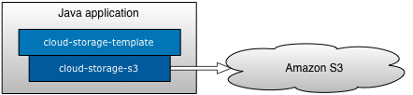
The S3Template is the implementation of StorageOperations specifically to provide access to Amazon's Simple Storage Service (S3). It is based on the free, open-source JavaTM toolkit and application suite JetS3t v.0.7.2.
You can use Spring to configure an S3Template as shown below, providing your own AWS account details:
<!-- Credentials required to access Amazon S3 -->
<bean id="awsCredentials" class="org.opencredo.cloud.storage.s3.AwsCredentials">
<constructor-arg value="AmazonS3-AWS-key" />
<constructor-arg value="AmazonS3-AWS-secret-key" />
</bean>

<!-- Template for accessing Amazon S3 -->
<bean id="s3Template" class="org.opencredo.cloud.storage.s3.S3Template">
<!-- Reference to credentials used by this template to access Amazon S3 -->
<constructor-arg ref="awsCredentials" />
</bean>

OpenCredo cloud storage template for Windows Azure (cloud-storage-azure)
The cloud-storage-azure module is an implementation of the cloud-storage-template for Windows Azure. A Windows Azure platform account is required to use cloud-storage-azure.
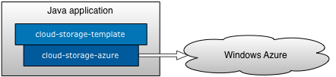
The AzureTemplate is an implementation of StorageOperations specifically for Windows Azure. cloud-storage-azure interacts with the Windows Azure Storage Services REST API. A REST client is implemented inside the module (this is briefly explained below) and it uses the free and open source Apache HttpComponents v.4.0.1.
You can configure the AzureTemplate using Spring as shown below, replacing the indicated credentials with your own account's Azure credentials:
<!-- Credentials required to access Windows Azure -->
<bean id="azureCredentials" class="org.opencredo.cloud.storage.azure.AzureCredentials">
<constructor-arg value="Windows-Azure-account-name" />
<constructor-arg value="Windows-Azure-secret-key" />
</bean>

<!-- Template for accessing Windows Azure -->
<bean id="azureTemplate" class="org.opencredo.cloud.storage.azure.AzureTemplate">
<!-- Reference to credentials used by this template to access Windows Azure -->
<constructor-arg ref="azureCredentials" />
</bean>

Windows Azure REST client
REST clients core interface is AzureRestService and it has a single implementation – DefaultAzureRestService. This interface mirrors all methods specified in StorageOperations.
public interface AzureRestService {
void createContainer(String containerName);
void deleteContainer(String containerName);
List<String> listContainerNames();
void deleteObject(String containerName, String blobName);
void putObject(String containerName, Blob<?> blob);
InputStreamBlob getObject(String containerName, String blobName);
List<BlobDetails> listContainerObjectDetails(String containerName);
ContainerStatus checkContainerStatus(String containerName);
}

It is not intended that DefaultAzureRestService will be used directly, the intention being that developers will develop against the AzureTemplate instead.
Blob<?> is an abstract class encapsulating container object (blob) data to be sent to Windows Azure. This class has 3 implementations: StringBlob (sends string as blob), FileBlob (sends file content as blob), and InputStreamBlob (sends stream as blob). A received blob from Windows Azure cloud storage is always a InputStreamBlob. It's up to the caller to convert the stream to anything it expects. The AzureTemplate has convenience methods that encapsulate stream conversion to String or saving to the file.

OpenCredo Cloud Storage SI adapters (cloud-storage-spring-integration-support)
The cloud-storage-spring-integration-support is a link between Spring-Integration (SI) and cloud storage. It provides several SI end point adapters.
An Outbound adapter sends blob to the cloud storage. An Inbound adapter polls cloud storage for blob details (please note it is not a full blob, but just the details) and forwards those details to a blob details enricher. The Enricher's job is to download the full blob and forwardthat manipulated blob content for further processing. See the diagram below that explains this process:
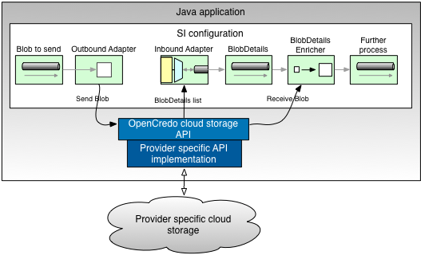
You can configure your Cloud storage adapters in Spring using custom namespace elements, which will be covered in the following individual adapter sections.

The Outbound adapter
The Outbound adapter takes a message from an SI channel and sends its content to the specified container in cloud storage. Currently the outbound adapter can handle SI messages with String or File payloads. A new blob name for the blob in the container can be defined by providing an implementation of the BlobNameBuilder strategy.
public interface BlobNameBuilder {

String createBlobName(Message<?> message);
}

The Default strategy is DefaultBlobNameBuilder, which returns a blob name in the pattern “object.<current_date-time_in_milliseconds>”.

Outbound Adapter Namespace Support
The outbound adapter can be defined in Spring using the custom namespace:
xmlns:xsi="http://www.w3.org/2001/XMLSchema-instance"
xmlns:cloud="http://www.opencredo.com/schema/si/cloud/storage"
xsi:schemaLocation="...
http://www.opencredo.com/schema/si/cloud/storage
http://www.opencredo.com/schema/si/cloud/storage/opencredo-si-cloud-storage.xsd">

<!-- Outbound adapter -->
<cloud:outbound-channel-adapter
template="template" container="${containerName}" channel="blobToSendChannel"
name-builder="blobNameBuilder" />

The Outbound adapter custom element includes the following attributes:
- 'template' – a reference to implementation of StorageOperations bean.
- 'container' – the name of the cloud storage container where blobs will be uploaded.
- 'channel' – a reference to the SI channel from where blobs are coming.
- 'name-builder' – a reference to an implementation of BlobNameBuilder bean. This attribute is optional as the DefaultBlobNameBuilder will be used by default.

The Inbound adapter
The Inbound adapter polls a specified cloud storage container and receives a list of BlobDetails (see BlobDetails description in previous sections). It is important to note that Inbound adapter never downloads the full blob. It filters received BlobDetails list to identify only those blobs which should be downloaded. Filtered BlobDetails are added to the queue (queue ordering can be customised to allow for prioritisation). Each subsequent poll will then remove the head of that queue with the BlobDetails instance then becoming the payload of the sent Spring Integration message. It is then the job of the enricher to download the full blob and transform its data to the expected form for further processing.
The Inbound adapter is state-full, that means it will not check online storage container on each polling request, but will return the first BlobDetails from the queue if there is any. The online storage container is checked for new BlobDetails if the queue is empty. The following diagram walks through this behavior in more detail:
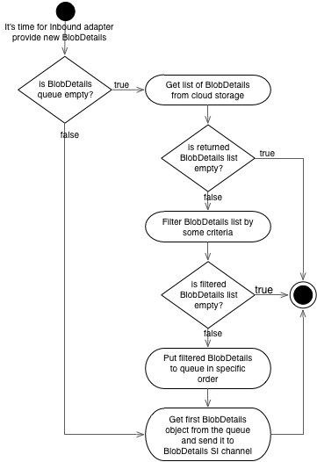
As mentioned before you can change the BlobDetails filtering criteria and the sequence in which filtered BlobDetails appear in the queue to be processed.
There are three predefined filters: AcceptOnceBlobNameFilter (default filter for Inbound adapter), PatternMatchingBlobNameFilter and CompositeBlobDetailsFilter. You can also create their own filters by implementing BlobDetailsFilter interface or extending AbstractBlobDetailsFilter.
public interface BlobDetailsFilter {

List<BlobDetails> filter(List<BlobDetails> objects);
}

Implementation of the marker interface BlobDetailsComparator gives you the opportunity to customize the sequence of BlobDetails in the processing queue. Only one default implementation is provided out of the box at the moment, and it is the BlobLastModifiedDateComparator that orders BlobDetails by last modified date.

Inbound Adapter Namespace Support
Indentically to the outbound adapter, an inbound adapter can be defined using a custom Spring namespace:
<!-- Inbound adapter -->
<cloud:inbound-channel-adapter channel="blobDetailsChannel"
template="template" container="${containerName}" filter="blobNameFilter"
comparator="lastModifiedDateComparator">
<si:poller>
<si:interval-trigger interval="5000" />
</si:poller>
</cloud:inbound-channel-adapter>

Inbound adapter custom element attributes:
- 'channel' – a reference to SI channel where incoming BlobDetails will be pushed.
- 'template' – a reference to an implementation of StorageOperations.
- 'container' – the name of the cloud storage container that will be polled for blobs.
- 'filter' – a reference to an implementation of BlobDetailsFilter bean. This attribute is optional; by default the AcceptOnceBlobNameFilter will be used.
- 'comparator' – a reference to an implementation of BlobDetailsComparator. This attribute is also optional; BlobLastModifiedDateComparator will be used by default.

BlobDetails enricher
Blob data is downloaded by an enricher that can be configured somewhere in the SI pipeline. Enrichers expects BlobDetails as the SI message payload and uses this information to identify the container and blob to be downloaded. Two enrichers are provided: ToByteArrayEnricher (creates a byte array from blob data) and ToStringEnricher (creates a string from the downloaded blob data). Both enrichers push results to an output SI channel for further processing.
A string enricher can be configured as shown below:

<!-- Blob to String enricher -->
<bean id="toStringEnricher" class="org.opencredo.cloud.storage.si.enricher.ToStringEnricher">
<constructor-arg ref="template" />
</bean>

<!-- SI enricher configuration -->
<si:service-activator input-channel="blobDetailsChannel"
ref="toStringEnricher" method="transform" output-channel="furtherProcessingChannel" />

It is important to note that the inbound adapter (providing BlobDetails) and enricher (downloading blob specified in BlobDetails) are using the same cloud storage provider account. Account details are provided when the 'template' (S3Template or AzureTemplate) is created.

Custom namespace
The custom SI namespace for OpenCredo cloud storage (http://www.opencredo.com/schema/si/cloud/storage) can be applied as shown below:
<?xml version="1.0" encoding="UTF-8"?>
<beans xmlns="http://www.springframework.org/schema/beans"
xmlns:xsi="http://www.w3.org/2001/XMLSchema-instance" xmlns:si="http://www.springframework.org/schema/integration"
xmlns:cloud="http://www.opencredo.com/schema/si/cloud/storage"
xsi:schemaLocation="http://www.springframework.org/schema/beans
http://www.springframework.org/schema/beans/spring-beans-2.5.xsd
http://www.springframework.org/schema/integration
http://www.springframework.org/schema/integration/spring-integration-1.0.xsd
http://www.opencredo.com/schema/si/cloud/storage
http://www.opencredo.com/schema/si/cloud/storage/opencredo-si-cloud-storage.xsd">

…

<!-- Inbound adapter -->
<cloud:inbound-channel-adapter channel="blobDetailsChannel"
template="template" container="${containerName}" filter="blobNameFilter"
comparator="lastModifiedDateComparator">
<si:poller>
<si:interval-trigger interval="5000" />
</si:poller>
</cloud:inbound-channel-adapter>

<!-- Outbound adapter -->
<cloud:outbound-channel-adapter
template="template" container="${containerName}" channel="blobToSendChannel"
name-builder="blobNameBuilder" />
</beans>

References:
Amazon Simple Storage Service (Amazon S3): http://aws.amazon.com/s3/
Windows Azure: http://www.microsoft.com/windowsazure/
Spring-Integration (SI): http://www.springsource.org/spring-integration
JetS3t: http://jets3t.s3.amazonaws.com/index.html
Apache HttpComponents: http://hc.apache.org/

